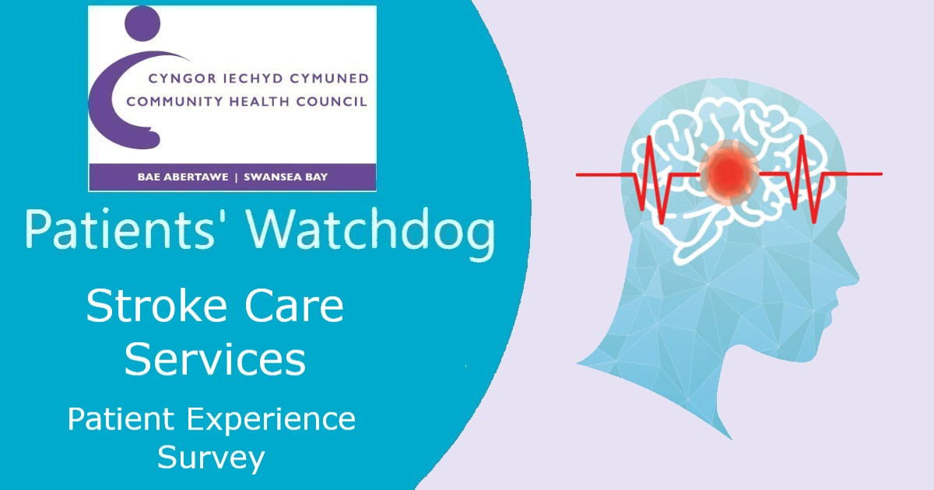

Have you had a stroke recently?
Do you look after someone who has?
We want to hear from you!

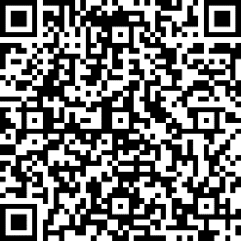

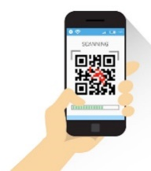


Your feedback will play a vital role in improving the service for others

Online:
https://forms.office.com/r/pMQUyG7TTa
OR
Scan the QR code with your
Smartphone or mobile device
Call us:
01639 683 490

Swansea Bay Community Health Council,
Cimla Health & Social Care Centre, Cimla,
Neath SA11 3SU
Email: swanseabay@waleschc.org.uk
Web: www.swanseabaychc.nhs.wales

