Meeting Date | 20 November 2025 |  | Agenda Item |  |  | 7.3
Name of Meeting | Audit Committee
Report Title | Spinal Operational Network Annual Report
Report Author | Scott Hurford, Operational Network Manager
Report Sponsor | Richard Evans, Executive Medical Director, SBUHB
Presented by | Scott Hurford, Operational Network Manager
Freedom of Information | Open
Purpose of the Report | To provide SBUHB Audit Committee with the South Wales Spinal Network (SWSN) Annual Report, covering the period of April 2024- April 2025.
Key Issues | - The South Wales Spinal Network launched on September 25th, 2023, with a remit of addressing and standardising spinal services across south Wales;  - It has an operational delivery network (ODN) which is hosted by the health board and commissioned by the NHS Wales Joint Commissioning Committee (NWJCC);  - As part of the governance arrangements within the health board to discharge its host responsibilities, an annual report is provided to the Audit Committee summarising the previous year’s activity.
Specific Action Required  (please choose one only) | Information | Discussion |  | Assurance | Approval
Specific Action Required  (please choose one only) | ☐ | ☐ |  | ☒ | ☐
Recommendations | Members are asked to:  - ACKNOWLEDGE the content of report.  - ACKNOWLEDGE the excellent progress across the work throughout the first year of the ODN establishment.  - ACKNOWLEDGE the SWSN mitigation and impact around the recurring risks.  - BE ASSURED that there are no risks to Swansea Bay as host organisation of the ODN.

SPINAL OPERATIONAL NETWORK ANNUAL REPORT

- INTRODUCTION
This report provides the Audit Committee with the SWSN Annual Report, covering the period of April 2024-April 2025.

- BACKGROUND
The SWSN launched on September 25th, 2023, with a remit of addressing and standardising spinal services across south Wales. It has an operational delivery network (ODN) which is hosted by the health board and commissioned by the NWJCC.

As part of this arrangement Swansea Bay University Health Board (SBUHB) has an MOU (memorandum of understanding) in place with all organisations which clearly defines the role of the ODN and the health board’s responsibility as its host. Its clinical governance responsibilities and ‘operational authority’ (in relation to patient flows) are discharged through its Network Board to NWJCC (via the SWSN Delivery Assurance Group). It also reports into the SBUHB Management Board and Quality and Safety Committee respectively.

The full governance structure is set out in the diagram below:

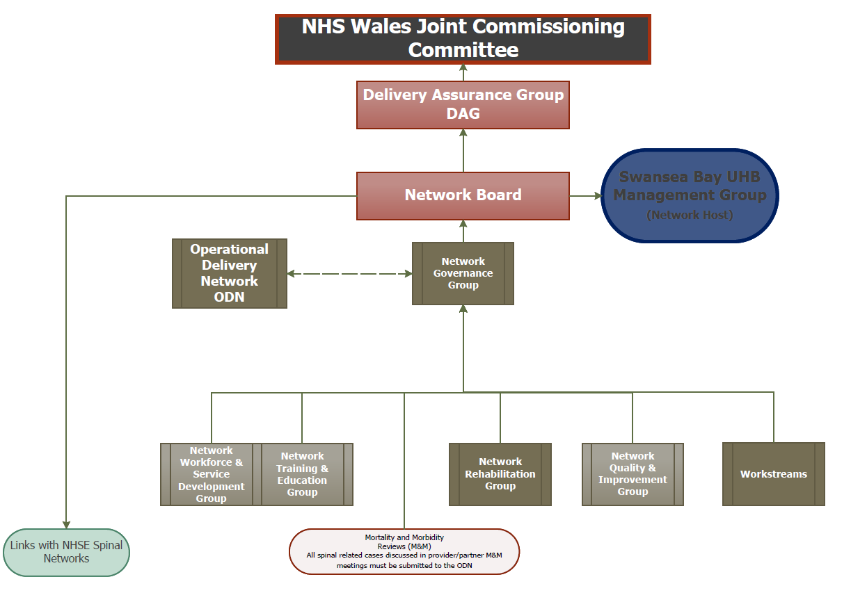

As this is an annual report, there are no key actions required of members other than ensuring that the required systems and controls are in place.

- GOVERNANCE AND RISK ISSUES
The annual report provides assurances in the following areas:
- Staffing
- Operational Policies, Clinical Guidelines & Clinical Pathways
- 24/7 MRI Provision from Health Boards
- Activity/Performance Data
- Spinal Incident Database (SID)

Concerns: Clinical & Operational

Risk and Issues log
- Metastatic Spinal Cord Compression Service
- Quality Improvement & Research
- Training and education
- Benefits Realisation Plan

While the full report is attached at appendix one, some key points to highlight include:

- The SWSN has continued working with various stakeholders across South Wales to develop and impliment clinical guidelines, operational policies and clinical pathways. One new clinical guideline has been approved with a number of others in progress;
- The ODN are working with the South Wales Trauma Network and Musculoskeletal Strategic Clinical Network (MSK SCN) to develop a training and education package;
- The interim solution for 24/7 MRI access at Prince Philip Hospital is now operational. However, the longer-term plan remains to deliver the 24/7 MRI service at Glangwili Hospital;
- For any spinal incidents, outcomes and lessons learnt are shared across the SWSN and form part of the governance programme, lessons learned reports and the network training plan.

In terms of risk, there is a live risks and issues log that is reviewed by SWSN Governance Group and presented to Network Board. The latest Risk and Issue Registers are attached as appendix 2 & 3 respectively.

There are currently 16 risks identified, two of which were presented to Network board as they are highlighted as a 12 or above RAG (red, amber, green) rating:
- SWSN.002- There is a risk of patients with time sensitive pathologies, outside of the spinal centre, may receive delayed or inappropriate care. Inconsistent access to 24/7 MRI in SEW (as a results of limited radiographer and radiologist cover) and the absence of standardised clinical pathways potentially resulting in patient harm/ irreversible neurological injury. Major medicolegal payouts. risk that time sensitive pathologies (cauda equina syndrome, metastatic spinal cord compression, traumatic acute spinal cord injury, acute deterioration from epidural abscess/ haematoma) are not managed in appropriate timescale- CTM to CAV pathway is only applicable to CES. Further solution required.
- SWSN.022- Long inpatient spinal waiting list. Lack of theatre access is leading to pressure to treat patients not on priority which is leading to potential paralysis and poor outcome- Risk increased due to ongoing bed pressures around elective spinal patients and poor access around the network, except ABUHB.

There are currently 21 live issues. One of these issues is critical:
- SWSN.001- Delayed access to MRI scan has led to delays in diagnosing and treating patients with Cauda Equina Syndrome, which in turn has resulted in suboptimal / poor outcomes for patients. Inadequate provision and convoluted clinical pathways for CES- The network has requested data from the Welsh Risk Pool to audit any ongoing trends. In addition to The Network Quality Improvement & Research Lead undertaking an audit of the patient’s journey in comparison to the Network published clinical guideline (CG01)

Finally, the Network has been developing a benefits realisation plan to ensure that the it is fulfilling its identified benefits of the service. The document was submitted to Network Board in April 2024 for review and ratification and is attached as appendix four.

- FINANCIAL IMPLICATIONS
There are no direct financial implications of this report. The ODN holds the budget for the ODN element of the South Wales Spinal Network only. This is broken down into the following elements:
- Pay - the ODN have no financial pay pressures.
- Non-Pay - the ODN are on target to breakeven from a non-pay perspective at the end of the financial year.

- RECOMMENDATION
Members are asked to:
- ACKNOWLEDGE the content of report.
- ACKNOWLEDGE the excellent progress across the work throughout the first year of the ODN establishment.
- ACKNOWLEDGE the SWSN mitigation and impact around the recurring risks.
- BE ASSURED that there are no risks to Swansea Bay as host organisation of the ODN.
Governance and Assurance

Link to Enabling Objectives  (please choose) | Supporting better health and wellbeing by actively promoting and empowering people to live well in resilient communities
Link to Enabling Objectives  (please choose) | Partnerships for Improving Health and Wellbeing |  | ☒
Link to Enabling Objectives  (please choose) | Co-Production and Health Literacy |  | ☒
Link to Enabling Objectives  (please choose) | Digitally Enabled Health and Wellbeing |  | ☐
Link to Enabling Objectives  (please choose) | Deliver better care through excellent health and care services achieving the outcomes that matter most to people
Link to Enabling Objectives  (please choose) | Best Value Outcomes and High Quality Care |  | ☒
Link to Enabling Objectives  (please choose) | Partnerships for Care |  | ☒
Link to Enabling Objectives  (please choose) | Excellent Staff |  | ☒
Link to Enabling Objectives  (please choose) | Digitally Enabled Care |  | ☐
Link to Enabling Objectives  (please choose) | Outstanding Research, Innovation, Education and Learning |  | ☒
Health and Care Standards
(please choose) | Staying Healthy |  | ☒
(please choose) | Safe Care |  | ☒
(please choose) | Effective Care |  | ☒
(please choose) | Dignified Care |  | ☒
(please choose) | Timely Care |  | ☒
(please choose) | Individual Care |  | ☒
(please choose) | Staff and Resources |  | ☒
Quality, Safety and Patient Experience
Delivery of a spinal network that fits with the ethos of improving spinal health for our population, by delivering the best possible treatment through an inclusive, equitable, collaborative and holistic approach.

Financial Implications
There are no financial implications from this paper. The ODN is hosted by SBUHB with the budget being set by JCC.

Legal Implications (including equality and diversity assessment)
There are no known legal or equality and diversity impacts over and above those developed within the setup of the service.

Staffing Implications
There are no current staffing implications.

Long Term Implications (including the impact of the Well-being of Future Generations (Wales) Act 2015)
- Long Term – The SWSN has developed a 5-year plan for the establishment of the network.
- Prevention – The SWSN is in the process of devising task and finish groups to identify specific elements of the pathway.
- Integration – Clinical pathways are delivered across the network.
- Collaboration – The SWSN works in collaboration with all HBs in Wales as well as with WAST and VNHST.
- Involvement – All HBs are involved in the network alongside 3rd sector groups.

Report History |  | November 2024
Appendices |  | Appendix 1 – Annual Report  Appendix 2- End of Year Delivery Assurance Group Report  Appendix 3 - Network Risk Register  Appendix 4 - Issue Log

