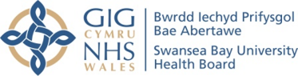

Young Adult Review

Thank you for coming to your young adult review appointment. We’ve included some extra information here that you might find helpful in the future.
How do I access treatment? 
If you’re an adult with a cleft lip and/or palate, you might have questions about your care or need extra support. Your local UK cleft team can help with things like revision surgery, psychological support, orthodontic treatment, speech and language therapy, or genetic testing.

You’re welcome to get in touch with the Welsh Centre for Cleft Lip & Palate for advice, treatment or support. Contact us on 01792 703810 if you need advice.

Psychology services?
The Cleft Psychology Team is here to support you at every step of your cleft journey. Whether you need help deciding about or preparing for surgery, or want to build your confidence and self-esteem, they are ready to assist.

While their service focuses on cleft-related needs, they can also guide you to other professionals and resources if you require more general support

Make sure to visit your dentist regularly for check-ups and routine care. If you have any concerns about your teeth, please talk to your Dentist first who may suggest you contact the Cleft Team for further advice and support.
What about Dental Care? 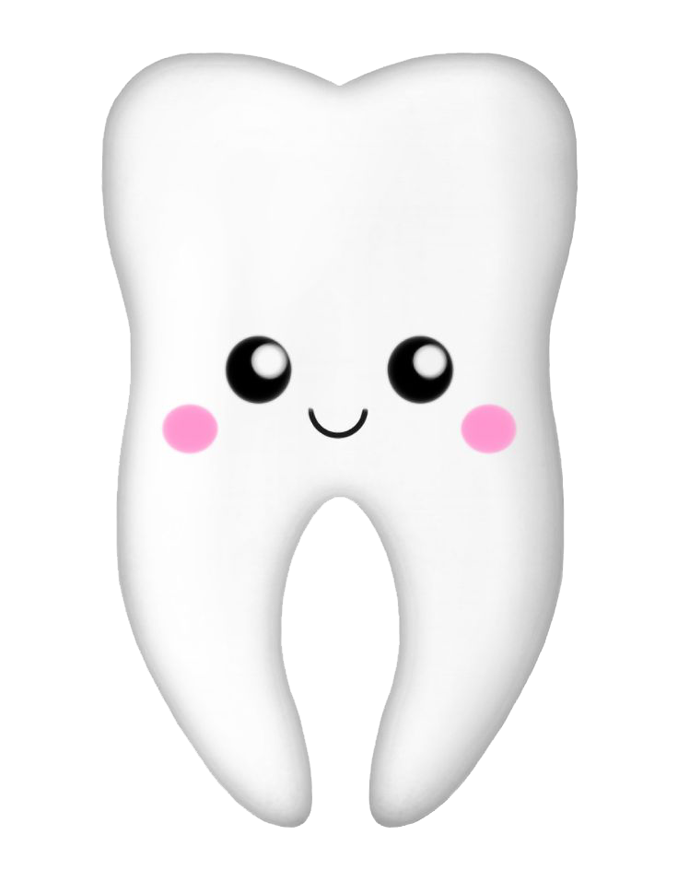

If you’re thinking about having children in the future, it’s helpful to know that around 1 in every 700 babies is born with a cleft. However, your chances may be different if other family members have a cleft or if it’s linked to other health conditions.

You can find out more about your likelihood of having a baby with a cleft at any time. Your GP or another healthcare professional can refer you to a genetics specialist for more information

Genetics & Family Planning?

Contact Us

The Welsh Centre for Cleft Lip & Palate at Morriston Hospital is the central point of contact to access any of the specialist services. You can contact the office via telephone or email: 01792 703810
SBU.CleftEnquiries@wales.nhs.uk

Adolygiad Oedolyn Ifanc
Diolch am ddod i'ch apwyntiad adolygu oedolyn ifanc. Rydym wedi cynnwys rhywfaint o wybodaeth ychwanegol yma a allai fod yn ddefnyddiol i chi yn y dyfodol.
Os ydych chi'n oedolyn â gwefus a/neu daflod hollt, efallai bod gennych chi gwestiynau am eich gofal neu efallai bod angen cymorth ychwanegol arnoch chi. Gall eich tîm hollt lleol yn y DU helpu gyda phethau fel llawdriniaeth adolygu, cefnogaeth seicolegol, triniaeth orthodontig, therapi iath a lleferydd, neu brofion genetig.

Mae croeso i chi gysylltu â Chanolfan Cymru ar gyfer Gwefus a Thaflod Hollt am gyngor, triniaeth neu gefnogaeth. Cysylltwch â ni ar 01792 703810 os oes angen cyngor arnoch.
Gwnewch yn siŵr eich bod yn ymweld â'ch deintydd yn rheolaidd am archwiliadau a gofal arferol. Os oes gennych unrhyw bryderon am eich dannedd, siaradwch â'ch Deintydd yn gyntaf a allai awgrymu eich bod yn cysylltu â'r Tîm Hollt i gael rhagor o gyngor a chymorth.
Mae'r Tîm Seicoleg Hollt yma i'ch cefnogi ym mhob cam o'ch taith hollt. P'un a oes angen help arnoch i benderfynu neu baratoi ar gyfer llawdriniaeth, neu os ydych chi eisiau meithrin eich hyder a'ch hunan-barch, maen nhw'n barod i gynorthwyo.

Er bod eu gwasanaeth yn canolbwyntio ar anghenion sy'n gysylltiedig â hollt, gallant hefyd eich tywys at weithwyr proffesiynol ac adnoddau eraill os oes angen cefnogaeth fwy cyffredinol arnoch.

Sut ydw i'n cyrchu triniaeth?

Gwasanaethau seicoleg?

Beth am Ofal Deintyddol?

Os ydych chi'n ystyried cael plant yn y dyfodol, mae'n ddefnyddiol gwybod bod tua 1 o bob 700 o fabanod yn cael eu geni â hollt. Fodd bynnag, gall eich siawns fod yn wahanol os oes gan aelodau eraill o'r teulu hollt neu os yw'n gysylltiedig â chyflyrau iechyd eraill.

Gallwch ddysgu mwy am eich tebygolrwydd o gael babi â hollt ar unrhyw adeg. Gall eich meddyg teulu neu weithiwr gofal iechyd proffesiynol arall eich atgyfeirio at arbenigwr geneteg i gael rhagor o wybodaeth.

Geneteg a Ghynllunio Teulu?

Cysylltwch â ni
Canolfan Cymru ar gyfer Gwefus a Thaflod Hollt yn Ysbyty Treforys yw'r pwynt cyswllt canolog i gael mynediad at unrhyw un o'r gwasanaethau arbenigol. Gallwch gysylltu â'r swyddfa dros y ffôn neu drwy e-bost: 01792 703810
SBU.CleftEnquiries@wales.nhs.uk

