On admission: calculate STUMBL Score (overleaf). If pain an issue, liaise with pain team and contact chest trauma physio team
NB: STUMBL Score is a predictor of complications and should be considered together with broader clinical picture (including PMH and frailty, injury profile)

NB: To refer for a follow-up appointment, please email Ceri Battle on ceri.battle@Wales.nhs.uk with the patient’s name, DOB and hospital number. Please include a brief summary of any relevant information (only if needed).

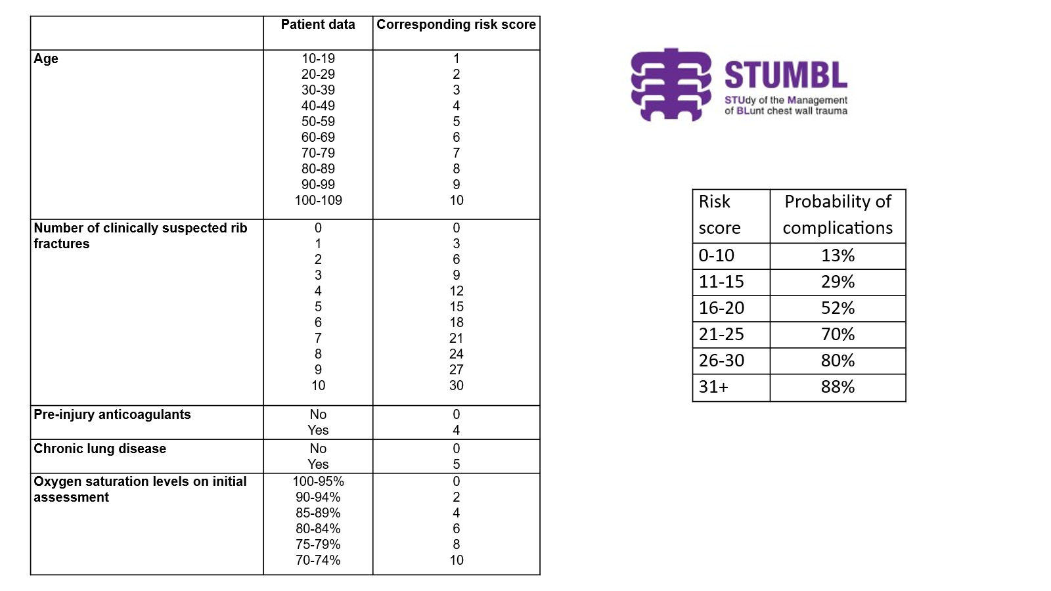

Contact numbers:

23920 Chest trauma physio team (to liaise with VW-FDS service)
23997 Pain Nurses (For all wards EXCEPT Cardiothoracics). Mon-Fri 8am-4pm.

For use by chest trauma physio team only:
23808 Consultant Anaesthetist 7 days a week 8am-8pm, Anaesthetic SPR 8pm-8am.
23488 Anaesthetic SPR/SHO 24/7
23794 Critical care outreach
##### VW-FDS team

