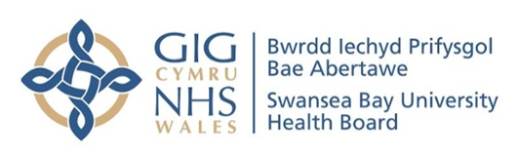

Standard Operating Procedure: Virtual Ward - Fracture Discharge Service (VW-FDS) management of adult patients with blunt chest trauma

Version information
Version no. | Date | Effective date | Review data
1.0 | 24th July 2023

Amendment information
Version no. and date | Detail of amendment | Authors | Signatures

Table of contents
SECTION HEADER | PAGE NO.
1.0 Purpose | 2
2.0 Definitions / glossary | 3
3.0 Scope | 3
4.0 Roles and responsibilities | 3
5.0 Service overview
5.1 Identification of suitable patients (including STUMBL Score form)
5.2 Referral criteria (including referral form)
5.3 Patient pathway
5.4 Clinical management in community
6. Communication
7. Staff training and maintenance of competency
8. Monitoring and evaluation of impact
9. Risks and mitigations

 | NAME | TITLE | SIGNATURE | DATE
Author | Ceri Battle | Respiratory physio, chest trauma service lead
Author | Sheree Breckon | ESD Team Lead
Author | Neil Hapgood | Project Manager
Reviewer | Emily Davies
Reviewer | A.N.Other
Authoriser | Anjula Mehta

READ BY
NAME | TITLE | SIGNATURE | DATE

1. PURPOSE
There are continual pressures on secondary care services with an increasing number of patients in hospital who could be managed safely in their home environment, with the support of community services. To enable the delivery of the AMSR programme within agreed timescales, improved performance and patient care, there is a need to find alternative solutions to increase flow from hospital to the community at the earliest point, reducing length of stay / bed occupancy and minimising the avoidable risks and costs associated with deconditioning and hospital-acquired infections.
For adult patients presenting to hospital with blunt chest trauma, the first 48-72 hours following injury are considered to be the high risk period, when the patient is most likely to develop a secondary pulmonary complication. At present, most adult patients with blunt chest trauma not requiring admittance to cardiothoracic services (for an intervention such as a chest drain or surgical fixation of rib fractures), or critical care services (for high level monitoring and respiratory support) are admitted to the Surgical Decision Making Unit (SDMU). They are admitted for a period of observation, pain management and physiotherapy, and once this high risk period is over, they will be discharged to their usual place of residence.

2. DEFINITIONS / GLOSSARY
Blunt chest trauma: any blunt injury sustained to the chest wall and underlying soft tissues / organs.
Rib fractures: a common injury sustained in blunt chest trauma, defined as a break in the continuity of the rib(s).

3. SCOPE
The Virtual Ward-Fracture Discharge Service targets the adult patients presenting to hospital with blunt chest trauma. This will include admission avoidance of older patients with blunt chest trauma with increased frailty who would without FDS, require a medical admission.
See referral criteria (page 4)

4. ROLES AND RESPONSIBILITIES

Area | Roles & Responsibilities
FDS | Fracture discharge service is provided by the virtual ward. It provides support for patients who have suffered a fracture in their own home, and involves input from medicine, nursing, therapy and pharmacy and ESD.
ESD | Early Supported Discharge is designed to enable the accelerated discharge of patients to their home, providing rehabilitation and social support in a home setting rather than an acute hospital ward. ESD is used independently from (when patient clinically optimised) or alongside (when patient not clinically optimised) VW-FDS, where additional rehabilitation needs are identified.
VW | Virtual Ward (VW) provides support for patients in their own home. Including a weekly multidisciplinary meeting, conducted over Teams, attended by primary care, secondary care and voluntary services, which provide support for the older patients with frailty, and those with complex health and social care needs, in their own homes rather than in hospital.
OPAS | Older Persons Assessment Service (OPAS) aims to provide a comprehensive assessment for older people and avoid hospital stays for them if possible.
In-patient chest trauma physio team | Hospital-based respiratory physiotherapy team (normal place of work being ITU / CITU) who manage the adult patients with blunt chest trauma, admitted to any area of the hospital
Wards | Wards are a group of Hospital Beds with associated treatment facilities managed as a single unit for the purposes of staffing and treatment responsibilities

5.0 SERVICE OVERVIEW
The following section provides an overview of the components of the adult blunt chest trauma service at Swansea Bay University Health Board

5.1 IDENTIFICATION OF SUITABLE PATIENTS
All adult patients with blunt chest trauma (located in ED and associated areas, SDMU or other ward) will be initially identified using the well-established daily email alert from the Trauma Audit Research Network co-ordinator or via referral to the inpatient chest trauma physio team via the other physiotherapy teams (who are familiar with the inpatient chest trauma physio team and alert them regarding new patients). From these patients, those who score 12-15 on the STUMBL Score (see below) will be assessed by the in-patient chest trauma physio team for suitability for management by the VW-FDS. An online MDCalc link to the STUMBL Score can be found at https://www.mdcalc.com/calc/10468/stumbl-battle-score
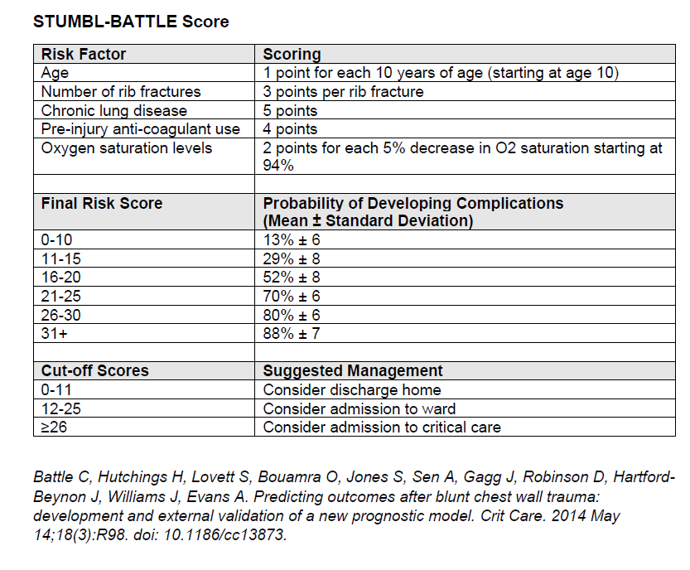
This cut-off is only to be used as a guide and clinical judgement can override the score’s management recommendation. If considered suitable for the VW-FDS, then this recommendation will be clearly documented in the patients' medical notes and a alert sent to the VW in reach team (via email/teams).
VW In reach team will discuss the patient with the relevant cluster, including any relevant information identified by the chest trauma physio team, and refer accordingly.

5.2. REFERRAL CRITERIA (VW-FDS Chest trauma)
- Adult patients with blunt chest trauma scoring 12-15 on the STUMBL Score
- To be admitted / admitted to hospital for a period of either observation and / or pain relief and / or physiotherapy
- Not requiring surgical intervention, invasive analgesia, chest drain, critical care management
- Discharge from secondary care via the fracture discharge pathway (fragility fractures) and the patient requires clinical optimisation.
- Unstable frailty (including unstable chronic condition that would benefit from MDT input)- possible reversible cause “off their legs” – preventing admission
- Requires palliation/end of life care (excluding cancer Patients)
- Patients on multiple (two or more) chronic condition registers

In cases where additional rehabilitation needs are identified, referral to Early Supported Discharge team will be considered. Referral criteria for ESD includes:

- Patient lives in the Neath Port Talbot (+ Cwmtawe cluster) area
- Patient was independent to ADLs prior to admission / good support networks in place
- Patient has short term rehabilitation goals to enable a return to independent living / no long term care needs identified
- Patient is able to complete transfers independently and is mobile with/without aid
- Able to manage own medication or have support in place for this.
- Patient is aware of the service objective/remit and is consenting to our input on discharge
- Patient is clinically optimized, if not clinically optimized they will be supported by the virtual ward.

5.3. PATIENT PATHWAY
Patient admitted to hospital with blunt chest trauma

Patient identified by in-hospital chest trauma physio team and assessed against criteria for referral to VW-FDS team

If criteria not achieved, patient remains under hospital-based services. If criteria achieved, recommendation documented in medical notes, followed by email/MS teams alert to VW in reach team

VW in reach make referral to the relevant ward. Discuss with CM/Physio re: capacity to accept. If patient identified as having additional rehabilitation needs, they will be referred to ESD and capacity discussed with ESD Team lead.

If VW-FDS team (+/-ESD) has capacity, they verbally accept patient. VW in reach to discuss discharge plan with patient and family, and medical team managing patient’s care and agree discharge. If the discharge doesn’t go ahead then the reason(s) must be sent to the in-reach team so these can be logged.

Patient is discharged by clinical team and seen either same / next day (as agreed in original handover).

Refer to “Community care” section of VW FSD SOP v3.0 08-12-2022

If patient identified as at risk of ongoing pain or disability (longer than the expected 6-8 weeks), they will be provided with advice as to who to contact within in-hospital chest trauma physio team

5.4 CLINICAL MANAGEMENT IN COMMUNITY
There are a number of key components to the management of adults with blunt chest trauma that will need to be considered.
Monitoring / assessment:
- Monitoring for deterioration in respiratory status. This is to include temperature, BP and HR, O₂ SATS, work of breathing / breathlessness, added sounds on auscultation, new onset cough or change in sputum, change in cognition, change in consciousness level (eg increasing drowsiness could indicate increasing CO₂ retention).
- Monitoring for deterioration in functional status. This is to include a change in baseline mobility status or independence in ADL. [?functional measure]
- Monitoring for deterioration in pain status. This can be completed using a Visual Analogue Scale (both static and dynamic assessment needed).
Management / treatment:
- Management of / assistance with patient’s analgesic strategy
- Check of patient’s compliance with breathing exercises (taught by in-hospital chest trauma physio team prior to discharge).
- Encourage patient to sit in chair / mobilise short distances regularly
- Encourage patient to complete gentle upper limb and thoracic mobility exercises
- Reassurance and education (to facilitate self-management on discharge from VW-FSD care)
[NB: We will need to ensure provision of appropriate advice sheets for patients, which include who to contact in case of change of status following discharge from VW-FDS care.]

6. COMMUNICATION
High level communication will be maintained between members of the in-hospital chest trauma physio team and the VW-FDS team. Including MS teams/Email + documentation in patient’s medical notes. A telephone/email contact sheet will be shared for both teams with direct access to team members.
The service will be communicated to the entire physiotherapy team in Morriston (on a 4 monthly basis to account for rotational staff) and the relevant medical and ward staff who routinely manage adult patients with blunt chest trauma.

7. STAFF TRAINING AND MAINTENANCE OF COMPETENCY
Training for the VW-FDS team will be provided by the in-hospital chest trauma physio team on a 4 or 6-monthly basis to allow for rotational staff. Additional online, pre-recorded teaching and educational material will be available for access outside of face to face teaching. Additional teaching can be arranged in response to individual cases on an ad-hoc basis.

8. MONITORING AND EVALUATION OF IMPACT
1) Hospital resource utilisation outcome measures will be assessed, including unplanned re-attendance at the Emergency Department, hospital length of stay, onset of pulmonary complications, adverse events, serious adverse events [insert others as needed]
2) Patient Reported Outcome Measures (PROMS) will be assessed, including a static and dynamic VAS for pain experience, EQ5D-5L as a health-related quality of life measure, and the Hospital Anxiety and Depression Scale (HADS). [insert others as needed]
3) Evaluation of Patient Reported Experience Measures (PREMS) will be completed as part of a research fellowship being completed by one of the in-hospital chest trauma physio team.

9. RISKS AND MITIGATIONS
There are a number of potential risks in this new service and this section is designed to be a live document that is updated as needed (rather than waiting for an annual review)

Identified risk | Action(s) needed to mitigate risk

Documents needed:
Patient advice sheets
Referral form
Assessment form for community care
Educational resources for VW-FDS team members
Outcome measures

