Scoping Document:
Establishment of a Women's Health Group for Staff

1. Summary
This scoping document outlines the rationale, need, and proposed model for establishing a Women’s Health Group for employees within Swansea Bay University Health Board. The group would aim to improve awareness, reduce stigma, and provide peer support, signposting and education on women’s health issues (via guest speakers) that can directly impact wellbeing, attendance, performance, and retention.

2. Background and Rationale
Women make up a significant proportion of the SBU workforce:
Female | 11,429 | 77.10%
Male | 3,395 | 22.90%
Total | 14,825
Figures as at 28.2.26, excludes Bank & Locum
Age range of females:
Female | 11429
Age Range | Numbers
<=20 Years | 26
>=71 Years | 54
21-25 | 626
26-30 | 1212
31-35 | 1464
36-40 | 1606
41-45 | 1377
46-50 | 1275
51-55 | 1450
56-60 | 1307
61-65 | 847
66-70 | 185

Many health conditions uniquely or disproportionately affecting women can impact attendance, wellbeing, and engagement, including menopause, menstrual disorders, fertility and pregnancy challenges, pelvic health issues, and hormonal wellbeing concerns.
Current sickness levels for the overall workforce (February 2026):
Overall | Long-term | Short-term
7.21% | 5.26% | 1.95%

The Occupational Health and Staff Wellbeing Service delivers several sessions directed at female members of the workforce and their managers:
- Menopause Cafes
- Mindful Menopause
- Menopause Champions
- Menopause Awareness for Managers
- Menstruation Awareness for Managers
- Pregnancy Risk Assessment for Managers

During various interactions (presentations, training etc.) with HB staff over the last few months, the question has been asked if attendees thought a general women’s health group would be more appealing than a dedicated menopause café, and all without exception thought it would. The reasons that were given included: some women may not realize they may be perimenopause or embarrassed and therefore reluctant to attend such an event and those not in the ‘menopause age range’ are excluded. Although those who have attended state, they have found them beneficial.
The Women’s Health Plan for Wales launched a ten-year vision to improve healthcare for women, developed from a National Strategic Clinical Network. There are list of 8 priorities for Women’s Health (in general).
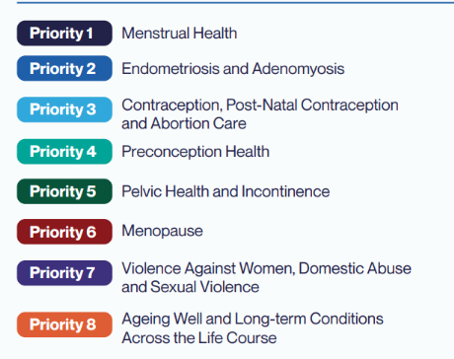
The draft document contains a raft of contributors, some of who are SBU employees (e.g. sexual health lead), demonstrating engagement from within the HB and the development of a Women’s Group or Health Group could be aligned to this.
Several English NHS Trusts have implemented staff networks for women, and Velindre Cancer Centre recently launched a Women's Network to coincide with International Women’s Day March 2026.

SBUHB recently launched an Online women's health hub which has wide range of topics on its page which could be additional resource.

3. Purpose of the Women’s Health Group
The group would aim to create a supportive forum for employees to discuss women’s health topics in a safe, confidential environment, improve access to high‑quality information and reduce stigma.

4. Stakeholder Mapping
Key stakeholders include Occupational Health & Staff Wellbeing, HR Business Partners, Operational Workforce, Culture, OD & Staff Experience, Trade Union Representatives, and a Senior Leadership Sponsor with representation from staff forums to inform the development using a co-production approach.

5. Proposed Structure and Governance
The group could meet monthly, bi‑monthly or quarterly, primarily via Microsoft Teams. Governance will sit under the Staff Health & Wellbeing structure with a Terms of Reference guiding confidentiality, boundaries, and membership.

6. Activities and Deliverables
Activities may include educational sessions, guest speakers, awareness campaigns, resource development, peer support, and signposting. It will not be to provide expert individual advice and guidance, this has been noted as a concern, and so the boundaries will be clear.

7. Resource Requirements
Minimal additional resources are required: staff time for facilitation, co-ordination, communications support.
It would be advisable if two staff members could be assigned to facilitate the sessions. Specialist professionals could be invited to present on various topics as determined in collaboration by the group members.

8. Risks and Mitigation
Risks include engagement levels, sensitivity of topics, accessibility for shift workers, and clarity of group purpose. Mitigation includes clear comms, inclusive messaging, structured agenda, and confidentiality guidance.

9. Measures of Success
Indicators include participation numbers, feedback surveys and impact on engagement & retention.

10. Recommendations
Approve establishment of the Women's Health Group with nomination of a senior sponsor,

