Organised for Success Programme
Terms of Reference v7 31st October 2025
1.0 Context
Following from feedback from across the organisation, there is a recognised need to review how we are organised so that we are best placed to respond to the challenges we face in the most effective and efficient way, balancing short-term actions required to ensure delivery of in-year targets, and our longer term goals as set out in our refreshed strategy, Better Health, Better Care, Better Lives. We also know from both internal and external feedback (including internal and external audit, independent reviews) that we don’t yet have the right operating framework in place that aligns planning, performance, accountability and delivering – from Board through to front line services.
From recent reviews it has become evident that some clinical services (e.g. Emergency Department, Perinatal and Mental Health) need a period of enhanced management oversight to improve patient and staff experience at pace. Furthermore, staff survey results and other workforce metrics, such as high sickness absence rates, indicate that there is variability in the capacity and capability of managers across the health board impeding on our ability to deliver our strategic objectives and priorities.
Our clinical services plan will be the vehicle through which we review and refresh our plans for how best to configure and delivery our clinical services – recognising the need to delivery more care through integrated community services which provide care closer to home, increase digitally enabled care, and focus more of our resources on population health management through better prevention and early intervention to tackle the widening health inequities in our communities.
Our workforce has grown by c2,200 over the last five years despite a large proportion (c26%) of our services transferring to a neighbouring health board. We are currently delivering services in a way that is unaffordable with a current cost reduction requirement of around 8% in 2025/26 and similar for 2026/7. This requires us to be more radical and injecting more pace in to transforming our services, so they are sustainable – in terms of quality and safety, cost and workforce. Our current pay bill is unaffordable and needs to reduce by a minimum of 10% to ensure we remain sustainable into the future. This requires short term action to significantly reduce what it costs to delivery our services and medium-term service transformation, building on the successes we see every day.
The Organised for Success programme has been set up to support us to be organised in the most effective way to delivery in year and medium terms improvements – to set us up so we can be successful for the populations we serve, for our team colleagues across the organisation and for Ministers, to whom we are ultimately accountable.
The Organised for Success Programme is a key enabler in the delivery of the savings benefit associated with headcount reduction (as identified by the Recovery and Sustainability Board), which will include a management restructure of our clinical services and corporate functions. This programme of work will review executive portfolios, service group structures and management spans of control and will make recommendations on how we organise ourselves for success.
2.0 Programme Scope
The programme will include:
Phase 1 – Executive Portfolios/ Delivery Unit
- A review of executive portfolios
- A review of the deputy/ tier 2 management structure (those reporting to an executive director)
- The establishment of a delivery unit to bring together our PMO, transformation and improvement capability
- To explore the opportunity for joint appointments to support regional working with Hywel Dda
Phase 2 – Service Group Structures
- The establishment of a new care group structure
- A review of the care group leadership structure – confirming the Triumvirate Leadership model (e.g. operationally led or clinically led)
- A review of the number of divisions or directorates within each new care group to ensure spans of control are reasonable and equitable. This will include a review of the specialities and services managed under each of the care groups to ensure they are organised in the best way for our patients
- A review of the number of management layers within the care groups with the aim to have a maximum of 6 layers, where appropriate, from Board to front line staff with a focus for this programme on the top 4 layers (Tri, Division, Directorate, speciality/ service).
Phase 3 – Corporate Service Structures
- A review of the wraparound support for each new care group (e.g. HRBP, Finance BP) to ensure this is reasonable and equitable
- A review of corporate functions sitting in/ out of the new care groups to ascertain the most appropriate design of the function (e.g. hub and spoke, centralised)
3.0 Out of scope
- Medical and dental staff with the exception of Medical Directors, Clinical Directors and Clinical Leads
- Agenda for change staff with the exception of those in an operational managerial position of band 7 and above and this forms 100% of their work
4.0 Phased Approach
The programme plan is set out in the diagram below:
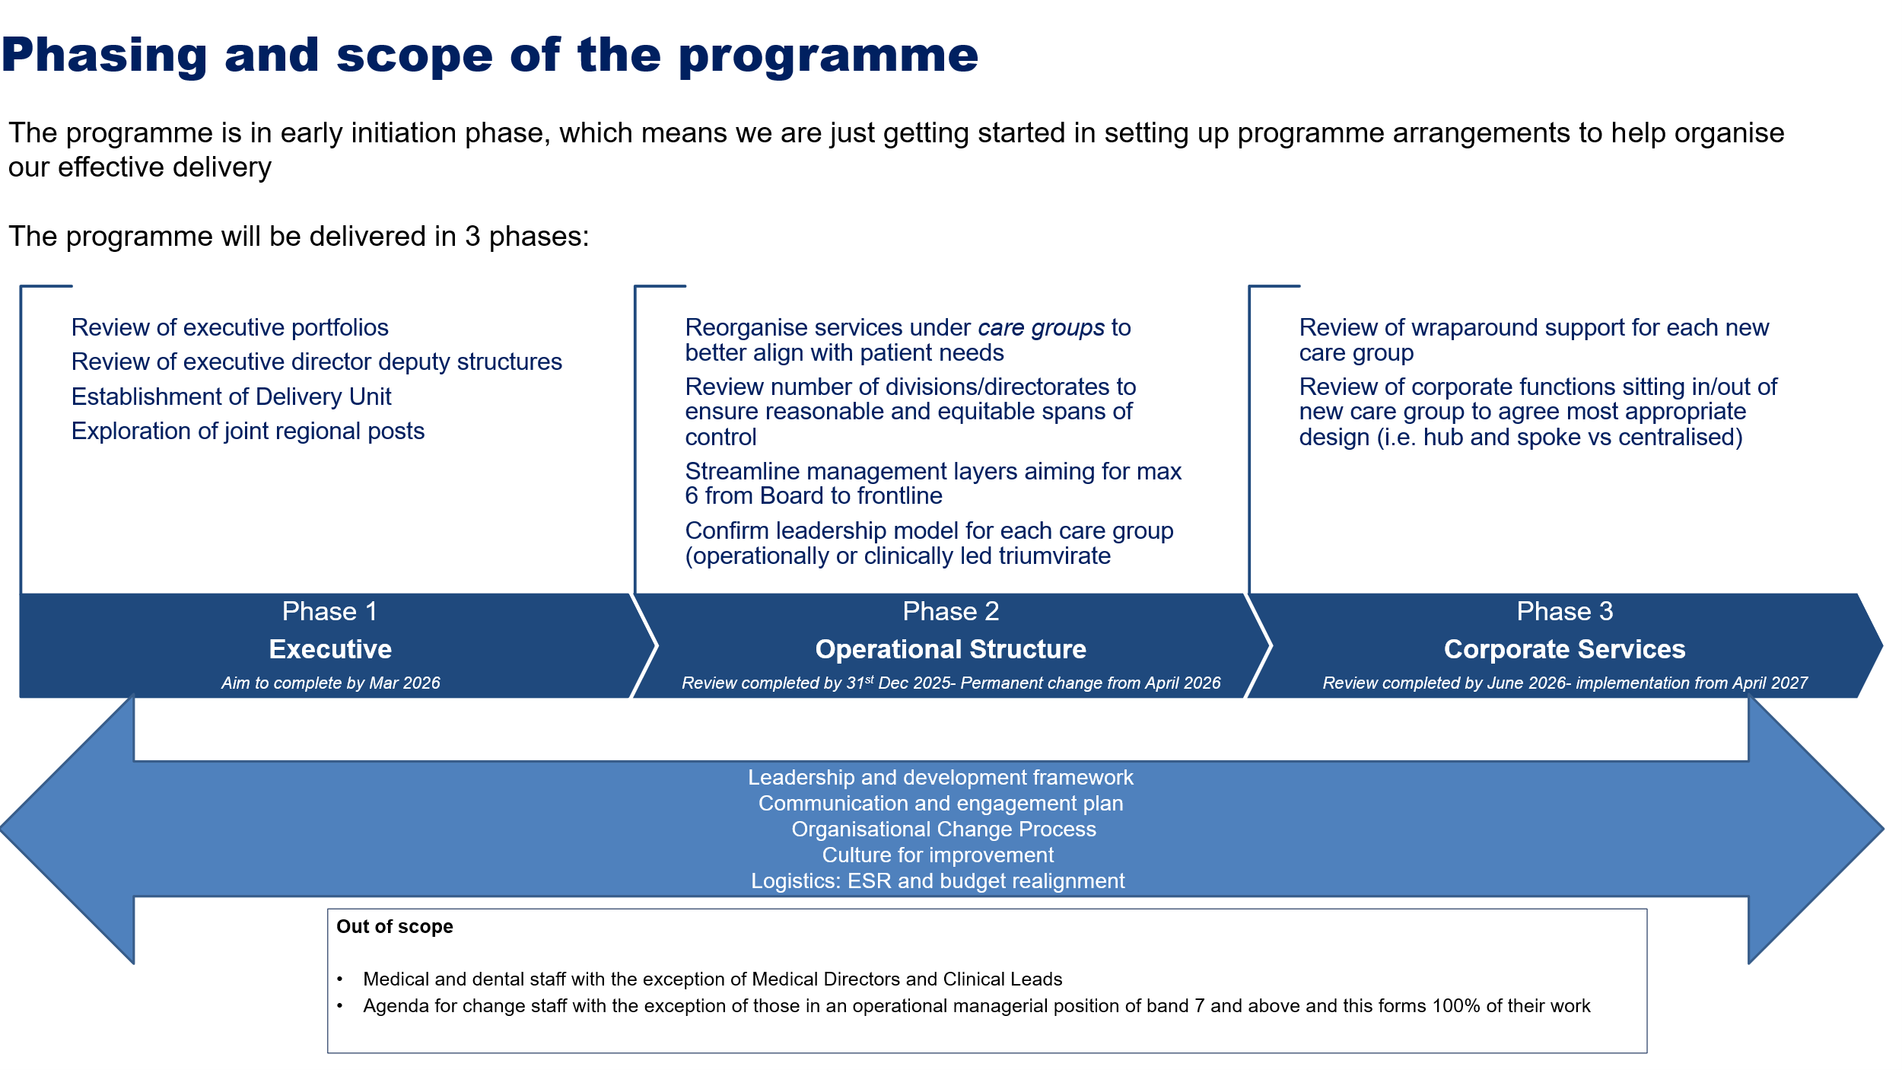
There are 5 enablers to the programme:
- Leadership and management development framework
- Programme communications and engagement plan
- Performance Management Framework
- Accountability Framework
- Single Improvement Methodology
We are still modelling how these enablers will interface with the programme.
The programme will be undertaken in 3 phases with the ambitious implementation dates detailed in the following table:
Phase 1 | Phase 2 | Phase 3
A:  - Review completed by  - New portfolios in place by 1/01/26  B:  - Review completed by 31/12/25  - New structure in place by 01/01/26  C:  - Review completed by 31/03/26  D:  - Review completed by 31/03/26 | E:  - Review completed by 31/12/25  - New structure in place 01/04/26  F:  - Review completed by 31/12/25  - Permanent change 01/04/26  G:  - Review completed by 31/03/26  - Permanent change 01/04/26  H:  - Review completed by 31/03/26  - Permanent change 01/04/26 | I:  - Review completed by 30/09/26  - Implementation date of 01/04/27  J:  - Review completed by 30/09/26  - Implementation date of 01/04/27

Appropriate staff engagement and organisational change processes will be undertaken for each stage of the programme (A to J) in line with the Organisational Change Policy.
5.0 Interdependencies
The change in service group structure will require a restructure of budgets, the electronic staff records system and other workforce IT systems. The programme plan will therefore include a support service resource plan (from existing resource) to enable this activity.
Permanent changes to the service group structures will come into effect at the beginning of the new financial year (April 2026) to avoid new hierarchies being established in-year.
6.0 Governance
The Governance structure for the programme is set out in the following diagram:
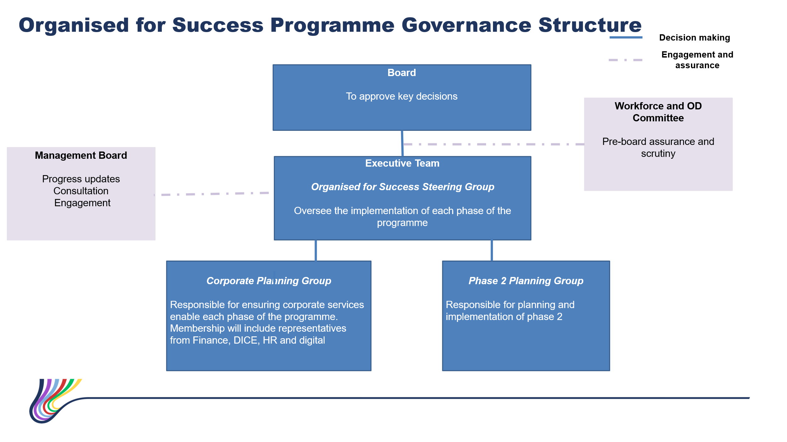
Two planning groups will be established.
The corporate planning group will support the required changes to the financial ledger, budget structures, workforce IT systems and digital systems. Membership will include representatives from Finance, DICE, HR and digital.
The Phase 2 Planning Group will support the planning and implementation of phase 2 and will include operational and staff group representation.
The lead for each phase of the programme is as follows:
Phase | Description | Proposed Lead
A | Executive Portfolios | Chief Executive officer
B | Deputy/ Tier 2 Management Structure | Director of Workforce & OD working with each of the Executive Directors
C | The Establishment of a Delivery Unit | Director of Workforce & OD working with Deloittes
D | Joint Posts across the Regional Partnership | Chief Executive officer
E | The establishment of a new care group structure | Chief Operating Officer
F | A review of the care group leadership structure – confirming the Triumvirate Leadership model (e.g. operationally led or clinically led) | Director of Workforce & OD working with the Executive Team
G | A review of the number of divisions or directorates within each new care group to ensure spans of control are reasonable and equitable. This will include a review of the specialities and services managed under each of the care groups to ensure they are organised in the best way for our patients | Chief Operating Officer working with the Care Group Tri’s
H | A review of the number of management layers within the new care groups with the aim to have a maximum of 6 layers, where appropriate, from Board to front line staff with a focus for this programme on the top 4 layers (Tri, Division, Directorate, speciality/ service) | Director of Workforce & OD working with Chief Operating Officer
I | A review of the wraparound support for each new care group (e.g. HRBP, Finance BP) to ensure this is reasonable and equitable | Director of Workforce & OD
J | A review of corporate functions sitting in/ out of care groups to ascertain the most appropriate design of the function (e.g. hub and spoke, centralised) | Director of Workforce & OD

The Director of Workforce & OD will be the overall programme lead and will be responsible for providing programme updates to relevant forums.
7.0 Programme RACI Table
Responsible, Accountable, Consulted, Informed
