

HEALTH BOARD RISK REGISTER
June 2025

HEALTH BOARD RISK REGISTER
SUMMARY OF ASSESSED RISKS

Impact/Consequences | 5 |  | 75: Whole Service Closure | 53: Compliance with Welsh Language Standards | 60: Cyber Security  69: Adolescents being admitted to Adult MH wards  93: Finance: Reduced capital funds  98: Overall condition/compliance and suitability of Health Board Estate  99: Failure to implement the population health strategy approaches at the required scale. | 50: Access to Cancer Services  66: Access to Cancer Services – SACT  92: Finance: Forecast Deficit
Impact/Consequences | 4 |  |  | 16: Access to Planned Care Reduced from 16  37: Operational and strategic decisions are not data informed De-escalated  52: Impact Assessment Requirements  94: CAMHS failure to meet required standards of performance | 01: Access to Unscheduled Care Service Reduced from 25  03: Recruitment of Consultant Medical and Dental Staff  27: Digital Transformation  36: Paper Record Storage  43: Deprivation of Liberty Safeguards  61: Paediatric Dental GA Service  101: Industrial Action (HCSW) Increased from 12  105: Increased Cost of replacement Pathology System LIMS | 04: Healthcare Acquired Infection  64: H&S Infrastructure  80: Transfer of Clinically Optimised Patients  85: Non-Compliance with ALN Act  89: Healthcare Nursing Staff Levels (HMP)  90: GDPR Subject Access Requests  96: Failure to Develop an Approvable IMTP  104: Clinical Coding Completeness
Impact/Consequences | 3 |  |  | 51: Nurse Staffing Levels Act (Section 25B) Reduced from 12 | 100: Partnerships & Collaboration
Impact/Consequences | 2
Impact/Consequences | 1
C X L |  | 1 | 2 | 3 | 4 | 5
 |  | Likelihood
Risk Register Dashboard

Strategic Objective | Risk Reference | Description of risk identified | Date Opened | Initial Score | Current Score | Trend | Controls | Last Reviewed | Scrutiny Committee
1 - People of Swansea Bay live healthier, equitable and prosperous lives | 52  (1763) | Statutory Compliance: Engagement & Impact Assessment  The Health Board does not have sufficient resource in place to undertake engagement & impact assess in line with Statutory Duties | Apr 2019 | 16 | 12 |  |  | Jun 2025 | Performance & Finance Committee
1 - People of Swansea Bay live healthier, equitable and prosperous lives | 99 | Failure to implement the population health strategy approaches at the required scale  This arises from risk of a failure of the organisation to understand and act on the provisions of the strategy for building whole of system actions across the 4 pillars; and the consequent lack of systems and processes to support the delivery of population health improvements. | Mar 2024 | 20 | 20 |  |  | Jun 2025 | Population Health Committee
1 - People of Swansea Bay live healthier, equitable prosperous lives | 100 | A lack of a robust approach to partnerships & collaboration  If the health board does not have effective structures, processes and working relationships with its external partners, there is a risk that areas of work dependent upon collaboration with partners may not deliver what is required in a timely way, impacting on the delivery of health board priorities. | May 2024 | 12 | 12 |  |  | Jun 2025 | Population Health Committee
2 - Care is high quality, safe, efficient, and delivers the best possible outcomes for people in partnerships | 75  (2522) | Whole Service Closure  Risk that services or facilities may not be able to function if there is a major incident or a rising tide that renders current service models unable to operate. | May 2021 | 20 | 10 |  |  | Jun 2025 | Performance & Finance Committee
2 - Care is high quality, safe, efficient, and delivers the best possible outcomes for people | 4  (739) | Healthcare Acquired Infection  Risk of patients acquiring infection as a result of contact with the health care system, resulting in avoidable harm, impact on service capacity, and failure to achieve national infection reduction goals. | Apr 2019 | 20 | 20 |  |  | Jun 2025 | Quality & Safety Committee
2 - Care is high quality, safe, efficient, and delivers the best possible outcomes for people | 51  (1759) | Nurse Staffing (Wales) Act (Section 25B wards)  Risk of Non Compliance with the Nurse Staffing (Wales) Act Current score reduced from 12  There is a risk we may not meet these requirements fully due to increased acuity, unplanned staff absence and vacancies. The potential impact of this maybe non-compliance with the ‘Act’, poor patient outcomes and experience, and suspension of services. | Jan 2024 | 16 | 9 |  |  | Jun 2025 | Workforce & OD Committee
2 - Care is high quality, safe, efficient, and delivers the best possible outcomes for people | 53  (1762) | Welsh Language Standards  Failure to fully comply with all the requirements of the Welsh Language Standards, as they apply to the University Health Board. | Apr 2019 | 15 | 15 |  |  | Jun 2025 | Health Board  (Welsh Language Group)
2 - Care is high quality, safe, efficient, and delivers the best possible outcomes for people | 101 | Industrial Action (Healthcare Support Workers)  (In Committee Risk) Current score increased from 12  Due to inconsistencies in the bandings of healthcare support workers across the UK and NHS Wales at a band two and three level, action is being taken in partnership with Unison and the RCN to address inequalities against the context of limited financial resource availability. [Full description In Committee] | Jul 2024 | 20 | 16 |  |  | Jun 2025 | Workforce & OD Committee
2 - Care is high quality, safe, efficient, and delivers the best possible outcomes for people in partnerships | 89  (3071) | Healthcare Nursing Staff Levels (HMPS)  There is a risk that the men in HMP Swansea will not receive the appropriate standard of care. This is due to the fact that the nursing establishment within the prison no longer fully meets the changed demographics and numbers of men being detained. | Nov 2022 | 20 | 20 |  |  | Jun 2025 | Quality & Safety  Committee
2 - Care is high quality, safe, efficient, and delivers the best possible outcomes for people in partnerships | 43  (1514) | DoLS  Due to a lack of Best Interest Assessor resource, there is a risk of failure to complete and authorise the assessments associated with Deprivation of Liberty/Liberty Protection Safeguards within the legally required timescales, exposing the health board to potential legal challenge and reputational damage. | Apr 2019 | 16 | 16 |  |  | Jun 2025 | Quality & Safety Committee
2 - Care is high quality, safe, efficient, and delivers the best possible outcomes for people in partnerships | 94  (3516) | CAMHS failure to meet required standards of performance  The CAMHS service is unable to meet the required level of performance due to workforce deficits in the team across all staff groups including medics, psychological therapies and nursing. | Oct 2023 | 20 | 12 |  |  | Jun 2025 | Performance & Finance Committee
2 - Care is high quality, safe, efficient, and delivers the best possible outcomes for people in partnerships | 1  (738) | Access to Unscheduled Care Service Current score reduced from 25  If we fail to provide timely access to Unscheduled Care then this will have an impact on quality & safety of patient care as well as patient and family experience and achievement of targets. There are challenges with capacity/staffing across the Health and Social care sectors. | Apr 2019 | 20 | 16 |  |  | Jun 2025 | Performance & Finance Committee
2 - Care is high quality, safe, efficient, and delivers the best possible outcomes for people in partnerships | 80  (1832) | Transfer of Clinically Optimised Patients  Risk that we fail to significantly reduce the number of Clinically Optimised Patients in hospital beds. A deficit in the availability of appropriate community / domiciliary care results in unacceptable delays in discharging patients from acute hospital beds. As a result, patients can decompensate and never gain the independence that could have been available from an early discharge. | May 2021 | 20 | 20 |  |  | Jun 2025 | Quality & Safety  Committee
2 - Care is high quality, safe, efficient, and delivers the best possible outcomes for people in partnerships | 16  (840) | Access to Planned Care Current score reduced from 16  There is a risk of harm to patients if we fail to diagnose and treat them in a timely way. | Apr 2019 | 16 | 12 |  |  | Jun 2025 | Performance & Finance Committee
2 - Care is high quality, safe, efficient, and delivers the best possible outcomes for people in partnerships | 61  (1587) | Paediatric Dental GA Service – Parkway  Safety risk of general anaesthetic procedures performed on children outside of an acute hospital setting. Repatriation of service to acute site delayed which means the health board continues to commission services for delivery outside of national guidance attracting reputational risk. There is also an associated risk in that the diagnosing clinician does not deliver the care to the patient resulting in increased risk of need for multiple GAs. | Apr 2019 | 15 | 16 |  |  | Jun 2025 | Quality & Safety  Committee
2 - Care is high quality, safe, efficient, and delivers the best possible outcomes for people in partnerships | 50  (1761) | Access to Cancer Services  There is a risk of delay in diagnosing patients with cancer, and consequent delay in commencement of treatment, which could lead to poor patient outcomes and failure to achieve targets. | Apr 2019 | 20 | 25 |  |  | Jun 2025 | Performance & Finance Committee
2 - Care is high quality, safe, efficient, and delivers the best possible outcomes for people in partnerships | 66  (1834) | Access to Cancer Services (SACT)  The demand & complexity of planned treatment regime for cancer patients requiring chemotherapy currently exceed the available chair capacity, risking unacceptable delays in access to SACT treatment in Chemotherapy Day Unit with impact on targets and patient outcomes. | Nov 2019 | 25 | 25 |  |  | Jun 2025 | Quality & Safety  Committee
2 - Care is high quality, safe, efficient, and delivers the best possible outcomes for people in partnerships | 69  (1418) | Adolescents are being admitted to adult mental health wards  Risk related to adolescent patients being admitted to Adult MH inpatient wards – Inappropriate settings potentially resulting in 'Safeguarding Issues'. The WG has requested that Health Boards identify Secondary Care inpatient facilities for the care of adolescents. In Swansea Bay University Health Board Ward F NPT Hospital is the dedicated receiving facility with one bed identified. | Feb 2020 | 20 | 20 |  |  | Jun 2025 | Quality & Safety  Committee
2 - Care is high quality, safe, efficient, and delivers the best possible outcomes for people in partnerships | 85  (2561) | Non-Compliance with ALN Act  There is a risk of the Health Board not fulfilling the statutory requirements of the Additional Learning Needs and Education Tribunal (Wales) Act 2018 (the ALN Act) within the timescales that are required under the ALN Act, resulting in non-compliance with these duties. | May 2022 | 25 | 20 |  |  | Jun 2025 | Quality & Safety  Committee
3 - Care is delivered in safe and appropriate settings | 64  (2159) | Health and Safety Infrastructure  Insufficient resource and capacity of the health, safety and fire function to maintain legal and regulatory compliance. | Sep 2019 | 20 | 20 |  |  | Jun 2025 | Quality & Safety  Committee
3 - Care is delivered in safe and appropriate settings | 98  (3692) | Overall condition/compliance and suitability of Health Board Estate  6 FACET survey undertaken in 2022 confirmed the poor condition and suitability of premises where health care services are provided. | Feb 2024 | 20 | 20 |  |  | Jun 2025 | Performance & Finance Committee
3 - The delivery of care is supported by innovative digital solutions | 27  (1035) | Digital Transformation to Deliver Sustainable Clinical Services  Inability to deliver sustainable clinical services due to lack of resources to deliver sustainable Digital Transformation and services. There are insufficient resources to invest in the delivery of the SBU Digital strategy; support the growth in utilisation of existing and new digital solutions; replace existing technology infrastructure or software at the end of its useful life. | Apr 2019 | 16 | 16 |  |  | Jun 2025 | Digital, Data Research & Innovation Committee
3 - The delivery of care is supported by innovative digital solutions | 36  (1043) | Storage of Paper Records  Failure to provide adequate storage facilities for paper records then this will impact on the availability of patient records at the point of care. Quality of the paper record may also be reduced if there is poor records management in some wards. | Apr 2019 | 20 | 16 |  |  | Jun 2025 | Digital, Data Research & Innovation Committee
3 - The delivery of care is supported by innovative digital solutions | 37  (1217) | Information Led Decisions De-escalated from HBRR  Risk that operational and strategic decisions are not data informed. | Apr 2019 | 16 | 12 |  |  | Jun 2025 | Digital, Data Research & Innovation Committee
3  The delivery of care is supported by innovative digital solutions | 60  (2003) | Cyber Security (In Committee Risk)  The level of cyber security incidents is at an unprecedented level and health is a known target. | Jul 2019 | 20 | 20 |  |  | Jun 2025 | Digital, Data Research & Innovation Committee
3 - The delivery of care is supported by innovative digital solutions | 90  (2796) | Non-compliance with UK-GDPR Article 15 regarding Subject Access Requests (SARs) and other requests for disclosure of personal data  The Health Board does not have adequate resources to deal with the sustained increase in volume and complexity of subject access /access to health records requests received from requestors. The ICO are already involved with a number of breaches and complaints in this area and there is the potential for future enforcement action if significant improvements are not made. | Jan 2023 | 16 | 20 |  |  | Jun 2025 | Digital, Data Research & Innovation Committee
3 - The delivery of care is supported by innovative digital solutions | 104 | Failure to meet Tier 1 targets in Clinical Coding Completeness  here is a risk that clinical notes for inpatient episodes will not be coded in a timely way. | May 2025 | 12 | 20 |  |  | Jun 2025 | Digital Data & Innovation Committee
3 - The delivery of care is supported by innovative digital solutions | 105 | Loss of pathology services  If the new Laboratory Information Management (LIMS) system is not live before 15th December 2025 then pathology will lose access to the current LIMS system resulting in the inability of pathology to deliver diagnostic results and blood transfusion services across all Health Board services including emergency, acute, primary and community services. | May 2025 | 25 | 20 |  |  | Jun 2025 | Quality & Safety Committee
4 - The Health Board is a great place to work where staff feel valued and work together towards a common goal | 3  (843) | Recruitment of Consultant Medical and Dental Staff  Due to national shortages, there is a risk that that the health board will be unable to recruit consultant medical & dental staff into particular hard to fill roles which may result in difficulties fulfilling rotas on all sites, and adverse impact upon patient safety, service provision, quality and financial matters. | Apr 2019 | 20 | 16 |  |  | Jun 2025 | Workforce & OD Committee
5 - The health board is a resilient, financially sustainable and responsible organisation | 92  (3444) | Finance: Forecast Deficit Risk  Forecast deficit is not met due to insufficient progress on run rate reduction, and the saving targets required across all areas are not achieved. | Jun 2023 | 20 | 25 |  |  | Jun 2025 | Performance & Finance Committee
5 - The health board is a resilient, financially sustainable and responsible organisation | 93  (3448) | Finance: Reduced capital funds  Reduced discretionary capital funds and reduced National NHS funds requiring a restricted Capital Plan for 2024/25. | Jun 2024 | 20 | 20 |  |  | Jun 2025 | Performance & Finance Committee
5 - The health board is a resilient, financially sustainable and responsible organisation | 96  (3571) | Failure to Develop an Approvable IMTP (statutory compliance)  If we fail to have an approvable Integrated Medium-Term Plan (IMTP) for 2026/27 then we will not meet our statutory duty to break even and may lose public confidence. | Oct 2023 | 20 | 20 |  |  | Jun 2025 | Performance & Finance Committee

Datix ID Number: 738 Current risk score reduced from 25  Health & Care Standard: |  |  | HBR Ref Number: 1  Risk Target Date: 31/12/2025 |  | Current Risk Rating  4 x 4 = 16
Objective: Urgent & Emergency Care (UEC) |  | BAF Ref: 2.4 | Director Lead: Deb Lewis, Chief Operating Officer  Assuring Committee: Performance & Finance Committee  For information: Quality & Safety Committee
Risk: Access to Unscheduled Care  If we fail to provide timely access to Unscheduled Care then this will have an impact on quality & safety of patient care as well as patient and family experience and achievement of targets. There are challenges with capacity/staffing across the Health and Social care sectors. (This risk includes ED, AMU and impact in community from ability to release ambulances at both front doors.) |  |  | Date last reviewed: Jun 2025
Risk Rating  (consequence x likelihood):  Initial: 4 x 5 = 20  Current: 4 x 4 = 16  Target: 3 x 4 =12 | 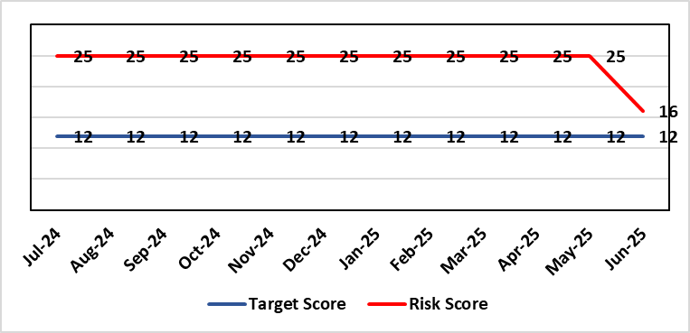 |  | Rationale for current score:  The UEC system continues to see high demand, with ambulance attendances higher than seen previously. However, this demand has been mitigated (beginning June 25) by improvement activity across the hospital resulting in improved flow away from ED. This improvement activity has been married with additional capacity at the front door (Ward) to decongest ED and resulted in the resultant reduced risk score (previously 25).
Level of Control  = 50% |  |  | Rationale for target score:  The HB is currently under escalating performance monitoring from WG (Targeted Intervention or TI) for delivery of UEC services. The improvement plan developed as a response to TI and that already included in the HB annual plan is to implement models of care that reflect best practice and focus on areas that will benefit patients, staff and the UEC system most. The implementation of this plan will improve patient flow, length of stay and reduce emergency demand.
Date added to the SBU HB risk register
Apr 2019
Controls (What are we currently doing about the risk?) |  |  | Mitigating actions (What more should we do?)
Five main areas of work within the plan:  - Frailty strategy (already achieved: Older Persons Assessment & Short Stay Unit stood up; Hub stood up to triage/stream/capture outcomes from incoming calls; standard operating procedures developed for Short Stay, Assessment Unit, Neck of Femur Pathways/beds, and Hub; Phase 1 capital works completed)  - Grip & control operational management and centralisation of patient flow resources  - Senior decision makers at front door services  - Pathway of care delays (PoCD) Implementation of Discharge-To-Reassess (D2RA)  - Home First  - Acute Care Team (ACT)  - Interface with local authority  - Urgent & Emergency Care redesign programme linked to capital expansion scheme.  - Development of a UEC Care Co-ordination Hub to promote pre-hospital triage redirection and streaming.  In addition to (Business As Usual) BAU improvement actions:  - Continued focussed roll-out of 6-Goals schemes of work  - D2RA / Trusted assessor model  - SAFER  - Criteria-led discharge  - Continuous Flow Model (CFM)  - Robust SDEC model  During June 25 improvement work (PDSA) was undertaken at Morriston Hospital including:  - Anglesey Ward to temporarily operate as a General Medical ward to help decompress the ED  - Streamlining ED assessment and direct referrals to medicine Redesigning the medical assessment model in the AMU  - Enhancing specialty assessment and patient allocation  - Implementing a 7-day Same Day Emergency Care (SDEC) model  - Reviewing and applying consistent criteria to reside  - Roll-out of a new Patient Flow Model: ‘Your Next Patient |  |  | Action | Lead |  | Deadline
 |  |  | Implementation of revised senior decision-making capacity within SDEC (Same Day Emergency Care) and AMU (Acute Medical Unit) | Group Medical Director, Morriston |  | 31/10/2025
 |  |  | Amended action: Review of community services being undertaken by Group Nurse Directors for PCT / Morriston to ensure return of investment ahead of expansion. (See below) | Group Nurse Directors (Morriston & PCT) |  | 31/10/2025
 |  |  | Implementation of UEC (Urgent & Emergency Care) Navigation Hub to decrease demand and implement right patient right place process | Chief Operating Officer |  | 31/09/2025  Pending WG funding-Six Goals
 |  |  | Focus on reducing pathway of care delays (PoCDs) as per the Care Action Committee 50-day Challenge | Associate Service Group Director, PCTS |  | 30/09/2025 (reduce to 100 Clinically Optimised Patients)
 |  |  | Further develop admission avoidance pathways with Welsh Ambulance Services Trust, focussing on Falls prevention and Respiratory conditions | Assistant Director Operations UEC |  | 30/09/2025 (linked to 6 Goals reporting & funding)
 |  |  | Reintroduce D2RA Principles across the Health Board with external consultancy support | Assistant Director of Operations UEC,  Associate Service Group Director PCTS |  | Complete
Assurances (How do we know if the things we are doing are having an impact?)  - Urgent & Emergency Care Board is meeting monthly chaired by the COO.  - Six Goals programme reviews the plan on a monthly basis  - UEC Redesign held 2-weekly to update on work streams  - UEC Summit meetings held x 2 with Executive Management Board – 3rd summit planned March 25.  - D2RA Executive meeting held Feb 25 – Memorandum of Understanding (MOU) re D2RA agreed. Operational workshop held Mar 25 with a plan to test D2RA principles pre-Easter weekend  - Ongoing delivery of the Integrated Discharge Hub with both front and back door focus – programme of work in progress to design sustainable solution  - Improved performance metrics (ambulance handover, patient time in ED department, flow & discharge) |  |  | Gaps in assurance (What additional assurances should we seek?)  Affordability of the UEC Care Co-ordination Hub pending approval of WG Six Goals funding.  Affordability of a sustainable D2RA model and right sizing of the community services and bedded facilities to support timely discharge.  Although the Test of Change initiatives have had a positive impact on ambulance handovers and flow through to down-stream wards, there remain unacceptably long delays for ED patients to be seen and treated. Therefore, the risk score remains as noted until improvement is made in this area. This now needs to be a focus in Q2.
Additional Comments / Progress Notes
11/07/2025: Action completed: Reintroduce D2RA Principles across the Health Board with external consultancy support. Significant progress made regarding key front door (e.g. ambulance handover, time in ED department etc) metrics coupled with reduced numbers bedding/ overcrowding front door services. Community services review has not been undertaken by the PCT Group Nurse Director as anticipated. Agreement with the END and DOF that additional support will be commissioned to undertake this crucial review. Anticipated start date of 1st August 2025, with review to run for 3 months.

Datix ID Number: 843  Health & Care Standard: |  |  | HBR Ref Number: 3  Risk Target Date: 31/03/2026 |  | Current Risk Rating  4 x 4 = 16
Objective: The Health Board is a great place to work where staff feel valued and work together towards a common goal |  | BAF Ref: 5 | Director Lead: Tina Ricketts, Director of Workforce and OD  Assuring Committee: Workforce & OD Committee
Risk: Recruitment of consultant medical & dental staff in hard to fill roles.  Due to national shortages, there is a risk that that the health board will be unable to recruit consultant medical & dental staff into particular hard-to-fill roles which may result in difficulties fulfilling rotas on all sites, and adverse impact upon patient safety, service provision, quality and financial matters. |  |  | Date last reviewed: Jun 2025
Risk Rating  (consequence x likelihood):  Initial: 5 x 4 = 20  Current: 4 x 4 = 16  Target: 4 x 3 = 12 | 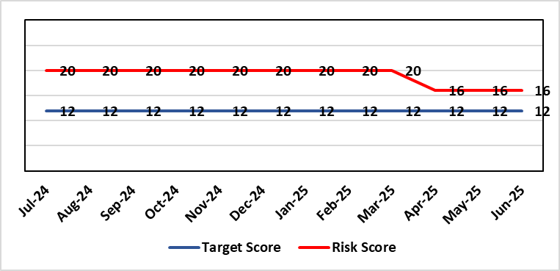 |  | Rationale for current score:  National shortages of numbers in some areas can lead to:  - Inability to recruit sufficient numbers of trainees to fulfil rotas on all sites  - Inability to attract non training grades to complete rotas  - Inability to fill Consultant grade posts in some specialties with adverse effects on patient safety and employer relations. Inability to recruit sufficient registered nursing staff.  Risk score has been reviewed and reflects current position across services as a whole. Services with particular difficulties are listed under Assurance section. Where risk at service level is significant and/or interdependencies could lead to service collapse, these will be escalated separately.
Level of Control  = 70% |  |  | Rationale for target score:  This remains a challenge and is also a national problem.
Date added to the SBU HB risk register
April 2019
Controls (What are we currently doing about the risk?) |  |  | Mitigating actions (What more should we do?)
- Regular monitoring of recruitment position with reports to Executive Team and Board via Medical Director and Medical Workforce Board.  - Specialty based local workforce boards established to monitor and control specific issues. The Health Board Workforce & OD Committee will seek assurance of medical workforce plans to maintain services.  - Engagement of the Deanery about recruitment position.  - Weekly workforce delivery meetings with Executive Medical Director to review progress against critical medical and clinical posts  - Working with specialist agency and head-hunters to improve chances to fill hard to recruit posts  - Working with a marketing agency to develop a branding and attraction campaign for the health board.  - Consideration of the RPO (Recruitment Process Outsourcing) model.  - Implemented the CESR (Certificate of Eligibility for Specialist Registration) framework to grow your own consultants  - Revised Consultant Development Programme, sponsored by the Medical Director. 28 Consultants have registered and 15 have attended to date, across modules 1 & 2. |  |  | Action | Lead |  | Deadline
 |  |  | Medical training initiatives pursued in a number of specialties to ease junior doctor recruitment | Service Group Medical Directors |  | 31/03/2026
 |  |  | The Medical Workforce Board continues to monitor recruitment and junior doctor’s rotas. | Executive Medical Director |  | 31/03/2026
 |  |  | Continue to recruit internationally. | Director W&OD |  | 31/03/2026
 |  |  | Continue to work with head-hunters | Director W&OD |  | 31/03/2026
Assurances (How do we know if the things we are doing are having an impact?)  - General situation monitored through W&OD Committee  - Communication with Deanery  - Recruitment campaigns  - Monitoring by Executive Teams and specialty based local workforce boards  - Workforce planning and deployment taskforce meetings with service groups  - Weekly workforce delivery meetings with CEO as above  - Areas currently experiencing recruitment difficulties are: mental health, oncology, anaesthetics, acute care physicians, care of the elderly, pathology and haematology. |  |  | Gaps in assurance (What additional assurances should we seek?)  Locum cover  Adequate supply of doctors who can work in this country  Ability to flexibly deploy doctors in training.  Dedicated work between workforce and finance to review and confirm budgeted medical workforce establishment by service group to confirm SIP and vacancy factor.
Additional Comments / Progress Notes
09/07/24: Some success with recruitment but no material change to the situation

Datix ID Number: 739  Health & Care Standard: |  |  | HBR Ref Number: 4  Risk Target Date: 31/03/2026 | Current Risk Rating  4 x 5 = 20
Objective: Care is high quality, safe, efficient, and delivers the best possible outcomes for people |  | BAF Ref: 2.1 | Director Lead: Elizabeth Rix, Executive Director of Nursing  Assuring Committee: Quality & Safety Committee
Risk: Healthcare Acquired Infection (HCAI)  Risk of patients acquiring infection as a result of contact with the health care system, resulting in avoidable harm, impact on service capacity, and failure to achieve Tier 1 national infection reduction goals. |  |  | Date last reviewed: Jun 2025
Risk Rating  (consequence x likelihood):  Initial: 4 x 5 = 20  Current: 4 x 5 = 20  Target: 4 x 3 =12 | 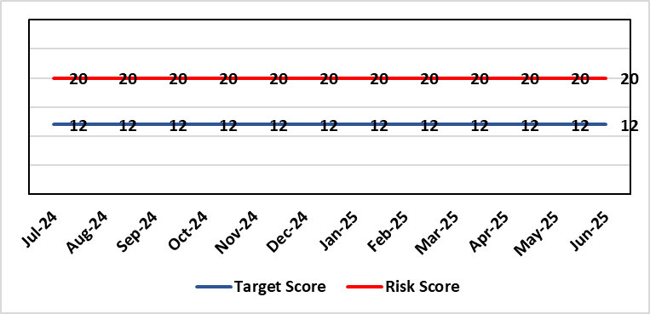 |  | Rationale for current score:  Health Board incidence of key Tier 1 infections per 100,000 population above All Wales rates, indicating Health Board’s population at greater risk of infection. High occupancy rates & frequent ward moves associated with increased risk of infection transmission. Lack of decant facilities compromises environment deep cleaning & decontamination and planned preventative maintenance programmes.
Level of Control
= 40%
Date added to the SBU HB risk register
Apr 2019
Date added to the SBU HB risk register  Apr 2019 |  |  | Rationale for target score:  Improved governance structures for IPC and antimicrobial stewardship will drive improved local ownership and embed responsibility for these priorities for all levels of staff. Adequately maintained & clean environments facilitate good IPC & minimise infection risks. Reduced occupancy & frequency of patient moves mitigate against infection transmission. Compliant ventilation systems and water safety minimise infection risks. Access to timely data on infections, training, antimicrobial stewardship, cleaning at ward/unit/practice level enables Service Groups to identify areas for focused QI programmes, drive improvement, & effectively measure outcomes.
Controls (What are we currently doing about the risk?) |  |  | Mitigating actions (What more should we do?)
- Policies, procedures, protocols and guidelines supplement the National Infection Control Manual.  - Infection Prevention & Control (IPC) related training provided programmes.  - Surveillance of infections, with early identification of increased incidence, and instigation of controls.  - Antimicrobial stewardship programmes and systems of monitoring and feedback.  - Provision of cleaning service to meet National Standards of Cleanliness.  - Engineering controls for water safety, ventilation, and decontamination.  - Infection Prevention Improvement Plans 2024/25 for HB and Service Groups were approved by the Health Board's Infection Prevention & Control Strategic Group on 30/04/24 and 31/07/24 respectively. Progress is reported at SG Infection Control Committees, HB Infection Prevention & Control Group, Quality & Safety Group, Quality & Safety Committee, and Management Board. These include trajectories to meet national targets and report performance against them.  - The Health Board has been escalated to Targeted Intervention for its position relating to healthcare associated infection (HCAI). Governance processes for HCAI have been revised to provide strengthened scrutiny and assurance. |  |  | Action |  | Lead | Deadline
 |  |  | Achieve 85% compliance with IPC mandatory training (Levels 1 & 2) |  | Service Group Directors | 31/03/2026
 |  |  | Achieve reduction in Tier 1 infections to meet de-escalation criteria for intervention targets |  | Service Group Directors | 31/03/2026
Assurances (How do we know if the things we are doing are having an impact?)  - Clear Corporate and Service Group IPC Assurance Framework in place.  - Infection Prevention Improvement Plans for HB and Service Groups with progress reported at SG Infection Control Committees, HB Infection Prevention & Control Group, Quality & Safety Group and at Management Board. These include trajectories to meet national targets and report performance against them. This is also reported to Quality & Safety Committee.  - Ongoing monitoring of infection control rates.  - IPC, antimicrobial, decontamination and cleaning audit programmes.  - Annual completion of IPC Level 2 mandatory training for all HB staff.  - Compliance and validation systems for water safety, ventilation systems and decontamination.  - Revised and strengthened governance structure for HCAI, including monthly meetings of Executive HCAI Scrutiny Group. |  |  | Gaps in assurance (What additional assurances should we seek?)  - High occupancy rates & frequent ward moves associated with increased risk of infection transmission.  - Lack of single room availability, leading to delays in isolating patients with infections and increasing risks to patient contacts.  - Increased numbers of clinically optimised patients remaining in hospital leads to increased length of stay, increased risk of over-occupancy and over-crowding, with consequence of increasing risks of acquisition of infection.  - General infrastructure of the aging hospital estate compromises the ability to clean and decontaminate effectively.  - Antimicrobial prescribing, relating particularly to total volume of antibiotics, with the SBUHB having second highest total volume of antibiotics prescribed in primary care in Wales.  - Lack of decant facilities compromises environment deep cleaning & decontamination and planned preventative maintenance programmes.  - Varying levels of IPC responsibility embedded across all disciplines and groups, with variable medical engagement at all levels in infection prevention-related Quality Improvements programmes.
Additional Comments / Progress Notes
09/07/2025: SBUHB continues to have the highest incidence rate per 100,000 population for C. difficile infections SBUHB 54.56/100,000 (Wales = 40.56).
Staph aureus bacteraemia – highest incidence rate; SBUHB = 32.94/100,000 (Wales = 28.38).
E coli Bacteraemia – third lowest incidence rate; SBUHB 66.91/100,000 (Wales = 67.18).
Klebsiella spp bacteraemia – fourth highest incidence rate; SBUHB 27.79/100,000 (Wales 22.18).
Pseudomonas aeruginosa bacteraemia – highest incidence rate; SBUHB 9.26/100,000 (Wales = 4.94).

Tier 1 position against the Targeted Intervention de-escalation hospital onset (HO) criteria in June 2025 and, also the cumulative position Apr-Jun 2025
> C. difficile: (HO target - 6) = 11 cases. Combined cumulative position - Community (CO) and hospital onset (HO) = 53 cases
> Staph aureus: (HO target - 3) = 4 cases. Combined, cumulative position - Community (CO) and hospital onset (HO) = 32 cases.
> E coli: (HO target - 4) = 7 cases. Combined, cumulative position - Community (CO) and hospital onset (HO) = 65 cases.
> Klebsiella Spp: (HO target - 4) = 7 cases. Combined, cumulative position of Community (CO) and hospital onset (HO) = 27 cases.
> Pseudomonas aeruginosa (not included in targeted intervention monitoring). Combined, cumulative total = 9 cases.

IPC training compliance: level 1 - 90.23% (increase), Level 2 – 82.34% (increase).

Datix ID Number: 840 Current risk score reduced from 16  Health & Care Standard: |  |  | HBR Ref Number: 16  Risk Target Date: 31/03/2026 | Current Risk Rating  4 x 3 = 12
Objective: Planned Care |  | BAF Ref: 2.5 | Director Lead: Deb Lewis, Chief Operating Officer  Assuring Committee: Performance & Finance Committee  For information: Quality & Safety Committee
Risk: Access and Planned Care  There is a risk of harm to patients if we fail to diagnose and treat them in a timely way. |  |  | Date last reviewed: Jun 2025
Risk Rating  (consequence x likelihood):  Initial: 4 x 4 = 16  Current: 4 x 3 = 12  Target: 4 x 2 = 8 | 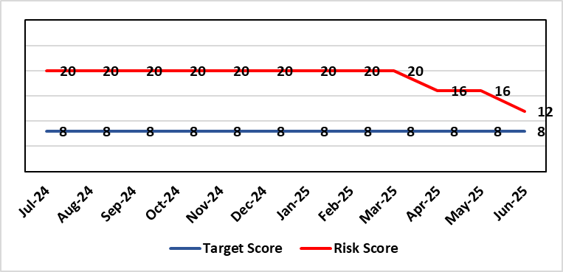 |  | Rationale for current score:  Patients are still waiting in excess of 104 weeks for surgical intervention, which is outside of national policy on RTT. However, the position is improving: targets set for 2024/25 were met and the Health Board de-escalated by Welsh Government from Targeted Intervention (TI) for delivery of Planned Care services, to Enhanced Monitoring. Current risk score reflects that improved position.
Level of Control
= 90%
Level of Control  = 90% |  |  | Rationale for target score:  There is scope to reduce the likelihood score to reduce the overall risk to an acceptable level. The risk target date indicates when we expect to see some reduction in waiting lists – albeit the overall risk level may remain as work continues.
Date added to the SBU HB risk register
Apr 2019
Controls (What are we currently doing about the risk?) |  |  | Mitigating actions (What more should we do?)
- There is a bi-weekly Targeted Intervention (TI) meeting specifically for assurance on the recovery of our elective programme.  - Specialty level capacity and demand models set out the baseline capacity and identify solutions to bridge the gap this financial year.  - A focused intervention is in train to support to the 10 specialties with the longest waits.  - Long waiting patients are being outsourced to the Independent Sector, where appropriate  - Additional internal activity is being delivered on weekends (via insourcing), although this is currently at risk due to changes in policy pertaining to the payment of enhanced rates to A4C staff.  - Planned care trajectories were developed and submitted to Welsh Government.  - Governance process put in place to monitor performance against trajectories internally, and with Welsh Government as part of Targeted Intervention.  - External & internal validation continues.  - All long waiting patients are receiving clinical reviews to ascertain continued need for surgery. |  |  | Action |  | Lead | Deadline
Assurances (How do we know if the things we are doing are having an impact?)  - TI dashboard developed to monitor performance in a live state  - Weekly TI monitoring meetings chaired by the Chief Operating Officer  - Bi-weekly planned care meetings chaired by the Chief Operating Officer  - Monthly TI monitoring meetings with Welsh Government |  |  | Gaps in assurance (What additional assurances should we seek?)
Additional Comments / Progress Notes
16/05/2025: Action complete: Theatre Optimisation Programme now in place to maximise efficient use of theatre capacity. Risk assessment revised to reflect improved performance and de-escalation by Welsh Government to Enhanced Monitoring status. Monitoring of continued delivery is ongoing.
18/07/2025: Risk score reduced in line with continued delivery of RTT targets.

Datix ID Number: 1035  Health & Care Standard: |  |  | HBR Ref Number: 27  Risk Target Date: 31/03/2026 |  | Current Risk Rating  4 x 4 = 16
Objective: The delivery of care is supported by innovative digital solutions |  | BAF Ref: 4 | Director Lead: Matt John, Director of Digital  Assuring Committee: Digital, Data, Research & Innovation Committee
Risk: Digital Transformation  Inability to deliver sustainable clinical services due to lack of resources to deliver sustainable Digital Transformation and services. There are insufficient resources to:  - Invest in the delivery of the SBU Digital strategy  - Support the growth in utilisation of existing and new digital solutions  - Replace existing technology infrastructure or software at the end of its useful life. |  |  | Date last reviewed: Jun 2025
Risk Rating  (consequence x likelihood):  Initial: 4 x 4 = 16  Current: 4 x 4 = 16  Target: 5 x 2 = 10 | 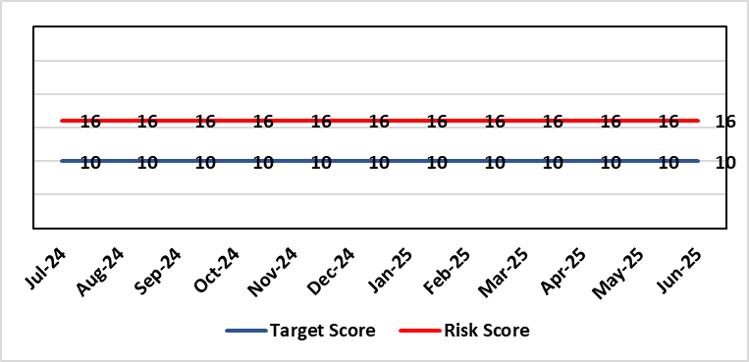 |  | Rationale for current score:  C – Reliance on digital ways of working has increased. Loss of IT service has a greater impact on ability to provide clinical care. Lack of investment in new digital solutions to make services more effective will mean clinical service provision will become unsustainable.  L- Reduction in capital funding in 2022/23/24 has increased the likelihood of HB not being able to replace aging infrastructure such as the network equipment. There is a £15m capital requirement over the next 3 years. Acceleration of the CTM SLA disaggregation has been proposed and there are further pressures on revenue funding. The shift to cloud and software as a service contracting models will increase the requirement for revenue funding to deliver digital transformation and ongoing services.
Rationale for target score:
C – Of failure will increase as the reliance and proliferation of the use of digital solutions increases.
L – Investment will mean the support mechanisms, rate of failure and ability to deliver solutions that meet the needs of users will improve sustainable digital services. There will however always be an inherent risk of failure of IT solutions.
Level of Control
= 50%
Date added to the SBU HB risk register
Apr 2019
Controls (What are we currently doing about the risk?) |  |  | Mitigating actions (What more should we do?)
- Digital Strategy has been approved by the Health Board and outlines requirements  - HB Capital priority group considers digital risks for replacement technology which is fed into the annual discretionary capital plan  - Digital Services prioritisation process is in place Digital Leadership Group provides the overarching governance to the delivery of the Digital Strategic Plan including financial considerations.  - Digital Services Management Group assesses current service provision and flags risks and issues  - Digital Services revenue requirements are included in 2025/26 annual plan |  |  | Action | Lead |  | Deadline
 |  |  | Review 10-year financial plan for Digital Strategy and prioritise key costs for the next 3 years. Share plan with Director of Finance for consideration and alignment to 2026/27/28/29 IMTP process | Assistant Director of Digital: Business Management and Information Governance |  | 31/08/2025
Assurances (How do we know if the things we are doing are having an impact?)  - Internal Audit Program assesses Digital in 4 areas annually |  |  | Gaps in assurance (What additional assurances should we seek?)  - Lack of certainty over future capital and revenue funding streams makes planning and implementation difficult/less effective.
Additional Comments / Progress Notes
08/05/2025: Action complete: Refresh the Digital Strategy including a high-level investment plan to set out vision for the Health Board
16/06/2026: Risk to be adapted and transferred to the Strategic Risk Register
09/07/2025: Q1 Performance and Finance Review meeting due 06/08/25 where plan will be discussed.

Datix ID Number: 1043  Health & Care Standard: |  |  | HBR Ref Number: 36  Risk Target Date: 31/07/2025 | Current Risk Rating  4 x 4 = 16
Objective: The delivery of care is supported by innovative digital solutions |  | BAF Ref: 4 | Director Lead: Matt John, Director of Digital  Assuring Committee: Digital, Research & Innovation Committee  For information: Quality & Safety Committee
Risk: Paper Record Storage  Lack of a single electronic record means there is greater reliance on the provision of the paper record. If we fail to provide adequate storage facilities for paper records, then this will impact on the availability of patient records at the point of care. Quality of the paper record may also be reduced if there is poor records management in some wards. There is an increased fire risk where medical records are stored outside of the medical record libraries. |  |  | Date last reviewed: Jun 2025
Risk Rating  (consequence x likelihood):  Initial: 4 x 5 = 20  Current: 4 x 4 = 16  Target: 3 x 3 =9 | 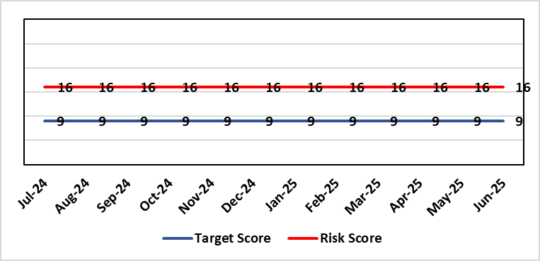 |  | Rationale for current score:  C - Inability to find records for patients could delay care/increase length of stay over 15 days. Could also mean patients receive incorrect treatment. Increased risk of fire where records are stored outside of the medical record libraries.  L - we know this happens from incidents raised
Level of Control  = 70% |  |  | Rationale for target score:  C - The increased development and adoption of the digital record will reduce the need for the paper health record being available at the point of care.  L - The increased development and adoption of the digital record, the introduction of RFID and the approach to management of the paper record identified in the Business case process should reduce the amount of paper required to be stored and managed.
Date added to the SBU HB risk register
Apr 2019
Controls (What are we currently doing about the risk?) |  |  | Mitigating actions (What more should we do?)
- There is a plan in place to increase the functionality of the electronic record to document patient care. The delivery of the plan is overseen by the Digital Leadership Group and progress provided to Management Board. (Supported by individual project boards as appropriate).  - Records managed by the Medical Records libraries are RFID-tagged (Radio Frequency Identification) and location tracked.  - Medical Record libraries are regularly risk assessed for fire by health and safety.  - Alternative offsite storage arrangements have been identified.  - All records must be documented on the Information Asset Register (IAR). |  |  | Action |  | Lead | Deadline
 |  |  | Allow for new process to stabilise and evaluate benefits of new centralised unit. |  | Head of Health Records & Clinical Coding | 01/08/2025
Assurances (How do we know if the things we are doing are having an impact?)  - RFID has been implemented for the acute record improving the management and storage of records  - Health Records performance reports developed in line with RFID technology  - Attainment of the Tier 1 Health Board target for clinical coding completeness which relies on the timely availability and quality of the Paper record and electronic sources  - Monitoring complaints and incident reporting.  - Electronic record is being implemented in accordance with the plan eg implementation of WNCR (Welsh Nursing Care Record), ETR (Electronic Test Requesting), HEPMA (Hospital Electronic Prescribing and Medicines Administration) |  |  | Gaps in assurance (What additional assurances should we seek?)  Investment required supporting the delivery and operational costs of the Digital strategy.  Reliance on DHCW (Digital Health & Care Wales) for delivery of the solution for a fully electronic patient record.  Impact of the Infected Blood Enquiry on the Health Boards ability to destroy notes.  Process for ensuring clinical adoption of electronic ways of working and cessation of adding information to the paper record that is already available electronically needs to be agreed and enforced by the Health Board.  Impact of the infected Blood Inquiry on the health board’s ability to destroy notes and the change in the records code of practice is being reviewed by the Director of Digital.
Additional Notes
01/07/2025 – Reviewed – no further update

Datix ID Number: 1514  Health & Care Standard: |  |  | HBR Ref Number: 43  Risk Target Date: TBC |  | Current Risk Rating  4 x 4 = 16
Objective: Mental Health & Learning Disability Services |  | BAF Ref: 2.3 | Director Lead: Elizabeth Rix, Executive Director of Nursing  Assuring Committee: Quality & Safety Committee  For Information: Mental Health Legislation Committee
Risk: Deprivation of Liberty Safeguards  Due to a limited resources within the MCA/DoLS (Mental Capacity Act/Deprivation of Liberty Safeguards) service (lack of Best Interest Assessor resource and signatory approval) there is a risk of failure to complete and authorise the assessments associated with Deprivation of Liberty within the legally required timescales, exposing the health board to potential legal challenge and reputational damage. |  |  | Date last reviewed: Jun 2025
Risk Rating  (consequence x likelihood):  Initial: 4 x 4 = 16  Current: 4 x 4 = 16  Target: 3 x 2 = 6 | 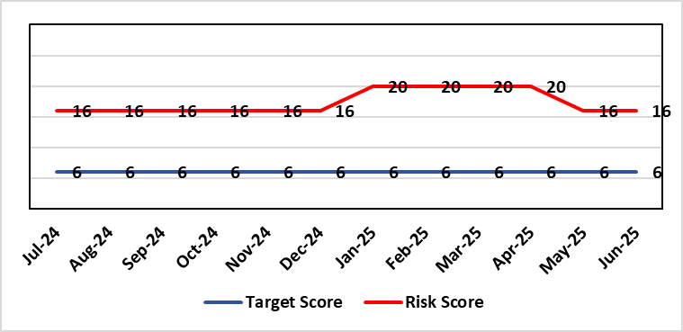 |  | Rationale for current score:  Multiple breaches in statutory duty  Breaches confirmed as expected at least as frequently as weekly, but not daily.  No claims received to date.
Level of Control  = 40% |  |  | Rationale for target score:  Consequences of DoLS breaches for the Health Board will not change. With controls in place, over time likelihood should decrease.  Risk target date indicates date of review following mitigating actions
Date added to the SBU HB risk register
Apr 2019
Controls (What are we currently doing about the risk?) |  |  | Mitigating actions (What more should we do?)
- Duty system in place. Duty BIA (Best Interest Assessors) scrutinise referrals and liaise with managing authority to ensure safeguards are in place to mitigate risks.  - Four signatory authorisers in place.  - Monthly Performance & Assurance Meeting  - Monthly Legislative Assurance Meeting with Group Nurse Director and Finance.  - Quarterly reports to Mental Health & Legislative Committee on MCA/DoLS compliance. |  |  | Action | Lead |  | Deadline
 |  |  | Amended: Board Paper to be completed and submitted to PCT Service Group Management Board to identify risks and mitigation of an additional 4 WTE (Whole Time Equivalent) BIA | Deputy Head of Nursing for Long Term Care |  | 31/07/2025
 |  |  | Amended: Signatory Process reviewed to reduce the breach risk. Workforce Plan to be discussed with Director of Nursing PCT | Deputy Head of Nursing for Long Term Care |  | 31/07/2025
Assurances (How do we know if the things we are doing are having an impact?)  Monthly Legislative Assurance Meeting with Group Nurse Director and Finance.  Quarterly reports to Mental Health & Legislative Committee on MCA/DoLS compliance. |  |  | Gaps in assurance (What additional assurances should we seek?)  Current resources  - 3 substantive BIA (3 wte)  - 6 external BIA (£250 per assessment)  - 4 (band 8) signatories  Additional 4 WTE BIAs required to meet service demands.  Substantive BIA’s role includes additional duties compared to external BIA whose only role is to complete form 3a of the DoLS process. In addition to form 3a completion, substantive BIA also undertake the following to meet service demand (Daily Duty Rota to scrutinise referrals; Facilitate Level 3 MCA/DoLS Training; Capacity Assessments; Advice and support to Managing Bodies; Support during Best Interest Meetings)
Additional Comments / Progress Notes
14/07/2025: Risk reviewed and remains unchanged at 16. All controls and assurances in place.

Datix ID Number: 1761  Health & Care Standard: |  |  | HBR Ref Number: 50  Risk Target Date: TBC | Current Risk Rating  5 x 5 = 25
Objective: Cancer Care |  | BAF Ref: 2.6 | Director Lead: Deb Lewis, Chief Operating Officer  Assuring Committee: Performance & Finance Committee  For information: Quality & Safety Committee
Risk: Access to Cancer Services  There is a risk of delay in diagnosing patients with cancer, and consequent delay in commencement of treatment, which could lead to poor patient outcomes and failure to achieve targets.  The health Board remains unable to deliver on the target of 75% of patients being treated within 62 days and is currently under targeted intervention by Welsh Government to improve performance. |  |  | Date last reviewed: Jun 2025
Risk Rating  (consequence x likelihood):  Initial: 4 x 5 = 20  Current: 5 x 5 = 25  Target: 4 x 3 = 12 | 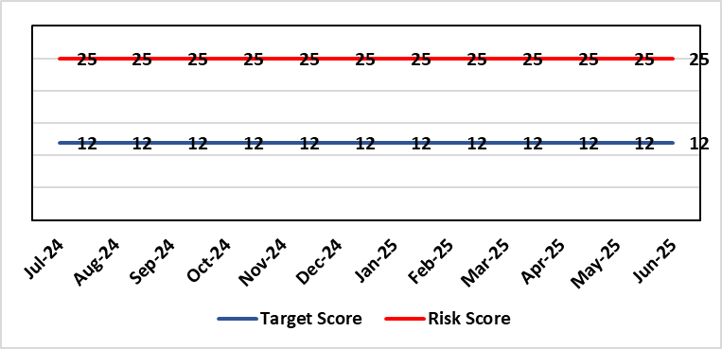 |  | Rationale for current score:  Risk score is based on being off trajectory for SCP.
Level of Control  = 70% |  |  | Rationale for target score:  Target score reflects the challenge this area of work presents the Board and where small numbers of patients impact on the potential to breach target.
Date added to the SBU HB risk register:
Apr 2019
Controls (What are we currently doing about the risk?) |  |  | Mitigating actions (What more should we do?)
- Tight management processes to manage each individual case on the Single Cancer Pathway (SCP). Enhanced monitoring & weekly monitoring of action plans for top 6 tumour sites.  - Initiatives to protect surgical capacity to support SCPs have been put in place  - Tumour sites have been given additional targets to achieve by the end of Qtr1:  - Achieve the 10-day 1st Outpatient target  - Deliver a decision to treat (DTT) by day 31  - A specific plan is being delivered to support Pathology services and ensure SCP tests are turned around within 5 days. |  |  | Action |  | Lead | Deadline
 |  |  | Following a review of governance processes for our Annual plan, Cancer monitoring will now be included in the Planned Care Board |  | Chief Operating Officer / Director of Planning Partnerships | 30/09/2025
Assurances (How do we know if the things we are doing are having an impact?)  - TI dashboard developed to monitor performance in a live state  - Weekly TI monitoring meetings chaired by the Chief Operating Officer  - Bi-weekly Cancer meetings chaired by the Deputy Chief Operating Officer  - Monthly TI monitoring meetings with Welsh Government |  |  | Gaps in assurance (What additional assurances should we seek?)  Performance and activity data monitored, but delays to treatment continue while sustainable solutions found.
Additional Comments / Progress Notes
16/05/2025: Action complete: Cancer Performance & Information Group to monitor improvement trajectories for both cancer backlog and SCP performance on a monthly basis. The Health Board missed the target of 70% for the end of March and delivered 62%. This will increase at the 3-month refresh point. Actions noted above will continue during 2025/26 to deliver sustainable improvements.

Datix ID Number: 1759  Health & Care Standard: |  |  | HBR Ref Number: 51  Risk Target Date: TBC |  | Current Risk Rating  3 x 3 = 9
Objective: Care is high quality, safe, efficient, and delivers the best possible outcomes for people |  | BAF Ref: 2.1 | Director Lead: Elizabeth Rix, Executive Director of Nursing  Assuring Committee: Workforce & OD Committee
Risk: Non-Compliance with Nurse Staffing Levels Act (2016) – Section 25B Wards  The Nurse Staffing Levels (Wales) Act 2016 (NSLWA) legally requires the health board to make provision for appropriate nurse staffing levels within their nursing services. In accordance with section 25B, there is a duty to calculate nurse staffing levels in adult and paediatric acute medical and surgical inpatient wards. There is a risk we may not meet these requirements fully due to increased acuity, unplanned staff absence and vacancies. The potential impact of this maybe non-compliance with the ‘Act’, poor patient outcomes and experience, and suspension of services. |  |  | Date last reviewed: Jun 2025
Risk Rating  (consequence x likelihood):  Initial: 4 x 4 = 16  Current: 3 x 3 = 9  Target 3 x 3 = 9 | 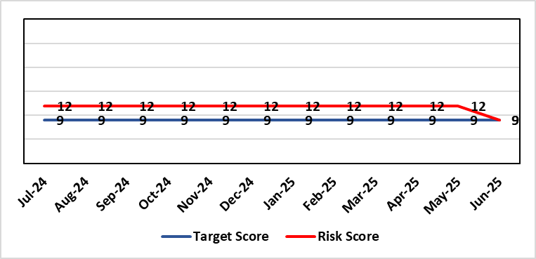 |  | Rationale for current score:  - The scope of the risk has been reviewed to disaggregate the 25B reportable wards as part of the NSLWA to enable clearer identification of risk of non-compliance with the’ Act’ from the aggregated risk across all nurse staffing areas of inadequate staffing levels previously scored 20.  - There has been a steady decline in the number of vacancies across the 25B wards as a result of successful international recruitment and student streamlining  - The Service Group risk assessments for 25B wards reported at the Nursing and Midwifery Safe Staffing Assurance Group NMSSAG (Jun 2025) are as follows:  - Morriston Service Group – 9  - NPTS Service Group – 9  - Paediatrics: In-patient wards – 9
Level of Control  = |  |  | Rationale for target score:  - The Health Board has the required structures and processes in place to provide reassurance to the Board that SBUHB is compliant under the Act and as such are allocating resources accordingly.  - Health boards are duty bound to take all reasonable steps to maintain nurse staffing levels.  - Ward skill mix, recruitment and induction plans impacting on ward  - Projected continued decrease in vacancies by end of 2024.
Date added to the SBU HB risk register
Apr 2019
Scope Refreshed:
Jan 2024
Controls (What are we currently doing about the risk?) |  |  | Mitigating actions (What more should we do?)
- The designated person as part of the requirements of the ‘Act’ is the Executive Director of Nursing & Patient Experience  - The responsibility for decisions relating to the maintenance of the nurse staffing level rests with the health board is based on evidence provided by, and the professional opinions of the Executive Directors with the portfolios of Nursing, Finance, Workforce, and Operations  - Bi-annual calculations undertaken across all Section 25B wards using the triangulated methodology which Service Groups formally present at Executive led scrutiny panels with representation from Nursing, Workforce and Digital and Finance Colleagues.  - The Ward Sister / Charge Nurse, Senior Nurses and Group Nurse Director continuously assess the situation and keep the designated person formally apprised  - The health board has representation at the All-Wales Nurse Staffing Group and its sub groups to ensure the organisation is aware of national updates  - The Board receive a bi-annual report - May (agreed Once for Wales) and November (mandatory). The final 3 yearly mandatory paper was submitted to Welsh Government 7th October 2024. The mandatory nurse staffing paper was presented to Board on 28th November 2024. The statutory (agreed Once for Wales) paper will be presented to Management Board 16th April 2025.  - Workforce planning & redesign, training and development. Recruitment and retention continue. HB Workforce Group has been set up and links to HEIW Retention Work stream, HB representatives on HEIW Group are Associate Head of HR, Recruitment and Retention Manager and Matron, Corporate Recruitment. Workforce plans have been developed by Service Group Nurse Directors and each Service Group agrees staffing, with consideration of all reasonable steps to maintain the nurse staffing level  - Work assessing the impact of the 'Team around the Person' continues on a HB and All Wales basis.  - Rostering Policy - the Service Groups have a robust roster scrutiny process that is undertaken to ensure roster efficiency and appropriate utilisation of temporary staff.  - The health board has a nursing retention plan and actively supports the Retire and Return policy.  - SafeCare has been implemented, the All Wales SOP remains a working document as understanding evolves.  - Service Groups continue daily staffing huddles and daily staffing tool and escalate as appropriate. |  |  | Action | Lead |  | Deadline
 |  |  | Student Streamlining and Overseas recruitment | Executive Director of Nursing |  | Monthly ongoing
 |  |  | Review of workforce, consider more diverse skill mix, including development of Band 3 and Band 4 roles. Bi-annual re-calculations of inpatient wards have resulted in the addition of Band 3 and 4 roles within the NSA templates. These posts are being recruited into, there is a need for training and supervision for these new posts. Development of Service Group workforce plans to support an overall Corporate Workforce Plan. | Executive Director of Nursing |  | Monthly ongoing
Assurances (How do we know if the things we are doing are having an impact?)  - Ongoing robust recruitment and retention plans in place to reduce vacancies in key clinical areas.  - Accurate reporting of acuity data and governance around sign off.  - Agreed establishments are funded.  - E-Rostering implemented and roster scrutiny undertaken, ensuring effective staff allocation.  - All Wales Templates are visible informing patients/visitors of planned roster on all Section 25B wards. Service Groups have access to the All Wales Nurse Staffing Programme documents via NHS Wales Executive webpage.  - Bi-annual Board reports, provide assurance and outline compliance and any key risks, submitted in November and May each year, with the final three yearly report submitted to Welsh Government in October 2024.  - The Health Board Nursing and Midwifery Safe Staffing Assurance Group (renamed October 2024) (formally the Nurse Staffing Act Steering Group, amended July 2023) meets on a bi-monthly basis, ensuring risks from all Service Groups are presented, discussed and escalated as appropriate at each meeting. This group is chaired by an Associate Director of Nursing and reports to Nursing and Midwifery Group (formally Nursing and Midwifery Board, amended October 2024), and the Workforce & OD Committee.  - Service Group risk assessments have been updated and disaggregated into 25B and 25A areas to enable clear risk assessment and escalation of specific risks to ensure robust governance and risk assurance  - There is a clear process for scrutiny during bi-annual re-calculations and at any other time when wards require a re-calculation, for example: change to ward purpose, increased bed numbers or increase patient acuity  - SafeCare system has been implemented. Support given to help embed the system into everyday use. Use of SafeCare linked to daily staffing huddles.  - Historical information and all reporting templates available on a share drive |  |  | Gaps in assurance (What additional assurances should we seek?)  - Issue remains regarding Information Technology barriers around the capture of data required for the Act on an All- Wales and Health Board basis. All Wales work with Allocate (Safecare) to improve reporting capabilities of Safecare, via a dashboard continued to progress, SBU is pilot site for testing. Update to Allocate system received, working with rostering team and BCU NSA Lead to check accuracy of reporting.  - Ongoing work across Wales to ensure IT systems are compatible with each other for operational and reporting purposes.
Additional Comments / Progress Notes
Section 25B wards covered by this risk:
NPTSSG |  | Morriston Service Group
Ward 2, Ward 4, Ward 12, Ward A, Ward E  Paediatric: Ward M and Oakwood Ward |  | Ward G, H, W and Clydach Ward  Ward C, Cyril Evans Ward, Dan Danino Ward  Powys Ward, Tempest Ward, Cardigan Ward  Ward K, L, R, T and Pembroke Ward  Ward D, F, J, S and Gowers Ward
For information – 25A areas not covered by this risk include (These are managed within Service Groups and would be escalate for Executive consideration as appropriate).
Morriston Service Group | NPTSSG | Mental Health & Learning Disabilities | Community Areas
Critical care areas – GITU, CITU, Tempest Burns & CCU  Short stay and assessment areas  Ward E (Area for Clinically Optimised Patients over the age of 65 years)  SAU, SSSU, CSSU, Plastic Surgery Treatment Centre  Emergency Department | Neonates  Theatres  Ward B, C, D & Neuro Rehab NPTH  Ward 8 & 11 SH  Midwifery | Mental Health, Forensic Psychiatry and Learning Disabilities | District Nursing  Health Visiting  Gorseinon Hospital  Ty Olwen

26/06/2025: Following June 2025 Nursing and Midwifery Safe Staffing Assurance Group meeting score has been reduced to 9, following reduction in score in Paediatrics.

Datix ID Number: 1763  Health & Care Standard: |  |  | HBR Ref Number: 52  Risk Target Date: TBC |  | Current Risk Rating  4 x 3 = 12
Objective: People of Swansea Bay live healthier, equitable and more equal and prosperous lives |  | BAF Ref: 1 | Director Lead: Richard Thomas, Director of Communications and Engagement  Assuring Committee: Performance & Finance Committee
Risk: Impact Assessment Requirements  The Health Board does not have sufficient skills & resource in place to undertake integrated equality impact assessments in line with strategic service change and policy development. |  |  | Date last reviewed: Jun 2025
Risk Rating  (consequence x likelihood):  Initial: 4 x 4 = 16  Current: 4 x 3 = 12  Target: 4 x 2 = 8 | 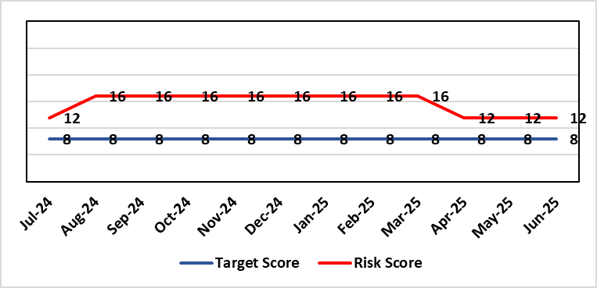 |  | Rationale for current score:  - Current lack of required skills / staff to deliver requirements.  - Impact assessment process has progressed
Level of Control  = 50% |  |  | Rationale for target score:  - All of these areas need to have adequate resourcing and robust processes / policies in place for the organisation to make robust plans, engage public confidence and meet our statutory and public duties.
Date added to the SBU HB risk register
Apr 2019
Controls (What are we currently doing about the risk?) |  |  | Mitigating actions (What more should we do?)
- Robust policies and processes to be in place for Impact Assessment going forward.  - EIA responsibilities incorporated into wider Impact Assessments.  - Development of Strategic Equality Group across organisation to support processes. |  |  | Action | Lead |  | Deadline
 |  |  | Action amended: Revised structure within Engagement team to ensure equity, diversity & belonging (EDB) issues coordinated across Health Board. | Assistant Director of Insight, Charity & Engagement & DICE |  | 01/08/2025
 |  |  | Revised structure agreed and posts appointed to. | Assistant Director of Insight, Charity & Engagement & DICE |  | 01/10/2025
 |  |  | Roll out Impact Assessment process across organisation. Training and integration with planning processes across the organisation will be required. | Assistant Director of Insight, Charity & Engagement & DICE |  | 30/09/2025
Assurances (How do we know if the things we are doing are having an impact?)  Advice on Equality Impact Assessment and then wider Impact Assessments available across organisation supported by robust policies and procedures, overseen by Strategic Equality Group. |  |  | Gaps in assurance (What additional assurances should we seek?)  Participation from across organisation in Strategic Equality Group.
Additional Comments / Progress Notes
09/07/2025: Risk reviewed. Rationale comments & action target refreshed.

Datix ID Number: 1762  Health & Care Standard: |  |  | HBR Ref Number: 53  Risk Target Date: 31/03/2026 (Review point) |  | Current Risk Rating  5 x 3 = 15
Objective: Care is high quality, safe, efficient, and delivers the best possible outcomes for people |  | BAF Ref: 2.1 | Director Lead: Elizabeth Rix, Executive Director of Nursing  Assuring Committee: Health Board (Welsh Language Group)
Risk: Welsh Language Standards  Failure to fully comply with all the requirements of the Welsh Language Standards, as they apply to the University Health Board. |  |  | Date last reviewed: Jun 2025
Risk Rating  (consequence x likelihood):  Initial: 5 x 3 = 15  Current: 5 x 3 = 15  Target: 3 x 3 = 9 | 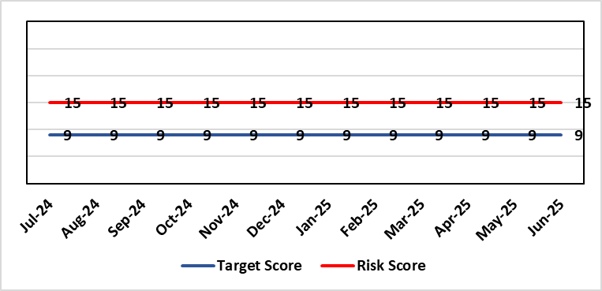 |  | Rationale for current score:  As a consequence of an internal assessment of the Standards and their impact on the UHB, it is recognised that the Health Board will not be fully compliant with all applicable Standards. This position has been confirmed/verified via an independent baseline assessment.  There has been an increase of 512% in the demand for translation services since May 2024, this is an increasing trend. Capacity within the current team is based on previous activity, meaning our reliance on external translators and associated costs has increased.
Level of Control  = 60% |  |  | Rationale for target score:  Working through its related improvement plan the likelihood of noncompliance will reduce as awareness and staff training in response to the Standards, is raised. Risk Target Date refreshed to indicate a review point following completion of actions planned for 2025/26.
Date added to the SBU HB risk register
Apr 2019
Controls (What are we currently doing about the risk?) |  |  | Mitigating actions (What more should we do?)
- An independent baseline assessment of the Health Board’s position against the Standards has been undertaken. This is in addition to the Health Board’s own self-assessment.  - Work to implement the recommendations in the above baseline assessment was completed in 2023.  - An online staff Welsh Language Skills Survey has been launched. This resulted in a response rate of 15%  - We have a record of staff Welsh language skills for 47% of our staff and continue to work to improve this  - Close constructive working relationships are in place with the Welsh Language Commissioner’s Office  - Strong networks are in place amongst Welsh Language Officers (WLO) across NHS Wales to inform learning and development of responses to the Standards.  - Proactive communication and marketing activity is being undertaken across the Health Board to raise awareness of Welsh language compliance, customer service standards and training opportunities.  - Plan to provide clinical consultations through the medium of Welsh launched in 2024 (Standard 110 and Standard 110a) |  |  | Action | Lead |  | Deadline
 |  |  | Review demand for translation services to ascertain whether activity level return to their baseline level | Welsh Language Officer |  | 31/03/2026
 |  |  | Independent Member lead for Welsh Language to be identified | Director of Corporate Governance |  | 30/06/2025
Assurances (How do we know if the things we are doing are having an impact?)  - Compliance with Statutory requirements outlined in Welsh Language Act and related Standards.  - Meetings with the Welsh Language Commissioner.  - Self-Assessment against the requirements of More Than Just Words.  - Production of an Annual Report.  - Reporting to QSG  - Outcome of compliance spot checks |  |  | Gaps in assurance (What additional assurances should we seek?)  Formal and regular reporting to the Board will recommence with the production of the next annual report.  Incorporation of relevant Welsh Language Standards into ward assurance processes.  Welsh Language Delivery Group to be re-established, following nomination of chair.
Additional Comments / Progress Notes
10/04/25: Action complete: Recruit to current vacancy within the Welsh language Translation Team.
12/06/25: Action complete: Progress against Standard 110 reported through Annual Quality Report; Action complete: Progress against Standard 110 included within QSG workplan

Datix ID Number: 1587  Health & Care Standard: |  |  | HBR Ref Number: 61  Risk Target Date: TBC |  | Current Risk Rating  4 X 4 = 16
Objective: Planned Care |  | BAF Ref: 2.5 | Director Lead: Deb Lewis, Chief Operating Officer  Assuring Committee: Quality & Safety Committee
Risk: Paediatric dental GA (General Anaesthetics)/Sedation services provided under contract from Parkway Clinic, Swansea. Medical Safety risk as general anaesthetics are performed on children outside of an acute hospital setting. Repatriation of service to acute site delayed due to theatre capacity which means the health board continues to commission services for delivery outside of national guidance (WHC 2018-09) attracting reputational risk. There is also an associated risk in that the diagnosing clinician does not deliver the care to the patient resulting in increased risk of need for multiple General Anaesthetics. |  |  | Date last reviewed: Jun 2025
Risk Rating  (consequence x likelihood):  Initial: 5 x 3 = 15  Current: 4 x 4 = 16  Target: 4 x 2 = 8 | 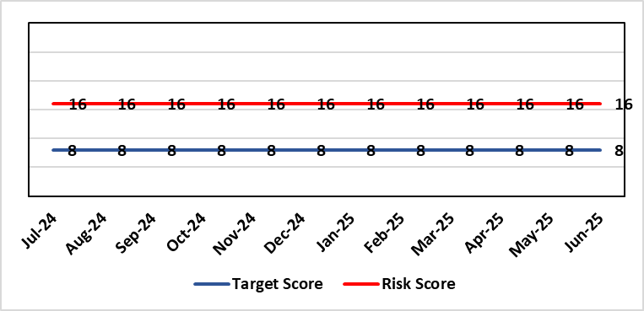 |  | Rationale for current score:  There is no immediate access to crash team/ICU facilities in in Parkway Clinic – the client group are undergoing GA (general anaesthetic)/sedation. Paediatric GA/Sedation services provided under contract from Parkway Clinic, Swansea continue due to lack of capacity for these patients to be accommodated in Secondary Care.
Level of Control  = 60% |  |  | Rationale for target score:  Relocation of the paediatric general anaesthetics service [provided by Parkway Clinic] to a hospital site being treated as a priority.
Date added to the SBU HB risk register
Apr 2019
Controls (What are we currently doing about the risk?) |  |  | Mitigating actions (What more should we do?)
Consultant Anaesthetist present for every general anaesthetic clinic.  Assurance Documentation supplied by Parkway Clinic including confirmation of arrangements in place with WAST and Morriston Hospital for transfer and treatment of patients  New care pathway implemented - no direct referrals to provider for general anaesthetics.  Multi-drug sedation ceased from Sep 2018 in line with WHC 2018 009  Revised SLA (Service Level Agreement)/Service Specification  HIW (Healthcare Inspectorate Wales) Inspection Visit Documentation provided to Health Board  All extended general anaesthetics cases require approval from paediatric specialist prior to treatment |  |  | Action | Lead |  | Deadline
 |  |  | Include transfer of services from Parkway on new theatre programme. Options to be considered by Theatre Planning Group | Associate Service Group Director (Surgery) |  | Closed (See Comments below)
Assurances (How do we know if the things we are doing are having an impact?)  RMC (Referral Management Centre) collate referral and treatment outcome data for review by Paediatric Specialist  Regular clinical meeting arranged with Parkway to discuss individual cases/concerns  Regular clinical/ management meeting for CDS/primary care management team to discuss service pathway /concerns/issues arising |  |  | Gaps in assurance (What additional assurances should we seek?)  Deputy Chief Operating Officer-led Task & Finish Group is no longer in place – it will need to be re-established to progress transfer when theatre capacity is agreed.  Pressures on the Princess of Wales special care dental general anaesthetics list and this service is considered alongside any plans for the Parkway contract.
Additional Comments / Progress Notes
11/03/2025: A paper is going to Management Board in March 2025 to consider extension of Parkway Contract to 31/03/2026.
06/05/2025: Health Board Management Board agreed that current contract with provider will be extended for 2+1 years whilst the Health Board explores capital bid for regional service as part of wider Paediatrics Day Case Unit

Datix ID Number: 2159  Health & Care Standard: |  |  | HBR Ref Number: 64  Risk Target Date: 31/03/2026 | Current Risk Rating  4 X 5 = 20
Objective: Care is delivered in safe and appropriate settings |  | BAF Ref: 3 | Director Lead: Darren Griffiths, Director of Finance & Performance  Assuring Committee: Quality & Safety Committee
Risk: Health & Safety (H&S) Infrastructure  Insufficient resource and capacity of the health, safety and fire function within SBUHB to maintain legal and regulatory compliance for the workforce and for the sites across SBUHB. |  |  | Date last reviewed: Jun 2025
Risk Rating  (consequence x likelihood):  Initial: 5 x 4 = 20  Current: 4 x 5 = 20  Target: 4 x 3 = 12 | 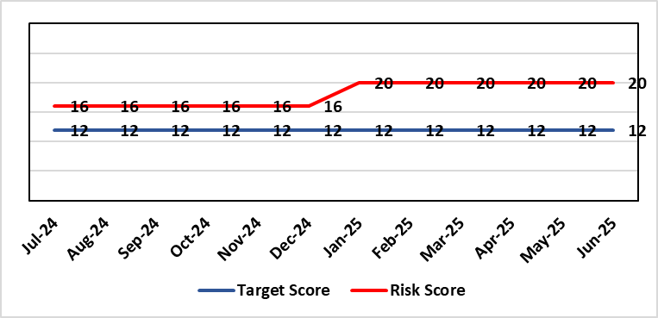 |  | Rationale for current score:  The Health Board received 12 Health & Safety Executive (HSE) improvement notices during 2019-20 covering various Health & Safety legal breaches covering a range of areas. There is the potential for future multiple notices for not meeting legal requirements based on current available resources. Due to retirement resources in the team has reduced and the risk level increased to 20.
Rationale for target score:
Compliance with the notices and to have sufficient resources to implement a sustainable health and safety provision to support the legal requirements of the Health Board and demonstrate that suitable resources are in place to undertake the roles and responsibilities of the department, also to undertake suitable and sufficient training, provide corporate overview/audit to ensure practices are being employed in the workplace.
Level of Control
= 70%
Date added to the SBU HB risk register
September 2019
Controls (What are we currently doing about the risk?) |  |  | Mitigating actions (What more should we do?)
- Assistant Director of Health and Safety in post to support strengthening and develop the H&S function to support the organisation. Business case submitted for additional resources.  - Health and Safety Operational Group and the Health and Safety Committee monitor compliance. Refreshed the Fire Safety Group with additional controls in place.  - Fire risk assessments (FRA) are being prioritised with temporary additional resources put in place in March 2021 to reduce the number of FRA overdue and brought up to date. However, due to leavers and recruitment, resource levels have fluctuated along with compliance levels that are continually monitored.  - Fire training in place and fire wardens in place  - Fire risk assessment schedule in place for the next 12 months to maintain 100% compliance of completion and is regularly reviewed |  |  | Action |  | Lead | Deadline
 |  |  | Having completed staffing structure review, next action is to work through Health Board governance processes to ensure affordability and to agree a risk-based, phased approach to implement any agreed structure going forward. |  | Assistant Director of Capital and H&S | 31/03/2026
Assurances (How do we know if the things we are doing are having an impact?)  - Monitoring through the appropriate group/committees (H&S committee) to receive assurance and or identify gaps for key compliance and adherence to applicable legislation.  - Site visits/tours to identify compliance and gaps in compliances. |  |  | Gaps in assurance (What additional assurances should we seek?)  Health and safety, capital and estates now sit under the umbrella of Finance and is currently going through a restructure, with the H&S structure also included in this and will be phased in, with a target date of 31/03/2026 for the proposed new structure to be in place.
Additional Comments / Progress Notes
07/05/25: Vacancy panel approved new head of health and safety post which will oversee the modernisation of the function. Resource remains limited so key risks will be prioritised and matched to the next phase of recruitment that the head of health and safety will oversee.
15/06/2026: Head of H&S post out to advert, risks monitored and prioritised within resources.
09/07/202: Interviews for Head of H&S scheduled 23/07/2025, if successful recruitment anticipated commencement end October/beginning November 2025, with risks monitored and prioritised within resources.

Datix ID Number: 1834  Health & Care Standard: |  |  | HBR Ref Number: 66  Risk Target Date: TBC | Current Risk Rating  5 x 5 = 25
Objective: Cancer Care |  | BAF Ref: 2.6 | Director Lead: Richard Evans, Executive Medical Director  Assuring Committee: Quality & Safety Committee
Risk: Access to SACT (Systemic Anti-Cancer Therapy)  The demand & complexity of planned treatment regime for cancer patients requiring chemotherapy currently exceed the available chair capacity, risking unacceptable delays in access to SACT treatment in Chemotherapy Day Unit with impact on targets and patient outcomes. |  |  | Date last reviewed: Jun 2025
Risk Rating  (consequence x likelihood):  Initial: 5 x 5 = 25  Current: 5 x 5 = 25  Target: 2 x 2 = 4 | 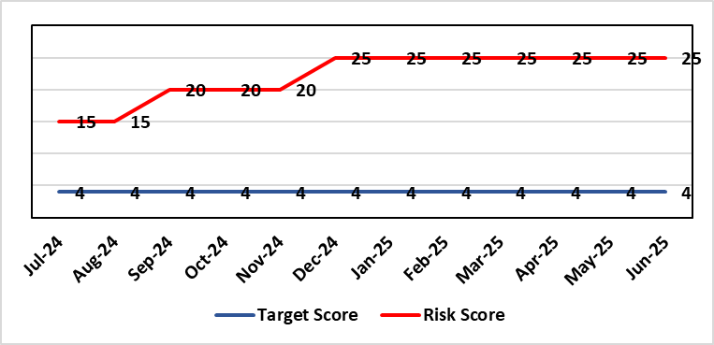 |  | Rationale for current score:  Due to staff sickness across the Multi-Disciplinary Team, the demands for SACT continues to outstrip capacity.  There are continuing workforce challenges in CDU and PTS. Patient waiting times and number of patients breaching SACT KPIs remain. New diagnoses and NICE approvals continue to require implementation of additional SACT adding further pressure.  Two Chairs have been verbally agreed however staff recruitment and training are now needed before this increase can be implemented.
Level of Control
=
Date added to the SBU HB risk register  30/11/2019 |  |  | Rationale for target score:  Reduced delays in treatment will reduce risk of harm.
Controls (What are we currently doing about the risk?) |  |  | Mitigating actions (What more should we do?)
Review of scheduling by staff to ensure all chairs used appropriately.  Previous business case endorsed by CEO for shift of capacity to home care.  A daily scrutinizing process in progress to micro-manage individual cases, deferrals etc.  Changes made to prescribing & authorising processes to improve workflow for PTS reducing potential delays to supply and administration of treatment.  Responsibility for checking bisphosphonate prescriptions in CDU moved to nursing staff to free up Pharmacy capacity allowing them to focus on key clinical tasks within Pharmacy.  Joint project with Nuclear Medicine to streamline pathways and prioritise SACT patients appropriately halved the average time waiting for MUGA/EDTA tests required before starting SACT.  Increased homecare capacity  Adopted principles from UK SACT board publication: General Principles to Support Systemic anti-Cancer Therapy Aseptic Pressures September 2023 |  |  | Action | Lead | Deadline
 |  |  | Recruiting to posts | Divisional Manager (Cancer) | 31/08/2025
 |  |  | Training of new staff (full competency) | SACT Training Team / Pharmacy | 28/02/2026
Assurances (How do we know if the things we are doing are having an impact?)  Additional funding agreed to support increase in nurse establishment to appropriately staff the unit during its main opening hours. Additional scheduling staff also agreed. This funding has been utilised but with further increase demand further funding for Pharmacy and Nursing would be required  Pre-Assessment process has been separated from start date in an attempt to fill deferral slots at short notice where possible. Improved communication between MDT (Multi-Disciplinary teams) to streamline booking and deferral process.  Continue to monitor patient experience via friends and family in conjunction with the Welsh Cancer Patient Experience Survey results under our PTR procedures. Monitoring our waiting times against new SACT metrics, which is a measure based on treatment intent and is no longer reported as average waiting time so is more linked to expected outcomes etc. This performance metric is included in our Cancer Performance report we send to WG and Management Board and internally via governance arrangements with NPTSSG where Oncology services sit.  SBU Capacity Task and Finish group meeting monthly to analysis demand and capacity gap.  Common themes for delays will continue to be identified and analysed each month. A quarterly report will be provided to the SACT, Consultant meeting and Division Business meeting to inform of the outcome  Main breach causes are due to CDU capacity and SACT booking delays. Quarterly reports demonstrate this trend. Further work being done on new ways of working and possible increase in chair capacity & workforce.  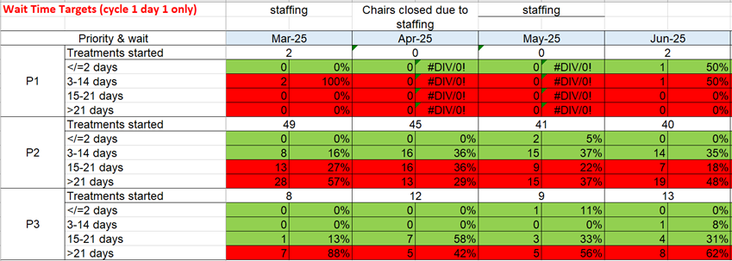  Welsh SACT performance metrics – P2 to start within 14 days. P3 to start within 21 days |  |  | Gaps in assurance (What additional assurances should we seek?)  Workforce requirements are to be mapped to demonstrate additional capacity required to meet current and future predicted SACT Demand.
Additional Comments / Progress Notes
March 2025:
- Recruitment for pharmacy and nursing workforce in progress
- Three-year plan business case developed ready for submission
April 2025:
- Action complete: 3-year plan approved at Business Case Assurance Group 22/04/2025
- Recruiting to posts and training additional SACT staff
May 2025
- SACT competency increased CDU (chemotherapy day unit) 100%, BMT (bone marrow transplant) 93.5%, Ward12 79%
- 29 CNS (clinical nurse specialists) going through refresher framework to provide resilience
Recruitment process underway
June 2025:
Action previously completed - A demand and capacity options paper has now been shared with the Service Group Senior Leadership Team and agreed in principle. Paper went to CPIG in January 2025. Verbal approval from Director of Finance for two chairs in Feb 2025 and request for resubmission of 3-year business case plan. Three-year plan approved for Year 1 by the Business Case Assurance Group (BCAG) (additional 2 chairs 24/25 6 chairs per year for years 2 and 3 to run at 80%) on 22nd April 2025. Recruitment has commenced.
SACT competency has dropped in percentage terms however this is due to an increase in staff and a plan is in place to train all new staff.

Datix ID Number: 1418  Health & Care Standard: |  |  | HBR Ref Number: 69  Risk Target Date: See Target Rationale |  | Current Risk Rating  5 X 4 = 20
Objective: Children & Young People Services |  | BAF Ref: 2.7 | Director Lead: Deb Lewis, Chief Operating Officer  Supporting Director: Elizabeth Rix, Executive Director of Nursing  Assuring Committee: Quality & Safety Committee
Risk: Issues related to adolescent patient admission to adult mental health inpatient wards  Risk of inappropriate settings resulting in 'Safeguarding Issues'. The Welsh Government has requested that Health Boards identify Secondary Care in -patient facilities for the care of adolescents- in Swansea Bay University Health Board Ward F NPT hospital is the dedicated receiving facility with one bed identified. |  |  | Date last reviewed: Jun 2025
Risk Rating  (consequence x likelihood):  Initial: 2 x 3 = 6  Current:5 x 4 = 20  Target: 2 x 3 = 6 | 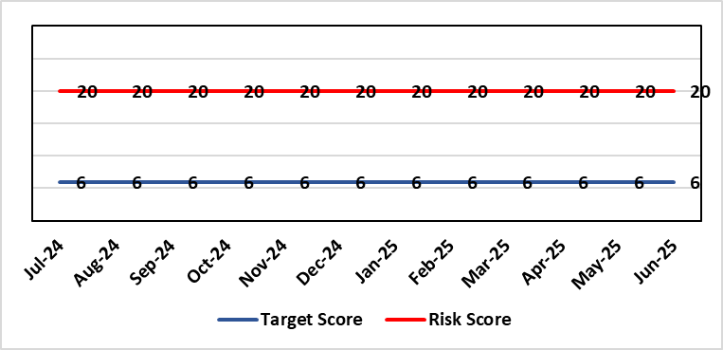 |  | Rationale for current score:  Every health board is required to have an admission facility for adolescent Mental Health patients. Whilst ward F has been identified as the single point of access in SBU and provides access to a bed for adolescent admissions if available at the time of request it is a mixed sex adult ward. Therefore the facilities are less than ideal for young patients in crisis.
Level of Control
=
Date added to the SBU HB risk register  27/02/2020 |  |  | Rationale for target score:  The longer-term aim for the Health Board remains to create an admission facility for adolescent Mental Health patients but this will not be possible until the new Adult Inpatient Unit is built.
Controls (What are we currently doing about the risk?) |  |  | Mitigating actions (What more should we do?)
Safeguarding Training for Staff, Joint protocol with Cwm Taf LHB [CAMHS] currently subject to review, Local SBUHB policy on providing care to young people in this environment. This includes the requirement for all such patients on admission to be subject to Level 3 Safe and Supportive observations.  Only Adolescents within 16-18 age range are admitted to the adult ward.  The health board works with CAMHS to make sure that the length of stay is as short as possible. |  |  | Action | Lead |  | Deadline
 |  |  | Next service group review of effectiveness of current controls. | MH&LD Head of Operations & Clinical Directors |  | 30/06/2025.
Assurances (How do we know if the things we are doing are having an impact?)  Individual Rooms with en Suite Facilities, Joint working with CAMHS, monitoring of staff training, Monitoring of admissions by the MH&LD SG Legislation Committee of the Health Board. The ongoing issues with the risks presented by the use of this has recently been raised at an all Wales level with Welsh Government and a formal review is anticipated. The Service Group continues to flag the risk particularly in light of Ward F being identified as the SPOA for AMH in the Health Board which has resulted in an increase in acuity and a greater concentration of individuals who are experiencing the early crisis of admission - this has served to increase the already identified risks for young people in the environment. |  |  | Gaps in assurance (What additional assurances should we seek?)
Additional Comments / Progress Notes
01/04/2025: No change currently to detail.
01/07/2025: No change in service provision but this will now be incorporated in the refresh of the Clinical Services Plan.

Datix ID Number: 2522  Health & Care Standard: |  |  | HBR Ref Number: 75  Risk Target Date: TBC |  | Current Risk Rating  5 x 2 = 10
Objective: Care is high quality, safe, efficient, and delivers the best possible outcomes for people |  | BAF Ref: 2 | Director Lead: Deb Lewis, Chief Operating Officer  Assuring Committee: Performance & Finance Committee
Risk: Whole-Service Closure  Risk that services or facilities may not be able to function if there is a major incident or a rising tide that renders current service models unable to operate |  |  | Date last reviewed: Jun 2025
Risk Rating  (consequence x likelihood):  Initial: 5 x 4 = 20  Current: 5 x 2 = 10  Target: 5 x 1 = 5 | 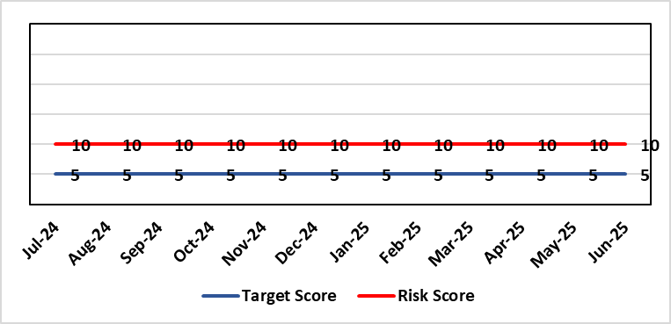 |  | Rationale for current score:  Risk reflects transition to business as usual as part of living with Covid strategy. BCP plans in place. There is still fluctuation in patient numbers and new variants continue to emerge so score maintained as watching brief.
Level of Control  = 25% |  |  | Rationale for target score:  The strategy of moving towards living with Covid will eventually lower the risk level to target.
Date added to the SBU HB risk register
May 2021
Controls (What are we currently doing about the risk?) |  |  | Mitigating actions (What more should we do?)
- Sites have business continuity plans and the impact of one site being overwhelmed by COVID demand has been reviewed.  - Monitoring of associated risks has been being transferred to appropriate forums such as UEC Board, Elective Care Board and Nosocomial Group with overall oversight by Management Board.  - Ongoing surveillance of epidemiology data for early warning and further change to risk level via live Covid dashboard. |  |  | Action | Lead |  | Deadline
 |  |  | Periodic review of risk | COO |  | See Notes Below
Assurances (How do we know if the things we are doing are having an impact?)  Monitored via Management Board for early warning signs. |  |  | Gaps in assurance (What additional assurances should we seek?)
Additional Comments / Progress Notes

Datix ID Number: 1832  Health & Care Standard: |  |  | HBR Ref Number: 80  Risk Target Date: 31/12/2025 | Current Risk Rating  4 x 5 = 20
Objective: Urgent & Emergency Care |  | BAF Ref: 2.4 | Director Lead: Deb Lewis, Chief Operating Officer  Assuring Committee: Quality & Safety Committee
Risk: Transfer of Clinically Optimised Patients  Risk that we fail to significantly reduce the number of Clinically Optimised Patients in hospital beds. A deficit in the availability of appropriate community / domiciliary care results in unacceptable delays in discharging patients from acute hospital beds. As a result, patients can decompensate and never gain the independence that could have been available from an early discharge.  Lack of access to same day domiciliary care/emergency placements in the community hinders ability to avoid admission and associated harms. |  |  | Date last reviewed: Jun 2025
Risk Rating  (consequence x likelihood):  Initial: 4 x 5 = 20  Current: 4 x 5 = 20  Target: 4 x 2 = 8 | 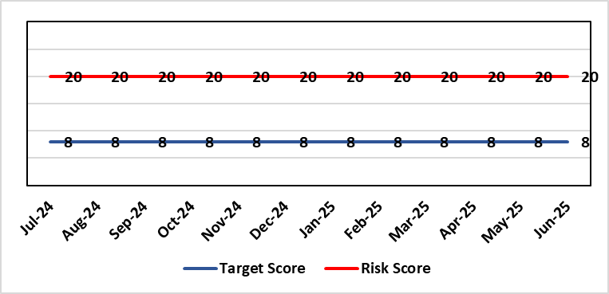 |  | Rationale for current score:  - Sustained levels of clinically optimised patients (COPs) leading to overcrowding within ED, use of inappropriate or overuse of decant capacity in ED and delays in accessing medical bed capacity, clearly emerged as themes.  - Constraints in relation to all patient flows out of Morriston to a more appropriate clinical setting, identified and included in an expanded risk.  - Delay in discharge for clinically optimised patients can result in deterioration of their condition.
Level of Control
= 25%
Level of Control  = 25% |  |  | Rationale for target score:  Targeted reduction of Clinically Optimised patients remains a priority for the HB in order to minimise risk of avoidable harm to patients within the HB and in the wider community.
Date added to the SBU HB risk register
May 2021
Controls (What are we currently doing about the risk?) |  |  | Mitigating actions (What more should we do?)
- One of the measures under targeted intervention is to see a reduction in pathway of care delays, which specifically supports the reduction in the number of clinically optimised patients.  - Review is undertaken on a patient-by-patient basis – with explicit action agreed in order to progress transfer to appropriate clinical setting.  - Critical constricts in relation to access/time delays for social workers and assessment for package of care and social placement  - Weekly escalation meetings are held with health and social service colleagues to ensure the requirements of the patients are reviewed and patients are pulled through the system where possible. |  |  | Action |  | Lead | Deadline
 |  |  | Reintroduce D2RA Principles across the Health Board with external consultancy support |  | Assistant Director of Operations UEC  Associate SGD PCTS | Complete
 |  |  | Work programme and governance structure agreed by local partnership (health board & local authorities) to work up sustainable D2RA model. |  | Associate Director UEC | 31/03/2026
Assurances (How do we know if the things we are doing are having an impact?)  - Patient level dashboard allows breakdown by delay type  - Regular (weekly) COP reviews and escalations  - Shared vision with NPT & Swansea LA CEOs agreed and governance structure with Executive Directors for sign off |  |  | Gaps in assurance (What additional assurances should we seek?)  Capacity and demand exercise required to inform reshaping of community services
Additional Comments / Progress Notes
12/05/2025: Action previously completed: The Care Action Committee (CAC) focus on reducing the impact of clinically optimised patients within acute hospitals. The Health Board engaged with the work from the CAC and currently developing the Winter Plan for 24/25, of which reducing COPs will be a key focus. This work is being taken forward by the Associate SGD PCTS to ensure cross-boundary support.
Integrated Discharge hub now established from within existing resources following a successful test of change. Positive turnaround of patients from front door services reducing admission demand and long-term care demand. Roll-out of true Discharge to Recover then Assess (D2RA) principles/ activity planned in conjunction with Local Authority partners to improve timeliness of all discharges (which will positively impact COP position)
17/07/2024: Action complete: Reintroduce D2RA Principles across the Health Board with external consultancy support

Datix ID Number: 2561 Risk Refreshed  Health & Care Standard: |  |  | HBR Ref Number: 85  Risk Target Date: 31/07/2026 | Current Risk Rating  4 x 5 = 20
Objective: Children & Young People Services |  | BAF Ref: 2.7 | Director Lead: Christine Morrell, Director of Therapies & Health Sciences  Assuring Committee: Quality & Safety Committee
Risk: Non-Compliance with ALN Act  There is a risk of the Health Board not fulfilling the statutory requirements of the Additional Learning Needs and Education Tribunal (Wales) Act 2018 (the ALN Act) within the timescales that are required under the ALN Act, resulting in non-compliance with these duties.  The Health Board has historically held a risk of ALN non-compliance caused by gaps in the data regarding its compliance with statutory duties. The Health Board now has a digital infrastructure that provides data regarding its compliance with its statutory duties under Sections 65 and 20 of the ALN Act. These duties relate to the timely provision of information to support Education planning and decision-making (Section 65), and to timely decision-making about relevant Health provision followed by delivery of this provision where it is found to be required (Section 20). Data for 2025 shows there are breaches against both duties with a high level of frequency (as at July 2025, breaches are generally occurring on an approximately daily basis).  Informed by this data, activity is planned to better understand the causes of the risk and to identify and progress mitigating actions.  In addition to the above, the Health Board is currently unable to provide assurance with its duty to notify Education of pre-school children with probable ALN under Section 64 of the legislation. This risk is caused by process and data quality issues.  Potential consequences of the risk of the Health Board not fulfilling the statutory requirements of the ALN Act within the timescales required are: non-compliance with statutory duties; parent / carer and young peoples' dissatisfaction leading to complaints and legal challenge; reputational impact; and children failing to access the multi-agency support that they need with their learning needs, leading to poor outcomes. |  |  | Date last reviewed: Jun 2025
Rationale for current score:
2025 compliance data shows that the Health Board is breaching multiple statutory duties (duties under both Sections 65 and 20 of the ALN Act) with a high level of frequency (approximately daily). The Health Board is currently unable to provide assurance regarding compliance with its legal duties under Section 64 of the Act,

The risk consequence is major (multiple breaches of a statutory duty - 4) and the likelihood is expected (breaches occurring approximately daily - 5), hence the current risk score of 20.
Risk Rating  (consequence x likelihood):  Initial: 5 x 5 = 25  Current: 4 x 5 = 20  Target: 2 x 3 = 6 |  |  | Rationale for target score:  As the ALN Act is new legislation, there remains some ongoing likelihood of risk events during the initial phases of implementation, though with lessened consequences as a result of mitigating actions.
Level of Control
=
Date added to the SBU HB risk register
14/05/2022
Controls (What are we currently doing about the risk?) |  |  | Mitigating actions (What more should we do?)
- Designated Educational Clinical Lead Officer (DECLO) is in post, providing a single point for direction and co-ordination of the Health Board’s activity under the ALN Act. The post is a statutory requirement.  - Operational processes through which the Health Board fulfils its statutory duties under the ALN Act are in place.  - Activity is planned to develop a clear understanding of the causes of the current risk and to identify the actions required to mitigate the risk. This activity will be progressed within the Health Board’s ALN governance structures.  - Health Board ALN Steering Group has been established, wi ALN Operational Group working under the governance of this,  - There is close and ongoing collaborative working with Local Authority Education partners, including their involvement in the ALN Steering and Operational Groups as noted above. |  |  | Action | Lead | Deadline
 |  |  | Amended: Securing longer-term business and project management support, to support activity required to mitigate the risks. | Executive Director of Allied Health Professions & Health Science | 30/11/2025
 |  |  | Activity to be progressed to revise and refresh the Health Board’s ALN operational workplan for the 2025 / 26 school year, with a focus on actions required to mitigate the compliance risk. | DECLO | 30/10/2025
 |  |  | Establish a structure of regular meetings to monitor and review compliance data between the DECLO and leads for ALN-impacted operational services | DECLO | 30/08/2025
 |  |  | Revise processes through which the Health Board fulfils its duty under Section 64 of the ALN Act and ensure that accurate and reliable data is available. | DECLO | 30/10/2025
Assurances (How do we know if the things we are doing are having an impact?)  - The Health Board has a digital infrastructure to monitor compliance  - There is regular reporting on compliance with the ALN Act that is now data-informed through the Patient Safety and Compliance Group.  - The Health Board has an ALN Steering Group, chaired by the Deputy Director for Allied Health Professions and Health Sciences, ensuring oversight at a senior level within all impacted operational and corporate areas. The Health Board also has an ALN Operational Group, chaired by the DECLO, to co-ordinate activity required to address the risk. The Operational Group has an ALN workplan and reports are made to the Steering Group regarding progress |  |  | Gaps in assurance (What additional assurances should we seek?
Additional Comments / Progress Notes
09/07/2025: Action complete - Review of the Health Board’s compliance with its legal requirements under the ALN Act based on data collected through the new ALN App for January – March 2025, and reassess the level of risk for noncompliance with the ALN Act based on this. The risk has been substantially revised in view of compliance data that is available and plans in place that are informed by this data.

Datix ID Number: 3071  Health Care Standards: |  |  | HBR Ref Number: 89  Target Risk Date: TBC | Current Risk Rating  4 x 5 = 20
Objective: Primary & Community Care |  | BAF Ref: 2.2 | Director Lead: Elizabeth Rix, Executive Director of Nursing  Supporting Director: Deb Lewis, Chief Operating Officer  Assuring Committee: Quality & Safety Committee
Risk: Healthcare Nursing Staff Levels at HMP Swansea  There is a risk that the men in HMP Swansea will not receive the appropriate standard of care. This is because the nursing establishment within the prison no longer fully meets the changed demographics and numbers of men being detained. The maximum operational capacity of the Prison can reach circa 480 men. The Health Board investment into the Prison is based on delivering services to 250 men. This was also highlighted as a risk in the June 2022 HIW governance review. In addition there is no head room built into the Prison nursing establishment so periods of sickness, leave and study renders the roster short. |  |  | Date last reviewed: Jun 2025
Risk Rating  (consequence x likelihood):  Initial: 4 x 5 = 20  Current: 4 x 5 = 20  Target: 2 x 2 = 4 | 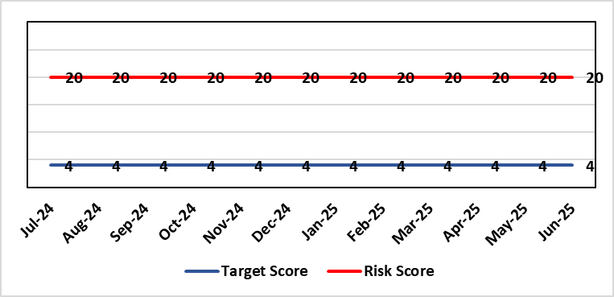 |  | Rationale for current score:  Consequence major – unable to fully deliver on the recommendations of HIW due to low healthcare staffing numbers, further impacted during periods of sickness or absence as no headroom. Recommendations also raised in Prison & Probation Ombudsman reports. Likelihood expected – suboptimal care provided on a daily basis.
Level of Control  = % |  |  | Rationale for target score:  Consequence minor – With sufficient staffing numbers the prison will be able to deliver on HIW recommendations and fully implement the actions in the Health Delivery Plan. Likelihood unlikely – With full establishment and headroom, suboptimal care is less likely.
Date added to the SBU HB risk register
30/11/2022
Controls (What are we currently doing about the risk?) |  |  | Mitigating actions (What more should we do?)
Daily communication with the Governor about the availability and priority of healthcare nursing staff.  Pharmacy technician role established – can administer drugs to support nursing establishment.  Agreed that Health Care Support Workers to be 2nd checkers for CD drugs and to support substance withdrawal monitoring (awaiting accreditation).  Bank and agency staff are used in a limited way, when skillset allows.  E-roster implemented and scrutinised with regular reporting to Service Group Patient Safety & Compliance Group.  Escalation for overtime and additional hours to fill shortfalls. |  |  | Action | Lead | Deadline
 |  |  | Review of staffing in prison. Royal College of Psychiatrists Substance Misuse and Mental Health Baseline assessment completed – analysis of outcome and agreement of further action next. (Following financial deep dives) | Deputy Head of Nursing | 31/09/2025
Assurances (How do we know if the things we are doing are having an impact?)  Prison feedback and complaint process  Progress reporting on action plans through Service Group PS&C Group, and Health Board Q&S structures (via Patient Safety & Compliance Group). |  |  | Gaps in assurance (What additional assurances should we seek?)  Implementation and reporting of clinical audits. Audit framework for HMP Swansea in development - Clinical Pathways/Audits and Health Promotion groups taking forward.
Additional Comments / Progress Notes
10/07/2025 – Financial deep dive completed within PCT Nursing services to identify potential scope for additional RGN post within HMP. SBAR to be presented to PCT Board for consideration once spend identified. Risk will be reviewed and risk assessment updated following consideration of the SBAR.

Datix ID Number: 2796  Health Care Standards: |  |  | HBR Ref Number: 90  Target Risk Date: 30/04/2025 |  | Current Risk Rating  4 x 5 = 20
Objective: The delivery of care is supported by innovative digital solutions |  | BAF Ref: 4 | Director Lead: Matt John, Director of Digital  Assuring Committee: Digital, Research & Innovation Committee
Risk: Non-compliance with UK-GDPR Article 15 regarding Subject Access Requests (SARs), along with other health records requests for disclosure of personal data  If the Health Board is non-compliant with the UK-GDPR, then there is a risk of ICO enforcement action being taken against SBUHB, reputational damage and the potential for claims.  The Health Board does not have adequate/identified resources to deal with the sustained increase in volume and complexity of subject access/access to health records requests received from requestors and is seeing a large number of SARs exceeding the required legal timeframe for response, which poses the risk of ICO involvement if backlogs continue to grow.  There are significant challenges across the Health Board pertaining to the timely redaction and clinical review of records prior to disclosure. Individual services/departments do not have adequate health professional resources and/or knowledge on undertaking redaction. Currently, a high number of records are released without adequate redaction and review in order to meet the legal timeframe. The lack of review/adequate redaction increases the risk of personal data breaches occurring.  Complex requests received can include both corporate and medical records. Information can be located across multiple services/departments which can be paper based or held within numerous systems, databases and applications or non-corporate communication channels. They can include particularly sensitive and contentious information relating to safeguarding, ongoing complaints claims or legal aspects.  There is a risk of personal data breaches occurring without higher scrutiny of the amount of misfiling happening at a service level resulting in SARs needing to be double checked by Health Records Team to ensure don’t include other individual’s personal data.  There will also be a knock-on effect/impact on staff who are already working on other priority work when they are required to have input in the SAR process. |  |  | Date last reviewed: Jun 2025
Rationale for current score:
C – The Health Board has a statutory requirement to comply with UK GDPR and Data Protection Act 2018. This includes compliance with an individual’s Right to Access their personal data. The Information Commissioner has the power to take enforcement action, including substantial monetary penalties, for non-compliance (up to 4% of annual worldwide turnover), for serious breaches of data protection principles. Historically, a number of complaints regarding the handling of SARs within SBUHB have been highlighted previously in both the mainstream media and on social media, leading to a loss of trust in the Health Board with damage to staff and Health Board reputation and a breach of data subjects’ fundamental right.
L- The Health Board does not have adequate/identified resources to deal with the sustained increase in volume and complexity of SARs received from both patients and staff as a result of changes to the SAR landscape since the introduction of UK-GDPR and advancements in technology and data availability. There are inconsistent processes across the Health Board, with varying levels of robustness regarding legal compliance. The increased use of various digital applications has impacted the volume and complexity of content and the ability to retrieve the personal data required to comply with SARs. Since Covid, there have been rapid changes in ways of working such as the use of non-corporate communication channels (e.g. WhatsApp) and increased e-mails with clinical relevance - with no or limited recording back to the clinical and corporate records. The process for ensuring information is appropriately reviewed and redacted by health professional within services has become far more complex and resource intensive increasing the likelihood of personal data breaches and/or non-compliance with legal timescales for disclosure. The ICO have previously been involved with a number of complaints in this area and there is an increased potential for future enforcement action if significant improvements are not made. SBUHB is already seeing an increase in complaints and ICO input relating to the handling of SARs to the extent that further complaints are expected to materialise with a very high level of frequency and probability. Solicitors’ correspondence on behalf of individuals is becoming increasingly difficult with threats of legal action. The ICO has this year issued a reprimand to an NHS Trust in England in connection with their poor compliance with the statutory timescales to respond to SARs and the ICO have indicated an intention to more closely monitor organisations who develop significant backlogs when responding to SARs.
Risk Rating  (consequence x likelihood):  Initial: 4 x 4 = 16  Current: 4 x 5 = 20  Target: 4 x 3 = 12 | 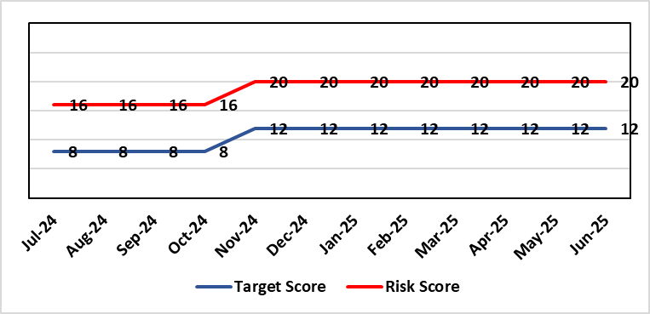
Level of Control  = 50% |  |  | Rationale for target score:  C – As above  L – Additional resources would allow the organisation to make significant improvements to the process by which SARs are managed. Being able to adequately comply with legal requirements reduces the likelihood of enforcement action and fines from the ICO, as well as minimising the risk of reputational damage.
Date added to the SBU HB risk register
Jan 2023
Controls (What are we currently doing about the risk?) |  |  | Mitigating actions (What more should we do?)
- New SAR (Subject Access Request) Working Group established in February 2024  - Prioritisation of workload  - Revised SAR policy in place (to be reviewed & updated in line with Working Group actions)  - Advice sought from Legal and Risk on complex cases  - Escalating areas of concern to IGCAG (Information Governance & Cyber Assurance Group) |  |  | Action | Lead |  | Deadline
 |  |  | Implement detailed Action Plan in line with the timescales outlined within the Plan | Data Protection Officer/Head of Health Records |  | 31/03/2026
Assurances (How do we know if the things we are doing are having an impact?)  - Bi-monthly IGCAG chaired by SIRO (Senior Information Risk Owner) and attended by Deputy Caldicott Guardian and Data Protection Officer  - Bimonthly reporting to DDRI with progress reports  - Escalation reports from IGCAG to Management Board & Digital, Data, Research and Innovation Committee as required  - IG governance structures in place with key roles and responsibilities established e.g. SIRO, Caldicott Guardian, DPO (Data Protection Officer) |  |  | Gaps in assurance (What additional assurances should we seek?)  Recent internal audit identified the requirement to invest in resources to address gap in assurance.
Additional Comments / Progress Notes
12/5/2025 - Action plan has been presented to IGCAG on 10/4 and was ratified at that meeting. Action plan is now in the process of going to DDRI meeting on 13/5 and is intended to go to Management Board on 21/5.
9/6/2025 - Confirmation received that SAR Action Plan has been formally approved at DDRI meeting. New actions added to implement action plan and to provide updates on progress of actions on a quarterly basis. Next meeting of SAR Working Group to be arranged to discuss progress.
4/7/2025 - SAR Working Group to meet shortly. Actions up to June 2025 on SAR Action Plan have been completed. Progress update to be discussed at Working Group meeting and then taken to next IGCAG meeting before feeding up to DDRI.

Datix ID Number: 3444  Health & Care Standard: |  |  | HBR Ref Number: 92  Risk Target Date: 31/03/2026 | Current Risk Rating  5 x 5 = 25
Objective: The health board is a resilient, financially sustainable and responsible organisation |  | BAF Ref: 6 | Director Lead: Darren Griffiths, Director of Finance and Performance  Assuring Committee: Performance & Finance Committee
Risk: Forecast Deficit  Forecast deficit is not met due to (1) insufficient progress on run rate reduction, (2) the saving targets required across all areas are not achieved. |  |  | Date last reviewed: Jun 2025
Risk Rating  (consequence x likelihood):  Initial: 5 x 4 = 20  Current: 5 x 5 = 25  Target: 5 x 1 = 5 | 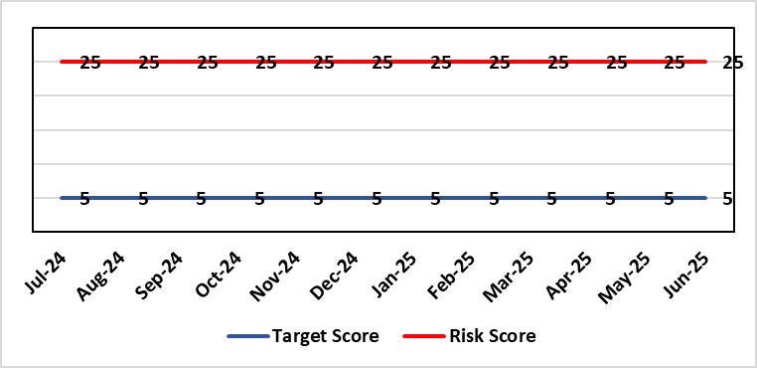 |  | Rationale for current score:  - Delivery of the deficit plan is predicated on a combination of savings and run rate reductions  - Consequence is significant as failure to deliver the plan could impact service delivery if cost reduction required later in the year  - A deficit plan is a failure to meet a statutory duty
Level of Control
= 25%
Date added to the SBU HB risk register  June 2023 |  |  | Rationale for target score:  - The consequence will not change given the important of financial delivery and its relationship with the delivery of the Health Board recovery and sustainability plan  - Reducing likelihood to 1 supports a confidence that the deficit plan will be delivered.
Controls (What are we currently doing about the risk?) |  |  | Mitigating actions (What more should we do?)
The Health Board is doing the following:  - Accountability Letters and Budgetary Management Framework were issued to all Directors in April 2025, which set the expectation and budget for 2025/26.  - Introduced in Q3 of 2024/25 the Health Board has put in place further oversight via the Recovery & Sustainability Board, which reported directly to PFC and is chaired by the CEO. This Board is held bi-weekly.  - Supporting the R&S Board is the R&S Team, which for 2025/26 has dedicated resource to lead the programmes of work agreed for 2025/26, of which the Board has agreed on 5 key areas.  - Budgetary Management approach 2025/26 requires all Services Groups to produce a Financial Strategy by end May 2025.  - Continued transparent exchange of position with NHS Executive & Welsh Government, with both weekly and monthly meetings with the NHS Executive.  - Standard Day 5 Finance Reports on Variable Pay, Savings Performance and Flash report published via SharePoint site.  - Variable Pay Cap agreed by the organisation to deliver £32m of savings as set out in the Financial Framework dated 30th June 2025. |  |  | Action | Lead | Deadline
 |  |  | Commissioning of external support, in collaboration with Welsh Government, which will commence on 14th July 2025 | DOF | 14/07/2025
 |  |  | Financial Framework submitted to WG on 30th June clearly outlines recovery actions required by HB to meet WG expectations | DOF | 30/06/2025
Assurances (How do we know if the things we are doing are having an impact?)  The Health Board financial performance is reviewed and monitored through:  - WG Monthly Monitoring Returns and letter signed by CEO and DOF  - Monthly financial performance meetings  - Monthly performance meetings (New 2025/26)  - Performance & Finance Committee  - Independent Member briefings  - Recovery & Sustainability Board  - Routine reporting to Board of most recent monthly position and financial forecasts  - Weekly meetings with the NHS Executive  - Monthly TI Meetings with NHS Executive  - Face to Face meetings with Director Finance for NHS Wales |  |  | Gaps in assurance (What additional assurances should we seek?)
Additional Comments / Progress Notes
09/05/2025: Risk entry comprehensively refreshed for 2025/26 year.
06/06/2025: WG letter received setting out requirement for the HB to maintain the 2024/25 Outturn position of no greater than £42.5m for 2025/26
11/07/2025: Financial Framework submitted to WG on 30th June clearly outlines recovery actions required by HB to meet WG expectations

Datix ID Number: 3448  Health & Care Standard: |  |  | HBR Ref Number: 93  Risk Target Date: TBC |  | Current Risk Rating  5 x 4 = 20
Objective: The health board is a resilient, financially sustainable and responsible organisation |  | BAF Ref: 6 | Director Lead: Darren Griffiths, Director of Finance and Performance  Assuring Committee: Performance & Finance Committee
Risk: Reduced Capital Funds  Reduced National NHS funds available for major capital schemes requiring a restricted Capital Plan for 2025/26. |  |  | Date last reviewed: Jun 2025
Risk Rating  (consequence x likelihood):  Initial: 5 x 4 = 20  Current: 5 x 4 = 20  Target: 5 x 1 = 5 | 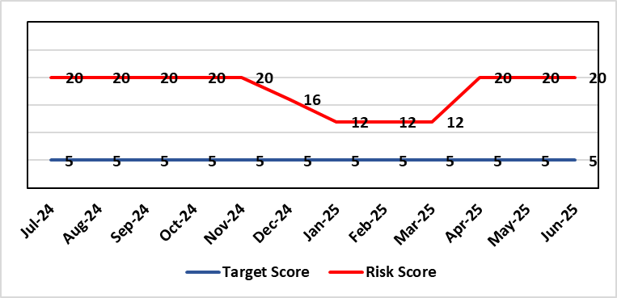 |  | Rationale for current score:  - The Health Board has been advised that its discretionary capital allocation for 2025/26 is £13.875m.  - The funding available within the Capital Resource Limit (CRL) will not meet the demands for capital investment. Discretionary capital is deployed to replace ageing medical devices & equipment; to address backlog maintenance of premises; and to support small scale, non-National service improvements with capital investments  - The outcome of the national capital prioritisation exercise means some major capital scheme business cases are on hold. A number of high-risk priority schemes will require funding support from WG, including interim measures for ED and Acute Adult Mental Health In-patients services.  - The approved plan assumes additional disposal income of £0.800m which is yet to complete.  - The approved plan assumes income of £0.749m from WG for expended business case fees.  - There is potential for further capital requirements arising from service model changes which will need to be managed.  - Potential consequences of this risk are the inability to achieve the ambitions set out within health board plans; the potential failure of ageing equipment leading to service disruption; the exposure to potential environmental health & safety risks.
Level of Control
= 25%
Date added to the SBU HB risk register  June 2023  (refreshed June 2024) |  |  | Rationale for target score:  The target score expresses the aspiration of the health board for addressing this risk. The target date indicated above reflects the point which the current actions are anticipated to reduce the risk, though knowledge of the actual funding available is required to reduce it further and this is not available until some months into the financial year.
Controls (What are we currently doing about the risk?) |  |  | Mitigating actions (What more should we do?)
The Health Board is doing the following:  - Regular dialogue with Welsh Government regarding capital requirements.  - Clear communication and reporting of the capital position, the risks and limitations.  - Close management of all schemes to ensure slippage is understood along with the impact on service.  - Clear prioritisation of any new requirements recognising the current constraints |  |  | Action | Lead |  | Deadline
 |  |  | Routine review and flexing of plan as spending is committed through the year. Routine monitoring processes will identify any potential slippage and will deploy this on risk-based basis. | Director of Finance & Performance |  | Monthly through the financial year as plan is dynamic
 |  |  | Examine the specific prioritisation and phasing of capital investment to meet health board objectives through the Capital & Estates Taskforce. | Director of Finance & Performance |  | Bi-Monthly
 |  |  | Maintenance of risks through the Capitalisation Prioritisation Group should additional WG funding become available later in the year. | Assistant Director of Finance (Strategy & Planning) |  | On-going
Assurances (How do we know if the things we are doing are having an impact?)  The Health Board capital position is reviewed and monitored through:  - Quarterly capital prioritisation group  - Performance & Finance Committee quarterly finance report  - Monthly Monitoring Returns to Welsh Government. |  |  | Gaps in assurance (What additional assurances should we seek?)  Reporting on impact of constraints to the capital programme on service delivery.
Additional Comments / Progress Notes
24/6/2025: Risk remains at 20 following Performance & Finance Committee meeting.
24/6/2025: Some uncertainty around the future approval of capital funding following WG letter of 6/6/25 on the unapproved revenue financial plan for the Health Board.

Datix ID Number: 3516  Health Care Standards: |  |  | HBR Ref Number: 94  Risk Target Date: TBC |  | Current Risk Rating  4 x 3 = 12
Objective: Mental Health & Learning Disability Services |  | BAF Ref: 2.3 | Director Lead: Deb Lewis, Chief Operating Officer  Assuring Committee: Performance & Finance Committee  For information: Quality & Safety Committee
Risk: CAMHS failure to meet required standards of performance  The CAMHS service is unable to meet the required level of performance due to workforce deficits in the team across all staff groups including medics, psychological therapies and nursing.  Links to other CAMHS risk register entries: (Ref: 3410/3373/3351/3346/3349/3350) |  |  | Date last reviewed: Jun 2025
Risk Rating  (consequence x likelihood):  Initial: 4 x 5 = 20  Current: 4 x 3 = 12  Target: 3 x 3 = 9 | 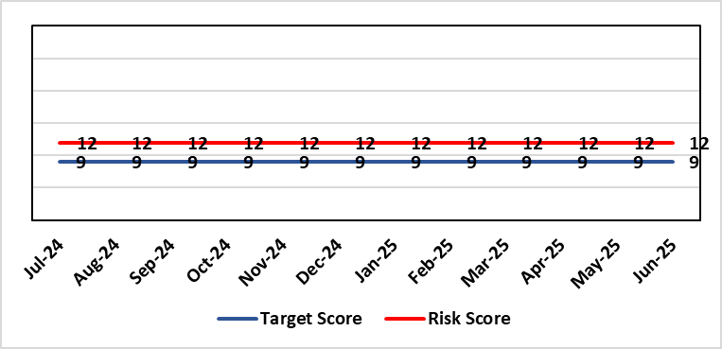 |  | Rationale for current score:  Marked improvement in the performance against the Mental health Measure for CAMHS. Data validation for new patients complete. Current risk score 12 in view of improved performance however this reflects the fragility in the workforce to deliver sustained performance. Work is still ongoing within CAMHs to maintain and improves the situation.
Level of Control  = % |  |  | Rationale for target score:  The rationale for the target score is linked to successful recruitment and more timely access to services for children and young persons which will reduce risk.
Date added to the SBU HB risk register
October 2023
Controls (What are we currently doing about the risk?) |  |  | Mitigating actions (What more should we do?)
-Ongoing recruitment into all staff groups  -Temporary agency workforce in nursing at premium pay rates to sustain current levels of performance  -Recent appointment into psychological therapies lead posts.  -Recent appointments to substantive consultants psychiatrist posts.  -Moved vacancy nursing establishments into part 1 of the services to recruit and increase capacity. |  |  | Action | Lead |  | Deadline
 |  |  | Continued efforts at recruitment | Acting Associate Service Director |  | 31/05/2025
Assurances (How do we know if the things we are doing are having an impact?)  -Monthly CAMHS Directorate meeting in place where performance and workforce are scrutinised  -Reporting into Weekly Business Team and MH & LD management board.  -Reporting into SBU Performance & Finance Committee and IQPD (Integrated Quality & Performance Delivery) meeting with Welsh Government  -Ongoing validation of the waiting list to ensure robust reporting going forward |  |  | Gaps in assurance (What additional assurances should we seek?)
Additional Comments / Progress Notes
28/01/25: Compliance against Part 1a (national target 80%) of the measure has continued to improve Aug 84%, Sept 91%, Oct 89%, Nov 80% and while Dec is 77%, Jan prediction is back in target. This demonstrates ongoing improvement from when CAMHs transferred across to SBUHB from last April (23%).
We have recruited to some of the workforce for part 1a of the service awaiting start dates, which will also allow ceasing of agency staff that we inherited. There is wider recruitment continuing in relation to medical and psychology workforce which is also improving. With all this detail the risk score remains appropriate at 12 currently.
01/04/25: Welsh Government have now removed this part of CAMHs services out of targeted intervention. There was a dip in compliance in January 2025 which recovered in February - but this still demonstrates the fragility of the available workforce is this area which is still being addressed, so risk rating remains the same. Two nursing posts and two new consultant psychiatrists have been appointed – awaiting start dates. There is some further discussion regarding requirement to make the service provision sustainable so will review further in two months.
09/07/25: Review of all vacancy posts across CAMHs has been completed and vacant funds moved to Part 1 of the service to improve the potential capacity to meet the demand and maintain the performance against target. There was a reporting error in Part 1b which has now been rectified and additional control measure put in place to monitor the data and the activity on a weekly basis.

Datix ID Number: 3571  Health & Care Standard: |  |  | HBR Ref Number: 96  Target Date: 31/03/2026 |  | Current Risk Rating  4 x 5 = 20
Objective: The health board is a resilient, financially sustainable and responsible organisation |  | BAF Ref: 6 | Director Lead: Marie Davies, Executive Director of Planning & Partnerships  Assuring Committee: Performance & Finance Committee
Risk: Failure to Develop an Approvable IMTP (statutory compliance)  If we fail to have an approvable Integrated Medium-Term Plan (IMTP) for 2026/27 then we will not meet our statutory duty to break even and may lose public confidence. |  |  | Date last reviewed: Jun 2025
Risk Rating  (consequence x likelihood):  Initial: 4 x 5 = 20  Current: 4 x 5 = 20  Target: 4 x 2 = 8 |  |  | Rationale for current score:  The Health Board does not have a WG approved IMTP and has been placed in enhanced monitoring for Finance, Strategy and Planning following the inability of the Health Board to submit a balanced IMTP since March 2023. Given the All-Wales financial context the Health Board was not able to submit an IMTP in March 2025. It has instead developed an Annual Plan 25/26 set in a three-year context.
Level of Control
= 70%
Date added to the SBU HB risk register
October 2023
Date added to the SBU HB risk register  October 2023 |  |  | Rationale for target score:  The target remains to develop a financially balanced IMTP so that we meet our statutory duties.
Controls (What are we currently doing about the risk?) |  |  | Mitigating actions (What more should we do?)
- As per the Welsh Government de-escalation criteria for Strategy and Planning, work has commenced to update and realign the Health Board’s strategy and clinical services strategic plan.  - As per the Welsh Government de-escalation criteria for Strategy and Planning, work has been undertaken to assess the Health Board against the planning maturity matrix and develop an action plan in response. This will be reported via the Board Planning & Partnerships formal report.  - The Recovery and Sustainability Board monitors delivery of agreed actions in relation to the financial position.  - The Annual Plan Oversight Group chaired by the COO, monitors delivery of Plan actions each quarter reporting to Management Board, Performance & Finance Committee and Board.  - Plan development will continue to be subject to robust challenge and scrutiny through regular briefings to Independent Members, Performance and Finance Committee (now meeting twice a month, once informally and once formally) and with detailed oversight from the Board itself. |  |  | Action | Lead |  | Deadline
 |  |  | A review of the planning process to produce the 2025/26 Annual Plan will be undertaken and recommendation for the 2026/27 Plan process will be developed. The review will be undertaken by the existing Integrated Planning Group and overseen by the IMTP Executive Steering Group. The process will report directly into Board | Executive Director of Planning & Partnerships |  | Complete
 |  |  | Review and update Health Board Organisational strategy | Executive Director of Planning & Partnerships/ Medical Director |  | Complete
 |  |  | Refresh Clinical Services Plan | Executive Director of Planning & Partnerships/ Medical Director |  | 31/03/2026
 |  |  | Strengthen governance and scrutiny of delivery of the plan through development of new performance management and accountability framework | Executive Director of Finance and Performance / Executive Director of Planning and Partnerships |  | Complete
 |  |  | Recovery and Sustainability Board to continue to focus on savings delivery and now shift to a more sustainable approaches in the longer term.  A new monthly performance review regime and Executive Team members to oversee thematic savings workstreams and support Service Groups to meet targets. | Executive Director of Finance and Performance |  | 31/03/2026
Assurances (How do we know if the things we are doing are having an impact?)  Progress against the delivery of the plan will be scrutinised through strengthened governance supported by a new performance management and accountability framework. |  |  | Gaps in assurance (What additional assurances should we seek?)
Additional Comments / Progress Notes
03/04/2025: Rationale, Control, Actions, Assurances refreshed
12/06/2025: No change
08/07/2025: Actions complete:
- Review of the planning process to produce the 2025/26 Annual Plan and recommendation for the 2026/27 Plan process to be developed - paper went to Management Board in June 2025.
- Review and update of Health Board Organisational strategy – it will be presented to Health Board Annual General Meeting in Sept 2025
- Strengthening of governance and scrutiny of delivery of the plan through development of new performance management and accountability framework (now in place)

Datix ID Number: 3692  Health & Care Standard: |  |  | HBR Ref Number: 98  Target Date: TBC | Current Risk Rating  5 x 4 = 20
Objective: Care is delivered in safe and appropriate settings |  | BAF Ref: 3 | Director Lead: Darren Griffiths, Executive Director of Finance & Performance  Assuring Committee: Performance & Finance Committee
Risk: Overall condition/compliance and suitability of Health Board Estate  6 FACET survey undertaken in 2022 confirmed the poor condition and suitability of premises where health care services are provided. The backlog maintenance costs are in excess of £200 million. The overall level of controllable risk is affected – compounded – by the resilience of the HB’s H&S infrastructure (Datix 2159) and the level of resourcing of Operational Estates, which influences the adequacy of capacity and capability for responding to priority risk mitigation (Datix 3444) |  |  | Date last reviewed: Jun 2025
Risk Rating  (consequence x likelihood):  Initial: 5 x 4 = 20  Current: 5 x 4 = 20  Target: 3 x 3 = 9 | 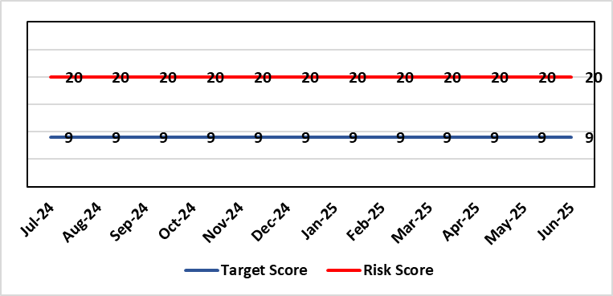 |  | Rationale for current score:  6 FACET survey  Estates Strategy and Development control plans  General compliance with fire regulations and WHTM/WHBN requirements.  Backlog maintenance  Health Board estates strategy and DCP task and finish group  Audit and Assurance limited assurance report  Access to funding  Ability to respond effectively to key HB initiatives such as the centralisation of medical records and the need to support mental health services and primary and community care services.
Level of Control  = 40% |  |  | Rationale for target score:  Through the 6 FACET survey a number of key items have been identified covering the Physical condition, Functional suitability, Space utilisation, Quality audit, Statutory compliance and Environmental management. All of which identified significant issues with the current estate, with very few areas achieving condition ‘B’. The overall backlog maintenance is in excess of £200m. The development of a plan to improve the capabilities of Operational Estates will allow a more proactive approach to risk mitigation.
Date added to the SBU HB risk register
07/02/2024
Controls (What are we currently doing about the risk?) |  |  | Mitigating actions (What more should we do?)
- Planned preventative maintenance, prioritising highest risk depending on funding available (EFAB Year 2, Targeted Estate Fund 25/27 (TEF), Discretionary) – linked to creation of decant space through service changes  - Planned preventative maintenance. Update Asset Register and review of all PPMs to ensure that these remain relevant and a good use of available resource  - Reactive maintenance.  - Address issues where practicable through EFAB/Discretionary capital  - Estates Strategy and development control plans task and finish group  - Regular reviews of the estate with reference to benchmarked best practice from NHS Wales/NHS England.  Further Developing Arrangements:  - Review 6 Facet conclusions with Oakleaf Consulting Ltd with reference to Operational Estates site knowledge and updated Asset Register, with a focus on the patient journey and patient safety.  - Develop partnership approach to working with Capital Planning to ensure that capital schemes are better informed of risks from an Operational Estates perspective.  - Develop Workforce Plan with HR/OD to address disproportionately high numbers of ‘retire and returns’ and loss of considerable experience, which is increasing in frequency.  - Review and make recommendations on structure of Operational Estates and investment plans, which will need to be cost neutral as far as reasonably possible.  - Continual review of the overall backlog maintenance and the risk to business continuity and where new risks are identified, re-prioritise to minimise impact on business continuity. |  |  | Action |  | Lead | Deadline
 |  |  | Maintain effective engagement with Welsh Government to provide funding to implement estates strategy and development control plans to address all areas outlined. |  | Assistant Director of Capital Planning | Achieved (TEF as below).  Engagement will remain ongoing
 |  |  | Work with Welsh Government (WG) to source alternative solutions to funding the HB estates strategy and development control plans i.e. Private Financial Investment (PFI) - Mutual Investment Model (MIM) or other investment sources. |  | Assistant Director of Capital Planning | Work with WG will remain ongoing
 |  |  | Review capacity and capability of Operational Estates and make recommendations on cost neutral investment in a longer-term plan to improve effectiveness. |  | Assistant Director of Estates | 30 September 2025  Plans are on track with the estates review.
 |  |  | Update Asset Register, review PPMs, and implement SFG20 (industry standard compliance management) to enhance approach to ensuring viability of core infrastructure and provide assurance on business continuity. Deadline dates to be reviewed 01/09/25 as progress varies by objective: SFG20 purchased; Asset register update currently cost prohibitive |  | Assistant Director of Estates | 30 September 2025
Assurances (How do we know if the things we are doing are having an impact?)  - Monitoring through quality & Safety, Audit & Assurance and Performance and Finance committee to receive assurance and or identify gaps for key compliance and adherence to applicable legislation.  - NWSSP internal audits  - Site visits/tours to identify compliance and gaps in compliances with NWSSP Shared Services  - Completion of FRA’s within targeted schedule  - Estates strategy and development control plans being implemented  - Half yearly Board oversight of strategy implementation. Consider appointment of Independent Member to support review of Operational Estates to provide advice to Officers and assurance to the Board on the range of proposed improvements.  Further Developing Arrangements:  - Complete review of capacity and capability of Operational Estates, which commenced in December 2024, and make recommendations on a way forward for improved effectiveness of resource utilisation and enhanced resilience.  - Complete review of Approve Persons and how duties are quality assured. This to also include action to address current gaps, i.e. AE Lifts and AE Pressure Vessels  - Continual review of the overall backlog maintenance and the risk to business continuity and where new risks are identified, re-prioritise to minimise impact on business continuity. |  |  | Gaps in assurance (What additional assurances should we seek?)  - Suitable funding to implement the estates strategy and development control plans and sufficient resource to ensure that Operational Estates is capable and competent with regard to critical risk mitigation. This will need to be planned and implemented iteratively over the longer term, say 5 to 10 years, etc.  - Allocate funds where available to address issues outlined  - Detailed work and level of resourcing available for supporting same to be commissioned to consider primary and community estates strategy along with mental health services
Additional Comments / Progress Notes
Through the 6 FACET survey a number of key items have been identified covering the Physical condition, Functional suitability, Space utilisation, Quality audit, Statutory compliance and Environmental management. The benefits of the 6 FACET survey will be enhanced through more detailed review of assets through updating the HB’s critical infrastructure asset register. All of which identified significant issues with the current estate, with very few areas achieving condition ‘B’. The overall backlog maintenance is in excess of £200m.
Key areas include ventilation and cooling with major infection control and other implications. Theatres/Wards/ED and general acute settings including mental health and learning disabilities being old and not compliant with the latest WHBN’s and WHTM’s. The heating, power and medical gas systems have also been identified as issues for concern in the 6 FACET surveys and from independent audits. The health board’s latest NWSSP estates audit received a limited assurance due to limited Welsh Government funding available to undertake backlog maintenance and implementation of estates strategy.
09/05/2025: Actions completed: Work with Welsh Government to source alternative solutions to funding the HB estates strategy and development control plans - TEF bids were successful with £16.3m funding agreed for 2025/26 & 2026/27. Health Board capital prioritisation submitted in May 2024 – WG approved 3 schemes to progress with business cases in Q4 2024/25: Emergency Department, OR1 Theatre NPTH, and Hybrid Theatre, Morriston Hospital.
Programme of works for approved TEF funding in place for next 2 years. AHU works commenced April 2025 at Singleton Hospital. Due to the scale of the backlog maintenance, there is no change in the overall risk score.
09/07/2025: TEF works continue to be rolled out over 2025/26 & 2026/27 covering, Infrastructure, Fire, IP&C, Decarbonisation, Decontamination and Mental Health &LD. This in in parallel with priority works identified by estates based on risk to coordinate works overall programme. Overall risk score remains the same.

Datix ID Number: TBC  Health Care Standards: |  |  | HBR Ref Number: 99  Target Risk Date: See Rationale |  | Current Risk Rating  5 x 4 = 20
Objective: People of Swansea Bay live healthier, equitable and more equal and prosperous lives |  | BAF Ref: 1 | Director Lead: Gillian Richardson, Interim Director of Public Health  Assuring Committee: Population Health Committee
Risk: Failure to implement the population health strategy approaches at the required scale.  Risk arises if there is a failure of the organisation to understand and act on the provisions of the strategy, develop a strategic population health plan to enable a whole system response; and the consequent lack of systems and processes to support the delivery of population health improvements.  Currently identified contributors to this risk include the absence of an agreed methodology, strategic health board plan and the tactical level planning, design and delivery of cross-cutting programmes within a federated operational delivery system; lack of systematic review and capture of population health contributions of existing services; limited executive ownership to enable adoption of a population health focus at service and corporate level; a limited focus on prevention; and a clearly defined approach to partnership working to tackle the wider determinants that affect the population’s health and how the Health Board might contribute to addressing these. The consequences for not addressing this risk are that the health board is missing opportunities to prevent worsening health in our population. The likelihood of health inequalities widening through non adoption of population health approaches is significant. . |  |  | Date last reviewed: Jun 2025
Risk Rating  (consequence x likelihood):  Initial: 5 x 5 = 25  Current: 5 x 4 = 20  Target: 4 x 2 = 8 | 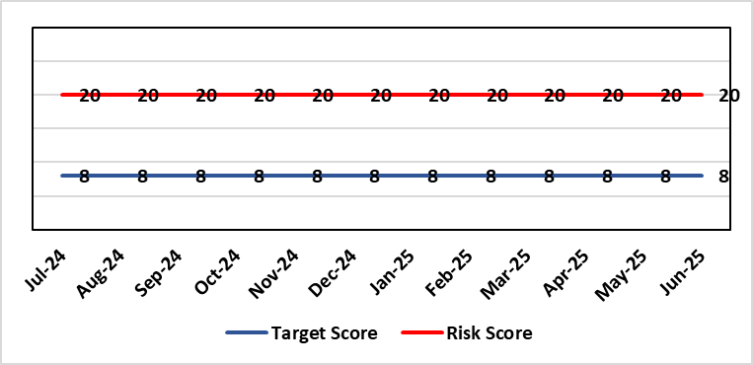 |  | Rationale for current score:  Within SBUHB there is a limited but increasing focus on prevention.  The 2025/26 Welsh Government NHS Planning framework now includes explicit requirements around prevention and population health that the health board wasn’t able to fully meet in the development of the 25/26 plan.  Developing a transformative approach to how we conduct our business is dependent upon the ability of SBUHB to: better understand our population’s needs and address them; focus on actions which foster and maintain health and wellbeing; incorporate prevention, public & population health principles into the design of new and existing services that tackle inequities; and develop robust partnerships that tackle the wider determinants of health that ultimately drive demand for healthcare.  Currently there is a lack of capacity and capability in the wider organisation to create the conditions to enable delivery of this transformation agenda. This is in part being driven by the financial climate and political focus on key targeted intervention areas.
Date added to the SBU HB risk register  14/03/24 |  |  | Rationale for target score:  The consequences for not addressing this risk are that for the population opportunities are being missed for early intervention and prevention of conditions in the population that increase the likelihood of worse health outcomes and increased inequity. Given the system wide changes required to mitigate this risk achievement of this target has to be a long-term consideration.  Target Risk Date will be reviewed as part of gateway checkpoint on risk/actions.
Controls (What are we currently doing about the risk?) |  |  | Mitigating actions (What more should we do?)
- Population Health Strategy adopted by SBUHB Board 30/03/23.  - Population Health Strategy aligned to organisational strategic objective 1. Population health integrated into planning infrastructure through R&S plan 24/25 process.  - Population Health and Partnerships Committee and Population Health & Commissioning Management Board established as governance mechanisms for Population Health.  - Mandate through governance to progress on key strategic workstreams:  - Capability & Capacity building  - Anchor Institution baselining  - Anti-poverty  - Strategic Indicators for Population Health  - Repurposing SBUHB financial resource to support population health  - Behavioural change resource identified and procurement process underway to develop behavioural change framework for SBUHB to develop capability and capacity in support of required cultural change.  - Health Intelligence resource needed to lead organisational work to build health intelligence infrastructure has been scoped and identified.  - Local population health actions and measures in development with SDGs for 2025/26, building on work to date, and will be reported quarterly.  - Annual plan population health actions/deliverables to be reported through Annual Plan Oversight Group (APOG) by service group.  - Population Health reserves for 2024/25 confirmed at £250k with delegation through Executive Director of Public Health.  - Supporting SDG development of SBUHB 25/26 IMTP with corporate partners.  - Internal Audit of Population Health Strategy supporting organisational wide action to implement the PHS  - Preventative approaches to care being developed and delivered across SBUHB clusters, including:  - New model of community psychology across 2 clusters looking to enhance prevention and early intervention.  - RPB Emotional Wellbeing and Mental Health Strategy 2023/33, delivering upstream prevention by provision of better support in the community.  - Universal & targets falls prevention.  - Lifestyle Medicine & Weight Management including Diabetes:  - Dedicated cluster projects (Cardio vascular disease, Healthy weight interventions, Non-Fatty Liver Disease)  - GMS & Diabetes education programme  - All-Wales Diabetes Prevention Programme tackling modifiable risk factors to developing Type 2 Diabetes through weight management interventions – Programme is now delivered in 8 clusters.  - Pre-diabetes approach and delivery of All Wales Diabetes Prevention Programme  - Supporting reduction in Childhood obesity, co-produced programme development working together with Third Sector  - Promoting healthy behaviours inc. Making Every Contact Count  - City Health podiatry-led Vascular Diagnostic service  - SBUHB Women’s Health 10 Year Plan Steering Group in place prevention & public health focus for the work programme |  |  | Action | Lead |  | Deadline
 |  |  | Gateway review of progress on governance actions:  - SDG reporting changes;  - Implementation of Population Health Strategy Audit recommendations | Executive Director of Public Health / Director of Corporate Governance (support)  Executive Director of Public Health / Service Group Leads |  | 30/06/2025  31/03/2026
 |  |  | Development of joint work programme for improved health intelligence as part of supporting the implementation of the Digital Strategy | Executive Director of Public Health / Director of Digital |  | Areas scoped. Development of programme initiated.
Assurances (How do we know if the things we are doing are having an impact?)  Progress on 2025/26 Population health priorities in the annual plan (weight management & tobacco control pathways) through utilising a One Bay Way approach and agreement to be reported through APOG.  Population Health Internal Audit has been undertaken Jan 2025. Audit review recommendations focused on the public health team supporting the organisation by outlining the methodology and priority areas for focus to support population health strategy implementation at scale. The SDGs will be required to develop action plans in line with the priorities.  The revised performance reporting arrangements within the Health Board will support monitoring of the actions plans arising from the internal audit.  An approach to ‘earth’ the population health strategy has been presented to executives and the Population Health Committee. Adoption of the CORE20PLUS5 methodology will provide a specific focus for targeted impact across 5 key conditions but is yet to be widely adopted. The Public Health Team are doing some work to identify the areas that public health should lead, the governance arrangements are being established through the Population Health Committee to better support executive ownership of the agenda. CORE20PLUS5 has also been presented to the Executive Team. Population health dashboard & outline strategic indicators have been developed, these will need to be revised and refined in line with CORE20PLUS5 rollout. |  |  | Gaps in assurance (What additional assurances should we seek?)  The performance reporting arrangements for the Health Board have been revised (Apr 25) and now take place monthly.  Need for consistent engagement from all SDGs to enable progress to be made.  No mechanism to develop approaches which sit across more than one SDG or which are not directly related to SDG responsibilities.  Available data are fragmented due to federated operational delivery structures in support of population health.  Service delivery remains the primary focus of the health board. Developing partnership agenda but limited focus on prevention and the wider determinants that drive health & wellbeing.  Population Health Audit: Population health priorities identified by the Public Health Team and Service Groups - plans need to be developed including outcomes, measures linked to priorities and strategic objectives.
Additional Comments / Progress Notes
Given the complexity of the requirements to enable system change at scale the implementation of the population health strategy the organisational journey to becoming population health focused and competent has to be viewed as a long-term objective.
14/04/2025: Actions complete: Capability and capacity review and development work; Systems working capability development programme – 2-year programme has been scoped, identified priority: locally accessible and affordable food, joint PSB (Public Services Board) & shaping places programme alignment, contribution towards Regional Health Economy developing work programme. The Population Health Committee has been newly formed and governance arrangements to support implementation of population health approaches have been revised. The Public Health Team are planning to utilise CORE20PLUS5 methodology to ‘earth’ the population health strategy and define the public health priorities for the organisation. The revised governance arrangements include closer working across our clusters through the Pan Cluster Planning Group.

Datix ID Number: TBC  Health & Care Standards: |  |  | HBR Ref Number: 100  Target Risk Date: 31/09/2025 | Current Risk Rating  4 x 3 = 12
Objective: People of Swansea Bay live healthier, equitable and more equal and prosperous lives |  | BAF Ref: 1 | Director Lead: Marie Davies, Executive Director of Planning & Partnerships  Assuring Committee: Population Health Committee
Risk: A lack of a robust approach to partnerships & collaboration  If the health board does not have effective structures, processes and working relationships with its external partners at the Public Services Board (PSB) and/or Regional Partnerships Board (RPB), there is a risk that areas of work dependent upon collaboration with partners may not deliver what is required in a timely way, impacting on the delivery of health board priorities. |  |  | Date last reviewed: Jun 2025
Risk Rating  (consequence x likelihood):  Initial: 4 x 3 = 12  Current: 4 x 3 = 12  Target: 4 x 2 = 8 | 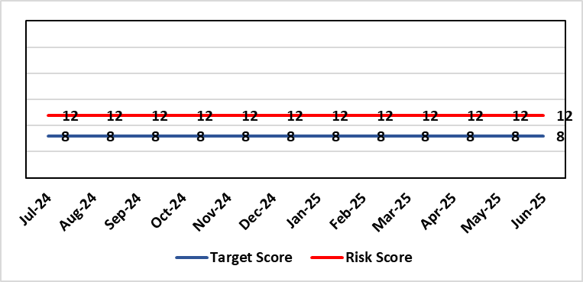 |  | Rationale for current score:  Currently the likelihood of non-delivery of partnership priorities that meet expectations is possible.
Level of Control  = % |  |  | Rationale for target score:  The occurrence of non-delivery of partnership priorities will reduce with an improved partnership approach within the Health Board, although given the complex nature of partnership working it is unlikely to completely eradicate the risk.
Date added to the SBU HB risk register
29/05/2024
Controls (What are we currently doing about the risk?) |  |  | Mitigating actions (What more should we do?)
- Senior Health Board leadership is now embedded across the West Glamorgan Regional Partnerships Board (WGRPB) governance to improve visibility and decision making, and the internal Strategic Partnerships Group and the Population Health & Partnerships Committee – both established in 2023, provide oversight for external partnerships.  - Collaborative Partnerships Framework has been agreed by SBUHB Management Board, setting out a Health Board approach to Partnerships.  - The Annual Plan 2025/26 outlines clear priorities for working with PSB and RPB Board and governance and leadership arrangements have been strengthened to support delivery  - The Director of Planning & Partnerships and the Chief Operating Officer meet weekly with Directors of Social Services and are continuing to align work programmes and develop trusted relationships. Two key areas of work that are being integrated/closely aligned are: 6 Goals programme to be integrated into RPB governance and RPB Emotional Wellbeing & Mental Health programme will be aligned through governance and reporting structures. |  |  | SB) | Lead | Deadline
 |  |  | Further work to be developed in relation to children & young people services. This will be considered as part of the Health Boards work on the CYP strategic plan. | Executive Director of Planning and Partnerships | 30/09/2025
Assurances (How do we know if the things we are doing are having an impact?)  Strategic Partnerships Group (SPG) established in October 2023 will provide oversight of partnership discussions, including the WGRPB and the Public Service Boards (PSB).  Regular updates and assurance will be provided to Health Board via the Dir of Planning and Partnerships Board report. |  |  | Gaps in assurance (What additional assurances should we seek?)
Additional Comments / Progress Notes
08/05/2025: Action Completed: Alignment of Partnership priorities with the Health Board IMTP. The Annual Plan 2015/26 outlines clear priorities for working with PSB and RPB Board and governance and leadership arrangements strengthened to support delivery.
12/06/2025: No change

Datix ID Number: 443  Health & Care Standard: Effective Care 3.1 Clinically Effective Care |  |  | HBR Ref Number: 104  Risk Target Date: 31/03/2027 |  | Current Risk Rating  4 x 5 = 20
Objective: Care is delivered in safe and appropriate settings supported by innovative digital solutions |  | BAF ref: | Director Lead: Matt John, Director of Digital  Assuring Committee: Digital Data & Innovation Committee  For information: Quality & Safety Committee
Risk: Failure to meet Tier 1 targets in Clinical Coding Completeness  Because: The volume of new inpatient episodes exceeds the available clinical coding staff capacity; There are difficulties recruiting and retaining a sufficient number of trained clinical coding staff to address the gap, and; Clinical information is not always of sufficient quality or completeness electronically (such as DALs) to support swift coding.  There is a risk that: Clinical notes for inpatient episodes will not be coded in a timely way.  Resulting in: The non-achievement of the Tier 1 Welsh Government target (which is that 95% of inpatient activity should be coded within 30-days of discharge); Insufficient coded data to support effective service planning for population health needs; Inadequate data being available for mortality review/quality and safety purposes, with increased risk of failure to spot variance that are negatively impacting levels of patient care and potentially causing avoidable deaths; Negative impact on accuracy of analysis to understand how resources are being allocated and used at Health Board level and national level (programme budgeting); Delays in claiming casemix sensitive contract lines with JCC, Hywel Da and Cwm Taff (circa 70m per annum value in total) due to lack of coding data. |  |  | Date last reviewed: Jun 2025
Risk Rating  (consequence x likelihood):  Initial: 3 x 4 = 12  Current: 4 x 5 = 20  Target: 4 x 3 =12 | 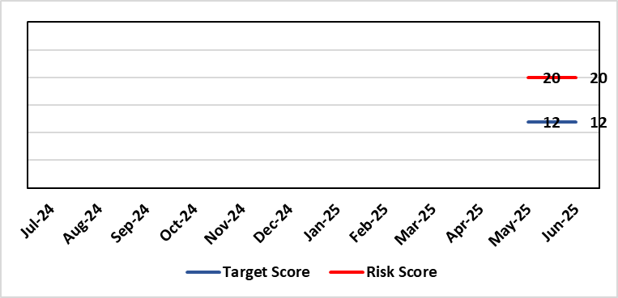 |  | Rationale for current score:  C - Insufficient coding data will negatively impact service planning for population health needs and inadequate data being available for mortality review/quality and safety purposes. This could result in failures at spotting patterns of variance that are negatively impacting levels of patient care and potentially causing avoidable deaths.  Clinically coded activity is also used to understand how resources are being allocated and used at Health Board level and national level (programme budgeting), and therefore a reduction in coding completeness will impact on the accuracy of this analysis. It is also used to claim casemix sensitive contract lines with JCC, Hywel Da and Cwm Taff of circa 70m per annum with lack of coding data impacting on the timeliness in making these claims.  L - Tier 1 target is currently not being met on a regular basis.
Level of Control  = |  |  | Rationale for target score:  C - Insufficient coding data will negatively impact service planning for population health needs and inadequate data being available for mortality review/quality and safety purposes. This could result in failures at spotting patterns of variance that are negatively impacting levels of patient care and potentially causing avoidable deaths.  Clinically coded activity is also used to understand how resources are being allocated and used at Health Board level and national level (programme budgeting), and therefore a reduction in coding completeness will impact on the accuracy of this analysis. It is also used to claim casemix sensitive contract lines with JCC, Hywel Da and Cwm Taff of circa 70m per annum with lack of coding data impacting on the timeliness in making these claims.  L – Increase in what can be coded electronically, unit centralisation, greater staff retention and the development of an auto-coding model will lead to increased capacity and a reduction in likelihood for targets not being met.
Date added to the SBU HB risk register
18/06/2025
Controls (What are we currently doing about the risk?) |  |  | Mitigating actions (What more should we do?)
- A three-year coding modernisation plan has been approved by executive board on 26th February 2025. This plan will see the implementation of an auto-coding solution and a re-banding of the clinical coding department within existing budgets to attain Tier 1 targets by 27/28.  - The coding management team assess the staffing complement on a daily basis to ensure resources are deployed in the most efficient and effective manner, in line with demand and clinical coding priorities.  - There is a comprehensive training programme in place for new Trainee Coders.  - The Clinical Coding Departments raise incidents when clinical information is missing from the patient’s health records and prevents the activity being coded in a timely manner. These incidents are highlighted at the Directorate Business Meetings held on a monthly basis as part of the Clinical Coding Key Performance Indicators.  - Clinical coding staff performance continues to be monitored and discussed during the monthly Clinical Coding Managers Meetings, which are chaired by the Head of Health Records & Clinical Coding and an update is also reported and presented on the Health Board Performance Scorecard.  - An App has been developed by Digital Intelligence that shows any relevant data relating to a patient episode from different systems including Signal, TOMs, EPOA and DAL in one place. This will reduce the number of systems a clinical coder needs to log into. |  |  | Action | Lead |  | Deadline
 |  |  | Completion of all Actions on Audit Action Plan | Head of Digital Intelligence Programmes |  | 31/10/2025
 |  |  | Auto-coding model in production for two specialties | Head of Digital Intelligence Programmes |  | 30/09/2025
 |  |  | Organisational Change Process for re-banding of clinical coding department completed | Head of Health Records & Clinical Coding |  | 30/09/2025
 |  |  | Centralising of coding department leading to efficiencies | Head of Health Records & Clinical Coding |  | 31/10/2025
Assurances (How do we know if the things we are doing are having an impact?)  - Attainment of the Tier 1 Health Board target for clinical coding completeness which relies on the timely availability and quality of the paper record and electronic sources. Coding 95% of in-patient activity within 30 days of discharge is a tier 1 Welsh Government target that is currently not being achieved regularly within SBU – with an average of circa 74% for 24/25. Performance is reported to Digital Business Meeting every 3 months, and to Digital, Data, Research & Innovations Committee via a Coding Paper.  - Episodes are coded from paper and electronic sources; the ability to code from electronic sources improves the timeliness & accuracy; approximately 52,000 episodes of 150,000 episodes are coded from electronic sources currently. This is reported to Digital Business Meeting every 3 months, and to Digital, Data, Research & Innovations Committee via a Coding Paper.  - An Audit has been carried out by NHS Wales Assurance and Audit Services of the Coding Department was completed in June 2024 with a result of limited assurance. In response a twelve-point action plan was developed of which one action remains which is the escalation of the coding risk to the Health Board Risk register. |  |  | Gaps in assurance (What additional assurances should we seek?)  Investment required supporting the delivery and operational costs of the Digital strategy.  Replacing qualified coders who have left the department with trainees reduces productivity - the only mitigation against this is an auto-coding product to increase productivity and re-banding across coding department to put staff at same bandings as NHS England and help staff retention – the investment required for this is yet to be funded.  The Quality of Discharge Summary provision and standard of clinical information available at the point of coding requires improvement to assist with prompt and accurate coding.  There continues to be missing clinical information at the point of coding, preventing accurate and timely coding.
Additional Comments / Progress Notes
Supplementary Notes:
- Coding 95% of in-patient activity within 30 days of discharge is a tier 1 Welsh Government target that is currently not being achieved regularly within SBU – with an average of circa 74% for 24/25.
- Contract coders and overtime have been used to achieve that 75% average which has stopped due to the current financial situation of the Health Board.
- Retaining and recruiting qualified coding staff is a big challenge due to higher bandings in England and the availability of digitised record to allow home working.
- 6 WTE qualified coders have been lost to English Health Boards or DHCW in the last 3 years due to higher bandings with a further 2WTE retiring. This has resulted in circa 44% of the current coding WTE being trainees/unqualified. Currently, there are 5 qualified coder vacancies (June 2025).

01/07/2025: Following escalation to Health Board Risk Register only one action remains from audit report which is appointment of Service Improvement role – this will be carried out as part of re-banding OCP (Organisational Change Policy) process. The OCP process has started and re-banding on-track to be completed in September 2025.
14/07/2025: The Service improvement role will now be advertised following the conclusion of the Clinical Coding OCP which concludes end of August 2025. New completion date for the advertising of the post of October 2025

Datix ID Number: 3114  Health & Care Standard: 3.4 Information Governance and Communications Technology |  |  | HBR Ref Number: 105  Target Date: TBC |  | Current Risk Rating:  4 x 4 = 16
Objective: Care is delivered in safe and appropriate settings supported by innovative digital solutions |  | BAF Ref: | Director Lead: Chris Morrell, EDAHPHS  Supporting Director: Matt John, Director of Digital  Assuring Committee: Quality & Safety  For information: Digital, Data & Innovation
Risk: Significant increased cost for the replacement Pathology System LIMS  If the new Laboratory Information Management (LIMS) system is not live before 15th December 2025 then there will be significant more cost across NHS Wales which could impact the Health Board’s financial plans in 2025/26 and 2026/27. Costs would have to be covered to avoid pathology losing access to the current LIMS system resulting in the inability of pathology to deliver diagnostic results and blood transfusion services across all Health Board services including emergency, acute, primary and community services. |  |  | Date last reviewed: Jun 2025
Risk Rating  (consequence x likelihood):  Initial: 5 x 5 = 25  Current: 4 x 4 = 16  Target: 4 x 1 = 4 | 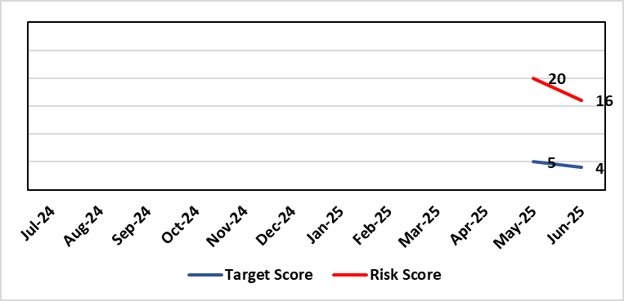 |  | Rationale for current score:  Consequence – Additional costs could be in region of approximately £1m for the Health Board depending on the length of delay  Likelihood – probable (10-50% chance currently) – due to being off-track on project and lack of confirmed back-up plan.
Level of Control  = |  |  | Rationale for target score:  Consequence as above  Likelihood will be negligible if effective system / mitigations put in place in time
Date added to the SBU HB risk register
18/06/2025
Controls (What are we currently doing about the risk?) |  |  | Mitigating actions (What more should we do?)
Working with Digital Health and Care Wales to explore how access to the current LIMS system could be extended beyond 15th December 2025  The current LIMS system is accessed through remote access software. Licenses for the remote access software end on 14th December 2025. This means from 15th December 2025 SBUHB Pathology services will not be able to access the current LIMS system through the current remote access software. Digital Health and Care Wales are underway with a procurement exercise that would either extended licenses for, or replace, the current remote access software.  Configuring and testing the new LIMS system with the aim of go-live before 15th December 2025  The new LIMS system does not require remote access software. If the Health Board can go live on the new LIMS system before 15th December 2025 the risk will not be realised. SBUHB Pathology services are working in collaboration with other Health Boards and Trusts to share configuration and testing as part of a national programme. However, there is low confidence in achieving go-lives in September (Cellular Pathology), Blood Sciences (October) and Blood Transfusion (November) given the number of issues in the system. Testing has been already extended from two months to twelve months.  Pursuing only a ‘Minimal Viable Product’ to avoid scope-creep  SBUHB Pathology Services are only seeking to pursue a safe replacement system, known as a ‘Minimal Viable Product’. This is to eliminate the possibility of testing timescales being extended. Other Health Boards and Trusts report they are following the same approach.  Challenging the supplier and Digital Health and Care Wales for their technical delivery  The supplier is responsible for addressing any defects identified during testing. Digital Health and Care Wales (DHCW) are responsible for delivering some of the technical integrations (in addition to co-ordinating the national programme). The SBUHB Project Team, through the programme governance, challenge the supplier and DHCW to deliver on their commitments. |  |  | Action | Lead |  | Deadline
 |  |  | Blood Transfusion is the last pathology discipline to go live (November) and is consequently most at risk from access being lost from 15th December 2025. Explore how the Blood Transfusion Module of the current LIMS could potentially be accessed without the need for remote access software. | Head of Laboratory Medicine |  | TBC
Assurances (How do we know if the things we are doing are having an impact?)  National Programme Board  SBUHB, together with all Health Boards, Trusts and the supplier belong to the national LIMS Programme Board.  The Programme Board receives updates on Digital Health and Care Wales progress towards procuring extended licenses, or a replacement of, the current remote access software.  The Programme Board receives updates on testing activities, including metrics showing the number of outstanding system issues. It is chaired by the Executive Director of Allied Health Professions and Health Science for Aneurin Bevan University Health Board.  SBUHB Project Team  A Project Manager is in place to manage the SBUHB Project Team on daily basis.  Operational Delivery Network LIMS 2.0 Sub-Group  SBUHB work in regional partnership with Hywel Dda University Health Board (HDUHB) and hold a joint, monthly Operational Delivery Network LIMS 2.0 Sub-Group, which receives reports from the SBUHB and HDUHB Project Managers, along with Programme Managers from the supplier and Digital Health and Care Wales.  This group is jointly chaired by the SBUHB Clinical Lead for Laboratory Medicine and HDUHB Head of Pathology Service, who are also Senior Responsible Officers for the SBUHB and HDUHB projects.  Morriston Management Board  The SBUHB project regularly reports progress to the Morriston Management Board.  Digital, Data, Research and Innovation Committee  The SBUHB project regularly reports progress to the Digital, Data, Research and Innovation Committee. |  |  | Gaps in assurance (What additional assurances should we seek?)  The national programme team have stated that engagement on costs will initiated with Directors of Finance by the DHCW Director of Finance. SBUHB should seek assurance on minimising and meeting the costs of the proposed mitigation and backup plans:  Meeting the costs of mitigation  The SBUHB go-live date had been planned for June 2025, but a proposed ‘mitigation plan’ put forward by the national programme team seeks both to extend testing timescales and extend licensing for the current LIMS (otherwise due to expire in June 2025) while still achieving go-live before 15th December 2025. It also re-profiles non-SBUHB Blood Transfusion activities into Q1 2025/26. The national programme estimate the cost across Wales at £1.6m for the initial extension that has already been agreed.  Meeting the costs of the backup plan  If a go-live before 15th December 2025 is not achieved, a backup plan has been proposed by the national programme team which would extend both access to the current LIMS system and the programme to implement the new LIMS system.  The national programme estimate the cost across Wales between £7.2m (for 3 months) and £12.3m (for 12 months).  A significant proportion of these costs are associated with the remote access software. If the procurement exercise by Digital Health and Care Wales to source an extension or replacement of the remote access software is unsuccessful, then the current supplier is only willing to extending licenses for a minimum of 3 years at a cost of around £5m.
Additional Comments / Progress Notes
User Acceptance Testing sign-off
User Acceptance Testing across Wales was originally expected to take place across the two months of September and October 2024. However, a significant number of issues in the system, coupled with partial delivery of integrations between the LIMS and national systems managed by Digital Health and Care Wales, were identified early in the process. Maintaining the availability of Pathology staff to undertake testing across an extended duration, alongside maintaining service delivery, has also been challenging.

User Acceptance Testing has been extended to, depending on the pathology discipline, around twelve months. Go-lives have not been delayed by the same amount and the decreased duration between the end of User Acceptance Testing and go-live puts additional pressure on the project:
 | Previously | Currently
Duration of User Acceptance Testing | 2 months | 12 months
Duration between User Acceptance Testing sign-off and go-live | 3 months | 1 month

Business Continuity
The Health Board’s current Business Continuity Plan to address a failure in digital pathology systems is to revert back to paper based reporting, which is unsustainable and would only be effective over a very short-term period (days).

Blood Transfusion services in other part of Wales
SBUHB Blood Transfusion are the only Blood Transfusion service in Wales that have successfully migrated onto the current LIMS system. Other Blood Transfusion services use other legacy systems and will potentially be impacted after the 15th December 2025 in other ways (e.g. by having to extend support for their existing legacy systems).

Pathology resource for testing
Testing is reliant on the knowledge and skills of Health Board staff whose availability is limited, having to manage testing alongside normal service delivery. With a national shortage of Biomedical Scientists, there is no readily available external resource to support this process.

Risk Score Calculation

For each risk identified, the LIKELIHOOD & CONSEQUENCE mechanism will be utilised. Essentially this examines each of the risks and attempts to assess the likelihood of the event occurring (PROBABILITY) and the effect it could have on the Health Board (IMPACT). This process ensures that the Health Board will be focusing on those risks which require immediate attention rather than spending time on areas which are, relatively, a lower priority.

This indicates whether there has been an increase / decrease in risk score since the previous month’s HBRR.

