Meeting Date | 31 July 2025 |  | Agenda Item |  |  | 3.2
Name of Meeting | Special Health Board
Report Title | Screening uptake in Swansea Bay
Report Author | Kimberley Cann, Consultant in Public Health
Report Sponsor | Gill Richardson, Executive Director of Public Health
Presented by | Gill Richardson, Executive Director of Public Health
Freedom of Information | Open
Purpose of the Report | This paper summarises the status of uptake of screening programmes in Swansea Bay as the basis for plans to reduce disparities in our population.
Key Issues | Population screening is a key way to prevent important conditions and diseases such as cancer. Inequalities in uptake of screening also contribute to inequalities in the health and outcomes of the population of Swansea Bay. There is wide variation in uptake/coverage of screening programmes across Wales and within Swansea Bay.
Specific Action Required  (please choose one only) | Information | Discussion |  | Assurance | Approval
Specific Action Required  (please choose one only) | ☒ | ☐ |  | ☒ | ☐
Recommendations | Members are asked to:  - RECEIVE a report on the current status of screening uptake in Swansea Bay with a specific focus on equity issues.  - ENDORSE the development of an effective plan to reduce disparities in screening uptake in Swansea Bay.  - AGREE to updates, on progress, to be presented to the Population Health Committee of the Board.

SCREENING UPTAKE IN SWANSEA BAY

- INTRODUCTION
Cancer is the leading cause of death in Wales. Wales has the second highest cancer mortality in the UK and the UK has one of the highest cancer mortality rates of all Organisation for Economic Co-operation and Development (OECD) countries. It is estimated that 4 in 10 cancer cases in Wales could be prevented. Mortality rates are significantly worse for people living in deprived areas and the gap between the most and least deprived is growing. A recent report by Public Health Wales (PHW) shows that only 52% of people from the most deprived areas in Wales are surviving to 5 years compared to 70% of people from the least deprived areas.

In January 2025, Audit Wales published a review of the strategic approach to improving the timeliness of cancer diagnosis and treatment by services in Wales. It highlighted that 24% of cancer patients were diagnosed at stage 4 and 18% at stage 3 in 2021. Survival decreases as stage advances for all cancer types and screening plays a vital role in early detection. Recommendations from the report include developing a more coherent national approach to population health improvement and harnessing opportunities associated with prevention to reduce the incidence of cancer. It also focuses on improving data and digital and ensuring accurate information on equity of access, such as ethnicity, as well as experiences of different patient groups.

PHW recently linked cancer data to Census data for the first time to enable a more granular snapshot of the socio-demographic profile of people diagnosed with cancer in Wales. They found that female breast cancer incidence was higher in those with Asian ethnicity and those with Mixed ethnicity had the highest proportion of cancers diagnosed at stage 4. People living in overcrowded accommodation had a cancer incidence seven times higher than those living with two or more spare rooms (after adjusting for age). Those living in social housing had a cancer incidence nearly three times higher than those who owned their home outright.

Screening aims to identify apparently healthy people who may be at increased risk of a disease or condition. This means that they can be offered early treatment or information to help them make informed decisions. Inequalities in screening uptake can contribute to widening inequalities in morbidity and mortality in the population. There are seven national population-based screening programmes in Wales, six of which are delivered by Public Health Wales with Antenatal screening delivered by the Health Boards.

The Swansea Bay Public Health Team are working collaboratively with Public Health Wales Screening Engagement Team to develop an action plan to address disparities in screening uptake locally. This includes exploring if the successful work of the Vaccine Equity Team in Swansea Bay can be adapted for screening.

- BACKGROUND
2.1 Bowel cancer screening
- Bowel screening aims to find bowel cancer at an early stage when treatment is likely to be more effective. At least 9 out of 10 people will survive bowel cancer if it is found and treated early.
- People aged between 50 and 74 years who live in Wales are invited to take the test every 2 years. The test kit can be completed at home.
- In 2022-23, around 32,000 people in Swansea Bay completed their screening test – an uptake of 65.0%. This was the lowest uptake of any Health Board in Wales, though unlikely to be statistically significantly different.

Health Board | Responded | Uptake
Aneurin Bevan UHB | 51,480 | 66.2%
Betsi Cadwaladr UHB | 63,527 | 65.9%
Cardiff and Vale UHB | 36,269 | 65.4%
Cwm Taf Morgannwg UHB | 37,468 | 65.3%
Hywel Dda UHB | 37,935 | 66.9%
Powys Teaching HB | 14,183 | 67.7%
Swansea Bay UHB | 31,975 | 65.0%
Unknown | 91 | 61.9%
All Wales | 272,928 | 65.9%

- There is inequality in uptake by deprivation, with 72.3% of those living in the least deprived areas of Swansea Bay taking up screening compared to only 56.9% of those in the most deprived areas.

Figure 1: Bowel screening uptake by deprivation quintile and health board of residence, 2022-23
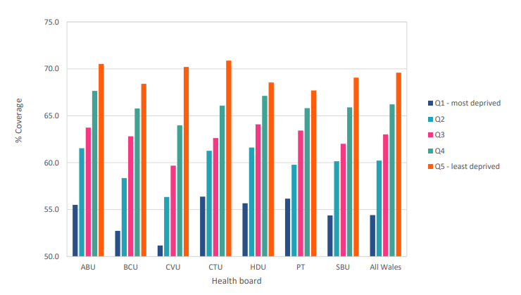

- City Health and Penderi primary care clusters have some of the lowest uptake rates of primary care clusters in Wales (55.5% and 60.9% respectively compared to 65.5% for Wales as a whole in 2023-24) and are in the lowest 20% of Welsh clusters for uptake.
- Uptake of bowel screening also varies by age and is lowest in younger age groups. The inequality gap in uptake between different age groups was bigger in Swansea Bay than in any other Health Board in 2020/21. However, the inequality gap in uptake by gender was one of the lowest of the Health Boards.
- Unstandardised 1-year and 5-year net survival rates for bowel cancer in Swansea Bay are significantly lower than the Wales average, based on the most recent data (73.7% and 55.5% compared to 74.4% and 58.6% for Wales respectively).
- Bowel cancer 5-year survival has dropped sharply in men aged <55 years across Wales over the last 9 years (69.9% to 53.3%). A similar trend has been seen in England and Scotland.

2.2 Breast cancer screening
- Breast screening aims to find breast cancer before symptoms show. Women living in Wales aged between 50 and 70 years are invited for screening every 3 years using mammograms.
- Around 12,800 women were screened in Swansea Bay in 2021/22 – an uptake rate of 72.5%. This was the highest of the Health Boards and higher than the all-Wales average of 70.0%.
- There is a clear gradient in uptake of breast screening by deprivation across Wales and in Swansea Bay. Uptake varied from only 63.7% in the most deprived areas of Swansea Bay to 78.7% in the least deprived areas.

Figure 2: Breast screening uptake by deprivation quintile and health board of residence, 2021/22

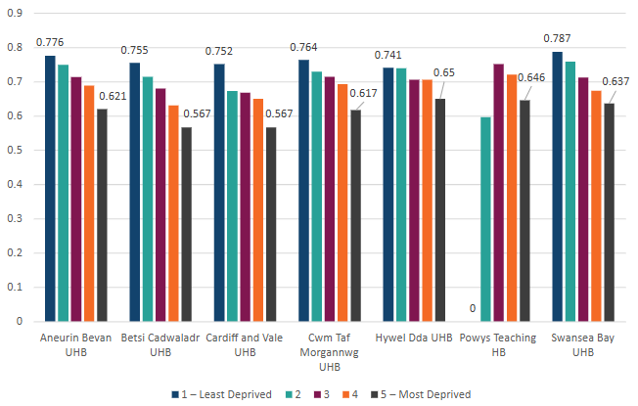

- City Health primary care cluster has one of the lowest uptake rates of clusters in Wales (65.0% compared to 72.3% for Wales as a whole, as of May 2021) and is in the lowest 10% of Welsh clusters.
- Uptake of breast screening is also lower in younger age groups (50-52 years) across Wales.
- Unstandardised 10-year net survival for breast cancer in Swansea Bay is significantly lower than the Wales average (84.5% compared to 89.1%), based on the most recent figures. However, 1-year and 5-year survival is higher than the Wales average (97.0% and 91.6% compared to 96.8% and 91.2% for Wales).
- Breast cancer survival has improved in Wales as a whole over the last 8 years. For example, 84.0% to 90.5% for age-standardised 5-year breast cancer survival.

2.3 Cervical cancer screening
- Cervical screening aims to prevent cervical cancer from developing or to pick it up at an early stage. Women and people with a cervix aged between 25 and 64 years are invited for a smear test every 5 years.
- In April 2021, coverage (proportion of those eligible who were screened) for cervical screening was 68.5% in Swansea Bay. Other Health Boards ranged from 68.3% to 72.8% coverage.

Figure 3: Cervical screening uptake by health board of residence, on 1st April 2021

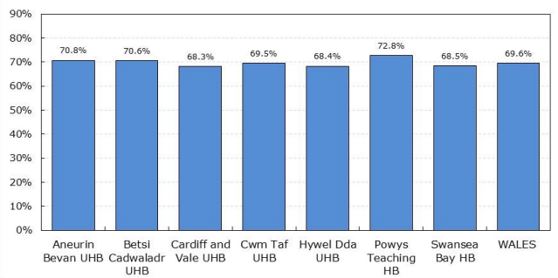

- In 2020/21 there was still a clear gradient in coverage of cervical screening by deprivation quintile in Swansea Bay and across Wales. Coverage was only 62.9% is the most deprived areas in Swansea Bay compared to 74.9% in the least deprived areas.
- City Health and Penderi primary care clusters have some of the lowest coverage rates of clusters in Wales (57.2% and 64.5% respectively compared to 68.7% for Wales as a whole in 2023-24) and are in the lowest 10% of Welsh clusters.

Figure 4: Cervical screening uptake by deprivation quintile by health board, 2021-22
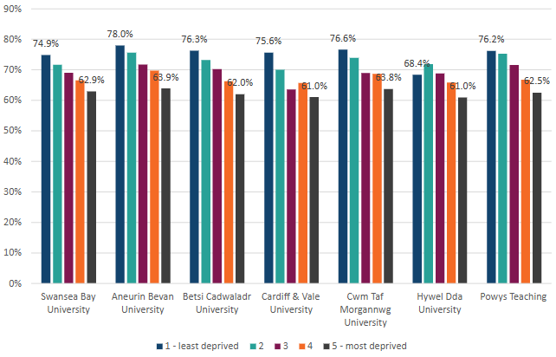

- The percentage of new referrals from cervical screening offered an appointment within 8 weeks by Swansea Bay UHB was the second highest of any Health Board (97.4%) in 2021/22. The percentage of ‘high-grade dyskaryosis or worse’, referrals offered an appointment within 4 weeks was third highest of any Health Board (97.3%).
- Unstandardised 5-year net survival rates for cervical cancer in Swansea Bay are significantly lower than the Wales average (68.2% compared to 73.1% for Wales), based on the most recent data. However, 1-year survival rates are significantly higher than the Wales average (90.3% compared to 85.9% for Wales).
- Recently, the UK National Screening Committee approved the offer of home testing kits to individuals with a cervix who haven’t taken up their invitation to be screened for 6 months or more. This may impact on figures in future.
2.4 Lung cancer screening
- Following a recommendation by the UK National Screening Committee, PHW is currently preparing a proposal for a national pathway for lung cancer screening. The full report is expected in September 2025. Draft recommendations are that lung cancer screening is delivered by Public Health Wales, but there will be impacts on a number of Health Board services by the introduction of the screening programme.
- Unstandardised 10-year and 5-year net survival for lung cancer in Swansea Bay (9.1% and 16.4%) is lower than the Wales average, based on the most recent figures (10.5% and 16.6% for Wales respectively). However, 1-year survival is higher than the Wales average (41.3% compared to 39.1% for Wales).
- Health inequalities in lung cancer survival have widened in Wales in recent years due to survival greatly improving in the least deprived areas (from 8% to 15%) but little in the most deprived areas (7% to 9%).

2.5 Abdominal aortic aneurysm (AAA) screening
- AAA screening aims to reduce the number of ruptured AAA and deaths in Wales. Mortality from AAA repair is significantly lower when performed electively than in an emergency. Up to 80% of people with ruptured AAA do not survive.
- Men aged 65 are invited to be screened by ultrasound. In 2021/22, uptake of AAA screening was 77.3% in Swansea Bay. Other Health Boards ranged from 73.4% to 82.1% coverage.
- Across Wales and in Swansea Bay, uptake of AAA screening is lowest in the most deprived areas. Only 68.6% of those living in the most deprived areas of Swansea Bay take up the offer of screening compared to 82.8% of those living in the least deprived areas.
- City Health and Penderi primary care clusters have some of the lowest uptake rates of clusters in Wales (69.2% and 73.5% respectively compared to 77.6% for Wales as a whole in 2023-24) and are in the lowest 20% of Welsh clusters.
Figure 5: AAA screening uptake by deprivation quintile by health board, 2021-22
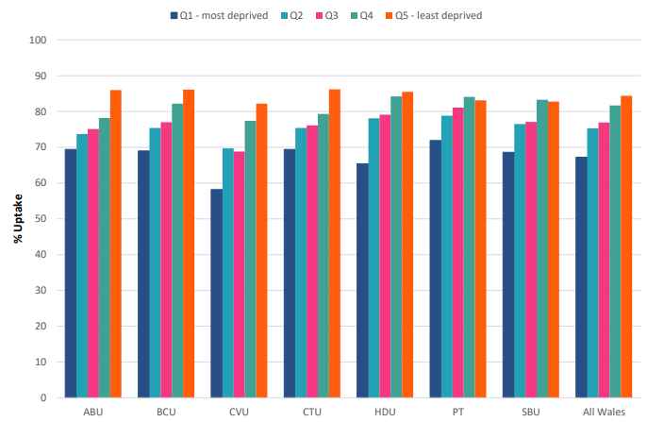
2.6 Diabetic eye screening
- Diabetic eye screening aims to detect diabetic retinopathy before symptoms show. By detecting it early the risk of permanent sight loss is reduced. Individuals who are at low risk (no signs of diabetic eye disease at the last two screens) are screened every 2 years. Those at higher risk are screened more often.
- In 2022/23, coverage of diabetic eye screening was 29.6% in Swansea Bay compared to 31.5% for Wales as a whole. Other Health Boards ranged from 25.5% to 36.1% coverage.
- There is a clear gradient in coverage of diabetic eye screening by deprivation across Wales and in Swansea Bay. Coverage varied from only 25.7% in the most deprived areas of Swansea Bay to 33.0% in the least deprived areas.

Figure 6: Diabetic eye screening coverage by deprivation quintile by health board, 2022-23
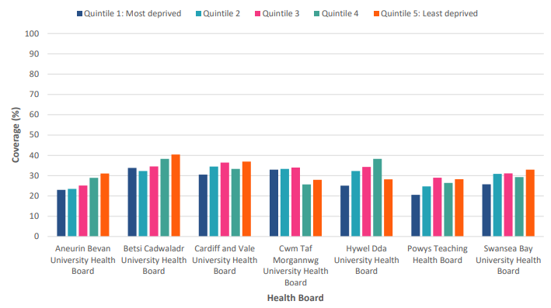
2.7 Newborn and Antenatal screening
- There are three other national screening programmes in Wales. Antenatal screening tests are offered to people who are pregnant to check their health and the health of their baby. Newborn bloodspot screening identifies babies who may have rare but serious conditions around 5 days after birth. And newborn hearing screening identifies if a baby has a hearing loss that could affect their speech and language development after birth.
- Coverage for Newborn Hearing and Newborn Bloodspot is consistently very high (99.0% and 99.6% respectively in Wales in 2021-22) and there is no variation by factors that can be measured. For Antenatal Screening, some elements of the programme are centred around enabling choice so looking at measures of uptake would not be appropriate.

2.8 Work already underway in Swansea Bay in 2025
- PHW Screening Engagement Team (SET) are engaging locally with a range of organisations such as Swansea and NPT Council for Voluntary Services (CVS), Swansea Community Connectors, and Swansea and NPT Carers services. And with community groups such as local LGBTQ+ groups, Men’s groups, Women’s groups, and to facilitate sessions on screening for those in contact with BAME groups.
- SET are engaging with the primary care clusters in NPT and Penderi in Swansea to discuss how they can support improving uptake locally. They have also met with the Women’s group in City Cluster and the social prescribers for City and Penderi clusters.
- SET attend events such as those by Western Bay Carers, local council Staff Wellbeing Days, Ageing Well, and other community events, where they engage with many private and public organisations to raise awareness of screening among different groups in the population.
- This has provided the opportunities to engage with groups who work with minority communities and people seeking asylum, and projects such as those supporting advocacy for older people, supporting young people at risk of offending and women at risk/with history of offending, and supporting people who are homeless.

2.9 Challenges to improving screening uptake
- There is often a significant time delay before uptake rates are available from PHW which makes it challenging to chart progress on increasing local uptake (the most recent data currently available for some of the programmes is 2021-22).
- While we aim to increase uptake across the whole population, there is a danger that those who are under-represented will be left further behind so there will need to be targeted actions in some areas.

2.9 Next steps
- The Public Health Team are continuing to develop at pace an effective plan to reduce disparities in cancer screening uptake in Swansea Bay. We are working with PHW’s SET and local Primary care services and exploring if the successful work of the Vaccine Equity Team in Swansea Bay can be adapted for screening.
- Examples of the successful approach taken by the Vaccine Equity Team include the work of the BAME Outreach Officer through focused engagement with BAME Mum’s groups, local mosques, and Home Educators coffee networks.
- We are also exploring whether we can pilot utilising capacity within the Immunisation Team call centre over the summer months to contact non-responders in some of our more deprived clusters with very low uptake of screening. This includes identifying non-responders in a timely way and ensuring they can be followed up to evaluate the success of the pilot. It may also present an opportunity to gain additional insight into the reasons non-responders do not take up the first offer of screening.
- The Public Health Team will also work with PHW Screening Division to improve timeliness of reporting so that interventions can be targeted and evaluated.
- A full report on Lung Cancer Screening pilot is awaited and we will work with Welsh Government and Screening Services once plans for roll out are confirmed, bringing a full report to Board in due course.

- GOVERNANCE AND RISK ISSUES
Where Immunisation Team call handlers are asked to operate outside of business as usual they will be provided with a script to follow and a clear algorithm for referral of more complex queries from non-responders.

There is a risk associated with raising awareness of screening that there will be greater uptake among groups with greater health-seeking behaviour. Targeting of hard-to-reach groups, gaining additional insight from non-responders during the calls, and evaluation of the pilot will enable us to understand if there is an impact on health inequalities.

If information on non-responders cannot be sourced in a timely way from PHW it may need to be accessed directly from the General Practices involved in the pilot. Where needed Data Sharing Agreements will be put in place to ensure compliance with GDPR.

If the intervention is successful, it will increase the number of those screened and potentially the number requiring follow up by Health Board services, for example colonoscopy. There are currently challenges around waiting times for colonoscopy within the Health Board due to staff shortages.

- FINANCIAL IMPLICATIONS
PHW National Screening Engagement team have a 2 day a week post to cover Swansea Bay UHB, and we will be working with them to direct this resource to support this work for example, through focused attempts to raise awareness of screening in deprived areas.

Their team consists of a total of 14 team members covering the 7 Health Boards in Wales, working mainly on central campaigns and prioritised themes (for example Carers are a current focus) including training and toolkits.
We believe that there is more local support that could be given.

In addition, the Population Health Strategy requires recruitment of Primary care sessional time (GP, Nurse /Pharmacy) as part of ‘Earthing the Population Health Strategy’ to support Population Health and Core 20 Plus 5 in areas of deprivation which will also give additional capacity for Screening promotion.

Subject to data sharing protocols being agreed, we propose to use call handling resource serving the immunisation function to conduct a pilot over the summer months with the aim to contact non-responders to screening invitations, in deprived areas. It is anticipated that the Team could make up to 40 calls per day to non-responders during July-August (dependent on the length of the call and any additional insight questions that are asked). The exact support we will require from PHW Screening services to identify individuals who take up screening following local intervention in order to evaluate the success of the pilot is to be discussed.

It should be noted that current capacity of the core Swansea Public Health Team is reduced due to post vacancies, and maternity leave therefore targeting of our limited resources to Core 20 Plus 5 prevention priorities (including Cancers) will be imperative especially since there are significantly fewer staff to implement preventative interventions in comparison to other Public Health Teams in Wales when bench-marked against other Health Boards.

- RECOMMENDATIONS
Members are asked to:
- Receive the report on the current status of screening uptake in Swansea Bay with a specific focus on equity issues.
- Endorse our emerging plan to enhance screening uptake in collaboration with Primary care, and to reduce disparities in uptake associated with deprivation in Swansea Bay UHB area.
- Agree to updates, on progress, to be presented to the Population Health Committee of the Board.

Governance and Assurance

Link to Enabling Objectives  (please choose) | Supporting better health and wellbeing by actively promoting and empowering people to live well in resilient communities
Link to Enabling Objectives  (please choose) | Partnerships for Improving Health and Wellbeing |  | ☐
Link to Enabling Objectives  (please choose) | Co-Production and Health Literacy |  | ☐
Link to Enabling Objectives  (please choose) | Digitally Enabled Health and Wellbeing |  | ☐
Link to Enabling Objectives  (please choose) | Deliver better care through excellent health and care services achieving the outcomes that matter most to people
Link to Enabling Objectives  (please choose) | Best Value Outcomes and High Quality Care |  | ☐
Link to Enabling Objectives  (please choose) | Partnerships for Care |  | ☐
Link to Enabling Objectives  (please choose) | Excellent Staff |  | ☐
Link to Enabling Objectives  (please choose) | Digitally Enabled Care |  | ☐
Link to Enabling Objectives  (please choose) | Outstanding Research, Innovation, Education and Learning |  | ☐
Health and Care Standards
(please choose) | Staying Healthy |  | ☒
(please choose) | Safe Care |  | ☐
(please choose) | Effective Care |  | ☐
(please choose) | Dignified Care |  | ☐
(please choose) | Timely Care |  | ☐
(please choose) | Individual Care |  | ☐
(please choose) | Staff and Resources |  | ☐
Quality, Safety and Patient Experience
Where Immunisation Team call handlers are asked to operate outside of business as usual they will be provided with a script to follow and a clear algorithm for referral of more complex queries from non-responders.
Financial Implications
None
Legal Implications (including equality and diversity assessment)
If information on non-responders cannot be sourced in a timely way from PHW it may need to accessed directly from the General Practices involved in the pilot. Where needed Data Sharing Agreements will be put in place to ensure compliance with GDPR.
Staffing Implications
Current capacity of the Core Swansea Public Health Team is reduced due to post vacancies and maternity leave therefore targeting of our resources to Core 20 Plus 5 prevention priorities (including Cancers) will be imperative.
Long Term Implications (including the impact of the Well-being of Future Generations (Wales) Act 2015)
Population screening programmes support The Well-being of Future Generations (Wales) Act 2015, 5 ways of working. In particular: Prevention – acting to prevent problems occurring or getting worse.
Report History |  | Presented to Population Health Committee on 05/06/25.
Appendices |  | None

Public Health Wales (2025). Cancer survival in Wales, 2002-2021 [accessed 06/06/25]
Audit Wales (2025) Cancer services in Wales: A review of the strategic approach to improving the timeliness of diagnosis and treatment [accessed 23/05/25]
Public Health Wales (2025). Inequalities in cancer incidence in Wales by socio-demographic characteristics, 2011-2020 [accessed 06/06/25]
Taken from Public Health Wales: Bowel Screening Wales Annual Statistical Report 2022-23 [accessed 20/05/25]
Taken from Public Health Wales: Cervical Screening Wales Annual Statistical Report 2021-22 [accessed 20/05/25]
Taken from Public Health Wales: Screening Division Inequity Report 2023 [accessed 20/05/25]
Taken from Public Health Wales: Wales Abdominal Aortic Aneurysm Screening Programme Annual Statistical Report 2022-23 [accessed 20/05/25]
Taken from Public Health Wales: Diabetic Eye Screening Wales Annual Statistical Report 2022-23 [accessed 20/05/25]

