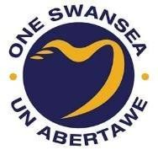
Swansea Public Services Board Annual Report 2024-25


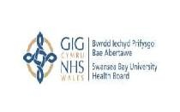
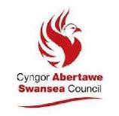

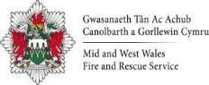

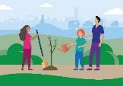

Contents

Message from Swansea Public Services Board
Our Vision and Local Well-being Objectives

The Way we Work- Governance

Swansea’s Local Well-being

Progress towards Our Local Well-being Objectives
- Early Years
- Live Well, Age Well
- Climate Change & Nature Recovery
- Strong Communities

Our Next Steps

How you can get involved?

Message from Swansea PSB

Welcome to the 2024-25 Annual Report of the Swansea Public Services Board (PSB). This has been a year of meaningful progress, stronger collaboration, and renewed focus on the outcomes that matter most to our communities.

Together, we have delivered significant improvements across all eight steps of our Well-being Plan. We have supported more families through the expansion of Flying Start, taken practical steps to embed Swansea’s Human Rights City status, and made strong progress on climate action. We’ve launched a new Cultural Strategy shaped by community voices, strengthened multi-agency community safety work, and backed an innovative co-location project to better support local people.

Our systems mapping work helped us take a step back and view the bigger picture - identifying where we can better align our actions, share data more effectively, and plan for the long term. This learning has shaped our priorities for 2025–26, including new approaches to joint workforce development, a shared regional data portal, and a coordinated effort to tackle access to food as part of a Whole System Approach to Healthy Weight.

We know there is more to do, from closing the gap in healthy life expectancy to strengthening public engagement and tackling persistent inequalities. But our direction is clear, our partnerships are strong, and our shared commitment to change is delivering results.

We hope this report provides a clear picture of what we’ve achieved together - and what comes next. It also fulfils the PSB’s duty under the Well-being of Future Generations (Wales) Act 2015 to assess and report on progress towards delivering our Well-being Plan.

Thank you to all our partners, communities, and colleagues who continue to work with passion and purpose to build a fairer, greener, safer and healthier Swansea.
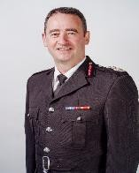


Cllr Andrea Lewis Chief Fire Officer
Roger Thomas
PSB Chair PSB Vice Chair

Our Vision and Local Well-being Objectives

In Swansea, we believe in the rights of every person. Our vision is to work together to make Swansea a place which is prosperous, where our natural environment is appreciated and maintained and where every person can have the best start in life, get a good job, live well, age well and have every opportunity to be healthy, happy, safe and the best they can be.
To achieve our vision we have prioritised our Local Well-being Objectives. We hope that by focusing our collective efforts, we can make the biggest difference by working together.

Early Years | Live Well, Age Well
To ensure that children have the best start in life to be the best they can be | To make Swansea a great place to live at every stage of life
Climate Change & Nature Recovery | Strong Communities

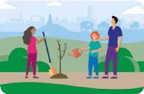

To restore and enhance biodiversity, tackle the causes, and reduce the impact of climate change | To build cohesive and resilient communities with a sense of pride and belonging

The Way We Work - Governance

The Sustainable Development Principle

Swansea PSB is committed to acting in a manner which seeks to ensure the needs of the present are met without compromising the ability of future generations to meet their own needs. We do this by ensuring every decision we make or action we take considers the sustainable development principle’s five ways of working.






Long term: The importance of balancing short-term needs with the need to safeguard the ability to also meet long-term needs.

Prevention: How to act to prevent problems occurring or getting worse may help public bodies meet their objectives.
Integration: Considering how public body’s well-being objectives may impact upon each of the well-being goals, on their other objectives, or on the objectives of other public bodies.

Collaboration: Acting in collaboration with any other person (or different parts of that body itself) that could help the body meet its well-being objectives.

Involvement: The importance of involving people with an interest in achieving the well-being goals and ensuring that those people reflect the
diversity of the area which the body services.

The National Well-being Goals
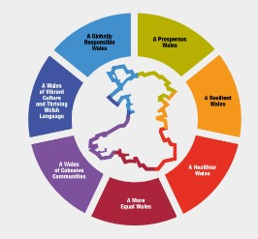
We aim to make our actions deliver as much value as possible by ensuring we look for multiple outcomes in all we do. By ensuring we think about each of the national Well-being Goals below we maximise our contribution to the Wales We Want.

How we work as a Public Services Board

Swansea PSB operates with governance arrangements that place the delivery of the Well-being Objectives at the centre of its work. These arrangements reflect the sustainable development principle and embed the five ways of working - long-term thinking, prevention, integration, collaboration, and involvement - across all activities.
PSB priorities are recognised as core business for all member organisations, not an additional layer of responsibility. This approach encourages staff at all levels to contribute to shared goals as part of their everyday work, while acknowledging the continuing challenge of working within limited resources.

The Public Services Board Structure

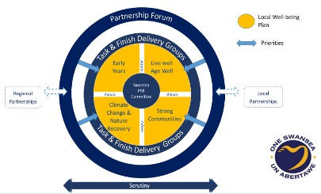

Swansea’s Local Well-being

Understanding local well-being is central to shaping effective services and delivering our shared priorities. This section summarises Swansea’s most recent position against a selection of National Indicators (NIs) published by Welsh Government, drawing comparisons with national averages and highlighting local trends.

Health and Inequality

Swansea continues to experience a significant gap in healthy life expectancy between the most and least deprived areas. For 2018–20, this gap was 19.8 years for females (Wales: 16.9) and 14.9 years for males (Wales: 13.3). Since 2011-13, the female gap has widened, while the male gap has narrowed slightly. While updated life expectancy figures are available up to 2021–23, the specific 'gap' measure has not been refreshed (NI 2).

Lifestyle behaviours remain a critical area for public health. Only 5.6% of adults in Swansea reported fewer than two healthy lifestyle behaviours, a positive figure compared to the Welsh average of 7.4% (2021–23). Swansea performs better than average on healthy weight, fruit and vegetable consumption, and physical activity, but scores less favourably on alcohol consumption and e-cigarette use (NI 3). No National Survey was conducted in 2023–24, with updated results expected in 2025.

Environment and Sustainability
Air quality has continued to improve, with average NO₂ levels falling from 12.9 µg/m³ in 2012 to 8.3 µg/m³ in 2022, though still slightly above the Wales average (7.7 µg/m³) (NI 4). These improvements support Swansea’s climate and nature recovery objectives.

Poverty and Living Conditions
In 2022–23, 13.3% of adults in Swansea experienced material deprivation - lower than the Wales average (15.5%) and down from 20.6% in 2017–18 (NI 19). This suggests improving financial resilience, though significant inequalities remain.

Community Safety and Belonging
In 2021–22, 60% of adults in Swansea reported feeling safe after dark - below the Wales average of 66% and unchanged from 2018-19 (NI 25). Community cohesion scores were also lower than average, with only 59% agreeing with all three cohesion statements (Wales: 64%). The sense of belonging was particularly low at 40% (Wales: 45%) (NI 27).

Volunteering and Loneliness
Volunteer engagement remains strong, with 29.5% of people aged 16+ reporting volunteering in 2022–23 (Wales: 29.7%), a slight increase from 2019–20 (NI 28). Reported loneliness decreased from 14.2% to 11.3% between 2021–22 and 2022–23, now below the national average (12.6%) (NI 30).

Housing and Homelessness
Homelessness prevention efforts supported 59 households per 10,000 in 2023–24, down from 67 the previous year. While this is a local decline, Swansea’s rate remains considerably higher than the Welsh average of 37 (NI 34), reflecting both the scale of need and the intensity of local response.

Looking Ahead
In 2025, the PSB will finalise a new set of population outcome measures and monitoring arrangements to strengthen how we track progress. This will build on recent systems mapping work and ensure local performance measurement aligns with national goals.
Progress is influenced by the availability and timing of data. The pause in the 2023– 24 National Survey and changes to ONS reporting (e.g. the suspension of Personal Well-being in the UK due to sample size issues) have limited updates in some areas.
Despite these challenges, Swansea is making measurable progress in key domains such as health behaviours, volunteering, and environmental quality. Persistent gaps in inequality, safety perceptions, and community cohesion remain a priority for joint action under the PSB’s Well-being Plan.

Progress towards Our Local Well-being Objectives


Step1: Early Years - To ensure that children have the best start in life to be the best they can be What was planned
The PSB committed to strengthening the Early
Years system by finalising and implementing a
regional set of Strategic Principles to drive integration, early intervention, and multiagency collaboration. A key priority was the development of a high-level, multi-agency Early Years Pathway to guide strategic planning and service design. Expansion of Flying Start services to reach more children in areas of greatest need was also central to the 2024–25 action plan, alongside improving referral processes and aligning workforce capacity across partners.

What was delivered
The regional Strategic Principles for Early Years Integration were agreed during a multi-agency workshop in December 2024 and are now informing the development of a regional work programme. These principles support closer alignment between local partners and national programmes such as the Early Years Integration Transformation (EYIT) and respond to findings from the Early Years Maturity Matrix. They are already helping to strengthen collaboration, evidenced by increased Health Visiting referrals to key services such as Sure Start and the patient-led speech and language therapy (SaLT) model.
Progress has also been made on designing a high-level Early Years Pathway. This will consolidate learning from pathfinder projects and help inform joint strategic planning across Swansea and Neath Port Talbot. A dedicated workshop in March 2025 agreed the pathway and identified service gaps, with full sign-off expected by June.
The expansion of Flying Start services has been guided by detailed analysis of Lower Super Output Area (LSOA) data on child populations and deprivation. Twelve priority LSOAs were identified, with initial expansions targeting areas such as Penderry 2, Bonymaen 1, and Castle 4. Current workforce capacity will allow around 175 additional children to benefit from the full Flying Start programme. Further expansion is planned later in 2025 as staffing levels increase. This staged approach ensures that services are targeted where need is greatest, and that workforce capacity is managed sustainably.
Through this work, Swansea continues to improve early years provision by embedding integration, targeting resources effectively, and strengthening the foundations of a whole-system approach to supporting children and families.

Step 2: Live Well, Age Well - To make Swansea a great place to live at every stage of life.
Building on Swansea’s Human Rights City Status

What was planned
The PSB committed to embedding human rights principles in public services by increasing awareness, strengthening training for frontline staff, and improving safeguarding practices. There were also plans to establish a biannual newsletter and a Stakeholder Panel to engage the public and key organisations in monitoring and supporting Swansea’s progress as a Human Rights City.

What was delivered

In 2024, significant progress was made in strengthening Swansea’s commitment to human rights.
The Mid and West Wales Fire and Rescue service enhanced its Community Safety programme by integrating training to help staff recognise signs of poverty and connect individuals to the right support. Led by the Partnership Officer and Community Safety team, this initiative ensures that frontline responders can identify and act on key issues, providing direct assistance to those in need.
The Swansea Council for Voluntary Service (SCVS) delivered safeguarding courses for the sector and secured funding to expand its safeguarding support. A sector-wide questionnaire was issued to identify priority areas for this funding, and a new safeguarding section is being developed on the SCVS website to provide additional resources.
For the first time Swansea Council combined our Human Rights commitments to our Strategic Equality Plan. This integrated approach took effect in April 2024. A Human Rights based approach was used to develop and monitor this plan, and each commitment within the plan has been explicitly linked to a Human Rights based approach.
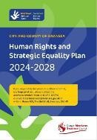
The 2nd edition of the Human Rights City newsletter was released on 10 December, aligning with Human Rights Day. By sharing success stories and updates, the newsletter continues to foster pride and engagement within the community. It helps to enhance the visibility and credibility of our human rights work across the city. This edition helped grow the Stakeholder Panel, which held its inaugural meeting in December. The panel, including experienced human rights lawyers, will assess the city’s progress, helping to identify gaps and support learning opportunities from other Human Rights Cities.
A survey was undertaken to assess Human Rights awareness amongst the public and compare the results to the previous survey. A Child and Young person version of the survey was also conducted. Initial findings are showing that people’s knowledge and awareness of human rights have increased slightly, especially with children and young people.
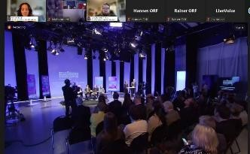
Our work has been recognised on international and national levels. We were invited to contribute to UNESCO’s “Human Rights Go
Local” publication series, which culminated in appearing as panellists in a global conference to share our experience and insights into our work as a Human Rights City. We were also asked by Welsh Government to make a contribution to their film celebrating and marking Human Rights Day by sharing our journey of becoming a Human Rights City to help inspire other local authorities in Wales.

Through these initiatives, Swansea continues to embed human rights in local governance, ensuring it remains a great place to live for all.

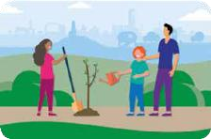
Step 3: Climate Change & Nature Recovery - To restore and enhance biodiversity, tackle the causes, and reduce the impact of climate change

What was planned
Swansea’s commitment to tackling climate change
focused on developing a city-wide climate adaptation strategy, expanding tree planting efforts, and driving forward projects aimed at reducing carbon emissions. The PSB aimed to strengthen partnerships with local organisations and businesses to support the transition towards net-zero emissions.

What was delivered
The development of the Adaptation and Mitigation Strategy got under way with 2 online workshops delivered for key officers across partner organisations, 1 workshop for wider PSB members and 12 community workshops involving representatives from across the community and business sectors. This bottom-up approach, using the Climate Change Committees Adaptation Framework as a structure and guide, has been fruitful and challenging and the evidence gained from this, and other research, has been brought together in a Technical Report. This will be used as the evidence for the writing of the strategy and action plan. In addition, following on from last year’s Climate Change and Nature Recovery Mapping exercise, the Signatories group has shared key information and good practice, and begun to coordinate our collective input on areas of focus such as the Local Area Energy Plan. Identified opportunities and actions from the mapping exercise will now be tied in with the next steps of the adaptation and mitigation strategy.

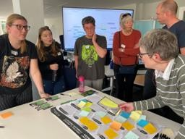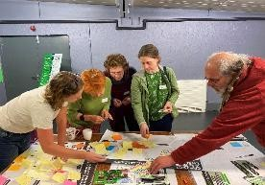

Trees have been planted across Swansea to enhance biodiversity and contribute to urban greening efforts. The public sector has successfully reduced carbon emissions by 20%, exceeding initial projections. Community engagement workshops have been instrumental in raising awareness about climate adaptation and sustainability. Challenges remain in securing additional funding for further initiatives, but momentum continues with plans to expand renewable energy projects and nature recovery programs in the coming year.


Step 4: Strong Communities - To build cohesive and resilient communities with a sense of pride and belonging

What was planned
The PSB sought to enhance community safety through collaborative initiatives, including large-scale engagement events, crime prevention workshops, and better-coordinated public safety campaigns. Strengthening partnerships between emergency services, local authorities, and community groups was a priority.

What was delivered
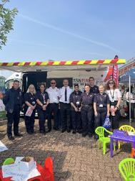
The Community Safety Village event attracted significant public participation, providing valuable insights into local safety concerns and priorities. Workshops focusing on crime prevention and safeguarding have helped improve community resilience, with increased reporting and intervention rates. A notable reduction in anti-social behaviour has been observed in targeted areas, and the PSB will continue building on these successes in the coming year.
A Targeting Prevention workshop was held on 20 November 2024, featuring eight presentations with guest speakers and workshops that allowed participants to discuss a range of prevention topics such as Sharing Personal Information, Maximising Impact through Partnerships and referral pathways, Safeguarding vulnerable people and much more.

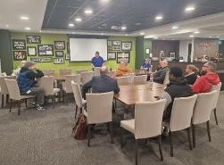

The event was a huge success and provided the perfect opportunity for our partner agencies to discuss and promote best practice on how to keep our communities safe.

Another key development this year has been the PSB’s support for a co-location project to bring together Swansea Council and South Wales Police Community Safety Partnership staff in a shared city-centre location. The PSB agreed to take forward the initial phase of the project in Swansea under Step 4. The vision is to create a more joined-up, multi-agency team capable of more responsive, coordinated support to communities. Scoping work is underway to assess potential locations and costs, and the timescale will be finalised following completion of the user requirements phase. The proposed city-centre location also supports broader local objectives around placemaking and economic vibrancy.

Step 5: Developing Swansea’s Integrated Cultural Offer

What was planned
Plans were put in place to develop a cohesive Cultural Strategy, aligning arts, sport, and well-being programmes to promote wider participation and cultural engagement. A new arts festival and network ‘Creative Swansea’ was planned to secure engagement from the wider community and creative and cultural industries, with a strengthened sports and leisure offer within the new Regional Sports Partnership.
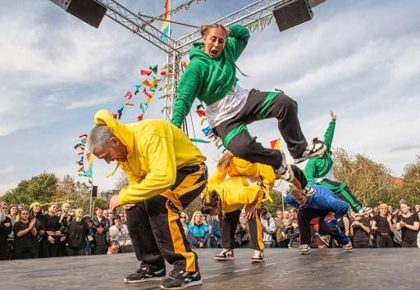

What was delivered
Funding achieved through Shared Prosperity Fund assisted us launching public consultation events and the new network, Creative Swansea was launched at Swansea Arena. A cross sector Cultural Strategy is now in its final development stages following stakeholder and public consultation events. The strategy harnesses Swansea’s strengths in delivering events, cultural tourism, arts, sports and health programmes. Tens of thousands of people participated in these activities over the year, increasing engagement, health and wellbeing, digital inclusion, literacy, cohesion and boosting the local economy.

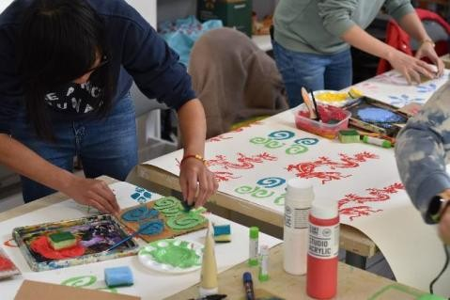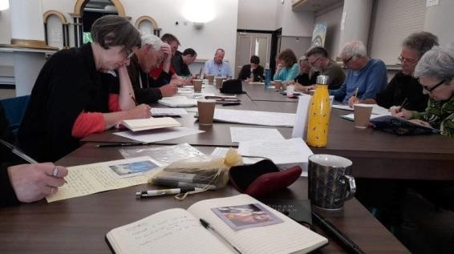

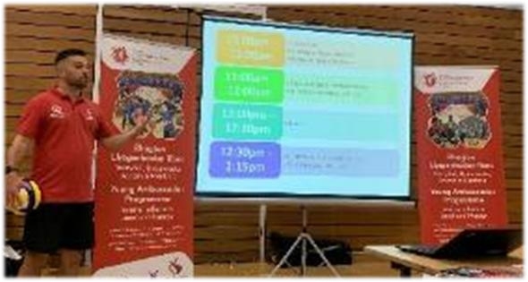

Collaborative Regional Initiatives

In addition to the steps above the PSB continues to engage in strategic work across organisational and geographical boundaries, contributing to wider regional initiatives that complement and strengthen delivery of our Well-being Plan. Two key areas of collaboration this year have been the Whole System Approach to Healthy Weight and systems mapping to support long-term integration and planning.

A Regional Whole System Approach to Healthy Weight

During 2024–25, Swansea PSB supported the development of a regional Whole System Approach (WSA) partnership with the regional WSA team, Neath Port Talbot and Cwm Taf Morgannwg PSBs, and the Swansea Bay and Hywel Dda University Health Boards. This work forms part of the ‘Leadership and Enabling Change’ theme within Welsh Government’s Healthy Weight: Healthy Wales strategy.

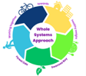
The challenge is significant: only a third of adults in Swansea Bay are a healthy weight, and three in ten children begin school already living with excess weight. This programme recognises that these outcomes are shaped not only by individual behaviours, but by wider environmental, economic, and societal factors.

In 2023, five county-level workshops brought together PSB members and wider partners to map these factors. Two system maps - one for physical activity and one for food - highlighted eight potential sub-systems influencing healthy weight, including school food, active travel, affordability, and marketing of unhealthy food.

In Autumn and Winter 2024, five further prioritisation workshops narrowed the focus to a single regional priority: access to food, with an emphasis on affordability and availability. This priority will now form the focus of collaborative regional work into 2025–26 and aligns with the PSB’s ambition to improve local well-being and build healthier communities.

Next steps include mapping relationships across the regional food system, launching a Regional Learning Network with strong PSB interest, and exploring joint working with Neath Port Talbot PSB. These actions will support a more sustainable food system and help improve health and well-being across the region.

PSB Systems Mapping Workshop

On 6 March 2025, Swansea PSB hosted a Systems Mapping Workshop at the Swansea.com Stadium, aimed at deepening our understanding of how the steps in the Well-being Plan interconnect. The session brought together PSB members and partners to explore the relationships, gaps, and synergies across the system.

The workshop aimed to map each PSB Well-being Plan step, identify collaboration opportunities, review 2025–26 actions, and strengthen partnerships through better resource alignment.

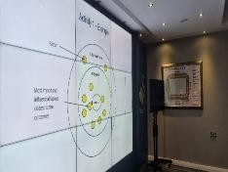
The session built on previous work and showed how taking a broad view can help organisations work more closely together and plan ahead more effectively. The ideas shared are now helping to shape PSB priorities, improve joint working, and use resources more wisely. It also highlighted the value of taking time to look at how everything connects, reminding us that we make the biggest difference when we understand the whole picture—not just individual pieces.

Step 6: To influence and connect with other governance arrangements across the Swansea Bay region.

What was planned
The PSB aimed to strengthen regional collaboration by refining governance structures and improving alignment between partnerships across the Swansea Bay region. The goal was to enhance strategic coordination, avoid duplication, and ensure collective impact across shared priorities.

What was delivered

A comprehensive governance review has been completed, providing clear recommendations to improve how regional partnerships work together. Chairs of key strategic partnerships have been engaged to promote shared understanding and strengthen collaboration. This has already led to improved alignment of priorities across regional boards, laying the groundwork for more coherent decision-making and joined-up delivery in the years ahead.

Step 7: To improve data quality and accessibility across the Swansea Bay region


What was planned

The PSB committed to developing a joint digital data portal to support better data sharing across the region. The aim was to strengthen evidence-based decision-making and service planning by exploring national integration models and best practice.

What was delivered

A regional data portal proposal has been developed in collaboration with Swansea, Neath Port Talbot, and Cwm Taf Morgannwg PSBs, working alongside Data Cymru.
Funding has been secured to implement the platform, which will enable partners to monitor key well-being indicators and support more consistent, transparent, and data-driven policymaking across the region.

Step 8: To Develop Swansea PSB performance management arrangements which measure and monitor the PSB’s progress


What was planned

The PSB set out to develop a robust performance monitoring framework to improve accountability, track progress against well-being objectives, and support informed decision-making.

What was delivered
A new performance monitoring system has been
established, including a regularly updated dashboard that captures key indicators across PSB priorities. This framework enhances transparency, enables partners to track progress more effectively, and provides a stronger evidence base to shape future actions and policy decisions.

Engagement, Involvement and Participation

The Swansea Public Services Board is built on partnership — not just between organisations, but with the people and communities we serve. We believe that meaningful engagement leads to better decisions, stronger relationships, and more sustainable outcomes. That’s why participation is embedded in every step of our work:
shaping priorities, influencing delivery, and holding us to account.

Bringing Partners Together
In September 2024, we hosted the Swansea PSB Partnership Forum - an open, collaborative event attended by over 50 representatives from local authorities, health, emergency services, universities, the third sector and community partners. Through presentations, workshops and conversations, we explored progress, shared learning, and shaped next steps.
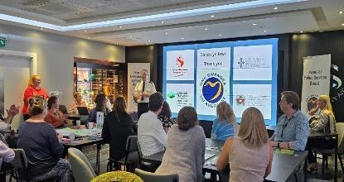
Feedback was overwhelmingly positive. The Forum created space for honest discussion, practical ideas, and new connections - a reminder that collaboration thrives when we bring people together with purpose.
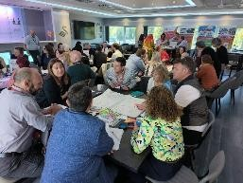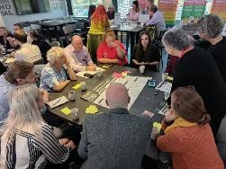

Involving People in What Matters
Engagement across our Well-being Plan isn’t one-size-fits-all. We use different approaches tailored to each priority, ensuring we hear from those with lived experience and those delivering services on the ground.
- Early Years: Engagement is built into the system, through surveys, assessments and stakeholder events like the Childcare and Play Sufficiency Assessments.
- Human Rights City: Our priorities were chosen through public events and dialogue with partners. A new Human Rights Stakeholder Panel, made up of residents and professionals, is being established to guide our work as a critical friend.
- Climate Change & Nature Recovery: We’ve held 12 open-access community workshops, two partner workshops involving over 80 officers, and outreach through schools and the Green Economy Conference to shape our Adaptation and Mitigation Strategy.
- Strong Communities: Engagement happens every day — from fire safety visits to youth interventions and safeguarding support. Mid and West Wales Fire and Rescue Service works closely with partners and the public to prevent harm and build trust in the community.
- Cultural Offer: Public consultation shaped our new Cultural Strategy, including targeted engagement with older people on sport and physical activity.
We also work through partnerships like Safer Swansea, where agencies coordinate involvement activity and share insights to better support community needs.

Listening, Learning, and Improving
Engagement is only meaningful when it leads to action. That’s why we welcome scrutiny. Swansea Council’s Scrutiny Programme Committee reviewed our work and made clear recommendations: involve more people, use better data, and show more clearly what’s changing.
We’ve responded by:
- Launching new stakeholder forums
- Improving how we measure and report outcomes
- Making our work more open and transparent

This is not just about compliance — it’s about trust. Listening, involving, and learning helps us stay grounded in what matters most: the people of Swansea.

Our Next Steps

Looking Ahead: Priorities for 2025–26

In 2025–26, Swansea PSB will build on the momentum of systems mapping work to drive smarter collaboration, stronger partnerships, and clearer impact. A new datasharing system will support better coordination across services, while a shared digital hub will strengthen how we listen to and involve the public. Human Rights will be embedded across all areas of PSB work through formal impact assessments, and joint workforce training will enhance skills in early intervention, digital inclusion, and climate resilience. Mapping tools will be used to identify service gaps, and PSB planning will align more closely with the Local Development Plan to support sustainable, joined-up delivery.

Each step of the Well-being Plan has clear actions. Early Years work will focus on reviewing the model for Health Visiting, expanding access to free childcare, and reaching more families through schools, libraries, and community hubs. As a Human Rights City, partners will complete self-assessments, raise awareness among staff and service users, and work toward achieving Age Friendly City status. The final Adaptation and Mitigation Strategy will be launched, with every PSB member expected to take forward actions to reduce emissions and enhance biodiversity. Community safety efforts will include a major public engagement event, enhanced multi-agency teams, and closer links between urban planning and crime prevention. A new Cultural Strategy will be published, followed by an annual action plan to grow inclusive, community-led events and strengthen the Welsh language and cultural identity across the city.
How can you get involved?

The work undertaken by Swansea Public Services Board is published online at www.swansea.gov.uk/psb
Our Swansea PSB Meetings are held in public and questions from the public are invited via a standing agenda item Public Question Time.
We also offer individuals to sign up to receive emails involving our PSB work. If you would like to receive PSB updates, please sign up via https://www.swansea.gov.uk/psbemail
You can also contact our Public Services Board Co-ordinator directly by email at Swansea.psb@swansea.gov.uk
We welcome your involvement, ideas and suggestions in all areas of our work so that we could consider for our future work.

Conclusion

This report highlights a year of real progress for Swansea Public Services Board, grounded in partnership, purpose, and a shared ambition to improve lives across our city. From expanding early years support and embedding human rights, to tackling climate change and developing a cultural strategy shaped by communities, we have taken important steps toward the vision set out in our Well-being Plan.

We know that challenges remain. Inequality, climate pressures, and rising demand continue to test our systems. But this year has also shown the strength of our collaboration, across organisations, sectors, and communities, and the value of thinking and acting together.

As we look to 2025–26, we are focused on delivery: embedding what works, acting on what we’ve learned, and continuing to listen and adapt. With strong foundations in place and a clear set of shared priorities, we are confident that, together, we can keep building a fairer, greener, safer, and healthier Swansea - not just for today, but for future generations.

