Swansea Bay University Health Board

Climate Action Plan

2026-2030

Approved on: 25 February 2026
Approved by: Management Board



Table of Contents
Foreword 3
1 Introduction 4
1.1 Climate change 4
1.2 Why Climate & Health? 4
1.3 What is climate mitigation and adaptation? 5
1.4 SBUHB and climate change 6
2 What does our future climate look like? 9
3 Our journey so far 11
3.1 Our successes 11
3.2 Our challenges 11
3.3 Emissions profile 12
3.4 Climate risks and opportunities 12
4 Developing this plan 15
4.1 Context 15
4.2 Methodology 17
4.3 Mitigation 18
4.4 Adaptation 18
5 Our plan 20
5.1 Aim and objectives 20
5.2 What success looks like 20
5.3 Our Culture & Ways of Working 21
5.4 Our Buildings & Estate 22
5.5 Our Procurement 23
5.6 Our Travel 24
5.7 Our Sustainable Healthcare 25
5.8 Implementation 26
6 Future challenges 28
Glossary 29
Appendix 1 31
Appendix 2 41
Acknowledgments 42

Foreword
I am proud to be able to introduce Swansea Bay University Health Board’s (SBUHB) third plan responding to the Climate Emergency. This plan sets out a cohesive approach to decarbonisation and climate resilience, positioning the Health Board to meet future challenges while delivering on national priorities. It is aligned with the NHS Wales Decarbonisation Strategic Delivery Plan (2025) and the Climate Adaptation Strategy for Wales (2024), ensuring an integrated response to their interconnected objectives.
ADD PHOTO HERE
This Climate Action Plan highlights the amazing work undertaken over the last 24 months including our incredible staff led initiatives, our Green Group, initiating climate adaptation work, and the Sustainability Clinical Leads who are driving substantial change. We know a healthier, greener, and brighter future for the staff and people of Swansea Bay is possible.
However, we also recognise that we are at a critical point in history with the impacts from climate change being felt quicker and more severely than previously predicted. This is reflected in record increases in the price of coffee, chocolate, and olive oil; a rise in the number of named storms; drought declarations across parts of Wales; and 13 days over 25°C in Swansea and Neath Port Talbot during summer 2025.
We are committed to A Healthier Swansea Bay - Swansea Bay University Health Board recognising that climate change impacts could prevent us meeting this. Therefore, as a Health Board we must work collaboratively across NHS Wales and with local partners and communities to build resilience through a population health approach. This means understanding how these efforts can drive value by reducing cost, improving patient experience, and minimising waste. Giving our staff ‘Permission to Act’ is key in building a sustainable and climate resilient healthcare system.
The health impacts caused by the climate emergency demand bold and decisive action from all of us if we are to truly thrive. I remain committed to empowering our teams to build on their successes and to working in close partnership with Welsh Government and our stakeholders to deliver the transformative change we require.
ADD E-SIGNATURE
Abigail Harris
Chief Executive Officer, Swansea Bay University Health Board

Introduction
Climate change is a global issue, but there is a role for all to play in protecting the planet. Healthcare is in a unique position, with being a major contributor to climate change as the 5th largest emitter in the world; and being one of the principal areas impacted by the effects of climate change. This urgency was recognised in the Climate Emergency declared by Welsh Government in 2019.
The good news is there has been substantial progress in the Health Board since emissions reduction work was commenced by our Estates Team and then widened to the rest of the Health Board in 2021. Whilst the Heath Board’s emissions continue to increase there have been substantial reductions in emissions from our buildings. However, even if global emissions reduced substantially tomorrow, there is a degree of climate change that cannot be undone, it is critical that the Health Board is prepared for this as it will impact the whole system including population health, service delivery, and ability to respond to emergencies.

Climate change
Climate change is here now! Figure 1 highlights how average temperatures in Wales have changed since 1884.
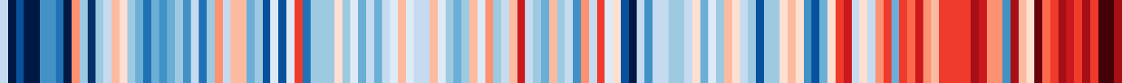
Figure 1: Temperature change in Wales between 1884 and 2024 (Source: #ShowYourStripes)
The summer of 2024 saw global temperatures surpass the 1.5°C target for controlling temperature increases, as agreed in the Paris Agreement. This was followed by five named storms over autumn/winter 2024/25 resulting in a red alert for wind and multiple flooding events across South Wales (Ashley, 20-21 October 2024; Bert, 22-25 November 2024; Conall, 27 November 2024; Darragh, 6-7 December 2024; and Éowyn, 24 January 2025). As well as changes to global food supplies with increases in the price of coffee and chocolate, and the West Nile virus was detected for the first time in UK mosquitoes in Nottinghamshire.
Summer 2025 saw four heatwaves, each short-lived and interspersed with near-average conditions. This was not an exceptionally hot summer but was noticeably warmer. In Swansea and Neath Port Talbot there were more than 13 days exceeding 25°C, becoming one of the hottest summers on record.

Why Climate & Health?
Climate change and health are closely related as demonstrated in Public Health Wales Climate Change Health Impact Assessment (PHW HIA)(2023). This work highlights how climate change will impact population health and equity, including:
‘Potential major, multifaceted, co-occurring and inequitable impacts across a range of determinants of health for example, nutrition and food security, community resilience and cohesion, displacement of people, access to healthcare, damage to housing, transport and infrastructure, environmental determinants including water supply, biodiversity and the economy.’
With the impact to:
‘the health and wellbeing of the whole population of Wales, and some population groups are likely to experience disproportionate negative impacts. For example, those on low incomes, children and young people, older adults, farmers, fishers, and those who live in coastal areas.’
However, the report also recognises the co-benefits to health of addressing climate change including:
- Increasing physical activity via active travel
- Nature-based solutions that enhance access to green spaces and nature
- Improving health from sustainable diets
- Improving air quality from lower fossil fuel emissions
- Improving mental wellbeing through community-led climate action which builds trust, social capital, enhances a sense of control and resilience
Understanding the connection between climate and health is an enabler to action, bringing our population on this journey with us.

What is climate mitigation and adaptation?
Action is required on two fronts:
- Reducing emissions from healthcare (climate mitigation); and
- Building resilience, through long-term planning, to the impacts from climate change (climate adaptation)
Climate mitigation is a term used to describe actions taken to reduce or prevent the emission of greenhouse gases into the atmosphere and to enhance carbon sinks (like forests) that absorb these gases. The goal is to lessen the severity of climate change by limiting the increase of global warming, thereby preserving ecosystems and human civilization.
Whilst these reductions are critical to reduce the impacts of climate change, there is a level of change that cannot be avoided, and this is what the Health Board needs to adapt to.
‘Climate adaptation’ is a term used to describe actions taken to address climate risks and amplify opportunities that increase an organisation’s climate resilience. This is through:
- Understanding how climate change will impact us now and into the future
- Making changes to the way we live, work, make, and do things
- Adjusting our natural and built environments
- Working to reduce risks and maximise opportunities

It is important to understand that these are not two separate agendas that can be prioritised one over the other. Mitigation and adaptation need to be complimentary, Figure 2.
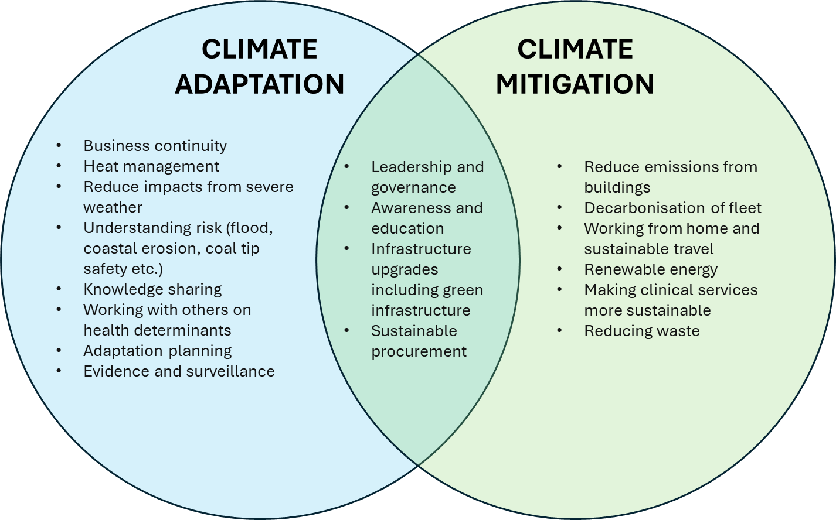
Figure 2: Climate mitigation, climate adaptation and how they intersect
Approaches to climate change are aligned with the prevention agenda:
- Primary: Efforts to prevent the onset of disease / creating the conditions so problems don't arise in the future – emissions reduction / decarbonisation
- Secondary: Early detection of disease, followed by interventions to improve outcomes / targeting action on high-risk areas – adaptation
- Tertiary: Treatment or rehabilitation of people already affected / intervening once there is already a problem to stop it getting worse – adaptation / Emergency Preparedness Resilience & Response (EPRR)
This approach is evident in A Healthier Wales - Action refresh 2024-25.
If there is no adaptation, the Health Boad will be unable to deliver on its’ objectives to the population of Swansea and Neath Port Talbot. Following the Marmot principles embedded within our Population Health Strategic Plan and Strategic Objective 1 of ‘A Healthier Swansea Bay’, it is essential the Health Board address environmental sustainability and health equity together.

SBUHB and climate change
The Health Board’s influence goes beyond the walls of our sites, and this is particularly evident within the climate space. ‘A Healthier Swansea Bay - Swansea Bay University Health Board’ recognises four different roles, Table 1 demonstrates how both climate mitigation and adaptation interact with each of these areas through existing work.
Table 1: Roles of the Health Board and examples of links with climate change mitigation and adaptation
 | Climate mitigation (emissions reduction) | Climate adaptation
Healthcare provider | Low carbon healthcare including Virtual Wards, community by design etc.  Remote appointments  Implementing the vaccine equity strategy | Nutrition and hydration  De-conditioning  Use of green space
Employer | Supporting staff in being able to respond to the climate crisis | Uniform changes allowed during heat
Major local organisation | Reducing the emissions from our buildings including LED lighting, optimising heating, and cooling; and an energy saving campaign  Development of the solar farm  Sustainable travel | Business Continuity Plans  South Wales Local Resilience Forum
Productive partner | GreenED  Greener Critical Care  Public Services Boards | Resilient Swansea project with Swansea Public Services Board  Adaptation Accelerator scheme  Climate Preparedness Leads collaboration

The importance of considering climate change as a Health Board is shown by Figure 3. The climate mitigation approaches and adaptation opportunities offer further opportunities/co-benefits for achieving the strategic objectives, whereas the climate risks have the potential to limit success.

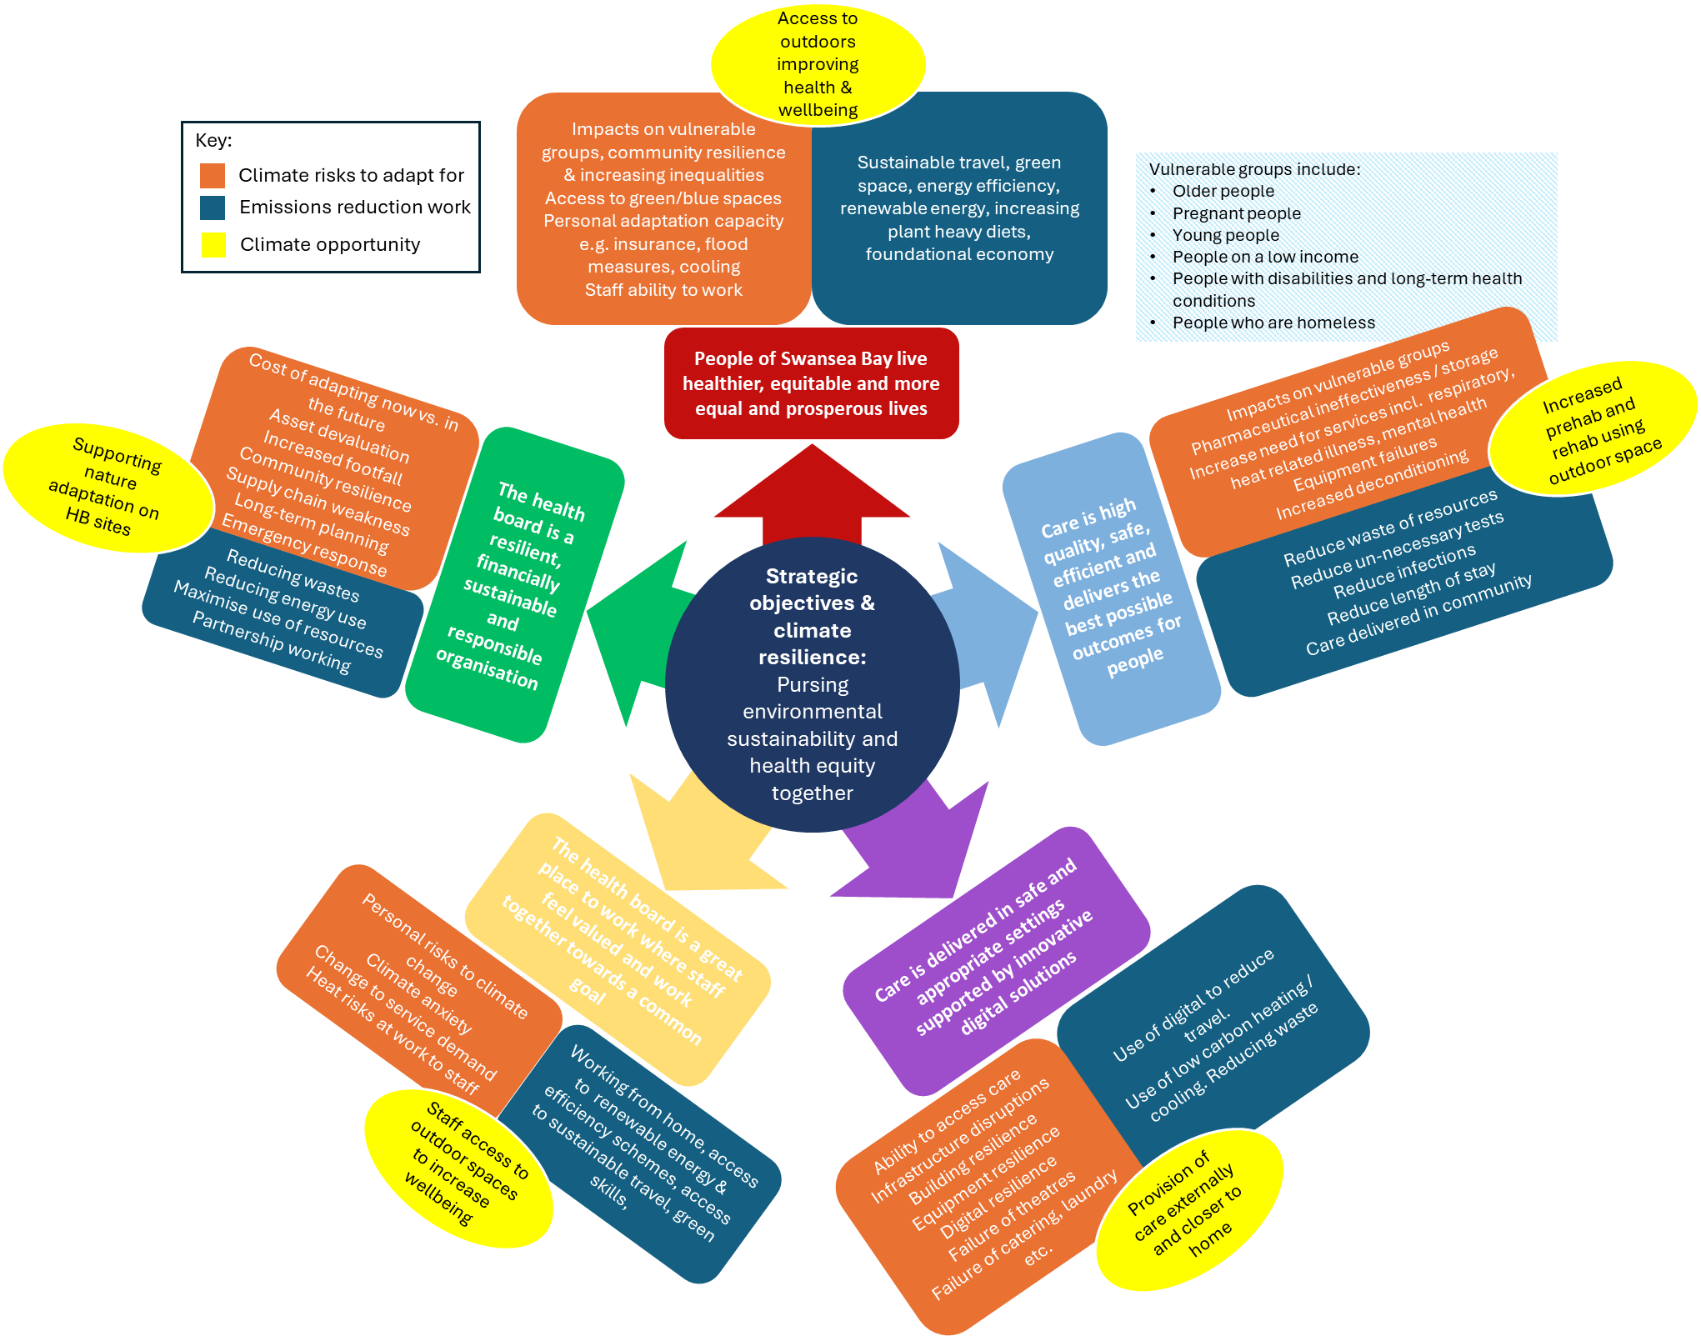
Figure 3: Interactions between climate mitigation, risks, and opportunities with the strategic objectives

What does our future climate look like?
Wales future climate will include:
Warmer, wetter winters and hotter, drier summers with more extreme weather events.
Key hazards identified because of the warming climate include heat, wildfires & drought; flooding; storms; air quality fluctuations; and coastal erosion & sea level rise, temperature and precipitation changes. These are highlighted in Table 2. The potential impacts on health systems are summarised in Figure 4, with recognition that reduced availability/quality of food and increasing inequalities are two critical areas that will impact our population.
Table 2: Met Office climate change predictions
Aspect | 2°C rise (mid-century 2050) | 4°C rise (end of century 2100)
Summer temperature:
Days above 25°C | 20 days (17 to 27 days) | 43 days (36 to 55)
Days above 30°C | 2 days (1 to 3 days) | 10 days (8 to 18)
Precipitation
Summer | -12% (-26 to -6%) | -35% (-49 to -26%)
Winter | +10% (+3 to +16%) | +25% (+20 to+37%)

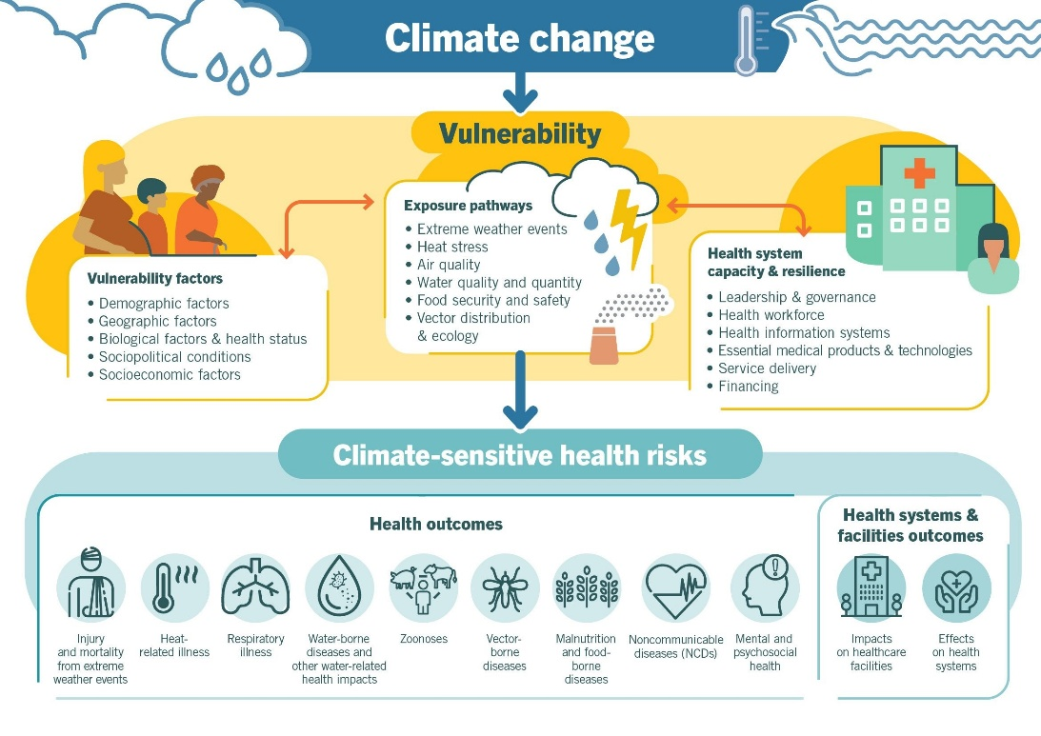
Figure 4: World Health Organisation – climate sensitive health risks
Climate change poses the greatest health challenge for Wales , this is recognised in PHW HIA (2023), with wide-ranging impacts including:
- Rising temperatures increasing risks of heatstroke and dehydration, while exacerbating cardiovascular and respiratory conditions
- Cold snaps and wetter winters heighten vulnerability to hypothermia, injuries, and mould-related respiratory illness
- Flooding disrupts housing, healthcare access, and critical infrastructure
- Poor air quality from heat and wildfires worsens chronic respiratory and heart disease
- Mental health impacts including anxiety, depression, and post-traumatic stress are linked to extreme weather events and climate-related uncertainty, particularly among socially isolated or economically disadvantaged groups
In addition, climate change also threatens food security, employment, and transport, which is expected to compound inequalities, especially health related ones. It also recognises that certain groups face disproportionate risks:
- Older adults are highly vulnerable due to impaired thermoregulation, higher likelihood of multimorbidity, and isolation.
- Children, infants, and pregnant women are at risk because of physiological sensitivity and dependency.
- People with disabilities or long-term conditions, outdoor workers, and emergency responders face heightened exposure to heat and pollution.
- People with pre-existing conditions / multi-morbidities requiring priority attention include cardiovascular disease, chronic respiratory illness, diabetes, kidney disease, and mental health disorders
- Mobility and sensory disabilities, pregnancy, and co-morbidities increase susceptibility
- Social determinants including housing quality, income, and access to care shape exposure and resilience, with socioeconomically disadvantaged households, those in poor housing or flood-prone areas, and individuals experiencing homelessness or displacement having limited adaptive capacity
However, those with intersecting vulnerabilities for example age combined with chronic illness and low income have an even further amplified risk.
This recognises that there is a role for the Health Board in this, but that collaboration with partners, the population, and wider NHS Wales is going to be critical to success in building climate resilience in Wales.

Our journey so far

Our successes
The period from April 2024- March 2026 has been challenging, with financial and resource constraints across the organisation. Despite these pressures, significant progress has been made, particularly in clinical areas, through the introduction of Sustainability Clinical Leads roles, the expansion of Green Group membership, and strengthened support for All-Wales networks for Critical Care, Emergency Departments and Primary Care.
Key successes include:
 | Regular communications to staff, including 2 weeks where climate and sustainability are the focus |  | Working with public transport providers to improve connectivity e.g. Singleton to NPT Hospital service
 | Inclusion of sustainability and climate change in the induction handbook for new starters |  | Investigations into items move from single use to reusable, first item executed blood pressure cuffs
 | Independent Member champion |  | Development and implementation of a Healthy and Sustainable Catering Plan
 | Embedded into the Research and Development protocol through Well-Being of Future Generations Act |  | Nominated leads in Infection Prevention & Control to work with Sustainability Clinical Leads
 | Delivery of bespoke training to Digital, Strategic Partnerships, Managers Pathway, & Lymphoedema |  | Sustainability awards in 2024 and 2025 to Health Board teams for their leadership
Further successes are shown in Sections 5.3 to 5.7.

Our challenges
This plan acknowledges the challenges of resourcing, including staff capacity and funding However, by embedding sustainability into existing processes, optimising resources, and collaborating across NHS Wales, we can work smarter- saving staff time, reducing costs, minimising waster, and enhancing patient experience.
Key challenges include:
- Cost of adapting: Adapting to climate change expected to cost up to 6 times more in the future than if we reduce our emissions and minimise the impact of climate change now
- Staff engagement: Need to reach more people to build momentum and awareness.
- Strategic partnerships: Ensuring any Health Board response does not limit our partners’ ability to act. By working in partnership we can maximise opportunities to develop solutions that deliver benefits for all.
- Primary Care: Responsibility for adapting primary care is unclear and complex, with limitations of what the Health Board can and cannot influence.
- Current state of buildings: Some buildings are at higher risk of damage with high-risk backlog maintenance estimated at £10.3 million for Morriston Hospital and £9 million for Singleton Hospital. Whilst this is a challenge there could also be opportunity in building climate adaptation to maintenance projects at the Health Board.
- Perceptions of climate impacts: Still viewed as significantly further in the future and not associated with present day events e.g. storms in 2024 and heat in 2025.
Despite the challenges, staff are engaged with this space and keen to include in their work.

Emissions profile
2024/25 saw the highest carbon footprint by the Health Board since reporting began in 2022 with 174,225.71 tCO₂e or equivalent to driving 824,932,339 miles in a petrol vehicle in 1 year. With 79% of emissions linked to the supply chain and purchased goods and services, this area represents our greatest opportunity for meaningful reductions. However, it is a complicated picture including evolving methods for calculating these emissions and regular changes to emissions factors by the UK Government.
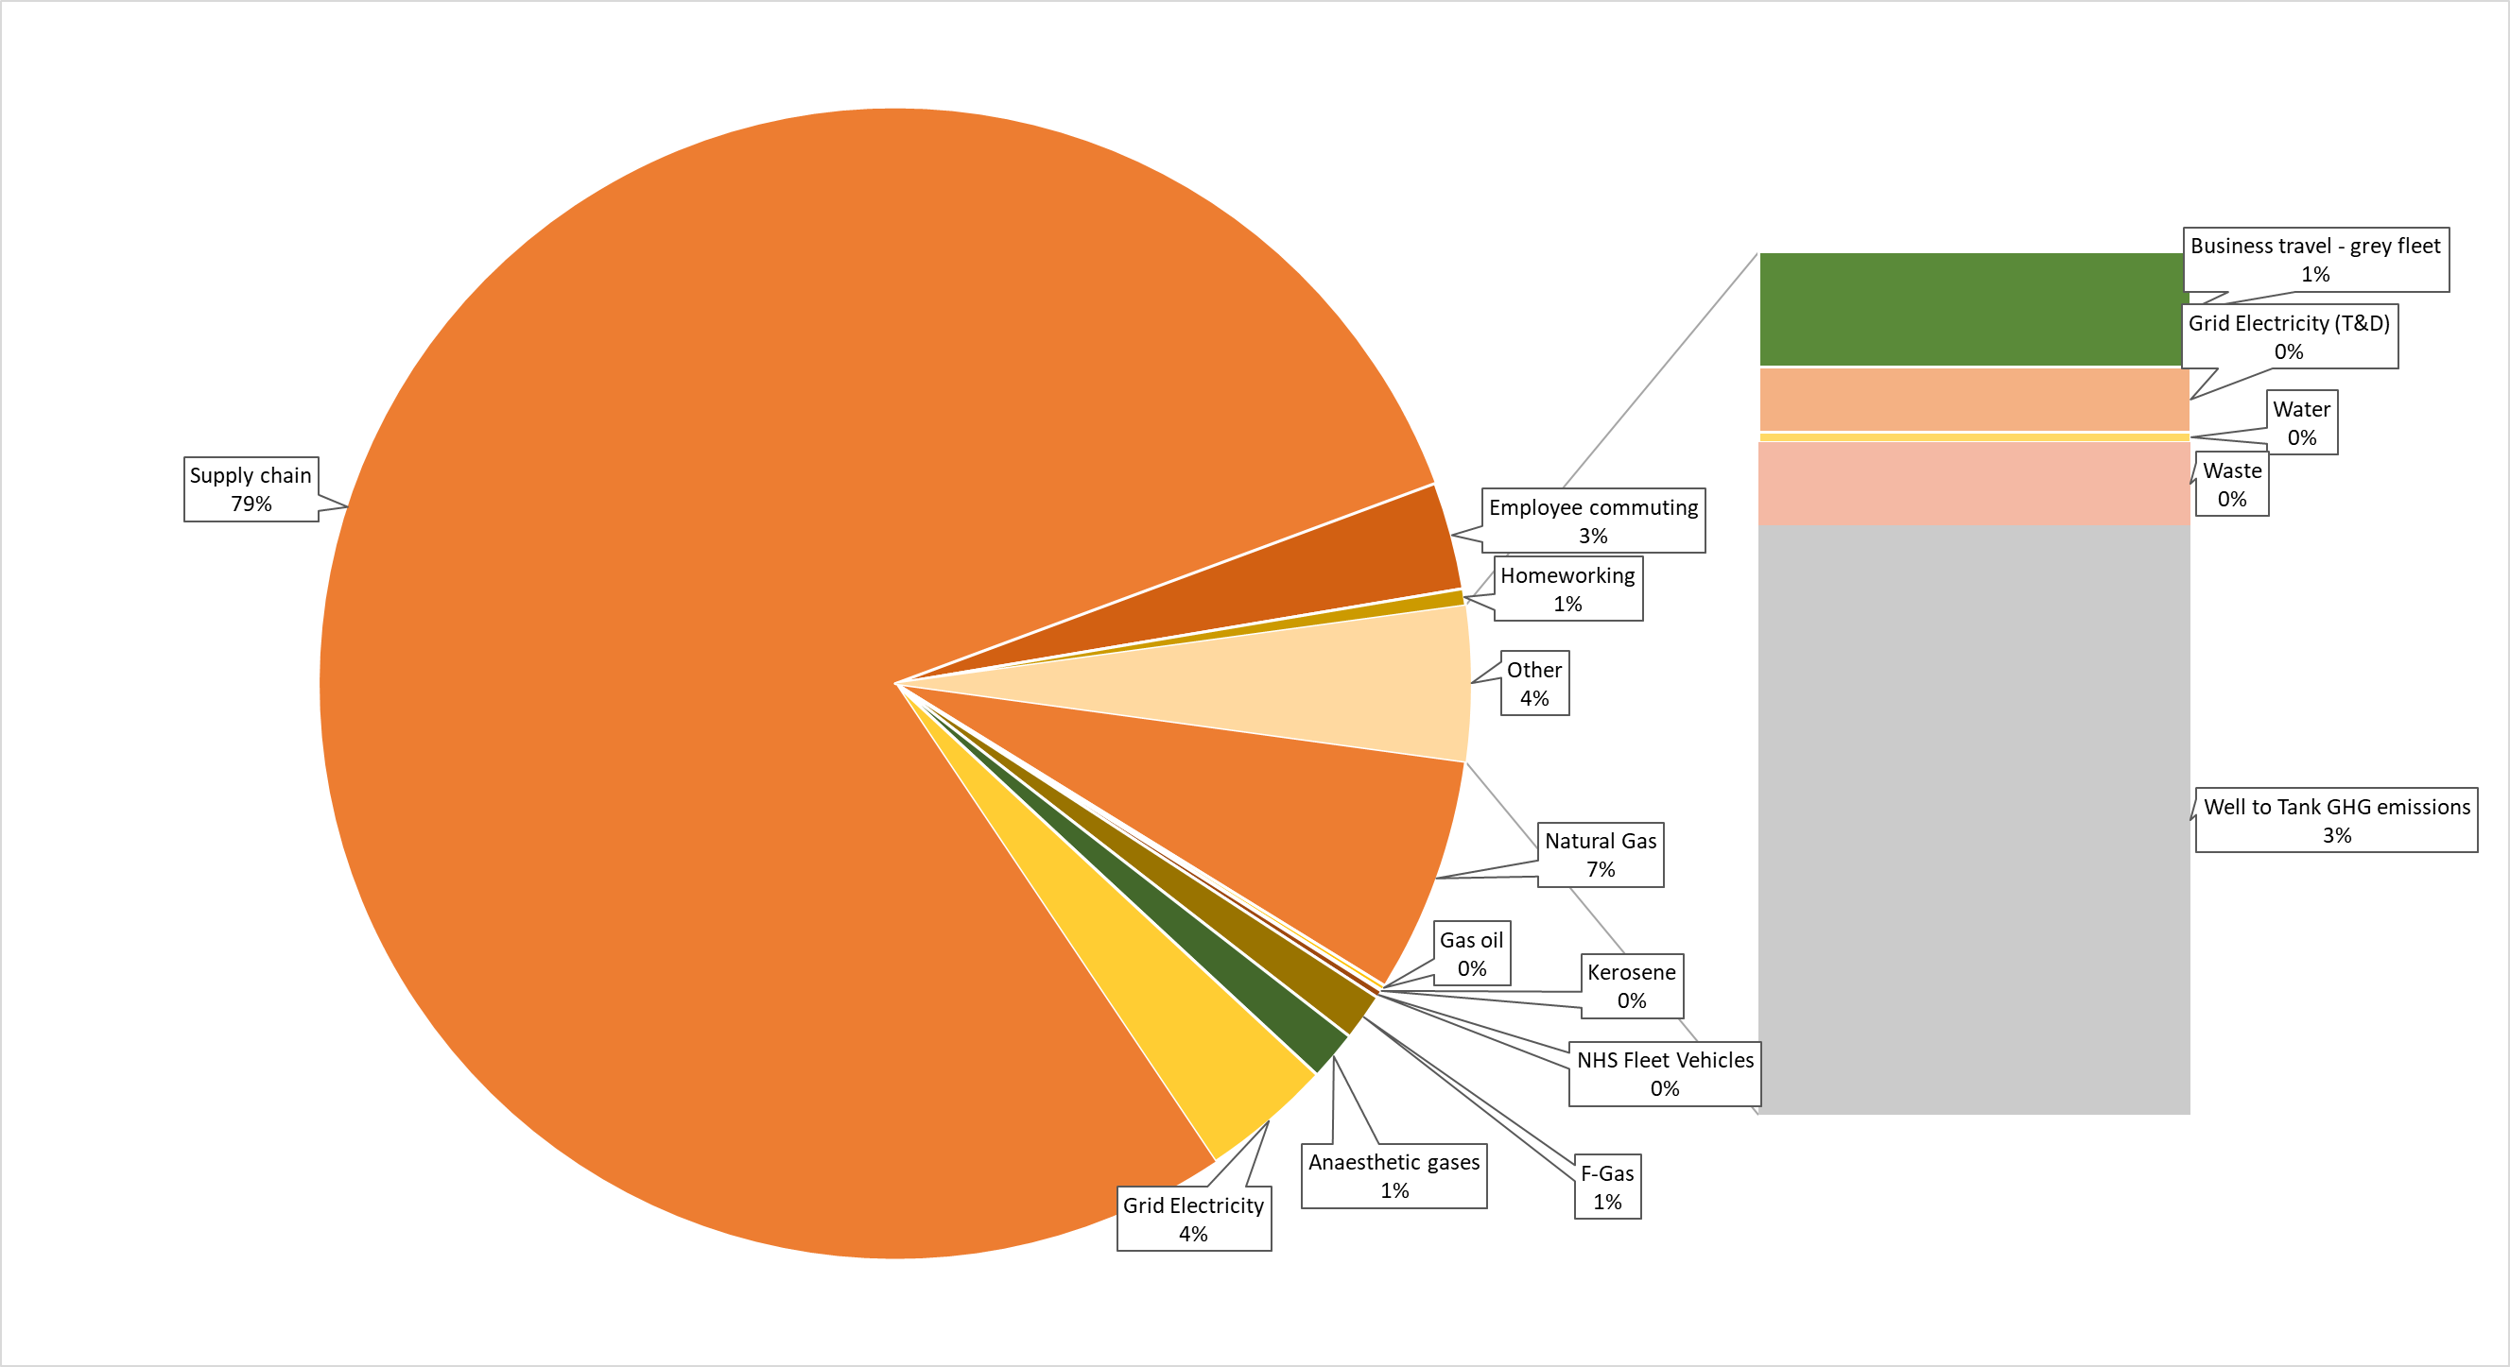
Figure 5: 2024/5 Health Board emissions

Climate risks and opportunities
2025 saw the first iteration of the Health Board’s Climate Change Risk and Opportunity Assessment. A copy of the full report and risk assessment is available on request SBU.Sustainability@wales.nhs.uk

Current vulnerability
Staff identified multiple ways the Health Board has been impacted by climate related events, examples include:
 | Staff experiences of fatigue, dehydration and difficulty concentrating in excessive heat |  | Failure of fridge/freezer facilities, storing samples / pharmaceuticals during heat
 | Increased stress and anxiety for staff due to increased utility bills for heating and cooling when working from home |  | Fluctuations in food prices from impacts of climate change incl. olive oil, coffee, chocolate, vegetables, fruits etc
 | GP surgery closed after damage sustained during multiple storms, impacted services |  | Perceived water scarcity during hotter weather and in particular access to water during heatwaves
 | Outpatient cancellations across SBUHB from Storm Darragh |  | Seasonal increases in fractures when there is better weather
 | The delivery of plasma giving sets from Costa Rica were delayed due to hurricanes |  | Tonna Hospital operated on emergency power for 18 hours during Storm Darragh
 | Reports of bed closures in ITU due to rain ingress |  | Difficulties in community staff delivering care to flooded communities

Existing response
Whilst processes and work may not be labelled as ‘climate adaptation’ during the Health Board’s Climate Change Risk and Opportunity Assessment (CCROA)development in 2025, it was recognised there is considerable work occurring that supports adaptation to climate impacts. This includes, but is not limited to:
- Business Continuity Plans: importance of formal procedures to maintain service delivery during climate related disruptions. These plans cover a wide range of areas that support our climate adaptation agenda; from service delivery continuity, patient safety and care, staffing arrangements, communications protocols, and supply chain management, to IT and Digital resilience and actions to protect and adapt building, equipment, and infrastructure. However, the extent to which climate impacts were covered did vary by plan.
- Digital solutions: The reliance and expectation that digital solutions can be used was highlighted, from working at home to shifting to remote video and telephone consultations. It was also recognised there might not be capacity in the system to sufficiently support.
- Estates approaches: Systems and guidelines that support adaptation in buildings and wider sites, from the preventative maintenance programme, inspections, back-up power checks, and guidance from the Welsh Health Technical Memorandums (WHTMs).
Evidence current adaptation approaches were not suitable, included:
- Use of fans in clinical areas that did not align with the Infection Prevention & Control Team’s requirements during heat periods, as well as challenges with suitable testing e.g. PAT.
- Provision of ad-hoc bottles of water during heat periods resulting in a costly process which is also damaging to the environment with excessive plastic waste produced and insufficient recycling points.

Risks
The CCROA process identified 135 risks across the Health Board. To ensure there is a managed approach, the highest risks will be targeted initially, this includes risks scoring 12 or more totalling 33 risks. The Health Board’s climate risks fell into 11 different categories, including:

Areas of further investigation
During the CCROA it was recognised that there were risks but the extent of the risk was not fully understood, due to lack of evidence base, access to knowledge, and/or available data. This includes:
- Clinical disciplines e.g. diabetes, renal, ED, older adults, neurology, oncology, maternity, haematology, radiotherapy, respiratory, nuclear medicine, rheumatology, community, children & young people, mental health
- Population health
- Suppliers’ resilience
- IPC & increased microbes/pathogens
- Buildings
  - Devaluation of assets
  - Flood risk and how to adapt
  - Increase in lease costs
- Pharmaceuticals & heat including:
  - Storage (onsite, in staff vehicles, in homes)
  - Impacts on body temp/temperature regulation
  - Effectiveness of pharmaceuticals
- Service delivery partners including commissioned services from public sector/ private sector / other HBs, and delivery partners’ e.g. social care, as well as collaborative spaces incl. Regional Partnership Board, Public Services Boards, Regional partnership etc.
- Some areas not considered due to limited availability / traction

Opportunities
Opportunities were identified during the discussions. However, these do not compensate for the risks that health and healthcare are facing. These opportunities included:
- Use of nature / outdoor spaces to support staff wellbeing
- Use of nature / outdoor spaces to support patient wellbeing, rehabilitation & condition management
- Further developing and utilising the role of greener prescribing
- Improvements to population health through being outside more from warmer weather
Collaboration and work in partnership spaces e.g. social care

Developing this Climate Action Plan

Context

Legislative context
Wales has a complex legislative framework for climate action, anchored by the Environment (Wales) Act 2016, which sets a legally binding target for net-zero greenhouse gas emissions by 2050. In 2019 Welsh Government declared a climate emergency with the public sector, including NHS Wales, expected to lead with an ambition to achieve net-zero emissions by 2030.
Key policy instruments include the Net Zero Wales Plan, which outlines cross-sectoral decarbonisation strategies, and the NHS Wales Decarbonisation Strategic Delivery Plan (2021), which provides a roadmap for reducing emissions across healthcare services. This includes actions in estates, procurement, transport, and clinical care.
Adaptation is equally critical. The Health and Social Care Climate Emergency National Programme (established in 2021) supports health and social care in responding to climate risks such as heatwaves, flooding, and air pollution. The Climate Change Health Impact Assessment (2023) by Public Health Wales further highlights the disproportionate effects of climate change on vulnerable populations and the need for integrated planning. The publication of the ‘Adaptation Strategy for Wales’ and ‘Health and Social Climate Adaptation Toolkit’ by Welsh Government in 2024 has supported this.
Further to this, December 2025 saw the publication of the Just Transition Framework 2025, outlining Wales’s vision for reaching net-zero emissions by 2050 in a way that distributes costs and benefits fairly, underpinned by equality, social partnership, and wellbeing principles. It focuses on three pillars which include analysing impacts, mobilising stakeholders, and integrating transition criteria into decisions. Guided by fairness, inclusion, and inter-generational justice, it requires embedding equity and climate considerations in everything, from estate retrofit, workforce planning, procurement, to community engagement to ensure health services lead a just, low-carbon transition.
All these requirements are brought together through the Well-being of Future Generations (Wales) Act (2015) which embed climate mitigation and adaptation into public decision-making by requiring public bodies to pursue a “resilient,” “prosperous,” and “globally responsible” Wales. Reducing emissions is critical to safeguard long-term environmental well-being, while adaptation supports communities in preparing for climate impacts, strengthening social, economic, and ecological resilience. The Act’s sustainable development principle ensures decisions consider long-term climate risks, prevent harm, and integrate environmental, social, and economic outcomes. The Act reinforces an integrated approach that protects ecosystems, supports future prosperity, and improves the well-being of current and future generations.
These policies position NHS Wales as a key actor in both mitigating climate change and adapting services to protect population health and ensure system resilience.

NHS Wales Decarbonisation Strategic Delivery Plan (DSDP)
2025 has seen a refresh of the DSDP, led by Welsh Government Energy Services. The Health Board has been actively involved in the refresh process through attendance at national meetings, multiple reviews, and participation in a workshop with over 20 staff from the Health Board. Input on the refresh has also been submitted via the Directors of Planning meeting and the Chief Executives of NHS Wales meetings.
The resulting actions in the refreshed plan will form the basis for the emissions reduction actions undertaken by the Health Board until 2030.

Climate adaptation accelerator project
2025 also saw the formation of Welsh Government’s NHS Wales Climate Adaptation Accelerator project through the Health and Social Care Climate Emergency Programme. Two Health Board representatives, Sustainability Planning Manager and Technical Services Manager, participated in this initiative through . Two online training workshops and two check-in sessions with Local Partnerships, the consultancy who developed the Health & Social Care Climate Adaptation Toolkit. Further to this, leads from across to NHS Wales formed their own networking space, sharing developments on the assessments, problem solving, and proposing areas that require a broader All-Wales approach.

Wider Health Board strategies
A review of the Health Board’s current Annual Plan was undertaken to understand whether low carbon healthcare projects are already underway. Initiatives were identified, highlighting a lack of understanding of what low carbon healthcare looks like, and an assumption it is more around nature and recycling. Some examples of the findings are provided in Appendix 2, and demonstrate ways in which Service Delivery Groups have been supporting the agenda.

Public Services Boards
The Climate and Nature Working Groups in Swansea and Neath Port Talbot (NPT) Public Services Boards (PSBs) are both working on climate adaptation initiatives and are at various stages.
- Swansea PSB: Swansea PSB’s Climate Signatories Group has developed a ‘Resilient Swansea’ climate adaptation strategy that was approved by the Health Board in November 2025. An action plan will be developed to support the implementation of this strategy.
- NPT PSB: NPT PSB Climate & Nature working group is commencing their Climate Change Risk Assessment in 2026. Any actions relevant to the Health Board from this will be added to monitoring spreadsheet and included in future updates of the plan.

Other areas of activity
This action plan is not the only space demonstrating how the Health Board is addressing climate change. This is due to the complex partnerships linked to climate change, existing work covered by other plans, and roles within the wider NHS Wales system. Therefore, this plan should alongside wider activities within:
- Emergency Preparedness, Resilience and Response (EPRR): Team facilitating service resilience in the Health Board. Membership from across the organisation, responding to any emergency, linked to climate change through responding to extreme weather including heatwaves, flooding storms.
- Local Resilience Forum (LRF): Statutory space that brings together all responder organisations that have a duty to co-operate under the Civil Contingencies Act. Related to climate change through links with extreme weather including heatwaves, flooding storms.
- Wider NHS Wales system: NHS Wales Performance and Improvement; NHS Wales Shared Services Partnership including Specialist Estates Services and Procurement; Health Education and Improvement Wales; Digital Health and Care Wales; Public Health Wales; and Welsh Ambulance Service Trust
- Corporate Joint Committee (CJC): Statutory group responsible for regional plans on economic development, energy, and transport, which are all linked to climate mitigation and resilience. Health Board is a co-opted member of the committee, not a statutory partner.
This is not an exhaustive list but a sample to demonstrate the awareness and connectivity required within the climate action space.

Sustainability Clinical Leads
Since the last plan three Sustainability Clinical Leads have been appointed, including a Consultant from the Emergency Department, a Consultant Anaesthetist, and a Unit Manager for the Neurology Ambulatory Unit. These roles have led to significant developments in clinical spaces. Their input into the development of this plan has been integral to ensuring it is relevant to staff across the Health Board.

Methodology
The revised plan has sought to:
- Align with strategies
- Spread and scale what is working
- Collaborate with our partners
This process has increased participation in the plan’s development, highlighting how many people have ideas that can support our journey. Figure 6 shows how the development has used the Well-being of Future Generations Act (2015) ‘Five Ways of Working’.

Figure 6: How the ‘5 Ways of Working’ are used in development of the Climate Action Plan

Mitigation
Emissions reduction actions (climate mitigation) are being taken from the refreshed DSDP. Additional actions will not be included in this plan unless part of the Sustainability Clinical Leads work areas. However, there will be reviews to capture other initiatives being driven by the Health Board’s phenomenally enthusiastic staff.

Adaptation
The five-step process, detailed in the Health and Social Care Climate Adaptation Toolkit, was utilised to undertake the CCROA. This was developed under the premise of planning for a 2°C rise, and risk assessing for a 4°C rise by 2100. However, as of 15th October 2025 the Climate Change Committee has recommended the UK Government plan for a 2°C rise by 2050, moving it 50 years earlier.
To compile the CCROA, the Health Board undertook a climate adaptation literacy session, distributed questionnaires, Service delivery group / corporate area meetings, sessions with Green Group, formation of a task and finish group, and regular updates to the Climate Action Plan Implementation Group.
Key representatives included Mental Health & Learning Disabilities; Primary Care, Community & Therapies (including buildings); GP contractor; Morriston Hospital; Singleton Hospital, Neath Port Talbot Hospital; Support Services; Workforce & OD; Commissioning; Estates & Capital Planning; and Digital. This was also accompanied by a pilot with a GP from Upper Valleys cluster to evaluate whether the Welsh Government toolkit was appropriate in this situation.
A supporting report was developed and approved, with the CCROA, by the Executive Team in November 2025 and endorsed by the Board in January 2026.
The full report and CCROA is available on request: SBU.Sustainability@wales.nhs.uk

Our plan

Aim and objectives
Aim: To build the Health Board’s climate resilience across the four roles: ‘Healthcare provider’, ‘Employer’, ‘Major local organisation’, and ‘Productive Partner’ , as defined in ‘A Healthier Swansea Bay - Swansea Bay University Health Board’.
This will be achieved through reducing emissions and developing a proactive approach to climate adaptation. The objectives of this plan include:
- Build adaptive capacity and understanding of low-carbon models of care
- Build the evidence and data base around climate risk and opportunity gaps
- Build emissions reduction and climate adaptation into existing processes
- Continue reducing emissions from our buildings and estate
- Enhance sustainable procurement and waste reduction
- Improve biodiversity on sites to benefit staff, patients, and local environments
- Work collaboratively across NHS Wales and wider system to ensure that adaptations between organisations are not conflicting

What success looks like
Success means creating a climate resilient Health Board- one that invests in prevention not only within the physical environment but also through collaboration with partners to safeguard population health, all while minimising our contribution to climate change!

Climate mitigation
Quantification of emissions is not easy, especially in clinical services, and there are no dedicated resources in NHS Wales to support this. However, success for this plan moves beyond emissions reductions. Success is when we collaborate with our staff across the Health Board to support them in understanding and becoming more sustainable in their spaces and services.

Adaptation
Success in climate adaptation is shifting from a reactive space to a proactive space, considering and addressing risk before the impacts are felt.

Monitoring and measuring
For every action that is included in the plan, outcomes have been identified that are:
- Specific
- Measurable
- Achievable
- Relevant
- Time-bound
It is highlighted where emissions calculations are possible.



Our Culture & Ways of Working
This section covers:
- Supporting our staff
- Training and support
- Governance
- Building into planning and other core processes

What the Health Board has done…
 | Building sustainability into the Health Board’s Quality Improvement template
 | Providing training on sustainability in nursing inductions since 2024
 | Cross organisational business continuity procedures to support response to extreme weather

Our actions
This plan will see the Health Board building a better understanding of what sustainable healthcare is as well as the mechanisms to achieve this, from climate adaptive capacity to the partnerships in the PSBs. Actions include:
- Embedding climate mitigation and adaptation into planning and decision-making mechanisms
- Regular communications to continue to build momentum for climate action
- Develop a workforce strategy to support delivery of the ‘Delivering sustainable healthcare: position statement,’ including climate adaptation requirements.
- Share spread and scale projects across the Health Board
- Use questionnaires to build an understanding of lived experience of Health Board staff during climate events
- Publish and share resources to support staff in delivering emissions reduction and climate adaptation
- Promote public health campaigns on climate impacts and health, including heat
- Collaborate with All Wales colleagues on addressing evidence and data gaps
- Map partners, purpose of partnership, and links with climate adaptation
- Providing updates around climate risks to support Business Continuity Plans and other resilience mechanisms
- Build understanding of areas where there may be increased demand from different population groups and how these are distributed across the Health Board / Clusters
- Build CCROA recognised risks into local risk assessments to enable ownership and accountability
- Build regional climate resilience in partnership with the PSBs (Swansea and NPT)
See Appendix 1 for the full details of the actions.



Our Buildings & Estate
This section covers how the Health Board manages the buildings and land within its footprint. This includes owned and leased buildings, as well as managing land unsuitable for building. This highlights the intersection between addressing climate change and the nature emergency!

What the Health Board has done…
 | Run an energy switch-off campaign in 2025 to encourage switching off unnecessary items
 | Expansion of the solar farm in 2024 to include generation of power to 5 megawatts, with 2,000 extra panels taking the amount to 12,000 solar panels, as well as battery storage to enable excess power to be used later
 | Undertaking a calendar of preventative maintenance to ensure that the sites are maintained and not subject to seasonal issues

Our actions
Actions cover the buildings and estate, including how biodiversity is managed. Key actions that will be undertaken include:
- Monitor energy consumption address areas of over-consumption
- Conduct seasonal reviews of building controls to optimise efficiency
- Embed energy management practices in staffs’ day‑to‑day
- Utilise opportunities for space rationalisation
- Share scalable decarbonisation projects and measures across the NHS Wales estate
- Review electrical capacities across sites to determine limitations
- Plan and implement targeted decarbonisation projects aligned with the principles of the UKGBC Net Zero Carbon Buildings Framework
- Undertake renewable energy opportunities assessments and progress viable ones, where funding is available
- Ensure alignment with the guidance on all new buildings and major refurbishments, and report compliance where required.
- Consider increased design criteria to account for climate change temperature fluctuation
- Flood risk and climate change assessments for new leases and new capital builds.
- Review access and availability to cold drinking water for staff and patients
- Work with NWSSP Specialist Estates Services to build resilience to climate related events in buildings
This is the first time nature has been included, highlighting the way it brings climate mitigation and climate adaptation together. Actions to support nature include:
- Support localised initiatives to expand, maintain or use green spaces
- Sharing learning on green infrastructure
- Continue to run 'No mow May, maintain areas created by the Biophilic Wales project, and limiting pesticide use
- Identify how new developments can support improvements to biodiversity.
See Appendix 1 for the full details of the actions.



Our Procurement
The Health Board spent over £600,000,000 on purchasing in 2024/25, as well as being the highest area of emissions with 79% of total emissions. It is critical that the way money is spent considers climate and sustainability. This is closely related to Section 5.7.

What the Health Board has done…
 | Building sustainability Key Performance Indicators into third sector contracts
 | Establishing a ‘Return to Reusables’ programme addressing shift to single use items post Covid-19, commencing with reusable blood pressure cuffs
 | Developing stronger social values questions for All Wales contracts for the third sector

Collaboration
NHS Wales Shared Services Partnership (NWSSP) Procurement Services has made progress in embedding sustainability and resilience into sourcing, incorporating supply chain resilience requirements in all tenders and aligning with Welsh Government priorities. This includes measures such as sourcing Welsh beef and lamb, requiring MSC and Red Tractor standards, and integrating social value and carbon reduction tools. While continuing to focus on achievable actions within Wales, NWSSP acknowledges challenges like price sensitivity, limited local produce, and supply chain constraints. Further to this fish sourcing, sustainably caught products are already procured under existing contracts, and future tenders will strengthen traceability of origin and fishing methods to ensure transparency without imposing excessive monitoring burdens.

Our actions
The ‘Supply Chain’ and what the Health Board spends is where 79% of our emissions are from. However, to reduce that and build resilience there needs to be collective action, recognising the role of NWSSP, our local Procurement Team, global supply chain, and those in the Health Board who purchase. Actions to include:
- Work with NWSSP to assess the effectiveness of procurement criteria in advancing low-carbon and resource efficient delivery.
- Include an organisational environmental sustainability representative in any procurement exercise exceeding £6 million (inc. VAT)
- Work with NWSSP to develop an emissions quantification methodology for surplus stock.
- Where feasible, report on surplus and expired stock volumes
- Where feasible, include environmental impact reporting in stock management and consumption programmes.
- Any contract in the future to include climate resilience in business continuity plans.
- Once determined, use NWSSP climate adaptation assessment methodology for supply chain resilience. Undertake an assessment of local procurement for all future contracts from that point.
See Appendix 1 for the full of actions.



Our Travel
This section covers the way in which the Health Board moves, including reducing movement through agile working. Travel is one of the largest emissions contributors globally and impacts local air quality through release of particulate matter, nitrous oxide, and ozone.

What the Health Board has done…
 | Encouraging staff to cycle to work during Bike Week including a free breakfast!
 | Continued partner with the Healthy Travel Charter for Swansea Bay.
 | Expanding the Cycle to Work scheme to run for longer

Our actions
2024/25 saw staff claim for more than 4.26 million miles of travel! Ensuring our staff can access our communities is critical, as well as getting staff, patients and visitors to and from our sites. Actions to reduce the impact from this includes:
- Provide efficient or eco driving training to staff who are required to drive regularly (i.e. more than once per week) as part of their job role (including work travel in an employee-owned vehicle).
- All new owned or leased NHS vehicles will have a telematics system installed at the point of sale or lease - excluding any obtained on the salary sacrifice scheme.
- Develop an agreed approach and implementation plan to Electric Vehicle Charging Infrastructure covering:
  - Fleet
  - NHS Wales partners
  - Other delivery partners
  - Staff
  - Patients and visitors
  - Provision of charging for work vehicles
- Actively participate in the All-Wales Fleet and Transport Group
- Align vehicle purchasing with NHS Wales Decarbonisation Strategic Delivery Plan requirements.
- Conduct an organisational staff travel, commuting and homeworking survey to collect baseline data and identify opportunities to increase uptake in low‑carbon travel and homeworking practices.
- Develop a staff travel plan outlining an organisational approach to encouraging the Sustainable Transport Hierarchy and embedding Healthy Travel Charters across staff travel, including commuting and business travel.
- Create user‑friendly guides that map out practical low‑carbon transport options for staff and the public, including routes, accessibility details, and sustainable travel tips.
See Appendix 1 for the full of actions.



Our Sustainable Healthcare
This section considers how healthcare services are delivered and in what ways they can reduce emissions and be more resilient to the impacts of climate change. With sustainable healthcare defined as:
“Sustainable healthcare delivers high quality care without damaging the environment, is affordable now and in the future and delivers positive social impact” (Centre for Sustainable Healthcare)
Actions in this section will impact all the emissions categories and are where most of the climate risks sit.

What the Health Board has done…
 | Clinical and Estates teams working together to switch off the nitrous oxide manifolds to reduce the release of gas to air
 | Achieving a ‘bronze Green ED’ status in the Emergency Department
 | Recognition of extensive work by Cardiac ITU in improving the sustainability of the department, including ‘Sustainability in Cardiothoracic Surgery Award’ at the Society for Cardiothoracic Surgery and ‘Improvement and Innovation’ at the NHS Wales Sustainability Awards

Our actions
Actions to reduce emissions and build climate resilience include:
- Assign a Your Medicines, Your Health (YMYH) Programme Lead(s) for primary and secondary care to embed the principles of YMYH in reducing medicines waste and improving adherence, with regular attendance at YMYH Programme Lead meetings.
- Initiate an Only Order What You Need Campaign.
- Report sustainability related key performance indicators, where included in clinical guidelines.
- Continue to digitalise clinical records and communications to increase resource efficiency and reduce printing resource requirements.
- Develop a tailored organisational waste management plan considering the waste hierarchy and circular economy principles
- A communication strategy to promote effective waste segregation at the source across all departments.
- Collaboration arrangements involving internal stakeholders (e.g., procurement managers) and external partners (e.g., licensed waste management contractors).
- Defined roles and responsibilities within the NHS organisation.
- Map and investigate how nature can be used in healthcare delivery.
- Sustainability Clinical Leads to continue to develop schemes to support Health Board sustainability.
- Investigate how low carbon healthcare and climate adaptative healthcare is already used in the Health Board and other opportunities.
See Appendix 1 for the full of actions.

Implementation

Leadership
The Senior Responsible Officer (SRO) for climate change is the Executive Director of Planning and Partnerships.

Governance
Governance will be managed through a two-prong approach, depending on whether the Action Owner reports through the Annual Plan reporting process or not. This will include:
- Digital, Workforce & OD, and Service Delivery Groups: Built into their IMTP actions and reported through this route utilising existing Annual Plan/IMTP governance in local directorates.
- All others: Use local governance structures to implement and monitor completion of actions, with ‘assurance’ provided to Sustainable Swansea Bay Steering Group every 3 months.
Wider governance is shown in Figure 7.
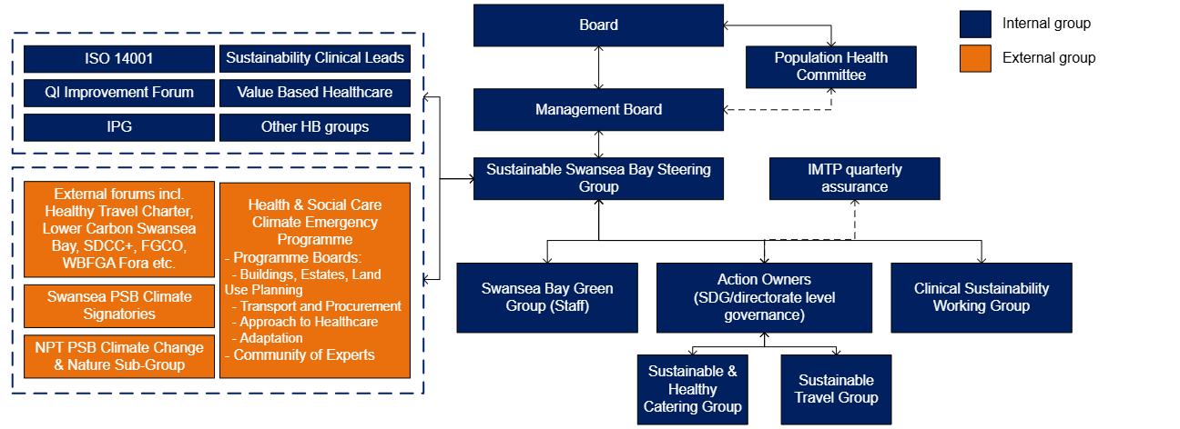
Figure 7: Governance structure

Roles and responsibilities
Table 3 shows the roles and responsibilities in relation to the Climate Action Plan.
Table 3: Climate Action Plan roles and responsibilities
Role | Responsibilities
Senior Responsible Officer (SRO) | - Acts as executive lead for the Climate Action Plan (CAP), ensuring alignment to A Healthier Swansea Bay objectives and IMTP/Annual Plan processes.  - Sponsors and signs off CAP updates, major decisions, and escalations; removes blockers across SDGs/directorates.  - Assures governance, ensuring actions are built into planning and performance routes and that resilience/adaptation considerations are embedded.
Sustainable Swansea Bay Steering Group | - Serves as the central assurance forum for CAP delivery every 3 months, receiving progress and risk updates from Action Owners not reporting via IMTP.  - Holds Action Owners to account, requests corrective actions, and coordinates cross‑functional support.  - Tracks interdependencies across Culture, Buildings & Estate (incl. Nature), Procurement, Travel, and Sustainable Healthcare; escalates systemic risks.
IMTP quarterly assurance | - Provides the formal performance route for actions embedded in directorate IMTPs, delivering quarterly assurance on milestones, KPIs, and risks.  - Integrates climate mitigation/adaptation into routine planning and performance reviews across Digital, Workforce & OD, and Service Delivery Groups.  - Feeds exceptions and cross‑cutting risks back to the SRO/Steering Group for resolution.
Local Senior Leadership Team (SLT) | - Own local delivery of CAP actions within services/directorates; ensure resourcing, sequencing, and operational enablement.  - Embed CAP actions into local governance, risk registers (incl. CCROA items), and business continuity planning; ensure frontline feasibility.  - Report via the appropriate route (IMTP or Steering Group) and lead issue management and benefits realisation locally.
Action Owner | - Leads the design and delivery of specific CAP actions (scope, milestones, KPIs, dependencies).  - Maintains evidence and data, including outcome measures and (where feasible) emissions/waste metrics for Procurement/Clinical actions.  - Reports progress through the correct governance channel: IMTP (quarterly) or Steering Group (bi‑monthly); raises risks/needs early.  - Implements co‑benefits and partnership working where actions touch NWSSP, PSBs, NRW or other system partners.
Swansea Bay Green Group | - Functions as the staff‑led innovation and engagement network, testing, spreading and scaling practical sustainability ideas.  - Channels staff feedback (e.g., lived experience during heat/adverse weather) into CAP development and CCROA updates.  - Promotes behaviour change communications and supports campaigns (e.g., energy switch‑off, nature engagement)
Clinical Sustainability Working Group | - Translates CAP into clinical practice, aligning with frameworks (e.g., GreenED, Greener Theatres) and clinical guidelines.  - Co‑develops low‑carbon models of care, leads clinical audits/KPIs, and supports digitalisation and waste reduction initiatives.  - Works with Infection Prevention & Control, Estates and Digital to operationalise changes safely (e.g., equipment, records, ventilation/heat).
All staff | - Adopt everyday sustainable practices (energy, waste segregation, travel hierarchy, nature use for wellbeing) and participate in surveys during heat/adverse weather.  - Use available resources/training, contribute ideas to the Green Group, and support business continuity during climate events.  - Consider climate impacts in QI projects and routine decisions; escalate risks or opportunities through local governance

Future challenges
Three challenges that are on the horizon that will need to be considered within the climate change programme and wider organisational processes include:
1: Changing understanding of climate impacts and timeframes
 | The climate is changing at a quicker rate than anticipated with critical thresholds being reached in natural systems. This means that the scenarios associated are being reached quicker than first expected, highlighted by the letter from the Climate Change Committee to the UK Government recommending the 2°C scenario, originally predicted for 2100, be used for 2050 shifting it 50 years earlier. This requires there to be regular updates and reviews to enable the Health Board to be aware of the impacts and approach.

2: New climate risks being identified
 | Significant gaps have been recognised in this report. As these are addressed, new risks and actions will be raised, these will need to be addressed outside of this action plan. All additional actions will be added to the delivery plan and monitored accordingly, including reporting mechanisms to Welsh Government.

3: Systems wide collaboration
 | The CCROA clearly demonstrated that partners’ responses to climate will impact Health Board, as well as our response impacting them. Significant work is required to ensure that systems wide conversations are had to minimise conflict between responses. It is recognised existing forums may be suitable; the challenge will be to ensure it is on the agenda.

Glossary
Active travel | Travel, especially commuting or movement in one's local area, of a kind that involves physical exercise, such as walking, wheeling, or cycling.
Built environment | Manufactured structures, features, and facilities viewed collectively as an environment in which people live and work in.
Climate adaptation | Altering our behaviour, systems, and—in some cases—ways of life to protect our families, our economies, and the environment in which we live from the impacts of climate change (Climate Change Mitigation and Adaptation Explained | World Wildlife Fund)
Climate emergency | A situation in which urgent action is required to reduce or halt climate change and avoid potentially irreversible environmental damage resulting from it.
Climate mitigation | Avoiding and reducing emissions of heat-trapping greenhouse gases into the atmosphere to prevent the planet from warming to more extreme temperatures (Climate Change Mitigation and Adaptation Explained | World Wildlife Fund)
Corporate Joint Committee | a type of local government institution introduced in Wales by the Local Government and Elections (Wales) Act 2021 with powers relating to economic well-being, strategic planning, and the development of regional transport policies
Decarbonisation | Reduction or elimination of carbon dioxide emissions from a process
Determinants of health | The social and economic environment, the physical environment, and the person's individual characteristics and behaviours that influence health
Emissions | An amount of a substance that is produced and sent out into the air that is harmful to the environment, especially carbon dioxide (Cambridge Dictionary, 2023)
Employer | An organisation that employs people
Extreme weather events | Occurrences of unusually severe weather or climate conditions that can cause devastating impacts on communities and agricultural and natural ecosystems. Weather-related extreme events are often short-lived and include heat waves, freezes, heavy downpours, tornadoes, tropical cyclones, and floods.
Fabric of buildings | Elements that characterise the structure as a building, such as walls, roofs, internal surfaces, floors, stairs and landings and all doors and windows. The fabric of the building also includes plumbing and central heating systems, and mains wiring and lighting systems. (Gov.UK, 2016)
Food security | The state of having reliable access to enough affordable, nutritious food.
Health equity | Everyone has a fair and just opportunity to be as healthy as possible
Healthcare provider | An organisation that provides healthcare to a population or group
Heatwave | A UK heatwave threshold is met when a location records a period of at least three consecutive days with daily maximum temperatures meeting or exceeding the heatwave temperature threshold. In Swansea and Neath Port Talbot this 25°C: What is a heatwave? - Met Office
Local Resilience Forum | Space which brings together all responder organisations that have a duty to co-operate under the Civil Contingencies Act.
Major local organisation | large organisations whose long-term sustainability is tied to the wellbeing of the populations they serve
Multimorbidity | The presence of two or more long-term health conditions
Net zero | a target of completely negating the amount of greenhouse gases produced by human activity, to be achieved by reducing emissions and implementing methods of absorbing carbon dioxide from the atmosphere (Oxford Languages, 2023)
Paris agreement | A legally binding international treaty on climate change. It was adopted by 195 Parties at the UN Climate Change Conference (COP21) in Paris, France, on 12 December 2015.
Physiological | Relating to the branch of biology that deals with the normal functions of living organisms and their parts.
Place-making | Creating places and focuses on transforming public spaces to strengthen the connections between people and these places (Arch Daily, 2021)
Population health | Tthe health outcomes of a group of individuals, including the distribution of such outcomes within the group (Kindig & Stoddart, 2003)
Prevention | Keeping people healthy and avoiding the risk of poor health, illness, injury, and early death.
Public Services Board (PSB) | Statutory body responsible for improving joint working across all public services in each local authority, responsible for conducting a well-being assessment, publishing a local well-being plan, and publishing an annual report. The plan sets out how they will meet their responsibilities under the Well-being of Future Generations (Wales) Act.
Scope 1 | Emissions from sources that an organisation owns or controls directly – for example from burning fuel in our fleet of vehicles (if they’re not electrically-powered) (National Grid, 2023)
Scope 2 | Emissions that a company causes indirectly and come from where the energy it purchases and uses is produced. For example, the emissions caused when generating the electricity that we use in our buildings would fall into this category (National Grid, 2023)
Scope 3 | Emissions that are not produced by the company itself and are not the result of activities from assets owned or controlled by them, but by those that it is indirectly responsible for up and down its value chain. An example of this is when we buy, use and dispose of products from suppliers (National Grid, 2023)
Social capital | The networks of relationships among people who live and work in a particular society, enabling that society to function effectively.
Social value | Social, environmental, cultural and economic impacts of actions taken by communities, organisations, governments and individuals (Gov.Wales, 2022)
Supply chain | The sequence of processes involved in the production and distribution of a commodity and/or service
Sustainable diet | One which has a low impact on the environment but is still good for our health. Diet recommendations should also take into consideration other factors such as health, cost, and accessibility.
Sustainable Healthcare | Sustainable healthcare delivers high quality care without damaging the environment, is affordable now and in the future and delivers positive social impact (Centre for Sustainable Healthcare)

Appendix 1
Detailed Action Plan
All actions are coded, for example:
- A letter indicating which section it is from: ‘C’ for Culture & Ways of Working; ‘T’ for Transport; ‘B’ for Buildings & Estate; ‘P’ for Procurement; or ‘S’ for Sustainable Healthcare
It is also shown where:
- Role in ‘A Healthier Swansea Bay’ – see Section 1.4
- Whether the action is supporting climate mitigation, adaptation or both
- Source of the action:
  - SDP: NHS Wales decarbonisation strategic delivery plan 2025 to 2030 [HTML] | GOV.WALES
  - CCROA: Health Board Climate Change Risk and Opportunity Assessment
  - Adaptation Strategy for Wales: Climate Adaptation Strategy for Wales 2024 | GOV.WALES
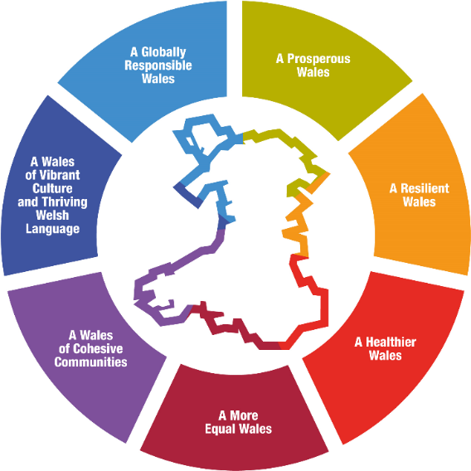
  - JT: Just Transition Framework 2025
In addition, each action has been mapped against how it supports the Well-Being of Future Generations Act’s seven goals. The key that has been used is shown below:
WBFGA key:
 | A Prosperous Wales |  | A Resilient Wales
 | A More Equal Wales |  | A Wales of Cohesive Communities
 | A Globally Responsible Wales |  | A Healthier Wales
 | A Wales of Vibrant Culture and Thriving Welsh Language

OUR CULTURE & WAYS OF WORKING
# | Action | Owner | Role ‘A Healthier Swansea Bay’ | Mitigation or adaptation? | Completion date | Source | WBFG
C01 | Build climate action (emissions reduction and adaptation) into planning mechanisms to support staff-led initiatives e.g. Medium-Term Plan, Clinical Strategic Plan and Planning and Finance Assurance Group, cluster planning, partnerships | Planning & Partnerships | Major local org Healthcare provider | Both | Dependent on IMTP timelines | SDP 1b  JT
C02 | Develop and implement a communications approach and plan to build momentum for climate action | DICE - Communications | Major local org Healthcare provider | Both | Dec-26 | SDP 3c
C03 | Develop a workforce strategy to support delivery of the ‘Delivering sustainable healthcare: position statement,’ including climate adaptation requirements. | Workforce & OD | Employer  Major local org Healthcare provider | Both | Dec-26 | SDP 3d  JT
C04 | Allocate spread and scale initiatives to responsible group for consideration, and where feasible delivery. | Planning & Partnerships | Healthcare provider | Both | As required | SDP 4b
C05 | Use questionnaires during heat periods to identify areas of highest impact and build an understanding of lived experience of Health Board staff | Planning & Partnerships | Employer  Healthcare provider | Adaptation | As required | CCROA
C06 | Use questionnaires during adverse weather incl. flood, storm and cold to identify areas of highest impact and build an understanding of lived experience of Health Board staff | Planning & Partnerships | Employer  Healthcare provider | Adaptation | As required | CCROA
C07 | Publish and share resources to support staff in delivering emissions reduction and climate adaptation | Planning & Partnerships | Employer  Healthcare provider | Both | Ongoing | SDP 3a  CCROA JT
C08 | Promote public health campaigns on climate impacts and health, including heat | DICE - Communications | Major local org  Healthcare provider  Productive partner | Adaptation | As required | CCROA  JT
C09 | Collaborate with All Wales colleagues on addressing evidence and data gaps | Planning & Partnerships | Healthcare provider  Productive partner | Adaptation | 2026-2030 | CCROA
C10 | Map partners, purpose of partnership, and links with climate adaptation including, but not limited to:  - Commissioning - Private, third sector and inter NHS Wales  - Other groups e.g. PSB, RPB, LRF etc. | Planning & Partnerships | Major local org  Healthcare provider | Adaptation | 2026-2030 | CCROA
C11 | Providing updates around climate risks to support Business Continuity Plans and other resilience mechanisms | Planning & Partnerships | Major local org Healthcare provider  Employer | Adaptation | Ongoing, as evidence base develops – C09 | CCROA
C12 | Build understanding of areas where there may be increased demand from different population groups and how these are distributed across the Health Board / Clusters | Public Health | Major local org  Productive partner | Adaptation | 2026 | CCROA  JT
C13 | Build CCROA recognised risks into local risk assessments to enable ownership and accountability | Planning & Partnerships | Major local org | Adaptation | 2027 | CCROA
C14 | Build regional climate resilience in partnership with the Public Services Boards (Swansea and NPT) | Planning & Partnerships | Productive partner | Both | Ongoing – see relevant plans for detailed actions | CCROA  JT
C15 | Maintain and develop the CCROA as understanding of impacts and risks develops | Planning & Partnerships | Major local org  Healthcare provider  Employer  Productive partner | Adaptation | Updated as required | CCROA

OUR TRAVEL
# | Action | Owner | Role ‘A Healthier Swansea Bay’ | Mitigation or adaptation? | Completion date | Source | WBFG
T01 | Provide efficient or eco driving training to staff who are required to drive regularly (i.e. more than once per week) as part of their job role (including work travel in an employee-owned vehicle). | Support Services | Major local org Healthcare provider Employer | Mitigation | Mar-27 Pending All Wales module development | SDP 13a
T02 | All new owned or leased NHS vehicles will have a telematics system installed at the point of sale or lease - excluding any obtained on the salary sacrifice scheme | Support Services | Major local org Healthcare provider | Mitigation | Dec-25 | SDP 13b
T03 | Develop an agreed approach and implementation plan to Electric Vehicle Charging Infrastructure covering fleet, NHS Wales partners, other delivery, partners, staff, patients and visitors, and provision of charging for work vehicles | Support Services | Major local org Healthcare provider | Mitigation | Mar-27 | SDP 14a, 14b, 14d, 14e
T04 | Actively participate in the All-Wales Fleet and Transport Group | Support Services | Productive partner | Mitigation | Mar-26 | SDP 14f
T05 | Align vehicle purchasing with NHS Wales Decarbonisation Strategic Delivery Plan requirements. | Support Services | Major local org | Mitigation | As per action | SDP 15a
T06 | Conduct an organisational staff travel, commuting and homeworking survey to collect baseline data and identify opportunities to increase uptake in low‑carbon travel and homeworking practices. | Support Services | Major local org Employer | Mitigation | May-27 & then annually | SDP 16b  JT
T07 | Develop a staff travel plan outlining an organisational approach to encouraging the Sustainable Transport Hierarchy and embedding Healthy Travel Charters across staff travel, including commuting and business travel. | Support Services | Major local org Healthcare provider Employer | Both | May-28 | SDP 17a  JT
T08 | Create user‑friendly guides that map out practical low‑carbon transport options for staff and the public, including routes, accessibility details, and sustainable travel tips. | Support Services | Major local org Healthcare provider Employer | Both | Sep-26 | SDP 17b  JT

OUR BUILDINGS & ESTATE
# | Action | Owner | Role ‘A Healthier Swansea Bay’ | Mitigation or adaptation? | Completion date | Source | WBFG
B01 | Establish and embed a process to actively monitor each building’s (or site’s) energy consumption to identify and address excess consumption and inform development of energy saving projects. | Estates - Technical Services Team | Major local org | Mitigation | Sep-26 | SDP 5a
B02 | Conduct seasonal reviews of building controls (i.e. BMS, heating timers, thermostats) to optimise efficiency and ensure standard operating procedures (SOPs) are being followed. | Estates - Technical Services Team | Major local org | Both | Mar-26 | SDP 5b
B03 | Embed energy management practices in day‑to‑day healthcare practice through energy reduction campaigns (e.g. posters, labels, intranet campaigns, etc.) | Assistant Director PFI hand back, commercial and decarbonisation | Major local org | Mitigation | Sep-26 | SDP 5d
B04 | Provide NWSSP with a list of scalable reference decarbonisation projects and measures across the NHS Wales estate and align with All‑Wales contract frameworks to enable efficient procurement and delivery. | Interim Director of Capital & Estates | Major local org Productive partner | Mitigation | List provided by Dec 2026 and updated every two years | SDP 6b
B05 | Estates and facilities teams will actively engage with transport teams across the NHS (e.g. WAST, NWSSP) to identify and implement requirements for NHS front‑line electric vehicle charging at their sites to enable vehicle electrification and actively engage with Welsh Government to identify funding opportunities for implementation. | Interim Director of Capital & Estates | Major local org Productive partner | Mitigation | To align with relevant deadlines in T03 Pending funding | SDP 6c
B06 | Review electrical capacities across sites to determine limitations for electrification and identify priority locations for electrical supply upgrades. | Interim Director of Capital & Estates | Major local org | Mitigation | Mar-27 Pending funding | SDP 6d
B07 | Where opportunities for space rationalisation (e.g. office space) may exist, monitor utilisation through smart technologies (e.g. occupancy sensors) to inform decisions on estate rationalisation, shared workspaces, and energy‑efficient building use. | Capital Planning | Major local org | Both | Mar-28 | SDP 6e
B08 | For non‑acute sites (e.g. community hospitals, health centres or clinics, offices), plan and implement targeted decarbonisation projects aligned with the principles of the UKGBC Net Zero Carbon Buildings Framework (e.g. optimisation, energy efficiency upgrades) to meet building decarbonisation targets. Larger projects should follow a fabric first approach (thermal surveys may be beneficial) and include the replacement of fossil fuel heating systems with low carbon alternatives | Interim Director of Capital & Estates | Major local org Healthcare provider  Productive partner | Both | Pending funding | SDP 7a
B09 | For acute sites and large hospitals, plan and implement targeted decarbonisation projects (e.g. optimisation, energy efficiency upgrades) to meet building decarbonisation targets. Larger projects, where viable and operationally effective opportunities exist, should follow a fabric‑first approach aligned with the principles of the UKGBC Net Zero Carbon Buildings Framework. (https://ukgbc.org/resources/net-zero-carbon-buildings-framework/). | Interim Director of Capital & Estates | Major local org Healthcare provider  Productive partner | Both | Pending funding | SDP 7b
B10 | Continue to operate all current CHP plant to the end of its current working life without major refurbishment and certify to the CHPQA programme to ensure efficient operation. | Estates | Major local org | Mitigation | Annual | SDP 8a
B11 | Decommission fossil fuel CHP in line with plant life expiry, prioritising decommissioning over major refurbishment (e.g. engine replacement), with all fossil fuel CHP to be decommissioned by 2035. | Estates | Major local org | Mitigation | All fossil fuel systems decommissioned by 2035 | SDP 8b
B12 | New renewable CHP (e.g. biomass) and emerging sustainable technologies will be supported (subject to feasibility and air quality impacts). No new fossil fuel or ‘hydrogen‑ready’ CHP units will be installed. | Estates | Major local org | Mitigation | As required | SDP 8c
B13 | Undertake renewable energy opportunities assessments (e.g. roof‑mounted solar PV, solar car ports, waste heat recovery, etc.) for all sites to identify on‑site and off‑site private wire opportunities. Viable opportunities should be progressed or installed to ensure each organisation meets their renewable energy generation targets. | Interim Director of Capital & Estates | Major local org | Both | Dec-28 Pending funding | SDP 9a
B14 | Ensure alignment with the guidance on all new buildings and major refurbishments, and report compliance where required. | Capital Planning | Major local org | Both | Dec-26 | SDP 11b
B15 | On new projects identify current and future requirements for electric vehicle charging infrastructure for delivery of NHS front‑line services, including requirements of partners e.g. WAST. | Capital Planning | Major local org Productive partner | Mitigation | Mar-26 Pending funding | SDP 11c
B16 | Where a new or renewed building lease is being explored (both as a tenant and a landlord), follow the NWSSP guidance during discussions to ensure buildings will operate as efficiently as possible. | Capital Planning | Major local org Productive partner | Both | Dec-26 | SDP 12b
B17 | Install EVCI infrastructure at NHS sites as identified in the Electric Vehicle Charging Infrastructure Plan in line with the NHS Wales Electric Vehicle Charge Point Best Practice Guidance (where applicable). | Capital planning | Major local org Productive partner | Mitigation | See 15a Pending funding | SDP 14c
B18 | Create and maintain a log of Power Purchase Agreements (PPAs) opportunities; in partnership with the Welsh Government Energy Service, engage with community groups and other public sector bodies to understand local generation-supply opportunities. | Estates | Major local org Productive partner | Mitigation | Sep-26 | SDP 21b
B19 | Where specific temperatures are critical to the clinical process, consider increased design criteria to account for climate change temperature fluctuation. | Capital Planning | Major local org Healthcare provider | Adaptation | Mar-27 | CCROA
B20 | Flood risk and climate change assessments will be considered for new leases and new capital builds. This will be dependent on available finance and the lease-term. | Capital Planning | Major local org Healthcare provider | Adaptation | Mar-26 | CCROA
B21 | Review access and availability to cold drinking water for staff and patients | Water Committee | Healthcare provider  Employer | Adaptation | Dec-27 | CCROA
B22 | Work with NWSSP Specialist Estates Services to build resilience to climate related events in buildings e.g. flood, storms, and heat | Interim Director of Capital & Estates | Major local org Healthcare provider  Productive partner | Adaptation | Mar-30 | CCROA

OUR BUILDINGS & ESTATE: NATURE
# | Action | Owner | Role ‘A Healthier Swansea Bay’ | Mitigation or adaptation? | Completion date | Source | WBFG
N01 | Support localised initiatives to expand or maintain green spaces on hospital and community sites (e.g. NHS Forest) for use by staff, the public and patients, to enhance well‑being and aid recovery and social prescribing. | Interim Director of Capital & Estates | Major local org Healthcare provider  Employer  Productive partner | Both | Dec-26 Pending funding | SDP 9C
N02 | Undertake a session with Swansea Council and NRW to build understanding of green infrastructure and opportunities to use at the Health Board | Interim Director of Capital & Estates | Major local org  Productive partner | Both | Mar-27 | CCROA
N03 | Continue to run 'No mow May' | Estates | Major local org | Both | Ongoing | Adaptation Strategy for Wales
N04 | Maintain areas created by the Biophilic Wales project | Estates | Major local org Productive partner | Both | Ongoing | Adaptation Strategy for Wales
N05 | Limit pesticide use e.g. only by contractors for invasive species including knotweed | Estates | Major local org | Both | Ongoing | Adaptation Strategy for Wales
N06 | Share opportunities for staff to take action including Wales Nature Week and any other identified opportunities | DICE - Communications | Major local org Healthcare provider  Employer  Productive partner | Both | Annual, starting Mar-26 | Adaptation Strategy for Wales
N07 | Encourage teams to identify ways to spend more time in nature through e.g. promoting walking meetings, using meeting venues with access to green space, well-being walks, etc. | Planning & Partnerships | Major local org Healthcare provider  Employer | Both | Annual, starting Mar-26 | CCROA
N08 | Identify how new developments at the Health Board can support improvements to Health Board biodiversity | Capital Planning | Major local org Healthcare provider | Both | Sep-26 | Adaptation Strategy for Wales
N09 | Consider opportunities to co-manage sites biodiversity with Council partners. Where feasible, progress as funding is obtained. | Estates | Major local org Healthcare provider | Both | Mar-26 | Adaptation Strategy for Wales

OUR PROCUREMENT
# | Action | Owner | Role ‘A Healthier Swansea Bay’ | Mitigation or adaptation? | Completion date | Source | WBFG
P01 | Work with NWSSP to assess the effectiveness of procurement criteria in advancing low-carbon and resource efficient delivery | Procurement | Major local org Productive partner | Mitigation | Dec-26 Pending NWSSP | SDP 19b
P02 | Include an organisational environmental sustainability representative in any procurement exercise exceeding £6 million (inc. VAT) | Procurement | Major local org | Both | Sep-26 | SDP 19d
P03 | Work with NWSSP to develop an emissions quantification methodology for surplus stock | Procurement | Healthcare provider | Mitigation | Sep-26 Pending NWSSP | SDP 22a
P04 | Where feasible, report on surplus and expired stock volumes | Procurement | Healthcare provider | Mitigation | Quarterly reports from Sep-26 Pending NWSSP | SDP 22b
P05 | Where feasible, include environmental impact reporting in stock management and consumption programmes | As per Programme Owner | Healthcare provider | Mitigation | TBC - upon completion of method Pending NWSSP | SDP 22c
P06 | Any contract in the future to include climate resilience in business continuity plans | Procurement | Major local org Healthcare provider  Productive partner | Adaptation | From April-26 | CCROA
P07 | Once determined, use NWSSP climate adaptation assessment methodology for supply chain resilience. Undertake an assessment of local procurement for all future contracts from that point | Procurement | Major local org Healthcare provider  Productive partner | Adaptation | TBC - upon completion of NWSSP method | CCROA

OUR SUSTAINABLE HEALTHCARE
# | Action | Owner | Role ‘A Healthier Swansea Bay’ | Mitigation or adaptation? | Completion date | Source | WBFG
S01 | Assign a Your Medicines, Your Health (YMYH) Programme Lead(s) for primary and secondary care to embed the principles of YMYH in reducing medicines waste and improving adherence, with regular attendance at YMYH Programme Lead meetings. | Pharmacy | Healthcare provider | Mitigation | Sep-26 | SDP 22d
S02 | Initiate an Only Order What You Need Campaign. | Pharmacy | Healthcare provider | Mitigation | Sep-27 | SDP 22e
S03 | Report sustainability related key performance indicators, where included in clinical guidelines | Dependent on guidelines | Healthcare provider | Mitigation | Dependent on guidelines | SDP 23d
S04 | Continue to digitalise clinical records and communications to increase resource efficiency and reduce printing resource requirements. | Digital | Healthcare provider | Both | Annual reporting | SDP 24d
S05 | Develop a tailored organisational waste management plan considering the waste hierarchy and circular economy principles. As well as ensuring compliance with Natural Resources Wales regulations, this plan should outline:  - A communication strategy to promote effective waste segregation at the source across all departments.  - Collaboration arrangements involving internal stakeholders (e.g., procurement managers) and external partners (e.g., licensed waste management contractors).  - Defined roles and responsibilities within the NHS organisation. | Estates | Major local org Productive partner | Mitigation | Sep-26 Pending additional resources and clarifications | SDP 25b
S06 | Conduct a baseline audit of nature-based interventions: Identify and document current nature-based healthcare initiatives (e.g., green spaces for recovery, therapeutic gardens) across facilities. | Sustainable Swansea Bay Steering Group | Major local org Healthcare provider  Productive partner | Both | Mar-27 | CCROA
S07 | Engage Stakeholders to Explore Opportunities: Organize stakeholder workshops (clinicians, estates, patients, community partners) to understand potential uses of nature in healthcare delivery. | Dependent on completion of S06 | Major local org Healthcare provider  Productive partner | Both | Mar-28 | CCROA
S08 | If feasible, develop Nature-in-Healthcare actions for considering outdoor therapy spaces, green prescribing pathways etc. | Dependent on completion of S06 | Major local org Healthcare provider  Productive partner | Both | Mar-29 | CCROA
S09 | Sustainability Clinical Leads to continue to develop schemes to support Health Board sustainability | Planning and Partnerships | Healthcare provider  Productive partner | Both | Nov-26 | --
S10 | Develop a literature review providing evidence of what low carbon healthcare and climate adaptative healthcare looks like, identifying where it is already used in the Health Board and further opportunities to inform plans and strategies in the future | Planning & Partnerships | Major local org Healthcare provider  Productive partner | Both | Aug-26 | CCROA

Appendix 2
Sustainable healthcare – What does low carbon healthcare look like?
Efficiency | Community by design | Prevention | Patient led
Increasing efficiency reduces waste across the system – maximising how we use resources. | Care at home and based in the community is less carbon intensive than treatment at acute sites | Reducing overall healthcare need of a population reduces the emissions of a healthcare organisation | Only uses resources when needed, increasing efficiency and reducing waste
- Reducing wastes of time, energy & materials  - Early mobilisation leading to earlier discharge  - Running at capacity  - Reducing DNAs/CNAs | - Community Psychology  - Independent prescribers  - Minor surgery in Primary Care  - Ring pessary service  - Community Drug and Alcohol Team | - Primary prevention reduces the ‘need’ on services, therefore reducing emissions associated  - Smoking cessation  - All-Wales Diabetes Prevention Programme  - All-Wales Weight Management Pathway  - Vaccine equity | - Your Medicines Your Health  - See on Symptom (SoS)  - Patient Initiated Follow-Up (PIFU)  - Family initiated care in Neonatal Units
Digital | Quality, value, and care | Green Group | Other
Reduces physical resources and associated waste and duplication |  | Related to wider examples: | Wider schemes that support emissions reduction:
- Paperless systems: Questionnaires, patient information, digital patient records, digital prescriptions  - Virtual / remote consultations  - Swansea Bay Patient Portal & Hybrid mail  - Working from home | - Programme to reduce frailty  - Work to increase hydration  - Quality improvement inclusion of sustainability  - Frameworks e.g. GreenED, Green Endoscopy, Greener Theatres etc.  - Value Based Healthcare – building emissions into value calculations  - Arts in Health – bringing nature into staff and patient wellness | - Greener Care Framework – Being led by SBU – staff empowerment  - Peripheral Plasma Exchange: Cost savings and improved patient experience support emissions savings  - Renal: Locations closer to patients home e.g. intro of the Bridgend unit saves patients a collective 5,097 miles per week  - Occupational Therapy: Use of outside space to improve patient experience including litter picking and visits to Cae Felin | - Prehabilitation: Keeping people well and reducing recovery times also reduces emissions impact e.g. Waiting well  - Virtual wards: ‘Virtual ward’ bed uses 4 times less carbon than traditional inpatient bed (Source: BMJ Group)  - Optimising breastfeeding  - Cae Felin Community Support Agriculture and greener social prescribing

Acknowledgments
The action plan was co-ordinated by the Sustainability Team and made possible by a collaborative effort involving enthusiastic staff from across the Health Board. Thank you to all the staff and wider teams who are enabling this amazing response and truly living the Well-Being of Future Generations Act. Thanks to all those who have shared their work and committed to building climate action that truly reflects the emergency we are in! This includes:
- Capital Planning
- Climate Action Plan Implementation Group
- Communications
- PFI, Commercial and Decarbonisation
- Digital
- Dr Rebecca Jones at Dulais Valley Primary Care Centre
- Estates
- Finance
- Green Group
- Lymphoedema
- Mental Health and Learning Disabilities Service Delivery Group
- Morriston Service Delivery Group
- Neath Port Talbot Singleton Service Delivery Group
- Pharmacy
- Planning & Partnerships
- Primary Care, Community and Therapies Service Delivery Group
- Public Health Team
- Quality Improvement
- Support Services
- Sustainability Clinical Leads
- Sustainable Swansea Bay Steering Group
- Therapies
- Value Based Healthcare
- Workforce & Organisational Development
As well as working beyond our organisation, thanks to partners including:
- Natural Resources Wales
- Neath Port Talbot Public Services Board Climate & Nature Working Group
- NHS Wales Climate Preparedness Leads
- Swansea Public Services Board Climate & Nature Working Group
- Welsh Government and the Health and Social Care Climate Emergency Programme, including the Community of Experts
- Wider NHS Wales colleagues

What is a heatwave? - Met Office – 3 days over 25°C in Swansea and Neath Port Talbot geographical areas
Summer 2025 is the warmest on record for the UK - Met Office
PHW-Climate-Change-HIA-Summary-Report-English-Final-10_2023-002.pdf
LCAT-Introduction-to-Local-Climate-Adaptation-May-2024.pdf

