Contaminated Casualties Procedure for Swansea Bay University Health Board (SBUHB)

DOCUMENT AUTHOR: | Head of Emergency Preparedness, Resilience and Response (EPRR)
APPROVED BY: | Emergency Preparedness Resilience and Response (EPRR) Oversight Group
APPROVAL DATE: | 18th September 2025
REVIEW DATE: | 17th September 2027
DOCUMENT No: | 4

Definition of a Procedure
This procedure is a set of detailed step-by-step instructions that describe the appropriate methods for decontaminating persons exposed to hazardous substances to the highest standards possible and to ensure efficiency, consistency and safety.

Minor Amendments
If a minor change is required to the document, which does not require a full review please identify the change below and update the version number.

Type of change | Why change made | Page number | Date of change | Version 1 to 1.1 | Name of responsible person
Development of Document |  |  | 22.11.2012 | 1.1 | KJones/M MCabe
 |  |  | 20.06.2013 | 1.2 | KJones/M MCabe
 |  |  | 18.07.2013 | 1.3 | KJones/M MCabe
 |  |  | 31.07.2013 | 1.4 | KJones/M MCabe
Final |  |  | 26.09.2013 | 2 | KJones/M MCabe/Emergency Procurement Group
Reviewed | Due for review |  | April – September 2016 | 2.1 | K Jones/M McCabe
Reviewed | To reflect recent changes in guidance |  | April – July 2017 | 3 | K Jones/EPRR Strategy Group
Review | Due for review, exercise arranged to test Procedure March 2024 |  |  | 3.1 | Head of EPRR / EPRR Manager / EPRR Strategy Group
Review | Additional action cards – Pharmacy, Radiation Physics, IP&C |  | March 2024 | 3.2 | Head of EPRR / EPRR Manager / EPRR Strategy Group
Review | Full review following live incident, debrief and lessons identified |  | September 2024 | 3.3 | Head of EPRR / EPRR Manager / Hannah Williams (Graduate Trainee)
Review | Reviewed and updated following Contaminated Casualties Exercise (April 2025) and release of the Health Protection Framework (June 2025) |  | September 2025 | 4 | Head of EPRR / EPRR Manager

IMMEDIATE ACTIONS

If You Have Received Notification That The Contaminated Casualties Procedure Has Been Invoked And a Major Incident or Business Continuity/Critical Incident Has Been Declared And You Are Required to Attend The Site Where The Incident Has Been Declared And to Undertake The Actions Specified Within the Respective Action Cards.

If You Have Not Read This Procedure

DO NOT READ THIS NOW

FIND YOUR RELEVANT ACTION CARD IN THE APPROPRIATE SECTION
AND FOLLOW THE INSTRUCTIONS

This procedure should be read in conjunction with the following HB procedures:
Major Incident
Business Continuity
Pandemic
Countermeasures
Evacuation/Invacuation
Lockdown
Mass Casualty Incident Arrangements for NHS Wales

CONTENTS
- Procedure Statement
- Incident Identification and Activation
- General CBRN Visual Indicators
- Chemical Incident
  - Individual Chemical Exposure Events (ICE)
- Biological Incidents
- Radiological Incidents
- Process For Immediate Incident Management For Hospital Staff for a CBRN Incident
  - Recognise, Assess, React (RAR) - Indicators for a hazardous substance
    - Recognise
    - Assess
    - React
  - Evacuation, disrobe and Decontamination – REMOVE principles
  - Evacuation
  - Disrobe
  - Decontamination
    - Dry Decontamination
    - Wet Decontamination
  - Situation Reporting
  - Communication to Casualties
  - Responder Guidance & PPE
  - Care After Death
- Waste Management
- Service Continuity
- Multi-Agency Coordination
- Seeking Specialist Advice
- Recovery
- Post Incident
- Training
- Health Board Response & Action cards
- Welsh Health Protection System
- Equality Impact Assessment Statement
- Document References
- Action Cards
  - First Responder at scene
  - Switchboard
  - Emergency Department
  - Emergency Department Senior Clinician/Consultants
  - Emergency Department Decontamination Team
  - Silver Command
  - Service Group Nurse Director/Deputy
  - Portering Team Leaders
  - Estates
  - Security
  - Domestic Services
  - Emergency Department Receptionist
  - Minor Injuries Unit
  - Large Volume Decontamination
  - Pharmacy
  - Radiation Physics
  - IP&C
- Annexes
Annex A Disrobe Pictogram
Annex B Decontamination Procedures
Annex C Chemical Incident Questionnaire
Annex D Radioactivity contaminated/ irradiated casualties: Identification, treatment and monitoring
Annex E PPE
Annex F CBRN Body Bag
Annex G Annex F- Sodium Azide Data Sheets
Annex H Activating Multi Agency Command and Control
Annexe I Key Contacts
Annex J JESIP Principles for Joint Working
Annex K Health Protection Framework

HEALTH BOARD EMERGENCY RESPONSE, COMMAND, CONTROL & CO-ORDINATION (C3)

The following will be a standard process as articulated within the Health Board (HB) Major Incident (MI) Procedures or BC/Critical incident Procedures for any Emergency Response:

- C3 arrangements
- JESIP Interoperability Principles
- Information management
- Communication Strategy
- Service Business Continuity Procedures to be invoked alongside any Emergency Response

All Emergency Response Procedures are flexible and adaptable; this allows for a tailored response to all emergencies and any additional threats and risks that may arise at the time.

PROCEDURE STATEMENT
The purpose of this procedure is to set out how the Health Board will respond in the event of a contamination incident. The catchment area of the Health Board contains sites that sit under the COMAH regulations, numerous (small) industrial units. In addition, there are other risks linked with the potential for a contaminated casualties incident. There are five separate COMAH sites (with procedures in place) in the SBUHB area.
These factors carry a small but inherent risk of contamination incidents occurring. This procedure aims to set out how to deal with such incidents and resulting casualties/fatalities.
The internal key stakeholders associated with this procedure are:
- Support Services
- Emergency Department (ED)
- Minor Injuries Unit (MIU)
- Emergency Admission areas – Acute Medical Unit (AMU)
- SDG Directors
- Estates
- HB Procurement (Shared Services)
- Infection, Prevention & Control (IPC)
- Radiation Physics
- Pharmacy
- Mortuary
- Health And Safety
- EPRR

Hazardous Material (HazMat), Chemical, Biological, Radiation, Nuclear (CBRN) and Individual Chemical Exposure (ICE) incidents pose an enormous risk to the Health Boards infrastructure. Upon receiving or identifying contaminated casualties on Health Board Premises, efforts should be focused on safety and preventing further contamination of staff, patients and facilities.
It must be noted that this procedure, could be actioned at the same time and alongside the Health Board Major Incident Procedures and other emergency response and Business Continuity Procedures, but may also be invoked as a stand- alone procedure as a result of an isolated incident.
The term CBRN is reserved for the deliberate release of a hazardous material such as in a terrorist attack.
The term Hazmat is used for the accidental release or exposure to a hazardous material.
The term ICE is frequently characterised by the use of a chemical or a mixture of chemicals by an individual/s with the intent to self-harm predominantly via ingestion or inhalation.
*In the event of a HazMat, CBRN or ICE incident, protect yourself, patients, all staff and the Health Board Infrastructure. There is a high risk of contamination spreading therefore proceed with the overarching principles in this order to;
- Self-Protect
- Isolate
- Treat

Do not make matters worse by allowing contamination to spread.
Remember that patients could arrive unannounced at any Health Board premises. In addition, the hospital could also be the site of a CBRN, HazMat or ICE incident.

INCIDENT IDENTIFICATION AND ACTIVATION
When an incident occurs, either of the following trigger mechanisms will take place:
- Switchboard/ Morriston Hospital (ED) are informed of an incident, (CBRN, HazMat or ICE) by Ambulance Control and inform if the casualties have been decontaminated at the scene or not;
- Contaminated patient(s) self-presenting to the Emergency Department, MIU or any other Health Board Premises;
- Health Board Premises becomes the site of a CBRN, HazMat or ICE incident.
In the event of any of the above trigger mechanisms taking place, the Contaminated Casualties Procedure will be invoked by the Service Group Director/Clinical Site Matron/ On-Call Manager. This may be alongside other emergency response procedures or as a standalone procedure.

- GENERAL CHEMICAL, BIOLOGICAL, RADIATION, NUCLEAR (CBRN) VISUAL INDICATORS
- Dead or distressed people, birds and animals.
- Multiple individuals showing unexplained signs of skin, eye or airway irritation, nausea.
- Vomiting, twitching, sweating, pin-point pupils, runny nose, disorientation, breathing difficulties and convulsions.
- The presence of hazardous materials or unusual materials / equipment.
- Unexplained vapour or mist clouds.
- Unexplained oily droplets or films on surfaces or water.
- Withered plant life and vegetation.
Symptoms of exposure to a biological or radiological attack may not be present within the first minutes or hours of an attack occurring. Chemical releases are often, but not always accompanied by a more rapid onset of symptoms.
CBRN Substance Assessment
The information received from initial reports regarding the characteristics of any substance(s) causing concern, will help to categorise and potentially lead to subsequent identification of the substance(s). The BAD COLDS tool (see below) may be used to support this process even prior to the deployment of specialist resources.

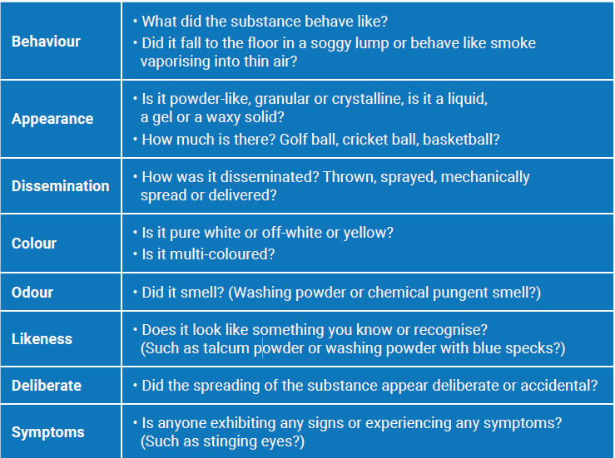
BAD COLDS Tool

Casualty assessment
Symptoms of exposure to some hazardous substances, such as those used in a biological or radiological attack, may not be present within the first minutes, hours or days of a release occurring. Chemical releases are often, but not always, accompanied by a more rapid onset of symptoms. Without sufficient medical training, it can be difficult to recognise the cause of specific symptoms. Using the CRESS tool to report back key information could help health services identify the type and nature of the hazardous substance incident.

CRESS Tool
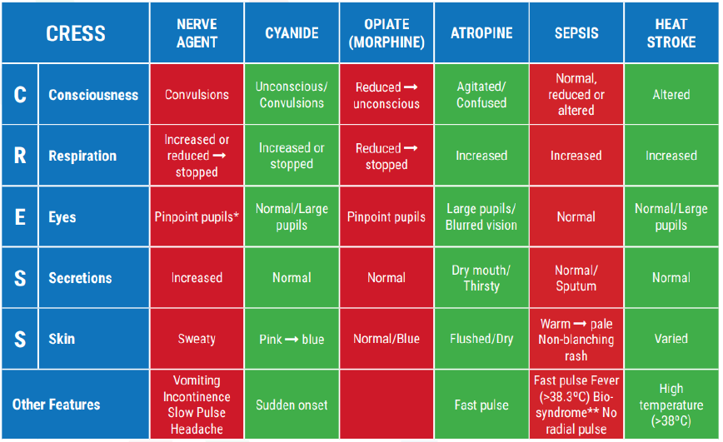

- CHEMICAL INCIDENTS
Indicators of chemical contamination:
- A strong chemical smell or vapour;
- The person complains of burning skin/eyes/nose;
- The person states that they have been contaminated;
- Atypical chest pains/Unexplained/unusual respiratory symptoms in the context of a possible chemical exposure;
- Neurological/Neuromuscular/Neuropsychiatric symptoms/signs;
- A combination of the above.
Annexe C is a Chemical Incident Questionnaire that could aid in identifying the substance if contamination from a chemical is suspected.
  - Individual Chemical Exposure (ICE) Events
ICE events are frequently characterised by the use of a chemical or a mixture of chemicals with the intent to self-harm predominantly via ingestion or inhalation. These events commonly occur in sealed or partially sealed environments where a small amount of gas can quickly reach lethal concentrations such as vehicles, residential bathrooms and hotel rooms. Any event involving exposure of an individual to chemicals or other hazardous substances may present a serious risk to the public, to the emergency services and to other health workers, such as hospital and mortuary staff, who may come into contact with the contaminated individual.
The most common type of events of this nature reported to the emergency services are:

Inhalation
- The combining of household or other chemicals to create a toxic gas. Commonly, hydrogen sulphide, hydrogen cyanide or phosphine gas have been produced by the mixing of substances such as lime sulphur, potassium cyanide or aluminium phosphide with bleach or acids. These incidents commonly occur in an enclosed area and may involve doors, vents and windows being sealed with tape to prevent the gas escaping.
- The use of asphyxiant gases such as helium or nitrogen that may involve plastic bags or hoods being placed over the victims head and are attached to a cylinder by rubber tubing. This can lead to death by asphyxiation.
- Barbeque fatalities commonly involve the lighting of a barbeque in a confined space which creates carbon monoxide (CO) gas. Incidents typically occur in a vehicle, a cupboard, a small room such as a bathroom or a tent. Duct tape or a similar material is often placed around vents and windows in order to contain the gas.
Ingestion
- The ingestion of a hazardous chemical such as cyanide, phosphide salts or sulphurous compounds e.g. lime sulphur. This is frequently ingested as a drink although ingestion via capsules has been noted. Although the majority of the hazard may be ‘trapped’ inside the victim’s body after ingestion, there may still be a potential risk to others from off-gassing and/or contamination of clothing or the surrounding area.
Indications of an ICE Event - It is important to note that the signs of an ICE event may not be immediately obvious, however there may be certain indications or manifestations at the scene that may alert emergency services personnel or Hospital Staff to the possibility that an ICE event is ongoing. These may include:
- The signs and symptoms being displayed by casualties and their severity. Casualties or emergency responders may be experiencing breathing difficulties and/or have irritation to the eyes and nose.
- The event is taking place in an unusual location e.g. a beauty spot in a rural area or a small, enclosed room;
- Information has been received (e.g. from a witness) that a person at the scene may be in possession of chemicals or that there is some history or intelligence that suggests the person has attempted to self-harm on a previous occasion;
- Warning notes or safety data have been taped to vehicle or house/building windows or doors;
- Duct tape, plastic or towels have been used to cover air vents windows and/or doors in order to produce a sealed environment;
- Vehicle occupant/s appears unconscious or unresponsive;
- Presence of a ‘suicide bag’ or hood at the scene;
- Suspicious (possibly spilled or empty) containers or cylinders at the scene of an event;
- Unexplained vapour in the air or a strong chemical smell present at the scene e.g. the smell of rotten eggs, bitter almonds, garlic or decaying fish;
- The presence of a barbecue within a sealed or partially sealed environment;
- Disabled smoke alarms and/or carbon monoxide alarms.
- BIOLOGICAL INCIDENTS
Biological incidents may be deliberate or naturally occurring. A deliberate release may be overt (announced openly by perpetrators, e.g. the envelopes
containing threatening notes and biological spores) or covert (unannounced, without any warning or indication of the organism involved). Many different organisms could, in theory, be used deliberately and be distributed through food, water, or the air (by an explosive device, aerosol canister, or crop duster).
Be alert to the unusual, the unexpected, and the case that ‘just doesn’t fit’. The following are examples:
- An unusual illness (e.g., sudden unexplained febrile death, critical illness or pneumonia death in a previously healthy young adult)
- An unusual number of patients with the same symptoms
- An illness unusual for the time of year (e.g., ‘severe flu’ in summer)
- An illness unusual for the patient’s age group (e.g., apparent ‘chickenpox’ in a middle-aged adult)
- An illness in an unusual patient (e.g., cutaneous anthrax in a patient with no history of contact with animals, animal hides or products)
- An illness acquired in an unusual place (e.g., tularaemia acquired in the UK)
- Unusual clinical signs (e.g., mediastinal widening on CXR; sudden onset of symmetrical flaccid paralysis)
- Unusual progression of an illness (e.g., lack of response to usually effective antibiotics; ‘chickenpox’ rash predominant on extremities)
- Large scale illicit drug contamination could be associated with / mimic biological / chemical incidents
Intentional and naturally occurring outbreaks may be indistinguishable initially. In addition, a high consequence infectious disease may present with similar features. Please refer to the Health Board Infection Prevention and Control Procedures and Pandemic Framework.
Infection control is intended to prevent transmission of infection between patients, from patients to health care workers, and from health care workers to patients
You will find the most up to date IPC Policies, Protocols, Quick Reference Guides and Information Leaflets on the SBUHB Infection Prevention and Control Share Point site;
https://sbushare.cymru.nhs.uk/sites/InfPrevCont/_layouts/15/start.aspx#/SitePages/Policies%20and%20Quick%20Reference%20Guides.aspx
Have a low threshold for seeking advice from the senior emergency medicine clinician, and your consultant microbiologist, Health Protection Unit, National Fever Service, or Infection Disease Specialist (Infectious Disease Consultant or Consultant Microbiologist).
Annexe E is an algorithm designed to help with the correct selection of PPE appropriate to whether the contamination is chemical, biological or radiological.

- RADIOLOGICAL INCIDENTS
A person is contaminated when radioactive material is deposited on skin and/or clothing (external contamination), or into the body (internal contamination) by inhalation, ingestion (hand-to-mouth, food, drink), or absorption via a wound.
If a patient is contaminated, internally or externally, then they will continue to be irradiated by that radioactive material until it is removed.
Radioactively contaminated casualties are unlikely to emit radiation that is harmful to rescuers and hospital staff.
Irradiated casualties are those that have been exposed to high levels of radiation, (X-rays or gamma emissions) which has passed through them. Such casualties do not re-emit harmful radiation and would not be a risk to rescuers and hospital staff

Priorities for ED Staff on radioactively contaminated casualties

First Priority | Treatment of life-threatening injuries (shock, bleeding, thermal burns, fractures, etc.) by whichever type of specialist is appropriate for the condition.
Second Priority | Assessment of the extent and magnitude of contamination, and decontamination as necessary. Any person with external contamination should be specially and separately treated. The most effective decontamination procedure is washing, subject to control by monitoring.
Third Priority | If there is suspected internal contamination, a quick assessment should be made:  - Collection of samples such as nasopharyngeal swabs, urine and faeces  - Whole body radiation monitoring  - External decontamination

Identifying and treating a contaminated casualty
Anyone of the following scenarios will lead to a high index of suspicion that a casualty is contaminated:
- You are informed by ambulance control that paramedic, fire & rescue, or police electronic personal dose-meters (EPDs) have alarmed at the incident scene;
- The patient tells you that they work with radioactive materials and they have had an accident e.g., industrial radiographer, driver of vehicle transporting radioactive materials;
- The accident occurs in a controlled area where radioactive materials are used;
- Vehicles, equipment or materials involved in the incident have radiation decal markings;
- In any newly diagnosed bone marrow depression (leukopenia: infection; thrombocytopenia: bleeding gums, nosebleeds, bruising);
- ‘Burns’, erythema, or bullae with no history of heat or chemical exposure;
- Sudden, rapid, hair loss especially if there is no relevant occupational history;
- Unexplained nausea / vomiting +/- diarrhoea 2-4 weeks before onset.
- When dealing with ANY incident involving a bomb or other intentionally placed explosive device.
Ionising radiation is detectable and quantifiable. Casualties should be screened with the radiation detector instrument known as the RAM GENE-1. Radiation Physics has equipment for detecting beta and gamma radiation and are trained in the use of this equipment. This equipment is kept in the Radiation Physics Office at The MPCE Singleton Hospital.
Knowing the type of radioactive material involved is important in assessing how to manage it.

Control Zones
The ED needs to be divided into two areas: a dirty area and clean area. These areas must be defined by visual and/or physical barriers. A member of staff is designated the Dirty Monitor and another Member of staff is designated as the Clean Monitor. See Annex D for control Zones and management of these zones.
Treating a radiologically contaminated casualty
- At the scene of the incident the Emergency Services will decontaminate uninjured and non-critically injured people. Only contaminated casualties who have life threatening injuries will be brought to the ED.
- Triage and treat life and/or limb threatening problems before considering decontamination; if the patient’s clinical condition permits, decontaminate first, and then treat.
- It is important that help and support is obtained from a Medical Physicist (available via switchboard) as soon as possible. Do not wait for them to arrive before admitting the patient and beginning to treat them.
- The health/medical physics department will monitor to reassure EM staff that they are not being exposed to harmful levels of radiation.
- Isolate all patients in appropriate single rooms or provide cohort care if a large number of casualties present.
- Forbid eating, drinking or smoking where medical/health physics team confirm the presence of radioactive material
- Decontamination by removal of the outer layer of the patient’s clothing followed by Wet Decontamination will usually be sufficient to effectively remove most external contamination; the medical/health physics team will undertake a repeat screen and direct you to remove any residual contamination if found.

Annexe D is the Radiological Incident Procedure required to deal with casualties contaminated with radioactive material.

PROCESS FOR IMMEDIATE INCIDENT MANAGEMENT FOR HOSPITAL STAFF FOR A CHEMICAL, BIOLOGICAL OR RADIOLOGICAL INCIDENT.

Recognise, Assess, React (RAR) - Indicators for a hazardous substance
The initial actions taken following a hazardous substance incident have a significant effect on the outcome for all involved. The following principles will aid first responders:
R – RECOGNISE the indicators of a hazardous substance incident;
A – ASSESS the incident to inform an appropriate response strategy;
R – REACT appropriately to reduce the risk of further harm.
Ensure you apply at this stage the overarching principles of Self Protect, Isolate, Treat.
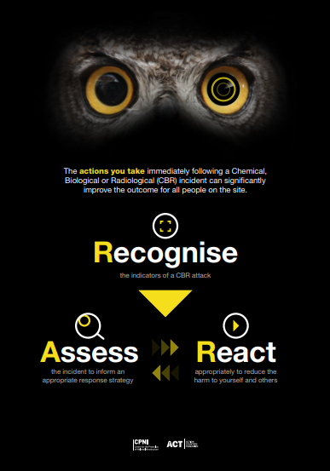
RAR Poster
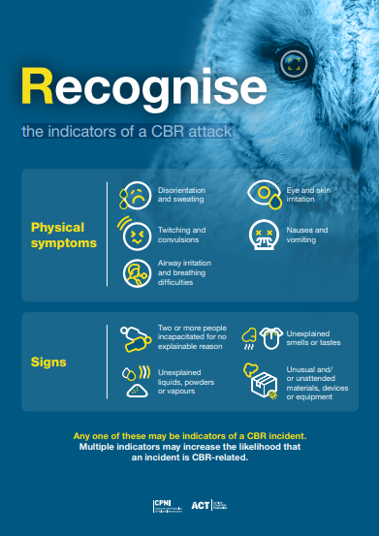
    - Recognise
In the early stages it may be difficult to establish what has occurred and if hazardous substances have been used. Not all incidents involving hazardous substances will involve casualties, therefore any one of the following may be indicators of a CBRN incident;
• Pools of liquid
• Vapours
• Mist clouds
• Droplets or films on surfaces
• Odours
Section 3,4,5 & 6 of this document lists common signs and symptoms of CBRN, Chemical, Biological and Radiological contamination respectively.
If unprotected responders observe incapacitated casualties for no explainable reason – they MUST NOT PROCEED any closer to avoid becoming a further casualty themselves (remember the three overarching principles Self Protect, Isolate, Treat) However, they must consider opportunities to understand what has happened or is still happening, Recognise and Assess and report this back to senior personnel. Unprotected responders can still assist without committing themselves into a contaminated area. Using instructions from a distance they can communicate appropriate advice and information.
Once it is recognised that a CBRN, HazMat or ICE incident is occurring escalate internally and dial 999.

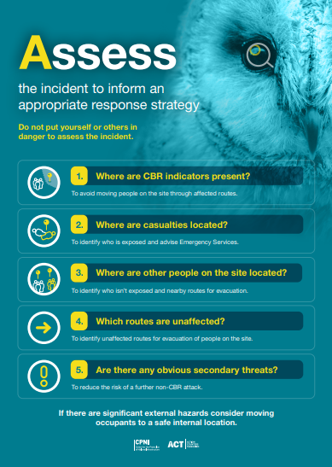
7.1.2 Assess
See Section 3 of this document for CBRN substance and casualty assessment tools.

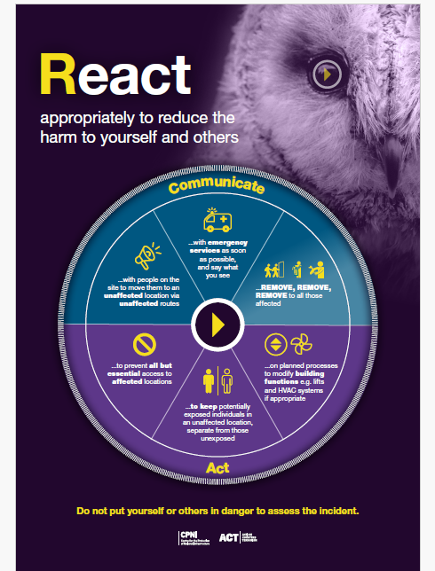
    - React

If a person (or persons) are suspected to be in a hazardous area, or could potentially be affected by a hazardous substance, they should be advised in accordance with the REMOVE principles.

Additional considerations for enclosed space settings include but are not limited to:
- Consider evacuating / invacuating – for quick evacuation from an enclosed space the use of the fire alarm system may be beneficial;
- Consider the route out – note that some gases are heavier than air and may pool in lower areas which may affect your evacuation considerations;
- Following consultation with emergency service partners and site operators, consider shutting down air conditioning, fans and air recirculation systems but only where this action would not delay evacuation or have an adverse effect.
Advise casualties that they should:
- Avoid eating, drinking, smoking or touching their face and eyes as this can increase the risk of further contamination through ingestion, inhalation and absorption;
- Continue to move away upwind and preferably uphill from the release;
- Not to leave the area by doing so they may be putting themselves or others at risk by exposing them to contaminants which may be on their clothing or skin.

  - Evacuation, Disrobe and Decontamination (REMOVE Principles) – Most likely used for the purpose of a chemical contamination.
Moving casualties away from the scene of contamination if possible and with appropriate protection followed by immediate disrobing and decontamination is the most effective measure to save life and improve casualty outcomes in CBRN, HazMat and ICE events. The maximum benefit of this will be realised if conducted within fifteen minutes of exposure. These early operational activities should be considered an absolute priority.
REMOVE Protocol
In the event of an incident where people have been exposed to, or contaminated by, a potentially hazardous substance, the speed of advice communicated to affected people and the emergency services response is critical to saving lives. It is essential that all means of communication, either remote from or at the scene, are considered. By utilising the REMOVE3 principles, ideally within 15 minutes of contamination, most skin contaminants can be removed or their effects reduced, thereby helping to reduce further injury or death.

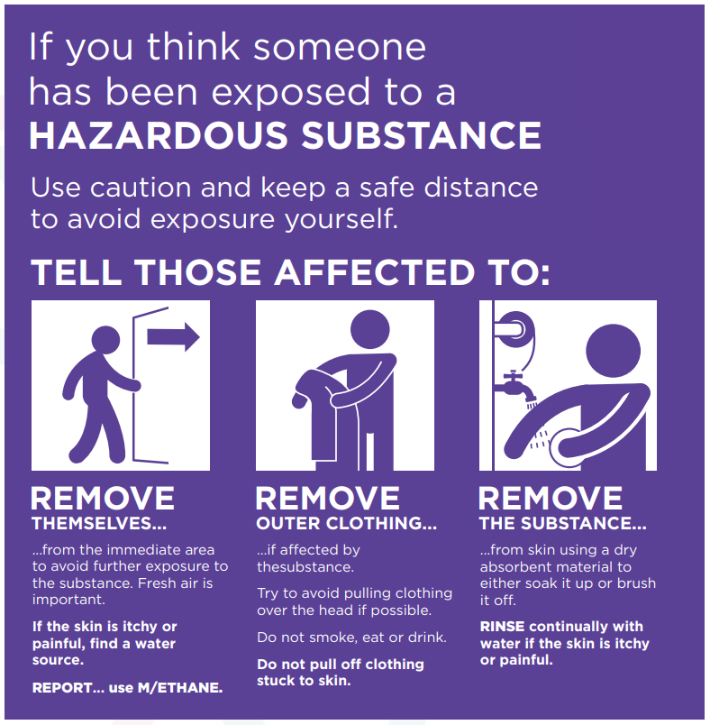

  - Evacuation
Remember that the hospital or other Health Board facilities could be the site of a CBRN, HazMat or ICE incident. As such, there may be a need to evacuate a Health Board (HB) facility and or invoke HB Lockdown Procedures. In addition, if casualties arrive unannounced at an Emergency Department/MIU there may be a need to instruct the casualties to leave the unit so that a controlled assessment can occur.
Casualties should be directed away from the scene of contamination and point of release if safe to do so. Identify an area away from the scene of contamination (i.e. the suspected point of release) and include any subsequent contamination spread. The identified area of safety should, where practicable, be upwind and ideally uphill of the incident. Any casualties who are able to walk should be directed to this area with the minimum of direct physical contact from hospital staff. Consider use of a loud hailer, tannoy system or other means to mobilise/direct people.

  - Disrobe
Evacuation followed by disrobing must be considered as the primary action.
The process of disrobing is highly effective at reducing the effect of exposure to contaminants across the chemical, biological and radiological spectrum, when performed within fifteen minutes of exposure. Scientific research has shown that the vast majority of skin surface contaminants are removed if disrobing, followed by appropriate decontamination, is done effectively.
Disrobe procedures should be, where possible, conducted by the casualty themselves and should be systematic and consistent with the steps outlined in Annex A. Consideration should be given to ensuring the welfare and, as far as is practicably possible, dignity of casualties. Responders should consider the potential for hypothermia as well as, where practicable, modesty concerns. If available, alternative clothing or blankets should be used.
It is essential for crime scene investigation purposes that contaminated waste materials and clothing is contained in bags and left for the police investigation team. Where this can be achieved without compromising the speed and efficacy of the evacuation and decontamination of casualties it should be given full attention/consideration. Undressing should be systematic to avoid transferring any contamination from clothing to the skin.

  - Decontamination
    - Dry Decontamination
DRY decontamination is used as the default intervention for anyone that is suspected of being contaminated during a suspected chemical incident unless there are obvious signs of burning, skin irritation or the contaminant is believed to be either biological or radiological material.

Annexes A, B & E are the Decontamination Procedures including using appropriate PPE.
To perform improvised dry decontamination:
    - Any available dry, absorbent material can be used, for example:
    - paper tissues, such as ‘white roll’
    - towels
    - Exposed skin surfaces should be blotted and rubbed, starting with the face, head and neck and moving down and away from the body
    - Sufficient absorbent material should be used to avoid transferring contamination from one part of the body to another.
    - Start with face, head and neck and move down and away from the body
    - Rubbing and blotting should not be too aggressive, or it could drive contamination further into the skin
    - All absorbent materials used in this process may also be contaminated and should not be used on a new casualty
    - All waste material arising from dry decontamination should be left in situ and double bagged if possible. Each casualty will be issued with an orange hospital waste bag for their individual use. Casualties should be moved away from waste materials arising from improvised dry decontamination as soon as possible.
    - Double bag and label all personal items

    - Wet decontamination procedure

Water should not be used for decontamination unless casualty signs and symptoms are consistent with exposure to caustic substances such as acids and alkalis.

Clinical Decontamination

Clinical Decontamination is the process where trained healthcare professionals using purpose designed decontamination equipment treat contaminated persons individually. Morriston Hospital’s Emergency Department has a permeant Decontamination Room sited at the main entrance of A&E which can be used upon the arrival of self-presenting casualties.
The enclosed action cards detail the actions to be taken by staff in the event of an incident occurring. If contaminated patients arrive at A&E requiring decontamination this will be done by ED staff.

Interim Wet Decontamination- for patients who are not in a dedicated decontamination room

Interim wet decontamination is the use of standard equipment to provide a planned and structured decontamination process prior to the availability of purpose-designed decontamination equipment. This might be implemented in response to the presentation of contaminated people at NHS premises and services other than an acute setting with an Emergency Department or casualties contaminated on hospital premises.

The use of copious amounts of water from any available source such as water bottles, taps, showers, hose-reels, sprinklers etc. to dilute and flush the contaminant away from the body surface. Where water is not available, water based wet wipes/baby wipes can be used as an alternative as they are effective in removing contaminants and are easier to control in terms of waste, see Annex B.

When using water, it is important to try and limit the duration of decontamination to between 45 and 90 seconds and ideally, to use a washing aid such as a cloth.

Mass Decontamination
In the event of a large number of casualties being involved (i.e. the number of contaminated casualties are overwhelming the facilities available Silver Command must inform Ambulance Control and advise them that “mass decontamination is required”. Action card 14 has been drawn up jointly with the Fire & Rescue Service and details the actions required by both Fire & Rescue Service and Health Board personnel.
It is recognised that healthcare facilities are not able to manage large numbers of casualties, especially those requiring wet decontamination. In any scenario where hospitals are unable to manage multiple patients requiring decontamination, assistance and support should be support from the Ambulance and/or Fire and Rescue Service. The Fire Service is equipped with mobile mass decontamination units and specialist equipment including Disrobe and Re-robe packs for when there are large numbers of contaminated casualties. When the decision to initiate Mass decontamination has been made the Fire & Rescue Service will set up the Unit in the grounds of the hospital in an acceptable area.

  - Initial and update Situation Reporting
If staff become aware of an incident, inform senior staff using the METHANE algorithm;
Major incident or business continuity. A Major incident activation maybe required if there are a number of contaminated casualties which overwhelms resources. A Business continuity/critical incident may be activated if service delivery is affected.
Exact location
Type of incident
Hazards at the scene
Access
Number of casualties and severity
Emergency services present or required.
Effective situation reporting from the scene of contamination is vital to ensure that correct information can be disseminated appropriately to enable all agencies to maintain shared situational awareness.
  - Communication to casualties
Communicate:
• Why and how casualties need to be disrobed and decontaminated
• That those who are capable should assist others who are injured or less able to carry out tasks - if they can
• That more help is coming and do not leave the area
• Casualties should not eat, drink or smoke and avoid touching their face due to the risk of ingesting or transferring hazardous materials
Consider all options to communicate this message effectively, including use of loudhailers and providing demonstrations of disrobe and dry decontamination.
  - Responder Guidance and Personal Protective Equipment (PPE)
Staff assisting casualties with decontamination should wear appropriate PPE. Appropriate PPE will protect the responder, the patient and other patients and colleagues from infection and from other hazards, but only if selected, worn, and discarded correctly. The level of PPE required should be based upon the unique circumstances of the incident, with reference to appropriate Hazmat/CBRN and ICE plans, see Annex E.
It is the responsibility of the Health Board to ensure that appropriate PPE is available and that staff are suitably trained in its use.
If patients are presenting with infectious problems use FFP3 masks and standard PPE clothing as for the Health Board Infection Control Policies for respiratory infections.
The responder will need to hold the action card from Annex A and show it to the casualty and ensure that they follow all the processes as outlined. It is important that an orange hospital waste bag is used to collect all the waste. Six bags will need to be provided; for waste, for valuables and for clothing and all should be double bagged. As noted, the specific detail for this process, including the equipment and actions is included within the Emergency Departments and MIU’s as there are dedicated trainers for this purpose.
  - Care after death
In the event of a death, the Coroner/Procurator Fiscal should be notified of the incident at the earliest opportunity. This will assist in deciding upon the process for the removal of the deceased, the maintenance of the identification standards and any subsequent post-mortem procedure.
This direction will help formulate the recovery strategy and will assist in identifying an appropriate mortuary that will be suitable for accepting the deceased.
There may be the potential for off-gassing from the body of the deceased following an incident and moving the deceased may reintroduce the risk of secondary exposure. Therefore, the safe handling of a contaminated fatality is considered to be a critical part of the management of the scene.
Chemical resistant body bags (also known as CBRN body bags or gas tight body bags) are designed to provide a physical barrier to articulate, liquid, vapour and gas materials. Annex E of this document provides advice on the features and use of chemical resistant body bags. The body bags generally have a minimum breakthrough time of 48 hours although this may be dependent on the concentrations of the relevant chemical at the scene and therefore the decision to determine whether a chemical resistant body bag should be utilised for a particular ICE event should be dependent on scientific advice. Each bag has a filter that allows gases produced from the decomposition of the body to escape whilst retaining any harmful chemicals. Therefore, it is important that scientific advice is obtained if a contaminated casualty is being left enclosed inside a chemical resistant body bag for longer than the 48-hour period.
Chemical resistant body bags are generally accessed through the Fire Service, Police or Ambulance Service’s hazardous area response team.
The Health Board has adopted and is aligned to the All Wales Charter for Families Bereaved through Public Tragedy.
- WASTE MANAGEMENT
Clean-up/remediation of contaminated areas and materials within healthcare facilities is the responsibility of SBUHB. In the event of undertaking decontamination processes within the hospital setting, advice regarding the disposal of waste should be sought from the Technical Services in Estates together with advice received from referencing Toxbase, Public Health Wales and from Defra’s CBRN Emergencies Team who may be able to assist in identifying a suitable contractor to undertake the clean-up.
Defra CBRN emergency contact
For a chemical, biological, radiological, nuclear (CBRN), HazMat or ICE incident call the duty officer on 03300 416565 (24/7availability).
The Police Senior Investigating officer (SIO) may have declared the contaminated area as a crime scene and therefore, the clean-up of the scene should not take place until it has been authorised by the SIO. It is important that the scene is formally ‘handed over’ to SBUHB by the emergency services and that this process is appropriately documented.

SERVICE CONTINUITY
Contaminated casualties self-presenting to hospital or casualties contaminated on Health Board premises through ICE, HazMat or CBRN incidents have the potential to contaminate both the staff and the Department(s) that they are being treated in. This type of incident could result in a significant section of the hospital being sealed off. This scenario is totally dependent on the following factors:
- Type and effect of the contaminant;
- Volume of the contamination;
- Areas affected.
Hospital lockdown procedures might need to be invoked.
Incidents of secondary contamination can be significantly reduced by ventilating the clinical area, rotating staff away from the patient (‘tag-team’ system) and where possible ensuring the patient is treated in an isolated bay. In addition, there is the potential risk of the spread of toxic vapours through the hospital ventilation or air-conditioning system. If the Emergency Department’s or wards air-conditioning system is connected to the rest of the hospital then, dependent on the incident and subject to a Dynamic Risk Assessment (DRA), it may be necessary to switch it off. However, if the air-conditioning system is switched off then an independent air-conditioning system should be kept running as it will improve the ventilation of the ward/ department and help to minimise airborne concentrations.

- MULTI-AGENCY COORDINATION
Once the emergency services are aware that a CBRN, HazMat or ICE incident is ongoing, then the incident will require a rapid multi-agency response and, to achieve the best outcomes, all responders must work together effectively as soon as they arrive on the scene. It is vital that the emergency services communicate and co-operate with each other so as to provide an effective response to such an incident in order to PRESERVE AND PROTECT LIFE.
The principles for joint working should be adopted in line with Joint Emergency Service Interoperability Programme (JESIP) principles, see Annex I. It is vital that each responder organisation identifies suitably qualified and experienced
commanders to come together and formalise actions already taken, develop a joint understanding of risk to identify priorities, determine appropriate specialist resources and respond accordingly.
It is possible that the organisation with the lead role may change as the incident develops. In most cases, the agency with responsibility for mitigating the emergency effects of a release particularly where there is a risk to life will be the Fire and Rescue Service. Thereafter, the Police, Local Authority or Natural Resources Wales will coordinate the multi-agency response based on the nature and impact of the incident. This decision will need to be recorded.
There should not be any delays in identifying a lead or primacy at the onset of the incident and during the course of the incident, the lead may change, and any handover must be justified, agreed by all agencies and recorded. The lead organisation will not have command and control authority over any other responding agency.
Multi-Agency Command and Control Structure
The incident is likely to be first coordinated at the scene of the incident. If the incident escalates or becomes protracted, officers from each agency may than need to liaise at a higher multi-agency level, to agree on course of action including the early activation of either a Tactical Co-ordination group (TCG) or even subsequently Strategic coordination group (SCG). Any category 1 responder organisation can request a TCG/SCG via the South Wales Police (SWP) Force Incident Manager (FIM). Contact details can be found in Annex H.

Potential triggers for TCG:
- Requirement for coordinated multi-agency response
- Protracted incident – beyond 24 hrs

If a TCG is required, the lead agency will be responsible for setting up the timing and location of the first meeting by contacting SWP, see Annex G. However, all agencies have a responsibility to ensure a multi-agency coordinating group is convened early on if required.
The purpose of the tactical level is to ensure that the actions taken by the operational level are co-ordinated, coherent and integrated in order to achieve maximum effectiveness and efficiency. The group will be comprised of Tactical Command officers from each agency committed within the area of operations and will assume tactical command of the event or situation.
The role of an SCG is to take overall responsibility for the multi-agency management of an incident and establish a strategic framework within which lower levels of command and coordination groups will work. Strategic Coordination Group (SCG) and Tactical Coordination Group (TCG) are often referred to by the term Multi Agency Coordination Group or MACG.
- SEEKING SPECIALIST ADVICE
Chemical datasheets produced by Public Health England (PHE) may be referred to in order to assist in the identification of the specific type of HazMat, CBRN or ICE event and provide general safety advice to emergency responders. In addition to the datasheets, scientific advice can be accessed through the utilisation of each emergency services standard protocols or via the National CBRN Centre, National Poisons Information service & Defra CBRN Emergencies Team. A list of key contacts can be located in Annex I.
12 RECOVERY
Recovery is included within the SBUHB Major Incident Procedures and Overarching Business Continuity/Significant Incident Procedure.
The recovery phase of an incident needs to be considered at the onset of an emergency. The recovery phase continues until disruption has been rectified, demands on services have returned to normal and the needs of the affected population have been met.
Recovery management should encompass the physical, social, psychological, political and financial consequences of an emergency.
It is the responsibility of the Health Boards Strategic/Tactical Director to anticipate consequences and appropriate recovery planning right from the beginning of any response and a recovery team should be convened to manage the recovery of an incident.

POST INCIDENT
When an incident occurs a debrief will be arranged to ensure that lessons are learned and, where necessary, the procedure is revised. Occupational Health support (including counselling) will be provided where necessary.

TRAINING
All staff that work in areas where there is the highest risk of exposure to this type of incident (ED and Minor Injuries Unit) will receive regular training and drills in this procedure. Annex A of this procedure applies to ED staff using full PPE.

HEALTH BOARD RESPONSE AND ACTION CARDS
The following action cards articulate the HB response when the Contaminated Casualties Procedure is invoked as noted in section 4.6:
- Switchboard
- ED Nurse in Charge
- ED Senior Consultant
- ED Decontamination Team
- ED Receptionist
- Morriston SDG Director/Clinical Site Matron / Silver Commander / on Call Manager
- Nurse Director/Deputy
- Portering Team Leader
- Security Staff
- Domestic Services
- Estates
- MIU/AMU
- Infection, Prevention & Control (IPC)
- Radiation Physics
- Pharmacy
- Large volume decontamination
- WELSH HEALTH PROTECTION SYSTEM
The Wales Health Protection Framework has been developed to build and strengthen the health protection system to prevent, prepare and respond to existing and future health protection hazards arising from communicable diseases and environmental incidents. The framework adopts an "all hazards" approach, which includes environmental, chemical, biological, radiological, nuclear (CBRN), technological and natural events.
The core organisations in Wales who make up the health protection system that deliver and/or commission health protection preparation, prevention and response as part of their remit are:
• Welsh Government
• NHS Executive
• Public Health Wales
• health boards and primary care
• local authorities

These organisations are supported by specialised provision delivered by:
• Food Standards Agency
• Animal and Plant Health Agency
• Natural Resources Wales
• UK Health Security Agency
• Health and Safety Executive

Health protection functions within the health protection system in Wales are outlined below:
NHS organisations which are responsible for provision of clinical services to meet the health and wellbeing needs of their local populations. Health boards clinically assess and treat patients who have been exposed to communicable and environmental hazards and prevent ill health through the delivery of vaccination and prophylaxis. Health boards work in partnership with PHW and local authorities, to contribute to both national and regional (health board Footprint) preparedness, prevention, response and recovery.
The Health protection framework is attached in annex K.

EQUALITY IMPACT ASSESSMENT STATEMENT
This Procedure has been subject to a full equality assessment and some issues have been identified and highlighted to ensure that due regard and weight is given to them in carrying out this Procedure.

DOCUMENT REFERENCES
Health Board Business Continuity Procedures;
Health Board Major Incident Procedures;
SBUHB Security Procedures;
SBUHB Infection Prevention and Control Policies;
Respiratory Viruses
PPE (Personal Protection Equipment)
Outbreak
Isolation Precautions
Communicable Disease and Food Poisoning
SBUHB Pandemic Framework;
SBUHB Distribution of Counter Measures;
SBUHB Alternative premises for critical care areas;
SBUHB Lockdown Procedures;
Strategic Documents;
JESIP Responding to a CBRN(e) Event – Joint Operating Principles for the Emergency Services – First Edition – September 2016;
JESIP Operational Response (IOR) to Incidents Suspected to Involve Hazardous Substances or CBRN Materials
Public Health Wales Chemical Decontamination Update: Guidance for Health Boards, 2016;
Home Office Initial Operational Response to a CBRN Incident, 2015
Health Protection Agency (CBRN Incidents. Clinical Management and Health Protection);
WG Communicable Outbreak Procedure;
Welsh Government Mass Vaccination Procedure;
Welsh Government Counter Measures;
COMAH Site Procedures
Fire and Rescue Service Operational Guidance Incidents involving chemical, biological, radiological, nuclear and explosives (CBRN (E)), Department for Communities and Local Government 2012;
SWLRF Multiagency Group Coordination Group Implementation Protocol.

ACTION CARDS:

SBUHB Contaminated Casualties – First Responder at scene (If internal incident). Any Health Board Premises. Action Card 1
First Responder at Scene Action Card 1
ROLE SUMMARY
**This action card is specific to an incident that has been detected from an area within the Health Board.
In the event of a Chemical, Biological, Radiation, Nuclear (CBRN), Hazardous Material (HazMat) or Individual Chemical Exposure (ICE) incident, protect yourself, all staff and the Health Board Infrastructure. There is a high risk of contamination spreading; Self Protect, Isolate and Treat in this order. Do not make matters worse by allowing contamination to spread.
The first person to assess a suspected casualty(s) needs to be aware of a potential CBRN, HazMat or ICE incident. Casualties who are contaminated with a harmful substance may self-refer to the ward/department or become contaminated within the ward/department.
If any Health Board staff become aware of an incident inform switchboard (Dial 2222) and senior staff using the ETHANE algorithm to communicate the information.
Exact location
Type of incident
Hazards at the scene
Access
Number of casualties and severity
Emergency services present or required

The Contaminated Casualties Procedure will need to be invoked and the ‘first aid measures’ should be followed immediately- See charts 1 &2
There will be a need for the following - Identify, Evacuate, Disrobe, Dry Decontamination

On recognising a contaminated patient or being informed that there is a suspected contaminated patient:
- Adhere to the overarching principles of Self Protect, Isolate and Treat.
- Tell the patient to remain where they are if in a room, if not direct outside and to enter the nearest dedicated isolation facility or single room.
- Keep as far away from the patient as possible. If you can, stay outside of the room and don PPE.
See Chart 3 for PEE guidance.

- Follow Recognise, Assess, Respond (RAR) protocol. See chart 4 for RAR protocol.
Recognise- the indicators of a hazardous substance incident. See charts 5&6.
- Assess- the incident to inform an appropriate response strategy. See chart 7.
6. React appropriately to reduce the risk of further harm See chart 8.
      - Inform switchboard (Dial 2222) and senior staff using the ETHANE algorithm.
      - If you suspect a person(s)to be in a hazardous area, or could potentially be affected by a hazardous substance, they should be advised in accordance with the REMOVE principles. See chart 9.
- Instruct disrobing as per Chart 1. Disrobe procedures should be, where possible, conducted by the casualty themselves and should be systematic and consistent with the steps outlined. You will need to guide the casualty through the disrobing process from a safe distance or hold up Chart 1 for the casualty to see.

- Instruct decontamination using decontamination guide (Chart 2).
Dry decontamination is used as the default intervention for anyone that is suspected of being contaminated during a suspected chemical incident unless there are obvious signs of burning, skin irritation or the contaminant is believed to be either biological or radiological material.
Wet decontamination should be used if signs and symptoms are consistent with exposure to caustic substances such as acids and alkalis, or the contamination has been identified as biological or radiological in nature.

- You may have become contaminated – Be prepared to be decontaminated yourself
- If the patient collapses before help arrives do not approach them without appropriate PPE for the suspected contaminant.
- Continue to update senior staff and switchboard using the ETHANE algorithm.
ISOLATION
- All contaminated casualties should be isolated from other patients.
- Consideration should occur for an alternative premises to be established to deal with routine patients in that ward/department. Discuss further within Silver Command and utilise alternative premises procedures that are in place for that department.
- Avoid spread of contamination to avoid hospital facilities suffering long term damage.

Chart 1 – Disrobe Pictogram
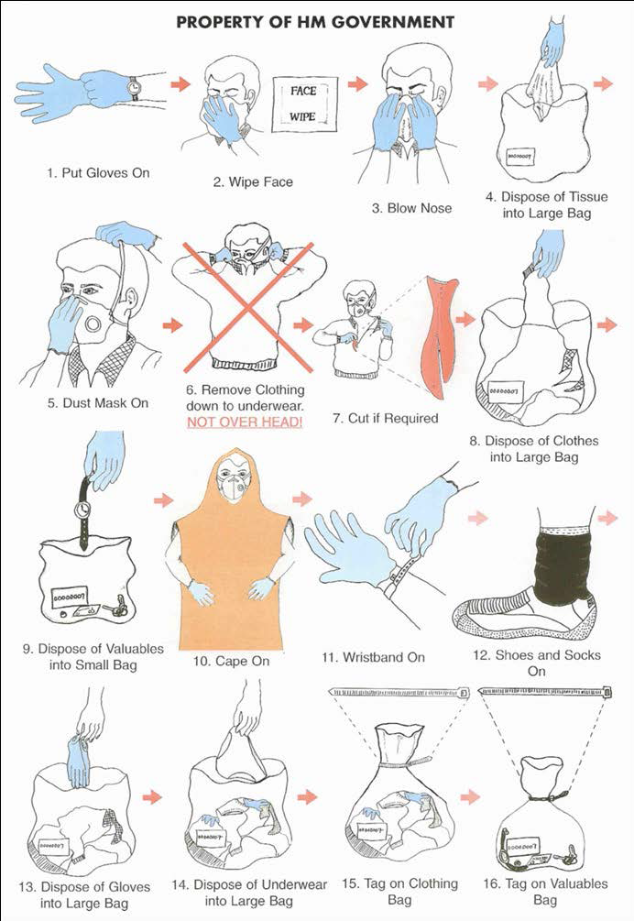

Chart 2 – Decontamination Guidance

DISROBE
- As soon as possible after exposure ideally within 15-20 mins
- Remove all out layers, ideally to underwear as noted in the Disrobe Pictogram and instructions by the staff member

followed by:
Dry decontamination | Wet decontamination
IF  - Chemical confirmed as non-caustic / non corrosive  - No signs of burning, irritation of eyes, nose of throat  - Patient(s) not reporting pain due to chemical exposure | IF:  - Chemical confirmed as caustic / corrosive (e.g. acid, alkali)  - Signs of burning, irritation of skin, eyes, nose, throat etc.  - Reports of pain due to chemical exposure  - If hair is contaminated (if chemical is non-caustic, dry decontaminate first)  - Biological agent  - Radiological agent
MetHod | Method
- Use any available dry, absorbent material such as  - Blue roll  - Paper tissues  - Wound dressings  - Gently blot or rub any exposed skin surfaces (it should not too aggressive as it could drive contamination into the skin)  - Start with face, head and neck and move down and away from the body  - Double bag all waste material  - Double bag and label all personal items. | - Use any available water  - Portable/mobile decontamination Units  - Static/fixed decontamination units  - Showers  - Buckets  - Limit shower duration to between 45-90 seconds  - Use warm water (30-35ºC)  - Make up a water/detergent solution of 0.5% detergent if possible.  - Use a washing aid such as a cloth or cotton flannel

Chart 3 – PPE algorithm

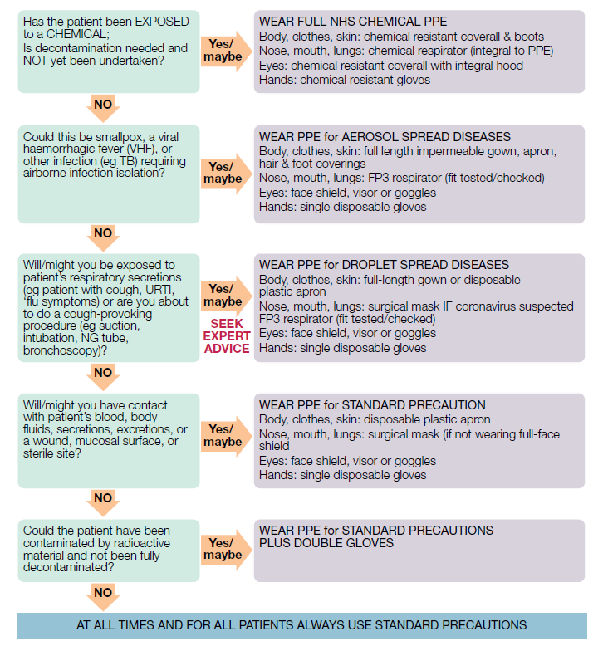
Chart 4- Recognise, Assess, React (RAR)

Chart 5- Recognise

Chart 6- Signs and symptoms of Chemical, Biological and Radiological contamination
Chemical Involved | Signs & Symptoms
General Chemical, Biological, Radiological | - Dead or distressed people, birds and animals;  - Multiple individuals showing unexplained signs of skin, eye or airway irritation, nausea;  - Vomiting, twitching, sweating, pin-point pupils, runny nose, disorientation, breathing difficulties and convulsions;  - The presence of hazardous materials or unusual materials / equipment;  - Unexplained vapour or mist clouds;  - Unexplained oily droplets or films on surfaces or water;  - Withered plant life and vegetation.
Chemical Contamination | - A strong chemical smell or vapour;  - The person complains of burning skin/eyes/nose;  - The person states that they have been contaminated;  - Atypical chest pains/Unexplained/unusual respiratory symptoms in the context of a possible chemical exposure;  - Neurological/Neuromuscular/Neuropsychiatric symptoms/signs;  - A combination of the above.
Biological Contamination | - An unusual illness (e.g., sudden unexplained febrile death, critical illness or pneumonia death in a previously healthy young adult)  - An unusual number of patients with the same symptoms  - An illness unusual for the time of year (e.g., ‘severe flu’ in summer)  - An illness unusual for the patient’s age group (e.g., apparent ‘chickenpox’ in a middle-aged adult)  - An illness in an unusual patient (e.g., cutaneous anthrax in a patient with no history of contact with animals, animal hides or products)  - An illness acquired in an unusual place (e.g., tularaemia acquired in the UK)  - Unusual clinical signs (e.g., mediastinal widening on CXR; sudden onset of symmetrical flaccid paralysis)  - Unusual progression of an illness (e.g., lack of response to usually effective antibiotics; ‘chickenpox’ rash predominant on extremities)  - Large scale illicit drug contamination could be associated with / mimic biological / chemical incidents
Radiation Contamination | - The patient tells you that they work with radioactive materials and they have had an accident e.g., industrial radiographer, driver of vehicle transporting radioactive materials;  - The accident occurs in a controlled area where radioactive materials are used;  - Vehicles, equipment or materials involved in the incident have radiation decal markings;  - In any newly diagnosed bone marrow depression (leukopenia: infection; thrombocytopenia: bleeding gums, nosebleeds, bruising);  - ‘Burns’, erythema, or bullae with no history of heat or chemical exposure;  - Sudden, rapid, hair loss especially if there is no relevant occupational history;  - Unexplained nausea / vomiting +/- diarrhoea 2-4 weeks before onset.  - When dealing with ANY incident involving a bomb or other intentionally placed explosive device.

Chart 7 – Assess Poster

Chart 8- React Poster

Chart 9- Remove, Remove, Remove

SBUHB Contaminated Casualties – Switchboard Action Card 2

Switchboard Action Card 2
ROLE SUMMARY
Notification of a Contaminated Casualty Incident into switchboard could be via WAST Ambulance Control, the Emergency Department or any ward or Health Board site. Be aware that any Health Board Premises could be the site of a Chemical, Biological, Radiation, Nuclear (CBRN), Hazardous Material (HazMat) or Individual Chemical (ICE) incident (Please note this could be as part of a Major Incident response if alerted by WAST or as an incident that is not a declared Major Incident but declared as a Business Continuity/Critical Incident if declared from within the Health Board).

If suspected contaminated casualties arrive unannounced or if the Health Board Premises is the site of a CBRN, HazMat or ICE incident and you have been informed, dial 999. Inform the police and ambulance service that there are CBRN type casualties on the premises and confirm if the informing person is declaring a Major Incident or Business Continuity/Critical Incident.

In the event of a Major Incident being declared, the Major Incident Procedures and the Contaminated Casualty Procedure will be invoked, as well as the Distribution of Countermeasures Procedure. Alternatively, you will be informed to invoke the SDG Business Continuity Procedures and this procedure will be invoked.

ALWAYS USE THE METHANE ALGORITHM

Major incident or business continuity/critical incident – confirm with caller and note;
Exact location
Type of incident
Hazards at the scene
Access
Number of casualties and severity
Emergency services present or required.

- Confirm if a major incident Standby or Declared has been activated;
- If Major Incident Standby occurs follow the Standby Procedure;
- If a major incident has been declared, confirm this and then INVOKE THE MAJOR INCIDENT PROCEDURE;

If a major incident is declared allocate a colleague to follow the Switchboard action cards from the Major Incident Procedure to ensure that all appropriate actions are taken and one Switchboard member to follow the actions within this Procedure.

If a Business Continuity Incident is declared, confirm the type of incident and communicate via the business continuity incident cascade. For a business continuity incident as a result of Contaminated Casualties follow this action card (go to action 1).

ACTION:- |  | Tick when completed
1 | Inform Ambulance Control that contaminated casualties have been reported on Health Board Premises and are requesting assistance. State the location of incident as per METHANE. Transfer the Controller to the site of incident if they require more details.
2 | Activate the Contaminated Casualties Cisco voice broadcast.
3 | Inform the Service Group Director On call Silver Commander (out of hours) and confirm if a business continuity incident or critical incident declaration should be invoked if you have not already been asked to invoke.
4 | Ensure the following are alerted:  - Radiation Physics  - Pharmacy (in hours – Pharmacy department, out of hours – on call Pharmacist)  - Health Board Public Health Director  - Nurse Director/Deputy  - Public Health Wales  - AMU and NPT MIU

SBUHB Contaminated Casualties: Nurse in Charge (NIC) ED Action Card 3

ED Nurse in Charge Action Card 3
ROLE SUMMARY
**This action card should be invoked by the Nurse in Charge upon receipt of a call from Ambulance Control that a Chemical, Biological, Radiation, Nuclear (CBRN), patient will be arriving in the department or if a contaminated patient self presents in the department.

In the event of a CBRN, Hazardous Material (HazMat) or Individual Chemical Exposure (ICE) incident, protect yourself, all staff and the Health Board Infrastructure. There is a high risk of contamination spreading; Self Protect, Isolate and Treat in this order. Do not make matters worse by allowing contamination to spread.

Remember ED may be the first contact with the incident, with CBRN patients self-presenting or an incident occurring within the department. If you become aware of an incident involving a number of unannounced CBRN patients or that the hospital has been the site of an incident, inform Switchboard (Dial 2222) using the METHANE algorithm.

METHANE
Major incident or business continuity incident
Exact location
Type of incident
Hazards at the scene
Access
Number of casualties and severity
Emergency services present or required

The Contaminated Casualties Procedure will need to be invoked and the ‘first aid measures’ should be followed immediately. There will be a need for the following - Identify, Evacuate, Disrobe, Dry Decontamination- See charts 1 &2.

If 1 or 2 patients arrive unannounced inform Switchboard to declare a Business Continuity/Critical Incident noting specifically that it is a Contaminated Casualties Incident. If more than 2 casualties arrive Command and Control will discuss regarding declaring a major incident. As a result Silver Command will be established on site.

If a major indent is declared allocate a second senior nurse to follow the ED action cards from the Major Incident Procedure to ensure that all appropriate actions are taken, as well as following the actions in this Procedure.

Follow Action Set A – If you are alerted via Ambulance Control of a CBRN patient arriving in the department.

Follow Action Set B- If a contaminated patient self presents to the department or the department becomes the site of a CBRN, HazMat or ICE incident.

ACTION Set A:- |  | Tick when completed
1 | Alert all Department staff to the situation including reception. Note the expected time of patient arrival.
2 | Brief the most Senior Clinician on duty, Service Group Director, Clinical Site Matron, Silver Commander
3 | Consider lock down of hospital entrances and a known contaminated casualty arriving patient should be directed immediately to the decontamination room external entrance so that the potential for contamination is contained from the outset.
4 | Identify the decontamination team advise on PPE based on the suspected chemical see Chart 3.  Prepare to suit up if caustic chemical and wet decontamination is required.
5 | In the event of the biological incident, staff should use FFP3 masks and appropriate PPE clothing in accordance to infection control policies. Refer to the Health Protection Agency CBRN incidents (Clinical Management and Health Protection) document for more detailed advice.
6 | Delegate a member of staff to assist/co-ordinate the preparation of the decontamination facility
7 | Instruct the decontamination team to keep as far away from the patient as possible. If they can, stay outside of the decontamination room.
8 | Once the patient is in the decontamination room. Instruct disrobing as per Chart 1. Disrobe procedures should be, where possible, conducted by the casualty themselves and should be systematic and consistent with the steps outlined.
9 | Use Annexe C for a chemical incident. Ensure for chemical contamination.
10 | Instruct decontamination using decontamination guide (Chart 2).  Dry decontamination is used as the default intervention for anyone that is suspected of being contaminated during a suspected chemical incident unless there are obvious signs of burning, skin irritation or the contaminant is believed to be either biological or radiological material.  Wet decontamination should be used if signs and symptoms are consistent with exposure to caustic substances such as acids and alkalis, or the contamination has been identified as biological or radiological in nature.
11 | If the contaminant is radioactive follow the steps as set out in Annex D.
12 | Inform the Neath Port Talbot Hospital Minor Injuries Unit (if within opening times) and the AMU and ask them to accept minor injury type cases unrelated to the potential CBRN incident
13 | Inform Public Health Wales in every incident and SBUHB Director of Public Health
14 | Monitor procurement of supplies and liaise with Silver Command
15 | Ensure that patient property is placed in yellow bags, clearly labelled secured with ties and to retain within the decontamination room; the room should be guarded by security until a decision is made about further action on the property. The outside of the bags could be contaminated and as such all staff should have appropriate PPE.
ACTION Set B
1 | If you suspect a contaminated patient has self-presented to A&E ED adhere to the overarching principles of Self Protect, Isolate and Treat.
2 | Send the patient immediately outside and to enter directly via the external entrance to the decontamination room. Keep as far away from the patient as possible.
3 | Isolate the area if contaminated, e.g., if the patient arrived at reception, to prevent the risk of cross contamination until further advice is sought
4 | Consider lock down of hospital entrances. Delegate a member of staff to the main hospital entrance to triage any self-referred contaminated casualties to the ED entrance.
5 | Follow Recognise, Assess, Respond (RAR) protocol. See chart 4 for RAR protocol.  Recognise- the indicators of a hazardous substance incident. See charts 5&6.
6 | Assess- the incident to inform an appropriate response strategy. See chart 7.
7 | React appropriately to reduce the risk of further harm See chart 8.  Inform switchboard (Dial 2222) of a contaminated casualty incident and ask for the contaminated casualty Cisco voice over group is activated  Inform senior ED staff  If you suspect a person(s)to be in a hazardous area, or could potentially be affected by a hazardous substance, they should be advised in accordance with the REMOVE principles. See chart 9.
8 | Go to Action Set A above and follow steps 7-17
ISOLATION
- All contaminated casualties should be isolated from other patients, both within ED as well as in the hospital wards.
- Consideration should occur for an alternative Emergency Department to be established to deal with routine emergency patients (Adopt ED Alternative Premises / BCP). This will need to be discussed with Silver Command if required and if necessary.
- There may be a need for an adjacent hospital to take on emergency admissions.
- Avoid spread of contamination to avoid hospital facilities suffering long term damage.
- Patients who are contaminated should arrive at the front of the ED and enter the decontamination room via the external door.
- Normally patients will have undergone Primary Decontamination by the Ambulance Team if arriving by ambulance. However, in some cases, such as self-presenting patients, contaminated casualties may arrive without being decontaminated.

Chart 1 – Disrobe Pictogram

Chart 2 – Decontamination Guidance

DISROBE
- As soon as possible after exposure ideally within 15-20 mins
- Remove all out layers, ideally to underwear as noted in the Disrobe Pictogram and instructions by the staff member

followed by:
Dry decontamination | Wet decontamination
IF  - Chemical confirmed as non-caustic / non corrosive  - No signs of burning, irritation of eyes, nose of throat  - Patient(s) not reporting pain due to chemical exposure | IF:  - Chemical confirmed as caustic / corrosive (e.g. acid, alkali)  - Signs of burning, irritation of skin, eyes, nose, throat etc.  - Reports of pain due to chemical exposure  - If hair is contaminated (if chemical is non-caustic, dry decontaminate first)  - Biological agent  - Radiological agent
MetHod | Method
- Use any available dry, absorbent material such as  - Blue roll  - Paper tissues  - Wound dressings  - Gently blot or rub any exposed skin surfaces (it should not too aggressive as it could drive contamination into the skin)  - Start with face, head and neck and move down and away from the body  - Double bag all waste material  - Double bag and label all personal items. | - Use any available water  - Portable/mobile decontamination Units  - Static/fixed decontamination units  - Showers  - Buckets  - Limit shower duration to between 45-90 seconds  - Use warm water (30-35ºC)  - Make up a water/detergent solution of 0.5% detergent if possible.  - Use a washing aid such as a cloth or cotton flannel

Chart 3 – PPE algorithm

Chart 4- Recognise, Assess, React (RAR)

Chart 5- Recognise

Chart 6- Sings and symptoms of Chemical, Biological and Radiological contamination
Chemical Involved | Signs & Symptoms
General Chemical, Biological, Radiological | - Dead or distressed people, birds and animals;  - Multiple individuals showing unexplained signs of skin, eye or airway irritation, nausea;  - Vomiting, twitching, sweating, pin-point pupils, runny nose, disorientation, breathing difficulties and convulsions;  - The presence of hazardous materials or unusual materials / equipment;  - Unexplained vapour or mist clouds;  - Unexplained oily droplets or films on surfaces or water;  - Withered plant life and vegetation.
Chemical Contamination | - A strong chemical smell or vapour;  - The person complains of burning skin/eyes/nose;  - The person states that they have been contaminated;  - Atypical chest pains/Unexplained/unusual respiratory symptoms in the context of a possible chemical exposure;  - Neurological/Neuromuscular/Neuropsychiatric symptoms/signs;  - A combination of the above.
Biological Contamination | - An unusual illness (e.g., sudden unexplained febrile death, critical illness or pneumonia death in a previously healthy young adult)  - An unusual number of patients with the same symptoms  - An illness unusual for the time of year (e.g., ‘severe flu’ in summer)  - An illness unusual for the patient’s age group (e.g., apparent ‘chickenpox’ in a middle-aged adult)  - An illness in an unusual patient (e.g., cutaneous anthrax in a patient with no history of contact with animals, animal hides or products)  - An illness acquired in an unusual place (e.g., tularaemia acquired in the UK)  - Unusual clinical signs (e.g., mediastinal widening on CXR; sudden onset of symmetrical flaccid paralysis)  - Unusual progression of an illness (e.g., lack of response to usually effective antibiotics; ‘chickenpox’ rash predominant on extremities)  - Large scale illicit drug contamination could be associated with / mimic biological / chemical incidents
Radiation Contamination | - The patient tells you that they work with radioactive materials and they have had an accident e.g., industrial radiographer, driver of vehicle transporting radioactive materials;  - The accident occurs in a controlled area where radioactive materials are used;  - Vehicles, equipment or materials involved in the incident have radiation decal markings;  - In any newly diagnosed bone marrow depression (leukopenia: infection; thrombocytopenia: bleeding gums, nosebleeds, bruising);  - ‘Burns’, erythema, or bullae with no history of heat or chemical exposure;  - Sudden, rapid, hair loss especially if there is no relevant occupational history;  - Unexplained nausea / vomiting +/- diarrhoea 2-4 weeks before onset.  - When dealing with ANY incident involving a bomb or other intentionally placed explosive device.

Chart 7 – Assess Poster

Chart 8- React Poster

Chart 9- Remove, Remove, Remove

SBUHB Contaminated Casualties – SENIOR ED CLINICIAN - ED CONSULTANT Action Card 4

SENIOR ED CLINICIAN/ED CONSULTANT Action Card 4
ROLE SUMMARY
**This action card should be invoked by the Senior ED on receipt of a brief from the Nurse in Charge of a contaminated casualty within the Emergency Department.

In the event of a Chemical, Biological, Radiation, Nuclear (CBRN), Hazardous Material (HazMat) or Individual Chemical Exposure (ICE) incident, protect yourself, all staff and the Health Board Infrastructure. There is a high risk of contamination spreading; Self Protect, Isolate and Treat in this order. Do not make matters worse by allowing contamination to spread.

Access and relay information using the Methane algorithm.

Major incident or business continuity
Exact location
Type of incident
Hazards at the scene
Access
Number of casualties and severity
Emergency services present or required.

If 1 or 2 patients arrive unannounced inform Switchboard to declare a Business Continuity/Critical Incident noting specifically that it is a Contaminated Casualties Incident. If more than 2 casualties arrive Command and Control will discuss regarding declaring a major incident. As a result, Silver Command will be established on site.

If a major incident is declared allocate a second senior colleague to follow the ED action cards from the main Major Incident Procedure to ensure that all appropriate actions are taken.

ACTION :- |  | Tick when completed
1 | Access other sources of information/advice such as:  - ToxBase  - Chemical Incident Management Support Unit;  - Public Health Wales;  - Medical Physics  See Chart 1 below for a list of key contacts.
2 | In the event of a biological incident, staff should use FFP3 masks and appropriate PPE clothing in accordance to infection control policies. Also, in the event of a biological incident, please contact the microbiologist on call as well as the public health team. Refer to the Health Protection Agency CBRN incidents (Clinical Management and Health Protection) document for more detailed advice.
3 | Liaise with on call pharmacist or in hour’s pharmacy for counter measures and need for pharmaceutical supplies. Please refer to Counter Measure Procedure and specifically the flow chart. Inform Service Group Director/Site Management/1st on Call Manager that the Distribution of Countermeasures Procedure is to be invoked
4 | Inform public health team in every incident and discuss if Distribution of Countermeasures Procedure is to be invoked, (see flow chart in Countermeasure Procedure).
5 | Ensure that appropriate biochemistry and biological samples are taken
6 | Contact Biochemistry and Microbiology for advice
7 | Advise the decontamination team of any special measures/precautions that they must take. They may only need to undertake dry decontamination in incidences of a non-caustic chemical event. If so follow the dry decontamination procedures included within the department. See Chart 2
ISOLATION
- In principle all contaminated casualties should be isolated from other patients, both within ED as well as the hospital wards.
- Consideration should occur for an alternative Emergency Department to be established to deal with routine emergency patients. (Adopt ED Alternative Premises / BCP, if required, discuss with Silver Command and if contamination has not be contained)
- There may be a need for an adjacent hospital to take on emergency admissions; discuss with Silver Command as appropriate
- Avoid spread of contamination to avoid hospital facilities suffering long term damage.
- Patients who are contaminated should arrive at the front of ED, enter via the external entrance to decontamination room and be contained until decontaminated.
- Normally patients will be decontaminated before arrival. However, in some cases patients may arrive without being decontaminated and the principles should be identify, send outside to enter the decontamination room only, disrobe and dry decontamination process to be undertaken in accordance to departmental procedure.

Chart 1- Key Contacts

National Poisons Information Service | 0344 8920111 - available 24 hours to provide specialist and consultant medical advice to clinicians
CBRN Tactical Advisor Number | 0845 000 6382 – 24/7 OPS Hotline.
Police National CBRN Centre | 08450006382
Public Service Centre (PSC) Force Incident Manager (FIM) Desk | 01656 869380
Swansea LA Contact Number | In Hours – 01792 636109  Or duty officer 07980912585  Out of Hours - duty officer 07980912585
NPT LA Contact Number | In Hours - General Office No: 01639 686409  Emergency Planning Manager: 07980 727109  E-mail: ept@npt.gov.uk  Out of Hours - Emergency Control Room (CCTV): 01639 686899  (Ask for the Emergency Planning Duty Officer)
Defra CBRN Emergencies team  Defra Duty Room (if above number busy) | 03300 416565  0345 051 8486
PHE Chemicals hotline (24 hours) | 0344 892 0555
Public Health Wales Health Protection Team | 0300 00 300 32
Imported Fever Service | 0844 778 8990
UK Health Security Agency | 0113 267 9041
PHE Radiation Protection Division | In hours- 01235 831600  Out of hours- 01235 834590

Chart 2 – Decontamination Guidance

DISROBE
- As soon as possible after exposure ideally within 15-20 mins
- Remove all out layers, ideally to underwear as noted in the Disrobe Pictogram and instructions by the staff member

followed by:
Dry decontamination | Wet decontamination
IF  - Chemical confirmed as non-caustic / non corrosive  - No signs of burning, irritation of eyes, nose of throat  - Patient(s) not reporting pain due to chemical exposure | IF:  - Chemical confirmed as caustic / corrosive (e.g. acid, alkali)  - Signs of burning, irritation of skin, eyes, nose, throat etc.  - Reports of pain due to chemical exposure  - If hair is contaminated (if chemical is non-caustic, dry decontaminate first)  - Biological agent  - Radiological agent
MetHod | Method
- Use any available dry, absorbent material such as  - Blue roll  - Paper tissues  - Wound dressings  - Gently blot or rub any exposed skin surfaces (it should not too aggressive as it could drive contamination into the skin)  - Start with face, head and neck and move down and away from the body  - Double bag all waste material  - Double bag and label all personal items. | - Use any available water  - Portable/mobile decontamination Units  - Static/fixed decontamination units  - Showers  - Buckets  - Limit shower duration to between 45-90 seconds  - Use warm water (30-35ºC)  - Make up a water/detergent solution of 0.5% detergent if possible.  - Use a washing aid such as a cloth or cotton flannel

SBUHB Contaminated Casualties – DECONTAMINATION TEAM (ED STAFF) Action Card 5

DECONTAMINATION TEAM (ED STAFF) Action Card 5
ROLE SUMMARY
** This action card should be invoked following being informed of the impending arrival of contaminated casualties

In the event of a Chemical, Biological, Radiation, Nuclear (CBRN), Hazardous Material (HazMat) or Individual Chemical Exposure (ICE) incident, protect yourself, all staff and the Health Board Infrastructure. There is a high risk of contamination spreading; Self Protect, Isolate and Treat in this order. Do not make matters worse by allowing contamination to spread.

The Contaminated Casualties Procedure will need to be invoked and the ‘first aid measures’ should be followed immediately- See charts 1 &2

There will be a need for the following - Identify, Evacuate, Disrobe, Dry Decontamination

ACTION :- |  | Tick when completed
1 | Agree who will be the team leader
2 | Collect the personal protective equipment. See chart 3 for guidance on PPE depending on the contaminant involved.  In the event of the biological incident, staff should use FFP3 masks and appropriate PPE clothing in accordance to infection control policies. Refer to the Health Protection Agency CBRN incidents (Clinical Management and Health Protection) document for more detailed advice.
3 | Patients should have been directed to the decontamination room, with direct access from outside.
4 | Keep as far away from the patient as possible. If you can, stay outside of the decontamination room.
5 | Once the patient is in the decontamination room. Instruct disrobing as per Chart 1. Disrobe procedures should be, where possible, conducted by the casualty themselves and should be systematic and consistent with the steps outlined.
6 | Instruct decontamination using decontamination guide (Chart 2).  Dry decontamination is used as the default intervention for anyone that is suspected of being contaminated during a suspected chemical incident unless there are obvious signs of burning, skin irritation or the contaminant is believed to be either biological or radiological material.  Wet decontamination should be used if signs and symptoms are consistent with exposure to caustic substances such as acids and alkalis, or the contamination has been identified as biological or radiological in nature.
7 | Use Annexe C for a chemical incident.
8 | If the contaminant is radioactive follow the steps as set out in Annex D.
9 | Ensure that appropriate biochemistry and biological samples are taken
ISOLATION
- All contaminated casualties should be isolated from other patients, both within ED as well as the hospital wards.
- Consideration should occur for an alternative Emergency Department to be established to deal with routine emergency patients. (Adopt ED Alternative Premises / BCP, if required, discuss with Silver Command and if contamination has not be contained).
- There may be a need for an adjacent hospital to take on emergency admissions; discuss with Silver Command as appropriate
- Avoid spread of contamination to avoid hospital facilities suffering long term damage.
- Patients who are contaminated should arrive at the front of ED, enter via the external entrance to decontamination room and be contained until decontaminated.
- Normally patients will be decontaminated before arrival. However, in some cases patients may arrive without being decontaminated and the principles should be identify, send outside to enter the decontamination room only, disrobe and dry decontamination process to be undertaken in accordance to departmental procedure.

Chart 1 – Disrobe Pictogram

Chart 2 – Decontamination Guidance

DISROBE
- As soon as possible after exposure ideally within 15-20 mins
- Remove all out layers, ideally to underwear as noted in the Disrobe Pictogram and instructions by the staff member

followed by:
Dry decontamination | Wet decontamination
IF  - Chemical confirmed as non-caustic / non corrosive  - No signs of burning, irritation of eyes, nose of throat  - Patient(s) not reporting pain due to chemical exposure | IF:  - Chemical confirmed as caustic / corrosive (e.g. acid, alkali)  - Signs of burning, irritation of skin, eyes, nose, throat etc.  - Reports of pain due to chemical exposure  - If hair is contaminated (if chemical is non-caustic, dry decontaminate first)  - Biological agent  - Radiological agent
MetHod | Method
- Use any available dry, absorbent material such as  - Blue roll  - Paper tissues  - Wound dressings  - Gently blot or rub any exposed skin surfaces (it should not too aggressive as it could drive contamination into the skin)  - Start with face, head and neck and move down and away from the body  - Double bag all waste material  - Double bag and label all personal items. | - Use any available water  - Portable/mobile decontamination Units  - Static/fixed decontamination units  - Showers  - Buckets  - Limit shower duration to between 45-90 seconds  - Use warm water (30-35ºC)  - Make up a water/detergent solution of 0.5% detergent if possible.  - Use a washing aid such as a cloth or cotton flannel

Chart 3 – PPE algorithm

SBUHB Contaminated Casualties - Silver Command Action Card 6

SILVER COMMAND Action Card 6
ROLE SUMMARY
ON BEING INFORMED OF AN INCIDENT BY SWITCHBOARD

In the event of a Chemical, Biological, Radiation, Nuclear (CBRN), Hazardous Material (HazMat) or Individual Chemical Exposure (ICE) incident, protect yourself, all staff and the Health Board Infrastructure. There is a high risk of contamination spreading; Self Protect, Isolate and Treat in this order. Do not make matters worse by allowing contamination to spread.

If a major incident is declared the Major Incident Procedure will be invoked and both Silver command action cards will need to be followed. Allocate a second senior colleague to follow the action cards from the main Major Incident Procedure to ensure that all appropriate actions are taken and Silver Command is established; ensure this Procedure is referred to in addition.

However, for any other incident, no matter how severe the impact the same management arrangements will be established within the Health Board and will be declared as a Business Continuity/Critical incident. If a business continuity incident is declared, refer to the Service Group Business Continuity Procedure to ensure that all appropriate actions are taken and Silver Command is established; ensure this Procedure is referred to in addition. Establishment of Silver Command as per Service Group Business Continuity Procedure is imperative.

Silver Command meetings with the key service sectors will be established, frequency of meetings will be determined. The group will consist of core members with additional members being called upon as/when required.

The frequency of Silver Command group meetings will depend on the severity of the impact of the incident. The chair of the Silver Command group (or a nominated representative) will report to Health Board Gold, (if required and established). Other Groups may also be required;

- Logistics T&F Group; to prepare and procedure for the distribution of Countermeasures and to provide a logistical procedure when these requirements are identified. This Group will be led by Pharmacy and as per Distribution of Countermeasures Procedure.
- Combined Service Delivery Group T&F Group with representation from Secondary Care Services and Primary Community Therapies Services Groups may also be required.

A Silver Command group will need to be established quickly with the representation as noted below. In the interim the core Silver Command Group will be established as per Major Incident Procedure or Business Continuity Procedure.

The chair of Silver Command will be established by the SG Director/Clinical Site Matron/ Silver Commander or nominated by an Executive Director.

Silver Command Group Membership
- Executive Lead if Health Board Gold not established
- SDG Director/deputy
- Site Manger
- WAST Representative
- Occupational Health
- Finance
- Police representatives
- PHW
- GPOOH
- PHW
- Service Group Nurse Director/Deputy
- Head of EPRR / EPRR Manager
- Head of Communications
- Infection Prevention and Control
- Pharmacy
- Pathology
- Critical Care
- Chairs of T&F Groups if established

ACTION :- |  | Tick when completed
1 | All other emergencies may need to be diverted, (see in section; Isolation below).
2 | Confirm if the Distribution of Countermeasures Procedure is to be invoked, refer to the Distribution of Countermeasures Procedure also
3 | Bear in mind any risks associated with the contaminant
4 | The Service Group Director or Nursing/Deputy will need to undertake Action Card 7 included within this Procedure
5 | Make arrangements to clear ED prior to the arrival of any casualties from the incident if there is prior warning
6 | Confirm and then arrange for any additional support that may be required (e.g. runners to assist in clearing the area)
7 | Co-ordinate/liaise with the Porters and Security staff to ensure that the Department is secured. Seek Police advice regarding cordoning of the whole site if necessary. Invoke Lockdown Procedure. Arrange appropriate signage for lockdown purposes.
8 | Identify a location for temporary storage of waste material if necessary;
9 | If specialist cleaning is required that is unable to be undertaken by ED staff in PRPS (due to high risk chemical or contamination), the Support Services Manager (in hours) or Support Services Manager on call (out of hours) should be contacted. They will be able to provide the appropriate contact details of a suitable company to undertake the required cleaning.
10 | If specialist waste management is required, refer to Estates action card 9
11 | May need to consider assistance from the Fire and Ambulance Services if large volume decontamination is required (refer to Large volume decontamination Action Card 14)
12 | Consider requesting Multi Agency Command and Control. Any category 1 responder organisation can request a TCG/SCG via the South Wales Police (SWP) Force Incident Manager (FIM).  FIM Desk Contact Number - 01656 869380
13 | In the event of a biological incident, staff should use FFP3 masks and appropriate PPE clothing in accordance to infection control policies. Refer to the Health Protection Agency CBRN incidents (Clinical Management and Health Protection) document for more detailed advice
14 | Liaise with on call Pharmacist or the Pharmacy Department for pharmaceutical supplies
15 | Confirm with Switchboard that Public Health Wales have been informed and SBUHB Public Health Director
16 | Monitor procurement of supplies and liaise with the ED team
17 | Contact Environmental Agency, the Local Authorities and Welsh Water for advice about environmental issues if necessary
18 | Staff arriving for duty must have an ID badge and report via the main entrance
19 | Following the incident confirm with the Nurse in Charge ED, the arrangements for Occupational Health support, debriefing etc
NOTE: In the event of a patient self-referring to a Minor Injuries Unit or an alternative Health Board Premises or if the incident occurs on Health Board Premises the respective Service Group Command and Control will need to be established and declaration of a business continuity/critical incident if service delivery is affected.

Morriston Site Management should be informed if patients at an alternative Health Board site to ED require wet decontamination. In this instance dry decontamination procedures will be undertaken at that Health Board site and WAST will be informed to transfer. If the arrival of these contaminated casualties at ED will affect service delivery consideration of declaration of a business continuity for Morriston will be required

 | NOTE: Waste bags containing personal property must not be removed from the site until it has been confirmed by the Police that it will not be required for evidence. Ensure that the bag label details are recorded and contained within the decontamination room; Ensure that patient property is placed in yellow bags, clearly labelled secured with ties and the room may need to be guarded by security until a decision is made about further action on the property.
ISOLATION
- All contaminated casualties should be isolated from other patients, both within ED as well as in the hospital wards.
- Consideration should occur for an alternative Emergency Department to be established to deal with routine emergency patients (refer to ED Alternative Premises / BCP) if contamination not contained and deemed as necessary.
- Avoid spread of contamination to avoid hospital facilities suffering long term damage.
- Check with estates about air handling and whether sections should be isolated.
- If a patient has become contaminated on Hospital Premises access to the site of contamination needs to restricted and Alternative Premises Procedures followed for that department.

SBUHB Contaminated Casualties – Service Group Nurse Director/Deputy Action Card 7

Service Group Nurse Director/Deputy Action Card 7
ROLE SUMMARY
In the event of a CBRN, HazMat or ICE incident protect yourself, all staff and the Health Board Infrastructure. There is a high risk of contamination spreading; Self Protect, Isolate and treat in this order. Do not make matters worse by allowing contamination to spread. If a major incident is declared allocate a second senior colleague to follow the action cards from the Major Incident Procedure to ensure that all appropriate actions are taken within both Procedures.

If a major incident is declared the Major Incident Procedure will be adopted as well as the Contaminated Casualties Procedure. However, for any other incident, no matter how severe the impact, the same management arrangements will be established within the Health Board and will be declared as a Business Continuity/Critical incident. Early, additional command and control arrangements should be adopted.

ACTION :- |  | Tick when completed
1 | Receive a brief from the Clinical Site Matron on the situation and ensure that they are being supported. You will be part of the Silver Command and Control Team.
2 | If not already completed; contact Ambulance Control and confirm with Switchboard that Public Health Wales and surrounding DGH’s have been alerted and if required to do so
3 | Outside of normal hours brief the Senior Manager and Gold on call
4 | Inform on call teams to consider diverting GP expected patients (refer to ED Alternative Premises / BCP) following discussions within Silver Command.
5 | If the patient needs to be seen at Morriston (i.e. cardiac/stroke burn cases), then the patient must go directly to the admitting ward/unit.
6 | Be prepared to call in additional protective equipment from neighbouring Health Boards, confirm within Silver Command.
7 | Be prepared to scale up the response if large numbers of casualties arrive; in this instance declare major incident if not already declared. Advise Ambulance Control immediately. If >30 casualties consider Large Scale Decontamination.
8 | Once the contaminant has been confirmed inform Public Health Wales.
9 | Advice regarding the disposal of waste should be sought from the Technical Services in Estates together with advice received from referencing Toxbase, Public Health Wales and from Defra’s CBRN Emergencies Team who may be able to assist in identifying a suitable contractor to undertake the clean-up.
10 | In the event of a biological incident, staff should use FFP3 masks and appropriate PPE clothing in accordance to infection control policies.  Refer to the Health Protection Agency CBRN incidents (Clinical Management and Health Protection) documents for more detailed advice.

SBUHB Contaminated Casualties – Portering Team Leader Action Card 8

Portering Team Leader Action Card 8
ROLE SUMMARY
On being contacted by Switchboard and informed of an incident the Team Leader Porter on duty will:
In the event of a CBRN, HazMat or ICE incident protect yourself, all staff and the Health Board Infrastructure. There is a high risk of contamination spreading; Self Protect, Isolate and treat in this order. Do not make matters worse by allowing contamination to spread. If a major incident is declared allocate a second senior colleague to follow the action cards from the Major Incident Procedure to ensure that all appropriate actions are taken within both Procedures.
Remember that patients could arrive unannounced in a department. In addition, any Health Board Premises could be the site of an incident. You will be alerted as follows;
Major incident declared or business continuity/critical incident declared
Exact location
Type of incident
Hazards at the scene
Access
Number of casualties and severity
Emergency services present or required.
If a major incident is declared and you are alerted allocate a second senior colleague to follow the action cards from the main Major Incident Procedure to ensure that all appropriate actions are taken from both procedures.
ACTION :- |  | Tick when completed
1 | Liaise with Silver Command to confirm advice regarding cordoning of the site
2 | Lock down all hospital entrances as per Lockdown Procedure.
3 | Deploy a porter to erect the diversion signs outside the ED entrance ( if contaminated patient arrives at ED) or signs outside site of scene of incident as instructed by Silver Command and then deploy as many staff as possible to limit access to the ED;
4 | Confirm with the co-ordination Centre that the below activities have taken place:  - In the event of a biological incident, staff should use FFP3 masks and appropriate PPE clothing in accordance to infection control policies.  - Ensure that Porters are withdrawn from the Ambulance Entrance prior to the casualties arriving.
5 | Contact the Estates waste management team for waste management advice:  In hours:  Internal Ext: 35540  If no answer contact Howard Stevens via TEAMS  Out of hours:  Via Switchboard and ask for the Estates on call engineer
Post Incident
- You will be informed by the Co-ordination Centre when it is safe to return to the area to collect the waste etc.;
- Waste will be contained within the decontamination room until the process is confirmed.

SBUHB Contaminated Casualties – Estates Action Card 9

Estates Action Card 9
ROLE SUMMARY
On being contacted by Switchboard and informed of the incident:
In the event of a CBRN, HazMat or ICE incident protect yourself, all staff and the Health Board Infrastructure. There is a high risk of contamination spreading; Self Protect, Isolate and treat in this order. Do not make matters worse by allowing contamination to spread. If a major incident is declared allocate a second senior colleague to follow the action cards from the Major Incident Procedure to ensure that all appropriate actions are taken within both Procedures.
Remember that patients could arrive unannounced in a department. In addition, any Health Board Premises could be the site of an incident. You will be alerted as follows;
Major incident declared or business continuity/critical incident declared
Exact location
Type of incident
Hazards at the scene
Access
Number of casualties and severity
Emergency services present or required.
If a major incident is declared allocate a second senior colleague to follow the action cards from the Major Incident Procedure to ensure that all appropriate actions are taken in both Procedures.
ACTION :- |  | Tick when completed
 | During normal working hours:
1 | Operational Maintenance Manager or Deputy to allocate staff to assist to ensure that the compressed air, water and waste are connected correctly. Staff dealing with waste flows need to be especially vigilant for personal protection. See advice from the Health Board Environment Officer and regarding any air handling issues
2 | Arrange appropriate signage as instructed by Silver Command
3 | In the event of undertaking decontamination processes within the hospital setting, advice regarding the disposal of waste should be sought from Toxbase, Public Health Wales and from Defra’s CBRN Emergencies Team who may be able to assist in identifying a suitable contractor to undertake the clean-up.
 | Out of hours:
1 | On call Estates Officer, on being informed of an incident, contact the on call Maintenance Craftsman – Mechanical
2 | Arrange appropriate signage as instructed by Silver Command

SBUHB Contaminated Casualties – Security Staff Action Card 10

Security Staff Action Card 10
ROLE SUMMARY
On being contacted by Switchboard and informed of the incident:

In the event of a CBRN, HazMat or ICE incident protect yourself, all staff and the Health Board Infrastructure. There is a high risk of contamination spreading; Self Protect, Isolate and treat in this order. Do not make matters worse by allowing contamination to spread. If a major incident is declared allocate a second senior colleague to follow the action cards from the Major Incident Procedure to ensure that all appropriate actions are taken within both Procedures.

Remember that patients could arrive unannounced in a department. In addition, any Health Board Premises could be the site of an incident. You will be alerted as follows;

Major incident declared or business continuity incident declared
Exact location
Type of incident
Hazards at the scene
Access
Number of casualties and severity
Emergency services present or required

If a major incident is declared allocate a second senior colleague to follow the action cards from the Major Incident Procedure to ensure that all appropriate actions are taken in both Procedures.

ACTION :- |  | Tick when completed
1 | Liaise with the Co-ordination Centre, (Silver Command) regarding cordoning of the site  NOTE: depending on advice from the Co-ordination Centre a larger cordon may be necessary. Additional Security personnel and Police support may be required.
2 | A member of security staff to go to the ED entrance and restrict access to Ambulance casualties only. All others are to be redirected to an agreed alternative entrance where an ED Nurse will triage them, discuss with ED and Silver Command. If contaminated casualties are at a Health Board Site other than ED security staff are to restrict access to this area.
3 | In the event of a biological incident, staff should use FFP3 masks and appropriate PPE clothing in accordance to infection control policies
4 | Maintain your position until advised by the Co-ordination Centre
SBUHB Contaminated Casualties – Domestic Services Action Card 11

Domestic Services Action Card 11
ROLE SUMMARY
On being contacted by Switchboard and informed of an incident the domestic supervisor on duty will contact the domestic manager/ on call facilities manager.

In the event of a CBRN, HazMat or ICE incident protect yourself, all staff and the Health Board Infrastructure. There is a high risk of contamination spreading; Self Protect, Isolate and treat in this order. Do not make matters worse by allowing contamination to spread. If a major incident is declared allocate a second senior colleague to follow the action cards from the Major Incident Procedure to ensure that all appropriate actions are taken within both Procedures.

Remember that patients could arrive unannounced in a department. In addition, any Health Board Premises could be the site of an incident. You will be alerted as follows.

Major incident declared or business continuity/critical incident declared
Exact location
Type of incident
Hazards at the scene
Access
Number of casualties and severity
Emergency services present or required.

If a major incident is declared and you are alerted allocate a second senior colleague to follow the action cards from the main Major Incident Procedure to ensure that all appropriate actions are taken from both procedures.

ACTION :- |  | Tick when completed
1 | Inform Domestic Services Manager and immediately call in additional Domestic staff. Domestic Services Office; Tel 01792 703721, extension; 33721. Domestic Team Leader; Tel 01792 516539 or extension 31256. Domestic Supervisor (24-hour Cisco Phone number 23944). Ensure contact numbers for staff are up to date.
2 | Domestic Manager to liaise with Silver Command to update on staffing levels and implementation of additional staff to attend/ remain in work
3 | Domestic supervisor to link in with Nurse-in-Charge of the ED, deploy Domestic support to carry out cleans.  Domestic supervisor to update Domestic Manager.
4 | Confirm with the co-ordination Centre that the below activities have taken place:  - CHART 3 – PPE ALGORITHM TO BE FOLLOWED  - Staff should only enter areas that have been instructed by ED and wearing PPE.
Post Incident

- In the absence of the domestic services manager, the senior facilities manager on call/domestic services team leader will undertake these duties.

SBUHB Contaminated Casualties – Emergency Department Receptionist Action Card 12

Emergency Department Receptionist
Action Card 12
ROLE SUMMARY
In the event of a Chemical, Biological, Radiation, Nuclear (CBRN), Hazardous Material (HazMat) or Individual Chemical Exposure (ICE) incident, protect yourself, all staff and the Health Board Infrastructure. There is a high risk of contamination spreading; Self Protect, Isolate and Treat in this order. Do not make matters worse by allowing contamination to spread.
The first person to assess a suspected casualty(s) needs to be aware of a potential CBRN, HazMat or ICE incident. Casualties who are contaminated with a harmful substance may self-refer to the Emergency Department (ED) or become contaminated within the department. If a patient arrives and they note contamination send them outside and alert the ED Nurse in Charge (NIC) immediately.

The Contaminated Casualties Procedure will need to be invoked and the ‘first aid measures’ should be followed immediately- See charts 1 &2

There will be a need for the following - Identify, Evacuate, Disrobe, Dry Decontamination

On recognising a contaminated patient or being informed that there is a suspected contaminated patient:
  - Adhere to the overarching principles of Self Protect, Isolate and Treat.
  - If you are suspicious that a person is contaminated, tell them to go outside and wait for a nurse to attend to them. Call the ED NIC immediately and tell them that a potentially contaminated patient is outside.

Remember if in doubt send them out. The ED NIC will issue disrobe kits
  - Isolate the area if contaminated, e.g., if the patient arrived at reception, to prevent the risk of cross contamination until further advice is sought.
  - Consider lock down of hospital entrances. Delegate a member of staff to the main hospital entrance to triage any self-referred contaminated casualties to the ED entrance.
  - Follow Recognise, Assess, Respond (RAR) protocol. See chart 4 for RAR protocol.
Recognise- the indicators of a hazardous substance incident. See charts 5&6.
  - Assess- the incident to inform an appropriate response strategy. See chart 7.
  - React appropriately to reduce the risk of further harm See chart 8.
  - If you suspect a person(s)to be in a hazardous area, or could potentially be affected by a hazardous substance, they should be advised in accordance with the REMOVE principles. See chart 9.
If no help has arrived instruct contaminated casualty to enter decontamination room via outside entrance and follow REMOVE Principles.
- Instruct disrobing as per Chart 1. Disrobe procedures should be, where possible, conducted by the casualty themselves and should be systematic and consistent with the steps outlined. You will need to guide the casualty through the disrobing process from a safe distance or hold up Chart 1 for the casualty to see.

- Instruct decontamination using decontamination guide (Chart 2).
Dry decontamination is used as the default intervention for anyone that is suspected of being contaminated during a suspected chemical incident unless there are obvious signs of burning, skin irritation or the contaminant is believed to be either biological or radiological material.
Wet decontamination should be used if signs and symptoms are consistent with exposure to caustic substances such as acids and alkalis, or the contamination has been identified as biological or radiological in nature.
- You may have become contaminated – Be prepared to be decontaminated yourself
- If the patient collapses before help arrives do not approach them without appropriate PPE for the suspected contaminant.
13 Book patients on system in reception
14 Continue to update senior staff
ISOLATION
- All contaminated casualties should be isolated from other patients.
- Consideration should occur for an alternative premises to be established to deal with routine patients in that ward/department. Discuss further within Silver Command and utilise alternative premises procedures that are in place for that department.
- Avoid spread of contamination to avoid hospital facilities suffering long term damage.

Chart 1 – Disrobe Pictogram

Chart 2 – Decontamination Guidance

DISROBE
- As soon as possible after exposure ideally within 15-20 mins
- Remove all out layers, ideally to underwear as noted in the Disrobe Pictogram and instructions by the staff member

followed by:
Dry decontamination | Wet decontamination
IF  - Chemical confirmed as non-caustic / non corrosive  - No signs of burning, irritation of eyes, nose of throat  - Patient(s) not reporting pain due to chemical exposure | IF:  - Chemical confirmed as caustic / corrosive (e.g. acid, alkali)  - Signs of burning, irritation of skin, eyes, nose, throat etc.  - Reports of pain due to chemical exposure  - If hair is contaminated (if chemical is non-caustic, dry decontaminate first)  - Biological agent  - Radiological agent
MetHod | Method
- Use any available dry, absorbent material such as  - Blue roll  - Paper tissues  - Wound dressings  - Gently blot or rub any exposed skin surfaces (it should not too aggressive as it could drive contamination into the skin)  - Start with face, head and neck and move down and away from the body  - Double bag all waste material  - Double bag and label all personal items. | - Use any available water  - Portable/mobile decontamination Units  - Static/fixed decontamination units  - Showers  - Buckets  - Limit shower duration to between 45-90 seconds  - Use warm water (30-35ºC)  - Make up a water/detergent solution of 0.5% detergent if possible.  - Use a washing aid such as a cloth or cotton flannel

Chart 3 – PPE algorithm

Chart 4- Recognise, Assess, React (RAR)

Chart 5- Recognise

Chart 6- Sings and symptoms of Chemical, Biological and Radiological contamination
Chemical Involved | Signs & Symptoms
General Chemical, Biological, Radiological | - Dead or distressed people, birds and animals;  - Multiple individuals showing unexplained signs of skin, eye or airway irritation, nausea;  - Vomiting, twitching, sweating, pin-point pupils, runny nose, disorientation, breathing difficulties and convulsions;  - The presence of hazardous materials or unusual materials / equipment;  - Unexplained vapour or mist clouds;  - Unexplained oily droplets or films on surfaces or water;  - Withered plant life and vegetation.
Chemical Contamination | - A strong chemical smell or vapour;  - The person complains of burning skin/eyes/nose;  - The person states that they have been contaminated;  - Atypical chest pains/Unexplained/unusual respiratory symptoms in the context of a possible chemical exposure;  - Neurological/Neuromuscular/Neuropsychiatric symptoms/signs;  - A combination of the above.
Biological Contamination | - An unusual illness (e.g., sudden unexplained febrile death, critical illness or pneumonia death in a previously healthy young adult)  - An unusual number of patients with the same symptoms  - An illness unusual for the time of year (e.g., ‘severe flu’ in summer)  - An illness unusual for the patient’s age group (e.g., apparent ‘chickenpox’ in a middle-aged adult)  - An illness in an unusual patient (e.g., cutaneous anthrax in a patient with no history of contact with animals, animal hides or products)  - An illness acquired in an unusual place (e.g., tularaemia acquired in the UK)  - Unusual clinical signs (e.g., mediastinal widening on CXR; sudden onset of symmetrical flaccid paralysis)  - Unusual progression of an illness (e.g., lack of response to usually effective antibiotics; ‘chickenpox’ rash predominant on extremities)  - Large scale illicit drug contamination could be associated with / mimic biological / chemical incidents
Radiation Contamination | - The patient tells you that they work with radioactive materials and they have had an accident e.g., industrial radiographer, driver of vehicle transporting radioactive materials;  - The accident occurs in a controlled area where radioactive materials are used;  - Vehicles, equipment or materials involved in the incident have radiation decal markings;  - In any newly diagnosed bone marrow depression (leukopenia: infection; thrombocytopenia: bleeding gums, nosebleeds, bruising);  - ‘Burns’, erythema, or bullae with no history of heat or chemical exposure;  - Sudden, rapid, hair loss especially if there is no relevant occupational history;  - Unexplained nausea / vomiting +/- diarrhoea 2-4 weeks before onset.  - When dealing with ANY incident involving a bomb or other intentionally placed explosive device.

Chart 7 – Assess Poster

Chart 8- React Poster

Chart 9- Remove, Remove, Remove

SBUHB Contaminated Casualties – Minor Injuries Unit Action Card 13

In the event of a patient self-referring to MIU or becoming contaminated on MIU, the same processes should be adhered to, therefore, please also refer to Action Cards 1, 3, 6, 7, 8, 9, 10,11, 12

Minor Injury Unit Action Card 13
ROLE SUMMARY
The first person to assess a suspected casualty(s) needs to be aware of a potential CBRN, HazMat or ICE incident. Casualties who are contaminated with a harmful substance may self-refer to the ward/department or become contaminated within the ward/department.

If any Health Board staff become aware of an incident inform switchboard (Dial 2222) and senior staff using the ETHANE algorithm to communicate the information.

Exact location
Type of incident
Hazards at the scene
Access
Number of casualties and severity
Emergency services present or required

The Contaminated Casualties Procedure will need to be invoked and the ‘first aid measures’ should be followed immediately- See charts 1 &2

There will be a need for the following - Identify, Evacuate, Disrobe, Dry Decontamination

Section A Actions
On being informed that there is a suspected contaminated patient or suspecting a patient is contaminated:
- If you suspect a contaminated patient has self-presented to the MIU adhere to the overarching principles of Self Protect, Isolate and Treat.

- Send the patient immediately outside. Keep as far away from the patient as possible

- Isolate the area if contaminated, e.g., if the patient arrived at reception, to prevent the risk of cross contamination until further advice is sought.

- Consider lock down of hospital entrances.

- Follow Recognise, Assess, Respond (RAR) protocol. See chart 4 for RAR protocol.

Recognise- the indicators of a hazardous substance incident. See charts 5&6.
- Assess- the incident to inform an appropriate response strategy. See chart 7.
- React appropriately to reduce the risk of further harm See chart 8.

Inform switchboard (Dial 2222) and senior staff using the ETHANE algorithm.

If you suspect a person(s)to be in a hazardous area, or could potentially be affected by a hazardous substance, they should be advised in accordance with the REMOVE principles. See chart 9.
- Instruct disrobing as per Chart 1. Disrobe procedures should be, where possible, conducted by the casualty themselves and should be systematic and consistent with the steps outlined. You will need to guide the casualty through the disrobing process from a safe distance or hold up Chart 1 for the casualty to see.

- Instruct decontamination using decontamination guide (Chart 2).

Dry decontamination is used as the default intervention for anyone that is suspected of being contaminated during a suspected chemical incident unless there are obvious signs of burning, skin irritation or the contaminant is believed to be either biological or radiological material.

Wet decontamination should be used if signs and symptoms are consistent with exposure to caustic substances such as acids and alkalis, or the contamination has been identified as biological or radiological in nature.

- Ask that the Consultant in Public Health Wales to be contacted for further advice and refer to Toxbase if chemical/agent is known.
- Contact and inform the ED at Morriston that the patient may need wet decontamination

- Contact and inform the Service Group Director/Clinical Site Matron

- Provide the Consultant in Public Health with as much information as possible

- If more than one casualty arrives, or if the department has been contaminated or wet decontamination is required, dial 999

- Liaise/confirm with the Clinical Site Matron/Bed Manager regarding waste disposal and informing the Environment Agency
- In the event of a biological incident, staff should use FFP3 masks and appropriate PPE clothing in accordance to infection control policies. Also in the event of a biological incident, please contact the microbiologist on call as well as the public health team. Refer to the Health Protection Agency CBRN incidents (Clinical Management and Health Protection) document for more detailed advice.

ISOLATION
- All contaminated casualties should be isolated from other patients, both within MIU as well as in the hospital wards.
- Consideration should occur for an alternative MIU facility to be established to deal with routine patients (Adopt MIU Alternative Premises / BCP). Discuss further within Silver Command.
- Avoid spread of contamination to avoid hospital facilities suffering long term damage.
- Normally patients arriving by Ambulance will be decontaminated before arrival. However, in some cases patients may arrive without being decontaminated such as self-presenting patients.
- Patients may need to disrobe and use disrobe kits and wait outside for further treatment, if they are identified before arriving in the unit. Otherwise make sure that they remain where they are do not move.

Chart 1 – Disrobe Pictogram

Chart 2 – Decontamination Guidance

DISROBE
- As soon as possible after exposure ideally within 15-20 mins
- Remove all out layers, ideally to underwear as noted in the Disrobe Pictogram and instructions by the staff member

followed by:
Dry decontamination | Wet decontamination
IF  - Chemical confirmed as non-caustic / non corrosive  - No signs of burning, irritation of eyes, nose of throat  - Patient(s) not reporting pain due to chemical exposure | IF:  - Chemical confirmed as caustic / corrosive (e.g. acid, alkali)  - Signs of burning, irritation of skin, eyes, nose, throat etc.  - Reports of pain due to chemical exposure  - If hair is contaminated (if chemical is non-caustic, dry decontaminate first)  - Biological agent  - Radiological agent
MetHod | Method
- Use any available dry, absorbent material such as  - Blue roll  - Paper tissues  - Wound dressings  - Gently blot or rub any exposed skin surfaces (it should not too aggressive as it could drive contamination into the skin)  - Start with face, head and neck and move down and away from the body  - Double bag all waste material  - Double bag and label all personal items. | - Use any available water  - Portable/mobile decontamination Units  - Static/fixed decontamination units  - Showers  - Buckets  - Limit shower duration to between 45-90 seconds  - Use warm water (30-35ºC)  - Make up a water/detergent solution of 0.5% detergent if possible.  - Use a washing aid such as a cloth or cotton flannel

Chart 3 – PPE algorithm

Chart 4- Recognise, Assess, React (RAR)

Chart 5- Recognise

Chart 6- Sings and symptoms of Chemical, Biological and Radiological contamination
Chemical Involved | Signs & Symptoms
General Chemical, Biological, Radiological | - Dead or distressed people, birds and animals;  - Multiple individuals showing unexplained signs of skin, eye or airway irritation, nausea;  - Vomiting, twitching, sweating, pin-point pupils, runny nose, disorientation, breathing difficulties and convulsions;  - The presence of hazardous materials or unusual materials / equipment;  - Unexplained vapour or mist clouds;  - Unexplained oily droplets or films on surfaces or water;  - Withered plant life and vegetation.
Chemical Contamination | - A strong chemical smell or vapour;  - The person complains of burning skin/eyes/nose;  - The person states that they have been contaminated;  - Atypical chest pains/Unexplained/unusual respiratory symptoms in the context of a possible chemical exposure;  - Neurological/Neuromuscular/Neuropsychiatric symptoms/signs;  - A combination of the above.
Biological Contamination | - An unusual illness (e.g., sudden unexplained febrile death, critical illness or pneumonia death in a previously healthy young adult)  - An unusual number of patients with the same symptoms  - An illness unusual for the time of year (e.g., ‘severe flu’ in summer)  - An illness unusual for the patient’s age group (e.g., apparent ‘chickenpox’ in a middle-aged adult)  - An illness in an unusual patient (e.g., cutaneous anthrax in a patient with no history of contact with animals, animal hides or products)  - An illness acquired in an unusual place (e.g., tularaemia acquired in the UK)  - Unusual clinical signs (e.g., mediastinal widening on CXR; sudden onset of symmetrical flaccid paralysis)  - Unusual progression of an illness (e.g., lack of response to usually effective antibiotics; ‘chickenpox’ rash predominant on extremities)  - Large scale illicit drug contamination could be associated with / mimic biological / chemical incidents
Radiation Contamination | - The patient tells you that they work with radioactive materials and they have had an accident e.g., industrial radiographer, driver of vehicle transporting radioactive materials;  - The accident occurs in a controlled area where radioactive materials are used;  - Vehicles, equipment or materials involved in the incident have radiation decal markings;  - In any newly diagnosed bone marrow depression (leukopenia: infection; thrombocytopenia: bleeding gums, nosebleeds, bruising);  - ‘Burns’, erythema, or bullae with no history of heat or chemical exposure;  - Sudden, rapid, hair loss especially if there is no relevant occupational history;  - Unexplained nausea / vomiting +/- diarrhoea 2-4 weeks before onset.  - When dealing with ANY incident involving a bomb or other intentionally placed explosive device.

Chart 7 – Assess Poster

Chart 8- React Poster

Chart 9- Remove, Remove, Remove

SBUHB Contaminated Casualties - Large volume decontamination Action Card 14

Large Volume Decontamination Action Card 14
ROLE SUMMARY
**This action card will be used in the event of a declared Major Incident where Mass Casualty Decontamination is required.

If the number of people requiring decontamination threatens to overwhelm the Health Service’s capacity (i.e. over 30) a request will be made via Ambulance Control for the attendance of the Fire Service to initiate Mass Decontamination procedures.

In the event of a Chemical, Biological, Radiation, Nuclear (CBRN), Hazardous Material (HazMat) or Individual Chemical Exposure (ICE) incident, protect yourself, all staff and the Health Board Infrastructure. There is a high risk of contamination spreading; Self Protect, Isolate and Treat in this order. Do not make matters worse by allowing contamination to spread.

Initial Attendance

Initial decontamination will be undertaken by the hospital using ED decontamination room equipment or using improvised dry or wet decontamination if the incident is at an alternative Health Board site other than ED.

On receipt of a request from Ambulance Control, Fire and Rescue Service Control will mobilise response units and if additional IRU’s are required. The fire service will assess the need to the need for additional resources.

Hospital Staff Action

When the decision to initiate Mass decontamination has been made the Fire & Rescue Service will set up the Unit in the grounds of the hospital in an acceptable area. All staff will be required to follow any instructions issued by the Senior Fire Officer including submitting themselves to decontamination if necessary

CONTAMINATED CASUALTIES ACTION POINTS – SENIOR NURSE, PORTERS AND SECURITY STAFF
Please see existing action cards 6, 7, 8, 9, 10 and 11 as noted above.

In the event of a biological incident, staff should use FFP3 masks and appropriate PPE clothing in accordance to infection control policies. Refer to the Health Protection Agency CBRN incidents (Clinical Management and Health Protection) document for more details.

SBUHB Contaminated Casualties – Pharmacy Action Card 15

PHARMACIST Action Card 15
(Informed by Switchboard)
ROLE SUMMARY
The provision of medicine advice, additional drugs, intravenous fluids and other items as required.

ACTION: As soon as the incident is declared the following actions should be completed : | Tick when completed
- During core opening hours when the pharmacy is open, switchboard will contact the Pharmacy Manager of the relevant hospital site. This person will act as the Pharmacy Incident Co-ordinator.

- Out of hours the emergency duty pharmacist will be contacted via switchboard. As soon as the incident is declared the emergency duty pharmacist will:
- Contact the most senior pharmacist at home using the cascade staff contact list who will then become the nominated Pharmacy Incident Co-ordinator
- The emergency duty pharmacist will attend the hospital and open the pharmacy department. Once support staff arrive he/she may return to on call duties.

- The first person on site should refer to the departments contaminated casualties SOP for details on specific actions.

- Out of hours the emergency duty pharmacist or whoever first attends the hospital will report to the Hospital Co-ordination Centre to inform them that the Pharmacy Department is open.
- The Pharmacy Incident Co-Ordinator will attend the hospital co-ordination centre to liaise with the Nurse-in-Charge and senior clinician to assess the need for Pharmacy Services.

- Pharmacy staff in attendance will issue drugs and other items, as required and provide medicines advice when required, including contacting the National Poisons Information Service for advice. See list of contacts in Chart 1.

- If necessary, contact Pharmacy staff who are usually based at other hospitals and, if necessary, Primary Care teams if additional skills and/or manpower are required.

Chart 1 – List of Key Contacts

National Poisons Information Service | 0344 8920111 - available 24 hours to provide specialist and consultant medical advice to clinicians
CBRN Tactical Advisor Number | 0845 000 6382 – 24/7 OPS Hotline.
Police National CBRN Centre | 08450006382
Public Service Centre (PSC) Force Incident Manager (FIM) Desk | 01656 869380
Swansea LA Contact Number | In Hours – 01792 636109  Or duty officer 07980912585  Out of Hours - duty officer 07980912585
NPT LA Contact Number | In Hours - General Office No: 01639 686409  Emergency Planning Manager: 07980 727109  E-mail: ept@npt.gov.uk  Out of Hours - Emergency Control Room (CCTV): 01639 686899  (Ask for the Emergency Planning Duty Officer)
Defra CBRN Emergencies team  Defra Duty Room (if above number busy) | 03300 416565  0345 051 8486
PHE Chemicals hotline (24 hours) | 0344 892 0555
Public Health Wales Health Protection Team | 0300 00 300 32
Imported Fever Service | 0844 778 8990
UK Health Security Agency | 0113 267 9041
PHE Radiation Protection Division | In hours- 01235 831600  Out of hours- 01235 834590

SBUHB Contaminated Casualties – Medical Physicists Action Card 16. This is an SBUHB wide action card

MEDICAL PHYSICISTS ACTION CARD 15 Action Card 16
(Informed by Switchboard Singleton)
ROLE SUMMARY
In the event of a Chemical, Biological, Radiation, Nuclear (CBRN), Hazardous Material (HazMat) or Individual Chemical Exposure (ICE) incident, protect yourself, all staff and the Health Board Infrastructure. There is a high risk of contamination spreading; Self Protect, Isolate and Treat in this order. Do not make matters worse by allowing contamination to spread.

Provision of specialist advice and monitoring of radioactively contaminated/irradiated casualties.

Contaminated/irradiated casualties with injury or requiring treatment will normally be taken to the ED at Morriston Hospital. Those with life-threatening injuries will be taken to the nearest ED. Arrangements for contacting Medical Physicists are as follows: -

- Casualties at Morriston Hospital – the ED will contact the Morriston Hospital Switchboard who will contact the Singleton Hospital Switchboard, who will then contact one Medical Physicist from the call-out list.

- Casualties at other Hospitals or sites – the relevant site will contact the Singleton Hospital Switchboard, who will then contact four Physicists from the call-out list.

ACTION:- First Physicist (contacted by Singleton Hospital Switchboard) |  | Tick when completed
1. | If it is Out of Hours, contact three other persons on the Emergency Call-out list for Radiation Incidents, or confirm that Singleton Switchboard will do so. During normal working hours, personally contact three of the other persons on the List.
2. | Collect the ‘NAIR kit’ from the Radiation Physics Laboratory at MPCE Singleton Hospital. The Kit is kept on the top three shelves of the storage cupboard. The kit consists of: -  (1) Large aluminium case (labelled NAIR kit) containing radiation contamination monitors;  (2) Decontamination kit;  (3) PDM 1 dose-rate meter;  (4) Field SPEC digital spectrometer;  (5) Personal protective equipment, (PPE) box  Make sure you are wearing your personal dosemeter and your SBU ID badge.  If possible, collect additional radiation contamination monitors (including a scintillation probe and a GM probe) from Nuclear Medicine at Singleton Hospital.
3. | Proceed to the ED at the Receiving Hospital.
 | Other Physicists
1. | Make sure you find out the name of the Hospital receiving casualties, report to the ED at the relevant receiving Hospital.
 | All Physicists
1. | On arrival, report to the Nurse in Charge of the ED, and obtain as much information as possible about: -  - Circumstances of the exposure (contamination and/or external irradiation)  - Radionuclides involved  - Names of the ED staff, for monitoring purposes  - Number of casualties (and any deceased) expected
2. | Designate a Team Leader (normally the Radiation Protection Adviser) to co-ordinate monitoring and communicate with medical and senior nursing staff.
3. | If expert advice is required contact the Centre for Radiation, Chemicals and Environmental Hazards Directorate (RCE) of the UK Health Security Agency (UKHSA) using the telephone number below.  UK Health Security Agency +44 (0) 113 267 9041
4. | Put on protective clothing
5. | The Team Leader will allocate the following tasks:  Preparation:  - Post controlled radiation area signs at entry point  - Place an ample supply of clinical waste bags at strategic points  Inside Controlled Area:  - Monitor casualties and advise/assist medical and nursing staff during decontamination. Refer to action card 5 if assisting during decontamination.  - Monitor staff leaving at the barrier  Outside Controlled Area:  - Monitor Ambulance personnel and advise on decontamination.  - Log Ambulances and supervise decontamination before they leave.
6. | Ensure that contaminated materials and clothing are retained in labelled clear plastic bags.
7. | On completion of the incident, monitor staff, surfaces of the Controlled Area, bags of contaminated material and any bodies held in the Mortuary.
8. | The Radiation Protection Advisor will advise on the disposal of radioactive waste.
Note | The Medical Physicists Call-Out Lists and up to date telephone numbers are held by the Switchboard at Singleton Hospital through whom contact for a Medical Physicist should be made.
 | More detailed Action Cards are located with the NAIR Kit
 | Advise of actions to the Hospital Co-ordination Centre, service corridor, Morriston Hospital, adjacent to Telephone Exchange (extension, 33479, 32904, 32905, 33778)

SBUHB Contaminated Casualties – IP&C Action Card 17

IP&C Action Card
ROLE SUMMARY
**This action card is to be invoked in the case of a biological hazard.

In the event of a Chemical, Biological, Radiation, Nuclear (CBRN), Hazardous Material (HazMat) or Individual Chemical Exposure (ICE) incident, protect yourself, all staff and the Health Board Infrastructure. There is a high risk of contamination spreading; Self Protect, Isolate and Treat in this order. Do not make matters worse by allowing contamination to spread.

The role of the IPC team is to provide advice and support regarding PPE, decontamination of equipment and the environment during and after a biological hazard.

The Nurse in Charge of the receiving unit / Site Matron / Switchboard will contact the IP&C Team to notify them of this incident. Details of incident to be provided using Methane algorithm;
Major incident or business continuity/critical incident
Exact location
Type of incident
Hazards at the scene
Access
Number of casualties and severity
Emergency services present or required.

Out of working hours (09:00-17:00, Monday- Friday) the Microbiologist on-call will provide the IPC support and should be contacted via Switchboard. A telephone message should also be left for the IPC team on the Morriston site (ext. 33690). The IPCN team will resume responsibility for the actions detailed below during working hours.

ACTION :- |  | Tick when completed
1 | In the event of the biological incident, staff should use FFP3 masks and Personal Protective Equipment in line with standard and transmission based precautions outlined in the NIPCM. Refer to the Health Protection Agency CBRN incidents (Clinical Management and Health Protection) document for more detailed advice.
2 | Liaise with Hospital Co-ordination centre to assess the IPC support required and whether Infectious Diseases Consultant / Consultant Microbiologist on-call and Consultant in Health Protection have already been informed.
3 | The IPC team will liaise with the Infectious Diseases Consultant / Consultant Microbiologist on-call and Consultant in Health Protection to discuss PPE/equipment and environment decontamination requirements.
4 | IPCN to inform Senior IPC team of the incident, including the immediate advice provided by the Infectious Diseases Consultant / Consultant Microbiologist on-call. Senior IPCT will then update the AND (IP&C).
5 | If the incident involves exposure to a possible/confirmed High Consequence Infectious Disease (HCID), advise staff to invoke the HCID Protocol.
6 | Provide support and education regarding organism specific PPE donning and doffing to staff caring for patients.
7 | Provide guidance around equipment/environment decontamination and management of waste and linen, liaising with laundry staff and environment officers as needed.

15. Annexes

Annex A - DISROBE PICTOGRAM

Annex B- Advanced Decontamination

DISROBE
- As soon as possible after exposure ideally within 15-20 mins
- Remove all out layers, ideally to underwear as noted in Annexe A and instructions by the staff member

followed by:
Dry decontamination | Wet decontamination
IF  - Chemical confirmed as non-caustic / non corrosive  - No signs of burning, irritation of eyes, nose of throat  - Patient(s) not reporting pain due to chemical exposure | IF:  - Chemical confirmed as caustic / corrosive (e.g. acid, alkali)  - Signs of burning, irritation of skin, eyes, nose, throat etc.  - Reports of pain due to chemical exposure  - If hair is contaminated (if chemical is non-caustic, dry decontaminate first)  - Biological agent  - Radiological agent
MetHod | Method
- Use any available dry, absorbent material such as  - Blue roll  - Paper tissues  - Wound dressings  - Gently blot or rub any exposed skin surfaces (it should not too aggressive as it could drive contamination into the skin)  - Start with face, head and neck and move down and away from the body  - Double bag all waste material  - Double bag and label all personal items. | - Use any available water  - Portable/mobile decontamination Units  - Static/fixed decontamination units  - Showers  - Buckets  - Limit shower duration to between 45-90 seconds  - Use warm water (30-35ºC)  - Make up a water/detergent solution of 0.5% detergent if possible.  - Use a washing aid such as a cloth or cotton flannel

NOTE: Regardless of the nature of the contaminant and the decontamination options available the Evacuation and Disrobe steps remain effective priority responses.
Annex C - Chemical Incident Questionnaire

A member of the Emergency Department staff should complete this questionnaire, with the help of the patient if the senior doctor or nurse on duty believes that a chemical incident is being dealt with.
Please answer all questions

Surname |  | Address
Forename
Gender
Date of Birth
Age |  | Post Code
 |  | Telephone
GP Name |  | GP Address

 | Yes | No | Unsure
Q1 Do you know where you came into contact with the substance?
If yes please give as much detail as possible:

Q2. How much time did you spend at the scene?

 | Yes | No | Unsure
Q3 Were you evacuated from the scene?
Q4 Were your clothes removed during the incident?
Q5 Were you washed during the incident?
Q6 Did you feel unwell during the period?

 |  | Yes | No | Unsure
Q7 Did you notice any unusual substances at the scene
Q8 Did you notice any unusual smells at the scene?
Substance Colour / Texture | Please describe the smell

 | Yes | No | Unsure
Q9 Did you receive any advice from the Emergency Services?
Advice Given

Q10 If YES to Q9 please indicate all symptoms you experienced including the date and time:

SYMPTOM(S) | Date Started | Time Started |  |  | Date Finished |  | Time Finished
Q11. Have you suffered any of the following in the two weeks prior to the incident? |  |  | Please tick each box appropriately
 |  |  | Yes | No |  | Date
Coughing
Hoarse voice
Shortness of breath
Wheezing
Chest pain
Feeling faint
Headaches
Loss of balance
Drowsiness
Increased Sweating
Abdominal pain
Nausea
Vomiting
Diarrhoea
Eye irritation or discharge
Eyes hurt by light
Twitchiness of the eyelid
Stinging eyes
Painful eyes (EYE)
Increased secretion from the nose
Increased salivation
Skin rash
Skin blisters
Others (Please list:

Q12 Please describe your current state of health. | Good | Fair | Poor

Q13 Past Medical History

Q14 Drug History

Q15 Allergy History

 | Yes | No | Unsure
Q16 Have you sought advice from the Emergency Unit, your GP, Health Visitor, NHS Direct or other Health Care provider?
If yes please indicate any or all, together with advice received.

Q17 Is there anything else you wish to tell us that might be pertinent to the incident?

Annexe D - Radioactively Contaminated/ Irradiated Casualties: Identification, Treatment and Monitoring | 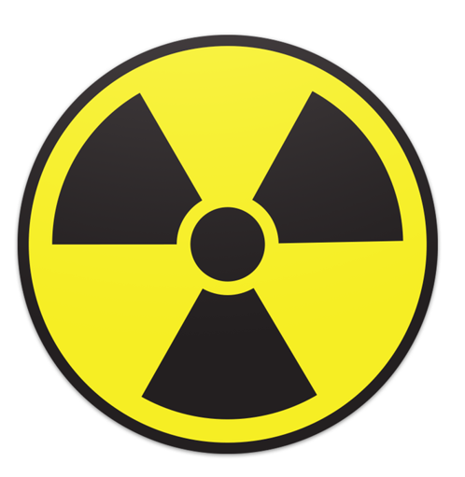
Introduction
Radioactively contaminated casualties are unlikely to emit radiation that is harmful to rescuers and hospital staff.
Irradiated casualties are those that have been exposed to high levels of radiation, (X-rays or gamma emissions) which has passed through them. Such casualties do not re-emit harmful radiation and would not be a risk to rescuers and hospital staff.
Ionising radiation is detectable and quantifiable. If radioactive material is the only contaminant (i.e. no chemicals present) and injuries are life threatening, the patient should be treated at the nearest appropriate Emergency Department (ED).
On no account must the treatment of serious injury or necessary evacuation to hospital be delayed. Even where a radioactive contaminant is unknown, such as with a CBRN incident, casualties should be dealt with at the incident site but upon arrival at ED, the casualty shall be screened with the radiation detector instrument known as the RAM GENE-1. Two of these instruments are kept in the ED Major Incident Room.
In addition to any contaminated casualties, as a precaution, the ambulance crew shall be screened using the RAM GENE-1 and given expert advice if necessary.
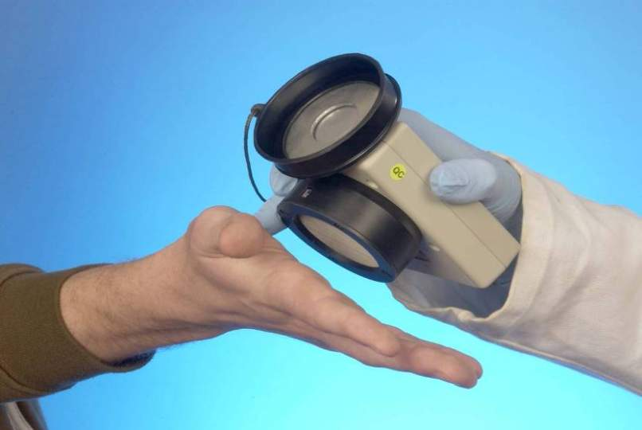 | 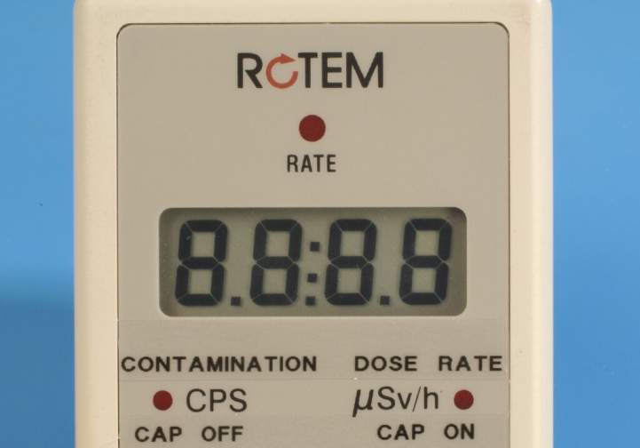 | 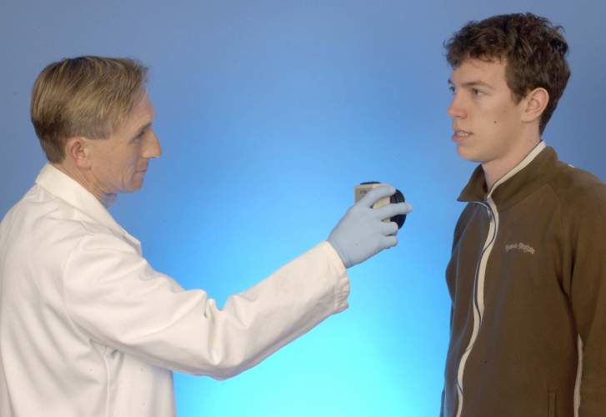
RAM GENE

This procedure is set out in three sections:
Section A Identifying and treating a contaminated casualty
Section B Routine monitor maintenance
Section C Staff training

Annex D: SECTION A - Identifying and treating a contaminated casualty
Any one of the following scenarios will lead to a high index of suspicion that a casualty is contaminated:
- You are informed by ambulance control that paramedic, fire & rescue, or police electronic personal dosemeters have alarmed at the incident scene;
- The patient tells you that they work with radioactive materials and they have had an accident e.g. industrial radiographer, driver of vehicle transporting radioactive materials;
- The accident occurs in a controlled area where radioactive materials are used;
- Vehicles, equipment or materials involved in the incident have radiation decal markings;
  - MoD announces the release of an alpha emitter (weapon accident). Personal dosemeters cannot detect alpha radiation but the RAM GENE-1 can when set to contamination mode.
At the scene of the incident the Emergency Services will decontaminate uninjured and non-critically injured people. Only contaminated casualties who have life threatening injuries should be sent to the ED.
Treatment and stabilisation of injuries for these persons should be the first priority followed by decontamination.
The following system of practice applies only to critically injured patients with potential radioactive contamination. All other patients and persons should have been decontaminated before admission.
It is important that help and support is obtained from a Medical Physicist (available via switchboard) as soon as possible. Do not wait for Medical Physics staff to arrive before admitting the patient and beginning to treat them.
More staff will be required to undertake this procedure. Local procedures must be in place to quickly mobilise staff to support the ED quickly, 24/7. It is important to exercise this system if you are going to use it effectively.
The ED needs to be divided into two areas; a dirty area and clean area. These areas must be defined by visual and/or physical barriers.
Dirty Area
This is the decontamination area. The casualty receives care necessary to stabilise clinical condition and is decontaminated here before transfer for definitive care to other hospital departments.
A member of staff is designated the dirty monitor. This person works within the decontamination area and their purpose is to protect the clinical team and survey the casualty. The dirty monitor is trained to perform the radiation contamination survey and is familiar with the use of the radiation monitor (RAM GENE-1). The trauma team stabilising the casualty works under the direction of the dirty monitor. No-one leaves the dirty area unless given permission by the dirty monitor.
Before the casualty is admitted to the designated dirty area the dirty monitor will:
- Ensure that clinical staff are appropriately dressed;
- Ensure that ambulance staff and porters know which is the designated facility that the patient is to be brought to;
- Remove the RAM GENE-1 from its storage box and ensure that it is operating satisfactorily;
- Ensure the RAM GENE-1 is in the dose-rate mode (CAP ON) and record the background dose rate. If background dose-rate is > 1µSv/h contact the Medical Physicist for advice, but continue to admit the casualty and give treatment for life threatening injuries;
- Switch the RAM GENE-1 to contamination mode (CAP OFF) and record the average background count-rate (cps). If the average background contamination reading is greater than 2 cps, contact the Medical Physicist for advice, but continue to admit the casualty and provide treatment for life threatening injuries.
- When the casualty is admitted to the designated assessment/ resuscitation facility the dirty monitor will:
- Ensure the RAM GENE-1 is in the dose rate mode (CAP ON);
- Perform a careful scan (in about 30 seconds) of the casualty’s body with the detector held at a distance of about 30 cm from the body surface;
- If the dose-rate rises above 1 µSv/h then the casualty is provisionally graded as contaminated;
- Direct the clinical staff to remove all the patient’s clothing, which is to be double bagged and sealed;
- Ensure the RAM GENE-1 is then placed in the contamination mode (CAP OFF)
- Perform a detailed scan for external contamination
- Scan the body slowly at a distance of about 1 cm. The full scan should take at least three minutes.
- Where the count-rate rises above 300 cps then the presence of contamination is confirmed.
- Identify these contaminated areas on the Monitoring/Contamination Report Form (Appendix 1) and record the measured count-rates.
If no contamination is identified by the detailed scan declare that no contamination has been found and discontinue any precautions necessary for the management of radioactive contamination.
If contamination is detected direct the clinical team to remove contamination from the patient in the following order of priority:
- Wounds;
- Airways;
- Remaining body surface.
Any identifiable fragments of materials are to be handled with 6” forceps and placed in clear plastic specimen container and to be retained for analysis.
Non-visible materials remove with wet/dry/wet/dry gauze swabs (one pass – one direction)
Airways: nose blows if conscious, nose swabs if unconscious.
Repeat the detailed scan for external contamination. Scan the body slowly at a distance of about 1 cm. The full scan should take at least three minutes. In areas where the count-rate remains above 300 cps repeat local decontamination measures. Record changes in the measured count-rates following decontamination process.
Remember to carefully check superficial areas likely to retain low dose materials: hair, hands and feet.
Keep rechecking the effectiveness of your decontamination with the RAM-GENE. The aim of decontamination is to remove transferable radioactive materials. Keep on swabbing until the count rate from the contaminated site cannot be reduced any further.
The dirty monitor should check the operators’ hands regularly – any cross-contamination found is removed by simply changing the outer layer of gloves.
When external contamination is below 300 cps, and the casualty is stable, they are ready for transfer to the next clinical care area.
If new information arrives from the incident scene that no radioactive material has been released these procedures can be discontinued.
Clean area
This is the area immediately outside the dirty area. The clean monitor is the person that polices the decontamination area, is trained to perform the radiation contamination survey and is familiar with the use of the RAM GENE-1. The clean monitor allows only appropriate personnel to enter the decontamination area. The clean monitor ensures that people are screened for radioactive contaminants and are clean before they are allowed to leave the decontamination area.
The ‘clean’ casualty in the dirty area can now be moved. The dirty team wheels the trolley to the edge of the decontamination area and stand back from trolley; a new clinical team waiting with a clean trolley transfers the casualty to clean trolley.
The dirty team, one by one, disrobe (hence decontaminating themselves) at the edge of decontamination area under the supervision of the clean monitor, placing all their PPE in a waste bag to be left in the decontamination area.
The clean monitor performs a detailed contamination survey of each team member after they have disrobed. Scan each member of staff slowly at a distance of about 1 cm. The full scan should take at least three minutes. Where the count-rate is above 300 cps then the presence of contamination is confirmed; identify these contaminated areas on the Monitoring/Contamination Report Form and record the measured count-rates.
Any staff member with such contamination after the removal of their standard precaution clothing should shower and change into clean clothing and be re-scanned before release from the treatment area; and if clean, records that they are clean and releases them back to normal duties.
Bag and keep all removed materials including the swabs used to decontaminate the patient with the casualty’s own clothes. These remain in the decontamination area.
The room should be sealed with all used clinical materials, casualty and staff clothing left in the room until Medical Physics staff from Singleton hospital arrive to sort, clear, and supervise any cleaning required and authorise as fit to be returned to use.

Annex D – APPENDIX 1

RADIATION INCIDENT
CONTAMINATION & DECONTAMINATION RECORD FORM

Full operating procedures, including the management of the contaminated patient, are included in the RAM GENE-1 equipment box.
If casualty has life-threatening injury, treat first, then assess contamination; if no life-threatening injury, assess, decontaminate, then treat.
If you suspect that your casualty has been contaminated with radioactivity, immediately contact the Medical Physics Department in Singleton hospital.
You MUST wear PPE (surgical mask, gown, waterproof apron, hair & shoe covers, DOUBLE gloves) until casualty is known to be contaminant free.
You DO NOT need an NHS decontamination suit, lead apron (unless using X-ray equipment), personal dosimeter or stable iodine tablets.
CASUALTY DETAILS
Hospital/Unit:
Casualty’s surname: |  | First names/initials:
Date of birth (dd/mm/yy): |  | Unit number:
Date of incident (dd/mm/yy): |  | Place of incident:
BACKGROUND RADIATION RATES
Before the casualty arrives at the designated decontamination area
Background dose rate: __________µSv/h | Background contamination rate: __________cps
INITIAL RAPID SURFACE SCAN
Set instrument to dose-rate mode (instrument cap on); hold 30 cm from casualty’s body surface; scan should take around 30 seconds
Date of scan (dd/mm/yy): |  | Time of scan (24 hr clock):
Maximum dose rate µSv/h at (record site):
Maximum dose rate µSv/h at (record site):
Maximum dose rate µSv/h at (record site):
Dose rates < 1µsv/h everywhere on body (Y/N)?
provisionally UNCONTAMINATED (No X/ gamma-ray contamination)
One or more areas found where dose rate > 1µsv/h (Y/N)?
provisionally CONTAMINATED

1 of 2

DETAILED SURFACE MONITORING BEFORE and AFTER DECONTAMINATION
- Set RAM GENE-1 to contamination mode (CAP OFF)
- Hold instrument 1cm from body surface; monitoring should take around 3 minutes
- Shade / circle any areas of contamination found on the body shapes below
- Record the contamination rates (counts per second, cps) found BEFORE decontamination in the centre column
- Link the recorded contamination rate in the centre column to the relevant body area using an arrow
- Decontaminate (remove any contaminated clothing, decontaminate any wounds, then nose, mouth and face, followed by rest of body)
- Repeat detailed surface scan, and record contamination rates found AFTER decontamination
FRONT | MONITOR COUNT RATES |  |  |  | BACK
 | Before ……………………….. cps  After ………………………….. cps  Before ……………………….. cps  After ………………………….. cps  Before ……………………….. cps  After ………………………….. cps  Before ……………………….. cps  After ………………………….. cps  Before ……………………….. cps  After ………………………….. cps  Before ……………………….. cps  After ………………………….. cps  Before ……………………….. cps  After ………………………….. cps |  |  |  | 
FINAL MONITORING (To document casualty has no remaining significant contamination)
All monitored rates for all body surfaces below_____________cps
Cleared for transfer from dirty/decon area? |  | Yes | No | Recorded by (print name):  ……………………………………………………………
Repeat decontamination, and re-scan |  | No | Yes | Signature  ……………………………………………………………
- of 2
Annex D: SECTION B
Routine RAM GENE-1 maintenance: Instrument check
Location
Major Incident Room, Morriston Hospital Emergency Department
Frequency
Monthly and after use/ cleaning.
Requires
1. RAM GENE-1
2. Instrument service log.
Procedure
1. Make visual inspection of RAM GENE-1 to identify any external damage
2. Check RAM GENE-1 service log to see whether annual battery change is due, if so, change battery before proceeding further
3. Turn RAM GENE-1 on. If instrument fails to switch on, change batteries and re-start procedure. If instrument still fails to switch on go to section ‘action in event of RAM-GENE failing’
4. Record that battery condition is good and whether battery has been changed
5. Perform a function test as follows:
5.1. Turn RAM GENE-1 on
5.2. Ensure that the audio sounds continuously for about 1 second
5.3. Ensure that the RATE LED illuminates continuously for about 1 second
5.4. Ensure that the liquid crystal display shows 8.8:8.8
5.5. Set the RAM GENE-1 to the dose rate mode (CAP ON)
5.6. Ensure that the DOSE RATE LED is illuminated continuously
5.7. Observe for at least 10 seconds and ensure that the audio bleeps and the RATE LED illuminates intermittently
5.8. Ensure the display indicates between 0.01 and 0.20 µSv/h
5.9. Set the RAM GENE-1 to the contamination mode (CAP OFF)
5.10. Ensure that the CONTAMINATION LED is illuminated continuously
5.11. Observe for at least 10 seconds and ensure that the audio bleeps and the RATE LED illuminates intermittently
5.12. Ensure the display indicates between 0 and 1 cps
5.13. Replace cap and ensure that the instrument returns to the dose rate mode
6. Switch instrument off and return to storage box.
Action in event of RAM GENE-1 failing:
1. Return RAM GENE-1 to storage box
2. Clearly label the outside of the box ‘instrument faulty’
3. Inform Radiation Physics that the RAM GENE-1 has failed on Ext 35520 or 34164

Annex D: SECTION B
Routine RAM GENE-1 maintenance: Battery check
Frequency
Annually irrespective of RAM GENE-1 internal check stating that battery is good; or when instrument indicates that battery level is low; or when instrument appears to have failed
Requires
1. RAM GENE-1
2. Replacement battery
Procedure
1. Turn RAM-GENE so that battery compartment is uppermost, ensuring that the detector surface is protected
2. Open battery compartment
3. Remove used battery and dispose of according to Health Board policy for hazardous materials; check the condition of the terminals for damage or degradation.
4. Place new battery in compartment ensuring that it is correctly orientated;
5. Replace battery cover and secure
6. Turn RAM GENE-1 on and ensure that there are no low power warning symbols lit
7. Record the date and reason for battery change (low power warning/ RAM GENE-1 failure/ routine annual battery change) on RAM GENE-1 maintenance log (Appendix 2)

.

.

Annex D: APPENDIX 2 - RAM GENE-1 maintenance log
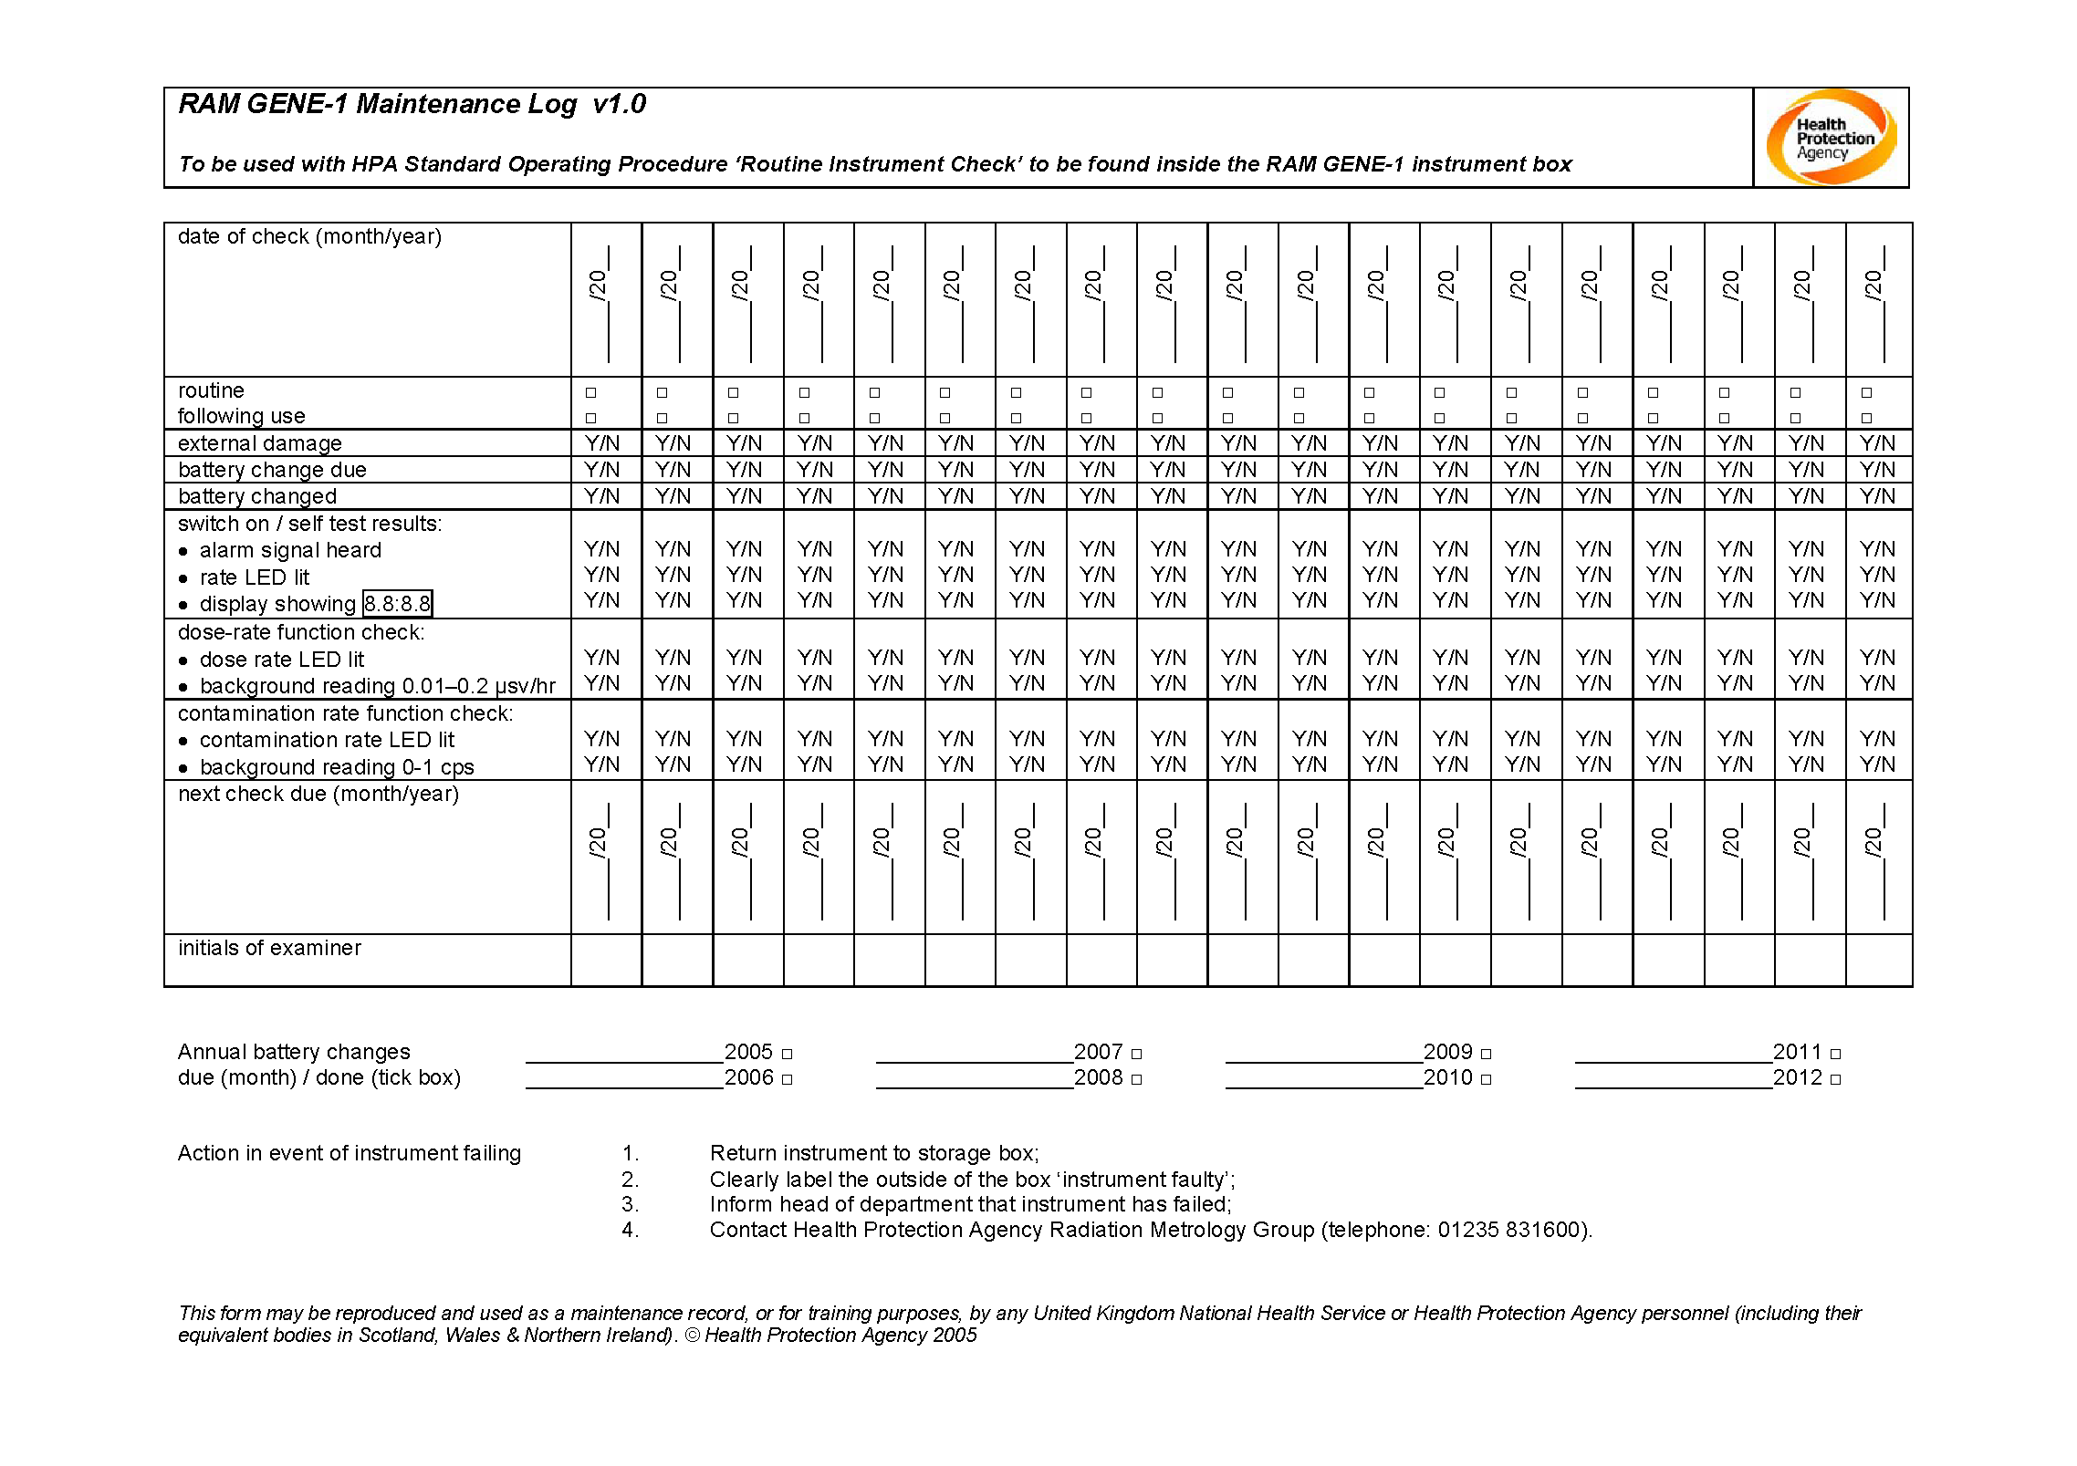
Annex D: SECTION C Staff Training

RAM-GENE Contamination Monitoring Equipment Training Record

Name
Role
Department
Date

Knowledge Check
Switch instrument on successfully | Yes / No
Identify instrument self-test sequence successfully | Yes / No
Change battery successfully | Yes / No
Set instrument to dose-rate and read background dose-rate to +/- 50% | Yes / No
Perform rapid surface dose rate measurement successfully  • instrument set to dose-rate mode  • instrument held 30cm from surface  • monitoring performed at correct rate | Yes / No  Yes / No  Yes / No
Set instrument to contamination rate and read background contamination rate to +/- 5 cps | Yes / No
Perform contamination surface monitoring successfully  • instrument set to contamination mode  • instrument held 1cm from surface  • scan performed at correct rate | Yes / No  Yes / No  Yes / No
All confidence reassurance checks passed

Approved by: …………………………………………………………………..
Title: ……………………………………………………………………………..
Date: ……………………………….

Annex E – PPE Algorithm

Annex F – CBRN Body Bag

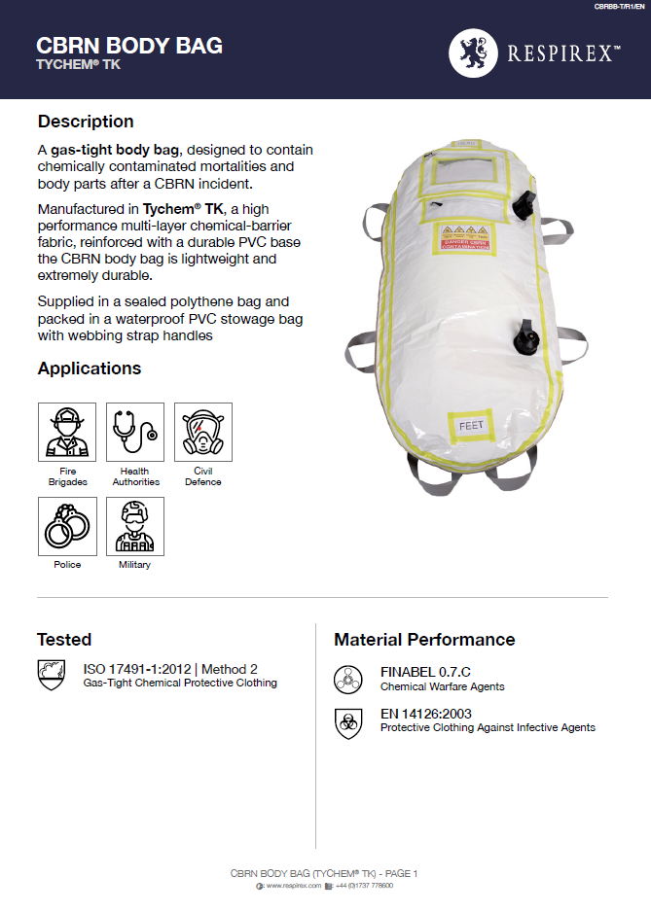
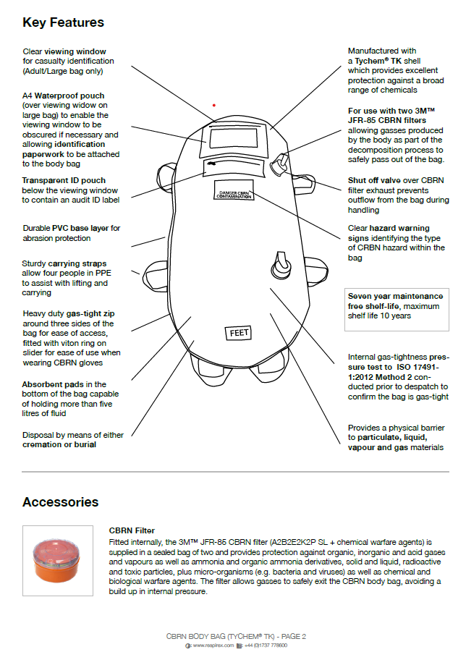
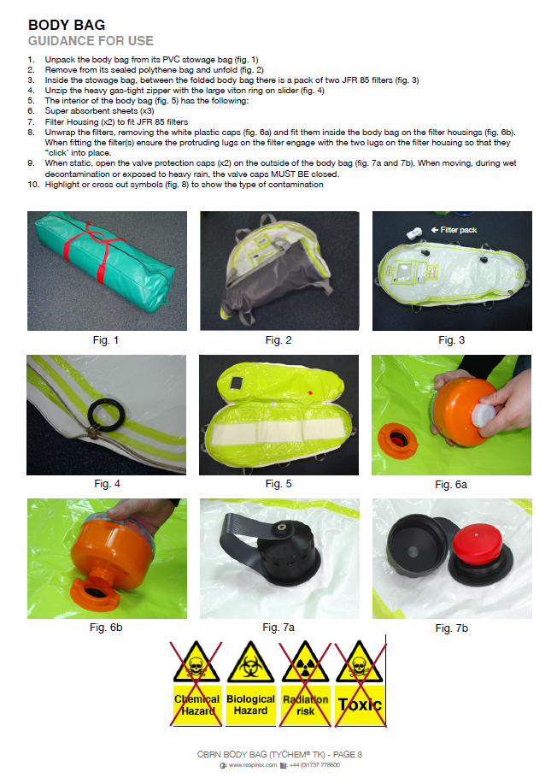

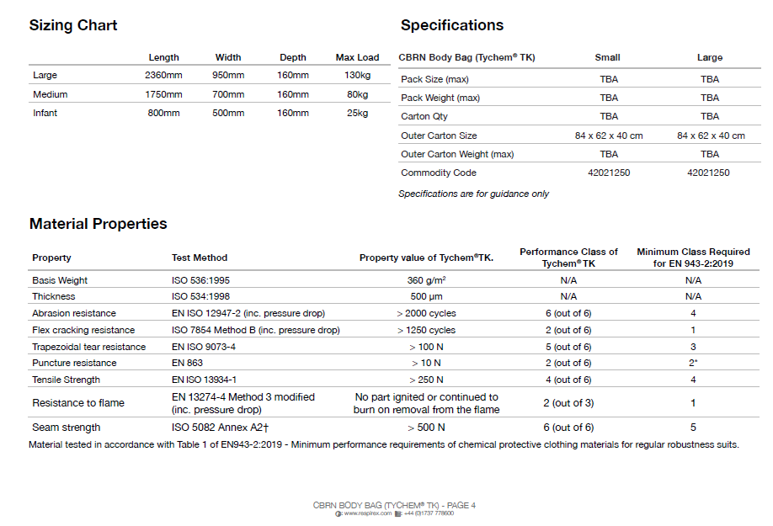

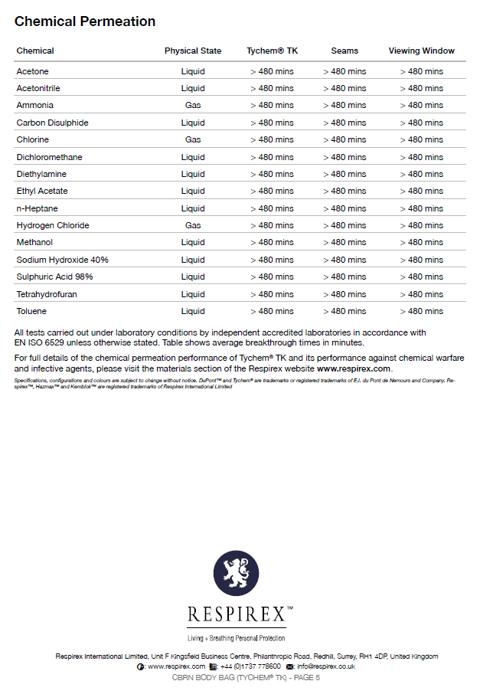

Annex G- Sodium Azide Data Sheets

PHE - ICE datasheet

Sodium Azide / Hydrazoic acid.

Properties: Sodium azide is a colourless and odourless white solid. It is soluble in water, forming the toxic compounds hydrazoic acid and hydrogen azide gas. The gas has a pungent odour. Its formation can be explosive causing combined traumatic and toxicological effects.

  Routes of toxicity
  Ingestion of sodium azide is highly toxic and is the most likely route of exposure
  Inhalation of hydrazoic acid vapour or hydrogen azide gas may occur when sodium azide is exposed to moisture or water.
  The extent of sodium azide absorption through the skin is unclear but systemic toxicity has been reported.
  Symptoms of exposure
  Ingestion causes headache, nausea, vomiting, diarrhoea, pallor, blurred vision, dilated pupils, restlessness, faintness, muscle weakness, sweating and hypothermia. This can lead to coma and respiratory failure.
  Inhalation also causes coughing, nasal irritation and bronchospasm
  In severe cases there may be profound hypotension, bradycardia, ventricular tachycardia and fibrillation. Acute lung injury, cerebral oedema and cardiomyopathy may occur.
  Risk of secondary contamination
  Hydrazoic acid/ hydrogen azide gas:
  Minimal risk of secondary contamination from inhalation once the patient has been removed from the site of exposure.
  Sodium azide: Hydrazoic acid/hydrogen azide gas may be exhaled following ingestion of sodium azide.
  First responders, hospital and mortuary staff could be affected by breathing in exhaled vapours, off-gassing from vomitus or if residual sodium azide on clothing comes into contact with moisture.
  Is decontamination required?
  Hydrazoic acid/ hydrogen azide: Unlikely to be required if the victim has only been exposed to vapour.Sodium azide: May be necessary if clothing or skin contaminated with sodium azide, contaminated vomit or other chemicals. NB: consider dry decontamination due to risk of hydrazoic acid/hydrogen azide release in contact with water.
  Is a chemical resistant body bag required?
  Hydrazoic acid / hydrogen azide: A chemical resistant body bag is unlikely to be required following inhalation exposures.
  Sodium Azide: A chemical resistant body bag may be indicated following significant ingestions

Personal Protective Equipment | The following is generic advice. Always follow site specific dynamic risk assessment
First responders:  Hospital:  Mortuary Staff: | Only responders with access to appropriate PPE should enter the ‘hot zone’ or carry out rescues  Self-contained breathing apparatus and PPE (e.g. fire kit) may be considered for immediate rescues to preserve life  Full PPE such as GTS/PRPS may be used for scene assessment and body recovery  PPE for chemical hazards unlikely to be required for patient only exposed via inhalation.  Following ingestion be aware of potential risks of off gassing from patient / any contaminated vomit. NHS PRPS PPE may be required  Following ingestion appropriate PPE may be required.  PPE for chemical hazards would not usually be required for inhalational exposures.
Antidote: | No specific antidote  Contact the National Poisons Information Service (24 hrs. number: 0844 892 0111) for advice on treating patients following exposure.
Post-mortem considerations

Potential hazards | Off-gassing may pose a hazard even if the body cavity is not opened. Harmful products are to be expected in the stomach as well as the body cavity.
DIM monitoring beneficial at post-mortem | Yes for ingestion.
Exposure Levels (ppm)

Odour threshold | No data
UK 15min workplace exposure limit | 0.1
UK 8 hour workplace exposure limit | 0.3
Explosive Limits

Lower | No data but highly explosive.
Upper

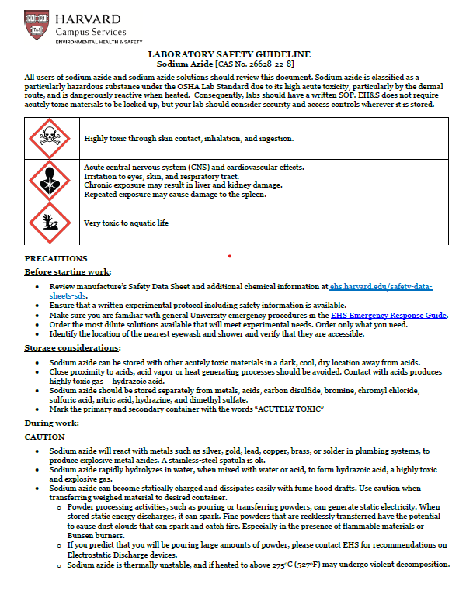
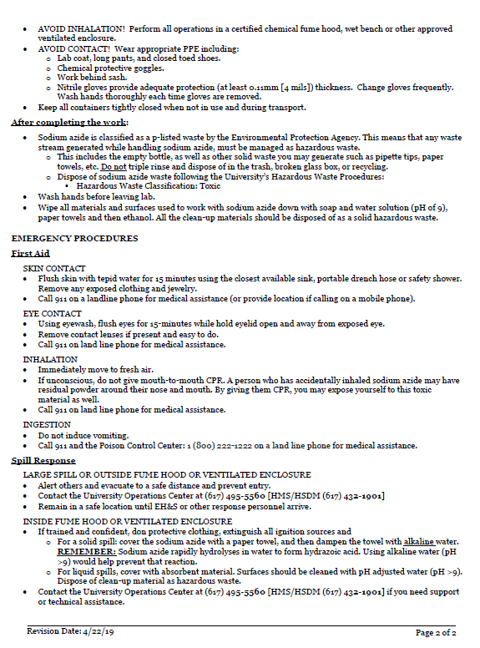

Annex H- Activating Multi Agency Command and Control

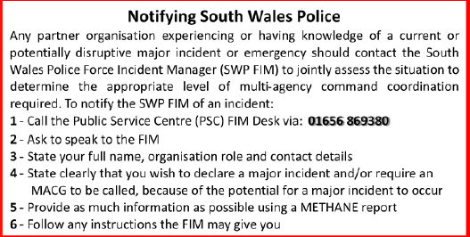

Annex I- Key Contacts

National Poisons Information Service | 0344 8920111 - available 24 hours to provide specialist and consultant medical advice to clinicians
CBRN Tactical Advisor Number | 0845 000 6382 – 24/7 OPS Hotline.
Police National CBRN Centre | 08450006382
Public Service Centre (PSC) Force Incident Manager (FIM) Desk | 01656 869380
Swansea LA Contact Number | In Hours – 01792 636109  Or duty officer 07980912585  Out of Hours - duty officer 07980912585
NPT LA Contact Number | In Hours - General Office No: 01639 686409  Emergency Planning Manager: 07980 727109  E-mail: ept@npt.gov.uk  Out of Hours - Emergency Control Room (CCTV): 01639 686899  (Ask for the Emergency Planning Duty Officer)
Defra CBRN Emergencies team  Defra Duty Room (if above number busy) | 03300 416565  0345 051 8486
PHE Chemicals hotline (24 hours) | 0344 892 0555
Public Health Wales Health Protection Team | 0300 00 300 32
Imported Fever Service | 0844 778 8990
UK Health Security Agency | 0113 267 9041
PHE Radiation Protection Division | In hours- 01235 831600  Out of hours- 01235 834590

Annex J- JESIP Principles for Joint Working
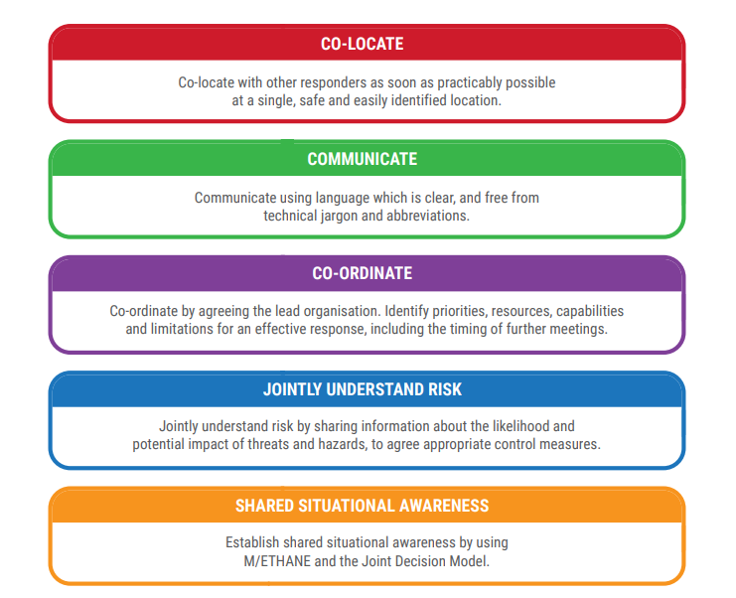

Annex k - Health protection framework

