Resilient Swansea
Climate Change Adaptation Strategy for Swansea
May 2025 - 2040


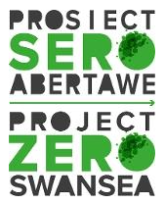
Swansea Climate Signatories Swansea Public Services Board
Contents
- Foreword – Message from the Climate Signatories Group
- Executive summary
- Background
- Climate risks
- Swansea now
- Strategic approach
- Monitoring
- Potential risks to implementation
- Definitions
- References

Figures

Figure 1: Strategy Structure.
Figure 2: Summary table of climate risks for Wales.
Figure 3: Ten principles of Good Adaptation.
Figure 4: The One Health Principle.
Figure 5: The relationship between local and national fifths, based on the Welsh Index of Multiple Deprivation (WIMD).

Tables

Table 1: Climate projections for Swansea show changes under intermediate and higher scenarios, based on a central estimate (50th percentile) compared to 1981-2000.
Table 2: Flooding and potential increased response to climate risks and future mitigation priorities.
Table 3: Storms and potential bad weather days response to climate risks and future priorities.
Table 4: Storms and potential extreme weather response to climate risks and future priorities.
Table 5: Drought and Heat, and potential extreme weather response to climate risks and future priorities.
Table 6: Examples of public services decarbonisation plans reported in Swansea.

Appendices

Appendix A: Key Influencing legislation, policy and guidance.
Appendix B: Climate Risk Summary
Appendix C: Technical Reports Executive Summary
Appendix D: Technical Reports Findings

- Foreword - Message from the Climate Signatories Group
This strategy is published at a time when global temperature rises, attributed to manmade climate change, have reached a record high. According to the World Meteorological Organization (WMO), 2024 became the warmest year on record and the first to exceed 1.5°C above pre-industrial levels.
Climate Models predict that without significant climate action, the world is headed for a 2.5 to 2.9°C temperature rise above pre-industrial levels this century, which is well above safety limits established by scientists. This both directly and indirectly impacts the health and well-being of people and planet, particularly impacting vulnerable communities. However, climate action also creates opportunities that if embraced could ensure resilience for the future.
Much of the focus on climate change has been to mitigate, attempting to stop further rise in the harmful greenhouse gas emissions that cause it, with legislation to control and reduce carbon emissions by 2050. The UK Climate Change Commission reported in 2023 that the First Carbon Budget (2016-2020) for Wales was achieved, with Welsh greenhouse gas emissions decreasing to an average of 28% below 1990 levels during this period.
Efforts by the public and private sectors to reduce emissions across scopes 1 (direct emissions) and 2 (Indirect emissions from purchased energy) continue, with renewable energy schemes, investment in the retrofit of buildings and changes in practices to reduce consumption and waste through the adoption of a more circular economic model. Whilst this has been challenging, the real test ahead will be dealing with scope 3 emissions (those emitted by supply chains and therefore outside direct control) which will require greater collaboration and a shift towards economic models that include the value of social and natural capital. Swansea can work towards this aim taking opportunities such as a moving towards the 'Doughnut' economic model of good practice.
The Swansea Climate Adaptation Strategy – Resilient Swansea, recognises that climate change is already with us and that even with all the mitigation work continuing, the effects of increased carbon dioxide and other greenhouse gas emissions already in our atmosphere will continue to warm our climate for years to come. This will lead to more frequent and severe storm events such as Storm Darragh in December 2024 when winds reached over 72 mph and caused damage to property; increased occurrences of flooding as seen at the Mond Valley Golf Club in 2023; longer periods of hotter weather with temperatures regularly reaching over 30̊C experienced in July 2025 which can lead to regular drought periods and continuing sea level rise that will affect tourism and low lying areas. This places the natural environment under increasing pressure and results in resource pressures impacting the rights to health, housing and a safe environment for the population of Swansea. The need to adapt to these, and the expected continuing changes is evident, if we are to ensure we can thrive as a community going forward.
This strategy is the beginning of the journey for Swansea in adapting to the effects of climate change and looks at the opportunities we have now to ensure we have a vibrant place to live and work in the future.

- Executive Summary
The Swansea Climate Adaptation Strategy – Resilient Swansea, addresses the urgent need for the City and County to adapt to the impacts of climate change. With global temperatures rising and the effects of climate change becoming more frequent and severe, this strategy outlines the collective approach organisations in Swansea – Wales’s first Human Rights City - will take towards a sustainable, and resilient future grounded in equality, dignity and participation for all communities. This common strategic approach will facilitate the strategic alignment of individual organisational plans for action.
The strategy recognises that while efforts to mitigate climate change continue, adaptation is essential to cope with the inevitable changes already set in motion. It highlights the importance of collaboration between various sectors, including public services, businesses, and the community, to build resilience against climate risks such as flooding, storms, heatwaves, drought and sea level rise.
Key areas of focus include:
- Partnership and Collaboration: Emphasising the need for joint efforts across different organisations and the community to achieve climate resilience
- Leadership: Ensuring long-term commitment and leadership beyond election cycles to drive the adaptation strategy forward.
- Resilient Services: Planning ahead to maintain and improve public services in the face of increasing climate pressures.
- Resilient Communities: Supporting and building strong communities to enhance their capacity to respond to climate-related events.
The strategy has been prepared by the Climate Signatories Group based on the findings of detailed Technical Reports commissioned to independently engage with stakeholders and experts. The strategy’s implementation will be governed and monitored by the Climate Signatories Group and Swansea Public Services Board. These partnership organisations bring together the stakeholders who will drive and influence action on climate change adaptation by individuals, business, the public and voluntary sectors.
The Strategy also aligns with existing legislation, plans and policies to ensure a cohesive approach to climate adaptation. Overall, the Swansea Climate Adaptation Strategy aims to create a vibrant, sustainable, and resilient Swansea that can thrive in the face of climate change.

Figure 1: Strategy Structure.
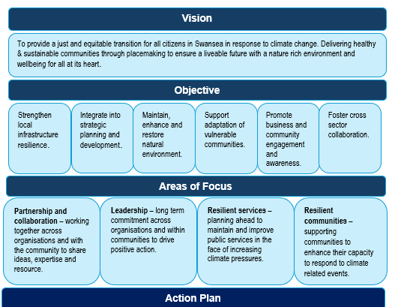
3. Background
The purpose of this strategy is to respond collaboratively to an evidenced gap in Swansea’s future resilience and to uphold the human rights of our residents to live in safety, dignity and good health in the face of climate risks by developing a shared strategy so all stakeholders in Swansea can take the co-ordinated actions necessary for effective climate change adaptation.
Swansea Public Services Board and the Climate Signatories Group (CSG) commissioned an independent extensive stakeholder engagement and research project. This Strategy draws together and acts on the technical information resulting from the project. It also responds to existing and emerging expectations and duties in relation to climate change adaptation activity in Swansea.
3.1 Legislation
Wales is committed, through the Well-being of Future Generations (Wales) Act 2015 to thinking, not only about those who are living and working in Wales now, but also about those yet to be born and the importance of enabling a Prosperous, Resilient, Healthier and More Equal Wales, with thriving Culture and Communities that looks outward and is Globally Responsible. This groundbreaking legislation, together with the Environment (Wales) Act 2016 form the basis of other strategies and policies, such as Welsh Government Net Zero strategic plan to reduce carbon emissions and reach net zero by 2050 and ensure the sustainable management of natural resources.
In October 2024, the Welsh Government (WG) published its latest strategy relating to climate change and nature recovery. The Climate Adaptation Strategy for Wales sets objectives for adapting to our changing climate with an action plan set out with goals or asks for Welsh Government, public and strategic partner bodies, business and industry as well as the general public. The accompanying action plan for Swansea will take a similar approach.
A table summarising key influencing legislation, policy and guidance is set out in Appendix A.
3.2 Swansea Public Services Board
Public Services Boards (PSBs) in Wales were established in 2015 through the Well-being of Future Generations (Wales) Act 2015 The main function of PSBs in Wales is to improve joint working across all public services in each local authority area, to enhance local well-being. They do this by assessing local well-being, developing and delivering a local well-being plan, and publishing an annual report, all aligned with the requirements of the Well-being of Future Generations (Wales) Act 2015.
Swansea Public Services Board comprises of the four statutory members: Swansea Bay University Health Board, Natural Resources Wales, Mid and West Wales Fire and Rescue Service and Swansea Council, with invited members such as Police and Universities. All participants sign up to a set of commitments when they join. These go above and beyond the legal duties of the different organisations.
The PSB is required to carry out an Assessment of local well-being - Swansea to understand current levels of well-being and what matters most to local communities and to produce a Local Well-being Plan in order to improve well-being of citizens. The second such assessment was carried out in 2022. This formed the evidence for the current Local well-being plan 2023-28 - Swansea.
Swansea PSB has undertaken systems mapping work help take a step back and view the bigger picture - identifying where we can better align actions, share data more effectively, and plan for the long term. This Strategy and the resulting Action Plan will form part of that long term systems approach.

3.3 The Climate Change and Nature Action Charter Signatories Group
The Climate Change and Nature Action Charter Signatories Group (The Climate Signatories Group (CSG)) was set up in 2023 after Swansea Council and its key partners had declared climate (2019) and nature (2021) emergencies. The partners all recognised that to respond positively and robustly to climate change and nature recovery, a collaborative effort would be required. A Charter, to this effect, was drawn together and leaders from key partner organisations invited to sign.
In January 2023, nominated representatives from the four statutory PSB members, Swansea University, UWTSD, Gower College, Swansea BID, Swansea Council for Voluntary Services, Pobl and Beacon (then Coastal), together with other representatives from the third sector and business, met for the first time. In July, the same year, the Swansea Public Services Board (PSB) tasked The Climate Signatories Group (CSG) to undertake the co-ordination and delivery of Step 3 of the Local Well-being Plan including the development and delivery of a Climate Change Adaptation and Mitigation Strategy and Action Plan for the county. Funding for this work was secured through the Shared Prosperity Fund and a working group from the CSG was formed to lead on this work.
The CSG continue to lead on Step 3 of the Local Well-being Plan. This strategy is the result of the first phase of that work, and the action plan will form the basis of its work, over the coming years.

4. Climate Risks
4.1 Climate Risk Assessment
Every 5 years the UK Government undertakes a climate risk assessment, looking at the key risks in the UK based on the UK Climate Risk provided by the Climate Change Committee (CCC). Climate risk assessments provided for the UK and the devolved administrations consider sixty-one UK-wide climate risks and opportunities, and prioritise the following eight risk areas for action (UK Climate Change Risk Assessment 2022):
- risks to the viability and diversity of terrestrial and freshwater habitats and species from multiple hazards
- risks to soil health from increased flooding and drought
- risks to natural carbon stores and sequestration from multiple hazards
- risks to crops, livestock and commercial trees from multiple climate hazards
- risks to supply of food, goods and vital services due to climate-related collapse of supply chains and distribution networks
- risks to people and the economy from climate-related failure of the power system
- risks to human health, wellbeing and productivity from increased exposure to heat in homes and other buildings
- multiple risks to the UK from climate change impacts overseas.

Figure 2: Summary table of climate risks for Wales.
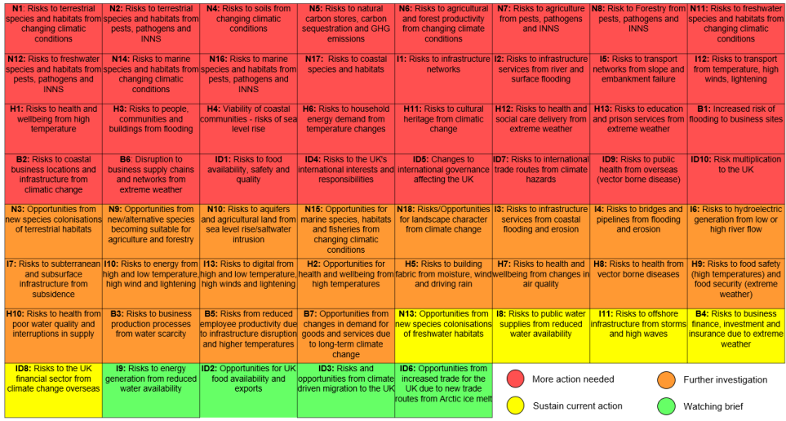
- Source: Natural Resources Wales/Welsh Government (2024) Climate Change Risk Assessment Framework for Public Services Boards
The Climate Change Committee’s Monitoring Framework Climate Change Committee's Monitoring Framework tasks regions with looking at two significant temperature scenarios, that of a 2̊ C and a 4̊C rise. When assessing the risks for Swansea these scenarios were considered in line with Climate Change Commission advice on best practice.
Figure 3: Ten principles of Good Adaptation.
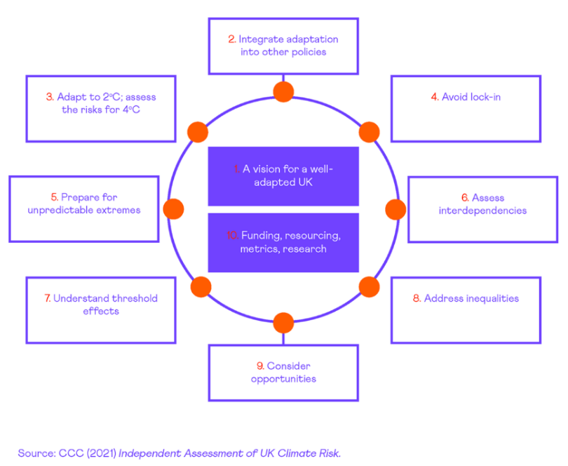
These temperature rises would have a profound effect on biodiversity and on the health and wellbeing of the population as evidenced in the PHW Climate Change in Wales Health Impact Report. With the Welsh Index of Multiple Deprivation 2019 (WIMD) showing that 11.5% of Swansea’s population is in the 10% most deprived areas of Wales and the fact that climate change is likely to affect the most vulnerable in society the hardest, Swansea needs to fully understand and take into account these risks in all future service planning to ensure a thriving community in the future.
The following section reviews both adaptation and mitigation within ‘future priorities’ tables 2 – 5 as these are taken directly from workshops.

Table 1: Climate projections for Swansea show changes under intermediate and higher scenarios, based on a central estimate (50th percentile) compared to 1981-2000.

 |  | 2050s | 2070s | 2100
Annual Average temperature  (°C change) | Intermediate (RCP4.5) | 1.4 | 1.9 | 2.8
Annual Average temperature  (°C change) | Higher (RCP 8.5) | 1.9 | 3.0 | 4.7
Average Summer temperature  (°C change) | Intermediate (RCP4.5) | 1.7 | 2.6 | 4.1
Average Summer temperature  (°C change) | Higher (RCP 8.5) | 2.4 | 4.0 | 6.6
Average Winter temperature  (°C change) | Intermediate (RCP4.5) | 1.2 | 1.6 | 2.2
Average Winter temperature  (°C change) | Higher (RCP 8.5) | 1.7 | 2.4 | 3.7
Summer Rainfall  (% change) | Intermediate (RCP4.5) | -18.5 | -24.6 | -33.6
Summer Rainfall  (% change) | Higher (RCP 8.5) | -23.6 | -34.5 | -49.2
Winter Rainfall  (% change) | Intermediate (RCP4.5) | 9.8 | 15.5 | 21.3
Winter Rainfall  (% change) | Higher (RCP 8.5) | 14.0 | 24.0 | 35.6
Sea Level rise (m) | Intermediate (RCP4.5) | 0.3 | 0.4 | 0.5
Sea Level rise (m) | Higher (RCP 8.5) | 0.3 | 0.5 | 0.8
Source: JBA Consulting/Swansea Council (2025) Technical Reports to support the development of the Climate Change Adaptation and Mitigation Strategy for Swansea.

The following hazards were identified in the Technical Reports as commonly referenced and are in line with key risks identified by the Climate Change Committee.

Flooding and Sea level Rise

Flooding and sea level rise are a significant concern for Swansea as a county. It is surrounded on three sides by the ocean and has one of the greatest tidal ranges in the world with the River Tawe near the city centre and its eastern boundaries and the River Lougher on its northern boundaries. This is of particular concern for low lying areas along the coastline and river sides. At time of publication, according to Properties at risk of flooding 2024 by local authority 851 households are undefended and at high risk of flooding while 317 households are defended from high risk of flooding in the context of an approximate 109,00 households in Swansea. Flood risks maps of Swansea are included in Appendix B Climate Risk Summary.
Mitigation projects to ensure the protection of property and infrastructure are taking place across Swansea as part of a multimillion-pound Flood and Coastal Erosion Risk Management Programme 2025 to 2026 .
Surface water flooding, also known as pluvial or flash flooding, occurs when heavy rainfall overwhelms drainage systems. This happens when there is so much rain that it can't drain away quickly enough, either because drainage networks are overwhelmed, or due to blockages in pipes and sewers. Surface water flooding issues occur regularly in certain areas of Swansea as reported by attendees at community workshops. Natural Resources Wales produce detailed Flood Risk Maps.

Table 2: Flooding and potential increased response to climate risks and future mitigation priorities.
Climate hazards | Potential response to climate risks and future priorities
Increased flooding | To improve resilience to flooding, possible responses include:  - Developing and promoting green infrastructure in urban areas, with a well-connected network of green and blue spaces across Swansea providing multiple environmental and health benefits to an area.  - Retrofitting buildings with resilience measures to protect them from flooding. This in turn could support job creation in these sectors and contribute to a more prosperous Wales.  - Design new buildings to be resilient to storms and heavy rain, improving resilience and providing new areas for the industry to explore.  - Development of local flood warning systems to support community preparedness and help communities respond to flood events.  - Within urban areas, permeable surfaces and soakaways should be prioritised, alongside the implementation of wider sustainable urban drainage systems (SuDS) measures.  - Incentivise public adoption of SuDS in driveways/gardens.  - Encouraging investment in flood risk management systems for businesses and homes was identified as a priority to reduce the impact of flooding in highly developed areas, which was seen as vital in ensuring the long-term resilience of Swansea.  - Training and investment in resilient infrastructure.
Source: JBA Consulting/Swansea Council (2025) Technical Reports. Potential responses and future priorities identified during all workshops in relation to climate hazards.

4.1.3 Storms
Wales is experiencing more frequent storm events. Storm Darragh brought strong winds and heavy rain to Wales in early December 2024, causing widespread damage and power outages, with over 57,000 homes and business without power across South Wales alone. The storm also caused significant damage to infrastructure, with trees coming down and blocking roads.

Table 3: Storms and potential bad weather days response to climate risks and future priorities.
Climate Hazards | Potential response to climate risks and future priorities
Bad weather days | There was concern over the resilience of Swansea's transport systems to disruption caused by increased occurrence of bad weather days and extreme weather events. Suggested responses included:  - Investment in transport infrastructure: More electric buses and cycle path improvements.  - Prioritising pedestrian-friendly measures, including an increase in well-lit accessible walkways across the city-centre.  - Focusing on pedestrian-friendly measures to reduce pressure on public transport, encouraging healthier, more accessible methods of transport.  - Encourage solutions included in the Bus Reform for Wales Roadmap published by the Welsh Government (Welsh Government, 2024).  - Encourage growth in green technologies to minimise people travelling to work during adverse weather. ICT technologies could be enhanced to support more remote working. Also, encouraging working from home where possible could contribute to Net Zero goals (Circular Ecology, 2023). This is dependent on how far people travel to work (The London School of Economics, 2021).  - Move towards more renewable-based energy systems across Swansea. These systems could be more reliable during bad weather events and contribute to the net zero goals.  - Developing plans for flexible working during bad weather events. This ensures there are lower barriers to accessing work during these events, promoting a more equal Wales.  - Financial incentives for businesses to incorporate climate adaptation into their plans and day-to-day operations was seen as a priority for building thriving businesses and a prosperous Wales in the face of climate change.  - Prioritising the development of training opportunities and climate resilient hubs and training programmes will help to strengthen community preparedness and enhance their capacity to respond to climate-related events.  - Ensuring that, where business travel is necessary, appropriate 'bad-weather exceptions' are implemented.  - Business plans could incorporate policies to encourage home and remote working in the event of weather-related travel disruptions. This measure would reduce the reliance on commuting and emissions associated with the use of personal vehicles and public transport.
Source: JBA Consulting/Swansea Council (2025) Technical Reports. -Potential responses and future priorities identified during all workshops in relation to climate hazards.
Table 4: Storms and potential extreme weather response to climate risks and future priorities.
Climate Hazards | Potential response to climate risks and future priorities
Extreme weather events such as increased storm effects, wildfire events and heatwaves | Extreme weather and heatwaves will present an increasing risk over the coming years. Designing resilient urban and rural areas across Swansea is considered key to protecting communities from extreme weather and heatwaves. Through the workshop, there was a consensus that to ensure community preparedness, measures must be taken to design urban spaces with heat mitigation strategies in place. This could include:  - Retrofitting buildings to withstand extreme weather events by integrating green roofs and walls into existing structures, to reduce the reliance on non-renewable energy sources for heating and cooling.  - Encouraging urban tree planting to reduce the urban heat island effect in densely populated areas, and also reduce the impacts of heatwaves, particularly for vulnerable populations.  - Designing shaded areas and green spaces that will reduce temperatures in the city centre. These spaces could also be designed to support the conservation of water during heatwaves through water storage and reduction of runoff. The measures could be used to develop public health campaigns which encourage the use of green space.
Source: JBA Consulting/Swansea Council (2025) Technical Reports-. Potential responses and future priorities identified during all workshops in relation to climate hazards.

4.1.4 Drought and Heat
Swansea, like the rest of the UK, is set to experience an increase in the number of days of hot weather. A heatwave is classified as when a location experiences more than three consecutive days with maximum temperatures meeting or exceeding a specific threshold. That threshold in Wales is currently set at 25̊ C. When temperatures reach or exceed this threshold it can be uncomfortable for the majority of people but those who are more vulnerable can experience life threatening conditions. Livestock, pets and wildlife are also likely to suffer requiring special consideration during these heat spells.
Prolonged such spells can also lead to drought and water shortages which can exacerbate risks from heat waves and cause additional problems with food supply and infrastructure issues such as railway lines buckling and road surfaces melting.

Table 5: Drought and Heat, and potential extreme weather response to climate risks and future priorities.
Climate Hazards | Potential response to climate risks and future priorities
Warmer, drier summers | The pressure on water supplies due warmer, drier summers will require current water resource strategies (e.g. how excess water is stored) to be adapted. Potential responses to this included:  - Promoting water-saving technologies like rainwater harvesting and greywater recycling to build resilience to water shortages.  - Ensure all communities are still able to access food and water: adjust agricultural practices and adopt practices that are drought-resistant to ensure a consistent food supply. It is recognised this a change in practices is reliant on funding and policy change.  - Taking the opportunity to review land management practices with respect to wildfire was also seen as being beneficial for mitigating the risks of wildfire to Swansea, for example, creating strategic fire breaks across areas at risk.  - Implement energy-efficient cooling systems, alongside green roofs, to mitigate the risks of increased temperatures.  - Efficient water management can also be collaborative, and community led. For example, restoring local wetlands as a form of natural flood management to conserve water and keep water within local systems.  - Develop green infrastructure in urban areas to reduce urban temperatures during heatwaves
Source: JBA Consulting/Swansea Council (2025) Technical Reports-. Potential responses and future priorities identified during all workshops in relation to climate hazards.

4.2 Cross-cutting themes
There are a number of cross cutting themes in climate adaptation. These are interconnected issues that impact multiple sectors and areas of life. Considering these cross-cutting themes helps to ensure effective and sustainable adaptation. These themes also cut across other areas of the Swansea Local Well-being Plan. Adaptation is acknowledged to be a fast moving and dynamic policy field where our understanding of many of the following themes is evolving. Adaptation activity positively impacts each of the seven national well-being goals and demonstrate the sustainable development principle’s five ways of working.

4.2.1 Social justice

The term social justice, as described in the recent Welsh Government paper Exploring a potential approach to understand and map the local level impacts and opportunities of a Just Transition to Net Zero refers to a fair distribution of social, political and economic opportunities, benefits and burdens across society. It is recognised that a just transition to a net zero emissions future needs to ensure any socio-economic inequities are not exacerbated by sharing the benefits across society. This is termed a Just Transition.

4.2.2 One Health
This plan recognises the importance of focusing on the health of the population alongside the health of nature and the environment. Integrating these aspects into our ways of working are strongly aligned with the One Health approach, which recognises the interdependence of human, animal and environmental health as part of sustainable development. The consideration of One Health approaches is highlighted in the Climate Adaptation Strategy for Wales and should guide our response to climate action and its relationship with interconnecting issues, including animal health and welfare, agriculture, impact on vector-borne diseases and pandemic risk.
Figure 4: The One Health Principle.
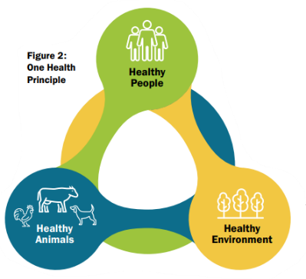
Source: Climate Adaptation Strategy for Wales

4.2.3 Prevention through mitigation and adaptation
Mitigation and adaptation are two distinct, yet interconnected, responses for addressing the effects of climate change. Mitigation focuses on reducing greenhouse gas emissions to prevent the most severe impacts of climate change, while adaptation involves adjusting to the changes that are already happening or are unavoidable in the future. They work together to protect people and ecosystems from the effects of climate change.
Mitigation is the reduction or prevention of the release of heat trapping greenhouse gases such as carbon dioxide, methane and nitrous oxide. It attempts to address the root causes of climate change by reducing emissions from sources such as transport and industry and switching to renewable forms of energy and improving energy efficiency as well as reducing deforestation and planting more trees to limit the future extent of climate change and its impacts.
Adaptation is the adjustment to the actual and expected effects of climate change such as rising temperatures, increased rainfall, sea level rise and more frequent storm events to minimize the negative impacts of climate change on human societies and natural ecosystems. It focuses on reducing the vulnerability to the impacts of climate change by modifying infrastructure, ecosystems and social systems such as the building of sea walls as seen in Mumbles, the strengthening of public health systems as seen in the Swansea Bay Population Health Strategy and even the development of drought resistant crops as seen in work carried out in Aberystwyth University.
These two responses are synergistic as mitigation reduces the need to adapt further in the future and adaptation helps manage the unavoidable impacts of climate change that is already with us. Some mitigation actions, like afforestation, can also improve adaptation by enhancing ecosystem services and reducing the frequency of climate extremes. Both mitigation and adaptation are crucial for addressing climate change, as mitigation alone cannot prevent all impacts, and adaptation alone cannot solve the problem.

These responses to climate change can be framed in the context of the Well-being of Future Generations Act (Wales) 2015’s sustainable development principle by applying the Prevention Definition, taking account of the Well-being of Future Generations Act in the budget process agreed by Welsh Government below.
Prevention is working in partnership to co-produce the best outcomes possible, utilising the strengths and assets people and places have to contribute. Breaking down into four levels, each level can reduce demand for the next:
- Primary prevention (PP) – Building resilience – creating the conditions in which problems do not arise in the future. A universal approach. Climate change mitigation can be categorised as an example of this approach.
- Secondary prevention (SP) – Targeting action towards areas where there is a high risk of a problem occurring. A targeted approach, which cements the principles of progressive universalism*. Adaptation often exemplifies this approach.
- Tertiary prevention (TP) – Intervening once there is a problem, to stop it getting worse and prevent it reoccurring in the future. An intervention approach. Adaptation activity can also exemplify this approach along with Emergency Preparedness, Resilience and Response activity.
- Acute spending (AS) – Spending, which acts to manage the impact of a strongly negative situation but does little or nothing to prevent problems occurring in the future. A remedial approach – currently employed where climate change is not explicitly addressed with preventative approaches.
* progressive universalism is a determination to provide support for all, giving everyone and everything a voice and vested interest, but recognises more support will be required by those people or areas with greater needs.
4.2.4 Decarbonisation Plans and Reporting
All public bodies in Wales are expected to produce decarbonisation plans and report on progress through the Net Zero Wales Carbon Budget reporting process Net Zero Wales Carbon Budget Reporting Process.
Table 6: Examples of public services decarbonisation plans reported in Swansea.
Public Service | Current Carbon Management Plan (at time of strategy publication)
SBUHB | Swansea Bay University Health Board: Climate Action Plan 2024-26 - Swansea Bay University Health Board
Swansea Council | Climate Change and Nature Strategy 2022-2030 - Swansea
MAWWFRS | MAWWFRS carbon reduction road map-2024-2030

The Future Generations Report 2025 recommends “climate resilience and adaptation must become a core public service priority. By the end of 2027, Public Services Boards should assess climate change and risks for their communities, updating their findings every five years as part of their well-being assessments. Public bodies must integrate these findings into their corporate and strategic planning.”

4.2.5 Supply chain and circular economy
In today’s global economy, the stability of supply chains for essential goods and services such as food and energy supplies is increasingly exposed to risks. While many global influences are beyond our direct control, we can strengthen resilience by embedding circular economy principles into local systems. These principles prioritise designing out waste, keeping materials in use for as long as possible, and regenerating natural systems, and reducing dependence on finite resources.
The Welsh Government has set a clear direction through its commitment to a more circular economy, as outlined in Beyond Recycling. This transition is central to climate adaptation efforts, helping to mitigating the risks associated with supply chain disruptions while building long-term resilience in a rapidly changing world. A circular economy mirrors natural systems, where nothing is wasted, and all outputs are reused, recycled, or transformed into new resources. This regenerative approach ensures that products, components, and materials retain their maximum value and utility throughout their lifecycle. It also supports broader objectives such as economic growth, job creation, and a reduction in environmental impacts, including carbon emissions.
Climate change amplifies these challenges, with food systems agriculture being particularly vulnerable. Research by Wales Centre for Public Policy as part of the Welsh Government’s Net Zero 2035 Challenge Group, highlights the importance of integrating behaviour change and agricultural reform to improve food security and increase domestic production. Energy security concerns and a shift toward renewable energy sources aligns with circular principles and supports climate goals.
By shortening supply chains, encouraging local production, prioritising the reuse & repair of products, and incorporating recycled materials, we can significantly reduce our reliance on primary resources. Importantly, the circular economy also delivers social and economic benefits. It creates local employment opportunities, builds skills, and enhances community wellbeing. In Swansea, there is growing momentum towards a circular and ethical economy. This includes the emergence of B Corps, and those working across the region to promote the sharing of ideas, good practice and the delivery of training for both businesses and public sector leaders.

4.2.6 Emergency preparedness resilience and response
Emergency preparedness, resilience and response is a long-established process, developed to effectively manage and respond to a wide range of incidents and emergencies, including extreme weather events linked to climate change. WG published the Wales Resilience Framework 2025 in May 2025 which recognises the increasing impacts from climate change on the resilience of service delivery. Recognising the role of the Local Resilience Forum and linking will support local climate adaptation in Swansea.
The Welsh Government is working with partners to develop a new resilience architecture for national and local preparedness and crisis management response. The local authority and its partners, here in Swansea already have emergency planning and procedures to respond to emergencies of all kinds but now must also mitigate and adapt to the range of climate change risks which are expected to become more frequent, thereby protecting services, industry and business, as well as communities.

5. Swansea now
5.1 Population and Demographics
Comprehensive information About Swansea is regularly updated and accessible at www.swansea.gov.uk/keyfacts. In addition to a summary of key statistics and information, Swansea Council’s latest statistics on population and household estimates are available as well as other socio-economic data which can be drilled down to each local area.
Swansea is a particularly diverse area where rural and urban, English and Welsh speaking communities co-exist. This diversity is exemplified in terms of the spectrum represented in terms of deprivation with Swansea home to both some of the most and least deprived areas in Wales. Overall, Figure 3 below shows that Swansea covers the whole range of the deprivation scale nationally.

Figure 5: The relationship between local and national fifths, based on the Welsh Index of Multiple Deprivation (WIMD).
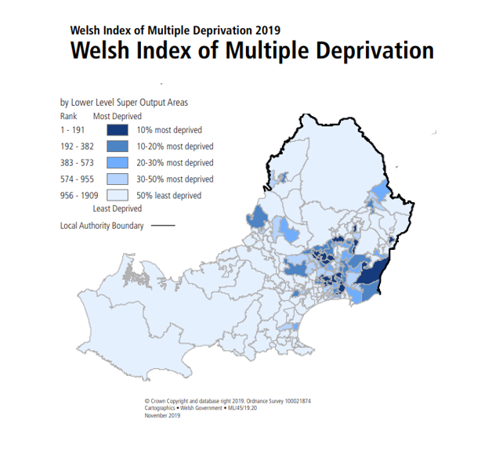
Source: WIMD Maps from 2019
Swansea's population and demographics, employment rates, and economic output, when compared to Wales as a whole, show some key distinctions. Swansea's population is the second-largest in Wales, but its median age is lower than the Welsh average, potentially influenced by a higher proportion of students. Swansea's employment rate is lower than the Welsh average. Economically, Swansea's Gross Value Added (GVA) per head is above the Wales average, but still significantly below the UK average.

5.2 Existing initiatives
The CSG undertook a mapping exercise to understand the existing strategies and policies of each partner organisation in March 2024. This was an important initial undertaking as this strategy development should not be in contradiction to any other and should potentially highlight where alignment may need to occur.
The aim was to help improve understanding of who is doing what across Swansea that would lead to a more cohesive and coordinated approach to ensuring a just and equitable transition to net zero by 2050. It was also intended to help build capacity and capability, through the sharing of good practice and innovation, and identifying gaps and opportunities for collaboration, as part of Project Zero Swansea.
The survey was structured around 12 themes and asked respondents to outline existing policies and strategies; current projects and future plans related to each theme. Respondents were also invited to give their organisation a simple self - assessment score for each theme and to share ideas for collaboration, collective action and shared learning, and the main challenges to progress that they face.
The self-assessment scores suggested a higher level of activity and confidence in relation to the Nature Recovery, Energy Generation, and Transport and Travel themes. The two themes with the joint lowest level of activity and confidence were Adaptation and Managing Risk, and Health and Wellbeing. Other low scoring themes were Food and Food Supply Chain, Procurement and Supply Chains, and Non-Residential Properties.
The survey revealed examples of good practice and innovative actions already being taken by partners across most themes, which could be used to inspire action by others. It also identified where partners would benefit most from support.

5.3 Workshops and community engagement
As a Human Rights City, Swansea recognises participation as a core rights. Engagement process has been designed to be inclusive, accessible and empowering, ensuring a diverse range of voices, particularly those from marginalised groups, are heard. During July 2024 two officer workshops were held online. Attendees were from the organisations representing the Signatory Group membership. Those attending included Senior Lecturer in Environment, Estates Managers, Transport Managers, Local Development Planner and Primary Health Care Manager, with 80 attendees altogether over two workshops. After a brief introduction attendees were put in groups according to expertise to discuss what is already happening in their areas, associated with the 13 areas from the CCC Adaptation Monitoring Framework in Swansea, what influences those actions and what adaptation opportunities there are for the future.
The 12 community workshops and 1 PSB workshop took a similar format with an introduction to climate change adaptation and then groups being able to comment on the 13 areas and what they would like to see happen. There was an online feedback form, for those wishing to add further comments after the workshops or for those unable to attend any workshop but wanted to input into the strategy. All comments were collated and assigned an owner (whether from the officer, community or PSB workshops).
The Technical Reports Executive Summary details the broad context of the consultation and engagement process in Appendix C.

5.4 Technical reports findings
The Technical Reports document the extensive research and consultation process undertaken with distinct sections relating to different activity. Information relating to existing and future climate risk was collected via a broad variety of stakeholders and sources reflecting the geographic, socio-demographic and cultural diversity of Swansea and its population.
The collated information resulted in the identification of potential responses and future priorities relating to key hazards perceived as most relevant to Swansea. While 150 action areas and future priorities were identified and classified into the 13 CCC Adaptation Monitoring Framework areas. The key findings which emerged are captured in Technical Reports Tables that form Appendix D.
6. Strategic approach
The development of this strategy has taken a systems-based approach by mapping across the key influences such as CCC Adaptation Monitoring Framework, One Health Wales, Climate Change Risk Assessment 3 Wales (CCRA3) and the Well-being of Future Generations (Wales) Act 2015 as well as mapping the existing strategies and policies of the key partner organisations. It has also taken a unique approach by not consulting on specifics with officers and the community but rather using the above framework and the CCRA3 to gather information and ideas at the outset, thereby ensuring those who will help deliver on many of the actions, have truly shaped and influenced the strategy and action plan.
This strategy recognises the need for social justice for a fair and equitable transition to net zero and in the adaptation to the already changing climate. The action plan will consider social justice and in order to be effective will look for opportunities to collaborate with the other initial steps of Swansea's Local Well-being Plan:
- Early years - To ensure that children have the best start in life to be the best they can be.
- Live well, age well - To make Swansea a great place to live at every stage of life.
- Strong communities - To build cohesive and resilient communities with a sense of pride and belonging.

6.1 Vision, aim & objectives
6.1.1 Vision
To provide a just and equitable transition for all citizens in Swansea in response to climate change. Delivering healthy & sustainable communities through placemaking to ensure a liveable future with a nature rich environment and wellbeing for all at its heart.

6.1.2 Aim
To provide the collaborative direction of travel for the adaptation of Swansea to the risks of climate change. Recognising Swansea is already experiencing changes to its climate and action is needed to adapt to these and future changes to protect its citizens particularly our more vulnerable communities and enable Swansea to thrive in the future.
    - Objectives

- Strengthen local infrastructure resilience.
- Integrate into strategic planning and development.
- Maintain, enhance and restore natural environment.
- Support adaptation of vulnerable communities.
- Promote business and community engagement and awareness.
- Foster cross sector collaboration.

6.2 Governance
This strategy and action plan has been developed for Swansea PSB. The Climate Signatories are the working group for step 3 of Swansea’s Local Well-being Plan and therefore will be the main drivers to implement the strategy and action plan.
Review of the strategy and action plan will be in line with the timings of Swansea Local Well-being Plan. Monitoring and evaluation of progress will be done in line with PSB key performance indicators and those that are expected to be developed by Welsh Government as outlined in the Wales Climate Adaptation Strategy.
The overall Governance is through the Climate Signatories Group to Swansea Public Services Board, with specific organisational targets being reported appropriately. Oversight and scrutiny will be provided in line with the governance arrangements of each partner organisation e.g. Swansea Council Cabinet.
6.3 Scope and influence
This strategy is for all those living and working within the county of Swansea, who wish to take part in enabling Swansea to thrive and become resilient with the threats associated with our changing climate. This strategy is supporting the Wales Climate Adaptation Strategy. It does not attempt to override approaches of partner organisations but support, complement and add value to them. When new strategies and policies are written, or those in existence are reviewed, this strategy should influence them and be referred to. This will be a major contributor to the Swansea Local Well-being Plan and Action Plan.
6.4 Action plan areas of focus
Four main areas of focus have been identified through the development of the Technical Report, that provides much of the Swansea based evidence for the strategy. These will form the key areas of focus for the Action Plan moving forward. They are in line with the four areas of focus from Wales Climate Adaptation Strategy and in addition reflect two further key priorities that emerged through local consultation as important to Swansea - Food and Nature will be focus areas within Partnership and collaboration as it is recognised that there are already strong networks across Swansea.

6.4.1 Partnership and collaboration
Climate risks cross local boundaries and disproportionately affect vulnerable communities. By working together, public services, local authorities, and community groups can share resources, align strategies, and ensure no area or group is left behind. Regional collaboration, where appropriate, enables more effective planning, supports innovation, and ensures that adaptation efforts reflect local needs while aligning with national goals.
In Swansea, the partnership between the Public Services Board and the Climate Signatories Group demonstrates how coordinated, inclusive action can build resilience and deliver fair outcomes for all communities facing climate change. However, this needs to go further and faster, bringing representation from our diverse communities into our forums. The initial workshops were a good start but there is a lot more to do.
It is recognised that the PSB and CSG alone do not have all the expertise or resources, to undertake the actions required to adapt now, and in the future, therefore experts will be asked to contribute where appropriate and partnerships for delivery of specific actions will be set up. This will require an extensive stakeholder mapping exercise, beyond what has already been undertaken, to ensure the right organisations and individuals are invited to contribute. By widening the partnerships and enabling greater collaboration with more opportunity to share good practice and resources, a properly joined up approach will be enabled. It will help ensure equity and avoid duplication of resource, giving organisations and communities a clear, shared direction of travel.

a. Nature
Nature at a regional level in Wales is vital for socially just climate adaptation. Natural systems—such as wetlands, forests, and green spaces—provide essential protection against climate impacts like flooding, heatwaves, and poor air quality. It was also discussed in all the community and officer workshops, further highlighting the importance.
Regional collaboration enables the strategic restoration and management of these ecosystems, ensuring benefits are shared across urban and rural communities. In Swansea, nature-based solutions are already helping to reduce risk while enhancing biodiversity and public wellbeing. Prioritising access to green spaces in deprived areas supports health equity and resilience. A regional approach ensures that nature is protected and enhanced not just for environmental gain, but for social justice too.
There are many nature-based solutions to many of the effects of climate change such as temperature regulation in urban areas and flood water management, providing not only for the community but also enhancing biodiversity at the same time.
In Swansea there is a very active Local Nature Partnership and many of the Climate Signatories are active contributors. This partnership has produced an extensive Swansea Local Nature Recovery Action Plan and Swansea Council is responsible, under Section 6 Environment (Wales) Act 2016 for maintenance and enhancement of biodiversity;
A public authority must seek to maintain and enhance biodiversity in the exercise of functions in relation to Wales, and in so doing promote the resilience of ecosystems, so far as consistent with the proper exercise of those functions.
There is also a city Climate action - Green infrastructure strategy led by Natural Resources Wales and Swansea Council in partnership with local deliverers. Lots of work around this has been developed for some time and a new website was launched in 2025 Green the City.
This strategy will support the valuable work already taking place and use data supplied by our partners for any monitoring required.

b. Food
The Future Generations Commissioner in the 2025 Future Generations Report states “Our food system is unsustainable. Cymru cannot achieve its seven well-being goals, net zero targets or improved public health without ensuring equal access to local, affordable, healthy and sustainable diets”. He recommends that, “each Local Authority should develop a local food resilience plan in collaboration with Local Food Partnerships and Public Services Boards.”
There are numerous successful sustainable food initiatives across Swansea, including community supported agriculture schemes, community food growing and redistribution of surpluses from businesses and crops such as fruits from gardens and orchards. However serious and far-reaching challenges in the face of climate change remain, including food security in an increasingly uncertain global supply chain, difficult farming conditions closer to home, and equity of access to nutritious, local food.
With food systems responsible for a third of global GHG emissions, there a need to do more transforming our local food system. As the Status of Local Food Partnerships report notes that, “Action around catering and procurement provides the scale necessary to support increased local production and transform local supply chains. This scale ensures it often remains the most difficult area for Local Food Partnerships to influence, given how much it has been centralised.” Swansea PSB has also undertaken systems mapping work to ensure a coordinated effort to tackle access to food as part of a Whole System Approach to Healthy Weight.

6.4.2 Leadership
Leadership in Wales is essential for delivering socially just climate adaptation. It ensures long-term, place-based decision-making that reflects local needs and vulnerabilities, especially in communities most at risk. By coordinating across sectors through structures like Public Services Boards, regional leaders can align adaptation with the Well-being of Future Generations Act, embed equity into planning, and drive consistent action beyond political cycles.
In Swansea, leadership through the Climate Signatories Group enables shared responsibility, accountability, and inclusive governance. This collaborative leadership model ensures that adaptation is not only effective but also fair, empowering communities and reducing inequalities in the face of climate change. However, leadership is needed from across the community as well as from the different CSG partners and local businesses.

6.4.3 Resilient services
As climate impacts intensify—flooding, heatwaves, storms—public services face growing pressure. Coordination ensures services are prepared, accessible, and responsive, especially for vulnerable communities. By embedding climate risk assessments into service planning, Swansea can protect both service users and frontline workers. Through collaboration across health, transport, housing, and emergency services, resilience can be built into infrastructure and delivery. This proactive, joined-up approach ensures that adaptation efforts are equitable, reducing disparities and safeguarding essential services for all, particularly those most at risk from climate change.
Swansea has already experienced flooding, wildfires and longer periods of high temperatures. Flood risks from sea level rise and groundwater are mapped by NRW and need to be used to assess how the public access services. It is not just those wishing to access services that need to be considered but also those who are delivering them. Effective planning will be required. Swansea Bay University Health Board is undertaking an extensive climate change risk assessment. All other public services will be required to do this under Wales Climate Adaptation Strategy. Once these are complete, an action will be to share findings to enable better understanding of potential need and with comprehensive cross public sector scenario planning this will further highlight what is required for emergency planning but also what can be achieved through more proactive planning and collaboration.

6.4.4 Resilient communities
Local communities are often the first to experience the impacts of climate change, such as flooding, heatwaves, and resource shortages. Regional collaboration enables tailored support, shared resources, and consistent messaging across diverse areas. Involving communities in adaptation planning builds trust, empowers local leadership, and ensures that solutions reflect lived experiences—especially in areas of high deprivation. In Swansea, this approach supports the Well-being of Future Generations Act by fostering strong, connected communities. Resilient communities are better equipped to respond to climate shocks, and ensuring their participation and empowerment is essential to protecting their human rights reducing inequality and enhancing long-term well-being. These local leaders should be good, positive communicators, with practical knowledge and enthusiasm and be representative of the diversity within Swansea’s communities, as they will need to disseminate and gather information and may be the first ‘port of call’ within and for the communities they serve.
6.5 The adaptation action plan
The strategy and specifically the areas of focus identified within it drive the development and implementation of the Adaptation Action Plan providing a strategic direction and context. The Action Plan is to be refreshed annually in line with short, medium and long-term objectives providing clear milestones and including specific KPIs for monitoring purposes.
The Action Plan will:
- Prioritise actions based on the risk faced by Swansea region
- Incorporate ‘asks’ from Climate Adaptation Strategy for Wales
- Incorporate actions identified during the officer, community and PSB workshops
- Consult with the public on whether the plan goes far enough, gaps, and how they can be supported in climate adaptation
- Where applicable align those actions to existing policies and strategies of CSG organisations.

Actions will be divided into:
- Short term actions will be completed within 1 Year
- Medium term actions will be completed within 3 years
- Long-term actions will be completed by 2040

Additional working groups may be created to execute a specific action.

6.5.1 The initial action plan
It is recognised that to develop a full and comprehensive action plan will take time therefore the actions to take forward until the end of 2025-26 financial year are as follows:
 | Action
1 | Publish the Strategy autumn 2025
2 | Develop easy read version of strategy (and action plan once fully developed) and translate. Upload to Swansea Project Zero website
3 | Identify lead partners for specific areas of focus
4 | Leads to establish networks and/or be CSG rep on existing networks to promote the Wales and Swansea Strategies
5. | Continue to develop the full and comprehensive action plan
6. | Obtain funding to enable further community consultation and engagement
7. | Develop the Community Council Toolkit for Mitigation and Adaptation and trail it with 2 Community Councils
8. | Continue to develop and promote the Swansea project zero website as the one stop shop for Swansea on the climate change related agenda
9. | Develop the emergency response for climate change by working with emergency services, incorporating climate risks into emergency planning risk registers and into scenario planning

7. Monitoring
Oversight of the Strategy’s implementation and the regular monitoring of progress will be undertaken by Swansea Public Services Board and CSG has overall responsibility for the delivery of the strategy and action plan underpinning Step 3 of Swansea’s Local Well-being Plan’s action plan.
Each partner organisation will be responsible for individual actions and will need to monitor appropriately, the progress they make and report in a timely fashion to CSG. Any ongoing issues not possible to resolve at CSG level will therefore have visibility and the opportunity to benefit from challenge and support at Swansea Public Services Board.
Welsh Government are working on adaptation monitoring and aligning this to the mitigation, net zero monitoring for public services. Once established the use of the monitoring system established by Welsh Government will be adhered to in addition to action plan reporting. This process will use the specific monitoring and evaluation tools provided by Welsh Government for this purpose.

8. Potential risks to implementation
Climate change adaptation is taking place against a backdrop of outdated infrastructure, an aged housing stock, extractive economy and consumer culture. Public sector resources are increasingly stretched, funding and investment is limited, and few dedicated resources exist. The challenge is significant and can only be met through co-ordinated action. This strategy aims to mitigate the risk of failure by providing a clear strategic vision around which Swansea can align action.
9. Definitions
Adaptation: The process of adjustment to actual or expected climate and its effects (IPCC, 2023).
Climate Change Risk Assessment: Evaluation of the potential impacts, vulnerabilities, and risks posed by climate change to ecosystems, economies, and societies to inform mitigation and adaptation strategies (IPCC, 2022).
Climate Change: Long-term alterations in temperature, precipitation, wind patterns, and other elements of the Earth's climate system, largely driven by human activities such as burning fossil fuels, deforestation, and industrial processes (IPCC, 2021).
Climate risks: The potential negative impacts of climate change on natural and human systems, including physical, transitional, and liability risks (IPCC, 2021).
Hazards: The potential occurrence of a natural or human-induced physical event or trend that may cause loss of life, injury, or other health impacts, as well as damage and loss to property, infrastructure, livelihoods, service provision, ecosystems and environmental resources (IPCC, 2023).
Mitigation: A human intervention to reduce emissions or enhance the sinks of greenhouse gases (IPCC, 2023).
Net zero: The condition where the amount of greenhouse gas produced is equal to the amount removed from the atmosphere (IPCC, 2023).
Resilience: The capacity of interconnected social, economic and ecological systems to cope with a hazardous event, trend or disturbance, responding or reorganizing in ways that maintain their essential function, identity and structure (IPCC, 2023).

10. References
- World Meteorological Organization - https://wmo.int/news/media-centre/wmo-confirms-2024-warmest-year-record-about-155degc-above-pre-industrial-level
- Climate Models - https://www.un.org/en/climatechange/science/key-findings#:~:text=Under%20current%20national%20climate%20plans,years%2C%20have%20continued%20to%20rise.
- UK Climate Change Commission - Progress Report: Reducing emissions in Wales https://www.theccc.org.uk/wp-content/uploads/2023/06/Progress-Report-Reducing-emissions-in-Wales.pdf
- 'Doughnut' economic model - https://futuregenerations.wales/cym/wp-content/uploads/2025/05/Future-Generations-Report-2025.pdf p84
- Well-being of Future Generations (Wales) Act 2015 – https://futuregenerations.wales/discover/about-future-generations-commissioner/future-generations-act-2015/
- Environment (Wales) Act 2016 - https://www.legislation.gov.uk/anaw/2016/3/contents
- Welsh Government Net Zero strategic plan - https://www.gov.wales/welsh-government-net-zero-strategic-plan
- Swansea Public Services Board - Swansea - https://www.swansea.gov.uk/psb
- Assessment of local well-being Swansea - https://www.swansea.gov.uk/psbassessment2022
- Local well-being plan 2023-28 - Swansea - https://www.swansea.gov.uk/localwellbeingplan
- The Climate Signatories Group (CSG) - https://www.swanseaprojectzero.co.uk/
- UK Climate Risk - https://www.ukclimaterisk.org/
- UK Climate Change Risk Assessment 2022 –https://www.gov.uk/government/publications/uk-climate-change-risk-assessment-2022
- Climate Change Committee's Monitoring Framework - https://www.theccc.org.uk/publication/ccc-adaptation-monitoring-framework/?chapter=3-how-we-monitor-progress-on-preparing-for-climate-change#3-how-we-monitor-progress-on-preparing-for-climate-change
- Natural Resources Wales/Welsh Government (2024) Climate Change Risk Assessment Framework for Public Services Boards
- Independent Assessment of UK Climate Risk - Climate Change Committee - https://www.theccc.org.uk/publication/independent-assessment-of-uk-climate-risk/
- Flood and Coastal Erosion Risk Management Programme 2025 to 2026 - https://www.gov.wales/flood-and-coastal-erosion-risk-management-programme-2025-2026-html
- Flood Risk Maps - https://flood-risk-maps.naturalresources.wales/
- JBA Consulting/Swansea Council (2025) Technical Reports Table 5-1 Potential responses and future priorities identified during all workshops in relation to climate hazards
- Exploring a potential approach to understand and map the local level impacts and opportunities of a Just Transition to Net Zero https://www.gov.wales/sites/default/files/statistics-and-research/2025-01/exploring-a-potential-approach-to-understand-and-map-the-local-level-impacts-and-opportunities-of-a-just-transition-to-net-zero.pdf
- Climate Adaptation Strategy for Wales - https://www.gov.wales/sites/default/files/publications/2024-10/climate-adaptation-strategy-for-wales-2024.pdf
- Mumbles - https://www.swansea.gov.uk/mumblescoastalprotection
- Aberystwyth University - https://www.aber.ac.uk/en/news/archive/2022/11/title-259684-en.html#:~:text=Aberystwyth%20University%20and%20the%20International,disruptions%20caused%20by%20climate%20change.
- Swansea Bay Health Strategy - https://sbuhb.nhs.wales/about-us/key-documents-folder/population-health-and-partnerships-committee/partnership-health-and-partnerships-committee-june-2024/2-2-appendix-1-our-journey-to-sustainable-healthcare-2023-24-pdf/
- Net Zero Wales Carbon Budget Reporting Process - https://www.gov.wales/net-zero-wales-carbon-budget-2-2021-2025
- Future Generations Report 2025 - https://futuregenerations.wales/cym/wp-content/uploads/2025/05/Future-Generations-Report-2025.pdf
- Beyond Recycling - https://www.gov.wales/sites/default/files/publications/2021-03/beyond-recycling-strategy-document.pdf
- Wales Centre for Public Policy - How could Wales feed itself by 2035? – Wales Net Zero 2035
- Climate Adaptation Strategy for Wales - https://www.gov.wales/sites/default/files/publications/2024-10/climate-adaptation-strategy-for-wales-2024.pdf
- About Swansea - https://www.swansea.gov.uk/aboutswansea
- www.swansea.gov.uk/keyfacts
- phw.nhs.wales/services-and-teams/observatory/data-and-analysis/publication-documents/measuring-inequalities-2011/inequalitiesprofilesla-swansea-v1-pdf/
- Climate Change Risk Assessment 3 Wales - https://www.ukclimaterisk.org/publications/summary-for-wales-ccra3-ia/#section-148-benefits-of-further-adaptation-action-in-the-next-five-years
- Climate Change and Nature Action Charter - https://www.swansea.gov.uk/climatechangecharter
- Swansea Local Nature Recovery Action Plan https://www.swansea.gov.uk/swansealnrap
- Climate action - Green infrastructure strategy - https://www.swansea.gov.uk/climateactiongreeninfrastructure
- Green the City - https://greenthecity.co.uk/
- Status of Local Food Partnerships report - https://www.foodsensewales.org.uk/app/uploads/2025/04/PartnershipsReportENG.pdf

