Appendix D
Executive Summary
JBA Consulting has worked with the Swansea Climate Change and Nature Action Signatories Group (SCCNASG) to conduct a series of workshops across the region with communities and officers from the Climate Charter Signatories and Public Service Board (PSB). The aim has been to inform a community centred climate change Adaptation and Mitigation Strategy and action plan.
The City and County of Swansea Council and partners are taking a pioneering to approach climate adaptation and mitigation planning. They are taking an innovative, "bottom-up" approach, by first engaging with communities to hear their concerns and priorities. Communities were given an opportunity to voice concerns and priorities, with conversations framed around the Climate Change Committee (CCC) Adaptation Monitoring Framework areas to ensure that community priorities and concerns will be accounted for across all areas of adaptation planning. The CCC areas represent thirteen critical areas or sectors for adaptation action and monitoring.
This report outlines phase one of the process. This technical report summarises the outcomes of the workshops to support the future development of the strategy and action plan. The workshops produced many rich conversations that cannot be captured in full for this report but will inform future stages of adaptation and mitigation planning for Swansea.
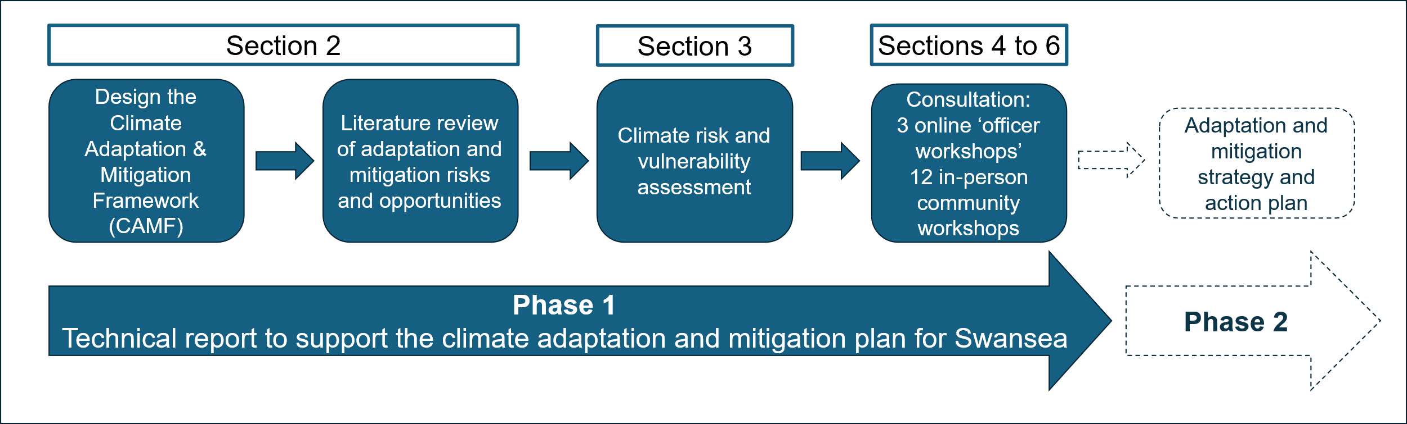
To guide the process, a 'Climate Adaptation and Mitigation Framework' (CAMF) was developed. This provides a robust 'line of sight' from the 13 key policy areas outlined in the CCC Adaptation Monitoring Framework and seven Well-being and Future Generations Act (WBFGA) goals through to implementable adaptation and mitigation actions.
A high-level climate change risk and vulnerability assessment was then undertaken which explored how local communities in Swansea will be impacted. This helps the signatories to understand the complexities and plan for service delivery in the future. The main risks were:
Risks | Indicator (University of Reading , 2023)
Increased flooding due to higher winter rainfall will cause damage to property and threaten Swansea's wider infrastructure. | Expected Annual Damage (All flooding SW Wales) Residential (Direct) (£ m)
Warmer, drier summers with reduced summer rainfall and higher temperatures will cause water resource pressure for urban and rural communities. | Hydrological drought  Summer rainfall - % change from 1981-2010 mean
Increased climate linked disruption, such as bad weather days, will threaten Swansea's transport infrastructure. | Days with temperature, rainfall and windspeed beyond thresholds
Increased storm effects and heavy rainfall will impact communities and infrastructure in the area. For example ground movement and landslides at legacy mining sites. | Record breaking weather  Number of months per year at least as wet as the wettest month (Tmax) between 1981 and 2010
The increasing frequency of wildfire events due to climate change pose an increasing risk to Swansea's natural habitats and communities including property. | Days of 'very high' Met Office fire index used to issue wildfire warnings for open access land.
Changing climate conditions, such as increased heatwaves and extreme weather events, can have direct and indirect effects on the physical and mental health of Swansea's residents. | Met Office heatwave - three consecutive days with daily maximum temperatures (events/year)

These risks (and opportunities) were presented at a series of workshops. This report identifies the 13 CCC policy areas that need to be developed and by who, to ultimately address these risks and at the same time gain buy in from different organisations and communities. This is supplemented with draft suggestions for who is responsible for strategy and taking action.
Communities reported that action around nature, health and community preparedness and response should be a particular priority. Across the board, people spoke about what they valued, whether they were living well or in challenging circumstances. There was recognition that relationships across sectors and between communities, businesses, local, national and central government may need to change. This could potentially include mechanisms that provide greater 'dialogue', or delegation of responsibility and liability. To meet the challenges ahead, it was also recognised that systems would need to adapt and, in some cases, transform. These discussions have been distilled into the following draft vision statement for Swansea's Adaptation and Mitigation Strategy: "Community values, changing relationships, adapting and transforming systems to support our shared capacity for resilience."
To maintain transparency, the next step should be to communicate these findings and the vision to communities. Phase 2 of the Adaptation and Mitigation Strategy should involve the production of a visually attractive public facing document. This process should then engage more people in the development, decision making and accountability for the Adaptation and Mitigation Strategy. This is particularly important in relation to mental health and wellbeing as stated in the Climate Change in Wales: Health Impact Assessment report (Public Health Wales, 2023). Issues in relation to anxiety about the future, sense of control, democratic participation, and trauma from extreme weather, and flooding are key factors influencing mental health and wellbeing and were extensively discussed during the community and signatory officer workshops.

