Meeting Date | 27 November 2025 |  | Agenda Item |  |  | 4.1
Name of Meeting | SBUHB Board
Report Title | Perinatal Report
Report Author | Sharron Price, Group Nurse Director  Sujoy Banerjee, Associate Service Group Medical Director  Kathryn Greaves, Director of Midwifery
Report Sponsor | Elizabeth Rix, Executive Director of Nursing and Patient Experience
Presented by | Elizabeth Rix, Executive Director of Nursing and Patient Experience
Freedom of Information | Open
Purpose of the Report | The purpose of the paper is to provide the Board with an update:  - from the Perinatal Committee, assurance and information relating to the risks to quality, safety and patient experience in maternity and neonatal services, with escalation of any key areas of concern; and  - on the progress against the Recommendations of the independent review since the report was published in July 2025.
Key Issues | - Ongoing development of Perinatal Improvement Plan – collaborating with Independent Oversight Panel.  - Publication of the Maternity and Neonatal Independent Review Report in July 2025  - Subsequent escalation of Maternity and Neonatal Services by Welsh Government from Level 3 to Level 4 in July 2025
Specific Action Required  (please choose one only) | Information | Discussion |  | Assurance | Approval
Specific Action Required  (please choose one only) | ☐ | ☐ |  | ☒ | ☐
Recommendations | Members are asked to:  BE ADVISED:  - Project management support to develop and monitor improvement plans in response to the Independent Review now in place.  - Perinatal Improvement Programme Executive Board to be held in December 2025.  - Perinatal Committee meets monthly and reviews all key metrics for perinatal services.  - Learning Event held 19.11.25, with over 200 attendees from across Wales and UK.  - Perinatal Improvement Plan will be submitted to the January 2026 Board meeting.  BE ASSURED:  - The Perinatal Service does not currently have any elements or care that would flag as a Negative Outlier.  - Any stillbirths or neonatal deaths have been reported through the MBBRACE process.  - There have been 6 case of HIE reported to MBBRACE in this period.  BE ALERTED TO:  - The Single Point of Access Maternity Triage is due to launch in March 2026; this is dependent on a review of the business case and authorisation through normal processes and successful recruitment of midwives and obstetricians.

PERINATAL REPORT

- INTRODUCTION

This report is intended to provide assurance and information relating to the risks to quality, safety and patient experience in maternity and neonatal services, with escalation of any key areas of concern.

The purpose of the paper is to provide the Board with updates from the Perinatal Committee and assurance around quality, safety and patient experience outcomes and escalation of any key areas of concern.

The report provides some details on progress against the Recommendations of the independent review since the report was published in July 2025, including on critical safety measures highlighted as high priority actions by the Independent Oversight Panel.

- BACKGROUND

As noted in previous reports, the inaugural Perinatal Committee meeting was held on the 9th of June 2025, meeting monthly and chaired by the Executive Director of Nursing and Patient Experience, and co-chaired by an Independent Member of the Board.

The Perinatal Committee reports directly into Quality and Safety Committee and noted via Service Group Quality, Safety & Risk Group and Senior Leadership Team.

- KEY UPDATES FROM COMMITTEE

As previously agreed, the following measures are some of the high level information we review within our perinatal committee.

3.1 Births
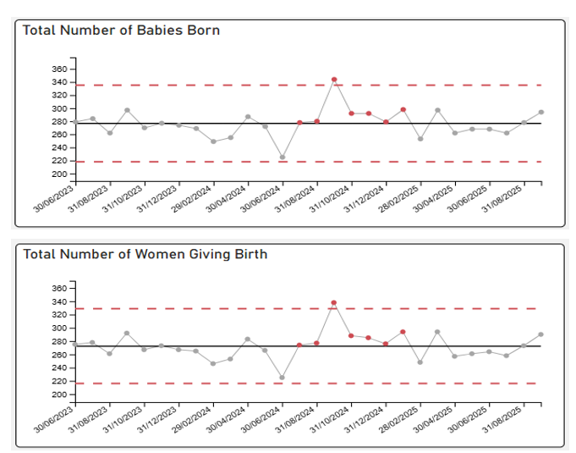

There has been an increase in the birth rate between September 2024 and February 2025, likely to be linked to the closure of the Maternity and Neonatal Services at the Princess of Wales Hospital, Bridgend. In September, 290 Women gave birth and there were 294 babies born.

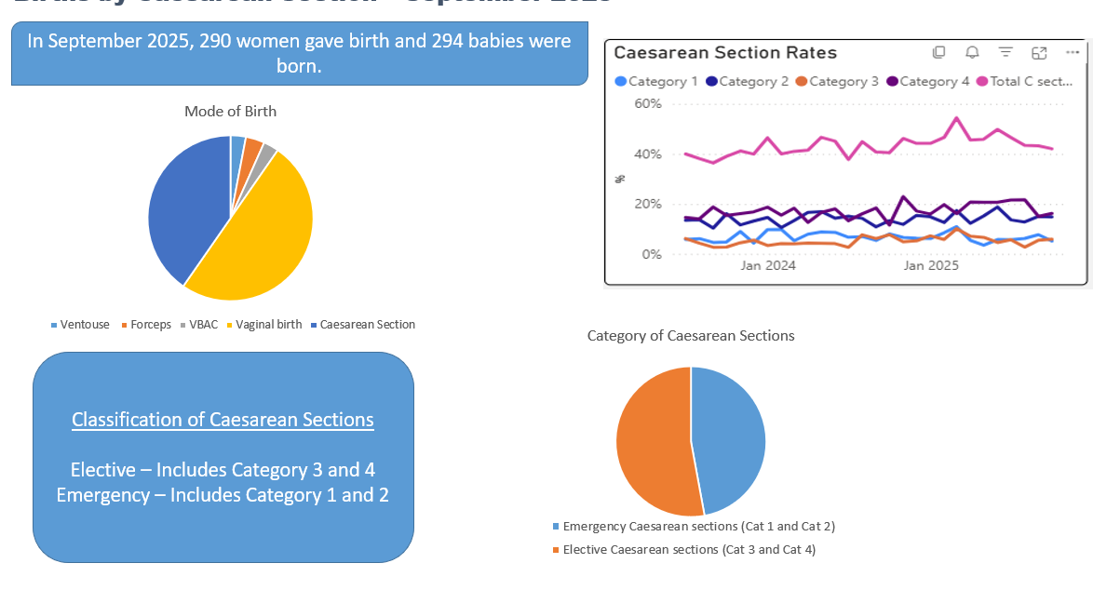

The overall Caesarean Section rate September 2025 was reported at around 40% which is a reduction from previous months, with Elective C Section rates reported at 16.2%.

3.2 Neonatal Mortality and Morbidity
All stillbirths, Neonatal Deaths and brain injury cases are reported via Mothers and Babies: Reducing Risk through Audits and Confidential Enquiries (MBRRACE). MBRRACE’s purpose is to identify patterns, causes, and preventable factors in maternal and perinatal mortality and morbidity.

All cases receive internal and where indicated external investigation using the Perinatal Mortality Review Tool to support understanding and identify any modifiable causes to support families understand the causes of the death or brain injury and to support both local and national learning for improvement.

3.2.1 Stillbirths from January – September 2025

There have been 10 stillbirths during this period, all included in the MBBRACE reporting data. 1 case did not receive any antenatal care within Swansea Bay, 1 was an unknown pregnancy that delivered pre-hospital with maternity services involved postnatally to provide care and support.

3.2.2 Neonatal Deaths from January – September

There have been 7 neonatal deaths between January 2025 and September 2025, of these cases 2 are MBRRACE reportable, 3 were extremely pre-term (less than 24 weeks) and at the limit of viability.

3.2.3 Hypoxic-Ischemic Encephalopathy (HIE) from January –September

There have been 6 case of HIE reported to MBBRACE in this period, initial review of the cases do not indicate any areas of concern, all babies survived to discharge with good outcomes.

3.3 Incident Reporting

Work continues to maintain the improvement in reduction of overdue open incidents across maternity and neonatal services, this includes weekly incident review meetings, rapid reviews of any incident of moderate harm and above with early learning identified and shared.

3.4 Patient Feedback and Experience

The service continues to capture feedback via friends and family, and we are the pilot site for the NHS core questionnaire.

The Core Questionnaire pilot sends a text to users of our services at 5 points during their pregnancy, the responses are received and responded to by the senior midwifery and nursing team. Where concerns are raised, direct contact is made with the family either on the ward, or via a telephone call to talk about their experience and work with the woman and family to ensure improvements are made.

Both the Obstetric Unit and Neonatal unit have a “You Said – We Did” board visible to allow us to let those using our services know what we have done in response to feedback.

Monthly thematic reviews are undertaken of all feedback, including concerns and complaints. This provides actionable insights that inform both education programmes and quality improvement initiatives, driving continuous enhancement of patient safety and experience. In addition, monthly monitoring through the Perinatal Assurance Group and Perinatal Committee provides clear governance and assurance that incidents and complaints are actioned in a timely manner, with outcomes reported and tracked against agreed standards.

Common themes from patient feedback are around access to services, in particular waiting times within antenatal clinic, access to pain relief during the post-natal period continues to be a theme, which is being supported by an improvement project. In addition, following incidents that required some retraining the self-administration of medication process was paused on post-natal ward, this has recently been reinstated.

There are currently 10 outstanding Maternity formal concerns and whilst 7 are overdue they are in active management. 2 are in an external review process, 4 in final stages of completion and 1 due to close following a meeting with the service user. Neonatal services have 4 formal concerns, 1 pending external review, 2 at the final stages of drafting and 1 awaiting legal advice.

Swansea Bay University Health Board has actively engaged with the All-Wales Review of the ‘Putting Things Right’ process, demonstrating a commitment to learning and continuous improvement. Work is already underway to embed enhanced processes that will improve the timeliness and effectiveness of handling complaints, incidents, and claims, ensuring a more responsive and patient-focused approach.

As part of this improvement journey, the Health Board has hosted a series of listening events with governance teams, creating a collaborative space to explore what is working well and identify opportunities for refinement. These conversations have provided valuable insights that will shape future improvements, ensuring that changes are informed by those closest to the process and aligned with our values of openness, compassion, and accountability.

3.5 Workforce
There have been some challenges within the Neonatal medical workforce due to unavailability, this has been mitigated with flexible working arrangements which has meant there has been no gap in service.

Details are overleaf.

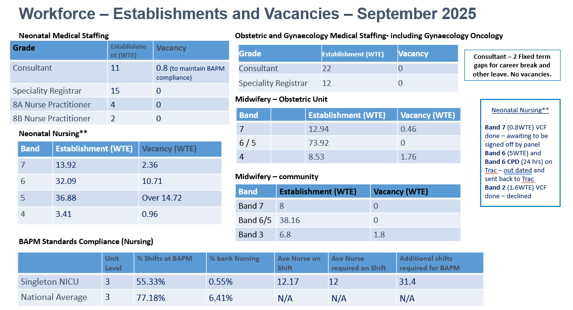
There are no vacancies within the obstetric staffing, and whilst there are some midwifery vacancies, these are in the process of being recruited into without any anticipation of challenges. Neonatal nursing staffing continues to have an over-recruitment at band 5 which is to enable development and a “grow your own” and train for the Qualification in Speciality. This over-recruitment offsets the vacancy at band 6, although there are a number of nurses now ready for progression and the band 6 vacancies have been advertised.

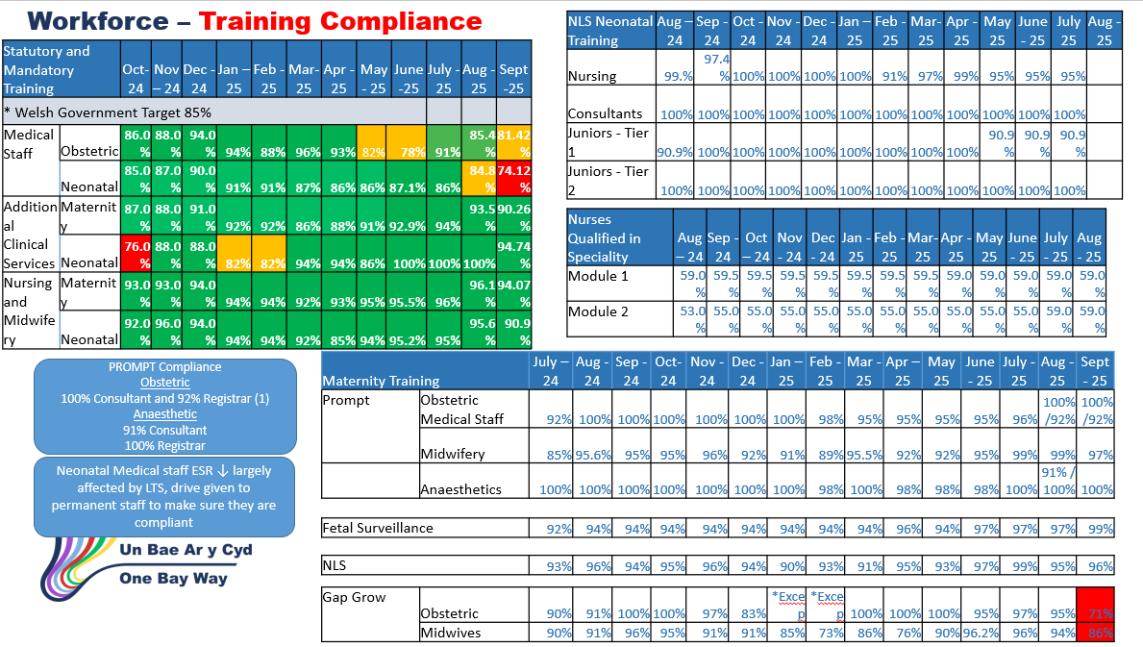
The Obstetric and Midwifery workforce undertake fetal monitoring training in line with the All-Wales Intrapartum Fetal Surveillance (IFS) training package. This includes attending the IFS study day and attending six cardiotocograph (CTG) reflections. Current compliance for the IFS study day is 97% and the IFS passports to demonstrate the attendance of reflections are due to be submitted September 2025.
3.6 National Neo-natal Audit Programme
The perinatal service is a positive outlier on the 2024 NNAP in 3 measures,

- Completed 2-year follow-up data entry for high-risk infants
- Normothermia on admission to NICU
- Breastmilk by day 2 of life

There are no measures that are negative outliers, but we are below national average in 4 measures. These are being actively monitored to identify any service improvement requirements.

Measures to monitor as below national %
- Antenatal steroids
- Blood stream infections
- Brain injury IVH / PHVD
- Milk at discharge

To note, there has been a significant improvement within blood stream infections from the same period last year due to improvement work.

- Independent Review update

To progress and monitor the implementation of the 10 core recommendations of the review the Perinatal Programme Improvement manager has been appointed.

A Perinatal Improvement Programme (PIP) will be established with a focus on 4 themes incorporating the 10 recommendations. This will be chaired by the Chief Executive Officer and report directly into the Health Board.

An initial implementation workshop was held with the service senior team, executive officers and the oversight panel on the 18th November 2025.

A Perinatal Learning event held on the 19th November 2025 to share learning and experiences with a multiprofessional, and multi-organisation attendance at the event.

There has been progress around the core recommendations with immediate actions taken:

- Induction of labour prioritisation – Immediate assurance recommendation. Induction scheduling is risk-based, with prioritisation guided by clinical urgency and maternal/fetal indicators. Daily handover huddles support dynamic adjustments, mitigating delays and ensuring safety-critical cases are addressed promptly. Any delay greater than 24 hours is escalated to the senior team and DATIX reported this enables the senior team to triangulate any adverse outcomes with delays in treatment.

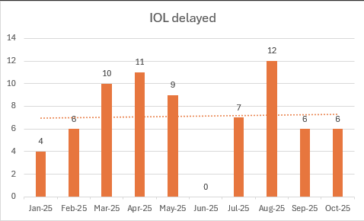
[Induction of labour delays <24hours]
Work is progressing to establish a digital solution to booking and prioritisation of Induction of Labour in support of prevention of delay on the pathway for women.

- Triage – an improved triage process has been in place since November 2024, including timely assessment and prioritisation of women presenting for care. A plan for 24/7 triage is in place, pending recruitment of midwifes and obstetricians. In September 2025, 493 women were seen in triage; 98% were seen within the standard triage time.
- Two-site working - Intensive care Standard Operating Procedure is in action although only one patient admitted since implemented.
- Implementation of MEWS - Implementation of MEWS and NEWTT2. MEWS was launched on the 15th July following completion of staff training. Phase 1 of the MEWS and NEWTT2 rollout across all maternal services was completed by July 2025, with audits confirming robust and appropriate use.
This has been successfully implemented with further areas for national standardisation noted as a result, that being the High Dependency Unit charts which use differing parameters to the All-Wales MEWS. This has been corrected locally but is a requirement for the All-Wales Programme to consider.
  - Rollout to admitting units will start with the Emergency Department as part of a maternal safety bundle (MEWS, VTE risk assessment, and obstetric team discussion when needed). The ED rollout will be complete by the end of 2025, with all other admitting units finished by March 2026.
  - NEWTT2 was launched in March 2025, the postnatal ward manager and specialist neonatal examination midwife have undertaken and audit following implementation
- Response to harm - The service undertook some transformation work to improve the timely and compassionate response when families raise concerns. Weekly meetings support monitoring of expected needs to respond to complaints made and ensure the multi-disciplinary responses are co-ordinated mitigating the delays previously encountered. Psychological support pathways for birth trauma are in place, with referrals monitored for timeliness. Staff training in trauma-informed care is in development to expand. Service design is being developed in and offer for Swansea Bay women and families. The Perinatal Mental Health Midwife continues to provide support and referral for women identified with trauma for appropriate support.

- FINANCIAL IMPLICATIONS
As previously advised there will be some financial implications because of the recommendations from the Independent review, these are currently being developed as part of developing the improvement plan.

- RECOMMENDATION

BE ADVISED:
- Project management support to develop and monitor improvement plans in response to the Independent Review now in place.
- Perinatal Improvement Programme Executive Board to be held in December 2025.
- Perinatal Committee meets monthly and reviews all key metrics for perinatal services.
- Learning Event held 19.11.25, with over 200 attendees from across Wales and UK.
- Perinatal Improvement Plan will be submitted to the January 2026 Board meeting.

BE ASSURED:
- The Perinatal Service does not currently have any elements or care that would flag as a Negative Outlier.
- Any stillbirths or neonatal deaths have been reported through the MBBRACE process.
- There have been 6 case of HIE reported to MBBRACE in this period.
BE ALERTED TO:
- The Single Point of Access Maternity Triage is due to launch in March 2026; this is dependent on a review of the business case and authorisation through normal processes and successful recruitment of midwives and obstetricians.

Governance and Assurance
Link to Enabling Objectives  (please choose) | Supporting better health and wellbeing by actively promoting and empowering people to live well in resilient communities
Link to Enabling Objectives  (please choose) | Partnerships for Improving Health and Wellbeing |  | ☒
Link to Enabling Objectives  (please choose) | Co-Production and Health Literacy |  | ☒
Link to Enabling Objectives  (please choose) | Digitally Enabled Health and Wellbeing |  | ☒
Link to Enabling Objectives  (please choose) | Deliver better care through excellent health and care services achieving the outcomes that matter most to people
Link to Enabling Objectives  (please choose) | Best Value Outcomes and High Quality Care |  | ☒
Link to Enabling Objectives  (please choose) | Partnerships for Care |  | ☒
Link to Enabling Objectives  (please choose) | Excellent Staff |  | ☒
Link to Enabling Objectives  (please choose) | Digitally Enabled Care |  | ☒
Link to Enabling Objectives  (please choose) | Outstanding Research, Innovation, Education and Learning |  | ☐
Health and Care Standards
(please choose) | Staying Healthy |  | ☒
(please choose) | Safe Care |  | ☒
(please choose) | Effective Care |  | ☒
(please choose) | Dignified Care |  | ☒
(please choose) | Timely Care |  | ☒
(please choose) | Individual Care |  | ☒
(please choose) | Staff and Resources |  | ☒
Quality, Safety and Patient Experience
The health board is dedicated to ensuring that pregnancy and childbirth is a safe and positive experience for all service users in order to support healthy life choices and to give children the best start in life. This requires safe and effective maternity and neonatal services. The actions identified within this paper will support us in achieving these goals.
Financial Implications
As noted in report, financial implications linked to
Legal Implications (including equality and diversity assessment)
There are no legal implications associated with the report.
Staffing Implications
There are some staffing implications noted in the report, linked to training and recruitment.
Long Term Implications (including the impact of the Well-being of Future Generations (Wales) Act 2015)
The health board has a 10-year vision to be a high-quality organisation. Work being undertaken to address the concerns raised and to de-escalate from enhanced monitoring will not only support that vision but develop maternity and neonatal services which are safe and sustainable in the longer-term.
Report History |  | Oversight of Quality and Outcomes in Maternity and Neonatal Services (27 March 2025)  Perinatal Committee and Independent Review Update Report (25 September 2025)
Appendices |  | None

