Meeting Date | 27 November 2025 |  | Agenda Item |  |  | 4.3
Name of Meeting | SBUHB Board
Report Title | Financial Report – Month 7 2025/26
Report Author | Samantha Moss, Deputy Director of Finance  Gemma Pearson, Finance Business Partner  Crystal Davies, Principal Finance Manager
Report Sponsor | Darren Griffiths, Executive Director of Finance and Performance
Presented by | Darren Griffiths, Executive Director of Finance and Performance
Freedom of Information | Open
Purpose of the Report | The report advises the Board of the Health Board on the financial position for Month 7 2025/26 (October 2025) and risks regarding the current forecast revenue year end outturn and the further actions required to address the delivery of the Annual Plan.
Key Issues | The report invites the Board to note and discuss the detailed revenue analysis of the financial position for Month 7 2025/26 (October 2025).  The report includes a summary of the key drivers of the revenue position either at Service level or by expenditure type (i.e. Non-Pay/Pay).  Risk will have been considered on the basis of the information provided within the report and the score updated where necessary.  The report invites the Board to note the Cash position, key Balance Sheet movements and the Capital position.  Whilst the key messages are provided within the main body of the report, further information is provided in the Appendices.
Specific Action Required  (please choose one only) | Information | Discussion |  | Assurance | Approval
Specific Action Required  (please choose one only) | ☐ | ☐ |  | ☒ | ☐
Recommendations | Members are asked to:  - ACKNOWLEDGE the 2025/26 Financial Plan, and the Health Board’s and Welsh Government’s inability to approve it given the planned deficit of £58.7m  - Consider and comment upon the Health Board’s financial performance for Month 7 2025/26, including cash, capital and balance sheet.  - SUPPORT the implementation of the actions to address the £15m savings gap.  - DISCUSS the risks to the position at Month 7  - AGREE the position that actions and choices must be identified to mitigate risks to the position which have emerged since the Health Board plan was developed in March 2025 as limited financial mitigation is available.  - APPROVE the 2025/26 Strategic and Working Capital Cash letter (Appendix 3).

FINANCIAL REPORT – MONTH 7 2025/26

- INTRODUCTION
The report invites the Board to note the detailed analysis of the Month 7 (October 2025) revenue financial position, along with Cash and Capital.

- BACKGROUND

The Health Board has two key statutory duties to achieve:

- To submit an Integrated Medium-Term Plan (IMTP) to secure compliance with breakeven over 3 years.
2023/24 3-year plan submitted
2024/25 3-year plan submitted
2025/26 3-year plan submitted
The Health Board will fail to meet this in 2025/26 as its plan will not breakeven over 3 years.

- To achieve financial breakeven over a rolling three-year period, which commenced on 1st April 2023 and will end on 31st March 2026.
2023/24 Deficit Control Total £17.1m achieved
2024/25 Deficit Control Total £43.7m achieved
2025/26 Deficit Plan £58.7m
The Health Board will fail to achieve this Statutory Duty.

Summary of Performance against Key Financial Targets

Financial KPIs: To ensure that net operating costs do not exceed the revenue resource limit set by Welsh Government | Value  £’000
Reported in-month financial position – deficit/(surplus) | 4.128
Reported cumulative financial position – deficit/(surplus) | 47.166
Capital KPIs: To ensure that costs do not exceed the capital resource limit set by Welsh Government | Value  £’000
Reported year to date financial position – deficit/(surplus) | (1.101)
Forecast outturn financial position – deficit/(surplus) (prior to additional allocations) | 1.415
PSPP Target: To pay a minimum of 95% of all non NHS creditors within 30 days of receipt of goods or a valid invoice | Value  %
Cumulative year to date % of invoices paid within 30 days (by number) | 96.2%

- FINANCIAL PLAN
The Annual Plan submitted to Welsh Government on 31st March 2025 included a financial assessment, as summarised in the table below:

Welsh Government (WG) issued a letter to the Health Board on 6 June 2025 indicating that the planning process has been closed in order to focus on delivery and improvement. WG issued a further letter on 18 August requesting an update on the Annual Financial Plan and actions being taken by the Health Board for submission by 11 September. This document was presented at the Special Board Meeting on the 11 September which provided full details of the actions and milestones to achieve the original £55.4m savings to support the delivery of the original plan submission made in March 2025. Progress against this Plan is detailed in Section 4 below.

Therefore, at Month 7 the forecast for 2025/26 remained as per the original plan submission of £58.7m.

- FINANCIAL PERFORMANCE

FINANCIAL REPORT REVENUE – MONTH 7.
The Health Board’s assessment on performance against the £58.7m deficit has three components Operational Pressure, Savings Target, and Planned Deficit. Performance against these three elements at Month 7 is summarised in the table below. At Month 7 there was an In-Month deficit of £4.1m, which is £0.8m below the £58.7m planned deficit, with the YTD position reporting a £47.2m deficit, which is £12.9m above £58.7m plan.

It is clear from the table above that currently the Year-to-Date issue remains the non-delivery of savings. However, there are variances, risks and pressures within the Operational Pressures line which are detailed within this report.

The submission made on 11 September 2025 set out the Plan to deliver the £55.4m savings in 2025/26. This was a combination of savings delivery supported by our external strategic partner, alongside an increased and sustained delivery of underspends in the operational budget specifically around the corporate directorates and N/R opportunities. Performance against the £55.4m plan submitted in September is provided below:

Summary Performance against £55.4m
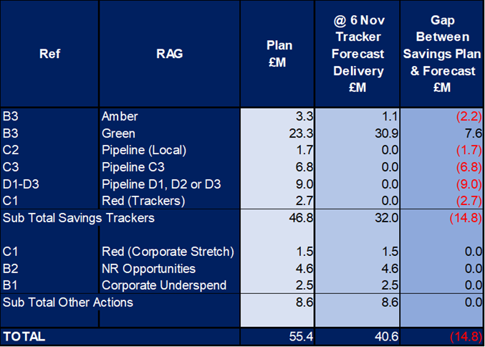

Whilst there remains a plan for the £55.4m, there is a forecast delivery gap of £14.8m. The two key areas of non-delivery identified to date relate to £6.8m of pipeline ideas presented by the Health Board’s External Strategic Partner and £9m in increased controls and associated spend reductions. Neither of these are identified on the trackers as delivering savings in year at the end of Month 7.

Of note is that since the trackers were assessed in the Month 7 closedown there have been several discussions on further opportunities to support the work underway on 2025/26 In Year and Recurrent Forecast. This has identified a further £1.2m of savings, although non-recurrent, which will be added to the tracker in readiness for the next round of reporting to R&S Board at the end of November 2025, thus reducing the gap to £13.6m. The forecast work has also allowed a detailed challenge of the forecast at Service Group level and the requirement for all areas to identify further opportunities to support the position either recurrent or non-recurrent. At the point of writing this report there are several areas where work is ongoing, and these along with the current position are included in the table below:

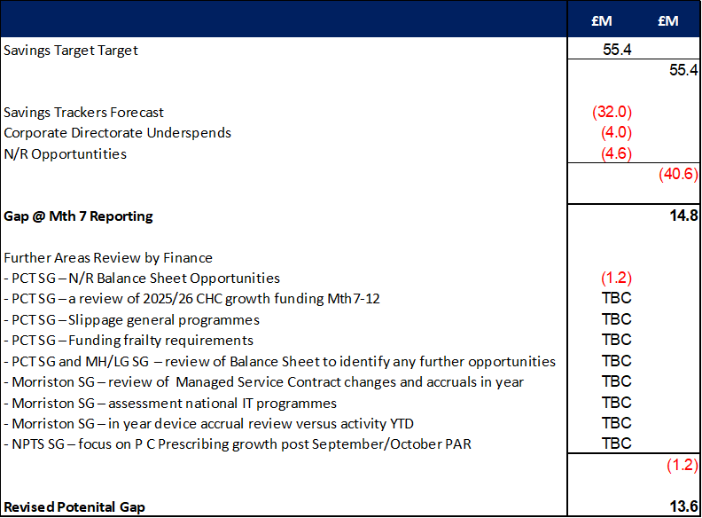

Whilst the 2025/26 In Year and Recurrent Forecast work confirms the ongoing pressures of non-delivery of savings, it has also provided insight into the operational pressures, risks and underspends, with key points summarised below:
- Service Groups
  - Both NPTS and PCT are underspending against their delegated budgets, excluding savings;
  - Morriston is £2m over against their delegated budgets, excluding savings with pressures in UEC and Specialist Surgical Services.
  - MH/LD presents greatest operational overspend against their delegated budgets, excluding savings, and the greatest risk to the delivery of the plan after savings. This is driven by CHC growth, temporary adult placements and variable pay. With regards to the temporary adult placements at the start of Month 7, this had reduced to 3 patients from a high in June of 26. However, during the latter half of Month 7 this increased to a high of 29.
- Corporate Directorates
  - It is forecast that the Corporate Directorates will exceed the target set in 11 September 2025 submission of £4.0m underspend.

- Central (Z Codes)
  - Assumes performance benefits for both Provider and Commissioner LTA of £2.4m combined, N/R opportunities as per 11 September 2025 submission of £4.6m but with pressures in areas such as Losses and Bad Debt provision, which the Health Board will need to find further mitigating actions.

Work on the forecast will continue through November 2025, and at time of writing this report the plan was for the initial output to be presented to PFC. Further details will be provided in future reports, as whilst the delivery of the £55.4m is key to the delivery of the Health Board plan, there are operational pressures and risks which will also need to be mitigated to enable the Health Board is to achieve the £58.7m deficit.

With regards to the overall financial performance at Month 7, Graph 1 below reflects the actual financial performance in each month, with the orange bars reflecting the performance required to achieve the original plan of £58.7m. Graph 2 outlines the savings delivered to date as the blue bars against the monthly target set (red line), and the orange bars reflect the level of savings required in future months to achieve the £55.4m target aligned to the £58.7m plan.

Graph 1: Performance Graph 2: Savings
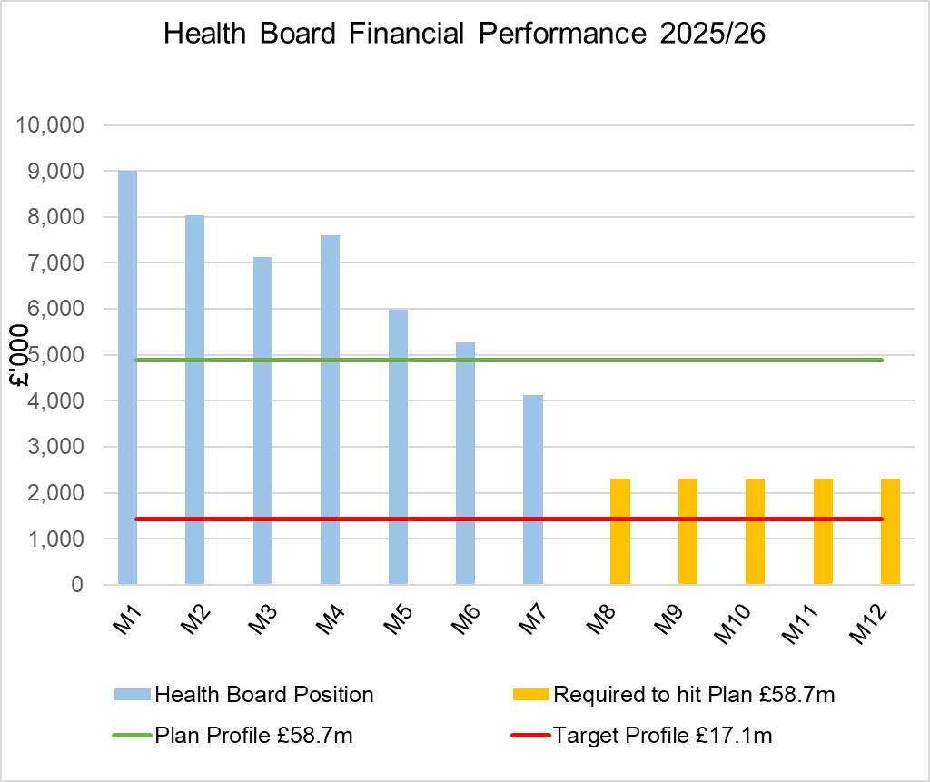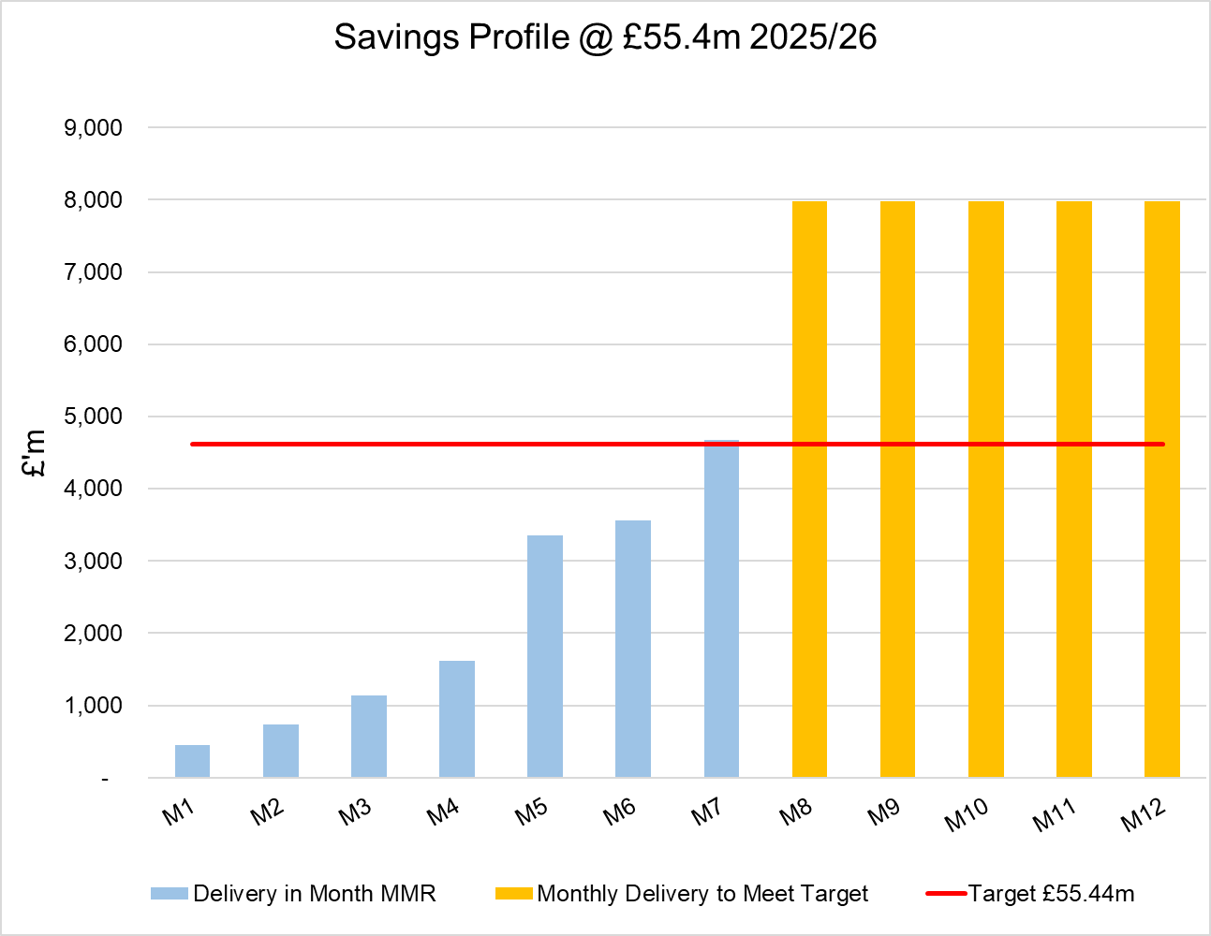

  - Key Drivers by Service Area In-Month

The key drivers of the Month 7 position are summarised in the table below. Further detail at a Health Board level of expenditure on Income, Pay and Non-Pay, is also provided in Appendix 1.

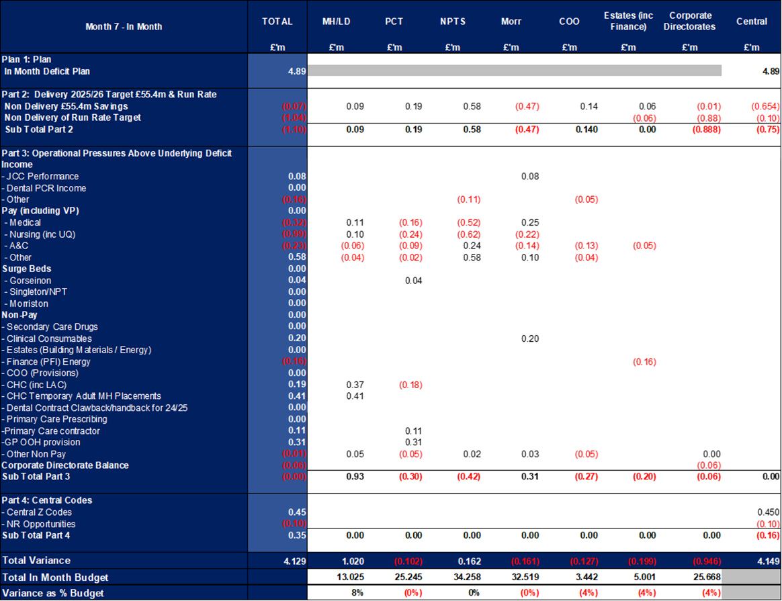

  - Key Drivers by Service Area YTD

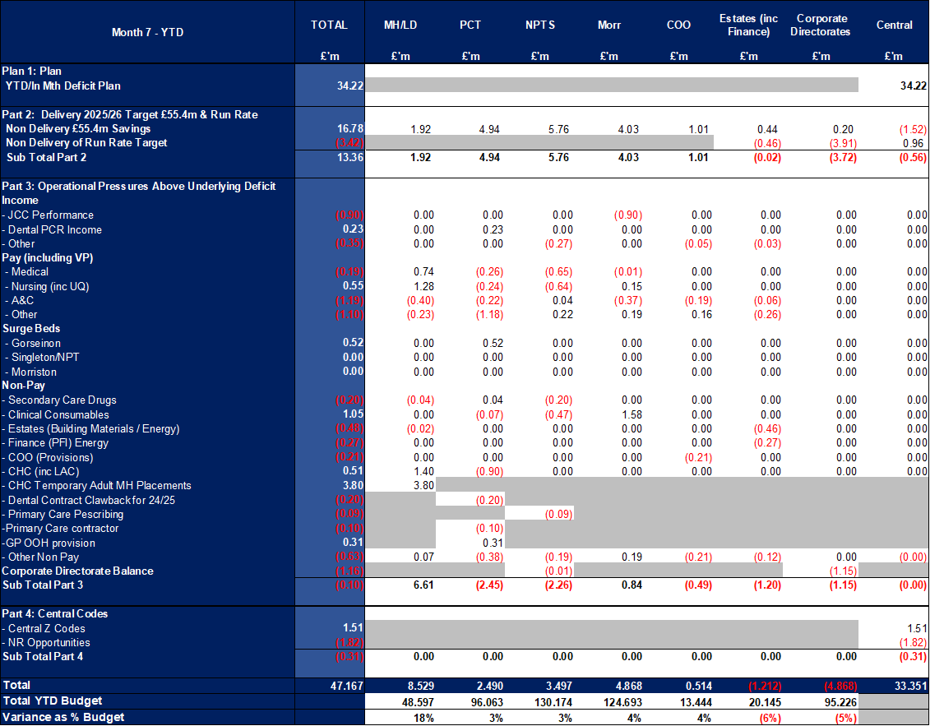

  - Summary By Expenditure Type

- Income
The Joint Commissioning Committee (JCC) Income as a provider under-performed by £0.04m in-month (£1.1m over-performance YTD). This has been driven by TAVI activity in Morriston.

- Pay
Month 7 pay is in line with the prior month; the continued vacancy freeze primarily in Admin & Clerical and other Pay Controls being the driver for this. Variable pay expenditure has held at the same level as September (£4.7m and the lowest achieved YTD).

- Clinical Consumables
(see Appendix 1)

- Prescribing
(see Appendix 1)

- KEY AREAS OF NOTE

  - Savings
The in-month delivery was £4.69m against a target of £4.62m; on a YTD basis the undelivered savings gap is £16.78m. Further details on savings at the point the Month 7 ledger was closed (6 November), are provided in Appendix 2.

  - Capital
The approved Capital Resource Limit (CRL) value issued on 7th November is £41.287m. The approved CRL value includes Discretionary Capital, schemes under the All-Wales Capital Programme and new/renewal IFRS 16 Leases.

Outturn Performance

The forecast outturn shows an overspend position of £1.415m. Allocations are anticipated on the following schemes, which will provide a balanced position.

Scheme | £m | Narrative
City Deal – Morriston Access Road Design | 0.151 | Funding approved.
Business Case Fees – Taith Newydd Fire | 0.319 | Business case fees incurred for schemes included in the Health Board 10-year capital programme/national prioritisation.
Tonna Mother and Baby / Steam | 0.945 | Bid submitted in September to Welsh Government for £0.945m to support increased cost on Tonna Mother and Baby / Steam.

The following allocations are classed as risks.

Scheme | £m / Risk Level | Narrative
Tonna Mother and Baby / Steam | 0.945 / High | Bid submitted in September to Welsh Government for £0.945m to support increased cost on Tonna Mother and Baby / Steam.
DPIF – RISP | 0.573 / Medium | The programme is reporting a lack of confidence in relation to the suppliers ability to deliver against a revised plan of a 23rd February 2026 go-live based upon current performance.  Discussions are in progress and we will quantify the financial risk over the coming weeks to determine whether all, or specific elements of the funding, are at risk this financial year.

All other schemes are low risk and any variances are linked to planned contributions from discretionary and in some instances payback of prior year fees.
Capital Disposals

The property disposal of Morriston Land completed with sale proceeds of £0.510m. There are no further property disposals planned for 2025/26.

  - Balance Sheet
The key issues in respect of the statement of financial position movements are as follows:
- The inventory value has increased from £8.473m at the end of September 2025 to £11.104m at the end of October 2025, an increase of £2.631m. The majority of this movement relates to Blood stocks, being £2.458m.

- There has been a decrease in trade receivables from £308.2m at the end of September 2025 to £300.754m at the end of October 2025, a decrease of £7.446m. This relates to a decrease in WRP (Welsh Risk Pool) debtors of £16.994m and an increase in NHS Debtors £8.110m, Non NHS income accruals £0.367m and the VAT Debtor £0.784m.

- The closing October 2025 cash balance of £1.839m is above the Health Board target of a cash balance of £2.5m at month end and the best practice cash target for the Health Board of £6m. Following discussions with WG, they have confirmed that they would be content with a closing cash balance of between £6-9m.

- The trade and other payables figure saw a decrease from £236.699m at the end of September 2025 to £231.144m at the end of October 2025, a decrease of £5.555m. This comprises a decrease in Accruals and NHS creditors.

- Provisions saw a decrease of £10.694m from £227.703m at the end of September 2025 to £217.009m at the end of October 2025. This decrease relates to a decrease in the Clinical Negligence provision of £8.695m and the Defence fees provision of £3.138m. There has been an increase in the provisions for Redress and GP Indemnity of £0.990m.

  - Cash
As at the end of October 2025, the Health Board had a cash balance of £1.839m, which is below the Health Board target of a cash balance of £2.5m at month end, and the best practice cash target for the Health Board of £6m. Following discussions with WG, they have confirmed that they would be content with a closing cash balance of between £6.0m-£9.0m.
Following a full review of the working capital requirements, and conversations with WG colleagues, the Health Board has reviewed its cash support requirements for 2025/26, to ensure it manages the revenue working capital cash to enable the delivery of a cash balance within the £2.5m Health Board target at 31st March 2026.
This is predicated on:
- Receiving revenue working capital cash support of £25.812m.
- Receiving strategic cash support of £55m.
- Recognising pressures relating to:
  - The Workforce realignment £9m (phased £7.5m in Dec 2025, £0.750m in both Jan and Feb 2026).
  - The estimated revised WRP risk share recovery - £6.977m (March 2026)
- Receiving most of the anticipated allocations prior to March 2026. Therefore, the timing of receiving this funding is key as it directly impacts when the Health Board cash position will deteriorate.

The table below provides a breakdown of the component parts of the cash requirements from WG:

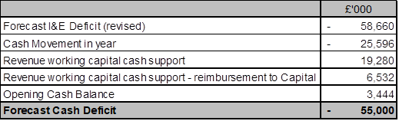
The working capital cash requirements excluding IFRS16 (£19.280m and £6.532m = £25.812m) are based upon the opening and closing Debtors and Creditors balances.
Full details on the cash requirement from 2025/26 is provided in Appendix 3. The letter within Appendix 3 is required to be submitted to WG by 8th December once approved by the Board as set out in WG Technical Update Letter 3.

The cash flow is updated daily, and a full review of the cash forecast is currently being undertaken monthly, to ensure that any changes to our cash requirements, can be communicated in a timely manner to WG.

  - Public Sector Payment Policy (PSPP)
The Health Board achieved the 95% PSPP target the % of Non-NHS Invoices Paid within 30 Days with compliance being 96.2% YTD.

NHS payment compliance for invoices paid within 30 days was, however, below 95% with the YTD performance being 89.2%. The Health Board remains focussed on improving PSPP compliance for NHS invoices and ensuring that performance remains above 95% for non-NHS invoices.

- GOVERNANCE AND RISK ISSUE
There are two Board level financial risks:

  - Achieving financial plan (HBR92) with the key elements as follows:
- Risk of delivery of savings quantum
- Risk of operational overspend being in excess of funding available agreed via the Financial Plan
- Risk of commitment of reserves (e.g. NICE) being above reserves available.
- Risk of achieving the actions and options outlined in the 2025/26 Financial Recovery & Sustainability Assessment.

Based on the financial performance at Month 7 and the shortfall in the identification of the savings at this point that is required to deliver the deficit plan of £58.7m, it is recommended that the Health Board Corporate Risk Register continues to reflect a risk score of 25.

The assessment at the end of October of the Risks, totalling £28.81m, is summarised in the table below.

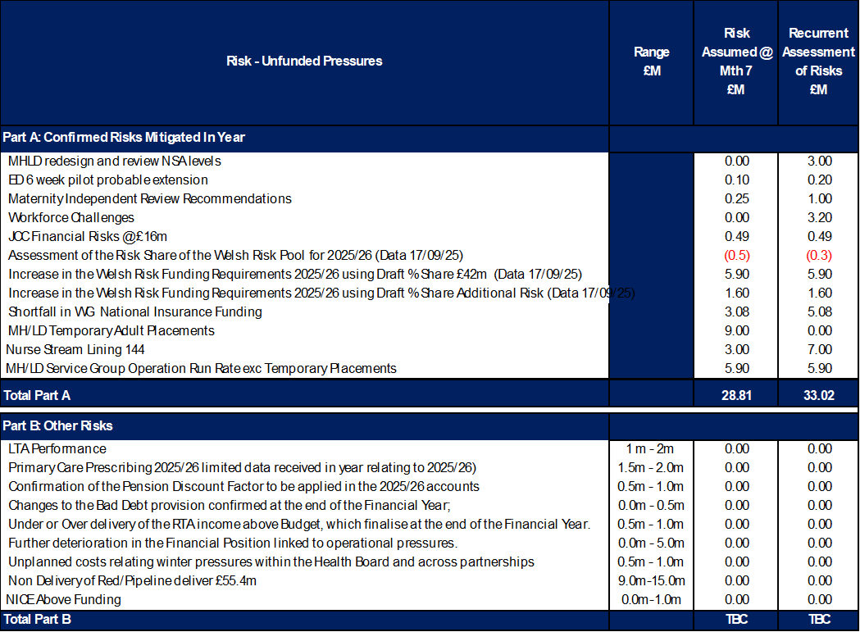

All risks will continue to be reviewed, and the tables updated as necessary.

  - Availability of capital (HBR93). This risk was re-opened in 2022/23 given the reduction in discretionary capital allocation. Due to the additional capital funding provided during 2024/25 the risk score was reduced to 12. The score was increased in June 2025 to reflect risks regarding Emergency Department and Adult Acute Mental Health. The current assessment is to continue with the risk score of 20.

- RECOMMENDATIONS
Members are asked to:
- ACKNOWLEDGE the 2025/26 Financial Plan, and the Health Board’s and Welsh Government’s inability to approve it given the planned deficit of £58.7m
- Consider and comment upon the Health Board’s financial performance for Month 7 2025/26, including cash, capital and balance sheet.
- SUPPORT the implementation of the actions to address the £15m savings gap.
- DISCUSS the risks to the position at Month 7
- AGREE the position that actions and choices must be identified to mitigate risks to the position which have emerged since the Health Board plan was developed in March 2025 as limited financial mitigation is available.
- APPROVE the 2025/26 Strategic and Working Capital Cash letter (Appendix 3).

Governance and Assurance

Link to Enabling Objectives  (please choose) | Supporting better health and wellbeing by actively promoting and empowering people to live well in resilient communities
Link to Enabling Objectives  (please choose) | Partnerships for Improving Health and Wellbeing |  | ☐
Link to Enabling Objectives  (please choose) | Co-Production and Health Literacy |  | ☐
Link to Enabling Objectives  (please choose) | Digitally Enabled Health and Wellbeing |  | ☐
Link to Enabling Objectives  (please choose) | Deliver better care through excellent health and care services achieving the outcomes that matter most to people
Link to Enabling Objectives  (please choose) | Best Value Outcomes and High Quality Care |  | ☐
Link to Enabling Objectives  (please choose) | Partnerships for Care |  | ☐
Link to Enabling Objectives  (please choose) | Excellent Staff |  | ☐
Link to Enabling Objectives  (please choose) | Digitally Enabled Care |  | ☐
Link to Enabling Objectives  (please choose) | Outstanding Research, Innovation, Education and Learning |  | ☐
Health and Care Standards
(please choose) | Staying Healthy |  | ☐
(please choose) | Safe Care |  | ☐
(please choose) | Effective Care |  | ☐
(please choose) | Dignified Care |  | ☐
(please choose) | Timely Care |  | ☐
(please choose) | Individual Care |  | ☐
(please choose) | Staff and Resources |  | ☐
Quality, Safety and Patient Experience
Financial Governance supports quality, safety, and patient experience

Financial Implications
The Board is reporting a forecast year-end deficit financial outturn.

Legal Implications (including equality and diversity assessment)
No implications

Staffing Implications
No implications

Long Term Implications (including the impact of the Well-being of Future Generations (Wales) Act 2015)
No implications

Report History |  | Updates on the financial position are provided at every meeting.
Appendices |  | Appendix 1 – Variances by Area and Type of Spend  Appendix 2 – Savings Position @ Mth 7  Appendix 3 – Strategic Cash Letter

APPENDIX 1 – FURTHER DETAIL ON VARIANCES BY AREA & TYPE OF SPEND

- Overview Financial Position

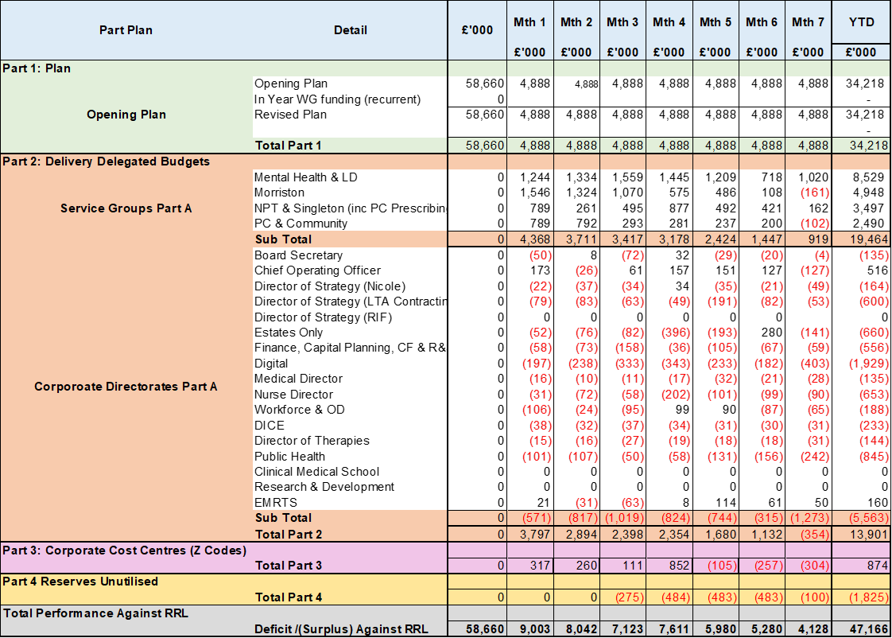

- Overview of Income

The table below compared the income performance in Month 7 to the average levels of 2023/24 and 2024/25.

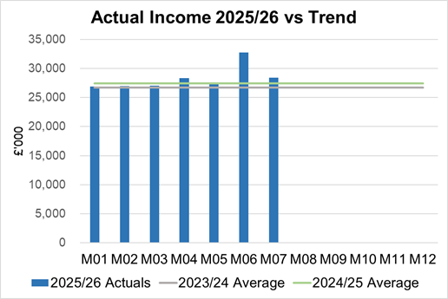

Income had increased in Month 6 due the quarterly receipt from HCRW in relation to the Clinical Research Unit, and a catch up for periods 1-6 of HEIW funding in relation to training grade posts.

  - Anticipated Income
The below table highlights anticipated income the Health Board expects to receive during 2025/26. The current deficit plan of £58.7m is predicated on receipt of these Welsh Government funds at the levels anticipated.

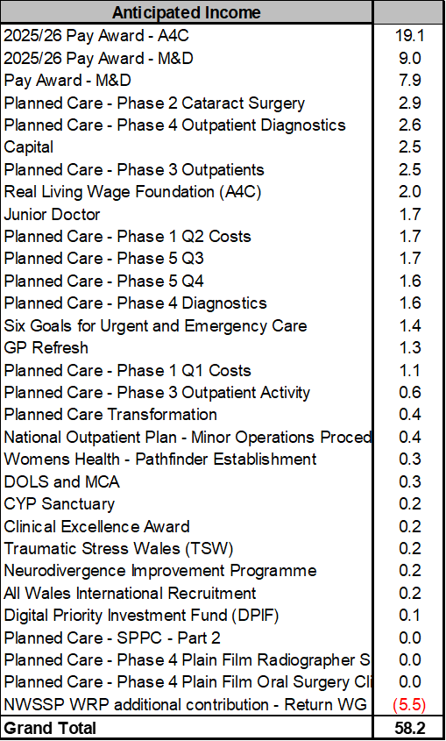

- Pay, Agency & Other Variable Pay Expenditure

Total Pay

The Month 7 total remains higher than the prior two years average (as shown in the graph below).

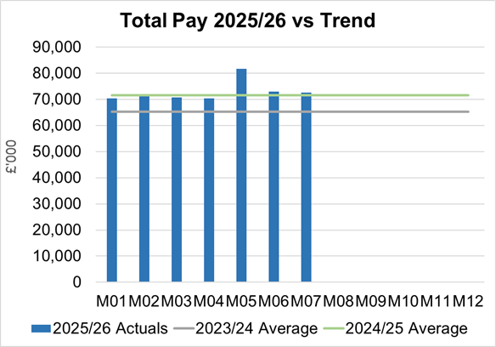
Note - 2023/24 and 2024/25 values have been notionally increased by pay award uplifts for comparison to current value of 2025/26 pay value.

Variable Pay
Variable pay is £1.112m lower in Month 7 2025/26 (£4.661m vs £5.773m) when compared to the same period last year (graph below shows this year’s actual versus prior year’s average) and is £0.015m lower than Month 6.

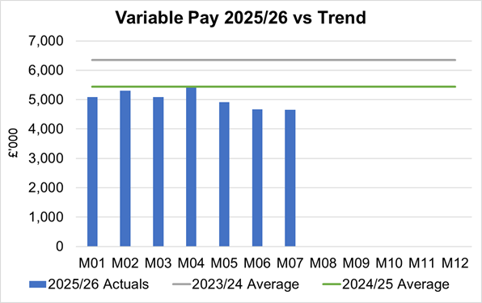

Variable Pay is classified by the Health Board into the following categories: Agency, Bank, Overtime, Waiting List Initiatives (WLI) and Irregular Sessions, a breakdown of the spend into these categorise is provided below.

Variable Pay Spend

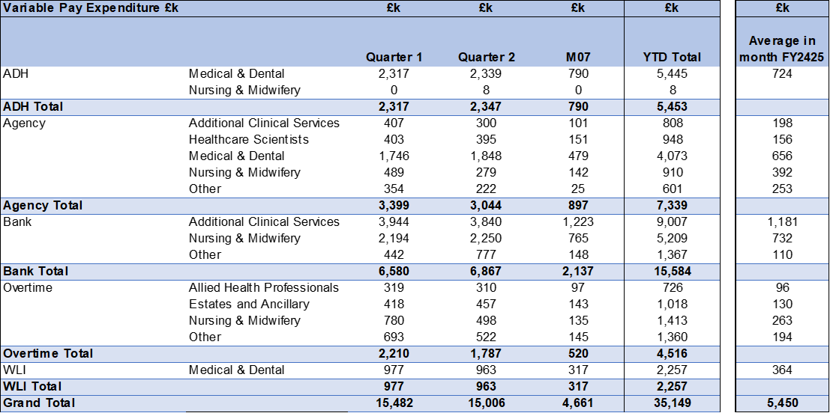

- Overview Non-Pay
Actual Non-Pay expenditure for Month 7 remains higher than the last 2 year’s average expenditure levels (as shown in the graph below):

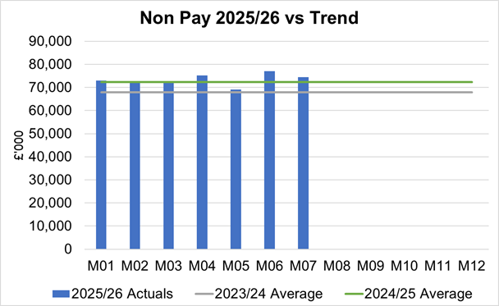

Below are further details on the key areas of non-pay:

  - Clinical Consumables
This area overall has an in-month overspend of £0.2m. Within the ledger the gross income is reflected within the income lines and not netted off against expenditure and so overall the Health Board position is not adversely affected where expenditure levels are driven by activity such as specialist services under JCC. The main drivers within this category of clinical consumable expenditure include heart valves & pacemakers. There are 80+ subjective lines within this category, including secondary care drugs.

  - Primary Care Prescribing
Prescribing was slightly overspent (£0.1m) in-month and YTD at breakeven following receipt of the latest dataset (August 2025).

  - CHC
In Month 7 CHC was overspent by £0.5m (YTD £4.1m). Expenditure on Adult Mental Health placements increased back up in month to £0.4m. The pressure remains at £0.26m in month in addition to standard CHC growth in excess of the Plan.

An analysis of actual expenditure and patient numbers for 2025/26, along with the average values from 2024/25 is provided in table below.
CHC Analysis by Month

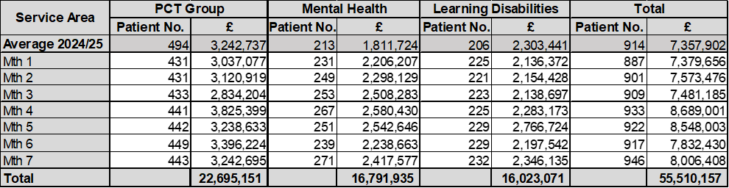
Please note:
- PCT Group numbers are based on bed days
- MHLD Group are based on cases
- PCT Group does not include the Singleton/NPT element. The NPTS element which covers Children and Young People CHC patients is provided internally by the Health Board and as such is part of the wider NPTS position and is not recorded in the ledger as PCT/MH/LD CHC.

  - Maternity Review
The total costs for this are allocated to a dedicated Cost Centre (6F34).
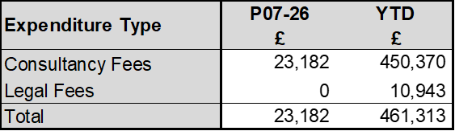

  - Z Codes (Section 1,3-4 Table Point 1 Appendix 1)
The narrative below groups together the key elements of the Z codes detailed in Point 1 of this appendix.

- Contracting: SLA /LTA performance: JCC (previously WHSSC), LTA and SLA contract income and expenditure are transacted within this area and financial performance reported. NICE approved high-cost drugs and associated LTAs are also transacted and monitored against targets set. In addition to this, non-contracted activity income in relation to English foundation trusts invoiced on a quarterly basis are reported.
- Capital: The Finance Capital Team manage a number of cost centres covering the PFI, IFRS16 and Depreciation charges for assets both owned and donated are transacted here.
- RRL and Central Reserves: The WG funding received at the start of the year is tracked within this area. Any anticipated allocations in year are also transacted through these codes. Other HB wide funding received from HEIW and SIFT is also captured in here. All central reserves remain within the Z cost centres.
- Corporate income and expenditure. Any income and expenditure that is not service group specific is transacted and reported through a number of corporate Z cost centres, examples include, payroll and pension costs, VAT recovery, losses and receipts in relation to funding from Welsh Risk Pool, overseas visitors’ income and Road Traffic Accident income.

  - LTA Values & Forecast performance
The table below is based on Month 5 activity undertaken by other Health Boards and Trusts for Swansea Bay residents (SBU Commissioner) and activity undertaken by Swansea Bay for residents of other Health Boards.

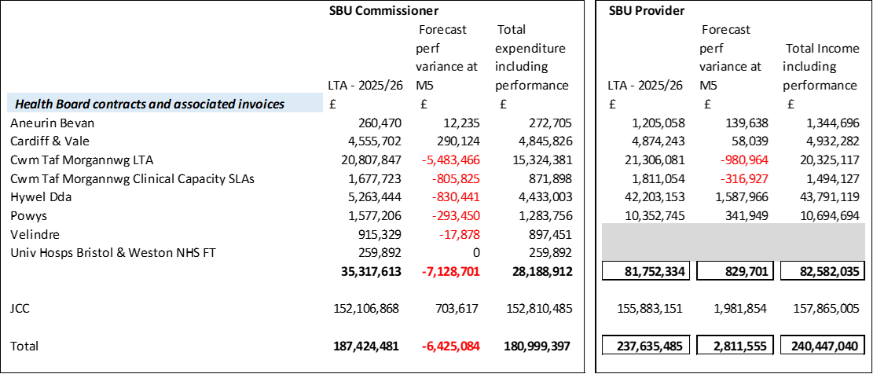

The above figures include the annual contract values plus invoices relating to patient activity. SBU Commissioner Performance variances are based on information received from each organisation. Forecast performance variances are subject to fluctuations and exclude NICE drug recharges.

APPENDIX 2 – SAVINGS

- Summary of Savings Position as at October 2025 (Month 7)

The section below reflects performance against the original £55.4m requirement taken from the Savings Trackers.

- Summary of Savings Position as at October 2025 (Month 7)

The below graph clearly shows the gap between the YTD savings target in red and the level of actual savings delivered in green, with full details provided in the table.

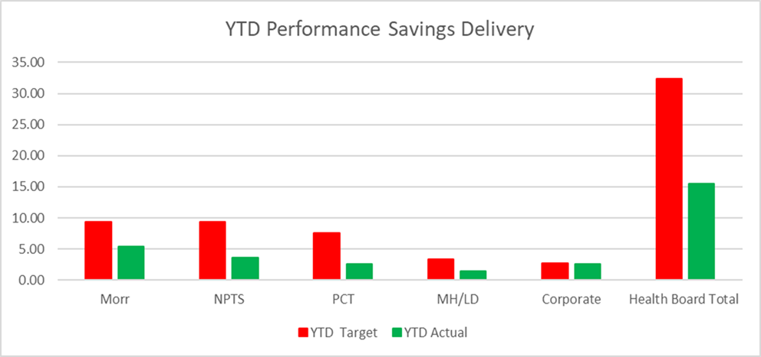

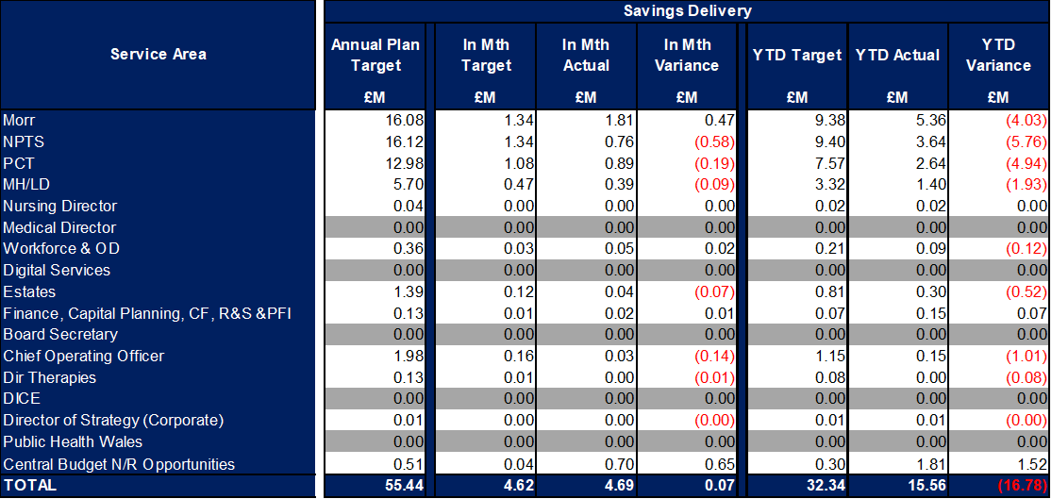
In summary the £58.7m plan required the Health Board to deliver £55.4m of savings. In Month 7 there was an overachievement of savings totalling £0.07m. YTD there remains a shortfall of £16.78m. This is the key issue in the delivery of the 2025/26 financial position.

- Savings schedule as at October 2025
An element of £55.4m plan submitted on the 11 September was not going to be delivered through savings, a proportion was to be achieved via Non-Recurrent Opportunities and underspend in operational budgets. The first below table provides a summary of the planned savings schemes, which total £46.9m, broken down by Pipeline, Red, Amber and Red. The second table provides the full reconciliation of the £55.4m and how the £8.6m will be achieved.

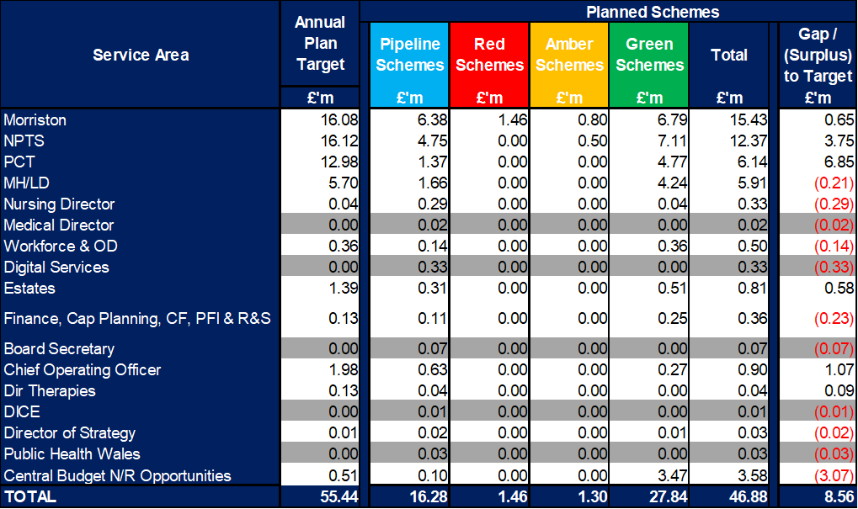

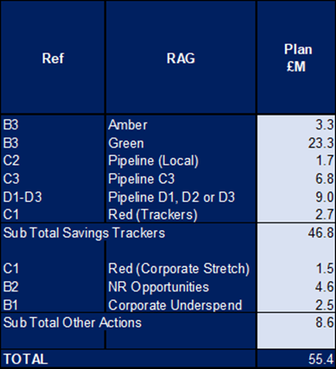
APPENDIX 3 – STRATEGIC CASH LETTER

