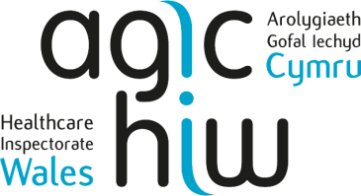

Chief Executives and Chairs
NHS Health Boards and Trusts Wales
Via Email
14 October 2025

EMBARGO: Healthcare Inspectorate Wales (HIW) Update: Annual Report 2024 – 2025
Dear Chief Executive and Chair,

I would like to inform you that HIW will be publishing its 2024-2025 Annual Report at 00:01 on Thursday 16 October 2025. Please find a copy of the report attached. Please note media outlets and key stakeholders will receive a copy under embargo on Wednesday 15 October 2025.
This report sets out our key findings from the regulation, inspection, and review of healthcare services in Wales. It outlines how we carried out our function across Wales, seeking assurance on the quality and safety of healthcare services. It provides a summary of what our work has found, the main challenges within healthcare across Wales and provides our view on areas of concern.

Our objectives are ambitious and through them we aim to make a difference to the people of Wales by contributing to improvements in healthcare. In this report you will find some examples of how we have used our work to further this aim. I am proud of the organisation I lead, and the contribution we can make to healthcare in Wales.

Should you wish to discuss any aspect of the report, please do not hesitate to get in touch. Yours sincerely

Alun Jones Chief Executive

Healthcare Inspectorate Wales

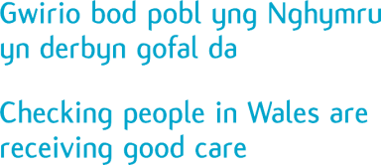
Llywodraeth Cymru / Welsh Government Parc Busnes Rhydycar / Rhydycar Business Park
Merthyr Tudful / Merthyr Tydfil
CF48 1UZ
Tel / Ffôn 0300 062 8163
Fax / Ffacs 0300 062 8387
www.hiw.org.uk

