



West Glamorgan
Regional Partnership

Winter Plan

2022 - 2023

Region: West Glamorgan Regional Partnership
 01792 633 805
 west.glamorgan@swansea.gov.uk

Table of Contents
1. Introduction and Context 3
1.1 Introduction 3
1.2 Context 3
1.2.1 Integrated Community Services Situation 4
2. Modelling 5
2.1 Emergency Admission Rates Graphs 5
2.2 Pathway Discharge Graphs 6
2.3 Community Demand Graphs 10
3. Issues and Risks to the Integrated System 12
4. Winter Planning Approach and Priorities 13
4.1 Key Priorities for West Glamorgan Regional Partnership 13
5. Communications 14
6. Governance 15
7. Links to Six Goals 15
Winter Action Plan 2022-2023 17

Introduction and Context

Introduction
The winter plan sets out additional actions that the Regional Partnership including Swansea Bay University Health Board, Swansea Council, Neath Port Talbot County Borough Council and Third Sector organisations to maintain key services to ensure that we keep the population safe
This plan sets out specific actions that the partners will commence to ensure that the delivery of Health and Social Care services are maintained during the winter of 2022/23.
A series of measurable actions are contained within the plan which also sets out the key risks and constraints across the system and mitigating actions.
The Regional Partnership Board will use it Regional Integrated Escalation Framework to monitor and support decision making across Community Services in both Health and Social Care and the Health Board will continue to use the National Framework to monitor its own services and support decision making.
The Regional Integrated Escalation Framework tool is an integral part of the Regions monitoring process and is presented twice weekly to the senior officer across the statutory and third sector partners. This allows us to continue to respond to changes in circumstances in the Community throughout winter.

Context
West Glamorgan has had strong partnership arrangements in place for a number of years and is well rehearsed in developing Winter Plans to respond to the predictable pressures that present during the winter months. This period can be particularly challenging in terms of patient access and flow in all parts of the health and social care system. Colder and more hazardous weather conditions; increases or changes in activity in some parts of the system; and spreading of infectious diseases such as influenza and norovirus can all result in additional pressure for front line services, and negatively impact on timeliness of patient care and patient and staff experience.
The COVID pandemic still continues to have a significant impact on the delivery of health and social care as the systems have not recovered to pre-pandemic levels. The backlog of patients waiting for care or treatment remains a key priority recognising that full recovery will take time.
Workforce challenges remain significant across the whole health and care system with the pandemic and EU Exit, impacting on the availability of staff, and in some cases, exacerbating pre-existing shortages in key areas. In Swansea work has been led to regrade reablement care staff to a higher grade, to attract more applicants, rolling recruitment campaigns are in place across Home First. Defecits in Therapies staff and Nursing staff continue to present challenges. During the winter months the resilience of the workforce is of critical concern as sickness levels and vacancies are traditionally expected to rise.

Coupled with Cost of Living Crisis and the War in Ukraine causing the current fuel crisis and potential supply chain issues will further exacerbate the issues through winter that are already being felt across the Health and Social Care Sector.
Modelling Suggests that the “Most Likely Scenario” this winter combines the following three scenarios:
- COVID-19 “Most Likely Scenario”, based on the SAGE Reasonable Worst Case scenario (The RWC was chosen because a lot of the activity has happened already from March-July 2022, so despite it being a RWC In February, it is now quite likely that we will see the remaining level of hospital activity)
- Influenza & pneumonia – A season with a normal peak – peaking in December 2022
- RSV – Early season with a peak of similar height to winter 2021-22
- Respiratory conditions are more prevalent for people with LD, increasing access to timely first line support, pharmacy, primary care cluster services (not necessarily GP) at this level will be important, alongside the vaccination programmes for flu and COVID.
Norovirus is already circulating and impacting on the delivery of hospital care and care within Residential Settings.
The sustainability of services in the social care sector (both commissioned and directly provided) remains a significant concern with workforce, quality and financial challenges in key areas including the care home and domiciliary care sector.

Integrated Community Services Situation
The precarious situation within the care market is the biggest factor affecting flow in the region. Due to ongoing shortages more people are needing urgent hospital care and length of stays are increasing where suitable packages of care or step down support cannot be secured. In response to this the Health Board commissioned Transitional Step Down Beds in 2021 and is actively working with regional partners to operationalise a refreshed step down for assessment model from December 2022, providing additionally into the system as part of the 1000 beds required by welsh government.
Social Care has seen an unprecedented demand for community support since 2019 and is still rising to levels that have not been seen by the sector. This is replicated for the health sector, with demand continuing to rise, despite a number of positive developments within the Health Board to support admission avoidance and flow. These include commissioning additional external beds for assessment, additional investment in Virtual Wards, additional in reach for Home First and activity to deliver an integrated discharge Hub, alongside a single point of access (SPA) in ED. The Health Board is also leading a large reform programme of Acute Medical service redesign, alongside prioritising quicker access to care for those patients waiting for treatment. The health board has a planned care board and outpatients redesign programme both actively supporting the transformation of planned care and outpatients and to reduce the backlog, using additional funding received form welsh government. All activity is designed to bolster performance for discharge and admissions avoidance as we prepare for winter.
As we moved into the Autumn / Winter of 2022 capacity has been directly impacted by the need to sustain of all elements of service provision. Significant staff sickness, vacancies are of significant concern, with deficits in Health Care Support workers, and community nursing. This is in tandem with the destabilisation of the external domiciliary care market and has led to significant numbers of provider failures which directly impacts our ability to maintain adequate levels of service to meet the required demand and maintain flow across the entire health and social care system.
The Regional Integrated Escalation Framework is the mechanism used within the region to monitor capacity and enable escalation. Due to the current challenging position a weekly meeting is held with all partners to review risk and implement mitigating activity. At present the REIF has shown the region to be at level 4 with a risk score of 20 for the last few weeks and it is not expected that this situation will improve and could even worsen through the winter period, to put community services into Business Continuity.

Modelling

Emergency Admission Rates Graphs

The number of COVID patients in emergency hospital beds
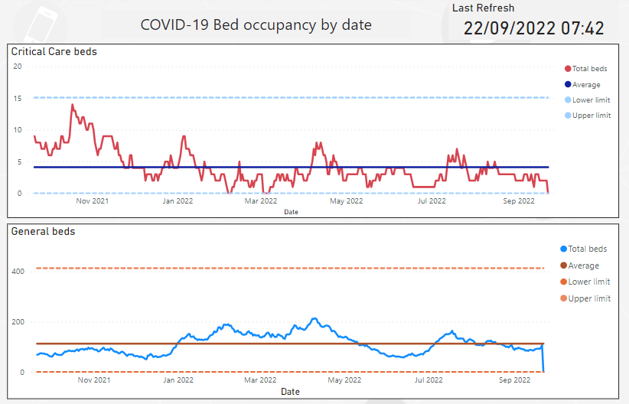
Source: Swansea Bay UHB Dashboard
The number of COVID patients in elective hospital beds
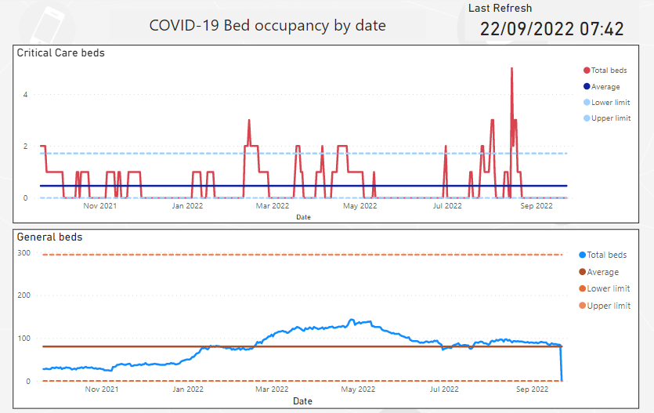
Source: Swansea Bay UHB Dashboard

Pathway Discharge Graphs
The Number of discharges from Pathway 0
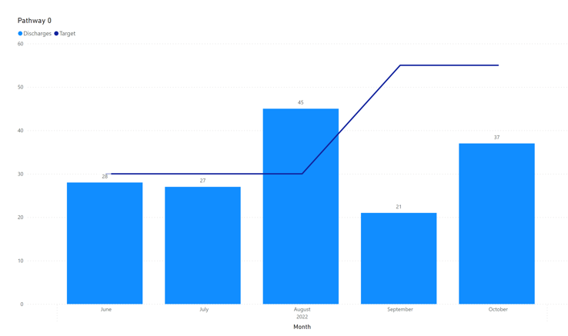

The Number of discharges from Pathway 2
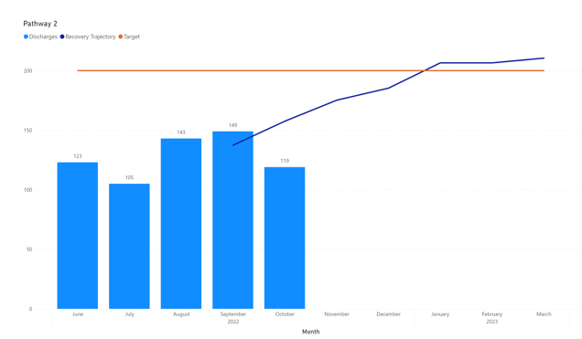

The Number of discharges from Pathway 3
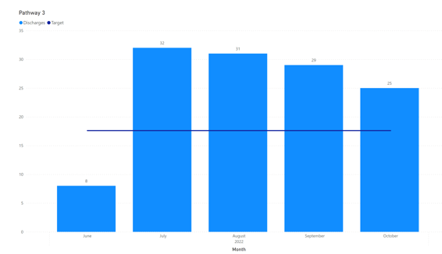

The Number of discharges from Pathway 4
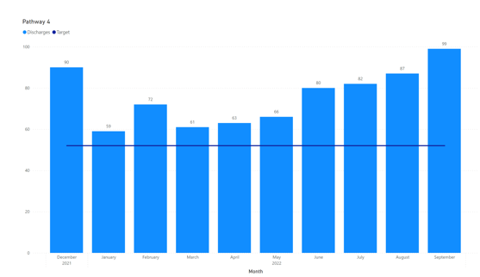

Source: Homes First Monthly returns

Home First Service – Discharge Performance by Pathway

Pathway 0 | Weekly Performance | Monthly Performance
Support for Discharge via Pathway 0 has consistently delivered since its launch.  During September levels reduced due to referral portal outage and the bank holiday.  October Data only collected for 23 days | 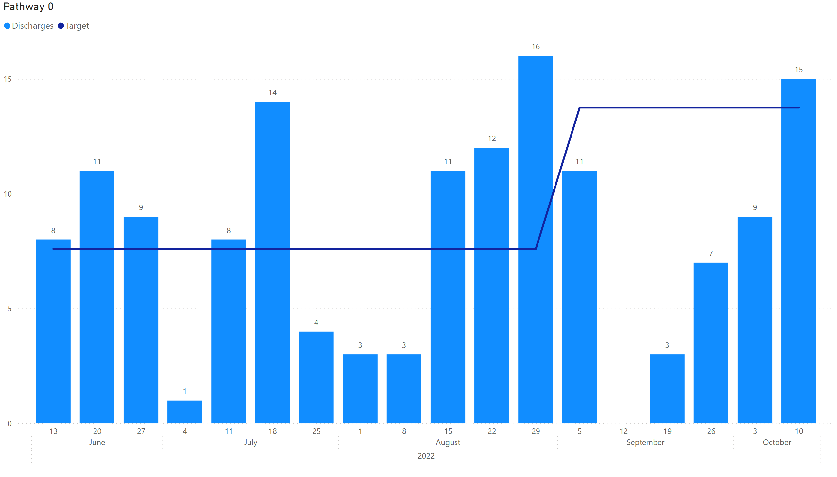
Pathway 2
Regional AHP recruitment has been achieved as per trajectory. This has facilitated enhanced in reach in Swansea and the ability to commence in reach in NPT hospital site .This is timely as there has been a drop in P2 referrals from the latter site .  Reablement carer recruitment has commenced in Swansea following regrading of role. Creative recruitment in job fayre in city centre has been positive  October Data only collected for 23 Days | 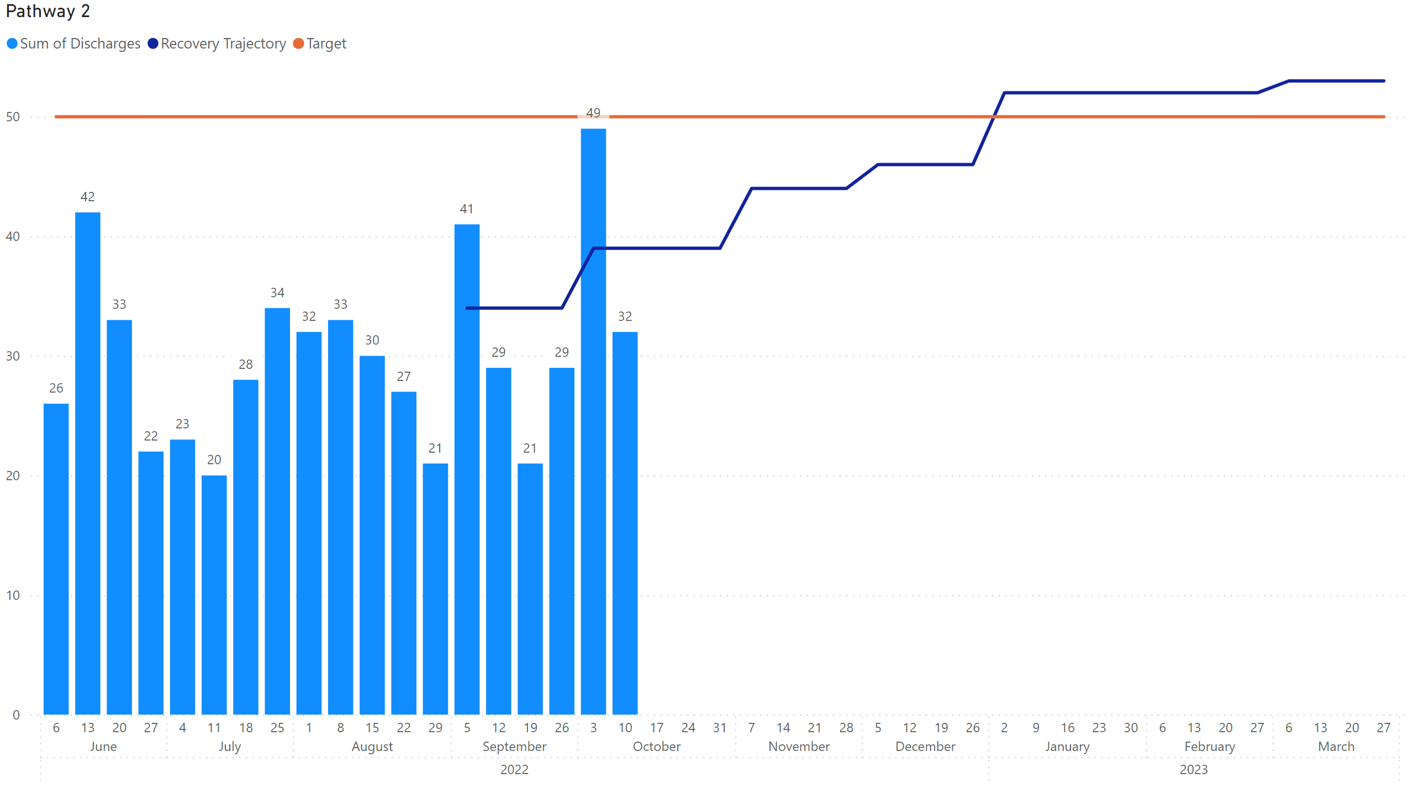
Pathway 3
Support for Discharge via Pathway 3 has consistently delivered.  October Data only collected for 23 Days and has already exceeded the target for the month. | 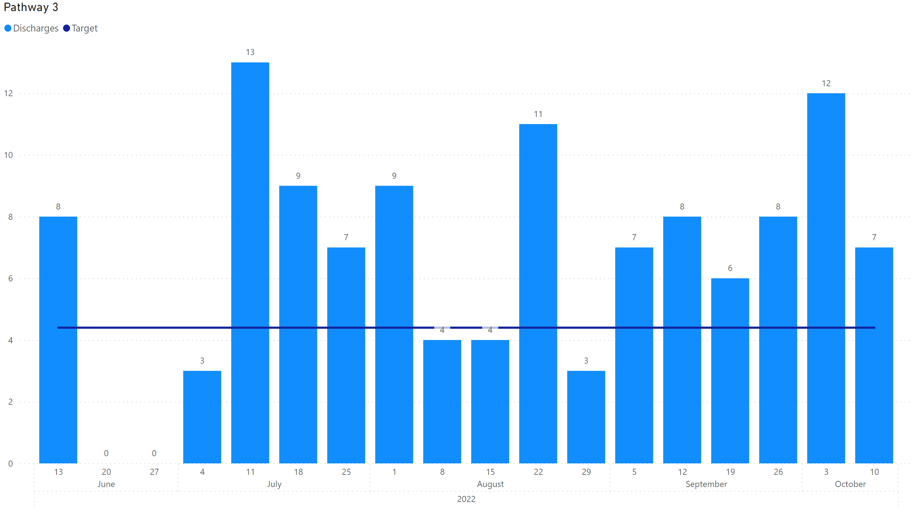
Pathway 4
Support for Discharge via Pathway 4 has consistently delivered month on month. | 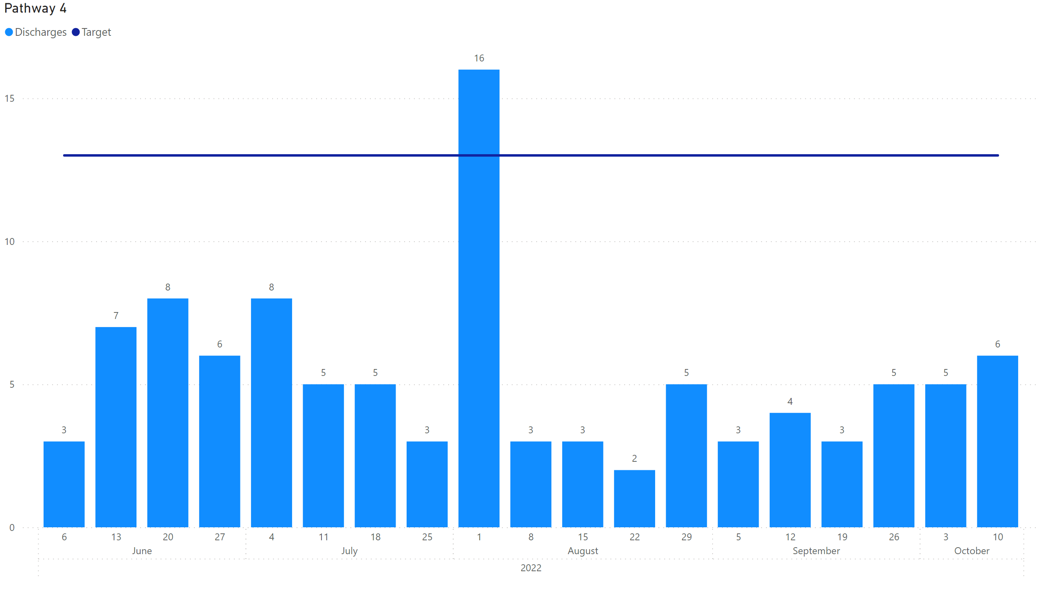

Community Demand Graphs

Bed availability in Care Homes –
Number of beds open for immediate* admissions per week. *immediate being available in next 24 hours
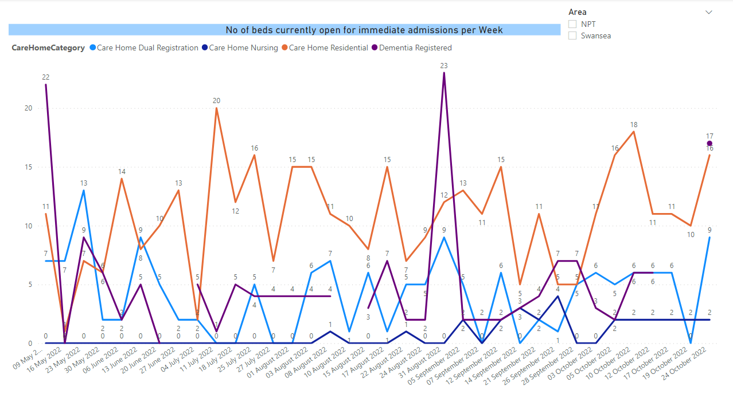
The Occupancy Levels of Older Adult Care Homes in West Glamorgan below 80%.
The number of older adult care homes occupancy levels that are below 80%
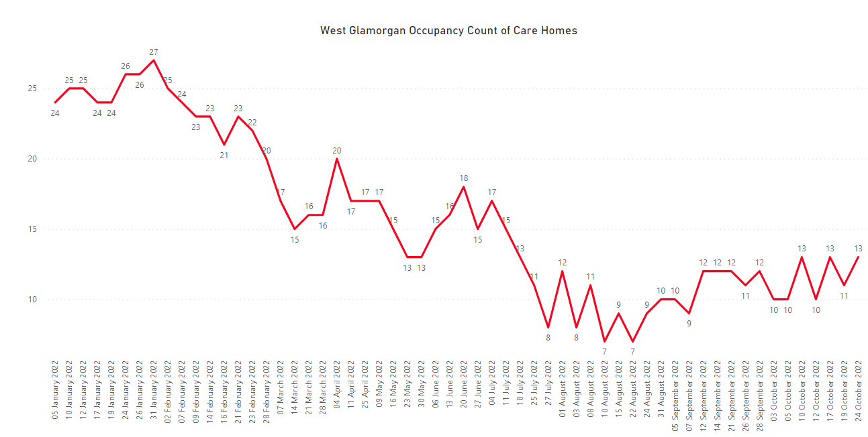
Staff sickness Levels in Older Adult Care Homes.
The total number of staff absent with COVID or non COVID related conditions
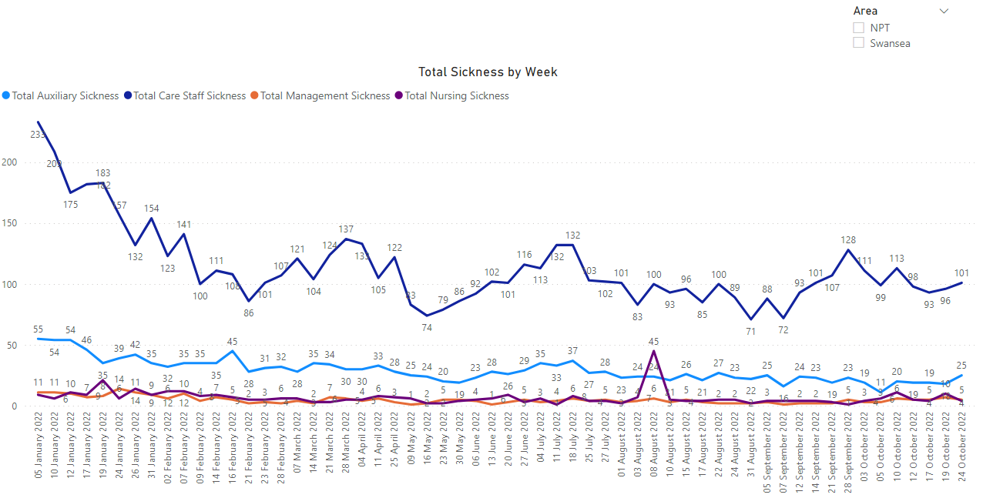
Source: West Glamorgan Care Home Monitoring system

2.4 Regional Integrated Escalation Framework
The Regional Integrated Escalation Framework has been reporting very high levels of risk for some months at 4/20, however over the last two weeks this has escalated to 4/25 where the risk is very high and will have a critical impact on care. Example of the Summary of the Framework for the week of 13th October is below.

Overall Assessment – Level 4 /25
Very High Risk / Will Happen Critical Impact
Care Homes |  |  | Unchanged - available bed numbers appear to be challenged based on current demand with staffing vulnerabilities in elements of the sector and there were 9 homes in incident due to Covid related concerns currently, 3 supported living settings and 2 home closed for other issues.  This overall position is accurate at the time of assessment but is an ever changing situation.  There are currently 6 care homes at financial risk with a total of 280 beds  Immediate Bed availability:  - No immediate availability in dual registered homes in NPT only 1 in residential;  - 5 available in Swansea dual registered homes;  - 6 available in dementia only (St Johns)  - 2 available in nursing only  - 11 available in general residential
Packages of Care |  |  | Overall unchanged - Reablement and domiciliary care capacity remains challenged with very little capacity at present. Brokerage levels overall remain high, with little to no capacity with external providers across the region
Intermediate Care Beds |  |  | Unchanged – Bonymaen House is out of incident
Community |  |  | Unchanged – significant capacity deficits noted across all sectors including district nursing, ACT, social work, long term care and therapies impacting on the ability to meet demand in part.
Primary Care |  |  | Largely Unchanged
Acute Hospitals | % bed availability | Based on highest hospital site | Unchanged – Level 4
Equipment Provision |  |  | Unchanged - whilst reporting as Green with stocks  and ability to supply maintained currently, there is a potential national risk with future deliveries of equipment
Covid 19 |  |  | As of 26th May, this information is no longer reported on PHW dashboard

Issues and Risks to the Integrated System
Workforce – there are significant workforce gaps across health and social care. These are monitored on a weekly basis through the Home First performance and assurance meetings, designed to support rapid mitigations. High deficits have been recorded in Therapies (average 28%) and severe deficits in nursing of up to 50% have been recorded at points during September and October. Whilst rolling adverts are out, deficits in therapies and reablement care workers impact on the ability to maintain flow.
The system is experiencing challenges with the retention and recruitment of care staff across community and residential settings.
Maintaining flow of patients out of acute care; known fragilities in care home and domiciliary care sector.
Availability and timely input of LD acute liaison in hospital should people come through unscheduled care routes will improve flow within acute general hospital. Any additional funding to increase this resource over the winter period would contribute.
Staff psychological health and well-being of staff – fatigue; disengagement; trauma.
Front line staff (reablement support worker) capacity restricted due to complexity and acuity of patients.
Capacity – linked to the above, Ability to sustain capacity against demand along the ability for the system to turn on additional capacity will be limited this winter and alternatives to traditional capacity (ie. beds) need to be considered.
Workforce Resilience – the ability to secure staff to undertake extra shifts or work will be impacted by a range of factors – generally our staff are reporting that they are exhausted from 2 ½ years months of unrelenting pressure and this may impact on their willingness to undertake additional work over the winter period. Skill mixing has been implemented to mitigate vacancies across therapies and reablement staff but is not sufficient mitigation to protect capacity.
Unpaid Carers - The strain on carers has intensified. Unpaid carers burning out, reaching crisis and being unable to continue caring. People cared for at home with high levels of intervention and/or supervision provided by unpaid carers, may need to be admitted if the level of need is greater than what can be provided through community and social care services e.g PEG and Dementia care.
Wellbeing and Mental Health - The need for mental health care has increased, with children and young people particularly badly affected.
Learning Disabilities - People with a learning disability have faced increased challenges as a result of the pandemic.
People with a learning disability are referenced within but as we know people with a LD are first and foremost people and therefore have all the same issues as others without a LD.
The learning form the pandemic is that the inequalities already in existence are made worse for people with a LD (and other disabilities) in crisis, which includes winter pressures.
Therefore health services (primary care, acute hospitals etc) and social care need to consider how they are dealing with winter pressures in a way that avoids widening the inequalities when planning actions. Accessibility, communication etc.
Delayed Treatment and Care - The impact of the pandemic on many who use health and social care services has been intensely damaging. Many people have struggled to get the care they need, and there is also evidence that some people have not sought care and treatment as a result of COVID-19. The Health Board have dedicated, focused activity to ensure that patients waiting for treatment are seen within Welsh Government Targets, set for Planned Care and Outpatients, with assurance provide through a planned care Board and an Outpatient Redesign Board.
Cost of Living Crisis - The cost-of-living crisis is posing a real threat to many families, making it more difficult for low-income households to make rent or mortgage payments, stopping people using gas and electricity, travelling, and causing food poverty. These factors will affect the most vulnerable in our society – not least those that are already using care support services.
Additional demand due to flu or other infectious diseases over previous seasons
Balancing unscheduled care demand and the requirement to maintain and expand essential services in line with national guidance
Risk of harm associated with unscheduled care pressures and/or inability to provide essential services to patients
Further waves of COVID-19 infection
Financial risks associated with core Winter Planning requirements including use of surge capacity in community, hospitals and diagnostic services and additional workforce implications.
Capacity of the third sector to deal with the increased demand on their services. Whilst Third sector are key partners, and support within reach for discharge and Admissions avoidance in both virtual wards and Home First capacity is limited.
Inequalities in accessing services for ethnic minority groups, homeless and vulnerable groups

Winter Planning Approach and Priorities
Integrated Winter Plans will be the responsibility of the Regional Partnership which includes all partners. The focus is on transformational change supported by short term additional measures which will be deployed to support areas of focus and to supplement strategic work programmes. All actions are consistent with the Regions Priorities. The Integrated Winter Plan will be endorsed by the Regional Governance arrangements that report to the Regional Partnership Board. The Unscheduled Care planning arrangements for are being overseen by the Chief Operating Officer. The development of the plan is also being supported by the Regional Partnership Board along with service delivery units within the Health Board, Local Authority, Third Sector partners.

4.1 Key Priorities for West Glamorgan Regional Partnership
- Stabilisation and Reconstruction:
Work with (and invest in) communities, third sector and volunteers in maintaining and strengthening an asset and strengths-based approach to safely supporting vulnerable individuals within their communities without unnecessary recourse to critical/essential health & social care services - making sure there is a particular focus on support for carers.
- Remodelling Acute Health and Community Services:
Continue remodelling (and shifting the balance of funding between) acute health and community health/social care services. The programme has recently been revised to encompass the broader national Discharge to Recover and Assess Pathways (D2RA) and has been relaunched as The Home First Programme.
- Transforming Complex Care
Establish fit for purpose joint funding arrangements to support the provision or commissioning of integrated/collaborative health/social care services to support children and adults with complex needs. This is intended to:
- Safely support regional LAC reduction anywhere on the continuum of need
- Safely support adults with complex needs to remain or return to living as independently as possible within their families or local communities within the region rather than within more institutional health or care settings.
- Ensure seamless transition between services across all services including young people into adulthood
- Transforming Mental Health Services
- Develop a continuum of support for the population who require Mental Health and Well Being Services
- Safely support children and young people with emotional mental health and wellbeing needs and other complex needs, including disabilities, to receive the support they need to live as fulfilled a life as possible with the minimum levels of intervention and receiving integrated care in a timely manner when they do.

Communications
The Partnership has an extensive communication and engagement approach and each winter targets key messages that both amplify national communications, as well as addressing local issues.
In addition to planned communication, there are some areas of particular focus under consideration this year:
- Supporting people to keep warm (in light of the impact of increasing energy prices)
- Continued focus on encouraging people to have their COVID and influenza vaccines

Governance
The Partnership has a well-established governance structure by which the winter plan will be monitored.

Links to Six Goals
The Integrated Services Winter Plan will ensure that each action taken also links to the Six Goals of Urgent and Emergency care defined below:

GOAL 1 - Coordination, planning and support for people at greater risk of Urgent and Emergency Care: Health and social care organisations should work in collaboration with public service and third sector partners to deliver a coordinated, integrated, responsive health and care service, helping people to stay well longer and receive proactive support, preventative interventions or primary treatment before it becomes urgent or an emergency.

GOAL 2 - Signposting, information and assistance: When people need or want urgent care they can access a 24/7 urgent care service via the NHS 111 Wales online or telephone service (NHS 111, Press 2 service for Mental Health that is live). Where they will be given advice and, where necessary, signposted or referred to the right community or hospital-based service, first time. This will be achieved through the development of an integrated 24/7 urgent care service

GOAL 3 - Clinically safe alternatives to admission: People access appropriate and safe care close to home, and with as much continuity of care, as possible. Admission for ongoing care to an acute hospital bed should only occur if clinically necessary. Linked to Goals 1 and 2, and the establishment of an integrated 24/7 urgent care service, Health Boards

GOAL 4 - Rapid response in Crisis: Individuals who are seriously ill or injured or in a mental health crisis should receive the quickest and best response commensurate with their clinical need – and, if necessary, be transported to the right place for definitive care to optimise their experience and outcome

GOAL 5 - Optimal hospital care and discharge practice from the point of admission: Optimal hospital based care provided for people who need short term, or ongoing, assessment or treatment for as long as it adds benefit to outcome, with a relentless focus on good discharge practice

GOAL 6 - Home first approach and reduce risk of admission: People will return home following a hospital stay – or to their local community with additional support if required – at the earliest and safest opportunity to improve their outcomes and experience, and to avoid deconditioning

West Glamorgan Partnership

Winter Action Plan 2022-2023

Programme | Key Deliverables for Winter 2022-2023 | Supports Goal |  |  |  |  |  | BAU / Innovation | In Progress / Would Do | Outcomes (Measures and Indicators to be developed if approved) | Funding in Place | Cost
 |  | 1 | 2 | 3 | 4 | 5 | 6
1000 Beds Scheme | Moving current transition beds to SD2R model |  |  |  |  | ✓ | ✓ | Innovation | In Progress | Part of the 1000 Beds Bi-Weekly Monitoring | Yes | Local Partners Funding
1000 Beds Scheme | Increase in virtual wards |  |  |  |  | ✓ | ✓ | Innovation | In Progress | Part of the 1000 Beds Bi-Weekly Monitoring | Yes | Local Partners Funding
1000 Beds Scheme | Increase in beds in Gorseinon Community Hospital |  |  |  |  | ✓ | ✓ | Innovation | In Progress | Part of the 1000 Beds Bi-Weekly Monitoring | Yes | Local Partners Funding
1000 Beds Scheme | Exploration of opportunities in community nursing to support earlier discharge. |  |  |  |  | ✓ | ✓ | Innovation | In Progress | Part of the 1000 Beds Bi-Weekly Monitoring | Yes | Local Partners Funding
1000 Beds Scheme | Additional Capacity in Domiciliary Care |  |  |  |  | ✓ | ✓ | Innovation | In Progress | Part of the 1000 Beds Bi-Weekly Monitoring | Yes | Local Partners Funding
1000 Beds Scheme | Increase in Pathway 3 Hours |  |  |  |  | ✓ | ✓ | Innovation | In Progress | Part of the 1000 Beds Bi-Weekly Monitoring | Yes | Local Partners Funding
1000 Beds Scheme | Expansion of Pathway 0 offer in the community. (Additionality is individuals being supported to discharge from hospital or step up into hospital) |  |  |  |  | ✓ | ✓ | Innovation | In Progress | Part of the 1000 Beds Bi-Weekly Monitoring | Yes | Local Partners Funding
1000 Beds Scheme | Recruitment of additional Therapy posts |  |  |  |  | ✓ | ✓ | Innovation | In Progress | Part of the 1000 Beds Bi-Weekly Monitoring | Yes | Local Partners Funding
1000 Beds Scheme | Recruitment into Home Care Posts |  |  |  |  | ✓ | ✓ | Innovation | In Progress | Part of the 1000 Beds Bi-Weekly Monitoring | Yes | Local Partners Funding
1000 Beds Scheme | Increase capacity in care homes to support Step Up Hospital Avoidance/ Step Down whilst waiting for domiciliary care support at home |  |  |  |  | ✓ | ✓ | Innovation | In Progress | Part of the 1000 Beds Bi-Weekly Monitoring | Yes | Local Partners Funding
1000 Beds Scheme | Specialist Team of Social Workers |  |  |  |  | ✓ | ✓ | Innovation | In Progress | Part of the 1000 Beds Bi-Weekly Monitoring | Yes | Local Partners Funding
Additional Winter activity to support Admission Avoidance and Discharge | Completed roll out of Virtual Wards from 4-8. Active in reach from Virtual Wards into Morriston and dedicated Band 7 at front door ED to SUPPORT Admission Avoidance |  |  |  |  | ✓ | ✓ | BAU to support winter | In Progress |  | Yes | HB Funded
 | Skill mixing applied across therapies workforce to mitigate against deficits going into winter |  |  |  |  | ✓ | ✓ | Innovation | In Progress  Could do more if funding available
 | Rolling recruitment campaigns for reablement care assistants in place |  |  |  |  | ✓ | ✓ | Innovation | In Progress  Could do more if funding available |  | Yes in Part for vacant posts | Local Partners
 | ACT in place in Swansea and Neath to prevent Admission Avoidance |  |  |  |  | ✓ | ✓ | Innovation | In Progress |  | Yes | Section 33
 | Acute Medical Service redesign programme to be completed by November |  |  |  |  | ✓ | ✓ | Innovation | In Progress |  | Yes | SBUHB
 | Scoping of Integrated Discharge Hub in Morriston to support flow and improve referrals to D2RA pathways |  |  |  |  | ✓ | ✓ | Innovation | In Progress  Could do more if funding available
 | Development of proposal to implement integrated SPA at Morriston ‘Front Door’ |  |  |  |  | ✓ | ✓ | Innovation | In Progress  Could do more if funding available
 | Internal mapping exercise on underway to determine improvements to recording of referrals and transfers of care to improve flow |  |  |  |  | ✓ | ✓ | Innovation | In progress |  | Yes | SBUHB
 | Development of new T & O pathway to provide early supported discharge for NOF patients |  |  |  |  | ✓ | ✓ | Innovation
 | Ensure all vacant posts within the Home First Service are advertised and filled | ✓ |  |  |  | ✓ | ✓ | BAU | In progress | Workforce at full complement to meet trajectories | Yes | Section 33
 | Pooled Fund to Support Discharge in Community Surge | ✓ |  |  |  | ✓ | ✓ | Innovation | Would do if Funding available |  | No | £50,000
 | Pooled Fund for Refurbishing and Adaptations and Equipment for Older Adults Care Homes in surge or crisis | ✓ |  |  |  | ✓ | ✓ | Innovation | Would do if Funding available – not appropriate this calendar year from Capital, would need to source from other areas |  | No | £50,000
 | Ongoing through continual review of caseload / demand in local authorities. Rag Rating of users across all community services – internally and externally | ✓ |  | ✓ |  |  |  | BAU | In progress |  | Yes | Section 33
 | Expand the Pathway 4 Offer |  |  |  |  | ✓ | ✓ | Innovation
 | Increase capacity within Senior community Care to support increased demand over 7 days  Revised Swansea Homecare Reablement senior community care assistant working hours/reablement rota to ensure appropriate skill mix across 7 days and to 8pm to process new referrals – this will avoid discharge delay |  |  |  |  | ✓ | ✓ | Innovation
 | Increase capacity and availability of a range of Community Equipment through investment in necessary equipment to support demand  Expansion of trained installers and delivery drivers to offer full 7-day service at surge & super surge | ✓ |  | ✓ |  | ✓ | ✓ | Innovation | Would do if Funding available | Maintenance of discharge ‘flow’  Improved intervention at discharge reducing risk of readmission  Improved intervention during delivery of a package of care to reduce admission  Increased stock levels to support anticipated demand  Supply level to support expansion of operating hours during surge | No
 | Swansea Adult Services - Domiciliary Consideration Panel: We are about to launch a pilot to trial a different approach to growing demand for domiciliary care. Set up for initially three months, this multi-disciplinary panel will be part of a learning and supportive process. It will consider each new request for domiciliary care, including increases in care, and what is available from our services, other services, and in our communities to meet need before passing the request on to the brokerage list. Your managers are aware, and I will keep you up to date through this briefing and staff development sessions on progress. |  |  |  |  | ✓ | ✓ | Innovation | In progress |  | Yes | Swansea Council
 | Weekly Performance & Assurance Meetings in place to ensure HF remains on track during winter. | ✓ |  |  |  | ✓ | ✓ | BAU | In progress | Workforce needs to be at full complement to meet trajectories | Yes | Section 33
 | Recovery Trajectory’s in place for P2 and P4 | ✓ |  |  |  | ✓ | ✓ | BAU | In progress |  | Yes | Section 33
 | In reach extended in Swansea (7 Days) and NPT (1 day) |  |  |  |  | ✓ | ✓ | Innovation | In progress |  | Yes | SBUHB
 | Home First Matron leading training workshops to align flow and DLN teams in advance of increased winter demand |  |  |  |  | ✓ | ✓ | Innovation | Could do more if funding available
 | Home First Summit held 10/10 to review any additional actions to support winter pressures | ✓ |  |  |  | ✓ | ✓ | BAU | In progress |  | No | Partners
 | Early discussions to develop Pathway 1, Admission Avoidance SPA at ED Morriston | ✓ |  |  |  | ✓ | ✓ | Innovation | Could do more if funding available
 | Early discussions to develop P3 to expand reablement capacity |  |  |  |  | ✓ | ✓ | Innovation | Could do more if funding available
 | Review of Pathway 0 community capacity and in reach to repurpose to facilitate additional discharge/AA during winter | ✓ |  |  |  | ✓ | ✓ | Innovation | Would do if Funding available |  | No
 | Development of ward focused comms campaign to increase knowledge of D2RA pathways. |  |  |  |  | ✓ | ✓ | BAU | In progress  Could do more if funding available |  | Yes
 | NPT and Swansea realigned Social Work presence in Morriston |  |  |  |  | ✓ | ✓ | BAU | In Progress |  | Yes | Partners
Prevention and Community Coordination | Mobile fall response service for NPT (Delta) |  |  |  |  | ✓ | ✓ | Innovation | Would do if Funding available | Reduction in long lies  Reduction in ambulance call outs  Reduction in hospital admissions  Quicker response time to person who has fallen (average time - 45 minutes)  Provision of personal care  Right-sizing, reassurance and review | No | £85,000
Prevention and Community Coordination | Prevention for Home First  Third Sector Pooled Fund to support individuals in exceptional circumstances to be discharged from hospital and supporting people to stay in their own homes  Any ad hoc equipment and support identified through the community wellbeing pathway – this will include decluttering and hoarding support | ✓ |  | ✓ |  | ✓ | ✓ | Innovation | P&CC Third sector slippage to be allocated - £45,000  RIF - £55,000 |  | Yes | £100,000
Prevention and Community Coordination | Cost of Living Support for Third Sector Prevention Schemes  Grant to cover additional costs from cost of living crisis for third sector prevention and community co-ordination schemes in order to ensure the services are sustainable and supports stabilising the sector through winter | ✓ |  |  |  |  |  |  | P&CC Third sector slippage to be allocated - £138k |  |  | £138,000
Prevention and Community Coordination | Prevention for Home First  Pathway 0 ‘welfare’ check ins with clients waiting on Brokerage/exploration of alternative means of support wherever possible (Swansea). | ✓ | ✓ | ✓ |  |  | ✓ | BAU | Yes – through Pathway 0 funding |  | Yes | RIF
Carers Partnership | Communication of the local cost of living crisis schemes, with links to the welcoming places being developed, to all carers so they are aware of all schemes available | ✓ |  |  |  |  |  |  | Information to be collated and communicated |  | NA
Carers Partnership | Young carers scheme, which could include ‘Grant for young carers to apply for funding for a service, activity, or equipment to support their social, physical and emotional development.  Other initiatives include trips to take part in Christmas activities, family trips to enjoy festive activities with the family  Provision of vouchers and tickets to young carers and their families so that they can take part in activities as families in their own time, vouchers towards Christmas food, including family Christmas hampers  Young Carers Care packages – items that young carers can use during the festive season to have fun and have a break from their caring roles while at home (colouring books, games etc.)  Transport support for young carers families - this could include bus and train tickets to other parts of the UK to visit their families  These proposals have been developed through YMCA young carers group | ✓ |  |  |  |  |  |  | Would do if Funding available  List is currently being prioritised by young carers. | Potential for funding from clusters as only £22k RIF slippage available | No
Carers Partnership | Grant for adult carers to top up the Carers Trust hardship grant, in line with initiative last year | ✓ |  |  |  |  |  |  | Would do if Funding available | List is currently being prioritised by carers.  Potential for funding from clusters as only £22k RIF slippage available | No
Carers Partnership | Lightening the load project, to provide gardening, cleaning (inside and outside), odd jobs, ironing and handyman service | ✓ |  |  |  |  |  |  | Would do if Funding available |  | No
Carers Partnership | Increased respite and short breaks for carers | ✓ |  |  |  |  |  |  | Would do if Funding available |  | Yes
Carers Partnership | Recognition scheme, ‘I see you’, providing carers with hampers, luxury gifts, e.g. afternoon tea or mindful gifts / feel good gifts | ✓ |  |  |  |  |  |  | Would do if Funding available |  | No
Digital Integrations | Development of Dashboard to provide up to date information on the status of the Integrated Community System | ✓ |  |  |  |  |  | BAU | In Progress |  | Yes | RIF and Partners
Digital Integrations | Home First Dashboards | ✓ |  |  |  |  |  | BAU | In Progress |  | Yes | RIF and Partners
Generic Planning | Flu Vaccination roll out to maximise impact across staff and the wider community | ✓ |  |  |  |  |  | BAU | In Progress | All staff and population are vaccinated which should prevent unscheduled admissions to hospital | Yes | Partners
Generic Planning | Emergency Care Home Response Team, Christmas & New Year Resilience Planning | ✓ |  | ✓ |  |  |  | Innovation |  |  | Yes | Partners
Generic Planning | Emergency Planning for Care Homes in Financial Crisis |  |  |  | ✓ |  | ✓ | BAU | In Place | Escalating Concerns Process will be implemented in any emergency. Care homes have got Business Continuity plans in place | Yes | Partners
Children and Young People Programme | Regular discussion and oversight with all partners of key issues in terms of CYP waiting for emotional and psychological well-being | ✓ |  |  |  |  |  | Innovation | In Progress | This is being considered by work currently inflight particularly as part of the NEST/NYTH project. | Yes | Partners
Children and Young People Programme | Bridging support either through local authorities, third sector provision or other professionals for children with complex needs given the waiting times within CAMHS | ✓ |  |  |  |  |  | Innovation | Circulate communications of all the CYP RIF grant funded schemes to all partners to ensure they are aware of the services available |  | No
Children and Young People Programme | Consideration of bridging support for CYP who could be presenting with MH issues, currently on waiting list for NDD service | ✓ |  |  |  |  |  | Innovation | Neurodevelopment |  | No
Wellbeing and Mental Health Programme | Linked to Prevention and Community Coordination  Third Sector/voluntary organisations to support and encourage people with Mental Health issues to reconnect with community groups in their areas. | ✓ |  |  |  |  |  | Innovation | Circulate communications of all the MH RIF grant funded schemes to all partners to ensure they are aware of the services available |  | No
Wellbeing and Mental Health Programme | 111 Press 2 – Live Service | ✓ |  |  |  |  |  | BAU | Live | Currently unable to identify trends and peak periods due to the service being in its infancy, however once a picture is built staff rotas will be adjusted to accommodate any peak times.  Abandoned calls may be due to ‘mental and dental’ being miss heard by the public, public coming through to press 2 hoping to Jump the queue. | Yes | Welsh Government
Wellbeing and Learning Disability | Linked to Prevention and Community Coordination  Third Sector/voluntary organisations to support and encourage people with learning disabilities to reconnect with community groups in their areas. | ✓ |  |  |  |  |  | Innovation | Mapping exercise of all organisations that support individuals with a Learning Disability across the region |  | No | None
Wellbeing and Learning Disability | Linked to Cluster Planning Group  Increasing uptake of annual health checks. Funding has been made available by Welsh Government to all health boards. | ✓ |  |  |  |  |  | Innovation | Event organised for October 2022 to support implementation of annual health checks. |  | Yes | Clusters
Workforce | Develop MOU to be used in exceptional circumstance where a care home can no longer operate due to extreme staffing pressures | ✓ |  | ✓ |  |  |  | BAU | In Place | Use of escalating concerns policy and regional emergency cover for care homes updated for 22/23 | Yes | Partners

Appendix A – National Programme
Goal |  | Winter priorities | National lead
1 | Coordination, planning and support for people at greater risk of needing urgent care | Health Boards to increase profile and distribution to vulnerable groups of ‘My Winter Health Plan’ document | Shane Mills  Alan Lawrie
1 |  | Health Boards to utilise the Pan Cluster Planning Group arrangements to coordinate and plan with partners | Shane Mills  Alan Lawrie
1 |  | Health Boards to optimise use of:  - Emergency Department Wellbeing and Home Safe service (delivered by British Red Cross); and  - Hospital to a Healthier Home service (delivered by Care and Repair) | Shane Mills  Alan Lawrie
2 | Signposting people with urgent care needs to the right place, first time | Health Boards to accelerate plans to deliver NHS 111 Wales MH ‘press 2’ pathway | Shane Mills /Richard Bowen
2 |  | Accelerate plans for NHS 111 Wales urgent dental pathways with support from Chief Dental Officer /LHB Clinical Leads | Richard Bowen
2 |  | Resilient NHS 111 Wales / UPC OOH services | Richard Bowen
2 |  | Incorporate Primary & Community escalation as part of the wider whole system escalation mechanisms | Richard Bowen
3 | Clinically safe alternatives to admission | Robust triangulation of clinical care and handover between GMS / 111 / UPC OOH services | Sue Morgan / Richard Bowen
3 | Clinically safe alternatives to admission | Use of the Urgent Primary Care Centres and evaluation to inform Health Board planning | Richard Bowen /Sue Morgan
3 | Clinically safe alternatives to admission | Health Board implementation of the Community Nursing Specification | Sue Morgan
3 | Clinically safe alternatives to admission | The Delivery Unit report published in April 2022 on step up Intermediate Care sets out clearly the projected number of intermediate care visits / teams that would be needed based upon figures that had been supplied and modelled. Health Boards and Local Authorities should have a clear plan in response to this work | Sue Morgan
3 | Clinically safe alternatives to admission | Seven day same day emergency care services throughout winter period | Adele Gittoes / SDEC Clinical Lead
4 | Rapid response in crisis | Health Boards to optimise use of Mental Health crisis response transport pilot (delivered by St. John) | Shane Mills
4 | Rapid response in crisis | Continued expansion of remote clinical support services through the consolidation and expansion of the use of ‘ECNS’ and ‘PTAS’ Models, to ensure that patients awaiting an emergency ambulance response are clinically assessed within 20 minutes of their call. | Stephen Harrhy
4 | Rapid response in crisis | Enhanced delivery of EASC improvement plan actions (WAST) | Stephen Harrhy
4 | Rapid response in crisis | Enhanced delivery of ambulance patient handover improvement plan actions (Health Boards) | Stephen Harrhy
5 | Optimal hospital care and discharge practice from the point of admission | To embed v1 of the optimal patients flow framework at ward and hospital level and commence national reporting against agreed measures (the measures will be determined as part of the expert group work over the next 3 months) | Adele Gittoes
5 |  | Consistent delivery of new repatriation policy following publication in January 2023 | Adele Gittoes
6 | Home first approach and reduce risk of readmission | Consistent reporting of Delayed Transfers of Care | Adele Gittoes
6 | Home first approach and reduce risk of readmission | Increased compliance with D2RA Pathways | Adele Gittoes
6 | Home first approach and reduce risk of readmission | Current Interim Placements reviewed and Step Down to Recover Rehabilitation Implemented to support better outcomes for the person | Adele Gittoes
6 | Home first approach and reduce risk of readmission | Step Down to Recover Community Bedded Facilities developed and operationalised. Workforce key roles recruitment campaign and options delivered | Adele Gittoes

