SWW Regional Cellular Pathology Laboratory Site Proposal

Pwrpas yr Adroddiad (dewiswch fel yn addas)
Purpose of the Report (select as appropriate)
Ar Gyfer Penderfyniad/For Decision

ADRODDIAD SCAA
SBAR REPORT
Sefyllfa / Situation

This paper presents the preferred site option for the south-west Wales Regional Cellular Laboratory to the Welsh Government Capital Team.

Cefndir / Background

At the March 2025 Hywel Dda and Swansea Bay March 2025 Public Board meetings the future direction of the Regional Pathology Programme was considered. This followed the decision by Welsh Government in January 2025 to cease support for the completion of an Outline Business Case (OBC) for a c£135m Centre of Excellence integrated laboratory on the Morriston Hospital site, due to the outcome of the national capital prioritisation exercise.

A working group to lead this work was formed, chaired by Lee Davies, Executive Director of Strategy and Planning in Hywel Dda UHB. The group included regional programme support, Capital and Finance representatives and operational service leads.

In September 2025, both Hywel Dda and Swansea University Health Boards received a paper at the Public Board meetings, which outlined the next steps for a regional Cellular Pathology service for south-west Wales. The Boards agreed to endorse the aspiration to develop a fully integrated regional cellular pathology service in a single facility for south-west Wales.

In October 2025, Health Board representatives met with Welsh Government to agree a timeline for the submission of the paper. It was advised that due to the time constraints relating to pre-election period, a paper detailing a preferred site suitable for the Laboratory development, would need to be submitted by 20 February 2026.

Sites were selected subject to their suitability to meet six hurdle criteria (see Appendix A).
At the time of the September 2025 Board Reports, two available sites had been identified, with a third option identified later, in November 2025. The two originally shortlisted sites were Canolfan Pentre Awel, Llanelli and Sandringham Court, Swansea. The third site was Bae Campus, Swansea.

Appropriate expert teams were commissioned to conduct a high-level test for fit on each site and to assess the suitability of the sites from a mechanical and engineering perspective.
Service teams worked together to evaluate the sites from a non-technical perspective.

A workshop took place on 2 February 2026, at which the Technical and Non-Technical Assessments were presented and discussed.

The output of the workshop was a clear regional consensus on a preferred site.

Asesiad / Assessment

- Non-Technical Evaluation Summary
As part of the agreed process, a non-technical site assessment was conducted by operational service leads from both Health Boards. This non-technical site evaluation assessed the relative performance and suitability of shortlisted sites against agreed non-technical criteria to inform decision-making on the preferred location for the Regional Cellular Pathology Laboratory. The criteria were informed by national and regional strategy and guidance, and best practice.
This approach ensured that early-stage decision-making was informed by a consistent and transparent framework, while acknowledging inherent uncertainties and the need for further validation as additional information becomes available
Whilst completing the assessment, the teams considered the basis by which the need for a regional cellular pathology service first emerged, as follows.
- A shortage of qualified pathologists
- Increased workload in volume and complexity
- Cancer Turnaround targets
- Premises-based Health and Safety Concerns
- Quality Assurance Demands

In 2021, the programme delivered an engagement session to both Health Board Executive Teams outlining the ambitions and opportunities for a south-west Wales Pathology Service to support the stability and sustainability of the service:
- To provide a first-class service – high quality service with timely access to all service users
- To resolve the recruitment crisis – attracting Pathologists and Scientists to the area
- To expand workforce modernisation – technology, advance practice
- To develop strong partnerships with universities – maximising on research and teaching
- To develop partnership working with the all-Wales Genomics Service
Process
The non-technical criteria were developed and agreed by Service Managers from both Health Boards prior to scoring (5/1/26). The 7 domains reflect key service priorities and the key drivers for service transformation. Each domain was attributed a % weighting, with all seven totalling 100%. Each domain featured a number of specific criteria.

The scoring was undertaken to compare laboratory site options based on existing knowledge of each individual site and its known potential. Scores reflect the assessors’ informed judgement of each site’s current capability and future potential against the defined criteria, recognising that more detailed data may refine these assessments at subsequent stages.
Scope
The non-technical evaluation was completed collaboratively by Service Leads from Hywel Dda University Health Board and Swansea Bay University Health Board, across two separate sessions (6/1/26 & 14/1/26) on Microsoft Teams. The session was facilitated by a Programme Manager and a Project Support Officer for the RJC PMO.

Outcome
The non-technical evaluation produced a % score for each site. These scores were supported by extensive narrative validation.
The process concluded that the preferred site for the service from a non-technical (service) perspective would be the Bay Campus, Swansea University closely followed by Pentre Awel, Llanelli and then finally, Sandringham, Swansea.
The Bay Campus site was deemed to be the strongest of the three sites from a service perspective for how strongly it supports the Workforce Resilience and Centre of Excellence priorities (see Appendix B).
- Facilities. A modern, high quality and appealing environment which would enhance organisational reputation and workforce recruitment, demonstrating investment
- Facilities. The site would help to attract specialists who are drawn to state-of-the-art facilities that support advanced practice, teaching, and research
- Location. Within a reasonable travelling distance to most other Welsh Health Boards

2. Technical Evaluation Summary
Technical and Cost advisors were commissioned to undertake feasibility assessments of three potential sites identified jointly by HDUHB and SBUHB as being suitable for the potential retrofit of a co-located Regional Cellular Pathology laboratory service.
The advisors were tasked with assessing each site in terms of technical feasibility for refit, functionality, and indicative capital/revenue affordability implications. Specifically, the technical advisors’ feasibility stage roles and key findings were as follows:
- Lifecycle Consultancy Services - to assess a range of service options and potential service and estates’ models and make recommendations for a sustainable regional service solution. Lifecycle validated technical advisors’ assumptions, refined spatial and advised on optimum functional flows to ensure designs and preferred site choice aligned with the future operating model and transformation objectives.
- Stride Treglown (Architects) - to provide feasibility stage appropriate test for fit evaluations to ensure each site can accommodate our draft Schedule of Accommodation’s (SoAs) spatial requirements (but not functional flows, which will be detailed at detailed design stage). Stride Treglown confirmed each shortlisted site can accommodate the draft SoA (see Appendix C), and to a greater or lesser degree, depending on their available footprint, each site provides future proofing space. See Appendix D for high level test for fit drawings for each shortlisted site.
- Hoare Lea (Mechanical & Electrical (M&E) engineers) - to provide technical evaluation of each site’s design and infrastructure to assess their suitability for a new pathology laboratory. Hoare Lea’s findings and recommendations for each shortlisted site are summarised in Appendix E.
- Gleeds (Cost Advisor) - to provide independent estimated capital budgets for each of the three shortlisted sites, informed by Hoare Lea’s technical site reports. See Section 5 (below) for the shortlisted sites estimated capital implications (see Annex 1).
- The Murray Partnership Limited (healthcare planning and financial planning specialist) - to work with both Health Board’s finance partners to evaluate baseline and future costs for staff and non-staff resources associated with merging cellular pathology services into a single site. Scope included identifying potential efficiency gains, cost avoidance and cash releasing benefits. See Section 5 (below) for the shortlisted sites’ estimated revenue affordability baseline and future implications (see Annex 1).
- An NWSSP – Specialist Estates Services (Property Services) Principal Property Surveyor provided expert advice on land and property matters.
The final SoA, laboratory flows and clinical adjacencies and technical requirements will be detailed at RIBA 1-2 stage.

3. Workshop Summary
The workshop took place on 2 February 2026, facilitated by Chris Fourie, from Lifecycle. The agenda for the workshop can be seen in Appendix F.
The Health Boards were well represented by the relevant subject matter experts to support a balanced and well-informed discussion. The workshop attendee list can be seen in Appendix G.
In addition to Health Board representatives there was representation from NHS Wales Shared Services and NHS Wales Performance and Improvement.
The Workshop stakeholders received several presentations from its technical advisors (Architectural, Mechanical & Electrical, Capital Finance and Revenue Implications) and considered their conclusions and recommendations as regards each shortlisted site’s complexity, deliverability and indicative cost & indicative programme implications (see Appendices C, D, & E for summaries of presentations). The Workshop stakeholders then received a non-technical presentation (see Appendix B).
The Architect and Mechanical & Electrical Technical Team representatives concluded:
- Sandringham Park was the preferred technical site (self-contained predominantly single storey; sole occupancy supports full strip-out least complex to fit out; large & appropriately configured interior providing optimum laboratory flow; significant future proofing space; dedicated (152) car parking);
- Pentre Awel was considered the least technically suitable (it is a complex building, which infrastructure is designed to support offices and leisure services; it is a multiple demise; long and narrow footprint with split laboratory spaces; complex ventilation & drainage refit required; highest planning risk), and;
- Bay Campus was considered suitable (relatively minor refit to provide mechanical & engineering requirements; potentially minimal changes to office areas).
The Capital Finance representative concluded the indicative capital investment required per site was as follows:
- Bay Campus required the lowest capital investment.
- Pentre Awel required more capital investment than the Bay Campus, and;
- Sandringham Park required the most capital investment.
See Annex 1.
The Revenue Finance representative concluded the indicative future costs per site were as follows:
- Bay Campus will incur the lowest combined lease & operational cost over a 15-year lease period, with the lowest estimated capital fit out costs but will incur the highest recurring annual operational cost (note years 1 and 2 have a lower operational cost taking account of the current rent-free period being offered).
- Pentre Awel will incur a higher combined lease & operational cost than the Bay Campus over a 15-year lease period
- Sandringham Park will incur the lowest operational cost over a 15-year period given it can be purchased out-right, with additional expansion space available.
- It was also assessed that once the regional site is fully established, from year 2 there could be potential annual cash releasing revenue savings for up to £1.450m and productivity and outcomes benefits across a number of areas.
The high-level capital & revenue costs for each option may need to be supplemented with additional laboratory equipment costs as a result of combining two different commercial models for equipment and consumables (Hywel Dda/leased and Swansea Bay/owned). These will be subject to the outcome of regional Managed Service Contract discussions. The costs will be the same for each site option.
The high-level summary of the Non-Technical, Technical and architectural findings are summarised in a SWOT. See Appendix H.

4. Workshop Findings
Key stakeholders agreed the preferred site as the Bay Campus, Swansea University. Neither the Pentre Awel nor the Sandringham Park site were agreed as second choice.

5. Indicative Financial Information (Bay Campus)
The project’s independent Cost Advisor (Gleeds) has informed the indicative Capital Requirements including recoverable VAT for the preferred location solution as follows

 | £000s
Works (incl external works) | 7,511
Fees | 901
Non-Works Costs | 601
Equipment costs | 380
Contingency | 1,409
VAT | 2,161
Forecast Outturn (pre VAT recovery) | 12,963
Recoverable VAT | -481
Forecast Outturn | 12,482

Capital assumptions:
- This project is at feasibility stage (RIBA Stage 0/1) - no design or tendering has been undertaken.
- Excludes Cellular Pathology laboratory equipment costs (subject to outcome of regional Managed Service Contract discussions).
- Costs are based on benchmarked market rates and assumes procurement would be under a Tier 1 Construction Framework.
- Capital will be funded by Welsh Government through the All-Wales Capital Programme (AWCP).

The Indicative additional revenue costs for each Health Board for the preferred location, split on the basis of current forecast 2026/27 Cellular Pathology revenue costs are as seen in Annex 1.
Revenue assumptions:
    - Include commercial offer of an 18- month rent free period.
    - Includes VAT where applicable.
    - Existing FM costs for NHS buildings are not releasable to this project.
    - Additional Revenue FM costs will be funded by each Health Board on a proportion of current service running costs.
    - Excludes additional laboratory equipment costs (subject to the outcome of regional Managed Service Contract discussions).
    - Service charges estimate (included in lease costs) on communal areas (shared circulation, public lifts, plant, toilet blocks, etc.) will be detailed at business case stage, subject to agreeing detailed charges with site owners.
    - Building Services, FM, Energy, Utilities and Rates costs are estimated (costs to be agreed and signed off with FM/Estates leads at detailed business case stage).
    - Lease revenue costs will require IFRS 16 Right of Use (ROU) capital funding from Welsh Government, with the associated lease revenue funding returned to Welsh Government.
    - Additional Depreciation and Impairment non-cash funding will be required from Welsh Government.

Firm capital and revenue costs will be developed following completion of detailed design and tendering stages.

6. Indicative Programme
This project has completed the Royal Institute of British Architects (RIBA) Stage 0 (Strategic Direction) and has completed technical feasibility studies, estimated project budget progressing and developed a Schedule of Accommodation under Stage 1 (Preparation & Briefing).
The RIBA Stages completed to date, ongoing and planned are outlined below:
RIBA Plan of Work Stages
0 | 1 | 2 to 5 | 6 to 7
Strategic Definition | Preparation & Briefing | Concept Design | Handover
Strategic Definition | Preparation & Briefing | Spatial Coordination | Handover
Strategic Definition | Preparation & Briefing | Technical Design | Operational
Strategic Definition | Preparation & Briefing | Construction | Operational
Completed | Ongoing | Next Stage

Procurement of design and construction appointments could be led by either the Health Board or by Swansea University (Bay Campus’ ‘landlord’). The preferred procurement approach will be confirmed at business case stage.
Subject to timely approval of capital requirements and confirmation of the procurement route, we anticipate that works stage would be handed over in Qtr4 2027/2028 (excludes clinical and technical commissioning and accreditation activities).

7. Key Risks
The key risks identified with this project on the preferred site are as follows:
Strategic
- If the preferred site is not deliverable, or due to protracted negotiations and funding approval, this site (and the two shortlisted sites) is no longer available, this will significantly impact programme

Operational
- Timely delivery of the preferred site solution will be critical to service sustainability
- Designing the optimum laboratory flow within the footprint is a key factor to achieving operational efficiencies

Financial
- Capital funding approval delayed or timing of funding does not match our current programme
- Capital cost over-run
- Agreement of lease terms
- Revenue affordability model is over/under-estimated
- Internal resource to support design activities and organisation change process are under resourced
- Anticipated cash and non-cash benefits are not realised.

Construction
- Indicative programme extends (funding delays, extended procurement timelines, internal and external approvals)
- Design stage funding is under resourced
- Planning approvals
- Drainage & Services’ approvals
- Construction within a live and multi-demise environment (general disruption, construction noise, accessibility, etc.)
- Operational policy or service model changes significantly impact scope
8. Key Benefits
With the service under the existing financial and demand pressures it is unlikely that there will be substantial savings to be made immediately through a single unit but there are identified areas that are expected, over the first five years, to deliver financial and productivity benefits that would be unachievable within the existing two-unit structure. These will be developed as part of the generation of the business case and include:
- Reduction in existing staff pressures through development of a single staffing structure.
- Development of a single structure management and admin structure.
- Procurement savings through economies of scale and moving towards single managed service contracts.
- Development of a new service staffing staff structure using new equipment and skill mix to maximise productivity and resilience.
- Enable the service to maximise use of new technology and equipment.
- Improve performance and turn-around-times to enhance patient outcomes and support efficient working of other hospital services.

9. Next Steps
Subject to formal endorsement of the preferred site by both Health Boards and Welsh Government, the next steps for the Regional Cellular Pathology Working Group are as follows:
- Engage with site owner to secure the site, to agree the procurement route and lease terms
- Agree design fee support with Welsh Government.
- Appoint Design Team and Laboratory lead consultant to inform laboratory design and mandatory compliance requirements
- Commence detailed design
- Develop a robust fully designed and tendered single option/single business case for approval by Welsh Government

Argymhelliad / Recommendation
Welsh Government is asked to:
1. Note the recommendation of the South-West Wales Regional Pathology Working Group that Bay Campus, Swansea University represents the preferred site for a regional Cellular Pathology Laboratory, subject to development of a full business case and confirmation of funding.

2. Acknowledge that the recommendation is in line with the remit received from Ministers to agree regional solutions.

3. Recognise that there is an affordability challenge which needs to be fully articulated within the full business case, including:
- An indicative capital funding requirement of £12.5m.
- Annual revenue funding requirement of £1.2m over a 15-year period (increasing from £0.7m in year 1, and £0.9m in year 2).
The full business case needs to clearly articulate how the additional revenue consequences will be fully addressed or funded, as neither Health Board have the ability to recognise these within their future commitments. This may include:
- Options to capitalise costs where this is in line with financial reporting standards.
- Options to recognise cash releasing savings from the consolidation of services.
- Options to develop commercial income streams.
- Options to mitigate future unabated demand growth so that the productivity benefits of consolidation do not require future funding to address demand
4. Subject to confirming affordability, agree capital funding to support detailed design activities during 2026/27, with the explicit understanding that:
- Site selection does not constitute commitment to proceed
- Full business case approval is required before any construction or lease commitment
- Revenue consequences must be fully addressed
- Both Health Boards retain discretion not to proceed if the full business case is not satisfactory.

Appendices

A | Site Hurdle Criteria
B | Non-Technical Evaluation Summary- Scoring Methodology and Summary Results
C | Indicative Schedule of Accommodation (SoA)
D | Architect’s hi-level test for fit drawings per site
E | M&E’s findings and recommendations per site
F | Workshop Agenda
G | Workshop Attendees
H | SWOT Analysis
I | See Annex 1
J | See Annex 1
K | See Annex 1

Appendix A – Site Hurdle Criteria

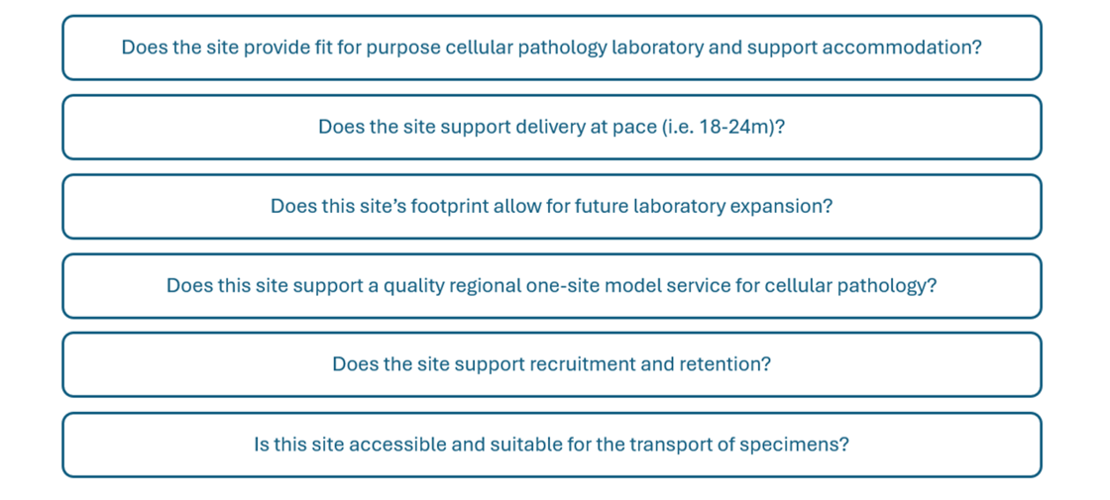

Appendix B - Non-Technical Evaluation Scoring Methodology

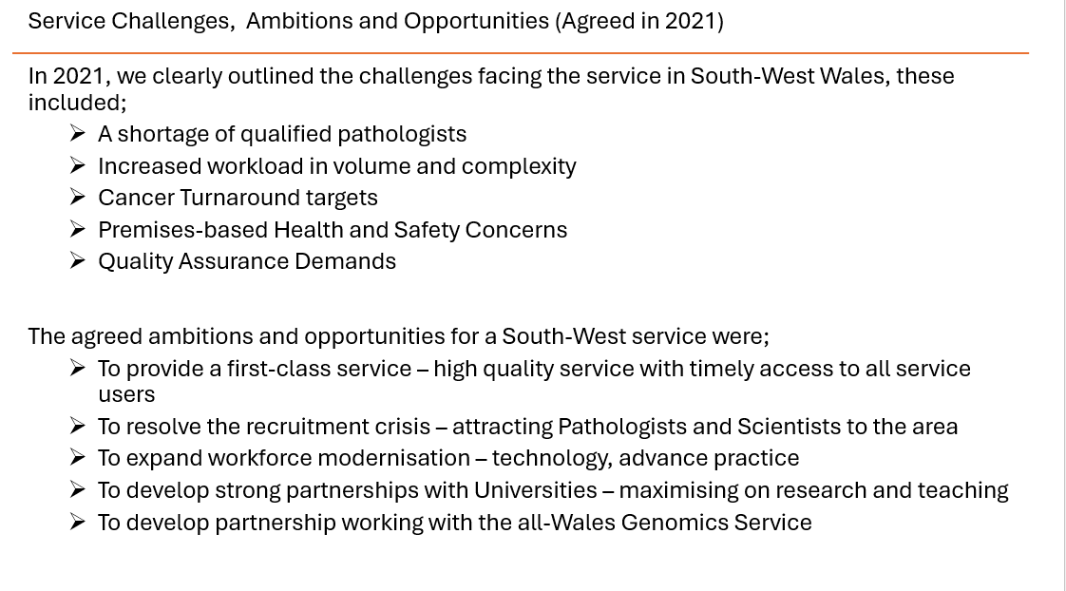
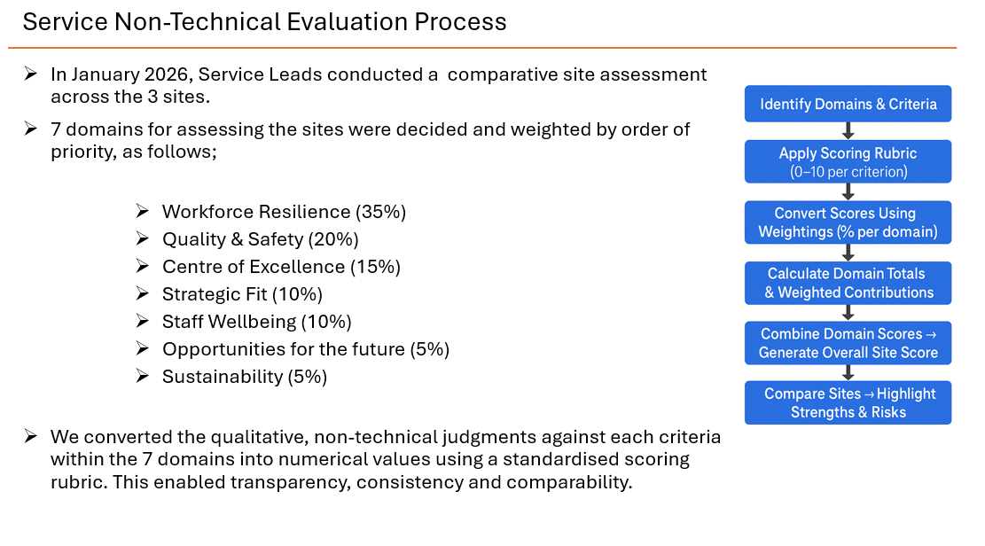

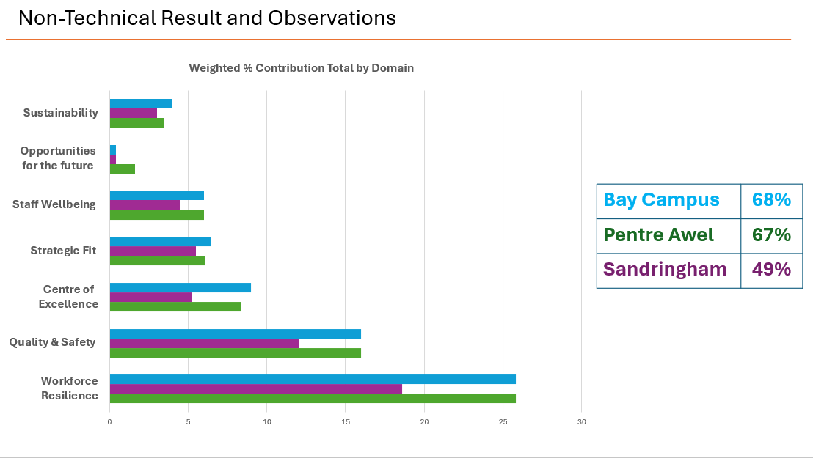

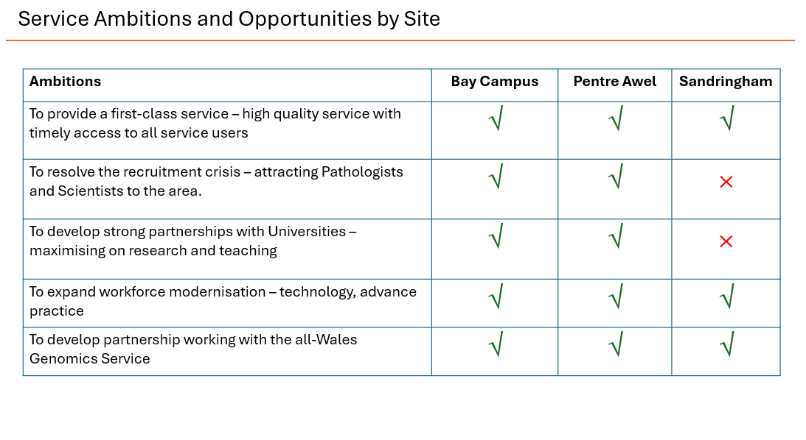

Appendix C – Schedule of Accommodation
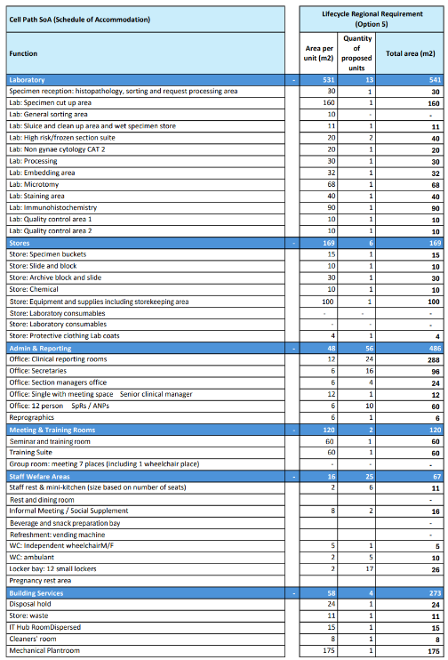

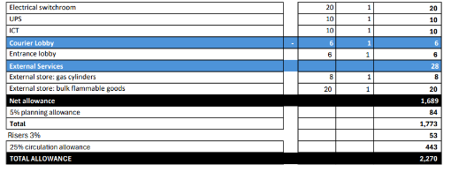

Appendix D – Architects Test for Fit

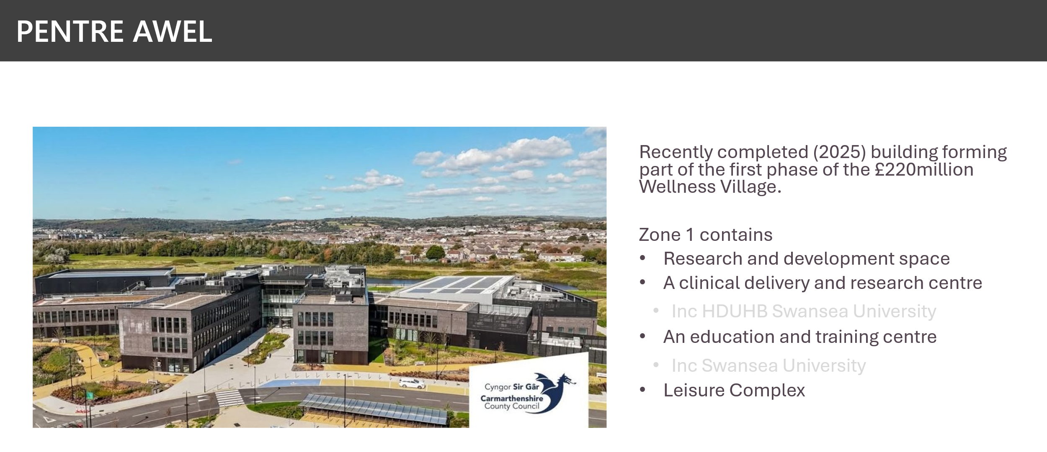

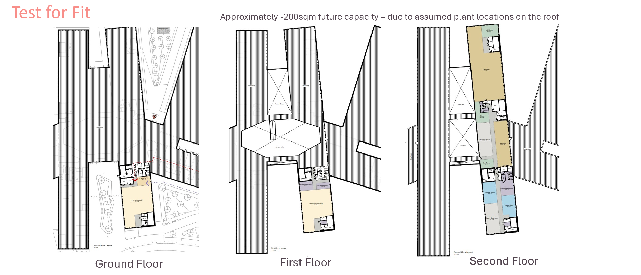

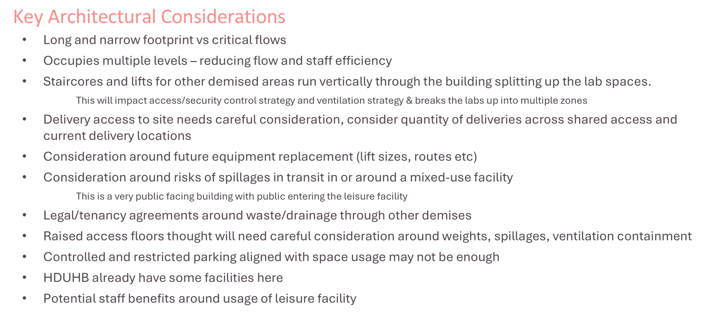

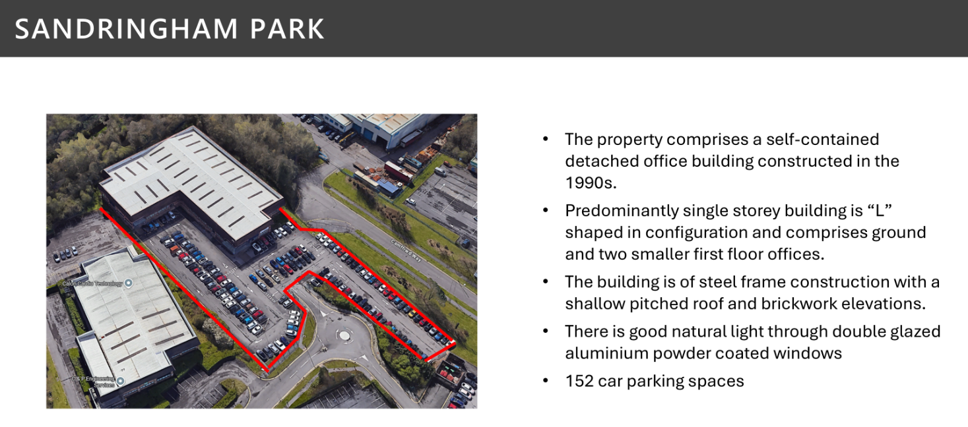

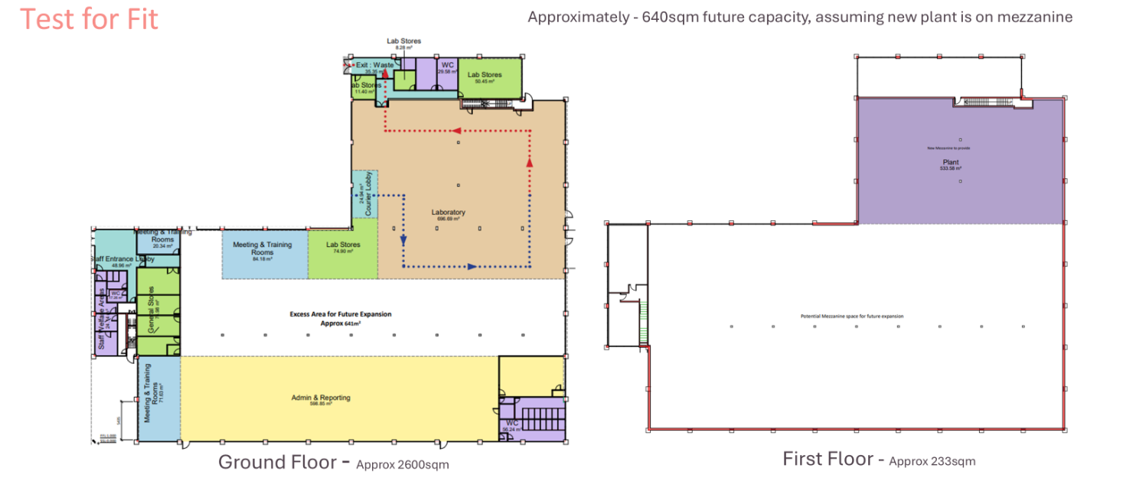

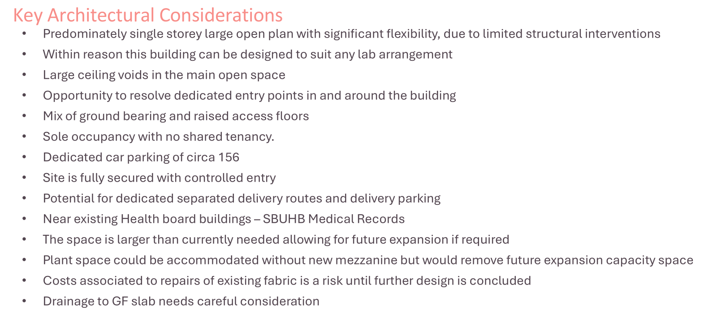

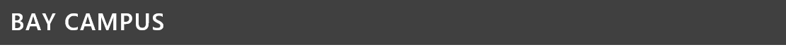
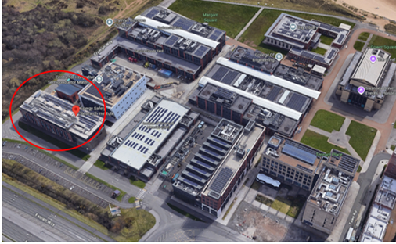 | 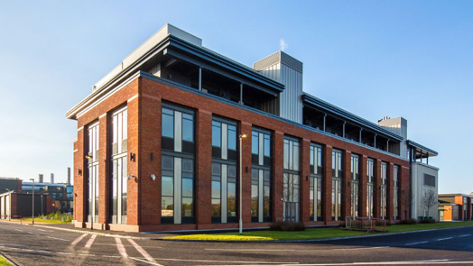
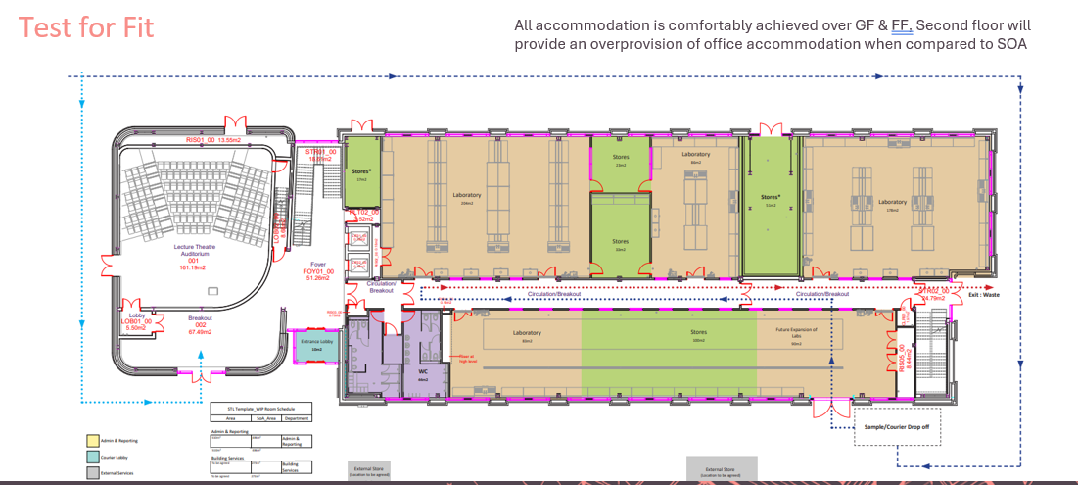

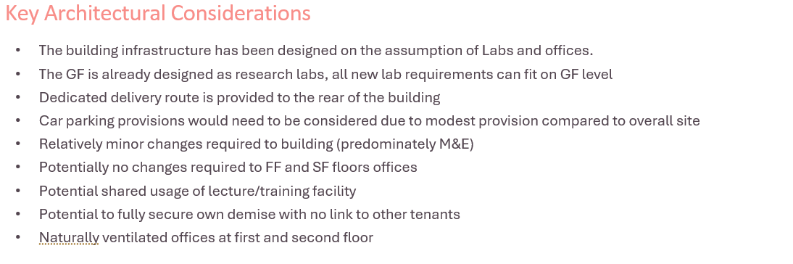

Appendix E – M&E Findings

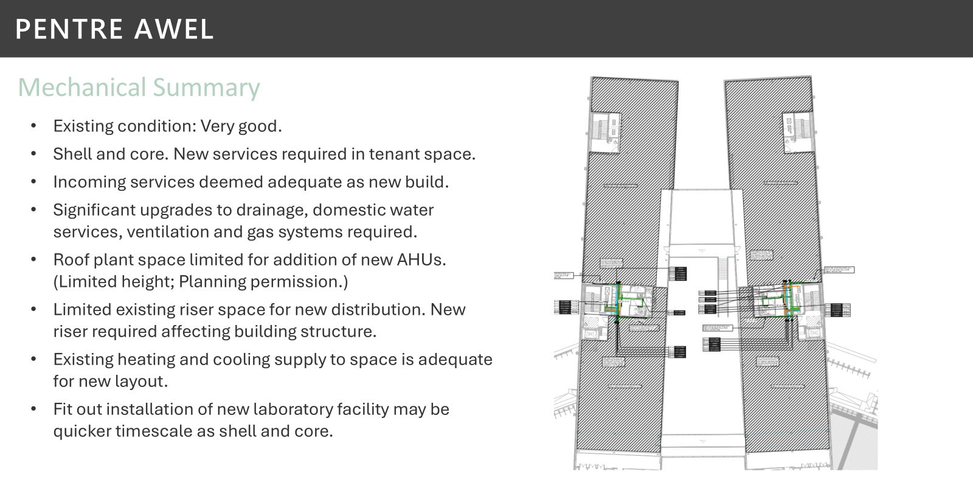
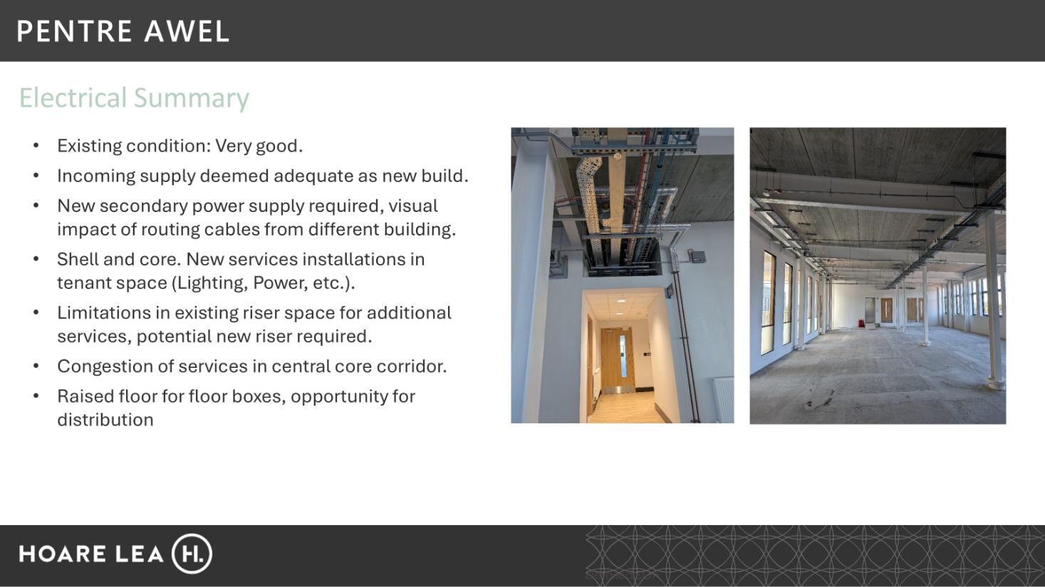

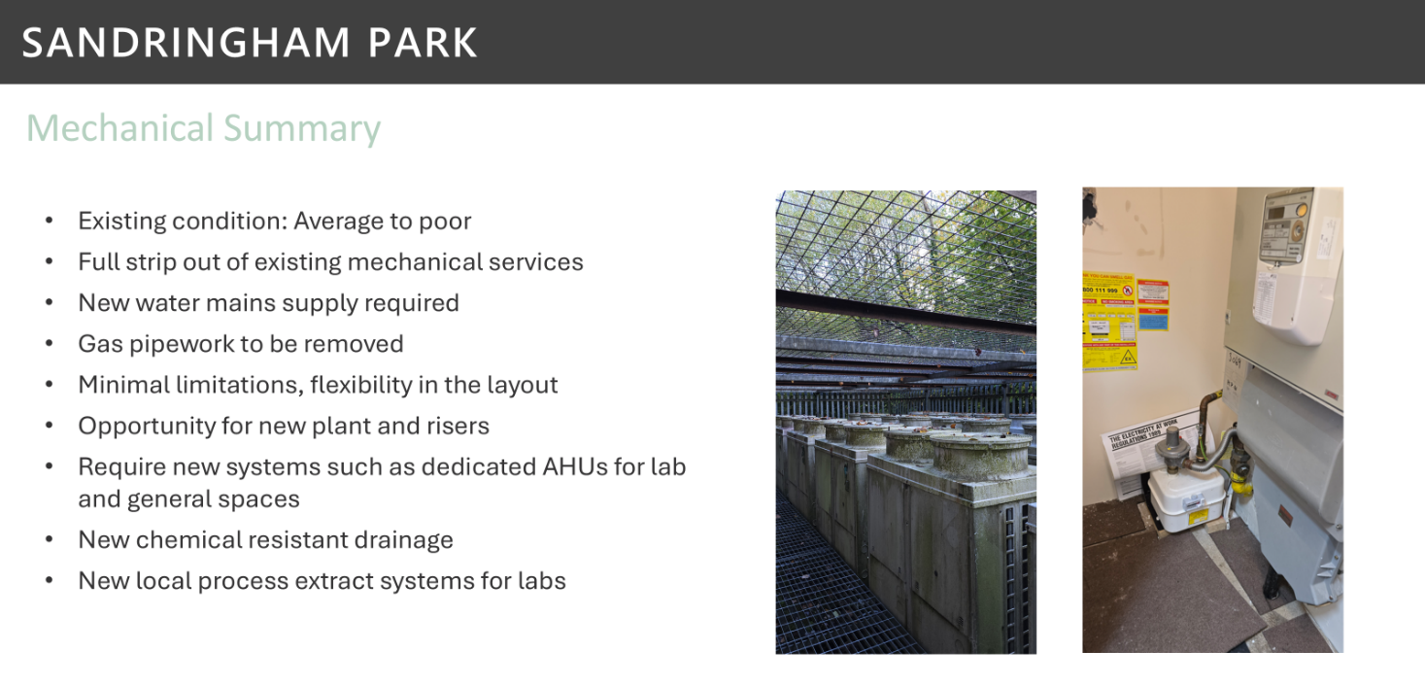
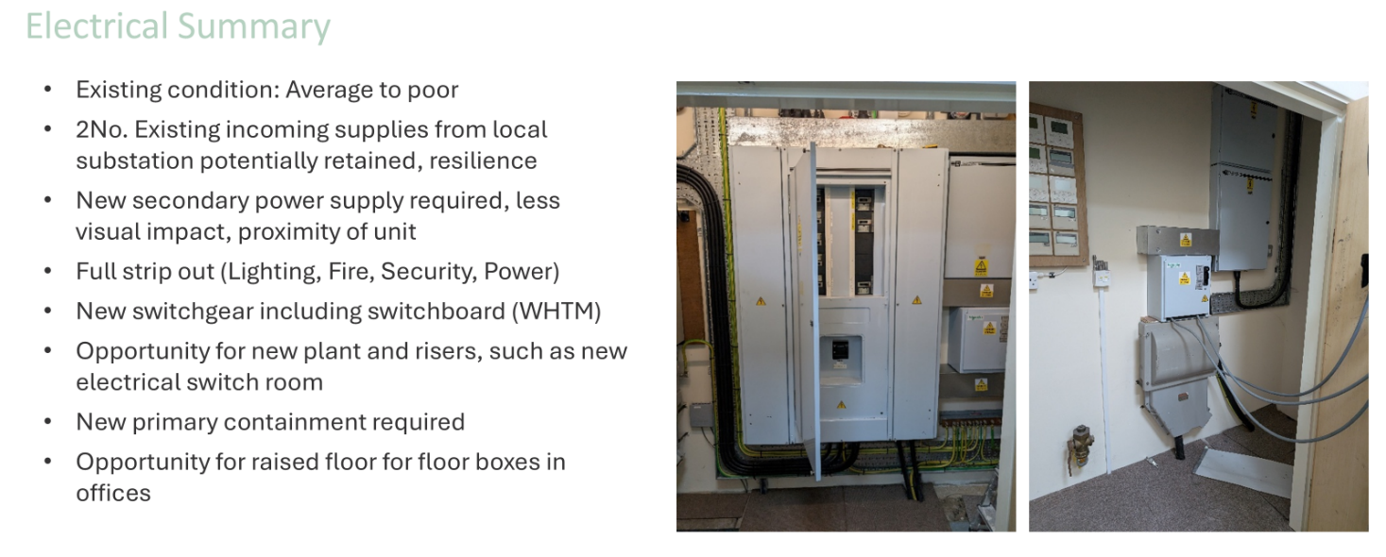

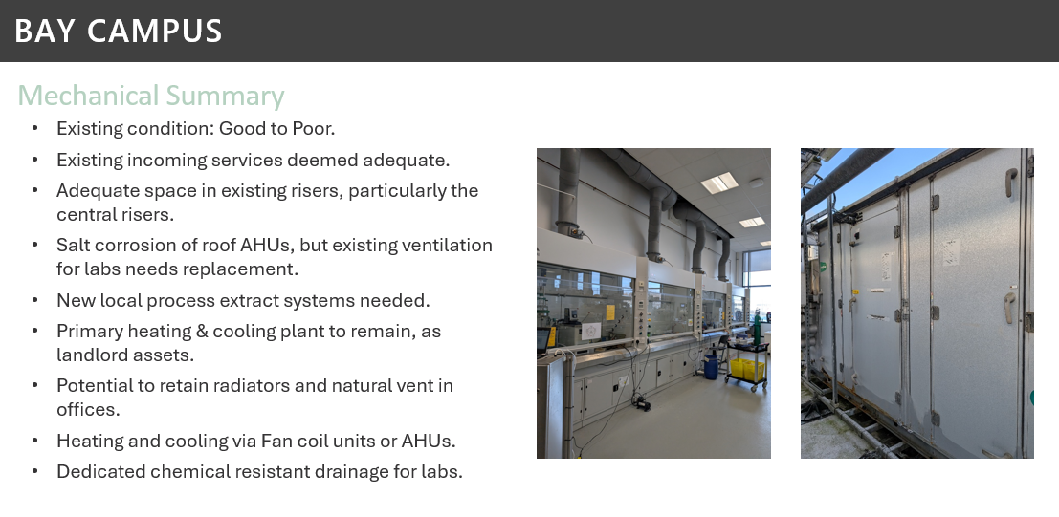
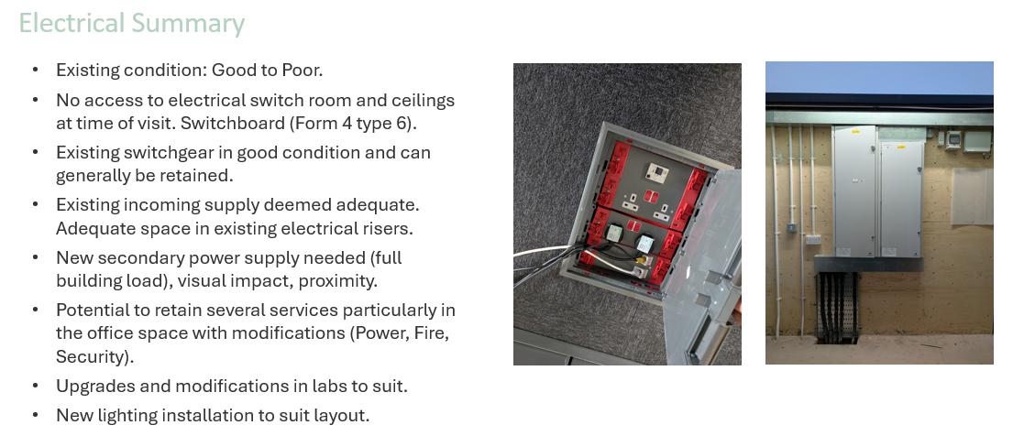

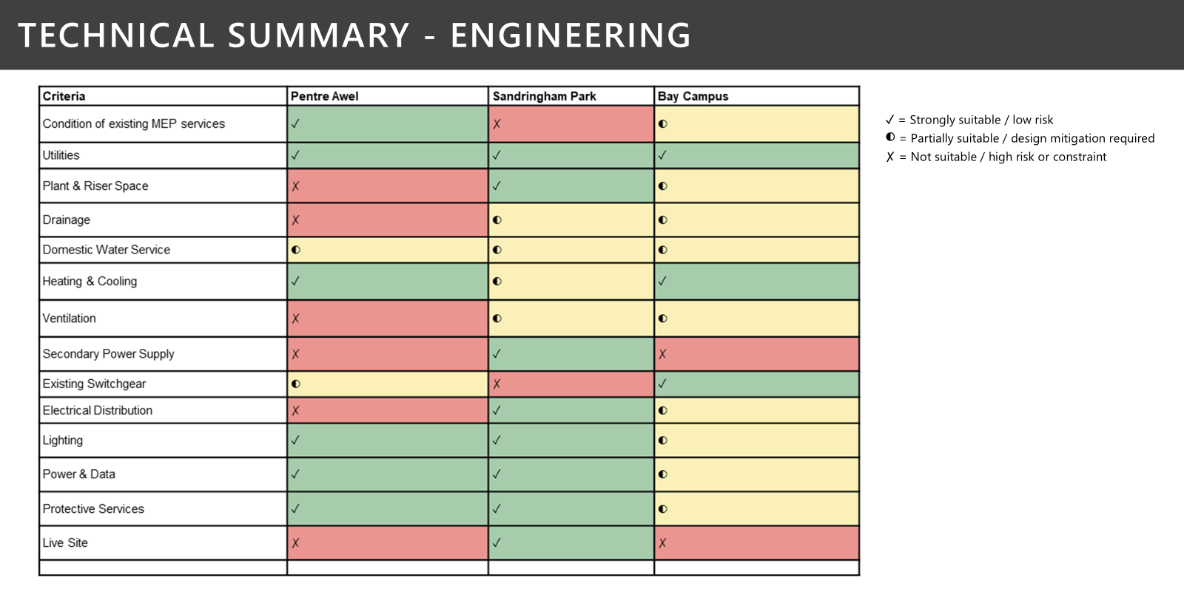

Appendix F – Workshop Agenda

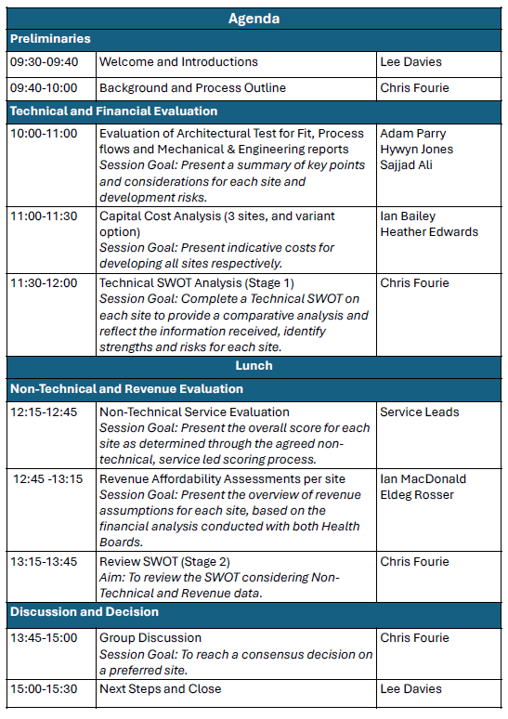

Appendix G – Workshop Attendees

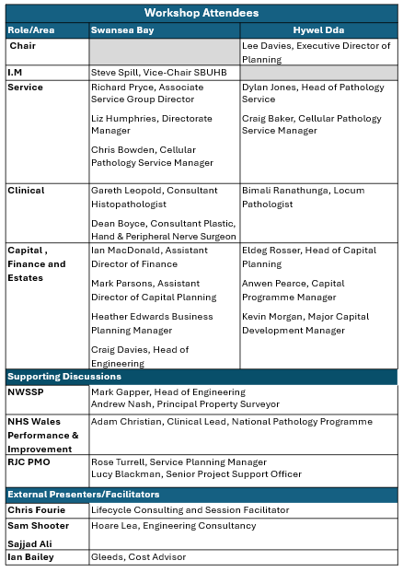

Appendix H – SWOT Analysis

