

Meeting Date | 30th January 2025 |  | Agenda Item |  | 4.2
Name of Meeting | Health Board
Report Title | Financial Report – Month 09 2024/25
Report Author | Samantha Moss, Deputy Director of Finance  Rebecca Hayes, Assistant Director of Finance  Gemma Pearson, Finance Business Partner
Report Sponsor | Darren Griffiths, Executive Director of Finance and Performance
Presented by | Darren Griffiths, Executive Director of Finance and Performance, Acting
Freedom of Information | Open
Purpose of the Report | The report advises the Board of the Health Board’s financial position for Month 09 (December 2024) and sets out the actions being undertaken to improve forecast financial performance.
Key Issues | The report invites the Board to note the detailed analysis of the financial position for Month 09 (December 2024).  The report includes details on the revenue position both in month and Year To Date (YTD) and the forecast year-end revenue position based on current planning assumptions.  The report describes the actions being undertaken to de-risk the financial forecast and improve the outturn position in year, alongside setting out actions for recovery and sustainability of financial performance.  The report invites the Board to note the Cash position, key Balance Sheet movements and the Capital position.
Specific Action Required  (please choose one only) | Information | Discussion | Assurance | Approval
Specific Action Required  (please choose one only) | ☒ | ☐ | ☒ | ☒
Recommendations | Members are asked to: -  - CONSIDER and comment upon the Board’s financial performance for Month 09 2024/25 (Revenue and Capital)  - TAKE ASSURANCE from the actions to ensure delivery of the financial assessment presented to Board on 19th December 2024, with a line of sight to £43.7m, supported by the Recovery & Sustainability Board.  - CONSDER the balance sheet at Month 9.  - CONSIDER the cash forecast at 31st March 2025.  - SUPPORT the position with regard to the risk scores.  - CONSIDER all actions and updates to support the management of the 2024/25 financial position.

FINANCIAL REPORT – MONTH 9

- INTRODUCTION
The report invites the Board to note the detailed analysis of the Month 9 (December 2024) revenue financial position, along with Cash and Capital.

- BACKGROUND
  - The Health Board has two key statutory duties to achieve:

- To submit an Integrated Medium-Term Plan (IMTP) to secure compliance with breakeven over 3 years.

2022/23 3-year plan approved
2023/24 3-year plan submitted
2024/25 3-year plan submitted

The Health Board will fail to meet this in 2024/25 as its plan will not breakeven over 3 years.

- To achieve financial breakeven over a rolling three-year period, which commenced on 1st April 2022 and will end on 31st March 2025.

2022/23 Breakeven position achieved
2023/24 Deficit Control Total £17.1m achieved
2024/25 Deficit Plan £43.7m

The Health Board will fail to achieve this Statutory Duty.

  - Summary of Performance against Key Financial Targets

Financial KPIs: To ensure that net operating costs do not exceed the revenue resource limit set by Welsh Government | Value  £’000
Reported in-month financial position – deficit/(surplus) | 1.457
Reported cumulative financial position – deficit/(surplus) | 47.465
Capital KPIs: To ensure that costs do not exceed the capital resource limit set by Welsh Government | Value  £’000
Reported year to date financial position – deficit/(surplus) | (2.822)
Forecast outturn financial position – deficit/(surplus) (prior to additional allocations) | 0
PSPP Target: To pay a minimum of 95% of all non NHS creditors within 30 days of receipt of goods or a valid invoice | Value  %
Cumulative year to date % of invoices paid within 30 days (by number) – Quarter 3 | 96.1

- FINANCIAL PLAN 2024/25
On the 26th September 2024 the Health Board submitted a revised Financial Assessment for 2024/25. The assessment and accompanying letter summarised a high degree of confidence in the delivery of £64.1m deficit position by the 31st March 2025, with further opportunities of £13.3m giving the Health Board line of sight to £50.8m. Recognising the risks around the delivery of the £50.8m but with a line of sight to £50.8m the forecast remained at £50.1m. In early December 2024 Welsh Government (WG) issued an additional £6.4m of recurrent funding to the Health Board, which has reduced the deficit plan to £43.7m.

On the 19th December 2024 a Special Board meeting was provided with an assessment of the position based on the information available following Month 8 closedown. In summary the financial assessment showed a possible outturn to end March 2025 of £57.9m, with a gap to the deficit plan figure of £14.3m. Full details of the work underway to mitigate the £14.3m were presented to the Board. The list of actions
are summarised in the table below:

Further details on the delivery of the Q4 actions are provided below:

- Part 1 Non- Recurrent Opportunities £25m – in the Financial Assessment at September 2024, £17.1m of potential non-recurrent opportunities had been identified. An assessment post Month 8 identified this could increase to £25.3m, however it is important to note that there were key items of risk that were not available at that point, including the Changes to Permanent Injury Discount Rate. Following Month 9 and some further information being available the latest assessment of the N/R Opportunities is provided in the table below. The categorisation of RAG = Green achieved and being phased into the position; Amber = partly achieved and built into Table A but value remains uncertain ; Red = less certainty than those items classified as Amber. Those highlighted pink in the table reflect changes from the position at 19th December 2024. On LTAs the assessed performance each month is within the positions Month 1-9, but the final level of performance will remain unknown until Month 12. On Prescribing, there are underspends against the budgeted position and, based on data available at Month 9, £0.250m of slippage will be brought into the position from Month 9 – Month 12 to reflect this underspend. However, with potential reductions linked to Cat M in Quarter 4, there is the possibility of further opportunities above this £1m, but this is uncertain. This table will continue to be refined further as information on non-recurrent areas emerge during Q4 and there remains moderate confidence in the delivery of this.

- Part 2 Productivity & Efficiency – details were provided in the Board paper as the majority of this value is attributed to variable pay, aligned to the revised approval approach adopted by the end of December 2024, the realisation of these actions should commence from Month 10 despite the high risk around delivery. Early indications from the workforce systems, which look at WTE usage seem to indicate a reduction in the first 2 weeks of January 2025 however the level of confidence in the delivery of this remains low.

- Part 3 Reducing Capacity – again the details were provided in the Board paper but at Month 9 there has been no significant improvement in the value of forecast savings delivery for 2024/25. Therefore the level of confidence in the delivery of this remains low.

- Of noting is that the first R&S Board meeting of 2025 was held on 10th January 2025. The meeting chaired by the CEO focused on the ongoing delivery of both the actions detailed in the opening table to this letter but also what other areas of savings and run rate reductions could be actioned and achieved by 31st March 2025. If all the actions discussed and identified at the R&S Board on 10th January 2025 are delivered, these could potentially reduce the £14.3m gap reported to Special Board on 19th December 2024 to £12m, although assurance is currently limited. The delivery of this will be discussed further at the next Recovery & Sustainability Board meeting on 22nd January 2025.

- FINANCIAL PERFORMANCE – MONTH 9
The key metrics linked to the revenue position are provided in the information below. Further details on the key drivers to this are provided in Table 2 below and in Appendix 1 of this report.

Summary Revenue Performance

Graph 1 & 2 Summary Revenue & Savings

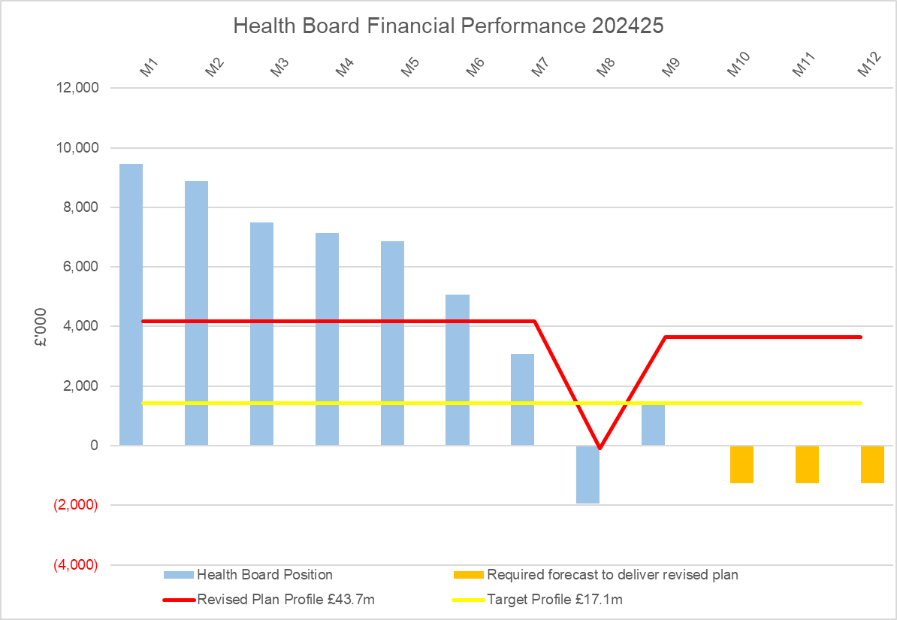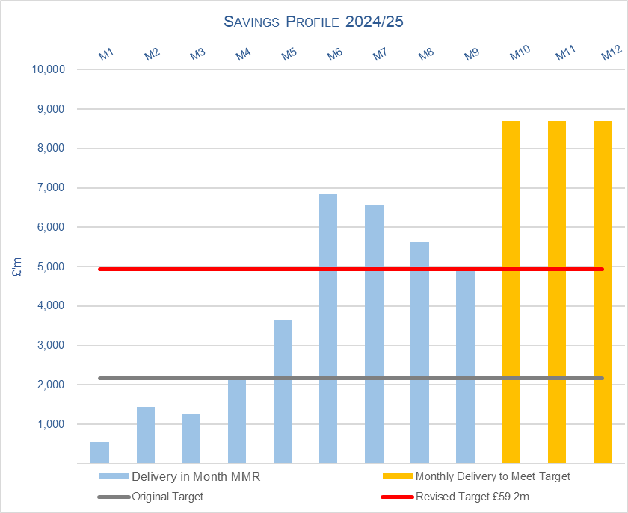

Table 1: Key Revenue Metrics
Target | In Month  £’m | Year To Date (YTD)  £’m
Delivery Against Revenue Resource Limit (RRL) DEFICIT / (SURPLUS) | 1.457 | 47.471
Performance Against Plan DEFICIT / (SURPLUS) | (2.185) | 14.696

In summary, the Month 9 financial position was £1.5m overspent, this was £2.2m better than the revised planned deficit for the month, which is a requirement given the year-to-date deficit of £47.5m exceeds the end of year deficit of £43.7m.

In summary the Month 9 financial position was an overspend of £1.5m. When comparing the in-month performance in Month 9 to Month 8, it should be considered against the normalised Month 8 position of £1.8m; this is because in Month 8 there was a recognition of 8/12^{ths} of the additional recurrent WG funding to reduce the deficit of £6.4m. The Month 9 position is therefore an improvement of £0.3m compared to Month 8, however this is due to the release of central non-recurrent opportunities (part of the £25m) and does not reflect the operational improvements needed within services.

At Month 9 the Health Board (HB) is £47.5m overspent against cumulative deficit plan of £32.8m YTD.

Table 2.1: Key Drivers by Service Area Month 9

Table 2.2: Key Drivers by Service Area YTD @ End Month 9
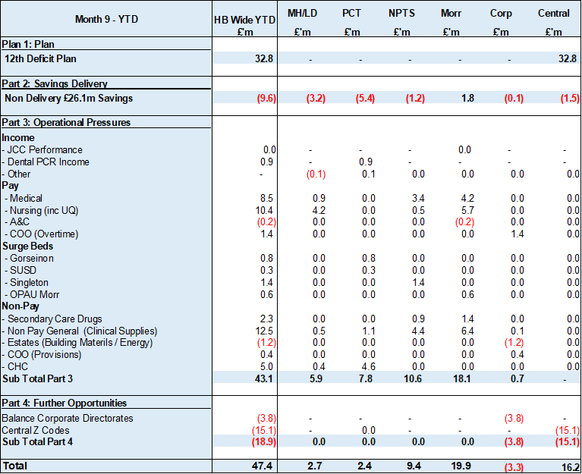

Key points of notes by type spent:
- Income
The Joint Commissioning Committee (JCC) Income as a provider underperformed in-month with reduced activity across most specialities due to capacity issues; the in-month underachievement was £0.1m. The YTD underachievement is £0.4m.

Dental Contract Income underperformed in-month by £0.1m, with an YTD underachievement of £0.9m.

- Pay
The Month 9 pay overspend was £1.2m (Month 8, £0.2m), this deterioration was largely due to an increase in surge bed capacity required, increase staff sickness absence and acuity in Critical Care. The YTD pay pressures are driven by a number of factors including the continuation of staffing surge bed capacity, pressures on services across the organisation and high levels acuity, coupled with high levels of sickness.

- Clinical Consumables
This area continues to be a pressure with an in-month position of £1.8m (Month 8, £2.2m). There are 80+ subjective lines within this category including secondary care drugs but areas seeing most pressures YTD continue to be general consumables (M&SE), laboratory products and implants (which in part will be driven by activity).

- Prescribing
Prescribing is providing a £0.2m underspend in-month following receipt of the latest datasets and there is a YTD underspend of £0.5m. We have at this point received 7 months of PAR data. The Q3 data is below the anticipated levels at this point in the year and therefore some of this anticipated benefit has been recognised in-month. The Pharmacy team are expecting potential further reductions linked to Cat M later in the year; there is the possibility of further opportunities. The position will remain under close review pending further PAR data in the coming months.

- Actions being Taken to Mitigate Position
Through previous Board papers, the Board will be aware of the work the Health Board has undertaken since Month 1, including the development of the Recovery & Sustainability Board.

Despite these actions an assessment post Month 8 highlighted a gap in delivery of the deficit plan of £14.3m. Further actions were detailed in the paper presented to the Board on 19th December 2025, aligned to the work programme of the Recovery & Sustainability Board. With a key focus on variable pay, agency spend controls and a vacancy freeze are currently in place. Each of these areas has executive oversight to assess and manage risk with expectations that consideration of all alternative options to cover workforce gaps have been robustly initiated locally before request to executives for cover.

- KEY AREAS OF NOTE
Further details on specific issues impacting the revenue position are provided in Appendix 1 of this report.

The section below provides an overview of the other issues influencing the delivery of the wider financial position, including Balance Sheet, Cashflow and Capital.
  - Savings

Based on the run rate reduction/savings position the schemes identified for delivery in 2024/25 by service areas are summarised below.

Table 3: All Savings

Table 3 – reflects all opportunities including those identified as red along with pipeline ideas, which total £49.2m. In summary, the table above shows a forecast savings delivery of £49.2m in year, and £40.4m forecast recurrently which includes red schemes and those schemes in progress of being developed. For 2024-25, against a target of £59.2m, this delivers a shortfall of £10m. Recurrently, there is a shortfall of £18.8m, to meet the required £59.2m target.

Table 4: Green & Amber Savings

Table 4 – reflects only those opportunities which are deemed Green and Amber schemes. As a result, the overall total reduces to £48.4m at end of December, which leaves £10.9m to meet the £59.2m 2024/25 target. Recurrently, there is a shortfall of £23.3m to meet the required £59.2m target

  - Capital
The approved Capital Resource Limit (CRL) value issued on 20th December is £47.210m. The approved CRL value includes Discretionary Capital, schemes under the All-Wales Capital Programme and new/renewal IFRS 16 Leases.

Outturn Performance

The forecast outturn shows a balanced position.

The following allocations are classed as risks.
Scheme | £m / Risk Level | Narrative
Burns Unit and Critical Care Expansion, Morriston Hospital | 0.089 / High | As discussed in the CRM on 7th January a scheme reinvestment will be requested.
Diagnostic Equipment – Prior Year | 0.107 / High | As discussed in the CRM on 7th January a scheme reinvestment will be requested.
Diagnostic Equipment – Current Year | 0.316 / High | As discussed in the CRM on 7th January scheme slippage to be managed by the Health Board and advised.

All other schemes are low risk, and any variances are linked to planned contributions from discretionary and in some instances payback of prior year fees.

Capital Disposals

There are two further planned property disposals this year for Phillips Parade and Morriston land with combined expected sale proceeds of £0.650m.

  - Balance Sheet
The key issues in respect of the statement of financial position movements are as follows:

- The inventory value has increased from £11.053m at the end of November 2024 to £11.890m at the end of December 2024, an increase of £0.837m.

- There has been an increase in trade receivables from £281.877m at the end of November 2024 to £303.106m at the end of December 2024, an increase of £21.229m. This is due to an increase within NHS Debtors of £11.267m and WRP (Welsh Risk Pool) Debtors (£11.2m). The WRP Debtor has increased due to the probability of 5 cases increasing (£13m) and 5 cases decreasing (£2.5m).

- The closing December 2024 cash balance of £3.787m is larger than the range of the Health Board target of a cash balance of £2.5m at month end and less than the best practice cash target for Health Board of £6m.

- The trade and other payables figure saw an increase from £235.846m at the end of November 2024 to £245.102m at the end of December 2024, an increase of £9.256m. This relates to increases in NHS and non NHS accruals of expenditure.

- Provisions increased by £10.527m from £213.086m at the end of November 2024 to £223.613m at the end of December 2024. This correlates with the changes in provisions from the monthly Quantums as referred to for Trade receivables.

  - Cash
As at the end of December 2024, the Health Board had a cash balance of £3.787m, which is greater than the Health Board target of a cash balance of £2.5m at month end and less than the best practice cash target for the Health Board of £6m.

Given the cash request to WG, our cash forecast is now showing a cash surplus for end of March 2025 of £1.927m, as detailed in the table below:

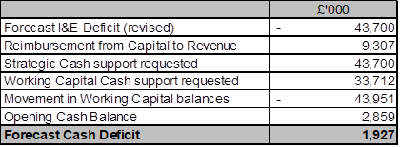

The difference between the £1.927m forecast cash surplus and the Forecast I&E deficit Cash figure, reflects the £9.307m of capital cash to reimburse revenue CRL, the requested Strategic and working capital cash support from WG, and the movement in the working capital balances.

The cash request to WG is as follows, with a revision for the Strategic Cash support in line with a revised forecast financial position: -

- Strategic Cash Support - £43.7m (revised from £50.1m)
- Working Capital Cash Support - £33.7m, detailed below

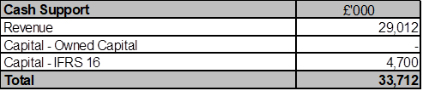

The letter approved by the Board in November 2024 outlined that the Health Board would only require cash support during March 2025, however an updated assessment reported to WG on 14th January 2025, showed that the cash pressure may impact during February 2025 and March 2025. This is a realistic position given that all WG allocations (£39.5m) may not be received prior to March 2025.

Therefore, the timing of receiving WG allocation letters is key because it directly impacts when the Health Board cash position will deteriorate, so an early indication of when the HB can expect to receive outstand allocations has been requested.

The cash flow is updated daily and a full review of the cash forecast is currently being undertaken weekly, to ensure that any changes to our cash requirements, can be communicated in a timely manner to WG.

  - Public Sector Payment Policy (PSPP)
The Health Board achieved the 95% PSPP target the % of Non-NHS Invoices Paid within 30 Days in Quarter 3 with compliance being 96.3% for the quarter, resulting in a YTD compliance of 96.1%.

NHS payment compliance for invoices paid within 30 days was, however, below 95% with the quarterly performance being 85%. The Health Board remains focussed on improving PSPP compliance for NHS invoices and ensuring that performance remains above 95% for Non-NHS invoices.

Further updates will be reported at the end of Quarter 4.

- RISKS (Revenue Income & Expenditure)

Two Board level financial risks:

- Achieving financial plan (HBR92) with the key elements as follows: -

- Risk of delivery of savings quantum
- Risk of operational overspend being in excess of funding available agreed via the Financial Plan
- Risk of commitment of reserves (e.g. NICE) being above reserves available.
- Risk of achieving the actions outlined in the 2024/25 Landing Plan.

Based on the financial performance at Month 9, it is proposed that the Health Board Corporate Risk Register retain the existing risk score to 25 given YTD variance from the revised deficit plan of £43.7m. This will be reviewed through the remainder of Q4 to assess delivery of the revised financial assessment and the associated actions/savings to support the revised assessment.

- Availability of capital (HBR93). This risk was re-opened in 2022/23 given the reduction in discretionary capital allocation. Whilst work is underway to manage schemes to reduce commitments in 2024/25 and to produce a balanced plan, the risk varies during the year as more details on schemes emerge and potential slippage funding is made available by Welsh Government. A paper was received by PFC in December 2024 to consider the current capital position. This paper described a balanced position. Whilst the delivery of the balanced position is reliant on a large number of actions being delivered, the plan has evolved to have less risk in it given the success of bids made for substantial sums of capital being received in year.

There is no change to this assessment at the end of Month 9 and it is therefore proposed that the score remains at 12 to reflect major consequence and possible likelihood at this time and aligned to that reported to PFC in December 2024.

- RECOMMENDATIONS
Members are asked to: -
  - CONSIDER and comment upon the Board’s financial performance for Month 09 2024/25 (Revenue and Capital)
  - TAKE ASSURANCE from the actions to ensure delivery of the financial assessment presented to Board on 19th December 2024, with a line of sight to £43.7m, supported by the Recovery & Sustainability Board.
  - CONSDER the balance sheet at Month 9.
  - CONSIDER the cash forecast at 31st March 2025.
  - SUPPORT the position with regard to the risk scores.
  - CONSIDER all actions and updates to support the management of the 2024/25 financial position.

Governance and Assurance

Link to Enabling Objectives  (please choose) | Supporting better health and wellbeing by actively promoting and empowering people to live well in resilient communities
Link to Enabling Objectives  (please choose) | Partnerships for Improving Health and Wellbeing |  | ☐
Link to Enabling Objectives  (please choose) | Co-Production and Health Literacy |  | ☐
Link to Enabling Objectives  (please choose) | Digitally Enabled Health and Wellbeing |  | ☐
Link to Enabling Objectives  (please choose) | Deliver better care through excellent health and care services achieving the outcomes that matter most to people
Link to Enabling Objectives  (please choose) | Best Value Outcomes and High-Quality Care |  | ☒
Link to Enabling Objectives  (please choose) | Partnerships for Care |  | ☒
Link to Enabling Objectives  (please choose) | Excellent Staff |  | ☐
Link to Enabling Objectives  (please choose) | Digitally Enabled Care |  | ☐
Link to Enabling Objectives  (please choose) | Outstanding Research, Innovation, Education and Learning |  | ☐
Health and Care Standards
(please choose) | Staying Healthy |  | ☐
(please choose) | Safe Care |  | ☐
(please choose) | Effective Care |  | ☐
(please choose) | Dignified Care |  | ☐
(please choose) | Timely Care |  | ☐
(please choose) | Individual Care |  | ☐
(please choose) | Staff and Resources |  | ☒
Quality, Safety and Patient Experience
Financial Governance supports quality, safety, and patient experience.

Financial Implications
The Board is reporting a forecast year-end deficit financial outturn.

Legal Implications (including equality and diversity assessment)
No implications

Staffing Implications
No implications

Long Term Implications (including the impact of the Well-being of Future Generations (Wales) Act 2015)
No implications
Report History |  | Updates on the financial position are provided at every meeting.
Appendices |  | Appendix 1 – Variances by Area and Type of Spend

APPENDIX 1 – FURTHER DETAIL ON VARIANCES BY TYPE OF SPEND

- Overview Financial Position

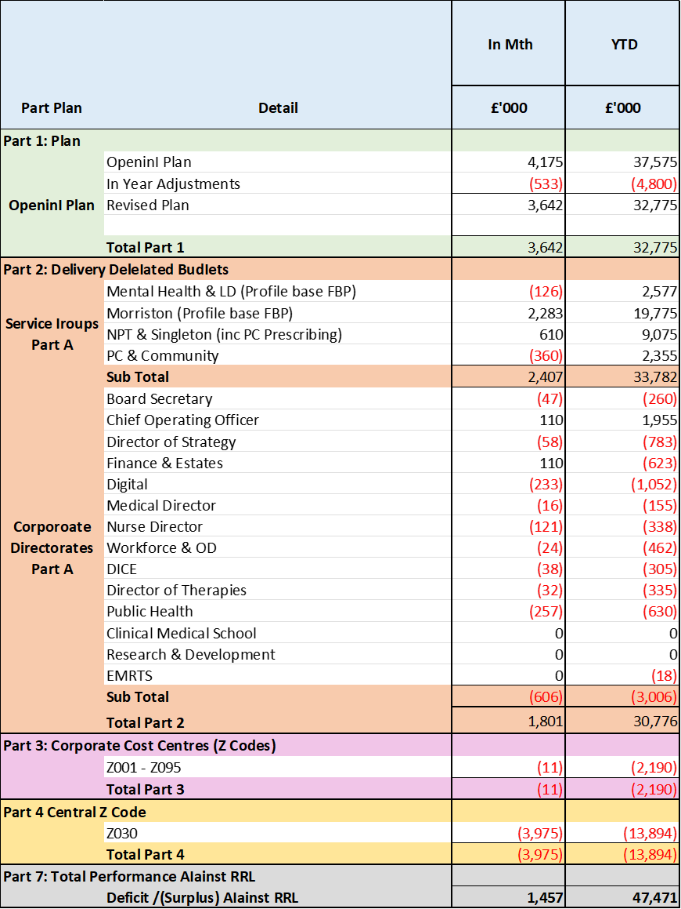

- Overview of Income

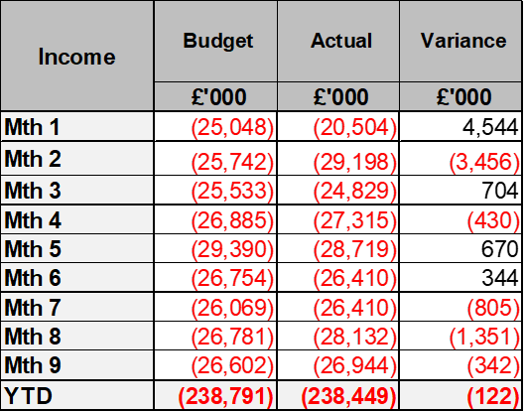

A correction was made in Month 2 to reflect the subjective being used in R&D between Income & Non-Pay totalling £3.9m

- Overview of Pay Variances

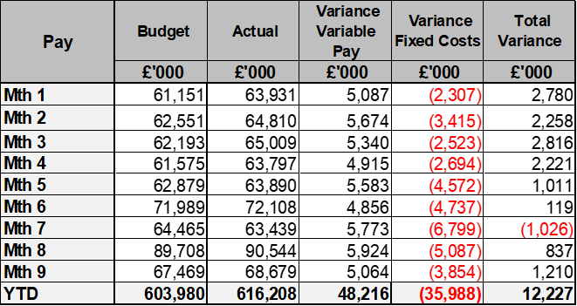

Month 8 included the year to date impact of the 2024/25 Pay Awards for both Agenda for Change (A4C) and Medical & Dental staff members. This is assumed to be fully funded by WG, with the exception of uplifts for Bank staff and for Overtime as these are types of variable pay.

Variable Pay by Quarter and type

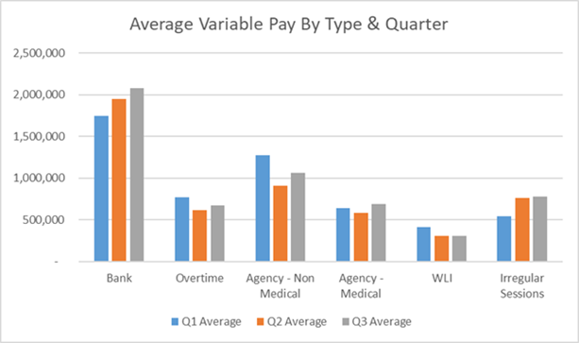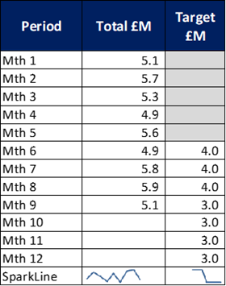

- Overview Non-Pay

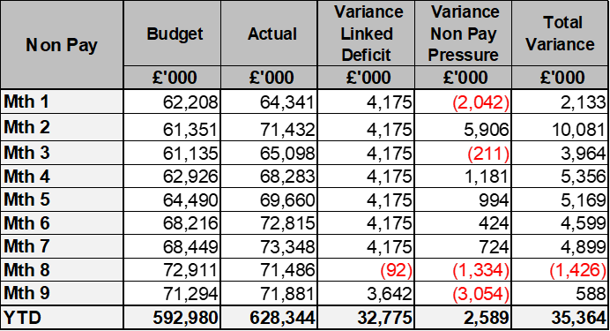

A correction was made in Month 2 to reflect the subjective being used in R&D between Income & Non-Pay totalling £3.9m

Below are further details on the key areas of non-pay:

  - Energy Forecast
Energy costs are procured via an All Wales contract, with NWSSP centrally co-ordinating forecast associated with this contract. An update was received on 10th June 2024 from NWSSP regarding the 2024/25 forecast which has been validated and included from Month 3. There has been no national changes to the forecast since Month 3 and the local team continues to work with Finance colleagues to assess the position.

  - CHC
The overall variance against budget for CHC is £0.2m overspent in-month. An analysis of actual expenditure and patient numbers for 2024/25, along with the average values from 2024/25 is provided in table below.

CHC Analysis by Month

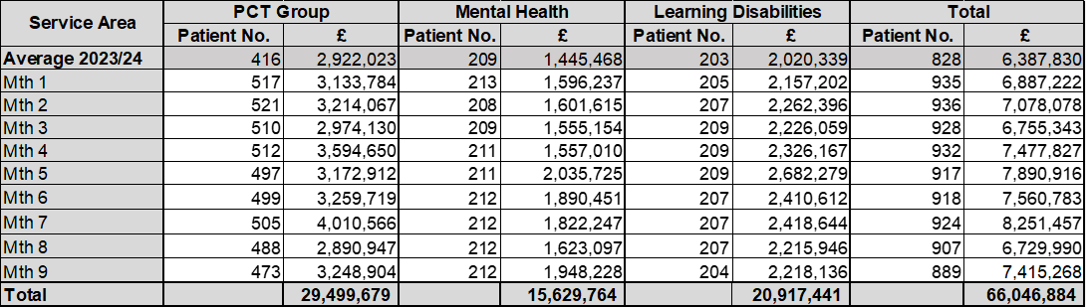

Please note:
- The above numbers include Domiciliary care cases.
- PCT Group does not include the Singleton/NPT element. The NPTS element which covers Children and Young People CHC patients is provided internally by the Health Board and as such is part of the wider NPTS position and is not recorded in the ledger as PCT/MH/LD CHC is recorded.

  - COVID Public Enquiry
The costs for this are allocated to a dedicated Cost Centre (6F25). A breakdown of spend YTD is provided below:

  - Maternity Review
In the 2024/25 Financial Plan £0.7m was set aside to support the Maternity Review. In August to improve the oversight of this area a dedicated Cost Centre was established (6F34). A breakdown of spend YTD as per the financial ledger is provided below:

  - Z Codes (Section 1,3-4 Table Point 1 Appendix 1)
The narrative below groups together the key elements of the Z codes detailed in Point 1 of this appendix.

- Contracting: SLA /LTA performance: JCC (previously WHSSC), LTA and SLA contract income and expenditure are transacted within this area and financial performance reported. NICE approved high-cost drugs and associated LTA’s are also transacted and monitored against targets set. In addition to this, non-contracted activity income in relation to English foundation trusts invoiced on a quarterly basis are reported.

- Capital: The Finance Capital Team manage a number of cost centres covering the PFI, IFRS16 and Depreciation charges for assets both owned and donated are transacted here.

- RRL and Central Reserves: The WG funding received at the start of the year is tracked within this area along with the £50.1m deficit. Any anticipated allocations in year are also transaction through these codes. Other HB wide funding received from HEIW and SIFT is also captured in here. All central reserves remain within the Z cost centres and details of these are provided in Appendix 2.

- Corporate income and expenditure. Any income and expenditure that is not service group specific is transacted and reported through a number of corporate Z cost centres, examples include, payroll and pension costs, VAT recovery, losses and receipts in relation to funding from Welsh Risk Pool, overseas visitors income and Road Traffic Accident income.

  - LTA Values & Forecast performance
The table below is based on Month 8 activity undertaken by other Health Boards and Trusts for Swansea Bay residents (SBU Commissioner) and activity undertaken by Swansea Bay for residents of other Health Boards. The final impact of this will not be known until Month 12 and so a final update will be provided as part of the Month 12 reporting.

