_
Report Date | 25th July 2024 |  | Agenda Item | 3.6
Report Title | Integrated Performance Report
Report Author | Charlotte Angell, Health Board Performance Support Officer
Report Sponsor | Darren Griffiths, Executive Director of Finance and Performance, Acting Deputy Chief Executive
Presented by | Darren Griffiths, Executive Director of Finance and Performance, Acting Deputy Chief Executive
Freedom of Information | Open
Purpose of the Report | The purpose of this report is to provide an update on the current performance of the Health Board at the end of the most recent reporting period (June 2024). It covers delivery against key local performance measures as well as the national measures outlined in the 2024/25 NHS Wales Performance Framework.
Key Issues | The Integrated Performance Report is a routine report that provides an overview of how the Health Board is performing against the National Delivery measures and key local quality and safety measures.  The format of the May 2024 Board report has changed to provide greater focus on Targeted Intervention (TI) escalation and outcomes. There are additional charts to highlight this.  Key high level issues to highlight this month are as follows: -  Unscheduled Care  - Performance against the 4-hour access has reduced by 0.5% to 77.6% in June 2024.  - Performance against the 12-hour wait has improved in June 2024 to 980 from 1,115.  - In June 2024, there were 590 ambulance to hospital handovers taking over 1 hour; this is a decrease of 105 compared with the previous month.  - In June 2024, 2,890 ambulance hours were lost in handover delays, compared with 3,158 in the previous month.  - There was a decrease in the average number of patients who were deemed clinically optimised in June 2024 (Pathway of care delays). The average number of clinically optimised patients decreased from 252 in the previous month to 242 in June 2024.  Planned Care  - OP waits remain under the 52 week Ministerial target level in June 2024, a position sustained since October 2023.  - At the end of June 2024, there were 1,477 patients waiting over 104 weeks for treatment an improvement of 102 from the previous month.  - In June 2024 there were just 4 patients waiting over 14 weeks for a therapy service, 2 in dietetics and 2 in Speech and Language therapy.  - In June 2024, there was a decrease in the number of patients waiting over 8 weeks for specified diagnostics. The position improved from 3,576 to 3,493. The breakdown is as follows: -  - Endoscopy= 2,963  - Cardiac tests= 482  - Other Diagnostics = 48  Cancer  - The final Single Cancer Pathway (SCP) measure of patients receiving definitive treatment in May 2024 was 57%, which is 1% higher than the figure reported in April 2024 (this measure is always reported a month in arrears due to data validation).  - 229 patients were waiting in excess of 63 days at the end of May 2024.  Mental Health  - Performance against the Mental Health Measures continues to be maintained. However, one of the Welsh Government targets was not achieved in April 2024.  - In May 2024, 64% of patients waited less than 26 weeks for Psychological Therapy. This was below the national target of 95%.  Child and Adolescent Mental Health Services (CAMHS)  - Access times for crisis performance has been maintained at 100% in March 2024.  - Neurodevelopmental Disorders (NDD) access times within 26 weeks continues to be a challenge, the performance showed a modest improvement of 3% to 29% in May 2024.  - Note: S-CAMHS now included with P-CAMHS measure. Access to therapeutic interventions remains strong at 98% within 28 days, however access to assessment remains a challenge at 41% (within 28 days) in month (an improvement of 18% on the previous month.
Specific Action Required | Information | Discussion | Assurance | Approval
Recommendations | Members are asked to:  - CONSIDER the Health Board performance against key measures and targets.  - SUPPORT the development of additional reports for Primary and Community Care Services which will be developed over the summer and received at the November 2024 meeting.

INTEGRATED PERFORMANCE REPORT

- INTRODUCTION
The purpose of this report is to provide an update on current performance of the Health Board at the end of the most recent reporting window in delivering key performance measures outlined in the NHS Wales Delivery Framework and local quality & safety measures.

- BACKGROUND
The NHS Wales Delivery Framework sets out measures under the quadruple aims which the performance of the Health Board is measured. The aims within the NHS Delivery Framework are:

- Quadruple Aim 1: People in Wales have improved health and well-being with better prevention and self-management
- Quadruple Aim 2: People in Wales have better quality and more accessible health and social care services, enabled by digital and supported by engagement
- Quadruple Aim 3: The health and social care workforce in Wales is motivated and sustainable
- Quadruple Aim 4: Wales has a higher value health and social care system that has demonstrated rapid improvement and innovation, enabled by data and focused on outcomes

In recent years, performance management against the Performance Framework targets has been undertaken by reviewing the previous months’ performance, to reduce the reporting function during the COVID-19 pandemic. Welsh Government have now deemed it appropriate to move away from reporting performance against the ‘Quadrants of Harm’ and focus will return to providing comprehensive performance updates in line with the All-Wales Performance Management Framework 2024/25.

- GOVERNANCE AND RISK ISSUES
Appendix 1 of this report provides an overview of how the Health Board is performing against the National Delivery measures and key local measures. Mitigating actions are listed where performance is not compliant with national or local targets as well as highlighting both short term and long terms risks to delivery.

- FINANCIAL IMPLICATIONS
At this stage in the financial year there are no direct impacts on the Health Board’s financial bottom line resulting from the performance reported herein.

- RECOMMENDATION:
Members are asked to:
  - CONSIDER the Health Board performance against key measures and targets.
  - SUPPORT the development of additional reports for Primary and Community Care Services which will be developed over the summer and received at the November 2024 meeting.

Governance and Assurance
Link to Enabling Objectives  (please choose) | Supporting better health and wellbeing by actively promoting and empowering people to live well in resilient communities
Link to Enabling Objectives  (please choose) | Partnerships for Improving Health and Wellbeing |  | ☒
Link to Enabling Objectives  (please choose) | Co-Production and Health Literacy |  | ☒
Link to Enabling Objectives  (please choose) | Digitally Enabled Health and Wellbeing |  | ☒
Link to Enabling Objectives  (please choose) | Deliver better care through excellent health and care services achieving the outcomes that matter most to people
Link to Enabling Objectives  (please choose) | Best Value Outcomes and High Quality Care |  | ☒
Link to Enabling Objectives  (please choose) | Partnerships for Care |  | ☒
Link to Enabling Objectives  (please choose) | Excellent Staff |  | ☒
Link to Enabling Objectives  (please choose) | Digitally Enabled Care |  | ☒
Link to Enabling Objectives  (please choose) | Outstanding Research, Innovation, Education and Learning |  | ☒
Health and Care Standards
(please choose) | Staying Healthy |  | ☒
(please choose) | Safe Care |  | ☒
(please choose) | Effective Care |  | ☒
(please choose) | Dignified Care |  | ☒
(please choose) | Timely Care |  | ☒
(please choose) | Individual Care |  | ☒
(please choose) | Staff and Resources |  | ☒
Quality, Safety and Patient Experience
The performance report outlines performance over the domains of quality and safety and patient experience, and outlines areas and actions for improvement. Quality, safety and patient experience are central principles underpinning the National Delivery Framework and this report is aligned to the domains within that framework.

There are no directly related Equality and Diversity implications as a result of this report.
Financial Implications
At this stage in the financial year there are no direct impacts on the Health Board’s financial bottom line resulting from the performance reported herein.

Legal Implications (including equality and diversity assessment)
A number of indicators monitor progress in relation to legislation, such as the Mental Health Measure.
Staffing Implications
A number of indicators monitor progress in relation to Workforce, such as Sickness and Personal Development Review rates. Specific issues relating to staffing are also addressed individually in this report.
Long Term Implications (including the impact of the Well-being of Future Generations (Wales) Act 2015)
The ‘5 Ways of Working’ are demonstrated in the report as follows:
- Long term – Actions within this report are both long and short term in order to balance the immediate service issues with long term objectives.
- Prevention – the NHS Wales Delivery framework provides a measurable mechanism to evidence how the NHS is positively influencing the health and well-being of the citizens of Wales with a particular focus upon maximising people’s physical and mental well-being.
- Integration – this integrated performance report brings together key performance measures across the seven domains of the NHS Wales Delivery Framework, which identify the priority areas that patients, clinicians and stakeholders wanted the NHS to be measured against. The framework covers a wide spectrum of measures that are aligned with the Well-being of Future Generations (Wales) Act 2015.
- Collaboration – in order to manage performance, the Corporate Functions within the Health Board liaise with leads from the Service Groups as well as key individuals from partner organisations including the Local Authorities, Welsh Ambulance Services Trust, Public Health Wales and external Health Boards.
- Involvement – Corporate and Service Group leads are key in identifying performance issues and identifying actions to take forward.
Report History |  | The last iteration of the Integrated Performance Report was presented to Performance & Finance Committee in October 2023. This is a routine monthly report.
Appendices |  | Appendix 1: Integrated Performance Report





Appendix 1- Integrated Performance Report
July 2024


CONTENTS PAGE
 | Page number(s):
- TARGETED INTERVENTION METRICS PERFORMANCE  - Unscheduled Care  - Planned Care and Cancer  - CAMHS  - Infection Control | 11-21  12-14  15-18  19  20-21
- Updates on Key Service Areas  - Covid  - Unscheduled care  - Critical Care  - Clinically Optimised  - Elective Procedures  - Healthcare Acquired Infections  - Planned Care  - Diagnostics  - Therapies  - Cancer  - Follow-up  - Stroke  - Adult Mental Health  - Child and Adolescent Mental Health | 22-45  23  24-29  30  31  31  32-34  25-38  39  39  40-41  42  43  44  45
- NHS Delievery Framework Measures & Ministerial Priority Trajectories  - Fractured Neck of femur  - Pressure Ulcers  - Inpatient Falls  - Nationally Reportable incidents  - Discharge Summaries  - Crude Mortality  - Workforce  - Theatre Efficiency  - Patient Experience  - Complaints  - Finance | 46-55  47-48  49  49  50  Page number(s):  51  51  52  53  54  55  56-58
- Table of All Measures  - Harm From Covid  - Unscheduled Care Overview  - Primary Care & Community Overview  - Planned Care Overview  - Vaccinations & Immunisations  - Mental Health Overview | 59-65  60  61  62  63  64  65
- APPENDIX 1: INTEGRATED PERFORMANCE DASHBOARD | 66-69

- TARGETED INTERVENTION METRICS PERFORMANCE

URGENT AND EMERGENCY CARE
- Ambulance handovers over 1 hour  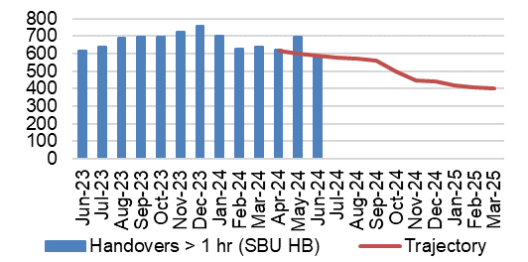  - A&E waits over 12 hours  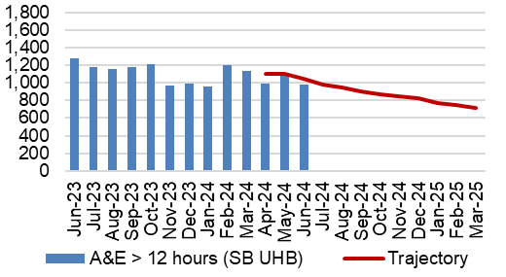  - Median time from arrival to assessment within 60 mins  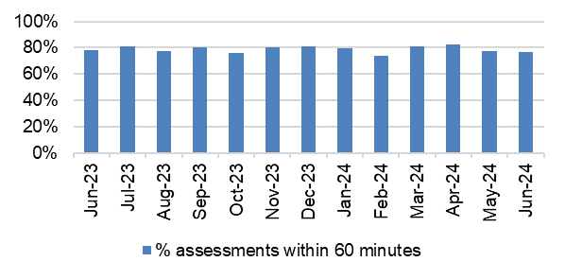  - Continuing reduction in pathway of care delays  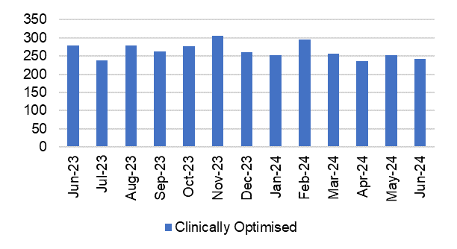  - Lost Ambulance Hours Total  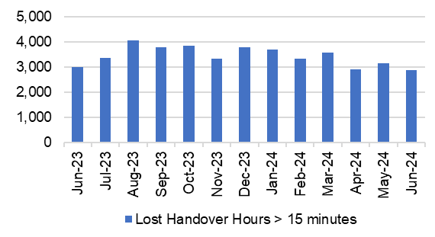  - Lost Ambulance Hours over 1 hour  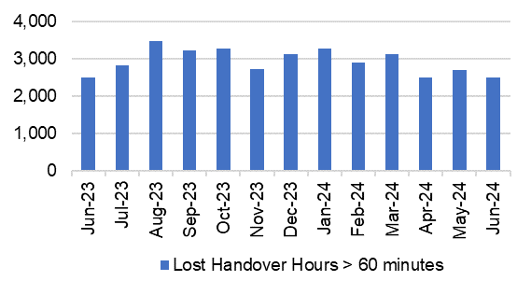 | - The number ambulance handovers over 1 hour has seen a reduction in June 2024. The number of handovers over 1 hour decreased from 695 in May 2024 to 590 in June 2024, which is in line with the outlined trajectory.  - Performance against the 12-hour wait has improved in-month and is currently performing slightly below the outlined trajectory. The number of patients waiting over 12-hours in the Emergency Department reduced to 980 in June 2024, from 1,115 in May 2024.  - In June 2024 76.81% of patients received their first assessment within 60 minutes of their arrival at the Emergency Department. This is a reduction of 0.7% on the figure reported in May 2024 (77.53%).  - There was a reduction in the average number of patients who were deemed clinically optimised in June 2024. The average number of clinically optimised patients decreased from 252 in May 2024 to 242 in June 2024.  - The ambulance handover lost hours rate has seen a reduction in June 2024. The ambulance handover lost hours decreased from 3,158 in May 2024 to 2,890 in June 2024.  - There has been a reduction in the number of lost ambulance hours over 1 hour in June 2024. There were 2500 lost hours over 1 hour in June 2024 which is a reduction of 194 compared with 2694 in May 2024.
PLANNED CARE & CANCER
- Single Cancer Pathway  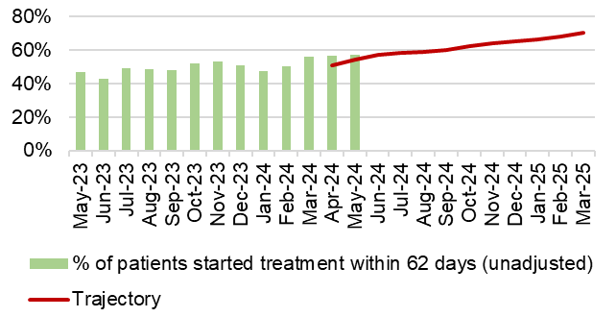  - Outpatients waiting over 52 weeks  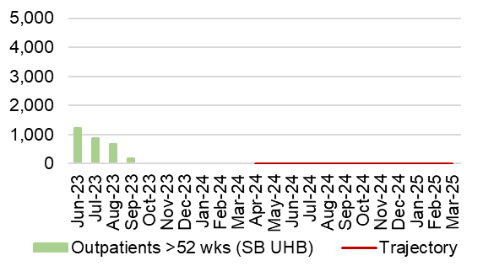  - 104 week waits – all pathways  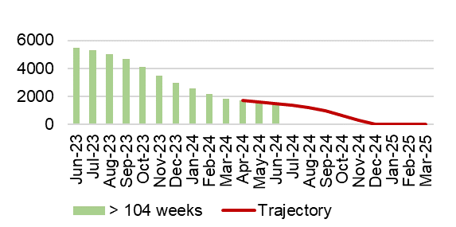  - % of patients waiting under 52 weeks (all pathways)  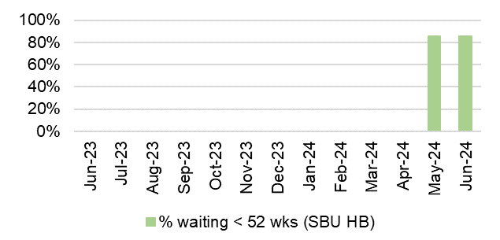  - Delayed follow ups over 100%  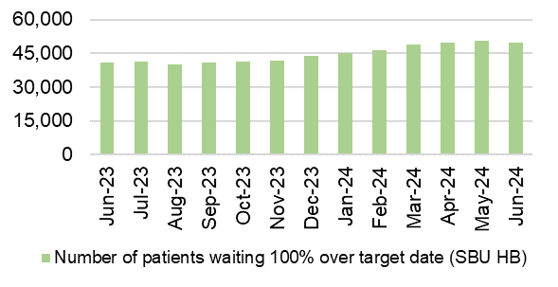  - R1 Ophthalmology  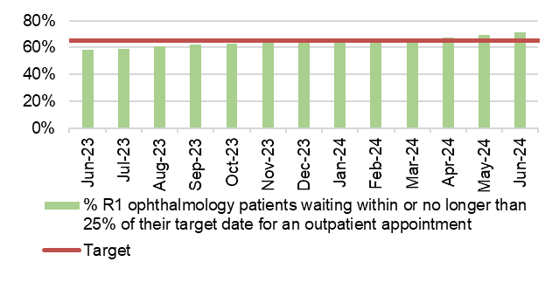  - Percentage of Patients waiting 8 weeks for a diagnostic test  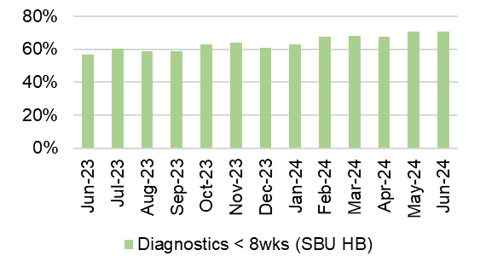  - Patients waiting 14 weeks for therapy services  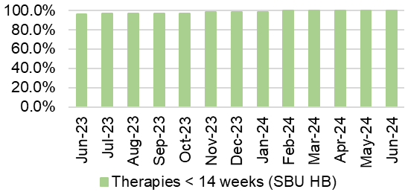 | - The final SCP performance for May 2024 was 57%, which is higher than the figure reported in April 2024. Performance is currently above the submitted trajectory (54%).  - The number of patients waiting over 52 weeks for a first outpatient appointment remained below the Ministerial target level of 0 in June 2024. This position has been sustained since October 2023.  - June 2024 saw an in-month reduction of 6% in the number of patients waiting over 104 weeks for treatment. The number decreased from 1,579 in May 2024 to 1,477 in June 2024.  - The percentage of patients waiting under 52 weeks for treatment decreased slightly in-month. In June 85.3% of patients were waiting under 52 weeks, compared with 85.8% in May 2024.  - The number of patients waiting 100% over target for a follow-up appointment decreased in June 2024. There were 49,585 patients waiting 100% over their target date in June 2024, a reduction of 1,061 when compared to May 2024 (50,646).  - In June 2024 71.2% of Ophthalmology RI patients were waiting within their clinical target date or within 25% of their target date. This is a 1.7% increase on the figure reported in May 2024.  - In June 2024, there was an increase in the percentage of patients waiting less than 8 weeks for a diagnostic test. It increased from 70.5% in May 2024 to 70.8% in June 2024.  More detail on the number of patients witing by diagnostic test is provided later in this report.  - In June 2024, 99.93% of patients were waiting less than 14 weeks for therapy services; this is a slight deterioration when compared with the figure reported in May 2024. The 0.07% equates to 4 patients, 2 in dietetics and 2 in speech and language therapy.

CAMHS
- LPMHSS assessments with 28 days and therapeutic assessment within 28 days  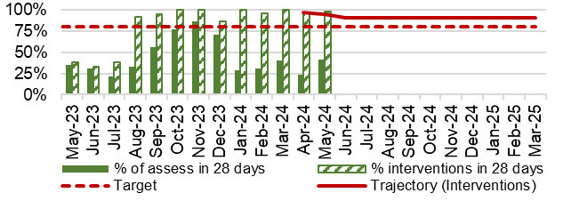  - Residents in receipt of a valid care and treatment plan  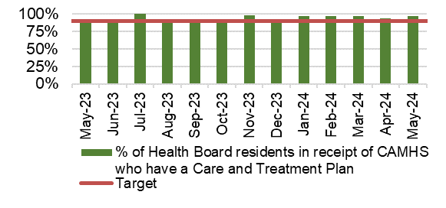 | - The percentage of routine assessments undertaken within 28 days increased to 41% in May 2024 from 23% in April 2024.  In May 2024, 98% of therapeutic assessments were undertaken within 28 days. This is above the outlines trajectory for May 2024.  - The percentage of residents in receipt of a valid care and treatment plan remained above the 80% target, achieving 97% in May 2024.
HEALTHCARE ACQUIRED INFECTIONS
- C. Difficile  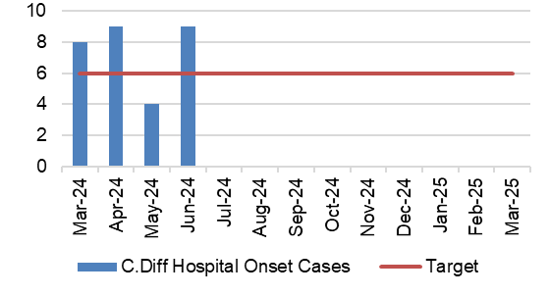  - Staph aureus  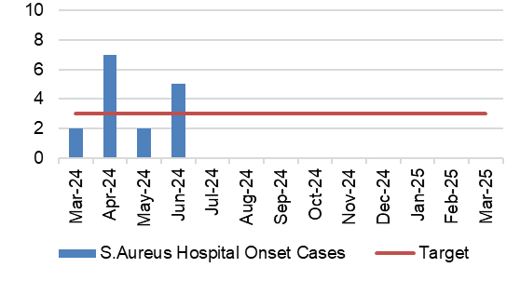  - E-coli  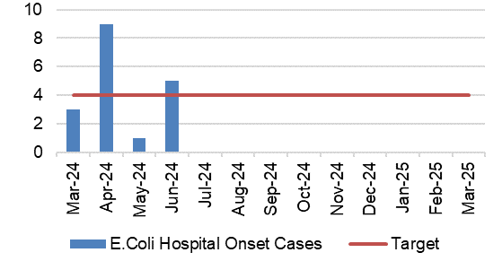  - Klebsiella  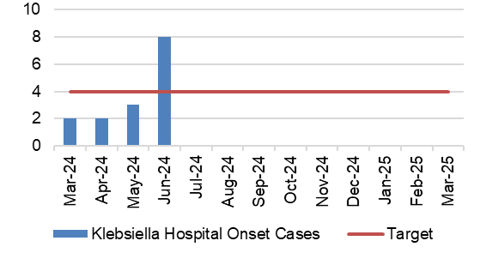 | - There were 9 hospital onset cases of C.Difficile reported in June 2024. This is 5 more than reported in May 2024 and is above the target of a maximum of 6 cases per month.  - There was an increase in the number of hospital onset cases of Staph aureus reported in June 2024. The number of cases reported increased to 5 in June 2024, compared to 2 in May 2024. This is above the target of a maximum of 3 cases per month.  - There were 5 hospital onset cases of E.Coli reported in June 2024. This is 4 more than the figure reported in May 2024 and is above the target of a maximum of 4 cases per month.  - The number of hospital onset cases of Klebsiella reported increased to 8 in June 2024 from 3 in May 2024. This is above the target of a maximum of 4 cases per month.

- updates on key service areas

COVID Data
Description | Current Performance | Trend
1. Number of new COVID19 cases in Swansea Bay population area | Number of new COVID cases  In June 2024, there were an additional 70 positive cases recorded bringing the cumulative total to 121,700 in Swansea Bay since March 2020. | Number of new COVID19 cases for Swansea Bay population  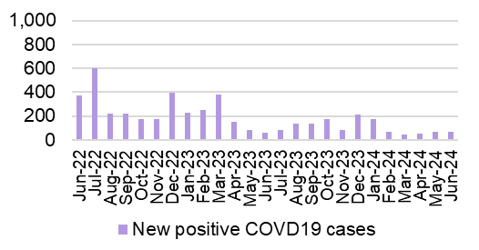

UNSCHEDULED CARE
Description | Current Performance |  |  |  |  | Actions of Improvement
Ambulance responses  1. The percentage of emergency responses to red calls arriving within (up to and including) 8 minutes.  2. The number of ambulance calls by category.  3.The percentage of emergency responses to red calls arriving within 8 minutes (last 90 days) | In June 2024, the number of red calls responded to within 8 minutes improved to 49.8% from 45.5% in May 2024. In June 2024, the number of green calls decreased by 7%, amber calls also decreased by 7%, and red calls decreased by 4% compared with May 2024. |  |  |  |  | Ambulance response rates have seen a small deterioration in performance in May 2024. Red and amber release escalation protocols have now been put in place, along with a dedicated medical team in the Emergency Department to ensure timely reviews are taking place to support flow.
 | Trend
 | - % of red calls responded to within 8 minutes  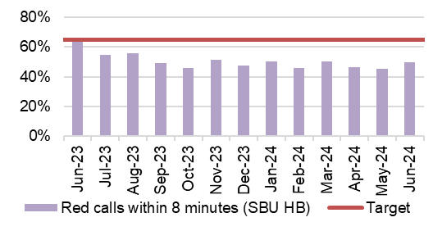 |  |  |  |  |  | - Number of ambulance call responses  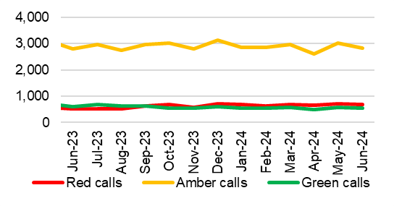
- % of red calls responded to within 8 minutes – HB total last 90 days
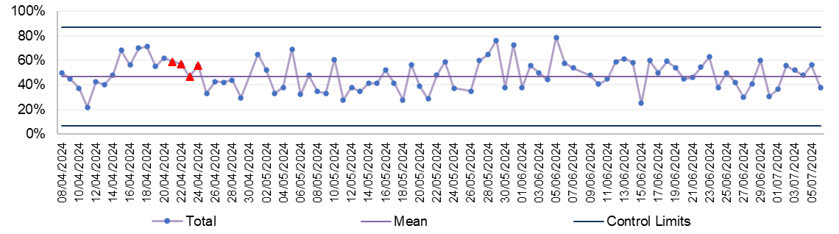
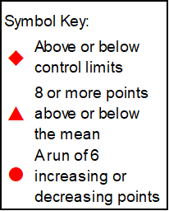
UNSCHEDULED CARE
Description | Current Performance |  |  |  |  |  | Actions of Improvement
Ambulance handovers  1.The number of ambulance handovers over one hour  2. The number of ambulance handovers over one hour- Hospital level  3.The number of ambulance handovers over one hour (last 90 days) | In June 2024, there were 590 ambulance to hospital handovers taking over 1 hour; this is a reduction of 105 compared with 695 in May 2024. In June 2024, 589 handovers over 1 hour were attributed to Morriston Hospital and 1 was attributed to Singleton Hospital. The number of handover hours lost over 15 minutes have decreased from 3,158 in May 2024 to 2,890 in June 2024. |  |  |  |  |  | Transformation of the urgent care pathways has been maintained with a focus on admission avoidance and length of stay reduction. Changes to medical staff rotas are being enacted and the first phases of the frailty model have been accelerated an implemented in July 2024 to reduce conveyance and admission where appropriate
 | Trend
 | - Number of ambulance handovers- HB total  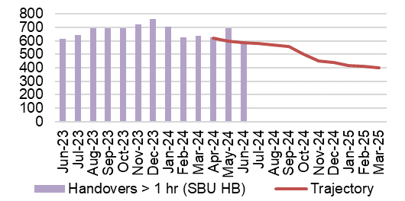 |  |  |  |  |  | - Number of ambulance handovers over 1 hour- Hospital level  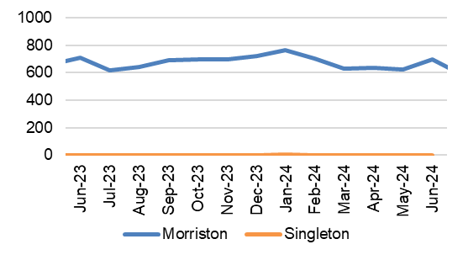
- Number of ambulance handovers- HB total last 90 days
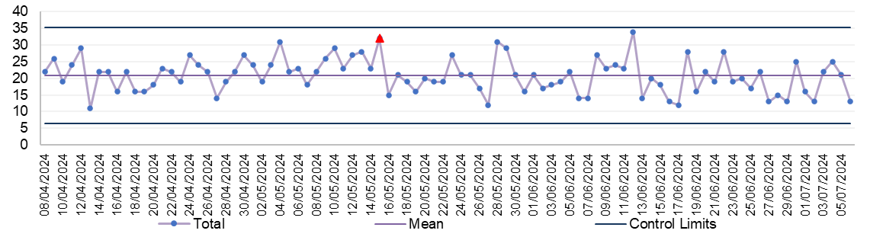
UNSCHEDULED CARE
Description | Current Performance |  |  |  |  |  |  | Actions of Improvement
A&E Attendances  1.The number of attendances at emergency departments in the Health Board  2.The number of attendances at emergency departments in the Health Board – Hospital level  3.The number of attendances at emergency departments in the Health Board (last 90 days) | In June 2024, there were 11,756 A&E attendances, which is a reduction of 762 when compared to May 2024. There were 6,959 attendances to A&E at Morriston hospital and 4,797 attendances to MIU at Neath Port Talbot hospital. |  |  |  |  |  |  | There is currently a medical SDEC model in place consisting of medics, GP’s, therapies, plus co-location of OPAS, ACT, virtual wards, paramedics (WAST stack review and direct access) – pull & push model from ED.
 | Trend
 | - Number of A&E attendances- HB total  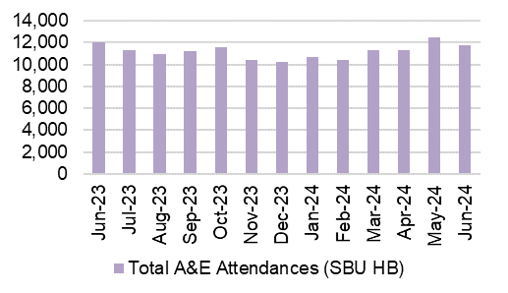 |  |  |  |  |  | - Number of A&E attendances- Hospital level  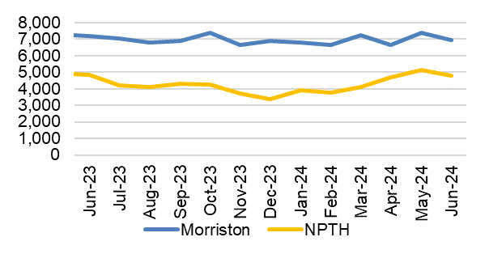
- Number of A&E attendances -HB total last 90 days
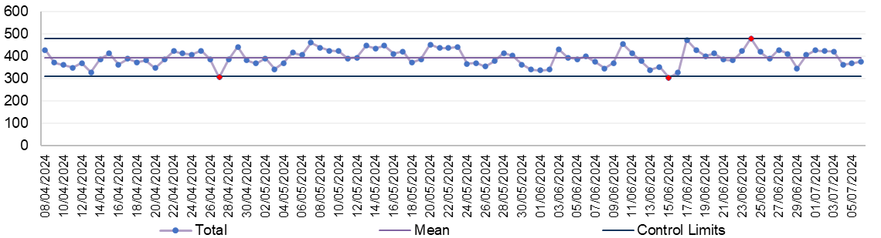
UNSCHEDULED CARE
Description | Current Performance |  |  |  |  |  | Actions of Improvement
A&E waiting times  1.% of patients who spend less than 4 hours in all major and minor emergency care facilities from arrival until admission, transfer or discharge  2. % of patients who spend less than 4 hours in A&E- Hospital level  3. % of patients who spend less than 4 hours in A&E (last 90 days) | The Health Board’s performance against the 4-hour measure deteriorated from 78.10% in May 2024 to 77.56% in June 2024. Neath Port Talbot Hospital Minor Injuries Unit (MIU) has remained above the national target of 95% achieving 97.12% in June 2024. Morriston Hospital’s performance deteriorated slightly between May 2024 and June 2024, achieving 64.00% against the target. |  |  |  |  |  | A frailty model design has been agreed which anticipates a reduction in attendances and improved length of stay; this has been accelerated and implementation commenced in July ahead of September 2024 as scheduled.
 | Trend
 | - % Patients waiting under 4 hours in A&E- HB total  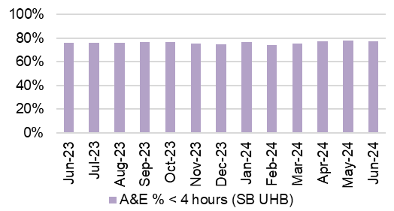 |  |  |  |  |  | - % Patients waiting under 4 hours in A&E- Hospital level  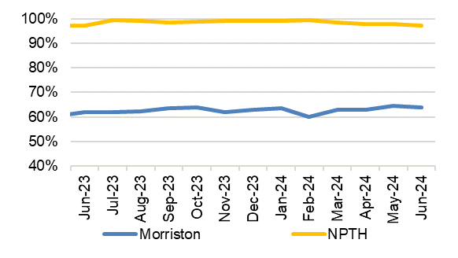
- % Patients waiting under 4 hours in A&E- HB total last 90 days
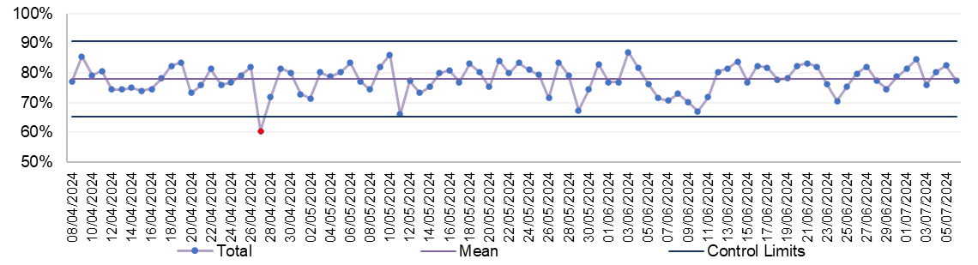
UNSCHEDULED CARE
Description | Current Performance |  |  |  |  |  | Actions of Improvement
A&E waiting times  1.Number of patients who spend 12 hours or more in A&E  2.Number of patients who spend 12 hours or more in A&E- Hospital level  3.Number of patients who spend 12 hours or more in A&E (last 90 days) | In June 2024, performance against the 12-hour measure improved when compared with May 2024, decreasing from 1,115 to 980. This is an decrease of 135 compared to May 2024. 978 patients waiting over 12 hours in June 2024 were attributed to Morriston Hospital and 2 were attributed to Neath Port Talbot Hospital. |  |  |  |  |  | A total of 8 virtual wards are now fully operational and the benefits of these are being experienced. The additional flow provided by the virtual wards and community engagement will support the flow from the ED department and the next stage includes NOF pathway changes and extended virtual wards.
 | Trend
 | - Number of patients waiting over 12 hours in A&E- HB total  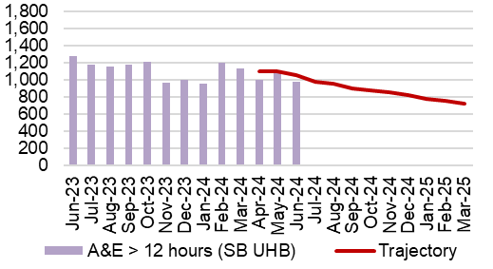 |  |  |  |  |  | - Number of patients waiting over 12 hours in A&E- Hospital level  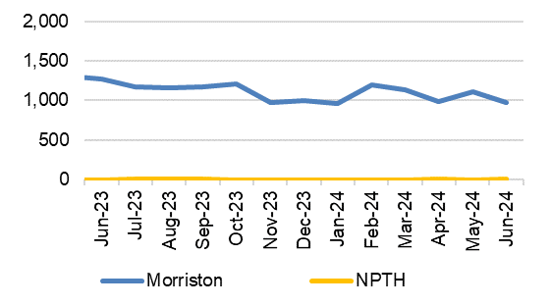
- Number of patients waiting over 12 hours in A&E – HB total last 90 days
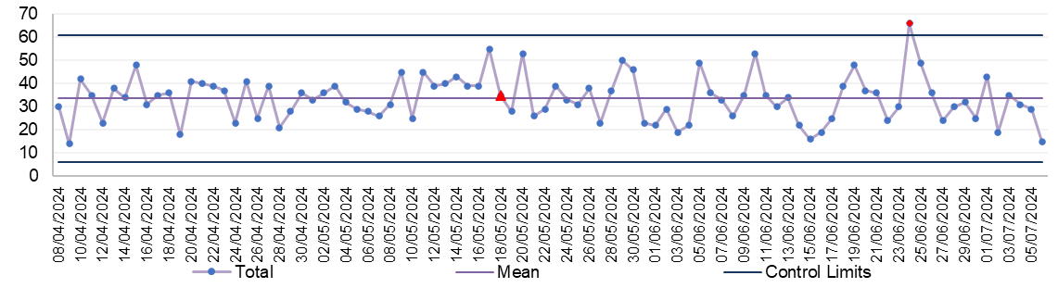
UNSCHEDULED CARE
Description | Current Performance |  |  |  |  |  |  |  | Actions of Improvement
Emergency admissions  1. The number of emergency inpatient admissions  2. The number of emergency inpatient admissions-Hospital level  3. The number of emergency inpatient admissions (last 90 days) | In December 2023, there were 4,328 emergency admissions across the Health Board, which is 26 higher than November 2023.  Singleton Hospital saw an in-month reduction, with 33 less admissions (from 308 in November 2023), Morriston Hospital saw an in-month increase from 3,871 admissions in November 2023 to 3,923 admissions in December 2023. |  |  |  |  |  |  |  | The increased number of emergency admissions is directly linked to the pressure within the system and the reduced flow from ED – this will be addressed by the previously referenced occupancy actions
 | Trend
 | - Number of emergency admissions- HB total  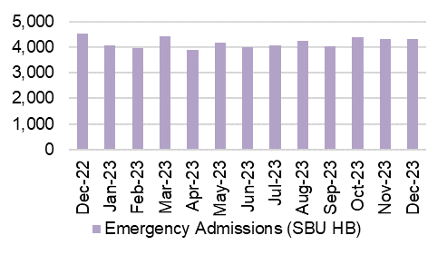 |  |  |  |  |  | 2.Number of emergency admissions- Hospital level  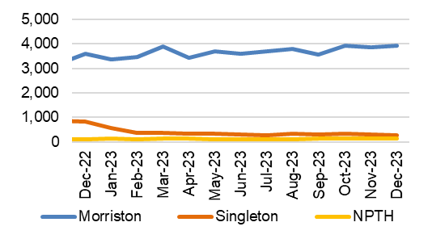
3.Number of emergency admissions- HB total last 90 days
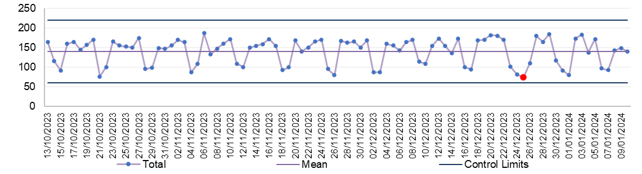
UNSCHEDULED CARE
Description | Current Performance |  |  |  |  |  | Actions of Improvement
Critical Care- Delayed Transfers of Care (DTOC)- Morriston Hospital  1.Total Critical Care delayed discharges (hours)  2. Average lost bed days per day  3.Percentage of patients delayed:  Up to 8 hours  Between 8 and 24 hours  Over 24 hours | In March 2024, there were a total of 76 admissions into the Intensive Care Unit (ICU) in Morriston Hospital, this is an increase when compared with 70 admissions in February 2024. March 2024, saw an increase in the number of delayed discharge hours from 1049.25 in February 2024 to 2903.1 in March 2024. The average lost bed days increased to 3.9 per day. The percentage of patients delayed over 24 hours increased to 52.73% in March from 26.53% in February 2024. |  |  |  |  |  | Delayed discharges from ICU are linked to capacity and flow constraints within the general wards and health/social-care system in general. Increased focus on flow through ICU as a result of capital works underway to meet burns requirements.
 | Trend
 | - Total Critical Care delayed discharges (hours)  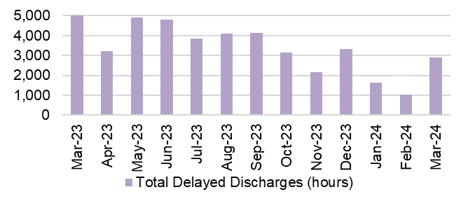 |  |  |  |  |  | - Average lost bed days per day  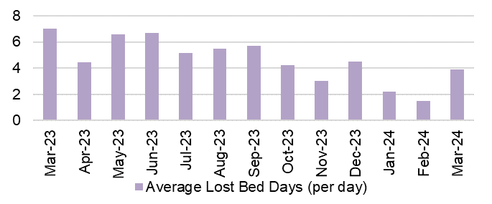
- Percentage of Critical Care patients delayed

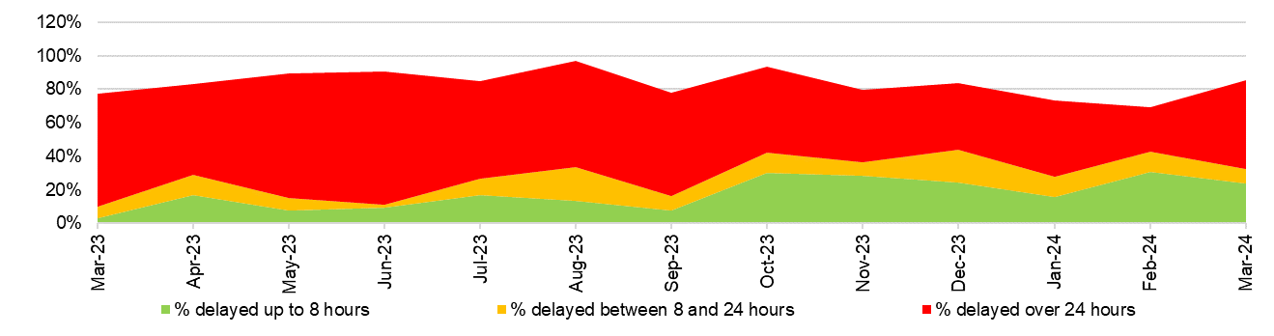
UNSCHEDULED CARE
Description |  |  | Current Performance |  | Trend
Clinically Optimised  The number of patients waiting at each site in the Health Board that are clinically optimised |  |  | In June 2024, there were on average 242 patients who were deemed clinically optimised but were still occupying a bed in one of the Health Board’s Hospitals.  In June, Morriston Hospital had the largest proportion of clinically optimised patients with 135, followed by Neath Port Talbot Hospital with 60.  Actions of Improvement;  Continued work is underway to implement opportunities to reduce the number of Clinically Optimised Patients in the Hospital. The implementation of the frailty model with further increase opportunities for reductions in delays. |  | 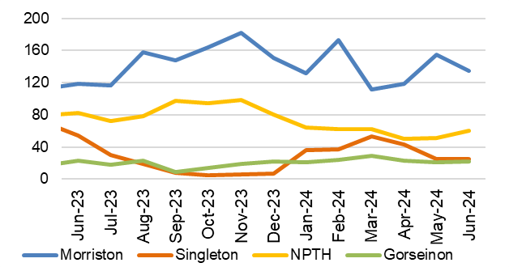  The number of clinically optimised patients by site
Elective procedures cancelled due to lack of beds  The number of elective procedure cancelled across the hospital where the main cancellation reasons was lack of beds |  |  | In June 2024, there were 30 elective procedures cancelled due to lack of beds on the day of surgery. This is 9 more cancellations than those seen in May 2024.  Of the 30 cancelled procedures, 29 were attributed to Morriston Hospital and 1 to Neath Port Talbot Hospital. |  | 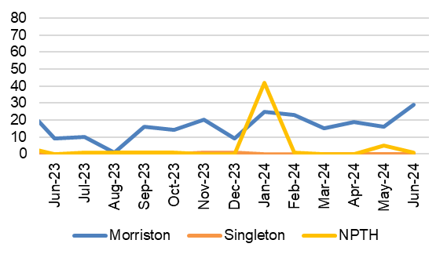  Total number of elective procedures cancelled due to lack of beds
HEALTHCARE ACQUIRED INFECTIONS
Description |  | Current Performance |  | Trend
Healthcare Acquired Infections (HCAI) - E.coli bacteraemia- Number of laboratory confirmed E.coli bacteraemia cases |  | - 16 cases of E. coli bacteraemia were identified in June 2024, of which 8 were hospital acquired and 8 were community acquired.  - The Health Board total is currently below the Welsh Government Profile target of 19 cases for June 2024.  Actions of Improvement;  Each Service Group has developed detailed action plans which reinforce the quality and safety guidelines to support the reduction of Infection rates |  | 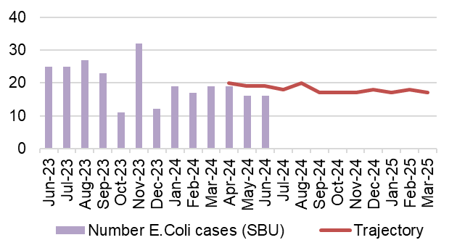  Number of healthcare acquired E.coli bacteraemia cases
Healthcare Acquired Infections (HCAI)-  S.aureus bacteraemia- Number of laboratory confirmed S.aureus bacteraemias (MRSA & MSSA) cases |  | - There were 7 cases of Staph. aureus bacteraemia in June 2024, of which 4 were hospital acquired and 3 were community acquired.  - The Health Board total is currently above the Welsh Government Profile target of 6 cases for June 2024  Actions of Improvement;  Each Service Group has developed detailed action plans which reinforce the quality and safety guidelines to support the reduction of Infection rates |  | 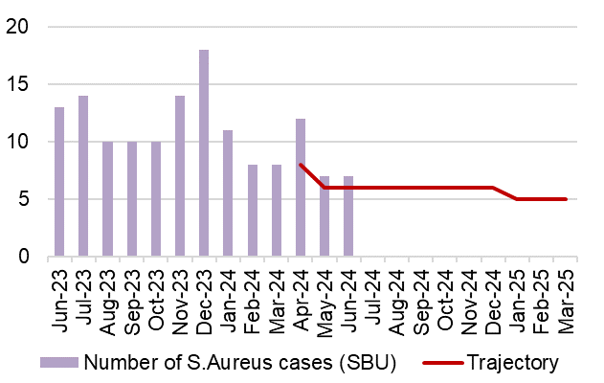  Number of healthcare acquired S.aureus bacteraemia cases
HEALTHCARE ACQUIRED INFECTIONS
Description |  | Current Performance |  | Trend
Healthcare Acquired Infections (HCAI)-  C.difficile-  Number of laboratory confirmed C.difficile cases |  | - There were 22 Clostridium difficile toxin positive cases in June 2024, of which 17 were hospital acquired and 5 were community acquired.  - The Health Board total is currently above the Welsh Government Profile target of 9 cases for June 2024.  Actions of Improvement;  Each Service Group has developed detailed action plans which reinforce the quality and safety guidelines to support the reduction of Infection rates |  | Number of healthcare acquired C.difficile cases  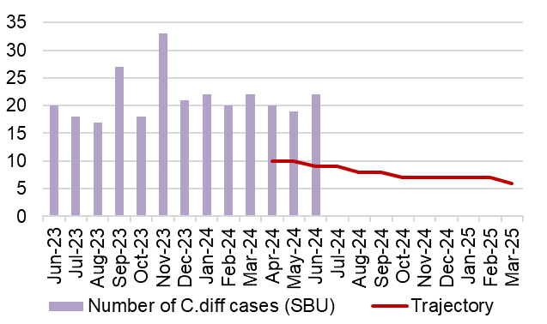
Healthcare Acquired Infections (HCAI)-  Klebsiella sp- Number of laboratory confirmed Klebsiella sp cases |  | - There were 13 cases of Klebsiella sp in June 2024, of which 8 were hospital acquired and 5 were community acquired.  - The Health Board total is currently above the Welsh Government Profile target of 7 cases for June 2024.  Actions of Improvement;  Each Service Group has developed detailed action plans which reinforce the quality and safety guidelines to support the reduction of Infection rates |  | 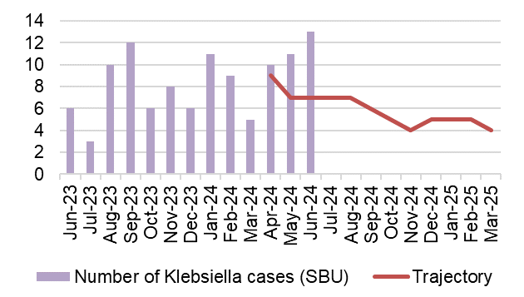  Number of healthcare acquired Klebsiella cases
HEALTHCARE ACQUIRED INFECTIONS
Description |  | Current Performance |  | Trend
Healthcare Acquired Infections (HCAI)-  Aeruginosa-  Number of laboratory confirmed Aeruginosa cases |  | - There were 0 cases of P.Aerginosa reported in June 2024.  - The Health Board total is currently below the Welsh Government Profile target of 2 cases for June 2024.  Actions of Improvement;  Each Service Group has developed detailed action plans which reinforce the quality and safety guidelines to support the reduction of Infection rates |  | 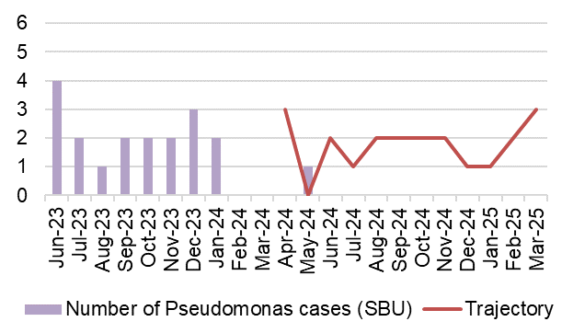  Number of healthcare acquired Pseudomonas cases

PLANNED CARE
Description | Current Performance |  | Actions of Improvement
Referrals and shape of the waiting list  - GP Referrals  The number of Stage 1 additions per week  - Stage 1 additions  The number of new patients that have been added to the outpatient waiting list  - Outpatient activity undertaken  Total number of patients seen each month  - Size of the waiting list  Total number of patients on the waiting list by stage as at June 2024. | In June 2024, there were 12,365 referrals received. This is lower than the number that was received in May 2024 (13,540). Chart 4 shows the shape of the current waiting list and Chart 3 shows the outpatient activity undertaken over the last year. |  | The number of referrals received has remained steady in recent months and is now showing a consistent pattern of demand. December is always seasonally low
 | Trend
 | - Number of GP referrals received by SBU Health Board  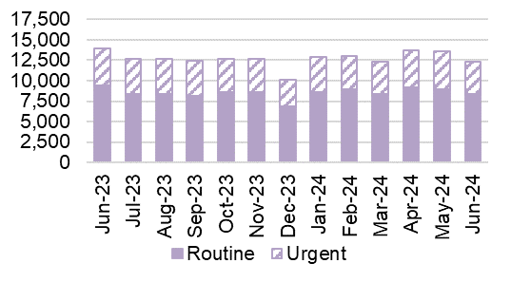 | - Number of stage 1 additions per week 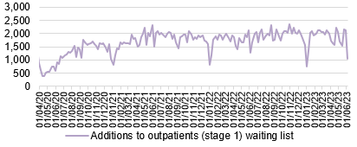
 | 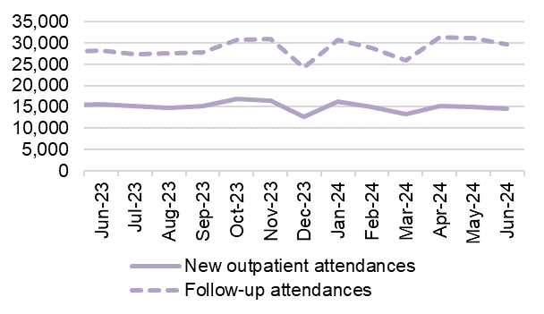  - Outpatient activity undertaken | - Total size of the waiting list (June 2024)  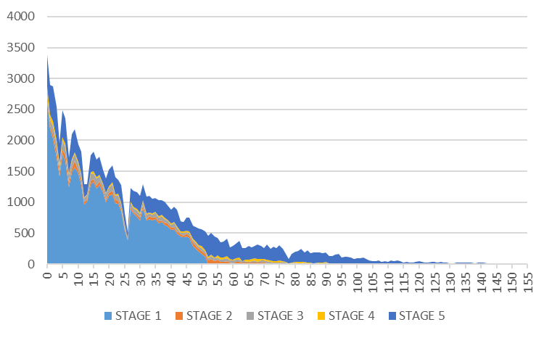
PLANNED CARE
Description | Current Performance |  |  | Actions of Improvement
Outpatient waiting times  1. Number of patients waiting more than 26 weeks for an outpatient appointment (stage 1)- Health Board Total  2. Number of patients waiting more than 26 weeks for an outpatient appointment (stage 1)- Hospital Level  3. Patients waiting over 26 weeks for an outpatient appointment by specialty  4. Percentage of patients waiting less than 26 weeks | The number of patients waiting over 26 weeks for a first outpatient appointment is still a challenge. June 2024 saw an in-month increase of 0.4% in the number of patients waiting over 26 weeks for an outpatient appointment. The number of breaches increased slightly from 14,205 in May 2024. Ophthalmology has the largest proportion of patients waiting over 26 weeks for an outpatient appointment, followed by Gynaecology and ENT. Chart 4 shows that the number of patients waiting less than 26 weeks for an outpatient appointment, this figure has increased to 60.3%. |  |  | Service Group specific recovery trajectories have been developed to further support recovery and these are currently being scrutinised by the Chief Operating Officer to ensure core capacity maximisation.
 | Trend
 | - Number of stage 1 over 26 weeks- HB total  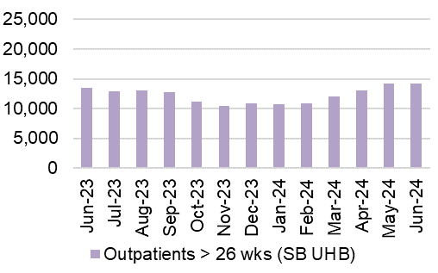 | - Number of stage 1 over 26 weeks- Hospital level  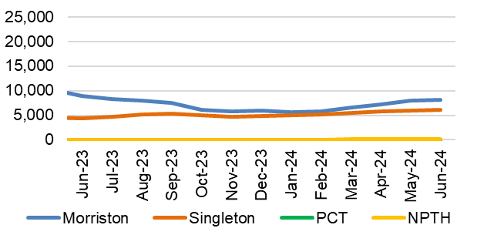
 | 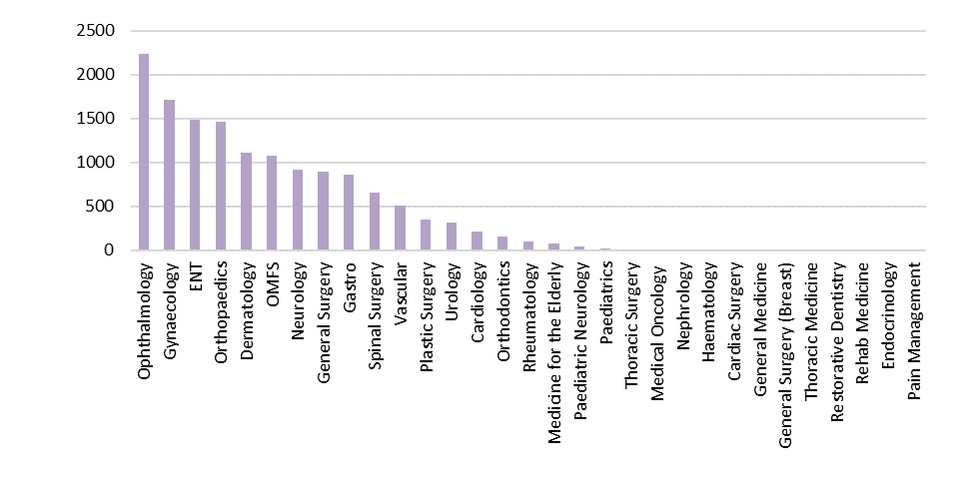  - Patients waiting over 26 weeks for an outpatient appointment by specialty as at June 2024 | - Percentage of patient waiting less than 26 weeks  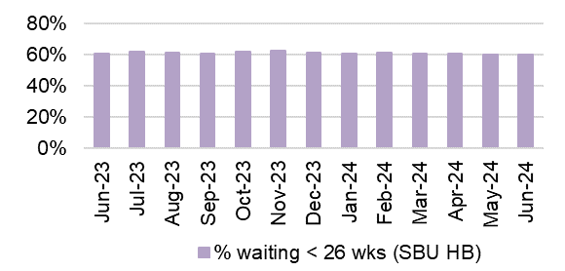

PLANNED CARE
Description | Current Performance |  |  |  | Actions of Improvement
Patients waiting over 36 weeks for treatment  1. Number of patients waiting more than 36 weeks for treatment and the number of elective patients admitted for treatment- Health Board Total  2. Number of patients waiting more than 52 weeks for treatment at Stage 1  3. Number of elective admissions  4. Number of patients waiting more than 104 weeks for treatment | In June 2024, there were 6,949 patients waiting over 36 weeks at Stage 1, which is an 8% in-month increase from May 2024. 13,623 patients were waiting over 52 weeks at all stages in June 2024. In June 2024, there were 1,477 patients waiting over 104 weeks for treatment, which is a 6% reduction from May 2024. |  |  |  | Focus is now on reducing the numbers of longest waiting patients and improving the productivity and efficiency of existing theatres to increase capacity within existing resources. There will be zero 4 year breaches and > 3 year breach numbers are reducing in line with plan and scheduled to clear by the end of August 2024.
 | Trend
 | - Number of patients waiting over 36 weeks at Stage 1- HB total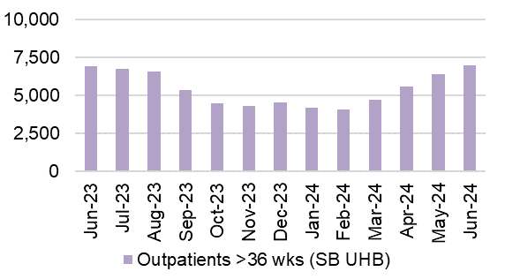 |  |  | - Number of patients waiting over 52 weeks at Stage 1- HB total  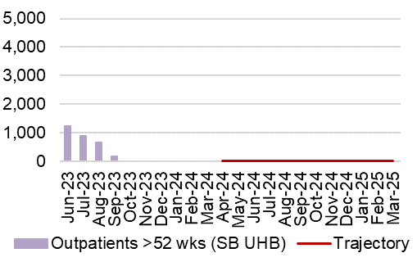
 | 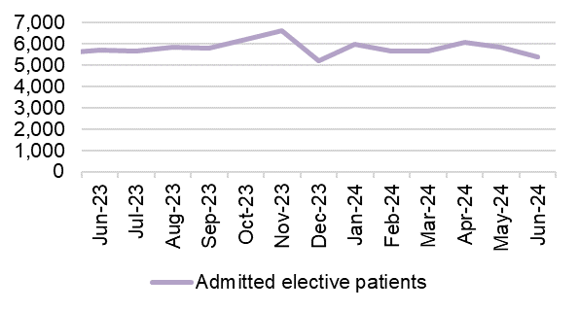  - Number of elective admissions |  |  | - Number of patients waiting over 104 weeks- HB total  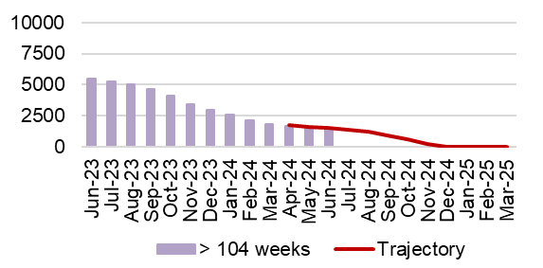
PLANNED CARE
Description | Current Performance
Ophthalmology Referrals  Number of patients referred into secondary care Ophthalmology services | In June 2024, there were 794 patients referred from Primary Care into secondary care ophthalmology services. This is an increase on the number of patients referred in May 2024, which was 783. |  |  | 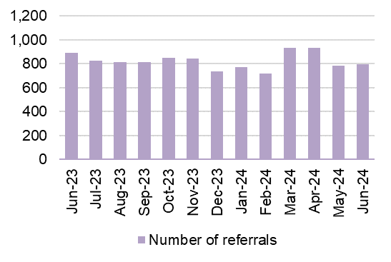  Number of referrals into secondary care Ophthalmology service
Ophthalmology waiting times  Percentage of ophthalmology R1 appointments attended which were within their clinical target date or within 25% in excess of their clinical target | In June 2024, 61.3% of Ophthalmology R1 appointments attended were within their clinical target date or within 25% of the target date.  Actions of Improvement;  A detailed Ophthalmology action plan is currently being executed which focusses on performance improvement schemes using insourcing and outsourcing resources, administrative validation and active recruitment to fill any current vacancies impacting capacity |  |  | 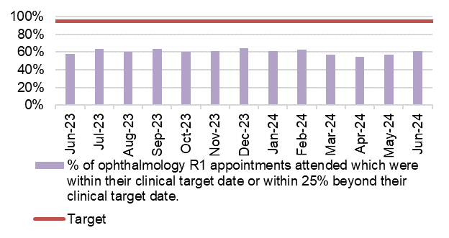  Percentage of ophthalmology R1 appointments attended which were within their clinical target date or within 25% in excess of their clinical target date
PLANNED CARE
Description | Current Performance |  |  | Trend
Diagnostics waiting times  The number of patients waiting more than 8 weeks for specified diagnostics | In June there was a reduction in the number of patients waiting over 8 weeks for specified diagnostics. It decreased from 3,576 in May 2024 to 3,493 in June 2024.  The following is a breakdown for the 8-week breaches by diagnostic test for June 2024:  - Endoscopy= 2,963  - Cardiac tests= 482  - Other Diagnostics = 48  Actions of Improvement;  Demand and capacity work has enabled significant improvement in access times for non-endoscopic diagnostics.  Detailed demand and capacity model for endoscopy has been commissioned to ensure sustained improvement across all aspects of endoscopic diagnostics. |  |  | 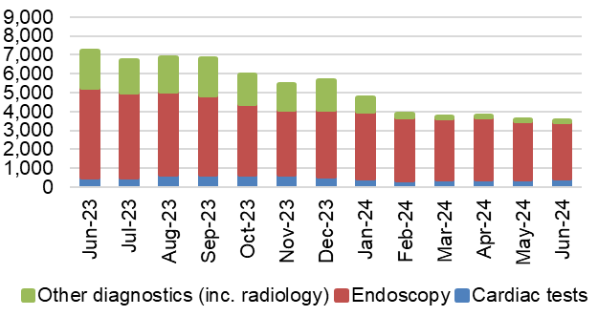  Number of patients waiting longer than 8 weeks for Diagnostics
Therapy waiting times  The number of patients waiting more than 14 weeks for specified therapies | In June 2024, there were 4 patients waiting over 14 weeks for specified Therapies, which is 4 more than seen in May 2024.  The breakdown for June 2024 is as follows:  - Dietetics = 2  - Speech & Language Therapy = 2 |  |  | 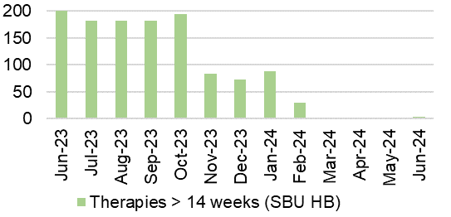  Number of patients waiting longer than 14 weeks for therapies
CANCER
Description | Current Performance |  |  | Trend
Single Cancer Pathway backlog  The number of patients with an active wait status of more than 63 days | June 2024 backlog by tumour site: |  |  | Number of patients with a wait status of more than 62 days  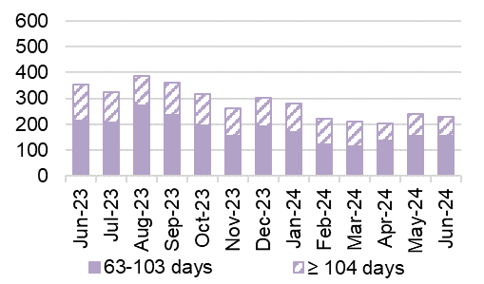
  Tumour Site | 63 - 103 days | ≥104 days
  Acute Leukaemia | 0 | 0
  Brain/CNS | 0 | 0
  Breast | 10 | 4
  Children's cancer | 1 | 0
  Gynaecological | 19 | 18
  Haematological | 6 | 0
  Head and neck | 10 | 1
  Lower GI (Exl. BSW) | 22 | 11
  BSW | 16 | 13
  Lung | 11 | 5
  Other | 0 | 1
  Sarcoma | 5 | 0
  Skin(c) | 19 | 2
  Upper Gastrointestinal | 13 | 7
  Urological | 22 | 13
  Grand Total | 154 | 75
Single Cancer Pathway backlog- patients waiting over 63 days | June 2024 saw a reduction in the number of patients waiting over 63 days. The following actions have been outlined to support backlog reduction;  - Targeted work is underway to prioritise patients waiting >104 days  - Milestone targets for OP access (10 days) and Decision to Treat (31 days) have also been set to reduce overall pathway waits.  - Tumour site specific plans have been developed and will be enacted through TI governance.  Note: backlog increased in May 2024 to reflect new reporting requirements for Bowel Screening Wales patients |  |  | Percentage of patients starting first definitive cancer treatment within 62 days from point of suspicion  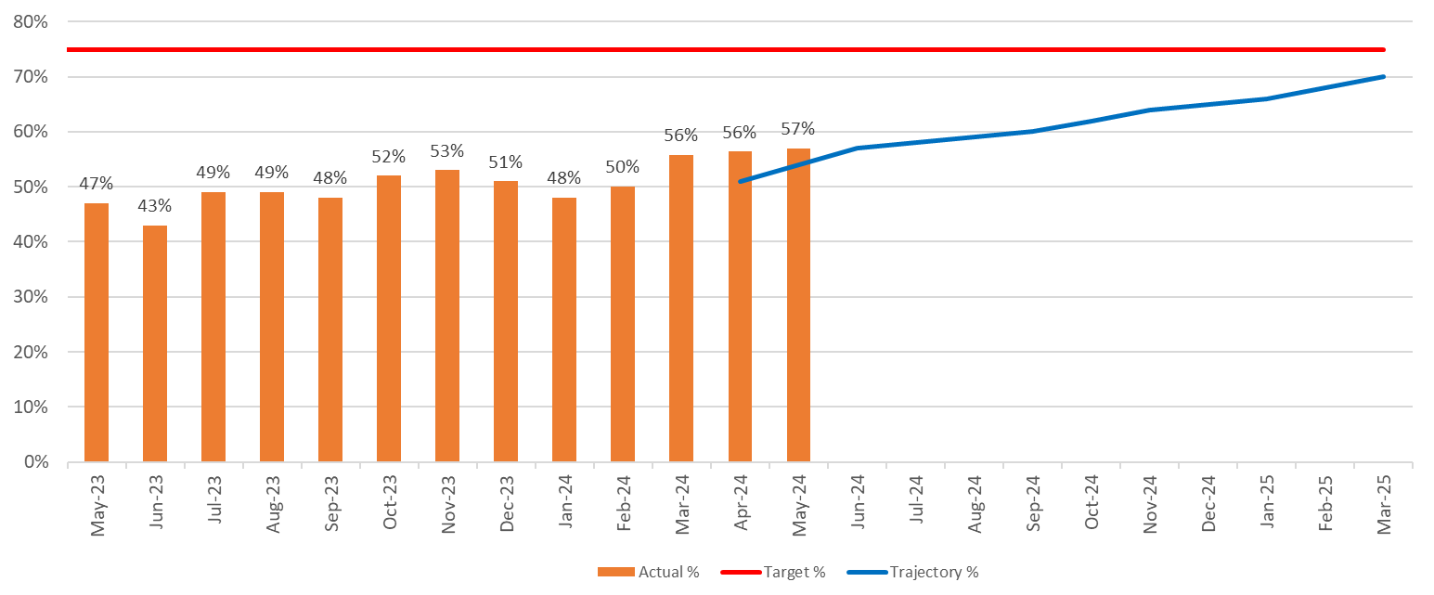
CANCER
Description |  | Current Performance | Trend
USC First Outpatient Appointments  The number of patients at first outpatient appointment stage by days waiting | June 2024 figures show total wait volumes for first outpatient appointment have decreased by 3% when compared with the previous week.  Of the total number of patients awaiting a first outpatient appointment, 44% have been booked, which is higher than figures seen in the previous months’ performance. | The number of patients waiting for a first outpatient appointment (by total days waiting) – June 2024  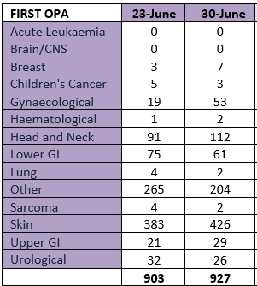
Radiotherapy waiting times  The percentage of patients receiving radiotherapy treatment | Radiotherapy waiting times are challenging however the provision of emergency radiotherapy within 1 and 2 days have hit their targets. | 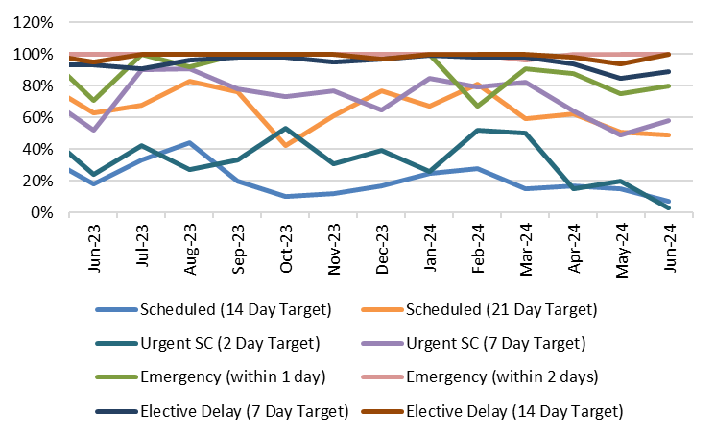  Radiotherapy waiting times
  Measure | Target | Jun-24
  Scheduled (14 Day Target) | 80% | 7%
  Scheduled (21 Day Target) | 100% | 49%
  Urgent SC (2 Day Target) | 80% | 3%
  Urgent SC (7 Day Target) | 100% | 58%
  Emergency (within 1 day) | 80% | 80%
  Emergency (within 2 days) | 100% | 100%
  Elective Delay (7 Day Target) | 80% | 89%
  Elective Delay (14 Day Target) | 100% | 100%
FOLLOW-UP APPOINTMENTS
Description | Current Performance | Trend
Follow-up appointments  1. The total number of patients on the follow-up waiting list  2. The number of patients waiting 100% over target for a follow-up appointment | In June 2024, the overall size of the follow-up waiting list increased by 1,659 patients compared with May 2024 (from 170,254 to 171,913).  In June 2024, there was a total of 78,946 patients waiting for a follow-up past their target date. This is a reduction of 1.9%% in-month (from 80,503 in May 2024).  Of the 78,946 delayed follow-ups in June 2024, 12,939 had appointment dates and 66,007 were still waiting for an appointment.  In addition, 49,585 patients were waiting 100%+ over target date in June 2024. This is a 2.1% reduction when compared with May 2024. | 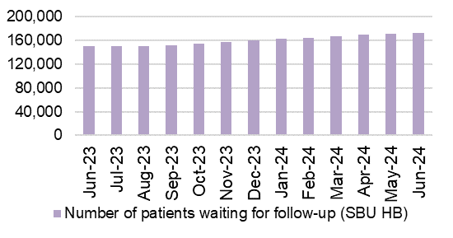  - Total number of patients waiting for a follow-up  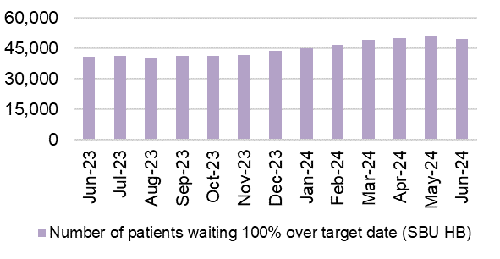  - Delayed follow-ups: Number of patients waiting 100% over target

STROKE
Description | Current Performance | Trend
Stroke Measures  - % of patients who have a direct admission to an acute stroke unit within 4 hours  - % of patients who received a CT Scan within 1 hour  - % of patients who are assessed by a stroke specialist consultant physician within 24 hours  - % of thrombolysed stroke patients with a door to door needle time of less than or equal to 45 minutes | - In June 2024, 18% of patients had a direct admission to an acute stroke unit within 4 hours. This is a deterioration on the performance reported in May 2024.  - In June 2024, 46% of patients received a CT scan within 1 hour of being admitted, this is a deterioration on the figure reported in May 2024.  - 84.6% of patients were assessed by a stroke specialist consultant physician within 24 hours in June 2024, which is a reduction of 2.9% from May 2024.  - In June 2024, 0% of patients were thrombolysed in a time of less than or equal to 45 minutes.  Actions of Improvement;  The lack of ring fenced beds on all wards across the hospital sites is challenging as bed capacity is limited by the pressures of unscheduled care demand. The lack of dedicated stroke beds is directly impacting the stroke related performance measures. Work is underway to focus on future stroke performance improvement. | 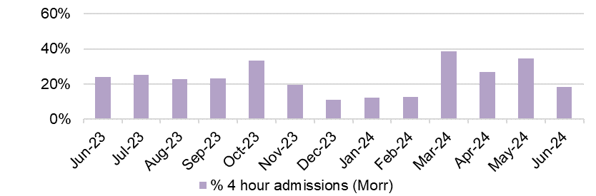  - % of patients who have a direct admission to an acute stroke unit within 4 hours  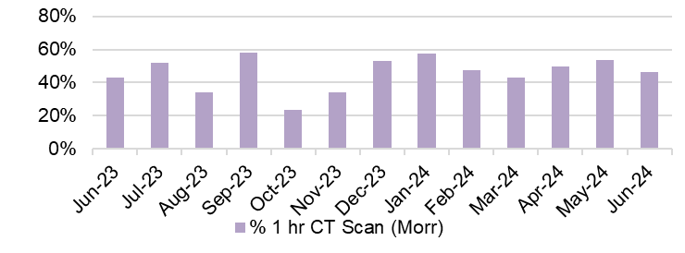  - % of patients who received a CT Scan within 1 hour  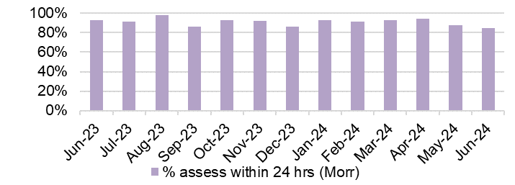  - % of patients who are assessed by a stroke specialist consultant physician within 24 hours  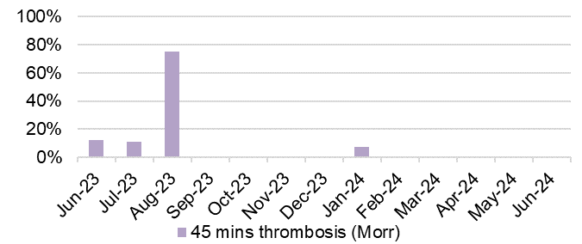  - % of thrombolysed stroke patients with a door to door needle time of less than or equal to 45 minutes

ADULT MENTAL HEALTH
Description | Current Performance | Trend
Adult Mental Health Measures:  - % of MH assessments undertaken within 28 days from the date of receipt of referral (18 years and over)  - % of therapeutic interventions started within 28 days following an assessment by LPMHSS (18 years and over)  - % of health board residents in receipt of secondary mental health services who have a valid Care and Treatment Plan (CTP) (18 years and over)  - % of patients waiting less than 26 weeks to start a psychological therapy in Specialist Adult Mental Health | - In May 2024, 90% of assessments were undertaken within 28 days of referral for patients 18 years and over.  - In May 2024, the percentage of therapeutic interventions started within 28 days following an assessment by the Local Primary Mental Health Support Service (LPMHSS) was 100%.  - 87% of residents in receipt of secondary care mental health services had a valid Care and Treatment Plan in May 2024.  - In May 2024, 64% of patients waited less than 26 weeks for psychological therapy. This was below the national target of 95%. | 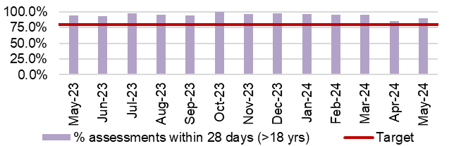  - % Mental Health assessments undertaken within 28 days from receipt of referral  - % Mental Health therapeutic interventions started within 28 days following LPMHSS assessment  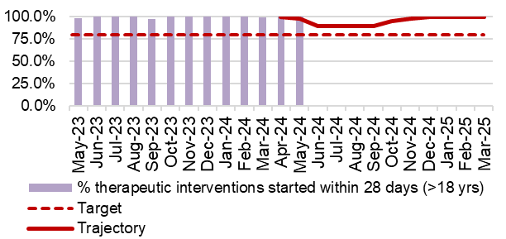  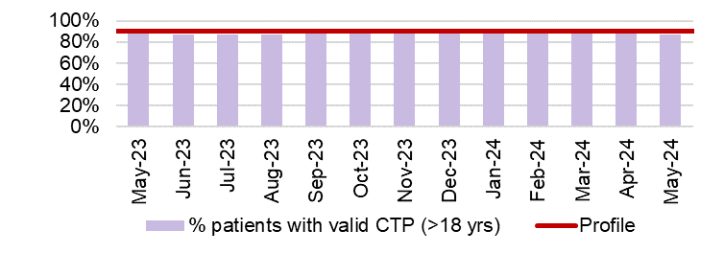  - % residents with a valid Care and Treatment Plan (CTP)  - % waiting less than 26 weeks for Psychology Therapy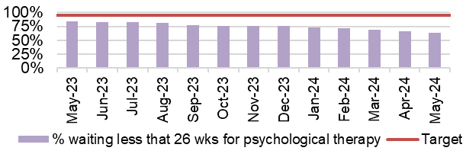
CHILD & ADOLESCENT MENTAL HEALTH (CAMHS)
Description | Current Performance | Trend
- Crisis - % Urgent Assessment by CAMHS undertaken within 48 Hours from receipt of referral  - Primary CAMHS (P-CAMHS) - % Routine Assessment by CAMHS undertaken within 28 days from receipt of referral  - Primary CAMHS (P-CAMHS) - % Therapeutic interventions started within 28 days following assessment by LPMHSS  - NDD - % Neurodevelopmental Disorder patients receiving a Diagnostic Assessment within 26 weeks  - Specialist CAMHS (S-CAMHS) - % Routine Assessment by SCAMHS undertaken within 28 days from receipt of referral | - In May 2024, 100% of CAMHS patients received an assessment within 48 hours.  - 41% of routine assessments were undertaken within 28 days from referral in May 2024 against a target of 80%.  - 98% of therapeutic interventions were started within 28 days following assessment by LPMHSS in April 2024.  - 29% of NDD patients received a diagnostic assessment within 26 weeks in May 2024 against a target of 80%.  - SCAMHS figures now included in illustration 2 and 3 combined.  *All routine assessments are now under PCAMHS* | - Crisis- assessment within 48 hours  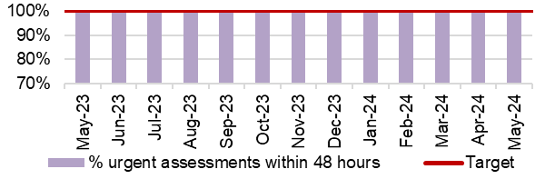  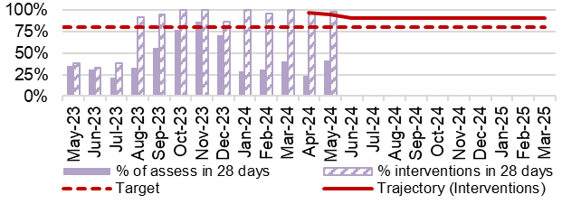  - and 3. P-CAMHS % assessments and therapeutic interventions within 28 days  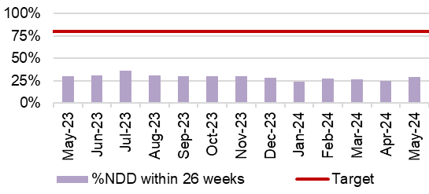  - NDD- assessment within 26 weeks
4. NHS Delivery framework Measures
&
Ministerial Priority trajectories

FRACTURED NECK OF FEMUR (#NOF)
Description | Current Performance | Trend
Fractured Neck of Femur (#NOF)  1. Prompt orthogeriatric assessment- % patients receiving an assessment by a senior geriatrician within 72 hours of presentation  2. Prompt surgery - % patients undergoing surgery the day following presentation with hip fracture  3. NICE compliant surgery - % of operations consistent with the recommendations of NICE CG124  4. Prompt mobilisation after surgery - % patients out of bed (standing or hoisted) by the day after operation | - Prompt orthogeriatric assessment- In May 2024, 97.6% of patients in Morriston hospital received an assessment by a senior geriatrician within 72 hours.  - Prompt surgery- In May 2024, 33.1% of patients had surgery the day following presentation with a hip fracture. This is a 5.3% improvement from May 2023 which was 27.8%.  - NICE compliant surgery- 70.6% of operations were consistent with the NICE recommendations in May 2024. This is 1.5% less than in May 2023.  - Prompt mobilisation- In May 2024, 85% of patients were out of bed the day after surgery. This is 5.3% more than in May 2023. | - Prompt orthogeriatric assessment  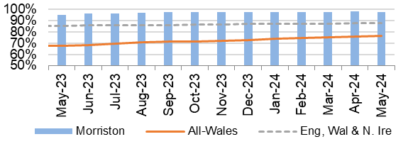  - Prompt surgery  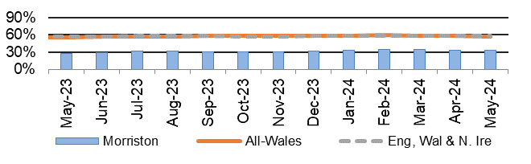  - NICE compliant Surgery  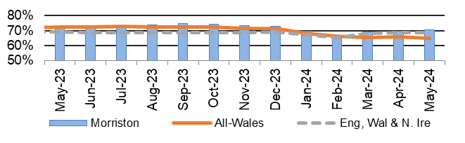  - Prompt mobilisation  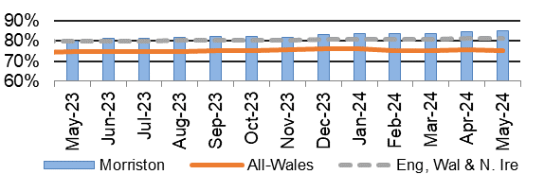
FRACTURED NECK OF FEMUR (#NOF)
Description | Current Performance | Trend
- Not delirious when tested- % patients (<4 on 4AT test) when tested in the week after operation  - Return to original residence- % patients discharged back to original residence, or in that residence at 120 day follow-up  - 30 day mortality rate (Case mix Adjusted) | - Not delirious when tested- 75.4% of patients were not delirious in the week after their operation in May 2024.  - Return to original residence- 73.4% of patients in February 2024 were discharged back to their original residence. This is 4.6% more than in February 2023.  - 30 day mortality rate- In Q4 23-24 the mortality rate for Morriston Hospital was 4.8%, which is 1.3% lower than the same period in the previous year and is 0.6% lower than the national average for the quarter. | 5. Not delirious when tested  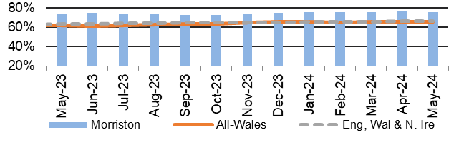  6. Return to original residence  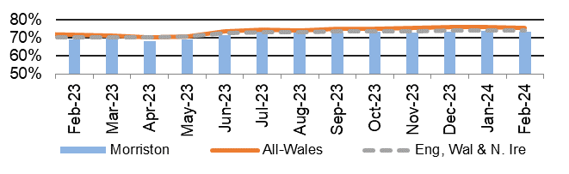  7. 30 day mortality rate  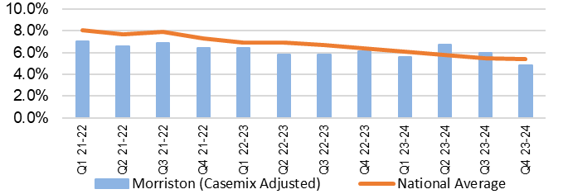
PRESSURE ULCERS
Description | Current Performance | Trend
Number of pressure ulcers  1. Total number of pressure ulcers developed in hospital and in the community  2. Rate of pressure ulcers per 100,000 admission | - In May 2024 there were 107 cases of healthcare acquired pressure ulcers, 41 of which were community acquired and 66 were hospital acquired.  There were 13 grade 3+ pressure ulcers in May 2024, 9 of which were community acquired and 4 were hospital acquired.  - The rate per 100,000 admissions was 1105 in May 2024. | Total number of hospital and community acquired Pressure Ulcers (PU) and rate per 100,000 admissions  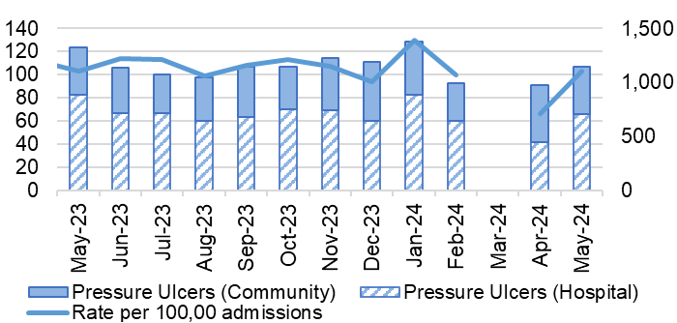  *March 24 data not available
INPATIENT FALLS
Description | Current Performance | Trend
Inpatient Falls  The total number of inpatient falls | - The number of Falls reported via Datix web for Swansea Bay UHB was 158 in June 2024. This is 1.9% more than May 2024 where 155 falls were recorded. | Number of inpatient Falls  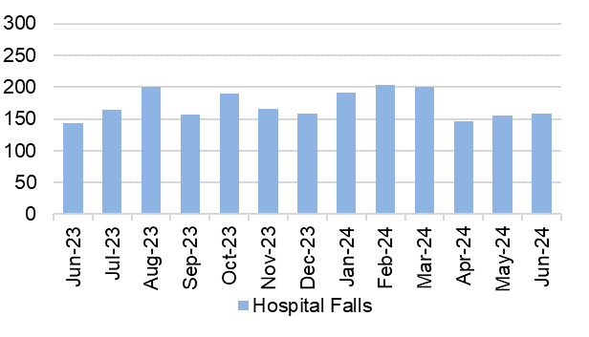
NATIONALLY REPORTABLE INCIDENTS
Description | Current Performance | Trend
Nationally Reportable Incidents (NRI’s)-  1. The number of Nationally reportable incidents  2. The number of Never Events  3. Of the nationally reportable incidents due for assurance, the percentage which were assured within the agreed timescales | - The Health Board reported 4 Nationally Reportable Incidents for the month of June 2024 to Welsh Government. The Service Group breakdown is as follows;  - PCT – 2  - Morriston – 1  - MH & LD -1  - There were no new Never Events reported in June 2024.  - In June 2024, 89% of the NRI’s were closed within the agreed timescale. | 1. and 2. Number of nationally reportable incidents and never events  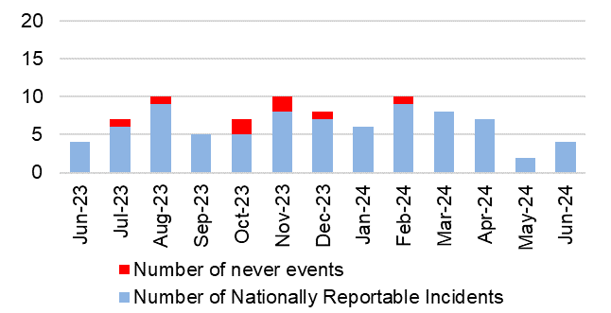  3. % of nationally reportable incidents closed within the agreed timescales  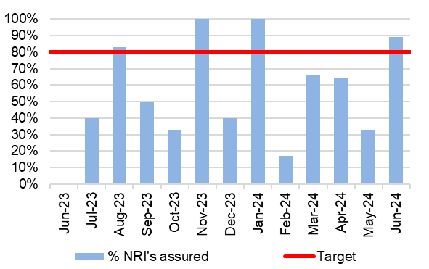
DISCHARGE SUMMARIES
Description | Current Performance | Trend
Discharge Summaries  Percentage of discharge summaries approved and sent to patients’ doctor following discharge | The latest data shows that in June 2024, the percentage of completed discharge summaries was 76%.  In June 2024, compliance ranged from 81% in Morriston Hospital to 61% in Singleton & Neath Port Talbot Hospitals. | % discharge summaries approved and sent  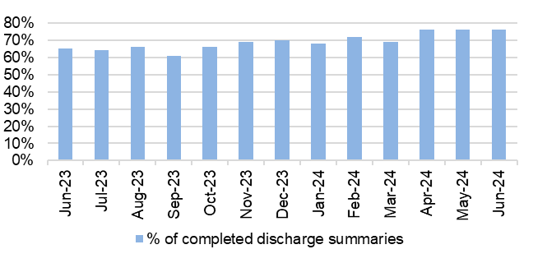
CRUDE MORTALITY
Description | Current Performance | Trend
Crude Mortality Rate | April 2024 reports the crude mortality rate for the Health Board at 0.66%, which is the same as the figure reported in March 2024.  A breakdown by Hospital for April 2024:  - Morriston – 1.18%  - Singleton – 0.16%  - NPT – 0.09% | 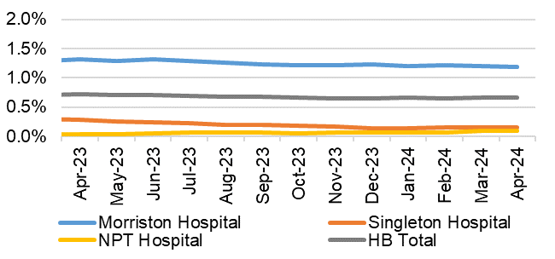  Crude hospital mortality rate by Hospital (74 years of age or less)

WORKFORCE
Description | Current Performance | Trend
Staff sickness rates- Percentage of sickness absence rate of staff | - Our in-month sickness performance deteriorated from 6.61% in April 2024 to 6.76% in May 2024.  - The 12-month rolling performance figure reported in May 2024 was 7.05%, which is 0.05% higher than the figures reported in April 2024.  - The following table provides the top 5 absence reasons by full time equivalent (FTE) days lost in May 2024. | 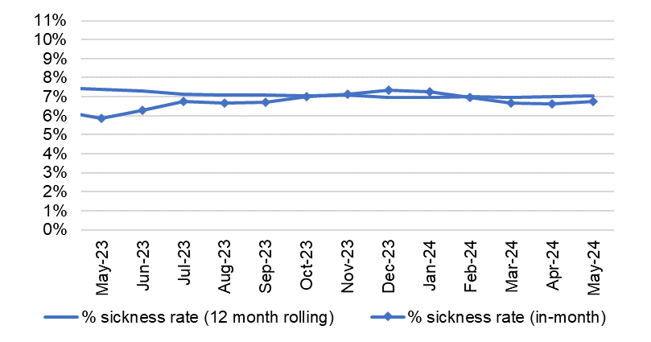  % of full time equivalent (FTE) days lost to sickness absence (12 month rolling and in-month)
  Absence Reason | FTE Days Lost | %
  Anxiety/ stress/ depression/ other psychiatric illnesses | 9,281.60 | 35.0%
  Other musculoskeletal problems | 2,913.00 | 11.0%
  Gastrointestinal problems | 2,002.11 | 7.5%
  Other known causes - not elsewhere classified | 1,694.09 | 6.4%
  Cold, Cough, Flu - Influenza | 1,618.59 | 6.1%
THEATRE EFFICIENCY
Description | Current Performance | Trend
Theatre Efficiency  1. Theatre Utilisation Rates  2. % of theatre sessions starting late  3. % of theatre sessions finishing early  4. % of theatre sessions cancelled at short notice (<28 days)  5. % of operations cancelled on the day | In June 2024 the Theatre Utilisation rate was 66%. This is 7% lower than May 2024 and is 3% lower than the figure reported in June 2023 (69%).  38% of theatre sessions started late in June 2024. This is 5% higher than the figure reported for in May 2024.  In June 2024, 53% of theatre sessions finished early. this is 4% higher than figure seen in May 2024 and 6% higher than those seen in June 2023.  9% of theatre sessions were cancelled at short notice in June 2024. This is 1% lower than the figure reported in May 2024 and is 2% lower than figures seen in June 2023.  Of the operations cancelled in June 2024, 42% of them were cancelled on the day. This is 8% higher than the figure reported in May 2024 (34%). | - Theatre Utilisation Rates  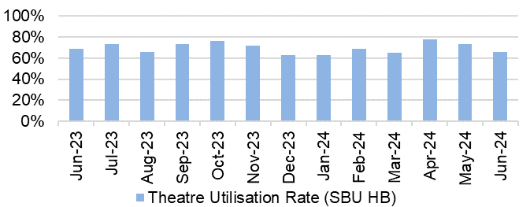  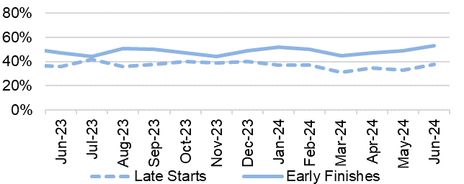  - And 3. % theatre sessions starting late/finishing  - % theatre sessions cancelled at short notice (<28 days)  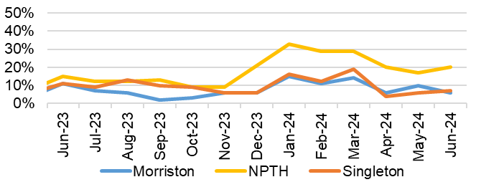  - % of operations cancelled on the day  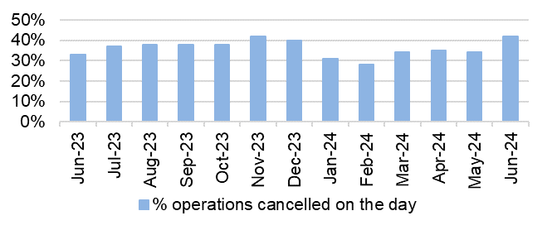
PATIENT EXPERIENCE
Description | Current Performance | Trend
Patient experience  1. Number of friends and family surveys completed  2. Percentage of patients/ service users who would recommend and highly recommend  3. Number of Service User feedback experience responses completed and recorded on CIVICA | Health Board Friends & Family patient satisfaction level in June 2024 was 93% and 5,535 surveys were completed.  - Singleton/ Neath Port Talbot Hospitals Service Group completed 2,193 surveys in June 2024, with a recommended score of 95%.  - Morriston Hospital completed 2,716 surveys in June 2024, with a recommended score of 90%.  - Primary & Community Care completed 625 surveys for June 2024, with a recommended score of 96%.  - The Mental Health Service Group completed 71 surveys for June 2024, with a recommended score of 92%.  There were 5,700 feedback experience responses completed and recorded on CIVICA in March 2024. This is 143 less than the figure reported in February 2024. Of the responses recorded, 4,375 were targeted and 1,325 were passive. | 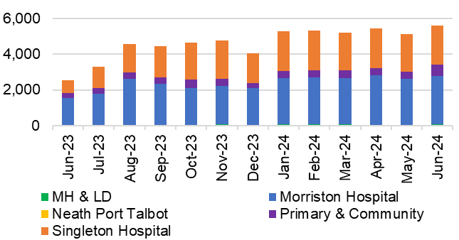  - Number of friends and family surveys completed  - % of patients/ service users who would recommend and highly recommend  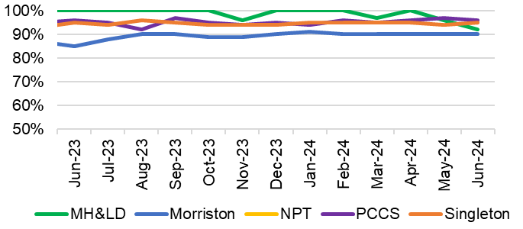  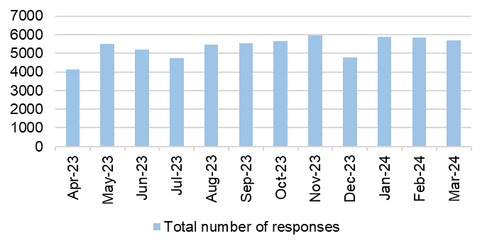  - Number of Service User experience responses
COMPLAINTS
Description | Current Performance | Trend
Patient concerns  1. Number of formal complaints received  2. Percentage of concerns that have received a final reply or an interim reply up to and including 30 working days from the date the concern was first received by the organisation | 1. In April 2024, the Health Board received 140 formal complaints; this is a reduction of 6% when compared with March 2023 figures (167).  2. The overall Health Board rate for responding to concerns within 30 working days was 74% in  April 2024, against the Welsh Government target of 75% and Health Board target of 80%.  Below is a breakdown of performance against the 30- day response target: | 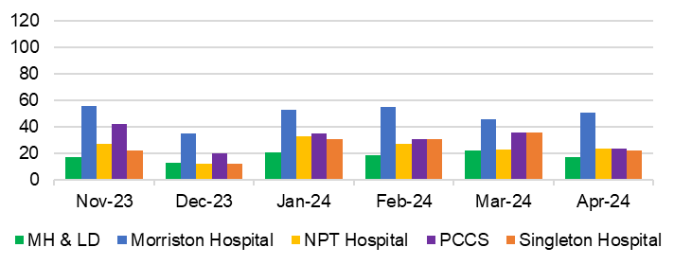  - Number of formal complaints received  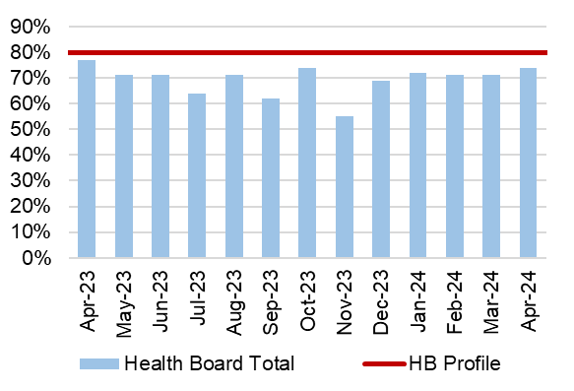  - Response rate for concerns within 30 days
   | 30 day response rate
  Neath Port Talbot Hospital | 67%
  Morriston Hospital | 76%
  Mental Health & Learning Disabilities | 82%
  Primary, Community and Therapies | 79%
  Singleton Hospital | 57%

Finance updates
This section of the report provides further detail on key workforce measures.

Description |  | Current Performance | Trend
Revenue Financial Position – expenditure incurred against revenue resource limit |  | - Health Board Plan submitted at end March 2024 reported a £50.1m planned deficit but control total set by Welsh Government is £17.1m.  - In Month 3 there is an in-month overspend of £7.5m (Month 2 £8.9m).  - YTD at Month 3 is an overspend of £25.8m.  - Overall, the Health Board YTD position is £13.3m off the delivery of the £50.1m deficit plan.  - In the graph the orange bars illustrate the potential financial change required to be able to deliver the £50.1m.  - The yellow line depicted the level required if the HB were to achieve the £17.1m control total.  - Savings: deterioration in month of £0.2m in delivery and overall, there remains a shortfall in delivery of the £26.1m targets YTD of £3.6m.  - Operational Run Rate: overall improvement of £1.6m in month as a result of two Non-Recurrent benefits in Mth 3 linked to rebate on energy and VAT recovery, however operational run YTD is £9.7m over. | 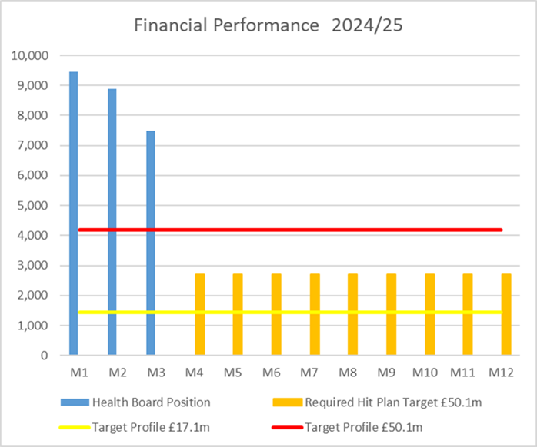
Description | Current Performance |  |  | Trend
Capital Financial Position – expenditure incurred against capital resource limit | - The forecast outturn capital position for 2024/25 is balanced. The balanced position mitigates any non-receipt of allocations which are anticipated from Welsh Government.  - Any All Wales Capital schemes where a high/medium risk is reported are closely monitored and discussed at the Capital Review progress meetings with Welsh Government. |  |  | 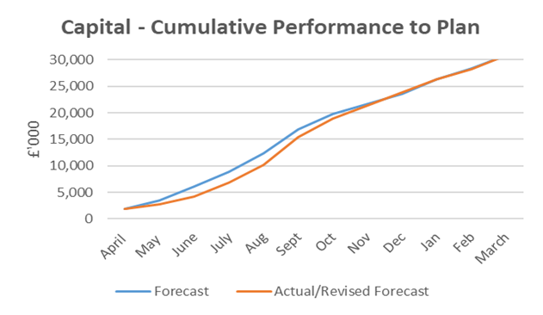
Description | Current Performance |  |  | Trend
Workforce Spend – workforce expenditure profile | - The pay budgets are overspent by £2.816m in June.  - Variable pay has decreased in June by circa. £339k. Broken down as follows: Irregular Sessions were overspent by £477k, & Overtime £11k offset by underspend in Bank £323k, Agency – Non-Medical £278k, WLI £211k, & Agency Medical £15k.  - Work is required to bring spend down in line with the current year budget. |  |  | 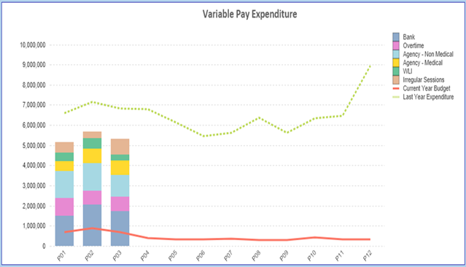
Description | Current Performance |  |  | Trend
PSPP – pay 95% of Non-NHS invoices within 30 days of receipt of goods or valid invoice | - The cumulative PSPP compliance has improved this month and is now above target at 95.40%. In June compliance was above target at 96.90% (May – 98.07%).  - Although the PSPP was achieved this month, there were still delays in receipting and authorisation. |  |  | Percentage of non-NHS invoices paid within 30 days of receipt of goods or valid invoice  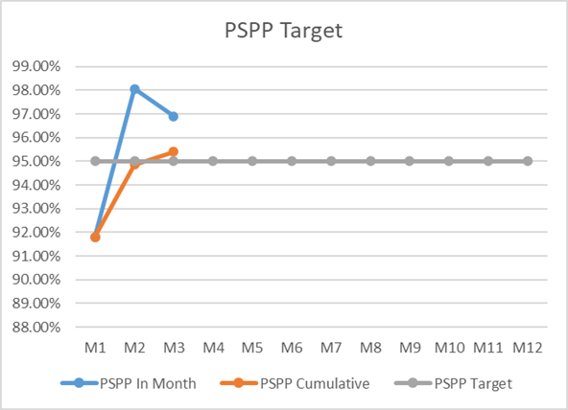

5. TABLE OF ALL MEASURES

Harm from COVID itself
Chart 1 Number of new COVID19 cases |  | Chart 2: Number of new COVID19 cases (cumulative) |  | Chart 3: Number of COVID19 tests completed and positivity rate |  | Chart 4: Number of staff referred for Antigen testing
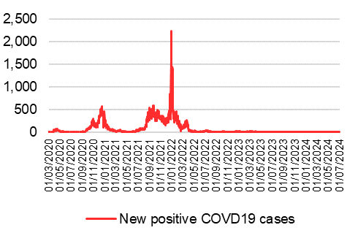 |  | 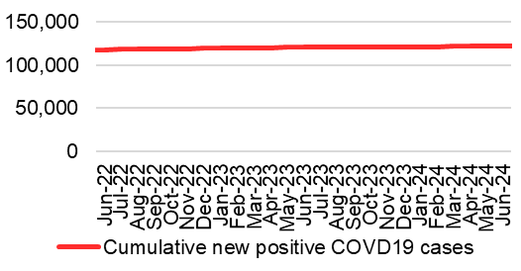 |  | 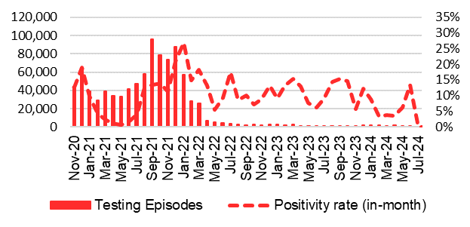 |  | 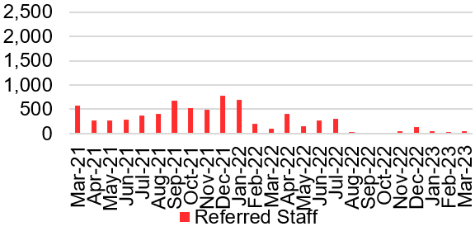
Chart 5: Outcome of staff COVID19/ antigen tests |  | Chart 6: Number of COVID19 related incidents |  | Chart 7: Number of COVID19 related serious incidents |  | Chart 8: Number of COVID19 related complaints
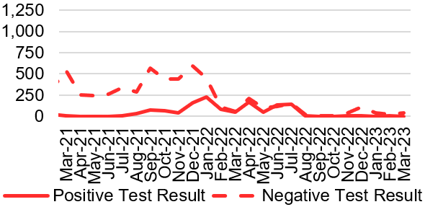 |  | 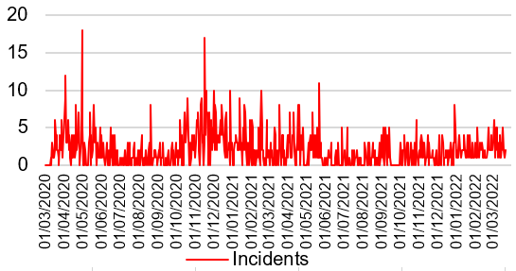 |  | 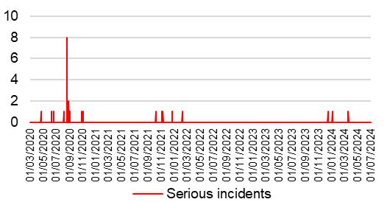 |  | 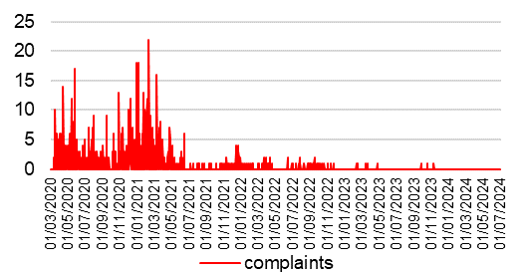
Chart 9: Number of COVID19 related risks |  | Chart 10: Number of staff self-isolating (asymptomatic) |  | Chart 11: Number of staff self isolating (symptomatic) |  | Chart 12: % staff sickness
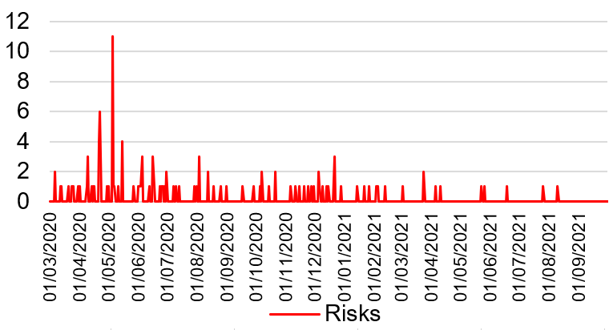 |  | 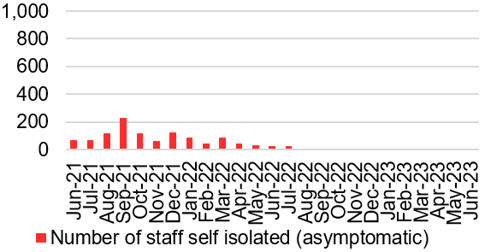 |  | 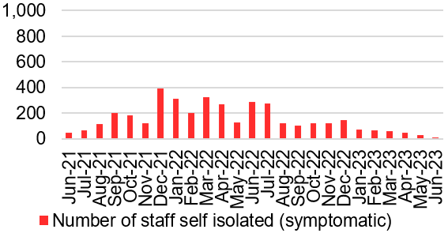 |  | 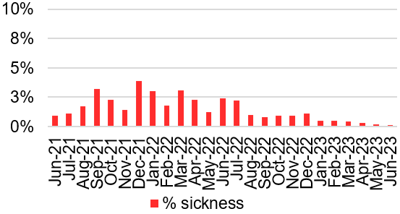
Chart 13: Bed Occupancy for suspected and confirmed COVID19 cases |  | Chart 14: Number of hospital deaths with any mention of COVID19 |  | Chart 15: Number of weekly registered deaths with any mention of COVID19 (ONS data) |  | Chart 16: Number of mortuary spaces
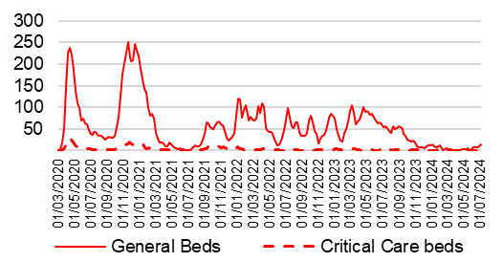 |  | 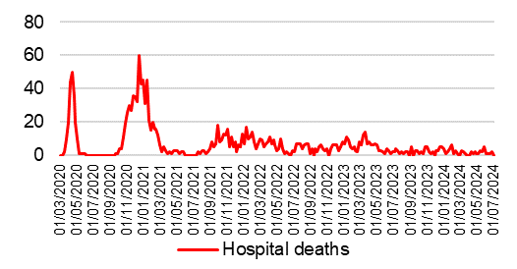 |  | 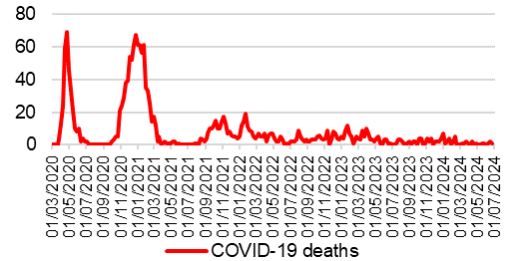 |  | 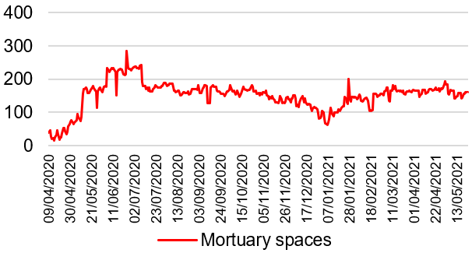

Harm from overwhelmed NHS and social care system
Unscheduled Care- Overview

Chart 1: GP Out of Hours/ 111 |  | Chart 2: % red calls responded to within 8 minutes |  | Chart 3: Number of ambulance handovers over 1 hour |  | Chart 4: Lost hours- notification to ambulance handover over 15 minutes
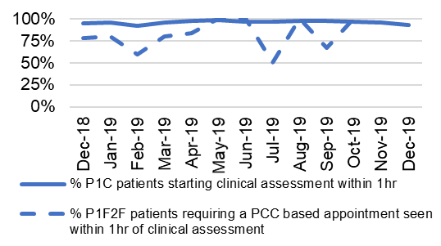  Service continues to experience issues with data reporting. It is anticipated that up to date accurate data will be available shortly. |  | 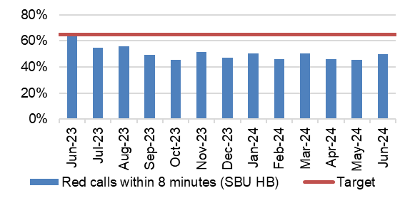
Chart 5: A&E Attendances |  | Chart 6: % patients who spend less than 4 hours in A&E |  | Chart 7: Number of patients waiting over 12 hours in A&E |  | Chart 8: Number of emergency admissions
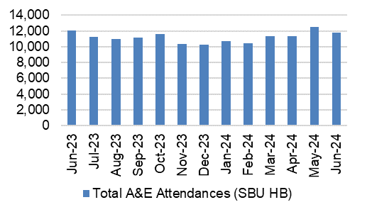 |  | 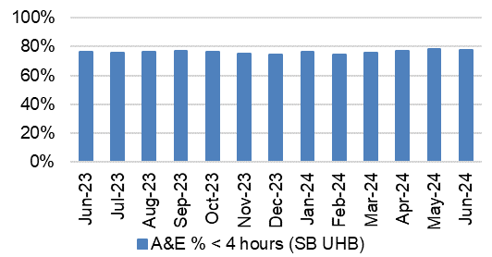 |  |  |  | 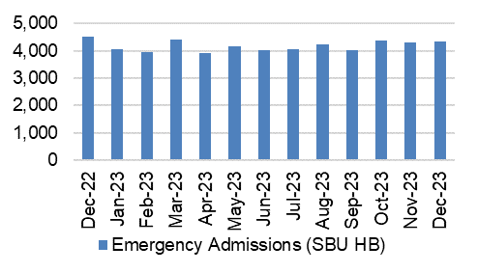
Chart 9: Elective procedures cancelled due to lack of beds |  | Chart 10: Number of clinically optimised patients |  | Chart 11: Delay reason for clinically optimised patients |  | Chart 12: Average lost bed days (per day)
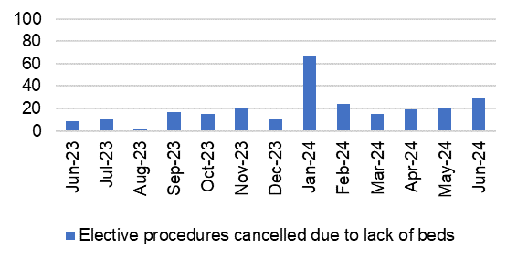 |  |  |  | 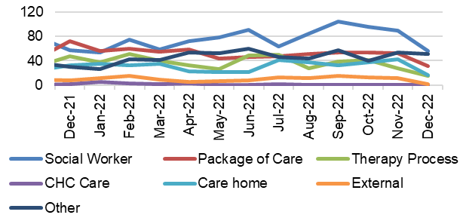 |  | 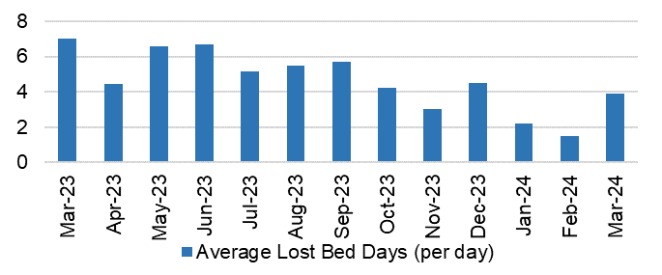
Chart 13; % of thrombolysed stroke patients with a door to door needle time of less than or equal to 45 minutes |  | Chart 14: Direct admission to Acute Stroke Unit within 4 hours |  | Chart 15: % of stroke patients receiving CT scan with 1 hour |  | Chart 16: % stroke patients receiving consultant assessment within 24 hours
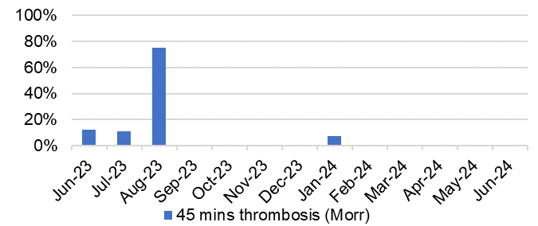 |  | 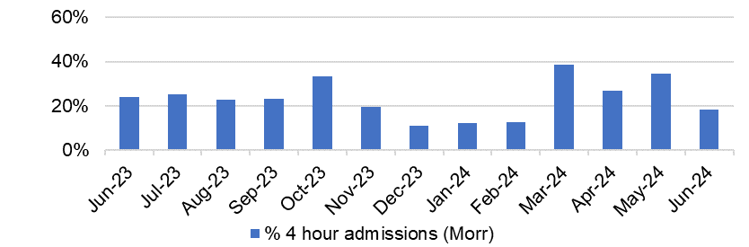 |  | 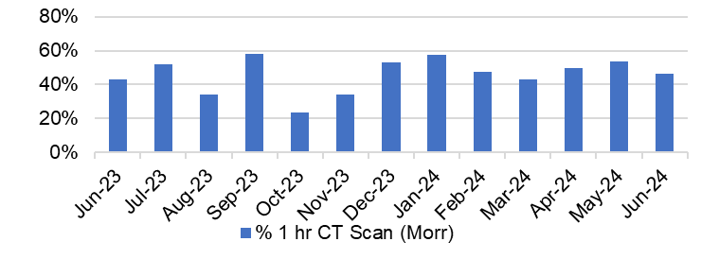 |  | 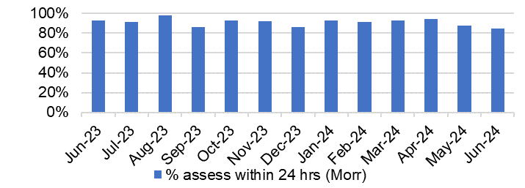
Harm from reduction in non-Covid activity
Primary and Community Care Overview

Chart 1: Total Number of patients receiving care from Eye Health Examination Wales (EHEW) |  | Chart 2: GMS - Escalation Levels |  | Chart 3: GMS - Sustainability |  | Chart 4: Number and percentage of adult dental patients re-attending NHS Primary Dental Care between 6-9 months
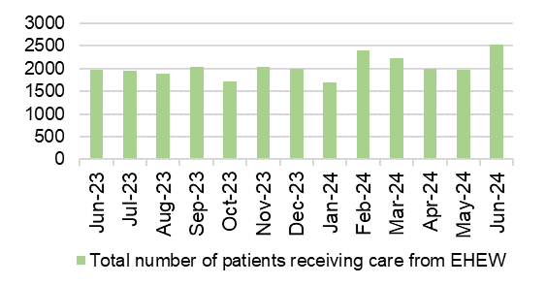 |  | 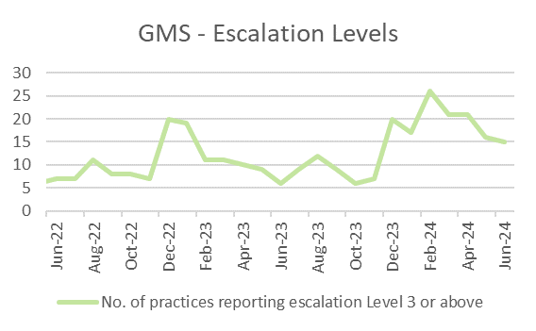 |  | 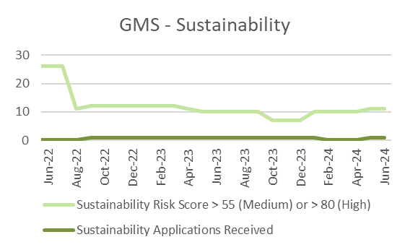 |  | 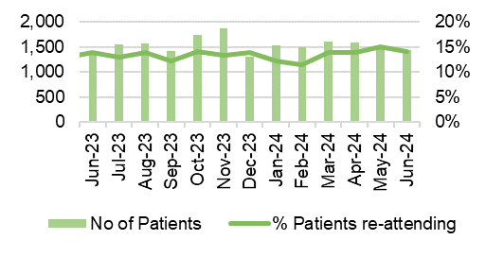
Chart 5: General Dental Services - Activity |  | Chart 6: General Dental Services - New Patients |  | Chart 7: General Dental Services - ACORNS/FV |  | Chart 8: Optometry Activity – sight tests
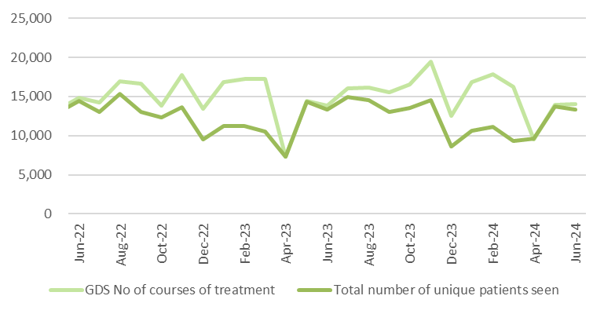 |  | 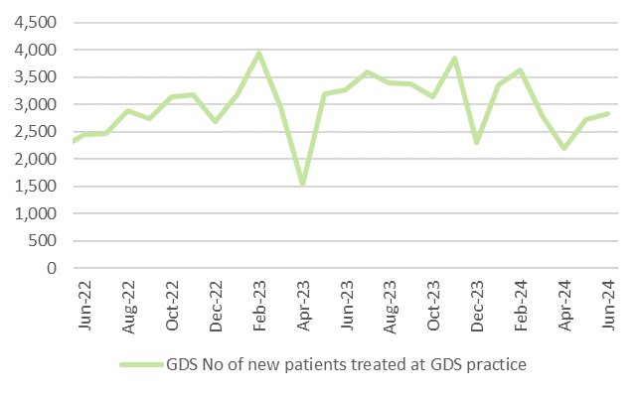 |  | 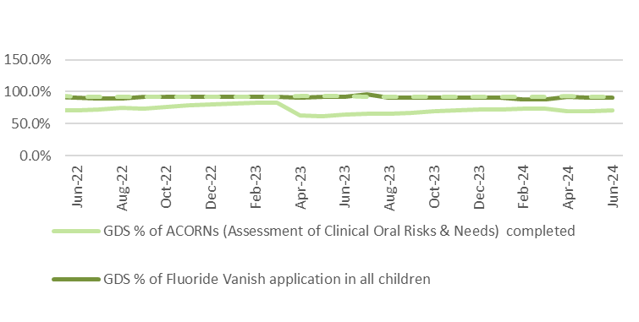 |  | 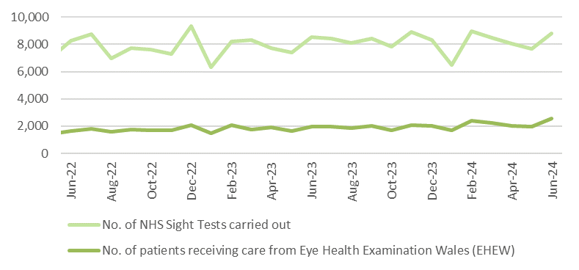
Chart 9: Optometry Activity – low vision care |  | Chart 10: Community Pharmacy – Escalation levels |  | Chart 11: Common Ailment Scheme – No. consultations provided |  | Chart 12: % of patients with a RTT (referral to stage 1) of 26 weeks or less for Restorative Dentistry
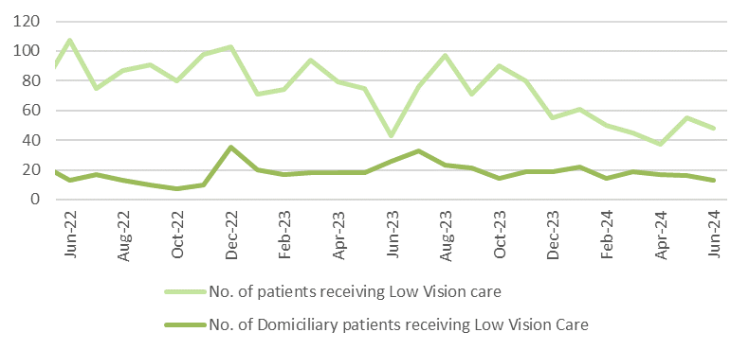 |  | 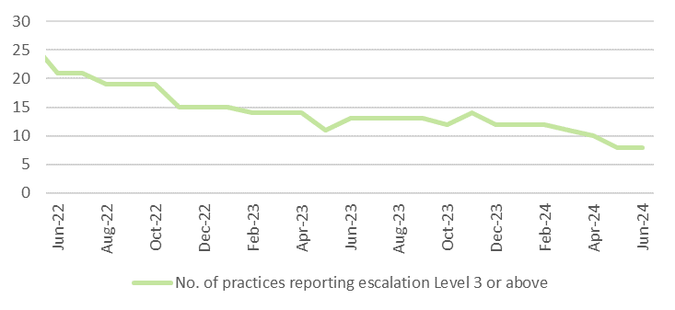 |  | 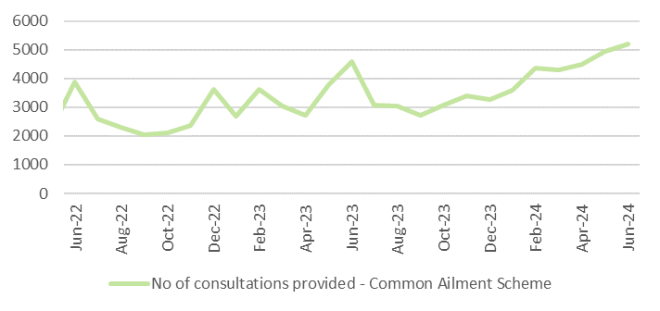 |  | 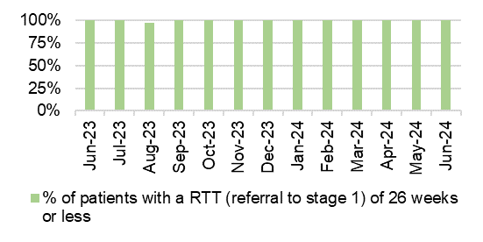
Chart 13: Podiatry - Total number of patients waiting > 14 weeks |  | Chart 14: Dietetics - Total number of patients waiting > 14 weeks |  | Chart 15: Audiology- Total number of patients waiting > 14 weeks |  | Chart 16: Speech & Language Therapy– Number of patients waiting > 14 weeks
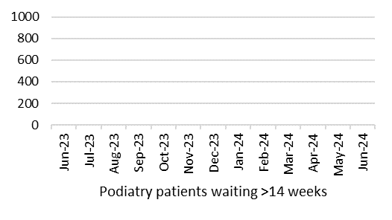 |  | 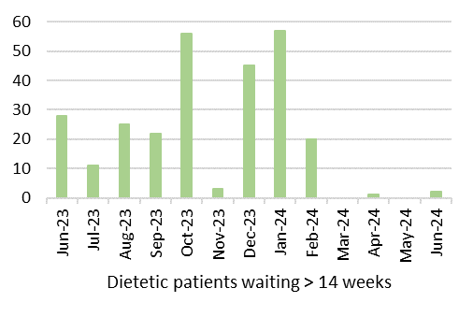 |  | 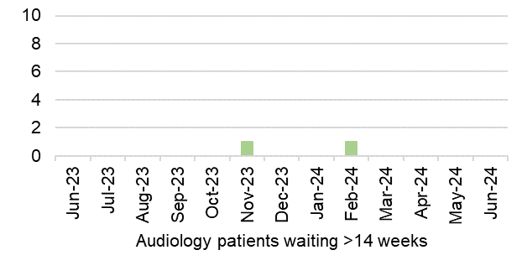 |  | 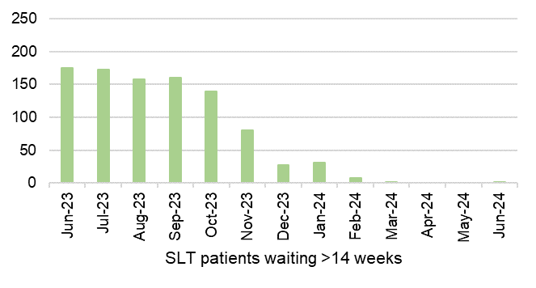
Harm from reduction in non-Covid activity
Planned Care Overview

Chart 1: Number of GP Referrals into secondary care |  | Chart 2: Number of patients waiting over 26 weeks for an outpatient appointment |  | Chart 3: Number of patients waiting over 36 weeks for treatment at stage 1 |  | Chart 4: Number of patients waiting over 52 weeks for treatment
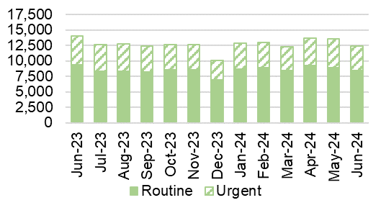 |  | 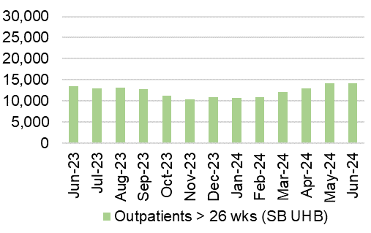 |  | 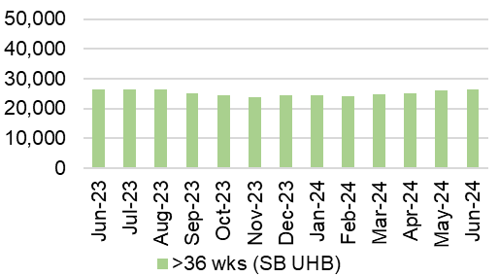
Chart 5: Number of patients waiting for reportable diagnostics over 8 weeks |  | Chart 6: Number of patients waiting for reportable Cardiac diagnostics over 8 weeks |  | Chart 7: Number of patients waiting more than 14 weeks for Therapies |  | Chart 8: Cancer referrals
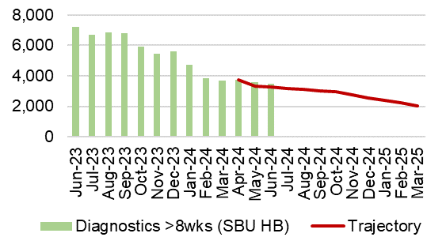 |  | 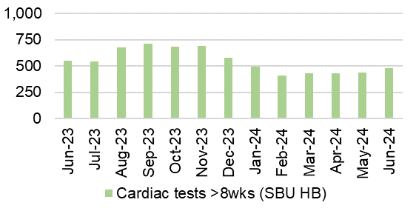 |  |  |  | 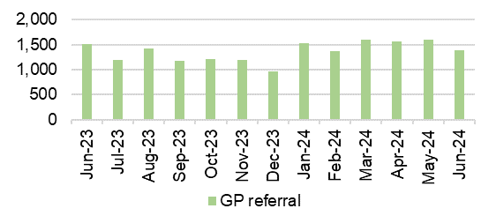
Chart 9: Single Cancer Pathway- % of patients starting definitive treatment within 62 days from point of suspicion |  | Chart 10: Number of new cancer patients starting definitive treatment |  | Chart 11: Single Cancer Pathway backlog- patients waiting over 63 days |  | Chart 12: Number of patients waiting for an outpatient follow-up who are delayed past their target date
 |  | 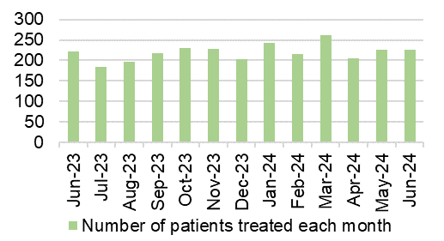 |  | 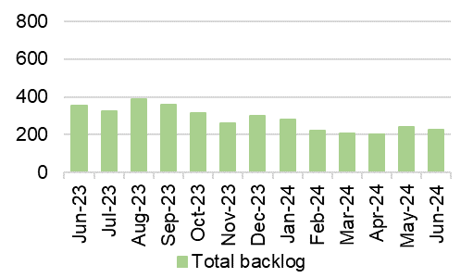 |  | 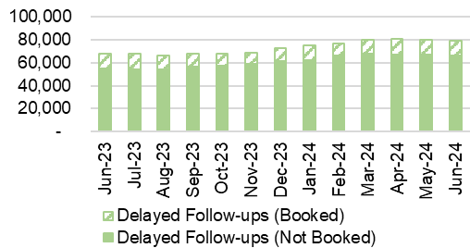
Chart 13: Number of patients without a documented clinical review date |  | Chart 14: Ophthalmology patients without an allocated health risk factor |  | Chart 15: Total number of patients on the follow-up waiting list |  | Chart 16: Number of patients delayed by over 100%
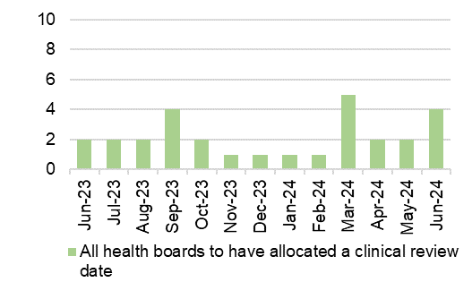 |  | 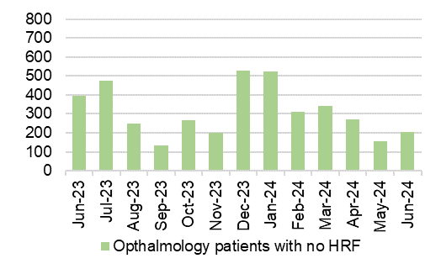 |  | 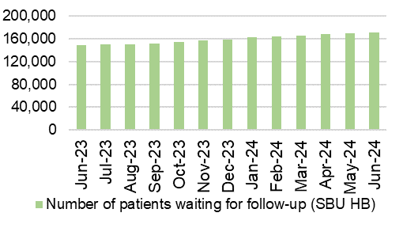
Harm from wider societal actions/lockdown

Vaccinations and Immunisations

Chart 1: % children who received 3 doses of the hexavalent ‘6 in 1’ vaccine and MenB2 vaccine by age 1 |  | Chart 2: % children who received PCV2 vaccine and Rotavirus vaccine by age 1 |  | Chart 3: % children who received MMR1 vaccine and PCVf3 vaccine by age 2 |  | Chart 4: % children who received MenB4 vaccine and Hib/MenC vaccine by age 2
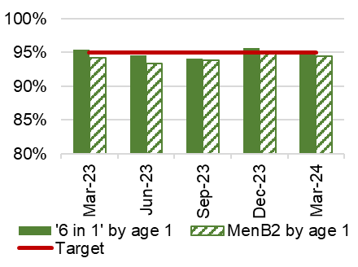 |  | 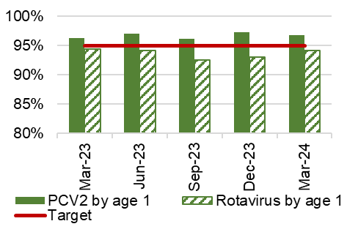 |  | 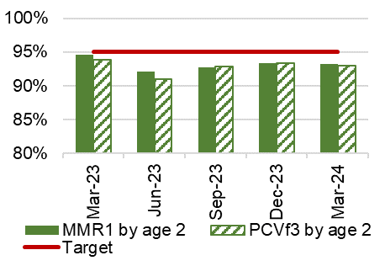 |  | 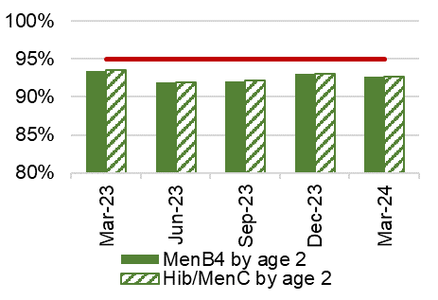
Chart 5: % children who are up to date in schedule by age 4 |  | Chart 6: % children who received 2 doses of the MMR vaccine and 4 in 1 vaccine by age 5 |  | Chart 7: % children who received MMR vaccine and teenage booster by age 16 |  | Chart 8: % children who received MenACWY vaccine by age 16
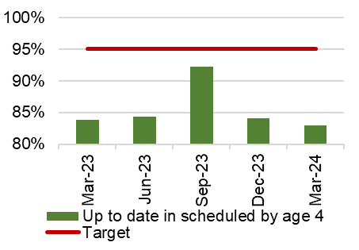 |  | 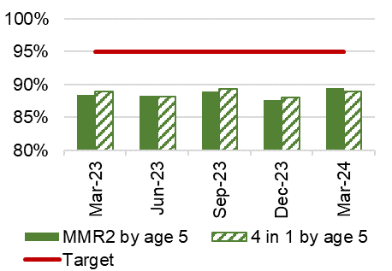 |  | 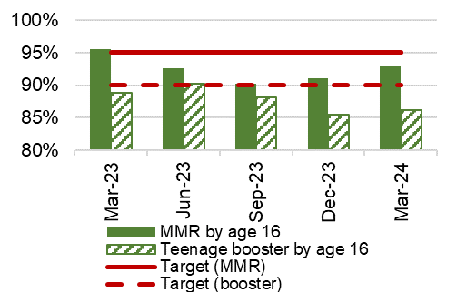 |  | 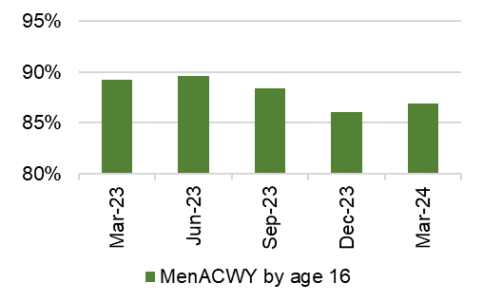
Chart 9: Influenza uptake for amongst 65 year olds and over |  | Chart 10: Influenza uptake for amongst under 65s in risk groups |  | Chart 11: Influenza uptake for amongst pregnant women |  | Chart 12: Influenza uptake for amongst healthcare workers
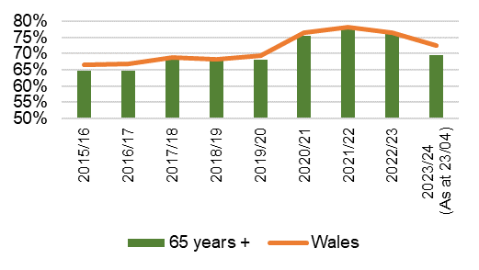  Data prior to April 2019 relates to Abertawe Bro Morgannwg University Health Board |  | 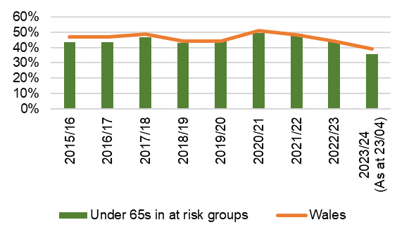  Data prior to April 2019 relates to Abertawe Bro Morgannwg University Health Board |  | 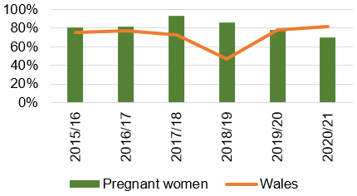  Data prior to April 2019 relates to Abertawe Bro Morgannwg University Health Board.  2021/22 data not available |  | 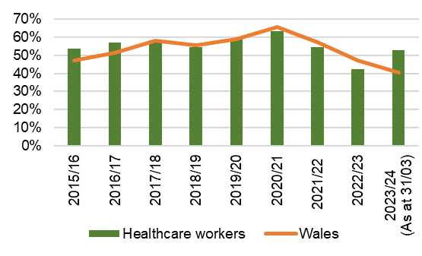  Data prior to April 2019 relates to Abertawe Bro Morgannwg University Health Board.
HArm from wider societal actions/lockdown

Mental Health Overview

Chart 1: % of mental health assessments undertaken within (up to and including) 28 days from the date of receipt of referral |  | Chart 2: % of therapeutic interventions started within (up to and including) 28 days following an assessment by LPMHSS |  | Chart 3: % of health board residents in receipt of secondary mental health services (all ages) who have a valid care and treatment plan |  | Chart 4: % of patients waiting less than 26 weeks to start a psychological therapy in Specialist Adult Mental Health
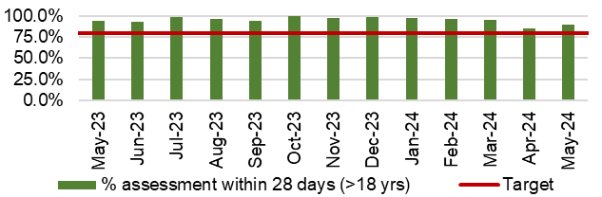 |  | 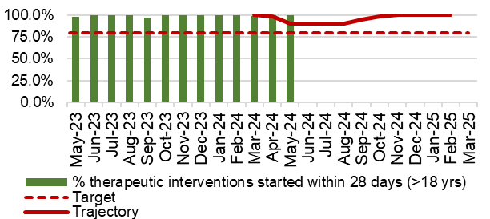 |  | 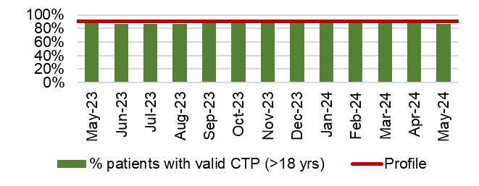 |  | 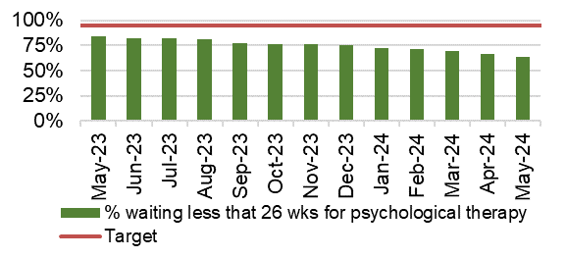
Chart 5: 95% of those admitted 0900-2100 will receive a gate-keeping assessment by the CRHTS prior to admission |  | Chart 6: 100% of those admitted without a gate keeping assessment will receive a follow up assessment by CRHTS within 24hrs of admission |  | Chart 7: % of patients waiting under 14 weeks for Therapies |  | Chart 8: Number of Mental Health Delayed Transfers of Care (DTOCs)
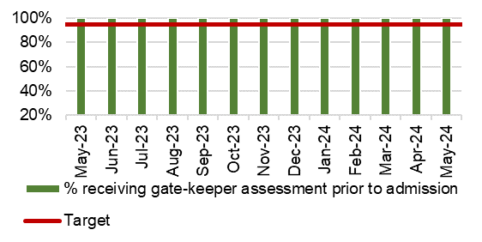 |  | 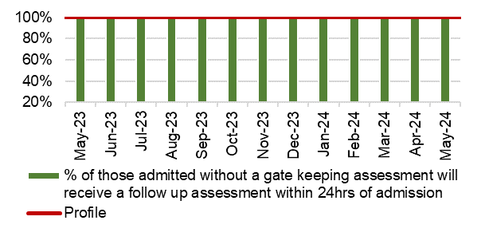 |  | 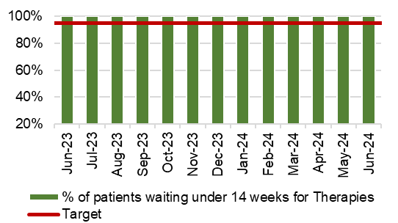 |  | 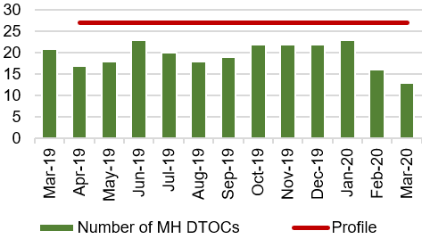
Chart 9: Number of patients detained under the Mental Health Act as a percentage of all admissions |  | Chart 10: Number of patients subject to Deprivation of Liberty Safeguards (DOLS) |  | Chart 11: Number of Nationally Reportable Incidents |  | Chart 12: Number of ligature incidents
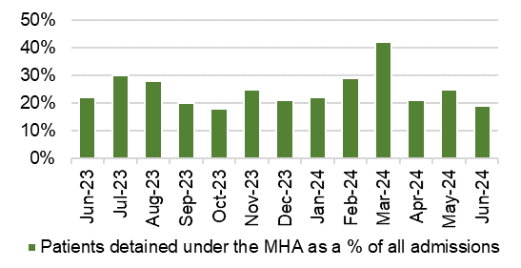 |  | 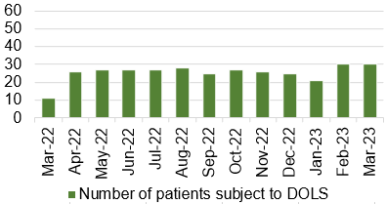 |  | 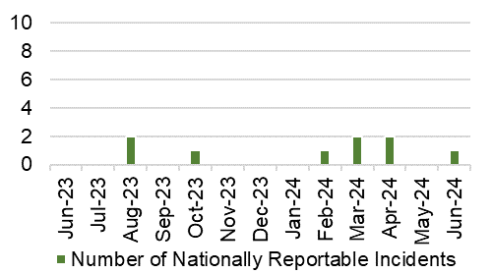 |  | 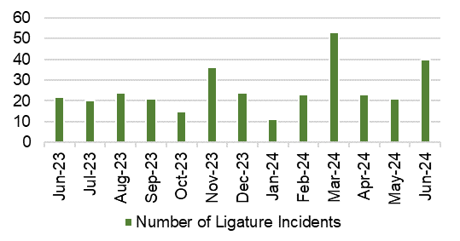
Child & Adolescent Mental Health Services (CAMHS)
Chart 13: Urgent assessments undertaken within 48 hours from receipt of referral |  | Chart 14: Neuro-developmental disorder assessment and intervention received within 26 weeks |  | Chart 15: Assessment and intervention within 28 days |  | Chart 16: % of residents with a Care and Treatment Plan
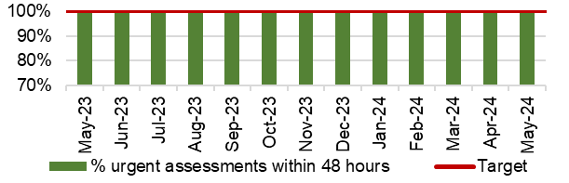 |  | 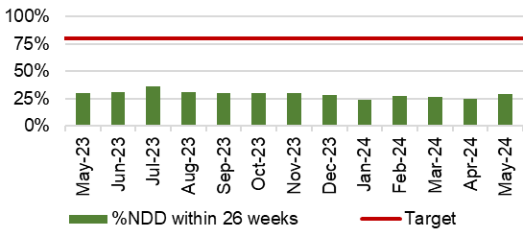
Appendix 1: INTEGRATED Performance Dashboard

