Meeting Date | 27th March 2025 |  | Agenda Item |  |  | 3.2
Name of Meeting | Health Board
Report Title | Final Draft Annual Plan 2025/26
Report Author | Ruth Tovey, Head of Strategic Planning  Ffion Ansari, Head of IMTP Development and Implementation  Karen Stapleton, Deputy Director of Planning and Partnerships  Samantha Moss, Deputy Director of Finance
Report Sponsor | Marie Davies, Executive Director of Planning and Partnerships
Presented by | Marie Davies, Executive Director of Planning and Partnerships
Freedom of Information | Open
Purpose of the Report | The purpose of this report is to ask the Board to receive the Health Board’s Annual Plan for 2025-26 and to consider and agree the recommendations as described.
Key Issues | - Work has progressed at pace to finalise the Annual Plan 2025/26 since the last report to Board. The Board has been kept updated on, and engaged in, the development of the Plan through ongoing briefing and development sessions.  - The planning process has been designed with a focus on recovery, sustainability and delivery of financial control, performance in targeted intervention areas and delivery of safe services.  - The key Delivery Actions in the Annual Plan have been subject to a robust prioritisation approach undertaken to focus and refine priorities for service change through criticality and feasibility and aligned to the Health Board’s Risk Register. Delivery Actions have also been mapped to Ministerial Delivery Expectations 25/26 and Cabinet Secretary Enabling Actions.  - The financial outlook is challenging and the forecast for 2025/26 does not meet target control total. An ambitious savings target of £55.4m has been set and support is required to de-risk the savings plan whilst also growing a savings pipeline.  - This Plan represents the best considered position of the Board at this time and the Board very clearly acknowledges that it must go further in 2025/26 to improve the financial forecast.
Specific Action Required  (please choose one only) | Information | Discussion |  | Assurance | Approval
Specific Action Required  (please choose one only) | ☐ | ☐ |  | ☒ | ☐
Recommendations | Members are asked to:  - ACKNOWLEDGE the progress made to finalising the draft Annual Plan 2025/26.  - ACKNOWLEDGE the risks to delivery and mitigation actions in place.  - ACKNOWLEDGE the significant efforts on the part of budget holders and Service Groups across the Health Board, both to secure the 2024/25 year-end position, and to identify major savings for 2025/26;  - CONSIDER AND ACCEPT the advice from the Performance and Finance Committee on the level of confidence around the savings identified to date in the 2025/26 plan; that the quantum of savings requirement is the optimum in terms of financial stretch at this time, with the need for more choices/decisions in 2025/26 to reduce risk in the current plan and make inroads into the forecast deficit;  - AGREE that further options and choices are required to make improvements of scale and at pace in 2025/26  - AGREE that external support be actioned to reduce risk in the plan, improv the forecast and identify pipeline savings to improve future year forecasts  - AGREE that the Board will continue with its detailed scrutiny on a weekly, fortnightly and monthly basis, at both informal and formal Performance and Finance Committee meetings.  - TAKE ASSURANCE that the work in hand to drive down costs will continue at pace from 1 April 2025 with further governance, grip and control enhancements to be added in 2025/26.  - RECOGNISE that the position in terms of financial forecast is not acceptable, as it does not meet the target control total.  - CONCLUDE that the 2025/26 Annual Plan cannot be approved, but that its submission to WG is for scrutiny and assessment purposes in the knowledge that further work is required.

SUBMISSION OF FINAL DRAFT ANNUAL PLAN 2025-26

- INTRODUCTION
This paper aims to present the Health Board’s 2025/26 Annual Plan and seeks the Board’s support to submit the plan to Welsh Government for further assessment and discussion in line with the recommendations outlined.

- BACKGROUND
The Health Board has a statutory duty to have an Integrated Medium-Term Plan (IMTP). It is recognised that the delivery of the 2025/26 plan does not get us to the financial position expected of us by Welsh Government, and therefore the requirement is for us to submit an Annual Plan, with a clear trajectory to get to a sustainable financial position where we are in financial balance, with the opportunity to reshape where we invest our resources - recognising the need for greater focus on illness prevention, managing wellbeing and building capacity in neighbourhood-based services for local communities.

  - Strategic Context
The Plan is underpinned by three key drivers:

- Responding to the health needs of our population which are significant in some communities – where life expectancy and healthy live years lived are deteriorating in some populations. We know that many families are struggling in the current economic climate – and the impact of the changes at Tata Steel are significant – which impacts on peoples' health and wellbeing. We also have high rates of death from suicide and substance use which we are committed to tackling with partners.
- Delivering the Cabinet Secretaries priorities: improving access for planned care, emergency and urgent care, cancer care and mental health; improving women's health services recognising the inequalities that exist; increasing the focus on illness prevention and building our capacity in community-based services.
- Continuing progress against our five strategic objectives on our journey to deliver excellent services for our patients, and support communities to live well

To achieve the Health Board’s aim of being a resilient, financially sustainable and responsible organisation, the Plan must set out a pathway to sustainability. It is imperative that the Health Board continues to drive productivity and efficiency to achieve financial grip and control, while simultaneously seeking transformational solutions to address the challenges in both service delivery and population health and wellbeing. The Plan has therefore been developed on the basis that actions we take must fall into the below three categories.

- Financial grip and control
- Short term service change and safe services
- Long term sustainability

As such, the Annual Plan 25/26 is set in a three-year context that enables us to develop our strategic direction while focussing on our immediate priorities that will establish the foundations for success

2.2 Planning Process and Overview
Our framework for planning and delivery is described in the diagram below. It aims to ensure that the actions we take culminate to deliver our strategic objectives.

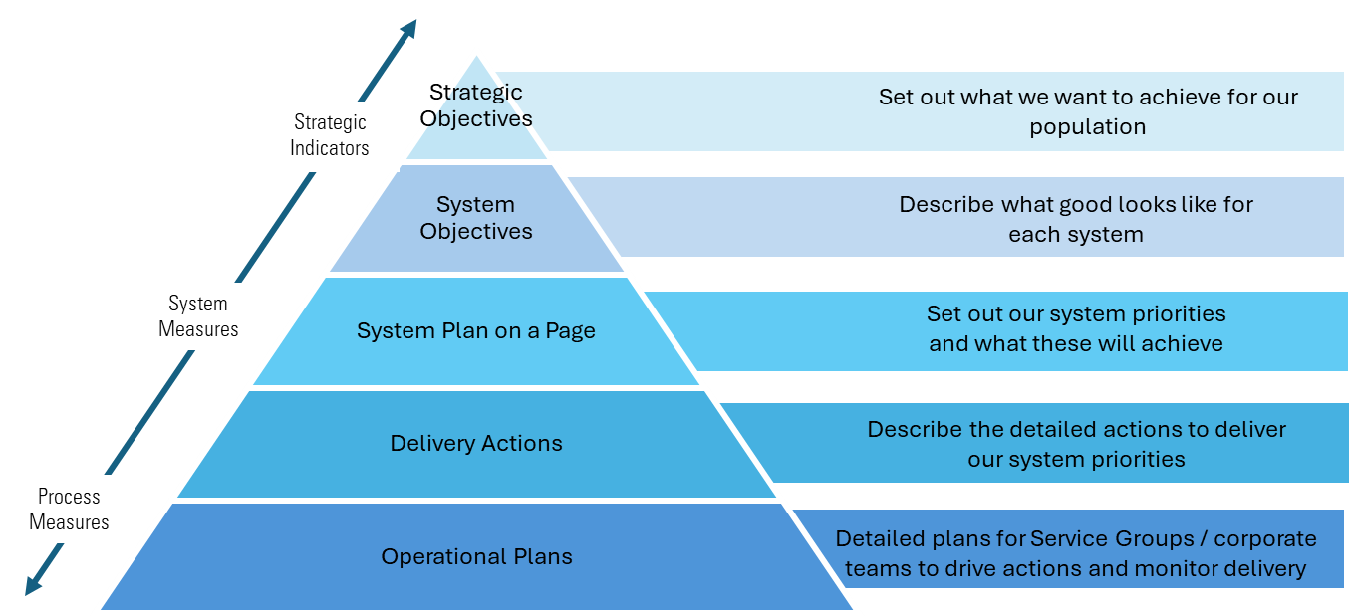

The Plan is divided into 'system areas'; Primary and Community Care, Unscheduled Care, Planned Care, Cancer, Mental Health, Learning Disabilities, Women’s Health, Maternity and Neonatal, and Children and Young people.

Our objectives for each system are set out, aligned to six of the core domains of quality and our strategic objectives. These objectives describe what good looks like for patients and the public. Aligned to these objectives are how we will measure delivery and where our actions will get us in terms of improved performance.

System 'Plans on a Page' have been developed which describe the critical priorities that will be delivered in 2025/26 and things we need to do to deliver them. Delivery Actions presented which describe in more detail the specific actions we will undertake in 2025/26 across Service groups and corporate teams.

These Delivery Actions have been through a thorough scrutiny process conducted with extensive senior leadership engagement and are fully aligned to our Financial, Workforce Digital and Capital plans. All actions in the plan have been aligned to the Welsh Government Enabling Actions and Delivery Expectations.

- GOVERNANCE AND RISK ISSUES
Our Plan is informed by our risks and challenges. Our highest risks to delivery are in unscheduled care, cancer care and in achieving financial sustainability. The required prioritisation of these areas was reinforced through our planning processes and our immediate actions and the way in which we will manage delivery are reflective of their importance.

We are also highly cognisant of the challenges faced across maternity, neonatal and mental health services and these areas will require specific, enhanced focus this year to ensure continued improvement in the quality of services delivered for our population.

We will also respond to the recommendations of the Ministerial Advisory Group when they are fully published and will identify actions that to address the issues raised.

The Annual Plan will form the basis of the work programme for the Board, its Committees and Management Board. Detailed work will be undertaken during April 2025 to further refine and quantify the outcomes and milestones of the plan and clearly set out accountability arrangements for delivery.

- FINANCIAL IMPLICATIONS
A detailed financial assessment has been made of the three main components of the financial plan for 2025/26: -

- Run rate pressures into 2025/26 from 2024/25
- Impact of additional forecast cost increase for growth, inflation and demand changes in 2024/25 in light of the Welsh Government allocation of 1.77%
- Savings framework

The combination of increased operational expenditure seen in 2024/25 and the use of non-recurrent options to mitigate in year pressures has led the organisation to a significant underlying run rate carrying from 2024/25 into 2025/26. This has been assessed as £92.5m following “bottom up” analysis from individual budget holders correlated with a “top down” assessment exercise.

In 2025/26 the Health Board has assessed the new costs in year of £36.9m offset by Welsh Government allocation increase of £15.2m (1.77%).

The Cost-Up assessment building in national and local growth, alongside inflation and changes to the commissioning contracts has been undertaken through a combination of: -

- Collaborative work with other Health Boards to test and challenge the assumptions;
- Nationally agreed rates for inflation;
- Directed changes to areas like the Welsh Risk Pool;
- LTA discussions with all commissioners;
- Detailed clinical assessment of areas such as NICE.

The Health Board welcomes the planning assumption additional funding will be provided by WG for the impact of the 2025/26 Pay Award and for the changes in Employers National Insurance Contributions from April 2025.

This presents a net pressure in-year for 2025/26 of £21.7m.

The organisation has set an ambitious savings delivery target of 5% for 2025/26 recognising that the starting position for the year is not acceptable. 5% is considered to be the maximum deliverable savings level in a financial year.

After inclusion of the 5% (£55.4m) savings requirement, the closing assessed Plan for 2025/26 of £58.7m deficit remains in excess of the forecast closing position from 2024/25; this is also in excess of the Health Board’s Target Control Total of £17m. The Health Board clearly recognises that this financial profile is not acceptable or supportable, but at this stage represents the health Board’s considered position. The Health board fully agrees that it must go further, quicker in 2025/26.

In terms of a three-year outlook, a summary of the financial outlook for Years 2025/26 – 2027/28 is provided in the table below:

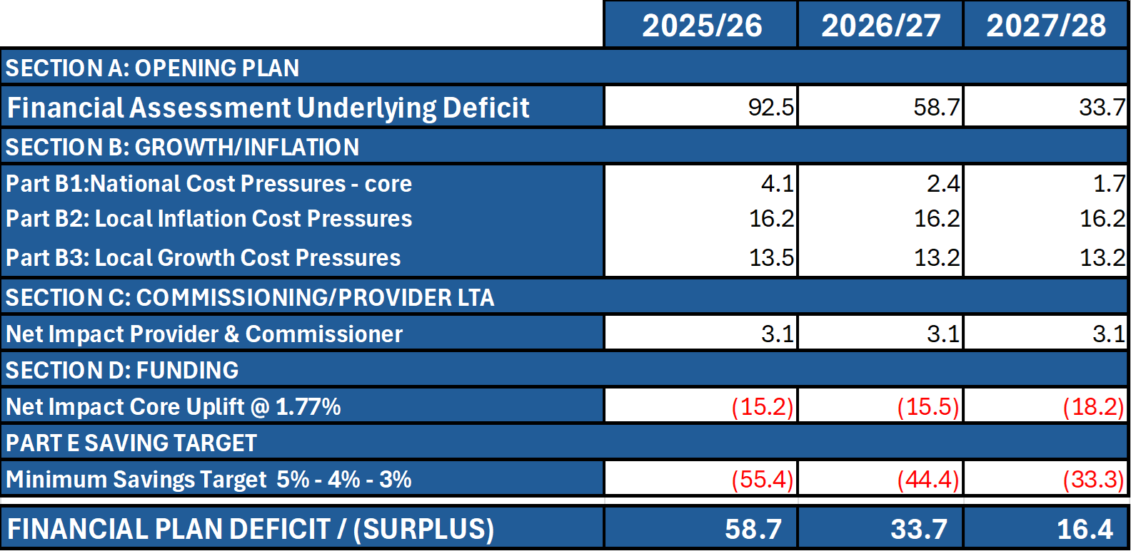

This outlook assumes allocations and wage award funding are broadly the same as 2025/26 and that cost pressures and service growth are also broadly stable. Savings delivery is adjusted to 4% and 3% for future years to account for deliverability after 5% in year 1.

A significant amount of work has been carried out by budget holders across Service Groups and Corporate Directorates in 2024/25 to enable line of sight to the forecast outturn of £43.7m for 2024/25. From a savings perspective this represents a major challenge for 2025/26; however, there is significant opportunity across the Health Board to deliver savings at scale.

- A first wave of savings of circa £14m has been identified for 2025/26
- 29 further schemes have been identified and are currently being costed
- £28.9m of benchmarked opportunities for further savings will be issued to budget holders for action

Whilst this action is welcome and positive this does not give delivery confidence yet on the £58.7m deficit plan or assurance on further identification of savings at pace and scale. The Health Board would benefit from external support to help with this acceleration and testing of existing schemes to increase delivery confidence in the plan and for it to be taken further. Discussions are ongoing with Welsh Government in this regard.

Internal governance arrangements have been strengthened and clarified with clear executive leadership and regular twice monthly reporting and monitoring regime in place. The Recovery and Sustainability Programme has been refreshed for 2025/26, reflecting on the learning from 2025/26 and further team resource has been allocated to strengthen it. Oversight of the plan and its delivery remain a primary matter for the Performance and Finance Committee (PFC) which is a direct sub-committee of the Full Board. Sufficient time will be given at these meetings with PFC meeting twice a month at present to scrutinise, challenge and support delivery plans.

A test as to the efficacy of this would also be welcome through the external support under discussion. The diagram below illustrates the clear framework for plan delivery.

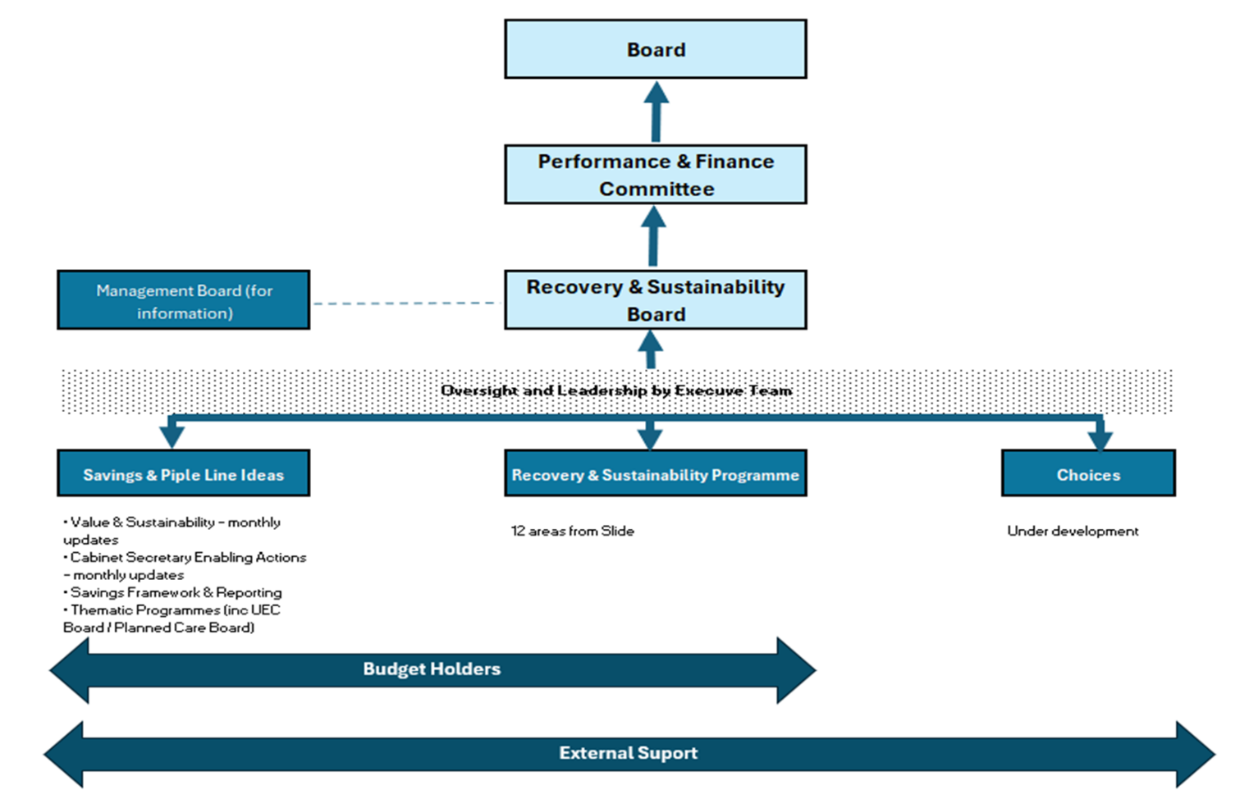

On the basis of the current financial profile the Health Board is maintaining its control system from 2024/25 into 2025/26 in terms of vacancy freeze and variable pay controls. The Health Board has further strengthened its governance arrangements and has clear Executive leadership through the Recovery and Sustainability Programme. There is absolute clarity that more is needed to reduce risk in this base plan, improve upon it and support is necessary to achieve the scale and pace required. It is acknowledged at this point that the plan cannot be approved and needs to be further worked through following submission, assessment and scrutiny by Welsh Government.

- RECOMMENDATIONS
Members are asked to: -
- ACKNOWLEDGE the progress made to finalising the draft Annual Plan 2025/26.
- ACKNOWLEDGE the risks to delivery and mitigation actions in place.
- ACKNOWLEDGE the significant efforts on the part of budget holders and Service Groups across the Health Board, both to secure the 2024/25 year-end position, and to identify major savings for 2025/26;
- CONSIDER AND ACCEPT the advice from the Performance and Finance Committee on the level of confidence around the savings identified to date in the 2025/26 plan; that the quantum of savings requirement is the optimum in terms of financial stretch at this time, with the need for more choices/decisions in 2025/26 to reduce risk in the current plan and make inroads into the forecast deficit;
- AGREE that further options and choices are required to make improvements of scale and at pace in 2025/26.
- AGREE that external support be actioned to reduce risk in the plan, improve the forecast and identify pipeline savings to improve future year forecasts
- AGREE that the Board will continue with its detailed scrutiny on a weekly, fortnightly and monthly basis, at both informal and formal Performance and Finance Committee meetings.
- TAKE ASSURANCE that the work in hand to drive down costs will continue at pace from 1 April 2025 with further governance, grip and control enhancements to be added in 2025/26.
- RECOGNISE that the position in terms of financial forecast is not acceptable, as it does not meet the target control total.
- CONCLUDE that the 2025/26 Annual Plan cannot be approved, but that its submission to WG is for scrutiny and assessment purposes in the knowledge that further work is required.

Governance and Assurance

Link to Enabling Objectives  (please choose) | Supporting better health and wellbeing by actively promoting and empowering people to live well in resilient communities
Link to Enabling Objectives  (please choose) | Partnerships for Improving Health and Wellbeing |  | ☒
Link to Enabling Objectives  (please choose) | Co-Production and Health Literacy |  | ☒
Link to Enabling Objectives  (please choose) | Digitally Enabled Health and Wellbeing |  | ☒
Link to Enabling Objectives  (please choose) | Deliver better care through excellent health and care services achieving the outcomes that matter most to people
Link to Enabling Objectives  (please choose) | Best Value Outcomes and High Quality Care |  | ☒
Link to Enabling Objectives  (please choose) | Partnerships for Care |  | ☒
Link to Enabling Objectives  (please choose) | Excellent Staff |  | ☒
Link to Enabling Objectives  (please choose) | Digitally Enabled Care |  | ☒
Link to Enabling Objectives  (please choose) | Outstanding Research, Innovation, Education and Learning |  | ☒
Health and Care Standards
(please choose) | Staying Healthy |  | ☒
(please choose) | Safe Care |  | ☒
(please choose) | Effective Care |  | ☒
(please choose) | Dignified Care |  | ☒
(please choose) | Timely Care |  | ☒
(please choose) | Individual Care |  | ☒
(please choose) | Staff and Resources |  | ☒
Quality, Safety and Patient Experience
No direct implications of this report, however the Plan is predicated on improving quality, safety and patient experience.
Financial Implications
No direct financial implications of this report, see financial implication section for detail on the Finance Plan.
Legal Implications (including equality and diversity assessment)
A Quality Impact Assessment and Equality Impact Assessment process will be part of the broader planning arrangements to ensure that service models detailed in the Plan are quality and equality/ diversity impact assessed.
Staffing Implications
No direct impact outlined in this report however there will be significant staffing implications as a result of new service models outlined in the Annual Plan – risks and implications to workforce form an integral part to planning arrangements.
Long Term Implications (including the impact of the Well-being of Future Generations (Wales) Act 2015)
The Annual Plan aims to deliver our Strategic Objectives which were aligned to our Wellbeing Objectives through the development of the Organisational Strategy. This paper sets out the alignment of the approved Health Board Wellbeing Objectives directly to the Annual Plan Deliverables.
Report History |  | First version of this report
Appendices |  | Appendix 1: Final Draft Annual Plan 2025/2026

