

Meeting Date | 27 March 2025 |  | Agenda Item |  | XX
Report Title | Financial Report – Month 11 2024/25
Report Author | Samantha Moss, Deputy Director of Finance  Rebecca Hayes, Assistant Director of Finance  Gemma Pearson, Finance Business Partner
Report Sponsor | Darren Griffiths, Executive Director of Finance and Performance
Presented by | Darren Griffiths, Executive Director of Finance and Performance,
Freedom of Information | Open
Purpose of the Report | The report advises the Board of the Health Board’s financial position for Month 11 (February 2025) and sets out the actions being undertaken to improve forecast financial performance.
Key Issues | The report invites the Board to consider the detailed analysis of the financial position for Month 11 (February 2025).  The report includes details on the revenue position both in month and Year To Date (YTD) and the forecast year-end revenue position based on current planning assumptions.  The report describes the actions being undertaken to de-risk the financial forecast and improve the outturn position in year, alongside setting out actions for recovery and sustainability of financial performance.  The report invites the Board to note the Cash position, key Balance Sheet movements and the Capital position.
Specific Action Required  (please choose one only) | Information | Discussion | Assurance | Approval
Specific Action Required  (please choose one only) | ☒ | ☐ | ☒ | ☒
Recommendations | Members are asked to: -  - CONSIDER and comment upon the Board’s financial performance for Month 11 2024/25 (Revenue and Capital)  - TAKE ASSURANCE from the further actions taken to ensure delivery of the financial assessment presented on 19th December 2024, with a line of sight to £43.7m, supported by the Recovery & Sustainability Board.  - CONSDER the balance sheet at Month 11.  - CONSIDER the cash forecast at 31 March 2025.  - SUPPORT the position with regard to the risk scores.  - CONSIDER all actions and updates to support the management of the 2024/25 financial position.
FINANCIAL REPORT – MONTH 11

- INTRODUCTION
The report invites the Board to note the detailed analysis of the Month 11 (February 2025) revenue financial position, along with Cash and Capital.

- BACKGROUND
  - The Health Board has two key statutory duties to achieve:

- To submit an Integrated Medium-Term Plan (IMTP) to secure compliance with breakeven over 3 years.

2022/23 3-year plan approved
2023/24 3-year plan submitted
2024/25 3-year plan submitted

The Health Board will fail to meet this in 2024/25 as its plan will not breakeven over 3 years.

- To achieve financial breakeven over a rolling three-year period, which commenced on 1st April 2022 and will end on 31 March 2025.

2022/23 Breakeven position achieved
2023/24 Deficit Control Total £17.1m achieved
2024/25 Deficit Plan £43.7m

The Health Board will fail to achieve this Statutory Duty.

  - Summary of Performance against Key Financial Targets

Financial KPIs: To ensure that net operating costs do not exceed the revenue resource limit set by Welsh Government | Value  £’000
Reported in-month financial position – deficit/(surplus) | (0.652)
Reported cumulative financial position – deficit/(surplus) | 47.004
Capital KPIs: To ensure that costs do not exceed the capital resource limit set by Welsh Government | Value  £’000
Reported year to date financial position – deficit/(surplus) | (1.495)
Forecast outturn financial position – deficit/(surplus) (prior to additional allocations) | 0
PSPP Target: To pay a minimum of 95% of all non NHS creditors within 30 days of receipt of goods or a valid invoice | Value  %
Cumulative year to date % of invoices paid within 30 days (by number) – Quarter 3 | 96.1

- FINANCIAL PLAN 2024/25
On the 26 September 2024 the Health Board submitted a revised Financial Assessment for 2024/25. The assessment and accompanying letter summarised a high degree of confidence in the delivery of £64.1m deficit position by the 31 March 2025, with further opportunities of £13.3m giving the Health Board line of sight to £50.8m. Recognising the risks around the delivery of the £50.8m but with a line of sight to £50.8m the forecast remained at £50.1m. In early December 2024 Welsh Government (WG) issued an additional £6.4m of recurrent funding to the Health Board, which has reduced the deficit plan to £43.7m.

On the 19 December 2024 a Special Board meeting was provided with an assessment of the position based on the information available following Month 8 closedown. In summary the financial assessment showed a possible outturn to end March 2025 of £57.9m, with a gap to the deficit plan figure of £14.3m. Full details of the work underway to mitigate the £14.3m were presented to the Board.

Since the meeting on the 19 December 2024 there have been five Recovery & Sustainability Board meetings, which have focused primarily on driving down the in-year overspend to support the delivery of the deficit plan of £43.7m. Further details on the Recovery & Sustainability Board meetings are presented to the Performance & Finance Committee in a separate paper, and the updated forecasts from these meetings are used to support the financial assessment summarised in the table below referred to as the ‘Performance Against £43.7m: Bottom-Up Assessment’

The assessment of the Month 11 position identified a number of opportunities which supported the position achieving £0.652m under in month. Some of these opportunities were known and were simply a change in the phasing from Month 12 to Month 11, whilst others were further non-recurrent fortuitous benefits within Service Groups.

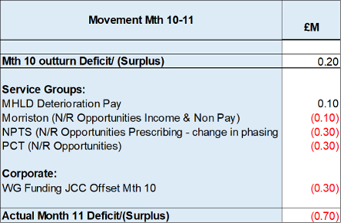

An assessment immediately following the Month 11 closedown was undertaken and builds in some of the data from the Recovery & Sustainability Board meeting held at the end of February. A summary of this assessment is provided in the table below:

Performance Against £43.7m: Bottom-Up Assessment

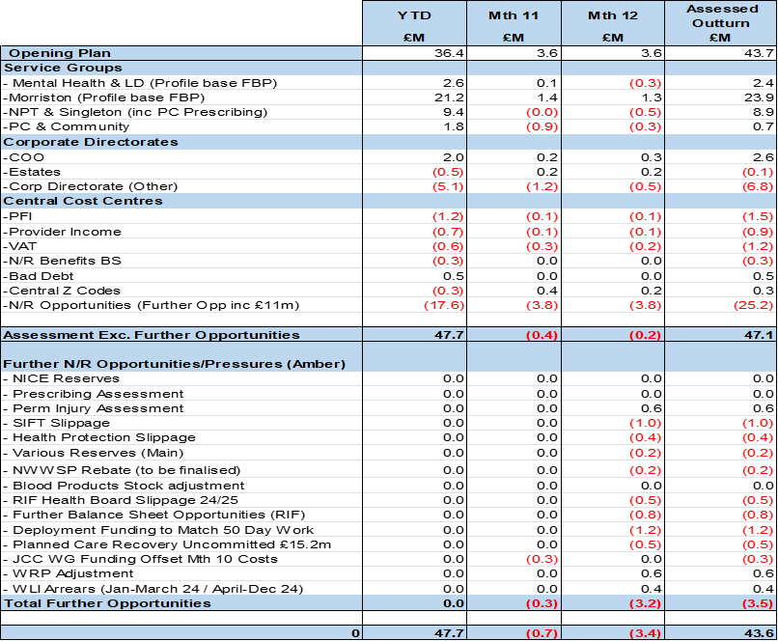

There remains a significant level of risk in the delivery of the 2024/25 plan, which has been summarised in the monthly MMR Letter to WG and in the Performance & Finance Committee paper. Of note, whilst it is not explicit within the above table, a reduction in run rate spend remains critical for two reasons:

• Some of the N/R Opportunities are an assessment and if you applied a RAG rating most would be Amber as opposed to Green; as the value is not confirmed and there are risks in the delivery.

• Run rate reductions in 2024/25 will flow into 2025/26, when the N/R Opportunities from this financial year will no longer be available. Therefore a reduction in run rate will be critical to deliver the 2025/26 Financial Plan.

- FINANCIAL PERFORMANCE – MONTH 11
The key metrics linked to the revenue position are provided in Table 2 below and in Appendix 1 of this report.

Summary Revenue Performance

Graph 1 & 2 Summary Revenue & Savings

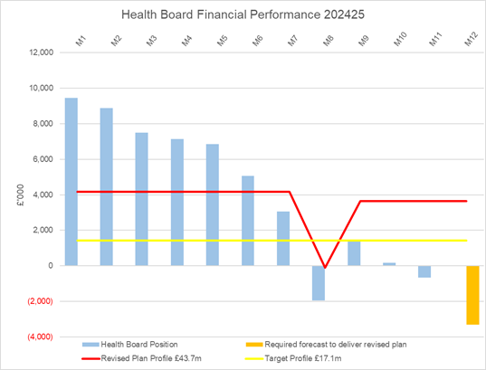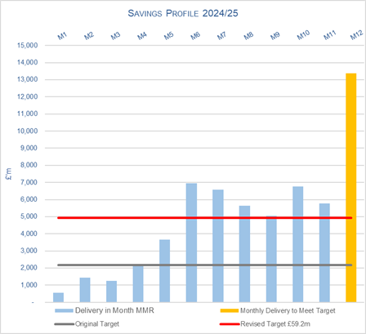

Table 1: Key Revenue Metrics
Target | In Month  £’m | Year To Date (YTD)  £’m
Delivery Against Revenue Resource Limit (RRL) DEFICIT / (SURPLUS) | (0.652) | 47.004
Performance Against Plan DEFICIT / (SURPLUS) | (4.294) | 6.942

In summary, the Month 11 financial position was £0.7m underspent; this was £4.3m better than the revised planned deficit for the month, which is a requirement given the year-to-date deficit of £47.0m exceeds the end of year deficit of £43.7m.

The Month 11 position is an improvement of £0.9m compared to Month 10, however this is due to a combination of the release of central non-recurrent opportunities (part of the £25m) earlier than originally phased and Service Group non-recurrent fortuitous benefits and does not reflect the operational improvements needed within services to both support run rate for 2024/25 and 2025/26.

At Month 11 the Health Board (HB) is £47.0m overspent against cumulative deficit plan of £40.1m YTD. The key drivers of the Month 11 and YTD position are summarised in the tables below.

Table 2.1: Key Drivers by Service Area Month 11
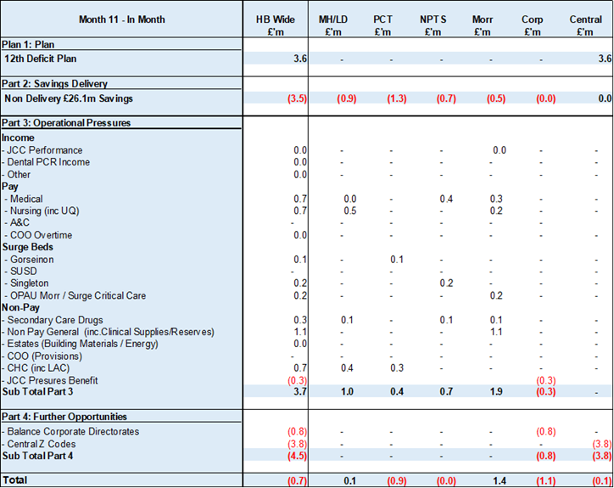

Table 2.2: Key Drivers by Service Area YTD @ End Month 11

Key points of notes by type spent:
- Income
The Joint Commissioning Committee (JCC) Income as a provider underperformed in-month with increased activity in Cardiology services offset by decreased activity in Burns services; the in-month underachievement was £0.1m. The YTD underachievement is £0.3m.

Dental Contract Income underperformed in-month by £0.1m, with an YTD underachievement of £1.1m.

- Pay
The Month 11 pay overspend was £2.1m (Month 10, £0.8m), this was again largely due to a continuation of surge bed capacity required, staff sickness absence and acuity in Critical Care. The YTD pay pressures are driven by a number of factors including the continuation of staffing surge bed capacity, pressures on services across the organisation and high levels acuity, coupled with high levels of sickness.

- Clinical Consumables
This area continues to be a pressure with an in-month position of £1.8m (Month 10, £1.1m). There are 80+ subjective lines within this category including secondary care drugs but areas seeing most pressures YTD continue to be general consumables (M&SE), laboratory products and implants (which in part will be driven by activity).

- Prescribing
Prescribing is providing a £0.7m underspend in-month following receipt of the latest datasets and there is a YTD underspend of £1.4m. We have at this point received 9 months of PAR data. The YTD data is below the anticipated levels at this point in the year and therefore a larger element of this anticipated benefit has been recognised in-month. The Pharmacy team are expecting potential further reductions linked to Cat M later in the year; there is the possibility of further opportunities. The position will remain under close review pending further PAR data in the final month of the year.

- KEY AREAS OF NOTE
Further details on specific issues impacting the revenue position are provided in Appendix 1 of this report.

The section below provides an overview of the other issues influencing the delivery of the wider financial position, including Balance Sheet, Cashflow and Capital.

  - Savings

Based on the run rate reduction/savings position the schemes identified for delivery in 2024/25 by service areas are summarised below.

Table 3: All Savings

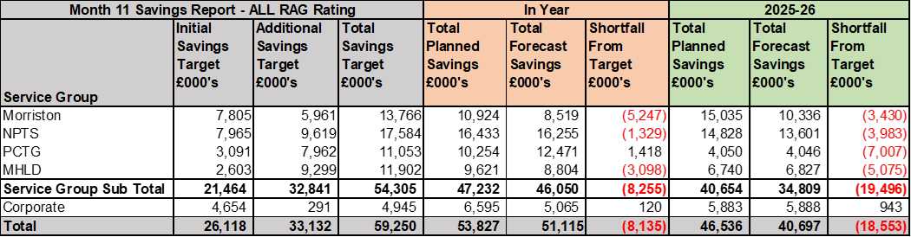
Table 3 – reflects all opportunities including those identified as Red along with pipeline ideas, which total £51.1m. In summary, the table above shows a forecast savings delivery of £51.1m in year, and £40.7m forecast recurrently which includes red schemes and those schemes in progress of being developed. For 2024/25, against a target of £59.2m, this delivers a shortfall of £8.1m. Recurrently, there is a shortfall of £18.6m, to meet the required £59.2m target.

Table 4: Green & Amber Savings

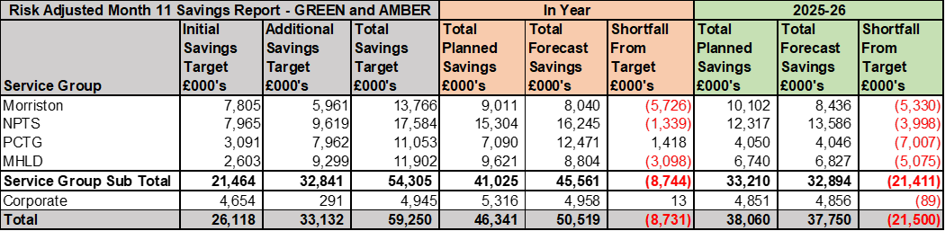

Table 4 – reflects only those opportunities which are deemed Green and Amber schemes. As a result, the overall total reduces to £50.5m at end of February, which leaves £8.7m to meet the £59.2m 2024/25 target. Recurrently, there is a shortfall of £21.5m to meet the required £59.2m target

  - Capital
The approved Capital Resource Limit (CRL) value issued on 28 February is £52.192m. The approved CRL value includes Discretionary Capital, schemes under the All-Wales Capital Programme and new/renewal IFRS 16 Leases.

Outturn Performance
The forecast outturn shows a balanced position.

The following allocations are classed as risks.
Scheme | £m / Risk Level | Narrative
EFAB | 0.396 / High | Scheme slippage to be managed by the Health Board
Year-End Funding – October 2024 | 0.230 / High | Scheme slippage to be managed by the Health Board.

All other schemes are low risk, and any variances are linked to planned contributions from discretionary and in some instances payback of prior year fees.

Capital Disposals
There is one further planned property disposal this year for Phillips Parade with expected sale proceeds of £0.275m.
Onerous Contracts
For Month 11 an additional entry has been included in the MMR submission for AME Impairment funding based on the assessed value completed in early March for the Onerous Contract provision required in the 2024/25 Annual Accounts. This provision relates to the national RISP work and ongoing issues linked to the new Phillips provider and the extension of the original Fuji contract agreed by the Health Board. This approach was adopted by several Health Boards in 2023/24. The final assessment of the AME requirement will be completed in the next 2 weeks, however confirmation of the final AME funding is not confirmed until mid-April 2025.

  - Balance Sheet
The key issues in respect of the statement of financial position movements are as follows:

- The inventory value has decreased from £11.426m at the end of January 2025, to £10.891m at the end of February 2025, a decrease of £0.535m.

- There has been a decrease in trade receivables from £303.246m at the end of January 2025 to £288.793m at the end of February 2025 a decrease of £14.453m. This is due to a decrease within WRP (Welsh Risk Pool) Debtors of £3m, a decrease in NHS Debtors and income accruals of £11.334m.

- The closing February 2025 cash balance of £9.834m is greater than the range of the Health Board target of a cash balance of £2.5m at month end and greater than the best practice cash target for Health Board of £6m. Due to the early reduced cash position expected in March, this was a deliberate action to hold more cash as a closing balance for February 2025.

- The trade and other payables figure saw a decrease from £247.019m at the end of January 2025 to £239.906m at the end of February 2025, a decrease of £7.113m. This relates to decreases in NHS and non NHS accruals of expenditure.

- Provisions decreased by £2.756m from £221.131m at the end of January 2025 to £218.375m at the end of February 2025. This movement relates to 24 legal cases, with a range of impact on the provisions totalling £2.756m. These movements are directed by the monthly quantums, and the changes in probability.

  - Cash
As at the end of February 2025, the Health Board had a cash balance of £9.834m, which is greater than the Health Board target of a cash balance of £2.5m at month end and greater than the best practice cash target for the Health Board of £6m. Due to the early reduced cash position expected in March, this was a deliberate action to hold more cash as a closing balance for February 2025.

The original cash request to WG is as follows, with a revision for the Strategic Cash support in line with a revised forecast financial position:
- Strategic Cash Support - £43.7m (revised from £50.1m)
- Working Capital Cash Support - £33.7m, detailed below

Following daily detailed reviews of cashflow, the forecast at Month 11 shows a revised working capital cash requirement of £19m, reduced from £33.712m.

With the expected strategic cash support of £43.7m, we would anticipate a closing cash position of £4.650m for end of March 2025, as detailed in the table below, against maximum best practice value of £6m:

The difference between the £4.650m forecast cash surplus and the Forecast I&E deficit Cash figure, reflects the £9.307m of capital cash to reimburse revenue CRL, the requested Strategic and working capital cash support from WG, and the movement in the working capital balances.

Therefore, the timing of receiving this funding is key because this directly impacts when the Health Board cash position will deteriorate, so an early indication of when the Health Board expects to receive some of the larger sums of outstanding funding from WG has been requested.

The cash flow is updated daily and a full review of the cash forecast is currently being undertaken weekly, to ensure that any changes to the cash requirements, can be communicated in a timely manner to WG.

  - Public Sector Payment Policy (PSPP)
The Health Board achieved the 95% PSPP target the % of Non-NHS Invoices Paid within 30 Days in Quarter 3 with compliance being 96.3% for the quarter, resulting in a YTD compliance of 96.1%.

NHS payment compliance for invoices paid within 30 days was, however, was below 95% with the Quarter 3performance being 85%. The Health Board remains focussed on improving PSPP compliance for NHS invoices and ensuring that performance remains above 95% for Non-NHS invoices.

Further updates will be reported at the end of Quarter 4.

- RISKS (Revenue Income & Expenditure)

Two Board level financial risks:

- Achieving financial plan (HBR92) with the key elements as follows: -

- Risk of delivery of savings quantum
- Risk of operational overspend being in excess of funding available agreed via the Financial Plan
- Risk of commitment of reserves (e.g. NICE) being above reserves available.
- Risk of achieving the actions outlined in the 2024/25 Landing Plan.

- 2024/25: Based on the financial performance at Month 11, it is proposed that the Health Board Corporate Risk Register retain the existing risk score to 25 given YTD variance from the revised deficit plan of £43.7m.

- 2025/26: An action from the January 2025 PFC was to add a supplementary note under HBRR 92 to reflect the challenges of the new financial year. At this point in the planning process the risk score would be 25 for a number of reasons:

  - Within 2024/25 a significant amount of Non recurrent opportunities have been deployed, these will not be available in 2025/26.
  - There is currently limited traction on the change in run rate spend in 2024/25, which will be needed in 2025/26 to address the deficit and allow the Health Board to achieve the WG Target Control Total of £17m.
  - Current plan requires a significant level of recurrent savings for which the Health Board does not yet have a clear plan on how this will be met.

- Availability of capital (HBR93). This risk was re-opened in 2022/23 given the reduction in discretionary capital allocation. Whilst work is underway to manage schemes to reduce commitments in 2024/25 and to produce a balanced plan, the risk varies during the year as more details on schemes emerge and potential slippage funding is made available by Welsh Government. A paper was received by PFC in December 2024 to consider the current capital position. This paper described a balanced position. Whilst the delivery of the balanced position is reliant on a large number of actions being delivered, the plan has evolved to have less risk in it given the success of bids made for substantial sums of capital being received in year.

There is no change to this assessment at the end of Month 11 and it is therefore proposed that the score remains at 12 to reflect major consequence and possible likelihood at this time and aligned to that reported to PFC in December 2024.

- RECOMMENDATIONS
Members are asked to: -
  - CONSIDER and comment upon the Board’s financial performance for Month 11 2024/25 (Revenue and Capital)
  - TAKE ASSURANCE from the further actions taken to ensure delivery of the financial assessment presented on 19 December 2024, with a line of sight to £43.7m, supported by the Recovery & Sustainability Board.
  - CONSDER the balance sheet at Month 11.
  - CONSIDER the cash forecast at 31 March 2025.
  - SUPPORT the position with regard to the risk scores.
  - CONSIDER all actions and updates to support the management of the 2024/25 financial position.

Governance and Assurance

Link to Enabling Objectives  (please choose) | Supporting better health and wellbeing by actively promoting and empowering people to live well in resilient communities
Link to Enabling Objectives  (please choose) | Partnerships for Improving Health and Wellbeing |  | ☐
Link to Enabling Objectives  (please choose) | Co-Production and Health Literacy |  | ☐
Link to Enabling Objectives  (please choose) | Digitally Enabled Health and Wellbeing |  | ☐
Link to Enabling Objectives  (please choose) | Deliver better care through excellent health and care services achieving the outcomes that matter most to people
Link to Enabling Objectives  (please choose) | Best Value Outcomes and High-Quality Care |  | ☒
Link to Enabling Objectives  (please choose) | Partnerships for Care |  | ☒
Link to Enabling Objectives  (please choose) | Excellent Staff |  | ☐
Link to Enabling Objectives  (please choose) | Digitally Enabled Care |  | ☐
Link to Enabling Objectives  (please choose) | Outstanding Research, Innovation, Education and Learning |  | ☐
Health and Care Standards
(please choose) | Staying Healthy |  | ☐
(please choose) | Safe Care |  | ☐
(please choose) | Effective Care |  | ☐
(please choose) | Dignified Care |  | ☐
(please choose) | Timely Care |  | ☐
(please choose) | Individual Care |  | ☐
(please choose) | Staff and Resources |  | ☒
Quality, Safety and Patient Experience
Financial Governance supports quality, safety, and patient experience.

Financial Implications
The Board is reporting a forecast year-end deficit financial outturn.

Legal Implications (including equality and diversity assessment)
No implications

Staffing Implications
No implications

Long Term Implications (including the impact of the Well-being of Future Generations (Wales) Act 2015)
No implications
Report History |  | Updates on the financial position are provided at every meeting.
Appendices |  | Appendix 1 – Variances by Area and Type of Spend

APPENDIX 1 – FURTHER DETAIL ON VARIANCES BY TYPE OF SPEND

- Overview Financial Position

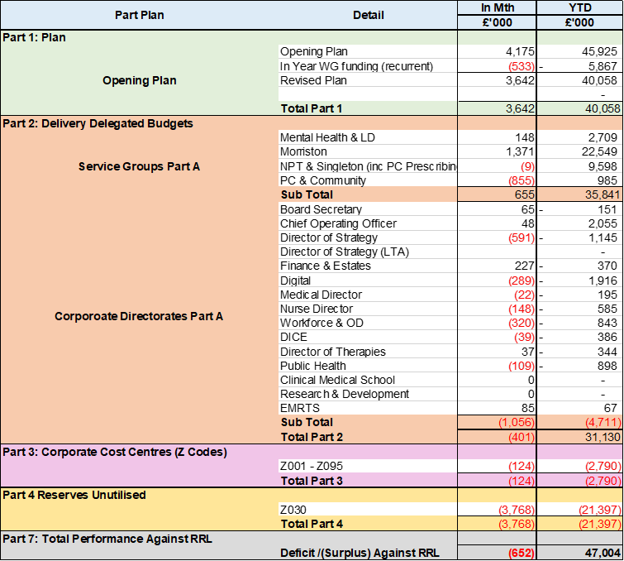

- Overview of Income

A correction was made in Month 2 to reflect the subjective being used in R&D between Income & Non-Pay totalling £3.9m
- Overview of Pay Variances

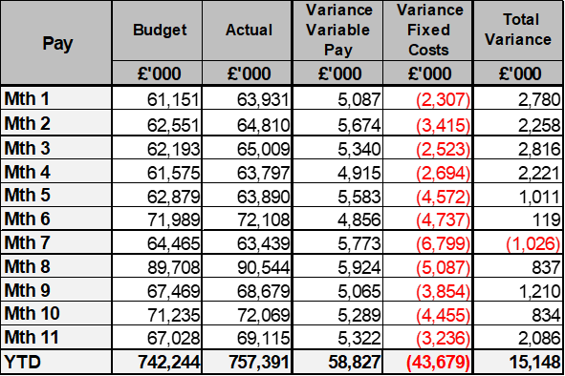

Month 8 included the year-to-date impact of the 2024/25 Pay Awards for both Agenda for Change (A4C) and Medical & Dental staff members. This has been fully funded by WG, with the exception of uplifts for Overtime as this is a type of variable pay.

Month 10 includes the year-to-date impact of the A4C Band 8a-9 increment 2024/25 Pay Award increase (which has been funded by WG), along with uplifts to the remaining Medical & Dental staff members not included in the Month 8 uplifts above (WG funding has not yet been confirmed in relation to the Month 10 Medical & Dental uplift).

Variable Pay by Quarter and type

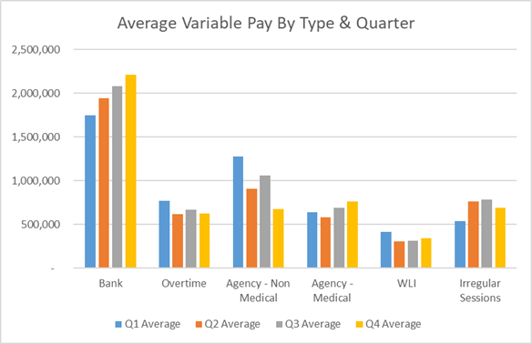

Variable Pay Spend

- Overview Non-Pay

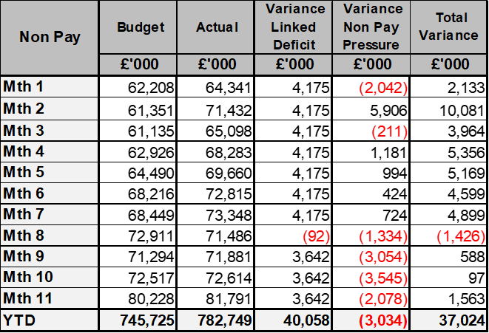

A correction was made in Month 2 to reflect the subjective being used in R&D between Income & Non-Pay totalling £3.9m

Below are further details on the key areas of non-pay:

  - Energy Forecast
Energy costs are procured via an All Wales contract, with NWSSP centrally co-ordinating forecast associated with this contract. An update was received on 10th June 2024 from NWSSP regarding the 2024/25 forecast which has been validated and included from Month 3. There have been no national changes to the forecast since Month 3 and the local team continues to work with Finance colleagues to assess the position.

  - CHC
The overall variance against budget for CHC is £0.2m underspend in-month. An analysis of actual expenditure and patient numbers for 2024/25, along with the average values from 2023/24 is provided in table below.

CHC Analysis by Month

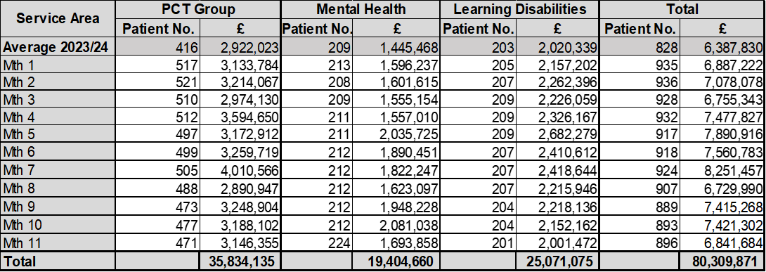

Please note:
- The above numbers include Domiciliary care cases.
- PCT Group does not include the Singleton/NPT element. The NPTS element which covers Children and Young People CHC patients is provided internally by the Health Board and as such is part of the wider NPTS position and is not recorded in the ledger as PCT/MH/LD CHC is recorded.

  - COVID Public Enquiry
The total costs for this are allocated to a dedicated Cost Centre (6F25).

The total YTD spend is £0.027m.

  - Maternity Review
In the 2024/25 Financial Plan £0.7m was set aside to support the Maternity Review. In August to improve the oversight of this area a dedicated Cost Centre was established (6F34).

The total YTD spend is £0.914m.

  - Z Codes (Section 1,3-4 Table Point 1 Appendix 1)
The narrative below groups together the key elements of the Z codes detailed in Point 1 of this appendix.

- Contracting: SLA /LTA performance: JCC (previously WHSSC), LTA and SLA contract income and expenditure are transacted within this area and financial performance reported. NICE approved high-cost drugs and associated LTA’s are also transacted and monitored against targets set. In addition to this, non-contracted activity income in relation to English foundation trusts invoiced on a quarterly basis are reported.

- Capital: The Finance Capital Team manage a number of cost centres covering the PFI, IFRS16 and Depreciation charges for assets both owned and donated are transacted here.

- RRL and Central Reserves: The WG funding received at the start of the year is tracked within this area along with the £50.1m deficit. Any anticipated allocations in year are also transaction through these codes. Other HB wide funding received from HEIW and SIFT is also captured in here. All central reserves remain within the Z cost centres and details of these are provided in Appendix 2.

- Corporate income and expenditure. Any income and expenditure that is not service group specific is transacted and reported through a number of corporate Z cost centres, examples include, payroll and pension costs, VAT recovery, losses and receipts in relation to funding from Welsh Risk Pool, overseas visitors income and Road Traffic Accident income.

  - LTA Values & Forecast performance
The table below is based on Month 8 activity undertaken by other Health Boards and Trusts for Swansea Bay residents (SBU Commissioner) and activity undertaken by Swansea Bay for residents of other Health Boards. The final impact of this will not be known until Month 12 and so a final update will be provided as part of the Month 12 reporting.

