_
Report Date | 27th March 2025 |  | Agenda Item
Name of Meeting | SBUHB Health Board Meeting
Report Title | Integrated Performance Report
Report Author | Meghann Protheroe, Head of Health Board Performance
Report Sponsor | Darren Griffiths, Executive Director of Finance and Performance
Presented by | Darren Griffiths, Executive Director of Finance and Performance
Freedom of Information | Open
Purpose of the Report | The purpose of this report is to provide an update on the current performance of the Health Board at the end of the most recent reporting period (February 2024) in delivering key local performance measures as well as the national measures outlined in the 2024/25 NHS Wales Performance Framework.
Key Issues | Note: during the drafting of this report the Health Board was notified by Welsh Government that it has been de-escalated from Targeted Intervention to Enhanced Monitoring for Planned Care and CAMHS.  The Integrated Performance Report is a routine report that provides an overview of how the Health Board is performing against the National Delivery measures and key local quality and safety measures.  Key high level issues to highlight this month are as follows: -  Unscheduled Care  - Performance against the 4-hour access has deteriorated 76.39% in January 2025 to 72.67% in February 2025.  - Performance against the 12-hour wait has deteriorated in February to 1,237 from January to 1,090.  - In February 2025, there were 554 ambulance to hospital handovers taking over 1 hour; this is a reduction of 40 compared with the previous month.  - There was a slight increase in the average number of patients who were deemed clinically optimised in February 2025 (Pathway of care delays). The average number of clinically optimised patients increased from 260 in the previous month to 268. The newly appointed Pathways of care delays lead is currently undertaking considerable work to reduce the COP figures.  Planned Care  - There were no patients waiting over 52 weeks for a first outpatient appointment in February 2025.  - At the end of February 2025, there were 291 patients waiting over 104 weeks for treatment, which is an improvement of 406 from the previous month.  - In February 2025, 97.92% of patients were waiting less than 14 weeks for therapy services; this is an improvement when compared with the figure reported in January 2025. There are 113 patients waiting over 14 weeks, the majority of which are in podiatry.  - In February 2025, there was a reduction in the number of patients waiting over 8 weeks for specified diagnostics. The position improved from 2,839 to 2,447. The breakdown is as follows: -  - Endoscopy= 2,084  - Cardiac tests= 328  - Other Diagnostics = 35^  Cancer  - The final Single Cancer Pathway (SCP) measure of patients receiving definitive treatment in January 2025 was 52%, which is lower than the figure reported in December 2024 (this measure is always reported a month in arrears due to data validation).  - 192 patients were wating in excess of 63 days as of 16/03/2025.  Mental Health  - Performance against the Mental Health Measures continues to be maintained at above target levels in February 2025 with the exception of psychological therapies.  - In January 2025, 52% of patients waited less than 26 weeks for Psychological Therapy. This was below the national target of 95%.  Child and Adolescent Mental Health Services (CAMHS)  - Access times for crisis performance has been maintained at 100% in December 2024.  - Neurodevelopmental Disorders (NDD) access times within 26 weeks continues to be a challenge, performance deteriorated to 26% in the month of February 2025.  - Note: S-CAMHS now included with P-CAMHS measure. Access to therapeutic interventions remains strong at 100% within 28 days. Access to assessment has improved in February 2025 to 74% which is now below target levels.
Specific Action Required | Information | Discussion | Assurance | Approval
Recommendations | Members are asked to:  - ACKNOWLEDGE and DISCUSS the Health Board performance against key measures and targets.  - ACKNOWLEDGE the de-escalation of planned care and CAMHS to enhanced monitoring

INTEGRATED PERFORMANCE REPORT

- INTRODUCTION
The purpose of this report is to provide an update on current performance of the Health Board at the end of the most recent reporting window in delivering key performance measures outlined in the NHS Wales Delivery Framework and local quality & safety measures.

- BACKGROUND
The NHS Wales Delivery Framework sets out measures under the quadruple aims which the performance of the Health Board is measured. The aims within the NHS Delivery Framework are:

- Quadruple Aim 1: People in Wales have improved health and well-being with better prevention and self-management
- Quadruple Aim 2: People in Wales have better quality and more accessible health and social care services, enabled by digital and supported by engagement
- Quadruple Aim 3: The health and social care workforce in Wales is motivated and sustainable
- Quadruple Aim 4: Wales has a higher value health and social care system that has demonstrated rapid improvement and innovation, enabled by data and focused on outcomes

In recent years, performance management against the Performance Framework targets has been undertaken by reviewing the previous months’ performance, to reduce the reporting function during the COVID-19 pandemic. Welsh Government have now deemed it appropriate to move away from reporting performance against the ‘Quadrants of Harm’ and focus will return to providing comprehensive performance updates in line with the All-Wales Performance Management Framework 2024/25.

- GOVERNANCE AND RISK ISSUES
Appendix 1 of this report provides an overview of how the Health Board is performing against the National Delivery measures and key local measures. Mitigating actions are listed where performance is not compliant with national or local targets as well as highlighting both short term and long terms risks to delivery.

- FINANCIAL IMPLICATIONS
At this stage in the financial year there are no direct impacts on the Health Board’s financial bottom line resulting from the performance reported herein.

- RECOMMENDATION:
Members are asked to:
  - ACKNOWLEDGE and DISCUSS the Health Board performance against key measures and targets.
  - ACKNOWLEDGE the de-escalation of planned care and CAMHS to enhanced monitoring

Governance and Assurance
Link to Enabling Objectives  (please choose) | Supporting better health and wellbeing by actively promoting and empowering people to live well in resilient communities
Link to Enabling Objectives  (please choose) | Partnerships for Improving Health and Wellbeing |  | ☒
Link to Enabling Objectives  (please choose) | Co-Production and Health Literacy |  | ☒
Link to Enabling Objectives  (please choose) | Digitally Enabled Health and Wellbeing |  | ☒
Link to Enabling Objectives  (please choose) | Deliver better care through excellent health and care services achieving the outcomes that matter most to people
Link to Enabling Objectives  (please choose) | Best Value Outcomes and High Quality Care |  | ☒
Link to Enabling Objectives  (please choose) | Partnerships for Care |  | ☒
Link to Enabling Objectives  (please choose) | Excellent Staff |  | ☒
Link to Enabling Objectives  (please choose) | Digitally Enabled Care |  | ☒
Link to Enabling Objectives  (please choose) | Outstanding Research, Innovation, Education and Learning |  | ☒
Health and Care Standards
(please choose) | Staying Healthy |  | ☒
(please choose) | Safe Care |  | ☒
(please choose) | Effective Care |  | ☒
(please choose) | Dignified Care |  | ☒
(please choose) | Timely Care |  | ☒
(please choose) | Individual Care |  | ☒
(please choose) | Staff and Resources |  | ☒
Quality, Safety and Patient Experience
The performance report outlines performance over the domains of quality and safety and patient experience, and outlines areas and actions for improvement. Quality, safety and patient experience are central principles underpinning the National Delivery Framework and this report is aligned to the domains within that framework.

There are no directly related Equality and Diversity implications as a result of this report.
Financial Implications
At this stage in the financial year there are no direct impacts on the Health Board’s financial bottom line resulting from the performance reported herein.

Legal Implications (including equality and diversity assessment)
A number of indicators monitor progress in relation to legislation, such as the Mental Health Measure.
Staffing Implications
A number of indicators monitor progress in relation to Workforce, such as Sickness and Personal Development Review rates. Specific issues relating to staffing are also addressed individually in this report.
Long Term Implications (including the impact of the Well-being of Future Generations (Wales) Act 2015)
The ‘5 Ways of Working’ are demonstrated in the report as follows:
- Long term – Actions within this report are both long and short term in order to balance the immediate service issues with long term objectives.
- Prevention – the NHS Wales Delivery framework provides a measurable mechanism to evidence how the NHS is positively influencing the health and well-being of the citizens of Wales with a particular focus upon maximising people’s physical and mental well-being.
- Integration – this integrated performance report brings together key performance measures across the seven domains of the NHS Wales Delivery Framework, which identify the priority areas that patients, clinicians and stakeholders wanted the NHS to be measured against. The framework covers a wide spectrum of measures that are aligned with the Well-being of Future Generations (Wales) Act 2015.
- Collaboration – in order to manage performance, the Corporate Functions within the Health Board liaise with leads from the Service Groups as well as key individuals from partner organisations including the Local Authorities, Welsh Ambulance Services Trust, Public Health Wales and external Health Boards.
- Involvement – Corporate and Service Group leads are key in identifying performance issues and identifying actions to take forward.
Report History |  | The last iteration of the Integrated Performance Report was presented to the Board in January 2025. This is a routine monthly report.
Appendices |  | Appendix 1: Integrated Performance Report





Appendix 1- Integrated Performance Report
March 2025


CONTENTS PAGE
 | Page number(s):
- TARGETED INTERVENTION METRICS PERFORMANCE  - Unscheduled Care  - Planned Care and Cancer  - CAMHS  - Infection Control | 11-21  12-14  15-18  19  20-21
- Updates on Key Service Areas  - Covid  - Unscheduled care  - Critical Care  - Clinically Optimised  - Elective Procedures  - Healthcare Acquired Infections  - Planned Care  - Diagnostics  - Therapies  - Cancer  - Follow-up  - Stroke  - Adult Mental Health  - Child and Adolescent Mental Health | 22-45  23  24-29  30  31  31  32-34  25-38  39  39  40-41  42  43  44  45
- NHS Delievery Framework Measures & Ministerial Priority Trajectories  - Fractured Neck of femur  - Pressure Ulcers  - Inpatient Falls  - Nationally Reportable incidents  - Discharge Summaries  - Crude Mortality  - Workforce  - Theatre Efficiency  - Patient Experience  - Complaints  - Finance | 46-55  47-48  49  49  50  Page number(s):  51  51  52  53  54  55  56-58
- Table of All Measures  - Harm From Covid  - Unscheduled Care Overview  - Primary Care & Community Overview  - Planned Care Overview  - Vaccinations & Immunisations  - Mental Health Overview | 59-65  60  61  62  63  64  65
- APPENDIX 1: INTEGRATED PERFORMANCE DASHBOARD | 66-69

- TARGETED INTERVENTION METRICS PERFORMANCE

Note: during drafting of this report the health board has been de-escalated to enhanced monitoring for planned care and camhs

URGENT AND EMERGENCY CARE
- Ambulance handovers over 1 hour  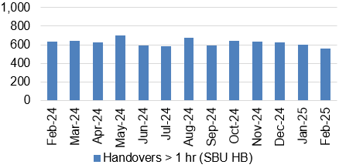  - A&E waits over 12 hours  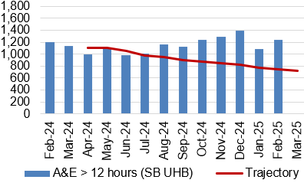  - Median time from arrival to assessment within 60 mins  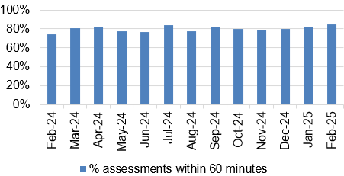  - Continuing reduction in pathway of care delays  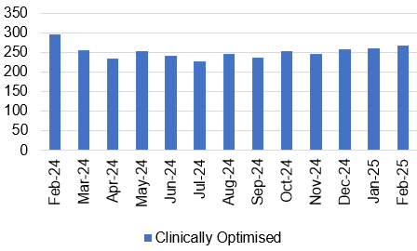  - Lost Ambulance Hours Total  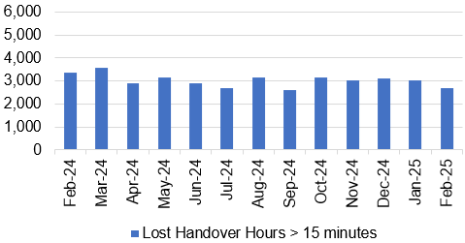  - Lost Ambulance Hours over 1 hour  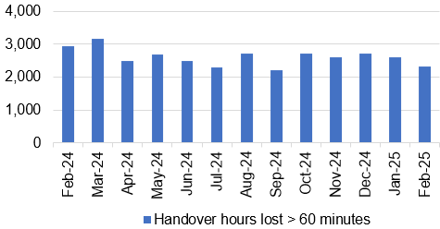 | - The number of ambulance handovers over 1 hour has reduced slightly in February 2025. The number of handovers over 1 hour decreased from 594 in January 2025 to 554 in February 2025, which is above the outlined trajectory.  - Performance against the 12-hour wait has improved in-month, and it is currently performing above the outlined trajectory. The number of patients waiting over 12-hours in the Emergency Department increased to 1.237 in February 2025 from 1,090 in January 2025.  - In February 2025 84.57% of patients received their first assessment within 60 minutes of their arrival at the Emergency Department. This is an increase of 2.5% on the figure reported in January 2025 (82.11%).  - There was an increase in the average number of patients who were deemed clinically optimised in February 2025. The average number of clinically optimised patients increased slightly from 260 in January 2025 to 268 in February 2025. The newly appointed Pathways of care delays lead is currently undertaking considerable work to reduce the COP figures.  - The ambulance handover lost hours rate has seen a slight reduction in February 2025. The ambulance handover lost hours decreased from 3,014 in January 2025 to 2,687 in February 2025.  - There has been a reduction in the number of lost ambulance hours over 1 hour in February 2025. There were 2,314 lost hours over 1 hour in February 2025 which is a reduction of 295 compared with 2,608 in January 2025.
PLANNED CARE & CANCER
- Single Cancer Pathway  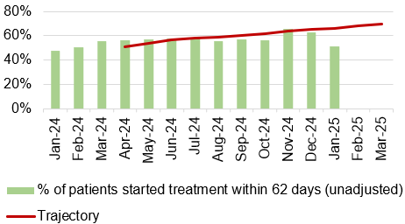  - Outpatients waiting over 52 weeks  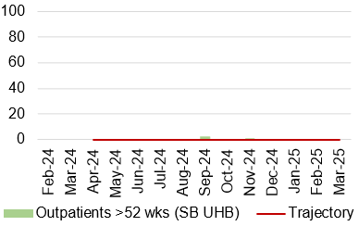  - 104 week waits – all pathways  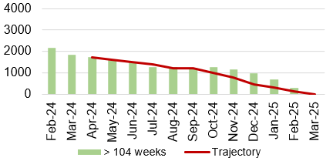  - % of patients waiting under 52 weeks (all pathways)  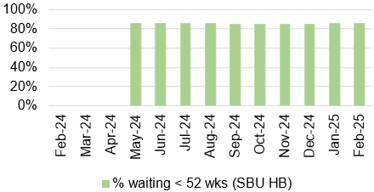  - Delayed follow ups over 100%  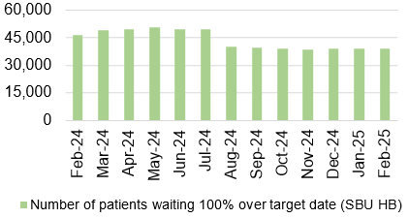  - R1 Ophthalmology  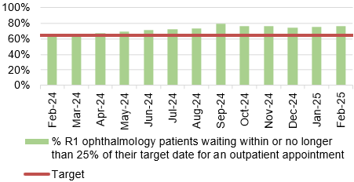  - Percentage of Patients waiting 8 weeks for a diagnostic test  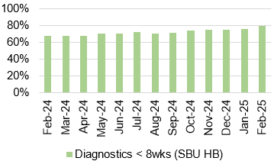  - Patients waiting 14 weeks for therapy services  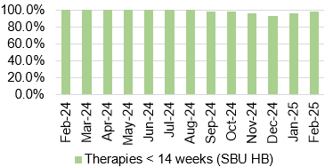 | - The final SCP performance for January 2025 was 52%, which is lower than the figure reported in December 2024. Performance is currently below the submitted trajectory (66%).  - There were no patients waiting over 52 weeks for a first outpatient appointment in February 2025.  - February 2025 saw an in-month reduction of 58% in the number of patients waiting over 104 weeks for treatment. The number decreased from 697 in January 2025 to 291 in February 2025.  - The percentage of patients waiting under 52 weeks for treatment increased slightly in-month. In February 2025 86% of patients were wating under 52 weeks, compared with 85.7% in January 2025.  - There were 38,841 patients waiting 100% over their target date in February 2025 which is a reduction when compared with January 2025.  - In February 2025, 76.1% of Ophthalmology RI patients were waiting within their clinical target date or within 25% of their target date. This is a 0.5% improvement on the figure reported in January 2025.  - In February 2025, there was an increase in the percentage of patients waiting less than 8 weeks for a diagnostic test. It was reported at 80%.  More detail on the breakdown of patients witing by diagnostic test is provided later in this report.  - In February 2025, 97.92% of patients were waiting less than 14 weeks for therapy services; this is an improvement when compared with the figure reported in January 2025. The majority of the breaches were within Podiatry – the team are currently working through a recovery plan.

CAMHS
- LPMHSS assessments with 28 days and therapeutic assessment within 28 days  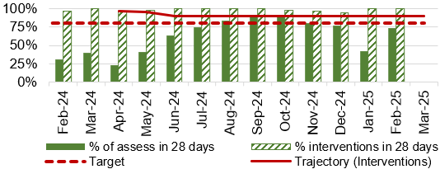  - Residents in receipt of a valid care and treatment plan  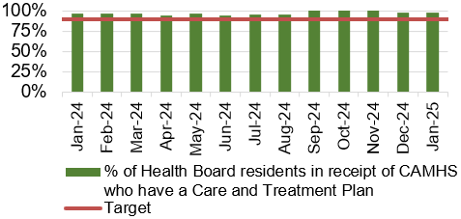 | - The percentage of routine assessments undertaken within 28 days increased to 74% in February from 42% in January 2025.  In February 2025, 100% of therapeutic assessments were undertaken within 28 days. This is above the outlined trajectory for February 2025.  - The percentage of residents in receipt of a valid care and treatment plan remained above the 90% target, achieving 98% in January 2025.
HEALTHCARE ACQUIRED INFECTIONS (HOSPITAL ONSET)
- C. Difficile  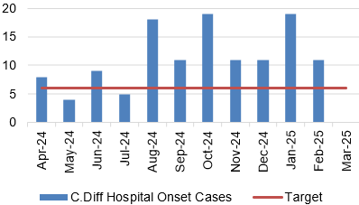  - Staph aureus  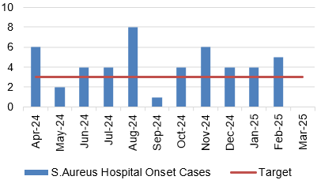  - E-coli  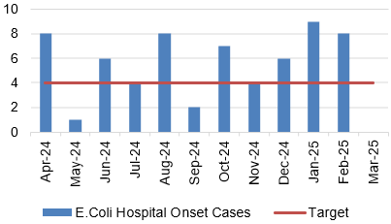  - Klebsiella  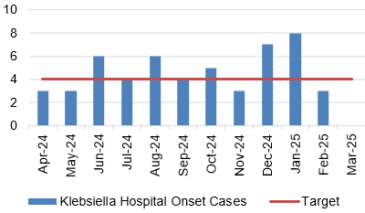 | - There were 11 hospital onset cases of C.Difficile reported in February 2025. This is lower than the figure reported in January 2025 and is above the target of a maximum of 6 cases per month.  - There were 5 hospital onset cases of Staph aureus reported in February 2025. This is the same figure reported in January 2025 and is above the target of a maximum of 3 cases per month.  - There were 8 hospital onset cases of E.Coli reported in February 2025. This is one less than the figure reported in January 2025 and is above the target of a maximum of 4 cases per month.  - The number of hospital onset cases of Klebsiella reported decreased to 3 in February 2025 from 8 in January 2025. This is below the target of a maximum of 4 cases per month.

- updates on key service areas

COVID Data
Description | Current Performance | Trend
1. Number of new COVID19 cases in Swansea Bay population area | Number of new COVID cases  In February 2025, there were an additional 25 positive cases recorded bringing the cumulative total to 121,984 in Swansea Bay since March 2020. | Number of new COVID19 cases for Swansea Bay population  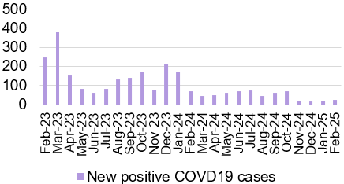

UNSCHEDULED CARE
Description | Current Performance |  |  |  |  | Actions of Improvement
Ambulance responses  1. The percentage of emergency responses to red calls arriving within (up to and including) 8 minutes.  2. The number of ambulance calls by category.  3.The percentage of emergency responses to red calls arriving within 8 minutes (last 90 days) | In February 2025, the number of red calls responded to within 8 minutes improved to 50.1% from 46.1% in January 2025. In February 2025, the number of green calls decreased by 3%, amber calls decreased by 13%, and red calls decreased by 14% compared with January 2025. |  |  |  |  | Ambulance response rates have seen a small improvement in performance in February 2025. Red and amber release escalation protocols are in place, along with a dedicated medical team in the Emergency Department to ensure timely reviews are taking place to support flow.
 | Trend
 | - % of red calls responded to within 8 minutes  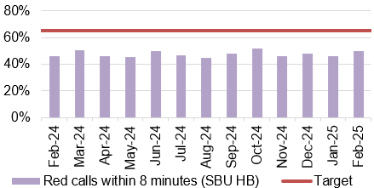 |  |  |  |  |  | - Number of ambulance call responses  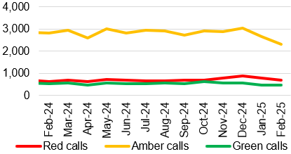
- % of red calls responded to within 8 minutes – HB total last 90 days
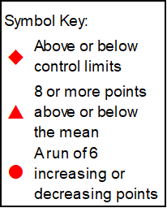
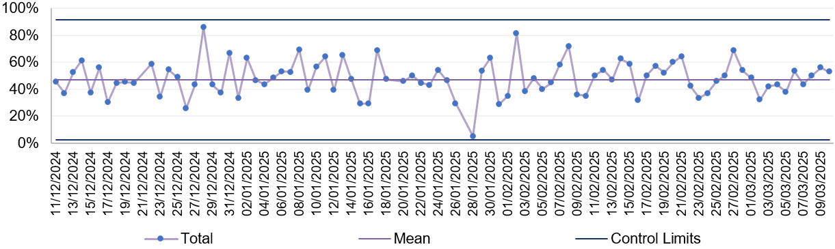
UNSCHEDULED CARE
Description | Current Performance |  |  |  |  |  | Actions of Improvement
Ambulance handovers  1.The number of ambulance handovers over one hour  2. The number of ambulance handovers over one hour- Hospital level  3.The number of ambulance handovers over one hour (last 90 days) | In February 2025, there were 554 ambulance to hospital handovers taking over 1 hour; this is a reduction of 40 compared with 594 in January 2025. In February 2025, all handovers over 1 hour were attributed to Morriston Hospital. Additional work is currently underway to incorporate the AMU data in the ambulance handover figures. |  |  |  |  |  | Transformation of the urgent care pathways has been maintained with a focus on admission avoidance and length of stay reduction. Changes to medical staff rotas are being enacted and the first phases of the frailty model have been accelerated and implemented in July 2024 to reduce conveyance and admission where appropriate
 | Trend
 | - Number of ambulance handovers- HB total  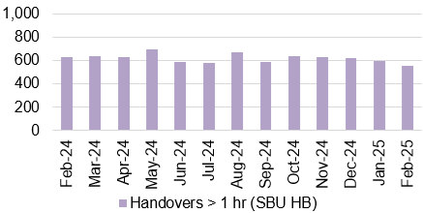 |  |  |  |  |  | - Number of ambulance handovers over 1 hour- Hospital level  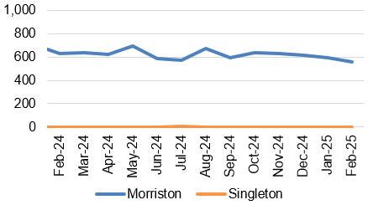
- Number of ambulance handovers- HB total last 90 days
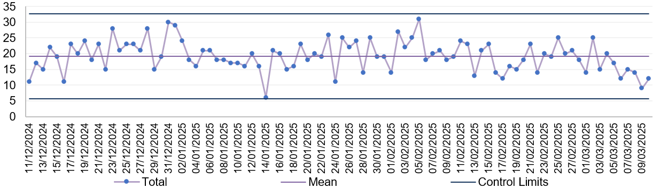
UNSCHEDULED CARE
Description | Current Performance |  |  |  |  |  |  | Actions of Improvement
A&E Attendances  1.The number of attendances at emergency departments in the Health Board  2.The number of attendances at emergency departments in the Health Board – Hospital level  3.The number of attendances at emergency departments in the Health Board (last 90 days) | In February 2025, there were 9,969 A&E attendances, which is a reduction of 1,021 when compared to January 2025. There were 6,026 attendances to A&E at Morriston hospital and 3,943 attendances to MIU at Neath Port Talbot hospital. |  |  |  |  |  |  | There is currently a medical SDEC model in place consisting of medics, GP’s, therapies, plus co-location of OPAS, ACT, virtual wards, paramedics (WAST stack review and direct access) – pull & push model from ED.
 | Trend
 | - Number of A&E attendances- HB total  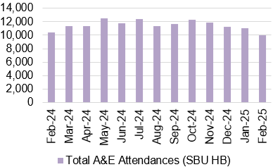 |  |  |  |  |  | - Number of A&E attendances- Hospital level  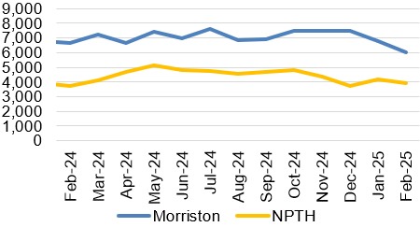
- Number of A&E attendances -HB total last 90 days
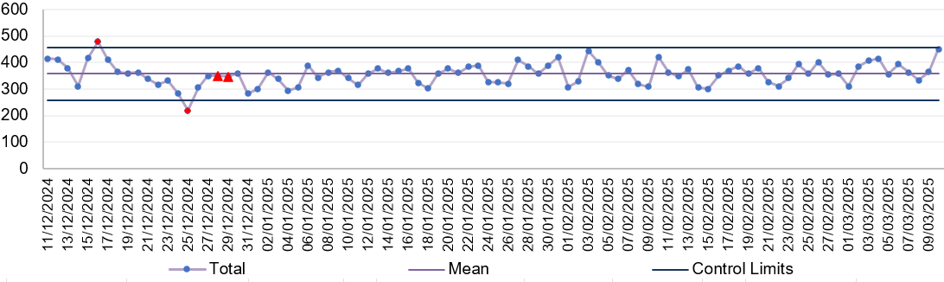
UNSCHEDULED CARE
Description | Current Performance |  |  |  |  |  | Actions of Improvement
A&E waiting times  1.% of patients who spend less than 4 hours in all major and minor emergency care facilities from arrival until admission, transfer or discharge  2. % of patients who spend less than 4 hours in A&E- Hospital level  3. % of patients who spend less than 4 hours in A&E (last 90 days) | The Health Board’s performance against the 4-hour measure deteriorated to 72.67% in February 2025 from 76.39% in January 2025. Neath Port Talbot Hospital Minor Injuries Unit (MIU) has remained above the national target of 95% achieving 98.30% in February 2025. Morriston Hospital’s performance improved between January 2025 and February 2025, achieving 55.90% against the target. |  |  |  |  |  | A frailty model design has been agreed which anticipates a reduction in attendances and improved length of stay; this has been accelerated and implementation commenced in July ahead of September 2024 as scheduled. Implementation and additional recruitment is ongoing.
 | Trend
 | - % Patients waiting under 4 hours in A&E- HB total  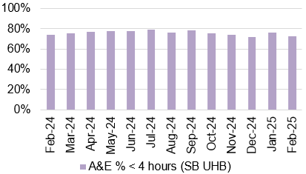 |  |  |  |  |  | - % Patients waiting under 4 hours in A&E- Hospital level  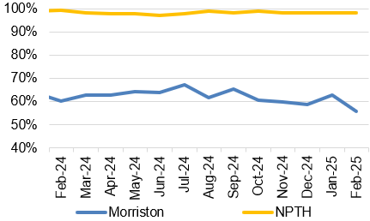
- % Patients waiting under 4 hours in A&E- HB total last 90 days
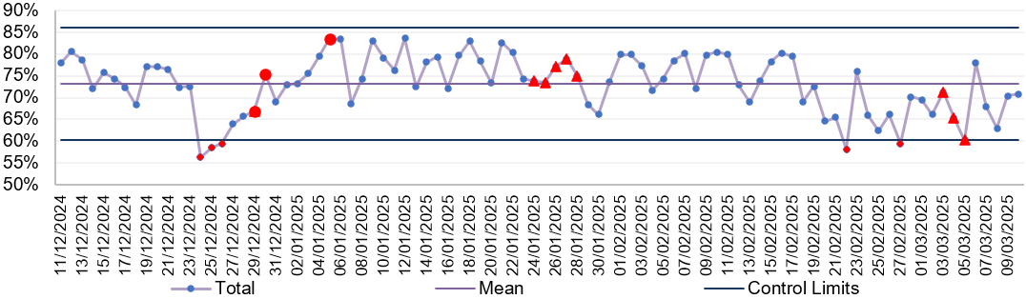
UNSCHEDULED CARE
Description | Current Performance |  |  |  |  |  | Actions of Improvement
A&E waiting times  1.Number of patients who spend 12 hours or more in A&E  2.Number of patients who spend 12 hours or more in A&E- Hospital level  3.Number of patients who spend 12 hours or more in A&E (last 90 days) | In February 2025, performance against the 12-hour measure deteriorated when compared with January 2024, increasing from 1,090 to 1,237. This is an increase of 147 compared to January 2025. All of the patients waiting over 12 hours in February 2025 were attributed to Morriston Hospital. |  |  |  |  |  | A total of 8 virtual wards are now fully operational and the benefits of these are being experienced. The additional flow provided by the virtual wards and community engagement will support the flow from the ED department and the next stage includes NOF pathway changes and extended virtual wards.
 | Trend
 | - Number of patients waiting over 12 hours in A&E- HB total  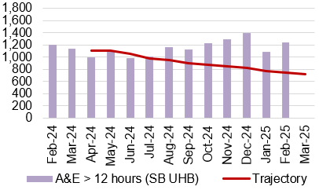 |  |  |  |  |  | - Number of patients waiting over 12 hours in A&E- Hospital level  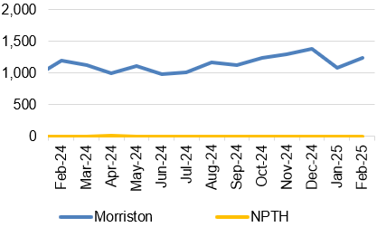
- Number of patients waiting over 12 hours in A&E – HB total last 90 days
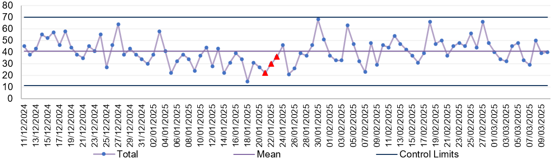
UNSCHEDULED CARE
Description | Current Performance |  |  |  |  |  |  |  | Actions of Improvement
Emergency admissions  1. The number of emergency inpatient admissions  2. The number of emergency inpatient admissions-Hospital level  3. The number of emergency inpatient admissions (last 90 days) | In December 2023, there were 4,328 emergency admissions across the Health Board, which is 26 higher than November 2023.  Singleton Hospital saw an in-month reduction, with 33 less admissions (from 308 in November 2023), Morriston Hospital saw an in-month increase from 3,871 admissions in November 2023 to 3,923 admissions in December 2023. |  |  |  |  |  |  |  | The increased number of emergency admissions is directly linked to the pressure within the system and the reduced flow from ED – this will be addressed by the previously referenced occupancy actions
 | Trend
 | - Number of emergency admissions- HB total  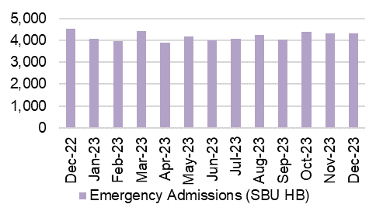 |  |  |  |  |  | 2.Number of emergency admissions- Hospital level  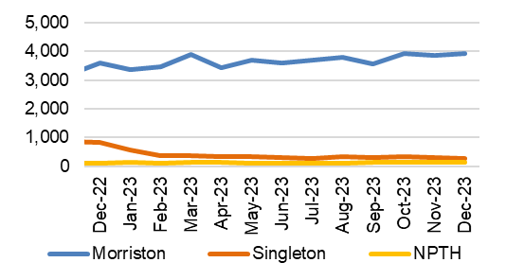
3.Number of emergency admissions- HB total last 90 days
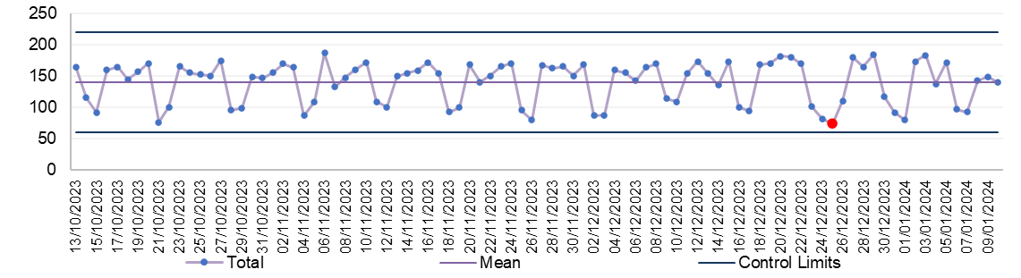
UNSCHEDULED CARE
Description | Current Performance |  |  |  |  |  | Actions of Improvement
Critical Care- Delayed Transfers of Care (DTOC)- Morriston Hospital  1.Total Critical Care delayed discharges (hours)  2. Average lost bed days per day  3.Percentage of patients delayed:  Up to 8 hours  Between 8 and 24 hours  Over 24 hours | In February 2025, there were a total of 86 admissions into the Intensive Care Unit (ICU) in Morriston Hospital, this is an increase when compared with 78 admissions in January 2025. February 2025, saw an increase in the number of delayed discharge hours from 3860.45 in January 2025 to 3930.15 in February 2025. The average lost bed days increased to 5.85 per day. The percentage of patients delayed over 24 hours increased to 61.90% in February 2025 from 59.68% in January 2025. |  |  |  |  |  | Delayed discharges from ICU are linked to capacity and flow constraints within the general wards and health/social-care system in general. Increased focus on flow through ICU as a result of capital works underway to meet burns requirements.
 | Trend
 | - Total Critical Care delayed discharges (hours)  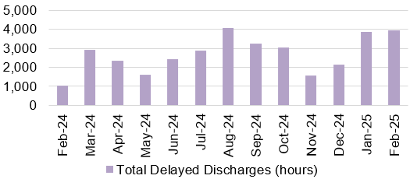 |  |  |  |  |  | - Average lost bed days per day  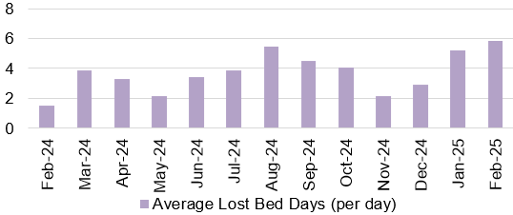
- Percentage of Critical Care patients delayed

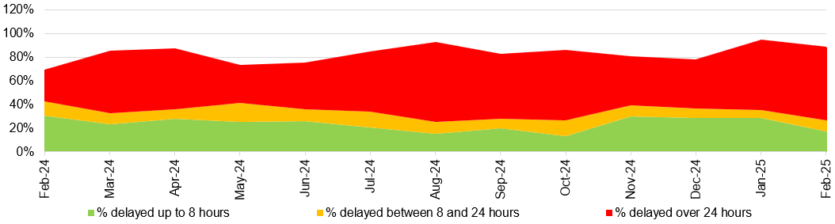
UNSCHEDULED CARE
Description |  |  | Current Performance |  | Trend
Clinically Optimised  The number of patients waiting at each site in the Health Board that are clinically optimised |  |  | In February 2025, there were on average 268 patients who were deemed clinically optimised but were still occupying a bed in one of the Health Board’s Hospitals.  In February, Morriston Hospital had the largest proportion of clinically optimised patients with 168, followed by Neath Port Talbot Hospital with 59.  Actions of Improvement;  The new pathways of care delays lead has undertaken considerable work since January to establish weekly deep dives into delays and launched new internal standards. Updated guidance has been provided by Welsh Government, clearly defining COP and CST (Clinically safe for Transfer), which has recently been reflected in coding.  Additional work is taking place with Welsh Government to classify Pathway 2 beds, however further clarity is required on the application of this and the impact on COP figures. |  | The number of clinically optimised patients by site 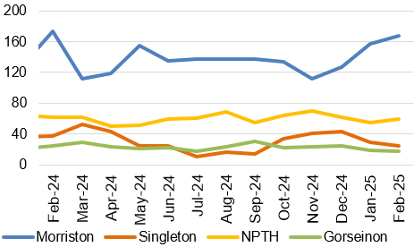
Elective procedures cancelled due to lack of beds  The number of elective procedure cancelled across the hospital where the main cancellation reasons was lack of beds |  |  | In February 2025, there were 23 elective procedures cancelled due to lack of beds on the day of surgery. This is 6 less cancellations than those seen in January 2025.  Of the 23 cancelled procedures, 21 were attributed to Morriston Hospital and 2 were attributed to Neath Port Talbot Hospital. |  | Total number of elective procedures cancelled due to lack of beds 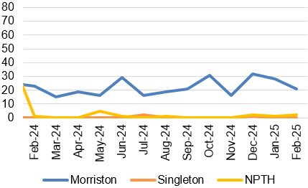
HEALTHCARE ACQUIRED INFECTIONS
Description |  | Current Performance |  | Trend
Healthcare Acquired Infections (HCAI) - E.coli bacteraemia- Number of laboratory confirmed E.coli bacteraemia cases |  | - 18 cases of E. coli bacteraemia were identified in February 2025, of which 11 were hospital acquired and 7 were community acquired.  - The Health Board total is currently below the Welsh Government Profile target of 18 cases for February 2025.  Actions of Improvement;  Each Service Group has developed detailed action plans which reinforce the quality and safety guidelines to support the reduction of Infection rates |  | Number of healthcare acquired E.coli bacteraemia cases 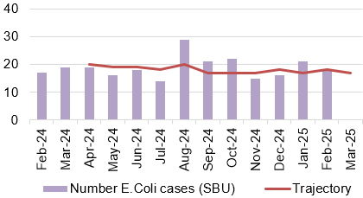
Healthcare Acquired Infections (HCAI)-  S.aureus bacteraemia- Number of laboratory confirmed S.aureus bacteraemias (MRSA & MSSA) cases |  | - There were 12 cases of Staph. aureus bacteraemia in February 2025, of which 10 were hospital acquired and 2 were community acquired.  - The Health Board total is currently above the Welsh Government Profile target of 5 cases for February 2025  Actions of Improvement;  Each Service Group has developed detailed action plans which reinforce the quality and safety guidelines to support the reduction of Infection rates |  | Number of healthcare acquired S.aureus bacteraemia cases  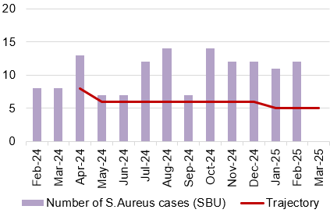
HEALTHCARE ACQUIRED INFECTIONS
Description |  | Current Performance |  | Trend
Healthcare Acquired Infections (HCAI)-  C.difficile-  Number of laboratory confirmed C.difficile cases |  | - There were 17 Clostridium difficile toxin positive cases in February 2025, of which 15 were hospital acquired and 2 were community acquired.  - The Health Board total is currently above the Welsh Government Profile target of 7 cases for February 2025.  Actions of Improvement;  Each Service Group has developed detailed action plans which reinforce the quality and safety guidelines to support the reduction of Infection rates |  | Number of healthcare acquired C.difficile cases  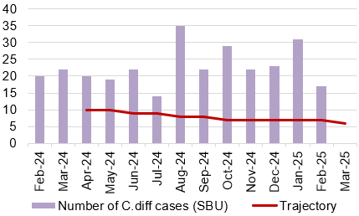
Healthcare Acquired Infections (HCAI)-  Klebsiella sp- Number of laboratory confirmed Klebsiella sp cases |  | - There were 10 cases of Klebsiella sp in February 2025, of which 3 were hospital acquired and 7 were community acquired.  - The Health Board total is currently above the Welsh Government Profile target of 5 cases for February 2025.  Actions of Improvement;  Each Service Group has developed detailed action plans which reinforce the quality and safety guidelines to support the reduction of Infection rates |  | Number of healthcare acquired Klebsiella cases 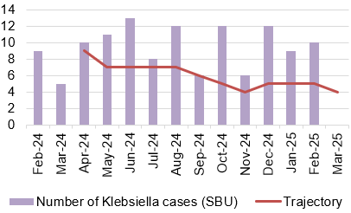
HEALTHCARE ACQUIRED INFECTIONS
Description |  | Current Performance |  | Trend
Healthcare Acquired Infections (HCAI)-  Aeruginosa-  Number of laboratory confirmed Aeruginosa cases |  | - There were 2 cases of P.Aerginosa reported in February 2025.  - The Health Board total is currently in line with the Welsh Government Profile target of 2 cases for February 2025.  Actions of Improvement;  Each Service Group has developed detailed action plans which reinforce the quality and safety guidelines to support the reduction of Infection rates |  | Number of healthcare acquired Pseudomonas cases 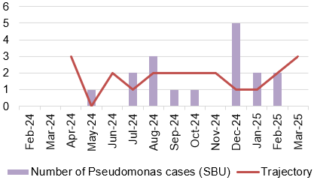

PLANNED CARE
Description | Current Performance |  | Actions of Improvement
Referrals and shape of the waiting list  - GP Referrals  The number of Stage 1 additions per week  - Stage 1 additions  The number of new patients that have been added to the outpatient waiting list  - Outpatient activity undertaken  Total number of patients seen each month  - Size of the waiting list  Total number of patients on the waiting list by stage as a February 2025. | In February 2025, there were 12,514 referrals received. This is lower than the number that was received in January 2025 (13,759). Chart 4 shows the shape of the current waiting list and Chart 3 shows the outpatient activity undertaken over the last year. |  | The number of referrals received has remained steady in recent months and is now showing a consistent pattern of demand.
 | Trend
 | - Number of GP referrals received by SBU Health Board 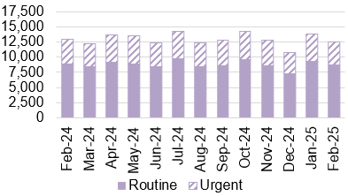 | - Number of stage 1 additions per week 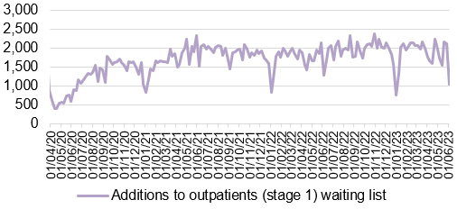
 | - Outpatient activity undertaken 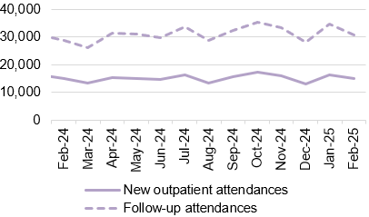 | - Total size of the waiting list (February 2025)  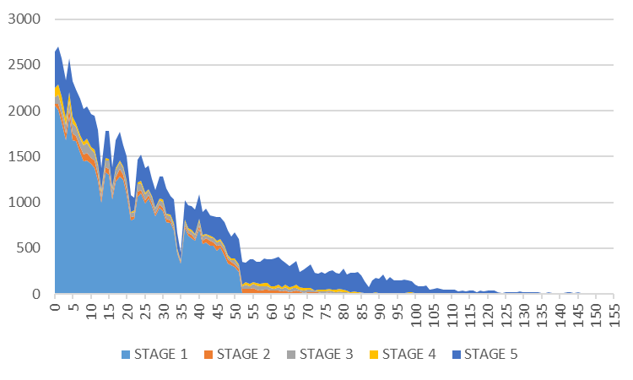
PLANNED CARE
Description | Current Performance |  |  | Actions of Improvement
Outpatient waiting times  1. Number of patients waiting more than 26 weeks for an outpatient appointment (stage 1)- Health Board Total  2. Number of patients waiting more than 26 weeks for an outpatient appointment (stage 1)- Hospital Level  3. Patients waiting over 26 weeks for an outpatient appointment by specialty  4. Percentage of patients waiting less than 26 weeks | The number of patients waiting over 26 weeks for a first outpatient appointment is still a challenge. February 2025 saw a minor in-month reduction of the number of patients waiting over 26 weeks for an outpatient appointment. The number of breaches decreased from 16,178 in January 2025 to 15,507 in February 2025. Ophthalmology has the largest proportion of patients waiting over 26 weeks for an outpatient appointment, followed by Orthopaedics and ENT. Chart 4 shows that the number of patients waiting less than 26 weeks for an outpatient appointment, this figure has improved slightly to 60.1%. |  |  | Service Group specific delivery trajectories have been developed to further support recovery and these are monitored by the Chief Operating Officer to ensure core capacity maximisation.
 | Trend
 | - Number of stage 1 over 26 weeks- HB total  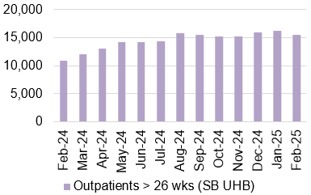 | - Number of stage 1 over 26 weeks- Hospital level  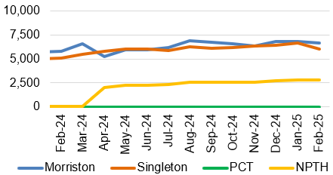
 | 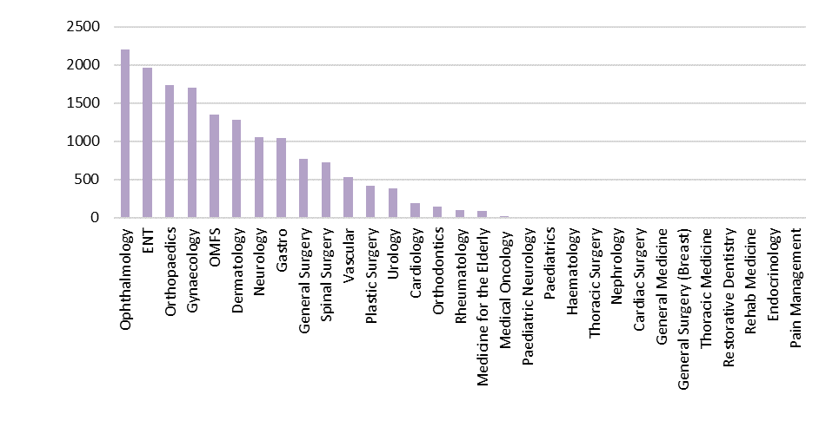  - Patients waiting over 26 weeks for an outpatient appointment by specialty as at February 2025 | - Percentage of patient waiting less than 26 weeks  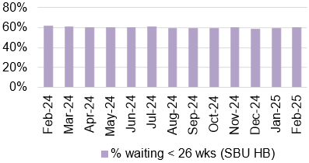

PLANNED CARE
Description | Current Performance |  |  |  | Actions of Improvement
Patients waiting over 36 weeks for treatment  1. Number of patients waiting more than 36 weeks for treatment and the number of elective patients admitted for treatment- Health Board Total  2. Number of patients waiting more than 52 weeks for treatment at Stage 1  3. Number of elective admissions  4. Number of patients waiting more than 104 weeks for treatment | In February 2025, there were 7,676 patients waiting over 36 weeks at Stage 1, which is a 5% in-month reduction from January 2025. 13,258 patients were waiting over 52 weeks at all stages in February 2025. In February 2024, there were 291 patients waiting over 104 weeks for treatment, which is a 58% reduction from January 2025. |  |  |  | Focus is now on reducing the numbers of longest waiting patients and improving the productivity and efficiency of existing theatres to increase capacity within existing resources.
 | Trend
 | - Number of patients waiting over 36 weeks at Stage 1- HB total 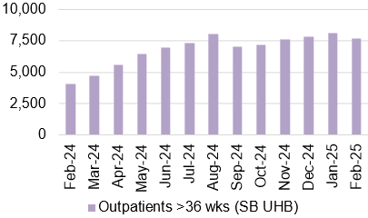 |  |  | - Number of patients waiting over 52 weeks at Stage 1- HB total  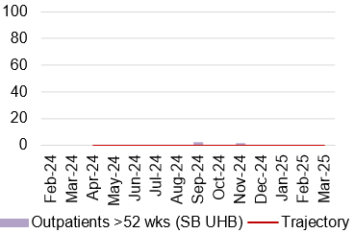
 | - Number of elective admissions 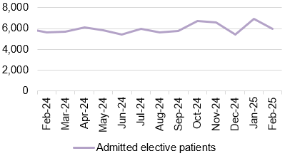 |  |  | - Number of patients waiting over 104 weeks- HB total  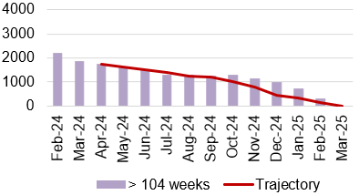
PLANNED CARE
Description | Current Performance
Ophthalmology Referrals  Number of patients referred into secondary care Ophthalmology services | In February 2025, there were 803 patients referred from Primary Care into secondary care ophthalmology services. This is a reduction on the number of patients referred in January 2024, which was 843. |  |  | Number of referrals into secondary care Ophthalmology service 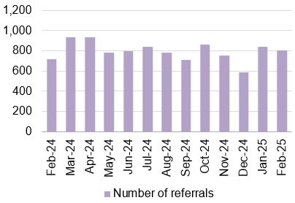
Ophthalmology waiting times  Percentage of ophthalmology R1 appointments attended which were within their clinical target date or within 25% in excess of their clinical target | In February 2025, 58.8% of Ophthalmology R1 appointments attended were within their clinical target date or within 25% of the target date.  Actions of Improvement;  A detailed Ophthalmology action plan is currently being executed which focusses on performance improvement schemes using insourcing and outsourcing resources, administrative validation and active recruitment to fill any current vacancies impacting capacity |  |  | Percentage of ophthalmology R1 appointments attended which were within their clinical target date or within 25% in excess of their clinical target date 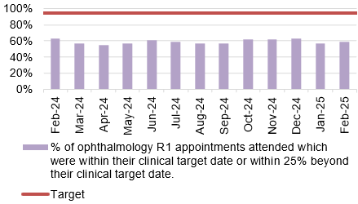
PLANNED CARE
Description | Current Performance |  |  | Trend
Diagnostics waiting times  The number of patients waiting more than 8 weeks for specified diagnostics | In February 2025 there was a reduction in the number of patients waiting over 8 weeks for specified diagnostics. It decreased from 2,839 in January 2025 to 2,447 in February 2025.  The following is a breakdown for the 8-week breaches by diagnostic test for February 2025:  - Endoscopy= 2,054  - Cardiac tests= 328  - Other Diagnostics = 35^  Actions of Improvement;  Demand and capacity work has enabled significant improvement in access times for non-endoscopic diagnostics.  Detailed demand and capacity model for endoscopy has been commissioned to ensure sustained improvement across all aspects of endoscopic diagnostics. |  |  | Number of patients waiting longer than 8 weeks for Diagnostics 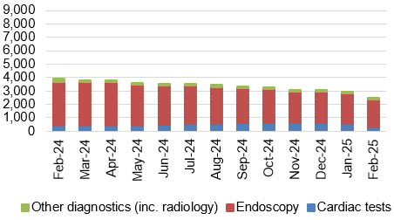
Therapy waiting times  The number of patients waiting more than 14 weeks for specified therapies | In February 2025, there were 113 patients waiting over 14 weeks for specified Therapies, which is 135 less than seen in January 2025.  - The majority of breaches are currently in Podiatry, the service continue to implement a recovery plan to help support the reduction of the waiting list. |  |  | Number of patients waiting longer than 14 weeks for therapies 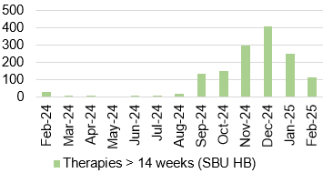
CANCER
Description | Current Performance |  |  | Trend
Single Cancer Pathway backlog  The number of patients with an active wait status of more than 63 days | Early March 2025 backlog by tumour site: |  |  | Number of patients with a wait status of more than 62 days  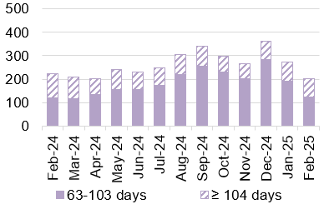
  Tumour Site | 63 - 103 days | ≥104 days
  Acute Leukaemia | 0 | 0
  Brain/CNS | 0 | 2
  Breast | 7 | 0
  Children's cancer | 0 | 0
  Gynaecological | 10 | 6
  Haematological | 3 | 6
  Head and neck | 4 | 2
  Lower GI (Exl. BSW) | 15 | 9
  BSW | 11 | 4
  Lung | 9 | 8
  Other | 3 | 0
  Sarcoma | 2 | 3
  Skin(c) | 18 | 15
  Upper Gastrointestinal | 13 | 10
  Urological | 17 | 15
  Grand Total | 112 | 80
Single Cancer Pathway backlog- patients waiting over 63 days | February 2025 saw a reduction in the number of patients waiting over 63 days. The following actions have been outlined to support backlog reduction;  - Continued focus on front end of pathway for all specialties  - Assess impact on capacity of agreed actions from skin workshop (including super clinics, locum consultant interviews and job plan reviews)  - Continued focus on cellular pathology  - Identify additional surgical (upper GI in particular) and chemotherapy capacity  - Radiology cancer performance review underway  - Further actions/improvement in Skin, LGI, Urology and Lung. Progress against actions to be monitored through Cancer Performance Improvement Group |  |  | Percentage of patients starting first definitive cancer treatment within 62 days from point of suspicion  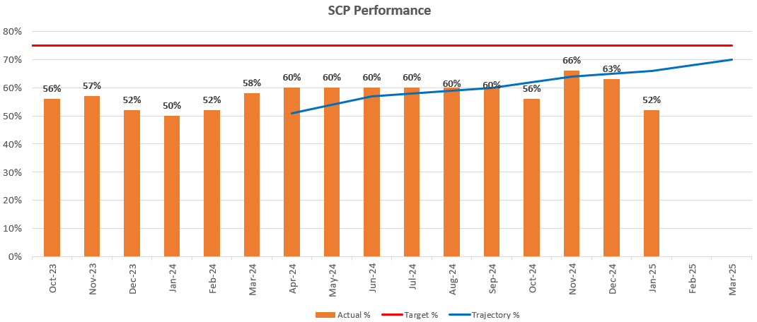
CANCER
Description |  | Current Performance | Trend
USC First Outpatient Appointments  The number of patients at first outpatient appointment stage by days waiting | Early March 2025 figures show total wait volumes for first outpatient appointment remain low.  Of the total number of patients waiting within the backlog, the majority of patients are waiting for diagnostic results, closely followed by treatment. | The number of patients waiting for a first outpatient appointment (by total days waiting) – Early March 2025  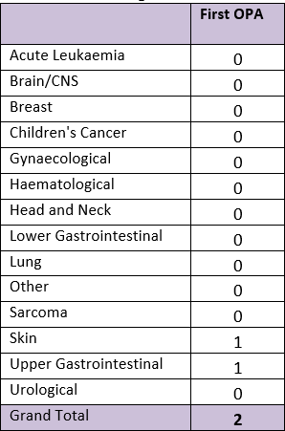
Radiotherapy waiting times  The percentage of patients receiving radiotherapy treatment | Radiotherapy waiting times continue to be a challenge, with only the 7 day Elective Delay target being met in February 2025. | Radiotherapy waiting times 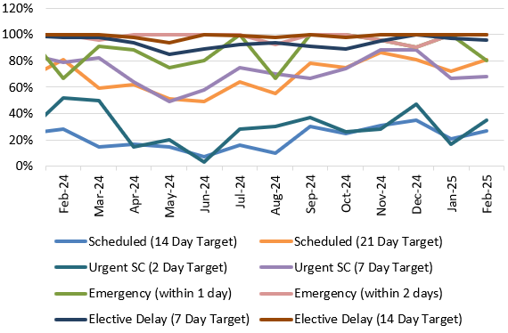
  Measure | Target | Feb-25
  Scheduled (14 Day Target) | 80% | 27%
  Scheduled (21 Day Target) | 100% | 81%
  Urgent SC (2 Day Target) | 80% | 35%
  Urgent SC (7 Day Target) | 100% | 68%
  Emergency (within 1 day) | 80% | 80%
  Emergency (within 2 days) | 100% | 100%
  Elective Delay (7 Day Target) | 80% | 96%
  Elective Delay (14 Day Target) | 100% | 100%
FOLLOW-UP APPOINTMENTS
Description | Current Performance | Trend
Follow-up appointments  1. The total number of patients on the follow-up waiting list  2. The number of patients waiting 100% over target for a follow-up appointment | In February 2025, there was a total of 150,598 patients waiting for a follow up outpatient appointment.  There was a total of 66,407 patients waiting for a follow-up past their target date in February 2025.  Of the 66,407 delayed follow-ups in February 2025, 13,000 had appointment dates and 53,407 were still waiting for an appointment.  In addition, 38,841 patients were waiting 100%+ over target date in February 2025.  - A significant reduction was noted in August 2024 due to a change in reporting where some specialties are excluded from monitoring going forward. Future trends will be assessed from the August 2024 position. | - Total number of patients waiting for a follow-up 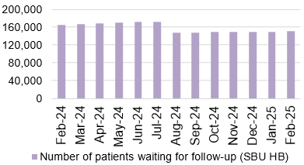  - Delayed follow-ups: Number of patients waiting 100% over target  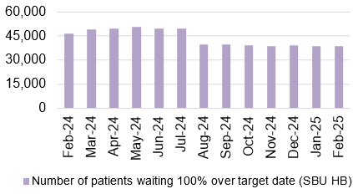

STROKE
Description | Current Performance | Trend
Stroke Measures  - % of patients who have a direct admission to an acute stroke unit within 4 hours  - % of patients who received a CT Scan within 1 hour  - % of patients who are assessed by a stroke specialist consultant physician within 24 hours  % of stroke patients who received a mechanical Thrombectomy | - In September 2024, 39% of patients had a direct admission to an acute stroke unit within 4 hours against the national target of 95%. This is an improvement on the performance reported in August 2024.  - In September 2024, 52% of patients received a CT scan within 1 hour of being admitted, this is an improvement on the figure reported in August 2024.  - 89.3% of patients were assessed by a stroke specialist consultant physician within 24 hours in September 2024, which is an increase of 4.8% from August 2024.  - In September 2024, the percentage of stroke patients who received a mechanical Thrombectomy was 3.7% against a national target of 10%. | - % of patients who have a direct admission to an acute stroke unit within 4 hours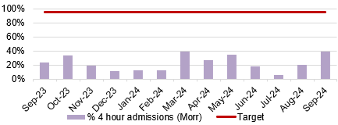  - % of patients who received a CT Scan within 1 hour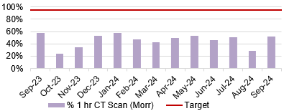  - % of patients who are assessed by a stroke specialist consultant physician within 24 hours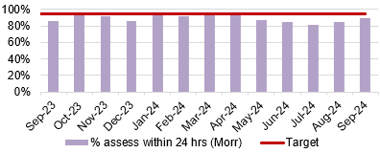  - % of stroke patients who receive a mechanical Thrombectomy  - 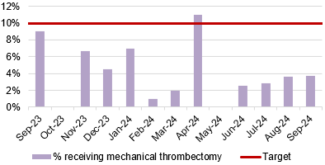

ADULT MENTAL HEALTH
Description | Current Performance | Trend
Adult Mental Health Measures:  - % of MH assessments undertaken within 28 days from the date of receipt of referral (18 years and over)  - % of therapeutic interventions started within 28 days following an assessment by LPMHSS (18 years and over)  - % of health board residents in receipt of secondary mental health services who have a valid Care and Treatment Plan (CTP) (18 years and over)  - % of patients waiting less than 26 weeks to start a psychological therapy in Specialist Adult Mental Health | - In February 2025, 100% of assessments were undertaken within 28 days of referral for patients 18 years and over.  - In February 2025, the percentage of therapeutic interventions started within 28 days following an assessment by the Local Primary Mental Health Support Service (LPMHSS) was 99%.  - 94% of residents in receipt of secondary care mental health services had a valid Care and Treatment Plan in January 2025.  - In January 2025, 52% of patients waited less than 26 weeks for psychological therapy. This was below the national target of 95%. | - % Mental Health assessments undertaken within 28 days from receipt of referral 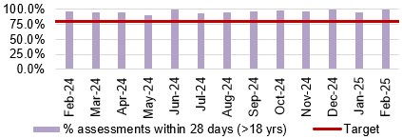  - % Mental Health therapeutic interventions started within 28 days following LPMHSS assessment  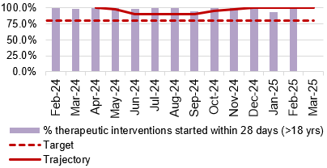  - % residents with a valid Care and Treatment Plan (CTP)  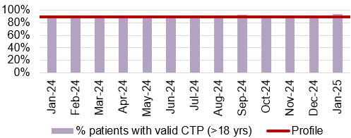  - % waiting less than 26 weeks for Psychology Therapy 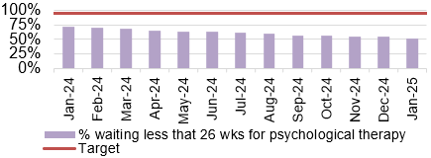
CHILD & ADOLESCENT MENTAL HEALTH (CAMHS)
Description | Current Performance | Trend
- Crisis - % Urgent Assessment by CAMHS undertaken within 48 Hours from receipt of referral  - Primary CAMHS (P-CAMHS) - % Routine Assessment by CAMHS undertaken within 28 days from receipt of referral  - Primary CAMHS (P-CAMHS) - % Therapeutic interventions started within 28 days following assessment by LPMHSS  - NDD - % Neurodevelopmental Disorder patients receiving a Diagnostic Assessment within 26 weeks  - Specialist CAMHS (S-CAMHS) - % Routine Assessment by SCAMHS undertaken within 28 days from receipt of referral | - In December 2024, 100% of CAMHS patients received an assessment within 48 hours.  - 42% of routine assessments were undertaken within 28 days from referral in January 2025 against a target of 80%.  - 100% of therapeutic interventions were started within 28 days following assessment by LPMHSS in February 2025.  - 22% of NDD patients received a diagnostic assessment within 26 weeks in January 2025 against a target of 80%.  - SCAMHS figures now included in illustration 2 and 3 combined.  *All routine assessments are now under PCAMHS* | - Crisis- assessment within 48 hours  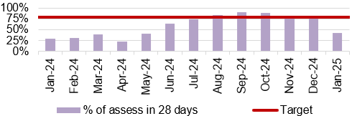  - and 3. P-CAMHS % assessments and therapeutic interventions within 28 days  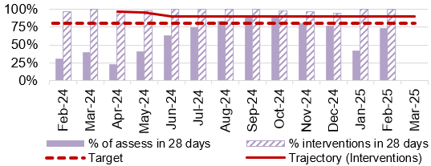  - NDD- assessment within 26 weeks 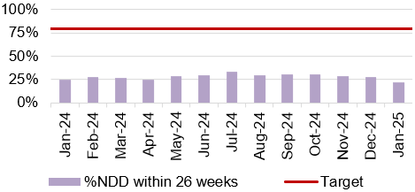
4. NHS Delivery framework Measures
&
Ministerial Priority trajectories

FRACTURED NECK OF FEMUR (#NOF)
Description | Current Performance | Trend
Fractured Neck of Femur (#NOF)  1. Prompt orthogeriatric assessment- % patients receiving an assessment by a senior geriatrician within 72 hours of presentation  2. Prompt surgery - % patients undergoing surgery the day following presentation with hip fracture  3. NICE compliant surgery - % of operations consistent with the recommendations of NICE CG124  4. Prompt mobilisation after surgery - % patients out of bed (standing or hoisted) by the day after operation | - Prompt orthogeriatric assessment- In January 2025, 97.2% of patients in Morriston hospital received an assessment by a senior geriatrician within 72 hours.  - Prompt surgery- In January 2025, 32.8% of patients had surgery the day following presentation with a hip fracture. This is a 1.0% deterioration from January 2024 which was 33.8%.  - NICE compliant surgery- 69.5% of operations were consistent with the NICE recommendations in January 2025. This is 0.2% less than in January 2024.  - Prompt mobilisation- In January 2025, 84.2% of patients were out of bed the day after surgery. This is 0.3% more than in January 2024. | - Prompt orthogeriatric assessment  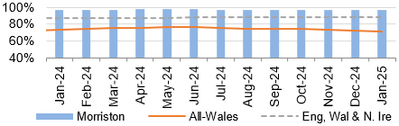  - Prompt surgery  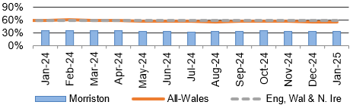  - NICE compliant Surgery  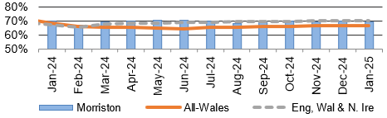  - Prompt mobilisation  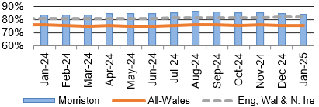
FRACTURED NECK OF FEMUR (#NOF)
Description | Current Performance | Trend
- Not delirious when tested- % patients (<4 on 4AT test) when tested in the week after operation  - Return to original residence- % patients discharged back to original residence, or in that residence at 120 day follow-up  - 30 day mortality rate (Case mix Adjusted) | - Not delirious when tested- 75.2% of patients were not delirious in the week after their operation in January 2025.  - Return to original residence- 71.0% of patients in October 2025 were discharged back to their original residence. This is 2.1% less than was reported in October 2024.  - 30 day mortality rate- In Q3 24-25 the mortality rate for Morriston Hospital was 5.6%, which is 0.4% lower than the figure reported in the same period in the previous year and is 0.3% above the national average for the quarter. | 5. Not delirious when tested  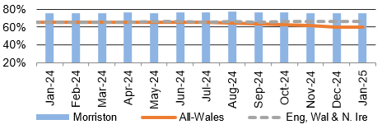  6. Return to original residence  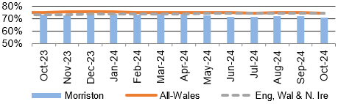  7. 30 day mortality rate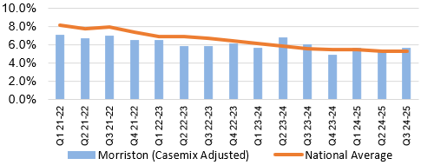
PRESSURE ULCERS
Description | Current Performance | Trend
Number of pressure ulcers  1. Total number of pressure ulcers developed in hospital and in the community  2. Rate of pressure ulcers per 100,000 admission | - In January 2025 there were 138 cases of healthcare acquired pressure ulcers, 61 of which were community acquired and 77 were hospital acquired.  There were 20 grade 3+ pressure ulcers in January 2025, 11 of which were community acquired and 9 were hospital acquired.  - The rate per 100,000 admissions was 1289 in January 2025. | Total number of hospital and community acquired Pressure Ulcers (PU) and rate per 100,000 admissions  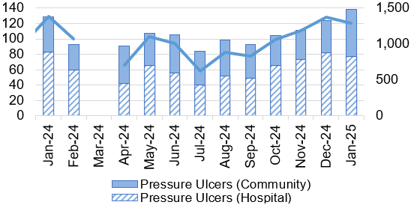  *March 24 data not available
INPATIENT FALLS
Description | Current Performance | Trend
Inpatient Falls  The total number of inpatient falls | - The number of Falls reported via Datix web for Swansea Bay UHB was 195 in February 2025. This is 3.7% more than January 2025 where 188 falls were recorded. | Number of inpatient Falls  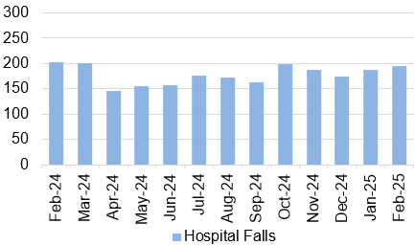
NATIONALLY REPORTABLE INCIDENTS
Description | Current Performance | Trend
Nationally Reportable Incidents (NRI’s)-  1. The number of Nationally reportable incidents  2. The number of Never Events  3. Of the nationally reportable incidents due for assurance, the percentage which were assured within the agreed timescales | - The Health Board reported 6 Nationally Reportable Incidents for the month of February 2025 to Welsh Government. The Service Group breakdown is as follows;  - Morriston – 3  - PCT -1  - Singleton - 1  - There were no new Never Events reported in February 2025.  - In February 2025, 33% of the NRI’s were closed within the agreed timescale. | 1. and 2. Number of nationally reportable incidents and never events  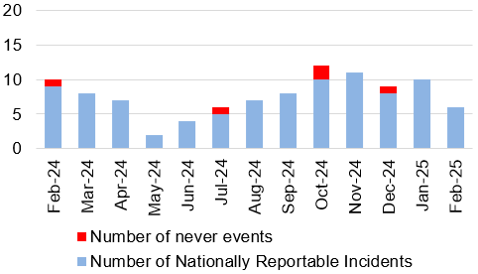  3. % of nationally reportable incidents closed within the agreed timescales 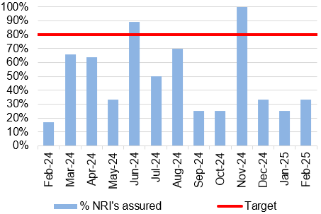
DISCHARGE SUMMARIES
Description | Current Performance | Trend
Discharge Summaries  Percentage of discharge summaries approved and sent to patients’ doctor following discharge | The latest data shows that in February 2025, the percentage of completed discharge summaries was 76%.  In February 2025, compliance ranged from 83% in Morriston Hospital to 63% in Singleton Hospital. | % discharge summaries approved and sent  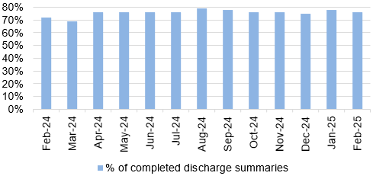
CRUDE MORTALITY
Description | Current Performance | Trend
Crude Mortality Rate | January 2025 reports the crude mortality rate for the Health Board at 0.69%, which is 0.01% higher than the figure reported in December 2024.  A breakdown by Hospital for January 2025  - Morriston – 1.21%  - Singleton – 0.20%  - NPT – 0.03% | Crude hospital mortality rate by Hospital (74 years of age or less) 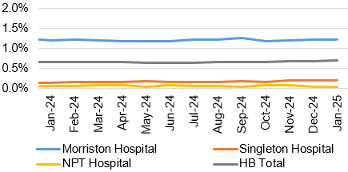

WORKFORCE
Description | Current Performance | Trend
Staff sickness rates- Percentage of sickness absence rate of staff | - Our in-month sickness performance improved to 7.06% in February 2025.  - The 12-month rolling performance figure reported in February 2025 was 7.08%, which was the same figure reported in January 2025.  - The following table provides the top 5 absence reasons by full time equivalent (FTE) days lost in February 2025. | % of full time equivalent (FTE) days lost to sickness absence (12 month rolling and in-month)  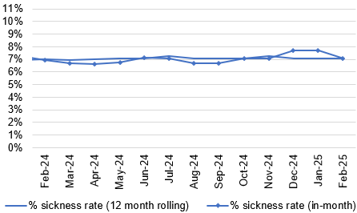
  Absence Reason | FTE Days Lost | %
  Anxiety/Stress/Depression/Other psychiatric illnesses | 10,381.00 | 34.5%
  Cold, Cough, Flu – Influenza | 3,348.00 | 11.1%
  Other musculoskeletal problems | 3,072.00 | 10.2%
  Gastrointestinal problems | 2,126.00 | 7.1%
  Injury, Fracture | 1,434.00 | 4.8%
THEATRE EFFICIENCY
Description | Current Performance | Trend
Theatre Efficiency  1. Theatre Utilisation Rates  2. % of theatre sessions starting late  3. % of theatre sessions finishing early  4. % of theatre sessions cancelled at short notice (<28 days)  5. % of operations cancelled on the day | In February 2025 the Theatre Utilisation rate was 55%. This is 2% higher than the figure reported in January 2025 and is 2% higher than the figure reported in January 2024 (53%).  43% of theatre sessions started late in February 2025. This is 2% higher than the figure reported in January 2025.  In February 2025, 33% of theatre sessions finished early. This is 5% lower than the figure seen in January 2025 and 4% lower than those seen in February 2024.  11% of theatre sessions were cancelled at short notice in February 2025. This is 1% higher than the figures reported in January 2025.  Of the operations cancelled in February 2025, 37% of them were cancelled on the day. | - Theatre Utilisation Rate 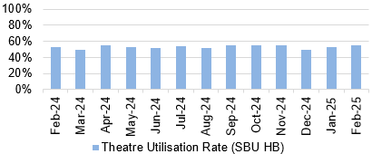  - And 3. % theatre sessions starting late/finishing 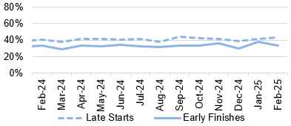  - % theatre sessions cancelled at short notice (<28 days) 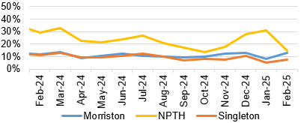  - % of operations cancelled on the day 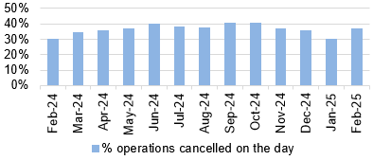
PATIENT EXPERIENCE
Description | Current Performance | Trend
Patient experience  1. Number of friends and family surveys completed  2. Percentage of patients/ service users who would recommend and highly recommend  3. Number of Service User feedback experience responses completed and recorded on CIVICA | Health Board Friends & Family patient satisfaction level in February 2025 was 93% and 5,456 surveys were completed.  - Singleton/ Neath Port Talbot Hospitals Service Group completed 2,018 surveys in February 2025, with a recommended score of 94%.  - Morriston Hospital completed 2,651 surveys in February 2025, with a recommended score of 91%.  - Primary & Community Care completed 783 surveys for February 2025, with a recommended score of 95%.  - The Mental Health Service Group completed 99 surveys for February 2025, with a recommended score of 98%.  There were 6,253 feedback experience responses completed and recorded on CIVICA in February 2025. This is 282 less than the figure reported in January 2025. Of the responses recorded, 5,206 were targeted and 1,047 were passive. | - Number of friends and family surveys completed 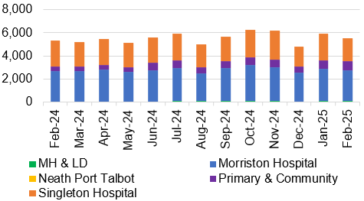  - % of patients/ service users who would recommend and highly recommend  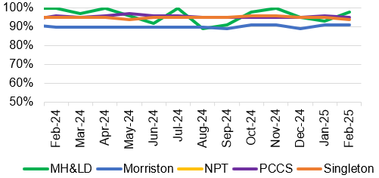  - Number of Service User experience responses 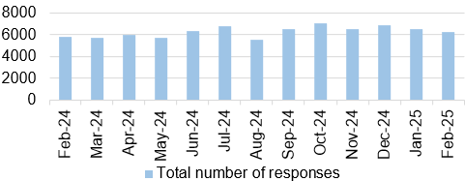
COMPLAINTS
Description | Current Performance | Trend
Patient concerns  1. Number of formal complaints received  2. Percentage of concerns that have received a final reply or an interim reply up to and including 30 working days from the date the concern was first received by the organisation | 1. In December 2024, the Health Board received 119 formal complaints; this is a deterioration of 10% when compared with December 2023 figures (108).  2. The overall Health Board rate for responding to concerns within 30 working days was 72% in  December 2024, against the Welsh Government target of 75% and Health Board target of 80%.  Below is a breakdown of performance against the 30- day response target: | - Number of formal complaints received  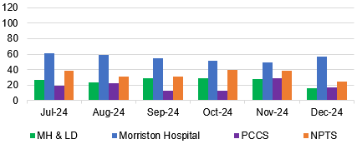  - Response rate for concerns within 30 days  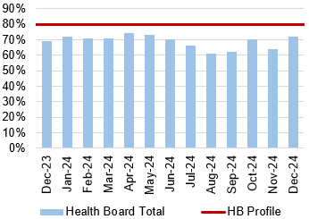
   | 30 day response rate
  Neath Port Talbot and Singleton Hospital(s) | 56%
  Morriston Hospital | 75%
  Mental Health & Learning Disabilities | 88%
  Primary, Community and Therapies | 76%

Finance updates
This section of the report provides further detail on key workforce measures.

Description |  | Current Performance | Trend
Revenue Financial Position – expenditure incurred against revenue resource limit |  | - On the 2nd December the Health Board were notified that WG will issue £6.4m of funding to reduce our planned deficit to £43.7m, noting that the control total for 2025/26 set by Welsh Government remains £17.1m.  - In Month 11 there is an in-month underspend of £0.7m.  - YTD at Month 11 is an overspend of £47m. This is in excess of the £43.7m 2024/25 revised plan.  - Overall, the Health Board YTD position is £7m off the delivery of the revised plan deficit figure of £43.7m.  - In the graph opposite the orange bars illustrate the potential financial change required to be able to deliver the revised plan deficit of £43.7m.  - The yellow line depicts the level required if the HB were to achieve the £17.1m 2025/26 control total.  - To hit the £43.7m revised Plan the HB needs to underspend in March by a total of £3.3m | 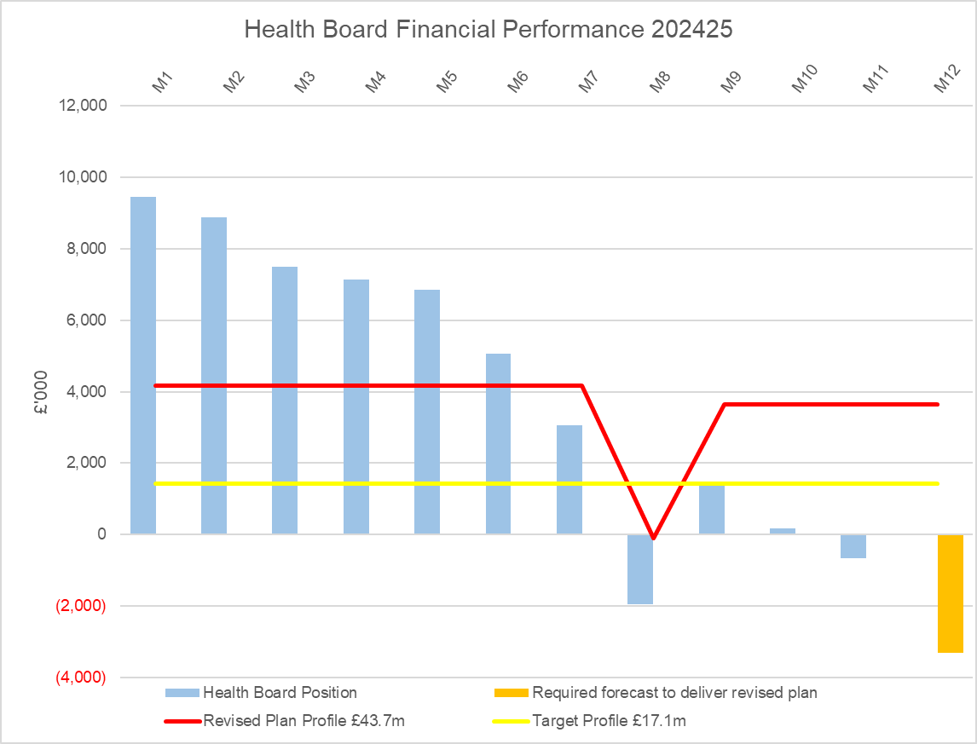
Description | Current Performance |  |  | Trend
Capital Financial Position – expenditure incurred against capital resource limit | - The balanced forecast outturn capital position for 2024/25 assumes income from disposals of £0.275m.  - Any All Wales Capital schemes where a high/medium risk is reported are closely monitored and discussed at the Capital Review progress meetings with Welsh Government. |  |  | 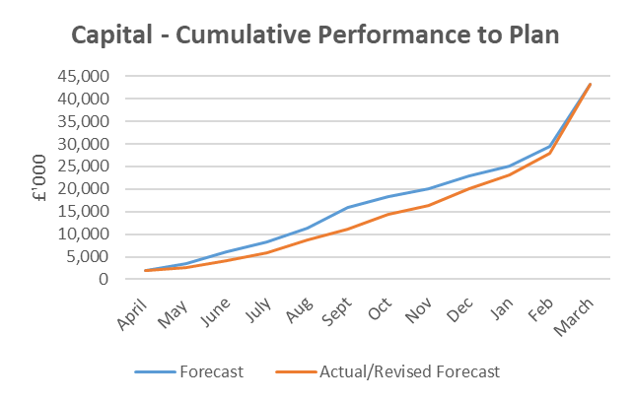
Description | Current Performance |  |  | Trend
Workforce Spend – workforce expenditure profile | - The pay budgets are overspent by £2.1m in February.  - Variable pay has increased in January by circa. £33k. Broken down as follows;  Overtime was overspent by £161k, & Irregular Sessions £47k offset by an underspend in WLI of £87k, Agency £53k and Bank £35k.  - Work is required to bring spend down in line with the current year budget. | 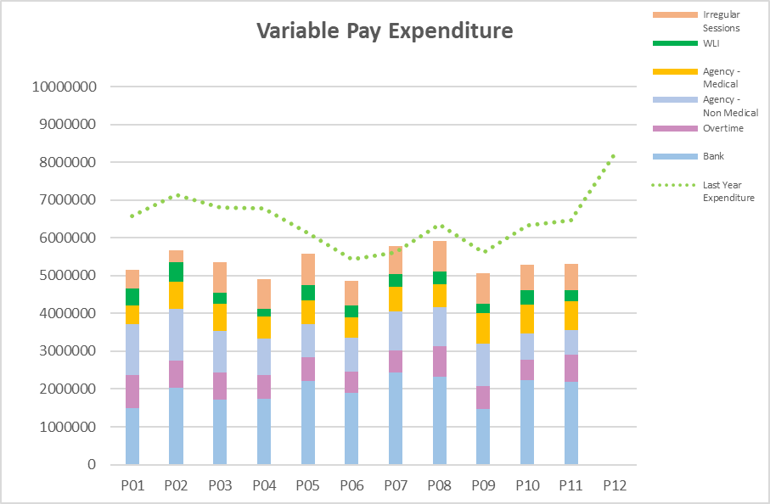
Description | Current Performance | Trend
PSPP – pay 95% of Non-NHS invoices within 30 days of receipt of goods or valid invoice | - The cumulative PSPP compliance has increased slightly this month, however it is still below target at 94.83%. In February compliance was above target at 97.51% (January – 84.06%).  - Although the PSPP was achieved this month, there were still delays in receipting and in authorisation. | Percentage of non-NHS invoices paid within 30 days of receipt of goods or valid invoice  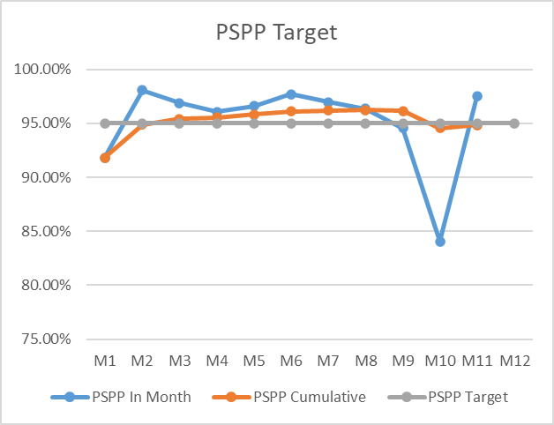

5. TABLE OF ALL MEASURES

Harm from COVID itself
Chart 1 Number of new COVID19 cases |  | Chart 2: Number of new COVID19 cases (cumulative) |  | Chart 3: Number of COVID19 tests completed and positivity rate |  | Chart 4: Number of staff referred for Antigen testing
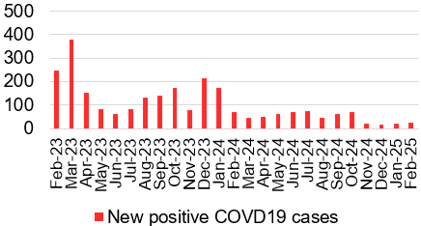 |  | 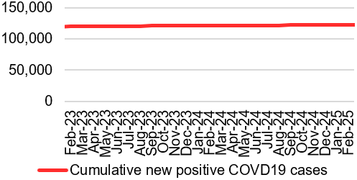 |  | 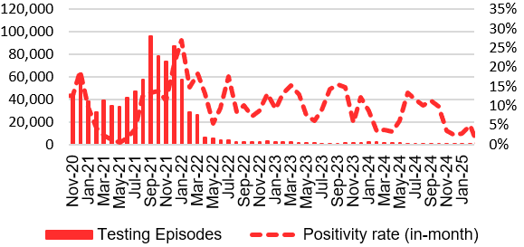 |  | 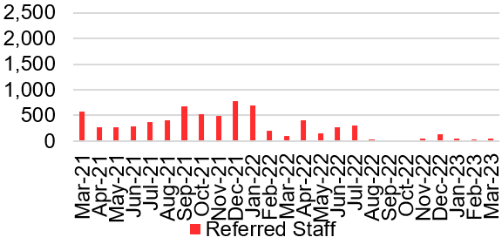
Chart 5: Outcome of staff COVID19/ antigen tests |  | Chart 6: Number of COVID19 related incidents |  | Chart 7: Number of COVID19 related serious incidents |  | Chart 8: Number of COVID19 related complaints
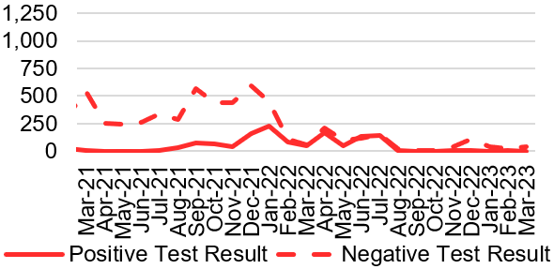 |  | 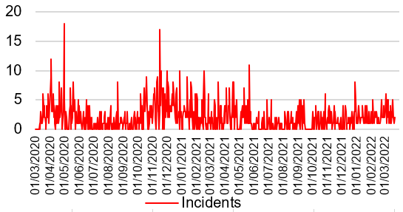 |  | 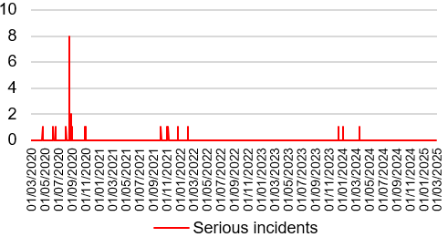 |  | 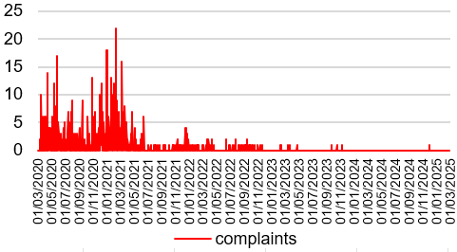
Chart 9: Number of COVID19 related risks |  | Chart 10: Number of staff self-isolating (asymptomatic) |  | Chart 11: Number of staff self isolating (symptomatic) |  | Chart 12: % staff sickness
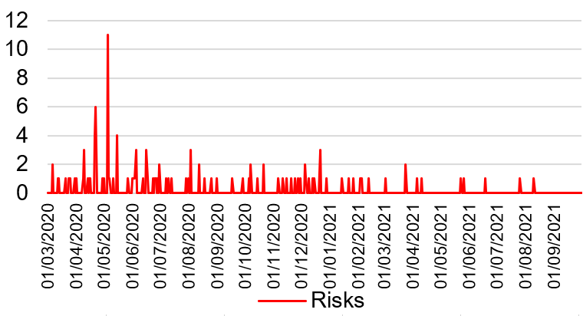 |  | 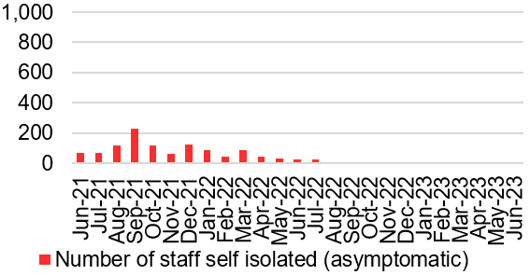 |  | 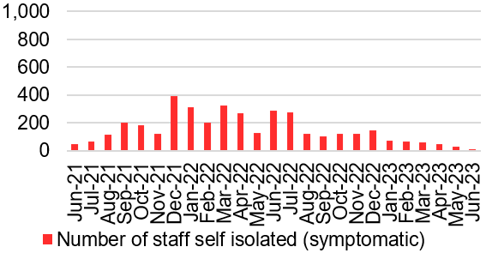 |  | 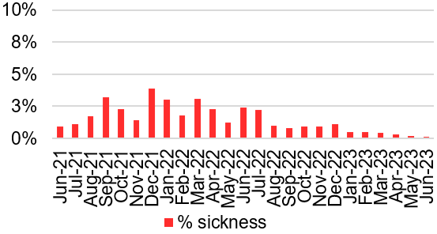
Chart 13: Bed Occupancy for suspected and confirmed COVID19 cases |  | Chart 14: Number of hospital deaths with any mention of COVID19 |  | Chart 15: Number of weekly registered deaths with any mention of COVID19 (ONS data) |  | Chart 16: Number of mortuary spaces
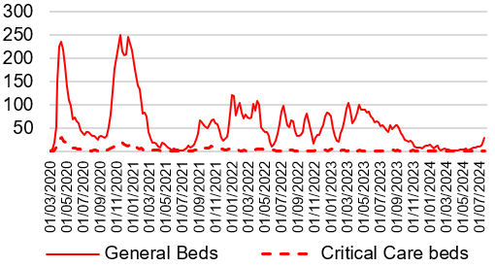 |  | 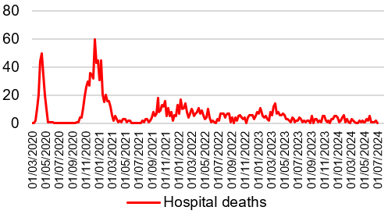 |  | 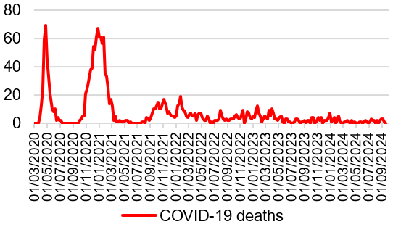 |  | 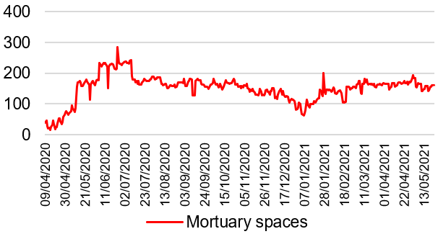

Harm from overwhelmed NHS and social care system
Unscheduled Care- Overview

Chart 1: GP Out of Hours/ 111 |  | Chart 2: % red calls responded to within 8 minutes |  | Chart 3: Number of ambulance handovers over 1 hour |  | Chart 4: Lost hours- notification to ambulance handover over 15 minutes
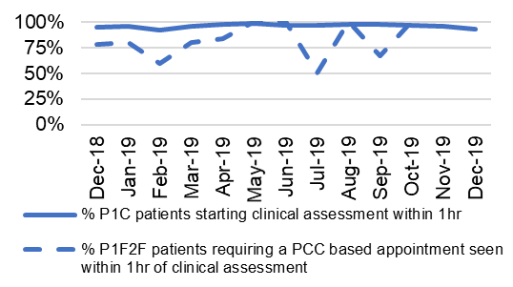  Service continues to experience issues with data reporting. It is anticipated that up to date accurate data will be available shortly. |  | 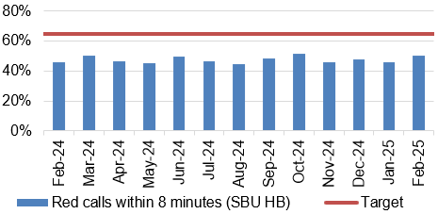 |  | 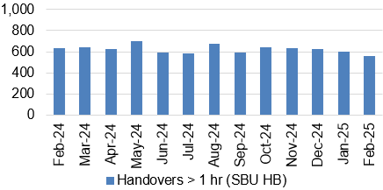 |  | 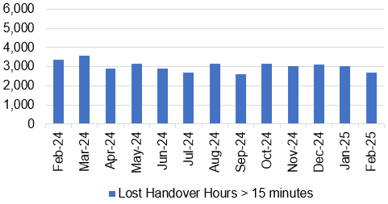
Chart 5: A&E Attendances |  | Chart 6: % patients who spend less than 4 hours in A&E |  | Chart 7: Number of patients waiting over 12 hours in A&E |  | Chart 8: Number of emergency admissions
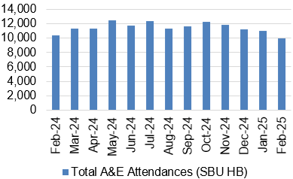 |  | 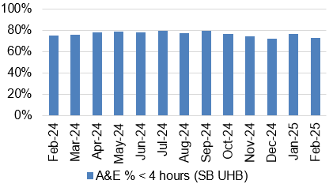 |  | 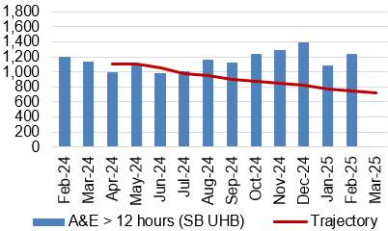 |  | 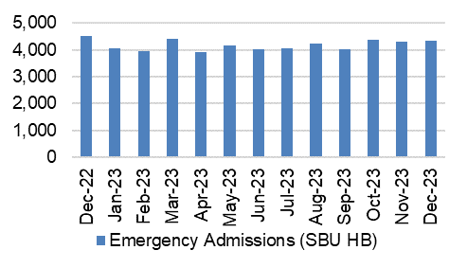
Chart 9: Elective procedures cancelled due to lack of beds |  | Chart 10: Number of clinically optimised patients |  | Chart 11: Delay reason for clinically optimised patients |  | Chart 12: Average lost bed days (per day)
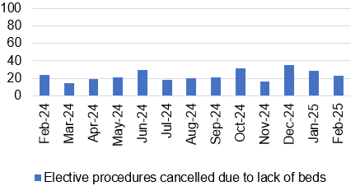 |  | 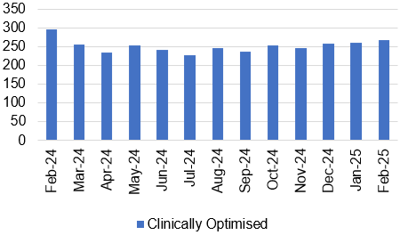 |  | 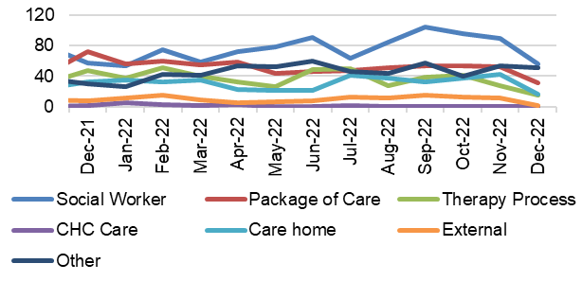 |  | 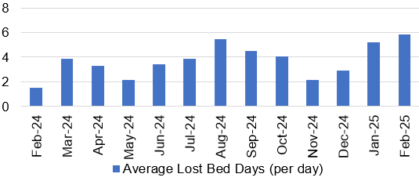
Chart 13; % of thrombolysed stroke patients with a door to door needle time of less than or equal to 45 minutes |  | Chart 14: Direct admission to Acute Stroke Unit within 4 hours |  | Chart 15: % of stroke patients receiving CT scan with 1 hour |  | Chart 16: % stroke patients receiving consultant assessment within 24 hours
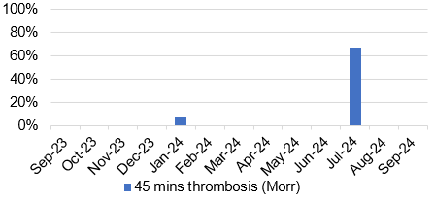 |  | 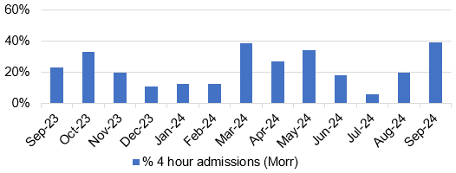 |  | 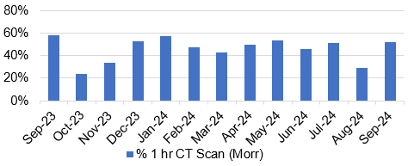 |  | 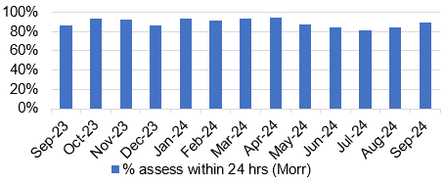
Harm from reduction in non-Covid activity
Primary and Community Care Overview

Chart 1: Total Number of patients receiving care from Eye Health Examination Wales (EHEW) |  | Chart 2: GMS - Escalation Levels |  | Chart 3: GMS - Sustainability |  | Chart 4: Number and percentage of adult dental patients re-attending NHS Primary Dental Care between 6-9 months
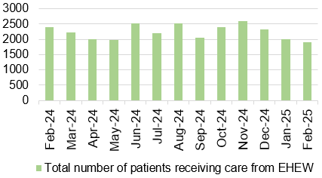 |  | 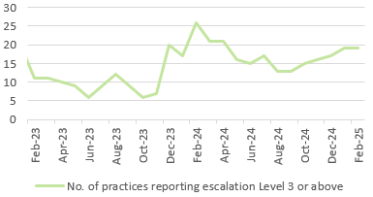 |  | 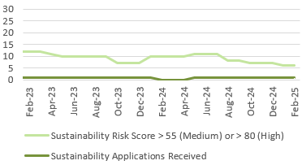 |  | 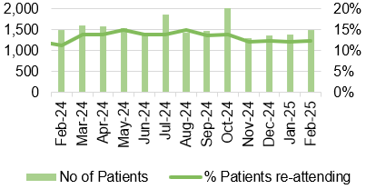
Chart 5: General Dental Services - Activity |  | Chart 6: General Dental Services - New Patients |  | Chart 7: General Dental Services - ACORNS/FV |  | Chart 8: Optometry Activity – sight tests
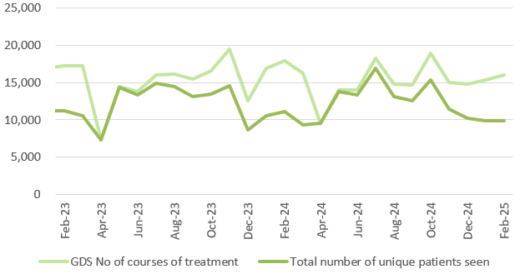 |  | 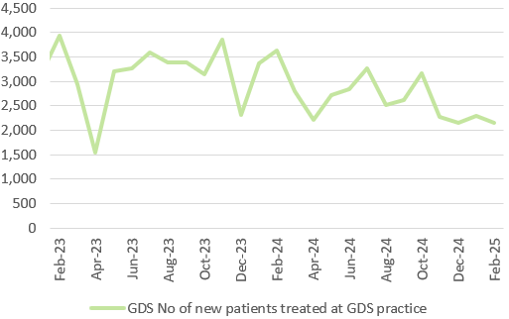 |  | 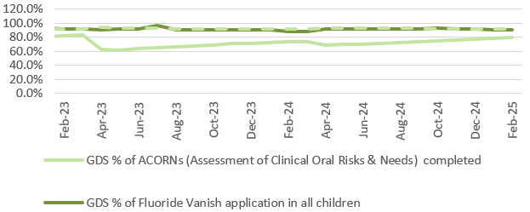 |  | 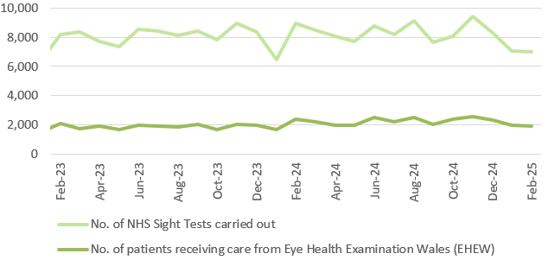
Chart 9: Optometry Activity – low vision care |  | Chart 10: Community Pharmacy – Escalation levels |  | Chart 11: Common Ailment Scheme – No. consultations provided |  | Chart 12: % of patients with a RTT (referral to stage 1) of 26 weeks or less for Restorative Dentistry
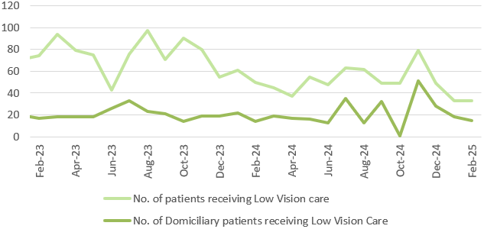 |  | 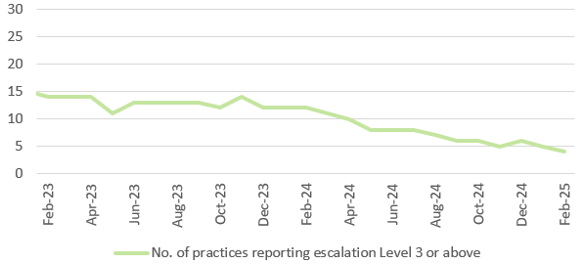 |  | 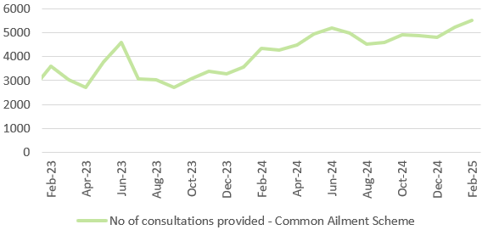 |  | 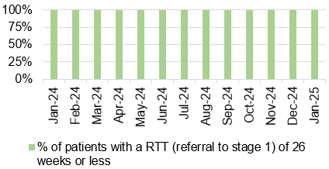
Chart 13: Podiatry - Total number of patients waiting > 14 weeks |  | Chart 14: Dietetics - Total number of patients waiting > 14 weeks |  | Chart 15: Audiology- Total number of patients waiting > 14 weeks |  | Chart 16: Speech & Language Therapy– Number of patients waiting > 14 weeks
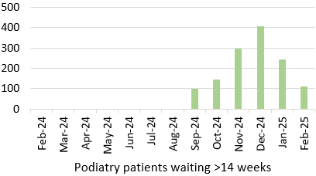 |  | 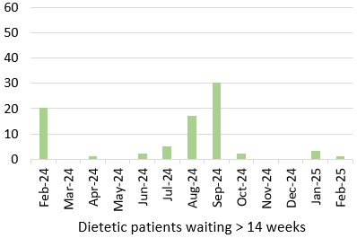 |  | 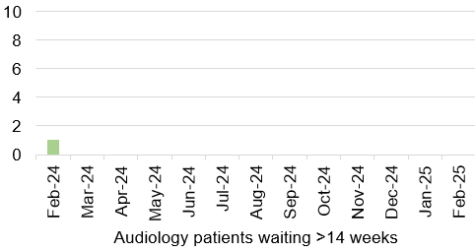 |  | 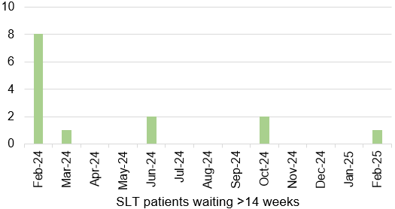
Harm from reduction in non-Covid activity
Planned Care Overview

Chart 1: Number of GP Referrals into secondary care |  | Chart 2: Number of patients waiting over 26 weeks for an outpatient appointment |  | Chart 3: Number of patients waiting over 36 weeks for treatment at stage 1 |  | Chart 4: Number of patients waiting over 52 weeks for treatment
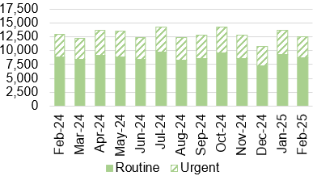 |  | 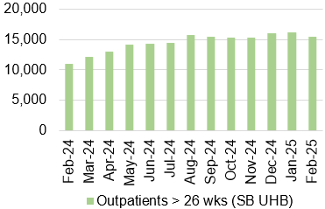 |  | 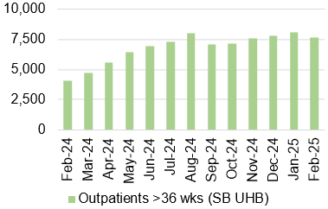 |  | 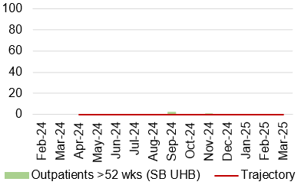
Chart 5: Number of patients waiting for reportable diagnostics over 8 weeks |  | Chart 6: Number of patients waiting for reportable Cardiac diagnostics over 8 weeks |  | Chart 7: Number of patients waiting more than 14 weeks for Therapies |  | Chart 8: Cancer referrals
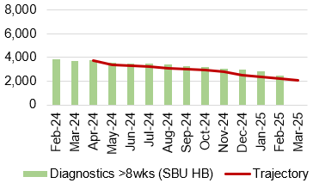 |  | 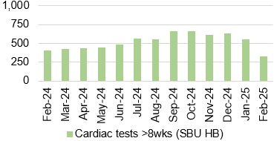 |  | 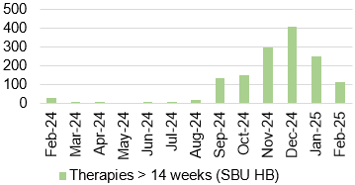 |  | 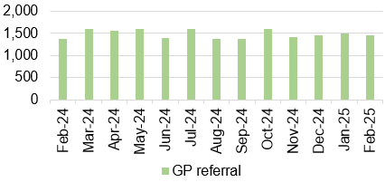
Chart 9: Single Cancer Pathway- % of patients starting definitive treatment within 62 days from point of suspicion |  | Chart 10: Number of new cancer patients starting definitive treatment |  | Chart 11: Single Cancer Pathway backlog- patients waiting over 63 days |  | Chart 12: Number of patients waiting for an outpatient follow-up who are delayed past their target date
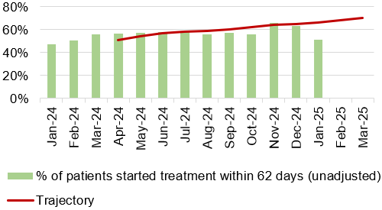 |  | 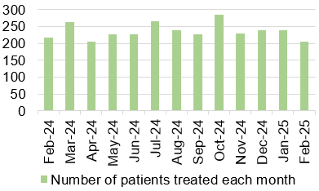 |  | 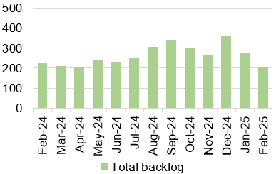 |  | 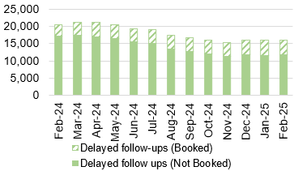
Chart 13: Number of patients without a documented clinical review date |  | Chart 14: Ophthalmology patients without an allocated health risk factor |  | Chart 15: Total number of patients on the follow-up waiting list |  | Chart 16: Number of patients delayed by over 100%
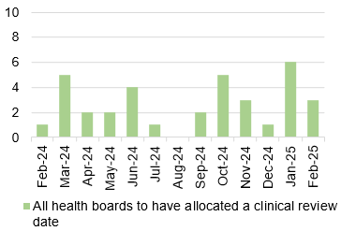 |  | 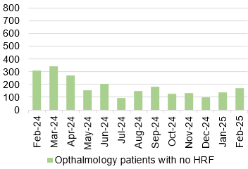 |  | 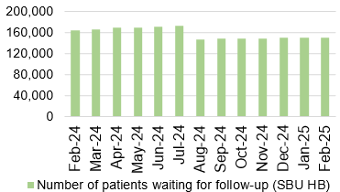 |  | 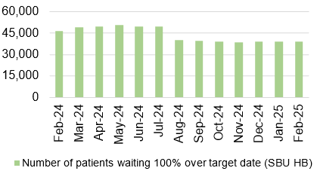
Harm from wider societal actions/lockdown

Vaccinations and Immunisations

Chart 1: % children who received 3 doses of the hexavalent ‘6 in 1’ vaccine and MenB2 vaccine by age 1 |  | Chart 2: % children who received PCV2 vaccine and Rotavirus vaccine by age 1 |  | Chart 3: % children who received MMR1 vaccine and PCVf3 vaccine by age 2 |  | Chart 4: % children who received MenB4 vaccine and Hib/MenC vaccine by age 2
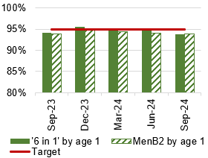 |  | 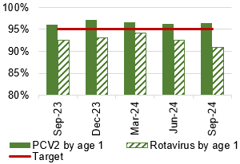 |  | 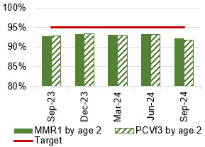 |  | 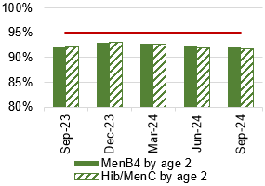
Chart 5: % children who are up to date in schedule by age 4 |  | Chart 6: % children who received 2 doses of the MMR vaccine and 4 in 1 vaccine by age 5 |  | Chart 7: % children who received MMR vaccine and teenage booster by age 16 |  | Chart 8: % children who received MenACWY vaccine by age 16
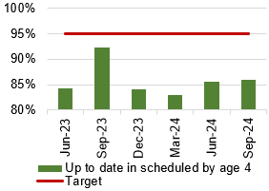 |  | 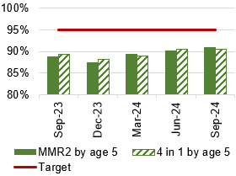 |  | 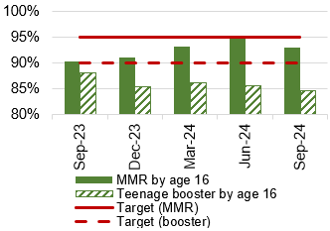 |  | 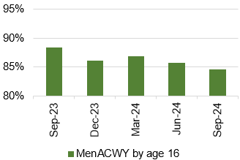
Chart 9: Influenza uptake for amongst 65 year olds and over |  | Chart 10: Influenza uptake for amongst under 65s in risk groups |  | Chart 11: Influenza uptake for amongst pregnant women |  | Chart 12: Influenza uptake for amongst healthcare workers
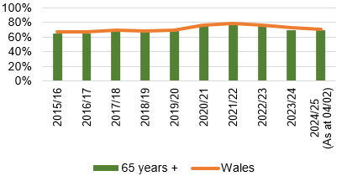  Data prior to April 2019 relates to Abertawe Bro Morgannwg University Health Board |  | 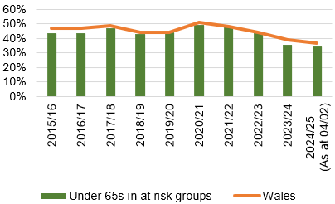  Data prior to April 2019 relates to Abertawe Bro Morgannwg University Health Board |  | 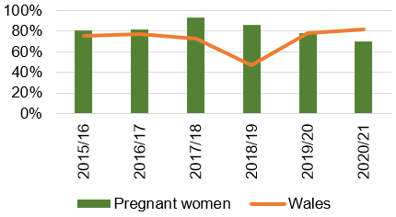  Data prior to April 2019 relates to Abertawe Bro Morgannwg University Health Board.  2021/22 data not available |  | 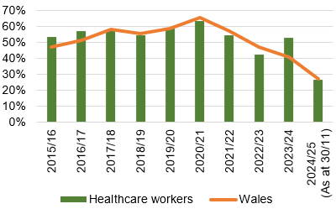  Data prior to April 2019 relates to Abertawe Bro Morgannwg University Health Board.
HArm from wider societal actions/lockdown

Mental Health Overview

Chart 1: % of mental health assessments undertaken within (up to and including) 28 days from the date of receipt of referral |  | Chart 2: % of therapeutic interventions started within (up to and including) 28 days following an assessment by LPMHSS |  | Chart 3: % of health board residents in receipt of secondary mental health services (all ages) who have a valid care and treatment plan |  | Chart 4: % of patients waiting less than 26 weeks to start a psychological therapy in Specialist Adult Mental Health
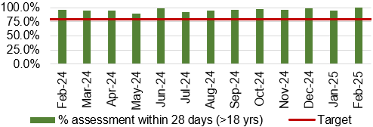 |  | 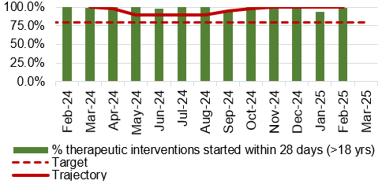 |  | 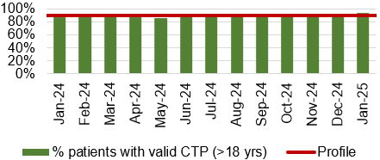 |  | 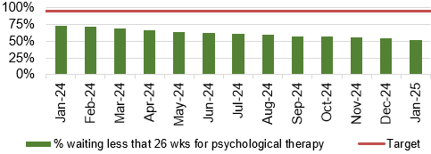
Chart 5: 95% of those admitted 0900-2100 will receive a gate-keeping assessment by the CRHTS prior to admission |  | Chart 6: 100% of those admitted without a gate keeping assessment will receive a follow up assessment by CRHTS within 24hrs of admission |  | Chart 7: % of patients waiting under 14 weeks for Therapies |  | Chart 8: Number of Mental Health Delayed Transfers of Care (DTOCs)
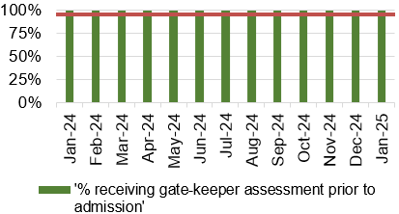 |  | 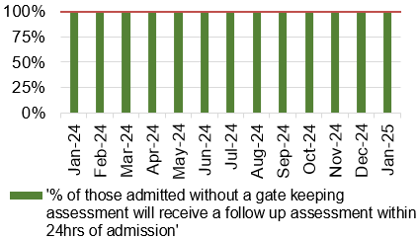 |  | 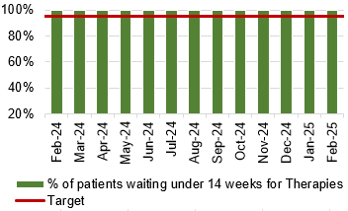 |  | 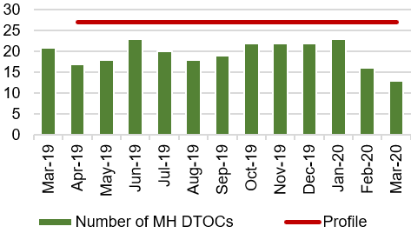
Chart 9: Number of patients detained under the Mental Health Act as a percentage of all admissions |  | Chart 10: Number of patients subject to Deprivation of Liberty Safeguards (DOLS) |  | Chart 11: Number of Nationally Reportable Incidents |  | Chart 12: Number of ligature incidents
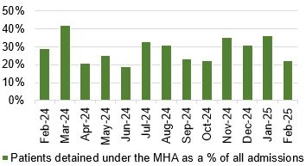 |  | 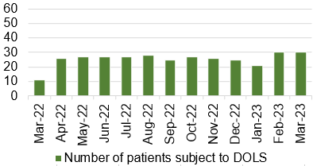 |  | 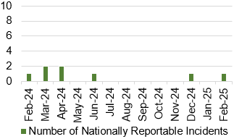 |  | 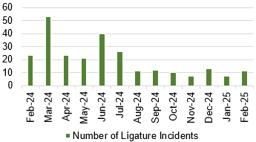
Child & Adolescent Mental Health Services (CAMHS)
Chart 13: Urgent assessments undertaken within 48 hours from receipt of referral |  | Chart 14: Neuro-developmental disorder assessment and intervention received within 26 weeks |  | Chart 15: Assessment and intervention within 28 days |  | Chart 16: % of residents with a Care and Treatment Plan
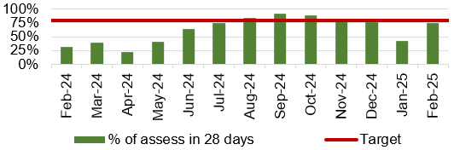 |  | 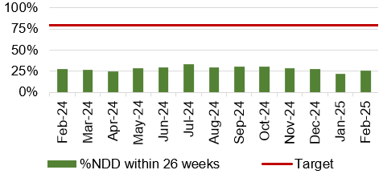 |  | 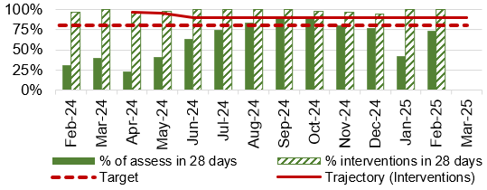 |  | 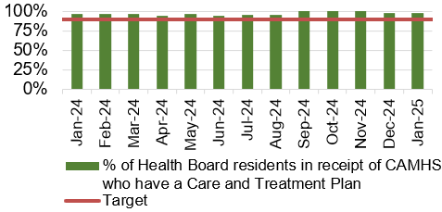

Appendix 1: INTEGRATED Performance Dashboard

