

Meeting Date | 1 May 2025 |  | Agenda Item |  | 2.1
Report Title | Annual Plan 2025/26 – Financial Plan Update
Report Author | Samantha Moss, Deputy Director of Finance  Darren Griffiths, Executive Director of Finance and Performance
Report Sponsor | Darren Griffiths, Executive Director of Finance and Performance
Presented by | Darren Griffiths, Executive Director of Finance and Performance
Freedom of Information | Open
Purpose of the Report | This report updates the Health Board on the progress made to de-risk the financial plan and the potential options and choices to improve the forecast position following submission of the plan to Welsh Government on 28 March 2025.  The report specifically focuses on the update required in the letter received from the NHS Wales Chief Executive dated 11 April 2025 (Appendix 1).
Key Issues | The Health Board Annual Plan for 2025/26 as submitted is deemed unsupportable and unacceptable by Welsh Government. The Health Board submitted the plan for scrutiny and assessment and acknowledged that it could not approve the plan given the financial profile of the plan.  The plan, as submitted, forecast a £58.7m revenue deficit which is after the planned delivery of a £55.4m (5%) savings programme in 2025/26.  The Health Board’s Target Control Total is £17m.  The Welsh Government response to the submission of the plan requests further urgent work on : -  - The actions to improve upon and derisk the financial position, both mitigating and reducing the current planned deficit  - Setting out the options and choices available to the organisation in order to improve further on the current plan, and what choices would be required to deliver the target control total set in 2024/25 alongside the impacts of doing so.  - Increasing the confidence in delivery of the current savings plan.  There are five elements to the Health Board’s response. These are set out in the detail of the paper.  - Currently identified savings  - Available pipeline of savings  - Mitigating opportunities in quarter 1 to manage savings gaps in early months  - Systems and processes in place to oversee financial improvement in 2025/26  - Current position in respect of options and choices to reduce the forecast deficit beyond £58.7m assuming the full savings plan is delivered  The confirmation from Welsh Government that the Health Board is able to source independent financial support is welcome and this will now be progressed urgently. Correspondence was received form Welsh Government confirming this on 23 April 2025. The letter and associated appendices of detail have been received by Board members  The financial plan as it currently stands continues to contain risk and there is currently not a clear line of sight to delivery of the full savings requirement. The commissioning of the external support will be welcome in progressing this.  Options and choices have been considered by the Health Board, and these will be set out in the Accountable Officer letter to be submitted on 2 May 2025. These have currently been quantified to have a potential value of £7.4m with more work to be done to assess and quantify these.
Specific Action Required | Information | Discussion | Assurance | Approval
Specific Action Required | ☐ | ☐ | ☐ | ☒
Recommendations | Members are asked to: -  - RECEIVE and CONSIDER correspondence from Welsh Government in response to the submitted plan and in relation to external support  - ACKNOWLEDGE increased level of savings in the plan  - ACKNOWLEDGE the identified pipeline of further potential savings and SUPPORT the immediate acceleration of these  - ACKNOWLEDGE that the currently available savings and pipeline opportunities do not meet the required £55.4m savings needed  - ACKNOWLEDGE that work is underway to identify mitigating opportunities in Quarter 1 to bridge the savings gap  - TAKE ACCOUNT of Accountable Officer advice in relation to the financial plan  - AGREE final response letter setting out the Board position  - SUPPORT the submission of further options and choices to Welsh Government for separate discussion  - AGREE that the Board will continue with its detailed scrutiny on a weekly, fortnightly and monthly basis, at both informal and formal Performance and Finance Committee meetings.

ANNUAL PLAN 2025/26 – FINANCIAL PLAN UPDATE

- INTRODUCTION
On 28th March 2025 the Health Board submitted its Annual Plan for 2025/26 for the scrutiny and assessment of Welsh Government.

The Board was unable to approve the plan as the financial element of the plan neither achieved a balanced position, nor did it meet the Health Board’s Target Control Total of £17m deficit.

The plan forecast a deficit of £58.7m in 2025/26 predicated on the full delivery of a £55.4m (5%) savings plan.

This report updates the Health Board on the progress made to de-risk the financial plan and the potential options and choices to improve the forecast position.

The report specifically focuses on the update required in the letter received from the NHS Wales Chief Executive of 11 April 2025 in response to the submission of the Plan. A copy of this letter is attached as Appendix 1 to this report.

- BACKGROUND
Table 1 below sets out the summary of the revenue financial forecast as per the submitted Health Board plan.

Table 1 – Financial plan summary
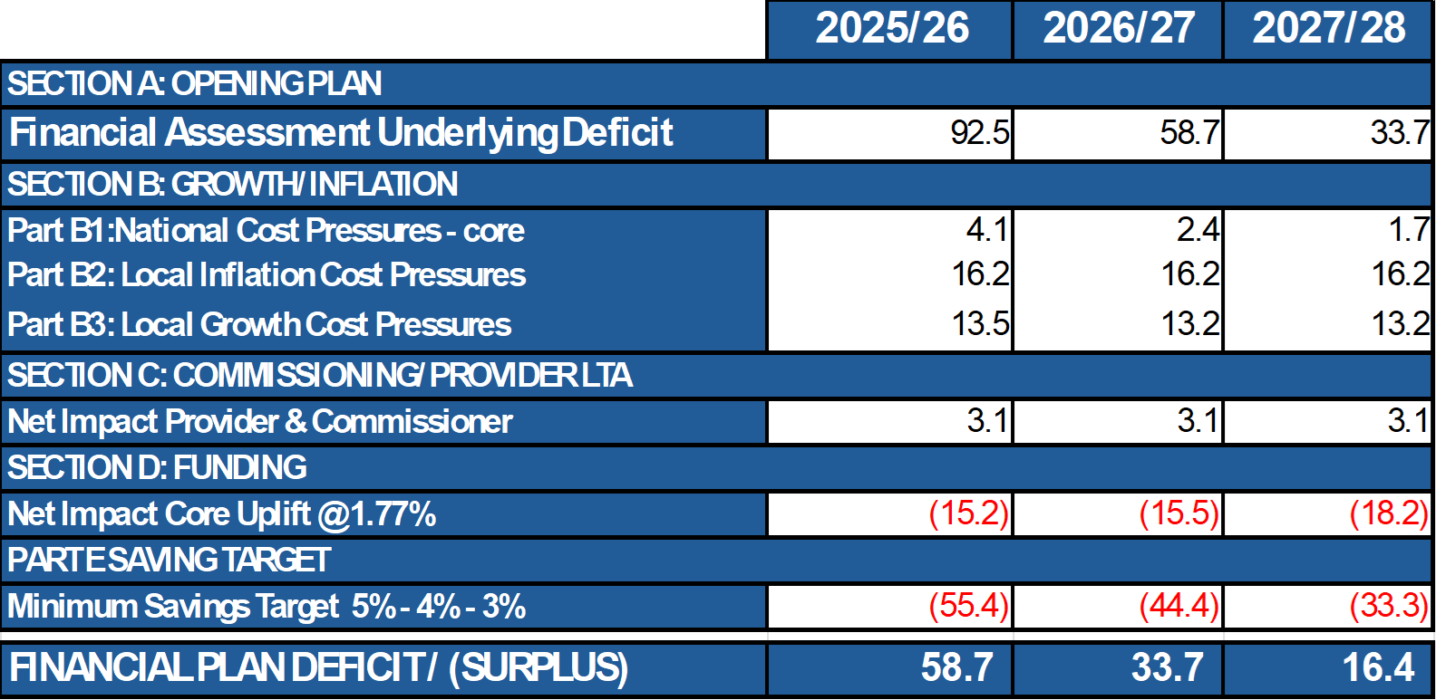

There are three key high-level elements of the forecast deficit in year 1: -

- Run rate pressures into 2025/26 from 2024/25
- Impact of additional forecast cost increases for growth, inflation and demand in 2025/26 above the Welsh Government allocation of 1.77%
- Savings framework

As stated earlier in this report, despite an ambitious and stretching savings requirement of £55.4m (5%), the impact of the opening underlying deficit in 2025/26 from 2024/25 of £92.5m and the assessed gap between new money available of £15.2m in 2025/26 compared to a demand, inflation and growth cost of £36.9m, the Health Board is unable, at this stage, to set out an improving financial position when compared to the 2024/25 predicted outturn.

The current plan does achieve target control total in year 3 and this is predicated on a significant savings programme of around 12% over 3 years, which must be recurrent in nature and still support and improve on key target delivery whilst maintaining/improving quality and safety.

The NHS Wales Chief Executive letter of 11 April 2025 clearly stated that the plan was unsupportable and unacceptable and that further urgent work was required on: -

  - The actions to improve upon and derisk the financial position, both mitigating and reducing the current planned deficit
  - Setting out the options and choices available to the organisation in order to improve further on the current plan, and what choices would be required to deliver the target control total set in 2024/25 alongside the impacts of doing so.
  - Increasing the confidence in delivery of the current savings plan.

The Health Board response to this urgent work is covered in the 5 sections (2.1 to 2.5) below. These cover: -

- Update on current savings position
- Update on savings pipeline
- Narrative on mitigating actions in quarter 1
- Refresh of the systems and processes in place to oversee the above
- Current position in respect of further options and choices

External Support
On the 23 April 2025 the Health Board received welcome confirmation from Welsh Government that expert external support would be made available to assist the Health Board to respond to its escalation for finance, strategy and planning. Board members have received this letter and associated supporting documentation. This will be commissioned as matter of urgency and will cover the following themes.

- Financial governance and control environment
- Understanding the existing deficit and key drivers
- Development and realisation of opportunities
- Clear financial plan and strategy
- Delivery of plan

The priority areas of focus set out in the letter are: -

- Testing the quality and effectiveness of the Board’s delivery structures
- Further work on the control environment, in key material expenditure and risk areas such as workforce.
- Urgent and emergency care given the significant increase in expenditure driving the organisations deficit with no material improvement in performance or outcomes.
- CHC given the significant increase in expenditure driving the organisations deficit and the need for sustainable solutions.
- External planning and delivery expertise to stress-test the health boards plan for 2025/26 identifying actions for improvement.

The Health Board recognises and supports the priority of work in these areas and will develop a clear accountability and governance arrangement with the Performance and Finance Committee to oversee this.

  - Current Savings Position
Table 2 below shows the current level of savings as set out on the Health Board’s formal savings trackers. The table shows, that at the time of writing, the total savings identified is £16.97m excluding corporate directorates.

Corporate Directorates have been instructed to maintain last year’s underspend of £3.3m and deliver £4.6m (£2.0m COO, £1.7m Estates) of savings.

The balance of corporate savings of circa £1.2m is anticipated that to be achieved, with scheme specific detail of these available by the end of May 2025.

Table 2 – Current savings position

Executive Directors are currently standing up their savings theme meetings as part of the overall savings framework agreed by the Board. These themes are specifically designed to support Service Groups to achieve the savings requirements given the scale of savings required.

  - Update on Savings Pipeline
The Health Board has identified a range of further savings opportunities which act as a pipeline to supplement the existing savings plans. The pipeline is generated from the application of benchmarking across variable pay, bed, medicines management and procurement. The translation of these pipeline/opportunity areas into quantifiable and delivering savings schemes is key and requires executive leadership and oversight to realise. The executive led savings theme meetings are designed to take these forward.

Additionally, the Recovery and Sustainability Workstreams will support delivery here and will specifically be looking to identify further pipeline opportunities to increase the scale of pipeline options to be explored.

Table 3 below sets out the pipeline areas as currently assessed which total £22.6m.

Table 3 – Savings pipeline

  - Mitigating Actions in Quarter 1
Every budget holder has been asked to consider further mitigating actions that can be delivered in Quarter 1 whilst the scale and pace of savings is increased. The nature of these can be one off, with the Board is absolutely clear that the savings quantum of £55.4m in 2025/26 needs to be met recurrently.

Work has also been started to test some of the assumptions in the opening deficit of the plan given changes in some run rate areas in quarter 4. These include, but not exhaustively: -

- Further focus on variable pay
- Prescribing patterns with 18% of prescribing spend subject to a reduction in Q4
- Run rate in pathology as a result of managed service contract is above expectations
- Impact of recruitment freeze on plans
- Further hold of non-pay spend

  - Systems and processes to oversee savings delivery
A significant amount of redesign of processes has been undertaken to strengthen the delivery of savings whilst focussing on grip and control of current spend rates. Board members will be aware of the financial plan framework and the agreement of Recovery and Sustainability work stream areas for 2025/26.

Diagram 1 below sets out the reporting and governance structure for the financial plan from a savings, run rate and pipeline perspective. Oversight of the plan and its delivery remain a primary matter for the Performance and Finance Committee (PFC) which is a direct sub-committee of the Full Board. Sufficient time will be given at these meetings with PFC meeting twice a month at present to scrutinise, challenge and support delivery plans.

Diagram 1 – Financial Plan Framework

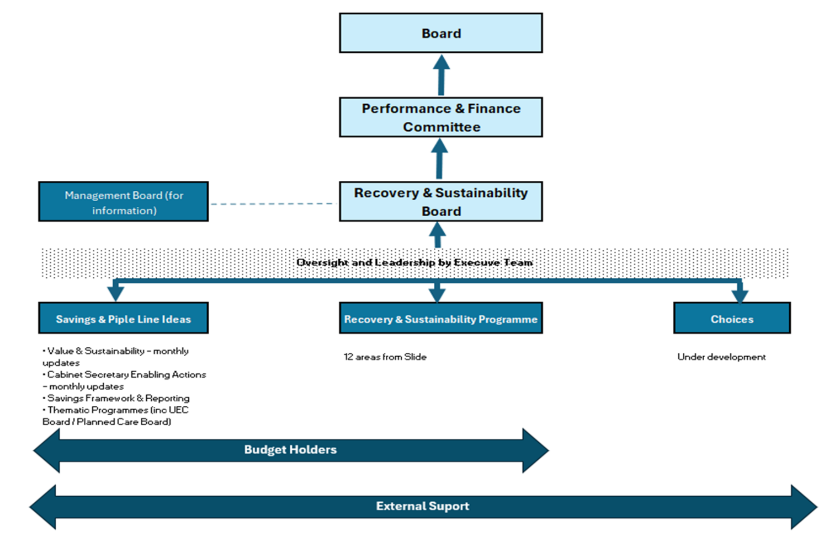

On the basis of the current financial profile the Health Board is maintaining its control system from 2024/25 into 2025/26 in terms of vacancy freeze and variable pay controls.

A test as to the efficacy of this system of delivery would also be welcome through the external support as outlined above.

The Recovery and Sustainability Programme has been refreshed for 2025/26, reflecting on the learning from 2025/26 and further team resource has been allocated to strengthen it.

The 2025/26 R&S programme plan was presented and agreed at the 9 April 2025 meeting. The programme for 2025/26 consists of 12 overarching work streams with the work streams initiated via a Project Initiation Document (PID) / plan on a page to provide an overview of the likely outcomes and delivery expectations.

Diagram 2 below sets out the work stream areas in the Recovery and Sustainability Programme

Diagram 2 – Recovery and Sustainability Workstreams
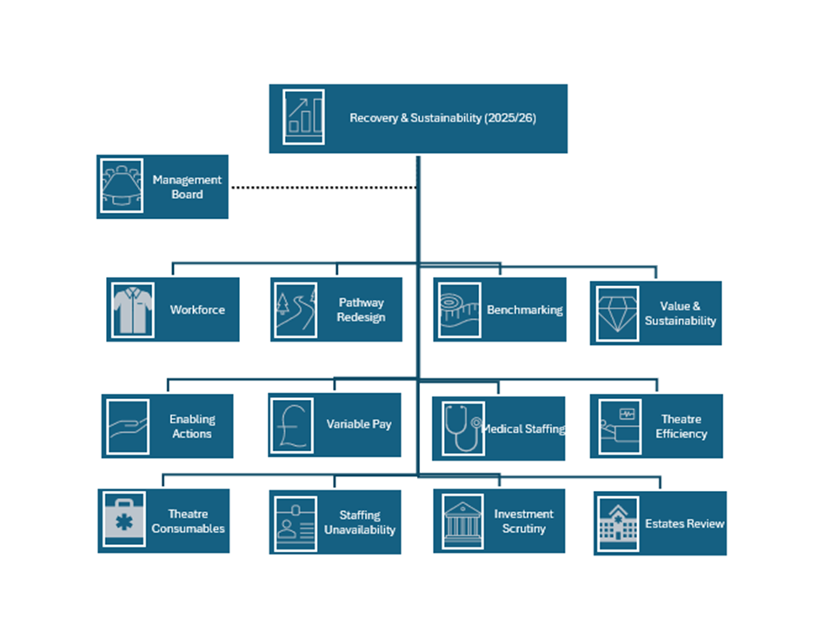
Following advice and consideration from the Health Board Performance and Finance Committee held on 29 April 2025 these workstreams are now being mapped to the main executive led savings themes to clearly set out how the resource available to identify and deliver savings is aligned.

  - Further Options and Choices
The Health Board has been developing a draft list of further options and choices that could be implemented with the support of Welsh Government. These options and choices are currently being impact assessed and where possible, assessed for their financial benefits based on estimated timelines of implementation.

The is being developed based on an agreed set of principles: -

- Reprovision of services which are currently delivered from accommodation with high backlog maintenance requirements
- Where combining disparate or fragile services could result in economies of scale and increased sustainability
- Where services are currently not achieving high benchmarked efficiency based on current size and configuration

The work is also considering service design both within the Health Board and across our service provision in the Regional Joint Committee with Hywel Dda but also for tertiary services across South Wales.

21 different draft choices are currently being explored. At present only 4 have been quantified to a possible value of £7.4m should they be supportable. These are currently not ready for full Board consideration and they will be worked trough and developed further with Welsh Government. An update on the position of these options and choices will be brought to a future Board meeting.

Further urgent work will be undertaken in light of the outcome of the publication of the recommendations from work of the Ministerial Advisory Group (MAG) and the outputs of this fed into the appropriate part of the savings plans

  - Section Summary
A significant amount of work is underway to derisk the financial plan and the position is evolving and improving on a weekly basis. The approach being taken is to improve the financial delivery of the current plan and not fundamentally change the delivery in terms of quality, safety, performance etc. within the plan at all.

In summary: -

- The current total of identified savings is £16.97m
- Confidence in delivery of reduced corporate department run rates and £1.2m of savings (not included in the £16.97m)
- Additional pipeline opportunities are £22.64m
- The options and choices identified are currently £7.4m and further discussion will be undertaken on these.

The current content of the savings plan does not provide a line of sight to the £55.4m target.

Based on historic delivery, the 5% CIP represents a stretch to what the Health Board can achieve. However, the underlying assessment of 2024/25 into 2025/26 requires the organisation to deliver an increased level of savings in 2025/26 and beyond to recover the financial position as quickly and sustainably as possible.

Savings in future years to deliver the Target Control Total will also need to be significant and the work that the external support will undertake with the Health Board is critical to making 2025/26 more robust. Looking forward, this work must identify future service change and service configuration to support sustainable savings delivery in future years.

At this stage there is risk to the delivery of the currently stated financial plan which will be mitigated by the new systems of work underway within the Health Board to identify and deliver savings alongside the external support.

- GOVERNANCE AND RISK ISSUES
The Health Board risk register is currently reporting the revenue risk through Risk number 92 - achieving financial plan with the key elements as follows: -

- Risk of delivery of savings quantum
- Risk of operational overspend being in excess of agreed Financial Plan
- Risk of commitment of reserves (e.g. NICE) being above reserves available.
- Risk of further options and choices not supporting an improved forecast position

At this stage it is proposed that this risk remains a 25 score. The risk will be refreshed routinely as the savings pipeline and delivery evolve alongside the arrival of external support.

An Accountable Officer letter summarising the position set out in this paper is attached as Appendix 2 to this letter for consideration and approval by the Board.

- FINANCIAL IMPLICATIONS
The financial implications of this report are set out throughout it.

- RECOMMENDATIONS
Members are asked to: -
- RECEIVE and CONSIDER correspondence from Welsh Government in response to the submitted plan and in relation to external support
- ACKNOWLEDGE increased level of savings in the plan
- ACKNOWLEDGE the identified pipeline of further potential savings and SUPPORT the immediate acceleration of these
- ACKNOWLEDGE that the currently available savings and pipeline opportunities do not meet the required £55.4m savings needed
- ACKNOWLEDGE that work is underway to identify mitigating opportunities in Quarter 1 to bridge the savings gap
- TAKE ACCOUNT of Accountable Officer advice in relation to the financial plan
- AGREE final response letter setting out the Board position
- SUPPORT the submission of further options and choices to Welsh Government for separate discussion
- AGREE that the Board will continue with its detailed scrutiny on a weekly, fortnightly and monthly basis, at both informal and formal Performance and Finance Committee meetings.

Governance and Assurance

Link to Enabling Objectives  (please choose) | Supporting better health and wellbeing by actively promoting and empowering people to live well in resilient communities
Link to Enabling Objectives  (please choose) | Partnerships for Improving Health and Wellbeing |  | ☐
Link to Enabling Objectives  (please choose) | Co-Production and Health Literacy |  | ☐
Link to Enabling Objectives  (please choose) | Digitally Enabled Health and Wellbeing |  | ☐
Link to Enabling Objectives  (please choose) | Deliver better care through excellent health and care services achieving the outcomes that matter most to people
Link to Enabling Objectives  (please choose) | Best Value Outcomes and High-Quality Care |  | ☒
Link to Enabling Objectives  (please choose) | Partnerships for Care |  | ☒
Link to Enabling Objectives  (please choose) | Excellent Staff |  | ☐
Link to Enabling Objectives  (please choose) | Digitally Enabled Care |  | ☐
Link to Enabling Objectives  (please choose) | Outstanding Research, Innovation, Education and Learning |  | ☐
Health and Care Standards
(please choose) | Staying Healthy |  | ☐
(please choose) | Safe Care |  | ☐
(please choose) | Effective Care |  | ☐
(please choose) | Dignified Care |  | ☐
(please choose) | Timely Care |  | ☐
(please choose) | Individual Care |  | ☐
(please choose) | Staff and Resources |  | ☒
Quality, Safety and Patient Experience
Financial Governance supports quality, safety, and patient experience.

Financial Implications
The Board is reporting a forecast year-end deficit financial outturn.

Legal Implications (including equality and diversity assessment)
No implications

Staffing Implications
No implications

Long Term Implications (including the impact of the Well-being of Future Generations (Wales) Act 2015)
No implications
Report History |  | Updates on the financial position are provided at every meeting.
Appendices |  | APPENDIX 1 – Letter – Swansea Bay University Health Board – Submission of Annual Plan 2025/26  APPENDIX 2 – Letter – Draft response to Welsh Government

APPENDIX 1 – Letter – Swansea Bay University Health Board – Submission of Annual Plan 2025/26
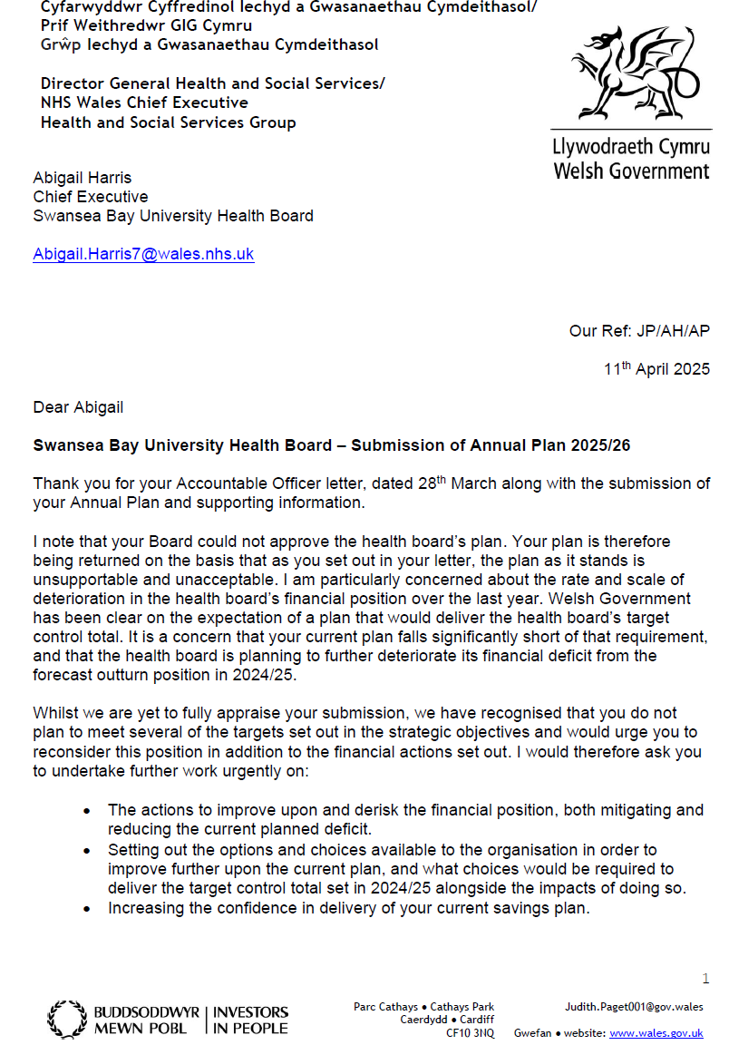

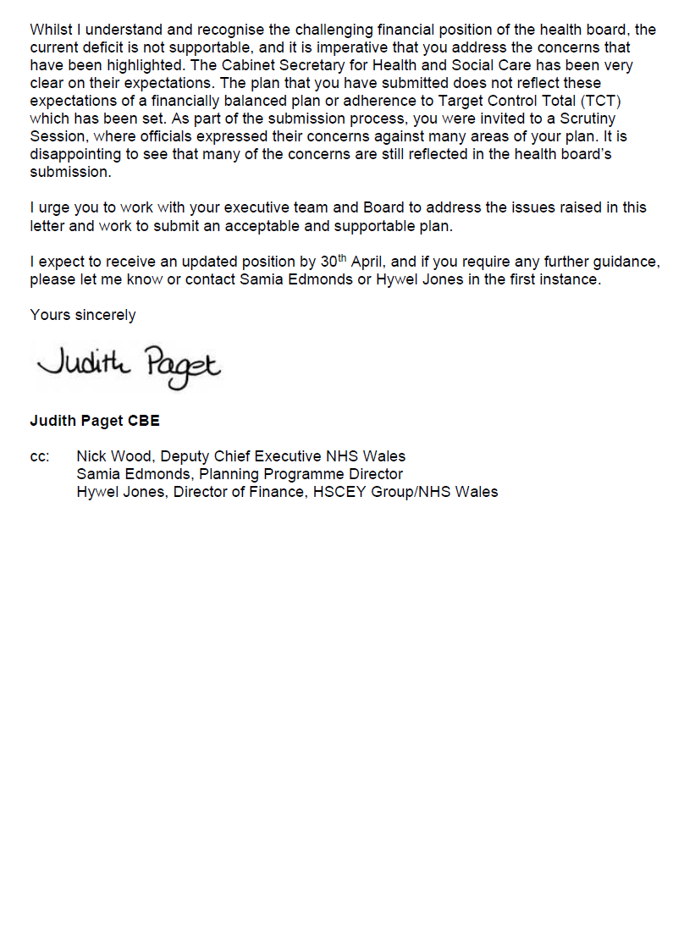

APPENDIX 2 – Letter – Draft response to Welsh Government

To follow

