Meeting Date | 23rd May 2024 |  | Agenda Item |  | 2.1
Report Title | Targeted Intervention Update
Report Author | Deb Lewis, Chief Operating Officer and SRO for Targeted Intervention
Report Sponsor | Deb Lewis, Chief Operating Officer and SRO for Targeted Intervention
Presented by | Deb Lewis, Chief Operating Officer and SRO for Targeted Intervention  Anjula Mehta, Interim Medical Director / Medical Lead for Targeted Intervention
Freedom of Information | Open
Purpose of the Report | To provide a summary of the Performance and Outcomes issues with services escalated to Targeted Intervention level of performance monitoring by Welsh Government; namely:  - Urgent and Emergency Care (UEC)  - Cancer  - Planned Care  - Healthcare Acquired Infections (HCAIs)  - Child and Adolescent Mental Health (CAMHs)
Key Issues | Following the Welsh Government’s tripartite meeting in December 2023, SBUHB was put into targeted intervention for performance and outcomes in the areas noted above. A comprehensive work-programme has been put in place across the Health Board to monitor progress. This report provides oversight and assurance of the programme.
Specific Action Required  (Please choose one only) | Information | Discussion | Assurance | Approval
Specific Action Required  (Please choose one only) | ☒ | ☐ | ☒ | ☒
Recommendations | Members are asked to:  - NOTE the plans developed in response to targeted intervention.  - CONSIDER and APPROVE the resource Implications to support the programme

TARGETED INTERVENTION UPDATE

- INTRODUCTION
This report describes the immediate actions and longer-term proposals being developed and implemented in response to escalated performance monitoring arrangements by Wales Government. The report provides an update on the operational programme to manage the delivery of improved performance and outcomes for services under targeted intervention, namely:

- Urgent and Emergency Care (UEC)
- Cancer
- Planned Care
- Healthcare Associated Infections (HCAIs)
- Child and Adolescent Mental Health (CAMHs)

It will also seek to identify any additional resource implications to support delivery that have not been included within the Annual Plan.

- BACKGROUND
Following Welsh Government’s tripartite meeting in December 2023, the Health Board was notified of an escalation of performance monitoring for performance and outcomes from enhanced monitoring to targeted intervention. The services noted above were specifically included in that escalation. On 12th April 2024, the HB had its inception meeting with WG colleagues and on 24th April the first quarterly meeting was held with the Chief Executive of NHS Wales. It is anticipated that the quarterly meeting will subsequently alternate with formal Joint Executive Team (JET) meetings. Monthly review meetings will be held with WG officers. The Chief Operating Officer has been given the function of SRO for targeted invention and each work programme is supported by senior management and clinical leads.

The escalation is managed formally via an escalation framework, which is attached for information. For services to move from targeted intervention back to enhanced monitoring, a set of de-escalation criteria are to be met and maintained for at least three months. The measures are noted below:

Cancer
- 60% performance maintained for 3 months against the SCP target.

Planned Care
- 100% of open outpatient pathways to be waiting less than 52 weeks and maintained for 3 months.
- 100% of open pathways to be waiting less than 104 weeks and maintained for 3 months.
- 80% of open pathways to be waiting less than 52 weeks and maintained for 3 months.
- 15% reduction in the number of patients delayed by 100% for their follow up appointment in three consecutive months and maintained for 3 months (Based on the November 2023 baseline.)
- 65% R1 ophthalmology patient pathways to be waiting within or no longer than 25% of their target date for an outpatient appointment and maintained for 3 months.
- 80% of patients waiting for a diagnostic test to be waiting less than 8 weeks and maintained for 3 months.
- 80% of patients waiting for a diagnostic endoscopy to be waiting less than 8 weeks and maintained for 3 months.
- 80% of patients waiting for a NOUS and non-cardiac MRI to be waiting less than 8 weeks and maintained for 3 months.
- 85% of patients waiting for therapies to be waiting less than 14 weeks and maintained for 3 months.
- Assessment of health board response and handling of concerns, complaints, incidents and patient experience feedback related to planned care.
- Improving ratings from patient experience surveys and evidence of use of Datix and CIVICA data to inform quality improvement processes and the experience of patients and their families.

Urgent and Emergency Care
- A continuous reduction of ambulance handovers over an hour of at least 11% in three consecutive months and maintained for 3 months (Based on quarter 2 and 3 2023 baseline).
- Continuous improvement towards no more than 7% of patients waiting over 12 hours at each individual site and across the health board.
- Median time from arrival at an emergency department to assessment by a clinical decision maker should not exceed 60 minutes.
- A continuous reduction in delayed pathways of care of 5% for three consecutive months and then maintained for three months (based on Oct-Dec 23 baseline).
- Assessment of health board response and handling of concerns, complaints, incidents and patient experience feedback related to planned care.
- Assessment of declared BCIs, including reasons why, actions taken, and lessons learnt.
- Improving ratings from patient experience surveys and evidence of use of Datix and CIVICA data to inform quality improvement processes and the experience of patients and their families.

CAMHS
- 80% of LPMHSS mental health assessments undertaken within 28 days from the date of receipt of referral.
- 65% of therapeutic interventions started within 28 days following an assessment by LPMHSS.
- 80% of HB residents in receipt of secondary mental health services who have a valid care and treatment plan.

HCAI Improvements
- Stabilisation of the increased trajectory of cases of HCAI and evidence of continuous improvement accompanied by a strong QI approach and plan that has oversight and monitoring by board Quality Safety Committee and Board.
- The health board to have a clear improvement plan based on a root cause analysis to address the issue of hospital onset HCAIs.
- C-Diff: reduce the number of hospital onset infections by 40% and maintain for 3 months (from a baseline of the average number of cases in quarter 3 of 10 cases to no more than 6 per month)
- Staph aureus: reduce the number of hospital onset infections by 25% and maintain for 3 months (from a baseline of the average number of cases in quarter 3 of 4 cases to no more than 3 per month)
- E-coli: reduce the number of hospital onset infections by 20% and maintain for 3 months (from a baseline of the average number of cases in quarter 3 of 5 cases to no more than 4 per month)
- Klebsiella: reduce the number of hospital onset infections by 10% and maintain for 3 months based on 2017/18 figures (baseline – 54 cases in 2017/18, reduce to average of at most 4 per month)

Target Intervention Work Programme
The following narratives gives an overview of the work programmes being implemented in response to targeted invention and an update on progress against the measures.

Urgent and Emergency Care (UEC)
In the context of UEC, it is important to note that although performance monitoring is predominantly between the Health Board and Welsh Government, services are delivered across all boundaries of the Health Board and in conjunction with Local Authority and Third Sector partners. From a HB perspective, there is a focus to:

- Safely limit the number of patients requiring attendance to the Emergency Department (ED) improve the flow of Emergency patients within the health board via promotion self-care and management via primary care and community service provision.
- Ensure timely clinical decision making within ED leading to discharge at the earliest opportunity or admission into the appropriate, specialist secondary care service.
- Minimise the length of stay in ED for patients requiring admission.

The focus on these key elements will ensure the population receives the appropriate level of care, at the appropriate time and in the most appropriate place. Current inconsistencies and high number of entry and exit points within the system coupled with gaps in service provision of critical clinical pathways lead to poor flow of patients across the system. This significantly increases the risk of patient harm due to delayed care, impacts on the timely discharge of clinically optimised patients and results in the excess number of patients being treated outside our core bed base.

In summary the lack of flow impacts on the following aspects of care provision:

- Delay in patient handover from ambulances into the ED – ambulances are being “held” at hospital sites resulting in long community waits to receive an ambulance response.
- Delays in patients accessing inpatient beds – patients waiting too long in ED on trolleys and in assessment areas which causes delays in specialist care provision and leads to increased risk of deconditioning, HCAI and general decline particularly within the frail elderly patient cohort.
- Increase in utilisation of “surge” capacity across the Hospital footprint and patients placed in clinically inappropriate spaces i.e. SDEC or cardiac short stay. Surge capacity is not routinely funded or staffed and puts increased financial, workforce and operational pressure on hospital teams.
- Delays in patients transferring to the next stage of their recovery – complex and general rehabilitation at peripheral sites.
- Delays in discharges home where ongoing assessment of ongoing needs can take place and targeted rehabilitation can be started.

Baseline performance against de-escalation criteria:

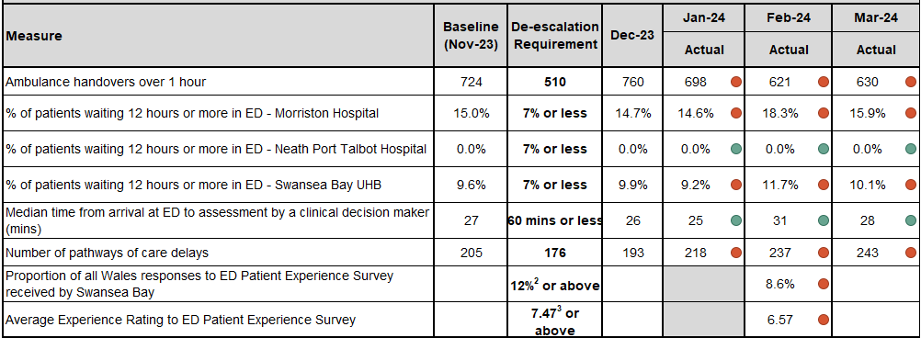

The Leadership team for UEC is as follows;

- Operations Director Lead – Neil Cooper, Assistant Director of Operations for UEC
- Medical Director Lead – Mark Ramsey, Group Medical Director - Morriston
- Nursing Director Lead – Emily Davies, Acting Associate Director of Nursing

In addition to the triumvirate, support will also be made available from specialist business partners from the following areas:
- Strategy,
- Finance,
- Workforce/OD and
- Informatics.

Whilst the escalation to TI is recent, the HB has been working on initiatives for service improvement as part of the National 6-Goals programme and the response to TI will see plans aligned to those already in inception. The recovery plan is being developed in five key areas:

- Management of Frailty – development of a comprehensive frailty strategy for the HB and across the Regional Partnership Board (RPB). This will include dedicated frailty pathways within USC.
- Medical rosters - provision of senior decision makers at the front door services, particular focus on ED, AMU and SDEC.
- Day-to-day grip and control of the operational management of flow – in line with the C&VUHB model.
- Optimisation and right-sizing of community service provision Home First (HF), District Nursing, Community Rehabilitation Teams and Community Specialist Palliative Care services.
- Reconfiguration of the ED footprint at Morriston Hospital to improve timely patient management.

Each of the work programmes identified above will be supported by a triumvirate consisting of operations, medical and nursing leads (where required) to ensure there is capacity to undertake the work required.

Work Programme

This section expands on the individual workstreams where detail has already been worked up. This detail will increase over quarter one this year.

Frailty Strategy

Triumvirate:
- Operations – Gareth Cottrell, Deputy Service Group Director – Morriston
- Medical – Liz Davies, Clinical Director Emergency Medicine / Consultant Geriatrician
- Nursing – Emma Mitchell, Head of Nursing, Medicine

The main focus for sustainable UEC improvement for the population of SBUHB is the development and implementation of frailty pathways. Patients with high frailty scores and urgent care needs will receive expert triage and if appropriate assessment and treatment by VW/ACT services in their own homes. Alternatively attendance/admission via an enhanced acute frailty unit will be facilitated avoiding delay of care and prolonged stay within ED and significantly reducing demand/overcrowding within ED.

A Frailty Proposal was presented to Management Board on 20h March and approved for implementation. The paper is attached for reference. There are several components to the plan and implementation is spread over the first six months of the year. Implementation of the frailty hub is planned ahead of Q3.

Optimisation of medical take

Triumvirate:
- Operations – Sue Moore, Service Group Director – Morriston
- Medical – Rhodri Edwards, Clinical Director Medicine / Consultant Geriatrician
- Nursing – Emma Mitchell, Head of Nursing, Medicine

The Acute Medical Services Redesign programme (AMSR) implementation identified the need to change medical staff rotas to support front door services at Morriston Hospital. Due to recruitment challenges, this work remains outstanding. A renewed focus will now be given to this work to ensure the consultant support within AMU and SDEC is available during key operating hours and is consistent with continuity of care. This work is also being supported by external consultants from NHS Improvement (Dr Jyoti Nippani and Claire Old). In addition further work is required to maximise same day ambulatory care opportunities within SDEC.

Day-to-day grip and control

Triumvirate:
- Operations – Shirely Hoskins, Interim General Manager – Hospital Operations, Morriston
- Medical – Liz Davies, Clinical Director Emergency Medicine / Consultant Geriatrician
- Nursing – Ceri Matthews, Service Group Nurse Director - Morriston

It is known throughout NHS Wales that the organisation with the best performance in front door flow is Cardiff & Vale UHB. Therefore, in Jan-24 a team from SBUHB visited UHW to see what improvements have been made and what could be transferred for local implementation to realise similar gain.

It was evident that aside from the physical infra-structure, the biggest difference between how the two HBs manage flow is the “grip and control” demonstrated across the whole system. Details on the structure within C&VUHB have been shared and the team is currently reviewing to identify opportunities to improve the structure at SBUHB. Main difference identified are:
- Team of very senior nurse and operational managers in place to cover flow on a daily basis
- Dedicated service manager input co-located with the flow hub with responsibility for pulling patients from ED to wards based on specialty requirement.
- Zero tolerance to 12-hour bed waits in ED with close monitoring of named lists and waits within the flow hub, led by dedicated senior manager
- Visible medical leadership with obvious ownership of the front door services, both ED and AMU.

Community Services – Maximising Capacity

Triumvirate:
- Operations – Brian Owens, Service Group Director - PCTSG
- Medical – Ceri Todd, Service Group Medical Director - PCTSG
- Nursing – Sian Passey, Service Group Nurse Director - PCTSG

The HB has invested considerable additional resource into the provision of community services over the last three years to facilitate timely discharge from acute hospital settings. Current configuration of the services is as follows:

- Home First (HF)
- District Nursing (DN)
- Clinical Resource Team (CRT)
- Community SPC

Performance metrics for these services is limited and this now needs to be a focus for improvement. The services need to be co-ordinated into a pathway format, with clear escalation / de-escalation criteria and clear performance metrics that give clarity on how resources are being used, where there is capacity not being utilised and where there is duplication in service provision. This will form a key part of the frailty strategy going forward but needs immediate attention in its current form. Metrics to be included that are not currently reviewed are:

- Hours of care available v hours utilised
- Number of referrals on pathways 1-3 with updated waiting times
- Live demand/capacity data to allow optimal management of available resources Escalation framework to understand any pathway of care delays
- Compliance with D2RA principles in assessing/right sizing care and re-ablement needs in the patient’s own environment

ED Reconfiguration

Triumvirate:
- Operations – Shirely Hoskins, Interim General Manager – Hospital Operations, Morriston
- Medical – Mark Poulden, Clinical Lead – Emergency Dept
- Nursing – Emma Mitchell, Head of Nursing - Medicine

This workstream originated from a visit to the ED by Nick Wood, Deputy Chief Executive, NHS Wales with SBUHB CEO, Richard Evans. The visit resulted in an indication that there may be funding available to undertake some structural changes to the ED, noting the relatively poor state of the department currently and the constraints it places on service provision. Further detail on this is awaited but provision plans are being drafted in anticipation.

Immediate Actions
The UEC improvement team acknowledges that some of the actions identified above are longer-term, sustainable service developments that will take six months to have any direct impact on performance against the UEC measures.

However, alongside these initiatives, there is already an improvement action plan in place that addresses the immediate issues and focus on performance improvement in parallel with the longer-term action. The plan was developed following supportive reviews undertaken by the national 6-Goals team. Particular focus was placed on the Same Day Emergency Care (SDEC) service, with the initial findings noted below and the full list of findings / recommendations outlined in Appendix 1 of this report.

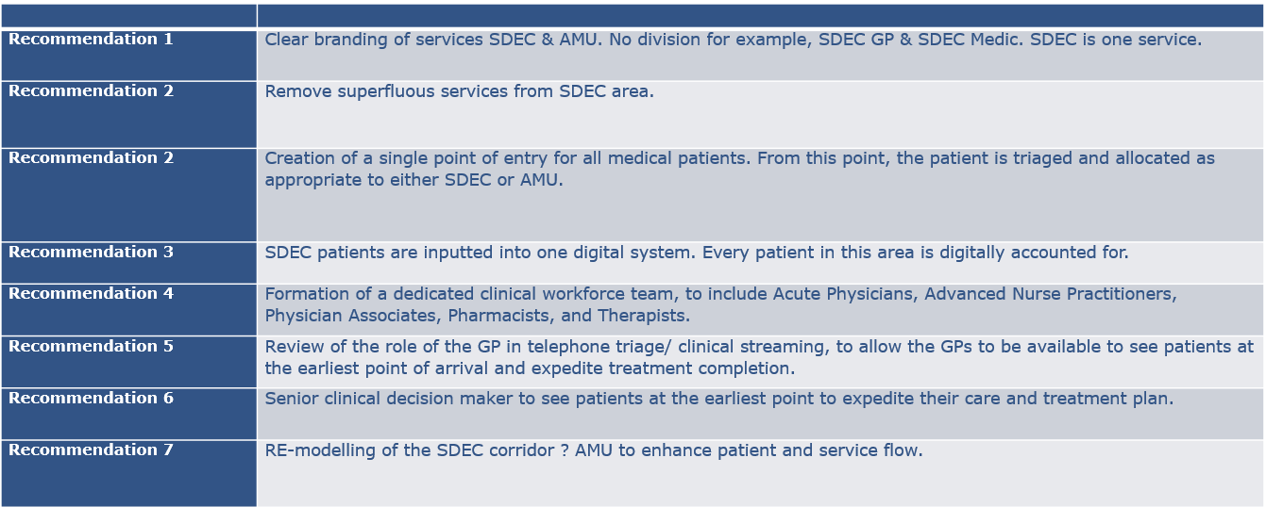

In addition to the SDEC actions, the immediate actions being taken include:

- Further development of the Continuous Flow Model
- Criteria Led Discharge
- Re-configuration of Inpatient / specialty wards
- D2RA/SAFER/Red to Green models of care
- Develop Operations hub for management of flow to include redesign of Silver On Call Rota
- Increase capacity of PAT team (7 day working)
- Pathway 1 Trusted Assessor development to improve bridging care opportunities
- Improved productivity measures for Community based ward
- Zero tolerance on using same day emergency care unit (SDEC) as surge capacity
- Reduce re-admissions to the Acute Hospital setting (To include frequent flyers)

TARGETED INTERVENTION – CANCER
The Leadership team for UEC is as follows;
- Operations Director Lead – Craige Wilson, Deputy COO
- Medical Director Lead – Raj Krishnan, Interim Executive Medical Director

Performance against the Single Cancer Pathway (SCP) target has been a focus for the HB over recent months, following some very poor monthly performance levels of just 48 over the winter period. Although all tumour sites are being closely monitored, the tumour sites of initial focus for improvement are those with the highest volumes and therefore greatest influence on overall performance, namely:
- Lower Gastrointestinal
- Breast
- Urology

The three next tumour sites which are being more closely monitored for improvement are:
- Lung
- Upper Gastrointestinal
- Gynaecology

Whilst Skin performs well against the SCP target, regularly achieving the 75% compliance target; as a high-volume tumour site, performance could improve further thereby supporting the HB’s overall compliance.
Under the current terms of targeted intervention, a compliance of a minimum of 60% must be achieved and sustained for three consecutive months.

Baseline performance:
The HB monitors two main metrics for the single cancer pathway:
- % Performance within the 62-day target
- Backlog volumes (patients waiting over 62 days)

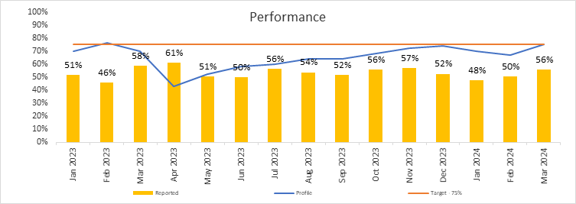

The graph above represents the patients receiving first definitive treatment (FDT) within the 62-day target and demonstrates the HB’s SCP performance over the last 13 months up to March 2024.

In-line with all Wales reporting schedules, data pre-January 2024 reflects the quarterly resubmission position (final reported position). The performance for October to December demonstrated an improvement between of 1% and 4%. The improved performance largely reflects an increase in the volume of patients confirmed as treated in target with a confirmed malignancy as a result of delayed pathology reporting.

Performance continues to fall short of the HB plan and aspirations and this is in part as result of the backlog volumes.

Backlog
The backlog trajectories were developed based on the anticipated improvement for individualised tumour sites, whilst reflecting traditionally what happened for previous bank holidays and holiday periods. Some tumour groups targets were set at zero for backlog throughout the year: Children’s Cancer, Acute Leukaemia and Brain/CNS, the reason for this is that referrals trigger backlog infrequently and volumes do not impact on the overall position.

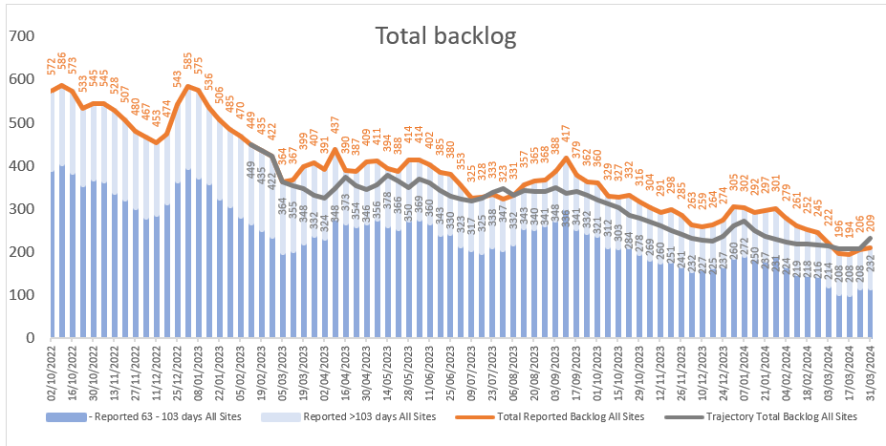

The end of year backlog position demonstrated a 41% reduction in volume over the year and 22 below trajectory despite the period of Industrial Action and the Easter break, albeit disappointing that the less than 200 position was not sustained. The most recently reported backlog position stands at 203 patients, this is a reduction of 31% over the last quarter.

Whilst there has been a reduction in the overall numbers of patients waiting over 62 days, this has not been reflected in an improvement in performance against the SCP target. This is due to the backlog number consisting of patients with a cancer diagnosis and those who do not yet have a clear diagnosis; only confirmed new diagnoses of cancer contribute to the overall SCP target.

Performance for 2024-25
A trajectory of improvement for 2024-25 for both backlog (by tumour site) and performance has been prepared. The production follows the methodology used in 2023/24.

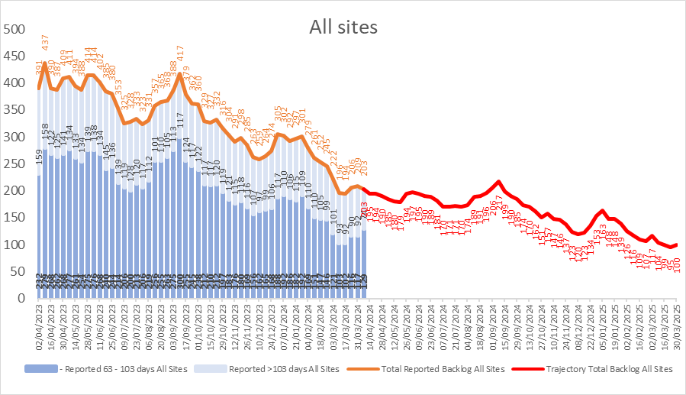

The backlog position is reported weekly and the target for March 2025 is to continue to reduce the backlog to 100 cases. It is anticipated that given the choices made by patients on a SCP, this is the lowest volume that can be delivered and sustained.
The SCP trajectory submitted as part of the annual plan is shown below; this shows the Health Board meeting the 60% TI target by the end of Quarter 2 and then maintaining and improving the position through the remainder of 2024/25.

Targeted Intervention Scrutiny
Weekly TI meetings for the cancer have been established with tumour site leads since the beginning of March-24 to scrutinise action plans with the lead clinician and divisional manager and other relevant colleagues (including those from diagnostic services). The meetings are led by the Deputy Chief Operating Officer and supported by the Interim Medical Director, Cancer Lead Clinician and Cancer Performance Manager. In addition to reviewing each action plan, there is also a review of the last 10 breaches within the tumour site to identify any trends and ensure that the action plans are correctly focused; 10-day outpatient performance of USC referrals and 31-day decision to treat performance are also scrutinised. In addition, there is a review of pathology turnaround times for each tumour site.

There are also weekly meetings with each tumour site, with the Deputy COO and Cancer Performance Manager to review at individual patient level detail performance at each stage of the Single Cancer Pathway. At these meetings service teams are asked to present the information for their particular specialty for scrutiny.

Cancer Improvement - Action Plans
As a consequence of the TI scrutiny meetings, tumour site action plans have been updated; the key actions for each tumour site are identified below:

Lower GI (Clinical Lead – Dean Harris; Divisional Management Lead – Mollie Kearns)

- There is sufficient capacity to meet the demand at outpatient stage and there is generally no backlog.
- Weekly average Demand: 10 - Now that the STT pathways are in place the demand for first OPA has significantly decreased.
- Weekly Core Capacity: Colorectal Clinic – 24 (capacity not used for USCs is converted to long waiting news or urgent/ cancer FUNBs).
- One Stop Rectal Bleed – 8 slots per week, we regularly review these clinics and will change urgent and routine slots for any USC demand.
- Current Backlog: 3 patients reporting over 10 days (all 3 are awaiting GP updates - fitness for prep / fit test not undertaken prior to referral).

Actions to recover:
- To closely monitor any referrals awaiting further GP information - this has been highlighted to the LMC and to request that some guidance/clarity be published in the GP newsletter.
- Monitoring clinic capacity closely and foreseeing and recovering any lost activity from IA, audit etc.
- The accelerated diagnostic pathway has now formally commenced and Dr Derrian Markham, has been instrumental in engaging with various departments and staff and reports that the initial period has been very successful. An early audit/evaluation of the pathway is planned later this month.
- A monthly meeting continues to be chaired by the Morriston Service Group Medical Director, bringing together clinical, managerial and cancer performance colleagues. Breach reports have been shared with the group and led to further discussion with a wider group of staff including anaesthetics. Additional data is being gathered to facilitate further discussion.
- Endoscopy waiting times across all modalities have improved from October/November 2023, although patient deferments to continue to impact our longest waiting cohorts.
- General Surgery is seeking to hold a time out session with the team to explore the sub-specialist areas within the consultant body, and changes required to process around MDT/MDM that will support the very specialist work undertaken by the team but not to negatively impact the more routine work or waiting times for these patients.
- Further issues raised and under review as part of the recovery plan for the tumour site include but are not limited to:
- Majority of patients not meeting 31-day DTT is CNA and DNAs at either OP or endoscopy. Further discussions required with booking team regarding out of hours working to contact patients and a script for booking and diagnostic teams to use when making appointment to be developed.
- A review of the ‘last 10 breaches’ demonstrated that 50% came through the BSW route. The BSW pathway is not aligned with the SCP and poses significant risk to performance.
- Morriston capacity perceived as factor due to the complex surgery undertaken there and limited access to surgery.

Breast (Clinical Lead – Chris Holcombe; Management Lead – Kerry Thompson)

The backlog position breast remains over trajectory. Breast performance is an area specifically targeted within the Health Board due to high volumes, particularly to treatment where we carry a high volume of breaches also.
- The service has appointed a new clinical lead.
- Treatment (surgical) capacity is a theme for patients in the backlog. Additional ad-hoc theatre capacity is secured where possible to mitigate waits but a sustainable solution is required.
- An Executive Summary of requirement for the service has been prepared for presentation within the Service Group has highlighted:
- Radiographer and radiologist capacity being the main factors in non-delivery of two-week first outpatient target.
- 20% of referrals are for breast pain. A Transformation Proposal submitted for nurse led community service for this patient group
- Clinical space in Singleton and NPTH is an issue
- Surgical capacity for treatment
- Outpatients’ capacity remains an issue with the average weekly demand for a first outpatient appointment being 45 referrals per week
- Average capacity is 62 but based on current attendance this would be more like 52 (taking into account annual/study leave/on call for both Breast Surgeons and Consultant Radiologists). This will increase slightly as we now have all day USC NPT on Tuesday and monitor this closely.
- The current back log is 38 patients waiting which will need at least 6 WLI clinics to reduce our currently 14 to 10 days. In order for Breast sustain this going forward, we will need to work jointly with our radiology colleagues and a meeting is planned on this supported by a business case for additional workforce.

In the short term the following is being undertaken:

- Improve DNA with text reminders (admin staff are contacting patients)
- Overbook book clinics by 1
- Consultant Radiographer 1.5 sessions to cover clinics (starting independent clinics 23.4.24) and cover Radiologists annual leave
- Advert for bank Advanced Nurse Practitioner (fixed term) – Locum Consultant Breast Surgeon reduced from 4 days to 3 days which we lost Thursday USC clinic
- Locum radiographer and assistant recruitment to open 2nd mammogram increasing by 10 slots.

Urology (Clinical Lead – Matt Jeffries; Divisional Management Lead – Mollie Kearns)

The Urology backlog position remains static but is an area specifically targeted within the Health Board due to high volumes, particularly with regards of waits to treatment where most breaches are contained. Specific areas of concerns are:

- Haematuria waits for first outpatient appointment are around 3 weeks and need to reduce by at least 1 week. This is the focus for the service to ensure current demand is met with sufficient capacity
  - Weekly Average Demand: 25
    - Haematuria: 10; PSA 9; other 6
  - Weekly Core Capacity:
    - Haematuria: 24; PSA: 10; other: 14
- Backlog:
  - PSA: 1 Haematuria: 0; Other: 0

- The waits for robotic treatment (RALP) remain exceptionally long; this is despite utilisation of additional capacity identified at C&V wherever possible. The robotic service at Swansea Bay will be in place from the 8th May. There is currently a gap of one week from when services will cease at C&V and commence locally, however capacity will double with two lists per week at Swansea.
- Longer term actions include improvements to deliver high care services (two beds); development of a business case for a 9th consultant surgeon with an interest in robotic surgery; providing cross cover arrangements for theatre lists and facilitating additional operating capacity at NPTH.
- The trans perineal biopsy service commenced at Swansea Bay during February, albeit training of further staff is underway to ensure continuity of service during leave. The service is running WLI activity in April to clear backlog for this investigation and bring waits down, with the aim to achieve biopsy within 1 week of request.
- The equipment for undertaking Transurethral laser ablation (TULA) has been received and will be operational by the end of March when works on the designated space will be complete, although the latter is not prohibitive as the equipment can be used in theatre. It is expected that the demand for surgical biopsy (TURBT) for small lesions will reduce, improving capacity and waiting times for those requiring treatment or diagnosis via TURBT. Staff training took place 19th March 2024.

Upper GI (Clinical Lead – Bilal Al-Sarireh; Divisional Management Leads – Mollie Kearns and Fiona Hughes)

In the initial TI meeting with the clinicians and management leads it was recognised that further detailed discussion is required to better appreciate the different pathways, issues and targeted improvements needed, based on the three separate subgroups: Gastro-oesophageal; Pancreas and Liver. Recovery plans will need to be developed independently for these areas and a follow up meeting is scheduled.

From an outpatient perspective capacity generally meets demand
- Weekly average demand:
  - Pancreatic: Very little demand as the majority go straight to MDT.
  - Oesophageal/Gastro: MDT discussion prior to an appointment.
- Weekly Core Capacity:
  - Pancreatic: 8 slots per week (capacity not used for USCs is converted to long waiting news or urgent/ cancer FUNBs).
  - UGI: 6 (with the opportunity to alter templates if the USC demand increases).
  - OG: 4 (Prof. Lewis single handed 0.5 WTE outreach from C&V – flex weekly clinic as required).
There is no backlog as there is close monitoring of patients and continual to flex outpatient capacity as required.

Skin (Clinical Lead Avad Mughal; Divisional Management Lead – Tracy Owen)

A joint action plan for Dermatology and Plastic Surgery has been prepared by the services. The areas identified for improvement include:
- First outpatient waits, ensuring demand and capacity plans are in place

Dermatology
- The average weekly demand for dermatology USC referrals in dermatology is currently 49. The average weekly capacity is 60 appointment slots
- The current backlog of first appointment patients waiting to be booked is 45 this due to loss of capacity relating to unexpected leave. There is also an issue with a backlog of triaging routine patients in the department as a small proportion of these patients are being upgraded to USC’s. This backlog has resulted due to sickness and unexpected leave.
- There will be additional clinics organised to eliminate the backlog. It is acknowledged that additional resilience needs to be built into core capacity to deal with unplanned absences and the department will work on this going forward.

Plastics
- Weekly demand for 1st outpatients in plastics is an average of 40
- Weekly capacity is being realigned in the job plans to achieve a capacity of 42 per week
- Backlog is currently 19 to achieve this target. Directorate Support staff are liaising directly with the Central Booking Team to displace non-USC cases
- Timely grading of non-USC GP referrals as delays incurred where referrals are upgraded to USC impact SCP waiting times.
- Ensuring adequate photographs of lesions to support grading are provided at time of referral
- Ensuring appropriate surgical capacity within Plastic Surgery to deliver treatment within 21 days and no longer than 31.

Gynaecology (Clincal Lead – Kerryn Lutchman-Singh; Management Lead – Abigail Morris)

Cancer performance within Gynaecology and Gynae-oncology has been subject to a Gold Command structure for the last six months due to on-going performance concerns. Detailed improvement plans are in place as part of that structure and are summarised below:
- At outpatient stage the weekly demand is 14 with weekly activity of 12. Shortfall is with Vulval and Oncology. Additional clinic secured with a Reg conducting clinics for Vulval and additional clinics ongoing in Oncology.
- Further improvement of First OPA waits is noted in March, the median wait maintained at 12 days and the percentage of patients seen within 2 weeks improved from 65% to 70%. Additional work is required to review gynae-oncology waiting times to first appointment; however, we recognise a lack of clinical nurse specialists within this area also impacts this service.
- Additional lists for the PMB/endometrial pathway utilising WLI and insourcing activities and will continue until sustainable solutions are worked through.
- An additional band 6 CNS has been advertised, with outcome from interviews held 5th April awaited.
- A band 4 support worker post has been submitted to the senior management team for consideration, Macmillan funding is a possibility, however an exit plan required before this can be progressed.
- Additional gynae-oncology theatre capacity on Saturdays was paused during March due to consultant leave and will recommence from the 13 April 2025 for 3 months.
- The locum Gynae-oncologist left at the end of February 2024, a replacement is being sourced through an outsourcing provider.
- As a result of the departure of the Locum Gynae-oncologist, the service has lost operating capacity as Monday theatre lists cannot be covered within the team. Thursday operating lists can be extended to a third session on a permanent basis and the detail is being worked through.
- A weekly theatre list at Neath has been secured in March which will help to reduce waiting times and better manage demand for GA hysteroscopies.

Lung (Clinical Leads – Madhukar Shetty, Rhian Finn, Divisional Management Lead – Fiona Hughes)

- From a thoracic outpatient perspective there is sufficient capacity to meet demand and there is no backlog.

However, there are still a number of key delays in the pathway for lung cancer patients, in particular diagnostic delays around access to CT biopsy and complex immunohistochemistry and molecular analysis of pathology specimens. Diagnostic difficulty has contributed to the breach position, where repeat biopsies have been required to establish a confirmatory diagnosis as well as synchronous presentation of multiple separate primary tumours.

- Radiology is progressing developments for dedicated space to accommodate patients requiring CT guided biopsy currently requiring admission to hospital for post procedure monitoring. Costings have been prepared for equipment and staffing.
- With the support of the Macmillan Lead GP a newsletter has been shared with primary care colleagues regarding direct to CT referrals where lung cancer is suspected to reduce the waiting times within the diagnostic phase.
- The Thoracic Surgery service has been affected greatly by sickness and other leave at the end of 2023 and into February 2024. This impacted on both outpatient waits and surgical waits. As part of the HB’s Adult Thoracic Surgical Centre plan a third consultant surgeon has been appointed, due to commence in post 29th April with clinic activity planned. Surgical capacity is a constraint within this area, primarily due to a lack of cardiothoracic trained ODP’s, which has been escalated.

Cellular Pathology (Clinical Lead – Suzie Howarth; Divisional Management Lead – Mollie Kearns)

As a number of the tumour site meetings have highlighted delays in the turnaround of histopathology reports and a 5-day turnaround has been set for reporting a separate cancer TI meeting. This highlighted a number of issues:
- Dr Namor Williams attended the meeting and demonstrated the system that he has developed to identify patients on the SCP. A list of these patients is circulated to his colleagues every week. This system is completely reliant on Dr Williams and therefore a more robust digital solution is required.
- There is a need for greater awareness across all consultant histopathologist of the need to prioritise SCP patients
- There appears to be an overuse of the USC prioritisation for histopathology specimen; the Interim Medical Director will issue a communication to consultants
- A review of the current job plans for consultant histopathologist is urgently required to explore the possibility of a greater ration of Direct Clinical Care sessions.

Head & Neck (Clincal Lead – Laysan Pope; Divisional Management Lead – Mollie Kearns)

There has not been a meeting to discuss Head and Neck cancer performance with the Divisional Manager and Clinical Lead to date. The focus has been on those tumour sites with larger volumes. However, there are weekly scrutiny meetings with the service teams.
In terms of first outpatient core capacity generally meets demand:

ENT
- Weekly average demand: 16
- Weekly Core Capacity: 32 (capacity not used for USCs is converted to long waiting news or urgent FUNBs)
- Current Backlog: 13 (all appointed other than 1 – patient unwell)

Actions to recover:
- Service tends to only run with about 3-5 in backlog at 1st OPA due to patient choice rather than capacity shortage (generic update below re plan to address this).
- WLIs have been utilised to recover backlog incurred by IA – recovery expected by next week.
- Actions for sustainable improvements have been implemented, D&C matched and managed proactively.

OMFS
- Weekly average demand: 27
- Weekly Core Capacity: 39 (capacity not used for USCs is converted to long waiting news or urgent FUNBs).
- Current Backlog: 20 (16 booked, 1 not 1st OPA (tertiary), 2 not yet accepted awaiting photos from GP, 1 patient choice 1st May).

Actions to recover:
- Service tends to run with about 5-8 in backlog at 1st OPA, due to patient unavailability/patient choice rather than capacity shortage (generic update below re plan to address this).
- Ad-hoc extra clinics have been possible due to surgeon not being able to operate utilising to recover backlog incurred by IA.
- Actions for sustainable improvements have been implemented, D&C matched and managed proactively.

Patients choosing not the attend for appointments is a particular issue within Head & Neck. Therefore the team is making enquiries with the LMC to see if there is a possible of some joint working, sharing data with GPs to seek GPs support to reiterate the urgency with which areferral is going to be treated by the secondary care services, ensuring that patients are aware they are on an urgent suspected cancer pathway to rule out the possibility of cancer. Also exploring with medical director’s office and comms the possibility of some generic comms pieces from the HB to share with the public how the services will push to appoint USCs within two weeks.

Radiology
A meeting with radiology is scheduled for April 24th to discuss issues that have been highlighted through the meeting with the tumour site leads and to discuss their prioritisation system for patients on a Single Cancer Pathway.

TARGETED INTERVENTION – PLANNED CARE
The Leadership team for Planned Care is as follows;

- Operations Director Lead – Deb Lewis, Chief Operating Officer
- Medical Director Lead – Dougie Russell, Group Medical Director - Singleton

The HB made significant improvements during 2023/24 on planned care delivery. The main are of concern for SBUHB was extremely long waits for surgery in some challenged specialties, specifically orthopaedics, spinal surgery and plastic surgery. However, although waits for treatment remain higher than the WG target of 104 weeks (in 23/24), the very long waits have now been eradicated and waits in SBUHB are in line with other HBs in Wales. As can be seen from the baseline data below, the HB is already achieving the targeted level of performance in 5 out of 8 measures. However, there remains three key areas of challenge, two of which where the HB is an outlier* in comparison across NHS Wales, these are:
- 100% of open RTT pathways waiting less than 104 weeks – current performance 98%
- * 80% of Endoscopy waits within 8 weeks – current performance 23%
- *Follow-up waits over 100% of target date = 15% reduction from 41,727 to 25,626 – current performance 48,969

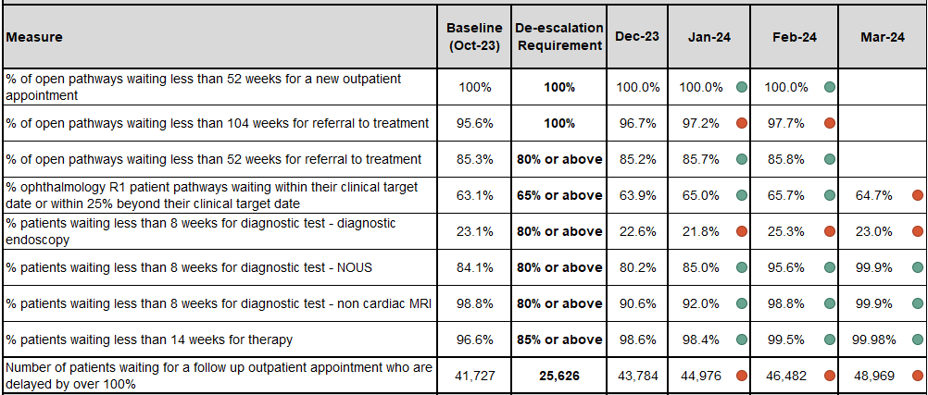
The baseline achieved in March-24 is outlined below for specialties breaching 104 weeks alongside the predicted reported April position (formally reported on 15th May).
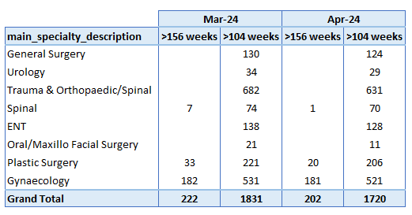
Each specialty is currently reviewing its demand and capacity plan for 2024/25 and is working on the principles of:
- No deterioration on end of March 24 reported position
- Eradication of waits in excess of 156 weeks by the end of quarter 1:
  - Current 3 specialties – Spinal, Plastic Surgery and Gynaecology
- Continued monthly improvement on waits in excess of 104 weeks
- Plan to deliver 100% within 104 weeks by 31st March 2025.
- Complete D&C plan for Endoscopy
- FUNB: Digital analysis, promotion of SOS/PIFU pathways, clinical reviews

There are specific challenges in some specialties that need to be addressed, namely:
- Gynaecology
- Spinal
- Plastic Surgery (complex cases)
- Endoscopy – robust D&C plan in progress of being presented to Management Board in May.

External support:
Recognising the challenges, NHS Executive has offered support for Gynaecology under targeted intervention, which has been accepted. The HB has also contacted the Getting it Right First Time team (GiRFT) for some specific clinical support in this specialty.

In addition, the HB is also working on a regional solution with Hywel Dda for Orthopaedic Surgery. Success in this area is essential to both provide capacity for the orthopaedic cases not suitable for surgery at NPTH but also to create capacity for complex spinal surgery at Morriston Hospital.

Resource Implications
The Healthcare Systems Engineering Team has reviewed the modelling required to deliver on the HB’s planned care target and with the current levels of efficiency and productivity across the services, there remains a significant requirement for additional funding to support the planned care programme this financial year. As can be seen from the table below, only Vascular Surgery is predicted to be able to deliver fully within core capacity. The HB will be putting more focus on productivity and efficiency gains this year but it is not anticipated to be able to give sufficient in-year gains to reduce the financial ask for RTT delivery. This is a risk to the delivery plan given the financial challenge also facing the HB.

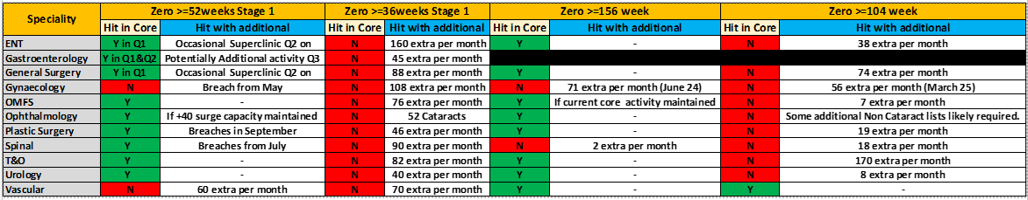

In addition to the risk on funding availability for RTT recovery in-year, an additional resource risk is the availability of non-medical staff to undertake the additional activity required to close capacity gaps. In previous years, since COVID19, HBs were able to offer enhanced rates of pay, outside of A4C T&Cs for A4C staff. These enhanced rates were permitted under the WG Planned Additional Activity Rates (PAAR), which was discontinued on 31st March 2024. Prior to the pandemic, enhanced rates to A4C staff were covered locally by “local agreements”. The HB has sought clarity from WG, alongside other HBs, on the mechanism for agreeing enhanced rates for A4C staff to enable support for the additional activities undertaken by medical staff. Medical staff are covered by their respective contracts, which are not affected by this change.

TARGETED INTERVENTION – HEALTHCARE ACQUIRED INFECTIONS (HCAIs)

The Leadership team for HCAIs is as follows;

- Medical Director Lead – Anjula Mehta, Interim Executive Medical Director
- Nursing Lead – Hazel Powell, Interim Executive Director of Nursing
- Nursing Support – Emily Davies, Acting Associate Director of Nursing – Corporate

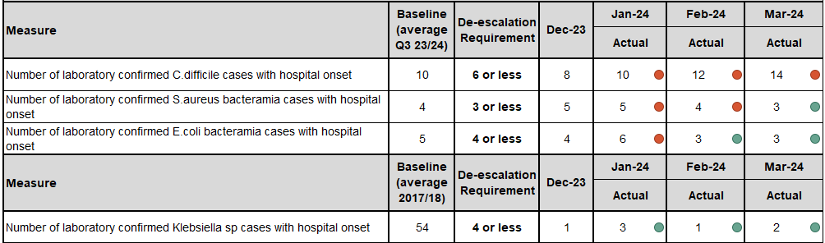

The priorities for the HCAIs improvements build on existing action plans and focus on:

- Joint executive leads: Shared accountability.
- Medical and Nursing leadership: consistent messaging.
- Whole system communication: shared responsibility.
- Revised governance structure and targeted scrutiny.
- Spotlight on C. difficile.
- Antimicrobial stewardship.
- Audit revision.
- Cleaning and decontamination priorities / equipment and environment
- Hand hygiene.

As part of the health board’s commitment to prioritising the HCAI reduction programme, a revised governance structure has been introduced. The aim is to place the right level of targeted scrutiny at ward, service and service group level, with shared responsibility for prioritised actions and clear lines of accountability. The revised governance and reporting structure is as follows;
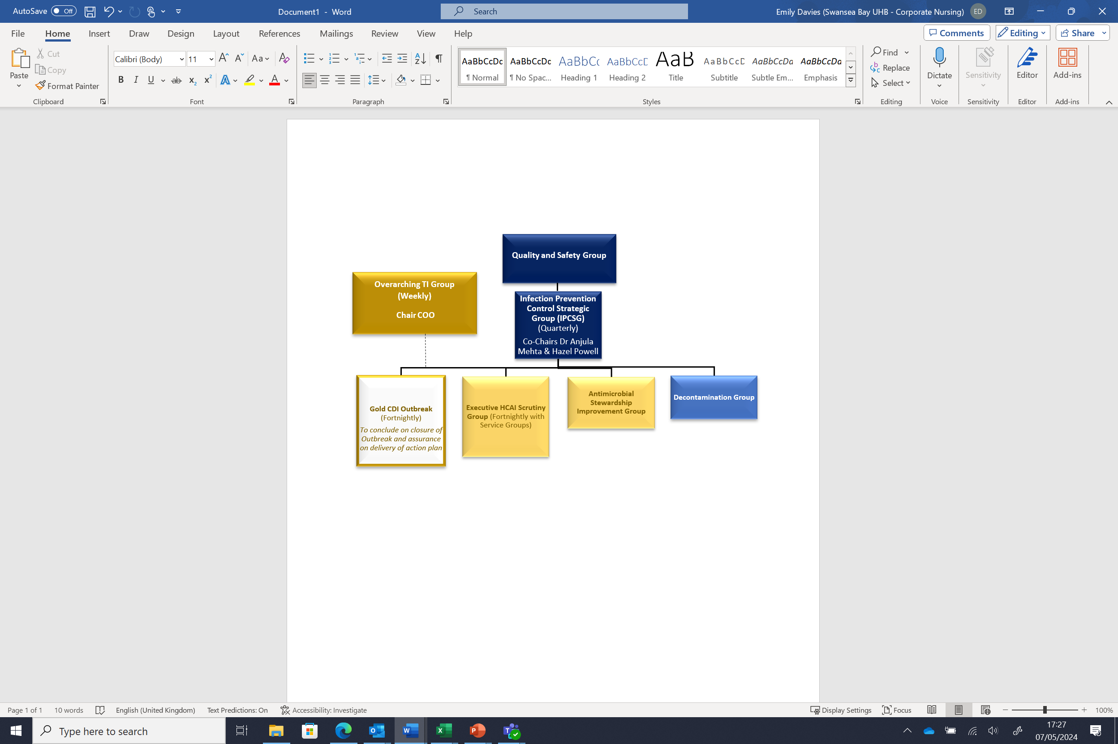
It is anticipated that the following outcomes will be realised:

- Clarity in reporting mechanisms and expectation of Service Group representation.
- Increased responsibility at operational level.
- Increased accountability at strategic level.
- Unified quality and operational priorities.
- Reduction in C. difficile cases per annum.
- Reduction in Staph. aureus cases per annum.
- Reduction/maintenance of E. coli and Klebsiella rates.

However, there are challenges to be overcome, of which the HB is well aware:
- UEC pressures.
- Intra hospital transfers, high/over occupancy.
- Clinically optimised patients/ pathway of care delays
- Lack of decant facilities.
- Lack of single room availability.
- General estates: infrastructure, access, workforce.
- Immediate HPV cleaning scheduling: decant, cost, environment.
- Antimicrobial prescribing volumes and broad-spectrum usage: General Medical Services, community, secondary care.
- Reporting anomalies: local/national trackers and dashboards.

TARGETED INTERVENTION - CAMHS
The Leadership team for CAMHs is as follows;

- Operational Lead - Janet Williams – Service Group Director, MH&LD
- Operational Support - Alison Gallagher, Head of Operations, MH&LD

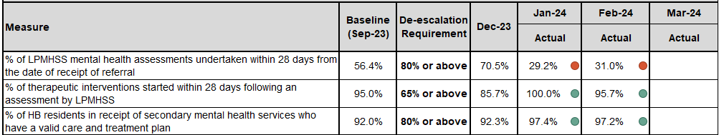

The recent drop in performance has been noted as being due to loss of agency nursing staff at short notice, impacting on the services’ ability to achieve the assessment target. However, performance in March improved to 39% and it is anticipated that this will continue to improve as staffing levels stabilise.

PERFORMANCE MONITORING
Alongside the external monitoring of targeted intervention, sits a comprehensive internal programme, illustrated below:

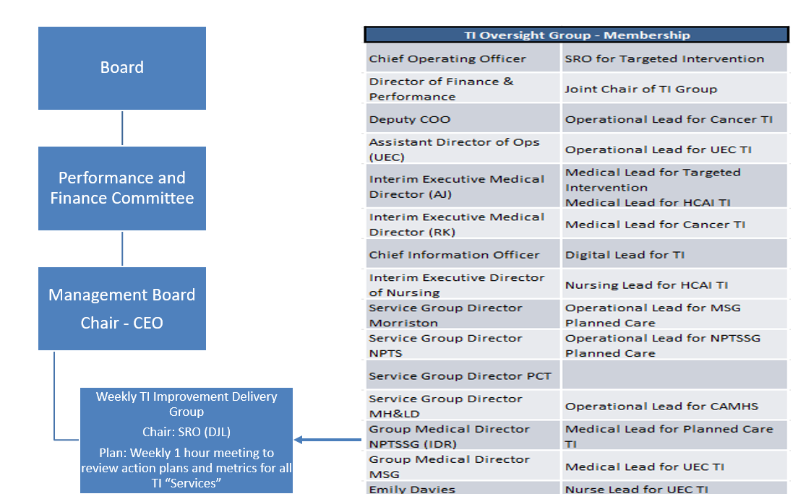

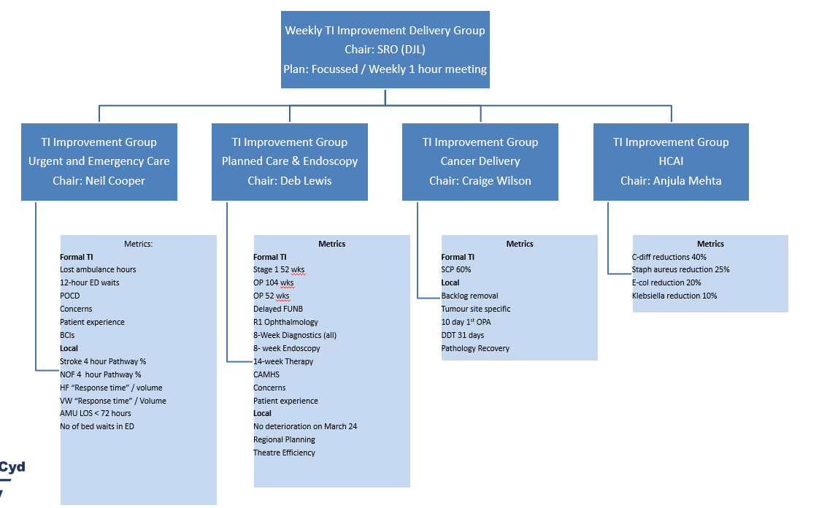

This structure is supported by a bespoke TI Dashboard currently under development by Digital Services. All of the services currently included have key performance indicators included and it is anticipated that this will be finalised within the next few weeks and a screenshot of the front sheet is included below.

e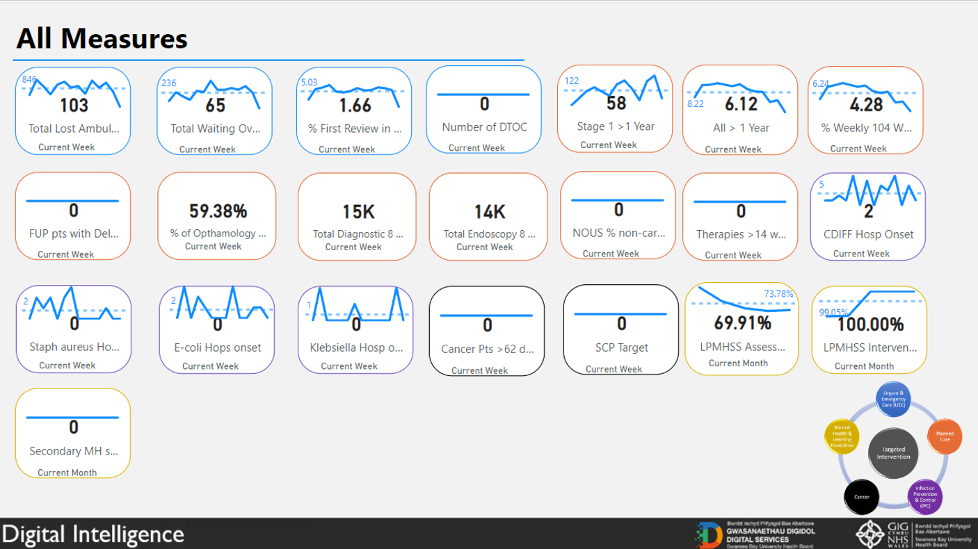

Resource Requirements
This report highlights the significant work required to make sustainable improvements in the HB’s delivery of improvements against targeted intervention. The UEC programme in particular is challenged, due to the size and complexity of the work programme being developed. The work will require significant input from clinical and operational teams that are already stretched during the working week. Acknowledging this, there is a requirement to ensure that the correct level of support is in place so that time for clinical and operational teams is protected where possible. The totality of additional resource is currently being worked through but initial review has identified the following:
- Dedicated senior management support to work across the boundaries of the UEC. This post needs to ideally be at 8D level, to allow autonomy and authority to act and needs to be someone with previous significant operational experience, ideally within the area of UEC.
- To ensure the development of a comprehensive set of performance metrics that covers the full spectrum of UEC services, there will be a need for additional digital / informatics support. This is currently being reviewed but is estimated as a WTE band 7 post.
- There are numerous projects being brought together within the UEC programme and project management and project support is imperative to ensure that action plans are up to date and on track to deliver. Currently there is a dedicated project management post (8C) within Morriston SG but that post is only funded until October 2024. Ideally this post would be extended for a further 12 months
- Although there are named clinical leads aligned to each workstream, there maybe a requirement for additional dedicated clinical sessions to support the improvement work. This is not yet quantified but will be worked through as schemes take shape.

Current Identified Resource:

Post | Indicative Band
Programme Manager – Flow across UEC | 8D
Project Management | 8C
Business Analyst | 7
Clinical sessions | Tbc

Recommendation
Members are asked to:
- NOTE the planned response to Targeted Intervention and the ongoing actions taken to support patient safety & experience.
- CONSIDER and APPROVE the additional resources required to deliver the programme of improvements.

Governance and Assurance

Link to Enabling Objectives  (please choose) | Supporting better health and wellbeing by actively promoting and empowering people to live well in resilient communities
Link to Enabling Objectives  (please choose) | Partnerships for Improving Health and Wellbeing | ☐
Link to Enabling Objectives  (please choose) | Co-Production and Health Literacy | ☐
Link to Enabling Objectives  (please choose) | Digitally Enabled Health and Wellbeing | ☒
Link to Enabling Objectives  (please choose) | Deliver better care through excellent health and care services achieving the outcomes that matter most to people
Link to Enabling Objectives  (please choose) | Best Value Outcomes and High Quality Care | ☒
Link to Enabling Objectives  (please choose) | Partnerships for Care | ☒
Link to Enabling Objectives  (please choose) | Excellent Staff | ☐
Link to Enabling Objectives  (please choose) | Digitally Enabled Care | ☐
Link to Enabling Objectives  (please choose) | Outstanding Research, Innovation, Education and Learning | ☐
Health and Care Standards
(please choose) | Staying Healthy | ☐
(please choose) | Safe Care | ☒
(please choose) | Effective Care | ☒
(please choose) | Dignified Care | ☐
(please choose) | Timely Care | ☒
(please choose) | Individual Care | ☐
(please choose) | Staff and Resources | ☒
Quality, Safety and Patient Experience
Outlined within the body of the paper but in summary considerable backlog of patients awaiting a diagnostic and treatment services across a range of services. Issues of harm in relation to high levels of HCAIs noted.
Financial Implications
Funding not yet agreed for 24/25
Legal Implications (including equality and diversity assessment)
Delay to diagnosis and treatment potential.in service delivery
Staffing Implications
Additional support staffing required to deliver the programme
Long Term Implications (including the impact of the Well-being of Future Generations (Wales) Act 2015)
Report History | First comprehensive update presented.
Appendices | Appendix 1 and 2

