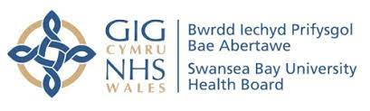

We All Belong

Our Strategic Equity Plan 2025-2028

May 2025

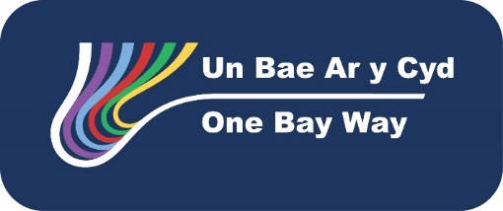
- Introduction
We All Belong is Swansea Bay Health Board’s Strategic Equity Plan for 2025-28. Outlined below is how it fits with our plans, how we developed it, the issues identified from our engagements and the actions we plan to take in 2025-26 to start addressing these.
We have called this plan We All Belong because throughout our discussions with people, be they the public, patients, families or our staff, they told us how they felt there were barriers to them accessing services because of their protected characteristic(s) under the Equality Act 2010, or because of their socioeconomic factors and they were made to feel different within our services (socioeconomic factors include income, education, occupation and social class, all of which can affect various aspects of life, including health, wellbeing and opportunities.)
We want to ensure that every single person feels that they belong in all our services – whether as a service user, family member supporting them, or as a member of staff.
This plan focuses on ensuring the Health Board is sensitive to individual differences between people and recognising that everyone deserves a bespoke approach tailored to their needs, whether as a patient, a carer, or a member of staff. This also applies to services we commission from other organisations for our population.
Equity is a key area for action for the Health Board and is defined as:
designing and delivering services based on need, seeking to overcome unfair differences in outcome linked to socioeconomic status, geography, protected characteristics, and other vulnerabilities.
This is purposefully different from equality, which is providing the same for everyone, which does not help to address health inequalities.
Our aim throughout this plan is to address inequity, but the term equality is widely used in the related legislation and guidance and so is also used here, but as an organisation our intent is to ensure everyone has the same access and opportunities to services and in working with us (equity) and therefore to underline this we have purposefully called this document We All Belong – Our Strategic Equity Plan.
Our equity priorities are shaped by our long-term vision, our values, and our engagement. This plan will be delivered across the Health Board over the next 3 years.
We are all responsible for making sure that our commitment to equity, diversity and belonging is at the heart of everything we do, and this is reflected across our organisation and through for example, our Quality Strategy, Population Health Strategy and People Strategy. This is about us all working together to develop a clear positive sense of direction for our organisation so that we can all live in harmony alongside each other, acting where things go wrong.
This approach to developing We All Belong is purposefully inclusive and focuses on issues across all -protected characteristic groups, which has elicited a wide range and extensive list of issues which our population and staff have identified as needing to be addressed. The Health Board has limited resources available to address these issues, alongside its other duties, but this is everyone’s business across the whole organisation, with the Executive Lead for Equity, Diversity and Belonging being the Director of Insight, Communications and Engagement, working with the Director of Workforce and Organisational Development, to ensure the plan, priorities and actions are both patient and staff focused.
It is important that all the outstanding issues are identified within this plan, but it is equally important that the actions which will be taken forward each year are realistic and are the ones which will make a real difference to our communities and staff. They are aimed to be challenging yet achievable.
This is not a plan for a minority of our population or staff but for all of us.
Most people will have at least one protected characteristic and lots of us will have more than one, and if we improve our services with this in mind, they will be better for everyone.
We engaged on our proposed action plan for 2025-26 and have revised relevant actions based on this feedback.

- Background
Swansea Bay University Health Board’s long-term vision is to become an organisation delivering high quality care. As part of this, we want to put our patients and staff at the centre of all we do.
This is the first Strategic Equity Plan where our objectives or priorities, as we describe them, are based directly on feedback from individuals and organisations about issues people with protected characteristic(s) under the Equality Act 2010 face in relation to the NHS in Swansea Bay.
We want to be an organisation where the best people come to learn and work, with research and services that are centred on the needs of patients, carers, and the population. This is to keep people healthy, support them to avoid ill health, maintain wellbeing and be there for our population with excellent healthcare when they need it.
Our culture is driven by our Values and Behaviours:
- Caring for each other – we’re friendly, kind and recognise everybody as an individual.
- Working together – we’re honest and open with one another, genuinely seeking and acting on feedback.
- Always improving – we do what we say we’ll do and always search for better.
Fundamentally this means that we need to be compassionate with each other, no matter how different we are to each other and how our viewpoints and perspectives may significantly differ from each other.
We need to work together to improve services in a respectful way, listening to each other, seeing each other and being open to each other, and this includes feeling safe to speak up when we see things which aren’t in line with these values. Only by doing all this will we see positive change for us all, and a greater sense of us all belonging to this organisation and of us serving our population to the best of all our abilities.
Swansea Bay University Health Board’s long-term vision focuses on:
- Putting patients, their carers, our staff, and the public we serve at the centre of all we do
- To do this we need to listen to and understand their experiences and design our services to provide the highest quality and best experience possible
- We also need to listen to and understand our staff’s experiences about how things could be done better
- We can then triangulate patient and staff feedback with data to provide insight into services which we will use to change / improve these services
- Understanding impacts and experiences of protected characteristic groups and seldom heard groups about our services is a fundamental part of this and if we address the barriers they face, we will improve experiences for everyone
- If we engage with our service users / patients on an ongoing basis we can better understand what is important to them, where there are problems and where processes can be streamlined and improved. This will involve us truly listening to what people say they want and need, not prescribe and act on what we think they want and need
- We can then co-design changes to address these – helping us to get things right first time
Therefore, for this plan, we have talked to lots of people, and organisations who support them, as well as analysing what people have said about equality and inequity through the engagements on service change that we have conducted over the past three years and Our Big Conversation where we received feedback from lots of our staff.
As a result, over 4,500 people’s views have been reviewed and used to shape We All Belong - our Strategic Equity Plan and the priorities identified.
Our People Strategy 2024-2029 identified Equality, Diversity and Belonging as one of our themes. We want to promote a compassionate culture that is inclusive and equitable, thrives on diversity and which actively addresses inequalities.
Our draft Plan was engaged upon in March and April 2025, both within and outside the Health Board, to check that we had reflected accurately the views we had heard, and appropriately translated these into actions which would make the greatest impact on our patients, their families and staff. This Plan has been updated to incorporate the range of responses received as part of this engagement so that We All Belong is truly based on listening to our population and staff.
We also considered a wide range of national plans and guidance in the preparation of this Plan, and this strategic context is attached as Appendix A.

- About our Population and Staff
The Health Board serves a population of approximately 390,000, employs almost 13,500 staff and receives around £1.6 billion financial allocation.
Within Swansea Bay, people living in the most deprived areas, those on low incomes, and individuals with protected characteristics experience worse health outcomes. People living in the most deprived 20% of our population have a difference in healthy life expectancy of 14.6 years for men and 19.9 years for women compared to those living in the least deprived 20%.
The factors influencing equitable access to healthcare include:
- Ability to pay for and access transport
- Ability to take time away from work
- Cultural and language factors
- Health literacy
- Trust in services
The differences which occur in health outcomes are known as health inequalities – unfair and avoidable differences in health across the population, and between diverse groups within society. Health inequalities arise because of the conditions in which we were born, grow, live, work and age. These conditions influence our opportunities for good health, and how we think, feel and act, and this shapes our mental health, physical health and wellbeing. These socioeconomic factors, along with protected characteristics, are complex and interact with each other, leading to differences in health outcomes. Individuals often fall into more than one category and subsequently, may experience multiple drivers of poor health at the same time – this is called intersectionality, which makes their outcomes disproportionately worse.
23.4% of the Swansea Bay population are disabled under the Equality Act, with Swansea having 22.4% and Neath Port Talbot 25.1%. Neath Port Talbot also has the highest proportion of two or more people with disabilities within a household across Wales at 10.4%.
Our Population Health Strategy – A better future for all – sets out how Swansea Bay University Health Board will work to improve the health of local people. In this we identify that as a health organisation we can look to what services we deliver to our communities and how we deliver them, the relationship we build with our employees and how we look after them, how we behave as a corporate body when we conduct our business, and how we work with others to achieve things we cannot achieve alone. As an anchor organisation we need to mobilise and repurpose our resources to ensure greater and longer lasting impact for our population and staff. More details about our population and its specific characteristics are included in our Population Health Strategy, with some of the key features outlined above. (An anchor organisation is a large, typically public sector, institution deeply rooted in a local community and whose long-term sustainability is linked to the wellbeing of the people it serves. These organisations are known for their significant presence in the area, often employing many people, spending large sums of money locally and owning substantial assets).
Ethnicity varies across Swansea Bay with 8.6% of the Swansea area and 4.4% in the Neath Port Talbot area. This compares with the Wales average of 6.2% (Census, Wales, 2021). Ethnic minority groups as a whole are more likely to report ill-health, and ill-health starts at a younger age than in the white Welsh population. Socio-economic deprivation disproportionately impacts on ethnic minority groups and is driven by a wider social context in which structural racism and discrimination reinforces the inequalities among ethnic groups. Research and engagement work shows that lower uptake of health care and screening can be attributed in part to cultural barriers and inaccessible information for people who do not have English as their first language alongside mistrust of authority, fear of seeing health professionals of a different gender and lower levels of health literacy. (The World Health Organisation defines health literacy as the ability of individuals to gain access to, understand and use information in ways which promote and maintain good health for themselves, their families and their communities.)

- How we prepared this Plan
In line with our long-term vision we focused on analysing what our patients, their carers, our staff and the public told us about their experiences so that we can design our services to provide the highest quality and best experience possible. Therefore, we have reviewed and analysed what the population we serve, and our staff told us in the following engagements about equity issues:
- Changing for the Future
- Older People’s Mental Health Services
- Adult Acute Mental Health Services
- Hydrotherapy
- Orthopaedics
- Primary Care feedback (Rosedale, Brunswick, Cheriton, Cymmer / Cwmafan)
- Feedback when developing our Anti-Racist Action plan
- Feedback when developing our LGBTQ+ Action plan
- Maternity Feedback from the Black, Asian and Minority Ethnic Communities
- Wider Feedback from the Black, Asian and Minority Ethnic Communities
- Feedback from patients using our blood test services
- Feedback from patients using our sexual health services
- Feedback from our Accessibility Focus Group and Accessibility Reference Group
- Swansea Human Rights City Feedback
- Bevan Commission Report
- Our Big Conversation
We further refined this Plan from engagement responses to the draft We All Belong before finalisation.

- Our Strategic Equity Priorities
Our priorities are shaped by our long-term vision, our Values, and our engagement. This plan will be delivered across the Health Board over the next 3 years. We are all responsible for making sure that our commitment to equity, diversity and belonging is at the heart of everything we do and this is reflected across our organisation and through for example, our Quality Strategy, Population Health Strategy and People Strategy.
Whilst we have focused on protected characteristic groups as outlined by the Equality Act 2010, we have also taken note of feedback and issues relating to other groups who may experience barriers to our services or to working in the Health Board, such as veterans, those with substance misuse challenges and prisoners, to make this as inclusive a plan as possible.
Fundamentally, feedback both from staff and the public we serve, highlights that:
- As an organisation, a focus on human rights inequalities, equality impacts, health inequities, eliminating discrimination, harassment & victimisation needs to be central to all we do
- This focus needs to be applied, taken account of, and mitigated against in all decisions, policies and actions taken by and across the Health Board
- This consideration needs to include not only protected characteristic groups under the Equality Act 2010, but also those covered by the Socio-economic Duty plus other groups who face barriers to accessing services or working within the Health Board
- It also needs to consider the enhanced impact of intersectionality, where people who share more than one protected characteristic are at risk of multiple disadvantages, inequity, discrimination and harassment
- As an anchor organisation, we need to work with and support our partners to promote equity, eliminate discrimination, harassment and victimisation.
- There are some general issues which need focused attention, and which will bring benefits for all protected characteristic groups, and indeed our whole population, if we can get them right
- There are some important issues for individual protected characteristic groups which need to be addressed

Therefore, we have organised our priorities into three headings:
- Strategic / Organisational Priority – embedding equity considerations in all we do:
- Initially focusing on refreshing our corporate decision making to ensure equity impacts are considered & mitigated as part of our decision-making processes
- Establishing clear leadership for Equity within the organisation at Board level and throughout the management structure, reflected in individual’s objectives and accountabilities
- Developing cultural intelligence across the organisation to support and impact a sense of belonging for all
- Developing a continuous engagement and insight approach across the organisation which is used to identify all equity and related impacts as plans develop so that resultant changes have been shaped by people with protected characteristics
- Developing an integrated assessment process that ensures all decisions are made with a clear understanding of impacts on protected characteristic groups and the mitigating actions which need to be implemented to address these. The intention is that this will be the single integrated assessment process for the Health Board and will incorporate Health Impact Assessment and Equality Impact Assessments to avoid duplication and lack of clarity
- Utilising the Public Services Ombudsman for Wales Principles of Good Administration to underpin our actions throughout the Health Board

- General Priorities – addressing those things which will provide benefits across multiple protected characteristic groups:
- Ensuring patient communications are provided in a range of formats to meet the individual needs of patients consistently and across services
- Ensuring that where interpretation services are required for patients they are provided automatically, as a right, in all circumstances
- Developing a programme that will ensure over time that information for the public and patients meets the coproduced accessibility standards endorsed by the Health Board and that information is co-produced with appropriate patient groups
- Ensuring that information is available to make Health Board facilities more easily accessible, such as addressing access issues and ensuring appropriate wayfinding using the already coproduced terminology
- Supporting a range of staff networks across the organisation to improve the experience of our staff regardless of their protected characteristics

- Protected Characteristic Specific Priorities
- Underpinning our Strategic Equity Priorities and the resultant action plans are a range of action plans specific to different protected characteristic groups (e.g. LGBTQ+, Anti-Racist, Sensory loss)
- Specific requirements around gender pay inequalities
- Themes which have been identified across a range of these plans have been considered under General Priorities highlighted above
- Actions / themes which are specific to a single protected characteristic group are included in the annual action plan for the Strategy Equity Plan to ensure these are progressed alongside general and strategic / organisational priorities
We are committed to make changes to improve the experience and outcomes of everyone with individual or multiple protected characteristics, recognising that this in turn will improve them for everyone. However, we also believe it is important that we are realistic in the plans we are proposing so that we can really make progress on these. Therefore, we are focusing on a manageable but ambitious range of changes for 2025-26 that can really make a difference to you, the people we serve, and our staff. Other issues which have been highlighted will then be reviewed to consider which will have the greatest impact ready for implementation in subsequent years.
Developed in parallel with We All Belong is a detailed action plan for 2025-26 which identifies the specific actions we have prioritised for the year, following feedback from our patients and the public.

- Equality and Equity Information
Information on equality characteristics has been collected inconsistently for both patients and staff in the past. Efforts are now being made to ensure that all patients and staff have basic demographic information collected about them on a standardised basis. This will mean that we will understand better our population and our people so that we can set baselines, monitor progress better and triangulate this data with feedback from patients, their families, and staff.
It is important that we can measure progress, and report this as required to Welsh Government, but it is also important that we act in areas where measurement is difficult, if these have been identified as a priority.

- How we will monitor implementation
We are committed to making a real difference for our patients and our staff members by implementing the priorities outlined in this document and specifically the actions we have identified for 2025-26. Monitoring will take place through reporting to our Health Board on an annual basis, with reports submitted to Management Board twice a year and reviewed by the Health Board’s Strategic Equity, Diversity and Belonging Group. An annual report will be prepared for the Board in March each year which will be published and shared with partners and stakeholders, alongside the actions proposed to address the priorities in the following year, following appropriate engagement.
Progress with implementation of this plan will be a topic included in quarterly performance reviews with each of the Service Groups within the Health Board, alongside reviewing progress against access targets and finance, to ensure that equity and this plan are given appropriate importance.
We will also hold an event each year with the public, patients, Carers, stakeholders and partners to help us review progress to date and identify priorities going forward.

- Updating our Strategic Equity Priorities
Going forward we will follow an annual process to update our Strategic Equity Priorities as outlined below:
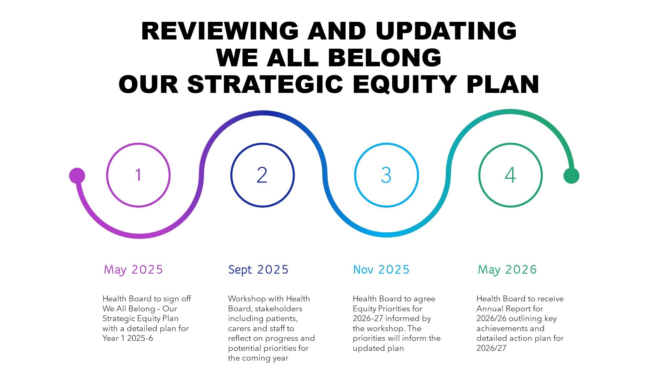

Appendix A
Strategic Context to this Plan

Equality Act 2010
The Equality Act 2010 applies to all employers. It contains a series of duties that seek to protect individuals, employees and others against direct and indirect discrimination. The Equality Act lists a set of characteristics that must not be used to treat some people worse than others. These are called “protected characteristics” and are:
- Age
- Disability
- Gender Reassignment
- Marriage and Civil Partnership
- Maternity / Pregnancy
- Race
- Religion and Belief
- Sex
- Sexual Orientation
This means that we must try to stop discrimination, increase opportunities and good relationships between people who share protected characteristics and people who do not. As part of this duty, we must show that we have considered the likely impact on protected groups when we create or review policies and practices. We do this using an Impact Assessment.
The Act includes a public sector equality duty replacing the separate duties on race, disability and gender equality. The aim of this duty is to ensure that public authorities consider how they can positively contribute to a fairer society through advancing equality and good relations in their day-to-day activities. The duty ensures that equality considerations are built into the design of policies and the delivery of services and that they are kept under review to achieve better outcomes for all.
The duty has three aims which public bodies need to have due regard of the need to:
- Eliminate unlawful discrimination, harassment and victimisation and other conduct that is prohibited by the Equality Act.
- Advance equality of opportunity between people who share a relevant protected characteristic and those who do not.
- Foster good relations between people who share a protected characteristic and those who do not.

Socio-Economic Duty
The Socio-Economic duty aims to deliver better outcomes for those who experience socio-economic disadvantage. We recognise the importance of reducing inequalities of outcome that mean that people are at a disadvantage because of their income or because of less / lack of opportunities.

National Equality Objectives
We have used these objectives as our overall context – creating a Wales:
- Where everyone has opportunities to prosper in line with our goal to reduce poverty
- Where everyone can be aware of their human rights, and where those rights are protected, promoted and underpin all public policy
- Where everyone can be aware of and has equitable access to high quality public services
- Free from discrimination, victimisation, harassment, abuse, hate crime and / or bullying against all people
- Where everyone from the full diversity of backgrounds can participate in public life, have their voices hear and see themselves reflected in leadership positions
- With fair and equal opportunities to gain employment and for fair and equal treatment in the workplace, including fair pay and conditions
- Which is environmentally sustainable with the capacity to both ensure our journey to net zero is fair and to respond to the inequitable impacts of climate change

The Well-Being of Future Generations (Wales) Act 2015
The Well-Being of Future Generations (Wales) Act aims to improve the social, economic, environmental and cultural well-being of Wales. This means that as a public body we must think more about the long-term, finding better ways of working with our communities, our people, our networks and partners and help to prevent problems by taking a more joined up approach, working towards the 7 well-being goals for Wales:
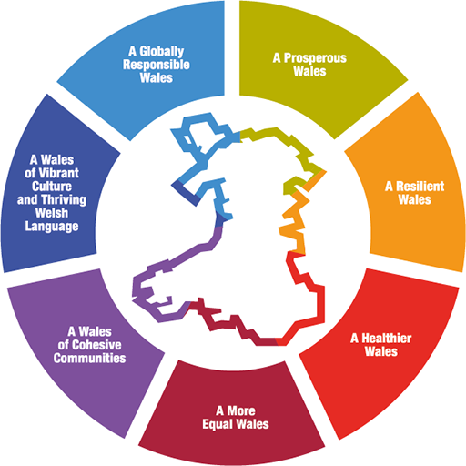

Public bodies need to make sure that when making their decisions they take into account the impact they could have on people living their lives in Wales in the future. There are 5 things that public bodies need to think about to show that they have applied the sustainable development principle. Following these ways of working will help us work together better, avoid repeating past mistakes and tackle some of the long-term challenges we are facing.
- Collaboration - acting in collaboration with any other person (or different parts of the body itself) that could help the body to meet its well-being objectives.
- Integration - considering how the public body’s well-being objectives may impact upon each of the well-being goals, on their other objectives, or on the objectives of other public bodies.
- Involvement - The importance of involving people with an interest in achieving the well-being goals, and ensuring that those people reflect the diversity of the area which the body serves
- Long-term - the importance of balancing short-term needs with the need to safeguard the longterm needs.
- Prevention - acting to prevent problems occurring or getting worse may help public bodies meet their objectives.

Welsh Language Measure 2011
Welsh is an official language in Wales and should be treated no less favourably than English. As an organisation and as an employer we have the responsibility of making sure that anyone can speak with us in Welsh and that we continue to encourage use of the Welsh language.

Welsh Government action plans and guidance
This plan reflects our responsibilities within the Strategic Equity Plan 2024-28, the Anti-racist Wales Action Plan and the LGBTQ+ Action Plan.
We will continue to develop action plans taking account of further Welsh Government action plans and guidance which address inequity in Swansea Bay.

Is Wales Fairer 2023
This report draws on all available data to measure progress on equality, equity and human rights in Wales. Its purpose is to support evidence-based decisions by the Welsh Government, public bodies and others over the coming years with the aim of driving action and meaningful change, to make life fairer for everyone.
A number of contextual factors have impacted since the last report, including the COVID-19 pandemic, the UK’s departure from the European Union, the period of high inflation and the economic impact of the war in Ukraine.
Some reported changes are a direct result of contextual factors such as the increase in home working following the pandemic has generally benefitted parents, older and disabled people, and those with caring responsibilities. It has also created challenges, including deteriorating mental health and changes to employment patterns.
Some contextual factors reinforced existing trends. data shows continuing regional inequalities in the most deprived areas in educational attainment and life expectancy, as well as healthy life expectancy.

Locked Out
The Report - Locked Out: Liberating disabled people’s lives and rights in Wales beyond COVID-19 highlighted the toll the pandemic placed on disabled people, exacerbating inequalities and provided a wealth of insights and a number of recommendations. The report focuses on 5 key areas:
- Social versus the Medical Model of disability
- Human rights
- Health and Well-Being
- Socio-economic disadvantages and Exclusion
- Accessibility and Citizenship.

All Wales Standards for Accessible Communication and Information for People with Sensory Loss
The purpose of these standards is to ensure that the communication and information needs of people with a sensory loss are met when accessing our healthcare services. These apply to adults, young people and children.

Sexual Safety in Healthcare
New legislation came into place in 2024 under the Worker Protection (Amendment of Quality Act 2010) Act 2023, placing a preventative duty on employers to protect employees from sexual harassment and includes the need to consider and address:
- Rethinking (and unlearning) how we manage risk
- Why it matters and why we can’t talk about sexual safety without understanding misogyny
- What preventative action looks like
- The legal ramifications and opportunities for learning
Equality Matters – improving inclusion and accessibility in public services in Wales
In January 2025 the Public Services Ombudsman for Wales issued a thematic review entitled Equality Matters. This highlighted their experience of issues raised by the public and identified the following themes:
- Lack of reasonable adjustments
- Good communication – an obligation to adapt approach
These issues have been reflected in this plan, and particularly the good practice guidance Principles of Good Administration.

Health Board Strategies
The Health Board has a range of strategies which align with this Strategic Equity Plan, including our Population Health Strategy, Quality Strategy, People Strategy and our Clinical Services Plan.

UK Supreme Court Judgment in For Women Scotland v The Scottish Ministers
The Equality and Human Rights Commission (EHRC) has provided an interim update on the practical implications of the UK Supreme Court Judgement. An interim update on the practical implications of the UK Supreme Court Judgement has been issued, with the new guidance from EHRC due Summer 2025.
We will review relevant policies, procedures, strategies and services in line with this guidance.

