

Meeting Date | 29 May 2025 |  | Agenda Item |  | 4.4i
Report Title | Financial Report – Draft Month 12 2024/25
Report Author | Samantha Moss, Deputy Director of Finance
Report Sponsor | Darren Griffiths, Executive Director of Finance and Performance
Presented by | Darren Griffiths, Executive Director of Finance and Performance,
Freedom of Information | Open
Purpose of the Report | The report advises the Board of the Health Board’s draft financial position for Month 12 (March 2025) as per the Draft Annual Accounts submitted to Welsh Government (WG) on 2nd May 2025.
Key Issues | The report invites the Board to discuss the draft financial position for Month 12 (March 2025). The figures in the report only provide the draft statement pending the completion of the full audit programme.  Key messages: -  - Delivery of Welsh Government best practice balance of Cash position control, subject to audit sign off.  - Delivery of Revenue Deficit Plan total, subject to audit sign off.  - Delivery of Capital Resource Limit (CRL), subject to audit sign off.  - Delivery of Public Sector Payment Policy (PSPP), subject to audit sign off.  The Health Board delivered its duty to breakeven over three years on the CRL but failed its duty to achieve the same for the RRL.
Specific Action Required  (please choose one only) | Information | Discussion | Assurance | Approval
Specific Action Required  (please choose one only) | ☒ | ☐ | ☒ | ☐
Recommendations | Members are asked to: -  - DISCUSS the Heath Board’s draft outturn financial performance for Financial Year 2024/25 for: -  - the cash balance at 31/03/25;  - the revenue draft outturn position;  - the capital draft outturn position; and  - Public Sector Payment Policy outturn position.  - ACKNOWLEDGE that the Health Board delivered its duty to breakeven over three years on the CRL but failed its duty to achieve the same for the RRL.  - ACKNOWLEDGE the Annual Accounts Timetable and the next steps in finalising the 2024/25 Financial Position.

FINANCIAL REPORT – DRAFT MONTH 12

- INTRODUCTION
The report invites the Board to note the draft financial position at Month 12 (March 2025) with regard to the revenue financial position, along with Cash, Capital and PSPP, pending the completion of the full audit programme.

- BACKGROUND
  - The Health Board has two key statutory duties to achieve:

- To submit an Integrated Medium-Term Plan (IMTP) to secure compliance with breakeven over 3 years.

2022/23 3-year plan approved.
2023/24 3-year plan submitted.
2024/25 3-year plan submitted.

The Health Board will fail to meet this in 2024/25 as its plan will not breakeven over 3 years.

- To achieve financial breakeven over a rolling three-year period, which commenced on 1st April 2022 and will end on 31st March 2025.

2022/23 Breakeven position achieved.
2023/24 Deficit Control Total £17.1m achieved.
2024/25 Draft Deficit Total £42.5m

The Health Board will fail to achieve this Statutory Duty.

  - Summary of Performance against Key Financial Targets

TARGET | ACTUAL PERFORMANCE
Cash Balance Bank < £6.0m | £3.444m
Revenue Resource Limit (RRL) < £43.7m | £42.5m Over
Capital Resource Limit (CRL) < £0m | (£0.061m) Under
Public Sector Payment Policy > 95% | 95.0%

- REVENUE FINANCIAL PERFORMANCE – MONTH 12
The Health Board was not forecasting a balanced plan for 2024/25 and through various plan submissions during 2024/25 had a line of sight to £50.1m. In early December 2024 Welsh Government issued an additional £6.4m of recurrent funding to the Health Board, which reduced the deficit plan to £43.7m.

The draft position against the Revenue Resource Limit as per the Draft Annual Accounts was £42.5m overspent, which is £1.2m under the deficit plan of £43.7m. Details on the breakdown of this is summarised in the table below:

Table 1: Breakdown RRL Performance 2024/25

- KEY AREAS OF NOTE

The section below provides an overview of the other issues influencing the delivery of the wider financial position, including Balance Sheet, Cashflow and Capital.

  - Savings

Based on the run rate reduction/savings position the schemes identified for delivery in 2024/25 by service areas are summarised below.

Table 2: 2024/25 Savings Summary

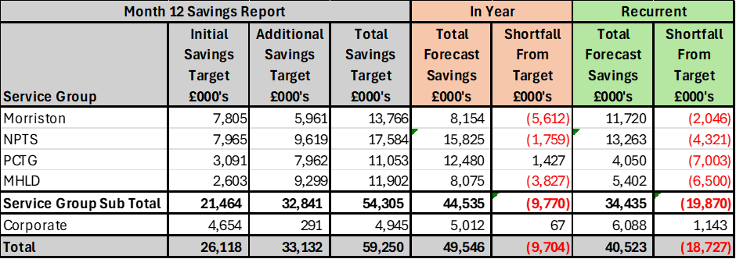
  - Capital

The performance against the Capital Resource Limit (CRL) value, at 31st March 2025, was £0.061m under. The approved CRL value of £53.964m includes Discretionary Capital and the schemes under the All-Wales Capital Programme. Performance against CRL for the last 3 Years is summarised in the table below:

Table 3: CRL Performance 2022/23 – 2024/25

  - Balance Sheet
The key issues in respect of the statement of financial position movements are as follows:

- The inventory value has decreased from £10.891m at the end of February 2025 to £12.886m at the end of March 2025, an increase of £1.995m. This increase is due to increases for Central Pharmacy (£0.344m), Other Pharmacy (£0.165m), Blood products (£1.2m) and Omnicell (£0.076m).

- There has been a decrease in trade receivables from £288.793m at the end of February 2025 to £251.046m at the end of March 2025 a decrease of £37.747m. This is due to a decrease within WRP (Welsh Risk Pool) Debtors of £13.436m, and a decrease in NHS Debtors of £24.865m.

- The closing March 2025 cash balance of £3.444m is greater than the range of the Health Board target of a cash balance of £2.5m at month end and less than the best practice cash target for Health Board of £6m.

- The trade and other payables figure saw a decrease from £239.906m at the end of February 2025 to £116.526m at the end of March 2025, a decrease of £123.380m. This relates to decreases in the accrual for WG allocation funding (£98m), NHS accruals of expenditure (£8.365m), and other non-NHS accruals of expenditure.

- Provisions decreased by £20.748m from £218.375m at the end of February 2025 to £197.627m at the end of March 2025. The majority of this movement relates to 16 legal cases, with a range of impact on the provisions totalling £17.5m. These movements are directed by the monthly quantums, and the changes in probability.

  - Cash

As at the end of March 2025, the Health Board had a cash balance of £3.444m, which is between the Health Board target of a cash balance of £2.5m and the best practice cash target for the Health Board of £6m.

The Health Board utilised Welsh Government cash support during March 2025 as follows: -

- Strategic Cash Support - £43.7m
- Working Capital Cash Support - £15m (originally requested £33.7m)

The cash movements during March 2025 were:

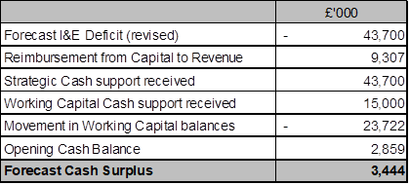

  - Public Sector Payment Policy (PSPP)

Compliance with the 95% PSPP target for Quarter 4, for the Health Board was:

- 92.1% for non-NHS
- 79.4% for NHS

However, the cumulative compliance for the financial year of 2024/25 against the Percentage of non-NHS bills paid within target was achieved at 95%.

- ACTIONS & NEXT STEPS

Annual Accounts Task | Deadline
Submission of Draft Accounts (WG Deadline) | 2nd May 2025
Commencement of External Audit Programme | 6th May 2025
Special Board for Audited Accounts | 25th June 2025
Submission of Audited Accounts (WG Deadline) | 30th June 2025

- RECOMMENDATIONS
Members are asked to: -
- DISCUSS the Heath Board’s draft outturn financial performance for Financial Year 2024/25 for:
  - the cash balance at 31/03/25;
  - the revenue draft outturn position;
  - the capital draft outturn position; and
  - Public Sector Payment Policy outturn position.
- ACKNOWLEDGE that the Health Board delivered its duty to breakeven over three years on the CRL but failed its duty to achieve the same for the RRL.
- ACKNOWLEDGE the Annual Accounts Timetable and the next steps in finalising the 2024/25 Financial Position.

Governance and Assurance

Link to Enabling Objectives  (please choose) | Supporting better health and wellbeing by actively promoting and empowering people to live well in resilient communities
Link to Enabling Objectives  (please choose) | Partnerships for Improving Health and Wellbeing |  | ☐
Link to Enabling Objectives  (please choose) | Co-Production and Health Literacy |  | ☐
Link to Enabling Objectives  (please choose) | Digitally Enabled Health and Wellbeing |  | ☐
Link to Enabling Objectives  (please choose) | Deliver better care through excellent health and care services achieving the outcomes that matter most to people
Link to Enabling Objectives  (please choose) | Best Value Outcomes and High-Quality Care |  | ☒
Link to Enabling Objectives  (please choose) | Partnerships for Care |  | ☒
Link to Enabling Objectives  (please choose) | Excellent Staff |  | ☐
Link to Enabling Objectives  (please choose) | Digitally Enabled Care |  | ☐
Link to Enabling Objectives  (please choose) | Outstanding Research, Innovation, Education and Learning |  | ☐
Health and Care Standards
(please choose) | Staying Healthy |  | ☐
(please choose) | Safe Care |  | ☐
(please choose) | Effective Care |  | ☐
(please choose) | Dignified Care |  | ☐
(please choose) | Timely Care |  | ☐
(please choose) | Individual Care |  | ☐
(please choose) | Staff and Resources |  | ☒
Quality, Safety and Patient Experience
Financial Governance supports quality, safety, and patient experience.
Financial Implications
The Board is reporting a forecast year-end deficit financial outturn.

Legal Implications (including equality and diversity assessment)
No implications

Staffing Implications
No implications

Long Term Implications (including the impact of the Well-being of Future Generations (Wales) Act 2015)
No implications
Report History |  | Updates on the financial position are provided at every meeting.
Appendices

