Meeting Date | 29 May 2025 |  | Agenda Item |  |  | 4.4ii
Name of Meeting | Board
Report Title | Financial Report – Month 1 2025/26
Report Author | Samantha Moss, Deputy Director of Finance  Gemma Pearson, Finance Business Partner  Crystal Davies, Principal Finance Manager
Report Sponsor | Darren Griffiths, Executive Director of Finance and Performance
Presented by | Darren Griffiths, Executive Director of Finance and Performance
Freedom of Information | Open
Purpose of the Report | The report advises the Board of the Health Board on the financial position for Month 1 2025/26 (April 2025) and risks regarding the current forecast revenue year end outturn.
Key Issues | The report invites the Board to note the detailed analysis of the financial position for Month 1 2025/26 (April 2025).  The report includes a summary of the key drivers of the revenue position either at Service level or by expenditure type (i.e. Non-Pay/Pay).  Risk will have been considered on the basis of the information provided within the report and the score updated where necessary.  The report invites the Board to note the Cash position, key Balance Sheet movements and the Capital position, where available.  Whilst the key messages are provided within the main body of the report, further information is provided in the Appendices.
Specific Action Required  (please choose one only) | Information | Discussion |  | Assurance | Approval
Specific Action Required  (please choose one only) | ☐ | ☐ |  | ☒ | ☐
Recommendations | Members are asked to:  - ACKNOWLEDGE the 2025/26 Financial Plan, and the Health Board’s and Welsh Government’s inability to approve it given the planned deficit of £58.7m.  - Consider and comment upon the Health Board’s financial performance for Month 1 2025/26.  - ACKNOWLEDGE the actions to support delivery of a balanced financial position per all Service Areas as per the accountability letters issued in April 2025 which include: -  - Submission of Financial Strategy by each Service Area on 31st May 2025. (Service Group Directors/ Corporate Directors)  - Full breakdown of the actions to be taken for next Financial Performance and Recovery & Sustainability meetings in May to address the savings gap and pressures seen in Month 1 for which there is no budget. (Service Group Directors)  - All savings to be identified and on trackers by 31st May 2025 (Service Group Directors/ Corporate Directors)  - DISCUSS the risks to the position at Month 1.  - SUPPORT the position with regards to Health Board Reserves.  - SUPPORT all actions and updates to support the management of the 2025/26 financial position.

FINANCIAL REPORT – MONTH 1 2025/26

- INTRODUCTION
The report invites the Board to note the detailed analysis of the Month 1 (April 2025) revenue financial position, along with Cash and Capital.

- BACKGROUND

The Health Board has two key statutory duties to achieve:

- To submit an Integrated Medium-Term Plan (IMTP) to secure compliance with breakeven over 3 years.
2023/24 3-year plan submitted.
2024/25 3-year plan submitted.
2025/26 3-year plan submitted.
The Health Board will fail to meet this in 2025/26 as its plan will not breakeven over 3 years.

- To achieve financial breakeven over a rolling three-year period, which commenced on 1st April 2023 and will end on 31st March 2026.
2023/24 Deficit Control Total £17.1m achieved.
2024/25 Deficit Control Total £43.7m achieved.
2025/26 Deficit Plan £58.7m
The Health Board will fail to achieve this Statutory Duty.

Summary of Performance against Key Financial Targets

Financial KPIs: To ensure that net operating costs do not exceed the revenue resource limit set by Welsh Government | Value  £’000
Reported in-month financial position – deficit/(surplus) | 9.003
Reported cumulative financial position – deficit/(surplus) | 9.003
Capital KPIs: To ensure that costs do not exceed the capital resource limit set by Welsh Government | Value  £’000
Reported year to date financial position – deficit/(surplus) | Not reported Mth 1
Forecast outturn financial position – deficit/(surplus) (prior to additional allocations) | Not reported Mth 1
PSPP Target: To pay a minimum of 95% of all non-NHS creditors within 30 days of receipt of goods or a valid invoice | Value  %
Cumulative year to date % of invoices paid within 30 days (by number) – Month 1 | 97.11%

- FINANCIAL PLAN
The Annual Plan submitted to Welsh Government on 31st March 2025 included a financial assessment, as summarised in the table below:

Whilst the Health Board acknowledges the Welsh Government Target Control Total of £17m, the Health Board must firstly deliver the plan submitted at the end of March, through the identification of £55.4m of savings and stabilise the expenditure growth to the value within the plan, before it can look for reduce the planned deficit.

- FINANCIAL PERFORMANCE

TARGET | ACTUAL PERFORMANCE
Cash Balance Bank < £6.0m | N/A Month 1
In Month Revenue Resource Limit < £58.7m Full Year = £4.89m Per Month | £9.003
YTD Revenue Resource Limit < £58.7m Full Year = £4.89m YTD | £9.003
In Month Capital Resource Limit < £0m | N/A Month 1
YTD Public Sector Payment Policy > 95% | 97.11%

FINANCIAL REPORT REVENUE – MONTH 1

The components of the Health Board’s actual performance at Month 1 are summarised below. The table shows that at the end of Month 1 the Health Board reported an overspend of £9.003m, which is £4.11m above the planned deficit for the month. The key driver of the overspend in Month 1 is the non-delivery of savings in Month 1.

Graph 1 below reflects the actual delivery in each month, with the orange bars reflecting the performance requirements to achieve the plan. Graph 2 outlines the savings delivered to date as the blue bars against monthly target set by red line, and the orange bars reflecting the level of savings required in future months to achieved £55.4m target.

Graph 1: Performance Graph 2: Savings

As per Graph 1, if the Health Board is to achieve the £58.7m plan it will need to recover the £4.11m during 2025/26 by delivering more savings in future months resulting in a lower variance for Month 2-12. The last R&S Board, held on 14th May 2025, focused on some further options the Health Board can consider as part of the actions to close the Month 1 gap; progress will be revised in the next meeting on 28th May 2025.

For Month 1 the key risk for the delivery of the Deficit Plan is the delivery of savings, as seen in the actual Month 1 performance. The Health Board has identified £17m of savings (this includes Red schemes totalling £13m) and whilst it continues to scrutinise delivery of these via the Recovery & Sustainability Team and Board (chaired by the CEO), there is a significant increase required to deliver the plan. Therefore, at this early stage in the year is it assumed that there is a significant risk in relation to identifying and delivering the required level of savings schemes.

The key drivers of the Month 1 position are summarised in the table below. Further detail at a Health Board level of expenditure on Income, Pay and Non-Pay, is also provided in Appendix 1.

  - Key Drivers by Service Area In-Month

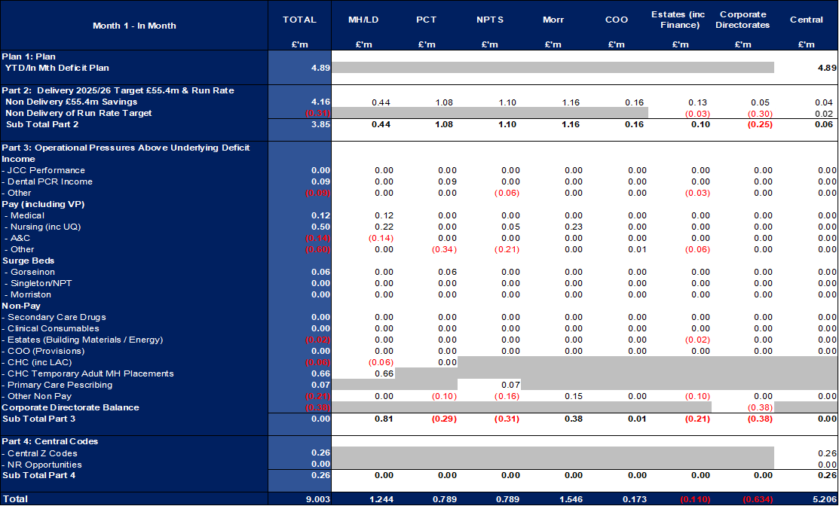

  - Summary By Expenditure Type

- Income
The Joint Commissioning Committee (JCC) Income as a provider delivered a breakeven position in Month 1.
Dental Contract Income underperformed in-month by £0.1m.

- Pay
Month 1 Pay was broadly a breakeven position, with vacancies offsetting the pressures in Medical & Dental and Nursing linked to high levels of sickness absence and a continuation of staffing surge bed capacity.

- Clinical Consumables
(see Appendix 1)

- Prescribing
(see Appendix 1)

- KEY AREAS OF NOTE

  - Savings
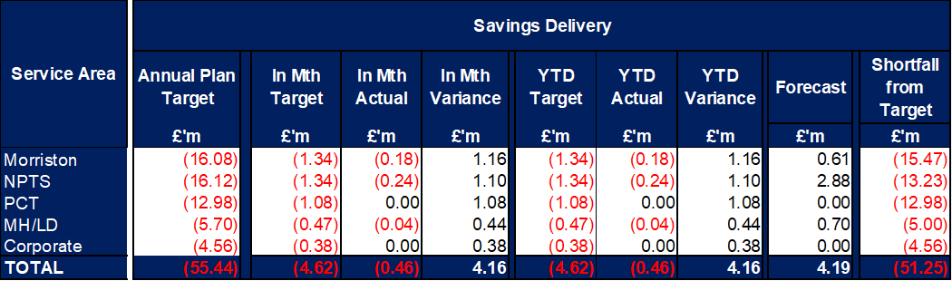

The above table only reflects the Green and Amber savings, there is a further £13m of Red/Pipeline Opportunities the Health Board is working to achieve.

In addition to the above shortfall from target of £51.2m, the Health Board will need to deliver mitigating cost reduction actions to address the YTD overspend of £4.1m to achieve the overall Plan of £58.7m deficit, which is over and above the £55.4m savings target.

Further details on savings, including the red schemes are provided in Appendix 2.

  - Capital
Not formally reported in Month 1.

  - Balance Sheet
Not formally reported in Month 1.

  - Cash
Not formally reported in Month 1.

  - Public Sector Payment Policy (PSPP)
The Health Board achieved the 95% PSPP target the % of Non-NHS Invoices Paid within 30 Days in Month 1 with compliance being 97.11%.

NHS payment compliance for invoices paid within 30 days was, however, was below 95% with the Month 1 performance being 91.14%. The Health Board remains focussed on improving PSPP compliance for NHS invoices and ensuring that performance remains above 95% for non-NHS invoices.

- GOVERNANCE AND RISK ISSUES
Two Board level financial risks:

- Achieving financial plan (HBR92) with the key elements as follows: -

  - Risk of delivery of savings quantum
  - Risk of operational overspend being in excess of funding available agreed via the Financial Plan
  - Risk of commitment of reserves (e.g. NICE) being above reserves available.
  - Risk of achieving the actions and options outlined in the 2025/26 Financial Recovery & Sustainability Assessment.

Based on the financial performance at Month 1 and the shortfall in the identification of the savings required to deliver the deficit plan, it is recommended that the Health Board Corporate Risk Register reflects a risk score of 25.

- Availability of capital (HBR93). This risk was re-opened in 2022/23 given the reduction in discretionary capital allocation. Due to the additional capital funding provided during 2024/25 the risk score was reduced to 12. However at the start of 2025/26, whilst there has been a 24% increase in discretionary capital, the outcome of the national prioritisation and interim solutions required for high risks projects included the Emergency Department and Adult Acute Mental Health, the assessment is that at this point in the year the risk score needs to increase to 20.

- RECOMMENDATIONS
Members are asked to:
- ACKNOWLEDGE the 2025/26 Financial Plan, and the Health Board’s and Welsh Government’s inability to approve it given the planned deficit of £58.7m.
- Consider and comment upon the Health Board’s financial performance for Month 1 2025/26.
- ACKNOWLEDGE the actions to support delivery of a balanced financial position per all Service Areas as per the accountability letters issued in April 2025 which include: -
- Submission of Financial Strategy by each Service Area on 31st May 2025. (Service Group Directors/ Corporate Directors)
- Full breakdown of the actions to be taken for next Financial Performance and Recovery & Sustainability meetings in May to address the savings gap and pressures seen in Month 1 for which there is no budget. (Service Group Directors)
- All savings to be identified and on trackers by 31st May 2025 (Service Group Directors/ Corporate Directors)
- DISCUSS the risks to the position at Month 1.
- SUPPORT the position with regards to Health Board Reserves.
SUPPORT all actions and updates to support the management of the 2025/26 financial position.

Governance and Assurance

Link to Enabling Objectives  (please choose) | Supporting better health and wellbeing by actively promoting and empowering people to live well in resilient communities
Link to Enabling Objectives  (please choose) | Partnerships for Improving Health and Wellbeing |  | ☐
Link to Enabling Objectives  (please choose) | Co-Production and Health Literacy |  | ☐
Link to Enabling Objectives  (please choose) | Digitally Enabled Health and Wellbeing |  | ☐
Link to Enabling Objectives  (please choose) | Deliver better care through excellent health and care services achieving the outcomes that matter most to people
Link to Enabling Objectives  (please choose) | Best Value Outcomes and High-Quality Care |  | ☐
Link to Enabling Objectives  (please choose) | Partnerships for Care |  | ☐
Link to Enabling Objectives  (please choose) | Excellent Staff |  | ☐
Link to Enabling Objectives  (please choose) | Digitally Enabled Care |  | ☐
Link to Enabling Objectives  (please choose) | Outstanding Research, Innovation, Education and Learning |  | ☐
Health and Care Standards
(please choose) | Staying Healthy |  | ☐
(please choose) | Safe Care |  | ☐
(please choose) | Effective Care |  | ☐
(please choose) | Dignified Care |  | ☐
(please choose) | Timely Care |  | ☐
(please choose) | Individual Care |  | ☐
(please choose) | Staff and Resources |  | ☐
Quality, Safety and Patient Experience
Financial Governance supports quality, safety, and patient experience.

Financial Implications
The Board is reporting a forecast year-end deficit financial outturn.

Legal Implications (including equality and diversity assessment)
No implications

Staffing Implications
No implications

Long Term Implications (including the impact of the Well-being of Future Generations (Wales) Act 2015)
No implications

Report History |  | Updates on the financial position are provided at every meeting.
Appendices |  | Appendix 1 – Variances by Area and Type of Spend  Appendix 2 – Savings

APPENDIX 1 – FURTHER DETAIL ON VARIANCES BY AREA & TYPE OF SPEND

- Overview Financial Position

- Overview of Income

The table below compared the income performance in Month 1 to the average levels of 2023/24 and 2024/25.

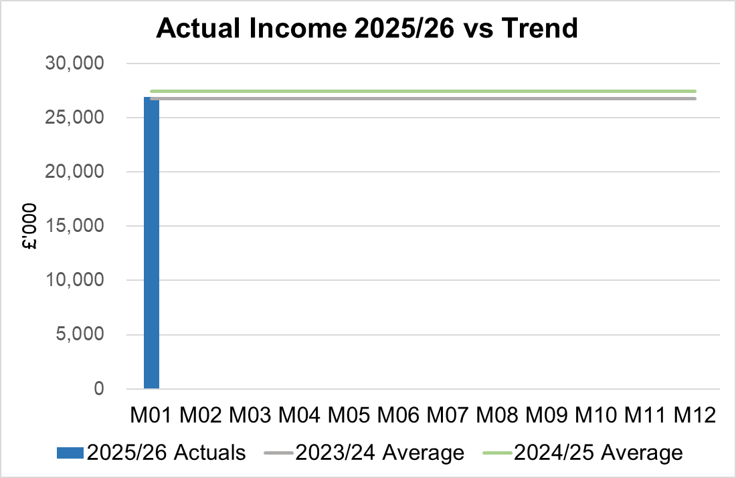

  - Anticipated Income
The below table highlights anticipated income the Health Board expects to receive during 2025/26. The current deficit plan of £58.7m is predicated on receipt of these Welsh Government funds at the levels anticipated. At this point, the 2024/25 Pay Award and new 2025/26 National Insurance (NI) increase funding are unconfirmed and present a risk to the delivery of the plan.

- Pay, Agency & Other Variable Pay Expenditure

Total Pay

The Month 1 total is higher than the prior two years average (as shown in the graph below).

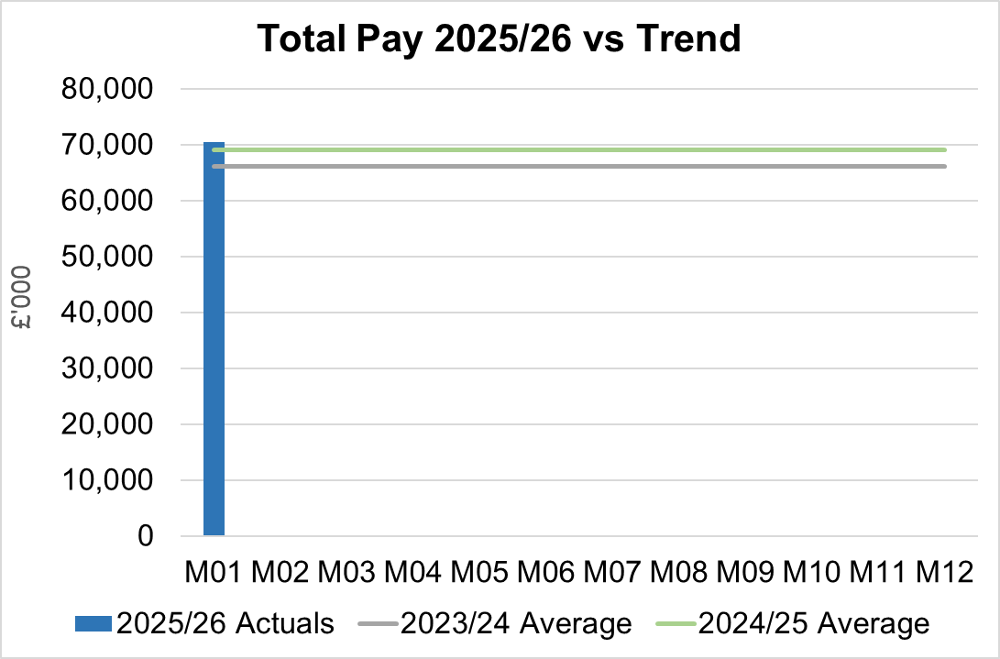

Note - 2023/24 average value has been notional increased by 5% to allow for comparison to 2024/25 and current value of 2025/26 pay value.

Variable Pay
Variable pay is £61k lower in April 2025 (£5.087m vs £5.148m) when compared to the same period last year (graph below shows this year’s actual versus prior year’s average).
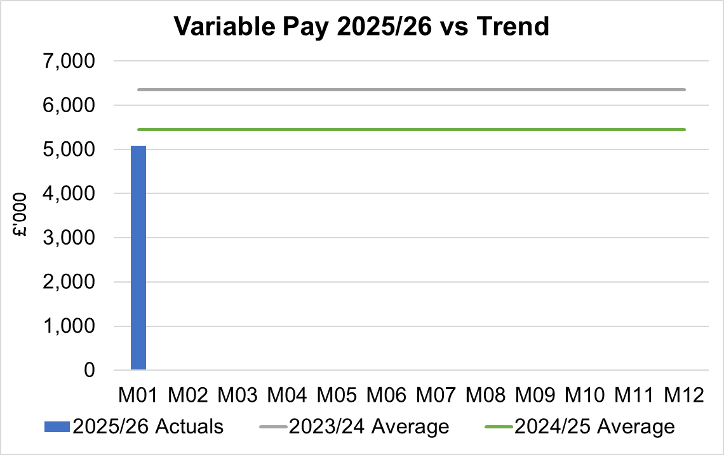

Variable Pay is classified by the Health Board into the following categories: Agency, Bank, Overtime, Waiting List Initiatives (WLI) and Irregular Sessions.
Both Agency/Premium Locum and Other variable pay remain key areas of focus for opportunities to reduce the current run rate of expenditure, with specific reduction targets having been issued to Service Groups.

Variable Pay Spend

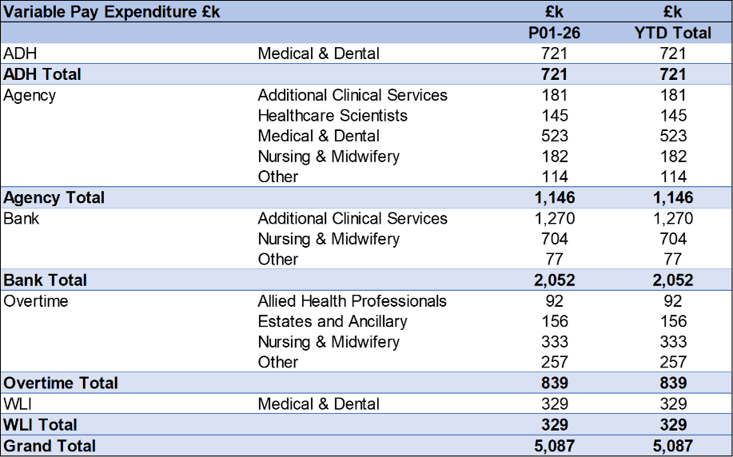

- Overview Non-Pay
Actual Non-Pay spend for Month 1 is higher than the prior two year’s average spend (as shown in the graph below):

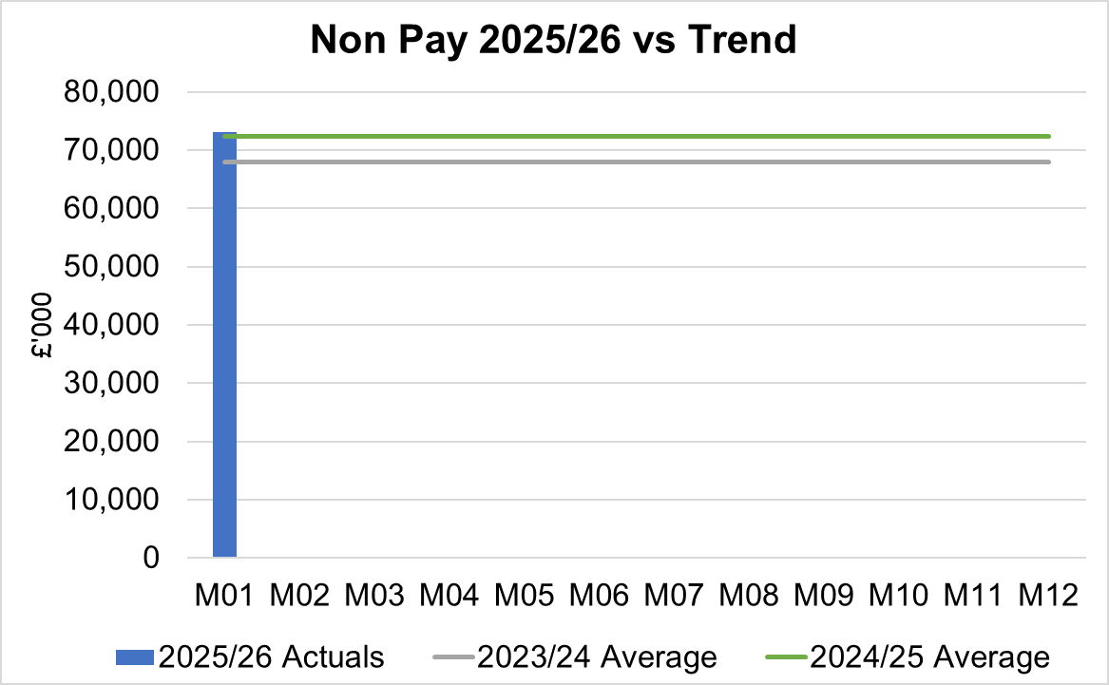

Below are further details on the key areas of non-pay:

  - Clinical Consumables
This area overall has an in-month position of breakeven. There are 80+ subjective lines within this category including secondary care drugs but areas seeing most pressures YTD continue to be general consumables (M&SE), laboratory products and implants (which in part will be driven by activity).

  - Primary Care Prescribing
Prescribing is providing a small overspend in-month following receipt of the February dataset. As PAR data is received 2 months in arrears the Health Board will not have any actual 2025/26 data until the end of June 2025.

  - CHC
In Month 1 CHC was overspent by £0.6m due to temporary Adult Mental Health placements with external providers due to demand being in excess of the Health Board’s internal bed capacity. An analysis of actual expenditure and patient numbers for 2025/26, along with the average values from 2024/25 is provided in table below.

CHC Analysis by Month

Please note:
- The above numbers include Domiciliary care cases.
- PCT Group does not include the Singleton/NPT element. The NPTS element which covers Children and Young People CHC patients is provided internally by the Health Board and as such is part of the wider NPTS position and is not recorded in the ledger as PCT/MH/LD CHC is recorded.

  - COVID Public Enquiry
The total costs for this are allocated to a dedicated Cost Centre (6F25). Total expenditure cumulatively in Month 1 is £0.02m.

  - Maternity Review
The total costs for this are allocated to a dedicated Cost Centre (6F34). Total expenditure in Month 1 of 2025/26 is £0.1m.

  - Z Codes (Section 1,3-4 Table Point 1 Appendix 1)
The narrative below groups together the key elements of the Z codes detailed in Point 1 of this appendix.

- Contracting: SLA /LTA performance: JCC (previously WHSSC), LTA and SLA contract income and expenditure are transacted within this area and financial performance reported. NICE approved high-cost drugs and associated LTAs are also transacted and monitored against targets set. In addition to this, non-contracted activity income in relation to English foundation trusts invoiced on a quarterly basis are reported.

- Capital: The Finance Capital Team manage a number of cost centres covering the PFI, IFRS16 and Depreciation charges for assets both owned and donated are transacted here.

- RRL and Central Reserves: The WG funding received at the start of the year is tracked within this area. Any anticipated allocations in year are also transacted through these codes. Other HB wide funding received from HEIW and SIFT is also captured in here. All central reserves remain within the Z cost centres and details of these are provided in Appendix 2.

- Corporate income and expenditure. Any income and expenditure that is not service group specific is transacted and reported through a number of corporate Z cost centres, examples include, payroll and pension costs, VAT recovery, losses and receipts in relation to funding from Welsh Risk Pool, overseas visitors’ income and Road Traffic Accident income.

  - LTA Values & Forecast performance
This will be reported quarterly with the first data being published in the Month 3 report.

APPENDIX 2 – SAVINGS

- Summary of Savings Position as at April 2025 (Month 1)

The below table provides a summary of the achievement against the 5% savings target (Green and Amber schemes only).

Green and Amber saving schemes identified in Month 1 were £0.46m, as a result the shortfall of £4.16m against plan was significant and will need to be absorbed in future months if the Health Board is going to achieve its savings target of £55.44m and deficit plan of £58.7m.

Corporate areas allocated a savings target have not yet identified any saving schemes on the trackers during the month, however overall the Corproate Directorates over achieved against their Run Rate delivery target.

- Savings schedule as at April 2025
The below table provides a summary of the planned, actual, and forecast achievement against the 5% savings target (including Red schemes).

The end of year forecast delivery for Green and Amber schemes as per the tracker is currently £4.19m, which is a shortfall of £51.25m against the target of £55.44m. This represents a significant risk to the Health Board’s delivery of the plan.

The Health Board trackers detail a further £13m of Red/Pipeline schemes that are being developed to support the achievement of the £55.4m target. Further opportunities are required to be identified and delivered at pace to close the gap.

