Meeting Date | 10 September 2024 |  | Agenda Item |  |  | 2.1
Report Title | Reinstatement of Community Based Intrapartum Services.
Report Author | Kathryn Greaves - Clinical Director of Midwifery  Victoria Owens - Consultant Midwife  Catherine Harris - Head of Midwifery
Report Sponsor | Raj Krishnan, Acting Executive Medical Director  Hazel Powell, Acting Executive Director of Nursing and Patient Experience
Presented by | Kathryn Greaves - Clinical Director of Midwifery
Freedom of Information | Open
Purpose of the Report | This paper sets out the recommendations to safely reinstate midwifery led intrapartum services within the community which include the Freestanding Midwifery Unit (FMU) at Neath Port Talbot Hospital and homebirth services. It also updates on the progress of the safety gateways and identifies any risk and mitigation.
Key Issues | - Community intrapartum services have been suspended since September 2021 with all services centralised to Singleton Hospital to support safe staffing and care delivery.  - Choice of clinically effective birth pathways are limited as a result. There is a need to ensure a safe re-instatement of these pathways with the minimal delay.  - A programme of work has been in place since May 2023 which focuses on the safe reinstatement of services.  - Six safety gateways are in place to support the reinstatement of community intrapartum, including the reopening of the FMU, in the autumn of 2024.
Specific Action Required  (please choose one only) | Information | Discussion |  | Assurance | Approval
Specific Action Required  (please choose one only) | ☐ | ☐ |  | ☐ | ☒
Recommendations | Members are asked to:  - BE ASSURED BY the content of the paper and the safety gateways outlined for re-instatement of community pathways  - AGREE re-instatement timeline for the Neath Port Talbot Birth Centre (Freestanding Midwifery Led Unit) for Monday 16th September 2024  - AGREE the re-instatement timeline for homebirth Services for Monday 21st October 2024

REINSTATEMENT OF COMMUNITY BASED INTRAPARTUM SERVICES

- INTRODUCTION
This paper sets out the recommendations to safely reinstate midwifery led intrapartum services within the community which include the Freestanding Midwifery Unit (FMU) at Neath Port Talbot Hospital and homebirth services. It also updates on the progress of the safety gateways and identifies any risk and mitigation.

- BACKGROUND
In September 2021, Maternity Services reported a midwifery staffing risk rating of 25 due to unplanned absences resulting from a combination of long and short-term sickness, compounded by the COVID pandemic, alongside high levels of maternity leave, which undermined the ability to maintain the full range of expected services safely.

To mitigate the risk of staffing pressures on safe care, delivery of intrapartum services in the FMU at Neath Port Talbot and homebirths were temporarily suspended. Services were centralised to Singleton Hospital during the pandemic in line with professional guidance from the Royal College of Obstetrics and Gynaecology (RCOG), developed to safely manage Maternity Services.

The impact of this was as follows:

- Place of birth choice;
- Individual experience;
- Reduction in the number of women receiving the benefits of birthing under midwifery-led care and in midwifery-led settings;
- Increased activity through the Obstetric Unit;
- Increased associated rates of obstetric intervention

Whilst service centralisation has supported mitigation of staffing constraints, it has also had an impact on workforce morale, staff experience and job fulfilment. The service has also seen an increase in freebirth (birthing without the support of a health care professional).

Work has now progressed to enable a phased reopening of community pathways for birth. This would significantly support birth in the right place, activity on the Singleton site, improved staff experience, and importantly the outcome and experiences for women and families.

The Birth Place Study 2011 in England looked at outcomes for 64,538 women. The findings of this seminal study indicated that for low-risk women having their first baby, birthing in midwifery led unit, alongside, free standing or home birth to be safe, and that they were less likely to receive interventions such as induction of labour, epidural, ventouse birth, caesarean section birth or episiotomy. For midwifery led intrapartum care between 83 – 88% of women achieved a physiological birth without intervention.

Graph 1 below shows the number of women who commenced and then the number of women who completed All Wales Pathway for Normal Labour (NLP). This shows that women birthing on an Obstetric Unit are more likely to receive interventions and complications due to the high-risk nature of the Labour Ward environment and correlates with the Birth Place Study findings.

Graph 1 - Women commenced on the NLP on the Singleton Labour Ward

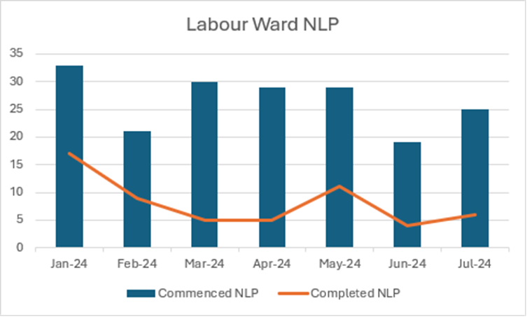

3. GOVERNANCE AND RISK ISSUES

The Swansea Bay University Health Board’s Annual Plan 2024/2025 sets out the vision for Maternity and Neonatal services by providing care that is equitable, efficient, safe, timely, effective and person centred, the ambition is clear:

‘Foundations of health and wellbeing start with pregnancy, birth and the early days of childhood. Person centred, safe and high quality care for mothers and babies throughout pregnancy, birth and following birth can have a positive impact on the health and life chances of women and babies and on the healthy development of children throughout their life This can help to reduce the impact of inequalities which can have longer term health consequences for families, securing the best possible outcomes for mothers, babies and communities.’

This is an integral part of the health board’s population health strategy. One of the objectives is to give every child the best start in life, based on the Marmot principles which focuses on health inequalities and this needs to start before birth.

Delivering of high-quality maternity care is the responsibility of every midwife. A Cochrane Systematic review (April 2024) of midwife led continuity of care versus other models of care reviewed 17 studies of over 18,000 women and concluded that women receiving continuity of care were less likely to experience intervention and experience improved outcomes for mother and baby.

The impact of midwives and midwifery led care for low-risk women is proven to have huge impact on the outcome for mothers and babies. One of the known greatest impact is women having the ability to make informed decisions and choices having developed close relationships of care with their midwife. The ability to support women throughout their pregnancy to make informed choice about place of birth is proven to keep mothers and babies safe and avoid unnecessary high risk interventions where these are not needed.

Significant work has progressed since May 2023, to stabilise the workforce capacity and transform community-staffing models to improve workforce design and resilience for the future to enable the safe re-introduction of community intrapartum pathways of care. This is demonstrated in the following sub sections.

3.1 Safety Gateways
Safety gateways were developed to guide safe service planning and delivery, with a focus on the safe reintroduction of community intrapartum birth settings. The safety gateways have been used to evaluate a timely and sustainable reinstatement plan.

The six safety gateways agreed to support the reinstatement of community intrapartum services include;

- Stable clinical establishment
- Clinical leadership, appointment of 8 Community Team Managers
- Midwifery proficiency assessment
- Environmental and operational assurance
- Phased reopening of the FMU, prior to home birth services
- A sustainable solution for the managing the obstetric unit at times of high acuity

3.1.1 Stable clinical establishment and Midwifery Staff availability including unregistered workforce (community and obstetric unit)

Table 1 references staffing establishments for community and FMU/homebirth models of care. These are agreed staffing availability percentages/wte (whole time equivalents) required to provide the full range of care and birth options for women in the community. The clinical availability as at 28th August 2024 is 44.1wte. This gateway exceeds the >40.02wte by 4.09wte and therefore indicates safe staffing levels to support the reintroduction of all FMU/homebirth community services.

Percentage of staff unavailability | Minimum WTE required | Service Model
>30% | <35.021 | Centralised
<30% | >35.021 | Reinstate Service at NPTBC (Hybrid model as discussed in OCP document section 5)
<25% | >37.55 | Reinstate of full 24/7 service in NPTBC
<22% | >39.02 | Reinstate full service in NPTBC plus home birth service for women who have given birth before
<20% | >40.02 | Full-service implementation to include NPTBC and home birth for all women

Table 1 - Clinical establishment requirement (registered and unregistered ratio of 85:15). Staffing unavailability %, wte and service modelling triggers via agreed community establishments.

Graph 2 below shows the absence trend for the past 12 months for Community Midwifery Teams for Midwives and the unregistered workforce. This shows an improving trend of absence.

Graph 2 Community Midwifery Team
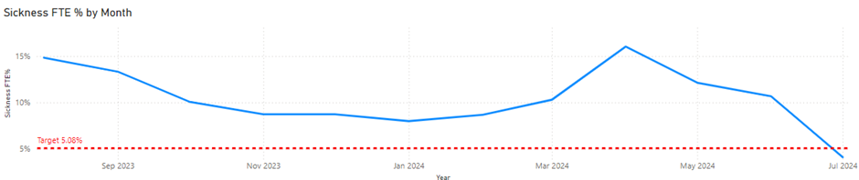
For the obstetric unit, graph three shows the current sickness levels are above the target of 5.08%. Despite this, the unit is able to operate at a staffing level compliant with BirthRate Plus® without relying on the Community Midwifery workforce. The BirthRate Plus® staffing modelling establishments predicts unavailability and allows for an increased staffing level of 26.9% uplift to account for this in relation to sickness, training and annual leave.

Graph 3 Obstetric Unit Midwifery Team
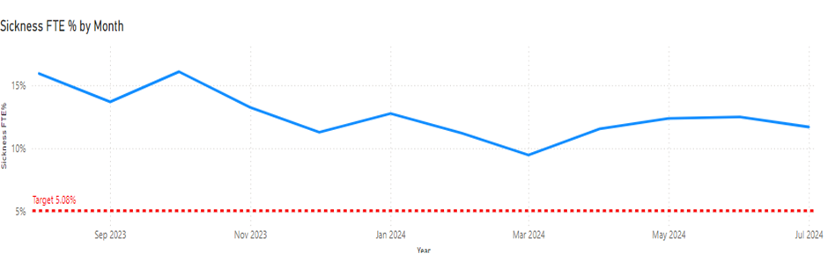

A good governance system has been established to monitor, support and provide oversight of the services to ensure they are delivering the care pathways and meeting the needs of the communities.

3.1.2 Clinical leadership, appointment of 8 Community Team Managers
Safety gateway of the recruitment of Community Midwifery Team Managers for the 8 Community Teams was required and the appointment of 8wte Community Midwifery Team Managers (Band 7) has been completed.

These posts have a dual function in providing clinical leadership capacity within the FMU (contributing to the 24/7 clinical rosters) and operational management of the 8 Community Teams.

These clinical leadership posts are part of the safety support plan for reinstatement of services providing opportunity for band 6 midwives to seek senior clinical support and advice in the care of women during labour and birth 24/7.

3.1.3 Midwifery Proficiency Assessment
A midwifery refresher programme including a proficiency self-assessment document which has been in place since September 2023. This is a supportive and academically sound tool to enable midwives to meet their regulatory obligations, and the organisational responsibility for assessing and managing any knowledge/skills gap within the workforce prior to reinstatement of services.

To date 91.5% of midwives have completed their proficiency assessments, the remaining have plans in place to complete these prior to the reinstating of services.

3.1.4 Environmental and operational assurance
A comprehensive environmental and operational plan is in place ensuring quality and safety assurance of the area prior to reopening. The programme of works and predicted timelines would support opening of the clinical environment from 16th September 2024. This programme is being monitored via a weekly working group with no delays being currently predicted.

3.1.5 Phased reopening of the FMU, prior to home birth services
The phased reinstatement plan has been devised to support a controlled reinstatement of services. The FMU provides a supportive 24/7 model which gives all community midwives working in the environment unlimited access to senior midwifery support, and increased capacity ratio for service delivery compared to home birth. This is an assurance measure to mitigate any unknown risk in the extensive period of centralisation. Homebirths would be reintroduced within 4 -6 weeks of reopening the FMU therefore, full community intrapartum service resumption is expected by 21st October 2024.

Communications plans have been developed, so should the Board support the decision to reinstate community intrapartum services, this can be shared with the local communities.

3.1.6 A sustainable solution for the managing the obstetric unit in line with escalation procedures
In order to provide assurance around the sustainability of community intrapartum services, there is a clear and reliable approach to managing the Obstetric Unit at times of high acuity; and this is noted within the unit escalation policy. Community midwives are no longer called to support the Obstetric Unit. However, they remain available for the escalation process in the event of a business continuity scenario, which is on a par with other maternity units.

There is an ongoing process of monitoring and escalation which consists of morning safety huddles where the acuity is reviewed against the available workforce. The acuity systems use a RAG rating to establish activity to safe staffing levels where staffing levels fall below this the escalation policy is enacted, utilising other specialist midwife resources during this period.

The Singleton Obstetric Unit currently holds the demand of all births for Swansea Bay. The local data show that for this year alone, 57 women have had low risk midwifery-led care on the Obstetric Labour Ward at Singleton. These women were accommodated on Labour Ward as the Bay Birthing Unit was at capacity. For the same period, 223 women birthed in the Bay Birthing Unit at Singleton Hospital, some of whom could have been homebirths or births in the FMU had this been available as a choice.

4.PRINCESS OF WALES HOSPITAL TEMPORARY CLOSURE OF MATERNITY SERVICES
The Princess of Wales Hospital planned temporary closure of maternity services in September 2024 for 12 weeks raises further risk of increasing the demand in the Obstetric Unit. If birth choices in every setting within Swansea Bay are available to women, this would reduce the impact on the Singleton Hospital site. The predicted number of women choosing Swansea Bay for place of birth during this period is between 11 and 20 per month. Offering a full range of birth choices to these women would support reducing the demand of activity on the Obstetric Unit, as they would be following the approved pathway of care in line with their presenting risk.

Staff (Midwives, Paediatric Nurses, HCAs and Nursery Nurses) currently working in Bridgend have been temporarily redeployed to the receiving care Health Boards (that is Swansea Bay and Cardiff and Vale) to support the increase in activity based on predicted flows. Clinical care pathways have been developed by Cwm Taf Morgannwg UHB (CTM) in partnership with both Swansea Bay UHB and Cardiff and Vale UHB. Regular meetings have been planned daily for the first two weeks of the closure with teams from Swansea Bay and CTM working together to ensure a smooth transition for staff and women, and so that any issues can be identified and resolved. These will move to three weekly with the option increase in frequency as required.

5. RISKS TO ONGOING SUSPENSION OF COMMUNITY INTRAPARTUM CARE PATHWAYS
As noted in the introduction, a phased reopening of community pathways for birth, would significantly support birth in the right place, activity on the Singleton site, improved staff experience, and importantly the outcome and experiences for women and families. The reopening of the FMU would be the initial plan, reopening community pathways with homebirth being considered once the pathways for FMU care have been established. The risks are as follows:

5.1 Risk of ongoing closure and birth choices for women
Women are having their birth experiences and aspirations for birth impacted by the ongoing closure of intrapartum care pathways. The service is seeing an increasing number of complaints from women who do not have this service provided by Swansea Bay Health Board. Women are reporting the employment of independent midwives to support their choice for homebirth and mothers have transferred their care so that the neighbouring Health Boards would support their choice for birth.

5.2 Risk to the staff retention and staff experience
The continued closure of community intrapartum pathways increases the risk of attrition due to staff experience while community intrapartum services remain suspended.

6. FINANCIAL IMPLICATIONS
There has been an assessment of financial implications and these do not impact on the re-introductions of community intrapartum care pathways.

CONCLUSION
The safety gateways provide assurance around safe reinstatement of community services and enable controllable risk to be identified and mitigated in readiness for the re-introduction of community intrapartum care pathways on 16th September 2024.

RECOMMENDATION
Members are asked to:
- BE ASSURED BY the content of the paper and the safety gateways outlined for re-instatement of community pathways
- AGREE re-instatement timeline for the Neath Port Talbot Birth Centre (Freestanding Midwifery Led Unit) for Monday 16th September 2024
- AGREE the re-instatement timeline for homebirth Services for Monday 21st October 2024

Governance and Assurance

Link to Enabling Objectives  (please choose) | Supporting better health and wellbeing by actively promoting and empowering people to live well in resilient communities
Link to Enabling Objectives  (please choose) | Partnerships for Improving Health and Wellbeing |  | ☐
Link to Enabling Objectives  (please choose) | Co-Production and Health Literacy |  | ☐
Link to Enabling Objectives  (please choose) | Digitally Enabled Health and Wellbeing |  | ☐
Link to Enabling Objectives  (please choose) | Deliver better care through excellent health and care services achieving the outcomes that matter most to people
Link to Enabling Objectives  (please choose) | Best Value Outcomes and High Quality Care |  | ☒
Link to Enabling Objectives  (please choose) | Partnerships for Care |  | ☒
Link to Enabling Objectives  (please choose) | Excellent Staff |  | ☒
Link to Enabling Objectives  (please choose) | Digitally Enabled Care |  | ☒
Link to Enabling Objectives  (please choose) | Outstanding Research, Innovation, Education and Learning |  | ☒
Health and Care Standards
(please choose) | Staying Healthy |  | ☐
(please choose) | Safe Care |  | ☒
(please choose) | Effective Care |  | ☒
(please choose) | Dignified Care |  | ☒
(please choose) | Timely Care |  | ☒
(please choose) | Individual Care |  | ☒
(please choose) | Staff and Resources |  | ☒
Quality, Safety and Patient Experience
The health board is dedicated to ensuring that pregnancy and childbirth is a safe and positive experience for all service users in order to support healthy life choices and to give children the best start in life. In addition to achieving the Health Board quality priorities, maternity services must also achieve the priorities identified by Welsh Government for maternity care, included in the ‘Maternity Care in Wales; A 5 Year Vision for the Future 2019-2024’. The Vision has embedded within its core principles, person-centred, high-quality care for mothers and babies throughout pregnancy, birth and following birth, this includes the availability of all birth place options.
Financial Implications
Financial implications are set out in the report.
Legal Implications (including equality and diversity assessment)
There are no legal implications.

Staffing Implications
Staffing implications are set out in the report.

Long Term Implications (including the impact of the Well-being of Future Generations (Wales) Act 2015)
The reinstatement of all midwifery-led intrapartum services will create a robust and sustainable maternity service within the health board to provide safe and effective services for the longer-term.
Report History |  | Regular updates have been provided to the board.
Appendices |  | Nil

