SWANSEA BAY UNIVERSITY HEALTH BOARD

RECOVERY AND SUSTAINABILITY ASSESSMENT

2024/25

Version | update
V0 | Structure and content
V1 | Developed for early sections – further structuring
V2 | Addition of aspects taken forward
V3 | Actions section added
V4 | Developed for performance and detailed emerging recovery options
V5 | Working draft document first cut
V6 | Working draft document for Board briefing 10th September 2024
V7 | Updated financials post Board briefing
V8 | Final draft to PFC 17th September 2024
V9 | From 16th Sept to Board Submission 20th September 2024
V10 | Final for Board
Table to be deleted for final document

September 2024



Contents
Executive Summary 3
Introduction 4
Summary of March 2024 Plan for 2024/25 6
Financial summary of March 2024 Plan 7
Month 5 plan delivery position 10
Month 5 financial position 11
Actions taken to reduce run rate pressure up to end of month 5 14
Post green and amber position 18
Further choices and options to improve run rate (reds) 19
Delivery against key performance metrics adjusted for choices 24
Summary of financial assessment for 2024/25 25
Setting Scene 2025/26 to 2027/28 Integrated Medium Term Plan 30
Summary of journey from September 2024 to March 25 34
Appendix 1 – Recovery and Sustainability Model 37
Appendix 2 – Financial Assessment by Service Area 38

Executive Summary
The Recovery and Sustainability assessment contained within this document allows the reader to follow the route from the submission of the original plan at end March 2024, through 2024/25 and the strategic approach for 2025/26-2027/28.

From the submission of the Month 1 position in early May 2024 the Health Board has been working on actions to address the operational pressures which have continued throughout 2024/25. A summary of the actions taken, which are linked to the Accountability Letters, decisions on controllable expenditure and wider Recovery & Sustainability Programme are summarised on Pages 14-16.

The output from this work, the options considered and recommended, financial assessment of these and the overview of the revised 2024/25 Assessment alongside further opportunities are provided in Pages 16-27. A summary of the Assessment is provided in the table below, with full details in Table 13 and Appendix 2:

This document outlines the further work underway by the Recovery & Sustainability Programme alongside an assessment of non-recurrent opportunities and potential further risks identified to date. The assessment of these at the start of September 2024 provides for a range in the delivery of the financial outturn for the Health Board for 2024/25. As per table 15, this range is £50.8m deficit to £87.0m deficit and is summarised below:

In summary there is a line of sight to £50.8m on the basis that all elements of the assessment are delivered in full and the risks detailed in pages 18-28 are mitigated in full. Therefore, the focus for the Health Board and the Recovery & Sustainability Board through 2024/25 will be to ensure that all elements are delivered to achieve a position close to the original plan submission. This enhanced approach is summarised on page 33.

Introduction
The Health Board submitted its Annual Plan for 2024/25 on 28th March 2024. The Plan set out the key deliverables for the Health Board which were set in the context of a £50.1m forecast deficit. There was a clear understanding from the Board that this planned deficit was not acceptable and would be worked on with a view to reduction in the ensuing months, as set out later in this plan.

This set out a reduction from the opening underlying deficit of £54.8m which had arisen due to a significant element of the 2023/24 landing pan being reliant upon non recurrent solutions. This forecast deficit is above both the Target Control Total (£17.1m) and the 2023/24 final outturn position of £16.8m deficit.

The plan set out opportunities for financial improvement and these themes were developed further in April and May 2024. For month 1 the Health Board reported a deficit of £9.5m in month, substantially above the plan of £4.175m a month.

National benchmarking and comparison of organisations’ plans as submitted at the start of the financial year highlighted that in some aspects of the financial plan, the Health Board differed from other Health Boards, with growth assumptions and local choices in the original plan, higher than the equivalent aspects of other Health Board plans. Assumptions around non pay inflation, Continuing Health Care (hereafter CHC) and prescribing costs were higher than the rest of Wales in percentage terms. Also, the allocation of resources to Urgent Emergency Care without financial and service benefits being realised is a major factor requiring address. Finally, the levels of recurrent savings identified are below those reported by other Health Boards

A series of immediate actions were implemented by the instruction of the Chief Executive with a clear focus on run rate reduction; at the same time the thematic review was concluding. Through further detailed analysis it became clear that the Health Board did not have a line of sight to improve on the stated deficit of £50.1m and the plan remained unchanged; whilst fully recognising that this was not where the Board nor its scrutineers would wish.

The plan was resubmitted at the end of May 2024 with no change in the predicted deficit, with operational pressures showing no signs of immediate improvement in financial terms and further options and choices to reduce the planned deficit were limited. Therefore, additional expenditure management instructions were issued and whilst there was some reduction in monthly variance from plan, this remained significantly adrift from the required levels to consider any changes to the plan with confidence.

The governance processes outlined in the Accountability Letters led the organisation to implement several focused actions, alongside instructions on controllable expenditure and the establishment of the Recovery & Sustainability Programme. The Performance & Finance Committee has provided the oversight of the financial plans and actions for 2024/25, all of which are to enhance the pace and grip on financial recovery.

The work of the Recovery & Sustainability Programme provides the Health Board with the support to drive a longer-term approach in achieving financial sustainability. The Programmes of three parts will challenge the benefits realisation and assessment of investments and choices to complement the short and immediate actions to slow run rate spend.

This assessment describes the position of the Health Board in financial and delivery terms at the time of writing (Month 5 data available) and then sets out the process undertaken to produce a revised assessment, the assessment itself, an approach to future years to further reduce the Health Board deficit, recognising the need to achieve Target Control Total as a first milestone on the way to financial balance as soon as possible, and finally sets out the governance processes and system changes to increase the visibility of, and delivery confidence in, the assessment.

Summary of March 2024 Plan for 2024/25
This section of the document provides a recap of the proposed performance delivery described (for key performance areas) in the Health Board plans of March 2024. These are taken from the Ministerial templates submitted with the plan (priority areas). The table is included as a point of reference to confirm that the delivery and financing of the plan are integrated. Later in the report this table will develop to show the impact of Targeted Intervention (TI) and any final impacts of the position and choices to improve the financial position.

Table 1 – March 2025 forecast performance levels per plan

The section which follows sets out how the financial plan for the year was developed to deliver these performance delivery requirements. The plan also set out a wider range of service delivery and planning assumptions across population health, quality, equality, social economic duty and future generations requirements. This new plan document is focussed on the financial and performance delivery aspects of the plan for the remainder of the financial year, with the wider aspects above being considered as part of the impact assessment later in the report when the financial options and choices are presented.

Financial summary of March 2024 Plan

March 2024
The 2024/25 Financial Plan submitted to Welsh Government (WG), following approval by the Board at the end of March 2024 is summarised in Table 2. It is directly linked, as part of the integrated planning process, to the performance delivery set out in Table 1 in the above section.

The principles behind this plan were:

- Stress tested by Board, Performance & Finance Committee and the Executive team throughout the period January to March, with significant challenge on the non-delivery of the £17.1m Control Total.

- The choices made in the Financial Plan were based on a range of assumptions modelled that linked to Growth, Inflation and Goals Outcomes Measures cases.

- Whilst there was a reduction in the opening underlying deficit (ULD) reported during 2023/24, the final reduced deficit was not at the value the Board had aspired to reach.

- £50.1m Deficit Plan at the end of March 2024 was an anchor point with further Thematic Opportunities to be explore with the potential to reduce the plan from £50.1m to £24.5m.

- Thematic opportunities aligned to the Board’s wider aspiration to move towards the control total of £17m.

- Clear governance and oversight on the Financial Plan, as set out in the key documents established by the Board: -

  - Accountability Letters
  - Budgetary Framework

- With the exception of four specific areas all funding was issued to the delegated budget holders at the start of the financial year, with the expectation that as the deficit was held centrally all services areas would achieve breakeven. This would assure delivery of the overall plan. Any thematic schemes that delivered benefits would be a further improvement on the forecast which would be part of a formal process that the board would oversee.

- Savings target of £26.1m was set and was to be supported by a focus on the opportunities presented through The Vault and the national Value and Sustainability programmes, which were encompassed in the development of the Swansea Bay Repository of Opportunities.

- New approach adopted for savings delivery for 2024/25, based on learning and reflection from previous years, has put an emphasis on run rate reduction and not budgetary savings to streamline and simplify the required recurrent delivery to ensure the focus was on breakeven and longer term reduction in run rate, to form the foundation for further future financial improvement.

Table 2 : 2024/25 Opening Financial Plan

The Thematic programmes and the work plans behind them provided opportunities to reduce the plan from the £50.1m deficit to £24.5m. A summary of the Thematic programmes in provided in Table 3 below:

Table 3 : Thematic Programmes

The delivery all six programmes, alongside the principle of delegated budget holder remaining within the budgetary funding provided, gave the Health Board an opportunity to reduce the plan later in the year, establishing progress towards the £17.1m Control Total.

May 2024
The Health Board’s formal feedback was that the above plan was neither acceptable not supportable by Welsh Government. The Board were asked to resubmit a plan at the end of May 2024 which looked to de-risk the plan and describe the actions being taken to improve on the £50.1m deficit.

For Month 1 the Health Board reported a deficit of £9.5m in month, substantially above the plan of £4.175m a month.

The Month 1 position was taken into consideration when refreshing the plan for submission at the end of May 2024 and given the scale of the variance from plan and the actions that would be needed to recover this, the Health Board was unable to describe a line of sight to a financial position better than £50.1m. At the same point there was also a lack of assurance that the opportunities within the thematic programme were unlikely to be delivered to the levels anticipated. An updated plan was therefore shared with Welsh Government at the end of May 2024 which was unable to show improvement from the forecast £50.1m position.

Given the scale of the financial challenge further actions were put in to place: -

- Additional grip and control
- Establishment of a Recovery & Sustainability Programme
- Detailed planning meetings (Star Chambers) with all Directors projecting deficit outturns to identify all options for financial improvement.

The output of these meetings, along with the other work undertaken takes the Health Board forward to a position where it can consider the options and choices available for further financial improvement.

The next sections of this report will set out the following: -

- Performance position at Month 5, again to frame the performance position of the Health Board against the current financial position.
- Financial position at Month 5. The most up to date financial position to frame the options and choices identified

This baselining describes a mid-year point against which options and choices for financial recovery will be considered.

Month 5 plan delivery position
This section sets out performance delivery at the end Month 5 and is followed by a description of the financial position at the end of Month 5. A column has been included to provide the Targeted Intervention measures which must be met to de-escalate the Health Board. Clarity on these measures and the required scale of delivery has emerged during the time that the plan is being assessed for options to improve the financial forecast.

Table 4 – Month 5 Performance and TI Update

Month 5 financial position

At the end of Month 5 the Health Board reported a cumulative deficit of £39.8m which is 79% of the 12 month plan of £50.1m. Graph 1 below shows the month by month position for the first 5 months of the year, represented by the blue bars.

The figure also shows the average required run rate for the rest of the year just to achieve the £50.1m position, represented as an illustration by the yellow bars.

Graph 1 : Monthly variance, Actual to Month 5 and Required Improvement Month 6-12
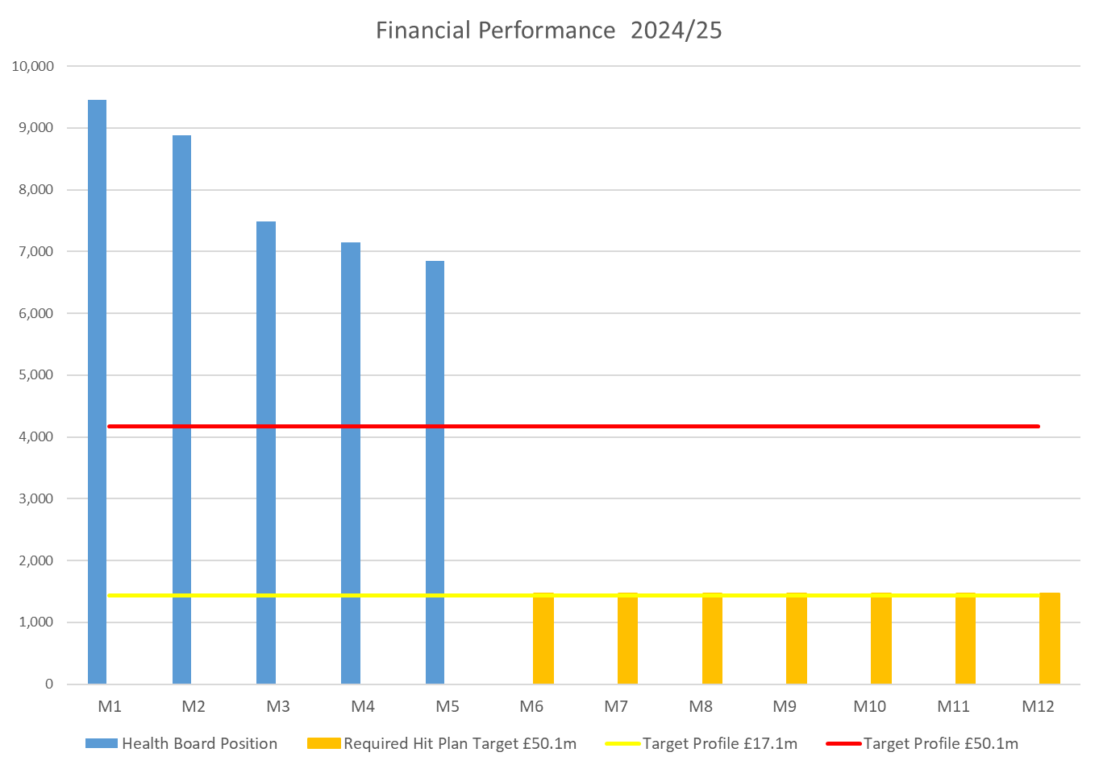

The figure below shows how the Year to Date (YTD) position is made up over 3 three key areas. This is important as it aligns specifically to the actions being taken through the Recovery & Sustainability Programme which is shown later.

Figure 1 : summary illustration by driver Month 5
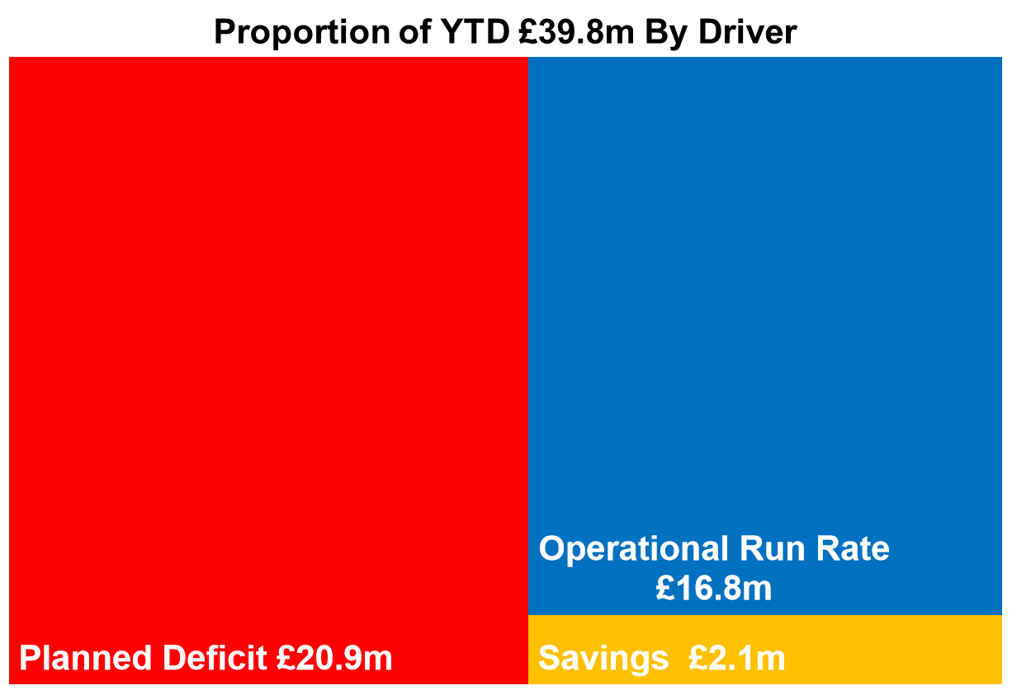

Table 5 expands on this further and highlights the main variances from plan.

Table 5 : Cumulative key drivers Month 5

Whilst there has been an improvement in monthly variance, neither the scale nor pace of the reduction in variance is sufficient to give confidence at this stage that the £50.1m position (or better) is deliverable. The savings position both in year and recurrently is set out below. Graph 1 above shows that without improved savings delivery and run rate reduction the financial position will not improve with sufficient pace to meet £50.1m or improve on this further.

Table 6: Savings Delivery Green & Ambers Schemes Only @ Month 5
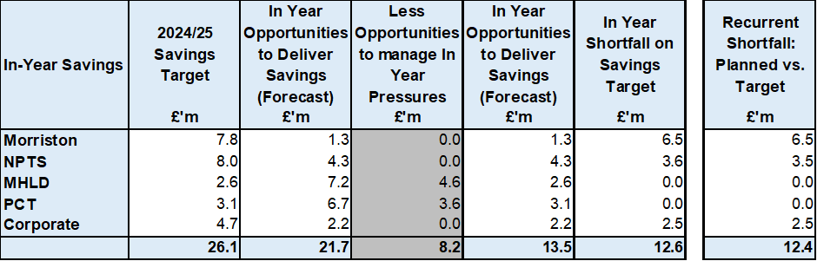

Tables 7: Savings Delivery All Schemes @ Month 5
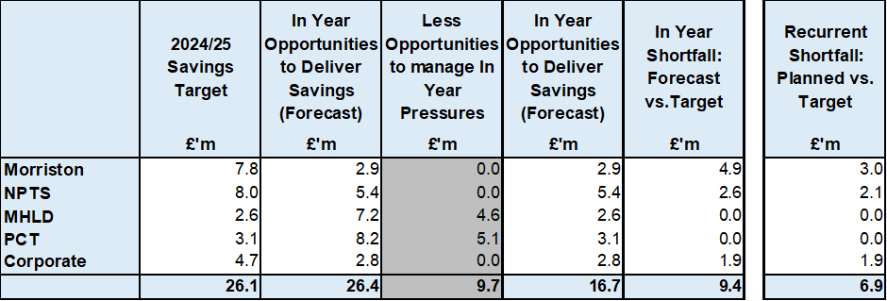

It is clear from the Month 5 position, that whilst performance in the majority of areas is moving in the appropriate direction, the expenditure run rate of the Health Board is not reducing quickly enough to provide confidence of delivery in 2024/25. This is a significant concern.

The focal point of this assessment now moves to the options and choices available to increase the pace and scale of financial improvement. These options and choices were introduced through the Star Chamber process. The next section of this assessment sets out the actions already undertaken to improve the financial position. The in-month variance of the Health Board has improved from £9.5m in Month 1 to £6.9m in Month 5 but this is not a sufficient rate of improvement.

The section which follows sets out the financial implications of the options and choices from the Star Chamber process recommended for implementation by the Health Board Executive Team as a collective. These recommendations have been scrutinised and supported as a unitary Board and have been agreed, accepting their impacts and mitigations to be implemented through this assessment to reduce run rate.

The outputs of the Star Chamber process were classified as green, amber and red (details later). Budget holders have been instructed to implement the options and choices they have identified as green and amber and to move these on to their formal tracking processes for implementation and monitoring.

The red schemes are very challenging in their nature and have been subject to a rigorous process for implementation. Not all were acceptable for implementation, and this is discussed in more detail later in this assessment.

Actions taken to reduce run rate pressure up to end of month 5
Actions underway since Month 1 have focused on enhancing the grip and control over the options routinely deployed on the use of Health Board Resources. For the purposes of the revised assessment these can be categorised into two areas:

- Those that stem from the Board Oversight and Governance put in place aligned to the Accountability Letter
- The additional actions that stem from the focus on expenditure grip and control following the Month 1 reported position

Table 8 : Part 1 - Board Oversight and Governance – Accountability Letter
Action / Output | Timescale
Deficit Financial Plan submitted | End March 2024
Accountability Letters issued to Delegated Budget Holders – set out all funding issued, with deficit sitting centrally | End April 2024
Requirement in response to Accountability Letters all areas submit Financial Strategy to achieve breakeven | End May 2024
Financial Strategies breached delegated budgets and first round Options | End June 2024
First Round Star Chamber Meetings | 11th-24th July
Further submission of Options with Green & Ambers assumed as Just Do Its and reds for further discussions at Star Chamber | 14th Aug 2024
Second Round Star Chamber Meetings | 19th-23rd Aug 2024
Discussion at PFC on Next Steps to presentation and recommendation of Red Options to Board. | 27th Aug 2024
Briefing Independent Members to provide update on Options & Financial Assessment | 3rd Sept 2024
Presentation and discussions of Red Options at Executive Team for conclusion on recommendations to Board by 9th September | 4th Sept 2024
Board briefing on Assessment for submission 26th September | 10th Sept 2024
Briefing Independent Members to provide update on Options & Assessment at a special meeting of the Performance and Finance Committee | 17th Sept 2024

Table 9 : Part 2 - Additional Expenditure Grip & Control
Action / Output | Timescale
Chief Executive Officer (CEO) set out a number of actions to address the run rate pressures and during May 2024 the CEO also established clear actions for each Executive Team member. These additional actions focused on:  - Medical Staffing Variable Pay – Acting Medical Director  - Nursing (Registered and Unregistered) Variable Pay – Director of Nursing  - Review Bank – Acting Director of Workforce  - Review Non-Pay Outsourcing – COO  - Maximising Value & Sustainability opportunities – Director of Finance & Performance  The variable pay work identified £13.5m of opportunities which are integrated into this assessment | 15th May 2024
Recovery & Sustainability Team established, working directly to the Director of Finance and Performance (SRO) leading on a three-programme approach supported by the existing Finance PMO Team. | 8th July 2024
Immediate pause on Admin & Clerical (A&C) Bank/Agency/Overtime and also a pause on all A&C Recruitment, with new vacancy panel being developed to increase the scrutiny on A&C posts being put in place after the 3 month pause. | 17th July 2024
Board authorised the Executive Team to consider and approve actions to reduce controllable expenditure. | 27th July 2024
Commencement of the specific review of investment and choices made through IMTP process over last 3-4 years. Work to date has focused on Omnicell Invest to Save (Non-Pay Theatres) and Emergency Department in Morriston. | 29th July 2024
Special Executive Team to consider options to reduce or cease controllable expenditure. Agreed reduction in Travel, Office Equipment, Telephones and Building/Maintenance Costs, which could reduce run rate by £0.9m in 2024/25. | 31st July 2024
Special Executive Team to consider options to reduce or cease controllable expenditure focusing on Variable Pay and the opportunities highlighted, which could reduce run rates by £13.5m. | 7th Aug 2024
Issued instruction to Service Areas on the Variable Pay Control targets for 2024/25, with 25% reduction required by end September and a further 25% reduction by the end of December. This has the potential to reduce Variable Pay by £13.5m by the 31st March 2025. | 12th Aug 2024
Issue further instructions to Service Areas on controllable expenditure agreed by the Executive Team, focusing on Travel, Office Equipment, Telephones and Building/Maintenance Costs. | 13th Aug 2024

Both strands of work have come together to support an update on the Financial Assessmentfor 2024/5.

During July the Health Board also launched Phase 1 of the new Repository of Opportunities which brought together benchmarking, value and sustainability opportunities nationally and locally identified, as well as research on good practice to support the wider Recovery & Sustainability agenda. The product is similar to the NHS Executive Financial Planning and Delivery (FP&D) Vault and has a direct link to this product. Phase 2 of this work, which is planned for the Autumn will include: -

- The latest Welsh Costing Return data
- Weekly Reporting of non-financial indicators that impact on financial position
- Theatre comparison data; and
- Further detailed analytics to highlight opportunities using the existing repository data.

The overarching aim is to the support the in-year, recurrent and long-term delivery of savings and opportunities, as well as supporting the Health Board in assessing why it is different to other Health Boards in Wales and areas of focus to mitigate this. The graph below was shared with the Health Board to illustrate the comparative difference in some of the cost assessments made in the original plan.

Graph 2 – cost growth assessment comparison
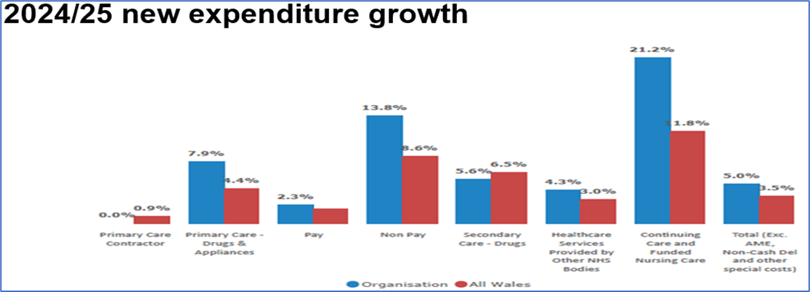

Source – NHSE Financial Planning and Delivery
In addition to the work aligned to the Repository of Opportunities there is further work underway focusing on those areas where the Health Board is different to the rest of Wales:
- CHC – programme of work commenced led by the Director of Strategy which will include centralisation of contracting for CHC and standardisation of processes across all areas of the Health Board.
- Primary Care Prescribing – increased focus through the provision of dedicated support from Finance Team and appointment of a dedicated senior Finance Analyst for all aspects of Drug expenditure.
- Non-Pay – aligned to Programme 3 of the Recovery & Sustainability Board through the development of robust Bed and Theatre modelling to support the level of non-pay included in the original plan.
All three of these areas will also line up with the national Value & Sustainability Programme outlined in the next section of this paper.

Post green and amber position
The resubmission of the options and choices requested for 14th August, building on the work assessed and challenged in the first round of Star Chamber meetings was based on principles that:

- GREEN Schemes will deliver imminently, with a confirmed value and date the savings will be delivered.
- AMBER Schemes will deliver, but the final value and/or date of delivery may not be known at this point, but estimates have been applied.
- RED Schemes are with an uncertain start date or value and for which there is some element of risk in delivery for which an impact assessment will be required.

On the basis that there is no element of risk associated on service delivery with Green and Amber schemes, these schemes were not discussed in the second round of Star Chamber meetings but were to be added to the savings trackers during September 2024, to ensure they are captured going forward as part of the standard WG and Board reporting. This will be closely monitored by the Performance and Finance Committee.

Within the assessment, detailed in the later section, a percentage reduction has been applied to the value of the green and amber schemes to address any delivery risk bias or delays in scheme delivery, particularly linked to amber schemes. The percentage is based on delivery of 2023/24 schemes versus target excluding Accountancy gains. In addition to the green and amber schemes included within the options submitted on 14th August, there were already a number of Green/Amber schemes that were delivering for the Health Board. These original schemes totalled £12.3m and are reflected in Part C of the revised financial assessment.

Alongside these options are the additional decisions made by the Executive Team on Controllable Expenditure. The core area is the control total set for Variable Pay, with 25% reduction from Q1 expected at the end of September and a further 25% reduction at the end of December. The assessed impact of these principles totals £13.5m and is reflected in Part D of the assessment. However, this needs to be assessed together with the options and choices presented to avoid duplications, and therefore the balance remaining in Section D is after the deduction of these schemes included in the options and choices. The impact of the original Green options, the additional Green and Amber options and controllable expenditure on the opening deficit plan is reflected in Graph 3.

Graph 3 : Amber and green options impact
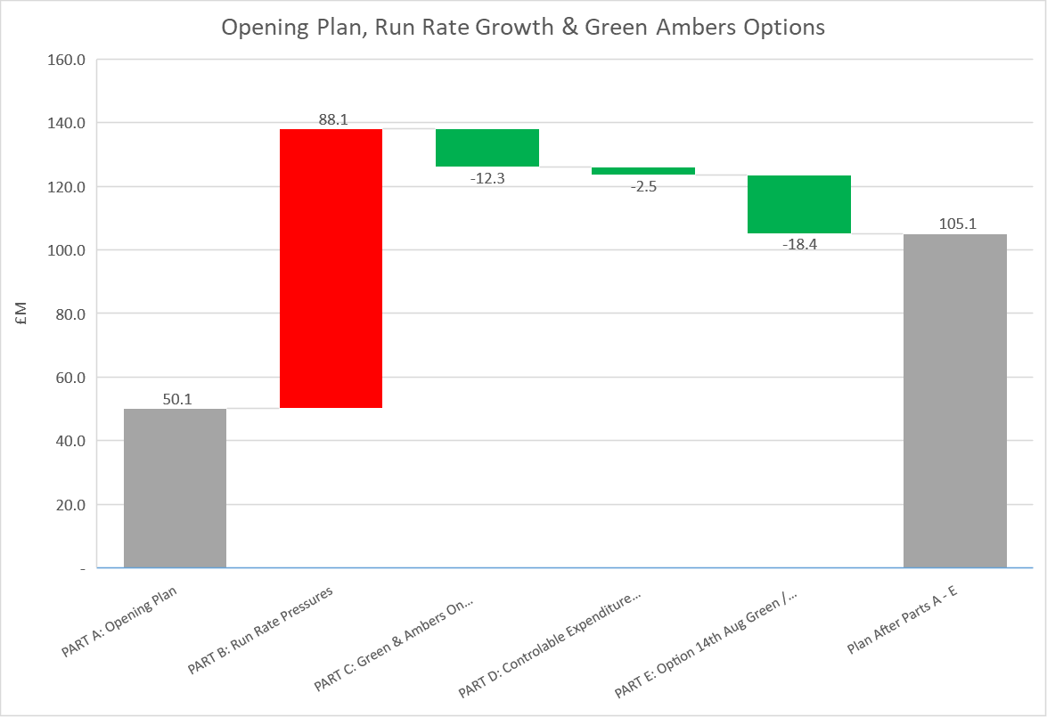

Further choices and options to improve run rate (reds)
The previous section focused on the outputs from the green and amber options and choices as part of the submissions on 14th August. There were a significant number of options assessed as red by the budget holders. It was these red options and choices that became the focus of the second round of Star Chamber meetings. Since these meeting the Health Board, through the Executive Team have focused on assessing these from perspectives of quality, safety and targeted intervention impact, as well as the ability to deliver real reductions within the last 6-7 months of the year.

The Star Chamber process identified 302 options and choices for financial improvement, of which 148 were classified as red. Through the executive review process all options and choices, put forward for implementation have been Quality Impact Assessed.

The 148 red options were subject to Executive Review and the output from this work has resulted in the options being categorised into four key headings, which are summarised in Table 10 below:

Table 10 : Red Category by Recommendation

These have all been categorised by area of impact and Table 11 below shows the matrix of category, financial impact and Executive Team approval.

Table 11 – Post scrutiny distribution of red recovery options and choices

Impact Assessment
The table below provides details of the options and choices that are proposed to be implemented. These have been filtered to those schemes with values over £0.25m.

Table 12 – Proposed red scheme value. Risk and mitigation
Scheme | Value in 2024/25  £m | Risks/Impact | Mitigation
Recruitment freeze in PCTS | 2.043 | Risk is low as the vacancies are already in the system | Vacancies will be released as when confidence in delivery of other PCTS actions is delivered.
Stop all HCSW agency in MH&LD | 1.160 | Risks to sustainable service provision without HCSW support | Baseline establishment is available to support posts. Recruitment to vacancies
Continue decommissioning Ward K Morriston | 0.798 | Risk is low as Ward is already decommissioned | None required as ward is closed linked to the IPC and Roof Repair programme.
Recovery underperformance from 2023/24 dental activity | 0.786  0.714 | Not reducing the activity commissioned but not commissioning extra ad hoc activity. Risk of unmet dental need – equivalent to 11.4 WTE dentists | Shortfall in the Patient Charges income delivering financial pressure. From April 2024 WG issued increased rates support sustainability into 2025/26. No mitigation available for 2024/25. Approach same deployed in 2023/24.
Cap HCSW activity in MH&LD to funded establishment | 0.683 | Risks to sustainable service provision without HCSW support | Baseline establishment is available to support posts. Recruitment to vacancies
Renegotiate IVF payments with JCC | 0.511 | Risk the JCC will not engage in either cap or tariff change | Push for tariff change as English services commissioned by JCC receive higher tariff
Cease agency for bank holidays and weekends in MH&LD | 0.488 | Risks to sustainable service provision without HCSW support | Baseline establishment is available to support posts. Recruitment to vacancies
Limit prescribing of pumps for diabetic patients to funded levels | 0.360 | Delivery would be within resource but demand is in excess of funded levels | Patients would receive injections as an alternative
Reduce backfill capacity in NPTH that aren’t covered by a surgeon | 0.300 | Loss of capacity as enhanced payment for backfill would be halted | Incorporate as plain rate into surgeon job plans and team job planning
Control variable pay at Ty Olwen to funded levels | 0.269 | Risk in reduction of bed pool from standard 14 beds if sickness and vacancies impacts on staffing levels to reduce the reliance of significant variable pay | Mitigate the high sickness levels and vacancies, the recruitment to establishment and support of return to work means reduction of 14 beds is minimised.
Re-negotiate marginal rates for angioplasty for JCC or only provide activity to funded levels | 0.262 | Risk the JCC will not engage in either cap or tariff change | Push for tariff change and rebalancing of contract across all lines
Reduce BMS locums in pathology | 0.259 | Rosters may not be fully covered and capacity affected | Recruitment strategy and targeted recruitment of locums currently in place.
Sub Total | 8.933
Other | 3.504
Total | 12.437

The delivery of the red schemes will require focus across the organisation as well as enhanced grip and control. The existing Savings Trackers will be used to monitor delivery, which will inform the Health Board overview and reporting. However, there will be a need for detailed scrutiny to ensure delivery; this will fall under the remit of the Recovery & Sustainability Team, reporting through the Recovery & Sustainability Board. The overview of the assurance is provided in the final section of the assessment.

As per the Green and Amber options within the assessment a percentage reduction has been applied to the value of the red schemes to address any delivery risk and delays in delivery. Again, this percentage is based on delivery of 2023/24 schemes versus target excluding Accountancy gains.

Whilst the revised Financial Assessment for 2024/25 includes those red options recommended by the Executive Team, there remain further opportunities regarding further exploration of the category 2 of the red schemes, with a value of £12.5m for 2024/25 and a further £7.8m to support 2025/26 savings target. Given the need to address the longer-term sustainability of the financial position the Recovery & Sustainability Team will continue to assess both the £12.5m and £7.8m of options and recommend to the Recovery & Sustainability Board, reporting into the Performance & Finance Committee, further options throughout 2024/25 and into 2025/26.

The ongoing assessment of the live data within the Repository of Opportunities, which links with the Vault and the Value & Sustainability Board will continue to feed into the options for reducing run rates throughout the year and will be a key part of the Recovery & Sustainability Programme for 2025/26.

With all budget holders, the Recovery & Sustainability Programme and the Executive Team focusing on options that have stemmed from: (1) the Board Oversight and Governance put in place aligned to the Accountability Letter; and (2) the additional actions that stem from the focus on expenditure grip and control following the Month 1 reported position, there has been ongoing work within Finance to assess whether there are non-recurrent options that could be deployed to support 2024/25 position. This work is undertaken every year to support the establishment of a ‘Landing Plan’ to the 31st March, and also to ensure that the Health Board’s balance sheet and associated processes are challenged to ensure the Health Board receives a clear ISA260 report by Audit Wales. Following the positive 2023/24 ISA260 report and the publication of the Annual Accounts the Team have been working on several areas to continue its focus on excellence, which includes:

- Assessment of 2023/24 Accruals;
- Processes adopted in the 2023/24 Annual Accounts to identify areas of improvement for 2024/25;
- Any changes in processes for the standard accrual processes;
- Focus on the delivery of Programme 6 of the Thematic Programmes, which is outside the scope of Green, Amber and Red Options;
- Slippage on funding received in year;
- Slippage on choices made as part of the original Plan;
- Assessment of finalised 2024/25 LTA;
- Initial forecast of LTA Performance (including JCC), Prescribing and VAT.

Whilst these would not be considered part of a Financial Assessment given their non-recurrent nature, but they have the potential to play a critical role in the delivery of the year-end target and more importantly allow the Health Board two things:

- Reduce the in year deficit non-recurrently whilst;
- Driving the red schemes to deliver more opportunity on a recurrent basis to support longer term sustainability.

Full details on the indicative assessment of these are included in the section below entitled “Summary of financial assessment for 2024/25”.

Value and Sustainability Links
Many of the options presented as part of this process have a direct link to the national Value and Sustainability programme. A summary is provided below: -

- Medicines Management – the adoption, where not already in place, of the 13 recommendations from the national programme has contributed a significant benefit to the Health Board savings schemes, with £1.6m already identified as green, including switches to biosimilars and generic drugs.

- CHC – in addition to the national work which focused on the 50 high-cost cases, the Health Board has established an internal programme, led by the Director of Strategy, focusing on the centralisation and standardisation of approaches in the commissioning and reviewing of packages, alongside improvements in the contracting arrangements.

- Procurement – the opportunities presented through the national and local procurement teams are scrutinised by the Finance PMO team to ensure deliverability for the Health Board. This data is then shared with the Service Groups to ensure all validated opportunities are reflected within the saving trackers for reporting to Board and WG. A 6 weekly internal Procurement Board ensures that these opportunities are integrated into Health Board plans and trackers where cash releasing savings are evidenced.

- Workforce – aligned to the national work there is a focus on reduction in agency costs and other elements of variable pay: -

  - opportunities presented by the success of the international recruitment programme
  - opportunities from nurse staffing level; and
  - roster management and benchmarking work

The Interim Medical Director is also driving forward a project to refresh local Job Planning processes ensuring effective and consistent aligned to the requirements of the organisation. All elements are contributing to the £11.5m of identified options to reduce variable pay, which will support the internal control total established in August 204.

- Clinical Variation/Service configuration – this programme cuts cross many of the themes within the options presented including procurement of clinical supplies and workforce. Further work is planned focusing on Theatre and Bed modelling, which will have a greater focus on this aspect of the programme.

Delivery against key performance metrics adjusted for choices
This section of the report is included to provide clarity any potential impact on key performance targets as a result of the choices and options recommended to proceed through the plan set out above.

In determining which aspects of the long list of red actions that are recommended, careful consideration has been given to the need to maintain improvement on the Ministerial Targets set out above in the context of the Health Board’s current escalation to Targeted Intervention for performance.

Choices and options that would compromise extant trajectories for the following areas have been carefully considered in terms of financial delivery and impacts on access, quality and safety. Whilst it cannot 100% be guaranteed that the stretch into the recommended red schemes will not impact performance, those being taken forward are those which have the least potential to affect delivery.

The delivery points set out in table 4 above therefore remain as reported prior to this plan being developed. The Health Board will explore negotiations around Waiting List Initiative (WLI) payments into job plans and plain rates but no benefit from this has been included in this plan at present as this needs to be worked through systematically alongside the job planning and theatre efficiency work already underway.

From a planned care perspective, the current trajectory for 104 weeks remained unchanged (i.e. delivery of zero waits by the end of March 2025). This is subject to a recent response to WG requests to identify delivery gaps to the year end and successful allocation of the financial support set out in the Health Board’s letter on this of 30th august 2024 will result in the trajectory remaining unchanged. Based on the financial challenge the Health Board is facing, it has not changed its stance that it will commit the planned care recovery monies in full in 2024/25 but will not go above this.

Summary of financial assessment for 2024/25
The overall revised Financial Assessment for 2024/25 comprises of a number of elements: -

- PART A: Plan @ End March 2024 Deficit / (Surplus)
- PART B: Run Rates Pressures Above Plan
- PART C: Achieved Green & Ambers on Trackers
- PART D: Controllable Expenditure Targets
- PART E: Options Presented Green & Amber
- Part F: Options Presented Red
- Part G: Planning Assumption Changes Recurrent

Parts A – F have been discussed in detail, in the previous sections of this assessment. Part G reflects changes to the planning assumptions since the 28th March and include: -

- Impact of the final LTA/SLA agreements signed at the end of June 2024;
- Reduction in the commissioner funding for JCC agreed at the end of June from the 3.67% included within the plan;
- Output from Thematic Programme 6;
- Start of the assessment of choices and the release of funding.

From the work undertaken from 28th March 2024 to submission of the revised assessment, which has assessed the combination of the existing plan, in year pressures, options, thematic work and savings delivery the revised assessment is summarised in Table 13 and Graph 3 below.

Table 13: Financial Assessment Including Assessment of Options
A breakdown of the assessment by Service Area is provided in Appendix 2

Graph 3: Financial Assessment Post Assessment of Options
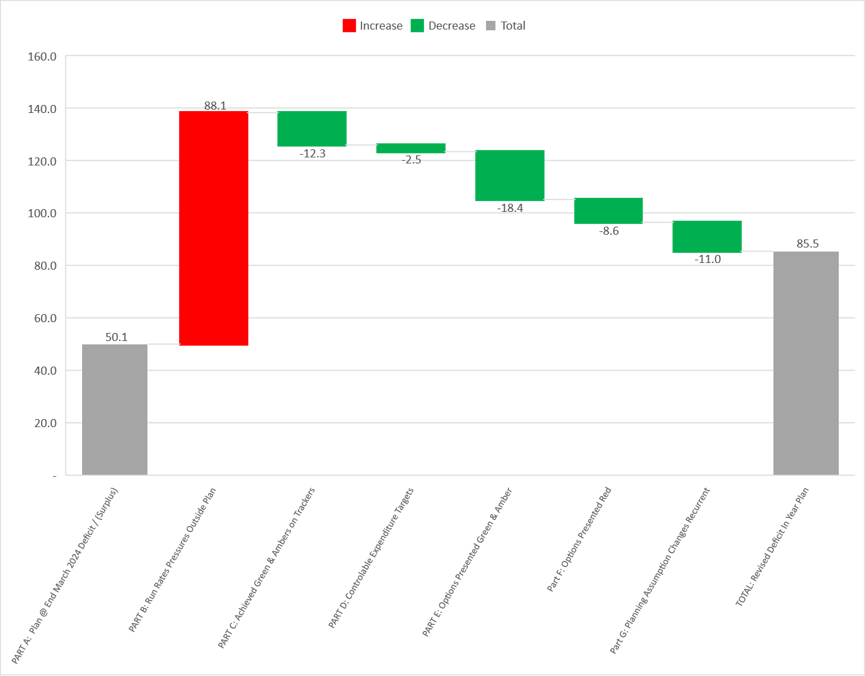

As well as the ongoing work of Recovery & Sustainability Programme it is recognised that there will be other non-recurrent opportunities to support the assessed output of the assessment detailed in Table 14, which will be incorporated in the 2024/25 Landing Plan. These are summarised based on assessment at the start of September. These are included as they assist with delivery in 2024/25 but the Health Board is clear that a focus on recurrent schemes remains a high priority.

Table 14: Non Recurrent Opportunities
These will continue to be refined over the next 2-3 months as further data is available, particularly about LTA performance and Prescribing. Each entry in Table 14 has been RAG rated to highlight where further focus will be needed.

Whilst some of the entries in the Landing Plan are robust the Health Board also need to consider changes which could impact the delivery of the assessment, and which will not be known until later in the Financial Year. These can be material in nature and include: -

- Finalised assessment of the Risk Share of the Welsh Risk Pool for 2024/25 completed by NWSSP;
- Confirmation of the Pension Discount Factor to be applied in the 2024/25 accounts, published nationally at the end of Q3 by the Treasury;
- Changes to the Bad Debt provision confirmed at the end of the Financial Year;
- Under or Over delivery of the RTA income above Budget, which finalise at the end of the Financial Year.

There will also be Risks regarding: -

- Delivery of options as per the assessment, although it is planned that the delivery risk adjustments assesses this.
- Further deterioration in the Financial Position linked to operational pressures.
- Changes in assumptions regarding LTA Performance and Prescribing which removes the opportunities included in the Landing Plan.
- Unplanned costs relating winter pressures within the Health Board and across partnerships

Those items listed above are currently reported as nil on both Table 13 and Table 14, but an initial value has been added to Part C of table 15. Once values have been confirmed these will be entered onto the landing plan for 2024/25. All other risks will continue to be assessed and reported as part of the WG Monthly Monitoring Returns.

Summary of Assessment
This section of the document brings together all of the options developed through a rigorous star chamber approach, the evolving outputs from the Recovery and Sustainability Programme, enhanced controls and corporate opportunity reviews for 2024/25.

The culmination of the assessed pressures, controllable expenditure targets and options provides a revised assessment of £85.5m.

This assessment has been risk adjusted to reflect experience of previous year delivery where 69% of savings identified are delivered. In the context of this plan, increased delivery confidence reduces the assessment by £13.2m

As with previous years, 6 months into the year clarity emerges on non-recurrent opportunities and risks which when brought into consideration move the assessment to be year-end forecast. The work completed to date, as summarised in Table 14 presents further significant opportunities to the support the planned deficit in year and as noted above this will continue to be reviewed. These are non recurrent in nature and whilst will help to drive improvement of the 2024/25 position focus on recurrent delivery will be strengthened and will form the foundation for financial recovery in future years.

Further, to bridge the assessment gap it is proposed that internal control totals are set to stretch delivery in-year and recurrently. These could add a further £4.3m improvement to the forecast

Table 15 below provides a range from Best Case, if all opportunities delivered to Worse Case where opportunities are limited but a number of the risks materialise.

Even in the best-case scenario the Health Board is unable to deliver below the original plan and remains significantly above the £17.1m control target set by WG. Therefore, work on driving forward further the red schemes totalling £26m (which have not been chosen to progress at this stage) becomes increasingly important both for 2024/25 and to ensure the starting point for 2025/26 remains at the £50.1m underlying deficit. The governance around this work is outlined further in the last section of this Plan.

Table 15: Scenarios 2024/25

In summary there is a line of sight to £50.8m on the basis that all elements of the assessment are delivered in full and the risks detailed in pages 18-29 are mitigated in full. Therefore, the focus for the Health Board and the Recovery & Sustainability Board through 2024/25 will be to ensure that all elements are delivered to achieve a position close to the original plan submission. Failure to change delivery performance above historical levels will increase this position to £64.1m.

Strengthening accountability arrangements, compliance with grip and control and maintaining the pipeline of further choices and options to continue improvement into future years will be fundamental to the deliverability of this assessment and future plans.

It is recognised that historical delivery of savings, particularly on a recurrent basis has been challenging for the Health Board and a recent Audit Wales report provides a range of recommendations to strengthen this. Through the delivery of these recommendations and the enhanced approach being implemented through the Recovery and Sustainability Programme, it is intended that previous issues with savings slippage and under delivery will be addressed. This enhanced approach is summarised on page 34 of the document.

The financial position is complex and will requires a full organisational response to implement and sustain. Discussions will be framed with Welsh Government and NHS executive colleagues across 5 main headings to ensure a consistent approach internally and externally. These are: -

- Investment/funding choices review and thorough scrutiny
- Expenditure assessment comparison
- Recurrent savings delivery
- Grip and control
- Exploring all recovery options.

These have all played a key role in the development of the revised 2024/25 assessment.

Setting Scene 2025/26 to 2027/28 Integrated Medium Term Plan
For the 2025/26-2027/28 Financial Plan, the Health Board will adopt a new approach to ensure that there is a trajectory to achieve financial balance by the end of the 3-year period. This is based on learning from previous years and assessments made by both Welsh Government and NHS Executive colleagues.

The assumptions underpinning the principles of 3 Year Plan 2025/26-2027/28 are: -

- Underlying deficit remains @ circa £50m to open 2025/26 financial year on the basis that sufficient recurrent measures are delivered to offset non recurrent opportunities in year
- Service Groups and Corporate Directorates to remain within the funding envelope provided
- Savings Target is set at maximum of 2.5% of core funding. This is based on historic level of savings achieved by the Health Board over the last 3-4 yeas against a minimum expectation from WG of 2% (2024/25 target).
- Principles of the approach for 2025/26-2027/28 is that it must sit alongside Programme 3 of the Recovery & Sustainability Board, to ensure we have a sustainable plan past Year 3.

The Strategic Context establishes a plan of two parts, summarised below:

Table 16 : Plan in 2 Parts
PART 1: Underlying Deficit | PART 2: Growth
Generally, the setting of Savings Target is to support the gap between the income received and the level of expenditure within the plan.  For 2025/26-2027/28 the Savings Target will be applied directly to the £50.1m underlying deficit held in Central Cost Centre to reduce the value over the period of the plan to zero and achieve a balanced underlying position. | All agreed growth in expenditure linked to demand, inflation, national business cases and local decisions MUST be contained within the Annual Uplift set through the WG Annual Budget setting process.  The type or level of investment will be prioritised by the Executive Team and approved by the Board as part of the Financial Planning process.
Underpinned by the Recovery & Sustainability Programme

Part 1:
There are several different approaches to addressing Part 1: Underlying Deficit. For illustrative purposes three options have been set out in the tables and graph below, the difference between the 3 options is the timescale at which the underlying deficit is removed. However, consideration also needs to be given to the ability of areas to deliver savings, at a time when areas will have less investment for Growth compared to previous financial years (Part 2).

Table 17 : 3 Options on Savings Targets
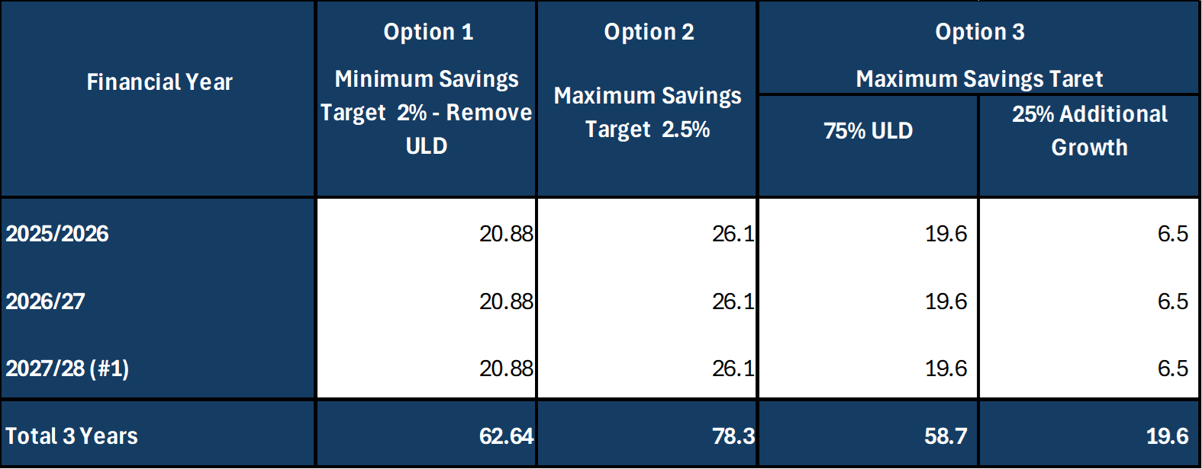

Table 18 : 3 Options Table 1 and Impact on Underlying Deficit
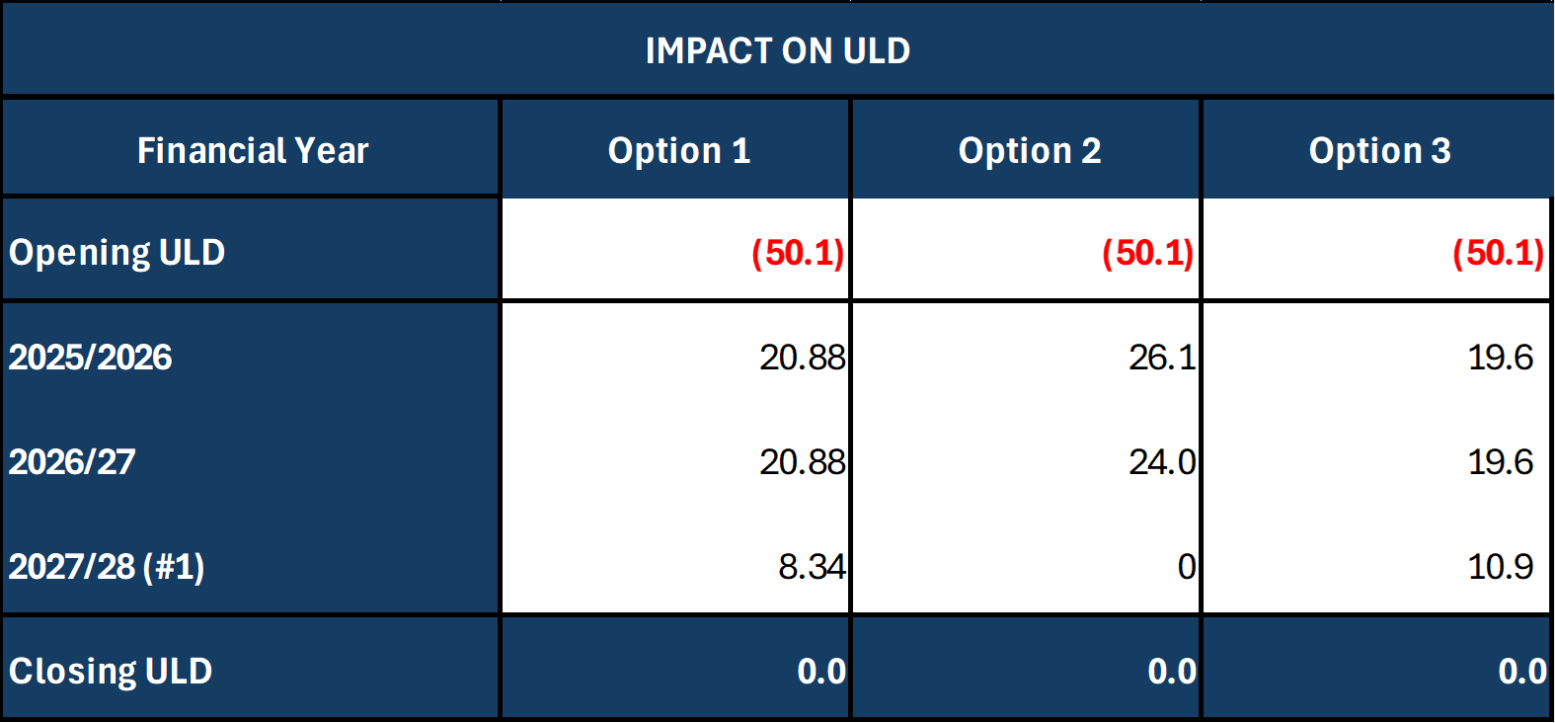

Graph 4 : Illustration on Underlying Deficit and 3 Options
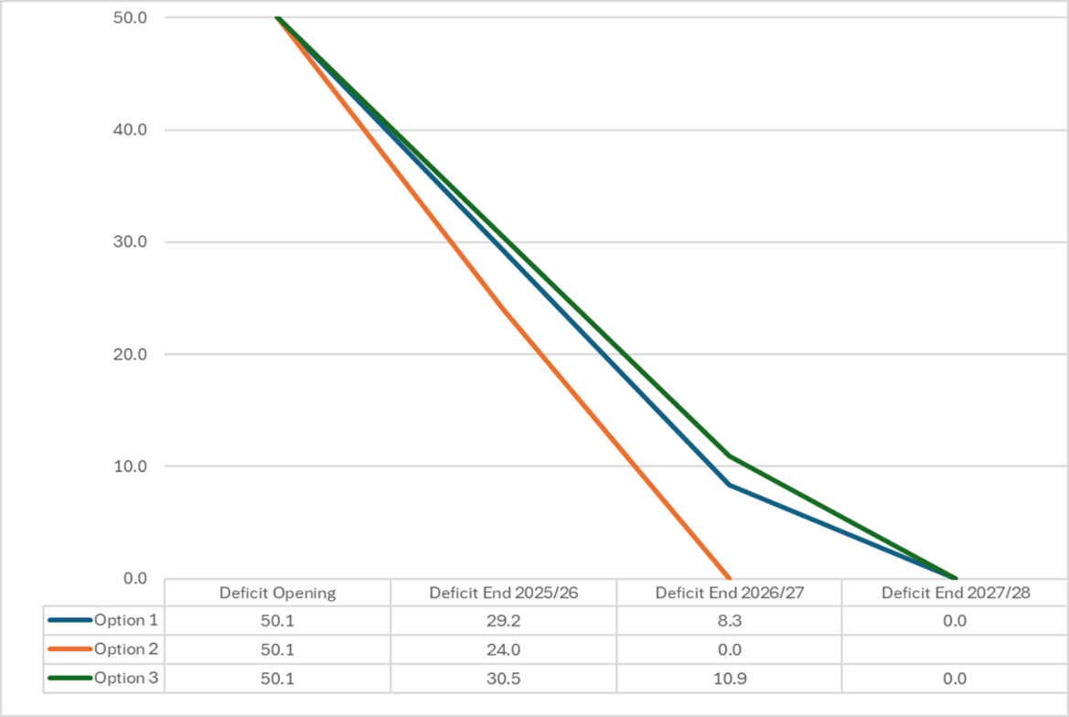

Part 2:
On the principle that Growth must be contained within the funding set by WG, a prioritisation process will be required, led by the Executive Team to recommend to the Board how this funding is deployed. The timeline for this is detailed in the figure below:

Figure 2 : Timeline to Draft Financial Plan

This prioritisation process will need to recognise the required shift from: -

- Treatment focused to Prevention focused
- From Hospital to Community Care
- Focus on digitally enabled solutions.

For 2025/26 – 2027/28 the plan will be approved at the end of January 2025, thus allowing the Health Board work on the establishment of the wider governance and associated actions required to be able to pro-actively manage financial performance and delivery earlier in 2025/26.

Figure 3 : Timeline Post Approval

Key to the successful delivery of this revised approach is the recurrent delivery of savings to address Part 1 of the plan. This will be a key focus of the Recovery & Sustainability Programme on areas including: -

- Assessment of benefits and disinvestment review;
- Management cost review;
- Continuation in delivery of Red options on those recommended to Board for delivery in 2025/26;
- Further opportunities identified by the programme;
- Translation of opportunities for the NHS Wales Value & Sustainability Board.

Further consideration will be made in this planning process to ensure that the following themes are also picked up and tested for inclusion in our future plans: -

- ‘A Healthier Wales’ refresh a shift from sickness/treatment to prevention
- a shift from hospital to community care
- a shift from analogue to digital/tech enabled solutions
- changing internal resource allocation processes to effect these shifts
- an increasing focus on services for children/young people and considering this in a life course approach to resource allocation which could begin to be developed through this 3 year plan process
- assessment of care models that could help reduce demands on services from those citizens and patients who access our care most frequently through a co-ordinated, personalised care planning approach.

Summary of journey from September 2024 to March 25
Figure 4 : Grip & Control Over Recommended Options:

Landing Plan 2024/25
As outline in the section on ‘Further Choices and Options to Improve Run Rate’ a significant amount of work has already been undertaken to support the development of a Landing Plan. The current opportunities are included within Table 14.

This will continue to be strengthened as we go through Q2/3 to support the likely year end delivery, recognising that some items will not be known until Quarter 4. As per the 2023/24 Landing Plan, monthly updates will be presented to both PFC and WG.

Recovery & Sustainability Programme & Board
This assessment remains at a point in time, with further work continuing led in part by the Recovery & Sustainability Board. Therefore, work regarding the short-term programmes listed below, will continue to yield benefits which will support the wider financial performance: -
- Programme 1 Expenditure Control
- Programme 2 Short Term Service Change

The Recovery & Sustainability Board providing the widder oversight and challenge will commence in October. The Board will have representatives from the Executive Team alongside the Service Group Directors. This Board will assess both the financial performance and delivery of the options, alongside operational performance. Where the combination of performance is outside the agreed parameters of the assessment and/or Minitrial Targets, the Recovery & Sustainability Board will recommend an escalation in oversight as per the original Budgetary Management Framework. The Recovery & Sustainability Board is also reviewing good practice from other organisations in regard to escalation to enhance this further.

Underlying Deficit and Opening Position 2025/26
The revised assessment has focused on 2024/25 delivery. During the period October – December 2024 assessments will continue on the options to establish the recurring impact, the progress of the category 2 Red Options and the underlying pressures to culminate in assessing the opening underlying position for the 2025/26-2027/28 Financial Plan, with clear direction form the Board that this needs to be £50.1m or lower to support the strategic approach for 2025/6-2027/28 Plan as outlined in the previous section.

Workforce Absence Management
At August the Health Boards rolling 12 month sickness was 7.07%, compared to the NHS Wales figure of 6.2%. The rolling 12 month trend over the last 3-4 year is reducing as per the solid blue line in the graph below:

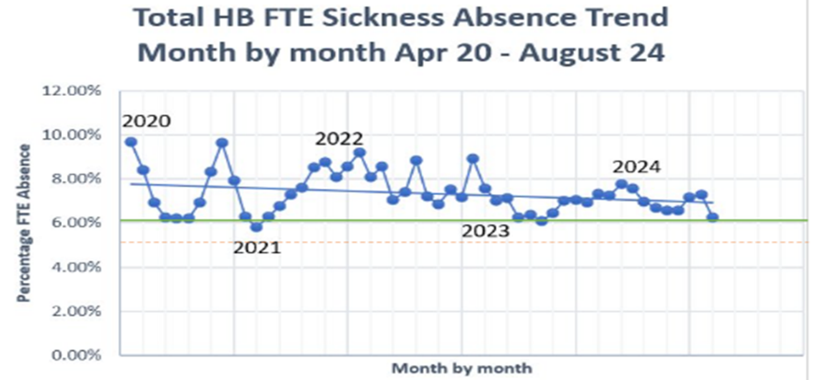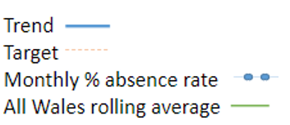

There is a continued focus across the organisation on pro-active absence management as this is one of the drivers for Variable Pay. Early intervention and prevention focused Occupational Health and Staff Wellbeing support is ensuring more staff are supported to manage their health whilst in work, reducing the need for sickness absence and the financial impact of this. The Occupational Health and Staff Wellbeing Service continue to deliver timely support for managers and staff with key KPI’s, developed between Welsh Government and staff-side, being consistently achieved. Overacrching this work is the ‘Managing Attendance at Work Action Plan’.

Appendix 1 – Recovery and Sustainability Model

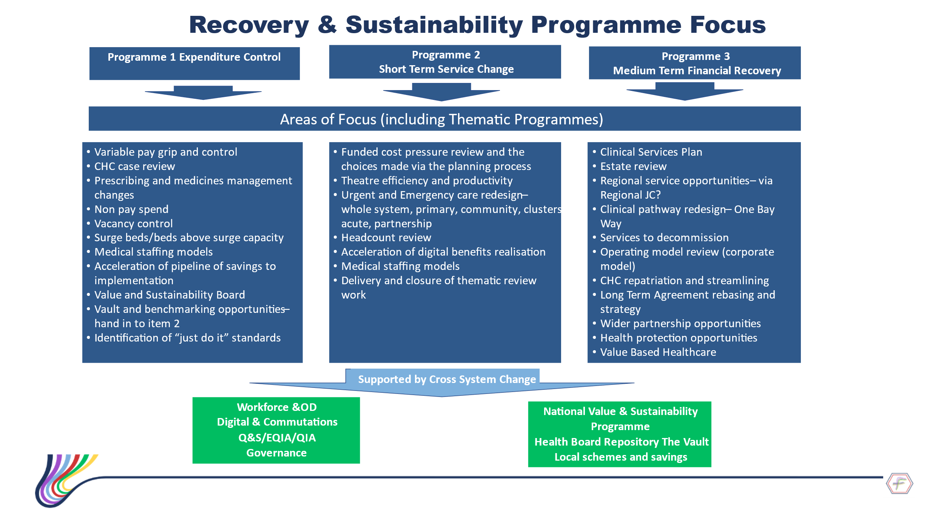

Appendix 2 – Financial Assessment by Service Area

