

Meeting Date | 19th December 2024 |  | Agenda Item |  | 2.1
Report Title | Quarter 4 Finance Delivery Plan
Report Author | Samantha Moss, Deputy Director of Finance  Darren Griffiths, Executive Director of Finance and Performance
Report Sponsor | Darren Griffiths, Executive Director of Finance and Performance
Presented by | Darren Griffiths, Executive Director of Finance and Performance
Freedom of Information | Open
Purpose of the Report | This report advises the Health Board of the plans and actions required to achieve the current Health Board forecast deficit by the end of March 2025.  This forecast has been revised from a deficit of £50.1m to £43.7m following the allocation of recurrent funding of £6.4m from Welsh Government in December 2024.  The report requires the Board to discuss and agree recommendations to achieve, or better, the deficit forecast.  The Health Board Target Control total remains £17.1m.
Key Issues | Detailed work has been undertaken to explore all options to deliver the 2024/25 outturn forecast.  The paper sets out the actions required to achieve the forecast deficit. The actions are structured in order of potential impact on operational activities.  The gap from forecast deficit of £43.7m was identified as £14.3m following 11th December 2024 Recovery and Sustainability Board.  Options to cover the £14.3m gap totalling £16.3m have been identified.  Witihn the £16.3m there is potential delivery risk and no further contingency available to mitigate any unforeseen pressures in quarter 4 or any changes in funding/planning assumptions that may arise.  All options identified are to be progressed to give delivery confidence.  Delivery mechanisms relating to workforce controls and reduction in variable pay are to be strengthened to reduce variable pay spend to the levels required.  At this time the plan includes no options to reduce planned care capacity, although these could be reviewed through quarter 4 should slippage from this plan be evident.
Specific Action Required | Information | Discussion | Assurance | Approval
Specific Action Required | ☐ | ☐ | ☐ | ☒
Recommendations | Members are asked to: -  - AKNOWLEDGE  - Current assessed gap in plan of £14.3m  - Plans in excess of £14.3m need to be agreed to increase confidence of delivery of £43.7m  - Improvement in the corporate contingencies identified, noting that there remains an element of risk  - Risks and further opportunities not currently impacting the plan  - Investment review to conclude at the end of January 2025  - A total of £16.3m worth of options have been presented, all of which need to be progressed urgently  - No further contingency available to mitigate any unforeseen pressures in quarter 4 or any changes in funding/planning assumptions  - AGREE  - Recovery and Sustainability Board will delivery the Value and Sustainability Board opportunities  - CHKS and Programme budgeting opportunities work to commence immediately and report back to first January 2025 Recovery and Sustainability Board meeting  - Further savings opportunities identified, but as yet unquantified, be expedited through the Recovery and Sustainability Board  - SUPPORT and AGREE  - Immediate development of an action plan to achieve variable pay requirements set out (excluding WLIs) driven directly by Recovery and Sustainability Board  - Vacancy freeze for all posts to be overseen by a revised vacancy panel process which considers the overall pay bill and variable pay impacts of decisions  - No planned care money directly allocated to the Health Board be used for any purpose other than waiting times reduction  - The immediate development of plans to release the benefits of options within star chamber pools of £3.018m, to be overseen by Recovery and Sustainability Board

QUARTER 4 FINANCE DELIVERY PLAN

- INTRODUCTION
The Health Board submitted an Annual Plan on 28th March 2024 which reported a deficit of £50.1m. This has not been approved by WG who have requested as a minimum the Health Board reduces its deficit to £17m.

Given both the in-year financial challenges and gap between the £50.1m deficit plan and the £17m control total, the Health Board was asked to submit a revised Financial Assessment for 2024/25; this was presented at the Public Board on 25th September 2024, having already been through a robust internal sign off process and was submitted to WG on 26th September 2024.

The assessment and accompanying letter summarised a high degree of confidence in the delivery of £64.1m deficit position by the 31st March 2025, with further opportunities of £13.3m, giving the Health Board line of sight to £50.8m.

The Health Board has established a Recovery and Sustainability Programme under the leadership of a Recovery and Sustainability Director to increase delivery confidence in-year and to lay the foundations for financial improvement in future years

On 2nd December 2024 the Health Board was notified of an additional in-year recurrent allocation of £6.4m. This reduced the forecast deficit to £43.7m. The letter confirming this from Welsh Government is attached as Appendix 1 to this paper.

This report sets out the actions required to deliver the forecast deficit of £43.7m. The Health Board’s Target Control Total remains at £17m.

- BACKGROUND
At the end of Month 8 2024 the Health Board reported a £46m deficit. This is after the application of 8/12^{ths} of the £6.4m additional allocation. The profile of variances across the financial year is sent out in Figure 1 below.

Figure 1 – Monthly Variance and Plan to £43.7m

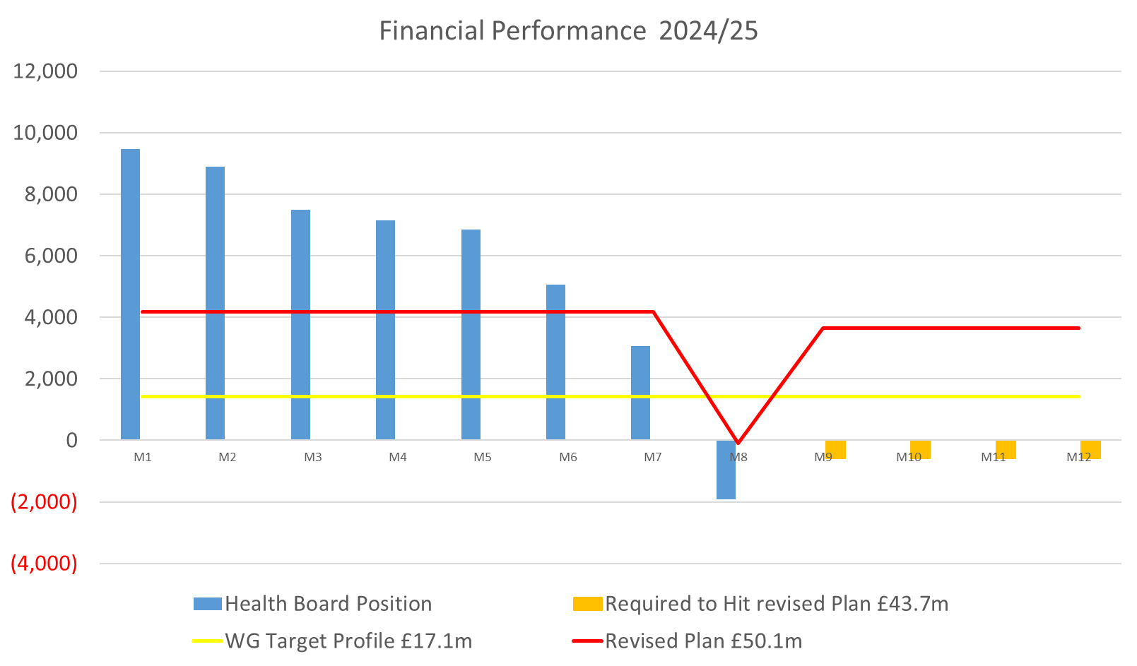

The Health Board therefore needs to underspend by a total of £2.3m over the last 4 months of the financial year to achieve its forecast deficit.

The assessed gap from the forecast deficit, following the Recovery and Sustainability Board held on 11th December 2024, was £14.3m. Delivery of the £43.7m forecast deficit (or better) is required. Table 1 below provides the assessment of the gap to £43.7m per the 11th December 2024 assessment.

Table 1 – Analysis of delivery against deficit forecast as at 11th December 2024

Set out below are the elements of the plan that are required to address the forecast gap in the plan. The elements of the delivery plan are set out in order of impact, ranging from technical reviews and opportunistic gains (2.1), to decisions to potentially impact access to services (2.8 & 2.9). This report appraises the Board of the actions and their potential financial impacts.

ELEMENTS OF THE DELIVERY PLAN
This section of the report set s out the estimated financial impacts of the actions required to close the forecast gap on a step by step basis. Readers are reminded that these are set against a revised run rate assessment compared to the September 20204 plan and the assessed gap to forecast is £14.3m. It would be prudent to plan for actions which total greater than the £14.3m gap to provide additional contingency within the plan.

  - Corporate Contingencies
The plan above sets out £17.1m of potential opportunities to support the plan through non recurrent actions in year. The Performance and Finance Committee and Board have both been appraised of progress in delivering the components of this plan since it was developed. A revised assessment shows that the potential contribution to the plan has increased from £17.1m to £25.3m. However, the financial values are not yet finalised and are provided as estimates hence remaining amber at this point.

Table 2 below sets out the changes from the original plan to the current assessment. It is worth note that some of the elements of the plan are yet to be quantified as they are only able to be properly assessed at the year end. At this stage no benefit or risk has been assumed from these lines and they are marked as amber.

Table 2 – Corporate contingencies update

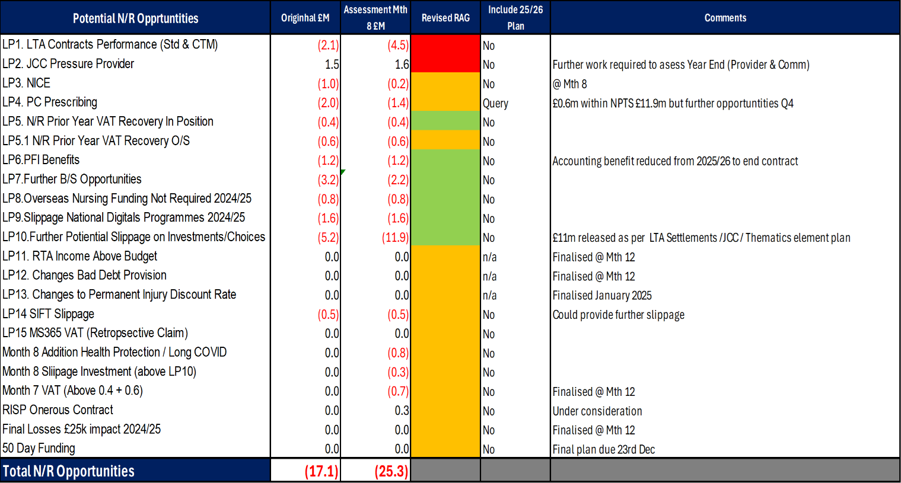

There also potential risks to the plan which could counteract the additional benefits identified here. Table 3 below sets these out as at 11th December 2024.

Table 3 – Risks and further opportunities

The most material risk is the full funding of the complex aspects of the wage award in-year. Whilst not all of the sum of the wage award £53.7m is at risk there is uncertainty, at the time of writing, that the full sum requested by the Health Board may not be received in full. Any underfunding of this line will directly, adversely, affect the plan. At this stage no assumption is made in the plan for any of these risks or opportunities.

For clarity, all non recurrent avenues have been exhausted. Any risks that materialise in the remaining quarter will adversely impact the plan without mitigation being available.

  - Assurance of delivery of Value and Sustainability Board Actions
The establishment of the recovery and Sustainability Board has increased the rigour with which the opportunities identified by the National Value and Sustainability Board have been applied to the Health Board plan.

The Board can take confidence that the revised processes are ensuring that nationally identified savings are being translated into local Health Board actions and are therefore within the existing plan. A forward look has been undertaken and a potential, estimated £0.7m could be expected in quarter 4 across procurement and stock management. Table 4 below sets out the two quantified areas and four other areas, as yet unquantified, which could further benefit the Health Board. It is therefore assumed that the £0.7m will contribute to closing the gap to forecast.

Table 4 – Value and Sustainability opportunities – quarter 4

The Recovery and Sustainability Board will ensure delivery of the opportunities set out and will oversee the translation of unquantified opportunities into savings.

  - CHKS and Programme Budget Opportunities
The Health Board has recently completed its costing exercise for 2023/24 which has been used to inform both CHKS benchmarking and comparison at different levels with other Health Boards in Wales.

CHKS benchmarking is a helpful tool to compare Health Board performance indicators with other similar organisations in a national peer group. Any opportunities arising from benchmarking often require further detailed analysis to crystallise the benefit as the detail of local service provision, staffing and supporting models of care in other organisations may be factors in contributing so say, lower lengths of stay, for instance.

The recent round of CHKS analysis showed the following potential benefits.

Table 5- Potential opportunities arising from benchmarking - Wales and England Peers

No financial benefit from this analysis is included in this assessment. It is therefore recommended that drill down work is immediately commenced and any benefits to be realised should be factored in to plans as soon as possible. The Recovery and Sustainability Board will oversee the outputs of this work which will need to be driven at Service Group level supported by the Recovery and Sustainability team. Programme budgeting outputs are not included here as any benefits are likely to be in future years.

This work is a key link into the outputs of the Urgent Emergency Care Summit and care should be taken not to double count any potential benefits.

  - Additional Savings Delivery
Table 1 above set out where the current gaps from plan are. The table shows that there remains a delivery gap from the planned total savings requirement of £59.2m. The gap is currently £9.7m.

The Recovery and Sustainability Board is overseeing savings delivery and in the last two cycles of meetings further improvement has been evident. The most recent returns from Service Groups have identified a range of possible further savings, to further close the £9.7m gap, but these have yet to be quantified. Table 6 below summarises these savings as per the most recent reports.

Table 6 – Further savings opportunities – Service Groups

At present no impact of these savings opportunities are set against closing the gap to forecast as they are not certain. Action must be immediately taken to translate these into true savings and enacted in Quarter 4. This will de-risk the plan. Wherever possible savings are to be recurrent; this is a key message for all actions being taken.

  - Enhanced Variable Pay Controls
Despite direct focus and oversight, the Health Board’s variable pay bill has remained largely unchanged throughout the financial year with total variable pay spend at month 8 at £43.2m. Figure 2 below simply illustrates the variable pay spend by month by main pay type.

Figure 2 – variable pay breakdown

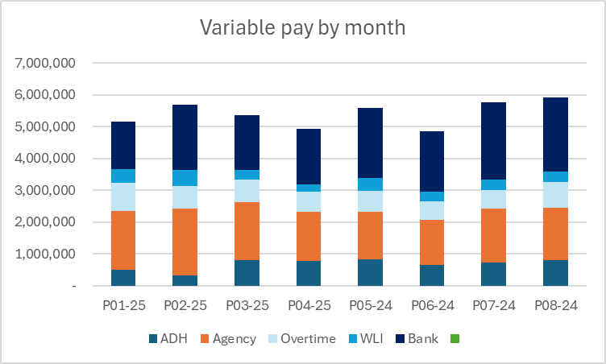

Variable pay control remains one of the most significant opportunities to close the gap in the plan. Previous targets for variable pay spend management have not been successful and a more directed approach to variable pay management is required with the Recovery and Sustainability Board now needing to take an increased active role in improvement.

Table 7 below proposes reduction targets by Service Group. These will need to be assessed alongside the opportunities set out in Table 6 above to avoid double counts. Further detail on the nature of the proposal follows the table.

Table 7 – Variable Pay reduction targets

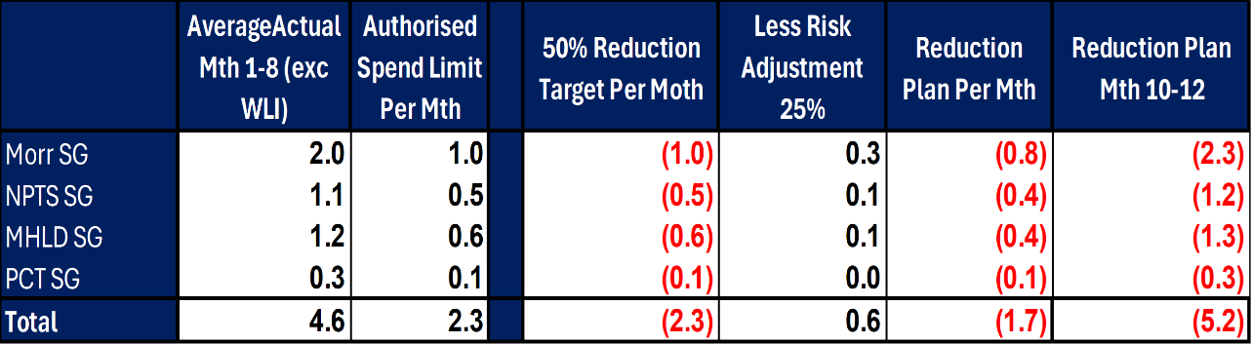

For the purposes of this assessment all spend classified as Waiting List Initiative (WLI) has been removed, as a proportion of this will be funded via the Planned Care Recovery funding. In the remaining months of the year, given the winter period, it is clearly not possible to remove all Variable Pay. This reduction aligns with work within the R&S Board which includes: -

- Rollout of effective rostering;
- Long Term Medical Agency spend
- Strengthening of Agency approval

This could deliver a benefit of circa £2.3m per month, however, to be prudent a 25% risk adjustment has been included which means the reduction for the Month 10-12 would only be £5.2m. It is assumed that this £5.2m will be a benefit to close the plan gap.

Stronger oversight and a process which works at pace (and with high frequency) to make these changes is required with the Recovery and Sustainability Board maintaining clear oversight of these processes.

  - Vacancy Freeze
The Health Board currently operates a Vacancy Control Panel for Administrative and Clerical classified staff only. Given the scale of financial gap to close and the need to plan for further contingencies, it is suggested that a vacancy freeze, with posts passing through a revised Vacancy Control Panel process, be overseen and implemented by the Recovery and Sustainability Board. A detailed proposal should be developed for implementation in early January 2025. This will need to be carefully considered alongside the variable pay controls and is proposed to be short term in nature only. At this stage no contribution to closing the gap to forecast has been assumed for this action.

  - Investment/Funding Review
A detailed review is underway of the funding allocated though Health Board plans in 2023/24 and 2024/25. The preliminary outcome of the initial stages of this work will be to withdraw funding from areas where the planned benefits have not been realised with a parallel move to removing the costs associated with such developments.

This preliminary work will report at the end of January 2025 and will be a key feature of recurrent improvements for 2025/26 and future years. It should be recognised that this is a complex and detailed exercise and is likely to continue into 2025/26. Therefore, at this point no contribution to closing the gap to forecast has been assumed for this action.

  - Revisit of Options Previously Discounted
Through the series of Star Chamber meetings which were used to formulate the recovery plan submitted at the end of September 2024, all possible options to reduce spend/deliver savings were put forward for consideration. These options set out actions that were beyond the normal tolerance the Health Board has for cost reduction with impacts on service access, capacity, recruitment and partnership featuring as potential consequences of the cost reductions.

Table 8.1 below provides the current assessment of the savings uptake from that exercise (based on values at the time – discounted values feature later in this section). The decision in September 2024 was to incorporate all pool 1 schemes in the deficit forecast. Pools 2 and 3 were to be retained with pool 2 including options agreed in principle, but which required further work and at the time, pool 3 schemes were decided to be non deliverable.

Table 8.1 – current status of options on trackers (September quantum)

The table shows that not all of pool 1 options are currently in savings plans and pools 2 and 3 are largely not progressed.

Table 8.2 below shows the current financial value of the options remaining in the pools based on the current position in the financial year.

Table 8.2 – current status of options not on trackers adjusted for quarter 4 delivery values

Table 8.2 clearly shows the reduction in values given the reassessment for the remainder of the financial year from £27.65m to £11.85m.

Further work has been undertaken to revisit the options in each of the pools. This work is a blend of assessments made by Services Groups on scheme deliverability, ability to release spend in 2024/25, removal of any double counting with the variable pay proposal and protecting the principle that schemes impacting planned care not be included. Table 8.3 below shows the financial value of the conclusion of this work.

Table 8.3 – final value of potential savings for 2024/25

Based on the process applied as per above, a further £3.018m of savings could be applied to close the gap to the deficit forecast. The key areas to progress within the £3.018m are as per below.

Table 8.4 – breakdown of £3.018m options

These options are to be supported and overseen by the Recovery and Sustainability Board.

  - Cessation of Activity with Variable Cost Drivers
The Health Board has historically received the following sums of money directly through Welsh Government allocations for planned care recovery: -

- £15.2m – general planned care recovery
- £18m & £1.5m for regional orthopaedic and endoscopy recovery

Further, in 2024/25 the Health Board has received non recurrent allocations for planned care recovery to achieve the 104 week RTT target: -

- £3.7m for recovery of Health Board commissioned services (a further £0.6m awaiting confirmation)
- £0.94m for plastic surgery recovery

The recurrent funding has been committed in full in 2024/25 and includes elements of in and out sourcing. The funding in-year has been allocated specifically to actions to increase capacity to meet targets with explicit instruction from Welsh Government that funding will be clawed back if target delivery is not achieved and funding is not to be used for other purposes. On this basis the Health Board will transparently and directly utilise the funding for its intended purpose.

This analytical work undertaken through the process outlined in section 2.8 above addresses options for cessation of internal activity and/or cessation of in/out sourcing.

SUMMARY OF DELIVERY PLAN
Table 9 below summarises the impacts of the actions set out above.

Table 9 – Overall options summary

Options to cover the £14.3m gap totalling £16.3m have been identified. However, within the £16.3m there is potential delivery risk and no further contingency available to mitigate any unforeseen pressures in quarter 4 or any changes in funding/planning assumptions that may arise. Therefore, all options identified are to be progressed to give delivery confidence. It is critical that delivery mechanisms relating to workforce controls and reduction in variable pay are to be strengthened to reduce variable pay to plan required levels.

At this time the plan includes no options reduce planned care capacity although these could be reviewed through quarter 4 should slippage from this plan be evident.

- GOVERNANCE AND RISK ISSUES

The Health Board risk register is currently reporting the revenue risk through Risk number 92 - achieving financial plan with the key elements as follows: -

- Risk of delivery of savings quantum
- Risk of operational overspend being in excess of funding available agreed via the Financial Plan
- Risk of commitment of reserves (e.g. NICE) being above reserves available.
- Risk of achieving the actions and options outlined in the 2024/25 Financial Recovery & Sustainability Assessment.

The plan set out above bridges the gap to the forecast position but remains a high risk plan with elements of uncertainty. At this stage it is proposed that this risks remains a 25 score whilst there are now more substantive mitigating actions (per the actions above) to manage the risk assessment.

Any further risks in the plan will be directly driven by the level of adoption of the options set out in 2.8 above.

- FINANCIAL IMPLICATIONS
The financial implications of this report are set out throughout it.

- RECOMMENDATIONS
Members are asked to: -
- AKNOWLEDGE
  - Current assessed gap in plan of £14.3m
  - Plans in excess of £14.3m need to be agreed to increase confidence of delivery of £43.7m
  - Improvement in the corporate contingencies identified, noting that there remains an element of risk
  - Risks and further opportunities not currently impacting the plan
  - Investment review to conclude at the end of January 2025
  - A total of £16.3m worth of options have been presented, all of which need to be progressed urgently
  - No further contingency available to mitigate any unforeseen pressures in quarter 4 or any changes in funding/planning assumptions
- AGREE
  - Recovery and Sustainability Board will deliver the Value and Sustainability Board opportunities
  - CHKS and Programme budgeting opportunities work to commence immediately and report back to first January 2025 Recovery and Sustainability Board meeting
  - Further savings opportunities identified, but as yet unquantified, be expedited through the Recovery and Sustainability Board
- SUPPORT and AGREE
  - Immediate development of an action plan to achieve variable pay requirements set out (excluding WLIs) driven directly by Recovery and Sustainability Board
  - Vacancy freeze for all posts to be overseen by a revised vacancy panel process which considers the overall pay bill and variable pay impacts of decisions
  - No planned care money directly allocated to the Health Board be used for any purpose other than waiting times reduction
  - The immediate development of plans to release the benefits of options within star chamber pools of £3.018m, to be overseen by Recovery and Sustainability Board

Governance and Assurance

Link to Enabling Objectives  (please choose) | Supporting better health and wellbeing by actively promoting and empowering people to live well in resilient communities
Link to Enabling Objectives  (please choose) | Partnerships for Improving Health and Wellbeing |  | ☐
Link to Enabling Objectives  (please choose) | Co-Production and Health Literacy |  | ☐
Link to Enabling Objectives  (please choose) | Digitally Enabled Health and Wellbeing |  | ☐
Link to Enabling Objectives  (please choose) | Deliver better care through excellent health and care services achieving the outcomes that matter most to people
Link to Enabling Objectives  (please choose) | Best Value Outcomes and High-Quality Care |  | ☒
Link to Enabling Objectives  (please choose) | Partnerships for Care |  | ☒
Link to Enabling Objectives  (please choose) | Excellent Staff |  | ☐
Link to Enabling Objectives  (please choose) | Digitally Enabled Care |  | ☐
Link to Enabling Objectives  (please choose) | Outstanding Research, Innovation, Education and Learning |  | ☐
Health and Care Standards
(please choose) | Staying Healthy |  | ☐
(please choose) | Safe Care |  | ☐
(please choose) | Effective Care |  | ☐
(please choose) | Dignified Care |  | ☐
(please choose) | Timely Care |  | ☐
(please choose) | Individual Care |  | ☐
(please choose) | Staff and Resources |  | ☒
Quality, Safety and Patient Experience
Financial Governance supports quality, safety, and patient experience.

Financial Implications
The Board is reporting a forecast year-end deficit financial outturn.

Legal Implications (including equality and diversity assessment)
No implications

Staffing Implications
No implications

Long Term Implications (including the impact of the Well-being of Future Generations (Wales) Act 2015)
No implications
Report History |  | Updates on the financial position are provided at every meeting.
Appendices |  | APPENDIX 1 – Letter - 2024/25 In-year financial allocations & revised Target Control Total

APPENDIX 1 – Letter - 2024/25 In-year financial allocations & revised Target Control Total

