
Service Groups’ Highlight Report for
Quality and Safety Committee

Meeting Date: | 23rd July 2024
Service Group: | Morriston Service Group
Author: | Suzanne Holloway, Head of Quality, Safety & Patient Experience
Sponsor: | Sue Moore, Group Service Director  Dr Mark Ramsey, Group Medical Director  Ceri Matthews, Group Nurse Director
Presenter: | TBC
Summary of Quality and Safety issues since last report to the Committee
Key Quality and Safety Issues

Access to unscheduled care services (including the Minor Injuries Unit) Performance:
This is scored as 25 on the Morriston Risk Register
In the 3 months from January to March 2024, a total of 32,420 new attendances were recorded at Morriston Emergency Department (ED) and NPT Minor Injuries Unit (20,687@ Morriston and 11,773 @NPT).

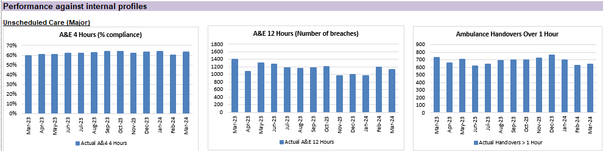

Older Person’s Assessment Unit
Modelling Phase
The dynamic flow chart (on the following page) has been created to assess the potential impact & benefits of the new Older Persons Assessment & Short Stay Unit, baselined against the 2023 calendar year, (applying a 30% demand reduction via Hub efficiency for illustrative purposes).

The summary bar charts / tables indicate the potential level of reduction in admissions/bed days/bed equivalent, and the length of stay charts set out the targeted reductions required.
A further development has now commenced to assess actual change now that phase1 of the transformation has gone live.

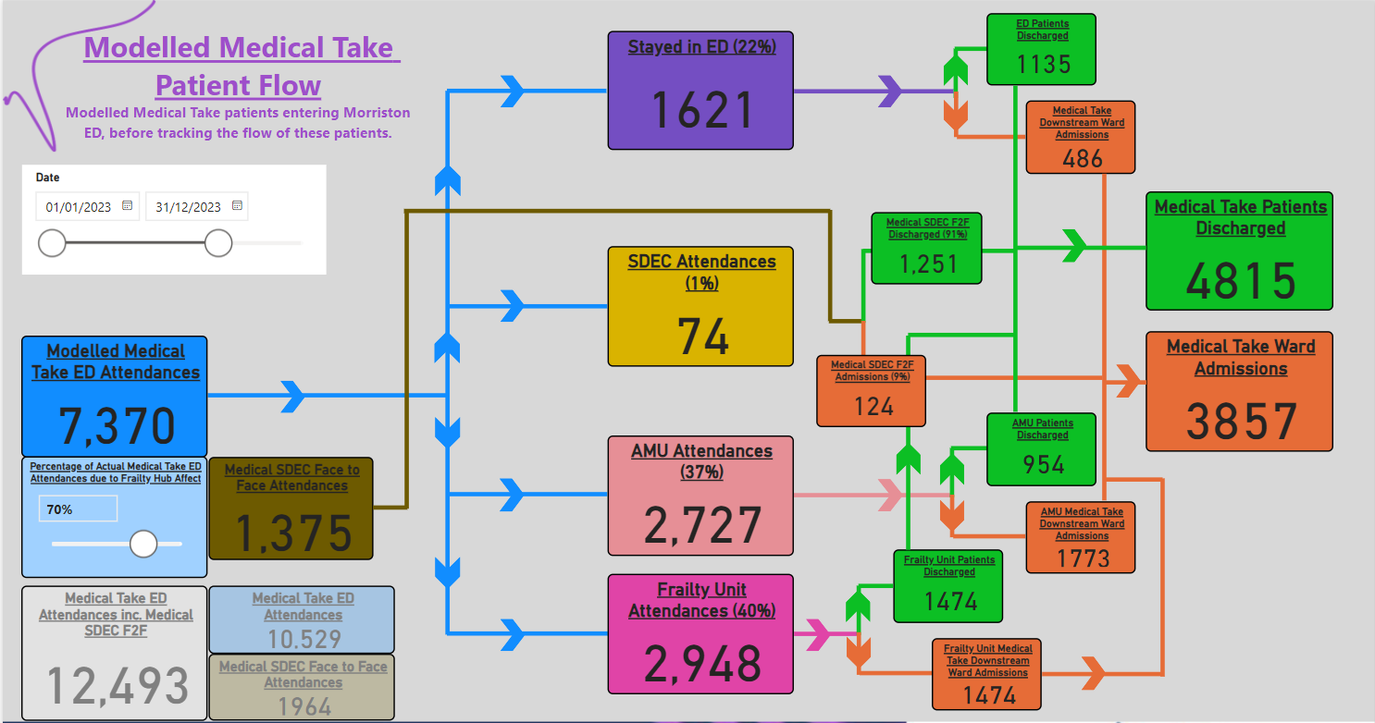

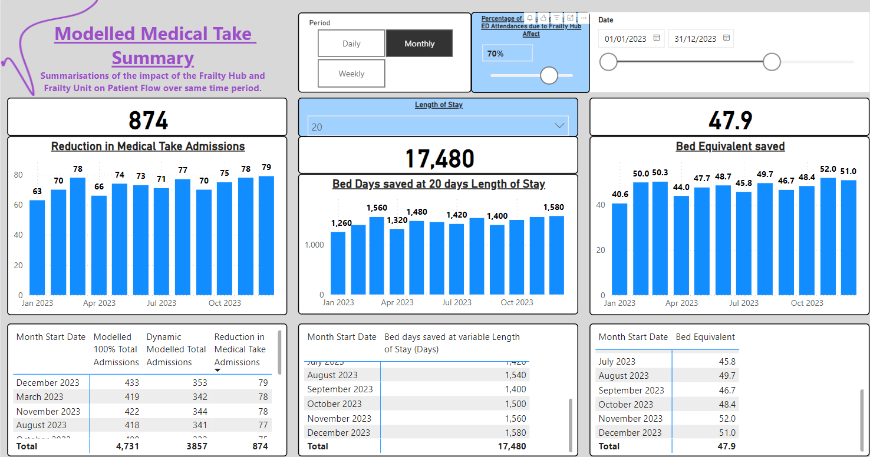 | 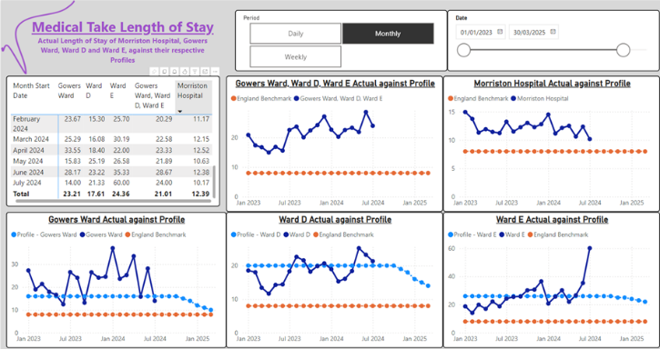

Planned Care Recovery
This is scored as 20 on the Morriston Risk Register

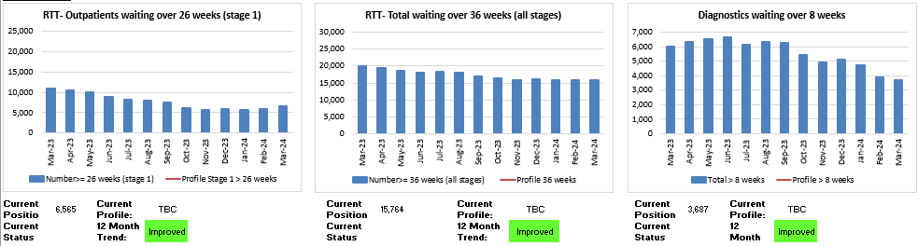

Qtr4 2023/2024 | Qtr1 2024/2025
- NIL Stage1 patients waiting over 52weeks for first appointment  - 34 patients waiting longer than 156wks – all stages  - 545 patients waiting longer than 104wks – Stage 5 | - NIL Stage1 patients waiting over 52weeks for first appointment  - NIL patients waiting longer than 156wks – all stages  - 383 patients waiting longer than 104wks – Stage 5

Access to Cancer Services
Access to cancer services is scored at 25 on the Morriston Risk Register

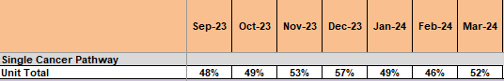

Cancer waiting times are managed across the Health Board to ensure that complex patient pathways which cross over Service Group boundaries are fully reviewed and monitored. The proportion of patients waiting longer than 62days to commence their definitive treatment continues to be stubbornly low and are managed across the Health Board.

Key Objectives
- Achievement of 10 day wait for 1st OPA or 21 day one-stop clinic.
- Achievement of a decision to treat (DTT) by day 31 of the pathway.
Actions:
- Performance scrutiny meetings have been established where waiting times are managed on a patient-by-patient basis.
- Tumour specific actions plan have been developed and are actively monitored.

Challenges, Risks, Mitigation and Action being taken relating to Quality and Safety issues noted above (what, by when, by who and expected impact)

Open Incidents
Under the NHS (Concerns, Complaints and Redress Arrangements) (Wales) Regulations 2011, incidents should be investigated within 30-working days (unless reported to the NHSE where the timeframe may be 30/60/90/120 working days).
As of 2nd July 2024:
- Morriston Service Group had 1330 Open Incidents; this is an overall caseload reduction of 551 incidents since the update provided in February 2024.
- Focused work to close incidents reported in 2022 and 2023 – overall number closed to date 1,102.
- 96% of all No/Low Harm Incidents reported in April 2024 closed within 30working days.

Ongoing Actions:
- Primary goal – close more incidents than we are opening
- Undertake rapid review and investigation of incidents reporting no or low harm and close within 30 working days.
- Focused work on outstanding incidents report in 2022 – target date for full closure 31/08/2024.
- Focused work on outstanding incidents reported in 2023 – target date for full closure 31/12/2024.
- Fortnightly control monitoring in place to ensure continual improvement and achievement of targets (full monitoring available in appendices).
- Assurance monitoring at Morriston Quality, Safety & Patient Experience Group (monthly) with updates provided to Health Board Patient Safety & Compliance Group.

Duty of Candour (DoC): Position as at 26/06/2024
Duty of Candour Triggered - Current Status | MSG | Health Board Total
Awaiting Closure | 5 | 32
Closed | 51 | 128
Management review/Make it safe plus | 27 | 44
Under Investigation | 21 | 57
Total | 104 | 261

Risk
- Complex process which cuts across multiple pieces of legislation and investigation requirements
- The introduction of Duty of Candour legislation has created additional pressure and demand within Service Group Q&S Teams but also across clinical staff.

To support the ongoing delivery of Duty of Candour a temporary post (Band 6) has been developed, supported by the Specialised Surgery Division. This is a clinical post which is able to support investigation. This post has had a significant impact on the ability to close Duty of Candour cases.

Actions
Following a retirement from the Quality & Safety Team there is a plan to develop and make this role substantive.

Risks
Interventional Radiology: Update
Three established consultants have been recruited substantively into Swansea Bay UHB to support the service and will start in the next few months. The service is currently covered by a pre-existing consultant and one full-time locum post as well as some ad hoc locum support.

Lack of dedicated Tissue Viability Nurse (TVN) based at Morriston Hospital: Update
The appointment of a dedicated TVN for Morriston Hospital Site has now been made.

New Risks
There has been 1 New Risks scored 20 and above reported since the last report.

Risk | Score | Current controls/mitigation
Risk Ref: 3796  Risk of harm to staff, patients and Radiology performance due to lack of maintenance contract being in place for MRI 1 (MDU) | 20 | Advice sought from GE engineers around constraints on use of scanner. Monitor the pressure three times daily until issue resolved.
Health & Care Standard Standard 6.3 - Listening and Learning from Feedback

Never Events
There has been one Never Event reported since the previous report; INC49195 (reported 15/02/2024)

This incident related to a retained guidewire following the insertion of a Naso-gastric Tube in the Intensive Care Unit, Morriston Hospital. The patient did not come to any harm as a result of the event.
The investigation concluded that there was a failure in communication and documentation; outcomes and recommendations shared both with those involved and wider across the Health Board.

Serious Incidents (SI)
Morriston Delivery Unit has 8 open SI investigations or which 2 are overdue.
Current themes are:
- Unexpected Death
- Self-harm Event
- Failure/Delay to Assess/Diagnose
Actions:
- Significant Case Review (SCR) process in place for all incidents which have caused more than minimal harm
- Fortnightly director-led monitoring/review meetings were established several years ago.
- Case specific actions in place for both overdue cases

Complaint Performance: Response within 30 days
Number of Formal Complaints Received | Number of Formal Complaints Closed
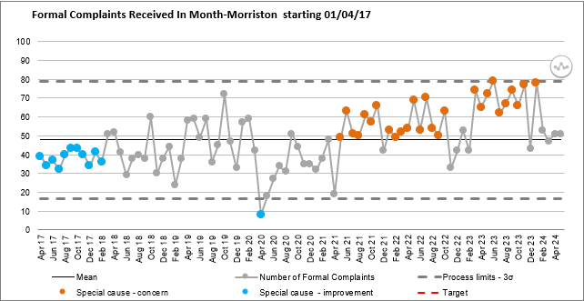 | 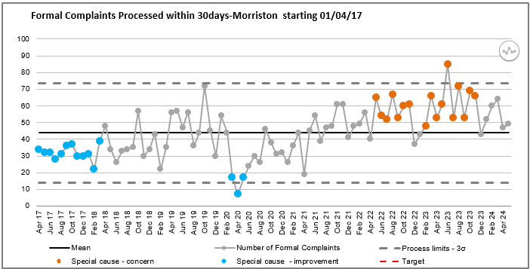

In general, the Service Group receives approximately 60 formal complaints per month and closes the same number per month.
Remedial work undertaken to improve performance against the 30-day target started in January 2024. This work has included using the PALS Team to address complaints that can be managed as Early Resolution cases –PALS have approximately 150 case contacts each month.
Compliance with the 30-day target last 3mths:
- 85% for February 2024
- 85% for March 2024
- 76% for April 2024

Actions:
- Continual review of complaint backlog with agreed action on a case-by-case basis – in place.
- Progress against 30-day performance monitored weekly – in place.
- Introduction of SOP for case review of all amber and above concerns – Completed.
- Recruitment to PALS Team – Completed Feb2024.
Progress Against Annual Plan Quality and Safety Priorities (as applicable)
Quality Priorities: reduction in healthcare acquired infections; improving end-of-life care; sepsis; suicide prevention; and reducing injurious fall; Pressure Ulcer Prevention (new for 2023/24); Nutrition & Hydration (new for 2023/24)
Exception Updates
Reducing Health Care Acquired Infection
High Level Performance: 59 Reported Infections in Quarter 1 2024/25
- 26 Patients with HCAI C. difficile
- 9 patients with HCAI Staph. aureus
- 14 patients with HCAI E. Coli
- 9 patients with HCAI Klebsiella
- 1 patient with Pseudomonas
MHSG is achieving the WG target or below for 4 out of the 5 Tier 1 target infections.
65 patients reviewed at weekly scrutiny panel in Quarter 1 2024/25
- Only 2 patients who developed a tier 1 HCAI in Q1 have not been through panel (1 now reviewed in Q2).
- 19 (29%) patients reviewed had elements of preventability.
- 26 (40%) patients reviewed were deemed to have had infections that were unlikely to have been prevented.
- 20 (31%) patients reviewed need to have more information gathered in order to close.
Learning Points/Themes from the reviews of patients who have been diagnosed with HCA C Diff
- Stool samples not being sent when patients have first type 5 or > episodes.
- Stool charts having gaps in documentation.
- Antimicrobial stewardship. The inappropriate use of tazocin was documented.
Good Practice
- Prompt review of PPI’s following diagnosis.
- Rapid start of treatment for C Diff.
Action plan
- Continue HPV programme (9 Wards completed as part of a site wide programme)
- Deep dive into June reported cases.
- Ongoing work with antimicrobial stewardship group.

Reducing Injurious Falls
The average number of inpatient falls reported monthly in 2023 was 100, this has reduced in the first 6mths of 2024 to 89.

When reviewing in-hospital falls it is important to note that not all falls are injurious. In Qtr1 2024/2025 there were 4 in-hospital fall incidents which resulted in more than minimal harm to the patient.

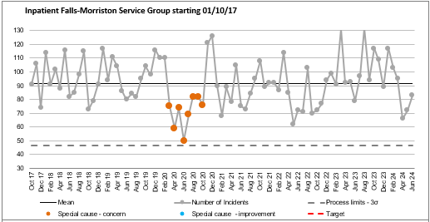

As shown in the SPC above, the pattern and number of falls at Morriston Hospital, is influenced by peaks and troughs. Previous case review has indicated that this was due to a very small number of individual patients having multiple falls whilst in hospital and as indicated previous a potential link with requirement for 1:1 nursing or enhanced observation. However, these numbers have reduced with the introduction of the “Bay Watch” scheme.

However, there is a new theme emerging specific to the urgent/emergency pathway of patients falling outside of the traditional ward/bed area and sustaining injuries which are more commonly associated to out-of-hospital events, such as facial injuries and dislocations.

Action:
- Thematic review of all reported falls in non-inpatient areas - by 31st August 2024.
- Revision of monthly case review process to ensure that all inpatient fall event reported as “moderate harm” or above are reviewed as part of the Duty of Candour process and scrutinised - Established

Improvement in Nutrition and Hydration
In addition to addressing identified key quality priority areas of:
- Training to support naso-gastric feeding.
- Training to support total parental nutritional skills requirements.
- Development and implementation of nutrition and hydration champions.
- Review of ward kitchen facilities to ensure their fitness for purpose.

A key feature and a recurring theme in patient experience feedback within the Service Group has related to food. As described in the Service Group’s previous reports, work has been undertaken to establish ward based “Nutrition & Hydration Boards” and Ward based snack trolleys. In addition, the following workstreams are being explored:
- Review Patient Choice: are there vegetarian/vegan and religious based food offerings available? – Food Tasting Sessions are ongoing.
- Should/could we encourage families to bring in own food – information leaflet? – peer review both within and outside the Health Board.
- Review options of using sustainable cutlery and crockery rather than plastic.
- Establish Sunday as the day to record patient’s weight as part of clinical monitoring.

Medicines Management
As advised in previous reports, Morriston Service Group has adopted Medicines Management as a local quality priority.

During 2023 there have been significant services changes which have impacted on Medicine’s Management the primary of which has been the introduction and implementation of electronic prescribing – HEPMA.

A desk-top review of reported medication safety events is currently in progress and will be shared in the next report.
Patient Experience Update
2,716 items of Patient Experience were received in June 2024
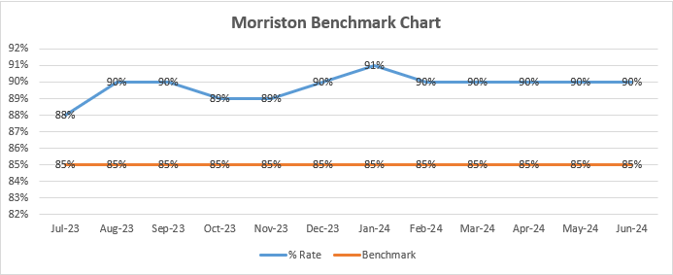
Patient Experience Feedback: Themes June 2024
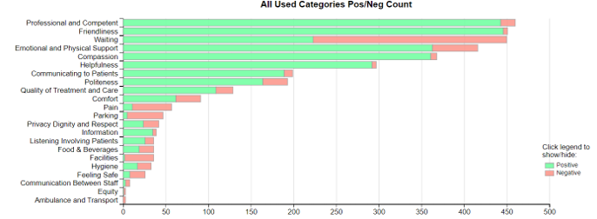
- Waiting/Access times continues to be the primary theme in negative feedback.
- Facilities, Food & Drink and Parking continue to the hot spots for negative feedback.
- There was overwhelming positive feedback for staff professionalism and competency.

Examples of Feedback Received across Hospital Sites for Morriston Service Group managed services:
Surgical Acute Assessment Bay – Morriston Hospital
Staff there were absolutely lovely. Very efficient doctors sat and spoke to me. I had tests and was given information about them. I left with antibiotics and to return 2 days later which involved bloods and a scan. I am attending again next week as they want to check my bloods. Excellent service.

Gastroenterology – Singleton Hospital
Nurse very friendly and polite. Consultant made me feel at ease and explained my scan results. Answered all my questions. Not rushed. I came away very positive. Another scan in six months and see consultant after it.

Emergency Department – Morriston Hospital
The staff were very good, helpful, friendly, professional, and attentive to their job. The efficiency of the service from arrival to departing was excellent. I am also very impressed with the large and free parking.

Functional Urology- Neath Port Talbot Hospital
The lead nurse I saw was absolutely amazing. I've felt so listened to and have a really good treatment plan in progress. My health had been a nightmare, but I feel I am going to be able to live a much better life with the treatment plan.

Ongoing Patient and Family Engagement Actions
- Ward based patient experience collection from patient who are currently admitted.
- Review of patient experience from services recently transferred to Morriston Service Group – ACT & Virtual Ward in order to establish baseline.
- Engagement with family members within the critical care areas – poster development and use of QR code access to feedback surveys.

Any Other Issues to Bring to the Attention of the Committee
No additional issues

Recommendations
Members are asked to note the report and acknowledge actions in place and progress to mitigate harm.

Appendices

Service Groups’ Health and Safety
Highlight Report

Summary of Health and Safety key issues since last report to the Committee
(Reporting period: April to June 2023)
Maintenance of the environment and infrastructure at Morriston Hospital continues to be the primary Health & Safety focus at Morriston Hospital.

Tawe Ward has now been removed from the Main Hospital Entrance.

A fire safety risk review of the use of additional temporary inpatient bed capacity at Morriston Hospital has been undertaken.

Annual Staff Incident Review 2023/2024 undertaken.

Challenges, Risks, Mitigation and Action being taken relating to Health and Safety issues noted above (what, by when, by who and expected impact)

Environmental/Infrastructure: Roof Repair and Maintenance
Essential repair and maintenance of part of the roof infrastructure has been is required for sometime and has resulted in leaks and water ingress into clinical and non-clinical areas.

A comprehensive Plan of Works is now in place and underway. This plan with enable both roof repairs and refresh work (including deep cleaning) to be undertaken. As part of the plan a number of ward areas will be both temporarily and permanently relocated across the hospital site.

Fire Safety Risk Review: Use of Additional Inpatient Capacity
In response to urgent and emergency care demands and in order to reduce patient safety risks within the “front door” locations at Morriston Hospital, it has been necessary to implement a process whereby additional patients are placed within ward locations, in excess of agreed baseline inpatient bed capacity.

In some cases, this has meant the creation of an additional temporary inpatient bedspace adjacent to or in front of a fire door.

As a result, the following risk has been identified
Avoidable risk to patients and staff as a result of a failure to comply with accepted standards for fire prevention and emergency hospital evacuation plans.

However, in conjunction with the Asst. Director of Capital Planning/Health & Safety – Finance, the Service Group have developed a set of controls and assurance processes aimed at mitigating risk, with a clear objective of;

On occasion when it is necessary to create additional temporary inpatient bedspace, to ensure that robust and sufficient fire risk mitigation is established in order to maintain patient and staff fire safety as set out in the Health Board’s Fire Safety Policy (September 2023)

Controls:
- Formal list of approved locations suitable for additional temporary bedspaces.
- Maintenance of a Hospital Site Situation Report (SITREP) that includes the location of all additional temporary bedspaces (4 times daily).
- Fire safety risk assessments are in place for all inpatient and patient assessment locations.
- Ward/Department fire safety risk assessments are updated to include explicit management action in relation to approved additional temporary bedspaces.
- Formal notification of the Fire Safety Manager and Fire Safety Advisor of the use of additional temporary bedspaces.
- Initial fire safety walkaround undertaken by Group Nurse Director and Asst. Director of Capital Planning/Health & Safety – Finance.
- Revision of site-based fire emergency action plan to include explicit management action in relation to additional temporary bedspaces, to include clear evacuation plans.
- All wards and departments for have appropriately trained Fire Wardens.
- Undertake location-based staff training to ensure that all staff are aware of the required actions should a response to a fire emergency be required.
- Maintain Fire Safety mandatory training.
- Identification of other exit routes and ensure staff are aware of all exit routes.
- Any equipment used, must be mobile to ensure items can be moved quickly, if required.
- Area drawings/plans to be displayed to identify all fire exit routes – primary and secondary routes.

Assurance
- Nurse Director sign-off of all proposed additional temporary bedspace locations.
- Weekly reporting of the use of additional temporary bedspaces.
- Monthly trend analysis to understand usage of additional temporary bedspaces to understand usage and support a long-term plan prevent future use of additional temporary bedspaces.

It is anticipated that as a result of the above controls and assurance actions risk as a result of harm caused by fire can be reduced to an acceptable level.

 | Consequence | Frequency | Score
Initial Risk | 5 | 3 | 15
Mitigated Risk | 3 | 3 | 9

Further consultation and review are underway and an update will be provided to the Health Board Quality & Safety Group in September 2024

Annual Staff Incident Review: 2023/2024
Detailed in - Appendix 2

Key Observations:
- The volume of staff incidents reported has been in a relatively steady state (1.5 incidents per day) since February 2022 and reporting during this period has been focused on a relatively small number of locations
- The greatest risk to staff continues to be patients.

Performance Progress to include: Statutory and Mandatory Training; PADR compliance; Serious Incidents; Staffing and Sickness Levels;

Training Compliance: Mandatory Health & Safety Training
 | Quarterly Average %
Q1 AVG | Q2 AVG | Q3 AVG | Q4 AVG | Variance against 85% Target
80.15% | 81.17% | 81.89% | 81.84% | -3.16%

Mandatory Training Overview
- MSG have consistently maintained an average of 80%+ compliance for mandatory training over the last four quarters.
- MSG Compliance training has increased in May 24 to 85.43% now exceeding WG target.

Mandatory Training Actions
- Re-communicate importance of completing training to managers/staff.
- HRBP to continue provide detailed monthly completion/outstanding reports to all directorates.
- HRBP to hold monthly meetings to discuss progress, challenges and support needed

Governance and Risk Issues to include risks relating to Health and Safety on the risk register
There are currently 45 risks on the Morriston Hospital Risk Register relating to Health & Safety or Environment, Estate and Infrastructure. With a breakdown by category shown below:
Environment | 25
Violence and Aggression | 5
COSHH | 5
Transport | 2
Manual Handling including LOLER | 2
Violence & Aggression, Lone Working | 1
Estates | 1
Waste Management | 1
Sharps | 1
Fire | 1
Security | 1

As indicated above site wide maintenance continues to be a challenge, with limited decant capacity a barrier to the speed of completion of works required to maintain patient and staff safety.

Current issues for 2024-25 for the Attention of the Committee
No additional issues
Llais Wales Reports and Action Logs
There we no Llais Wales Reports and Action Logs received in this reporting period.
Recommendations
Members are asked to note the report and acknowledge actions in place and progress to mitigate harm.

