Meeting Date | 23 July 2024 |  | Agenda Item |  |  | 3.1
Report Title | SBUHB Integrated Discharge Strategy 2024
Report Author | Emily Warren, Associate Director of Operations – PCTSG
Report Sponsor | Deb Lewis, Chief Operating Office
Presented by | Craige Wilson, Deputy COO / Interim Service Group Director – PCTSG  Emily Warren, Associate Director of Operations – PCTSG
Freedom of Information | Open
Purpose of the Report | To provide assurance on the processes around discharge planning and specifically progress against the Integrated Discharge strategy, which commenced in May 2024.
Key Issues | The Integrated Discharge strategy, is comprised of four programmes, designed to drive forward rapid and sustainable improvements to the discharge process, reducing LOS and reducing the number of clinically optimised patients.  The strategy is comprised of:  - Programme 1: Integrated Discharge Hub  - Programme 2: Refreshed Pathways of Care Action Plan  - Programme 3: Home First Operational Improvement Plan  - Programme 4: Refreshed COP process
Specific Action Required  (please choose one only) | Information | Discussion |  | Assurance | Approval
Specific Action Required  (please choose one only) | ☒ | ☐ |  | ☐ | ☐
Recommendations | Members are asked to:  - NOTE the change in process to managing discharge planning and minimising associated PoCD.  - NOTE the progress made following the implementation of the IDS

TITLE OF REPORT

- INTRODUCTION

This paper provides an overview of the Integrated Discharge Strategy (IDS) which was established in May 2024 on a resource neutral basis. It supersedes previous strategies on discharge planning, The objective of the strategy is to support the delivery of the UEC Six Goals Programme through improved discharge planning achieving a sustainable reduction in the number of Clinically Optimised Patients (COP) and their prolonged length of stay (LOS).

The Integrated Discharge Strategy is led by Primary, Community and Therapies Service Group (PCTSG) in partnership with acute Service Groups, social care and third sector. It is predicated on the SBUHB ‘one system approach’.

This paper provides assurance on the specific programmes within the Integrated Discharge Strategy including:

- Programme 1: Integrated Discharge Hub
- Programme 2: Refreshed Pathways of Care Action Plan
- Programme 3: Home First Operational Improvement Plan
- Programme 4: Refreshed COP process

The strategy is supported by robust governance and a collaborative approach to improvement. It has been developed working in partnership with Local Authorities and Neath & Swansea Councils for Voluntary Services (CVS). The strategy is predicated on best practice and a networked approach enabling learning and best practice to inform the approach in SBUHB and ensure improvement is achieved at pace.

- BACKGROUND

This paper provides assurance on the ongoing activity and progress made by the Integrated Discharge Strategy since its launch in May 2024.

Activity has been focused on developing a robust multi agency process to discharge planning, with better alignment of existing resources and delivery of Discharge to Recover and Assess (D2RA) principles, predicated on reducing assessments which take place on the acute hospital site. with a clear expectation that proportionate assessment is delivered across the hospital sites.

The strategy comprises four aligned programmes:

- Launch of the Integrated Discharge Hub
- Refreshed Pathways of Care Delays (PoCD) Action Plan
- Home First Operational Improvement Plan
- Refreshed COP process

The Integrated Discharge strategy has been developed to support the UEC six Goals programme, and to actively support required improvements in Hospital flow. The objective of the strategy is to enable each patient to experience a seamless journey of care from hospital into the community, adopting the principles of D2RA.

Programme 1: Integrated Discharge Hub

‘One Patient, One Form, One Process’

The Integrated Discharge Hub (IDH), which launched on July 8th 2024, is part of continuous improvement work to support the Six Goals Programme, and improve discharge processes into community services. Led by PCTSG and delivered in collaboration with Morriston Hospital and UEC leads, Phase 1 will streamline the discharge referral process. It is envisaged that Phase 2 will be launched in the early Autumn, focused on implementing an end-to-end discharge process. The objectives of the IDH are to improve efficiency, align all available workforce and adopt best practice from other Health Boards who operate similar ‘models’ (IDH).
The IDH is now the single point of access, for all ward referrals for primary and community services. This alleviates expectations and pressure on ward staff and deliver a coherent model of discharge management as part of the ‘One System’ approach across SBUHB. This will enable improved risk management, improved flow and a tighter grip on capacity and demand management, to support future community service redesign.
The Hub outputs will be measured through an agreed set of key performance indicators (KPIs), reviewed at weekly assurance meetings. In line with best practice across Wales, Phase 2 is currently under development to identify opportunities for greater alignment and collaboration in patient flow and discharge liaison teams, to enable the Hub to develop a ‘one system’ approach to discharge planning, an aligned workforce to better maximise the available resources.
Table 1- Integrated Discharge Hub Outcomes
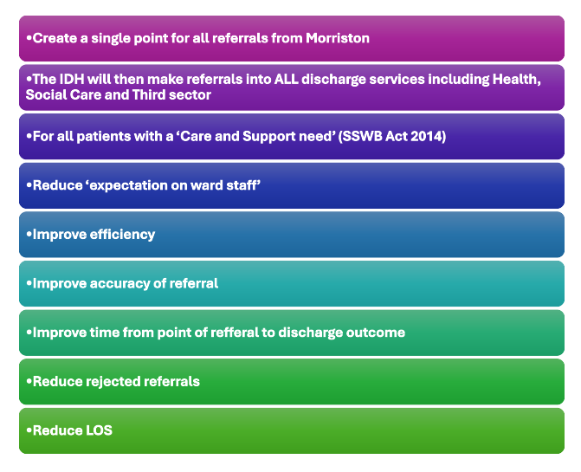

Programme 2: Refreshed Pathways of Care Delays (PoCD) Action Plan

A new PoCD Action Plan has been developed to drive forward progress on reducing unnecessary delays, as required by Welsh Government. Led by PCTSG the programme has implemented refreshed governance and accountability structures.

For each action code, improvement trajectories are being developed to achieve the required improvements set by the Care Action Committee and monitored via the Enhanced Community Care (ECC) dataset. The plan will be submitted for approval by PCTSG Board and UEC Board jointly in late July.

Progress can be evidenced as set out in Tables 2, 3 & 4 with improvements achieved in comparison to the 2023 position.

POCD REFRESHED PLAN
- Refresh Trusted Assessor Plan with clear targets agreed
- Realign and increase social worker capacity to reduce delays
- Achieve reduction in equipment delays through new agreements and discharge planning processes
- Reduce the number of red days patients accrue awaiting completion of AHP assessment
- Increase pace of funding decision for CHC
- Ensure improved compliance with Medicines Management completion prior to discharge

Table 2: Five priority areas for improvement in SBUHB have been identified
Issue | May-24 | Jun-24 | Combined May & June
Awaiting start of new home care package | 32 | 30 | 62
Awaiting completion of assessment by social care | 24 | 35 | 59
Awaiting joint assessment | 24 | 13 | 37
Awaiting Social worker allocation | 15 | 12 | 27
Awaiting reablement care package | 8 | 15 | 23

Table 3: May/June 2024 Analysis
During May and June 3/5 reasons for delays improved whilst 2/5 experienced a decline. This is being reviewed actively to ensure improvement in July

Table 4: 2023/2024 Comparison

Programme 3: Home First Operational Improvement Plan
The Home First Operational Improvement Plan will go live in July to support the wider IDS and particularly PoCD trajectories. The objective of the programme is to build sustainability into the service, improve productivity and enhance patient flow.
The plan has five elements, each with agreed GMO’s and which are reviewed at weekly operational accountability meetings.
- Performance/ Productivity
- Quality Improvement
- Workforce sustainability
- Communications
- Digital/Data Infrastructure

Programme 4: Clinically Optimised Patient Management (COP)
To support the current Targeted Intervention programme for UEC, the current COP process has been reviewed and refreshed, to ensure the grip and control needed to support a sustained improvement in the reduction of COPs.
Daily COP meetings have been refreshed, focusing on individual wards, prioritising medicine as that is where the majority of our COP pts are sitting. The expectation at these meetings is that they are solution focused, staff attending have up to date overview of where the patient is in relation to the plan for their discharge.
Refreshed bi-weekly site-wide COP meetings have been implemented and are focused on capturing PoCDs / reason in bed data, providing reliable, cleansed data to WG. The bi-weekly meeting will be attended by health and local authority partners, plus or minus other agencies as appropriate and an action log kept to maintain traction on actions agreed at the site meeting.
In addition, there will be a designated COP Ward on the Morriston site with clear inclusion/exclusion criteria and a clearly defined process for discharging pts within 10 days. In addition, there will be a cohort of COP pts across site that have been identified as suitable to move to the COP ward once a bed is available, following assessment, providing they still fit the inclusion criteria
Taken together the refreshed process, provides rigour into the system, allowing a clear overview of COP patients, ensuring that their care requirements remain the same and that we are not over commissioning services that we no longer require.

Table 5- Average Length of Stay of COP patients
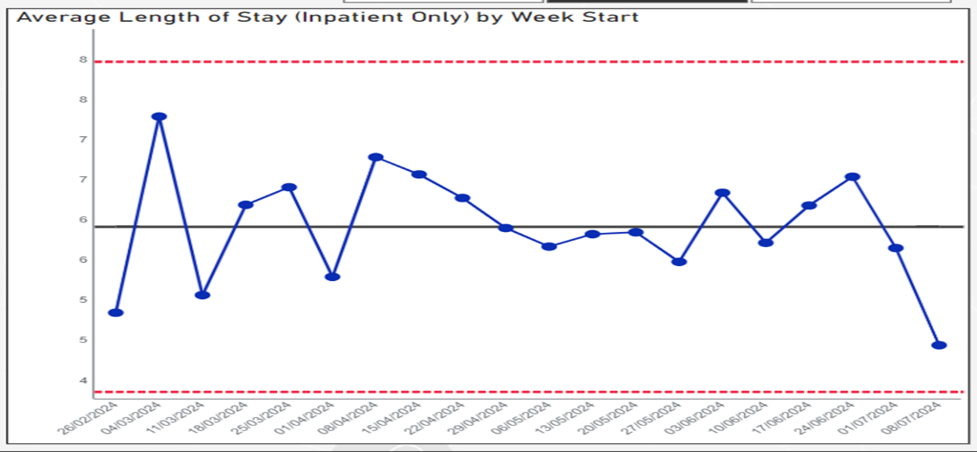

- GOVERNANCE AND RISK ISSUES

None identified
The IDS will also report into the West Glamorgan Older People’s Programme Board, chaired by Deb Lewis, Chief Operating Officer.

- FINANCIAL IMPLICATIONS

None identified

- RECOMMENDATION

Members are asked to:
- NOTE the change in process to managing discharge planning and minimising associated PoCD.
- NOTE the progress made following the implementation of the IDS

Governance and Assurance

Link to Enabling Objectives  (please choose) | Supporting better health and wellbeing by actively promoting and empowering people to live well in resilient communities
Link to Enabling Objectives  (please choose) | Partnerships for Improving Health and Wellbeing |  | ☒
Link to Enabling Objectives  (please choose) | Co-Production and Health Literacy |  | ☒
Link to Enabling Objectives  (please choose) | Digitally Enabled Health and Wellbeing |  | ☐
Link to Enabling Objectives  (please choose) | Deliver better care through excellent health and care services achieving the outcomes that matter most to people
Link to Enabling Objectives  (please choose) | Best Value Outcomes and High Quality Care |  | ☒
Link to Enabling Objectives  (please choose) | Partnerships for Care |  | ☒
Link to Enabling Objectives  (please choose) | Excellent Staff |  | ☒
Link to Enabling Objectives  (please choose) | Digitally Enabled Care |  | ☒
Link to Enabling Objectives  (please choose) | Outstanding Research, Innovation, Education and Learning |  | ☐
Health and Care Standards
(please choose) | Staying Healthy |  | ☒
(please choose) | Safe Care |  | ☒
(please choose) | Effective Care |  | ☒
(please choose) | Dignified Care |  | ☒
(please choose) | Timely Care |  | ☒
(please choose) | Individual Care |  | ☒
(please choose) | Staff and Resources |  | ☒
Quality, Safety and Patient Experience
All proposals are in line with required Quality and Safety standards. A specific emphasis on patient outcomes has been rooted into the IDS.
Financial Implications
None .

Legal Implications (including equality and diversity assessment)
None .

Staffing Implications
None at this point. Delivery of Phase 2 of the IDH, if approved by UEC Board, will require workforce realignment once developed and this will be done through appropriate engagement and consultation.

Long Term Implications (including the impact of the Well-being of Future Generations (Wales) Act 2015)
The IDS aligns with the five ways of working and is predicated on improved wellbeing, sustainability within services alongside collaboration and co production with staff and external partners.
Report History |  | N/A
Appendices |  | 3x Appendices – INCLUDED IN THE RESOURCE SECTION OF ADMIN CONTROL

