

Meeting Date | 22nd January 2025 |  | Agenda Item |  | 5.2
Meeting Name | Audit Committee
Report Title | Recovery and Sustainability (R&S) Board – Structure & Governance
Report Author | Brian Owens, Recovery & Sustainability Director
Report Sponsor | Darren Griffiths, Executive Director of Finance and Performance
Presented by | Darren Griffiths, Executive Director of Finance and Performance
Freedom of Information | Open
Purpose of the Report | The report advises the Audit Committee of the Health Board on the structure and governance underpinning the Recovery & Sustainability (R&S) Programme.
Key Issues | The report invites the Audit Committee to note the governance and reporting oversight of Recovery & Sustainability (R&S) Programme.  The report includes a high level summary work programme and breaks this into its three component parts.
Specific Action Required | Information | Discussion | Assurance | Approval
Specific Action Required | ☐ | ☐ | ☒ | ☐
Recommendations | Members are asked to:  - Consider and comment upon the structure and governance underpinning the R&S Programme.  - TAKE ASSURANCE from the work programme to address the immediate financial challenges to deliver 2024/25 plan and to address over medium term the mechanisms to support the recovery of the Health Board current financial deficit and deliver sustainable plan.  - SUPPORT the position with regards to Health Board approach adopted via the R&S Programme/Board.

RECOVERY AND SUSTAINABILITY BOARD – STRUCTURE & GOVERNANCE

- BACKGROUND
The Health Board submitted its Annual Plan for 2024/25 on 28th March 2024. The Plan set out the key deliverables for the Health Board which were set in the context of a £50.1m forecast deficit. There was a clear understanding from the Board that this planned deficit was not acceptable and would be worked on with a view to a reduction in the opening months of 2024/25.

However, at month 1 the Health Board reported a deficit of £9.5m in month, substantially above the plan of £4.175m a month, which is 1/12th of the £50.1m. A series of immediate actions were implemented by the instruction of the Chief Executive with a clear focus on run rate reduction; at the same time the thematic review was concluding. Through further detailed analysis it became clear that the Health Board did not have a line of sight to improve on the stated deficit of £50.1m and the plan remained unchanged; whilst fully recognising that this was not where the Board nor its scrutineers would wish.

The plan was resubmitted at the end of May 2024 with no change in the predicted deficit, with operational pressures showing no signs of immediate improvement in financial terms and further options and choices to reduce the planned deficit were limited. Therefore, additional expenditure management instructions were issued and whilst there was some reduction in monthly variance from plan, this remained significantly adrift from the required levels to consider any changes to the plan with confidence.

The governance processes outlined in the Accountability Letters led the organisation to implement several focused actions, alongside instructions on controllable expenditure and also the establishment of the Recovery & Sustainability Programme. The work of the Recovery & Sustainability Programme, detailed below, is providing the Health Board with the support to drive a longer-term approach in achieving financial sustainability.

- GOVERNANCE & REPORTING ARRANGEMENTS

The Recovery & Sustainability Programme was established in July 2024, with dedicated senior leadership. The oversight of the programme and how it links to existing governance arrangements is summarised in the diagram below:

Diagram 1: Governance Structure

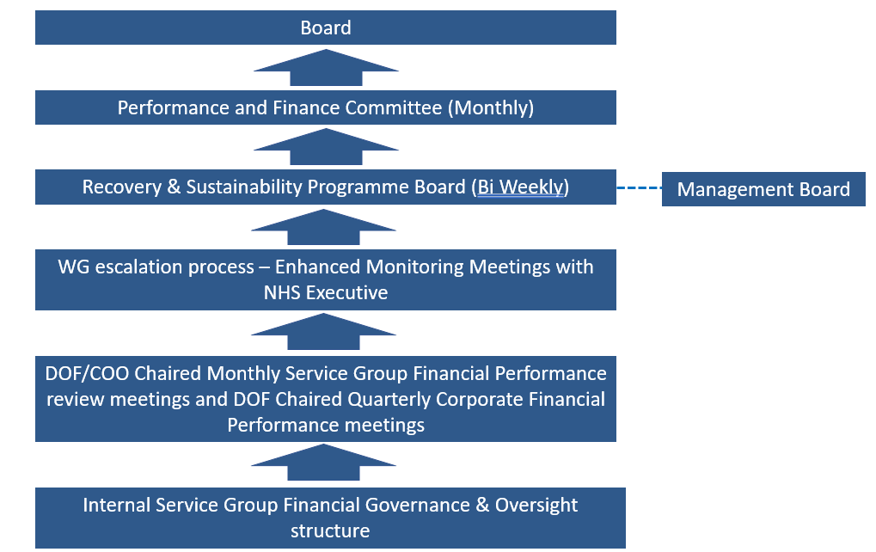

- R&S BOARD
The R&S programme is overseen by the R&S Board. This Board is chaired by the Chief Executive Officer, the first formal meeting was held on 21st October.

The R&S Board has been designed to receive assurance and to support the delivery of the financial plan, it has been established so that it does not become a ‘point of constraint’ where all decision are ratified or agreed. It builds on the established devolved accountability process already firmly established with the Service Groups.

The Terms of Reference of the R&S Board (board) is provided in Appendix 1 of this paper. The rhythm of the board has evolved and developed, reflecting the dynamic nature and responsiveness of the board to the ongoing financial challenge. The frequency of the board has increased from the original monthly cycle to every two weeks or twice per month, reflecting the enhanced scrutiny and focus on delivery of the current year financial plan.

The primary focus to date has been to establish robust ‘grip and control’ processes to support the delivery of the actions for the current deficit plan for 2024/25, with some actions having a longer term benefit into 2025/26. As we approach the end of Quarter 4 2024/25, the focus will move to sustainability and the challenges to address both the underlying financial position and the delivery of recurrent savings to support the 2025/26 Financial Plan, which is currently in development.

- THREE PROGRAMME RECOVERY & SUSTAINABILITY

The Work Programme for Recovery & Sustainability is allocated to one of three programmes, as per diagram 2 below:

Diagram 2: Overview of Work Programme

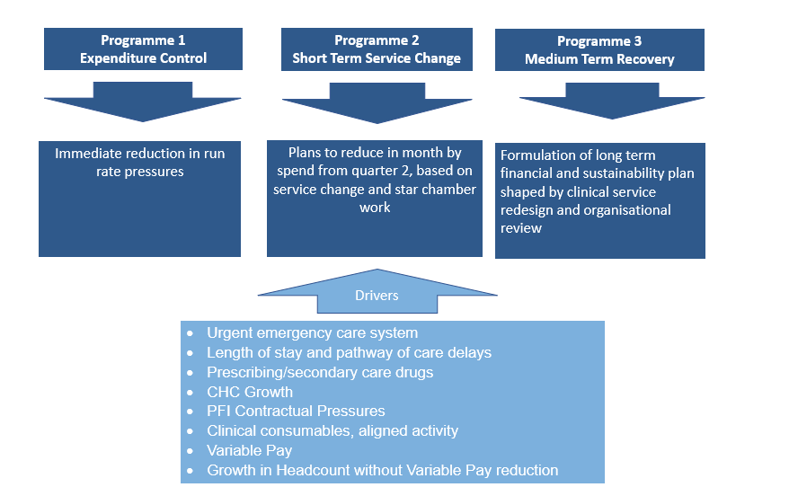

Further details on the work within each of these programmes is summarised in the table below:

R&S Programme | Detail Areas of Focus
Programme 1 | - Variable pay grip and control  - CHC case review  - Prescribing and medicines management changes  - Non pay spend  - Vacancy control  - Surge beds/beds above surge capacity  - Medical staffing models  - Acceleration of pipeline of savings to implementation  - Value and Sustainability Board  - Vault and benchmarking opportunities – hand in to item 2  - Identification of “just do it” standards
Programme 2 | - Funded cost pressure review and the choices made via the planning process  - Theatre efficiency and productivity  - Urgent and Emergency care redesign – whole system, primary, community, clusters, acute, partnership  - Headcount review  - Acceleration of digital benefits realisation  - Medical staffing models  - Delivery and closure of thematic review work
Programme 3 | - Clinical Services Plan  - Estate review  - Regional service opportunities – via Regional JC?  - Clinical pathway redesign – One Bay Way  - Services to decommission  - Operating model review (corporate model)  - CHC repatriation and streamlining  - Long Term Agreement rebasing and strategy  - Wider partnership opportunities  - Health protection opportunities  - Value Based Healthcare

This will be reviewed as we migrate from 2024/25 delivery into focusing on underlying financial deficit and the need for sustainable and recurrent savings and run rate reduction programmes into 2025/26.

- RECOVERY & SUSTAINABILITY AND ALIGNMENT WIDER ACTIONS
The R&S Programme is integrated with many of the work programmes in place across the Health Board and nationally, supporting the wider Financial Governance and utilisation of resources. An example of these are provided below: -

- Chief Executive Mid Week Message
In place for many years this message is read by in excess of 4,000 staff a week and has been a positive mechanism for sharing critical Health Board issues across all Service Areas. Throughout 2024/25 the Chief Executive has used this to communication both the financial challenges and the outputs from the actions agreed by the R&S Board.

- Star Chamber Programme
The requirement to resubmit a revised Plan on the 26th September 2024 at the request of WG, resulted in a comprehensive programme of work over the summer of 2024. This work included numerous meetings led by the Chief Executive Officer in assessing options to reduce run rates and deliver the 2024/25 Deficit Plan.

These meetings referred to as the Star Chambers, resulted in the establishment of a schedule of run rate reduction / savings opportunities.

R&S Programme and the R&S Board have been overseeing the outputs of this via the twice weekly meetings.

As part of the 2025/26 Financial Planning process all the opportunities identified via the Star Chamber meetings have not been met and so through the end of 2024/25 and into 2025/26 a focus of the programme will be the oversight and challenge on ensuring valid schemes deliver the required outputs.

- Repository of Opportunities / Vault
There is a significant amount of data available on benchmarking, value and sustainability opportunities, as well as research on good practice, which can all support the wider Recovery & Sustainability agenda. The NHS Executive have for a number of years had a ‘Vault’ of data. In 2024/25 the Finance PMO have centralised all data into one document, which is referred to has the ‘Swansea Bay Repository of Opportunities’. This repository is a live data source that is refined, updated and enhanced on a continual basis.

The information within the will be used to support and shape the R&S Programme, with updates to the Repository undertaken quarterly.

- Value & Sustainability (V&S)
The national V&S Programmes focus on Medicines Management, CHC, Workforce, Non Pay and Procurement, and Clinical Variation.
The local maturity of each of these work streams is variable and moving into 25/26 via the R&S programme there will be an enhanced focus to develop transparent and measurable outputs from each of the work streams.

Medicines management and procurement are both established programmes and have both presented to R&S Board for assurance however, in the spirit of always improving further opportunities are also being sought.

A formal update on the CHC programme has been agreed to be presented by the interim Director of Strategy in February’s board. Elements of the workforce opportunities currently features frequently in the board’s discussions around variable pay and effective rota management.

Many of the opportunities within the clinical variation work streams are already being driven by other local programmes i.e. UEC, Planned Care, Cancer board. However, discussions have already commenced with the Chief Operating Officer and Director of Finance & Performance, with an aim to bring the various information streams (national V&S outputs, CHKS benchmarking data, VBHC outputs, Vault) together into a single programme of work V&S around clinical variation. This is an active area of discussion.

As the focus on V&S is increased moving into 25/26 the R&S Board expects to receive on going assurance from the national programmes around local delivery and benefits realisation.

- GOVERNANCE AND RISKS
Governance flow is set out earlier in this document. The key risk is the sustainable resources of the R&S team. Whilst there is support from the Saving Programme Management Office and support form professional areas such as workforce, nursing and medical staffing, a substantive team who can drive change and horizon scan for future opportunities would ensure a more sustainable and focused approach.

- FINANCIAL IMPLICATIONS
The financial implications of this work translate directly into the Health Board financial position which is subject to routine detailed reporting.

- RECOMMENDATIONS
Members are asked to:
  - Consider and comment upon the structure and governance underpinning the R&S Programme.
  - TAKE ASSURANCE from the work programme to address the immediate financial challenges to deliver 2024/25 plan and to address over medium term the mechanisms to support the recovery of the Health Board current financial deficit and deliver sustainable plan.
  - SUPPORT the position with regards to Health Board approach adopted via the R&S Programme/Board.

Governance and Assurance

Link to Enabling Objectives  (please choose) | Supporting better health and wellbeing by actively promoting and empowering people to live well in resilient communities
Link to Enabling Objectives  (please choose) | Partnerships for Improving Health and Wellbeing |  | ☐
Link to Enabling Objectives  (please choose) | Co-Production and Health Literacy |  | ☐
Link to Enabling Objectives  (please choose) | Digitally Enabled Health and Wellbeing |  | ☐
Link to Enabling Objectives  (please choose) | Deliver better care through excellent health and care services achieving the outcomes that matter most to people
Link to Enabling Objectives  (please choose) | Best Value Outcomes and High-Quality Care |  | ☒
Link to Enabling Objectives  (please choose) | Partnerships for Care |  | ☐
Link to Enabling Objectives  (please choose) | Excellent Staff |  | ☐
Link to Enabling Objectives  (please choose) | Digitally Enabled Care |  | ☐
Link to Enabling Objectives  (please choose) | Outstanding Research, Innovation, Education and Learning |  | ☐
Health and Care Standards
(please choose) | Staying Healthy |  | ☐
(please choose) | Safe Care |  | ☐
(please choose) | Effective Care |  | ☐
(please choose) | Dignified Care |  | ☐
(please choose) | Timely Care |  | ☐
(please choose) | Individual Care |  | ☐
(please choose) | Staff and Resources |  | ☒
Quality, Safety and Patient Experience
Recovery & Sustainability programme, whilst addressing the need for a sustainable financial position, is focused on undertaking through delivery of good quality, safety, and patient experience.

Financial Implications
The Board is reporting a forecast year-end deficit financial outturn for 2024/25 and the this programme is in place to support the delivery both in year and recurrently.

Legal Implications (including equality and diversity assessment)
No implications

Staffing Implications
No implications

Long Term Implications (including the impact of the Well-being of Future Generations (Wales) Act 2015)
No implications
Report History |  | Updates on the financial position are provided at every meeting.
Appendices |  | Appendix 1 – Terms of Reference R&S Board

Appendix 1
Swansea Bay University Health Board

Recovery and Sustainability Board
Terms of Reference

Draft V2
24-10-2024

Contents
1. Introduction 3
2. Scope & Duties 3
3. Membership 5
4. Meetings 6
4.1 Quorum 6
4.2 Secretariat 6
4.3 Frequency of Meetings 7
4.5 Tools 7
4.6 Reporting 7
5. Review 7

1. Introduction

The Health Board is consuming resources in excess of the funding allocated to it based on its population share. This is even after the Health Board received an extra £24m in 2022/23 to re-base its share of the overall WG allocation to reflect its population need. The Health Board will therefore need to identify and deliver on actions to both reduce current levels of expenditure, either through changing the delivery model and or through planned and considered disinvestment.

The Health Board (HB) submitted an Annual Plan on 28th March 2024 which reported a deficit of £50.1m. This has not been approved by Welsh Government (WG) who have requested as a minimum the HB reduces its deficit to £17m; work and discussions are underway. In order to meet the £50.1m deficit plan operational savings totalling £26.1m need to be achieved and all service areas are required to breakeven to their delegated budgets. This will require the need for a significant reduction to the HB’s current run rate of expenditure.

During July-August 2024 the Health Board has been seeking further run rate reduction options to mitigate the current in year pressures, which are taking the Board away from the deficit plan submitted in March 2024. This work has resulted in the identification of 319 schemes. Given the scale of the schemes a simplified submission for Service Areas has been required which pick up key issues around impact/quality/safety.

In response to the challenging financial position the Health Board has established a Recovery & Sustainability Team by bringing together existing resources under a new overarching governance approach which will support the new Recovery and Sustainability Board.

2. Scope & Duties

To oversee the delivery of a significant reduction in the Health Board’s levels of expenditure to achieve service sustainability in the short and medium term (1-10 years) in a manner aligned to the Health Board’s wider strategy.

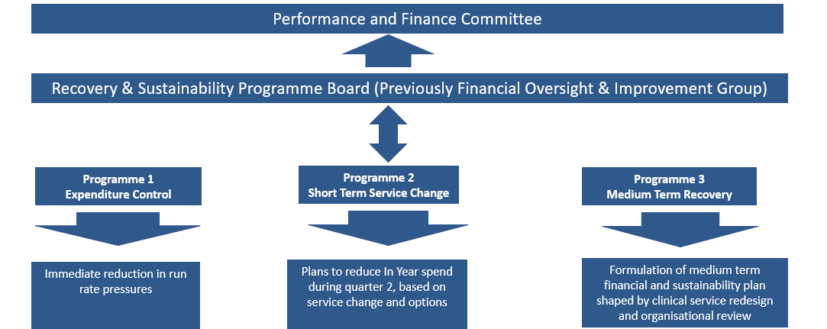

The Board will be responsible for: -

- Receiving the Service Groups (SG) and Corporate Teams (CT) recommended actions / plans to deliver against key financial and performance indicators.
  - Supporting principles:
  - Patient and staff safety must be maintained throughout the duration of the financial and performance plan.
  - Service Groups and Corporate Teams must deliver a financial plan that achieves within the delegated budgetary resources and achieves performance across a range of key indicators; specifically, but not exclusively the Targeted Intervention (TI) indicators and the ministerial prioritises.
  - SG’s and CT’s should only put forward plans that have been agreed through their internal governance routes and represents the senior views of the team.

- Scrutinising and gaining assurance of delivery from the Service Groups and Corporate Teams for their financial and performance plan.

- Monitoring delivery against the financial and performance plans and ensuring remedial actions are implemented in the event of a deviation from the original plan.

- Implementing escalation using the performance management framework, in addition:
  - The role of the board is not to make decisions on behalf of the SG’s or CT’s in respect to their plans and delivery. Direct board decision making, and instructional direction would represent an escalation under the performance management framework. This does not include active dialogue and supportive discussion.
  - Negative deviation from the financial plan that cannot be recovered in year or performance against the agreed key metrics within a period of three consecutive months would represent an escalation under the performance management framework. The exception to the above being in year changes that are supported by the Health Board or instructed by Welsh Government.

- Oversight of the delivery of the thematic executive led options presented to Board and ensuring updates are provided through the governance arrangements directly to Performance & Finance Committee.

- Receiving assurance from the Business Case Assurance Group (BCAG), scrutiny committee that investments have delivered against their original objectives and evidence that those objectives are relevant to the current clinical process

  - The board will make recommendations to the Performance and Finance Committee regarding the continuation or disinvestment of ongoing funding related to previous BCAG investment cases

- Directing ‘deep dives’ of specific areas, supported by appropriate benchmarking information, and evidenced analysis assessed under the ‘case for change’ model where appropriate.

- Receive recommendations from the programme management office (PMO) for health board opportunities identified via bench marking, National Value and Sustainability board, NHSE VAULT and other benchmarking data.

- Board will agree and delegate delivery to SG’s and CT’s on a maximum of six key new cross working programmes in a rolling twelve month period. SG’s and CT’s will jointly work towards delivering to facilitate a sustainable recovery in the longer term

  - Rhythm of board in respect to cross cutting sustainable working:
    - Month one – SG’s and CT’s provided with the evidence of the need for change and tasked with working together towards delivery
    - Month two – evidence of progress to be presented to board. It is not the expectation that each change will be completed by month two
    - The above cycle will continue across a rolling 12-month period. Therefore, a maximum of 6 key cross cutting programmes could be running simultaneously.
    - The rhythm of this programme is designed to keep the ‘pace of change’ swift and as programmes deliver and come to a closure then pressures will ease across the delivery teams

- Board will have delegated authority to deploy staff and resources across the organisation as required to deliver the objectives.

- Where resources are constrained, the board will make recommendations via the management board and the performance and finance committee to ‘stand down’ or defer other programmes and objectives to release the necessary resources.

3. Core Membership

Name | Position
Abigail Harris (Chair) | Chief Executive
Darren Griffiths (Vice Chair) | Director of Finance
Brian Owens | Director of Recovery & Sustainability
Deb Lewis | Chief Operating Officer
Sarah Jenkins | Director of Workforce and OD (interim)
Richard Evans | Medical Director
Samantha Moss | Deputy of Director of Finance
Ceri Gimblett | Service Groups Director – Neath and Singleton
Craige Wilson | Service Groups Director – Primary, Community and Therapies
Dermot Nolan / Janet Williams | Service Groups Director – Mental Health and Learning Disabilities
Sue Moore | Service Groups Director – Morriston
 | Director of Public Health
 | Director of Therapies
 | Nurse Director
Tony Clark | Head of Finance PMO (R&S)
Paul Harry | Head of Service Intelligence
TBC | Project Support

Attendees – not core members
- Finance business partners from each of the 4 SG’s
- Assistant Director of Finance for Revenue and FBP’s
- Corporate Team leads
- SRO for Thematic Savings

The board may require representation from other executives and senior leaders as required and reserves the right to request attendance.
Deputies for the core membership will be allowed but should be discussed with the chair prior to attendance. Deputies will be expected to attend with the full delegated authority and decision-making capability for the area they are representing.
N.B. if escalation under the PMF is required this will be considered even if the area is represented by a deputy.

Governance and Accountability
R&S Board will receive exception reports from the SG’s regarding their progress towards their sustainability performance target / forecast and details of their associated projects and actions to achieve this. The following classification will be used:

- Green = delivering and on track or completed – no concerns – no escalation from SG;

- Amber = local issues to resolve but will deliver full return by stated date but could still be complex – no escalation from SG;

- Red = SG cannot deliver actions or financial position and cannot recover to original value and or timeline and therefore requires board intervention

- Mitigations = automatically escalate under PMF unless SG’s and CT’s can offset lost savings with recurrent delivery elsewhere to the same value and or a failure to deliver the required performance / recovery in three consecutive months. PMF escalation will also be driven by the PMF indicators therefore the two automatic escalation points should not be considered the only triggers for escalation under the PMF.

All exception reports and any associated actions from the SG must have been agreed via the SG internal governance routes i.e. operational / performance groups and SG management boards. SG’s may be required to move their current arrangements to comply with the new R&S board governance and timeline, underlining the importance of the Recovery and Sustainability Board.

The R+S Board will report in writing to the Performance and Finance Committee monthly via a highlight report. Format and Content TBC.

The R&S Board will not be the primary decision maker for all decisions to avoid the creation of a point of constraint. SG’s are expected to exercise their delegated authority to ‘act’ within their current portfolios and budgetary responsibility and accountability in accordance with the signed delegation letters.

The R&S Board will collate and manage a Risk Register

5. Meetings

5.1 Quorum

- A minimum of five people including at least a representative from R+S Director/team, Senior Finance Officer (DoF / Deputy), two Service Group directors, COO/ deputy

5.2 Secretariat

The Group will be provided with a secretariat function by the Director of Finance. They will ensure that minutes of the meeting are taken and provide appropriate support to the Chair and members. Additional support will be provided by the R+S Team PMO.

The Performance & Finance Committee may ask the Group to convene further meetings to discuss particular issues on which they want the Board’s advice.

Where necessary, the Board will communicate electronically to take decisions outside of formal meetings. All decisions taken in this way will be formally recorded at the next meeting. Papers will be sent out 2 working days before Board.

For each meeting the Board will be provided with: -

- Agenda
- Minutes last meeting
- Summary Actions
- Summary Financial Performance Report (including SG Exceptions)
- Update / Progress of Options

Agenda standing items:
- Financial performance assurance - SG’s and CT’s
- Performance against key indicators assurance – SG’s & CT’s
- Evidence or next cross cutting transformation – PMO
  - Or on ‘month 2’, presentation of delivery progress from Service Group Directors
- Assurance of thematic delivery from SRO by exception – rolling basis i.e. one SRO / month
- Receipt of BCAG evidence of investment delivery and discussion on recommendations regarding ongoing funding

5.3 Frequency of Meetings

- Meetings will be held on a twice monthly basis

5.4 Tools

- A Risk, Assumptions, Issues, Decisions (RAID) log will be used to report and mitigate risks and lessons learnt;
- Microsoft Teams will be used to organise the work cell documentation;
- Microsoft Teams will be used to arrange team meetings and to liaise with team members;

5.5 Reporting

- Report to be developed and distributed to Performance and Finance Committee

6. Review

- These terms of reference shall be after the initial meeting, and then quarterly.

