Meeting Date | 15 January 2026 |  | Agenda Item |  |  | 2.3
Name of Meeting | Audit Committee
Report Title | Partnership Governance Tracker
Report Author | Angharad Rees, Strategic Planning Manager
Report Sponsor | Marie Davies, Executive Director of Planning and Partnerships
Presented by | Karen Stapleton, Deputy Director of Planning & Partnerships
Freedom of Information | Open
Purpose of the Report | To provide an update on the ongoing development of the Partnerships Tracker, how it can be accessed and any changes recorded in the tracker during Q3 of 2025/26.
Key Issues | Improving how the Health Board manages and achieves oversight and assurance of external partnership arrangements has been an area of focus for the Planning and Partnerships department over the last 20 months, including improvements to visibility and information sharing.  Oversight and management of Partnerships where the Health Board is a Statutory partner or are actively engaged is important and resources such as the Partnership Tracker have been developed to support colleagues across the Health Board.
Specific Action Required  (please choose one only) | Information | Discussion |  | Assurance | Approval
Specific Action Required  (please choose one only) | ☐ | ☐ |  | ☒ | ☐
Recommendations | Members are asked to:  - RECEIVE FOR ASSURANCE the amendments to the Tracker that follow the agreed process via the Partnerships Team to maintain integrity and accountability;  - ACCEPT the creation and use of a dedicated Microsoft Teams channel as a mechanism for members to access the Partnerships Tracker.

STRATEGIC PARTNERSHIPS
- INTRODUCTION

The purpose of the following report is to monitor amendments made to the governance of the formal partnerships where the Health Board is a Statutory Partner, as recorded in the Partnerships Tracker.

In September 2025 Committee members agreed to receive quarterly updates on the Partnerships Tracker, and this is the first report.

- BACKGROUND
Work on the Partnerships Tracker commenced in June 2025 to strengthen oversight and assurance of key partnership arrangements. The Tracker currently includes the following statutory and strategic partnerships:
- West Glamorgan Regional Partnership Board (WGRPB)
- Public Service Boards (PSBs) and associated Wellbeing Plan workstreams in Swansea and Neath Port Talbot
- Shared Services Partnership Committee (SSPC)
- Youth Justice Management Board
- Area Planning Board (APB)
- SBUHB / CTMUHB Bridgend Boundary Change
- Joint Commissioning Committee (JCC)
The Tracker provides a shared resource for colleagues across the Health Board, delivering:
- Increased visibility and awareness of critical partnership forums
- Oversight to ensure compliance with statutory requirements and effective partnership engagement
- Key information on Health Board representation, governance, and statutory guidance, supporting assurance on Executive Team and Independent Member involvement
  - Partnership Tracker Development
The initial focus of the Partnerships Tracker has been on statutory partnerships. As the Tracker evolves, colleagues across the Health Board will be asked to contribute to ensure all key partnership arrangements and relevant sub-groups are captured and up to date.
To enhance accessibility and collaboration, a dedicated Microsoft Teams channel has been created, with Independent Members and members of the Audit Committee invited to join. The Partnerships Tracker will be visible within this channel but any amendments must be routed through the Partnerships Team to maintain governance and assurance with quarterly updates provided to the Audit Committee.
  - Partnerships Tracker – Amendments– Quarter 3

Each quarter, and in advance of the audit committee report the partnerships team will contact the leads for each of the partnerships to identify any changes. Leads are also asked to submit any changes as soon as possible following the date of the change to ensure the Partnerships Tracker is up-to date.

Table 1 below provides a snapshot of the changes recorded in the Partnerships Tracker during quarter 3 of 2025/26. Further detail is provided in the section below on each of the amendments.

Reference | Partnership Name | Amendment | Date
1.1 | Swansea Public Services Board | New Vice Chair Appointed | October 25
1.2 | Regional Partnership Board | Streamlining of RPB Governance | December 25
1.3 | EPRR | Swansea and Neath Port Talbot Risk Group added  Regional CONTEST Board added | November 25

  - At the Swansea PSB meeting held in October 2025, members agreed to appoint Marie Davies, Director of Planning & Partnerships, SBUHB as Vice Chair of the Swansea PSB. This will further strengthen the role of the Health Board as a productive and statutory partner.

  - At the West Glamorgan RPB meeting in December, members of the Board approved recommendations to streamline and simplify the governance structure of the RPB. The revised structure simplifies programme governance, consolidates reporting, and aligns all activity more clearly to the Area Plan and national priorities. The changes to the governance structure will ensure that senior leaders are positioned closer to decision-making through a clearer tiered structure, including a Leadership Steering and Advisory Board, enabling faster escalation of risks and more responsive allocation of resources. The paper presented to the RPB in December is attached as Appendix 1 and below is the streamlined structure – the key programmes for delivery will be Older People, Regional Commissioning and Transformation of Mental Health Services. Whilst this change has been highlighted in the Q3 update it is likely that the tracker will not be updated until Q4 when further detail is known.

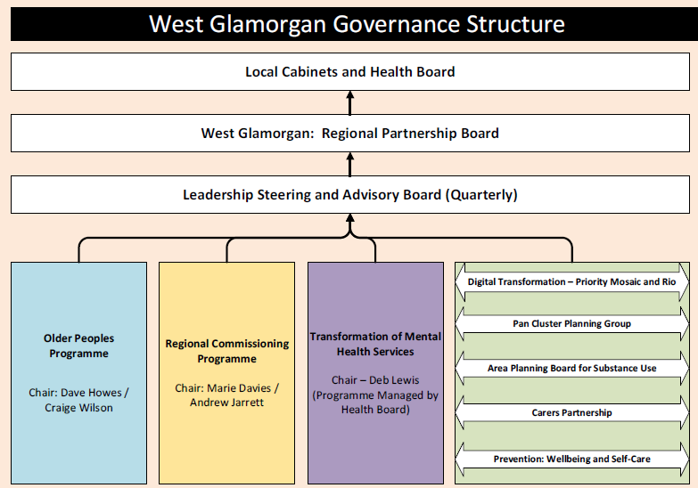

  - Two new EPRR related partnership groups have been added to the Tracker: The Regional CONTEST Board, reflecting the Health Board’s statutory responsibilities under the counterterrorism framework and its multiagency preparedness obligations; and the Swansea and Neath Port Talbot Local Authority Risk Groups, which directly inform local and regional risk assessments and community resilience activity. These groups were added to strengthen visibility of critical risk related partnerships, ensure alignment with SWLRF structures, and integrate EPRR considerations across local government, policing and regional resilience.

- GOVERNANCE AND RISK ISSUES
The Partnerships Tracker will be owned by the Planning & Partnerships Team and presented to the Audit Committee on a quarterly basis. The Audit Committee’s role will include oversight of governance arrangements, review of existing Memoranda of Understanding and Terms of Reference, and escalation of any risks to delivery to the relevant committees.

4. FINANCIAL IMPLICATIONS

There are no direct financial implications as a result of this report, however the work programme in relation to Partnerships is a key enabler to the Health Board becoming a productive partner.

5. RECOMMENDATIONS

Members of the Committee are asked to:

- RECEIVE FOR ASSURANCE the amendments to the Tracker that follow the agreed process via the Partnerships Team to maintain integrity and accountability;

- ACCEPT the creation and use of a dedicated Microsoft Teams channel as a mechanism for members to access the Partnerships Tracker.

Governance and Assurance
Link to Enabling Objectives  (please choose) | Supporting better health and wellbeing by actively promoting and empowering people to live well in resilient communities
Link to Enabling Objectives  (please choose) | Partnerships for Improving Health and Wellbeing |  | ☒
Link to Enabling Objectives  (please choose) | Co-Production and Health Literacy |  | ☐
Link to Enabling Objectives  (please choose) | Digitally Enabled Health and Wellbeing |  | ☐
Link to Enabling Objectives  (please choose) | Deliver better care through excellent health and care services achieving the outcomes that matter most to people
Link to Enabling Objectives  (please choose) | Best Value Outcomes and High-Quality Care |  | ☐
Link to Enabling Objectives  (please choose) | Partnerships for Care |  | ☒
Link to Enabling Objectives  (please choose) | Excellent Staff |  | ☐
Link to Enabling Objectives  (please choose) | Digitally Enabled Care |  | ☐
Link to Enabling Objectives  (please choose) | Outstanding Research, Innovation, Education and Learning |  | ☐
Health and Care Standards
(please choose) | Staying Healthy |  | ☐
(please choose) | Safe Care |  | ☐
(please choose) | Effective Care |  | ☒
(please choose) | Dignified Care |  | ☐
(please choose) | Timely Care |  | ☐
(please choose) | Individual Care |  | ☐
(please choose) | Staff and Resources |  | ☒
Quality, Safety and Patient Experience
There are no direct impacts, however responding to the needs of the communities of Neath Port Talbot and Swansea as set-out in partnership plans such as the Area Plan and the PSB Wellbeing Plans, will in the long term have a positive impact on meeting the needs of our population and patient experience.

Financial Implications
There are no direct financial implications as a result of this report, however the work programme in relation to Partnerships is a key enabler to the Health Board becoming a productive partner. In the longer term this will add value to the investment decisions, particularly in relation to the Regional Investment available via the WGRPB.

Legal Implications (including equality and diversity assessment)
There are no legal implications as a result of this report.

Staffing Implications
There are no staffing implications as a result of this report, however clarify in relation to the Health Board approach to Partnerships and Collaboration will support staff in the day to day work.

Long Term Implications (including the impact of the Well-being of Future Generations (Wales) Act 2015)
Working in partnership both internally within the Health Board and externally with other agencies is key to the delivery of the Well-being of Future Generations (Wales) Act 2015, and specifically Collaboration.

Report History |  | This is the first report to the Committee.
Appendices |  | Appendix 1 – RPB Governance Paper

