Meeting Date | 16 July 2026 | Agenda Item | 2.2
Name of Meeting | Audit Committee
Report Title | Audit Tracker – Status of Agreed Actions
Report Author | Head of Compliance
Report Sponsor | Director of Corporate Governance
Presented by | Head of Compliance
Freedom of Information | Open
FoI Closed detail | If closed, choose detail
Impact Assessment Summary Outcome |  | IA Completion date
N/A |  | Click or tap to enter a date.
Purpose of the Report | For Assurance
Report Summary; detailing any action required
The purpose of this report is to provide the Committee with an update on performance in delivering actions agreed as a result of the findings of audit reviews undertaken by NWSSP Audit & Assurance and Audit Wales.
Key Issues
This report summarises updates entered onto the Tracker since the last report, up to and including the 19/06/2026.
Audit Wales
There are currently 10 actions overdue, which represents a decrease of 1 when compared to the last resort. A total of 3 new actions became overdue during the reporting period; however, these has been more than offset by the closure of other actions which had previously been reported as overdue. In total, 7 actions were closed during the reporting period.
NWSSP Audit & Assurance
There are currently 82 actions overdue, which represents a decrease of 37 when compared to the last report. A total of 8 new actions became overdue during the reporting period; however, these has been more than offset by the closure of other actions which had previously been reported as overdue. In total, 72 actions were closed during the reporting period.
Internal Audit Wales themes
There is a section in the report which provides Committee Members with details of all Wales themes following Internal Audit work in 2024/25.
Decision / Action required | No
Recommendations
Members are asked to:
- CONSIDER the current position of the Audit Tracker and the status of the agreed actions therein.
AGREE any specific areas where the Committee feel that further assurance is required in order that these may be addressed with the relevant Lead Director(s).

AUDIT TRACKER AND
STATUS OF AGREED ACTIONS

- INTRODUCTION
1.1 The purpose of this report is to provide the Committee with an update on performance in the delivery of actions agreed as a result of the findings of audit reviews undertaken by NWSSP Audit & Assurance and Audit Wales.
- BACKGROUND AND CONTEXT
2.1 The Audit Committee receives and considers reports as part of normal business, which provide information and assurance in respect of:
- The delivery of Audit Plans;
- Receipt of draft and final reports; and
- Health Board management responses to the findings contained therein
2.2 This report is intended to provide assurance in respect of performance in implementing agreed actions across all reports received from both NWSSP Audit & Assurance, and Audit Wales.
2.3 Action plans in respect of all final audit reports are available on the Finance Portal through SharePoint for Directors and managers to access and update throughout the year, with the deadlines for the reporting periods to the Audit Committee clearly set out within the file set up. In addition, the Head of Compliance has produced and distributed guidance notes to assist users in the review and update of the Tracker.
2.4 It should be noted that the charts and tables within this report relate to all reports where outstanding actions remain, regardless of their age. When all actions within a given report are marked closed, the report is archived and will no longer be included as part of this update.
2.5 Where actions or findings have been superseded by the content of later reports, then the original has been closed and does not form part of the following.

3. OPEN AUDIT RECOMMENDATIONS
3.1 Other than those referred to within this report and its appendices, there are no further relevant open audit recommendations.

4. STATUS UPDATE – AUDIT WALES REPORTS
4.1 The following sets out the current position in respect of performance in implementing agreed actions stemming from Audit Wales findings, when measured against the original deadlines agreed by management at the time the reports were finalised.
Fig 1: Audit Wales Reports

4.2 Three new actions became overdue during the reporting period, all relating to the Structured Assessment 2025. The total number of overdue actions currently stands at 10.
4.3 A summary of all overdue Audit Wales actions is set out in the table below, with a more detailed breakdown included at Appendix A for information.
Report Title | Number of Overdue Actions
Report Title | High  Priority | Medium Priority | Other
Lead: Chief Operating Officer | 0 | 0 | 1
Operational Governance COO | - | - | 1
Lead: Director of Corp. Gov. | 0 | 0 | 6
Operational Governance DoCG | - | - | 5
Structured Assessment 2025 | - | - | 1
Exec Lead: Director of ICE | 0 | 0 | 1
Structured Assessment 2025 | - | - | 1
Lead: Director of Finance & Perf. | 0 | 0 | 2
Structured Assessment 2024 | - | - | 1
Structured Assessment 2025 | - | - | 1
Total | 0 | 0 | 10
4.4 Where agreed actions have become overdue, lead Directors and/or their teams are asked to provide targets/milestones for completion or further update as part of their progress reporting. Where available, these are included in the narrative update provided at Appendix A for information.
4.5 A total of 7 actions were closed during the reporting period. A table detailing all closed actions, including any comments made by the lead Directors or their teams in closing them, can be found at Appendix B. In some instances, changes to circumstances since the audit review have meant that it has not been possible to deliver actions as intended to address the audit findings. The foregoing notwithstanding, management feel it is reasonable to close these actions at this time given the current position and all other circumstances. Detail on these instances can be found at Appendix F.
5. STATUS UPDATE – NWSSP AUDIT & ASSURANCE REPORTS
5.1 The following sets out the current position in respect of performance in implementing agreed actions stemming from NWSSP Audit & Assurance findings, when measured against the original deadlines agreed by management at the time the reports were finalised.
Fig 2: NWSSP Audit & Assurance Reports

5.2 A total of 8 new actions became overdue during the reporting period, 4 of which relate to the audit of Asbestos Management. However, this figure has been more than offset by the closure of other previously overdue actions. The total overall number of overdue actions has decreased by 37.
5.3 A summary table of all overdue actions is set out at Appendix C, with a more detailed breakdown included at Appendix D for information.
5.4 Where agreed actions have become overdue, lead directors and/or their teams are asked to provide targets/milestones for completion or further update as part of their progress reporting. Where available, these are included in the detailed narrative update provided at Appendix D for information.
5.5 A total of 72 actions have been closed during the reporting period. A table detailing all of these, including any comments made by the lead director(s) or their teams in doing so, is included at Appendix E.
5.6 As already referenced at 4.5 above, in some instances, changes to circumstances since the audit review have meant that it has not been possible to deliver actions as intended to address the audit findings. The foregoing notwithstanding, management feel it is reasonable to close these actions at this time given the current position and all other circumstances. Detail on these instances can be found at Appendix F.
6. LESSONS LEARNED
6.1 The Head of Compliance has met with NWSSP Audit & Assurance colleagues in order to review information available via the Audit & Assurance Database. The database captures key information and statistics relating to audit activity in health bodies across Wales and allows benchmarking to be undertaken.
The all Wales data in Fig 3 sets out the themes of findings during 2024/25, governance has been the most frequently identified audit theme across NHS Wales (15%).
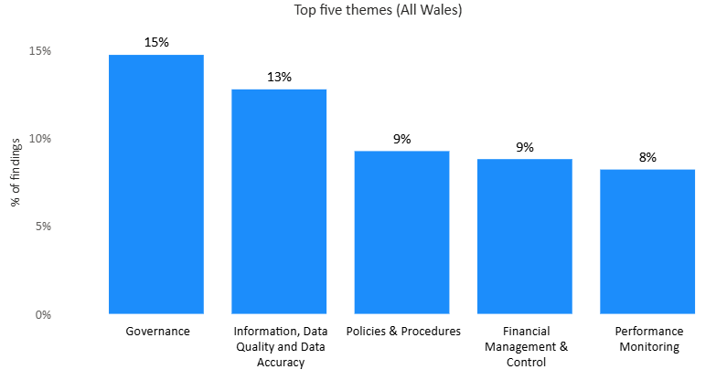
Fig 3

Fig 4 sets out the percentage of findings on an all Wales basis compared to the five Health Boards and Swansea Bay University Health Board.
Fig 4
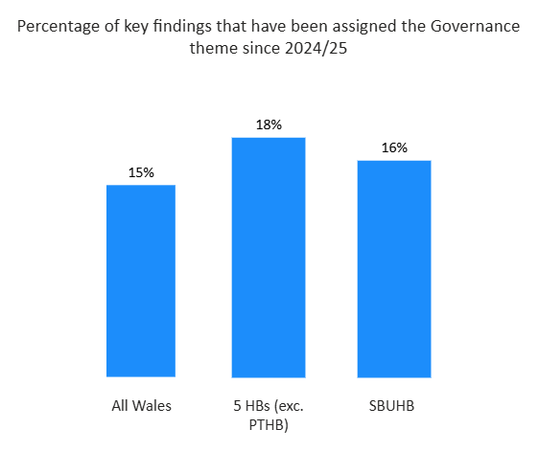

Figure 5 sets out the findings by priority of the recommendations on an all Wales basis.
Fig 5
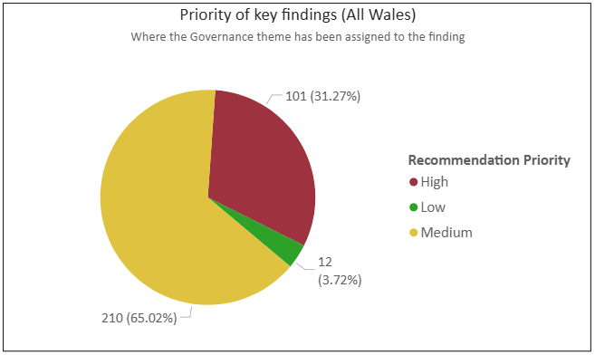

Fig 6 analysis shows on an all Wales basis the domains where governance issues are most prevalent and provides insight into areas where governance improvements may have the greatest impact on strengthening overall control and assurance arrangements.
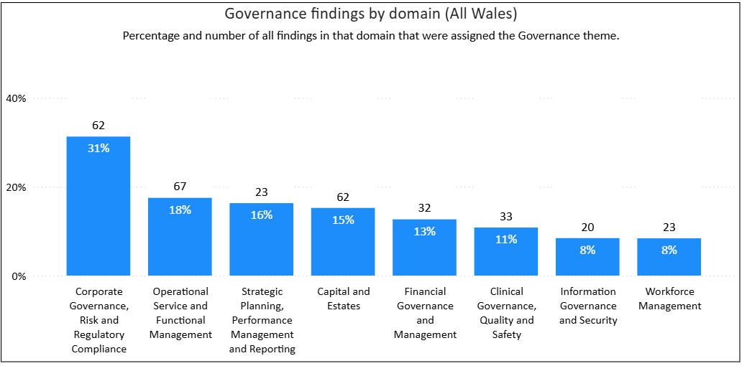
Fig 6

In support of strengthening governance arrangements work in Q2 – Q4 will be undertaken to support the Service Groups as they transition into Care Groups. This work will set out requirements for reporting to Executive level and in addition what meetings need to be in place to report up to the Senior Leadership Team in each Service Group/Care Group. A report will be provided to the Audit Committee in September 2026 setting out the plan.
7. FINANCIAL IMPLICATIONS
7.1 There are no direct financial implications arising from this report.
8. RECOMMENDATIONS
8.1 Members are asked to:
- CONSIDER the current position of the Audit Tracker and the status of the agreed actions therein.
- AGREE any specific areas where the Committee feel that further assurance is required in order that these may be addressed with the relevant Lead Director(s).

Governance and Assurance
Strategic Objectives
Strategic Objectives  (please choose which is impacted) | People of Swansea Bay live healthier, fairer and more prosperous lives |  | ☒
Strategic Objectives  (please choose which is impacted) | Care is high quality, safe, efficient and delivers the best possible outcomes for people in partnerships |  | ☒
Strategic Objectives  (please choose which is impacted) | Care is delivered in partnership with our communities in safe and appropriate setting, supported by innovation |  | ☒
Strategic Objectives  (please choose which is impacted) | The health board is a great place to work where staff feel valued and work together towards a common goal |  | ☒
Strategic Objectives  (please choose which is impacted) | The health board is a resilient, sustainable and responsible organisation |  | ☒
Health and Care Standards
Standards (please choose which applies) | Safe Care |  | ☒
Standards (please choose which applies) | Timely Care |  | ☒
Standards (please choose which applies) | Effective Care |  | ☒
Standards (please choose which applies) | Efficient Care |  | ☒
Standards (please choose which applies) | Equitable care |  | ☒
Standards (please choose which applies) | Person-centred Care |  | ☒
Standards (please choose which applies) | Staff and Resources |  | ☒
Enablers (please choose which applies) | Whole Systems Approach |  | ☒
Enablers (please choose which applies) | Leadership |  | ☒
Enablers (please choose which applies) | Workforce |  | ☒
Enablers (please choose which applies) | Culture |  | ☒
Enablers (please choose which applies) | Information |  | ☒
Enablers (please choose which applies) | Learning, Improvement and Research |  | ☒
Quality, Safety and Patient Experience
Outstanding audit recommendations may affect quality, safety and patient experience. It is essential that where audit recommendations are made, they are acted upon with leadership from the relevant Director. Reports addressing Q&S issues are discussed in more detail in the Q&S Committee.
Financial Implications
Whilst there are no direct financial implications that need to be highlighted in this report, such may arise from individual audit reports or recommendations made.
Legal Implications (including equality and diversity assessment)
Failure to address audit recommendations relating to areas such as staff and/or patient safety, or legislative compliance, may lead to action being taken against the health board.

Staffing Implications
Whilst there are no direct staffing implications that need to be highlighted in this report, there may be issues arising from individual audit reports or recommendations made which have staffing implications for the Health Board.
Long Term Implications (including the impact of the Well-being of Future Generations (Wales) Act 2015)
A robust Governance Work Programme will assist the Board in assessing risk and gathering assurance across all corporate objectives, which span the five ways of working, and the wellbeing goals identified in the Act.
Report History
The Audit Committee receive regular update reports
Appendices
Appendix A |  | Overdue Actions – Audit Wales
Appendix B |  | Closed Actions – Audit Wales
Appendix C |  | Overdue Actions – NWSSP A&A (Summary)
Appendix D |  | Overdue Actions – NWSSP A&A (Detail)
Appendix E |  | Closed Actions – NWSSP A&A
Appendix F |  | Closed with Alternative Actions

