

HEALTH BOARD RISK REGISTER
February 2024



HEALTH BOARD RISK REGISTER
SUMMARY OF ASSESSED RISKS

Impact/Consequences | 5 |  | 75: Whole Service Closure | 53: Compliance with Welsh Language Standards  66: Access to Cancer Services – SACT | 16: Access to Planned Care  60: Cyber Security  69: Adolescents being admitted to Adult MH wards  92: Finance: Forecast Deficit  93: Finance: Reduced capital funds  98: Overall condition/compliance and suitability of Health Board Estate  99: Failure to implement the population health strategy approaches at the required scale. | 01: Access to Unscheduled Care Service  50: Access to Cancer Services
Impact/Consequences | 4 |  |  | 37: Operational and strategic decisions are not data informed  51: Nurse Staffing Levels Act (Section 25B) Risk Revised  52: Impact Assessment Requirements  94: CAMHS failure to meet required standards of performance | 27: Digital Transformation to Deliver Sustainable Clinical Services  36: Electronic Patient Record  61: Paediatric Dental GA Service – Parkway  64: H&S Infrastructure  90: GDPR Subject Access Requests  91: Mental Health Capacity Act (MCA)  97: Disruption due to Industrial Action | 03: Workforce Recruitment of Medical and Dental Staff  04: Healthcare Acquired Infection  43: DOLS/LPS Authorisation and Compliance with Legislation  63: Screening for Fetal Growth Assessment in line with Gap-Grow (G&G)  80: Transfer of Clinically Optimised Patients  85: Non Compliance with ALN Act  89: Healthcare Nursing Staff Levels (HMP)  96: Failure to Develop an Approvable IMTP
Impact/Consequences | 3 |  |  |  | 95: National Nosocomial COVID-19 Programme
Impact/Consequences | 2
Impact/Consequences | 1
C X L |  | 1 | 2 | 3 | 4 | 5
 |  | Likelihood
Risk Register Dashboard

Strategic Objective | Risk Reference | Description of risk identified | Initial  Score | Current Score | Trend | Controls | Last Reviewed | Scrutiny Committee
1. Demonstrably Improved Quality, Safety & Reduced Harm | 4  (739) | Healthcare Acquired Infection  Risk of patients acquiring infection as a result of contact with the health care system, resulting in avoidable harm, impact on service capacity, and failure to achieve national infection reduction goals. | 20 | 20 |  |  | February 2024 | Quality & Safety Committee
 | 51  (1759) | Nurse Staffing (Wales) Act (Section 25B wards) Scope of risk revised and risk score adjusted  Risk of Non Compliance with the Nurse Staffing (Wales) Act | 16 | 12 | Risk Scope Revised | Risk Scope Revised | February 2024 | Workforce OD & Digital Committee
 | 53  (1762) | Welsh Language Standards  Failure to fully comply with all the requirements of the Welsh Language Standards, as they apply to the University Health Board. | 15 | 15 |  |  | February 2024 | Health Board  (Welsh Language Group)
 | 95  (3566) | National Nosocomial COVID-19 Programme  Failure to (effectively) complete the nationally mandated review of cases of nosocomial COVID-19 by the stipulated end date of the National Nosocomial COVID-19 Programme (NNCP), 31st March 2024. | 20 | 12 |  |  | February 2024 | Quality & Safety Committee
2. Delivering an Excellent Staff Experience | 3  (843) | Workforce Recruitment  Risk of failure to recruit medical & dental staff | 20 | 20 |  |  | February 2024 | Workforce OD & Digital Committee
3. Services working effectively through a systems approach | 75  (2522) | Whole Service Closure  Risk that services or facilities may not be able to function if there is a major incident or a rising tide that renders current service models unable to operate. | 20 | 10 |  |  | February 2024 | Performance & Finance Committee
 | 97  (TBC) | Disruption due to Industrial Action (In Committee Risk)  Notice has been received from the BMA of planned industrial action by junior doctors. There is a risk that inadequate numbers of staff will be available during strike days to sustain the safe delivery of services. This could result in the closure of services and/or the increased incidence of avoidable harm during the period (with potential additional impact on service performance during the recovery period). The industrial action applies across substantive, bank and agency staff. | 20 | 16 |  |  | February 2024 | Performance & Finance Committee
3.1  Primary & Community Care | 89  (3071) | Healthcare Nursing Staff Levels (HMPS)  There is a risk that the men in HMP Swansea will not receive the appropriate standard of care. This is due to the fact that the nursing establishment within the prison no longer fully meets the changed demographics and numbers of men being detained. | 20 | 20 |  |  | February 2024 | Quality & Safety  Committee
3.2. Mental Health & Learning Disability Services | 43  (1514) | DoLS  Due to a lack of Best Interest Assessor resource, there is a risk of failure to complete and authorise the assessments associated with Deprivation of Liberty/Liberty Protection Safeguards within the legally required timescales, exposing the health board to potential legal challenge and reputational damage. | 16 | 20 |  |  | February 2024 | Mental Health Legislative Committee
3.2. Mental Health & Learning Disability Services | 91  (3432) | There is a risk that assessments under the Mental Capacity Act (MCA) are not undertaken and recorded as required.  Where the UHB fails in its statutory duty to enact the MCA appropriately this could result in harm to vulnerable individuals, and/or unlawful deprivations of liberty, leading to litigation. Such cases could incur significant financial penalties, cause distress to staff members and patients, and risk damage to the organisations reputation. | 16 | 16 |  |  | February 2024 | Mental Health Legislative Committee
3.3. Networked Hospitals – A Systems Approach  Urgent & Emergency Care | 1  (738) | Access to Unscheduled Care Service  If we fail to provide timely access to Unscheduled Care then this will have an impact on quality & safety of patient care as well as patient and family experience and achievement of targets. There are challenges with capacity/staffing across the Health and Social care sectors. | 20 | 25 |  |  | February 2024 | Performance & Finance Committee
 | 80  (1832) | Transfer of Clinically Optimised Patients  If the health board is unable to discharge clinically optimised patients there is a risk of harm to those patients as they will decompensate, and to those patients waiting for admission. | 20 | 20 |  |  | February 2024 | Quality & Safety  Committee
3.4. Networked Hospitals – A Systems Approach  Planned Care | 16  (840) | Access to Planned Care  There is a risk of harm to patients if we fail to diagnose and treat them in a timely way. | 16 | 20 |  |  | February 2024 | Performance & Finance Committee
3.4. Networked Hospitals – A Systems Approach  Planned Care | 61  (1587) | Paediatric Dental GA Service – Parkway  Safety risk of general anaesthetic procedures performed on children outside of an acute hospital setting. | 15 | 16 |  |  | February 2024 | Quality & Safety  Committee
3.5. Networked Hospital – A Systems Approach  Cancer Care | 50  (1761) | Access to Cancer Services  There is a risk of delay in diagnosing patients with cancer, and consequent delay in commencement of treatment, which could lead to poor patient outcomes and failure to achieve targets. | 20 | 25 |  |  | February 2024 | Performance & Finance Committee
3.5. Networked Hospital – A Systems Approach  Cancer Care | 66  (1834) | Access to Cancer Services (SACT)  Delays in access to SACT treatment in Chemotherapy Day Unit. | 25 | 15 |  |  | February 2024 | Quality & Safety  Committee
3.5. Networked Hospital – A Systems Approach  Cancer Care | 63  (1605) | Screening for Fetal Growth Assessment in line with Gap-Grow  There is not enough Ultrasound capacity within Swansea Bay UHB to offer all women serial ultrasound scan screening in the third trimester in line with the UK perinatal Institute Growth Assessment Programme (GAP). | 12 | 20 |  |  | February 2024 | Quality & Safety  Committee
3.6. Children, Young People & Maternity Services
 | 69  (1418) | Adolescents are being admitted to adult mental health wards  Risk related to adolescent patients being admitted to Adult MH inpatient wards – Inappropriate settings potentially resulting in 'Safeguarding Issues'. The WG has requested that Health Boards identify Secondary Care inpatient facilities for the care of adolescents. In Swansea Bay University Health Board Ward F NPT Hospital is the dedicated receiving facility with one bed identified. | 20 | 20 |  |  | February 2024 | Quality & Safety  Committee
 | 85  (2561) | Non-Compliance with ALN Act  There are risks to the Health Board’s ability to meet its statutory duties and establish the effective collaborative arrangements required by the ALN Act, which is being implemented through a phased approach. | 25 | 20 |  |  | February 2024 | Quality & Safety  Committee
 | 94  (3516) | CAMHS failure to meet required standards of performance  The CAMHS service is unable to meet the required level of performance due to workforce deficits in the team across all staff groups including medics, psychological therapies and nursing.  This is further hindered by poor data quality which presents a risk to reporting until validation is complete. | 20 | 12 |  |  | February 2024 | Performance & Finance Committee
4. Focus on Population Health Needs | 52  (1763) | Statutory Compliance: Engagement & Impact Assessment  The Health Board does not have sufficient resource in place to undertake engagement & impact assess in line with Statutory Duties | 16 | 12 |  |  | February 2024 | Performance & Finance Committee
4. Focus on Population Health Needs | 99 | Failure to implement the population health strategy approaches at the required scale. | 20 | 20 | New Risk | New Risk | March 2024 | Population Health & Partnership Committee
5. Adopting and Developing Innovative Digital Solutions to Support Care Delivery | 27  (1035) | Digital Transformation to Deliver Sustainable Clinical Services  Inability to deliver sustainable clinical services due to lack of resources to deliver sustainable Digital Transformation and services. There are insufficient resources to invest in the delivery of the SBU Digital strategy; support the growth in utilisation of existing and new digital solutions; replace existing technology infrastructure or software at the end of its useful life. | 16 | 16 |  |  | February 2024 | Workforce OD & Digital Committee
 | 36  (1043) | Storage of Paper Records  Failure to provide adequate storage facilities for paper records then this will impact on the availability of patient records at the point of care. Quality of the paper record may also be reduced if there is poor records management in some wards. | 20 | 16 |  |  | February 2024 | Workforce OD & Digital Committee
 | 37  (1217) | Information Led Decisions  Risk that operational and strategic decisions are not data informed. | 16 | 12 |  |  | February 2024 | Workforce OD & Digital Committee
 | 60  (2003) | Cyber Security (In Committee Risk)  The level of cyber security incidents is at an unprecedented level and health is a known target. | 20 | 20 |  |  | February 2024 | Workforce OD & Digital Committee
 | 90  (2796) | Non-compliance with UK-GDPR Article 15 regarding Subject Access Requests (SARs), along with other health record’s requests for disclosure of personal data The Health Board does not have adequate resources to deal with the sustained increase in volume and complexity of subject access /access to health records requests received from requestors. The ICO are already involved with a number of breaches and complaints in this area and there is the potential for future enforcement action if significant improvements are not made. | 16 | 16 |  |  | February 2024 | Workforce OD & Digital Committee
6. Maintain and Deliver  Sustainable Financial Health | 92  (3444) | Finance: Forecast Deficit  Forecast deficit is not met due to insufficient progress on COVID cost reduction, savings identification, run rate reduction and the potential for new in-year pressures. | 20 | 20 |  |  | February 2024 | Performance & Finance Committee
6. Maintain and Deliver  Sustainable Financial Health | 93  (3448) | Finance: Reduced capital funds  Reduced discretionary capital funds and reduced National NHS funds requiring a restricted Capital Plan for 2023/24. | 20 | 20 |  |  | February 2024 | Performance & Finance Committee
 | 96  (3571) | Failure to Develop an Approvable IMTP (statutory compliance) Failure to have an approvable IMTP for 2024/5 then we will lose public confidence and breach legislation. | 20 | 20 |  |  | February 2024 | Performance & Finance Committee
7. Delivering Care in Safe, Modern Environments | 64  (2159) | Health and Safety Infrastructure  Insufficient resource and capacity of the health, safety and fire function to maintain legislative and regulatory compliance. | 20 | 16 |  |  | February 2024 | Quality & Safety  Committee
 | 98  (3692) | Overall condition/compliance and suitability of Health Board Estate | 20 | 20 | New Risk | New Risk | February 2024 | Performance & Finance Committee

Risk Schedules

Datix ID Number: 738  Health & Care Standard: 5.1 Timely Care |  |  | HBR Ref Number: 1  Risk Target Date: 31/03/2024 |  | Current Risk Rating  5 x 5 = 25
Objective: Networked Hospitals – A Systems Approach – Urgent & Emergency Care |  | BAF Ref: 3.3 | Director Lead: Deb Lewis, Chief Operating Officer  Assuring Committee: Performance and Finance Committee  For information: Quality & Safety Committee
Risk: Access to Unscheduled Care  If we fail to provide timely access to Unscheduled Care then this will have an impact on quality & safety of patient care as well as patient and family experience and achievement of targets. There are challenges with capacity/staffing across the Health and Social care sectors. (This risk includes ED, AMU and impact in community from ability to release ambulances at both front doors.) |  |  | Date last reviewed: February 2024
Risk Rating  (consequence x likelihood):  Initial: 4 x 5 = 20  Current: 5 x 5 = 25  Target: 3 x 4 =12 | 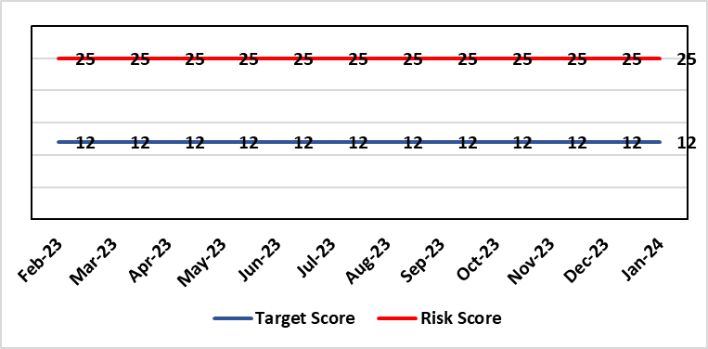 |  | Rationale for current score:  Post wave 2 of COVID 19 Morriston and Singleton have experienced a steady increase in emergency demand to pre-Covid levels. Current score raised due to increasing pressures. Implementation of All Wales Immediate Release Protocol puts additional pressure on already overcrowded ED dept.
Level of Control  = 50% |  |  | Rationale for target score:  Our annual plan is to implement models of care that reflect best practice. This will improve patient flow, length of stay and reduce emergency demand.
Date added to the HB risk register
26.01.16
Controls (What are we currently doing about the risk?) |  |  | Mitigating actions (What more should we do?)
- Increased reporting as a result of escalation to targeted intervention status.  - Phone First for ED model in place in conjunction with 111 to reduce demand.  - OPAS (Older People’s Assessment Service) have undertaken training with nursing homes (on management of patient falls) & set up direct contact details with nursing homes  - Frailty short-stay unit re-established  - Medical patient flow within Morriston has been refined between ED, AMU and wards.  - Roll out SAFER (Seen, Aim, Flow, Early Discharge and Recovery)  - WAST direct access to SDEC  - Expected medical patients conveyed by WAST go direct to AMU rather than ED, medical patients in ambulances outside ED diverted to AMU after initial assessment  - Stroke rehab pathway between MGH and NPT embedded  - Morning “golden” patients identified for early moves to discharge lounge freeing up beds earlier in the day  (Actions to improve the discharge of clinically optimised patients (risk HBR80) expected to assist with patient flow, are anticipated to free capacity to assist to address this risk HBR1 also.) |  |  | Action | Lead |  | Deadline
 |  |  | Increase of hours in SDEC planned. Currently increased hours from Monday to Friday (12 hours per day) | SGD (Morriston) |  | 01/03/2024  Completed
 |  |  | OPAS – exploring internal & external funding options. (Currently going through business case) | SDEC Clinical Lead |  | 31/03/2024
 |  |  | Looking to extend OPAS to non-surgical fractures. Resource requirements & options to be quantified and presented to the Chief Executive for consideration. | Head of Nursing (Service Transformation) |  | 31/03/2024
 |  |  | Monitoring of Continuous Flow Model now implemented. It will be monitored over 12 month period. | COO |  | 30/09/2024
 |  |  | Criteria led discharge roll out | Corporate patient flow team |  | Progress: Rolled out in Medicine. Other specialties to follow, timescales TBC
Assurances (How do we know if the things we are doing are having an impact?)  - Urgent & Emergency Care Board is meeting monthly.  - Six Goals programme has been reviewed, programme leads appointed  - UEC (Urgent and Emergency Care) dashboard has been developed and released by digital |  |  | Gaps in assurance (What additional assurances should we seek?)  The need to deliver sustained service.
Additional Comments / Progress Notes
12/02/2024: Action Complete: (1) Surgical SDEC open; (2) Continuous Flow Model implemented (from 9th October) but will be monitored over 12 months; (3) Zero tolerance on ambulance waits has been implemented. Criteria led discharge has been rolled out in Medicine and is continuing to embed. Further work will be required across other specialities over the course of the year.

Datix ID Number: 843  Health & Care Standard: Staff & Resources 7.1 Workforce |  |  | HBR Ref Number: 3  Risk Target Date: 31st March 2024 | Current Risk Rating  4 x 5 = 20
Objective: Delivering an Excellent Staff Experience |  | BAF Ref: 2 | Director Lead: Debbie Eyitayo, Director of Workforce and OD  Assuring Committee: Workforce OD & Digital Committee
Risk: Workforce recruitment of medical & dental staff |  |  | Date last reviewed: February 2024
Risk Rating  (consequence x likelihood):  Initial: 5 x 4 = 20  Current: 4 x 5 =20  Target: 4 x 3 = 12 | 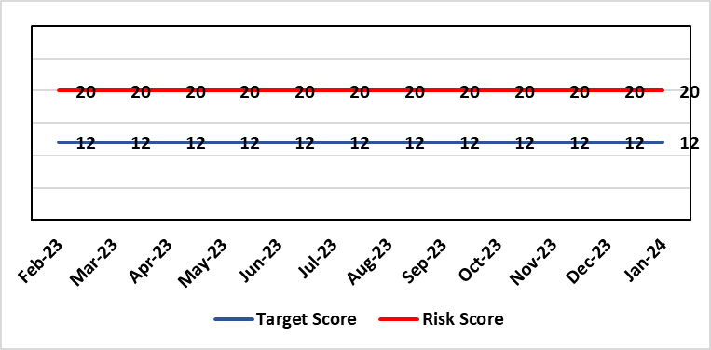 |  | Rationale for current score:  National shortages of numbers in some areas can lead to:  - Inability to recruit sufficient numbers of trainees to fulfil rotas on all sites  - Inability to attract non training grades to complete rotas  - Inability to fill Consultant grade posts in some specialties with adverse effects on patient safety and employer relations. Inability to recruit sufficient registered nursing staff.
Level of Control  = 70% |  |  | Rationale for target score:  This remains a challenge and is also a national problem.
Date added to the HB risk register
April 2012
Controls (What are we currently doing about the risk?) |  |  | Mitigating actions (What more should we do?)
- Regular monitoring of recruitment position with reports to Executive Team and Board via Medical Director and Medical Workforce Board.  - Specialty based local workforce boards established to monitor and control specific issues. The HB Workforce OD & Digital Committee will seek assurance of medical workforce plans to maintain services.  - Engagement of the Deanery about recruitment position.  - Weekly workforce delivery meetings with CEO to review progress against critical medical and clinical posts  - Working with specialist agency and head hunters to improve chances to fill hard to recruit posts  - Working with a marketing agency to develop a branding and attraction campaign for the health board. |  |  | Action |  | Lead | Deadline
 |  |  | Medical training initiatives pursued in a number of specialties to ease junior doctor recruitment |  | Director W&OD | 31/03/2024
 |  |  | The Medical Workforce Board continues to monitor recruitment and junior doctor’s rotas. |  | Director W&OD | 31/03/2024
 |  |  | Continue to recruit internationally. |  | Director W&OD | 31/03/2024
 |  |  | Continue to work with head hunters |  | Director W&OD | 31/03/2024
Assurances (How do we know if the things we are doing are having an impact?)  - General situation monitored through W&OD Committee  - Communication with Deanery  - Recruitment campaigns  - Monitoring by Executive Teams and specialty based local workforce boards  - Workforce planning and deployment taskforce meetings with service groups  - Weekly workforce delivery meetings with CEO as above |  |  | Gaps in assurance (What additional assurances should we seek?)  Locum cover  Adequate supply of doctors who can work in this country  Ability to flexibly deploy doctors in training.  Dedicated work between workforce and finance to review and confirm budgeted medical workforce establishment by service group to confirm SIP and vacancy factor.
Additional Comments / Progress Notes
25.01.2024: Workforce team reviewing & refreshing risk entry for Feb HBRR.

Datix ID Number: 739  Health & Care Standard: 2.4 Infection Prevention & Control & Decontamination |  |  | HBR Ref Number: 4  Risk Target Date: 31st March 2024 | Current Risk Rating  4 x 5 = 20
Objective: Demonstrably Improved Quality, Safety & Reduced Harm |  | BAF Ref: 1 | Director Lead: Gareth Howells, Executive Director of Nursing  Assuring Committee: Quality and Safety Committee
Risk: Healthcare Acquired Infection  Risk of patients acquiring infection as a result of contact with the health care system, resulting in avoidable harm, impact on service capacity, and failure to achieve Tier 1 national infection reduction goals. |  |  | Date last reviewed: February 2024
Risk Rating  (consequence x likelihood):  Initial: 4 x 5 = 20  Current: 4 x 5 = 20  Target: 4 x 3 =12 |  |  | Rationale for current score:  Health Board incidence of key Tier 1 infections per 100,000 population above All Wales rates, indicating Health Board’s population at greater risk of infection. High occupancy rates & frequent ward moves associated with increased risk of infection transmission. Lack of decant facilities compromises environment deep cleaning & decontamination, and planned preventative maintenance programmes.
Level of Control
= 40%
Date added to the HB risk register
January 2016
Date added to the HB risk register  January 2016 |  |  | Rationale for target score:  Improved governance structures for IPC and antimicrobial stewardship will drive improved local ownership and embed responsibility for these priorities for all levels of staff. Adequately maintained & clean environments facilitate good IPC & minimise infection risks. Reduced occupancy & frequency of patient moves mitigate against infection transmission. Compliant ventilation systems and water safety minimise infection risks. Access to timely data on infections, training, antimicrobial stewardship, cleaning at ward/unit/practice level enables Service Groups to identify areas for focused QI programmes, drive improvement, & effectively measure outcomes.
Controls (What are we currently doing about the risk?) |  |  | Mitigating actions (What more should we do?)
- Liaising with PHW expert advisors in relation to incidence of Cdifficile  - Policies, procedures, protocols and guidelines supplement the National Infection Control Manual.  - Infection Prevention & Control related training provided programmes.  - Surveillance of infections, with early identification of increased incidence, and instigation of controls.  - Provision of cleaning service to meet National Standards of Cleanliness.  - Engineering controls for water safety, ventilation, and decontamination.  - Infection Prevention Improvement Plans for HB and Service Groups with progress reported at SG Infection Control Committees, HB Infection Prevention & Control Group, Quality & Safety Group, Quality & Safety Committee, and Management Board. These include trajectories to meet national targets and report performance against them. |  |  | Action |  | Lead | Deadline
 |  |  | Drive improvements in prudent antimicrobial prescribing |  | Cons. Antimicrobial Pharmacist | 31/03/24
 |  |  | Reduce Key Tier 1 Infections to no more than WG maximum quarterly profile, identifying avoidability through Service Group scrutiny |  | Head of Infection Control | 31/03/24
 |  |  | Achieve 85% compliance with IPC mandatory training |  | Service Group Directors | 31/03/24
 |  |  | Maintain National Standards of Cleanliness compliance >95% |  | Support Services | 31/03/24
 |  |  | Develop a proactive schedule of IPC-related audit for Service Groups wards & services, and for IPC team. |  | Head of Infection Control  Service Group Directors | 31/03/24
Assurances (How do we know if the things we are doing are having an impact?)  - Clear Corporate and Service Group IPC Assurance Framework in place.  - Infection Prevention Improvement Plans for HB and Service Groups with progress reported at SG Infection Control Committees, HB Infection Prevention & Control Group, Quality & Safety Group and at Management Board. These include trajectories to meet national targets and report performance against them. This is also reported to Quality & Safety Committee.  - Ongoing monitoring of infection control rates.  - IPC, antimicrobial, decontamination and cleaning audit programmes.  - Compliance and validation systems for water safety, ventilation systems and decontamination. |  |  | Gaps in assurance (What additional assurances should we seek?)  - High occupancy rates & frequent ward moves associated with increased risk of infection transmission.  - Lack of decant facilities compromises environment deep cleaning & decontamination, and planned preventative maintenance programmes.  - Lack of robust system for Board oversight regarding IPC and ANTT training compliance due to ESR limitations.
Additional Comments / Progress Notes
12/01/2024:
Progress update re Tier 1 reduction goals 01 Apr- 31 Dec 2023.

The maximum, annual number of cases to achieve expected infection reduction goal for both C. difficile and for Staphylococcus aureus bacteraemia have been exceeded.

• C. difficile - 186 cases (2023/24 annual profile – 95 maximum).
• Staphylococcus aureus bacteraemia - 114 (2023/24 annual profile – 71 maximum).

Over trajectory for:
• E. coli bacteraemia - 203 (cumulative profile - 178 maximum).
• Klebsiella spp. bacteraemia - 69 (cumulative profile – 57 maximum).

Met trajectory for:
Pseudomonas aeruginosa bacteraemia – 19 (cumulative profile - 19 maximum).

The incidence of infections per 1,000 admissions has increased for Singleton Hospital, but it is important to note that a comparison of admissions to Singleton over the last 12 months indicates that the number of admissions to Singleton has deceased by over 50%. This significant reduction in the denominator data has resulted in an increase in the rate of infections per 1,000 admissions for Singleton.

The incidence of C. difficile in the Health Board continues to increase, and there has been confirmed nosocomial transmission. A meeting is scheduled for 08/02/24, in collaboration with expert advisers from Public Health Wales and the Healthcare Associated Infection & Antimicrobial Resistance Programme Team to review the position and identify quality improvement actions.

At this meeting the Health Board data was scrutinised, which included an analysis on periods of increased incidence and clusters of gnomically linked cases of CDiff (Causing an outbreak and spread between patients - which is a first for us), and it is clear from analysis, that there has been a change from the first half to the second half of the calendar year, with a pronounced increase of linked cases of CDiff at Morriston Hospital in particular.

Although there is no direct evidence, there is a causal sequence here that shows the impact of the operational challenges we have been experiencing (multiple patients moves, lack of a decant facilities, a poor environment which is challenging to clean, lack of single rooms, on-boarding of patients, the proximity of our patients in ED and the assessment unit and having high numbers of clinically optimised frail patients in our beds).

The feedback from PHW/DSU is that the Health Board are doing all that should be in terms of IPC actions / oversight and have robust plan and approach to IPC generally, but the main area we can focus on is specifically being able to deep clean our clinical areas. This has subsequently been confirmed by PHW that in their view we will struggle to get on top of what we need to with CDiff without doing this.

A plan is being enacted therefore for decanting the wards at Morriston Hospital in the first instance with a rolling programme of ward closures over the next 6 months or so to enable the cleaning and decluttering required to take place. To enable this to happen, clinical areas within Singleton Hospital and Neath Port Hospitals will be repurposed to cover the temporary bed closures for cleaning.

Datix ID Number: 841  Health & Care Standard: Safe Care 2.1 Managing Risk & Promoting Health & Safety |  |  | HBR Ref Number: 13  Risk Target Date: TBC | Current Risk Rating  4 x 4 = 16
Objective: Delivering Care in Safe, Modern Environments |  | BAF Ref: 7 | Director Lead: Darren Griffiths, Director of Finance  Assuring Committee: Quality & Safety Committee
Risk: Health & Safety Compliance – Environment of Premises.  Risk relates to compliance in terms of appropriate accommodation in line with Health and Safety Regulations. |  |  | Date last reviewed: February 2024
Risk Rating  (consequence x likelihood):  Initial: 4 x 4 = 16  Current: 4 x 4 =16  Target: 4 x 3 = 12 | 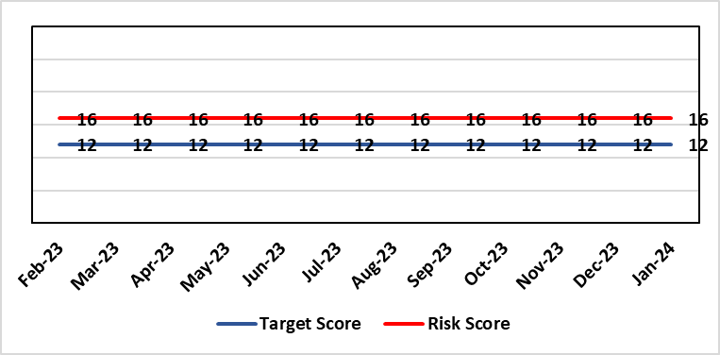 |  | Rationale for current score:  The accommodation is varied in age, tired and in need of upgrading/refurbishment to enable improved condition and compliance to regulations and WHBN/WHTMs. Score has increased following the Health Board commissioning a 6 FACET survey, this has highlighted key areas around compliance that require addressing
Level of Control  = 90% |  |  | Rationale for target score:  Risk assessments of premises.
Date added to the HB risk register
April 2012
Controls (What are we currently doing about the risk?) |  |  | Mitigating actions (What more should we do?)
- Key areas where performance linked to health & safety/fire issues. Health & Safety and Quality & Safety Committees and agreed actions to mitigate impacts.  - Actions addressed through site meetings trade improvements on the 2 acute hospital sites.  - Primary Care premises, audits commissioned and delayed due to Covid.  - Development of estates strategy and DCPs – Approved/adopted May 2023  - Capital programmes  - Priority of discretionary capital funding  - Development of appropriate capital business cases and present to Welsh Government |  |  | Action | Lead | Deadline
 |  |  | A review is currently taking place of current PCST structures and governance arrangements for estates and H&S to cover key compliances and escalation processes | Service Group Director (PCT) & Assistant Director of Health & Safety | 30/03/2024
Assurances (How do we know if the things we are doing are having an impact?) |  |  | Gaps in assurance (What additional assurances should we seek?)
Additional Comments / Progress Notes
15/12/2023: The HB are developing a 3 – 5 year discretionary capital plan along with EFAB (Estates Funding Advisory Board) funding to systematically address compliance. This includes information from 6 FACET survey and will be a long term rolling programme in conjunction with the capital development plan.
06/02/24: The works programme commenced in 2023/24 financial year, with a rolling programme in place. As stated, this is a long term plan to address areas of compliance.

Datix ID Number: 840  Health & Care Standard: 5.1 Timely Care |  |  | HBR Ref Number: 16  Risk Target Date: 31/01/2024 | Current Risk Rating  5 x 4 = 20
Objective: Networked Hospitals – A Systems Approach – Planned Care |  | BAF Ref: 3.4 | Director Lead: Deb Lewis, Chief Operating Officer  Assuring Committee: Performance and Finance Committee  For information: Quality & Safety Committee
Risk: Access and Planned Care  There is a risk of harm to patients if we fail to diagnose and treat them in a timely way. |  |  | Date last reviewed: February 2024
Risk Rating  (consequence x likelihood):  Initial: 4 x 4 = 16  Current: 5 x 4 = 20  Target: 4 x 2 = 8 | 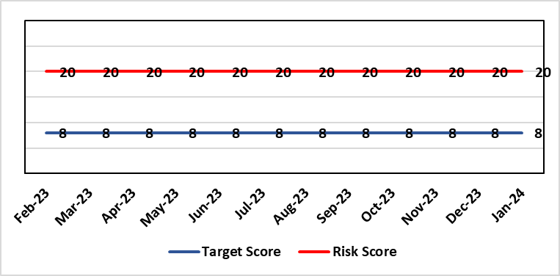 |  | Rationale for current score:  All non-urgent activity was cancelled due to response to the Covid-19 pandemic and has increased the backlog of planned care cases across the organisation. Whilst mitigating measures such as virtual clinics have been put in place new referrals are still being accepted which is adding to the outpatient backlog particularly in Ophthalmology and Orthopaedics. The significant reduction in theatre activity during the pandemic increased the number of patients now breaching 36 and 52 week thresholds.
Level of Control
= 90%
Level of Control  = 90% |  |  | Rationale for target score:  There is scope to reduce the likelihood score to reduce the overall risk to an acceptable level. The Risk target date indicates when we expect to see some reduction in waiting lists – albeit the overall risk level may remain as work continues.
Date added to the HB risk register
January 2013
Controls (What are we currently doing about the risk?) |  |  | Mitigating actions (What more should we do?)
- Post Covid 19 the focus is on minimising harm by ensuring that the patients with the high clinical priority are treatment first. The Health Board is following the Royal College of Surgeons guidance for all surgical procedures and patients on the waiting list have been categorised accordingly.  - There is a bi-weekly recovery meeting for assurance on the recovery of our elective programme.  - Specialty level capacity and demand models set out the baseline capacity and identify solutions to bridge the gap. Non-recurring pump – prime funding is available to support initial recovery measures. Fortnightly performance reviews track progress against delivery.  - A focused intervention is in train to support to the 10 specialties with the longest waits.  - Long waiting patients are being outsourced to the Independent Sector  - Additional internal activity is being delivered on weekends (via insourcing)  - Planned care trajectories developed and submitted to WG as part of IMTP.  - Governance process put in place to monitor performance against trajectories internally, and with Welsh Government.  - External & internal validation has commenced.  - A 10 bedded orthopaedic ward was created at Morriston Hospital in December to address the longest waits in the specialty that can only be operated on at Morriston.  - All long waiting patients are receiving clinical reviews to ascertain continued need for surgery. |  |  | Action |  | Lead | Deadline
 |  |  | Implement demand management initiatives |  | Deputy COO | 31/03/2024
 |  |  | Work ongoing with Finance colleagues to establish the funding allocation for elective recovery for 2023/24. |  | Deputy COO | 31/03/2024
Assurances (How do we know if the things we are doing are having an impact?)  - Weekly meetings in place to ensure patients with greatest clinical need are treated first. |  |  | Gaps in assurance (What additional assurances should we seek?)
Additional Comments / Progress Notes
09/11/2023: 52 week ministerial target was achieved at the end of Oct 2023 and will be sustained going forward. Alongside the Health Board plans we are looking at regional solutions for Orthopaedics to support SBU patients, and for SBU to support Hywel Dda in Ophthalmology.
29/01/2023: All but three of the longest waiting patients (5 years) will be treated by end January. Plans in place to treat all patients waiting over 4 years by end of March. Regional working in place for orthopaedics with SBUHB patients treated in Prince Philip Hospital and HDUHB patients treated in NPTH.

Datix ID Number: 1035  Health & Care Standard: Effective Care 3.1 Clinically Effective Care |  |  | HBR Ref Number: 27  Risk Target Date: 31st March 2024 |  | Current Risk Rating  4 x 4 = 16
Objective: Adopting and Developing Innovative Digital Solutions to Support Care Delivery |  | BAF Ref: 5 | Director Lead: Matt John, Director of Digital  Assuring Committee: Workforce OD & Digital Committee
Risk: Digital Transformation  Inability to deliver sustainable clinical services due to lack of resources to deliver sustainable Digital Transformation and services. There are insufficient resources to:  - Invest in the delivery of the SBU Digital strategy  - Support the growth in utilisation of existing and new digital solutions  - Replace existing technology infrastructure or software at the end of its useful life. |  |  | Date last reviewed: February 2024
Risk Rating  (consequence x likelihood):  Initial: 4 x 4 = 16  Current: 4 x 4 = 16  Target: 5 x 2 = 10 | 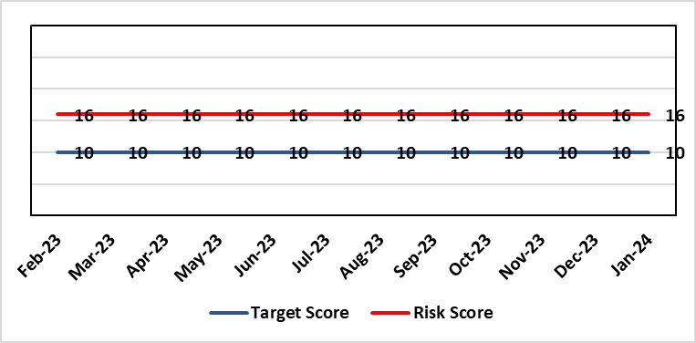 |  | Rationale for current score:  C – Reliance on digital ways of working has increased. Loss of IT service has a greater impact on ability to provide clinical care. Lack of investment in new digital solutions to make services more effective will mean clinical service provision will become unsustainable.  L- Reduction in capital funding in 2022/23/24 has increased the likelihood of HB not being able to replace aging infrastructure such as the network equipment. There is a £15m capital requirement over the next 3 years. Acceleration of the CTM SLA disaggregation has been proposed and there are further pressures on revenue funding. The shift to cloud and software as a service contracting models will increase the requirement for revenue funding to deliver digital transformation and ongoing services.
Rationale for target score:
C – Of failure will increase as the reliance and proliferation of the use of digital solutions increases.
L – Investment will mean the support mechanisms, rate of failure and ability to deliver solutions that meet the needs of users will improve sustainable digital services. There will however always be an inherent risk of failure of IT solutions.
Level of Control
= 50%
Date added to the HB risk register
2012
Controls (What are we currently doing about the risk?) |  |  | Mitigating actions (What more should we do?)
- Digital Strategy has been approved by the Health Board and outlines requirements  - HB Capital priority group considers digital risks for replacement technology which is fed into the annual discretionary capital plan  - Digital Services prioritisation process is in place Digital Leadership Group provides the overarching governance to the delivery of the Digital Strategic Plan including financial considerations.  - Digital Services Management Group assesses current service provision and flags risks and issues  - Digital Services revenue requirements are included in 2023/24 annual plan |  |  | Action | Lead |  | Deadline
 |  |  | Continue to develop the 10yr investment plan that has been submitted to WG, which will inform the Health Board IMTP submission. | Assistant Director of Digital: Business Management and Information Governance |  | 29/03/2024
 |  |  | Refresh the Digital Strategy including a high level investment plan to set out vision for the Health Board | Assistant Director of Digital: Business Management and Information Governance |  | 31/03/2024
Assurances (How do we know if the things we are doing are having an impact?)  - Internal Audit Program assesses Digital in 4 areas annually |  |  | Gaps in assurance (What additional assurances should we seek?)  - Lack of certainty over future capital and revenue funding streams makes planning and implementation difficult/less effective.
Additional Comments / Progress Notes
02/01/2024 – Risk entry refreshed: Risk description, rationale, controls, assurance, actions & targets

Datix ID Number: 1043  Health & Care Standard: Effective Care 3.1 Clinically Effective Care |  |  | HBR Ref Number: 36  Risk Target Date: 31st March 2024 |  | Current Risk Rating  4 x 4 = 16
Objective: Adopting and Developing Innovative Digital Solutions to Support Care Delivery |  | BAF Ref: 5 | Director Lead: Matt John, Director of Digital  Assuring Committee: Workforce OD & Digital Committee  For information: Quality & Safety Committee
Risk: Paper Record Storage  Lack of a single electronic record means there is greater reliance on the provision of the paper record. If we fail to provide adequate storage facilities for paper records, then this will impact on the availability of patient records at the point of care. Quality of the paper record may also be reduced if there is poor records management in some wards. There is an increased fire risk where medical records are stored outside of the medical record libraries. |  |  | Date last reviewed: February 2024
Risk Rating  (consequence x likelihood):  Initial: 4 x 5 = 20  Current: 4 x 4 = 16  Target: 3 x 3 =9 | 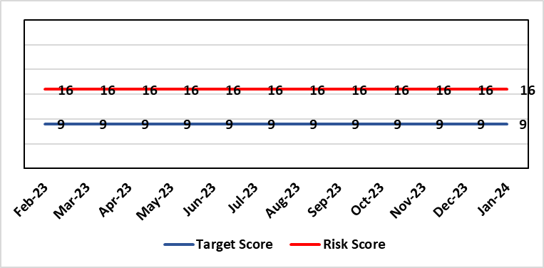 |  | Rationale for current score:  C - Inability to find records for patients could delay care/increase length of stay over 15 days. Could also mean patients receive incorrect treatment. Increased risk of fire where records are stored outside of the medical record libraries.  L - we know this happens from incidents raised
Level of Control  = 70% |  |  | Rationale for target score:  C - The increased development and adoption of the digital record will reduce the need for the paper health record being available at the point of care.  L - The increased development and adoption of the digital record, the introduction of RFID and the approach to management of the paper record identified in the Business case process should reduce the amount of paper required to be stored and managed.
Date added to the HB risk register
June 2016
Controls (What are we currently doing about the risk?) |  |  | Mitigating actions (What more should we do?)
- There is a plan in place to increase the functionality of the electronic record to document patient care. The delivery of the plan is overseen by the Digital Leadership Group and progress provided to Management Board. (Supported by individual project boards as appropriate).  - Records managed by the Medical Records libraries are RFID tagged and location tracked.  - Medical Record libraries are regularly risk assessed for fire by health and safety.  - Alternative offsite storage arrangements have been identified.  - All records must be documented on the Information Asset Register (IAR). |  |  | Action | Lead |  | Deadline
 |  |  | Amended: Re-develop a joint outline Business Case for centralisation of the health records | Head of Health Records & Clinical Coding |  | 31/03/2024
 |  |  | Welsh Government sign off for long term conditions retention of records | Head of Health Records & Clinical Coding |  | 30/12/2023
Assurances (How do we know if the things we are doing are having an impact?)  - RFID has been implemented for the acute record improving the management and storage of records  - Health Records performance reports developed in line with RFID technology  - Attainment of the Tier 1 Health Board target for clinical coding completeness which relies on the timely availability and quality of the Paper record and electronic sources  - Monitoring complaints and incident reporting.  - Electronic record is being implemented in accordance with the plan eg implementation of WNCR, ETR, HEPMA etc. |  |  | Gaps in assurance (What additional assurances should we seek?)  Investment required supporting the delivery and operational costs of the Digital strategy.  Reliance on DHCW for delivery of the solution for a fully electronic patient record.  Impact of the Infected Blood Enquiry on the Health Boards ability to destroy notes.  Process for ensuring clinical adoption of electronic ways of working and cessation of adding information to the paper record that is already available electronically needs to be agreed and enforced by the Health Board.  Impact of the infected Blood Inquiry on the health boards ability to destroy notes and the change in the records code of practice is being reviewed by the Director of Digital.
Additional Notes
07/12/2023 – Currently exploring another potential site for the relocation of the Health Records Service., no firm decisions have been made at present.

Datix ID Number: 1217  Health & Care Standard: Effective Care 3.1 Safe & Clinically Effective Care |  |  | HBR Ref Number: 37  Risk Target Date: 30th June 2024 |  | Current Risk Rating  4 x 3 = 12
Objective: Adopting and Developing Innovative Digital Solutions to Support Care Delivery |  | BAF Ref: 5 | Director Lead: Matt John, Director of Digital  Assuring Committee: Workforce OD & Digital Committee
Risk: Operational and strategic decisions are not data informed:  - Business intelligence and information already available is not utilised  - Users are unable to access the information they require to make decisions at the right time  - Gaps in information collection including patient outcome measures |  |  | Date last reviewed: February 2024
Risk Rating  (consequence x likelihood):  Initial: 4 x 3 = 12  Current: 4 x 3 = 12  Target: 4 x 2 = 8 | 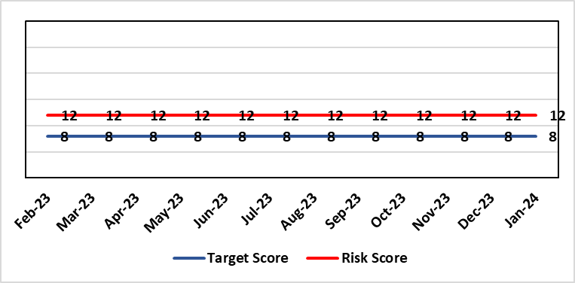 |  | Rationale for current score:  C – Opportunity cost of not acting on data could mean opportunities for improvement are missed, failures are not identified in a timely manner resulting in adverse national publicity and/or delays in care/increased length of stay.  L - Dashboard utilisation is lower than would be anticipated. Management Board have approved the investment for 4 BI partners to work with the SDGs to become more data driven.
Level of Control  = 70% |  |  | Rationale for target score:  C- Will remain the same or increase due to increased reliance in information  L- Investment in BI will lead to more information be available and used. The higher the use of information at operational level will lead to better quality data.
Date added to the HB risk register: June 2016
Controls (What are we currently doing about the risk?) |  |  | Mitigating actions (What more should we do?)
- BI partner roles have been funded and will be introduced to support the SDGs to become more data driven.  - COVID19 Dashboards Developed and utilised to inform the decision making process at Gold  - The Health Board has invested in interactive dashboards with the addition of the Power BI Business Intelligence software and infrastructure to support it.  - 33 dashboards in place including Cancer, Patient Flow, Outpatients, Mortality, Clinical Variation, Primary & Community Care Delivery Unit Dashboard and Ward Dashboard  - Safety Huddle implemented in Morriston has improved data quality and improved operational working  - Information Dept. working with Planning and Finance leads to develop meaningful indicators, utilising dashboards to present information in a user friendly way  - New technologies being reviewed for advanced analytics and integration into a new Health Board analytics platform.  - Health Board has representation on national groups such as the Advanced Analytics Group (AAG), all Wales Business Intelligence and Data Warehousing Group and Welsh Modelling Collaborative. |  |  | Action | Lead |  | Deadline
 |  |  | Additional development of self-service dashboards | Assistant Director of Digital Intelligence |  | Completed
 |  |  | Create Community of Practice for Power BI knowledge sharing across Health Board | Assistant Director of Digital Intelligence |  | 28th February 2024
 |  |  | Appointments of BI partners to vacant posts | Assistant Director of Digital Intelligence |  | 31st March 2024
 |  |  | Start of 2nd tranche of Data Literacy Module Manager’s Pathway program | Assistant Director of Digital Intelligence |  | 31st May 2024
 |  |  | Certified Analytical Programme with access to self- service datasets | Assistant Director of Digital Intelligence |  | 30th June 2024
Assurances (How do we know if the things we are doing are having an impact?)  More evidence based and proactive decisions being made.  Dashboard technology; assist in developing indicators / triangulating information to identify issues |  |  | Gaps in assurance (What additional assurances should we seek?)  Culture of the organisation needs to change to focus on information and Business intelligence for operational rather than reporting purposes. Capability of operational staff to utilise the tools and capacity to act on the intelligence provided.
Additional Comments / Progress Notes
15/01/2024 - Self-service dashboard has been completed, action closed; risk target date extended to 30th June 2024.

Datix ID Number: 1567  Health & Care Standard: Safe Care 2.1 Managing Risk & Promoting Health & Safety |  |  | HBR Ref Number: 41  Risk Target Date: 28th February 2024 |  | Current Risk Rating  3 x 4 = 12
Objective: Delivering Care in Safe, Modern Environments |  | BAF Ref: 7 | Director Lead: Darren Griffiths, Director of Finance & Performance  Assuring Committee: Quality & Safety Committee
Risk: Fire Regulation Compliance  Following a review of the fire compliance of the cladding applied to Singleton Hospital, in particular (as a high rise block), the HB commenced a programme of works to remove the non-compliant cladding and replace the cladding with fire compliant materials. |  |  | Date last reviewed: February 2024
Risk Rating  (consequence x likelihood):  Initial: 5 x 3 = 15  Current: 3 x 4 = 12  Target: 3 x 3 = 9 | 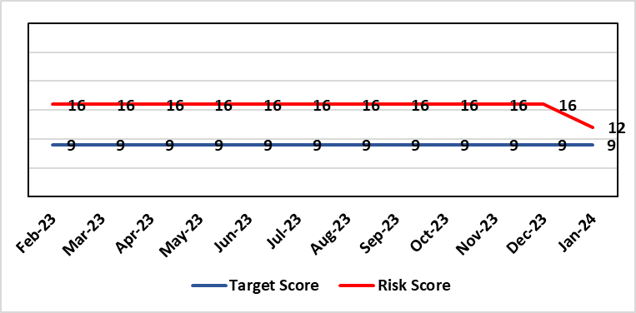 |  | Rationale for current score:  Cladding applied to Singleton Hospital front flank is not compliant with fire regulations.  General compliance with fire regulations and WHTM/WHBN requirements.  Risk level reduced as the majority of the works have been completed. With handover the end of February 2024.
Level of Control  = 50% |  |  | Rationale for target score:  Once sufficient resources and the cladding is replaced the risk score will reduce significantly. This will be reduced in stages as resources are implemented and cladding replaced.
Date added to the HB risk register
31/05/2018
Controls (What are we currently doing about the risk?) |  |  | Mitigating actions (What more should we do?)
- Fire risk assessments.  - Evacuation plans (vertical and horizontal).  - Fire safety training.  - Professional advice sought on compliance of panels.  - East flank panels removed  - Business case being developed for south panel removal and updating. |  |  | Action | Lead |  | Deadline
 |  |  | Change in fire evacuation plans and alarm and detection cause and effect | Head of Health & Safety |  | 01/04/2024
 |  |  | Replacing the existing cladding and insulation with alternative specifications and inserting 30 minute fire cavity barriers where appropriate | Service Improvement Manager |  | 28/02/2024
Assurances (How do we know if the things we are doing are having an impact?)  - Monitoring through the H&S committee to receive assurance and or identify gaps for key compliance and adherence to applicable legislation.  - NWSSP internal audits  - Site visits/tours to identify compliance and gaps in compliances.  - Completion of FRA’s within targeted schedule |  |  | Gaps in assurance (What additional assurances should we seek?)  Suitable resources to be in place, all fire risk assessments and actions from them completed. Fire safety audits carried out internally. Fire compartmentation surveyed to provide assurance of fire stopping. Fire schematics updated and fire evacuation drawings updated in in place.
Additional Comments / Progress Notes
15/12/2023: The cladding replacement is now, approx. 85% complete and in its final phase, with project completion now expected Feb 2024.
06/02/2024: The risk score can be reduced to 3x4=12 (majority of works have been completed - handover expected at the end of February 2024). There are other elements that impact on the overall fire compartmentation of which are being addressed through EFAB and discretionary capital to mitigate further.

Datix ID Number: 1514  Health & Care Standard: Safe Care 2.1 Managing Risk & Promoting Health & Safety |  |  | HBR Ref Number: 43  Risk Target Date: TBC |  | Current Risk Rating  4 x 5 = 20
Objective: Mental Health & Learning Disability Services |  | BAF Ref: 3.2 | Director Lead: Gareth Howells, Executive Director of Nursing  Assuring Committee: Mental Health Legislation Committee  For Information: Quality and Safety Committee
Risk: Deprivation of Liberty Safeguards  Due to a lack of Best Interest Assessor resource, there is a risk of failure to complete and authorise the assessments associated with Deprivation of Liberty within the legally required timescales, exposing the health board to potential legal challenge and reputational damage. |  |  | Date last reviewed: February 2024
Risk Rating  (consequence x likelihood):  Initial: 4 x 4 = 16  Current: 4 x 5 = 20  Target: 3 x 2 = 6 | 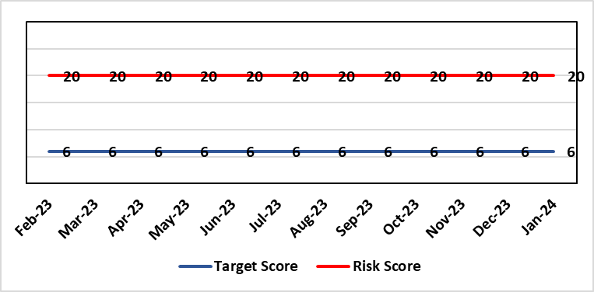 |  | Rationale for current score:  Although processes have been planned in order to reduce the breach position they have yet to be fully implemented. The impact is yet to be realised. Risk increased in Feb 2023 following discussion at Mental Health Legislative Committee.
Level of Control  = 40% |  |  | Rationale for target score:  Consequences of DoLS breaches for the Health Board will not change. With controls in place, over time likelihood should decrease.
Date added to the HB risk register
July 2017
Controls (What are we currently doing about the risk?) |  |  | Mitigating actions (What more should we do?)
Additional supervisory body signatories in place – this is being undertaken as overtime using additional WG funds.  Additional funding received from WG to manage the backlog of DoLS assessments.  DoLS assessments are being undertaken via a number of difference sources to address the backlog;  - External BIA’s payment to be increased from £120 to £250 (utilising substantive recurring funding) to encourage a large cohort of BIA’s to undertake role.  - 2 band 6 WTE BIA’s have been appointed (using WG money). This will reduce the need for agency BIA’s.  - Overtime/additional hours agreed utilising WG money for sign off completion.  - DoLS database updated and DoLS dashboard in place, monitoring applications and breaches via dedicated BIAs and Admin.  - Delivery of DOLS Action plan reviewed monthly.  - Regular reporting to Mental Health and Legislative Committee (MHLC).  - Monthly reporting to Unit Nurse Director and Finance on DoLS breaches.  - Health Board presence at National and regional meetings relating to DoLS / LPS.  - Increased IMCA services to support increased BIA resource.  - Current Mental Capacity Act practice reviewed to support MCA DoLS issues in practice. |  |  | Action | Lead |  | Deadline
 |  |  | Overtime/additional hours agreed to fund sign off from nurse assessor team to process the backlog assessments | GND Primary and Community |  | 30/09/2024
Assurances (How do we know if the things we are doing are having an impact?)  Regular scrutiny at Service Group and Safeguarding Committee and by DoLS Internal Audit; monitoring via DoLS Dashboard this will provide real-time accurate data.  Update report to MHLC, impact of backlog of DoLS breaches and new LPS implementation.  Monthly updates with Unit Nurse Director and Finance. |  |  | Gaps in assurance (What additional assurances should we seek?)
Additional Comments / Progress Notes
02/01/2024: Regular weekly scrutiny of the DoLS database is indicating that wait for allocation to BIA is improving. Breaches continue to occur but the improvement in allocation timescales to BIA, currently 4 to 6 weeks, ensures patients are safely and legally detained with the least restrictive care plan in place.
An increase in the BIA resource has been made in this year’s IMTP.
05/02/2024: Transition plan for a new enhanced MCA/DoLS team to be hosted in PCTSG from 1st April 2024. Oversight of BIA resource will from part of this.
MHL Committee will continue to monitor and scrutinise progress in embedding and enacting the actions in the associated development plan for the transition

Datix ID Number: 1761  Health & Care Standard: Timely Care 5.1 Access |  |  | HBR Ref Number: 50  Risk Target Date: 31/12/2023 |  | Current Risk Rating  5 x 5 = 25
Objective: Networked Hospital – A Systems Approach – Cancer Care |  | BAF Ref: 3.5 | Director Lead: Deb Lewis, Chief Operating Officer  Assuring Committee: Performance and Finance Committee  For information: Quality & Safety Committee
Risk: Access to Cancer Services A backlog of patients now presenting with suspected cancer has accumulated during the pandemic, creating an increase in referrals into the health board which is greater than the current capacity for prompt diagnosis and treatment. Because of this there is a risk of delay in diagnosing patients with cancer, and consequent delay in commencement of treatment, which could lead to poor patient outcomes and failure to achieve targets. |  |  | Date last reviewed: February 2024
Risk Rating  (consequence x likelihood):  Initial: 4 x 5 = 20  Current: 5 x 5 = 25  Target: 4 x 3 = 12 |  |  | Rationale for current score:  Risk score based on being off trajectory for SCP.
Level of Control  = 70% |  |  | Rationale for target score:  Target score reflects the challenge this area of work present the Board and where small numbers of patients impact on the potential to breach target.
Date added to the HB risk register: April 2014
Controls (What are we currently doing about the risk?) |  |  | Mitigating actions (What more should we do?)
- Tight management processes to manage each individual case on the Urgent Suspected Cancer Pathway. Enhanced monitoring & weekly monitoring of action plans for top 6 tumour sites.  - Initiatives to protect surgical capacity to support USC pathways have been put in place  - Additional investment in MDT coordinators, with cancer trackers appointed in April 2021.  - Prioritised pathway in place to fast track USC patients.  - Ongoing comprehensive demand and capacity analysis with directorates to maximise efficiencies. This will form part of the remit of the Cancer Performance Group.  - Weekly cancer performance meetings are held for both NPTS and Morriston Service Groups by specialty.  - The top 6 tumour sites of concern have developed cancer improvement plans – weekly monitoring arrangements have been put in place.  - Additional work being undertaken as part of diagnostic recovery and theatre recovery workstreams.  - Endoscopy contract has been extended for insourcing. |  |  | Action | Lead |  | Deadline
 |  |  | Cancer Performance Group to monitor improvement trajectories for both cancer backlog and SCP performance on a monthly basis | Deputy COO |  | 31/03/2024
 |  |  | Full review of gynaecology / gynae-oncology pathway given service constraints to be done. Additional theatre capacity for gynaecological cancer to be agreed to reduce current backlog | Deputy COO |  | 29/03/2024
Assurances (How do we know if the things we are doing are having an impact?)  Backlog trajectories updated at Management Board and will be going to Performance & Finance Committee in August. Cancer Performance Group established to support execution of the services delivery plans for improvements and meeting regularly. |  |  | Gaps in assurance (What additional assurances should we seek?)  Performance and activity data monitored, but delays to treatment continue while sustainable solutions found.
Additional Comments / Progress Notes
29/01/2024 – Slight in improvement in SCP performance during November and December, 52% and 53% respectively. Improvement in Upper GI performance (73%) but further work required in other tumour site area e.g. gynaecology, urology and breast.

Datix ID Number: 1759  Health & Care Standard: Staff & Resources 7.1 Workforce |  |  | HBR Ref Number: 51  Risk Target Date: 30th April 2024 | Current Risk Rating  4 x 3 = 12
Objective: Demonstrably Improved Quality, Safety & Reduced Harm |  | BAF Ref: 1 | Director Lead: Gareth Howells, Executive Director of Nursing  Assuring Committee: Workforce OD & Digital Committee
Risk: Non Compliance with Nurse Staffing Levels Act (2016) – Section 25B Wards  The Nurse Staffing Levels (Wales) Act 2016 (NSLWA) legally requires the health board to make provision for appropriate nurse staffing levels within their nursing services. In accordance with section 25B, there is a duty to calculate nurse staffing levels in adult and paediatric acute medical and surgical inpatient wards. There is a risk we may not meet these requirements fully due to increased acuity, unplanned staff absence and vacancies. The potential impact of this maybe non-compliance with the ‘Act’, poor patient outcomes and experience, and suspension of services. |  |  | Date last reviewed: February 2024
Risk Rating  (consequence x likelihood):  Initial: 4 x 4 = 16  Current: 4 x 3 = 12  Target 3 x 2 = 9 | 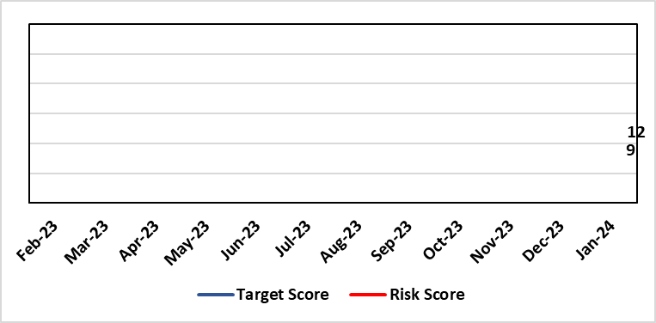 |  | Rationale for current score:  - The scope of the risk has been reviewed to disaggregate the 25B reportable wards as part of the NSLWA to enable clearer identification of risk of non-compliance with the’ Act’ from the aggregated risk across all nurse staffing areas of inadequate staffing levels previously scored 20.  - There has been a steady decline in the number of vacancies across the 25B wards as a result of successful international recruitment and student streamlining  - The Service Group risk assessments for 25B wards reported at the NMSSAIG 24.01.2024 are as follows:  - Morriston Service Group – 9 (previously 12)  - NPTSSG – 9 (unchanged)  - Paediatrics: In-patient wards – 16 (previously reported 12) increased risk due to vacancies, sickness and maternity leave
Level of Control  = |  |  | Rationale for target score:  - The health board has the required structures and processes in place to provide reassurance to the Board that SBUHB is compliant under the Act and as such are allocating resources accordingly.  - Health boards are duty bound to take all reasonable steps to maintain nurse staffing levels.  - Ward skill mix, recruitment and induction plans impacting on ward  - Projected continued decrease in vacancies by end of 2024.
Date added to the HB risk register
November 2018
Scope Refreshed:
January 2024
Controls (What are we currently doing about the risk?) |  |  | Mitigating actions (What more should we do?)
The Health board has put the following controls in place:  - The designated person as part of the requirements of the ‘Act’ is the Executive Director of Nursing & Patient Experience  - The responsibility for decisions relating to the maintenance of the nurse staffing level rests with the health board is based on evidence provided by, and the professional opinions of the Executive Directors with the portfolios of Nursing, Finance, Workforce, and Operations  - Bi-annual calculations undertaken across all Section 25B wards using the triangulated methodology which Service Groups formally present at Executive led scrutiny panels with representation from Nursing, Workforce and Digital and Finance Colleagues.  - The Ward Sister / Charge Nurse, Senior Nurses and Group Nurse Director continuously assess the situation and keep the designated person formally apprised  - The health board has representation at the All-Wales Nurse Staffing Group and its sub groups to ensure the organisation is aware of national updates  - The Board receive a bi-annual report - May (agreed Once for Wales) and November (mandatory). The 3 yearly mandatory paper to Welsh Government is due May 2024.  - Workforce planning & redesign, training and development. Recruitment and retention continues. HB Workforce Group has been set up and links to HEIW Retention Work stream, HB representatives on HEIW Group are Associate Head of HR, Recruitment and Retention Manager and Matron, Corporate Recruitment. Workforce plans have been developed by Service Group Nurse Directors and each Service Group agrees staffing, with consideration of all reasonable steps to maintain the nurse staffing level  - Work assessing the impact of the 'Team around the Person' continues on a HB and All Wales basis.  - Rostering Policy - the Service Groups have a robust roster scrutiny process that is undertaken to ensure roster efficiency and appropriate utilisation of temporary staff.  - The health board has a nursing retention plan and actively supports the Retire and Return policy.  - SafeCare has been implemented, the All Wales SOP remains a working document as understanding evolves.  - Service Groups continue daily staffing huddles and daily staffing tool and escalate as appropriate. |  |  | Action |  | Lead | Deadline
 |  |  | Student Streamlining and Overseas recruitment |  | Executive Director of Nursing | 31/12/2024  Monthly ongoing
 |  |  | Review of workforce, consider more diverse skill mix, including development of Band 3 and Band 4 roles. Bi-annual re-calculations of inpatient wards have resulted in the addition of Band 3 and 4 roles within the NSA templates. These posts are being recruited into, there is a need for training and supervision for these new posts. Development of Service Group workforce plans to support an overall Corporate Workforce Plan. |  | Executive Director of Nursing | 31/12/2024
Assurances (How do we know if the things we are doing are having an impact?)  - Ongoing robust recruitment and retention plans in place to reduce vacancies in key clinical areas.  - Accurate reporting of acuity data and governance around sign off.  - Agreed establishments are funded.  - E-Rostering implemented and roster scrutiny undertaken, ensuring effective staff allocation.  - All Wales Templates are visible informing patients/visitors of planned roster on all Section 25B wards. Patient Information available on all Section 25B wards, Service Groups have access to all HEIW documents via a SharePoint  - Bi-annual Board reports, provide assurance and outline compliance and any key risks, submitted in November and May each year, with three yearly report to Welsh Government due May 2024.  - The Health Board Nursing and Midwifery Safe Staffing Assurance and Improvement Group (formally the Nurse Staffing Act Steering Group, amended July 2023) meets on a bi-monthly basis, ensuring risks from all Service Groups are presented, discussed and escalated as appropriate at each meeting. This group is chaired by an Associate Director of Nursing and reports to Nursing and Midwifery Board and the Workforce, Organisational Development and Digital Committee  - Service Group risk assessments have been updated and disaggregated into 25B and 25A areas to enable clear risk assessment and escalation of specific risks to ensure robust governance and risk assurance  - There is a clear process for scrutiny during bi-annual re-calculations and at any other time when wards require a re-calculation, for example: change to ward purpose, increased bed numbers or increase patient acuity  - SafeCare system has been implemented. Support given to help embed the system into everyday use. Use of SafeCare linked to daily staffing huddles.  - Historical information and all reporting templates available on a share drive |  |  | Gaps in assurance (What additional assurances should we seek?)  - Issue remains regarding Information Technology barriers around the capture of data required for the Act on an All- Wales and Health Board basis. All Wales work with Allocate (Safecare) to improve reporting capabilities of Safecare, via a dashboard continued to progress, SBU is pilot site for testing. Update to Allocate system received, working with rostering team and BCU NSA Lead to check accuracy of reporting.  - Ongoing work across Wales to ensure IT systems are compatible with each other for operational and reporting purposes.
Additional Comments / Progress Notes
Section 25B wards covered by this risk:
NPTSSG | Morriston Service Group
Ward 2  Ward 4  Ward 12  Ward A  Ward E  Paediatric: Ward M and Oakwood Ward | Ward A, B, W and Clydach Ward  Ward C, Cyril Evans Ward, Dan Danino Ward  Powys Ward, Tempest Ward  Cardigan Ward  Ward K, L, R, T and Pembroke Ward  Ward D, E, F, G, H, J, S and Gower Ward

For information – 25A areas not covered by this risk include (These are managed within Service Groups and would be escalate for Executive consideration as appropriate).
Morriston Service Group | NPTSG | Mental Health & Learning Disabilities | Community Areas
Critical care areas – GITU & CITU  Short stay and assessment areas  AMU,SDMU  Emergency Department | Neonates  Theatres  Ward B, C, D NPTH | Mental Health and Learning Disabilities | District Nursing  Health Visiting  Gorseinon Hospital  Ty Olwen
Midwifery is not covered as part of the NSLWA – Refer to Midwifery Staffing Risk ID 2788 (HBR 81)
24/01/2024: Discussed and agreed in Nurse and Midwifery Safe Staffing Assurance and Improvement Group (NMSSAIG) on 24th January 2024.
The scope of this risk has changed. The description has been refreshed to clarify that only those services covered under Section 25B of the Act are within its scope.
Work is being undertaken to review risks in services outside this section of the Act (including Neonates and MH&LD where staffing level risks have been highlighted previously) in order to reflect separately on HBRR as appropriate.

This also includes ensuring the relevant clinical services achieve the required standards set out in the all Wales district nursing and mental health principles as well and the BAPM standards for Neonatal Units and Birth rate plus,

Datix ID Number: 1763  Health & Care Standard: Staff & Resources 7.1 Workforce |  |  | HBR Ref Number: 52  Risk Target Date: TBC |  | Current Risk Rating  4 x 3 = 12
Objective: Focus on Population Health Needs |  | BAF Ref: 4 | Director Lead: Richard Thomas, Director of Communications and Engagement  Assuring Committee: Performance and Finance Committee
Risk: Impact Assessment Requirements  The Health Board does not have sufficient skills & resource in place to undertake impact assessments in line with strategic service change and policy development. |  |  | Date last reviewed: February 2024
Risk Rating  (consequence x likelihood):  Initial: 4 x 4 = 16  Current: 4 x 3 = 12  Target: 4 x 2 = 8 |  |  | Rationale for current score:  - Current lack of required skills / staff to deliver requirements.
Level of Control  = 50% |  |  | Rationale for target score:  - All of these areas need to have adequate resourcing and robust processes / policies in place for the organisation to make robust plans, engage public confidence and meet our statutory and public duties.
Date added to the HB risk register
November 2018
Controls (What are we currently doing about the risk?) |  |  | Mitigating actions (What more should we do?)
- Head of EDI to be appointed to support equality impact assessment – funding previously agreed, paper going to Management Board and then Board on 25th January 2024. Funding to be agreed to allow appointment to be made.  - Creation of DICE has led to some additional capacity within Engagement Team but alongside a significant increase in demand for activity.  - Robust policies and processes to be in place for Impact Assessment going forward.  - EIA responsibilities incorporated into wider Impact Assessments.  - Development of Strategic Equality Group across organisation to support processes. |  |  | Action | Lead |  | Deadline
 |  |  | Appoint Head of EDI  Delayed due to need to confirm budget | Assistant Director of Insight, Engagement & Fundraising - DICE |  | 31/03/2024
 |  |  | Review of the current process for developing Equality Impact Assessments around service change, engagement and consultation. | Assistant Director of Insight, Engagement & Fundraising - DICE |  | 31/03/2024  In progress
 |  |  | Robust policies and processes to be in place for Impact Assessment going forward. | Assistant Director of Insight, Engagement & Fundraising - DICE |  | 30/06/2024  In progress
 |  |  | Roll out Impact Assessment process across organisation. | Assistant Director of Insight, Engagement & Fundraising - DICE |  | 30/09/2024
Assurances (How do we know if the things we are doing are having an impact?)  Advice on Equality Impact Assessment and then wider Impact Assessments available across organisation supported by robust policies and procedures, overseen by Strategic Equality Group. |  |  | Gaps in assurance (What additional assurances should we seek?)  Participation from across organisation in Strategic Equality Group.
Additional Comments / Progress Notes
19/01/2024: Reviewed – no change currently

Datix ID Number: 1762  Health & Care Standard: Staff & Resources 7.1 Workforce |  |  | HBR Ref Number: 53  Risk Target Date: 31st March 2024 |  | Current Risk Rating  5 x 3 = 15
Objective: Demonstrably Improved Quality, Safety & Reduced Harm |  | BAF Ref: 1 | Director Lead: Hazel Lloyd, Director of Corporate Governance  Assuring Committee: Health Board (Welsh Language Group)
Risk: Welsh Language Standards  Failure to fully comply with all the requirements of the Welsh Language Standards, as they apply to the University Health Board. |  |  | Date last reviewed: February 2024
Risk Rating  (consequence x likelihood):  Initial: 5 x 3 = 15  Current: 5 x 3 = 15  Target: 3 x 3 = 9 | 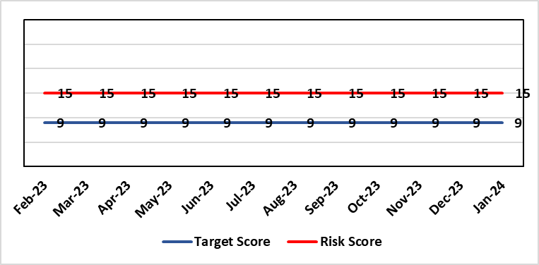 |  | Rationale for current score:  As a consequence of an internal assessment of the Standards and their impact on the UHB, it is recognised that the Health Board will not be fully compliant with all applicable Standards. This position has been confirmed/verified via an independent baseline assessment.
Level of Control  = 60% |  |  | Rationale for target score:  Working through its related improvement plan the likelihood of noncompliance will reduce as awareness and staff training in response to the Standards, is raised.
Date added to the HB risk register
November 2018
Controls (What are we currently doing about the risk?) |  |  | Mitigating actions (What more should we do?)
- An independent baseline assessment of the Health Board’s position against the Standards has been undertaken. This is in addition to the Health Board’s own self-assessment.  - Work to implement the recommendations contained within the above baseline assessment has commenced.  - An online staff Welsh Language Skills Survey has been launched.  - Close constructive working relationships are in place with the Welsh Language Commissioner’s Office  - Strong networks are in place amongst WLO across NHS Wales to inform learning and development of responses to the Standards.  - Proactive communication and marketing activity is being undertaken across the Health Board to raise awareness of Welsh language compliance, customer service standards and training opportunities.  - Meetings of the Welsh Language Standards Delivery Group have recommenced (March 2022) |  |  | Action | Lead |  | Deadline
 |  |  | Recruit to current vacancy within the Welsh language Translation Team. | Welsh Language Officer |  | 31/03/2024
Assurances (How do we know if the things we are doing are having an impact?)  - Compliance with Statutory requirements outlined in Welsh Language Act and related Standards.  - Meetings with the Welsh Language Commissioner.  - Self-Assessment against the requirements of More Than Just Words.  - Production of an Annual Report. |  |  | Gaps in assurance (What additional assurances should we seek?)  Formal and regular reporting to the Board will recommence with the production of the next annual report.
Additional Comments / Progress Notes
Dec 2023: The long-standing vacancy within the Translation Team has now been filled, with a substantive appointment being made with effect from 01/12/2023. However a further translator has now handed in their notice and will leave the Team on 02/01/2024. A recruitment exercise to fill this post is now underway.

Datix ID Number: 146  Health & Care Standard: Effective Care 3.1 Clinically Effective Care |  |  | HBR Ref Number: 58  Risk Target Date: 31/03/2024 |  | Current Risk Rating  4 x 3 = 12
Objective: Networked Hospitals – A Systems Approach – Planned Care |  | BAF Ref: 3.4 | Director Lead: Deb Lewis, Chief Operating Officer  Assuring Committee: Quality and Safety Committee
Risk: Ophthalmology Clinic Capacity  Failure to provide adequate clinic capacity for follow-up patients in Ophthalmology results in a delay in treatment and potential risk of sight loss. |  |  | Date last reviewed: February 2024
Risk Rating  (consequence x likelihood):  Initial: 4 x 3 = 12  Current: 4 x 3 = 12  Target: 4 x 2 = 8 | 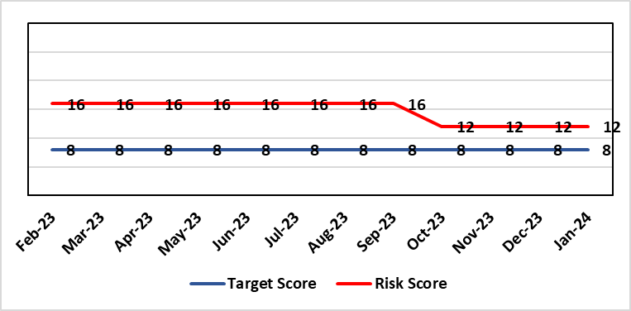 |  | Rationale for current score:  Risk rating increased to 20 in July 2020 due to Covid-19 pandemic but decreased subsequently due to the progress made by the department to reduce the number of delayed followed appointments.
Level of Control  = 40% |  |  | Rationale for target score:  Mitigation plan via outsourcing of work to optometrists where possible and re-introduction of pre-Covid capacity levels.
Date added to the HB risk register
December 2014
Controls (What are we currently doing about the risk?) |  |  | Mitigating actions (What more should we do?)
- All patients are categorised by condition in order to quantify issue.  - Community optometry scheme successfully implemented to reduce number of diabetic retinopathy patients on follow up list.  - Scheme developed for assessment of glaucoma patients by community optometrists for virtual review by consultant ophthalmologists to reduce follow up backlog.  - Outsourcing of cataract activity to reduce overall service pressures. |  |  | Action | Lead |  | Deadline
 |  |  | An overall Regional Sustainability Plan to be delivered | Service Group Manager Surgical Specialties |  | 31/12/2023
Assurances (How do we know if the things we are doing are having an impact?)  - Performance reported to Eye Care Collaborative Group on a monthly basis. |  |  | Gaps in assurance (What additional assurances should we seek?)  Regular liaison with patients on extended waiting list/times and validation.
Additional Comments / Progress Notes
29/01/24 – Gold Command meetings have now been stood down as result of the continued reduction in the number of follow up patients. Glaucoma backlog reduced to 2242. Performance reported to Eye Care Collaborative Group on a monthly basis.

Datix ID Number: 1587  Health & Care Standard: 3.1 Safe and Clinically Effective Care |  |  | HBR Ref Number: 61  Risk Target Date: 31st May 2024 |  | Current Risk Rating  4 X 4 = 16
Objective: Networked Hospitals – A Systems Approach – Planned Care |  | BAF Ref: 3.4 | Director Lead: Deb Lewis, Chief Operating Officer  Assuring Committee: Quality and Safety Committee
Risk: Paediatric dental GA (General Anaesthetics)/Sedation services provided under contract from Parkway Clinic, Swansea. Medical Safety risk as GA are performed on children outside of an acute hospital setting. Repatriation of service to acute site delayed due to theatre capacity which means the health board continues to commission services for delivery outside of national guidance (WHC 2018-09). There is also an associated risk in that the diagnosing clinician does not deliver the care to the patient. |  |  | Date last reviewed: February 2024
Risk Rating  (consequence x likelihood):  Initial: 5 x 3 = 15  Current: 4 x 4 = 16  Target: 4 x 2 = 8 | 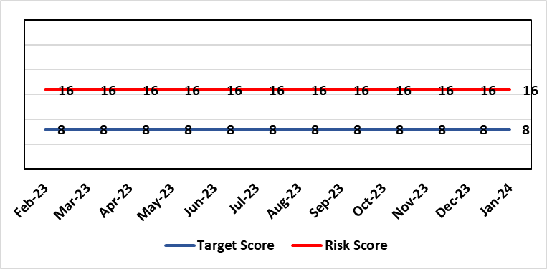 |  | Rationale for current score:  There is no immediate access to crash team/ICU facilities in in Parkway Clinic – the client group are undergoing G/A/sedation. Paediatric GA/Sedation services provided under contract from Parkway Clinic, Swansea continue due to lack of capacity for these patients to be accommodated in Secondary Care.
Level of Control  = 60% |  |  | Rationale for target score:  Relocation of the paediatric GA service [provided by Parkway Clinic] to a hospital site being treated as a priority.
Date added to the HB risk register
4th July 2018
Controls (What are we currently doing about the risk?) |  |  | Mitigating actions (What more should we do?)
Consultant Anaesthetist present for every General Anaesthetic clinic.  Assurance Documentation supplied by Parkway Clinic including confirmation of arrangements in place with WAST and Morriston Hospital for transfer and treatment of patients  New care pathway implemented - no direct referrals to provider for GA.  Multi-drug sedation ceased from Sep 2018 in line with WHC 2018 009  Revised SLA/Service Specification  HIW Inspection Visit Documentation provided to HB  All extended GA cases require approval from paediatric specialist prior to treatment |  |  | Action | Lead |  | Deadline
 |  |  | Transfer of services from Parkway. | Interim Head of Primary Care |  | 31/05/2024
Assurances (How do we know if the things we are doing are having an impact?)  RMC collate referral and treatment outcome data for review by Paediatric Specialist  Regular clinical meeting arranged with Parkway to discuss individual cases/concerns  Regular clinical/ management meeting for CDS/primary care management team to discuss service pathway /concerns/issues arising  Roll out of new pathway to encompass urgent referrals  T&F Group established to lead transfer from community centre to MHSDU. |  |  | Gaps in assurance (What additional assurances should we seek?)  ToR for the task and finish group should continue to include consideration of the pressures on the POW special care dental GA list and this service is considered alongside any plans for the Parkway contract.
Additional Comments / Progress Notes
18/08/2023 – Agreement with the Medical Director to maintain status with utilising Parkway. Suggested that Chief Dental Officer (CDO) be invited to visit Parkway for assurance.

Datix ID Number: 1605  Health & Care Standard: 3.1 Safe and Clinically Effective Care |  |  | HBR Ref Number: 63  Risk Target Date: 30/06/2024 | Current Risk Rating  4 X 5 = 20
Objective: Children, Young People & Maternity Services |  | BAF Ref: 3.6 | Director Lead: Gareth Howells, Executive Director of Nursing and Christine Morrell, Director of Therapies & Health Sciences  Assuring Committee: Quality and Safety Committee
Risk: Screening for Fetal Growth Assessment in line with Gap-Grow (G&G).  There is not enough Ultrasound scanning & clinic capacity within Swansea Bay UHB to offer all women serial ultrasound scan screening in the third trimester in line with the UK perinatal Institute Growth Assessment Programme (GAP). Welsh Government mandate fetal growth screening in line with the GAP programme, which states serial ultrasound growth scans should be performed at three weekly intervals. There is significant evidence of the increased risk for stillbirth or neonatal mortality/morbidity (hypoxic ischaemic encephalopathy) HIE, where a fetus is growth restricted (Intrauterine Growth Restriction - IUGR) and/or small for gestational age fetus (SGA). |  |  | Date last reviewed: February 2024
Rationale for current score:
Current score of 20 is 4 (consequence) x 5 (likelihood). Consequence score of 4 calculated due to the governance and assurance – non-compliance with national standards with significant risk if unresolved and likelihood of 5 as expected to happen daily/>50%.
The service is unable to provide third trimester scans at three weekly intervals in line with the Perinatal Institute recommendations.
Risk Rating
(consequence x likelihood):
Initial: 4 x 3 = 12
Current: 4 x 5 = 20
Target: 3 x 4 = 12
Level of Control
= 60%
Date added to the HB risk register  1st August 2019 |  |  | Rationale for target score:  When the service is able to provide third trimester ultrasound scan in line with GAP recommendations we will be providing care in line with evidence based best national practice as mandated by Welsh Government. Risk Target Date indicates when outcome of potential scanning/review capacity solutions anticipated.
Controls (What are we currently doing about the risk?) |  |  | Mitigating actions (What more should we do?)
All staff are required to complete the GAP GROW e-learning on an annual basis. Compliance is monitored via the Training & Education forum.  A local policy to scan women 4 weekly is in place.  Three qualified midwifery sonographers and a midwifery sonography lead who provides training are in place. One midwife sonographer continues training.  Lead sonographers created a governance process for the review of scan images of babies born with a birth weight centile under 10th centile to identify themes and trends within the department and areas for quality improvement. |  |  | Action |  | Lead | Deadline
 |  |  | Midwives provided until revised target of 30/01/2024 to complete training. CPD Midwives to escalate those non-compliant with training to Deputy Head of Midwifery for emails/meetings with staff members.  New starters have been allocated time as part of their induction to complete GAP Grow training |  | CPD Midwives & Deputy Head of Midwifery | 30/01/2024
 |  |  | Business case to be completed to include administrative support for midwife sonographer clinics to be secured to ensure streamlined service. |  | Maternity service business manager | 30/02/2024
 |  |  | Divisional manager for Women’s health and ophthalmology to arrange meeting with sonography services |  | Divisional Manager (WH&O) | 30/01/2024  Complete
 |  |  | Follow up meeting to discuss scanning & review capacity |  | HOM, Divisional Manager, Midwifery Sonographer lead & Lead for Sonography Department | 06/03/2024
 |  |  | Lead Midwife for QSR, Lead Midwife Sonographer and Lead Digital Midwife to arrange business case for introduction of GAP Grow 2 |  | Lead Midwife for QSR, Lead Midwife Sonographer and Lead Digital Midwife | 30/01/2024
Assurances (How do we know if the things we are doing are having an impact?)  Target 95% Gap Grow training compliance by End November 2023 originally – updated to end January 2024 (W/c 16/10/23 Gap Grow compliance level 72%; w/c 22/01/24 increased to 77%).  Aim is the provision of serial ultrasound scans on a three weekly schedule in accordance with the recommendations from the Perinatal Institute. (Currently the provision of serial ultrasound scans is provided on a four weekly schedule.)  The detection rate of IUGR/SGA will increase leading to improved antenatal management plans and intrapartum planning. We will report a reduced rate of stillbirth and/or neonatal mortality/morbidity with improved management of IUGR/SGA babies.  The administration support for the service will be fully functional.  Lead Sonographers for Singleton and Neath and Lead Midwife sonographer have developed a governance review group to meet monthly to review all ultrasound scan images where there was a baby born under the 10th centile to identify themes and learning for quality improvement. |  |  | Gaps in assurance (What additional assurances should we seek?)  Assurance of maintaining a sustainable third trimester ultrasound service. The provision of serial ultrasound scans on a three weekly schedule in accordance with the recommendations from the Perinatal Institute. (Currently the provision of serial ultrasound scans is provided on a four weekly schedule.)
Additional Comments / Progress Notes
24/01/2023: Meeting held 10th January 2024 between Head of Midwifery, Divisional Manager, Midwifery Sonographer lead & Lead for Sonography Department (within Radiology) to discuss feasibility of more frequent clinics to review scans in addition to scanning capacity. Further discussion required, engaging with consultant colleagues and Radiology, regarding clinic capacity & provision. Follow up meeting after this on 6th March 2024. Re Gap-Grow 2: Meeting on 26/1/2024 to discuss whether business case required.

Datix ID Number: 2159  Health & Care Standard: Safe Care 2.1 Managing Risk & Promoting Health & Safety |  |  | HBR Ref Number: 64  Risk Target Date: 31st March 2024 | Current Risk Rating  4 X 4 = 16
Objective: Delivering Care in Safe, Modern Environments |  | BAF Ref: 7 | Director Lead: Darren Griffiths, Director of Finance & Performance  Assuring Committee: Quality & Safety Committee
Risk: Health & Safety Infrastructure  Insufficient resource and capacity of the health, safety and fire function within SBUHB to maintain legislative and regulatory compliance for the workforce and for the sites across SBUHB. . |  |  | Date last reviewed: February 2024
Risk Rating  (consequence x likelihood):  Initial: 5 x 4 = 20  Current: 4 x 4 = 16  Target: 4 x 3 = 12 |  |  | Rationale for current score:  The Health Board received 12 Health & Safety Executive (HSE) improvement notices during 2019-20 covering various Health & Safety legislative breaches covering a range of areas. There is the potential for future multiple notices for not meeting legislative requirements. Score reduced to 16.
Level of Control  = 70% |  |  | Rationale for target score:  Compliance with the notices and to have sufficient resources to implement a sustainable health and safety provision to support the legal requirements of the Health Board and demonstrate that suitable resources are in place to undertake the roles and responsibilities of the department, also to undertake suitable and sufficient training, provide corporate overview/audit to ensure practices are being employed in the workplace.
Date added to the HB risk register
September 2019

Controls (What are we currently doing about the risk?) |  |  | Mitigating actions (What more should we do?)
- Assistant Director of Health and Safety in post to support strengthening and develop the H&S function to support the organisation. Business case submitted for additional resources.  - Health and Safety Operational Group and the Health and Safety Committee monitor compliance. Refreshed the Fire Safety Group with additional controls in place.  - Fire risk assessments are being prioritised with temporary additional resources put in place in March 2021 to reduce the number of FRA overdue.  - Fire training in place and fire wardens in place  - Fire risk assessment schedule in place for the next 12 months to maintain 100% compliance of completion and is regularly reviewed |  |  | Action |  | Lead | Deadline
 |  |  | It has been agreed to identify posts to progress recruitment on a phased approach over the next 12/24 months. This will be dependent upon availability of funding. |  | Assistant Director of H&S | 31/03/2024
Assurances (How do we know if the things we are doing are having an impact?)  - Monitoring through the appropriate group/committees (H&S committee) to receive assurance and or identify gaps for key compliance and adherence to applicable legislation.  - Site visits/tours to identify compliance and gaps in compliances. |  |  | Gaps in assurance (What additional assurances should we seek?)  Agreement of funding for resources identified in business case to implement structure in business case by Q2/3 2022/23 financial year.
Additional Comments / Progress Notes
15/12/2023: The H&S team will have an additional MH trainer/advisor from 15/01/2024, increasing establishment by 0.5wte. No change to risk score.
06/02/2024: Due to the resignation of a fire advisor and the timeframe to recruit another, there is no change in the current risk rating.

Datix ID Number: 1834  Health & Care Standard: 5.1 Timely Care |  |  | HBR Ref Number: 66  Risk Target Date: TBC | Current Risk Rating  5 X 3 = 15
Objective: Networked Hospital – A Systems Approach – Cancer Care |  | BAF Ref: 3.5 | Director Lead: Raj Krishnan, Acting Executive Medical Director  Assuring Committee: Quality and Safety Committee
Risk: Access to SACT (Cancer Services)  The demand & complexity of planned treatment regime for cancer patients requiring chemotherapy currently exceed the available chair capacity, risking unacceptable delays in access to SACT treatment in Chemotherapy Day Unit with impact on targets and patient outcomes. |  |  | Date last reviewed: February 2024
Risk Rating  (consequence x likelihood):  Initial: 5 x 5 = 25  Current: 5 x 3 = 15  Target: 2 x 2 = 4 | 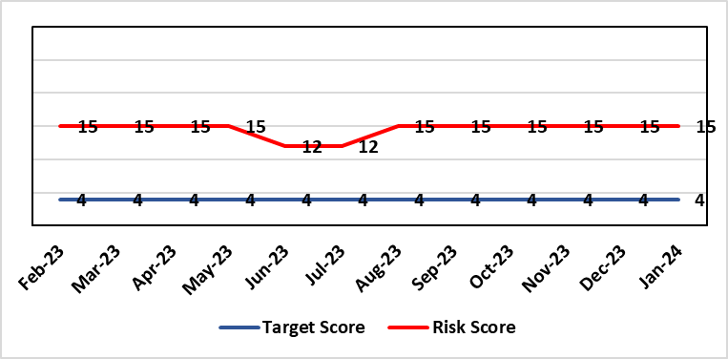 |  | Rationale for current score:  Risk was reduced to 12 in June 2023. Further feedback showed that this was not sustained and that there were still significant workforce challenges in CDU and PTS so the risk was returned to 15.
Level of Control
=
Date added to the HB risk register  30/11/2019 |  |  | Rationale for target score:  Reduced delays in treatment will reduce risk of harm.
Controls (What are we currently doing about the risk?) |  |  | Mitigating actions (What more should we do?)
Review of CDU by improvement science practitioner was completed in 2020. Resulted in change to booking processes to streamline booking process and deferral.  Review of scheduling by staff to ensure all chairs used appropriately.  Business case endorsed by CEO for shift of capacity to home care to be considered by the Management Board  A Daily scrutinizing process in progress to micro manage individual cases, deferrals etc.  Changes made to prescribing & authorising processes to improve workflow for PTS reducing potential delays to supply and administration of treatment.  Responsibility for checking bisphosphonate prescriptions in CDU moved to nursing staff to free up Pharmacy capacity allowing them to focus on key clinical tasks within Pharmacy.  Joint project with Nuclear Medicine to streamline pathways and prioritise SACT patients appropriately halved the average time waiting for MUGA/EDTA tests required before starting SACT. |  |  | Action | Lead | Deadline
 |  |  | A demand and capacity options paper is being prepared within the service and will be presented to Senior Management Team March 2024. | Interim Divisional Manager (Cancer) | 31st March 2024
Assurances (How do we know if the things we are doing are having an impact?)  Additional funding agreed to support increase in nurse establishment to appropriately staff the unit during its main opening hours. Additional scheduling staff also agreed.  Pre-assessment process has been separated from start date in an attempt to fill deferral slots at short notice where possible. Improved communication between MDT to streamline booking and deferral process.  Continue to monitor patient experience via friends and family in conjunction with the Welsh Cancer Patient Experience Survey results under our PTR procedures. Monitoring our waiting times against new SACT metrics, which is a measure based on treatment intent and is no longer reported as average waiting time so is more linked to expected outcomes etc. This performance metric is included in our Cancer Performance report we send to WG and Management Board and internally via governance arrangements with NPTSSG where Oncology services sit.  SBU Capacity Task and Finish group meeting monthly to analysis demand and capacity gap. |  |  | Gaps in assurance (What additional assurances should we seek?)  Capital & Revenue assumptions & resources for second business case for increasing chair capacity in 2022/23 to meet increased demand.  No change to this area which is why the risk remains at 15. A demand and capacity options paper is being prepared within the service and will be presented to Senior Management Team March 2024.  Workforce within Pharmacy remains an issue to increase chair capacity.
Additional Comments / Progress Notes
Action complete: SACT has now relocated onto Ward 9 of the main hospital. Workforce options and further new ways of working will be discussed as part of options paper, April 2024

Datix ID Number: 89  Health & Care Standard: 5.1 Timely Care |  |  | HBR Ref Number: 67  Risk Target Date: 31st January 2024 |  | Current Risk Rating  5 x 3 = 15
Objective: Networked Hospital – A Systems Approach – Cancer Care |  | BAF Ref: 3.5 | Director Lead: Raj Krishnan, Acting Executive Medical Director  Assuring Committee: Quality and Safety Committee
Risk: Risk target breaches – Radiotherapy  Clinical risk-target breaches in the provision of radical radiotherapy treatment. Due to capacity and demand issues the department is experiencing target breaches in the provision of radical radiotherapy treatment to patients. |  |  | Date last reviewed: February 2024
Risk Rating  (consequence x likelihood):  Initial: 4 x 4 = 16  Current: 5 x 3 = 15  Target: 2 x 2 = 4 | 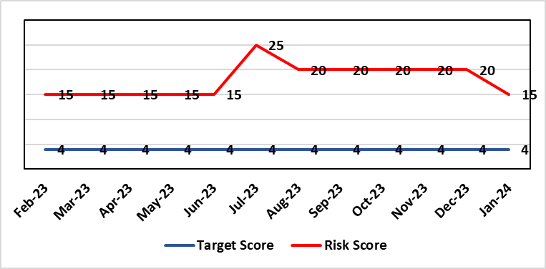 |  | Rationale for current score:  Risk reduced to 15 to reflect the recommissioned CT capacity and currently no single point of failure.
Level of Control
=
Date added to the HB risk register  30/11/2019 |  |  | Rationale for target score:  Reduced delays in treatment will reduce risk of harm.
Controls (What are we currently doing about the risk?) |  |  | Mitigating actions (What more should we do?)
Additional workforce alongside the CT2 recommissioning allows the service to provide the required capacity to meet demand and reduce breaching patients. Having the recommissioned CT simulator operating at 50%, will allow an increase in CT capacity, allowing more patients to be scanned and those scans to be more timely, thereby improving compliance with performance metrics. |  |  | Action | Lead |  | Deadline
 |  |  | Business case for 2nd CT (capital and revenue) has been approved. Funding risk: Ongoing discussions with HDUHB for 50% funding of recommissioned machine until arrival of new CT. Will update BCAG as below:  • Scrutiny Group on 8th Feb,  • Business Case Assurance Group on 22nd Feb  • Approval by Management Board expected 20th March. | Service Manager RT services |  | 31/03/2024
Assurances (How do we know if the things we are doing are having an impact?)  Performance and activity data is being monitored and monthly data shared with radiotherapy management meeting and cancer board. It is also now included in scorecard. The service report the number of patients scanned per month and the time to access a CT scan going forward. |  |  | Gaps in assurance (What additional assurances should we seek?)
Additional Comments / Progress Notes
20/12/2023: Re-commissioning work on CT-Sim 1 has been completed by Radiotherapy Physics. Can be clinically used from 21st December 21st 2023. Discussion to be had at next RTMM (end of Jan) to determine risk score.
26/01/2024: Action completed: Business case for 2nd CT case (capital and revenue) has been approved. Recommissioned machine up and running. Demand and capacity monitored monthly. Risk Reduced to 15 now that there is no single point of failure.

Datix ID Number: 1418  Health & Care Standard: 5.1 Timely Access |  |  | HBR Ref Number: 69  Risk Target Date: See Target Rationale |  | Current Risk Rating  5 X 4 = 20
Objective: Children, Young People & Maternity Services |  | BAF Ref: 3.6 | Director Lead: Deb Lewis, Chief Operating Officer / Gareth Howells, Executive Director of Nursing  Assuring Committee: Quality & Safety Committee
Risk: Risk of issues related to adolescent patients being admitted to Adult MH inpatient wards- Inappropriate settings resulting in 'Safeguarding Issues' The WG has requested that HBs identify Secondary Care in -patient facilities for the care of adolescents- in Swansea Bay University Health Board Ward F NPT hospital is the dedicated receiving facility with one bed identified. |  |  | Date last reviewed: February 2024
Risk Rating  (consequence x likelihood):  Initial: 2 x 3 = 6  Current:5 x 4 = 20  Target: 2 x 3 = 6 |  |  | Rationale for current score:  Every health board is required to have an admission facility for adolescent Mental Health patients. Whilst ward F has been identified as the single point of access in SBU and a dedicated bed is ring-fenced for adolescent admissions it is a mixed sex adult ward. Therefore the facilities are less than ideal for young patients in crisis.
Level of Control
=
Date added to the HB risk register  27/02/2020 |  |  | Rationale for target score:  The longer term aim for the Health Board remains to create an admission facility for adolescent Mental Health patients but this will not be possible until the new Adult Inpatient Unit is built.
Controls (What are we currently doing about the risk?) |  |  | Mitigating actions (What more should we do?)
Safeguarding Training for Staff, Joint protocol with Cwm Taf LHB [CAMHS] currently subject to review, Local SBUHB policy on providing care to young people in this environment. This includes the requirement for all such patients on admission to be subject to Level 3 Safe and Supportive observations.  Only Adolescents within 16-18 age range are admitted to the adult ward.  The health board works with CAMHS to make sure that the length of stay is as short as possible. |  |  | Action | Lead |  | Deadline
 |  |  | Next service group review of effectiveness of current controls. | MH&LD Head of Operations & Clinical Directors |  | 30/06/2024
Assurances (How do we know if the things we are doing are having an impact?)  Individual Rooms with en Suite Facilities, Joint working with CAMHS, monitoring of staff training, Monitoring of admissions by the MH&LD SG legislative Committee of the Health Board. The ongoing issues with the risks presented by the use of this has recently been raised at an all Wales level with Welsh Government and a formal review is anticipated. The Service Group continues to flag the risk particularly in light of Ward F being identified as the SPOA for AMH in the Health Board which has resulted in an increase in acuity and a greater concentration of individuals who are experiencing the early crisis of admission - this has served to increase the already identified risks for young people in the environment. |  |  | Gaps in assurance (What additional assurances should we seek?)
Additional Comments / Progress Notes
12/02/2024: Recent out of hours CAMHS admission to ward F and was then transferred a few days later to the CAMHS regional inpatient unit in CTMUHB. After reviewing the ongoing issues and increased acuity on ward F for the previous 12 months it is agreed that this risk is scored correctly, but will continue to be closely monitored.

Datix ID Number: 2595  Health & Care Standard: 3.1 Safe and Clinically Effective Care |  |  | HBR Ref Number: 74  Risk Target Date: 30/04/2024 |  | Current Risk Rating  3 x 4 = 12
Objective: Children, Young People & Maternity Services |  | BAF Ref: 3.6 | Director Lead: Gareth Howells, Executive Director of Nursing  Assuring Committee: Quality and Safety Committee
Risk: Delay in Induction of Labour (IOL) or augmentation of Labour  Due to staffing and capacity to deal with periods of high acuity in Maternity & NeoNates there is a risk of delays in IOL which can introduce avoidable risk and unnecessary intervention which can lead to poor clinical outcome for mother and/or baby. Delays in IOL lead to increased complaints and decreased patient satisfaction. |  |  | Date last reviewed: February 2024
Risk Rating  (consequence x likelihood):  Initial: 4 x 4 = 16  Current: 3 x 4 = 12  Target: 2 x 3 = 6 | 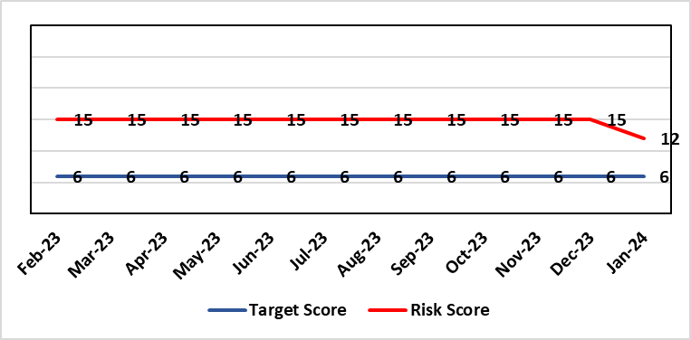 |  | Rationale for current score:  Rationale for score, the likelihood of the score has been revised to 4 due to occurrence being less than daily. The consequence of the score is assessed as 3, moderate under patient safety domain.  Delay in IOL is a less frequent occurrence in maternity care but delays can be for a number of reasons including high acuity and staffing levels in Neonatal unit. While adverse outcomes as a result of delay in care are infrequent, there may be long term consequences for mother and/or baby leading to high value claims. The service group review incidents to review the cause of the delay (acuity, staffing, neonatal capacity) when reviewing incidents to have a better understanding of the factors which contribute impacting delays in IOL and level of harm.  The service group recommend this risk continues on the HBRR, as NICE guidance for IOL is changing with IOL being offered at an earlier gestation. This is likely to have an impact on the current score and risk for the service.
Level of Control
= 60%
Date added to the HB risk register
30th April 2021
Date added to the HB risk register  30th April 2021 |  |  | Rationale for target score:  IOL delays would be minimal with increased patient flow, increased patient satisfaction and prevent avoidable poor outcomes
Controls (What are we currently doing about the risk?) |  |  | Mitigating actions (What more should we do?)
Daily obstetric consultant ward round reviews all women undergoing IOL.  Ongoing/regular monitoring by cardiotocograph for fetal wellbeing during IOL on hold.  Labour ward coordinator and labour ward obstetric lead ensure women on ward 19 for IOL are factored into daily planning of workload on labour ward.  Obstetric consultant review when IOL on hold for appropriate plan of care.  The MDT (Obstetric, Neonatal and Midwifery) consider individual risk factors and Escalation Policy is implemented. Neighbouring maternity units are contacted to ask if they are able to support by accepting the transfer of women.  Daily acuity is gathered and sent to the senior midwifery management team who can anticipate potential problems and support the clinical team. The matron of the unit is contacted in office hours and the senior midwife manager on call is contacted out of hours. If required midwifery staffing are redeployed including the specialist midwives and the community midwifery on call team. |  |  | Action | Lead |  | Deadline
 |  |  | See Actions in relation to Critical Midwifery Staffing risk (HBRR ref 81) the result of which should minimise disruption in IOL. | See HBR 81 |  | See HBR 81
 |  |  | Working group to be developed for the review of Induction of labour including review of criteria and guideline | Operational Midwife for Antenatal ward. |  | Meeting in January 2024
Assurances (How do we know if the things we are doing are having an impact?)  The below measures will be reviewed to monitor this risk:  Numbers of IOL delays; Number of adverse events for which IOL delay is causal factor; Number of complaints relating to experience of delay in IOL |  |  | Gaps in assurance (What additional assurances should we seek?)
Additional Comments / Progress Notes
24/01/24: Risk score has been reduced reflecting reduced frequency of IOL and low level of associated adverse outcomes. Meeting regarding dilapan scheduled for 31st January 2024, and the risk will continue to be closely monitored.

Datix ID Number: 2522  Health & Care Standard: 5.1 Timely Care |  |  | HBR Ref Number: 75  Risk Target Date: TBC |  | Current Risk Rating  5 x 2 = 10
Objective: Services working effectively through a systems approach |  | BAF Ref: 3 | Director Lead: Deb Lewis, Chief Operating Officer  Assuring Committee: Performance and Finance Committee
Risk: Whole-Service Closure  Risk that services or facilities may not be able to function if there is a major incident or a rising tide that renders current service models unable to operate |  |  | Date last reviewed: February 2024
Risk Rating  (consequence x likelihood):  Initial: 5 x 4 = 20  Current: 5 x 2 = 10  Target: 5 x 1 = 5 | 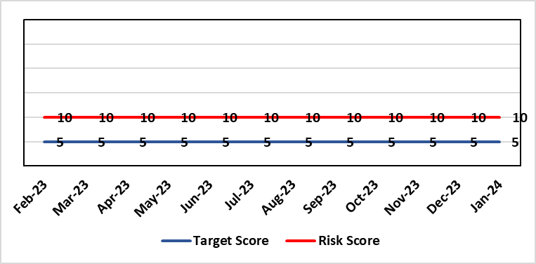 |  | Rationale for current score:  Risk reflects transition to business as usual as part of living with Covid strategy. BCP plans in place. There is still fluctuation in patient numbers and new variants continue to emerge so score maintained as watching brief.
Level of Control  = 25% |  |  | Rationale for target score:  The strategy of moving towards living with Covid will eventually lower the risk level to target.
Date added to the HB risk register
May 2021
Controls (What are we currently doing about the risk?) |  |  | Mitigating actions (What more should we do?)
- Sites have business continuity plans and the impact of one site being overwhelmed by COVID demand has been reviewed.  - Monitoring of associated risks has been being transferred to appropriate forums such as UEC Board, Elective Care Board and Nosocomial Group with overall oversight by Management Board.  - Ongoing surveillance of epidemiology data for early warning and further change to risk level via live Covid dashboard. |  |  | Action | Lead |  | Deadline
 |  |  | Periodic review of risk | COO |  | See Notes Below
Assurances (How do we know if the things we are doing are having an impact?)  Monitored via Management Board for early warning signs. |  |  | Gaps in assurance (What additional assurances should we seek?)
Additional Comments / Progress Notes
03/11/2023: Consideration currently being given to replacement of this risk with fresh entry on wider organisational business continuity arrangements

Datix ID Number: 1832  Health & Care Standard: : 3.1 Safe and Clinically Effective Care |  |  | HBR Ref Number: 80  Risk Target Date: 31/03/2024 |  | Current Risk Rating  4 x 5 = 20
Objective: Networked Hospitals – A Systems Approach – Urgent & Emergency Care |  | BAF Ref: 3.3 | Director Lead: Deb Lewis, Chief Operating Officer  Assuring Committee: Quality & Safety Committee
Risk: Transfer of Clinical Optimised Patients  If the Health Board is unable to discharge clinically optimised patients there is a risk of harm to those patients as they will decompensate, and to those patients waiting for admission. |  |  | Date last reviewed: February 2024
Risk Rating  (consequence x likelihood):  Initial: 4 x 5 = 20  Current: 4 x 5 = 20  Target: 4 x 2 = 8  Level of Control  = 25% |  |  | Rationale for current score:  - Sustained levels of clinically optimised patients (COPs) leading to overcrowding within ED, use of inappropriate or overuse of decant capacity in ED and delays in accessing medical bed capacity, clearly emerged as themes.  - Constraints in relation to all patient flows out of Morriston to a more appropriate clinical setting, identified and included in an expanded risk.  - Delay in discharge for clinically optimised patients can result in deterioration of their condition.
Rationale for target score:
Targeted reduction of Clinically Optimised patients remains a priority for the HB in order to minimise risk of avoidable harm to patients within the HB and in the wider community.
Date added to the risk register
May 2021
Controls (What are we currently doing about the risk?) |  |  | Mitigating actions (What more should we do?)
- Clinically optimised numbers are monitored and reviewed weekly by the MDU. Delays are reported and escalated to try to ensure timely progress along a patient's pathway.  - Review on a patient by patient basis – with explicit action agreed in order to progress transfer to appropriate clinical setting.  - Critical constricts in relation to access/time delays for social workers and assessment for package of care and social placement – lead times in excess of 5 weeks.  - Patient COVID-19 status has added an additional level of complexity to decision making.  - The health board has procured 63 additional care home beds to provide additional discharge capacity.  - Clinically optimised patients have been cohorted into the available capacity at Singleton Hospital to ensure that their needs can be met more appropriately. This has reduced the number of COPs at Morriston Hospital. Weekly escalation meetings are held with health and social service colleagues to ensure the requirements of the patients are reviewed and patients are pulled through the system where possible. |  |  | Action | Lead |  | Deadline
 |  |  | Paper highlighting outputs and lessons learned from the implementation of the Patient Assessment Team to be considered by UEC Board to inform further actions / next steps. | Medical Director / HON (Transformation) |  | 31/03/2024
Assurances  (How do we know if the things we are doing are having an impact?)  - Patient level dashboard allows breakdown by delay type Close management of utilization of additional care home beds. |  |  | Gaps in assurance  (What additional assurances should we seek?)
Additional Comments
09/10/2023: IDH pilot completed, data being analysed, initial review shows a positive impact on turning patients around at the front door. Roll out to be completed in Q3.
13/02/2024: Action completed: Patient Assignment Team (PAT) element of an Integrated Discharge Hub is in place. There are further potential elements that have not be implemented, but are to be considered next – a Ward-based facilitation team and a Complex Discharge Team. A paper will submitted for consideration by the UEC Board (currently planned for 6th March). It will highlight the outputs and lessons learned from the implementation of a PAT in order to support discussion of next steps including consideration of the additional teams not currently in place.

Datix ID Number: 2788  Health Care Standards: 7.1 Workforce |  |  | HBR Ref Number: 81  Risk Target Date: 30/04/2024 |  | Current Risk Rating  5 x 4 = 20
Objective: Children, Young People & Maternity Services |  | BAF Ref: 3.6 | Director Lead: Gareth Howells, Executive Director of Nursing  Assuring Committee: Quality & Safety Committee  For Information: Workforce OD & Digital Committee
Risk: Critical staffing levels – Midwifery  Unplanned absences resulting from long and short-term sickness, alongside maternity leave, have resulted in critical staffing levels, which undermine the ability to maintain the full range of expected services safely, increasing the potential for harm, poor patient outcomes and/or choice of birthplace. Poor service quality or reduction in services could impact on organisational reputation. |  |  | Date last reviewed: February 2024
Rationale for current score:
The vacancy position has improved further and for Band 5 & 6 registered staff there are no vacancies. Some aspects of service provision continue to be suspended and this is subject to review currently. In view of this the risk was reduced from 25 to 20 initially. Whilst the service is now over-established with registered midwives, the score remains as high risk (20) due to unregistered vacancies (which we are recruiting to) and unavailability (due to parenting leave and sickness). There are improved numbers of registered midwives per shift with most shifts achieving the required 14 midwives.
Risk Rating  (consequence x likelihood):  Initial: 4 x 5 = 20  Current: 5 x 4 = 20  Target: 4 x 4 = 16 | 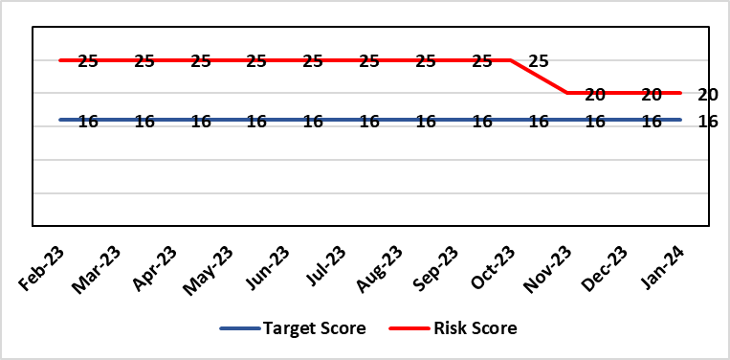
Level of Control  = % |  |  | Rationale for target score:  It is intended that through actions currently identified to address vacancies we can reinstate services fully and reduce the likelihood of the need to suspend elements further.
Date added to the risk register
12/10/2021
Controls (What are we currently doing about the risk?) |  |  | Mitigating actions (What more should we do?)
- Service Group Nurse Director chairs fortnightly roster scrutiny meetings to ensure effective deployment of staff.  - All midwives are working at the hours they require up to full time.  - Specialist midwives and management redeployed to support clinical care as required  - Birth rate plus Intrapartum acuity tool completed 4 hourly to guide safe service provision and escalation;  - Escalation meeting held daily during the week to review rotas and reallocate staff as required chaired by Head of Midwifery  - Morning safety huddle for community midwifery teams  - Morning safety huddle for obstetric unit generates RAG-rated daily acuity and shares this with the Service Group for its daily meeting.  - Additional shifts offered via Bank, additional hours and overtime at enhanced rates  - Utilisation of off-contract midwifery agency authorised by Executive Director of Nursing  - Open advert for recruitment on TRAC (recruitment system)  - On-Call Manager Rota in place.  - Continue to suspend services in the FMU (Freestanding Midwifery Unit) at Neath Port Talbot Hospital.  - International recruitment campaign initiated with MEDACS.  - Offer of additional support worker shifts particularly in the postnatal area for additional support for women  - Maternity Care Assistance (MCA) role in place to support Midwives in providing care in women and their families.  - Regular communication with stakeholders includes: Early warnings to Welsh Government; Verbal and formal communication with Llais; Internal communications on home births, RCM updates; weekly staff briefings and bulletins.  - Maternity Services Improvement & Assurance Board has been instated, meeting fortnightly, chaired by NPTS Nurse Director. This will report into the Midwifery & Neonatal Service Performance Board in place chaired by EDON |  |  | Action | Lead |  | Deadline
 |  |  | Advertising for Community Team Leaders (Band 7) to support plans to re-open services in Neath Port Talbot. | Community Matron / Consultant Midwife |  | 30/04/2024 (expected in post)
 |  |  | Shortlisting 5 WTE (whole time equivalent) Band 2 HCA (health care assistant) positions at Singleton. | Obstetric Matron |  | 31/03/2024 (expected in post)
 |  |  | Developed Escalation Policy – to be ratified. | HOM |  | 31/01/2024
 |  |  | Gateway review in place in relation to reinstatement of community services, first point is recruitment of band 7 community team leaders | HOM |  | End February 2024
Assurances (How do we know if the things we are doing are having an impact?)  The following assurance mechanisms in place currently:  Birth-rate Plus Intrapartum acuity tool completed 4 hourly  Daily staff escalation meetings chaired by Head of Midwifery which considers sickness & other absences and daily review of safety and quality outcomes. The Group Head of Quality Safety & Risk is supporting daily oversight of Datix incidents. The following red flag events are monitored:  • Delayed or cancelled elective caesarean sections;  • Missed or delayed care incidents;  • Delayed or cancelled induction of labour;  • Delay of 2 hours or more between admission for induction of labour and beginning of process;  • Delay of 30 minute or more between presentation and triage.  Birthrate Plus assessment outcome (last internal assessment Oct 2023 – now compliant) |  |  | Gaps in assurance (What additional assurances should we seek?)
Additional Comments / Progress Notes
24/01/2023: Actions completed: Development and dissemination of the organisational change to practice (OCP). Phase 1 consultation period closed. Outcome has been reviewed and further work undertaken to resolve; and OCP Phase 2 consultation period closed 24th Oct 2023 – Outcome reviewed and actions complete; Response to both OCPs issued to staff.
Transformational work is ongoing within community services to reinstate services in NPT Freestanding Midwifery Unit. Maternity Services Improvement & Assurance Board has been instated, meeting fortnightly, chaired by Neath Port Talbot Service Group Nurse Director. This will report into the Midwifery & Neonatal Service Performance Board in place chaired by Executive Director of Nursing. Re-opening of services will be subject to gateway review process.

The Risk Score for Critical Midwifery Staffing remains at 20 (ID 2788) with community intrapartum pathways remaining suspended to mitigate staffing constraints. There were a number of control measures and actions already in place to mitigate staffing shortfalls with additional actions put in place to support safe staffing. The following continue:

- Continued enhanced bank rate with rolling recruitment advert
- Proactive engagement with agencies to determine agency capacity and block bookings
- Central resourcing team fast tracking on-boarding recruitment
- Open rolling advert for registered midwives
- Twice weekly oversight at 1pm Safe Staffing Huddle, chaired by HOM or DHOM
- Addition of a focused Safety Huddle at 9.30 am attended by Ward Managers, Matrons, Deputy Head of Midwifery, Head of Midwifery, Lead Midwife for Quality and Intrapartum Lead Midwife to highlight safety events, emerging risks, acuity
- An agreement to “over establish” in the coming months to provide further support during this period of transition.

Workforce Investments - A phased investment of £750K confirmed

The Head of Midwifery has been substantively recruited into and to strengthen midwifery leadership, and in line with the Royal College of Midwives manifesto to introduce Director of Midwifery posts, the post of a Clinical Director of Midwifery will be introduced as part of the Service Group structure to strengthen strategic and operational delivery of maternity services.

Table 1 identifies the current vacancy position in the Maternity Service

Obstetric Unit
Band | Title | Vacancy
Band 7 | Ward Manager | 0.74 WTE
Band 5/6 | Registered Midwife | 0
Band 3 | Maternity Care Assistant | 0
Band 2 | Health Care Assistant | -7.21 WTE

Datix ID Number: 2561  Health & Care Standard: Effective Care 3.1 Safe & Clinically Effective Care |  |  | HBR Ref Number: 85  Risk Target Date: 31st December 2023 | Current Risk Rating  4 x 5 = 20
Objective: Children, Young People & Maternity Services |  | BAF Ref: 3.6 | Director Lead: Christine Morrell, Director of Therapies & Health Sciences  Assuring Committee: Quality & Safety Committee
Risk: Non-Compliance with ALNET Act There are risks to the Health Board’s ability to meet its statutory duties and establish the effective collaborative arrangements required by the ALN Act, which is being implemented through a phased approach. This risk is caused by:  - Lack of staff resource needed to carry out the additional work needed to comply with the ALN Act for operational services, especially those in the PCST Service Group.  - Issues around multi-agency working which may impact on levels of demand on operational services, and on existing SLAs through which the Health Board delivers some services to partner LAs.  - Implementation of the Act for those of above compulsory school age (post-16) commenced in September 2023. This presents risks because of gaps in service provision.  - Multiple pressures for operational services are impacting on capacity / engagement of leads within impacted services to progress tasks that need to be undertaken to mitigate the risks and current vacancy in ALN Project Manager post.  - Issues with Data Quality due to pressure on ALN and Service administration teams, process issues and absence of a robust system to enable data capture and analysis. This means that accurate and up-to-date data regarding the Health Board’s compliance is not available.  Potential consequences of this risk are: non-compliance with statutory duties, parent / carer and young peoples' dissatisfaction leading to complaints. Educational Tribunals and Judicial Reviews (this is new legislation with many points of ambiguity and is highly likely to be legally ‘tested’); reputational impact; and children failing to access the multi-agency support that they need with their learning needs, leading to poor outcomes. |  |  | Date last reviewed: February 2024
Rationale for current score:
Risk score reflects that while controls are in place, there are multiple areas of risks (relating to compliance with legislation; governance and assurance; workforce and OD; and sustainable services); and high probability (especially given multiple risk areas) of at least one of these areas of risk being realised. Caused by implementation timetable for the ALN Act, slippage against plan and need for strengthened governance (as described in ‘Risk’ section).

Risk Rating  (consequence x likelihood):  Initial: 5 x 5 = 25  Current: 4 x 5 = 20  Target: 2 x 3 = 6 |  |  | Rationale for target score:  As the ALN Act is new legislation, there remains some ongoing likelihood of risk events during the initial phases of implementation, though with lessened consequences as a result of mitigating actions.
Level of Control
=
Date added to the HB risk register
14/05/2022
Controls (What are we currently doing about the risk?) |  |  | Mitigating actions (What more should we do?)
- Progressing the necessary work within an appropriate structure (see under ‘ACTIONS’) are constrained by financial and/or service delivery pressures.  - DECLO (Designated Educational Clinical Lead Officer) is in post - this is a statutory requirement.  - Health Board ALN Steering Group has been established, with governance structure in place involving the ALN Operational Group working under the governance of this  - Operational processes through which the Health Board fulfils its statutory duties under the ALN Act are in place.  - Ongoing collaboration between the DECLOs at a national level ensures a broadly consistent approach across Wales to how Health Boards fulfil their requirements under the ALN Act. Some ongoing differences remain because of different Local Authority approaches, through Welsh Government have formed a national group to support improved consistency around Health-Education collaboration through the ALN Act.  - Regarding demand / capacity and staffing resource challenges, WG has a phased implementation timetable that has recently been extended from summer 2024 to summer 2025. From summer 2025, the Act will be fully in ‘delivery as usual’. The phased implementation offers partial short-term mitigation of the risks.  - Awareness has been raised at Board level through Development session and bi-monthly updates are provided to the Patient Safety & Compliance Group.  - Welsh Government have been engaging with the Designated Education Clinical Lead Officers on a national basis regarding ALN key performance indicators and compliance. A Welsh Health Circular requiring regular reporting against statutory key performance indicators is anticipated in the coming months.  - Audit and Assurance Services have conducted an audit of the Health Board in relation to the ALN Act, which provided an overall ‘limited assurance’ rating. Management responses have been developed and a work plan is in place, monitored through the ALN Steering Group, to address issues identified in the audit. |  |  | Action | Lead | Deadline
 |  |  | Collaboratively with partner LAs review progress and establish ALN implementation priorities for 23/24 school year | DECLO | 29/02/2024
 |  |  | Work with Informatics colleagues to ensure robust data regarding compliance, for which it is anticipated that national reporting will required. Activity is ongoing nationally to establish the national dataset. | DECLO & Director of Digital | 29/03/2024
 |  |  | Development and implement administrative operational model to support accurate data capture | DECLO | 31/03/2024
 |  |  | Effective, realistic operational processes - Activity to ensure operational processes through which statutory duties are fulfilled balance statutory duties and the ethos of the ALN Act with the need to deliver requirements without additional resource. | DECLO | 20/12/2024
 |  |  | Securing longer-term administrative and project management support needed to mitigate risks | DoTHS | 29/03/2024
 |  |  | Progress action plan in relation to ALN audit | DECLO | 30/09/2024
Assurances (How do we know if the things we are doing are having an impact?)  - There is regular reporting in respect of the ALN Act through the Patient Safety and Compliance Group.  - ALN Steering Board has been established, ensuring oversight at a senior level within all impacted operational and corporate areas.  - DECLO meets regularly with ADOTHS / DoTHS of the 3 health boards of South-West and Mid Wales for update and assurance.  - National ALN Reform Steering Group has been formed and will include Health representation (SBU Deputy DOTHS). This will provide a national forum for consideration of risks. |  |  | Gaps in assurance (What additional assurances should we seek?  - Extent of gap in staffing resource (gap between work required and capacity available) has been provisionally quantified, but data is imperfect and there remains some uncertainty. This is in a context where demands will increase significantly over the next year.
Additional Comments / Progress Notes
09/02/2024: Action closed: Limited progress on activity to assess the demand / capacity implications of the Act for operational services has been discussed in the ALN Steering Group, where there was agreement that in the current financial climate it is unlikely to be an effective use of time to invest significant energies in assessing demand / capacity implications in order to produce a business case. Energies should instead be in collaboration with partners to maximise process efficiencies and deliver the requirements and intentions of the Act as effectively as possible without additional resource for operational services. This existing action has therefore been closed.
Regarding development of an ALN data infrastructure to enable assurance to be provided that the Health Board is fulfilling its duties under the ALN Act, a neighbouring Health Board (Powys Teaching Health Board) are developing an App and there has been dialogue between Powys and Swansea Bay digital services regarding the adaption of this App for use in SBUHB. Use of the App would help ensure reliable data capture and would mitigate current risks regarding administrative capacity. The request foir digital support is currently going through the DPRG process, and progress is subject to the outcome of this process. Deadline date has been adjusted accordingly.
Absence of Project Management support has delayed progress in finalising the ALN priorities and workplan for the period to July 2024. Deadline date has been adjusted.
Action closed: Activity regarding SLAs is being progressed within the PCST Service Group and risks associated with this are being managed and monitored within the service group. This action has therefore been removed from the HBRR to avoid duplication.
An interim solution to the ALN Project Manager post has been identified and an individual has commenced in post, working through to March 2024. Conversations are ongoing between the DoTHS and the Director of Finance about how to strengthen the corporate staffing infrastructure for ALN, in order to support progress moving forward.
Audit and Assurance Services have undertaken an audit of the Health Board’s implementation of the ALN Act and provided an overall ‘limited assurance’ rating. An action plan has been developed to progress the management responses to the issues raised in the audit, and thereby improve the level of assurance the Health Board has regarding meeting the Act’s requirements.

Datix ID Number: 3071  Health Care Standards: Staff & Resources 7.1 Workforce |  |  | HBR Ref Number: 89  Target Risk Date: 31/06/2024 | Current Risk Rating  4 x 5 = 20
Objective: Primary & Community Care |  | BAF Ref: 3.1 | Director Lead: Gareth Howells, Executive Director of Nursing (lead) / Deb Lewis, Chief Operating Officer (support)  Assuring Committee: Quality & Safety Committee
Risk: Healthcare Nursing Staff Levels at HMP Swansea  There is a risk that the men in HMP Swansea will not receive the appropriate standard of care. This is due to the fact that the nursing establishment within the prison no longer fully meets the changed demographics and numbers of men being detained. The maximum operational capacity of the Prison can reach circa 480 men. The Health Board investment into the Prison is based on delivering services to 250 men. This was also highlighted as a risk in the June 2022 HIW governance review. In addition there is no head room built into the Prison nursing establishment so periods of sickness, leave and study renders the roster short. |  |  | Date last reviewed: February 2024
Risk Rating  (consequence x likelihood):  Initial: 4 x 5 = 20  Current: 4 x 5 = 20  Target: 2 x 2 = 4 | 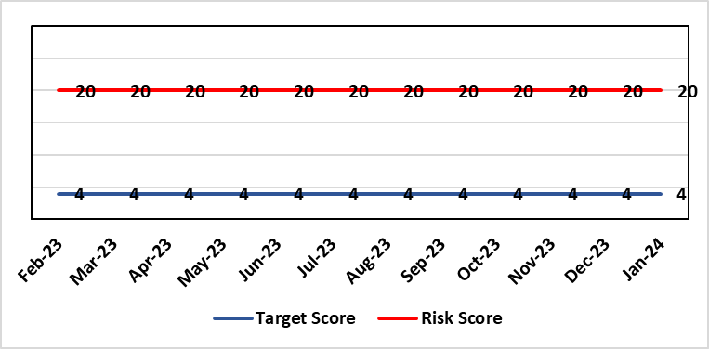 |  | Rationale for current score:  Consequence major – unable to fully deliver on the recommendations of HIW due to low healthcare staffing numbers, further impacted during periods of sickness or absence as no headroom. Recommendations also raised in Prison & Probation Ombudsman reports. Likelihood expected – suboptimal care provided on a daily basis.
Level of Control  = % |  |  | Rationale for target score:  Consequence minor – With sufficient staffing numbers the prison will be able to deliver on HIW recommendations and fully implement the actions in the Health Delivery Plan. Likelihood unlikely – With full establishment and headroom, suboptimal care is less likely.
Date added to the risk register
30/11/2022
Controls (What are we currently doing about the risk?) |  |  | Mitigating actions (What more should we do?)
Daily communication with the Governor about the availability and priority of healthcare nursing staff.  Pharmacy technician role established – can administer drugs to support nursing establishment.  Agreed that Health Care Support Workers to be 2nd checkers for CD drugs and to support substance withdrawal monitoring (awaiting accreditation).  Bank and agency staff are used in a limited way, when skillset allows.  E-roster implemented and scrutinised with regular reporting to Service Group Patient Safety & Compliance Group.  Escalation for overtime and additional hours to fill shortfalls. |  |  | Action | Lead | Deadline
 |  |  | HCSW second checkers of CDs to be accredited externally. | Healthcare Lead | 31/03/2024
 |  |  | Management Board paper to be presented setting out the current position and next steps. | Service Group Director (PCT) | 29/02/2024
 |  |  | Fresh Gap analysis to be undertaken to identify staffing shortfall and set out further proposals to address. | Service Group Director (PCT) | 30/04/2024
Assurances (How do we know if the things we are doing are having an impact?)  Prison feedback and complaint process  Progress reporting on action plans through Service Group PS&C Group, and Health Board Q&S structures (via Patient Safety & Compliance Group). |  |  | Gaps in assurance (What additional assurances should we seek?)  Implementation and reporting of clinical audits. Audit framework for HMP Swansea in development - Clinical Pathways/Audits and Health Promotion groups taking forward.
Additional Comments
27/11/2023: The Health care leads have only the capacity to support the clinical and operational aspects whilst performance, assurance and health promotion work is secondary. PCTG has not been able to identify recurrent funding post the 31st March 2023 to bolster the nurse roster. Action to establish task & finish group added. This will meet in early January 2024 and will focus on the following areas:
• Scope of the development work
• Current staffing challenges
• Clinical pathway development
• Benchmark with other models of care
• Specific areas of focus - Priority areas
• Who needs to be involved
• Updating Management Board
• Progress against the HIW Action plan
• Funding moving forward
22/01/2024: Actions Completed: Discussion in relation to internal sources of funding following cessation of the SLA with CTM – the Mental Health In-Reach team are now dedicated to Swansea; Task and finish group established between PCTSSG & MHLDSG – Executive Director of Nursing in Chair; Through Prison Partnership Board opportunities to implement the recommendations of HIW and Health Delivery Plan explored and progress reviewed at PCT Q&S Group – the Task & Finish Group is now reviewing opportunities and a programme of work set out as above.

A paper is being developed for presentation to the Management Board setting out the current position; this is to be followed by fresh gap analysis and proposals on how to address staffing issues and take forward the remaining work including the actions agreed within the Health Delivery Plan.

Two groups – Clinical Pathways/Audits and Health Promotion Groups have been established to take forward actions. Discussion is underway with Public Health colleagues to explore additional funding to cover vaccination and the Liver Plan.

Datix ID Number: 2796  Health Care Standards: Effective Care Standard 3.5 Record Keeping |  |  | HBR Ref Number: 90  Target Risk Date: 30th April 2024 |  | Current Risk Rating  4 x 4 = 16
Objective: Adopting and Developing Innovative Digital Solutions to Support Care Delivery |  | BAF Ref: 5 | Director Lead: Matt John, Director of Digital  Assuring Committee: Workforce OD & Digital Committee
Risk: Non-compliance with UK-GDPR Article 15 regarding Subject Access Requests (SARs), along with other health records requests for disclosure of personal data  The Health Board does not have adequate resources to deal with the sustained increase in volume and complexity of subject access /access to health records requests received from requestors. The ICO are already involved with a number of breaches and complaints in this area and there is the potential for future enforcement action if significant improvements are not made. Misfiling and redaction are major issues for Health Records, IG and Health Professionals. SAR breaches have led to successful compensation claims and media interest. |  |  | Date last reviewed: February 2024
Rationale for current score:
C – The Health Board has a statutory requirement to comply with UK GDPR and Data Protection Act 2018. This includes compliance with an individual’s Right to Access their personal data. The Information Commissioner has the power to take enforcement action, including substantial monetary penalties, for non-compliance. A number of complaints regarding the handling of SARs within SBUHB have been highlighted in both the mainstream media and on social media, leading to a loss of trust in the Health Board with damage to staff and Health Board reputation.
L- The Health Board does not have adequate resources to deal with the sustained increase in volume and complexity of SARs received from both patients and staff. There are inconsistent processes across the Health Board, with varying levels of robustness regarding legislative compliance. The increased use of various digital applications has impacted the volume and complexity of content and the ability to retrieve the personal data required to comply with SARs. The process for ensuring information is appropriately reviewed and redacted has become far more complex and resource intensive increasing the likelihood of personal data breaches and/or non-compliance with legal timescales. The ICO are already involved with a number of complaints in this area and there is an increased potential for future enforcement action if significant improvements are not made.
Risk Rating
(consequence x likelihood):
Initial: 4 x 4 = 16
Current: 4 x 4 = 16
Target: 4 x 2 = 8
Level of Control  = 50% |  |  | Rationale for target score:  C – As above  L – Additional resources would allow the organisation to make significant improvements to the process by which SARs are managed. Being able to adequately comply with legislative requirements reduces the likelihood of enforcement action and fines from the ICO, as well as minimising the risk of reputational damage.
Date added to the risk register
Jan 2023
Controls (What are we currently doing about the risk?) |  |  | Mitigating actions (What more should we do?)
- SAR (Subject Access Request) Task & Finish Group established  - Prioritisation of workload  - Existing policies and processes in place (to be reviewed & updated)  - Advice sought from Legal and Risk on complex cases  - Legal and risk completing redaction tasks on complex and lengthy cases  - Quarterly SARs report submitted to IGG (Information Governance Group) |  |  | Action | Lead |  | Deadline
 |  |  | Re-establish SAR Working Group to perform GAP analysis and produce action plan | Data Protection Officer |  | 31st July 2024
 |  |  | Implement priority tasks outlined within the action plan within agreed timescales | Data Protection Officer |  | 31st December 2024
Assurances (How do we know if the things we are doing are having an impact?)  - Quarterly IGG chaired by SIRO (Senior Information Risk Owner) and attended by Deputy Caldicott Guardian and Data Protection Officer  - Quarterly briefing from IGG to Management Board & Workforce OD & Digital Committee  - IG governance structures in place with key roles and responsibilities established e.g. SIRO, Caldicott Guardian (Deputy), DPO (Data Protection Officer) |  |  | Gaps in assurance (What additional assurances should we seek?)  Recent internal audit identified the requirement to invest in resources to address gap in assurance.
Additional Comments / Progress Notes
09/10/2023 – SAR Lead starting date confirmed as the 30th October 2023.
16/11/2023 – SAR Policy approved by WODDC in October 2023. Previous action to review all SAR documentation amended to indicate re-establishment of SAR working Group to perform gap analysis.

Datix ID Number: 3432  Health & Care Standard: Safe Care 2.7 Safeguarding Children and Safeguarding Adults at Risk |  |  | HBR Ref Number: 91  Risk Target Date: 31/03/2024 |  | Current Risk Rating  4 x 4 = 16
Objective: Mental Health & Learning Disability |  | BAF Ref: 3.2 | Director Lead: Gareth Howells, Executive Director of Nursing  Supporting Director: Hazel Lloyd, Director of Corporate Governance  Assuring Committee: Mental Health Legislation Committee  For Information: Quality and Safety Committee
Risk: There is a risk that assessments under the Mental Capacity Act (MCA) are not undertaken and recorded as required.  This is caused by:  - There is no identified MCA structure or designated resource to support the implementation and compliance with MCA across the organisation  - Recent DoLS (Deprivation of Liberty Safeguards) audits show that there are significant deficits in knowledge and awareness of the MCA in some areas, which could result in the Health Board failing to meet its statutory responsibilities.  - Lack of funded budget for Health Board Level 2 and 3 training and a lack of coordination in the review and development of training content  - No agreed structure for oversight and management of HB IMCA (Independent Mental Capacity Advocate) contract  Where the UHB fails in its statutory duty to enact the MCA appropriately this could result in harm to vulnerable individuals, and/or unlawful deprivations of liberty, leading to litigation. Such cases could incur significant financial penalties, cause distress to staff members and patients, and risk damage to the organisations reputation. |  |  | Date last reviewed: February 2024
Rationale for current score:
- The implementation of the MCA is accountable to the Court of Protection, which is a higher-level court equivalent to the High Court. This means that decisions carry precedence and fines are considerably higher and often high profile.
- There is a mixed approach to referral to the Court of Protection, and as such a need to improve the Governance structures around this. There is no current central system up to date with current court of Protection cases
- There is no local agreed MCA Policy in place, although the MCA has associated guidance which provides advice on implementation
- Standard operating procedures have been identified as necessary relating to elements required under the act, but there is a need for these to be centrally identified developed and managed.
- It is difficult to access percentage compliance data with MCA training due to the ongoing challenges with ESR
- This risk is linked to HBRR 43: Deprivation of Liberty and the work ongoing in this area overseen by a Task & Finish Group.
Risk Rating  (consequence x likelihood):  Initial: 4 x 4 = 16  Current: 4 x 4 = 16  Target: 4 x 2 = 8 | 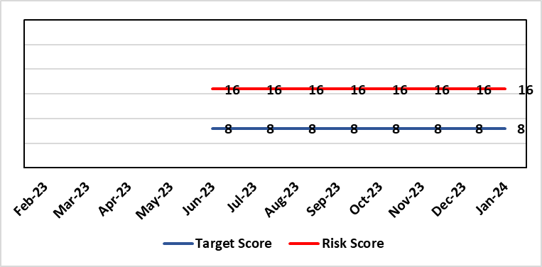 |  | Rationale for target score:  Consequences noncompliance for the Health Board will not change.  Addressing the oversight and Governance will reduce the likelihood of non-compliance.  The Risk Target Date reflects timescale for the MCA lead to take up position and the establishment of governance structures & processes.
Level of Control
=
Date added to the HB risk register
June 2023
Controls (What are we currently doing about the risk?) |  |  | Mitigating actions (What more should we do?)
- Director level responsibility confirmed in principle with the agreement to host the MCA / DoLS structure from April 2024. Head of Nursing MCA to continue to coordinate the various elements in the interim.  - Appointed a band 5 business manager and a band 6 professional development nurse 0.6 to support the coordination of the elements relating to MCA and support the service groups with application in practice.  - Agreement by the PCTSG Board in principle for PCT to host a combined MCA / DoLS team but not to include IMCA or Court of Protection at this point in time.  - Urgent support in practice is provided by the DoLS team lead and there are now three Best Interest Assessors in post to support increased monitoring of compliance and access to advice.  - Escalated and the Director of Nursing and Patient Experience has established a task and finish group to ensure any gaps in compliance are managed, the service is future proofed, and accountability agreed  - Core health board training remains in place. A review has demonstrated low compliance linked to the efficacy of the training to support the practical needs of front line staff. An all Wales benchmarking process showed training delivered in house to be more effective. The development of a training post will support delivery of training more flexibly to meet the needs of clinical staff.  - Corporate Head of Nursing is working with Corporate Governance and Service Delivery Group Governance leads to identify concerns, work to address these and ensure that those responsible for the local implementation of the MCA are aware of their responsibilities. |  |  | Action | Lead |  | Deadline
 |  |  | A review of training has been placed on the agenda for the MCA / DoLS / Subgroup of the West Glamorgan Safeguarding Board – Agreed to a regional approach to reviewing and planning MCA DoLS training. | Head of Nursing MCA |  | 20th January 2024
Assurances (How do we know if the things we are doing are having an impact?)  - Corporate Head of Nursing will provide regular updates and reports to Mental Health Legislative committee including any highlighted concerns.  - The ongoing development work to ensure a robust MCA DoLS process will continue to monitor MCA compliance and provide operational advice and support to the service groups  - Reporting processes are via  - The Mental Health and Legislative Committee  - The safeguarding committee  - West Glamorgan Safeguarding Board |  |  | Gaps in assurance (What additional assurances should we seek?)  Policies, standard operating procedures, accountability and assurance not yet in place.  With LPS not being implemented during this parliament and no agreed future date likely, policies, standard operating procedures, accountability and assurance arrangements for the MCA to be confirmed via the task and finish group established.
Additional Comments / Progress Notes
- There has been an update from Government on 5 May 2023 advising that LPS (Liberty Protection Safeguards) will no longer be implemented during this parliament but Health Boards are required to have a robust MCA / DoLS system in place.
- The Service Delivery Groups need to be assured they are working towards embedding the Mental Capacity Act 2005 (MCA), into everyday practice.
- To safeguard vulnerable patients and protect the Health Board from complaints and potential litigation there needs to be clear lines of escalation and accountability
- Whilst the Act is a legal requirement, it is not yet well understood or embedded into clinical practice. Some concerns identified include, a tendency among health and social care staff to make assumptions based on impairment; failure to conduct assessments when necessary; the poor quality of assessments generally, and a failure to take into account the impact of specific conditions on assessment.
- The Board needs to be assured of the effectiveness of the MCA in practice with oversight, audit, and reporting mechanisms agreed from ward to board. This requires a dedicated MCA resource.
- Discussions have started on the overarching accountability for MCA within the organisation
- Cases remain managed by Corporate Governance and the Service Group Governance teams
- Advice and support in managing these comes from the DoLS lead
- Once in place, the MCA Lead post will support a regular meeting with Governance lead from all areas to develop systems to effectively track and manage cases across the Health Board. This will support reporting and monitoring of CoP work.
05/02/2024: Actions Completed: (1) Agreement of a required structure with senior accountability for MCA and the DoLS service; (2) Agreement of accountabilities and structure, and an assessment undertaken of resource needs and funding options.

Datix ID Number: 3444  Health & Care Standard: 2.1.1 Managing Financial Risk |  |  | HBR Ref Number: 92  Risk Target Date: 31st March 2024 | Current Risk Rating  5 x 4 = 20
Objective: Maintain and Deliver Sustainable Financial Health |  | BAF Ref: 6 | Director Lead: Darren Griffiths, Director of Finance and Performance  Assuring Committee: Performance and Finance Committee
Risk: Forecast Deficit  Forecast deficit is not met due to insufficient progress on COVID cost reduction, savings identification, run rate reduction and the potential for new in-year pressures. |  |  | Date last reviewed: February 2024
Risk Rating  (consequence x likelihood):  Initial: 5 x 4 = 20  Current: 5 x 4 = 20  Target: 5 x 1 = 5 | 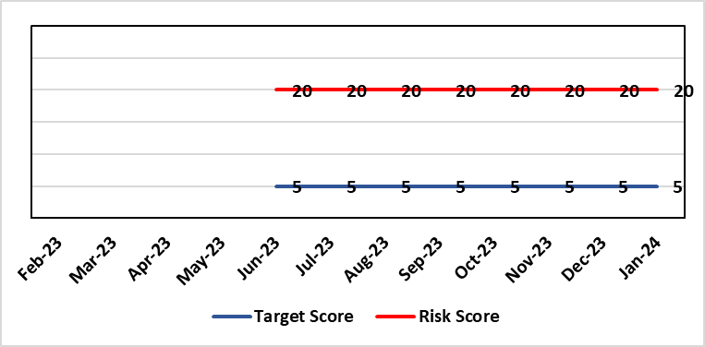 |  | Rationale for current score:  - Delivery of the deficit plan is predicated on a combination of £63.5m of savings and cost reduction which is a significant ask  - Consequence is significant as failure to deliver the plan could impact service delivery if cost reduction required later in the year  - A deficit plan is a failure to meet a statutory duty  - At the time of writing the Health Board still has to identify £31m of the risk mitigation to achieve the deficit plan leading to a high likelihood at this stage
Level of Control
= 25%
Date added to the risk register  June 2023 |  |  | Rationale for target score:  - The consequence will not change given the important of financial delivery and its relationship with the delivery of the Health Board recovery and sustainability plan  - Reducing likelihood to 1 supports a confidence that the deficit plan will be delivered.
Controls (What are we currently doing about the risk?) |  |  | Mitigating actions (What more should we do?)
The Health Board is doing the following:  - Finance Review Meetings with Units to agree cost exit plans  - Escalation plan for highest pressure areas (Morriston and Neath Port Talbot Singleton)  - Transparent exchange of position with NHS Executive & Welsh Government  - Clear financial plan in place for 2023/24  - Savings PMO in place to support savings delivery  - Additional support being targeted to key areas of pressure  - Focus on efficiency of core resource to avoid spending premium cost resource |  |  | Action | Lead | Deadline
 |  |  | Continuation of weekly escalation meetings and escalation of other areas as necessary | Director of Finance & Performance | Will run until targets met
 |  |  | Develop robust cross system service change plans which improve quality of care and reduce system cost | Director of Finance & Performance and Chief Operating Officer | Will run until target is met
Assurances (How do we know if the things we are doing are having an impact?)  The Health Board financial performance is reviewed and monitored through:  - Monthly financial recovery meetings  - Performance and Finance Committee  - Routine reporting to Board of most recent monthly position and financial forecasts  - Weekly escalation meetings with CEO and Director of Finance & Performance – temporary escalations until delivery is assured – each meeting has run rate trackers  - Weekly savings tracker reports from Savings PMO.  - Comprehensive mid-year review of trajectory to 31st March 2024 will be completed in October for discussion with WG and Board. |  |  | Gaps in assurance (What additional assurances should we seek?)
Additional Comments / Progress Notes
Update 16.08.2023 - Letter from WG dated 3rd August outlined that the Health Board had failed to meet its statutory duty to submit an IMTP and to have an IMTP approved by the Welsh Ministers. Although the deficit financial plan is not agreed with Welsh Government, the Board is working to deliver the deficit number unless advised to the contrary. Since submission of the plan the Health Board has also been required to identify options to reduce the deficit below the £86.6m which was submitted to Welsh Government on 11th August along with an Accountability Officer Letter.

Datix ID Number: 3448  Health & Care Standard: 2.1.1 Managing Financial Risk |  |  | HBR Ref Number: 93  Risk Target Date: 31st March 2024 |  | Current Risk Rating  5 x 4 = 20
Objective: Best Value Outcomes from High Quality Care |  | BAF Ref: 6 | Director Lead: Darren Griffiths, Director of Finance and Performance  Assuring Committee: Performance and Finance Committee
Risk: Reduced Capital Funds  Reduced discretionary capital funds and reduced National NHS funds requiring a restricted Capital Plan for 2023/24 |  |  | Date last reviewed: February 2024
Risk Rating  (consequence x likelihood):  Initial: 5 x 4 = 20  Current: 5 x 4 = 20  Target: 5 x 1 = 5 |  |  | Rationale for current score:  - The Health Board has been advised that its discretionary capital allocation for 2023/24 is £9.8m.  - The funding available within the Capital Resource Limit (CRL) will not meet the demands for capital investment. Discretionary capital is deployed to replace ageing medical devices & equipment; to address backlog maintenance of premises; and to support small scale, non-National service improvements with capital investments  - The current Health Board assessment of the carry forward and previously agreed commitments for inclusion in the 2023/24 capital plan currently suggests a requirement for an additional £9.8m to balance the plan and meet highest risk priorities only.  - It is likely that due to slippage on capital schemes, this over-commitment will reduce.  - There is potential for further capital requirements arising from service model changes which will need to be managed.  - Potential consequences of this risk are the inability to achieve the ambitions set out within health board plans; the potential failure of ageing equipment leading to service disruption; the exposure to potential environmental health & safety risks.
Level of Control
= 25%
Date added to the risk register  June 2023 – new for 2023/24 |  |  | Rationale for target score:  The target score expresses the aspiration of the health board for addressing this risk. The target date indicated above reflects the point which the current actions are anticipated to reduce the risk, though knowledge of the actual funding available is required to reduce it further and this is not available until some months into the financial year.
Controls (What are we currently doing about the risk?) |  |  | Mitigating actions (What more should we do?)
The Health Board is doing the following: -  - Regular dialogue with Welsh Government regarding capital requirements.  - Clear communication and reporting of the capital position, the risks and limitations.  - Close management of all schemes to ensure slippage is understood along with the impact on service.  - Clear prioritisation of any new requirements recognising the current constraints |  |  | Action | Lead |  | Deadline
 |  |  | Routine review and flexing of plan as spending is committed through the year. Routine monitoring processes will identify any potential slippage and will deploy this on risk based basis. | Director of Finance & Performance |  | Monthly through the financial year as plan is dynamic
Assurances (How do we know if the things we are doing are having an impact?)  The Health Board capital position is reviewed and monitored through:  - Monthly capital prioritisation group  - Performance and Finance Committee monthly finance report  - Monthly Monitoring Returns to Welsh Government. |  |  | Gaps in assurance (What additional assurances should we seek?)  Reporting on impact of constraints to the capital programme on service delivery.
Additional Comments
Board members will be aware that capital plans are dynamic through the year with mitigating actions taken and opportunities for slippage and further support from WG sought on a consistent basis. This process will continue in 2023/24 in efforts to de-risk the capital plan.
21/09/23: No additional information, therefore, no change.

Datix ID Number: 3516  Health Care Standards: Standard 3.1 safe and clinically effective services |  |  | HBR Ref Number: 94  Risk Target Date: TBC |  | Current Risk Rating  4 x 3 = 12
Objective: Children, Young People & Maternity Services |  | BAF Ref: 3.6 | Director Lead: Deb Lewis, Chief Operating Officer  Assuring Committee: Performance and Finance Committee  For information: Quality & Safety Committee
Risk: CAMHS failure to meet required standards of performance  The CAMHS service is unable to meet the required level of performance due to workforce deficits in the team across all staff groups including medics, psychological therapies and nursing.  This is further hindered by poor data quality which presents a risk to reporting until validation is complete.  Links to other CAMHS risk register entries: (Ref: 3410/3373/3351/3346/3349/3350) |  |  | Date last reviewed: February 2024
Risk Rating  (consequence x likelihood):  Initial: 4 x 5 = 20  Current: 4 x 3 = 12  Target: 3 x 3 = 9 | 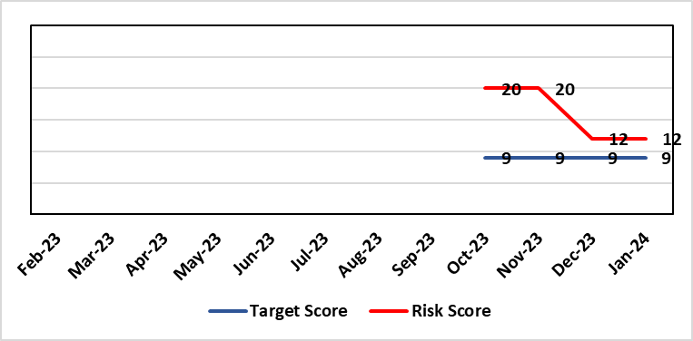 |  | Rationale for current score:  Marked improvement in the performance against the Mental health Measure for CAMHS. Data validation for new patients complete. Current risk score reduced to 12 in view of improved performance however this reflects the fragility in the workforce to deliver sustained performance.
Level of Control  = % |  |  | Rationale for target score:  The rationale for the target score is linked to successful recruitment and more timely access to services for children and young persons which will reduce risk.
Date added to the risk register
October 2023
Controls (What are we currently doing about the risk?) |  |  | Mitigating actions (What more should we do?)
-Ongoing recruitment into all staff groups  -Temporary agency workforce in nursing at premium pay rates to sustain current levels of performance  -Use of locum medical staff due to high vacancy level on medical workforce.  -Recent appointment into psychological therapies lead posts.  -Exploring fixed term appointment of Band 5 psychological therapies support staff to improve performance |  |  | Action | Lead |  | Deadline
 |  |  | Continued efforts at recruitment | Acting Associate Service Director |  | Monthly review
Assurances (How do we know if the things we are doing are having an impact?)  -Monthly CAMHS Directorate meeting in place where performance and workforce are scrutinised  -Reporting into Weekly Business Team and MH & LD management board.  -Reporting into HB Performance and Finance Committee  -Ongoing validation of the waiting list to ensure robust reporting going forward |  |  | Gaps in assurance (What additional assurances should we seek?)
Additional Comments / Progress Notes
13/12/2023: Marked improvement in the performance against the Mental health Measure for CAMHS. Data validation for new patients complete. Data validation for follow-up patients including ADHD in progress. Over recruitment into agency nursing has supported delivery of improved performance outputs however continue to struggle to recruit into substantive posts.
Current risk score reduced to 12 in view of improved performance however this reflects the fragility in the workforce to deliver sustained performance.

Datix ID Number: 3566  Health Care Standards: Governance & Accountability; 6.3 Listening & Learning |  |  | HBR Ref Number: 95  Risk Target Date: 31/03/2024 |  | Current Risk Rating  4 x 3 = 12
Objective: Demonstrably Improved Quality, Safety & Reduced Harm |  | BAF Ref: 1 | Director Lead: Gareth Howells, Executive Director of Nursing  Assuring Committee: Quality & Safety Committee
Risk: National Nosocomial COVID-19 Programme  Failure to (effectively) complete the nationally mandated review of cases of nosocomial COVID-19 by the stipulated end date of the National Nosocomial COVID-19 Programme (NNCP), 31st March 2024, resulting in possible reputational damage and the cessation of funding prior to completion of the work. This risk is caused, in part, by uncertainty in relation to continued availability of appropriate staff capacity to meet the demands of the reviews. |  |  | Date last reviewed: February 2024
Risk Rating  (consequence x likelihood):  Initial: 4 x 5 = 20  Current: 4 x 3 = 12  Target: 4 x 2 = 8 | 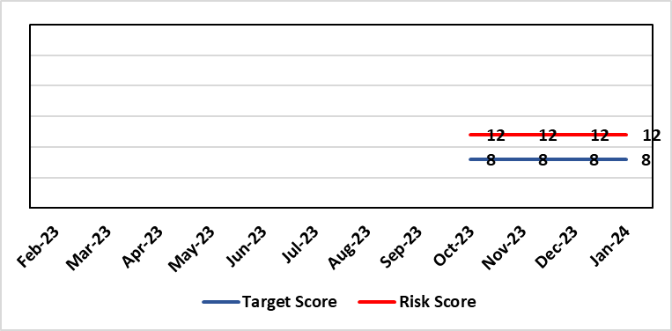 |  | Rationale for current score:  A reduced score from that which would have applied earlier in the Programme is put forward now as two approaches have recently been approved for the rapid and effective review of all cases in which no or low harm has occurred. This has enabled the successful consideration and closure of numerous cases, with particularly good progress reported in data relating to waves 1 and 3 of the pandemic. In turn, this has translated to a positive position against the NHS Executive trajectory for completion of the NNCP.
Level of Control  = % |  |  | Rationale for target score:  Reviews to continue at pace, with new approaches, referred to above, becoming slicker as they become practised. Application of the mitigating actions noted below will aid in proactively controlling activity which might, otherwise, distract from the processes of reviewing and communicating outcomes.
Date added to the risk register
October 2023
Controls (What are we currently doing about the risk?) |  |  | Mitigating actions (What more should we do?)
- Monthly data submission and highlight reports to the NHS Executive NNCP team;  - Workbook Review Process to determine outcomes for cases in which no harm has occurred.  - Triage Review Panels to determine outcomes for cases of no or low harm;  - Peer Review Panels to determine outcomes for cases of medium harm or above;  - Lessons identified reported via the Patient Stakeholder Experience Group;  - Lessons identified reported to operational staff during visits to site by the Nosocomial Review Team (NRT). The wellbeing offer to operational staff is being collated for reiteration in light of the emotive reception to visits;  - Recording progress and outcomes on Datix using set scripts and processes.  - Detailed Programme records kept to track progress, updates and notifications.  - Team processes documented, updated and shared to ensure consistency of approach. Rationale for approaches documented and approved by Executive, as required.  - Team communication channels which enable interim contact with patients/relatives monitored daily.  - Communication methods and content are adapted in response to feedback from the public / monitoring bodies.  - Programme timelines to ensure delivery targets are met at all stages of communication with the public are consistently monitored.  - Schedule of regular learning activity available to the team for development of skills specifically related to Programme.  - Input requested from specialist, multidisciplinary colleagues, as required, including IPC, medics, the patient feedback team and L&RS.  - Clinical Investigators appointed to undertake reviews are senior and experienced, affording a level of assurance across the Programme.  - Given the consistently difficult subject matter is considered by the Nosocomial COVID-19 Review Team, wellbeing is monitored which ensures that all team members remain able to work to an optimal level.  - NRT methodology has been shared for use by the Mortality Review Board in its consideration of nosocomial COVID-19 cases which are out of scope to the NRT (post-30.04.3022.) This will ensure some consistency in approach. |  |  | Action | Lead |  | Deadline
 |  |  | Review communication methods and content in response to feedback from the public | Business Manager (Nosocomial Review Team) |  | 31/12/2023
 |  |  | Develop the Nosocomial COVID-19 Review Team webpage to ensure the most up-to-date progress reports are available to the public | Business Manager (Nosocomial Review Team) |  | 31/12/2023
 |  |  | Develop and implement an action plan for dissemination of lessons identified to operational colleagues of all levels. | Business Manager (Nosocomial Review Team) |  | 31/03/2024
 |  |  | Adopt a process for the subsuming of nosocomial COVID-19 reviews into business as usual activity. This will need to consider all hospital-acquired COVID-19 infections occurring beyond the time remit of the NNCP, 30/04/2022. | Business Manager (Nosocomial Review Team) |  | 31/03/2024
Assurances (How do we know if the things we are doing are having an impact?)  - Consistent progress shown against NHS Executive trajectory for completion of the NNCP.  - Positive feedback from the NHS Executive.  - Positive feedback from patients/relatives.  - No take up of cases for investigation by the Ombudsman / Llais Cymru.  - Processes now in place relating to each of the many aspects of the Programme, including proportionate approaches for the review of varying categories of case.  - Reporting to various fora such as Management Board, Quality & Safety Committee, etc. is well-received. |  |  | Gaps in assurance (What additional assurances should we seek?)  The finite nature of the NNCP presents a risk for potential residual activity to occur following the disbanding of the NRT from end of March 2024. Due to the high number of cases requiring review, the full length of the Programme will be required for completion of the work meaning that Programme activity which instigates interaction with patients and families in the latter stages will pose the biggest risk in this regard. All patients/relatives who receive a review outcome from the Nosocomial COVID-19 Review Team are offered the opportunity to discuss this and to feedback on the process via a satisfaction survey, should they wish. A means of handling this contact from the public will be required beyond the Nosocomial Review Team being in post (31.04.2024)
Additional Comments / Progress Notes
The risk is multifaceted in that each of the factors which could cause a delay to the progress of the Programme, thus lead to failure to complete all required reviews by 31st March 2024, carries its own risk, also. The following constitute some examples of this:
- Findings of review report a breach of duty which leads to qualifying liability resulting in reputational damage and/or financial impact.
- Distress caused to patients / relatives by communication of review findings/delayed communication of findings resulting in receipt of additional complaints and/or negative media attention.
- High take-up of offer to discuss cases with the team by patients / relatives resulting in a variety of concerns/queries raised, some of which are out of the scope of the nosocomial COVID-19 review resulting in high volumes of work for other Health Board teams who are already working to capacity.
- Failure to effectively disseminate lessons identified during NNCP reviews resulting in the continuation of practice which causes harm and which might, otherwise, be avoidable.
- Members of the Nosocomial Review Team seeking alternative employment due to the finite nature of the programme resulting in a need to re-recruit, and consequently, retrain.

Plan being enacted to enable the review of COVUD 19 cases to become “business as usual”, and this will link in with a closure plan to end the task and finish nature of this review – currently 98.7% of cases requiring a review have been completed. Aim to update Management Board in April 2024 and Quality and Safety Committee

Datix ID Number: 3571  Health & Care Standard: Safe Care 2.1 Managing Risk & Promoting Health & Safety |  |  | HBR Ref Number: 96  Target Date: 31st March 2025 |  | Current Risk Rating  4 x 5 = 20
Objective: Demonstrating Value and Sustainability |  | . BAF Ref: 6 | Director Lead: Nerissa Vaughan, Interim Director of Strategy  Assuring Committee: Performance and Finance Committee
Risk: Failure to Develop an Approvable IMTP (statutory compliance)  Failure to have an approvable (Integrated Medium Term Plan) IMTP for 2024/5 then we will lose public confidence and breach legislation. |  |  | Date last reviewed: February 2024
Risk Rating  (consequence x likelihood):  Initial: 4 x5 = 20  Current: 4 x 5 = 20  Target: 4 x 2 = 8 | 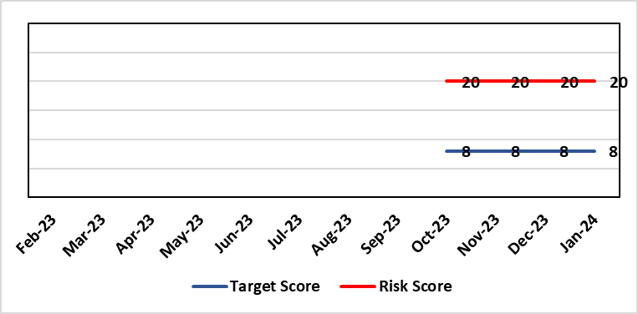 |  | Rationale for current score:  The Health Board does not have a WG approved IMTP and has been placed in enhanced monitoring for Finance and Planning following the inability of the HB to submit a balanced IMTP in March 2023. An Annual Plan was submitted for 2023/24. Given the all Wales financial context the HB is not expecting to submit an IMTP in March 2024 and will instead be developing an Annual Plan 24/25 set in a three year context.
Level of Control
= 70%
Date added to the HB risk register
October 2023
Date added to the HB risk register  October 2023 |  |  | Rationale for target score:  The target remains to develop a financially balanced IMTP so that we meet our statutory duties.
Controls (What are we currently doing about the risk?) |  |  | Mitigating actions (What more should we do?)
- An Annual Plan was submitted to WG in March 2023 with further detailed supporting information provided in July 2023.  - An integrated process is in place to develop the Annual Plan 2024/25.  - The existing IMTP Executive Steering Group will provide oversight of the R&S Plan, Performance and Finance Plans assured by P&F Committee. W&OD Committee reviews the workforce plan, Q&S Committee the Q&S elements. JET meetings with WG  - A prioritisation process will take place in Jan 2024 to establish GMOs for 24/25 along with a robust financial and workforce assessment which will determine whether an IMTP is achievable  - The outcome of the above will be submitted in an Accountability Officer Letter to WG in Feb 2024 |  |  | Action | Lead |  | Deadline
 |  |  | Development of a robust Annual Plan for 2024/25 and continued work to set out a timeline for financial recovery. | Dir of Strategy & Dir of Finance |  | 31/03/2025
Assurances (How do we know if the things we are doing are having an impact?)  Robust arrangements are in place to execute the Annual Plan and for 23/24 these arrangements have been strengthened with updated reporting and monitoring arrangements through the newly established Annual Plan Oversight Group chaired by the COO. |  |  | Gaps in assurance (What additional assurances should we seek?)
Additional Comments / Progress Notes

Datix ID Number: 3692  Health & Care Standard: Safe Care 2.1 Managing Risk & Promoting Health & Safety |  | HBR Ref Number: 98  Target Date: | Current Risk Rating  5 x 4 = 20
Objective: Best Value Outcomes |  | Director Lead: Darren Griffiths, Executive Director of Finance & Performance  Assuring Committee: Performance & Finance Committee
Risk: Overall condition/compliance and suitability of Health Board Estate – 6 FACET survey undertaken in 2022 confirmed the poor condition and suitability of premises where health care services are provided. The backlog maintenance of in excess of £200 million |  | Date last reviewed: February 2024
Risk Rating  (consequence x likelihood):  Initial: 5 x 4 = 20  Current: 5 x 4 = 20  Target: 3 x 3 = 9 |  | 6 FACET survey  Estates Strategy and Development control plans  General compliance with fire regulations and WHTM/WHBN requirements.  Backlog maintenance  Health Board estates strategy and DCP task and finish group  Audit and Assurance limited assurance report  Access to funding
Level of Control  = 50% |  | Rationale for target score:  Through the 6 FACET survey a number of key items have been identified covering the Physical condition, Functional suitability, Space utilisation, Quality audit, Statutory compliance and Environmental management. In addition an equality review was undertake on sites. All of which identified significant issues with the current estate, with very few areas achieving condition ‘B’. The overall backlog maintenance is in excess of £200m.
Date added to the HB risk register
07/02/2024
Controls (What are we currently doing about the risk?) |  | Mitigating actions (What more should we do?)
- Planned preventative maintenance, prioritising highest risk depending on funding available (EFAB – Discretionary) – linked to creation of decant space through service changes  - Regular reviews of the estate.  - Reactive maintenance.  - 20% annual review/update of 6 FACET surveys  - Undertaken capital schemes where funded  - Address issues where practicable through EFAB/Discretionary capital  - Estates Strategy and development control plans task and finish group |  | Action |  | Lead | Deadline
 |  | Maintain effective engagement with Welsh Government to provide funding to implement estates strategy and development control plans to address all areas outlined. |  | Assistant Director of Capital Planning | 31 March 2025
 |  | Work with Welsh Government to source alternative solutions to funding the HB estates strategy and development control plans |  | Assistant director of Capital Planning | 31 March 2025
Assurances (How do we know if the things we are doing are having an impact?)  - Monitoring through quality & Safety, Audit & Assurance and Performance and Finance committee to receive assurance and or identify gaps for key compliance and adherence to applicable legislation.  - NWSSP internal audits  - Site visits/tours to identify compliance and gaps in compliances.  - Completion of FRA’s within targeted schedule  - Estates strategy and development control plans being implemented  - Half yearly Board oversight of strategy implementation |  | Gaps in assurance  (What additional assurances should we seek?)  Suitable funding to implement the estates strategy and development control plans, this will be over a 10 – 15 year period.  Allocate funds where available to address issues outlined  Detailed work to be commissioned to consider primary and community estates strategy along with mental health services
Additional Comments
Through the 6 FACET survey a number of key items have been identified covering the Physical condition, Functional suitability, Space utilisation, Quality audit, Statutory compliance and Environmental management. In addition an equality review was undertake on sites. All of which identified significant issues with the current estate, with very few areas achieving condition ‘B’. The overall backlog maintenance is in excess of £200m.
Key areas include ventilation and cooling with major infection control and other implications. Theatres/Wards/ED and general acute settings including mental health and learning disabilities being old and not compliant with the latest WHBN’s and WHTM’s. The heating, power and medical gas systems have also been identified as issues for concern in the 6 FACET surveys and from independent audits. The health board’s latest NWSSP estates audit received a limited assurance due to limited Welsh Government funding available to undertake backlog maintenance and implementation of estates strategy.

Datix ID Number: TBC  Health Care Standards: Leadership & Whole Systems Approach |  | HBR Ref Number: 99  Target Risk Date: See Rationale |  | Current Risk Rating  5 x 4 = 20
Objective: People of Swansea Bay live healthier, more equal, prosperous lives |  | Director Lead: Keith Reid, Director of Public Health  Assuring Committee: Population Health & Partnerships
Risk: Failure to implement the population health strategy approaches at the required scale.  This arises from risk of a failure of the organisation to understand and act on the provisions of the strategy for building whole of system actions across the 4 pillars; and the consequent lack of systems and processes to support the delivery of population health improvements.  Currently identified contributors to this risk include the absence of the tactical level planning required to design and deliver cross-cutting programmes within a federated operational delivery system; lack of systematic review and capture of population health contributions of existing services; limited behaviour change to adopt a population health focus at service and corporate level; a limited focus on prevention; and a lack of consideration of how to act to influence the wider determinants that affect the population’s health and how the Health Board might contribute to addressing these. The outcome if the risk is not addressed is worsening health in our population with widening health inequities. |  | Date last reviewed: February 2024
Risk Rating  (consequence x likelihood):  Initial: 5 x 5 = 25  Current: 5 x 4 = 20  Target: 4 x 2 = 8 | 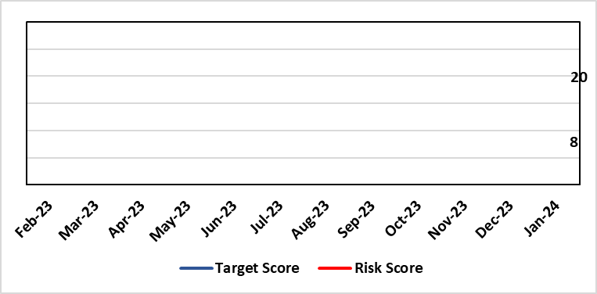 | Rationale for current score:  We are not in a position where marginal investment is available to begin to develop population health activity. Developing a transformative approach to how we conduct our business is dependent upon the ability of SBUHB to: better understand our population’s needs and address them; focus on actions which foster and maintain health and wellbeing; design services that incorporate prevention and tackle inequities; and develop robust partnerships that tackle the wider determinants of health that ultimately drive demand for healthcare.  Currently there is a lack of capacity and capability in the wider organisation to deliver on this agenda.
Date added to the risk register  14/03/24 |  | Rationale for target score:  Given the system wide changes required to mitigate this risk and the requirement to works across organisational boundaries achievement of this target has been be a long term consideration.  Target Risk Date will be reviewed as part of gateway checkpoint on risk/actions.
Controls (What are we currently doing about the risk?) |  | Mitigating actions (What more should we do?)
- Population Health Strategy adopted by SBUHB Board 30/03/23.  - Population Health Strategy aligned to organisational strategic objective 1. Population health integrated into planning infrastructure through R&S plan 24/25 process.  - Population Health and Partnerships Committee and Population Health Development Board established as governance mechanisms for Population Health.  - Mandate through governance to progress on key strategic workstreams:  - Capability & Capacity building  - Anchor Institution baselining  - Anti-poverty  - Strategic Indicators Population Health  - Repurposing SBUHB financial resource to support population health  - Behavioural change resource identified to develop behavioural change framework for SBUHB to develop capability and capacity in support of required cultural change.  - Health Intelligence resource identified to lead organisational work to build health intelligence infrastructure.  - Local population health measures in development with SDGs to be reported quarterly through Annual Plan Oversight Group (APOG). |  | Action | Lead |  | Deadline
 |  | Gateway review of progress on governance actions:  Population Health Board re-jig;  SDG reporting changes;  Capability and capacity review and development work. | Executive Director of Public Health / Director of Corporate Governance (support) |  | 31/06/2024
Assurances (How do we know if the things we are doing are having an impact?)  An approach to capturing activity through the quarterly performance reviews is being piloted with the aim of identifying at Service Delivery Group level how population health gain is being addressed. In addition these will then be reviewed at the APOG as appropriate.  The Population Health Development Board is being reformed to bring in appropriate senior representation from SDGs to enable it to act as a governance forum for population health activity. |  | Gaps in assurance (What additional assurances should we seek?)  SDG reporting will allow for development of a view of service group level activity and creation of monitoring framework but this is a development journey and there will be a delay of several quarters while this matures.  No mechanism to develop approaches which sit across more than one SDG or which are not directly related to SDG responsibilities.  Available data are fragmented due to federated operational delivery structures in support of population health. Work is underway to identify ‘strategic indicators’ which will provide a framework to monitor the impact of action on population health.
Additional Comments
Given the complexity of the requirements to enable system change at scale the implementation of the population health strategy the organisational journey to becoming population health focused and competent has to be viewed as a long term objective.

Risk Score Calculation

For each risk identified, the LIKELIHOOD & CONSEQUENCE mechanism will be utilised. Essentially this examines each of the risks and attempts to assess the likelihood of the event occurring (PROBABILITY) and the effect it could have on the Health Board (IMPACT). This process ensures that the Health Board will be focusing on those risks which require immediate attention rather than spending time on areas which are, relatively, a lower priority.

This indicates whether there has been an increase / decrease in risk score since the previous month’s HBRR.

