Meeting Date | 16 May 2024 |  | Agenda Item |  |  | 4.1
Report Title | Clinical Audit Plan 2024/25
Report Author | Sharon Rağbetli, Clinical Audit & Effectiveness Manager
Report Sponsor | Dr Raj Krishnan, Acting Executive Medical Director
Presented by | Dr Raj Krishnan, Acting Executive Medical Director
Freedom of Information | Open
Purpose of the Report | The report presents the Clinical Audit Plan for 2024/25, outlining the process for development and agreement.
Key Issues | - Clinical audit is a key element of the health board’s system of internal control and requires assurance to be given to the Audit Committee that a process is in place to agree a clinical audit plan for the year;  - The clinical audit plans for 2024/25 were agreed by the Clinical Outcomes and Effectiveness Group (COEG) in March 2024;  - The plan is fluid and progress will be reviewed by the COEG on a monthly basis;  - Recommendations from the Internal Audit review of Clinical Audit at SBUHB included improved timeliness for the development of Audit Plans and increased completion rates in addition to the identification of links to any risks or concerns, which have been delivered.
Specific Action Required  (please choose one only) | Information | Discussion |  | Assurance | Approval
Specific Action Required  (please choose one only) | ☐ | ☐ |  | ☒ | ☐
Recommendations | Members are asked to:  - NOTE the process undertaken to compile the 2024/25 clinical audit plan;  - NOTE the approval of the clinical audit plans for 2024/25 by the COEG in March 2024;  - NOTE there are processes in place within the service groups to monitor delivery of the local plans;  - NOTE overall delivery of the plan is reviewed by COEG on a monthly basis, and this will continue until all audits have been closed.

CLINICAL AUDIT PLAN 2024/25

- INTRODUCTION
The report presents the Clinical Audit Plan for 2024/25 as agreed at the Clinical Outcomes and Effectiveness Group meeting on 8th March 2024. It outlines the process in place for the development and capture of proposals and the identification of links to risks and concerns.

- BACKGROUND
Clinical audit is a key element of the health board’s system of internal control. As such, there is a requirement to provide assurance to the Audit Committee that a clinical audit plan for the year has been agreed, and a process in place to support and monitor delivery. This is supplemented by an annual report at the end of the year summarising what has been achieved.

Delivery of the health board’s clinical audit plans is part of the remit of the Quality and Safety Group but is discharged through the Clinical Outcomes and Effectiveness Group (CEOG). COEG meets on a monthly basis to report progress on each of the areas of focus as well as receive presentations on the lessons learned from various audits. It then reports to the Quality and Safety Group on a bi-monthly basis.

Assurance is also required at a board-level as to the progress and improvement around clinical audits, outcome and effectiveness. As such a regular report is provided to the Quality and Safety Committee.

The Clinical Audit and Effectiveness Policy outlines the Executive Medical Directors Department Audit Hierarchy;
- Level one - mandated national audits and registries;
- Level two - a small number of HB Audit Priority Topics
- Levels three and four - Audit Plans at Service Delivery Group and Department levels
- Level five - emergent necessary ad-hoc topics.

In 2022/23, Clinical Audit Plans at Levels 3 and 4 were re-instated. Prior to that date, at the request of the then Executive Medical Director, the Health Board had adopted the Welsh Government list of mandated national audit and registry topics as its only forward plan.

- GOVERNANCE AND RISK ISSUES

  - Planning Process
Audit Leads were advised by email that the planning round for 2024/25 was open on 7th December. They had 12 weeks to complete submissions, with the deadline of 29th February. Several reminders were issued during the interim period.
Leads were provided with a link to share with colleagues to prioritise topic choices and populate Microsoft Forms with details of the proposals (Appendix 1.). Once entered, the records were automatically added onto a SharePoint list for Audit Leads to review and approve or reject (see example below);
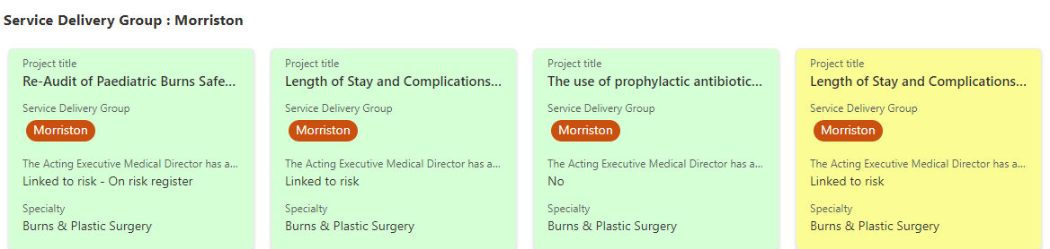

  - Pre-Populating Topics Linked to Risk
In addition to providing advice via COEG meetings and in correspondence direct with Audit Leads on linking topic choices to risks and concerns, the Clinical Audit team added records for any completed cycles of audit that indicated the need for re-audit within the time-period. These included ones identified by the department via the responsible individual completing the audit record and/or those topics that scored 4 or above on the assurance/risk matrix;

 | Level of Risk
Level of Assurance | None (1) | Low (2) | Minor (3) | Major (4)
Very limited (4) | 4 | 8 | 12 | 16
Limited (3) | 3 | 6 | 9 | 12
Significant (2) | 2 | 4 | 6 | 8
Full (1) | 1 | 2 | 3 | 4

  - COEG Approval
The submissions received for the 2024-25 clinical audit plan by the February deadline were then reviewed and approved at the COEG meeting on 8th March where it was agreed to add in 11 topics that were identified as needing a re-audit by ad-hoc (Level 5) topics completed within as far back as 2022/23.

However, this is a fluid plan. Audit Leads are still able to check the records and discern if they agree with the findings and scores and the timelines indicated, in addition to allocating the topics. They are also able to defer topics deemed as unnecessary at this time, to remove topics being progressed outside of audit work or deemed as no longer clinically relevant, altering the content of the plans (Table 1.).

Service Delivery Group | @ COEG 8/3/24 | @ 1/4/24
Mental Health and Learning Disabilities | 11 | 11
Morriston | 33 | 35
Primary Care, Community and Therapies | 28 | 29
Singleton and Neath Port Talbot | 20 | 28
Totals | 92 | 103

Table 1.

Audit leads will also continue to receive proposals in-year generated by completion summaries as topics from past plans are submitted in the closing down of the 2022/23 and 2023/24 plans. Scores of 4 or more on the assurance/risk matrix will be listed in this way for review and consideration.

The number of topics currently listed on the 2024/25 Clinical Audit Plan is similar to that listed for the half-year Clinical Audit Plan for 2023/24.

Service Delivery Groups have their own internal processes for monitoring progress with their plans. Some mirror the approach taken at the central COEG, while others manage it through the service group medical director. Overall monitoring will be undertaken by the COEG at every meeting.

  - Monitoring Plans

From 2022/23 onwards, Clinical Audit Plans will be monitored until all listed topics are accounted for, with monthly updates received at the COEG meetings. Table 2 illustrates progress with all active plans to date;

Service Delivery Group | Current Completion Rates
Service Delivery Group | 2022/23 | 2023/24 | 2024/25
Mental Health and Learning Disabilities | 12 (100%) | 6 (40%) | 0/11 (0%)
Morriston | 51 (88%) | 8 (32%) | 0/35 (0%)
Primary Care, Community and Therapies | 11 (100%) | 11 (61%) | 0/29 (0%)
Singleton and Neath Port Talbot | 14 (70%) | 7 (41%) | 0/28 (0%)
Totals | 88 (87%) | 44 (41.5%) | 0/103 (0%)
Table 2.
  - Internal Audit
In 2023, Internal Audit published a report into Clinical Audit at SBUHB with a limited assurance rating. The Clinical Audit team have worked closely with the COEG and Service Delivery Groups to support necessary improvements including timely finalisation of audit plans, improved completion rates for planned topics and the identification of any links to risks and concerns. All recommendations were closed by 31st March 2024.

It should be noted that one of the recommendations had been to use the Audit Management and Tracking (AMaT) system as an action tracker. However, based on user feedback on the and poor compliance with completion of audit records, the Clinical Audit team were supported by the Clinical Outcomes and Effectiveness Group in utilising Microsoft Forms and SharePoint to build and monitor the 2024/25 Audit Plan. This change has been positively received by clinical audit leads and is resulting in higher compliance.

- FINANCIAL IMPLICATIONS
There are no financial implications to this report.

- RECOMMENDATION
Members are asked to:
- NOTE the process undertaken to compile the 2024-25 clinical audit plan;
- NOTE the approval of the clinical audit plans for 2024-25 by the COEG in March 2024;
- NOTE there are processes in place within the service group to monitor delivery of the local plans;
- NOTE overall delivery of the plan is reviewed by COEG on a monthly basis, and this will continue until all audits have been closed.

Governance and Assurance
Link to Enabling Objectives  (please choose) | Supporting better health and wellbeing by actively promoting and empowering people to live well in resilient communities
Link to Enabling Objectives  (please choose) | Partnerships for Improving Health and Wellbeing |  | ☐
Link to Enabling Objectives  (please choose) | Co-Production and Health Literacy |  | ☐
Link to Enabling Objectives  (please choose) | Digitally Enabled Health and Wellbeing |  | ☒
Link to Enabling Objectives  (please choose) | Deliver better care through excellent health and care services achieving the outcomes that matter most to people
Link to Enabling Objectives  (please choose) | Best Value Outcomes and High Quality Care |  | ☒
Link to Enabling Objectives  (please choose) | Partnerships for Care |  | ☐
Link to Enabling Objectives  (please choose) | Excellent Staff |  | ☒
Link to Enabling Objectives  (please choose) | Digitally Enabled Care |  | ☒
Link to Enabling Objectives  (please choose) | Outstanding Research, Innovation, Education and Learning |  | ☒
Health and Care Standards
(please choose) | Staying Healthy |  | ☐
(please choose) | Safe Care |  | ☒
(please choose) | Effective Care |  | ☒
(please choose) | Dignified Care |  | ☒
(please choose) | Timely Care |  | ☒
(please choose) | Individual Care |  | ☒
(please choose) | Staff and Resources |  | ☒
Quality, Safety and Patient Experience
Appropriate identification and planning of necessary local audit priorities can support improvements in care, outcomes and experience and provide assurance.
Financial Implications
There are no financial implications
Legal Implications (including equality and diversity assessment)
There are no legal implications.
Staffing Implications
There are no staffing implications.
Long Term Implications (including the impact of the Well-being of Future Generations (Wales) Act 2015)
Long term the aim is to continue to embed a new culture in terms of the prioritisation of audit and improvement activities, while balancing the need to meet requirements placed on doctors and healthcare professionals in training. Generating themes and learning from deaths will contribute towards striving to give patients at the end of their life and their loved ones, the best possible experience.
Report History |  | As required.
Appendices |  | Appendix 1. – Audit Plan Proposal Form  Appendix 2. – Audit Plan 2024/25

Appendix 1. Audit Plan Proposal Form
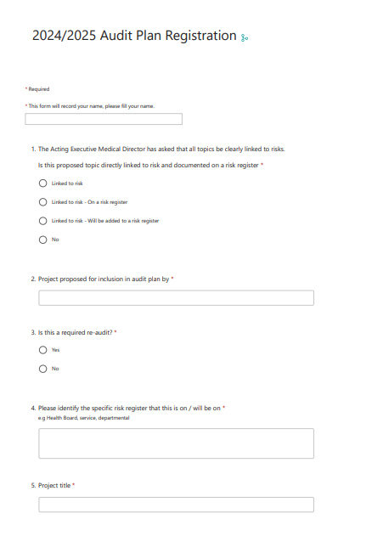
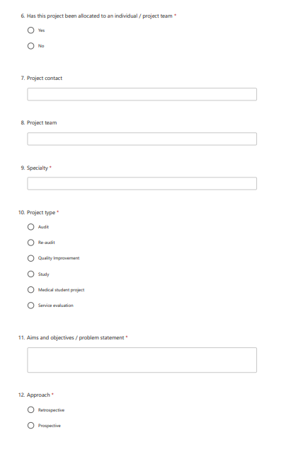
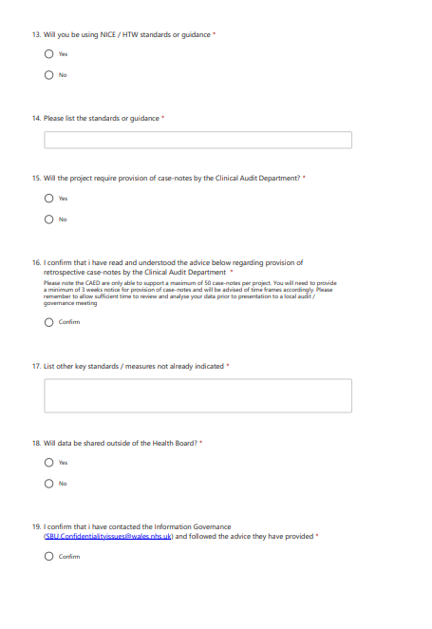
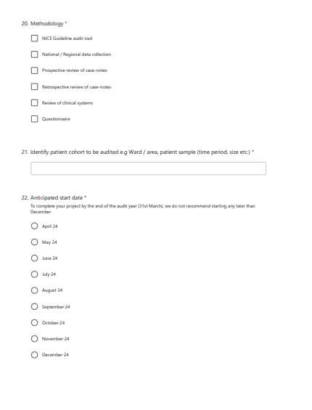
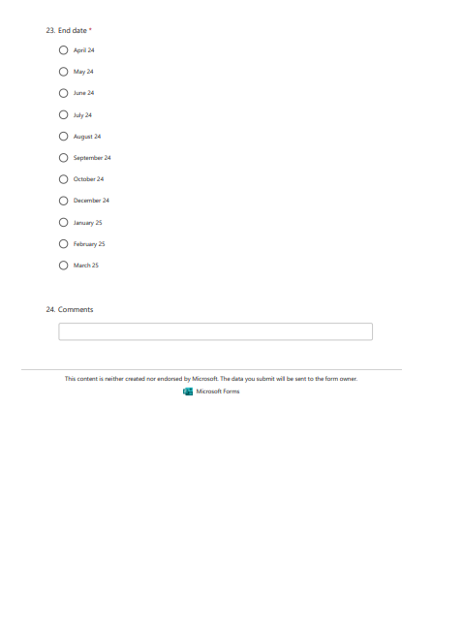

Appendix 2. Current Audit Plans 2024/25
Project Title | Service Delivery Group | Level | Specialty
Audit of long acting injectable or depot antipsychotic side effects among persons with mental disorders in Swansea Bay UHB | Mental Health & Learning Disabilities | 3 | Adult Mental Health
Topic 19b: Prescribing for depression in adult mental health services | Mental Health & Learning Disabilities | 3 | Adult Mental Health
ECG monitoring in patients prescribed high dose methadone and/or antipsychotics. | Mental Health & Learning Disabilities | 3 | Community Drug and Alcohol Team
3. Audit of the Prevalence of Opiate Substitution Therapy documentation in Patient’s GP Repeat Medication Records | Mental Health & Learning Disabilities | 3 | Community Drug and Alcohol Team
Audit of monitoring and duration of treatment of alcohol relapse prevention medications (RPM) | Mental Health & Learning Disabilities | 3 | Community Drug and Alcohol Team
Audit of urine drug screening for patients prescribed opiate substitute therapy | Mental Health & Learning Disabilities | 3 | Community Drug and Alcohol Team
Audit of assessment of risk and management of Wernicke’s Encephalopathy in patients undergoing alcohol detox. | Mental Health & Learning Disabilities | 3 | Community Drug and Alcohol Team
Impact of duration of stay of in-patient alcohol detoxification on maintaining abstinence from alcohol post detox: A Service Evaluation. | Mental Health & Learning Disabilities | 3 | Community Drug and Alcohol Team
An Audit of Clinical Supervision within the Caswell Clinic | Mental Health & Learning Disabilities | 4 | Forensic
Quality Audit of MHM (Wales) Care and Treatment Plan | Mental Health & Learning Disabilities | 3 | Mental Health & Learning Disabilities
Risk management audit | Mental Health & Learning Disabilities | 3 | Mental Health & Learning Disabilities.
Prospective Screening for Dementia for Adults with Down Syndrome in Cardiff, South Wales - An Audit of The British Psychological Society Guidelines | Mental Health & Learning Disabilities | 3 | Mental Health and Learning Disabilities
Audit to assess compliance of Swansea Bay CAMHS ADHD Monitoring service with NICE guidelines | Mental Health & Learning Disabilities | 3 | Mental Health and Learning Disabilities
HypoBox audit – Think Glucose | Mental Health & Learning Disabilities | 4 | Mental Health and Learning Disabilities
Treatment of UTI in Older Adults Mental Health Wards | Mental Health & Learning Disabilities | 4 | Older Persons Mental Health
An audit of physical health monitoring in perinatal mental health patients prescribed anti-psychotics | Mental Health & Learning Disabilities | 4 | Perinatal Mental Health
Re-Audit of Paediatric Burns Safeguarding - Action plans & re-audit | Morriston | 3 | Burns & Plastic Surgery
Length of Stay and Complications following acute lower limb open fracture 'fix & flap' | Morriston | 3 | Burns & Plastic Surgery
Project Title | Service Delivery Group | Level | Specialty
The use of prophylactic antibiotics in patients undergoing skin cancer excisions in Plastic Surgery Treatment Centre | Morriston | 4 | Burns & Plastic Surgery
Length of Stay and Complications following acute lower limb open fracture 'fix & flap' | Morriston | 3 | Burns & Plastic Surgery
The presentation of patients with open lower limb fractures by the ambulatory service in the South of Wales | Morriston | 4 | Burns & Plastics Surgery
Bleeding/return to theatre post cardiac surgery | Morriston | 3 | Cardiothoracic
Renal replacement therapy post cardiac surgery | Morriston | 3 | Cardiothoracic
Sternal wound infections post cardiac surgery | Morriston | 4 | Cardiothoracic
Diabetes Foot Risk Assessment | Morriston | 3 | Diabetes
Spontaneous Pneumothorax in Adults | Morriston | 3 | Emergency Department
Mental Health | Morriston | 3 | Emergency Department
Asthma | Morriston | 3 | Emergency Department
Fractured Neck of Femur | Morriston | 4 | Emergency Department
Cognitive Impairment in older people | Morriston | 3 | Emergency Department
Lumbar Spine X-Ray request | Morriston | 4 | Emergency Department
Emergency Department Patient Notes Audit | Morriston | 4 | Emergency Department
Patient experience in Diabetes Management | Morriston | 4 | Endocrinology
Oxygen Prescribing in the ENT department | Morriston | 3 | ENT
An Audit of Outcome Pathway in Acute Admissions with Biliary Pathology | Morriston | 3 | General Surgery
Improving the use of the Clinical Frailty Scale (CFS) in the ICU | Morriston | 4 | Intensive Care
Screening for delirium in ICU patients using CAM-ICU tool | Morriston | 3 | Intensive Care
Optimizing Outcomes for Out-of-Hospital Cardiac Arrest Patients: An Audit of Guideline Compliance and Physiological Parameter Management in the Intensive Care Unit | Morriston | 3 | Intensive Care
Neonate and infant referrals for ankyloglossia | Morriston | 4 | Maxillofacial
Monitoring the outcome of the introduction of efgartigimod treatment in refractory Myasthenia Gravis | Morriston | 4 | Neurology
Coding of functional/dissociative seizures | Morriston | 4 | Neurology
Status Epilepticus | Morriston | 4 | Neurology
Project Title | Service Delivery Group | Level | Specialty
Epi-Safe National Audit of Care for Pregnant Women with Epilepsy | Morriston | 4 | Neurology
Review the compliance of disease modifying therapies and fampridine for MS in line with NICE guidance | Morriston | 4 | Neurology
Audit of neuroradiology neuropathology correlation at the South Wales neuro-oncology MDT (HK) | Morriston | 4 | Radiology
Audit on Structured Reporting of Superficial Soft Tissue Masses on Ultrasonography in Relation to Guiding Clinical Management | Morriston | 4 | Radiology
Indication for Plain Abdominal X-Ray | Morriston | 4 | Radiology
Audit of imaging for acute aortic syndrome | Morriston | 4 | Radiology
Peritoneal Dialysis: Peritonitis and Access | Morriston | 4 | Renal
Vancomycin usage in HD patients | Morriston | 3 | Renal
Prevention of Bloodstream Infections in Patients Undergoing Haemodialysis | Morriston | 3 | Renal
DNACPR audit in Stroke against the All wales DNACPR policy | Morriston | 4 | Stroke Medicine
BAUS National nephrostomy Audit | Morriston | 4 | Urology
Minimising numbers of patients unable to receive a direct semi-circular canal function assessment | Primary, Community Care & Therapies | 3 | Audiology
Meeting standard 2 of the All Wales Dementia Care Pathway of Standards | Primary, Community Care & Therapies | 3 | Audiology
Audit the number of patients within SBUHB that are appropriate to be referred for heart failure cardiac rehabilitation (HFCR) | Primary, Community Care & Therapies | 3 | Cardiac Rehabilitation
Quality Assurance of dental radiographs in the community dental service | Primary, Community Care & Therapies | 3 | Community Dental Service
A re-audit of the use of flumazenil within Swansea Bay UHB | Primary, Community Care & Therapies | 3 | Community Dental Services
National Smoking Cessation Audit (NICE NG209) in the Dental service | Primary, Community Care & Therapies | 4 | Dental Practices
District Nurse Nutrition Risk Screening Audit | Primary, Community Care & Therapies | 3 | Health Access Team
Audit of Home enteral feeding electronic records against record keeping standards | Primary, Community Care & Therapies | 3 | Home enteral feeding
An audit of the nutritional management of Dementia patients | Primary, Community Care & Therapies | 3 | Nutrition and Dietetics
An audit of the Dietetic management of the UGI cancer patients referred to Nutrition and Dietetics | Primary, Community Care & Therapies | 3 | Nutrition and Dietetics Oncology team
Audit of observations and staff engagement with patients presenting with cognitive impairments. | Primary, Community Care & Therapies | 3 | Occupational Therapy
Project Title | Service Delivery Group | Level | Specialty
Occupational Therapy Neurological upper limb splinting audit | Primary, Community Care & Therapies | 4 | Occupational Therapy
Defensive documentation | Primary, Community Care & Therapies | 3 | Podiatry
Dental Oncology Timeline Audit | Primary, Community Care & Therapies | 4 | Restorative Dental
Radiographic audit: Quality and justification of dental radiographs | Primary, Community Care & Therapies | 3 | Restorative Dentistry
Improving Staff Access to the Medical Emergency Equipment in the Restorative Department, Port Talbot Resource Centre | Primary, Community Care & Therapies | 4 | Restorative Dentistry
HIV annual checks impact of new specialist role | Primary, Community Care & Therapies | 3 | Sexual Health
To assess if Sexual Health clinics are meeting BASHH Standards for the Management of STI's | Primary, Community Care & Therapies | 4 | Sexual Health
To measure the need for Specialist Palliative Physiotherapy input within the acute setting | Primary, Community Care & Therapies | 4 | Specialist Palliative Care
Improving Palliative and end of life Physiotherapy for patients and carers in Bay Cluster | Primary, Community Care & Therapies | 3 | Specialist Palliative Care - Physiotherapy
Connecting people with diagnosed or suspected dementia to Audiology services; the role of Speech and Language Therapy in Primary Care Mental Health Services | Primary, Community Care & Therapies | 3 | Speech and Language Therapy
To audit the current Speech and Language Therapy service provision for head and neck cancer patients, who receive their diagnosis and treatment within Swansea Bay UHB, against recommended national head and neck cancer guidelines | Primary, Community Care & Therapies | 3 | Speech and Language Therapy
Audit to assess RCPCH acute paediatric facing the future standards(standard 2,3 & 5) | Singleton & Neath Port Talbot | 4 | Acute Paediatrics
Obstetric Anaesthetic Chart Improvement | Singleton & Neath Port Talbot | 4 | Anaesthetics
Oral paracetamol pre-med for elective paediatric surgery patients | Singleton & Neath Port Talbot | 4 | Anaesthetics
Audit on Anaesthesia Record Keeping | Singleton & Neath Port Talbot | 4 | Anaesthetics
Total Knee Arthroplasty in Neath - Patient engagement in physiotherapy in immediate post op period | Singleton & Neath Port Talbot | 4 | Anaesthetics/Orthopaedics/Physiotherapists
Evaluate the potential for the IBEX Galen AI Prostate application to improve diagnosis of prostatic cancer | Singleton & Neath Port Talbot | 3 | Cellular Pathology
Audit of rates of VTE in patients with pancreatic cancer undergoing SACT | Singleton & Neath Port Talbot | 3 | Clincal Oncology
Audit of HPV and MMR vaccination coverage in a cohort of eligible looked after young people | Singleton & Neath Port Talbot | 4 | Community Paediatrics
Project Title | Service Delivery Group | Level | Specialty
Enhancing patient experience with procedure information leaflets | Singleton & Neath Port Talbot | 4 | Dermatology
Handover on Central Delivery Suite | Singleton & Neath Port Talbot | 3 | Obstetrics and Gynaecology
The Introduction of a smart phone app to provide information to patient diagnosed with gestational diabetes. | Singleton & Neath Port Talbot | 3 | Obstetrics and Gynaecology
Induction of Labour Quality Improvement Project | Singleton & Neath Port Talbot | 3 | Obstetrics and Gynaecology
Radiotherapy Treatment Times | Singleton & Neath Port Talbot | 3 | Oncology
SACT treatment metrics | Singleton & Neath Port Talbot | 3 | Oncology
MUO/CUP MDT re-audit of pathway time | Singleton & Neath Port Talbot | 4 | Oncology
Audit of time Oncology patients on Systemic Anti-Cancer Therapy received IV antibiotics after presentation to Morriston or Singleton hospitals with suspected neutropenic sepsis | Singleton & Neath Port Talbot | 3 | Oncology
Implementation of a dedicated primary care referral pathway and specialist MUO clinic: Comparative Audit of Patient Pathway and experience | Singleton & Neath Port Talbot | 3 | Oncology
Discontinuation rate of Docetaxel Chemotherapy in patients with metastatic prostate cancer | Singleton & Neath Port Talbot | 4 | Oncology / Uro Oncology
Immunotherapy side effects audit | Singleton & Neath Port Talbot | 3 | Oncology/ Immunotherapy
Compliance to the Paediatric sepsis 6 pathway | Singleton & Neath Port Talbot | 4 | Paediatrics
Audit to assess compliance to the Paediatric febrile neutropenia guideline | Singleton & Neath Port Talbot | 4 | Paediatrics
Service evaluation | Singleton & Neath Port Talbot | 4 | Paediatrics
Junior doctor’s adherence to the Orthopaedic Clerking proforma - full cycle audit | Singleton & Neath Port Talbot | 4 | Trauma & Orthopaedics

