Meeting Date | 21 May 2026 |  | Agenda Item |  |  | 6.2
Name of Meeting | Audit Committee
Report Title | Clinical Audit Plan 2026/28
Report Author | Sharon Rağbetli, Clinical Audit & Effectiveness Manager
Report Sponsor | Dr Raj Krishnan, Interim Executive Medical Director
Presented by | Dr Raj Krishnan, Interim Executive Medical Director
Freedom of Information | Open
Purpose of the Report | The report presents the Clinical Audit Plan for 2026/28, outlining the process for development and agreement.
Key Issues | - Clinical audit is a key element of the health board’s system of internal control and requires assurance to be given to the Audit Committee that a process is in place to agree a clinical audit plan for the year;  - The clinical audit plans for 2026/28 were agreed by the Clinical Outcomes and Effectiveness Group (COEG) in March 2026;  - The plan is fluid and progress will be reviewed by the COEG on a monthly basis;  - A two-year cycle was agreed by COEG as part of the previous clinical plan, acknowledging the time taken to be able to close down an audit record; complete data collection, collation and presentation of results to an audit meeting to agree actions and timeframes.
Specific Action Required  (please choose one only) | Information | Discussion |  | Assurance | Approval
Specific Action Required  (please choose one only) | ☐ | ☐ |  | ☒ | ☐
Recommendations | Members are asked to:  - ACKNOWLEDGE the process undertaken to compile the 2026/28 clinical audit plan;  - ACKNOWLEDGE the approval of the clinical audit plans for 2026/28 by the COEG in March 2026;  - ACKNOWLEDGE the achievement of improving to 72% completion for the extended 2024-26 Audit Programme;  - ACKNOWLEDGE overall delivery of the plan is reviewed by COEG on a monthly basis, and this will continue until all audits have been closed.

CLINICAL AUDIT PLAN 2026/28
- INTRODUCTION
The report presents the Clinical Audit Plan for 2024/25 as agreed at the Clinical Outcomes and Effectiveness Group meeting on 13th March 2026. It outlines the process in place for the development and capture of proposals and the identification of links to risks and concerns.

- BACKGROUND
Clinical audit is a key element of the health board’s system of internal control. As such, there is a requirement to provide assurance to the Audit Committee that a clinical audit plan for the year has been agreed, and a process in place to support and monitor delivery. This is supplemented by an annual report at the end of the year summarising what has been achieved.

Delivery of the health board’s clinical audit plans is part of the remit of the Quality and Safety Group but is discharged through the Clinical Outcomes and Effectiveness Group (CEOG). COEG meets on a monthly basis to report progress on each of the areas of focus as well as receive presentations on the lessons learned from various audits. It then reports to the Quality and Safety Group on a bi-monthly basis.

Assurance is also required at a board-level as to the progress and improvement around clinical audits, outcome and effectiveness. As such a regular report is provided to the Quality and Safety Committee.

The Clinical Audit and Effectiveness Policy outlines the Executive Medical Directors Department Audit Hierarchy;
- Level one - mandated national audits and registries;
- Level two - a small number of HB Audit Priority Topics
- Levels three and four - Audit Plans at Service Delivery Group and Department levels
- Level five - emergent necessary ad-hoc topics.

In 2022/23, Clinical Audit Plans at Levels 3 and 4 were re-instated. Prior to that date, at the request of the then Executive Medical Director, the Health Board had adopted the Welsh Government list of mandated national audit and registry topics as its only forward plan.

A two-year cycle was agreed by COEG as part of the previous clinical plan, acknowledging the time taken to be able to close down an audit record; complete data collection, collation and presentation of results to an audit meeting to agree actions and timeframes.

- GOVERNANCE AND RISK ISSUES
  - Planning Process
While early communications were issued to designated specialty Audit Leads in November and December of 2025, the actual Planning Round ran from early January to mid-March 2026.

In January 2026, a new Clinical Audit App was completed and introduced by the Clinical Audit team to complement the existing COEG dashboard and support Service Groups, Clinical Directors and Audit Leads in monitoring completion of required tasks for key agenda items.

The Audit Leads were supported with written guidance and video demonstrations to help them navigate and utilise the new Clinical Audit App to record known audit requirements for the 2026–2028 period.

Where required, members of the Clinical Audit Team met directly with any Audit Leads who preferred an onscreen demonstration, providing additional assistance to resolve outstanding actions for 2024-26 and to populate new audit topics for 2026-28.

  - Pre-Populating Topics Linked to Risk
Deferred 2024-26 projects and re-audit cycles triggered by risk assurance scores of 12 or more assigned to outcomes of completed topics were pre-populated by the Clinical Audit Team.

  - COEG Approval
The 2026-28 Audit Plans (Appendix 1.) were reviewed and signed off by the COEG at the March meeting, ready for launch on 1st April. It was noted that creation of the plans had been more controlled, with clearer scrutiny of proposals, improved alignment to risk, and stronger oversight of audits that must be retained and delivered for assurance purposes.

With the known requirements and planned activity now set out, any additional audit topics added for the period will be absorbed as part of the wider Audit Programme for 2026-28. These will either be triggered by risk assurance scores of 12 or above assigned to a closed audit cycle, or be newly identified and necessary additions e.g. for participation in any regional/national studies not listed at Level 1, emergent necessary topics to address concerns or an outlier status alert etc.

At closure of the planning round 101 confirmed topics were listed on the Audit Plan. 7 additional topics submitted during the period had not been reviewed by the Audit Leads at that time. A screenshot from the new Clinical Audit App in Figure 1 shows the status for 2026-28 at 30th April;

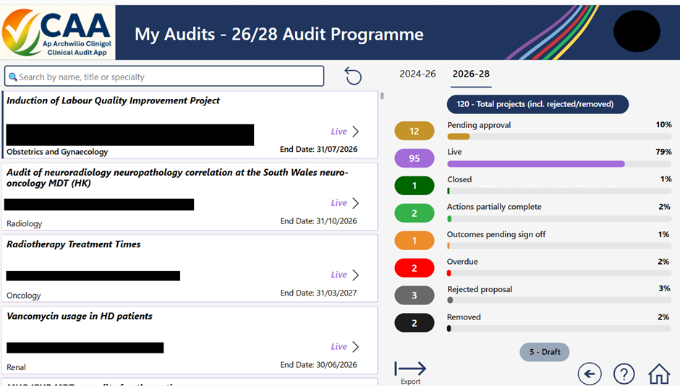

Fig. 1
  - Monitoring Plans
Service Delivery Groups now present on a number of key agenda items on a rota basis using a uniform template. Supported by the COEG dashboard and the new Clinical Audit App, Service Groups are now able to delve deeper into areas requiring mitigation to meet expectations in both the audit levels and assurance responses.

The position on the 2024-26 clinical audit programme has strengthened considerably, with clear improvements in governance, oversight, and delivery. Backlogs have been reduced, long-standing historic audits have been resolved where no longer required, and completion processes have been tightened to ensure audits are formally closed once outcomes are reviewed.

Engagement with audit leads has improved significantly, supported by direct follow-up and clearer accountability. The introduction of the new Clinical Audit App has been a major enabler, improving usability, visibility, and ownership for audit leads. Feedback indicates that the system is easier to navigate, less overwhelming, and better aligned to individual roles, supporting more timely review and decision-making.

Clinical Audit Plans are monitored until all listed topics are accounted for, with monthly updates received at the COEG meetings. Figure 1 provides an overview of the current status of recent audit programmes.

Current Status of Recent Audit Programmes
 | 2023/24 |  |  |  |  |  |  |  |  |  | 2024-26
 | @ 24/25 |  |  | @ 25/26 |  |  | @ 26/27 |  |  | @ 25/26 |  |  |  | @ 26/27
 | 39% |  |  | 86% |  |  | 86% |  |  |  | 25% |  |  |  | 72%
Fig. 2.
It is reassuring that the transition between the legacy and new systems has resulted in minimal disruption. The longer-term priority remains the establishment of effective and timely oversight of planned activity and triggered re-audit cycles, to ensure that they are delivered as intended.
In response to user feedback, the Clinical Audit and Effectiveness Department (CAED) reverted to using SharePoint for registration and monitoring of audit activities for topics logged from 1st April 2024 and this was used as the basis of the new Clinical Audit App. All historic topics unaccounted for on AMaT were migrated across to the new app.

At the request of Quality Improvement colleagues, the CAED no longer log Quality Improvement (QI) activities and signpost them to the QI Hive.

Nursing, Midwifery and Allied Health Professionals continue to utilise the Audit Management and Tracking (AMaT) system in support of several continuous or ongoing work-streams.

3.5 Process for Non-Compliance
Via the new Clinical Audit App project contacts receive automated email prompts 30 days before the listed end date. Where audits fail to be delivered by the documented end date, they will now receive further email communications on a monthly basis.

Designated Audit Leads will also receive monthly summaries to include progress updates and topics listed for action and/or reassignment. Topics can be removed if Audit Leads confirm it is no longer relevant/required e.g., where improvement work is being progressed through different means, care pathways and standards have changed etc.

- FINANCIAL IMPLICATIONS
There are no financial implications associated with this report.

- RECOMMENDATION
Members are asked to:
- ACKNOWLEDGE the process undertaken to compile the 2026/28 clinical audit plan;
- ACKNOWLEDGE the approval of the clinical audit plans for 2026/28 by the COEG in March 2026;
- ACKNOWLEDGE the achievement of improving to 72% completion for the extended 2024-26 Audit Programme;
- ACKNOWLEDGE overall delivery of the plan is reviewed by COEG on a monthly basis, and this will continue until all audits have been closed.

Governance and Assurance
Link to Enabling Objectives  (please choose) | Supporting better health and wellbeing by actively promoting and empowering people to live well in resilient communities
Link to Enabling Objectives  (please choose) | Partnerships for Improving Health and Wellbeing |  | ☐
Link to Enabling Objectives  (please choose) | Co-Production and Health Literacy |  | ☐
Link to Enabling Objectives  (please choose) | Digitally Enabled Health and Wellbeing |  | ☒
Link to Enabling Objectives  (please choose) | Deliver better care through excellent health and care services achieving the outcomes that matter most to people
Link to Enabling Objectives  (please choose) | Best Value Outcomes and High Quality Care |  | ☒
Link to Enabling Objectives  (please choose) | Partnerships for Care |  | ☐
Link to Enabling Objectives  (please choose) | Excellent Staff |  | ☒
Link to Enabling Objectives  (please choose) | Digitally Enabled Care |  | ☒
Link to Enabling Objectives  (please choose) | Outstanding Research, Innovation, Education and Learning |  | ☒
Health and Care Standards
(please choose) | Staying Healthy |  | ☐
(please choose) | Safe Care |  | ☒
(please choose) | Effective Care |  | ☒
(please choose) | Dignified Care |  | ☒
(please choose) | Timely Care |  | ☒
(please choose) | Individual Care |  | ☒
(please choose) | Staff and Resources |  | ☒
Quality, Safety and Patient Experience
Submission of data to national topics allows benchmarking performance for quality, safety and patient experience, while the appropriate identification and planning of necessary local priorities can support improvements and provide assurance.
Financial Implications
None
Legal Implications (including equality and diversity assessment)
None
Staffing Implications
None
Long Term Implications (including the impact of the Well-being of Future Generations (Wales) Act 2015)
Continue to embed appropriate prioritisation of audit activities while balancing the need to meet requirements placed on doctors and healthcare professionals in training.
Report History |  | Bi-annual report to the Committee
Appendices |  | Appendix 1. 2026-28 Confirmed Audit Plan

Appendix One – 2026-28 Confirmed Audit Plan
