

HEALTH BOARD RISK REGISTER
October 2024

HEALTH BOARD RISK REGISTER
SUMMARY OF ASSESSED RISKS

Impact/Consequences | 5 |  | 75: Whole Service Closure | 53: Compliance with Welsh Language Standards | 16: Access to Planned Care  60: Cyber Security  66: Access to Cancer Services – SACT  69: Adolescents being admitted to Adult MH wards  93: Finance: Reduced capital funds  98: Overall condition/compliance and suitability of Health Board Estate  99: Failure to implement the population health strategy approaches at the required scale.  101: Industrial Action (HCSW) | 01: Access to Unscheduled Care Service  50: Access to Cancer Services  92: Finance: Forecast Deficit
Impact/Consequences | 4 |  |  | 37: Operational and strategic decisions are not data informed  51: Nurse Staffing Levels Act (Section 25B)  94: CAMHS failure to meet required standards of performance | 27: Digital Transformation  36: Paper Record Storage  43: DOLS/LPS Authorisation & Compliance  52: Impact Assessment Requirements  61: Paediatric Dental GA Service  64: H&S Infrastructure  90: GDPR Subject Access Requests  102: Inability to maintaining Birthrate Plus complaint rosters  103: High Quality Choices in Birth Place | 03: Recruitment of Consultant Medical and Dental Staff  04: Healthcare Acquired Infection  80: Transfer of Clinically Optimised Patients  85: Non Compliance with ALN Act  89: Healthcare Nursing Staff Levels (HMP)  96: Failure to Develop an Approvable IMTP
Impact/Consequences | 3 |  |  |  | 63: Screening for Fetal Growth Assessment in line with Gap-Grow (G&G) Reduced from 20  100: Partnerships & Collaboration
Impact/Consequences | 2
Impact/Consequences | 1
C X L |  | 1 | 2 | 3 | 4 | 5
 |  | Likelihood
Risk Register Dashboard

Strategic Objective | Risk Reference | Description of risk identified | Initial  Score | Current Score | Trend | Controls | Last Reviewed | Scrutiny Committee
1  People of Swansea Bay live healthier, equitable and more equal and prosperous lives | 52  (1763) | Statutory Compliance: Engagement & Impact Assessment  The Health Board does not have sufficient resource in place to undertake engagement & impact assess in line with Statutory Duties | 16 | 16 |  |  | October 2024 | Performance & Finance Committee
1  People of Swansea Bay live healthier, equitable and more equal and prosperous lives | 99 | Failure to implement the population health strategy approaches at the required scale  This arises from risk of a failure of the organisation to understand and act on the provisions of the strategy for building whole of system actions across the 4 pillars; and the consequent lack of systems and processes to support the delivery of population health improvements. | 20 | 20 |  |  | October 2024 | Population Health & Partnership Committee
1  People of Swansea Bay live healthier, equitable and more equal and prosperous lives | 100 | A lack of a robust approach to partnerships & collaboration  If the health board does not have effective structures, processes and working relationships with its external partners, there is a risk that areas of work dependent upon collaboration with partners may not deliver what is required in a timely way, impacting on the delivery of health board priorities. | 12 | 12 |  |  | October 2024 | Population Health & Partnership Committee
2  Care is high quality, safe, efficient, and delivers the best possible outcomes for people | 75  (2522) | Whole Service Closure  Risk that services or facilities may not be able to function if there is a major incident or a rising tide that renders current service models unable to operate. | 20 | 10 |  |  | October 2024 | Performance & Finance Committee
2.1  Care is high quality, safe, efficient, and delivers the best possible outcomes for people | 4  (739) | Healthcare Acquired Infection  Risk of patients acquiring infection as a result of contact with the health care system, resulting in avoidable harm, impact on service capacity, and failure to achieve national infection reduction goals. | 20 | 20 |  |  | October 2024 | Quality & Safety Committee
2.1  Care is high quality, safe, efficient, and delivers the best possible outcomes for people | 51  (1759) | Nurse Staffing (Wales) Act (Section 25B wards)  Risk of Non Compliance with the Nurse Staffing (Wales) Act  There is a risk we may not meet these requirements fully due to increased acuity, unplanned staff absence and vacancies. The potential impact of this maybe non-compliance with the ‘Act’, poor patient outcomes and experience, and suspension of services. | 16 | 12 |  |  | October 2024 | Workforce OD & Digital Committee
2.1  Care is high quality, safe, efficient, and delivers the best possible outcomes for people | 53  (1762) | Welsh Language Standards  Failure to fully comply with all the requirements of the Welsh Language Standards, as they apply to the University Health Board. | 15 | 15 |  |  | October 2024 | Health Board  (Welsh Language Group)
2.1  Care is high quality, safe, efficient, and delivers the best possible outcomes for people | 101 | Industrial Action (Healthcare Support Workers)  (In Committee Risk)  Due to inconsistencies in the bandings of healthcare support workers across the UK and NHS Wales at a band two and three level, action is being taken in partnership with Unison and the RCN to address inequalities against the context of limited financial resource availability. [Full description In Committee] | 20 | 20 |  |  | October 2024 | Workforce OD & Digital Committee
2.2  Primary & Community Care | 89  (3071) | Healthcare Nursing Staff Levels (HMPS)  There is a risk that the men in HMP Swansea will not receive the appropriate standard of care. This is due to the fact that the nursing establishment within the prison no longer fully meets the changed demographics and numbers of men being detained. | 20 | 20 |  |  | October 2024 | Quality & Safety  Committee
2.3  Mental Health & Learning Disability Services | 43  (1514) | DoLS  Due to a lack of Best Interest Assessor resource, there is a risk of failure to complete and authorise the assessments associated with Deprivation of Liberty/Liberty Protection Safeguards within the legally required timescales, exposing the health board to potential legal challenge and reputational damage. | 16 | 16 |  |  | October 2024 | Quality & Safety Committee
2.3  Mental Health & Learning Disability Services | 94  (3516) | CAMHS failure to meet required standards of performance  The CAMHS service is unable to meet the required level of performance due to workforce deficits in the team across all staff groups including medics, psychological therapies and nursing. | 20 | 12 |  |  | October 2024 | Performance & Finance Committee
2.4  Urgent & Emergency Care | 1  (738) | Access to Unscheduled Care Service  If we fail to provide timely access to Unscheduled Care then this will have an impact on quality & safety of patient care as well as patient and family experience and achievement of targets. There are challenges with capacity/staffing across the Health and Social care sectors. | 20 | 25 |  |  | October 2024 | Performance & Finance Committee
2.4  Urgent & Emergency Care | 80  (1832) | Transfer of Clinically Optimised Patients  A deficit in the availability of appropriate community / domiciliary care results in unacceptable delays in discharging patients from acute hospital beds. As a result, patients can decompensate and never gain the independence that could have been available from an early discharge. | 20 | 20 |  |  | October 2024 | Quality & Safety  Committee
2.5  Planned Care | 16  (840) | Access to Planned Care  There is a risk of harm to patients if we fail to diagnose and treat them in a timely way. | 16 | 20 |  |  | October 2024 | Performance & Finance Committee
2.5  Planned Care | 61  (1587) | Paediatric Dental GA Service – Parkway  Safety risk of general anaesthetic procedures performed on children outside of an acute hospital setting. | 15 | 16 |  |  | October 2024 | Quality & Safety  Committee
2.6  Cancer Care | 50  (1761) | Access to Cancer Services  There is a risk of delay in diagnosing patients with cancer, and consequent delay in commencement of treatment, which could lead to poor patient outcomes and failure to achieve targets. | 20 | 25 |  |  | October 2024 | Performance & Finance Committee
2.6  Cancer Care | 66  (1834) | Access to Cancer Services (SACT)  Delays in access to SACT treatment in Chemotherapy Day Unit. | 25 | 20 |  |  | October 2024 | Quality & Safety  Committee
2.7  Children & Young People Services | 69  (1418) | Adolescents are being admitted to adult mental health wards  Risk related to adolescent patients being admitted to Adult MH inpatient wards – Inappropriate settings potentially resulting in 'Safeguarding Issues'. The WG has requested that Health Boards identify Secondary Care inpatient facilities for the care of adolescents. In Swansea Bay University Health Board Ward F NPT Hospital is the dedicated receiving facility with one bed identified. | 20 | 20 |  |  | October 2024 | Quality & Safety  Committee
2.7  Children & Young People Services | 85  (2561) | Non-Compliance with ALN Act  There are risks to the Health Board’s ability to meet its statutory duties and establish the effective collaborative arrangements required by the ALN Act, which is being implemented through a phased approach. | 25 | 20 |  |  | October 2024 | Quality & Safety  Committee
2.8  Maternity Services | 63  (1605) | Screening for Fetal Growth Assessment in line with Gap-Grow Reduced from 20  There is not enough Ultrasound capacity within Swansea Bay UHB to offer all women serial ultrasound scan screening in the third trimester in line with the UK perinatal Institute Growth Assessment Programme (GAP). | 12 | 12 |  |  | October 2024 | Quality & Safety  Committee
2.8  Maternity Services | 102 | Inability to maintain Birthrate Plus ® complaint rosters  Birthrate Plus® enables health boards to calculate their midwifery staffing requirements based on their specific activity, case mix, demographics and skill mix.  There is a risk non-compliance with roster templates due to increased acuity, unplanned staff absence and vacancies. The potential impact of this may be reduced staffing levels against the agreed Birthrate Plus ®, staffing template resulting in poor patient outcomes and experience, and potential suspension of services. | 20 | 16 |  |  | October 2024 | Quality & Safety  Committee
2.8  Maternity Services | 103 | High Quality Choices in Place of Birth  The Community Intrapartum services remain suspended  There is a risk of not being able to provide high quality choices in place of birth (via appropriately staffed and resourced community midwifery teams, the freestanding midwifery unit at Neath Port Talbot Hospital, the alongside midwifery unit and obstetric unit at Singleton Hospital). The potential impact of this is poor patient experience and birth outcomes, poor staff morale and increased attrition of community midwives, increased acuity within obstetric services at Singleton Hospital, and the reduction of services could impact on organisational reputation. | 16 | 16 |  |  | October 2024 | Quality & Safety  Committee
3  Care is delivered in safe and appropriate settings | 64  (2159) | Health and Safety Infrastructure  Insufficient resource and capacity of the health, safety and fire function to maintain legal and regulatory compliance. | 20 | 16 |  |  | October 2024 | Quality & Safety  Committee
3  Care is delivered in safe and appropriate settings | 98  (3692) | Overall condition/compliance and suitability of Health Board Estate  6 FACET survey undertaken in 2022 confirmed the poor condition and suitability of premises where health care services are provided. | 20 | 20 |  |  | October 2024 | Performance & Finance Committee
4  The delivery of care is supported by innovative digital solutions | 27  (1035) | Digital Transformation to Deliver Sustainable Clinical Services  Inability to deliver sustainable clinical services due to lack of resources to deliver sustainable Digital Transformation and services. There are insufficient resources to invest in the delivery of the SBU Digital strategy; support the growth in utilisation of existing and new digital solutions; replace existing technology infrastructure or software at the end of its useful life. | 16 | 16 |  |  | October 2024 | Workforce OD & Digital Committee
4  The delivery of care is supported by innovative digital solutions | 36  (1043) | Storage of Paper Records  Failure to provide adequate storage facilities for paper records then this will impact on the availability of patient records at the point of care. Quality of the paper record may also be reduced if there is poor records management in some wards. | 20 | 16 |  |  | October 2024 | Workforce OD & Digital Committee
4  The delivery of care is supported by innovative digital solutions | 37  (1217) | Information Led Decisions  Risk that operational and strategic decisions are not data informed. | 16 | 12 |  |  | October 2024 | Workforce OD & Digital Committee
4  The delivery of care is supported by innovative digital solutions | 60  (2003) | Cyber Security (In Committee Risk)  The level of cyber security incidents is at an unprecedented level and health is a known target. | 20 | 20 |  |  | October 2024 | Workforce OD & Digital Committee
4  The delivery of care is supported by innovative digital solutions | 90  (2796) | Non-compliance with UK-GDPR Article 15 regarding Subject Access Requests (SARs) and other requests for disclosure of personal data  The Health Board does not have adequate resources to deal with the sustained increase in volume and complexity of subject access /access to health records requests received from requestors. The ICO are already involved with a number of breaches and complaints in this area and there is the potential for future enforcement action if significant improvements are not made. | 16 | 16 |  |  | October 2024 | Workforce OD & Digital Committee
5  The Health Board is a great place to work where staff feel valued and work together towards a common goal | 3  (843) | Recruitment of Consultant Medical and Dental Staff  Due to national shortages, there is a risk that that the health board will be unable to recruit consultant medical & dental staff into particular hard to fill roles which may result in difficulties fulfilling rotas on all sites, and adverse impact upon patient safety, service provision, quality and financial matters. | 20 | 20 |  |  | October 2024 | Workforce OD & Digital Committee
6  The health board is a resilient, financially sustainable and responsible organisation | 92  (3444) | Finance: Forecast Deficit Risk  Forecast deficit is not met due to insufficient progress on COVID cost reduction, savings identification, run rate reduction and the potential for new in-year pressures. | 20 | 25 |  |  | October 2024 | Performance & Finance Committee
6  The health board is a resilient, financially sustainable and responsible organisation | 93  (3448) | Finance: Reduced capital funds  Reduced discretionary capital funds and reduced National NHS funds requiring a restricted Capital Plan for 2024/25. | 20 | 20 |  |  | October 2024 | Performance & Finance Committee
6  The health board is a resilient, financially sustainable and responsible organisation | 96  (3571) | Failure to Develop an Approvable IMTP (statutory compliance)  Failure to have an approvable IMTP for 2024/5 then we will lose public confidence and breach legislation. | 20 | 20 |  |  | October 2024 | Performance & Finance Committee

Risk Schedules

Datix ID Number: 738  Health & Care Standard: |  |  | HBR Ref Number: 1  Risk Target Date: 31/03/2025 |  | Current Risk Rating  5 x 5 = 25
Objective: Urgent & Emergency Care |  | BAF Ref: 2.4 | Director Lead: Deb Lewis, Chief Operating Officer  Assuring Committee: Performance & Finance Committee  For information: Quality & Safety Committee
Risk: Access to Unscheduled Care  If we fail to provide timely access to Unscheduled Care then this will have an impact on quality & safety of patient care as well as patient and family experience and achievement of targets. There are challenges with capacity/staffing across the Health and Social care sectors. (This risk includes ED, AMU and impact in community from ability to release ambulances at both front doors.) |  |  | Date last reviewed: October 2024
Risk Rating  (consequence x likelihood):  Initial: 4 x 5 = 20  Current: 5 x 5 = 25  Target: 3 x 4 =12 | 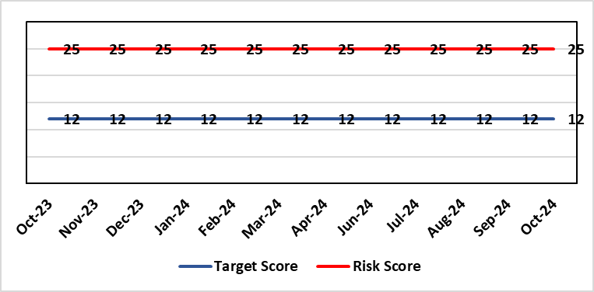 |  | Rationale for current score:  The UEC system continues to see high demand, with ambulance attendances in particular being higher than seen previously. This is coupled with reduced flow out of hospital beds due to an imbalance of acute / community / care service provision. These factors are resulting in unacceptable delays in patients accessing UEC services and therefore the risk score remains high.
Level of Control  = 50% |  |  | Rationale for target score:  The HB is currently under escalating performance monitoring from WG (Targeted Intervention or TI) for delivery of UEC services. The improvement plan developed as a response to TI and that already included in the HB annual plan is to implement models of care that reflect best practice and focus on areas that will benefit patients, staff and the UEC system most. The implementation of this plan will improve patient flow, length of stay and reduce emergency demand.
Date added to the HB risk register
26.01.16
Controls (What are we currently doing about the risk?) |  |  | Mitigating actions (What more should we do?)
Five main areas of work within the plan:  - Frailty strategy – approved via Management Board  - Grip & control operational management  - Senior decision makers at front door services  - Pathway of care delays (PoCD)  - Home First  - ACT  - Interface with local authority  - Reconfiguration of Emergency Dept  In addition to BAU improvement actions:  - Continued focussed roll-out of 6-Goals schemes of work  - D2RA / Trusted assessor model  - SAFER  - Criteria-led discharge  - Continuous Flow Model (CFM)  - Robust SDEC model |  |  | Action | Lead |  | Deadline
 |  |  | Review of senior decision making capacity within SDEC and AMU | GMD Morriston SG |  | 31/12/2024
 |  |  | Implementation of 7-day community services | Interim EMD |  | 31/12/2024
 |  |  | Implementation of UEC Navigation Hub to decrease demand and implement right patient right place process | COO |  | 30/11/2024
 |  |  | Reintroduce D2RA Principles across the Health Board | Corporate Patient Flow team & Assistant Director of Operations |  | 28/02/2025
Assurances (How do we know if the things we are doing are having an impact?)  - Urgent & Emergency Care Board is meeting monthly chaired by the COO.  - Six Goals programme reviews the pan on a monthly basis |  |  | Gaps in assurance (What additional assurances should we seek?)  The need to deliver sustained service.
Additional Comments / Progress Notes
08/05/2024: Risk assessment rationale, controls and actions fully refreshed. Focus on the implementation of the Frailty strategy, to be operational during September 2024.
14/10/2024: Actions remain current with the exception of the CFM, which is now on hold pending improvement from other actions. UEC summit held in October to consolidate system approach. This will be repeated in six weeks.
23/10/2024: Actions refreshed. Criteria led discharge was rolled out in Medicine and had been indicated to follow in other areas. The previous action in relation to that action has been closed as previously described and replaced with action to implement D2RA, during which further consideration will be given to criteria-led discharge.
06/11/2024: The Winter Plan is currently in development, along with actions to achieve the 50-day Challenge as laid out by the Care Action Committee. The plans will be submitted to WG and received by the Board at the end of November. There is a significant financial challenge in delivering the additional capacity, both in terms of physical space and 7-day working, required to achieve the progress required over Winter.

Datix ID Number: 843  Health & Care Standard: |  |  | HBR Ref Number: 3  Risk Target Date: 31/03/2025 | Current Risk Rating  4 x 5 = 20
Objective: The Health Board is a great place to work where staff feel valued and work together towards a common goal |  | BAF Ref: 5 | Director Lead: Sarah Jenkins, Interim Director of Workforce and OD  Assuring Committee: Workforce OD & Digital Committee
Risk: Recruitment of consultant medical & dental staff in hard to fill roles.  Due to national shortages, there is a risk that that the health board will be unable to recruit consultant medical & dental staff into particular hard to fill roles which may result in difficulties fulfilling rotas on all sites, and adverse impact upon patient safety, service provision, quality and financial matters. |  |  | Date last reviewed: October 2024
Risk Rating  (consequence x likelihood):  Initial: 5 x 4 = 20  Current: 4 x 5 =20  Target: 4 x 3 = 12 | 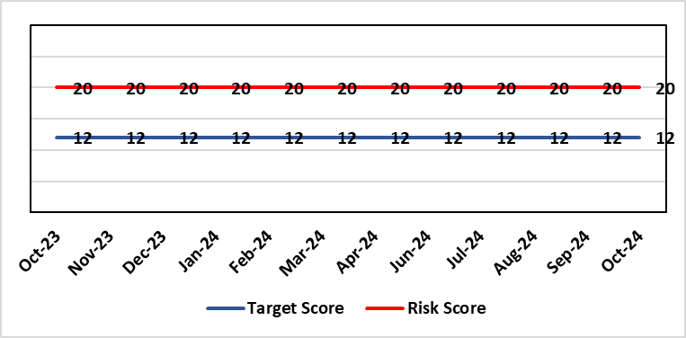 |  | Rationale for current score:  National shortages of numbers in some areas can lead to:  - Inability to recruit sufficient numbers of trainees to fulfil rotas on all sites  - Inability to attract non training grades to complete rotas  - Inability to fill Consultant grade posts in some specialties with adverse effects on patient safety and employer relations. Inability to recruit sufficient registered nursing staff.  - The situation has improved around the recruitment of junior staff but there are many hard to fill consultant posts which impact on the ability to run services which impacts patient care.
Level of Control  = 70% |  |  | Rationale for target score:  This remains a challenge and is also a national problem.
Date added to the HB risk register
April 2012
Controls (What are we currently doing about the risk?) |  |  | Mitigating actions (What more should we do?)
- Regular monitoring of recruitment position with reports to Executive Team and Board via Medical Director and Medical Workforce Board.  - Specialty based local workforce boards established to monitor and control specific issues. The HB Workforce OD & Digital Committee will seek assurance of medical workforce plans to maintain services.  - Engagement of the Deanery about recruitment position.  - Weekly workforce delivery meetings with CEO to review progress against critical medical and clinical posts  - Working with specialist agency and head hunters to improve chances to fill hard to recruit posts  - Working with a marketing agency to develop a branding and attraction campaign for the health board.  - Consideration of the RPO (Recruitment Process Outsourcing) model.  - Implemented the CESR (Certificate of Eligibility for Specialist Registration) framework to grow your own consultants |  |  | Action |  | Lead | Deadline
 |  |  | Medical training initiatives pursued in a number of specialties to ease junior doctor recruitment |  | Director W&OD | 31/03/2025
 |  |  | The Medical Workforce Board continues to monitor recruitment and junior doctor’s rotas. |  | Director W&OD | 31/03/2025
 |  |  | Continue to recruit internationally. |  | Director W&OD | 31/03/2025
 |  |  | Continue to work with head hunters |  | Director W&OD | 31/03/2025
Assurances (How do we know if the things we are doing are having an impact?)  - General situation monitored through W&OD Committee  - Communication with Deanery  - Recruitment campaigns  - Monitoring by Executive Teams and specialty based local workforce boards  - Workforce planning and deployment taskforce meetings with service groups  - Weekly workforce delivery meetings with CEO as above |  |  | Gaps in assurance (What additional assurances should we seek?)  Locum cover  Adequate supply of doctors who can work in this country  Ability to flexibly deploy doctors in training.  Dedicated work between workforce and finance to review and confirm budgeted medical workforce establishment by service group to confirm SIP and vacancy factor.
Additional Comments / Progress Notes
31/10/2024: No further updates at this stage the position remains as described.

Datix ID Number: 739  Health & Care Standard: |  |  | HBR Ref Number: 4  Risk Target Date: 31/03/2025 | Current Risk Rating  4 x 5 = 20
Objective: Care is high quality, safe, efficient, and delivers the best possible outcomes for people |  | BAF Ref: 2.1 | Director Lead: Hazel Powell, Executive Director of Nursing  Assuring Committee: Quality & Safety Committee
Risk: Healthcare Acquired Infection  Risk of patients acquiring infection as a result of contact with the health care system, resulting in avoidable harm, impact on service capacity, and failure to achieve Tier 1 national infection reduction goals. |  |  | Date last reviewed: October 2024
Risk Rating  (consequence x likelihood):  Initial: 4 x 5 = 20  Current: 4 x 5 = 20  Target: 4 x 3 =12 |  |  | Rationale for current score:  Health Board incidence of key Tier 1 infections per 100,000 population above All Wales rates, indicating Health Board’s population at greater risk of infection. High occupancy rates & frequent ward moves associated with increased risk of infection transmission. Lack of decant facilities compromises environment deep cleaning & decontamination, and planned preventative maintenance programmes.
Level of Control
= 40%
Date added to the HB risk register
January 2016
Date added to the HB risk register  January 2016 |  |  | Rationale for target score:  Improved governance structures for IPC and antimicrobial stewardship will drive improved local ownership and embed responsibility for these priorities for all levels of staff. Adequately maintained & clean environments facilitate good IPC & minimise infection risks. Reduced occupancy & frequency of patient moves mitigate against infection transmission. Compliant ventilation systems and water safety minimise infection risks. Access to timely data on infections, training, antimicrobial stewardship, cleaning at ward/unit/practice level enables Service Groups to identify areas for focused QI programmes, drive improvement, & effectively measure outcomes.
Controls (What are we currently doing about the risk?) |  |  | Mitigating actions (What more should we do?)
- Policies, procedures, protocols and guidelines supplement the National Infection Control Manual.  - Infection Prevention & Control related training provided programmes.  - Surveillance of infections, with early identification of increased incidence, and instigation of controls.  - Antimicrobial stewardship programmes and systems of monitoring and feedback.  - Provision of cleaning service to meet National Standards of Cleanliness.  - Engineering controls for water safety, ventilation, and decontamination.  - Infection Prevention Improvement Plans 2024/25 for HB and Service Groups were approved by the Health Board's Infection Prevention & Control Strategic Group on 30/04/24 and 31/07/24 respectively. Progress is reported at SG Infection Control Committees, HB Infection Prevention & Control Group, Quality & Safety Group, Quality & Safety Committee, and Management Board. These include trajectories to meet national targets and report performance against them.  - The Health Board has been escalated to Targeted Intervention for its position relating to healthcare associated infection (HCAI). Governance processes for HCAI have been revised to provide strengthened scrutiny and assurance. |  |  | Action |  | Lead | Deadline
 |  |  | Achieve 85% compliance with IPC mandatory training (Levels 1 & 2) |  | Service Group Directors | 31/12/2024
 |  |  | Undertake a programme of decant, deep clean and disinfection with hydrogen peroxide vapour (HPV) in Morriston Hospital. |  | Morriston Service Group Directors | 31/12/2024
 |  |  | Achieve reduction in Tier 1 infections to meet de-escalation criteria for intervention targets |  | Service Group Directors | 31/03/2025
Assurances (How do we know if the things we are doing are having an impact?)  - Clear Corporate and Service Group IPC Assurance Framework in place.  - Infection Prevention Improvement Plans for HB and Service Groups with progress reported at SG Infection Control Committees, HB Infection Prevention & Control Group, Quality & Safety Group and at Management Board. These include trajectories to meet national targets and report performance against them. This is also reported to Quality & Safety Committee.  - Ongoing monitoring of infection control rates.  - IPC, antimicrobial, decontamination and cleaning audit programmes.  - Annual completion of IPC Level 2 mandatory training for all HB staff.  - Compliance and validation systems for water safety, ventilation systems and decontamination.  - Revised and strengthened governance structure for HCAI, including monthly meetings of Executive HCAI Scrutiny Group. |  |  | Gaps in assurance (What additional assurances should we seek?)  - High occupancy rates & frequent ward moves associated with increased risk of infection transmission.  - Lack of single room availability, leading to delays in isolating patients with infections and increasing risks to patient contacts.  - Increased numbers of clinically optimised patients remaining in hospital leads to increased length of stay, increased risk of over-occupancy and over-crowding, with consequence of increasing risks of acquisition of infection.  - General infrastructure of the aging hospital estate compromises ability to clean and decontaminate effectively.  - Antimicrobial prescribing, relating particularly to total volume of antibiotics, with the SBUHB having second highest total volume of antibiotics prescribed in primary care in Wales.  - Lack of decant facilities compromises environment deep cleaning & decontamination, and planned preventative maintenance programmes.  - Varying levels of IPC responsibility embedded across all disciplines and groups, with variable medical engagement at all levels in infection prevention-related Quality Improvements programmes.
Additional Comments / Progress Notes
Progress updated 19/09/24:
- Executive HCAI Scrutiny Group are taking place regularly with Service Group Directors.
- C. difficile cases increased further in August and this was escalated by the establishment of the Gold C. difficile High Incidence Management Group which met on 5th September, with involvement of all Service Groups and expert advisors from PHW.
- Level 2 IPC training compliance continues to improve 81.47%; Level 1 training compliance 91.71% as of 31/08/24
- Tier 1 infection progress to Targeted intervention de-escalation criteria in August 2024:
- C. difficile - 18 hospital onset cases (target 6). Combined (hospital onset and community onset) cumulative total – 110 cases.
- Staph. aureus - 8 hospital onset cases (target 3). Combined cumulative total - 53 cases.
- E. coli - 8 hospital onset cases (target 4). Combined cumulative total - 96 cases.
- Klebsiella spp. - 6 hospital onset cases (target 4). Combined cumulative total - 54 cases.
- Pseudomonas aeruginosa - (Not included within targeted interventions). Combined cumulative total - 6 cases.

Datix ID Number: 840  Health & Care Standard: |  |  | HBR Ref Number: 16  Risk Target Date: 31/03/2025 | Current Risk Rating  5 x 4 = 20
Objective: Planned Care |  | BAF Ref: 2.5 | Director Lead: Deb Lewis, Chief Operating Officer  Assuring Committee: Performance & Finance Committee  For information: Quality & Safety Committee
Risk: Access and Planned Care  There is a risk of harm to patients if we fail to diagnose and treat them in a timely way. |  |  | Date last reviewed: October 2024
Risk Rating  (consequence x likelihood):  Initial: 4 x 4 = 16  Current: 5 x 4 = 20  Target: 4 x 2 = 8 | 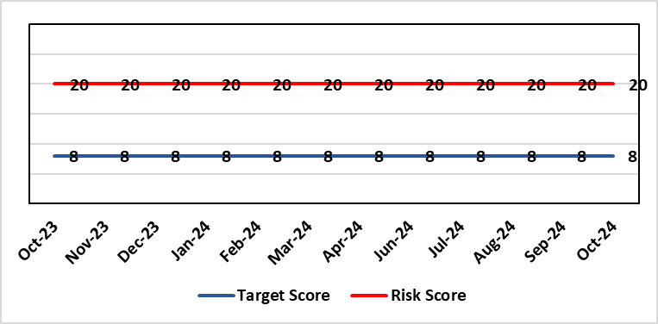 |  | Rationale for current score:  Whilst the HB has eradicated very long waits for surgery, patients are still waiting in excess of 104 weeks for surgical intervention, which is outside of national policy on RTT. The HB is currently under escalating performance monitoring from WG (Targeted Intervention or TI) for delivery of Planned Care services. The improvement plan developed as a response to TI mirrors that already included in the HB
Level of Control
= 90%
Level of Control  = 90% |  |  | Rationale for target score:  There is scope to reduce the likelihood score to reduce the overall risk to an acceptable level. The Risk target date indicates when we expect to see some reduction in waiting lists – albeit the overall risk level may remain as work continues.
Date added to the HB risk register
January 2013
Controls (What are we currently doing about the risk?) |  |  | Mitigating actions (What more should we do?)
- There is a bi-weekly Targeted Intervention (TI) meeting specifically for assurance on the recovery of our elective programme.  - Specialty level capacity and demand models set out the baseline capacity and identify solutions to bridge the gap this financial year.  - A focused intervention is in train to support to the 10 specialties with the longest waits.  - Long waiting patients are being outsourced to the Independent Sector, where appropriate  - Additional internal activity is being delivered on weekends (via insourcing), although this is currently at risk due to changes in policy pertaining to the payment of enhanced rates to A4C staff.  - Planned care trajectories are being developed and submitted to WG as part of the annual plan by the end of May 2024.  - Governance process put in place to monitor performance against trajectories internally, and with Welsh Government as part of Targeted Intervention.  - External & internal validation continues.  - All long waiting patients are receiving clinical reviews to ascertain continued need for surgery. |  |  | Action |  | Lead | Deadline
 |  |  | Theatre Optimisation Programme now in place to maximise efficient use of theatre capacity |  | NPTSSG SGD | 31/03/2025
 |  |  | Revised demand and capacity planning underway to utilise additional funding from WG to clear 104 week waits by the end of March 2025. |  | Chief Operating Officer | Complete (plan submitted to WG)
Assurances (How do we know if the things we are doing are having an impact?)  - TI dashboard developed to monitor performance in a live state  - Weekly TI monitoring meetings chaired by the COO  - Bi-weekly planned care meetings chaired by the COO  - Monthly TI monitoring meetings with WG |  |  | Gaps in assurance (What additional assurances should we seek?)
Additional Comments / Progress Notes
08/05/2024: All patients breaching the 104 week target are at treatment stage. Therefore all have a treatment plan in place.
14/06/2024: Actions completed: Development of comprehensive demand & capacity plans for 2024/25; Work with Finance colleagues to establish the funding allocation for elective recovery for 2024/25.
22/07/2024: All specialties with the exception of gynaecology have cleared their 156 week waits. 104 weeks continue to reduce.
14/10/2024: Progress against the Planned Care agenda continues with 52 weeks maintained and 156 weeks now removed.
31/10/2024: Action complete – Recovery plan to meet 104 target by March 2025 submitted to Welsh Government to secure additional funding.

Datix ID Number: 1035  Health & Care Standard: |  |  | HBR Ref Number: 27  Risk Target Date: 31/03/2026 |  | Current Risk Rating  4 x 4 = 16
Objective: The delivery of care is supported by innovative digital solutions |  | BAF Ref: 4 | Director Lead: Matt John, Director of Digital  Assuring Committee: Workforce OD & Digital Committee
Risk: Digital Transformation  Inability to deliver sustainable clinical services due to lack of resources to deliver sustainable Digital Transformation and services. There are insufficient resources to:  - Invest in the delivery of the SBU Digital strategy  - Support the growth in utilisation of existing and new digital solutions  - Replace existing technology infrastructure or software at the end of its useful life. |  |  | Date last reviewed: October 2024
Risk Rating  (consequence x likelihood):  Initial: 4 x 4 = 16  Current: 4 x 4 = 16  Target: 5 x 2 = 10 | 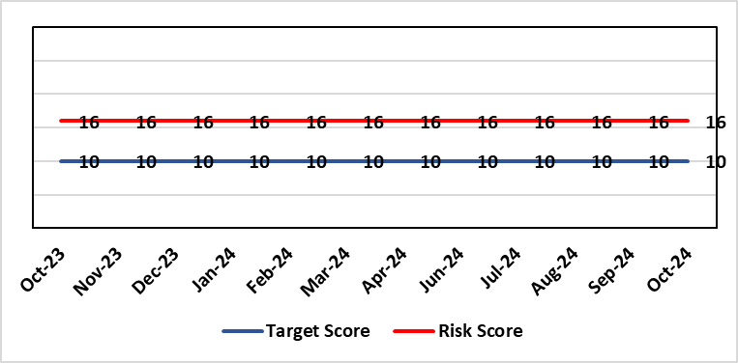 |  | Rationale for current score:  C – Reliance on digital ways of working has increased. Loss of IT service has a greater impact on ability to provide clinical care. Lack of investment in new digital solutions to make services more effective will mean clinical service provision will become unsustainable.  L- Reduction in capital funding in 2022/23/24 has increased the likelihood of HB not being able to replace aging infrastructure such as the network equipment. There is a £15m capital requirement over the next 3 years. Acceleration of the CTM SLA disaggregation has been proposed and there are further pressures on revenue funding. The shift to cloud and software as a service contracting models will increase the requirement for revenue funding to deliver digital transformation and ongoing services.
Rationale for target score:
C – Of failure will increase as the reliance and proliferation of the use of digital solutions increases.
L – Investment will mean the support mechanisms, rate of failure and ability to deliver solutions that meet the needs of users will improve sustainable digital services. There will however always be an inherent risk of failure of IT solutions.
Level of Control
= 50%
Date added to the HB risk register
2012
Controls (What are we currently doing about the risk?) |  |  | Mitigating actions (What more should we do?)
- Digital Strategy has been approved by the Health Board and outlines requirements  - HB Capital priority group considers digital risks for replacement technology which is fed into the annual discretionary capital plan  - Digital Services prioritisation process is in place Digital Leadership Group provides the overarching governance to the delivery of the Digital Strategic Plan including financial considerations.  - Digital Services Management Group assesses current service provision and flags risks and issues  - Digital Services revenue requirements are included in 2023/24 annual plan |  |  | Action | Lead |  | Deadline
 |  |  | Refresh the Digital Strategy including a high level investment plan to set out vision for the Health Board | Assistant Director of Digital: Business Management and Information Governance |  | 30/11/2024
Assurances (How do we know if the things we are doing are having an impact?)  - Internal Audit Program assesses Digital in 4 areas annually |  |  | Gaps in assurance (What additional assurances should we seek?)  - Lack of certainty over future capital and revenue funding streams makes planning and implementation difficult/less effective.
Additional Comments / Progress Notes
09/08/2024 – The digital strategy is going to Management Board and the Workforce Organisational Development & Digital Committee for endorsement in August 2024. Once it is endorsed, it would go to Health Board for approval.
24/09/2024 – Digital Strategy now planned to go to the November Health Board rather than September.

Datix ID Number: 1043  Health & Care Standard: |  |  | HBR Ref Number: 36  Risk Target Date: 31/07/2025 | Current Risk Rating  4 x 4 = 16
Objective: The delivery of care is supported by innovative digital solutions |  | BAF Ref: 4 | Director Lead: Matt John, Director of Digital  Assuring Committee: Workforce OD & Digital Committee  For information: Quality & Safety Committee
Risk: Paper Record Storage  Lack of a single electronic record means there is greater reliance on the provision of the paper record. If we fail to provide adequate storage facilities for paper records, then this will impact on the availability of patient records at the point of care. Quality of the paper record may also be reduced if there is poor records management in some wards. There is an increased fire risk where medical records are stored outside of the medical record libraries. |  |  | Date last reviewed: October 2024
Risk Rating  (consequence x likelihood):  Initial: 4 x 5 = 20  Current: 4 x 4 = 16  Target: 3 x 3 =9 | 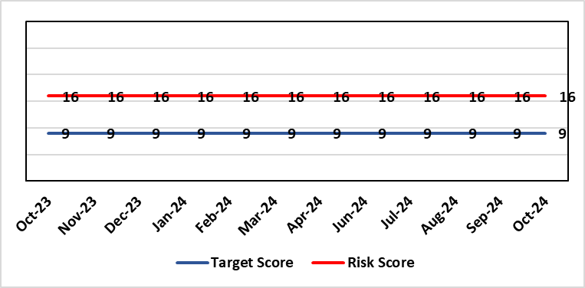 |  | Rationale for current score:  C - Inability to find records for patients could delay care/increase length of stay over 15 days. Could also mean patients receive incorrect treatment. Increased risk of fire where records are stored outside of the medical record libraries.  L - we know this happens from incidents raised
Level of Control  = 70% |  |  | Rationale for target score:  C - The increased development and adoption of the digital record will reduce the need for the paper health record being available at the point of care.  L - The increased development and adoption of the digital record, the introduction of RFID and the approach to management of the paper record identified in the Business case process should reduce the amount of paper required to be stored and managed.
Date added to the HB risk register
June 2016
Controls (What are we currently doing about the risk?) |  |  | Mitigating actions (What more should we do?)
- There is a plan in place to increase the functionality of the electronic record to document patient care. The delivery of the plan is overseen by the Digital Leadership Group and progress provided to Management Board. (Supported by individual project boards as appropriate).  - Records managed by the Medical Records libraries are RFID tagged and location tracked.  - Medical Record libraries are regularly risk assessed for fire by health and safety.  - Alternative offsite storage arrangements have been identified.  - All records must be documented on the Information Asset Register (IAR). |  |  | Action |  | Lead | Deadline
 |  |  | Movement of records and staff into new centralised unit |  | Head of Health Records & Clinical Coding | 31/03/2025
 |  |  | Allow for new process to stabilise and evaluate benefits of new centralised unit. |  | Head of Health Records & Clinical Coding | 30/05/2025
Assurances (How do we know if the things we are doing are having an impact?)  - RFID has been implemented for the acute record improving the management and storage of records  - Health Records performance reports developed in line with RFID technology  - Attainment of the Tier 1 Health Board target for clinical coding completeness which relies on the timely availability and quality of the Paper record and electronic sources  - Monitoring complaints and incident reporting.  - Electronic record is being implemented in accordance with the plan eg implementation of WNCR, ETR, HEPMA etc. |  |  | Gaps in assurance (What additional assurances should we seek?)  Investment required supporting the delivery and operational costs of the Digital strategy.  Reliance on DHCW for delivery of the solution for a fully electronic patient record.  Impact of the Infected Blood Enquiry on the Health Boards ability to destroy notes.  Process for ensuring clinical adoption of electronic ways of working and cessation of adding information to the paper record that is already available electronically needs to be agreed and enforced by the Health Board.  Impact of the infected Blood Inquiry on the health boards ability to destroy notes and the change in the records code of practice is being reviewed by the Director of Digital.
Additional Notes
09/04/2024 - Business Case for Centralisation project approvals to date: Business Case Assurance Group 30th Jan 24, Management Board 13th March 24 & Health Board 28th March 24.
07/05/2024 - Chairs Action received by Director of Digital, Executive Medical Director and Director of Corporate Governance which endorsed the removal of the non-adherence of patients with long term conditions as a recommendation within the revised NHS Records Management Code of Practice for Health & Social Care 2023
05/06/2024 - Update on Actions 1 & 2 -Submission has already been made to WG. Update discussions with NHS finance, awaiting approval 05/06/2024. Necessary legal discussions almost complete for all parties. Can only complete once WG approval received.
02/08/2024 – Actions completed: (i) WG approval for Health Records Business Case, and (ii) Legal agreement with landlord once approval from WG received.
Plans indicate that the Health Board will not transfer the records service to the new location until Q4 at the earliest. However, in light of the lease being in place the risk level will be reviewed at the next Digital Risk Management Meeting.
11/09/2024 (Revised 27/09/2024) – Two previous actions completed: WG approval for Health Records Business Case; legal agreement with landlord.
Actions & targets revised: Two actions now included within the risk. Action 1 – All necessary work in progress and milestones agreed with contractor. Action 2 – Allowing time for new staff and processes to settle within the new unit, evaluate impact and consider further actions if required.

Datix ID Number: 1217  Health & Care Standard: |  |  | HBR Ref Number: 37  Risk Target Date: 30/06/2026 |  | Current Risk Rating  4 x 3 = 12
Objective: The delivery of care is supported by innovative digital solutions |  | BAF Ref: 4 | Director Lead: Matt John, Director of Digital  Assuring Committee: Workforce OD & Digital Committee
Risk: Operational and strategic decisions are not data informed:  - Significant gaps in information collection due to lack of digital clinical systems especially within Primary, Community and Mental Health services (Connecting Care System) resulting in inability to deliver statutory reporting requirements.  - Users are unable to access the information they require to make decisions at the right time  - Business intelligence and information already available is not always utilised effectively |  |  | Date last reviewed: October 2024
Risk Rating  (consequence x likelihood):  Initial: 4 x 3 = 12  Current: 4 x 3 = 12  Target: 4 x 2 = 8 | 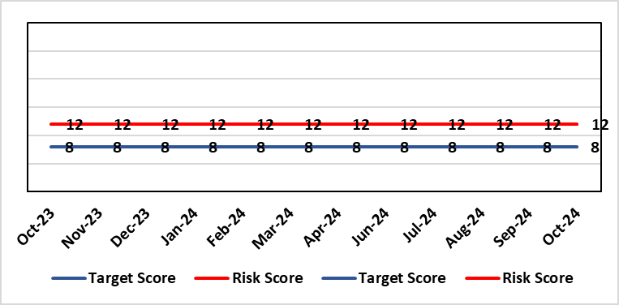 |  | Rationale for current score:  C – Opportunity cost of not acting on data could mean opportunities for improvement are missed, failures are not identified in a timely manner resulting in adverse national publicity and/or delays in care/increased length of stay.  L - Following appointments Business intelligence partners and introduction of data literacy course of Dashboard utilisation has significantly increased. However, there are significant data gaps with community and mental health areas due to the lack of digital systems.
Level of Control  = 70% |  |  | Rationale for target score:  C- Will remain the same or increase due to increased reliance in information  L- Investment in BI will lead to more information be available and used. The higher the use of information at operational level will lead to better quality data.
Date added to the HB risk register: July 2016
Controls (What are we currently doing about the risk?) |  |  | Mitigating actions (What more should we do?)
- Four BI partner roles have been appointed and are working with SDGs to help drive data literacy and data driven decision making with services.  - Ad-hoc Data literacy module training is given and a formal Manager’s Pathway Course has been developed which circa 100 manager’s a year attend.  - Self-service dashboards in areas such as UEC and Mental Health have been developed to allow service users to derive the data and insights they require.  - Over 100 dashboards in place including Cancer, Patient Flow, Outpatients, Mortality, Clinical Variation, Primary & Community Care Delivery Unit Dashboard and Ward Dashboard and Apps created for all key areas.  - Safety Huddle implemented in Morriston has improved data quality and improved operational working.  - Quality and Safety Dashboard continues to be developed delivering key insights around agreed measures.  - New technologies being reviewed for advanced analytics and integration into a new Health Board analytics platform.  - Health Board has representation on national groups such as the Advanced Analytics Group (AAG), all Wales Business Intelligence and Data Warehousing Group and Welsh Modelling Collaborative.  - Digital Intelligence representatives involved within Digital SDG meetings to emphasise importance of the implementation of digital solutions for data capture. |  |  | Action | Lead |  | Deadline
 |  |  | Digital Strategy to be approved through Health Board | Director of Digital |  | 30/11/2024
Assurances (How do we know if the things we are doing are having an impact?)  More evidence based and proactive decisions being made.  Dashboard technology; assist in developing indicators / triangulating information to identify issues  Number of unique users and unique dashboards used increases  Dashboard usage increases within areas where current digital maturity is low due to inadequate systems for data collection.  Number of people attending Data Literacy Training courses continues to grow  An internal audit of the Digital Intelligence Strategy implementation was completed in May 2023 and received a substantial grade. |  |  | Gaps in assurance (What additional assurances should we seek?)  Significant gaps in data still remain within certain areas primarily due lack of digital clinical systems. Culture of the organisation continues to change to focus on information and Business intelligence for operational rather than just reporting purposes. With the capability of operational staff to utilise the tools and capacity to act on the intelligence provided increasing through training and awareness.
Additional Comments / Progress Notes
01/05/2024 - Successful recruitment of BI Partner with start date end of May - action marked as completed. Monthly meeting invites sent to HCSE, VBHC and other reps to share learning. Have added another action around certified analytics programme - to give advanced users access to self-service data sets.
11/06/2024: Action completed: Start of 2nd tranche of Data Literacy Module Manager’s Pathway programme.
02/08/2024: Actions completed (i) Certified Analytical Programme with access to self- service datasets; and (ii) three additional Data Literacy and Power BI Modules to be created and offered on ad-hoc basis.
24/09/2024 – Digital Strategy now planned to go to the November Health Board rather than September.

Datix ID Number: 1514  Health & Care Standard: |  |  | HBR Ref Number: 43  Risk Target Date: TBC |  | Current Risk Rating  4 x 4 = 16
Objective: Mental Health & Learning Disability Services |  | BAF Ref: 2.3 | Director Lead: Hazel Powell, Executive Director of Nursing  Assuring Committee: Quality & Safety Committee  For Information: Mental Health Legislation Committee
Risk: Deprivation of Liberty Safeguards  Due to a lack of Best Interest Assessor resource, there is a risk of failure to complete and authorise the assessments associated with Deprivation of Liberty within the legally required timescales, exposing the health board to potential legal challenge and reputational damage. |  |  | Date last reviewed: October 2024
Risk Rating  (consequence x likelihood):  Initial: 4 x 4 = 16  Current: 4 x 4 = 16  Target: 3 x 2 = 6 | 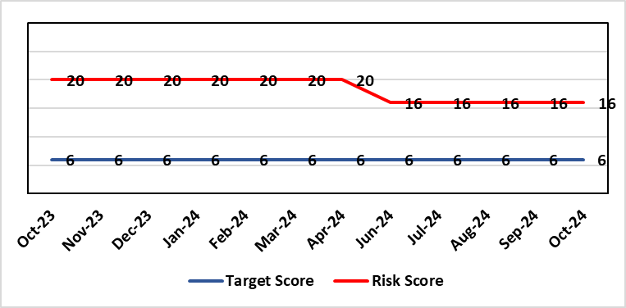 |  | Rationale for current score:  Although processes have been planned in order to reduce the breach position they have yet to be fully implemented. The impact is yet to be realised. Risk was increased to 20 in Feb 2023 following discussion at Mental Health Legislation Committee. Breaches in DOLS assessments have reduced as a result of increased capacity within the team and additional external Best Interest Assessors. This will continue to be monitored
Level of Control  = 40% |  |  | Rationale for target score:  Consequences of DoLS breaches for the Health Board will not change. With controls in place, over time likelihood should decrease.
Date added to the HB risk register
July 2017
Controls (What are we currently doing about the risk?) |  |  | Mitigating actions (What more should we do?)
Additional supervisory body signatories in place – this is being undertaken as overtime using additional WG funds.  Additional funding received from WG to manage the backlog of DoLS assessments.  DoLS assessments are being undertaken via a number of difference sources to address the backlog;  - External BIA’s payment to be increased from £120 to £250 (utilising substantive recurring funding) to encourage a large cohort of BIA’s to undertake role.  - 2 band 6 WTE BIA’s have been appointed (using WG money). This will reduce the need for agency BIA’s.  - Overtime/additional hours agreed utilising WG money for sign off completion.  - DoLS database updated and DoLS dashboard in place, monitoring applications and breaches via dedicated BIAs and Admin.  - Delivery of DOLS Action plan reviewed monthly.  - Regular reporting to Mental Health Legislation Committee (MHLC).  - Monthly reporting to Unit Nurse Director and Finance on DoLS breaches.  - Health Board presence at National and regional meetings relating to DoLS / LPS.  - Increased IMCA services to support increased BIA resource.  - Current Mental Capacity Act practice reviewed to support MCA DoLS issues in practice. |  |  | Action | Lead |  | Deadline
 |  |  | Weekly data monitoring meetings and monthly reporting to Group Nurse Director and Deputy Group Nurse Director. Updates sent through Q&S Groups. | Interim Head of Long Term Care |  | Ongoing
 |  |  | Quarterly reporting to Mental Health and Legislative Committee | Interim Head of Long Term Care |  | Ongoing
Assurances (How do we know if the things we are doing are having an impact?)  Regular scrutiny at Service Group and Safeguarding Committee and by DoLS Internal Audit; monitoring via DoLS Dashboard this will provide real-time accurate data.  Update report to MHLC, impact of backlog of DoLS breaches and new LPS implementation.  Monthly updates with Unit Nurse Director and Finance. |  |  | Gaps in assurance (What additional assurances should we seek?)
Additional Comments / Progress Notes
15/05/2024: Breaches in DOLS assessments have reduced as a result of increased capacity in the team and additional use of external BIA assessors. Therefore, risk level reviewed and likelihood of breaches reduced. Current sickness (not work related) is impacting on performance (66% {2xBIA} down in capacity). Performance should improve further on return to work – 1 BIA due to return to work the end of this month
05/09/2024: Breaches for Q1 are reported at 7. All substantive BIA’s have returned from sick leave. Risk remains unchanged at 16

Datix ID Number: 1761  Health & Care Standard: |  |  | HBR Ref Number: 50  Risk Target Date: 31/03/2025 | Current Risk Rating  5 x 5 = 25
Objective: Cancer Care |  | BAF Ref: 2.6 | Director Lead: Deb Lewis, Chief Operating Officer  Assuring Committee: Performance & Finance Committee  For information: Quality & Safety Committee
Risk: Access to Cancer Services  There is a risk of delay in diagnosing patients with cancer, and consequent delay in commencement of treatment, which could lead to poor patient outcomes and failure to achieve targets.  The HB remains unable to deliver on the target of 75% of patients being treated within 62 days and is currently under targeted intervention by WG to improve performance. The HB has been given an initial target of 60% to be delivered by the end of Dec-24, increasing to 70% by the end of March 2025. The most recent performance reported in for March 24, where the HB attained 56%. |  |  | Date last reviewed: October 2024
Risk Rating  (consequence x likelihood):  Initial: 4 x 5 = 20  Current: 5 x 5 = 25  Target: 4 x 3 = 12 |  |  | Rationale for current score:  Risk score based on being off trajectory for SCP.
Level of Control  = 70% |  |  | Rationale for target score:  Target score reflects the challenge this area of work present the Board and where small numbers of patients impact on the potential to breach target.
Date added to the HB risk register: April 2014
Controls (What are we currently doing about the risk?) |  |  | Mitigating actions (What more should we do?)
- Tight management processes to manage each individual case on the Single Cancer Pathway (SCP). Enhanced monitoring & weekly monitoring of action plans for top 6 tumour sites.  - Initiatives to protect surgical capacity to support SCPs have been put in place  - Tumour sites have been given additional targets to achieve by the end of Qtr1:  - Achieve the 10-day 1st Outpatient target  - Deliver a decision to treat (DTT) by day 31  - A specific plan is being delivered to support Pathology services and ensure SCP tests are turned around within 5 days. |  |  | Action |  | Lead | Deadline
 |  |  | Cancer Performance Group to monitor improvement trajectories for both cancer backlog and SCP performance on a monthly basis |  | Deputy COO | 31/12/2024
 |  |  | Full review of gynaecology / gynae-oncology pathway given service constraints to be done. Additional theatre capacity for gynaecological cancer to be agreed to reduce current backlog |  | Deputy COO | 31/12/2024
Assurances (How do we know if the things we are doing are having an impact?)  - TI dashboard developed to monitor performance in a live state  - Weekly TI monitoring meetings chaired by the COO  - Bi-weekly Cancer meetings chaired by the Dep COO  - Monthly TI monitoring meetings with WG |  |  | Gaps in assurance (What additional assurances should we seek?)  Performance and activity data monitored, but delays to treatment continue while sustainable solutions found.
Additional Comments / Progress Notes
29/01/2024: Slight in improvement in SCP performance during November and December, 52% and 53% respectively. Improvement in Upper GI performance (73%) but further work required in other tumour site area e.g. gynaecology, urology and breast.
08/05/2024: Further improvement seen in March 2024 with 56% delivered against the target.
18/05/2024: Sustained improvement for April (56%) and improvement in two-week first outpatient appointment target and decision to treat within 31 days evident
22/07/2024: Further improvement in May (57%) and noticeable improvement in first outpatient appointment in breast and gynaecology as a result introduction of daily monitoring meetings.
14/10/2024: August performance reduced against the trajectory (56% v 59%). The target of 60% for end of Sept remains in place.
31/10/2024: Retrospective performance for April to June (following review of outstanding pathology report) – 60% achieved for each month in the first quarter

Datix ID Number: 1759  Health & Care Standard: |  |  | HBR Ref Number: 51  Risk Target Date: TBC | Current Risk Rating  4 x 3 = 12
Objective: Care is high quality, safe, efficient, and delivers the best possible outcomes for people |  | BAF Ref: 2.1 | Director Lead: Hazel Powell, Executive Director of Nursing  Assuring Committee: Workforce OD & Digital Committee
Risk: Non Compliance with Nurse Staffing Levels Act (2016) – Section 25B Wards  The Nurse Staffing Levels (Wales) Act 2016 (NSLWA) legally requires the health board to make provision for appropriate nurse staffing levels within their nursing services. In accordance with section 25B, there is a duty to calculate nurse staffing levels in adult and paediatric acute medical and surgical inpatient wards. There is a risk we may not meet these requirements fully due to increased acuity, unplanned staff absence and vacancies. The potential impact of this maybe non-compliance with the ‘Act’, poor patient outcomes and experience, and suspension of services. |  |  | Date last reviewed: October 2024
Risk Rating  (consequence x likelihood):  Initial: 4 x 4 = 16  Current: 4 x 3 = 12  Target 3 x 2 = 9 | 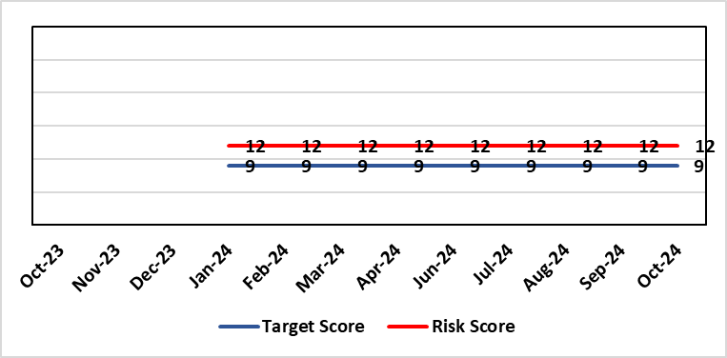 |  | Rationale for current score:  - The scope of the risk has been reviewed to disaggregate the 25B reportable wards as part of the NSLWA to enable clearer identification of risk of non-compliance with the’ Act’ from the aggregated risk across all nurse staffing areas of inadequate staffing levels previously scored 20.  - There has been a steady decline in the number of vacancies across the 25B wards as a result of successful international recruitment and student streamlining  - The Service Group risk assessments for 25B wards reported at the NMSSAIG (Oct 2024) are as follows:  - Morriston Service Group – 9 (unchanged)  - NPTSSG – 9 (unchanged)  - Paediatrics: In-patient wards – 12 (reduced from 16)
Level of Control  = |  |  | Rationale for target score:  - The health board has the required structures and processes in place to provide reassurance to the Board that SBUHB is compliant under the Act and as such are allocating resources accordingly.  - Health boards are duty bound to take all reasonable steps to maintain nurse staffing levels.  - Ward skill mix, recruitment and induction plans impacting on ward  - Projected continued decrease in vacancies by end of 2024.
Date added to the HB risk register
November 2018
Scope Refreshed:
January 2024
Controls (What are we currently doing about the risk?) |  |  | Mitigating actions (What more should we do?)
- The designated person as part of the requirements of the ‘Act’ is the Executive Director of Nursing & Patient Experience  - The responsibility for decisions relating to the maintenance of the nurse staffing level rests with the health board is based on evidence provided by, and the professional opinions of the Executive Directors with the portfolios of Nursing, Finance, Workforce, and Operations  - Bi-annual calculations undertaken across all Section 25B wards using the triangulated methodology which Service Groups formally present at Executive led scrutiny panels with representation from Nursing, Workforce and Digital and Finance Colleagues.  - The Ward Sister / Charge Nurse, Senior Nurses and Group Nurse Director continuously assess the situation and keep the designated person formally apprised  - The health board has representation at the All-Wales Nurse Staffing Group and its sub groups to ensure the organisation is aware of national updates  - The Board receive a bi-annual report - May (agreed Once for Wales) and November (mandatory). The final 3 yearly mandatory paper was submitted to Welsh Government 7th October 2024. The next mandatory paper will be presented to Board 28th November 2024.  - Workforce planning & redesign, training and development. Recruitment and retention continues. HB Workforce Group has been set up and links to HEIW Retention Work stream, HB representatives on HEIW Group are Associate Head of HR, Recruitment and Retention Manager and Matron, Corporate Recruitment. Workforce plans have been developed by Service Group Nurse Directors and each Service Group agrees staffing, with consideration of all reasonable steps to maintain the nurse staffing level  - Work assessing the impact of the 'Team around the Person' continues on a HB and All Wales basis.  - Rostering Policy - the Service Groups have a robust roster scrutiny process that is undertaken to ensure roster efficiency and appropriate utilisation of temporary staff.  - The health board has a nursing retention plan and actively supports the Retire and Return policy.  - SafeCare has been implemented, the All Wales SOP remains a working document as understanding evolves.  - Service Groups continue daily staffing huddles and daily staffing tool and escalate as appropriate. |  |  | Action |  | Lead | Deadline
 |  |  | Student Streamlining and Overseas recruitment |  | Executive Director of Nursing | 31/12/2024  Monthly ongoing
 |  |  | Review of workforce, consider more diverse skill mix, including development of Band 3 and Band 4 roles. Bi-annual re-calculations of inpatient wards have resulted in the addition of Band 3 and 4 roles within the NSA templates. These posts are being recruited into, there is a need for training and supervision for these new posts. Development of Service Group workforce plans to support an overall Corporate Workforce Plan. |  | Executive Director of Nursing | 31/12/2024
Assurances (How do we know if the things we are doing are having an impact?)  - Ongoing robust recruitment and retention plans in place to reduce vacancies in key clinical areas.  - Accurate reporting of acuity data and governance around sign off.  - Agreed establishments are funded.  - E-Rostering implemented and roster scrutiny undertaken, ensuring effective staff allocation.  - All Wales Templates are visible informing patients/visitors of planned roster on all Section 25B wards. Service Groups have access to the All Wales Nurse Staffing Programme documents via NHS Wales Executive webpage.  - Bi-annual Board reports, provide assurance and outline compliance and any key risks, submitted in November and May each year, with final three yearly report to Welsh Government due and submitted October 2024.  - The Health Board Nursing and Midwifery Safe Staffing Assurance Group (renamed October 2024) (formally the Nurse Staffing Act Steering Group, amended July 2023) meets on a bi-monthly basis, ensuring risks from all Service Groups are presented, discussed and escalated as appropriate at each meeting. This group is chaired by an Associate Director of Nursing and reports to Nursing and Midwifery Group (formally Nursing and Midwifery Board, amended October 2024), and the Workforce & OD Committee.  - Service Group risk assessments have been updated and disaggregated into 25B and 25A areas to enable clear risk assessment and escalation of specific risks to ensure robust governance and risk assurance  - There is a clear process for scrutiny during bi-annual re-calculations and at any other time when wards require a re-calculation, for example: change to ward purpose, increased bed numbers or increase patient acuity  - SafeCare system has been implemented. Support given to help embed the system into everyday use. Use of SafeCare linked to daily staffing huddles.  - Historical information and all reporting templates available on a share drive |  |  | Gaps in assurance (What additional assurances should we seek?)  - Issue remains regarding Information Technology barriers around the capture of data required for the Act on an All- Wales and Health Board basis. All Wales work with Allocate (Safecare) to improve reporting capabilities of Safecare, via a dashboard continued to progress, SBU is pilot site for testing. Update to Allocate system received, working with rostering team and BCU NSA Lead to check accuracy of reporting.  - Ongoing work across Wales to ensure IT systems are compatible with each other for operational and reporting purposes.
Additional Comments / Progress Notes
Section 25B wards covered by this risk:
NPTSSG |  | Morriston Service Group
Ward 2, Ward 4, Ward 12, Ward A, Ward E  Paediatric: Ward M and Oakwood Ward |  | Ward G, H, W and Clydach Ward  Ward C, Cyril Evans Ward, Dan Danino Ward  Powys Ward, Tempest Ward, Cardigan Ward  Ward K, L, R, T and Pembroke Ward  Ward D, F, J, S and Gowers Ward
For information – 25A areas not covered by this risk include (These are managed within Service Groups and would be escalate for Executive consideration as appropriate).
Morriston Service Group | NPTSSG | Mental Health & Learning Disabilities | Community Areas
Critical care areas – GITU, CITU, Tempest Burns & CCU  Short stay and assessment areas  Ward E (Area for Clinically Optimised Patients over the age of 65 years)  SAU, SSSU, CSSU, Plastic Surgery Treatment Centre  Emergency Department | Neonates  Theatres  Ward B, C, D & Neuro Rehab NPTH  Ward 8 & 11 SH  Midwifery | Mental Health, Forensic Psychiatry and Learning Disabilities | District Nursing  Health Visiting  Gorseinon Hospital  Ty Olwen

23.10.2024: Risk will be reviewed and updated following the Nursing and Midwifery Safe Staffing Assurance Group meeting on 30.10.2024
30.10.2024: Reduction in the Paediatric risk score from 16 to 12 recorded due to the introduction of band 6 development posts and the successful recruitment of RN’s and Internationally Educated Nurses. The overall corporate score remains unchanged at this time but will be reconsidered at the next meeting in December 2024.

Datix ID Number: 1763  Health & Care Standard: |  |  | HBR Ref Number: 52  Risk Target Date: TBC |  | Current Risk Rating  4 x 4 = 16
Objective: People of Swansea Bay live healthier, equitable and more equal and prosperous lives |  | BAF Ref: 1 | Director Lead: Richard Thomas, Director of Communications and Engagement  Assuring Committee: Performance & Finance Committee
Risk: Impact Assessment Requirements  The Health Board does not have sufficient skills & resource in place to undertake integrated equality impact assessments in line with strategic service change and policy development. |  |  | Date last reviewed: October 2024
Risk Rating  (consequence x likelihood):  Initial: 4 x 4 = 16  Current: 4 x 4 = 16  Target: 4 x 2 = 8 | 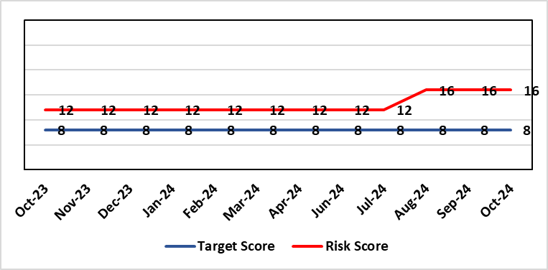 |  | Rationale for current score:  - Current lack of required skills / staff to deliver requirements.  - Judicial Review has been applied for in relation to EMRTS / Air Ambulance Changes which implicates the Health Board. This may indicate a rising likelihood of such challenges being launched in relation to service change.
Level of Control  = 50% |  |  | Rationale for target score:  - All of these areas need to have adequate resourcing and robust processes / policies in place for the organisation to make robust plans, engage public confidence and meet our statutory and public duties.
Date added to the HB risk register
November 2018
Controls (What are we currently doing about the risk?) |  |  | Mitigating actions (What more should we do?)
- Head of EDI to be appointed to support equality impact assessment – funding previously agreed, paper going to Management Board and then Board on 25th January 2024. Funding to be agreed to allow appointment to be made.  - Creation of DICE has led to some additional capacity within Engagement Team but alongside a significant increase in demand for activity.  - Robust policies and processes to be in place for Impact Assessment going forward.  - EIA responsibilities incorporated into wider Impact Assessments.  - Development of Strategic Equality Group across organisation to support processes. |  |  | Action | Lead |  | Deadline
 |  |  | Appoint Head of EDI  Delayed due to vacancy suspension | Assistant Director of Insight, Engagement & Fundraising - DICE |  | 31/12/2024
 |  |  | Review of the current process for developing Equality Impact Assessments around service change, engagement and consultation. Progress slowed as delay in recruitment of Head of EDI. | Assistant Director of Insight, Engagement & Fundraising - DICE |  | 31/01/2025  In progress
 |  |  | Robust policies and processes to be in place for Impact Assessment going forward. | Assistant Director of Insight, Engagement & Fundraising - DICE |  | 30/03/2025  In progress
 |  |  | Roll out Impact Assessment process across organisation. | Assistant Director of Insight, Engagement & Fundraising - DICE |  | 30/06/2025
Assurances (How do we know if the things we are doing are having an impact?)  Advice on Equality Impact Assessment and then wider Impact Assessments available across organisation supported by robust policies and procedures, overseen by Strategic Equality Group. |  |  | Gaps in assurance (What additional assurances should we seek?)  Participation from across organisation in Strategic Equality Group.
Additional Comments / Progress Notes
19/01/2024: Reviewed – no change currently
02/09/2024: Risk level increased – rationale added. Action target dates refreshed.

Datix ID Number: 1762  Health & Care Standard: |  |  |  | HBR Ref Number: 53  Risk Target Date: 31/03/2025 |  |  | Current Risk Rating  5 x 3 = 15
Objective: Care is high quality, safe, efficient, and delivers the best possible outcomes for people |  |  | BAF Ref: 2.1 | Director Lead: Hazel Lloyd, Director of Corporate Governance  Assuring Committee: Health Board (Welsh Language Group)
Risk: Welsh Language Standards  Failure to fully comply with all the requirements of the Welsh Language Standards, as they apply to the University Health Board. |  |  |  | Date last reviewed: October 2024
Risk Rating  (consequence x likelihood):  Initial: 5 x 3 = 15  Current: 5 x 3 = 15  Target: 3 x 3 = 9 | 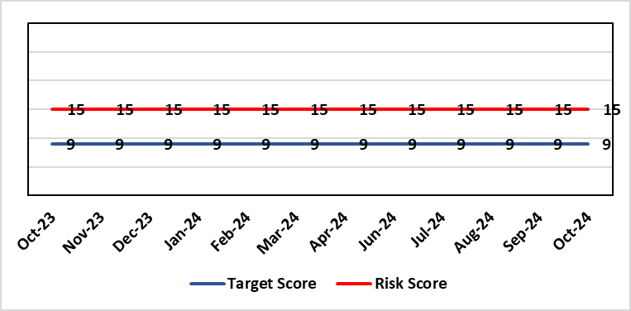 |  |  | Rationale for current score:  As a consequence of an internal assessment of the Standards and their impact on the UHB, it is recognised that the Health Board will not be fully compliant with all applicable Standards. This position has been confirmed/verified via an independent baseline assessment.
Level of Control  = 60% |  |  |  | Rationale for target score:  Working through its related improvement plan the likelihood of noncompliance will reduce as awareness and staff training in response to the Standards, is raised.
Date added to the HB risk register
November 2018
Controls (What are we currently doing about the risk?) |  |  |  | Mitigating actions (What more should we do?)
- An independent baseline assessment of the Health Board’s position against the Standards has been undertaken. This is in addition to the Health Board’s own self-assessment.  - Work to implement the recommendations in the above baseline assessment has commenced.  - An online staff Welsh Language Skills Survey has been launched.  - Close constructive working relationships are in place with the Welsh Language Commissioner’s Office  - Strong networks are in place amongst WLO across NHS Wales to inform learning and development of responses to the Standards.  - Proactive communication and marketing activity is being undertaken across the Health Board to raise awareness of Welsh language compliance, customer service standards and training opportunities.  - Meetings of the Welsh Language Standards Delivery Group have recommenced (March 2022) |  |  |  | Action |  | Lead |  |  | Deadline
 |  |  |  | Recruit to current vacancy within the Welsh language Translation Team. |  | Welsh Language Officer |  |  | 31/03/2025
Assurances (How do we know if the things we are doing are having an impact?)  - Compliance with Statutory requirements outlined in Welsh Language Act and related Standards.  - Meetings with the Welsh Language Commissioner.  - Self-Assessment against the requirements of More Than Just Words.  - Production of an Annual Report. |  |  |  | Gaps in assurance (What additional assurances should we seek?)  Formal and regular reporting to the Board will recommence with the production of the next annual report.
Additional Comments / Progress Notes
Oct 2024: Action timescale refreshed
Datix ID Number: 1587  Health & Care Standard: |  |  |  | HBR Ref Number: 61  Risk Target Date: TBC |  |  |  | Current Risk Rating  4 X 4 = 16
Objective: Planned Care |  | BAF Ref: 2.5 |  | Director Lead: Deb Lewis, Chief Operating Officer  Assuring Committee: Quality & Safety Committee
Risk: Paediatric dental GA (General Anaesthetics)/Sedation services provided under contract from Parkway Clinic, Swansea. Medical Safety risk as GA are performed on children outside of an acute hospital setting. Repatriation of service to acute site delayed due to theatre capacity which means the health board continues to commission services for delivery outside of national guidance (WHC 2018-09). There is also an associated risk in that the diagnosing clinician does not deliver the care to the patient. |  |  |  | Date last reviewed: October 2024
Risk Rating  (consequence x likelihood):  Initial: 5 x 3 = 15  Current: 4 x 4 = 16  Target: 4 x 2 = 8 | 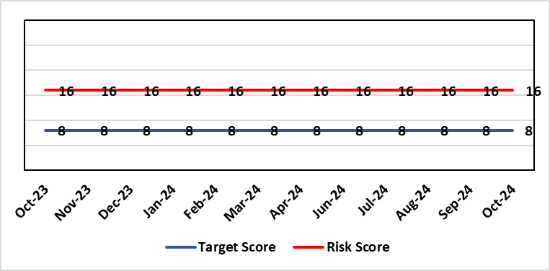 |  |  | Rationale for current score:  There is no immediate access to crash team/ICU facilities in in Parkway Clinic – the client group are undergoing G/A/sedation. Paediatric GA/Sedation services provided under contract from Parkway Clinic, Swansea continue due to lack of capacity for these patients to be accommodated in Secondary Care.
Level of Control  = 60% |  |  |  | Rationale for target score:  Relocation of the paediatric GA service [provided by Parkway Clinic] to a hospital site being treated as a priority.
Date added to the HB risk register
4th July 2018
Controls (What are we currently doing about the risk?) |  |  |  | Mitigating actions (What more should we do?)
Consultant Anaesthetist present for every General Anaesthetic clinic.  Assurance Documentation supplied by Parkway Clinic including confirmation of arrangements in place with WAST and Morriston Hospital for transfer and treatment of patients  New care pathway implemented - no direct referrals to provider for GA.  Multi-drug sedation ceased from Sep 2018 in line with WHC 2018 009  Revised SLA/Service Specification  HIW Inspection Visit Documentation provided to HB  All extended GA cases require approval from paediatric specialist prior to treatment |  |  |  | Action | Lead |  |  |  |  | Deadline
 |  |  |  | Include transfer of services from Parkway on new theatre programme. | Associate Service Group Director (Surgery) |  |  |  |  | TBC
Assurances (How do we know if the things we are doing are having an impact?)  RMC collate referral and treatment outcome data for review by Paediatric Specialist  Regular clinical meeting arranged with Parkway to discuss individual cases/concerns  Regular clinical/ management meeting for CDS/primary care management team to discuss service pathway /concerns/issues arising  Roll out of new pathway to encompass urgent referrals |  |  |  | Gaps in assurance (What additional assurances should we seek?)  Deputy COO led Task & Finish Group is no longer in place – it will need to be re-established to progress transfer when theatre capacity is agreed.  Pressures on the POW special care dental GA list and this service is considered alongside any plans for the Parkway contract.
Additional Comments / Progress Notes
18/06/2024: Risk action refreshed.
05/09/2024: The team are liaising with the Theatre Transformation work – no further update this month.
14/10/2024: This remains a noted risk with no further update.

Datix ID Number: 1605  Health & Care Standard: |  |  | HBR Ref Number: 63  Risk Target Date: 31/12/2024 | Current Risk Rating  3 X 4 = 12
Objective: Maternity Services |  | BAF Ref: 2.8 | Director Lead: Hazel Powell, Executive Director of Nursing and Christine Morrell, Director of Therapies & Health Sciences  Assuring Committee: Quality & Safety Committee
Risk: Screening for Fetal Growth Assessment in line with Gap-Grow (G&G).  There is not enough Ultrasound scanning & clinic capacity within Swansea Bay UHB to offer all women serial ultrasound scan screening in the third trimester in line with the UK perinatal Institute Growth Assessment Programme (GAP). Welsh Government mandate fetal growth screening in line with the GAP programme, which states serial ultrasound growth scans should be performed at three weekly intervals. There is significant evidence of the increased risk for stillbirth or neonatal mortality/morbidity (hypoxic ischaemic encephalopathy) HIE, where a fetus is growth restricted (Intrauterine Growth Restriction - IUGR) and/or small for gestational age fetus (SGA). |  |  | Date last reviewed: October 2024
Rationale for current score:
Previous score of 20 was 4 (consequence) x 5 (likelihood). Consequence score of 4 calculated due to the governance and assurance – non-compliance with national standards with significant risk if unresolved and likelihood of 5 as expected to happen daily/>50%.
The service group has reviewed the score as 3(consequence) x 4 (likelihood) due to the current progress of actions. The service group are going to monitor the implementation of three weekly scanning in the third trimester. On review in January if three weekly scanning has been achieved for a three month period the service will consider closing this risk.
Risk Rating  (consequence x likelihood):  Initial: 4 x 3 = 12  Current: 3 x 4 = 12  Target: 3 x 4 = 12 | 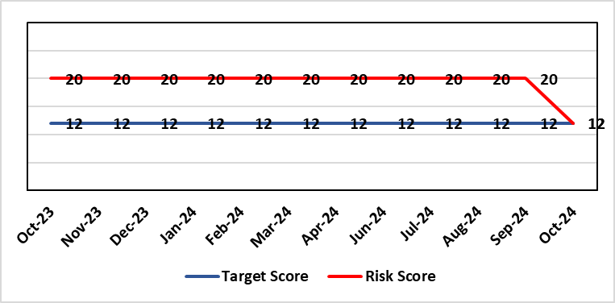
Level of Control  = 60% |  |  | Rationale for target score:  When the service is able to provide third trimester ultrasound scan in line with GAP recommendations we will be providing care in line with evidence based best national practice as mandated by Welsh Government. Risk Target Date indicates when outcome of potential scanning/review capacity solutions anticipated.
Date added to the HB risk register
1st August 2019
Controls (What are we currently doing about the risk?) |  |  | Mitigating actions (What more should we do?)
All staff are required to complete the GAP GROW eLearning on an annual basis. Compliance is monitored via the Training & Education forum.  A local policy to scan women 4 weekly is in place.  Four qualified midwifery sonographers and a midwifery sonography lead who provides training are in place.  Lead sonographers created a governance process for the review of scan images of babies born with a birth weight centile under 10th centile to identify themes and trends within the department and areas for quality improvement. |  |  | Action |  | Lead | Deadline
 |  |  | Business case written, including administrative support for midwife sonographer clinics to be secured to ensure streamlined service - currently in circulation for comment with aim of discussion at Senior Management Team by revised date of end of August 2024. |  | Maternity service business manager | This will be incorporated into the workforce plan
Assurances (How do we know if the things we are doing are having an impact?)  Target 95% Gap Grow training compliance by End November 2023 originally – was 85% at June 2024.  Aim is the provision of serial ultrasound scans on a three weekly schedule in accordance with the recommendations from the Perinatal Institute. (Currently the provision of serial ultrasound scans is provided on a four weekly schedule.)  The detection rate of IUGR/SGA will increase leading to improved antenatal management plans and intrapartum planning. We will report a reduced rate of stillbirth and/or neonatal mortality/morbidity with improved management of IUGR/SGA babies.  The administration support for the service will be fully functional.  Lead Sonographers for Singleton and Neath and Lead Midwife sonographer have developed a governance review group to meet monthly to review all ultrasound scan images where there was a baby born under the 10th centile to identify themes and learning for quality improvement. |  |  | Gaps in assurance (What additional assurances should we seek?)  Assurance of maintaining a sustainable third trimester ultrasound service. The provision of serial ultrasound scans on a three weekly schedule in accordance with the recommendations from the Perinatal Institute. (Currently the provision of serial ultrasound scans is provided on a four weekly schedule.)
Additional Comments / Progress Notes
19/04/2024: Radiology Service Manager unable to attend scanning capacity meeting – to be rescheduled by end of May 2024. Implementation of Gap Grow 2.0 in place from w/c 15/04/2024. Gap Grow training Compliance 85% March 2024. Action to complete updated.
01/07/2024: Meeting with Radiology moved to 4th July 2024 to accommodate staff leave. New appointment to Professional Development Midwife post – she will focus on drive to improve compliance with Gap Grow training uptake by end of August 2024.
13/09/2024 Following a successful meeting with Radiology a start date of W/C 14th October to re-instate three weekly scanning in Singleton and Neath and Port Talbot hospitals will commence.
10/10/2024 GAP/GROW target compliance reached September 2024 – actual 96% Midwives, 100% Obstetric Team
25/10/2024 – The service are going live with three weekly scanning appointments for all women undergoing serial scans in pregnancy on the 28/10/24. All new bookings have been booked for three weekly scans. Midwifery sonography service to provide clinic in NPT site.

Datix ID Number: 2159  Health & Care Standard: |  |  | HBR Ref Number: 64  Risk Target Date: 31/03/2026 | Current Risk Rating  4 X 4 = 16
Objective: Care is delivered in safe and appropriate settings |  | BAF Ref: 3 | Director Lead: Darren Griffiths, Director of Finance & Performance  Assuring Committee: Quality & Safety Committee
Risk: Health & Safety Infrastructure  Insufficient resource and capacity of the health, safety and fire function within SBUHB to maintain legal and regulatory compliance for the workforce and for the sites across SBUHB. |  |  | Date last reviewed: October 2024
Risk Rating  (consequence x likelihood):  Initial: 5 x 4 = 20  Current: 4 x 4 = 16  Target: 4 x 3 = 12 | 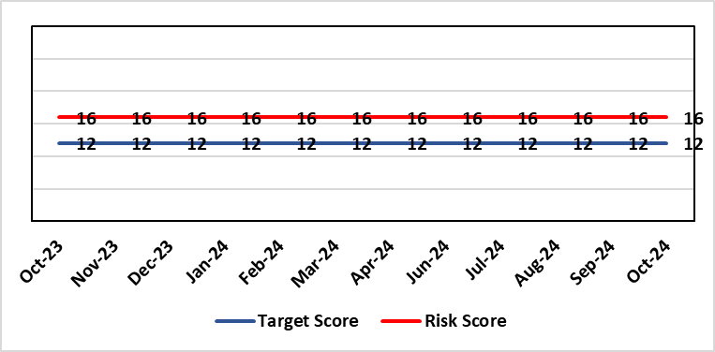 |  | Rationale for current score:  The Health Board received 12 Health & Safety Executive (HSE) improvement notices during 2019-20 covering various Health & Safety legal breaches covering a range of areas. There is the potential for future multiple notices for not meeting legal requirements.
Rationale for target score:
Compliance with the notices and to have sufficient resources to implement a sustainable health and safety provision to support the legal requirements of the Health Board and demonstrate that suitable resources are in place to undertake the roles and responsibilities of the department, also to undertake suitable and sufficient training, provide corporate overview/audit to ensure practices are being employed in the workplace.
Level of Control
= 70%
Date added to the HB risk register
September 2019
Controls (What are we currently doing about the risk?) |  |  | Mitigating actions (What more should we do?)
- Assistant Director of Health and Safety in post to support strengthening and develop the H&S function to support the organisation. Business case submitted for additional resources.  - Health and Safety Operational Group and the Health and Safety Committee monitor compliance. Refreshed the Fire Safety Group with additional controls in place.  - Fire risk assessments are being prioritised with temporary additional resources put in place in March 2021 to reduce the number of FRA overdue, and brought up to date. However, due to leavers and recruitment, resource levels have fluctuated along with compliance levels that are continually monitored.  - Fire training in place and fire wardens in place  - Fire risk assessment schedule in place for the next 12 months to maintain 100% compliance of completion and is regularly reviewed |  |  | Action |  | Lead | Deadline
 |  |  | Review the staffing structure within the Health & Safety function |  | Assistant Director of H&S | 31/03/2025
Assurances (How do we know if the things we are doing are having an impact?)  - Monitoring through the appropriate group/committees (H&S committee) to receive assurance and or identify gaps for key compliance and adherence to applicable legislation.  - Site visits/tours to identify compliance and gaps in compliances. |  |  | Gaps in assurance (What additional assurances should we seek?)  Health and safety, capital and estates now sit under the umbrella of Finance and is currently going through a restructure, with the H&S structure also included in this and will be phased in, with a target date of 31/03/2026.
Additional Comments / Progress Notes
25/10/2024: There has been a senior structure review, with some portfolio changes. The next stage is to review the portfolio structure and provide a structure that will be recommended to the Health Board for implementation, this will likely be on a phased approach.

Datix ID Number: 1834  Health & Care Standard: |  |  | HBR Ref Number: 66  Risk Target Date: TBC | Current Risk Rating  5 X 4 = 20
Objective: Cancer Care |  | BAF Ref: 2.6 | Director Lead: Raj Krishnan, Acting Executive Medical Director  Assuring Committee: Quality & Safety Committee
Risk: Access to SACT (Cancer Services)  The demand & complexity of planned treatment regime for cancer patients requiring chemotherapy currently exceed the available chair capacity, risking unacceptable delays in access to SACT treatment in Chemotherapy Day Unit with impact on targets and patient outcomes. |  |  | Date last reviewed: October 2024
Risk Rating  (consequence x likelihood):  Initial: 5 x 5 = 25  Current: 5 x 4 = 20  Target: 2 x 2 = 4 | 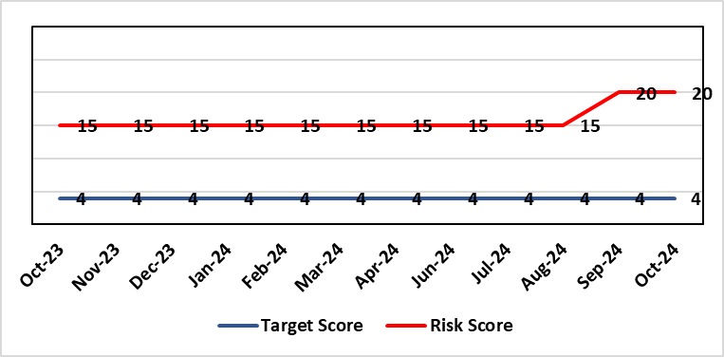 |  | Rationale for current score:  Due to staff sickness across the Multi-Disciplinary Team with the demands outstripping capacity the risk has increased to 20.  There are continuing workforce challenges in CDU and PTS. Patient waiting times and the number of patients breaching SACT targets are increasing due to increased demand, therefore increasing the risk 20 (September 2024).
Level of Control
=
Date added to the HB risk register  30/11/2019 |  |  | Rationale for target score:  Reduced delays in treatment will reduce risk of harm.
Controls (What are we currently doing about the risk?) |  |  | Mitigating actions (What more should we do?)
Review of scheduling by staff to ensure all chairs used appropriately.  Business case endorsed by CEO for shift of capacity to home care to be considered by the Management Board  A Daily scrutinizing process in progress to micro manage individual cases, deferrals etc.  Changes made to prescribing & authorising processes to improve workflow for PTS reducing potential delays to supply and administration of treatment.  Responsibility for checking bisphosphonate prescriptions in CDU moved to nursing staff to free up Pharmacy capacity allowing them to focus on key clinical tasks within Pharmacy.  Joint project with Nuclear Medicine to streamline pathways and prioritise SACT patients appropriately halved the average time waiting for MUGA/EDTA tests required before starting SACT.  Increased homecare capacity  Adopted principles from UK SACT board publication: General Principles to Support Systemic anti-Cancer Therapy Aseptic Pressures September 2023 |  |  | Action | Lead | Deadline
 |  |  | A demand and capacity options paper is being prepared within the service. | Interim Divisional Manager (Cancer) | 30/11/2024
Assurances (How do we know if the things we are doing are having an impact?)  Additional funding agreed to support increase in nurse establishment to appropriately staff the unit during its main opening hours. Additional scheduling staff also agreed. This funding has been utilised but with further increase demand further funding for Pharmacy and Nursing would be required  Pre-Assessment process has been separated from start date in an attempt to fill deferral slots at short notice where possible. Improved communication between MDT to streamline booking and deferral process.  Continue to monitor patient experience via friends and family in conjunction with the Welsh Cancer Patient Experience Survey results under our PTR procedures. Monitoring our waiting times against new SACT metrics, which is a measure based on treatment intent and is no longer reported as average waiting time so is more linked to expected outcomes etc. This performance metric is included in our Cancer Performance report we send to WG and Management Board and internally via governance arrangements with NPTSSG where Oncology services sit.  SBU Capacity Task and Finish group meeting monthly to analysis demand and capacity gap.  Common themes for delays will continue to be identified and analysed each month. A quarterly report will be provided to the SACT, Consultant meeting and Division Business meeting to inform of the outcome  Main breach causes are due to CDU capacity and SACT booking delays. Quarterly reports demonstrate this trend. Further work being done on new ways of working and possible increase in workforce.  April: 64% patients breached P2 (average number of days over is 4)  56% patients breached P3 (average number of days over is 3)  …  Aug: 78% patients breached P2 (average number of days over is 12)  71 % patients breached P3 (average number of days over is 11)  Sep: 94% patients breached P2 (average number of days over is 13)  92 % patients breached P3 (average number of days over is 8)  Welsh SACT performance metrics – P2 to start within 14 days. P3 to start within 21 days |  |  | Gaps in assurance (What additional assurances should we seek?)  Workforce requirements are to be mapped to demonstrate additional capacity required to meet SACT Demand.
Additional Comments / Progress Notes
Sept 2024:
- Weekly SACT meetings are being held with MDT to ensure staffing levels and deferral processes are being adhered to ensuring service is safe whilst staffing numbers are low in PTS. Workforce modelling is being mapped to increase capacity by 10% as part of draft business case.
- Monthly and quarterly SACT reports are shared with CPIG and WG monthly.
- Datix incidents are being submitted for deferrals due to late confirmation and not adhering to SACT scheduling booking rules
- Where patients have breached SACT target Datix are being submitted.
- Paperless drug administration is now complete and in use on CDU.
- Increase in booking times has led to an increased pressure on IP workload both in terms of SACT and for symptom control due to delayed start of treatment
- Strict adherence to SACT scheduling booking rules to support CDU and pharmacy services has led to late cancellation of SACT and patient distress (PALS complaint)
- PALS complaint received regarding length of wait for treatment experienced
Pharmacy Updates:
Lead Pharmacist off LT sick: Consequences
Pressure on following areas:
- Clinical verification checks of SACT prescriptions - having to be performed by staff working overtime at evenings and weekends and by a Pharmacist from Morriston which in turns impacts provision of Pharmacy service to Paediatrics
- Homecare Pharmacists struggling to maintain prescribing/clinical verification of prescriptions = possible risk to timely supply of home delivery SACT medicines
Nursing Updates:
- Staffing constraints are easing with LTS all returned to work in September on phased returns no vacancies within CDU.
- Revised theoretical training to one day and scheduled bi-monthly to ensure all RNs attend as a start to SACT training and annual refresher.
- Competency sign off now tiered to allow autonomous working within 3 months building to more complex aspects within a further 3-6 months.
- 13/15 (87%) SACT competent with 2 on trajectory to complete in October - 15/15 (100%)
- Successfully recruited into Band 7 interim position to expedite SACT training across cancer services.

Datix ID Number: 1418  Health & Care Standard: |  |  | HBR Ref Number: 69  Risk Target Date: See Target Rationale |  | Current Risk Rating  5 X 4 = 20
Objective: Children & Young People Services |  | BAF Ref: 2.7 | Director Lead: Deb Lewis, Chief Operating Officer  Supporting Director: Hazel Powell, Executive Director of Nursing  Assuring Committee: Quality & Safety Committee
Risk: Risk of issues related to adolescent patients being admitted to Adult MH inpatient wards- Inappropriate settings resulting in 'Safeguarding Issues' The WG has requested that HBs identify Secondary Care in -patient facilities for the care of adolescents- in Swansea Bay University Health Board Ward F NPT hospital is the dedicated receiving facility with one bed identified. |  |  | Date last reviewed: October 2024
Risk Rating  (consequence x likelihood):  Initial: 2 x 3 = 6  Current:5 x 4 = 20  Target: 2 x 3 = 6 | 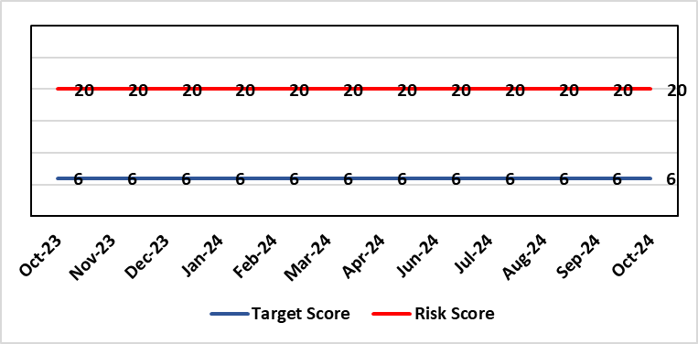 |  | Rationale for current score:  Every health board is required to have an admission facility for adolescent Mental Health patients. Whilst ward F has been identified as the single point of access in SBU and provides access to a bed for adolescent admissions if available at the time of request it is a mixed sex adult ward. Therefore the facilities are less than ideal for young patients in crisis.
Level of Control
=
Date added to the HB risk register  27/02/2020 |  |  | Rationale for target score:  The longer term aim for the Health Board remains to create an admission facility for adolescent Mental Health patients but this will not be possible until the new Adult Inpatient Unit is built.
Controls (What are we currently doing about the risk?) |  |  | Mitigating actions (What more should we do?)
Safeguarding Training for Staff, Joint protocol with Cwm Taf LHB [CAMHS] currently subject to review, Local SBUHB policy on providing care to young people in this environment. This includes the requirement for all such patients on admission to be subject to Level 3 Safe and Supportive observations.  Only Adolescents within 16-18 age range are admitted to the adult ward.  The health board works with CAMHS to make sure that the length of stay is as short as possible. |  |  | Action | Lead |  | Deadline
 |  |  | Next service group review of effectiveness of current controls. | MH&LD Head of Operations & Clinical Directors |  | 31/12/2024
Assurances (How do we know if the things we are doing are having an impact?)  Individual Rooms with en Suite Facilities, Joint working with CAMHS, monitoring of staff training, Monitoring of admissions by the MH&LD SG Legislation Committee of the Health Board. The ongoing issues with the risks presented by the use of this has recently been raised at an all Wales level with Welsh Government and a formal review is anticipated. The Service Group continues to flag the risk particularly in light of Ward F being identified as the SPOA for AMH in the Health Board which has resulted in an increase in acuity and a greater concentration of individuals who are experiencing the early crisis of admission - this has served to increase the already identified risks for young people in the environment. |  |  | Gaps in assurance (What additional assurances should we seek?)
Additional Comments / Progress Notes
15/09/2024: Joint Service Director review indicates nothing has changed in relation to service provision and the controls mentioned are still in place with no changes.
25/10/2024 No change to the current arrangements and controls. The Health Board is still awaiting the outcome of its capital prioritisation requests to Welsh Government of which the Adult Inpatient new build case is a part.

Datix ID Number: 2522  Health & Care Standard: |  |  | HBR Ref Number: 75  Risk Target Date: TBC |  | Current Risk Rating  5 x 2 = 10
Objective: Care is high quality, safe, efficient, and delivers the best possible outcomes for people |  | BAF Ref: 2 | Director Lead: Deb Lewis, Chief Operating Officer  Assuring Committee: Performance & Finance Committee
Risk: Whole-Service Closure  Risk that services or facilities may not be able to function if there is a major incident or a rising tide that renders current service models unable to operate |  |  | Date last reviewed: October 2024
Risk Rating  (consequence x likelihood):  Initial: 5 x 4 = 20  Current: 5 x 2 = 10  Target: 5 x 1 = 5 | 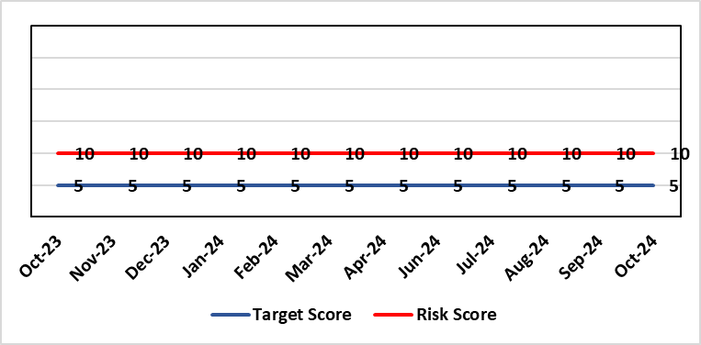 |  | Rationale for current score:  Risk reflects transition to business as usual as part of living with Covid strategy. BCP plans in place. There is still fluctuation in patient numbers and new variants continue to emerge so score maintained as watching brief.
Level of Control  = 25% |  |  | Rationale for target score:  The strategy of moving towards living with Covid will eventually lower the risk level to target.
Date added to the HB risk register
May 2021
Controls (What are we currently doing about the risk?) |  |  | Mitigating actions (What more should we do?)
- Sites have business continuity plans and the impact of one site being overwhelmed by COVID demand has been reviewed.  - Monitoring of associated risks has been being transferred to appropriate forums such as UEC Board, Elective Care Board and Nosocomial Group with overall oversight by Management Board.  - Ongoing surveillance of epidemiology data for early warning and further change to risk level via live Covid dashboard. |  |  | Action | Lead |  | Deadline
 |  |  | Periodic review of risk | COO |  | See Notes Below
Assurances (How do we know if the things we are doing are having an impact?)  Monitored via Management Board for early warning signs. |  |  | Gaps in assurance (What additional assurances should we seek?)
Additional Comments / Progress Notes
03/11/2023: Consideration currently being given to replacement of this risk with fresh entry on wider organisational business continuity arrangements

Datix ID Number: 1832  Health & Care Standard: |  |  | HBR Ref Number: 80  Risk Target Date: 31/12/2024 | Current Risk Rating  4 x 5 = 20
Objective: Urgent & Emergency Care |  | BAF Ref: 2.4 | Director Lead: Deb Lewis, Chief Operating Officer  Assuring Committee: Quality & Safety Committee
Risk: Transfer of Clinical Optimised Patients  A deficit in the availability of appropriate community / domiciliary care results in unacceptable delays in discharging patients from acute hospital beds. As a result, patients can decompensate and never gain the independence that could have been available from an early discharge. |  |  | Date last reviewed: October 2024
Risk Rating  (consequence x likelihood):  Initial: 4 x 5 = 20  Current: 4 x 5 = 20  Target: 4 x 2 = 8 |  |  | Rationale for current score:  - Sustained levels of clinically optimised patients (COPs) leading to overcrowding within ED, use of inappropriate or overuse of decant capacity in ED and delays in accessing medical bed capacity, clearly emerged as themes.  - Constraints in relation to all patient flows out of Morriston to a more appropriate clinical setting, identified and included in an expanded risk.  - Delay in discharge for clinically optimised patients can result in deterioration of their condition.
Level of Control
= 25%
Level of Control  = 25% |  |  | Rationale for target score:  Targeted reduction of Clinically Optimised patients remains a priority for the HB in order to minimise risk of avoidable harm to patients within the HB and in the wider community.
Date added to the risk register
May 2021
Controls (What are we currently doing about the risk?) |  |  | Mitigating actions (What more should we do?)
- One of the measures under targeted intervention is to see a reduction in pathway of care delays, which specifically supports the reduction in the number of clinically optimised patients.  - Review is undertaken on a patient by patient basis – with explicit action agreed in order to progress transfer to appropriate clinical setting.  - Critical constricts in relation to access/time delays for social workers and assessment for package of care and social placement  - The health board continues to procure 63 additional care home and hospital beds to provide additional discharge capacity.  - Clinically optimised patients (COP) have been cohorted into the available capacity at Singleton Hospital to ensure that their needs can be met more appropriately. This has reduced the number of COPs at Morriston Hospital. Weekly escalation meetings are held with health and social service colleagues to ensure the requirements of the patients are reviewed and patients are pulled through the system where possible. |  |  | Action |  | Lead | Deadline
 |  |  | The Care Action Committee (CAC) is focussing on reducing the impact of COPs within acute hospitals. The HB is actively engaging with the work from the CAC and currently developing the Winter Plan for 24/25, of which reducing COPs will be a key focus. This work is being taken forward by the Interim Head of Integrated Services in PCT to ensure cross-boundary support. |  | Interim Head of Integrated Services – PCT | 30/11/2024
Assurances (How do we know if the things we are doing are having an impact?)  - Patient level dashboard allows breakdown by delay type  - Close management of utilization of additional care home beds. |  |  | Gaps in assurance (What additional assurances should we seek?)
Additional Comments
09/10/2023: IDH pilot completed, data being analysed, initial review shows a positive impact on turning patients around at the front door. Roll out to be completed in Q3.
13/02/2024: Action completed: Patient Assignment Team (PAT) element of an Integrated Discharge Hub is in place. There are further potential elements that have not be implemented, but are to be considered next – a Ward-based facilitation team and a Complex Discharge Team. A paper will submitted for consideration by the UEC Board (currently planned for 6th March). It will highlight the outputs and lessons learned from the implementation of a PAT in order to support discussion of next steps including consideration of the additional teams not currently in place.
08/05/2024: This is integral component of the HB TI recovery plan.
14/10/2024: Action refreshed. This remains a current risk. It will be the main focus of the Winter Plan currently being developed and is also a key focus of the Care Action Committee.

Datix ID Number: 2561  Health & Care Standard: |  |  | HBR Ref Number: 85  Risk Target Date: 31/03/2025 | Current Risk Rating  4 x 5 = 20
Objective: Children & Young People Services |  | BAF Ref: 2.7 | Director Lead: Christine Morrell, Director of Therapies & Health Sciences  Assuring Committee: Quality & Safety Committee
Risk: Non-Compliance with ALNET Act There are risks to the Health Board’s ability to meet its statutory duties and establish the effective collaborative arrangements required by the ALN Act, which is being implemented through a phased approach. This risk is caused by:  - Lack of staff resource needed to carry out the additional work needed to comply with the ALN Act for operational services, especially those in the PCST Service Group.  - Implementation of the Act for those of above compulsory school age (post-16) commenced in September 2023. This presents risks because of gaps in service provision.  - Multiple pressures for operational services are impacting on capacity / engagement of leads within impacted services to progress tasks that need to be undertaken to mitigate the risks and current vacancy in ALN Project Manager post.  - Issues with Data Quality due to pressure on ALN and Service administration teams, process issues and absence of a robust system to enable data capture and analysis. This means that accurate and up-to-date data regarding the Health Board’s compliance is not available.  Potential consequences of this risk are: non-compliance with statutory duties, parent / carer and young peoples' dissatisfaction leading to complaints. Educational Tribunals and Judicial Reviews (this is new legislation with many points of ambiguity and is highly likely to be legally ‘tested’); reputational impact; and children failing to access the multi-agency support that they need with their learning needs, leading to poor outcomes. |  |  | Date last reviewed: October 2024
Rationale for current score:
Risk score reflects that while controls are in place, there are multiple areas of risks (relating to compliance with legislation; governance and assurance; workforce and OD; and sustainable services); and high probability (especially given multiple risk areas) of at least one of these areas of risk being realised. Caused by implementation timetable for the ALN Act, slippage against plan and need for strengthened governance (as described in ‘Risk’ section).

Risk Rating  (consequence x likelihood):  Initial: 5 x 5 = 25  Current: 4 x 5 = 20  Target: 2 x 3 = 6 |  |  | Rationale for target score:  As the ALN Act is new legislation, there remains some ongoing likelihood of risk events during the initial phases of implementation, though with lessened consequences as a result of mitigating actions.
Level of Control
=
Date added to the HB risk register
14/05/2022

Controls (What are we currently doing about the risk?) | Mitigating actions (What more should we do?)
- Progressing the necessary work within an appropriate structure (see under ‘ACTIONS’) are constrained by financial and/or service delivery pressures.  - DECLO (Designated Educational Clinical Lead Officer) is in post - this is a statutory requirement.  - Health Board ALN Steering Group has been established, with governance structure in place involving the ALN Operational Group working under the governance of this  - Operational processes through which the Health Board fulfils its statutory duties under the ALN Act are in place.  - Ongoing collaboration between the DECLOs at a national level ensures a broadly consistent approach across Wales to how Health Boards fulfil their requirements under the ALN Act. Some ongoing differences remain because of different Local Authority approaches, through Welsh Government have formed a national group to support improved consistency around Health-Education collaboration through the ALN Act.  - Regarding demand / capacity and staffing resource challenges, WG has a phased implementation timetable that has recently been extended from summer 2024 to summer 2025. From summer 2025, the Act will be fully in ‘delivery as usual’. The phased implementation offers partial short-term mitigation of the risks.  - Awareness has been raised at Board level through Development session and bi-monthly updates are provided to the Patient Safety & Compliance Group.  - Welsh Government have been engaging with the Designated Education Clinical Lead Officers on a national basis regarding ALN key performance indicators and compliance. A Welsh Health Circular requiring regular reporting against statutory key performance indicators is anticipated in the coming months.  - Audit and Assurance Services have conducted an audit of the Health Board in relation to the ALN Act, which provided an overall ‘limited assurance’ rating. Management responses have been developed and a work plan is in place, monitored through the ALN Steering Group, to address issues identified in the audit. | Action | Lead | Deadline
 | Requirement to establish data infrastructure to provide assurance regarding HB compliance with statutory duties | DECLO & Director of Digital | 30/10/2024
 | Develop and implement administrative operational model to support accurate data capture | DECLO | 30/12/2024
 | Effective, realistic operational processes - Activity to ensure operational processes through which statutory duties are fulfilled balance statutory duties and the ethos of the ALN Act with the need to deliver requirements without additional resource. | DECLO | 20/12/2024
 | Securing longer-term administrative and project management support needed to mitigate risks | DoTHS | 31/01/2025
 | Progress action plan in relation to ALN audit | DECLO | 31/03/2025
Assurances (How do we know if the things we are doing are having an impact?)  - There is regular reporting in respect of the ALN Act through the Patient Safety and Compliance Group.  - ALN Steering Board has been established, ensuring oversight at a senior level within all impacted operational and corporate areas.  - DECLO meets regularly with ADOTHS / DoTHS of the 3 health boards of South-West and Mid Wales for update and assurance.  - National ALN Reform Steering Group has been formed and will include Health representation (SBU Deputy DOTHS). This will provide a national forum for consideration of risks. | Gaps in assurance (What additional assurances should we seek?  - Extent of gap in staffing resource (gap between work required and capacity available) has been provisionally quantified, but data is imperfect and there remains some uncertainty. This is in a context where demands will increase significantly over the next year.
Additional Comments / Progress Notes
06/11/2024 – activity remains on track as per update 25/09/2024. Absence of project support continues to impact on the pace of work. It is expected that with data available in the new year, it will be possible to meaningfully review risk by 31/03/2025 as per current risk target date.

Datix ID Number: 3071  Health Care Standards: |  |  | HBR Ref Number: 89  Target Risk Date: 31/07/2024 | Current Risk Rating  4 x 5 = 20
Objective: Primary & Community Care |  | BAF Ref: 2.2 | Director Lead: Hazel Powell, Executive Director of Nursing  Supporting Director: Deb Lewis, Chief Operating Officer  Assuring Committee: Quality & Safety Committee
Risk: Healthcare Nursing Staff Levels at HMP Swansea  There is a risk that the men in HMP Swansea will not receive the appropriate standard of care. This is due to the fact that the nursing establishment within the prison no longer fully meets the changed demographics and numbers of men being detained. The maximum operational capacity of the Prison can reach circa 480 men. The Health Board investment into the Prison is based on delivering services to 250 men. This was also highlighted as a risk in the June 2022 HIW governance review. In addition there is no head room built into the Prison nursing establishment so periods of sickness, leave and study renders the roster short. |  |  | Date last reviewed: October 2024
Risk Rating  (consequence x likelihood):  Initial: 4 x 5 = 20  Current: 4 x 5 = 20  Target: 2 x 2 = 4 | 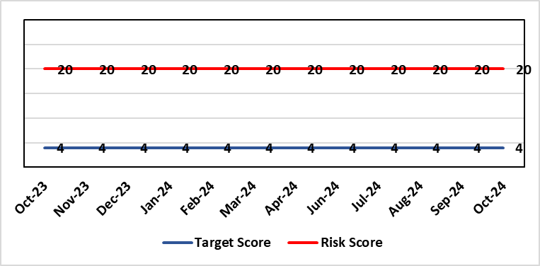 |  | Rationale for current score:  Consequence major – unable to fully deliver on the recommendations of HIW due to low healthcare staffing numbers, further impacted during periods of sickness or absence as no headroom. Recommendations also raised in Prison & Probation Ombudsman reports. Likelihood expected – suboptimal care provided on a daily basis.
Level of Control  = % |  |  | Rationale for target score:  Consequence minor – With sufficient staffing numbers the prison will be able to deliver on HIW recommendations and fully implement the actions in the Health Delivery Plan. Likelihood unlikely – With full establishment and headroom, suboptimal care is less likely.
Date added to the risk register
30/11/2022
Controls (What are we currently doing about the risk?) |  |  | Mitigating actions (What more should we do?)
Daily communication with the Governor about the availability and priority of healthcare nursing staff.  Pharmacy technician role established – can administer drugs to support nursing establishment.  Agreed that Health Care Support Workers to be 2nd checkers for CD drugs and to support substance withdrawal monitoring (awaiting accreditation).  Bank and agency staff are used in a limited way, when skillset allows.  E-roster implemented and scrutinised with regular reporting to Service Group Patient Safety & Compliance Group.  Escalation for overtime and additional hours to fill shortfalls. |  |  | Action | Lead | Deadline
 |  |  | Further baseline assessment commencing in July 2024, led by MH Substance Misuse & Vulnerable Groups Division of WG. | Healthcare Lead | Complete
 |  |  | Service Group are considering how it might reduce the risk and source additional resource | Service Group Director | See notes
 |  |  | Review of staffing in prison | Deputy Head of Nursing | 31/12/2024
Assurances (How do we know if the things we are doing are having an impact?)  Prison feedback and complaint process  Progress reporting on action plans through Service Group PS&C Group, and Health Board Q&S structures (via Patient Safety & Compliance Group). |  |  | Gaps in assurance (What additional assurances should we seek?)  Implementation and reporting of clinical audits. Audit framework for HMP Swansea in development - Clinical Pathways/Audits and Health Promotion groups taking forward.
Additional Comments
19/06/2024: Awaiting a start date for the mental health and clinical substance misuse service review. Public Health Wales have provided support to undertake the Prison Health Needs Assessment this work commenced June 2024 and will conclude September 2024. The assessment will contain data in relation to prison population health need and services delivered.
Actions completed: HCSW second checkers of CDs to be accredited externally; Fresh gap analysis to be undertaken to identify staffing shortfall and set out further proposals to address.
The service group are reviewing all services within PCT. Prison Healthcare lead will meet with Finance for review of health services baseline and nursing headroom cost. Most recent cost is £298.037 for 26.9% Nursing Headroom of which approx. £36,544 has been invested from the service group.
05/09/24: Investment in team expected by September 2024. Risk will be reviewed following this.
23/10/2024: Action complete – The base line assessment was completed by the proposed timeframe and we have received a draft report – management are in the process of responding to that report.
A Deputy Head of Nursing (DHoN) has been appointed and is to support review of staffing within the prison – expected completion December 2024. The findings of the baseline assessment will support the staffing review that the DHoN is undertaking.
A service specification for health protection works has been submitted to Public Health it is expected there will be investment from public protection team to support with vaccination and health protection screening work it is expected that £74,439 recurrent funding will be available for health protection works within the prison. Once funding has been confirmed and allocated there is an expectation of improved health protection health outcomes.

Datix ID Number: 2796  Health Care Standards: |  |  | HBR Ref Number: 90  Target Risk Date: 30/04/2025 |  | Current Risk Rating  4 x 4 = 16
Objective: The delivery of care is supported by innovative digital solutions |  | BAF Ref: 4 | Director Lead: Matt John, Director of Digital  Assuring Committee: Workforce OD & Digital Committee
Risk: Non-compliance with UK-GDPR Article 15 regarding Subject Access Requests (SARs), along with other health records requests for disclosure of personal data  The Health Board does not have adequate resources to deal with the sustained increase in volume and complexity of subject access /access to health records requests received from requestors. The ICO have previously been involved with a number of breaches and complaints in this area and there is the potential for future enforcement action if significant improvements are not made. Misfiling and redaction are major issues for Health Records, IG and Health Professionals. SAR breaches have led to successful compensation claims and media interest. |  |  | Date last reviewed: October 2024
Rationale for current score:
C – The Health Board has a statutory requirement to comply with UK GDPR and Data Protection Act 2018. This includes compliance with an individual’s Right to Access their personal data. The Information Commissioner has the power to take enforcement action, including substantial monetary penalties, for non-compliance. A number of complaints regarding the handling of SARs within SBUHB have been highlighted previously in both the mainstream media and on social media, leading to a loss of trust in the Health Board with damage to staff and Health Board reputation.
L- The Health Board does not have adequate resources to deal with the sustained increase in volume and complexity of SARs received from both patients and staff. There are inconsistent processes across the Health Board, with varying levels of robustness regarding legal compliance. The increased use of various digital applications has impacted the volume and complexity of content and the ability to retrieve the personal data required to comply with SARs. The process for ensuring information is appropriately reviewed and redacted by health professional within services has become far more complex and resource intensive increasing the likelihood of personal data breaches and/or non-compliance with legal timescales for disclosure. The ICO have previously been involved with a number of complaints in this area and there is an increased potential for future enforcement action if significant improvements are not made. There continues to be an increase in both the number and complexity of SARs received as data subjects become more aware of their rights and the mediums in which data are recorded expands.
Risk Rating
(consequence x likelihood):
Initial: 4 x 4 = 16
Current: 4 x 4 = 16
Target: 4 x 2 = 8
Level of Control  = 50% |  |  | Rationale for target score:  C – As above  L – Additional resources would allow the organisation to make significant improvements to the process by which SARs are managed. Being able to adequately comply with legal requirements reduces the likelihood of enforcement action and fines from the ICO, as well as minimising the risk of reputational damage.
Date added to the risk register
Jan 2023
Controls (What are we currently doing about the risk?) |  |  | Mitigating actions (What more should we do?)
- New SAR (Subject Access Request) Working Group established in February 2024  - Prioritisation of workload  - Revised SAR policy in place (to be reviewed & updated in line with Working Group actions)  - Advice sought from Legal and Risk on complex cases  - Escalating areas of concern to IGCAG (Information Governance & Cyber Assurance Group) |  |  | Action | Lead |  | Deadline
 |  |  | Undertake GAP analysis and develop action plan | Data Protection Officer |  | 31/10/2024
 |  |  | Implement priority tasks outlined within the action plan within agreed timescales | Data Protection Officer |  | 31/03/2025
Assurances (How do we know if the things we are doing are having an impact?)  - Bi-monthly IGCAG chaired by SIRO (Senior Information Risk Owner) and attended by Deputy Caldicott Guardian and Data Protection Officer  - Escalation reports from IGCAG to Management Board & Workforce OD & Digital Committee as required  - IG governance structures in place with key roles and responsibilities established e.g. SIRO, Caldicott Guardian, DPO (Data Protection Officer) |  |  | Gaps in assurance (What additional assurances should we seek?)  Recent internal audit identified the requirement to invest in resources to address gap in assurance.
Additional Comments / Progress Notes
09/10/2023 – SAR Lead starting date confirmed as the 30th October 2023.
16/11/2023 – SAR Policy approved by WODDC in October 2023. Previous action to review all SAR documentation amended to indicate re-establishment of SAR working Group to perform gap analysis.
08/02/2024 - First meeting of new SAR Working Group to take place on 8 February 2024. Terms of Reference have been agreed and an action plan is to be developed, approved and implemented with priority tasks to be given attention in the coming months.
10/05/2024 – Updated progress 2 to include entry: 08/05/24 - GAP analysis has been circulated for completion by membership of SAR Working Group to inform action plan. Comment added to reflect the above.
11/07/2024 - GAP analysis has been completed. Action Plan is in development stages but has been placed on hold in light of imminent meetings to discuss viable next steps for the SAR risk. Due date extended to September 2024.
08/08/24 - Discussions are taking place at executive level with reference to SARs which may have a bearing on this risk register entry going forward. First meeting has taken place with Risk & Assurance lead and work has commenced to consider rearticulating the risk. This is being progressed with input from relevant stakeholders.
27/09/2024 – Action targets refreshed.

Datix ID Number: 3444  Health & Care Standard: |  |  | HBR Ref Number: 92  Risk Target Date: 31/03/2025 | Current Risk Rating  5 x 5 = 25
Objective: The health board is a resilient, financially sustainable and responsible organisation |  | BAF Ref: 6 | Director Lead: Darren Griffiths, Director of Finance and Performance  Assuring Committee: Performance & Finance Committee
Risk: Forecast Deficit  Forecast deficit is not met due to (1) insufficient progress on run rate reduction, (2) the extended saving targets required across all areas to meet the financial assessment submitted to WG on 26th September are not achieved, and (3) 30 other risks within the financial assessment are not mitigated. |  |  | Date last reviewed: October 2024
Risk Rating  (consequence x likelihood):  Initial: 5 x 4 = 20  Current: 5 x 5 = 25  Target: 5 x 1 = 5 | 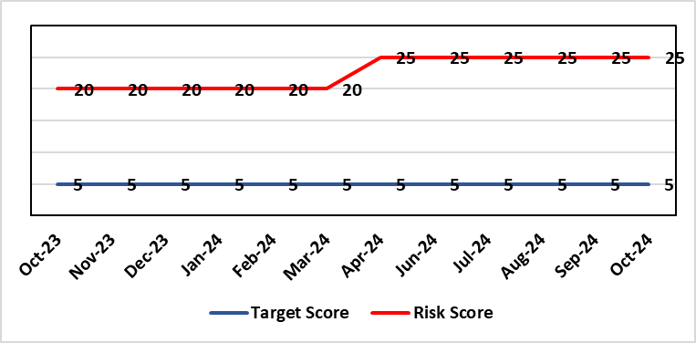 |  | Rationale for current score:  - Delivery of the deficit plan is predicated on a combination of savings and run rate reductions  - Consequence is significant as failure to deliver the plan could impact service delivery if cost reduction required later in the year  - A deficit plan is a failure to meet a statutory duty
Level of Control
= 25%
Date added to the risk register  June 2023 |  |  | Rationale for target score:  - The consequence will not change given the important of financial delivery and its relationship with the delivery of the Health Board recovery and sustainability plan  - Reducing likelihood to 1 supports a confidence that the deficit plan will be delivered.
Controls (What are we currently doing about the risk?) |  |  | Mitigating actions (What more should we do?)
The Health Board is doing the following:  - Enhanced governance arrangements in place from April 2024, including the submission of Financial Strategies from all Service Groups on 31st May 2024, which ultimately fed the financial assessment approved by Board on 25th September.  - From end June through to August, Service Areas have submitted options to address current pressures, which have been scrutinised through a number of Star Chamber meetings and via Executive Team. This links to the work required via the Accountability Letters issued in April 2024 and the submission of the Financial Strategies on 31st May 2024  - Financial plan was in place for 2024/25 alongside supporting documentation with regard to Budgetary Management, with further work being undertaken at the request of WG on revised financial assessment to be presented to the Board on 25th September. The initial plan set out the details on the Accountability Letters issued in April 2024, with further actions outlined in an email on 10th October following the submission of the financial assessment of WG and face-to-face discussions with the WG NHS Wales Director of Finance  - Publication of control targets on 10th October to all Service Areas for 2024/25 to provide additional controls in the process following the work on Star Chambers and associated options.  - Establishment of the Recovery and Sustainability (R&S) Team from July 2024 to support both immediate actions and longer term sustainability, with a Recovery & Sustainability Board overseeing the delivery, with its first meeting held on 21st October 2024.  - Review of all controllable expenditure and directions issued via the R&S Team, including Variable Pay targets.  - Clear action requested directly from interim CEO from May onwards agreed at Management Board meetings and shared with all Staff via the CEO mid-week message.  - Further actions set by interim CEO in April and May for Executive Directors above Thematic programmes.  - Transparent exchange of position with NHS Executive & Welsh Government, with both weekly and monthly meetings with the NHS Executive, which will continue throughout 2024/25.  - Savings Programme Management Office (PMO) in place to support savings delivery. In July 2024, the PMO team expanded their remit to support the Recovery & Sustainability Programme  - Enhancing the national data in the Vault the PMO have developed a ‘Repository of opportunities, which went live in Q1. Updates and developments such as weekly reporting of drivers of expenditure, will be added throughout the year and communications on updates issued.  - Focus on efficiency of core resource to avoid spending premium cost resource  - Using the learning from publications like the Review of Cost Savings Arrangements published by Audit Wales in August 2024 to further enhanced existing systems and processes. |  |  | Action | Lead | Deadline
 |  |  | Continuation of financial performance meetings and escalation as necessary | Director of Finance & Performance | Will run until targets met
 |  |  | Develop robust cross system service change plans which improve quality of care and reduce system cost led by the R&S team. | Director of Finance & Performance and Chief Operating Officer | Will run until target is met
 |  |  | Recommendations following Star Chamber and Executive Team meetings to be presented as part of the revised Financial Plan at the Board meeting on 25th September. This will then set the trajectory to the 31st March 2025. | Director of Finance & Performance | Complete
 |  |  | Recovery & Sustainability Board will strengthen and enhance the existing governance already in place and focus on short term and medium term delivery of financial opportunities. | Director of Finance & Performance (SRO), supported by Director of Recovery & Sustainability | Will run for 2+ years
 |  |  | Building on the work from point 3 and the submission of the financial assessment in September, all service areas will be issued with control totals to deliver, recognising the areas of options and controllable expenditure. Oversight of this will be via the Recovery & Sustainability Board commencing in October. | Director of Finance & Performance to issue targets.  Service and Corporate Directors to deliver targets | 10/10/2024  31/03/2025
Assurances (How do we know if the things we are doing are having an impact?)  The Health Board financial performance is reviewed and monitored through:  - Monthly financial recovery meetings  - Performance & Finance Committee  - Routine reporting to Board of most recent monthly position and financial forecasts  - Development of weekly reporting of drivers of expenditure.  - Weekly meetings with the NHS Executive  - Monthly Enhanced Monitoring Meetings  - Monthly Financial Face to Face meetings with Director Finance for NHS Wales from August onwards  - Comprehensive mid-year and ongoing review of trajectory supported by a live ‘assessment of plan to March’ will be shared during Q3 and Q4. |  |  | Gaps in assurance (What additional assurances should we seek?)
Additional Comments / Progress Notes
03/05/24 - Letter from WG dated 3rd May outlined that the plan as it stands is unacceptable and unsupportable and resubmission is required by 31st May 2024.
13/05/24 – Interim CEO set out clear action in the financial position
15/05/24 – Discussions with Management Board and setting position regarding agency spend
05/06/24 – Presentation to WG by DOF/Deputy DOF on Financial Plan and the position at Month 1
11/06/24 – Presentation and further actions agreed by Independent Members
23/07/24 – Update on actions to mitigate financial position and next steps shared with PFC.
12/08/24 – Full details of all actions to mitigate position described in MMR submission, which is part of PF papers
19/09/24 – Actions updated. Check and challenge meeting planned with WG 09/10/24 on Financial Position and trajectory to 31st March 2025.
25/09/24 – Action completed: Culmination work from June-August presented to Board as revised Financial Assessment 2024/25, submitted to WG on 26/10/24
09/10/24 - Check and challenge meeting with WG on Financial Position and trajectory to 31st March 2025.

Datix ID Number: 3448  Health & Care Standard: |  |  | HBR Ref Number: 93  Risk Target Date: TBC |  | Current Risk Rating  5 x 4 = 20
Objective: The health board is a resilient, financially sustainable and responsible organisation |  | BAF Ref: 6 | Director Lead: Darren Griffiths, Director of Finance and Performance  Assuring Committee: Performance & Finance Committee
Risk: Reduced Capital Funds  Reduced discretionary capital funds and reduced National NHS funds requiring a restricted Capital Plan for 2024/25. |  |  | Date last reviewed: October 2024
Risk Rating  (consequence x likelihood):  Initial: 5 x 4 = 20  Current: 5 x 4 = 20  Target: 5 x 1 = 5 | 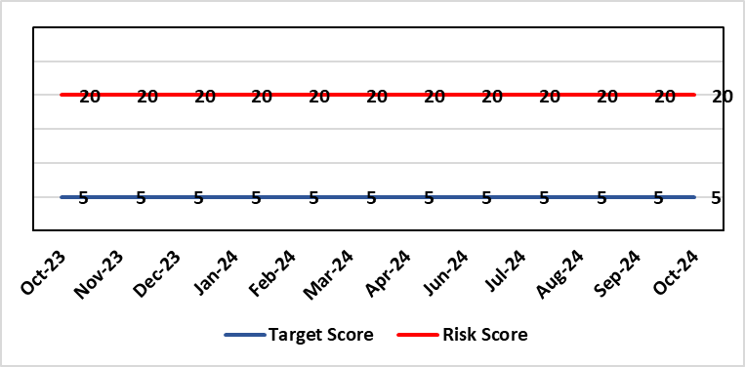 |  | Rationale for current score:  - The Health Board has been advised that its discretionary capital allocation for 2024/25 is £11.168m.  - The funding available within the Capital Resource Limit (CRL) will not meet the demands for capital investment. Discretionary capital is deployed to replace ageing medical devices & equipment; to address backlog maintenance of premises; and to support small scale, non-National service improvements with capital investments  - The current Health Board assessment of the carry forward and previously agreed commitments for inclusion in the 2024/25 capital plan currently suggests a requirement for an additional £8.4m to balance the plan and meet highest risk priorities only.  - WG are currently assessing the outputs from the national capital prioritisation exercise, which means some major capital scheme business cases are on hold.  - The approved plan assumes additional disposal income of £850m which is yet to complete.  - Assumed income of £1.124m from WG for business case fees has been removed from the plan due to the on-going national capital prioritisation exercise. A temporary hold of estates allocations agreed to mitigate this risk following receipt of an additional £4.4m capital funding from WG for estates backlog maintenance.  - There is potential for further capital requirements arising from service model changes which will need to be managed.  - Potential consequences of this risk are the inability to achieve the ambitions set out within health board plans; the potential failure of ageing equipment leading to service disruption; the exposure to potential environmental health & safety risks.
Level of Control
= 25%
Date added to the risk register  June 2023  (refreshed June 2024) |  |  | Rationale for target score:  The target score expresses the aspiration of the health board for addressing this risk. The target date indicated above reflects the point which the current actions are anticipated to reduce the risk, though knowledge of the actual funding available is required to reduce it further and this is not available until some months into the financial year.
Controls (What are we currently doing about the risk?) |  |  | Mitigating actions (What more should we do?)
The Health Board is doing the following: -  - Regular dialogue with Welsh Government regarding capital requirements.  - Clear communication and reporting of the capital position, the risks and limitations.  - Close management of all schemes to ensure slippage is understood along with the impact on service.  - Clear prioritisation of any new requirements recognising the current constraints |  |  | Action | Lead |  | Deadline
 |  |  | Routine review and flexing of plan as spending is committed through the year. Routine monitoring processes will identify any potential slippage and will deploy this on risk based basis. | Director of Finance & Performance |  | Monthly through the financial year as plan is dynamic
 |  |  | Slippage bids to WG. | Assistant Director of Finance (Strategy & Planning) |  | 30/09/2024
 |  |  | Additional Slippage Bids and Fix CRL | Assistant Director of Finance (Strategy & Planning) |  | 31/10/2024
Assurances (How do we know if the things we are doing are having an impact?)  The Health Board capital position is reviewed and monitored through:  - Quarterly capital prioritisation group  - Performance & Finance Committee quarterly finance report  - Monthly Monitoring Returns to Welsh Government. |  |  | Gaps in assurance (What additional assurances should we seek?)  Reporting on impact of constraints to the capital programme on service delivery.
Additional Comments
Board members will be aware that capital plans are dynamic through the year with mitigating actions taken and opportunities for slippage and further support from WG sought on a consistent basis. This process will continue in 2024/25 in efforts to de-risk the capital plan.
18/06/24: Updated for 2024/25 position.
02/09/24: Risk level rational updated
23/09/24: Updated for latest position.
29/10/24: Slippage bids £8.9m submitted to WG - approved £1.3m with remaining £7.6m not approved. 24/25 CRL position to be fixed by 31/10/14. Additional bids submitted for high risk equipment replacement £0.8m

Datix ID Number: 3516  Health Care Standards: |  |  | HBR Ref Number: 94  Risk Target Date: TBC |  | Current Risk Rating  4 x 3 = 12
Objective: Mental Health & Learning Disability Services |  | BAF Ref: 2.3 | Director Lead: Deb Lewis, Chief Operating Officer  Assuring Committee: Performance & Finance Committee  For information: Quality & Safety Committee
Risk: CAMHS failure to meet required standards of performance  The CAMHS service is unable to meet the required level of performance due to workforce deficits in the team across all staff groups including medics, psychological therapies and nursing.  Links to other CAMHS risk register entries: (Ref: 3410/3373/3351/3346/3349/3350) |  |  | Date last reviewed: October 2024
Risk Rating  (consequence x likelihood):  Initial: 4 x 5 = 20  Current: 4 x 3 = 12  Target: 3 x 3 = 9 | 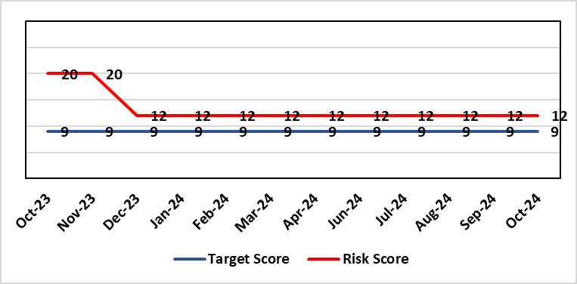 |  | Rationale for current score:  Marked improvement in the performance against the Mental health Measure for CAMHS. Data validation for new patients complete. Current risk score reduced to 12 in view of improved performance however this reflects the fragility in the workforce to deliver sustained performance.
Level of Control  = % |  |  | Rationale for target score:  The rationale for the target score is linked to successful recruitment and more timely access to services for children and young persons which will reduce risk.
Date added to the risk register
October 2023
Controls (What are we currently doing about the risk?) |  |  | Mitigating actions (What more should we do?)
-Ongoing recruitment into all staff groups  -Temporary agency workforce in nursing at premium pay rates to sustain current levels of performance  -Use of locum medical staff due to high vacancy level on medical workforce.  -Recent appointment into psychological therapies lead posts. |  |  | Action | Lead |  | Deadline
 |  |  | Continued efforts at recruitment | Acting Associate Service Director |  | Monthly review
Assurances (How do we know if the things we are doing are having an impact?)  -Monthly CAMHS Directorate meeting in place where performance and workforce are scrutinised  -Reporting into Weekly Business Team and MH & LD management board.  -Reporting into SBU Performance & Finance Committee and IQPD (Integrated Quality & Performance Delivery) meeting with Welsh Government  -Ongoing validation of the waiting list to ensure robust reporting going forward |  |  | Gaps in assurance (What additional assurances should we seek?)
Additional Comments / Progress Notes
03/09/2024: There has been sustained improvement performance against the Mental Health Measure for CAMHS since last review date in line with the predicted trajectories increases from 40% compliance against Part 1a in May to 62% in June and 72% in July. We are continuing to try and recruit to substantive nursing posts for part 1a of the service to reduce the need for agency nursing, to make the service provision more clinically and financially sustainable.
19/09/2023 August compliance figures have risen again to 84%. We have been unsuccessful with the recruitment to substantive nursing posts so still reliant on the agency workforce so the risk score will need to remain the same. Current risk score remains at 12 in view of improved performance over a period, however this reflects the fragility in the workforce to deliver sustained performance.
25/10/24: Sept 2024 compliance is 92% so now within the national required target for the past two months. Recruitment is still proving difficult which the service is continuing to manage so the risk will need to remain the same until we secure the required substantive workforce.

Datix ID Number: 3571  Health & Care Standard: |  |  | HBR Ref Number: 96  Target Date: 31/03/2025 |  | Current Risk Rating  4 x 5 = 20
Objective: The health board is a resilient, financially sustainable and responsible organisation |  | BAF Ref: 6 | Director Lead: Nerissa Vaughan, Interim Director of Strategy  Assuring Committee: Performance & Finance Committee
Risk: Failure to Develop an Approvable IMTP (statutory compliance)  Failure to have an approvable (Integrated Medium Term Plan) IMTP for 2024/5 and for 2025/26 then we will lose public confidence and breach legislation. |  |  | Date last reviewed: October 2024
Risk Rating  (consequence x likelihood):  Initial: 4 x 5 = 20  Current: 4 x 5 = 20  Target: 4 x 2 = 8 |  |  | Rationale for current score:  The Health Board does not have a WG approved IMTP and has been placed in enhanced monitoring for Finance, Strategy and Planning following the inability of the Health Board to submit a balanced IMTP in March 2023. Given the All Wales financial context the Health Board was not able to submit an IMTP in March 2024 and has instead developed an Annual Plan 24/25 set in a three year context. It is also unlikely that the HB will be able to submit financially balanced IMTP in March 2025
Level of Control
= 70%
Date added to the HB risk register
October 2023
Date added to the HB risk register  October 2023 |  |  | Rationale for target score:  The target remains to develop a financially balanced IMTP so that we meet our statutory duties.
Controls (What are we currently doing about the risk?) |  |  | Mitigating actions (What more should we do?)
- An integrated process is in place to develop the Annual Plan 2025/26.  - The existing IMTP Executive Steering Group will provide oversight of the Annual Plan/IMTP, Performance and Finance Plans assured by P&F Committee. W&OD Committee reviews the workforce plan, Q&S Committee the Q&S elements. JET meetings with WG  - An Annual Plan was submitted to WG in March 2024 along with an Accountability Officer Letter  - As per the Welsh Government de-escalation criteria for Strategy and Planning work has commenced to refresh the HB’s Clinical Services Plan with a view to develop a draft that can be shared with WG in March 2025.  - As per the Welsh Government de-escalation criteria for Strategy and Planning work in being undertaken to assess the HB against the Planning maturity Matrix and develop an action plan in response. The baseline assessment should go to Board in September at the latest. |  |  | Action | Lead |  | Deadline
 |  |  | Establish baseline assessment against the Planning Maturity Matrix with an associated action plan | Interim Director of Strategy |  | Feb 2025 (Board Development Session)
 |  |  | Development of a draft Clinical Services Plan to be shared with WG in March 2025. | Interim Director of Strategy |  | 31/03/2025
 |  |  | Amended: Development of a robust Annual Plan for 2025/26 in a three year context to be submitted to WG in March 2025. | Interim Director of Strategy |  | 31/03/2025
Assurances (How do we know if the things we are doing are having an impact?)  Robust arrangements are in place to execute the Annual Plan and for 2025/26 these arrangements are being strengthened with updated reporting and monitoring arrangements through the newly established Annual Plan Oversight Group chaired by the COO. |  |  | Gaps in assurance (What additional assurances should we seek?)
Additional Comments / Progress Notes
08/11/2024: Action refreshed

Datix ID Number: 3692  Health & Care Standard: |  |  | HBR Ref Number: 98  Target Date: TBC | Current Risk Rating  5 x 4 = 20
Objective: Care is delivered in safe and appropriate settings |  | BAF Ref: 3 | Director Lead: Darren Griffiths, Executive Director of Finance & Performance  Assuring Committee: Performance & Finance Committee
Risk: Overall condition/compliance and suitability of Health Board Estate  6 FACET survey undertaken in 2022 confirmed the poor condition and suitability of premises where health care services are provided. The backlog maintenance costs are in excess of £200 million. |  |  | Date last reviewed: October 2024
Risk Rating  (consequence x likelihood):  Initial: 5 x 4 = 20  Current: 5 x 4 = 20  Target: 3 x 3 = 9 | 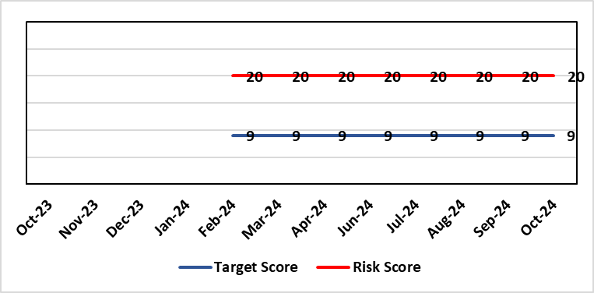 |  | Rationale for current score:  6 FACET survey  Estates Strategy and Development control plans  General compliance with fire regulations and WHTM/WHBN requirements.  Backlog maintenance  Health Board estates strategy and DCP task and finish group  Audit and Assurance limited assurance report  Access to funding
Level of Control  = 50% |  |  | Rationale for target score:  Through the 6 FACET survey a number of key items have been identified covering the Physical condition, Functional suitability, Space utilisation, Quality audit, Statutory compliance and Environmental management. In addition an equality review was undertake on sites. All of which identified significant issues with the current estate, with very few areas achieving condition ‘B’. The overall backlog maintenance is in excess of £200m.
Date added to the HB risk register
07/02/2024
Controls (What are we currently doing about the risk?) |  |  | Mitigating actions (What more should we do?)
- Planned preventative maintenance, prioritising highest risk depending on funding available (EFAB – Discretionary) – linked to creation of decant space through service changes  - Regular reviews of the estate.  - Reactive maintenance.  - 20% annual review/update of 6 FACET surveys  - Undertaken capital schemes where funded  - Address issues where practicable through EFAB/Discretionary capital  - Estates Strategy and development control plans task and finish group |  |  | Action |  | Lead | Deadline
 |  |  | Maintain effective engagement with Welsh Government to provide funding to implement estates strategy and development control plans to address all areas outlined. |  | Assistant Director of Capital Planning | 31 March 2025
 |  |  | Work with Welsh Government to source alternative solutions to funding the HB estates strategy and development control plans |  | Assistant Director of Capital Planning | 31 March 2025
Assurances (How do we know if the things we are doing are having an impact?)  - Monitoring through quality & Safety, Audit & Assurance and Performance and Finance committee to receive assurance and or identify gaps for key compliance and adherence to applicable legislation.  - NWSSP internal audits  - Site visits/tours to identify compliance and gaps in compliances.  - Completion of FRA’s within targeted schedule  - Estates strategy and development control plans being implemented  - Half yearly Board oversight of strategy implementation |  |  | Gaps in assurance (What additional assurances should we seek?)  Suitable funding to implement the estates strategy and development control plans, this will be over a 10 – 15 year period.  Allocate funds where available to address issues outlined  Detailed work to be commissioned to consider primary and community estates strategy along with mental health services
Additional Comments
Through the 6 FACET survey a number of key items have been identified covering the Physical condition, Functional suitability, Space utilisation, Quality audit, Statutory compliance and Environmental management. In addition an equality review was undertake on sites. All of which identified significant issues with the current estate, with very few areas achieving condition ‘B’. The overall backlog maintenance is in excess of £200m.
Key areas include ventilation and cooling with major infection control and other implications. Theatres/Wards/ED and general acute settings including mental health and learning disabilities being old and not compliant with the latest WHBN’s and WHTM’s. The heating, power and medical gas systems have also been identified as issues for concern in the 6 FACET surveys and from independent audits. The health board’s latest NWSSP estates audit received a limited assurance due to limited Welsh Government funding available to undertake backlog maintenance and implementation of estates strategy.
19/07/24 & 22/07/2024: Positive works continue through EFAB and additional funding through WG covering backlog maintenance during 2024, with plans in place to address backlog maintenance, within funding available. In addition to the existing £4.983m WG capital allocation for EFAB (Estates Funding Advisory Board), an additional capital allocation of £4.460m has been received from WG for estates backlog maintenance. No change in current risk score
05/09/2024: Some backlog maintenance issues are currently being addressed in accordance with the allocated WG funding.
To date a total of 11 schemes are being BLM addressed by Capital Planning and Estates teams using EFAB capital allocation. With a number of other areas for action pending further funding allocation. The expenditure and progress of associated schemes is being closely monitored via a monthly steering group and reported back to WG on a bi-monthly basis.
22/10/2024: Roofing is also being replaced as part of the backlog address and progress is being made in 2024/25 to replace aging roofing covering and structures, with just under a 1/3 of the roof expected to be completed by March 2025. Further work is required to complete the risk mitigation here with EFAB being used as the main vehicle to do this. Positive works have been undertaken covering fire alarm upgrades, fire doors/compartmentation, nurse call systems, flooring and windows.

Datix ID Number: TBC  Health Care Standards: |  |  | HBR Ref Number: 99  Target Risk Date: See Rationale |  | Current Risk Rating  5 x 4 = 20
Objective: People of Swansea Bay live healthier, equitable and more equal and prosperous lives |  | BAF Ref: 1 | Director Lead: Jennifer Davies, Interim Director of Public Health  Assuring Committee: Population Health & Partnerships
Risk: Failure to implement the population health strategy approaches at the required scale.  This arises from risk of a failure of the organisation to understand and act on the provisions of the strategy for building whole of system actions across the 4 pillars; and the consequent lack of systems and processes to support the delivery of population health improvements.  Currently identified contributors to this risk include the absence of the tactical level planning required to design and deliver cross-cutting programmes within a federated operational delivery system; lack of systematic review and capture of population health contributions of existing services; limited behaviour change to adopt a population health focus at service and corporate level; uncertainty about the financial commitment to support Population Health Strategy Implementation as well as a lack of clear processes for accessing available funding; a limited focus on prevention; and a lack of consideration of how to act to influence the wider determinants that affect the population’s health and how the Health Board might contribute to addressing these. The outcome if the risk is not addressed is worsening health in our population with widening health inequities. |  |  | Date last reviewed: October 2024
Risk Rating  (consequence x likelihood):  Initial: 5 x 5 = 25  Current: 5 x 4 = 20  Target: 4 x 2 = 8 | 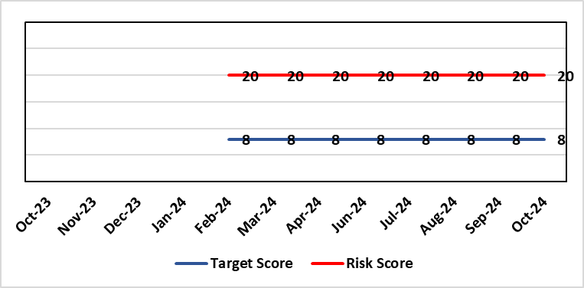 |  | Rationale for current score:  Within SBUHB there is a limited focus on prevention; and a lack of consideration of how to act to influence the wider determinants that affect the population’s health. The Population Health Development Board governance mechanism to enact population health is being reviewed and is not currently operational. We are not in a position where marginal investment is available to begin to develop population health activity. Developing a transformative approach to how we conduct our business is dependent upon the ability of SBUHB to: better understand our population’s needs and address them; focus on actions which foster and maintain health and wellbeing; design services that incorporate prevention and tackle inequities; and develop robust partnerships that tackle the wider determinants of health that ultimately drive demand for healthcare.  Currently there is a lack of capacity and capability in the wider organisation to create the conditions to enable delivery of this transformation agenda. This is in part being driven by the financial climate and political focus on key targeted intervention areas.
Date added to the risk register  14/03/24 |  |  | Rationale for target score:  Given the system wide changes required to mitigate this risk and the requirement to works across organisational boundaries achievement of this target has been be a long term consideration.  Target Risk Date will be reviewed as part of gateway checkpoint on risk/actions.
Controls (What are we currently doing about the risk?) |  |  | Mitigating actions (What more should we do?)
- Population Health Strategy adopted by SBUHB Board 30/03/23.  - Population Health Strategy Audit planned for 2024-25.  - Population Health Strategy aligned to organisational strategic objective 1. Population health integrated into planning infrastructure through R&S plan 24/25 process.  - Population Health and Partnerships Committee and Population Health & Commissioning Management Board established as governance mechanisms for Population Health.  - Mandate through governance to progress on key strategic workstreams:  - Capability & Capacity building  - Anchor Institution baselining  - Anti-poverty  - Strategic Indicators for Population Health  - Repurposing SBUHB financial resource to support population health  - Behavioural change resource identified and procurement process underway to develop behavioural change framework for SBUHB to develop capability and capacity in support of required cultural change.  - Health Intelligence resource needed to lead organisational work to build health intelligence infrastructure has been scoped and identified.  - Local population health actions and measures in development with SDGs for 2025/26, building on work to date, and will be reported quarterly.  - Annual plan population health actions/deliverables to be reported through Annual Plan Oversight Group (APOG) by service group.  - Population Health reserves for 2024/25 confirmed at £250k with delegation through Executive Director of Public Health.  - Supporting SDG development of SBUHB 25/26 IMTP with corporate partners. |  |  | Action | Lead |  | Deadline
 |  |  | Gateway review of progress on governance actions:  - SDG reporting changes;  - Capability and capacity review and development work;  - Population Health Strategy implementation audit to be undertaken. | Executive Director of Public Health / Director of Corporate Governance (support) |  | 31/12/2024  31/03/2025  31/01/2025
 |  |  | Systems working capability development programme in development – for both Health Board colleagues and for external partners | Executive Director of Public Health |  | 31/03/2025
 |  |  | Development of joint work programme for improved health intelligence as part of supporting the implementation of the Digital Strategy | Executive Director of Public Health / Director of Digital |  | 31/12/2024
Assurances (How do we know if the things we are doing are having an impact?)  An approach to capturing activity through the quarterly performance reviews is being piloted with the aim of identifying at Service Delivery Group level how population health gain is being addressed. Progress on 2024/25 Population health GMOs (weight management & tobacco control pathways) through utilising a One Bay Way approach and agreement to be reported through APOG.  Capability and capacity work along with the planned audit will provide a comprehensive set of actionable recommendations on factors limiting implementation. |  |  | Gaps in assurance (What additional assurances should we seek?)  SDG reporting will allow for development of a view of service group level activity and creation of monitoring framework but this is a development journey and there will be a delay of several quarters while this matures. Need for consistent engagement from all SDGs to enable progress to be made.  No mechanism to develop approaches which sit across more than one SDG or which are not directly related to SDG responsibilities.  Available data are fragmented due to federated operational delivery structures in support of population health. Work is underway to identify ‘strategic indicators’ which will provide a framework to monitor the impact of action on population health.  Service delivery remains the primary focus of the health board. Developing partnership agenda but limited focus on prevention and the wider determinants that drive health & wellbeing.
Additional Comments
Given the complexity of the requirements to enable system change at scale the implementation of the population health strategy the organisational journey to becoming population health focused and competent has to be viewed as a long term objective.
Jul 2024: The current financial climate and our targeted intervention status are not conducive to enabling and developing the capability and capacity to enable the required transformative approaches required to realise our strategic ambition.
Aug 2024: The inability to use the dedicated budget allocated to supporting the delivery of the Population Health Strategy due to the immediate financial control requirements is in danger of putting longer term action for more sustainable healthcare provision and population health outcomes at risk.
Oct 2024: Risk updated.

Datix ID Number: TBC  Health & Care Standards: |  |  | HBR Ref Number: 100  Target Risk Date: 31/03/2025 | Current Risk Rating  4 x 3 = 12
Objective: People of Swansea Bay live healthier, equitable and more equal and prosperous lives |  | BAF Ref: 1 | Director Lead: Nerissa Vaughan, Director of Strategy  Assuring Committee: Population Health & Partnerships Committee
Risk: A lack of a robust approach to partnerships & collaboration  If the health board does not have effective structures, processes and working relationships with its external partners at the Public Services Board (PSB) and/or Regional Partnerships Board (RPB), there is a risk that areas of work dependent upon collaboration with partners may not deliver what is required in a timely way, impacting on the delivery of health board priorities. |  |  | Date last reviewed: October 2024
Risk Rating  (consequence x likelihood):  Initial: 4 x 3 = 12  Current: 4 x 3 = 12  Target: 4 x 2 = 8 | 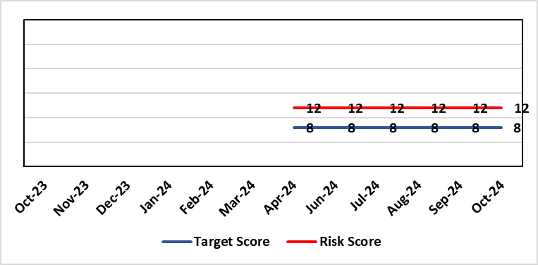 |  | Rationale for current score:  Currently the likelihood of non-delivery of partnership priorities that meet expectations is possible.
Level of Control  = % |  |  | Rationale for target score:  The occurrence of non-delivery of partnership priorities will reduce with an improved partnership approach within the Health Board, although given the complex nature of partnership working it is unlikely to completely eradicate the risk.
Date added to the risk register
29/05/2024
Controls (What are we currently doing about the risk?) |  |  | Mitigating actions (What more should we do?)
- Senior Health Board leadership has been identified across the West Glamorgan Regional Partnerships Board (WGRPB) governance to improve visibility and decision making.  - The newly established Strategic Partnerships Group (SPG) provides oversight of partnership discussions, including the WGRPB and the Public Service Boards (PSB)  In development:  - Organisational Development work is being progressed with the WGRPB Directors  - Collaborative Framework to be developed by the SPG to ensure a joined up and co-ordinated approach to partnership working. The Framework will set-out the roles & responsibilities of Health Board staff and the competencies and skills required to support partnership working.  - Joint working is in development between the Health Board Strategy Team and the West Glamorgan RPB regional team to identify alignment with priorities at the outset. |  |  | SB) | Lead | Deadline
 |  |  | Development of a robust Strategic Partnerships Group and the Collaborative Framework. | Director of Strategy | 31/12/2024
 |  |  | Improve visibility of partnership working across the Health Board | Director of Strategy | Completed
 |  |  | Alignment of Partnership priorities with the Health Board IMTP | Director of Strategy | 31/03/2025
 |  |  | Consideration of the OD working progressed with the WGRPB Directors | Director of Strategy | 31/12/2024
 |  |  | Consideration of Health Board position in relation to identified challenge areas incl. children & young people. | Director of Strategy | 31/12/2024
Assurances (How do we know if the things we are doing are having an impact?)  Strategic Partnerships Group (SPG) established in October 2023 will provide oversight of partnership discussions, including the WGRPB and the Public Service Boards (PSB). |  |  | Gaps in assurance (What additional assurances should we seek?)  There is no framework currently to direct partnership working in a consistent way (Collaborative Framework to be developed to address this)
Additional Comments
20/06/2024: Risk was discussed at Population Health & Partnerships Committee on 6th June 2024. All the actions are within date. There is therefore nothing to add at this stage.
Aug 2024: The Partnership Team will lose a member of the team in October – the Band 7 Planning Manager. The vacancy freeze will put the following work programmes at risk:
- Children & Young People – a large work programme has been initiated as a result of the CYP Summit and partnership discussions and the absence of the band 7 will affect the Team’s ability to take this critical work forward.
- Right Care Right Person – there is growing anxiety amongst staff in relation to the South Wales Police Policy and the Team are leading this work to assess the impact. Morriston has the highest number of AWOL/patient walk outs across Wales in February 2024, and there was a serious incident in August 2024 involving a fatality at the Morrison site. There is a risk that staff are not prepared, and it will have an impact in relation to public protection.
- Visibility at partnership work streams will be impacted as a result of the Team prioritising other work

Datix ID Number: TBC  Health Care Standards: |  |  | HBR Ref Number: 102  Risk Target Date: TBC |  | Current Risk Rating  4 x 4 = 16
Objective: Maternity Services |  | BAF Ref: 2.8 | Director Lead: Hazel Powell, Executive Director of Nursing  Assuring Committee: Quality & Safety Committee  For Information: Workforce OD & Digital Committee
Risk: Inability for maintaining Birthrate Plus ® complaint rosters  Birthrate Plus® enables health boards to calculate their midwifery staffing requirements based on their specific activity, case mix, demographics and skill mix.  There is a risk non-compliance with roster templates due to increased acuity, unplanned staff absence and vacancies. The potential impact of this may be reduced staffing levels against the agreed Birthrate Plus ®, staffing template resulting in poor patient outcomes and experience, and potential suspension of services. |  |  | Date last reviewed: October 2024
Rationale for current score:
The vacancy position has improved for Band 5 & 6 registered staff – there are no vacancies. Community Intrapartum services continue to be suspended and this is subject to review currently. The risk was reduced from 25 to 20 initially and on further assessment is being reduced to 16. Whilst the service is now over-established with registered midwives, the score will be moderate (16) due to unregistered vacancies (which will concluded in September following job evaluation and new JD’s to support the unregistered workforce) and unavailability (due to parenting leave, mandated study leave and sickness). There are improved numbers of registered midwives per shift with most shifts achieving the required 14 midwives. Additional staff in AAU have been put in place to ensure two on duty at all times in line with the RCOG Good Practice Guidelines for Maternity Triage.
Risk Rating  (consequence x likelihood):  Initial: 4 x 5 = 20  Current: 4 x 4 = 16  Target: 4 x 4 = 12 | 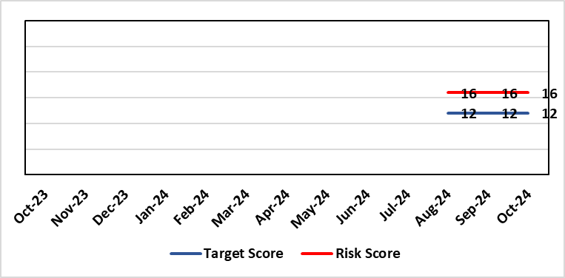
Level of Control  = |  |  | Rationale for target score:  It is intended through resolution of the unregistered job evaluation process and the recruitment of new unregistered workforce that the unavailability position will improve. Further, on review of the community Intrapartum pathways being re-established that the acuity on the Singleton site will lessen as women have all options for birth open to them and that via risk assessment women will be enabled to birth in the right settings.  Projected decrease in unregistered vacancies by end of 2024.
Date added to the risk register
11/09/2024
Controls (What are we currently doing about the risk?) |  |  | Mitigating actions (What more should we do?)
- The Health board has put the following controls in place:  - Service Group Nurse Director chairs fortnightly roster scrutiny meetings to ensure effective deployment of staff.  - All midwives are working at the hours they require up to full time.  - Specialist midwives and management redeployed to support clinical care as required  - Birth rate plus Intrapartum acuity tool completed 4 hourly to guide safe service provision and escalation  - Escalation meeting held daily during the week to review rotas and reallocate staff as required chaired by Head of Midwifery  - Escalation guidelines in place to support actions during periods of increased acuity  - Morning safety huddle for community midwifery teams  - Morning safety huddle for obstetric unit generates RAG-rated daily acuity and shares this with the Service Group for its daily meeting.  - Additional shifts offered via Bank, additional hours and overtime at enhanced rates  - Utilisation of off-contract midwifery agency authorised by Executive Director of Nursing  - Open advert for recruitment on TRAC (recruitment system)  - On-Call Manager Rota in place.  - International recruitment campaign initiated with MEDACS.  - Offer of additional support worker shifts particularly in the postnatal area for additional support for women  - Maternity Care Assistance (MCA) role in place to support Midwives in providing care in women and their families.  - Regular communication with stakeholders includes: Early warnings to Welsh Government; Verbal and formal communication with Llais; Internal communications on home births, RCM updates; weekly staff briefings and bulletins.  - Maternity Services Improvement & Assurance Board continue, meeting fortnightly, chaired by NPTS Nurse Director. This is reported into the Midwifery & Neonatal Service Performance Board in place chaired by EDON |  |  | Action | Lead |  | Deadline
 |  |  | Seventeen newly qualified midwives through streamlining to commence employment from October 2024 onwards. Expect all to be in post by December 2024. | HOM |  | 31/12/2024
 |  |  | Business case to support implementation of BSOTS (Birmingham Symptom Specific Obstetric Triage System) in the Ante Natal Assessment Unit to be developed. The service plans to implement a new AAU pathway and documentation process. | DHOM |  | 31/10/2024
 |  |  | Recruitment of 6.27 WTE (whole time equivalent) Band 2 HCA (health care assistant) positions at Singleton: will commence on completion of job matching of current workforce into band 3 posts following job evaluation implementation plan expected end of September | HOM |  | 30/09/2024  New date for completion to be advised on completion of band 3 competency assessment
Assurances (How do we know if the things we are doing are having an impact?)  The following assurance mechanisms in place currently:  Birth-rate Plus Intrapartum acuity tool completed 4 hourly  X3 weekly look ahead of rosters to alert and mitigate against unexpected staff absence  Daily staff safety briefings chaired by Head of Midwifery which considers sickness & other absences and daily review of safety and quality outcomes.  The Group Head of Quality Safety & Risk is supporting daily oversight of Datix incidents. The following red flag events are monitored:  • Delayed or cancelled elective caesarean sections;  • Missed or delayed care incidents;  • Delayed or cancelled induction of labour;  • Delay of 2 hours or more between admission for induction of labour and beginning of process;  • Delay of 30 minute or more between presentation and triage.  Birthrate Plus planned roster assessment Oct 2023 complaint – 3-year cycle of external assessment. |  |  | Gaps in assurance (What additional assurances should we seek?)
Additional Comments / Progress Notes
20/08/2024: Gateway review in place in relation to reinstatement of community services, recruitment of band 7 community team leaders completed. Paper being presented to Management Board 05.09.2024. Initial issues raised by staff side for job evaluation and approved job descriptions with competency frameworks for the un-registered workforce agreed and approved. Implementation plan in place expected to complete end of September
Recruitment of Band 2 HCA (health care assistant) positions at Singleton was suspended pending the outcome of the job evaluation. On completion of the implementation plan the 6.27 whole time equivalent band 2 Health Care Support Workers will commence.
10/10/2024: Implementation of BSOT to commence in October 2024 following completion of a complex implementation framework which includes Job Planning for Obstetric cover and the arrangement of appropriate safe waiting areas for women on the three escalation pathways for review.

Datix ID Number: TBC  Health Care Standards: |  |  | HBR Ref Number: 103  Risk Target Date: 31/10/2024 |  | Current Risk Rating  4 x 4 = 16
Objective: Maternity Services |  | BAF Ref: 2.8 | Director Lead: Hazel Powell, Executive Director of Nursing  Assuring Committee: Quality & Safety Committee  For Information: Workforce OD & Digital Committee
Risk: High Quality Choices in Place of Birth  The Community Intrapartum services remain suspended.  There is a risk of not being able to provide high quality choices in place of birth (via appropriately staffed and resourced community midwifery teams, the freestanding midwifery unit at Neath Port Talbot Hospital, the alongside midwifery unit and obstetric unit at Singleton Hospital). The potential impact of this is poor patient experience and birth outcomes, poor staff morale and increased attrition of community midwives, increased acuity within obstetric services at Singleton Hospital, and the reduction of services could impact on organisational reputation. |  |  | Date last reviewed: October 2024
Rationale for current score:
Community Intrapartum services continue to be suspended and this is subject to review currently.
Womens birth choices have been limited resulting in women choosing to freebirth, employ private midwives or transfer their care to neighbouring Health Boards to support their birth choice.
The service has experienced increased complaints and enquiries from women seeking support for intrapartum community pathways of care
Risk Rating  (consequence x likelihood):  Initial: 4 x 4 = 16  Current: 4 x 4 = 16  Target: 4 x 3 = 12 |  |  | Rationale for target score:  Re-instatement of community Intrapartum pathways of care.  Increased positivity of women’s experience and choice for birth
Level of Control
=
Date added to the risk register
11/09/2024
Controls (What are we currently doing about the risk?) |  |  | Mitigating actions (What more should we do?)
The Health board has put the following controls in place:  - Maternity and Neonatal Assurance Boards Chaired by the NPTSSG Group Nurse Director  - Senior Leadership Team Weekly Meeting  - Morning safety huddle for community midwifery teams  - Ongoing assurance and monitoring of complaints or concerns identified by the women  - ‘Transfer Meeting’ to review cases of women transferring from the NPT Birth Centre or Home into the Obstetric Unit at Singleton Hospital to assess any learning or improvements to be made  - Maternity Services Improvement & Assurance Board continue, meeting fortnightly, chaired by NPTS Nurse Director. This is reported into the Midwifery & Neonatal Service Performance Board in place chaired by EDON |  |  | Action | Lead |  | Deadline
 |  |  | Gateway review in place in relation to reinstatement of community services. Paper to go to Management Board. | CDoM |  | Completed (See Notes)
Assurances (How do we know if the things we are doing are having an impact?)  The Group Head of Quality Safety & Risk is supporting daily oversight of Datix incidents. The following red flag events are monitored:  - Inability to provide choice for place of birth  - Delayed transfer to the Obstetric Unit  - Adverse outcomes as a result of place of birth outside of the Obstetric Unit |  |  | Gaps in assurance (What additional assurances should we seek?)
Additional Comments / Progress Notes
20/08/2024: A measured re introduction of community Intrapartum pathways has been completed with the 6 safety gateways s having been met. These include:
• Stable clinical establishment
• Clinical leadership, appointment of 8 Community Team Managers (band 7)
• Midwifery proficiency assessment
• Environmental and operational assurance
• Phased reopening of the FMU, prior to home birth services
• A sustainable solution for the managing the obstetric unit at times of high acuity (Managed as part of the Obstetric Unit OCP)

A paper is going to Board on the 5th September the outcome from which may alter the scoring of this risk.
The paper outlines new risk of continued closure of the pathways for women that previous risk scoring did not capture. These include:
• A disaffected workforce unable to work to licence.
• Staff in post unable to support women’s choices for birth and underutilisation of their skill set
• Staff employed specifically to operationalise community midwifery services not able to fulfil their job descriptions and contract of employment
• An increase in complaints relating to community intrapartum care
• Increase in women choosing freebirth or to employ independent midwives to support their birth choices
• Women choices to transfer care to neighbouring HB’s to achieve their birth choices
• Reputational damage of not offering full birth choices to the population of Swansea Bay
10/10/2024 Birth Centre re-opened on 16th September. Community Home Birth pathways due to commence on the 21st October 2024.

Risk Score Calculation

For each risk identified, the LIKELIHOOD & CONSEQUENCE mechanism will be utilised. Essentially this examines each of the risks and attempts to assess the likelihood of the event occurring (PROBABILITY) and the effect it could have on the Health Board (IMPACT). This process ensures that the Health Board will be focusing on those risks which require immediate attention rather than spending time on areas which are, relatively, a lower priority.

This indicates whether there has been an increase / decrease in risk score since the previous month’s HBRR.

