Counter Fraud Annual Report 2024/25

May 2025

Table of contents
1. Introduction 1
2. Executive summary of organisational compliance 2
3. Declaration of compliance against the Functional Standard Requirements at the end of March 2025 3
Provider Organisation Declaration 3
4. Work carried out against the Functional Standard Requirements 4
Governance 5
Counter Fraud Bribery and Corruption Practices 5
5. Appendices 7
Appendix 1 – Counter Fraud Activity 7
Appendix 2 – Counter Fraud Costs 7
Appendix 3 – Nominations Overview 8
Appendix 4 – Case Information Overview 9
Appendix 5 – CLUE Investigation Information 10
Appendix 6 – Fraud Risk Based Exercises 11
Appendix 7 - Sanction & Redress Overview 12

1. Introduction
This report has been written in accordance with the provisions of the Fraud, Bribery and Corruption Standards for NHS Wales Bodies (the Functional Standards) which require Local Counter Fraud Specialists (LCFS) to provide a written annual report reflecting the counter fraud, bribery and corruption (economic crime) work undertaken during the financial year.
The Counter Fraud Work Plan for 2024/25 was approved by the Audit Committee in March 2024 and identified a total resource of 704 days for the year. The Counter Fraud Team delivered 704 split across 254 days of Proactive activity and 450 days of reactive activity. The total cost for the provision of local counter fraud services for the year was £177,484.
For ease of reference and in line with the Work Plan, this report is structured under in line with Functional Standards Requirements of Counter Fraud activity. The annual report should be completed in enough detail to enable the responsible officers within the organisation to gain sufficient assurance that the counter fraud, bribery and corruption work undertaken is compliant with the Functional Standard Requirements and has been completed in line with organisations counter fraud workplan.
When the required work has not been completed against the counter fraud work plan or is not fully compliant with the Functional Standard Requirements details of the corrective actions to be undertaken should be reported.

2. Executive summary of organisational compliance
The Functional Standards require each health body to produce a written work plan outlining the LCFS’ projected duties for the year. The 2024/25 work plan, agreed by both the Director of Finance and Audit Committee, took due account of the work required to ensure consistent and effective implementation and delivery of the newly introduced Functional Standards. It was designed to ensure a holistic risk-based approach to counter fraud work within the Health Board with work split between proactive and reactive counter fraud activity. Flexibility contained in the work plan allowed high-risk work to be undertaken urgently and dynamically.
Progress against the plan has been monitored during meetings with the Director of Finance, with update reports produced and presented to the Audit Committee in line with its agreed work programme.
The Counter Fraud Team continue to attend meetings and forums organised by the NHS Counter Fraud Service (CFS) Wales. These meetings provide an invaluable opportunity to share information and identify emerging risks, themes and areas of best practice with NHS Counter Fraud colleagues across Wales. They have also been utilised by the NHS Counter Fraud Authority Training Delivery Leads to deliver key skills development sessions, refreshing fundamental operational skills and providing information and training on any relevant new economic crime matters or legislation.
As part of the quality assurance process, NHS organisations in Wales are required to complete a self-review of their progress in implementing the Standards. NHS Wales have adopted the Government Functional Standards on Counter Fraud (NHS Requirements) to replace NHS Counter Fraud Authority’s (NHS CFA) ‘NHS Counter Fraud Standards (Wales)’. At the conclusion of 2024/25 the Health Board is assessed as Green rated across all Standards with a Green overall rating. This is a reflection of the Health Board’s support to counter fraud activity and a realisation of previous years counter fraud work to drive compliance with Standards. The 2025/26 Counter Fraud Work Plan seeks to consolidate these ratings.

3. Declaration of compliance against the Functional Standard Requirements at the end of March 2025
The annual report must contain the declaration listed below. This declaration must reflect the organisation type and be signed by the Accountable Board Member in order for the organisation to be compliant with the Functional Standard Requirements.

Provider Organisation Declaration
I declare that the counter fraud, bribery and corruption work carried out during 2024/25 has been self-reviewed against the Functional Standard Requirements relating fraud, bribery and corruption and Service Condition 24 of the NHS Standard Contract, and that the above rating has been achieved.
Organisation | Swansea Bay University Health Board
Accountable Board Member  Signature | Darren Griffiths

Date

4. Work carried out against the Functional Standard Requirements
In completing the annual report on the counter fraud, bribery and corruption work undertaken, the organisation should refer to the Functional Standard Requirements and the expected work needed to be compliant with each component.
The report should detail the work completed against each of the components relating to governance actives and counter fraud, bribery and corruption practices undertaken during the year, as set out below.
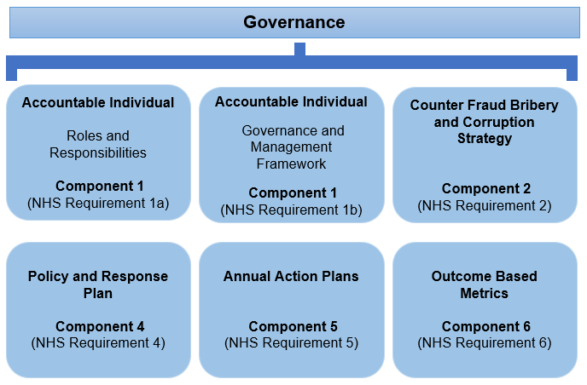
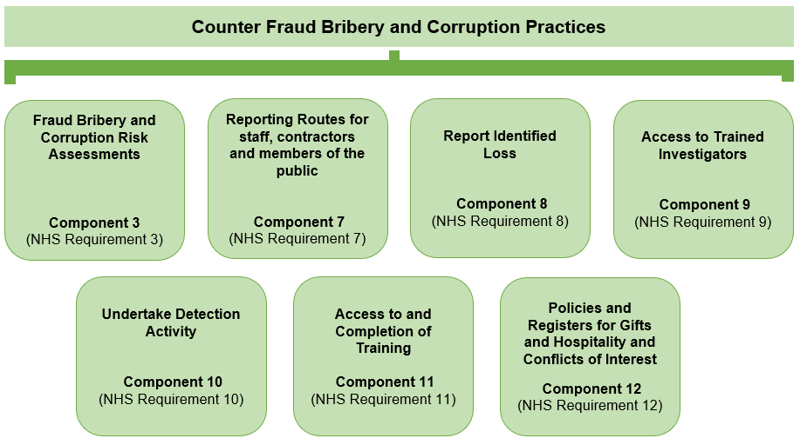

Governance
This section of the annual report should outline how the organisation supports and directs counter fraud, bribery and corruption work undertaken to create a strategic organisation wide response when combatting fraud bribery and corruption.
Work relating to each Governance Component of the Functional Standard is summarised and current and previous rating for each Requirement is set out below.
Function Standard Component | NHS Requirement |  | 2024 Rating | 2025 Rating | Current Position
Component 1  Accountable individual | NHS Requirement 1A | This relates to the role of the accountable board member and their responsibility for the strategic management of, and support for, counter fraud, bribery and corruption work, including timely reporting and accurate notification of nominations to the NHSCFA. | GREEN | GREEN | The Director of Finance is responsible for the strategic management and support of counter fraud work. A good level of support and assistance is given to the Counter Fraud Team in the discharge of responsibilities by the Director of Finance and the wider Finance Directorate.  The Health Board's Audit Committee receive regular reports of Counter Fraud activity throughout the year which includes quarterly benchmarking reports. The Audit Committee receive and approve the Health Board's Counter Fraud Annual Report and Workplan. All Counter Fraud submissions to the Audit Committee are sponsored and supported by the Director of Finance.
Component 1  Accountable individual | NHS Requirement 1B | This relates to the work of the organisations board / governing body in gaining assurance and evaluating the counter fraud work undertaken during the year. This requirement also covers the role of the Counter Fraud Champion. | GREEN | GREEN | The Audit Committee receives an Annual Report written in line with NHSCFA guidance using the template. This includes details of the Functional Standard Return for review.  The Director of Corporate Governance has been nominated as the Fraud Champion supported by the Assistant Director of Governance and Risk. Support around the implementation of fraud risk recording via DATIX, furthering counter fraud awareness at induction under Corporate Governance input, and supporting work around Standards of Behaviour Policy fraud proofing.
Component 2  Counter fraud bribery and corruption strategy | NHS Requirement 2 | This Component relates to the organisations over-arching counter fraud, bribery and corruption strategy, and how the counter fraud work plan and resource allocation is aligned to the objectives of the strategy and locally identified risks. | GREEN | GREEN | The Health Board’s Counter Fraud Policy & Response Plan includes the overall strategic aims of counter fraud work and operational response aligned to the NHSCFA counter fraud, bribery and corruption strategy.  A counter fraud work plan is developed in line with key objectives of the strategy, alignment to national standards and includes response to nationally and locally identified risks.  The CFP&RP and work plan are agreed by Director of Finance and Audit Committee and progress is tracked via regular reporting and attendance at Audit Committee.
Component 4  Policy and response plan | NHS Requirement 4 | This Component relates to the organisations counter fraud, bribery and corruption policy and response plan and its alignment to the NHSCFA strategic guidance. | GREEN | GREEN | The Health Board has a Counter Fraud Policy & Response Plan in place. The Policy is reviewed to ensure that it remains current.  Issues relating to bribery and fraud are also referenced within the Standards of Behaviour Policy.
Component 5  Annual Action Plan | NHS Requirement 5 | This Component relates to the development and management of the organisation’s annual counter fraud work plan. This plan should be informed by national and local fraud, bribery and corruption risk assessments. | GREEN | GREEN | A counter fraud work plan is developed in line with key objectives of the strategy and alignment to national standards. Resource is allocated in line with this within the context of 4 strategic areas of counter fraud activity; Inform and involve, prevent and deter, hold to account and strategic governance.  Progress against this work plan is monitored and evaluated through out the year with regular meetings with Director of Finance and regular reporting to Audit Committee. Allocated resource is included as part of this regular reporting along with benchmarking of overall resource availability.
Component 6  Outcome based metrics | NHS Requirement 6 | This Component relates to how the organisation identifies and reports on annual outcome-based metrics with objectives to evidence improvement in performance | GREEN | GREEN | All Wales Performance statistics are collated on a quarterly basis and shared between Health Boards and Welsh Government. Statistics are utilised to examine performance between NHS Wales organisations. Benchmarking undertaken on an organisational level against previous years and against other NHS Wales Organisations. Reports on performance and benchmarking are shared with the Audit Committee to scrutinise.  Clue3 includes recording and reporting mechanisms for proactive and reactive outcomes of counter fraud work which is utilised as a recording mechanism.

Counter Fraud Bribery and Corruption Practices
This section of the annual report should outline the organisations operational counter fraud activities undertaken during the year when detecting and combatting fraud.
The organisation should report against each Counter Fraud Practice Component, under the Functional Standard and summarise the work completed to meet each Requirement. A high-level summary of each of the Counter Fraud Practice Components is set out below.
Function Standard Component | NHS Requirement |  | 2024 Rating | 2025 Rating | Current Position
Component 3  Fraud bribery and corruption risk assessment | NHS Requirement 3 | This Component relates to the local risk assessments undertaken in line with Government Counter Fraud Profession methodology to identify fraud, bribery and corruption risks, and how the organisations counter fraud, bribery and corruption provision is proportionate to the level of risk identified. | GREEN | GREEN | Comprehensive risk assessments are carried out in line with the GCFP methodology and recording aligns to the Health Board’s Risk Management Policy. The annual counter fraud work is informed by these risk assessments. NHS CFA issued national fraud risks guidance containing 129 fraud risk descriptors across the entirety of business areas the NHS engages in. These risks have been concatenated into core risk areas for review locally. Work since introduction of this Component has been to map fraud risk descriptors to core risk assessments, development of a fraud risk profile around core risk areas, implementation of managing fraud risk via DATIX, implement sufficient scanning techniques and processes to ensure all emerging fraud risk is captured and reviewed against existing fraud risk assessments.
Component 7  Reporting routes for staff, contractors and members of the public | NHS Requirement 7 | This Component relates to the reporting routes in place at the organisations to report suspicions of fraud, bribery and corruption and a mechanism for recording these referrals and allegations on the approved NHS fraud case management system. | GREEN | GREEN | The Health Board has well documented reporting routes for any party to report incidents of fraud, bribery and corruption. Reporting routes are formalised in the Counter Fraud Policy & Response Plan and Bribery Policy. Reporting routes are also highlighted within counter fraud awareness training, newsletters and communications, included on the Counter Fraud Intranet pages and highlighted in the Counter Fraud Information Booklet available for staff. Reporting routes include a central Counter Fraud email inbox, email and phone directly to LCFSs, a Microsoft Forms Fraud Reporting form, the National Fraud and Corruption Reporting Line as well as alternative reporting routes to Director of Finance and whistleblowing charity Protect-Public Concern at Work.  The Counter Fraud Team have regularly received contact from individuals raising concerns resulting in the commencement of 41 new investigations in 2024/25.
Component 8  Report identified loss | NHS Requirement 8 | This Component relates to the organisations use of the approved NHS fraud case management system to record all allegation and investigative activity. Including all outcomes, recoveries and system weaknesses identified during the course of investigations and/or proactive prevention and detection exercise. | GREEN | GREEN | The Health Board fully utilises the Clue case management system to record and report identified loss. The system includes opportunity to record all investigaiton materials, local proactive exercises and operational statistical information.  Statistics are collated and submitted on a quarterly basis to Counter Fraud Service Wales and an All Wales Operational Performance report produced. A benchmarking report utilising this information is presented to Audit Committee on a quarterly basis.
Component 9  Access to trained investigators | NHS Requirement 9 | This Component relates to the accredited Local Counter Fraud Specialist (LCFS) at the organisation, and details of the continuous professional development undertaken. All LCFS undertaking counter fraud activity at the organisation must be nominated with the NHSCFA. | GREEN | GREEN | Local Counter Fraud Services for the Health Board are provided by Swansea Bay UHB under a Service Level Agreement. The service is delivered by qualified, nominated and accredited LCFS, who conduct the full range of anti-fraud, bribery and corruption work on behalf of the organisation. The LCFS attend all necessary training and continuous professional development events as required to appropriately fulfil their role on an ongoing basis.  The counter fraud accredited resource for 2024/25 was 3.2 FTE.
Component 10  Undertake detection activity | NHS Requirement 10 | This Component relates to the proactive work completed to detect fraud using relevant information and intelligence to identify anomalies that may be indicative of fraud, bribery and corruption and the work undertaken in response. | GREEN | GREEN | LCFS review Final Internal and External Audit reports and meet with the Head of Internal Audit to share details on identified risk. This would include instances where data mining or sampling has highlighted outliers or concerns. A PPV programme is undertaken in respect of GPs, Opticians and Pharmacies, with final reports received by the LCFS. Meetings are held with the PPV Manager. The HB also participates in the NFI process. Risk assessments are considered as part of this work and completed where necessary.  As a result of this information and intelligence review process the Counter Fraud Team have registered 16 local proactive exercises on the case management system in 2024/25.
Component 11  Access to and completion of training | NHS Requirement 11 | This Component relates to the programme of work undertaken at the organisation to raise awareness of fraud, bribery and corruption and to create a counter fraud, bribery and corruption culture among all staff. The effectiveness of the awareness programme is measured. | GREEN | GREEN | The Health Board has an ongoing programme of work to raise awareness of economic crime issues amongst all staff, using a range of methods including virtually delivered presentations and e-learning package availability. This is supported by newsletters and intranet pages alongside the regular release of counter fraud information via articles and alerts.  The awareness programme is sufficient to achieve a Green rating but is an area that is continually improvement. Work has been undertaken including risk based training resulting from proactive work, embedding of short from blog style communications which are driving connections with staff with a more informal style.
Component 12  Policies and registers for gifts and hospitality and Conflicts of Interest | NHS Requirement 12 | This Component requires the organisation to have in place policies and registers for gifts and hospitality and conflicts of interest that reference the requirements of the Bribery Act 2010 that are communicated to all staff. The effectiveness of which is regularly tested. | GREEN | GREEN | The HB has a Standards of Behaviour Policy in place, which has incorporated declarations of interest, gifts, hospitality and sponsorship. The Policy also includes reference to fraud, bribery and corruption and the requirements of the Bribery Act 2010, and is available to all staff via the intranet. It is also promoted during fraud awareness presentations.

5. Appendices

Appendix 1 – Counter Fraud Activity
This section of the annual report details the total counter fraud resources used by the organisation.

Area of activity | Days used
Proactive work | 254
Reactive work | 450
Total days used | 704

Appendix 2 – Counter Fraud Costs
This section of the annual report details the total costs of the counter fraud resources used by the organisation.

Cost of Counter Fraud, Bribery  and Corruption Work | Total Costs £
Proactive costs | £64,305
Reactive costs | £113,449
Total costs | £177,484

Appendix 3 – Nominations Overview
Role | Name of Nominated Person
Accountable Board Member | Darren Griffiths
Audit Committee Chair | Nuria Zolle
Counter Fraud Champion | Hazel Lloyd
Lead LCFS | Matthew Evans
Supporting LCFS | Neil Jones
Supporting LCFS | Michelle Newport-Edwards
Supporting LCFS | Zoe Whetton

Appendix 4 –Case Information Overview
This section of the annual report details case investigation activity recorded on the Clue case management system.

Case Information | Number
Cases carried forward from previous years | 20
Cases Opened during the period | 41
Cases Closed or Transferred during period | 38
Cases Ongoing | 23

Appendix 5 – CLUE Investigation Information
This section of the annual report should detail all the activity recorded on the CLUE Case Management System. The following information must be included in the counter fraud annual report in order for the organisation to be compliant with the Functional Standard NHS Requirement 1B, 6, 7 and 8.

CLUE Information | Number
Investigations opened during the most recent financial year | 41
Investigations closed during the most recent financial year | 38
Investigations open as at 31/03/2025 | 23

Appendix 6 – Fraud Risk Based Exercises
This section of the annual report should detail all the Fraud Risk Assessments (FRAs), Local Proactive Exercises (LPEs) and System Weakness Reports (SWRs) undertaken. The following information must be included in the counter fraud annual report in order for the organisation to be compliant with the NHS Counter Functional Standard NHS Requirement 1B, 3, 5, 6, 8 and 10.

Fraud Risk Assessments | Number
Number of FRAs reviewed in line with the organisations risk management policy | 4
Number of new FRAs recorded in line with the organisations risk management policy | 2

Local Proactive Exercises | Number
Number of LPEs conducted during the year | 16
Number of LPEs recorded on the NHS CFA Case management system as per component 8 | 16
Number of LPEs concluded during the year | 16

System Weakness Reports | Number
Number of SWRs identified during the year | 0
Number of SWRs concluded during the year on the NHS CFA Case management system as per component 8 | 0
Number of new processes adapted or introduced as a result of SWRs | 0

Appendix 7 - Sanction & Redress Overview
This section of the annual report should detail of any sanctions and redress activity undertaken. The following information must be included in the counter fraud annual report in order for the organisation to be compliant with the Functional Standard NHS Requirement 1B, 6 and 8.

Sanction Imposed | Number
Disciplinary applied and recorded during this financial year | 2
Civil applied and recorded during this financial year | 5
Criminal applied and recorded during this financial year | 3
Total Sanctions |  | 10

Redress Imposed | Total Amount £
Fraud identified | £51,057
Fraud Loss Identified | £51,057
Fraud Prevented | £2,947
Fraud Recovered | £20,874
Non-Fraud Loss | £41,832
Non-Fraud Recovery | £25,287

