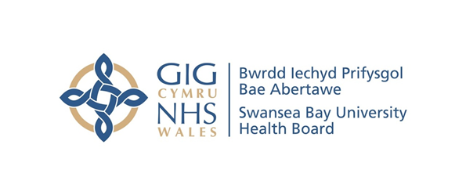
Item 7.1 Appendix 1 -
Counter Fraud Benchmark Report
Case Referral Rate | Swansea Bay UHB | All Wales Avg.
2019/20 | 2 | 2.8
2020/21 | 8 | 2.0
2021/22 | 2 | 2.8
2022/23 | 6 | 3.8
2023/24 | 2 | 8.9

Case Closure Rate | Swansea Bay UHB | All Wales Avg.
2019/20 | 1 | 2.7
2020/21 | 14 | 2.6
2021/22 | 3 | 1.7
2022/23 | 10 | 3.8
2023/24 | 5 | 4.2

Sanctions | 2019/20 |  |  |  | 2020/21 |  |  | 2021/22 |  |  | 2022/23 |  |  | 2023/24
Sanctions | Criminal | Disp | Civil | Criminal |  | Disp | Civil | Criminal | Disp | Civil | Criminal | Disp | Civil | Criminal | Disp | Civil
Swansea Bay UHB | 1 | 2 | 2 | 1 |  | 4 | 2 | 1 | 1 | 2 | 0 | 0 | 4 | 0 | 1 | 1
All Wales Avg. | 0.2 | 1.0 | 0.7 | 0.2 |  | 0.5 | 0.4 | 0.1 | 0.3 | 0.5 | 0.1 | 0.4 | 1.2 | 0 | 0.6 | 0.6
All Wales Total | 2 | 12 | 8 | 2 |  | 6 | 5 | 1 | 4 | 6 | 1 | 5 | 15 | 0 | 8 | 8

Number of Presentations | Swansea Bay UHB | All Wales Avg.
2019/20 | 20 | 7
2020/21 | 0 | 1
2021/22 | 14 | 5
2022/23 | 11 | 3
2023/24 | 13 | 6

Number of Attendees | Swansea Bay UHB | All Wales Avg.
2019/20 | 705 | 162
2020/21 | 0 | 25
2021/22 | 255 | 97
2022/23 | 184 | 73
2023/24 | 158 | 92

Average Attendance of a Presentation | Swansea Bay UHB | All Wales Avg.
2019/20 | 35 | 23
2020/21 | 0 | 20
2021/22 | 18 | 21
2022/23 | 17 | 24
2023/24 | 12 | 15

Attendance of Presentations as % Staff Headcount | Swansea Bay UHB | All Wales Avg.
2019/20 | 5.3% | 2%
2020/21 | 0.0% | 0.3%
2021/22 | 1.9% | 1.2%
2022/23 | 1.4% | 1%
2023/24 | 1.3% | 1.2%

