Meeting Date | 19 September 2024 |  | Agenda Item |  |  | 4.1
Report Title | Clinical Audit Mid-Year Update with 2023/24 Annual Report
Report Author | Sharon Rağbetli, Clinical Audit & Effectiveness Manager
Report Sponsor | Dr Raj Krishnan, Acting Executive Medical Director
Presented by | Dr Raj Krishnan, Acting Executive Medical Director
Freedom of Information | Open
Purpose of the Report | The report presents progress by the service groups with their clinical audit plans from 2022/23 as well as plans and discussions for improved accountability and monitoring for delivery of audit plan topics.
Key Issues | - Clinical audit, as a key element of the health board’s system of internal control, requires assurance to be given that a process is in place to agree a clinical audit plan for the year;  - The clinical audit plans for 2024/25 were agreed by the Clinical Outcomes and Effectiveness Group (COEG) in March 2024, in line with internal audit recommendations;  - As projects and assurance/risk scores are completed in-year, topics can be added as necessary re-audits;  - The COEG has committed to monitoring all clinical audit plans for each financial year until they completed in full;  - The annual report for 2023/24 was signed off at the July 2024 COEG meeting.
Specific Action Required  (please choose one only) | Information | Discussion |  | Assurance | Approval
Specific Action Required  (please choose one only) | ☐ | ☐ |  | ☒ | ☐
Recommendations | Members are asked to:  - ACKNOWLEDGE approval of clinical audit plans for 2024/26 by the COEG in March 2024 in line with internal audit recommendations and that this will now be a two year plan;  - ACKNOWLEDGE processes are in place to ensure service groups monitor delivery of local plans;  - ACKNOWLEDGE completion rates for 2022/23, 2023/24 and 2024/25 audit plans to date;  - ACKNOWLEDGE the ongoing discussions to improve timely completion of audit records for completed topics within the agreed plan period;  - ACKNOWLEDGE completion and sign off of the annual report for 2023/24.

CLINICAL AUDIT MID-YEAR UPDATE AND ANNUAL REPORT

- INTRODUCTION
In addition to the annual report, the paper outlines progress against clinical audit plans, ranging from 2022/23 to 2024/25 and details proposals and discussions for improved accountability for monitoring and delivering plans within service groups.

- BACKGROUND
As a key element of the health board’s system of internal control, there is a requirement to provide assurance to the Audit Committee that a clinical audit plan for the year has been agreed and a process is in place to support and monitor delivery. This is supplemented by a mid-year progress report at which time the annual report for the previous year is shared, summarising what has been achieved.

Delivery of the health board’s clinical audit plans is part of the remit of the Quality and Safety Group but is discharged through the Clinical Outcomes and Effectiveness Group (CEOG). It discharges this responsibility via monthly meetings, where agenda items are supplemented by periodic update presentations including on the lessons learned from various audits. It in turn, then reports to the Quality and Safety Group on a bi-monthly basis.

To provide additional assurance at board-level as to the progress and improvement around clinical audits, outcome and effectiveness, a regular report is provided to the Quality and Safety Committee.

The Clinical Audit and Effectiveness Policy outlines the Executive Medical Director’s Department audit hierarchy;
- Level one - mandated national audits and registries;
- Level two - a small number of HB audit priority topics;
- Levels three and four - audit plans at service group and department levels;
- Level five - emergent necessary ad-hoc topics.

In 2022/23, clinical audit plans at Levels 3 and 4 were re-instated. Prior to that date, at the request of the then Executive Medical Director, the health board had adopted the Welsh Government list of mandated national audit and registry topics as its only forward plan.

The clinical audit plan for 2024/25 was agreed by the COEG in March 2024. This was in-line with an internal audit recommendation as previously plans were being agreed much later into the financial year.

- GOVERNANCE AND RISK ISSUES
From 2022/23 onwards, the COEG has committed to monitoring all clinical audit plans until completed in their entirety. Table 1 overleaf shows the progress of each of the plans and illustrates an improved position for the 2023/24 plan in particular;

Service Delivery Group | Current Completion Rates
Service Delivery Group | 2022/23 | 2023/24 | 2024/26
Mental Health and Learning Disabilities | 12 (100%) | 11 (73.3%) | 1/15(7%)
Morriston | 51 (88%) | 22 (39%) | 0/38 (0%)
Primary Care, Community and Therapies | 11 (100%) | 14 (61%) | 0/22 (0%)
Singleton and Neath Port Talbot | 14 (70%) | 7 (41%) | 0/23 (0%)
Totals | 88 (87%) | 54 (51.4%) | 1/98 (1%)
Table 1.
Although the highest recorded completion figure for audit plans within SBUHB, the 2022/23 figure remains static as the handful of topics are being chased down. The 2023/24 half-year plan improved from 41.5% reported to committee in the last paper to 51.4% as at the August 2024 COEG meeting.

In acknowledging the time taken to be able to close down an audit record; complete data collection, collation and presentation of results to an audit meeting to agree actions and timeframes, it has been agreed to change the clinical audit plan period to two years, making this year’s plan now 2024/26. This should in theory, allow the service groups sufficient time to have the key learning outcomes summarised and listed actions completed or progressed sufficiently to complete the audit record.

The number of 2024/26 topics on plan reduced following detailed review by audit leads with the removal of 15 projects, some of which were delayed until 2026 or beyond. With confirmation of the extended plan period, relevant topics will be reinstated. A small number of topics were removed on the basis of duplication or improvement work being undertaken in a different way, for example, pathway development.

To accommodate completed audit cycles from older time-periods triggering the need for a re-look based on assurance and risk scores, the 2024/26 plan will be fluid, with topics added during the plan period as required.

Service Delivery Group | @ COEG 8/3/24 | @ 1/4/24 | @ 29/8/24
Mental Health & Learning Disabilities | 11 | 11 | 15
Morriston | 33 | 35 | 38
Primary Care, Community & Therapies | 28 | 29 | 22
Singleton & Neath Port Talbot | 20 | 28 | 23
Totals | 92 | 103 | 98
Table 2.

Service groups have their own internal processes for monitoring progress with their plans. Moving forward they will be asked to include an update on these figures and actions taken to mitigate, as part of an all-encompassing quarterly update presentation to the COEG on key agenda items for example, mortality and guidance responses. For audit plans, this will improve accountability for delivery of topics and timely submission of completion records.

It should be noted that the recommendation to use the Audit Management and Tracking (AMaT) system as an action tracker was not feasible based on negative user feedback and resultant poor compliance with timely completion of audit records during the 2023/24 plan period. The Clinical Audit Team moved to Microsoft Forms and SharePoint to build and monitor the 2024/26 plan.

In terms of the national mandated topics, the health board received the refreshed list of mandated national audit and registry topics at the end of June 2024 (appendix 1), SBUHB must participate in all topics relevant to the services it provides. The programme forms level 1 of the Executive Medical Director’s Clinical Audit and Effectiveness Policy.

Service Groups are asked to report any issues to the monthly COEG meetings which may impact on an audit’s completion, for example, audit lead absence or staff sickness affecting data entry. Some of the recent developments include:

- The need for a number of new audit leads for the new topics listed under cancer;
- A presentation to an upcoming COEG meeting from the new lead for the National Oesophago-Gastric Cancer Audit;
- Interruption in cardiology data collection due to staff changes within the service;
- National Audit of Care at the End-of-Life audits moving from time-limited data collection to continuous.

Alongside the national audits and clinical audit plans are the level two audit topics, identified by the Executive Medical Director’s department in order to generate data for the health board and to support healthcare professionals in training in evidencing participation in audit and quality improvement activities. Update presentations on each of the topics are scheduled into the COEG meetings regularly. Progress against these is set out below:

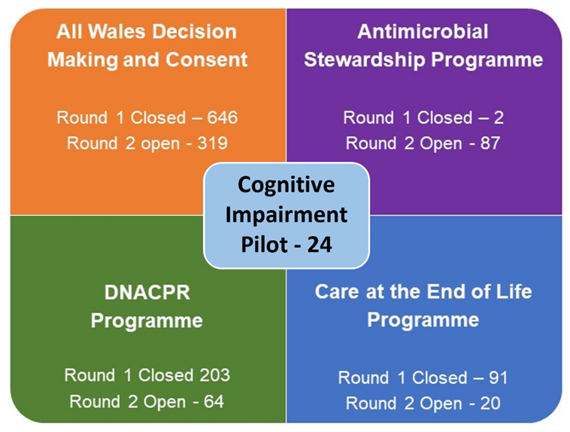

- Annual Report
The annual report for 2023/24 detailing individual completed project summaries for each of the service groups was circulated to COEG members for comment and subsequently signed off at the July 2024 COEG meeting (appendix 2). Also included in the report is a summary of the year’s compliance with the National Learning from Deaths Framework, another key area of focus for the COEG.

- FINANCIAL IMPLICATIONS
There are no financial implications to this report.

- RECOMMENDATIONS
Members are asked to:
- ACKNOWLEDGE approval of clinical audit plans for 2024/26 by the COEG in March 2024 in line with internal audit recommendations and that this will now be a two year plan;
- ACKNOWLEDGE processes are in place to ensure service groups monitor delivery of local plans;
- ACKNOWLEDGE completion rates for 2022/23, 2023/24 and 2024/25 audit plans to date;
- ACKNOWLEDGE the ongoing discussions to improve timely completion of audit records for completed topics within the agreed plan period;
- ACKNOWLEDGE completion and sign off of the annual report for 2023/24.

Governance and Assurance

Link to Enabling Objectives  (please choose) | Supporting better health and wellbeing by actively promoting and empowering people to live well in resilient communities
Link to Enabling Objectives  (please choose) | Partnerships for Improving Health and Wellbeing |  | ☐
Link to Enabling Objectives  (please choose) | Co-Production and Health Literacy |  | ☐
Link to Enabling Objectives  (please choose) | Digitally Enabled Health and Wellbeing |  | ☐
Link to Enabling Objectives  (please choose) | Deliver better care through excellent health and care services achieving the outcomes that matter most to people
Link to Enabling Objectives  (please choose) | Best Value Outcomes and High Quality Care |  | ☐
Link to Enabling Objectives  (please choose) | Partnerships for Care |  | ☐
Link to Enabling Objectives  (please choose) | Excellent Staff |  | ☐
Link to Enabling Objectives  (please choose) | Digitally Enabled Care |  | ☐
Link to Enabling Objectives  (please choose) | Outstanding Research, Innovation, Education and Learning |  | ☐
Health and Care Standards
(please choose) | Staying Healthy |  | ☐
(please choose) | Safe Care |  | ☐
(please choose) | Effective Care |  | ☐
(please choose) | Dignified Care |  | ☐
(please choose) | Timely Care |  | ☐
(please choose) | Individual Care |  | ☐
(please choose) | Staff and Resources |  | ☐
Quality, Safety and Patient Experience
Appropriate identification and planning of necessary local audit priorities can support improvements in care, outcomes and experience and provide assurance.
Financial Implications
There are no financial implications
Legal Implications (including equality and diversity assessment)
There are no legal implications.
Staffing Implications
There are no staffing implications.
Long Term Implications (including the impact of the Well-being of Future Generations (Wales) Act 2015)
Long term the aim is to continue to embed a new culture in terms of the prioritisation of audit and improvement activities, while balancing the need to meet requirements placed on doctors and healthcare professionals in training. Generating themes and learning from deaths will contribute towards striving to give patients at the end of their life and their loved ones, the best possible experience.
Report History |  | As required.
Appendices |  | Appendix 1. – Mandated National Audit/Registry Programme  Appendix 2. – Annual Report

Appendix 1. Mandated National Audit/Registry Programme

