Meeting Date | 16 September 2025 |  | Agenda Item |  | 2.5
Report Title | Strategic Partnerships – Partnerships Tracker
Report Author | Michelle Davies, Head of Strategic Partnerships
Report Sponsor | Karen Stapleton, Deputy Director of Planning and Partnerships
Presented by | Karen Stapleton, Deputy Director of Planning and Partnerships
Freedom of Information | Open
Purpose of the Report | The purpose of this report is to provide an update on the work undertaken by the Planning & Partnerships Department to develop a Swansea Bay approach to Strategic Partnerships and Collaboration including the development of the Partnerships Tracker  The Management Board endorsed the Collaborative Partnerships Framework at the meeting held on the 18th December 2025.
Key Issues | Improving how the Health Board manages and achieves oversight of external partnership arrangements has been an area of focus for the Planning and Partnerships department over the last 18 months, including visibility and information sharing.  Understanding the challenges and opportunities of Partnership working and how we embed Partnership priorities into our Health Board Plans is critical.  Oversight and management of Partnerships where the Health Board is a Statutory partner or are actively engaged is important and resources such as the Collaborative Partnerships Framework and the Partnership Tracker have been developed to support colleagues across the Health Board.
Specific Action Required  (please choose one only) | Information | Discussion | Assurance | Approval
Specific Action Required  (please choose one only) | ☐ | ☒ | ☒ | ☒
Recommendations | Members are asked to:  - RECEIVE and DISCUSS the draft Partnerships Tracker;  - CONSIDER the proposed approach to reviewing Partnership arrangements, using the Partnerships Tracker and the role of the Audit Committee in this process and  - APPROVE the scope of what is included in the Tracker

STRATEGIC PARTNERSHIPS
- INTRODUCTION

The following report provides an update on the development of the Swansea Bay UHB approach to Strategic Partnerships and the development of the Partnerships Tracker.

- BACKGROUND

Partnerships can be complicated and challenging and this report sets out the work programme progressed to improve the interface between the Health Board and its external partnerships.

Historically, the Health Board has participated in partnership forums and there are some areas in the Health Board where partnership working is evident, for example in mental health services, the home first programme, and children & young people services. However, whilst this work has seen some successful programmes of work, governance has been ad hoc and un-coordinated, with no central interface, particularly at a strategic level. There are a number of work programmes and priority areas that the Health Board are committed to as follows:

- In 2023, the Health Board approved and signed up-to the West Glamorgan Regional Partnership Board (WGRPB) Area Plan and the Public Service Board Wellbeing Plans, in both Swansea and Neath Port Talbot. Action plans are already in development and require Health Board participation to move into the implementation phase.
- The Health Board must move to a much more transformational space with our partners, shifting models of care.
- The Swansea Bay Population Health Strategy sets out the Health Board’s objectives for improving the health of the local population. The Strategy’s objectives will require a collective effort from all partner agencies.
- A Strategic Partnerships Group (SPG) has been established to provide an interface between the Health Board and external Partnerships - collating and sharing intelligence on local government and partnership issues.

In addition, the Shared Services Partnership audited the Health and Social Care Regional Integration Fund (RIF), resulting in several recommendations for SBUHB in relation to Strategic Partnerships. The Planning & Partnerships Department were already on a trajectory to improve the Health Board’s approach to partnership working; however, the audit recommendations provided a structure for that work. The Audit Committee has overseen progress against the audit recommendations, and all actions are now complete – the Partnerships Tracker has been developed to provide an additional layer of assurance.

2.1 Health Board approach to Partnerships

Over the last 18 months the Strategic Partnerships Team have worked on the outcomes of a series of development workshops that were held with Health Board colleagues, specifically with the aim to develop a Collaborative framework that identifies a Health Board approach to Partnerships and Collaborative working as follows:
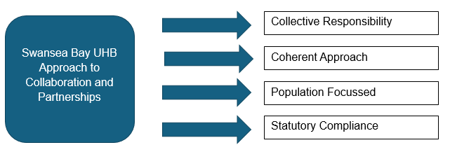
The Collaborative Partnerships Framework was considered and ratified by the SPG in November 2024, and the SBUHB Management Board in December 2024. Included within the Framework is a set of principles developed by colleagues across the Health Board; these principles underpin what the Framework must support to allow partnerships to thrive:

Swansea Bay UHB Principles for Collaboration:
- Recognise the value of partners and develop trust and mutual respect
- Demonstrate commitment to develop and agree shared goals and values
- Collaborate when there is a clear advantage for the population
- Practice open and transparent communication - be responsive and inclusive
- Effective representation of the views and interests of Health Board Service Groups and Corporate Departments (patients, public and partners as well, to ensure the voice of the population is reflected in decision making)
- Strong focus on transformation, this can sometimes involve a trial-and-error approach with some experimentation

The main purpose of the Framework is to raise awareness in relation to the importance of partnership and collaborative working, and to be an aide memoire for colleagues and to ensure that there is a basic level of understanding of the formal partnerships we work within, the Health Board governance in place and the statutory legislation.

2.2 Partnership Governance

THE SPG had been reporting into the Population Health & Partnerships committee (PHPC) and in 2024, the terms of reference for the PHPC were reviewed and it was agreed that the scope of the Committee would no longer include Partnerships, with the sole focus of the Committee being on Population Health.

The governance and reporting of the Strategic Partnerships Group has therefore been amended and updated as follows:

- the SPG will now report to Management Board on a bi -monthly basis and to the Health Board via the Director of Planning & Partnerships report.

- to ensure that the SPG is focussed on relevant areas of interest and assurance, 2 sub-groups have been set-up and the SPG meetings will now be held quarterly with bi-monthly sub-group meetings.

Please see the diagram below:
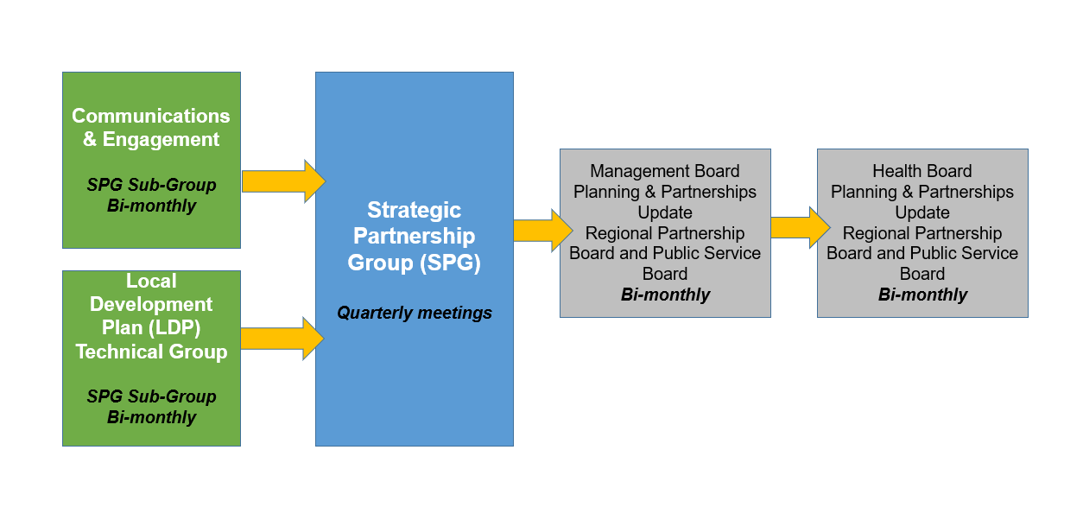

2.3 Partnerships Tracker

Work on the Partnerships Tracker was initiated in June 2025, and a number of key partnerships have been included as follows:

- West Glamorgan Regional Partnership Board (WGRPB)
- Public Service Boards (PSBs) and associated workstreams established to deliver the Wellbeing Plans in Swansea and Neath Port Talbot.
- Shared Services Partnership Committee (SSPC)
- Youth Justice Management Board
- Area Planning Board (APB)
- SBUHB/ CTMUHB Bridgend Boundary Change
- Joint Commissioning Committee (JCC)

The value and key benefits of the Partnerships Tracker are as follows:

- A shared resource for colleagues across the Health Board to increase visibility and awareness of critical partnership forums;
- Oversight of partnership forums to ensure that the Health Board is compliant with the requirements of being a statutory and effective partner;
- The tracker holds key information including Health Board representation, governance and statutory guidance. The Tracker can help provide assurance on how the Executive Team and IMs are engaging with external stakeholders

A snapshot taken from the Partnership’s Tracker is attached as appendix 1.

To note the focus of the Tracker has been on Statutory Partnerships and colleagues across the Health Board will be asked to contribute to the Tracker as it evolves to ensure that all key partnership arrangements are included.

Audit Committee are asked to consider the scope of the Partnerships included in the Tracker and it is recommended that the focus remains on key statutory and strategic partnerships and the sub groups that report to them.

- GOVERNANCE AND RISK ISSUES

The report sets out an approach to Partnerships and Collaborative working that has been progressed over the last 18 months and is supported by colleagues across the Health Board.

The latest development is the Partnerships Tracker which will be owned by the SPG and will be presented to Audit Committee on a regular basis. The role of the Audit Committee will be to oversee the governance arrangements including oversight of existing Memorandum of Understandings and Terms of Reference and be alerted of any risks to delivery so that we can refer these to the relevant committees.
Previously the Population Health and Partnerships Committee have undertaken a similar review of arrangements in place for the West Glamorgan Regional Partnership Board (WGRPB) Swansea and NPT Public services Boards (PSBs) and the Area Planning Board (APB).

- FINANCIAL IMPLICATIONS

There are no direct financial implications as a result of this report, however the work programme in relation to Partnerships is a key enabler to the Health Board becoming a productive partner. In the longer term this will add value to the investment decisions, particularly in relation to the Regional Investment available via the WGRPB.

- RECOMMENDATIONS

Members of the Committee are asked to:

- RECEIVE and DISCUSS the draft Partnerships Tracker;
- CONSIDER the proposed approach to reviewing Partnership arrangements, using the Partnerships Tracker and the role of the Audit Committee in this process and
- APPROVE the scope of what is included in the Tracker

Governance and Assurance

Link to Enabling Objectives  (please choose) | Supporting better health and wellbeing by actively promoting and empowering people to live well in resilient communities
Link to Enabling Objectives  (please choose) | Partnerships for Improving Health and Wellbeing |  | ☒
Link to Enabling Objectives  (please choose) | Co-Production and Health Literacy |  | ☐
Link to Enabling Objectives  (please choose) | Digitally Enabled Health and Wellbeing |  | ☐
Link to Enabling Objectives  (please choose) | Deliver better care through excellent health and care services achieving the outcomes that matter most to people
Link to Enabling Objectives  (please choose) | Best Value Outcomes and High-Quality Care |  | ☐
Link to Enabling Objectives  (please choose) | Partnerships for Care |  | ☒
Link to Enabling Objectives  (please choose) | Excellent Staff |  | ☐
Link to Enabling Objectives  (please choose) | Digitally Enabled Care |  | ☐
Link to Enabling Objectives  (please choose) | Outstanding Research, Innovation, Education and Learning |  | ☐
Health and Care Standards
(please choose) | Staying Healthy |  | ☐
(please choose) | Safe Care |  | ☐
(please choose) | Effective Care |  | ☒
(please choose) | Dignified Care |  | ☐
(please choose) | Timely Care |  | ☐
(please choose) | Individual Care |  | ☐
(please choose) | Staff and Resources |  | ☒
Quality, Safety and Patient Experience
There are no direct impacts, however responding to the needs of the communities of Neath Port Talbot and Swansea as set-out in partnership plans such as the Area Plan and the PSB Wellbeing Plans, will in the long term have a positive impact on meeting the needs of our population and patient experience.

Financial Implications
There are no direct financial implications as a result of this report, however the work programme in relation to Partnerships is a key enabler to the Health Board becoming a productive partner. In the longer term this will add value to the investment decisions, particularly in relation to the Regional Investment available via the WGRPB.

Legal Implications (including equality and diversity assessment)
There are no legal implications as a result of this report.

Staffing Implications
There are no staffing implications as a result of this report, however clarify in relation to the Health Board approach to Partnerships and Collaboration will support staff in the day to day work.

Long Term Implications (including the impact of the Well-being of Future Generations (Wales) Act 2015)
Working in partnership both internally within the Health Board and externally with other agencies is key to the delivery of the Well-being of Future Generations (Wales) Act 2015, and specifically Collaboration.

Report History |  | This is the first report to the Group specifically in relation to the Strategic Partnerships Group and the Collaborative Framework.
Appendices |  | Appendix 1 – Snapshot of the Partnerships Tracker  Appendix 2 – Partnerships Tracker

