

Clinical Audit & Effectiveness Annual Report 2024/25

Contents

 |  |  | Pages
 | Foreword |  | 2
1. | Report of the Clinical Audit & Effectiveness Department |  | 3-4
 | 1.1 Clinical Outcomes & Effectiveness Group (COEG)
 | 1.2 Clinical Audit and Effectiveness Policy, Audit Hierarchy
2. | Activity |  | 4-7
 | - Digital Systems
 | 2.2 Explaining Figures
 | 2.3 Health Board Overview 2022/23 to 2025
 | 2.4 Governance
 | 2.5 Re-audit
 | 2.6 NICE/Health Technology Guidance Recommendations
 | 2.7 National Audit/Registry Published Reports
 | 2.8 Deferred/Removed Projects
 | 2.9 Completed Projects
 | 2.10 Service Group and Department Breakdown
3. | Audit Plan Completion Rates and Summaries |  | 8-22
3.1 Recent Audit Plan Completion Rates, by Service
Group
3.2 2024/26 Audit Programme and Recent
Completion Project Summaries
3.2.1 Mental Health and Learning Disabilities
 | 3.2.2 Morriston
 | 3.2.3 Primary, Community Care and Therapies
 | 3.2.4 Singleton and Neath Port Talbot
4. | Mortality |  | 22-25
4.1 Medical Examiners Service and Mortality Reviews
4.2 Deaths and Referrals 2024/25

5. | Useful Links and Contacts |  | 26
Foreword
Clinical outcomes and effectiveness an essential part of clinical care as it provides an opportunity to determine if services are delivering to the right standards and where improvements can be made. The work spans a wide range of areas, including clinical audit, mortality reviews, consent training and compliance with changes to NICE (National Institute for Clinical Excellence) guidelines and forms part of the health board’s system of control and quality governance systems.

It is important that the learning from these processes is demonstrated and shared and as such, lessons learned presentations are a key part of the Clinical Outcome and Effectiveness Group (COEG) agenda. When presenting the outcomes of their clinical audits, leads include what they have learnt and the changes made as a result. The data gathered also allows us to benchmark against others. There are always opportunities to learn and develop, regardless of how well a service is working, and comparisons help us to see where we can better the outcomes and experiences of our patients and continue to develop our services to meet the needs of our population.

Following a review of performance against clinical audit plans, it was agreed this year change the clinical audit plan period to two years, making this year’s plan now 2024/26, to acknowledge the time taken to be able to close-down an audit record; complete data collection, collation and presentation of results to an audit meeting to agree actions and timeframes. This should allow the service groups sufficient time to have the key learning outcomes summarised and listed actions completed or progressed sufficiently to complete the audit record.

In addition, as of January 2025, service groups are now asked on a rota basis to present to the COEG using a standardised PowerPoint template, that covers off key agenda items such as clinical audit plan progress, mortality reviews and outstanding responses to NICE guidance.

I’d like to take the opportunity to thank Sharon Rağbetli and the clinical audit and effectiveness team for their continued support of clinical teams to develop and deliver the clinical audit plan as well as comply with nationally mandated audits. The team also works hard to improve our compliance rates with decision-making consent, while continuing to find new and innovative ways to use digital to present information to the service groups to aid their delivery of essential COEG work.

Dr Raj Krishnan
Deputy Executive Medical Director and Chair of COEG

Report from the Clinical Audit Team
  - Clinical Outcomes and Effectiveness Group (COEG)
Chaired by the Deputy Executive Medical Director, the COEG acts for the Health Board in ensuring that appropriate systems are in place to support the undertaking of effective clinical audit priorities and projects. The group reports (and as necessary escalates) to the Quality and Safety Committee, via the Quality and Safety Group.
Used in the right way clinical audit can; provide assurance, identify and minimise risk/ waste/inefficiencies and improve effectiveness of care pathways and the quality of patient outcomes and experience. The COEG is responsible for processes for Mortality Reviews and the review of NICE Guidance (as it applies in Wales) and Health Technology Wales (HTW) recommendations. It takes responsibility for developing and monitoring Policy and standards linked to delivering the Audit Programme; mandated National Topics, Health Board Priority Topics and Audit Plans.
In 2024, it supported extending the audit period to accommodate the time taken to deliver topics. As such, the 2024/25 Audit Plan period was extended into 2026. This report updates on the halfway point, in addition to progress with historic plans not yet accounted for.
1.2 Clinical Audit and Effectiveness Policy & Audit Hierarchy
The Policy sets out the framework for prioritisation, conduct, delivery and governance of clinical audit, in line with best practice guidance and requirements of the Health and Care Standards. Guided by a hierarchy approach (Fig 1.), it lists the structures, roles and processes in place to support the Health Board, Service Delivery Groups and doctors in training and other healthcare professionals;
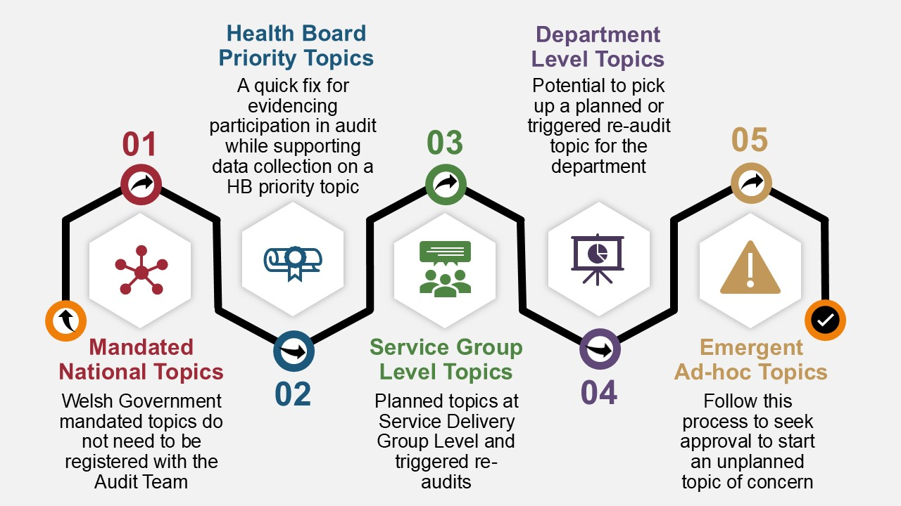 Fig 1. Hierarchy of Audit Priorities
Level 1 – Welsh Health Boards and Trusts are required to deliver on the Welsh Government (WG) mandated list of national audits, registries and studies for those topics that are relevant to the services provided.
Level 2 – Each year a small number of Health Board Priority Audit Topics are agreed, informed by system risks, adverse patient outcomes or patient safety issues that apply to more than one Service Delivery Group.
Levels 3 and 4 – Service Delivery Groups (Level 3) can identify and prioritise topics during the planning phase. Topic choices will be informed by risks, concerns and redress theses, data generated from national audits, new/refreshed NICE and key guidance etc. Level 3 projects are also generated during the audit period based on risk/assurance scores assigned to completed audit cycles.
Department level topics (Level 4) are prioritised during the planning phase. The guidance issued for topic choices mirrors that at Level 3.
Level 5 – It’s recognised that emerging issues may require conducting unplanned audits during the course of the audit period, in addition to accommodating Medical Student projects and participation in other regional and national topics not featured at Level 1. These ad-hoc proposals are logged as Level 5.
As an improvement and assurance process, clinical audit supports SBUHB staff to embrace the Health Board’s values framework, more specifically “Working Together” and “Always Improving”.

2. Activity
2.1 Digital Systems
Nursing colleagues continue to utilise the Audit Management and Tracking (AMaT) system in support of several work-streams.
In response to user feedback, the Audit team have reverted to using SharePoint for registration and monitoring of audit activities for topics logged from 1st April 2024 onwards. Historic data remains on AMaT until all topics are accounted for.
Audit tools for the Level 2 projects have now transferred to the SharePoint site from AMaT.
  - Explaining figures
Figures presented in the following section and within the report were taken from the Audit Management and Tracking (AMaT) system for the remainder of the 2022/23 and 2023/24 topics unaccounted for and from the SharePoint site for 1st April 2024 onwards.
The figures relate to Levels 3 and 4 of the Audit Hierarchy for 2022/23 and 2023/24. For the 2024/26 completion figures, Level 5 ad-hoc topics have been included.
  - Health Board Overview 2022/23 to 2025
Figure 2 below shows the Health Board’s progress with the individual audit periods at different points in time, underlining the move towards an extended two-year audit period for the current programme;
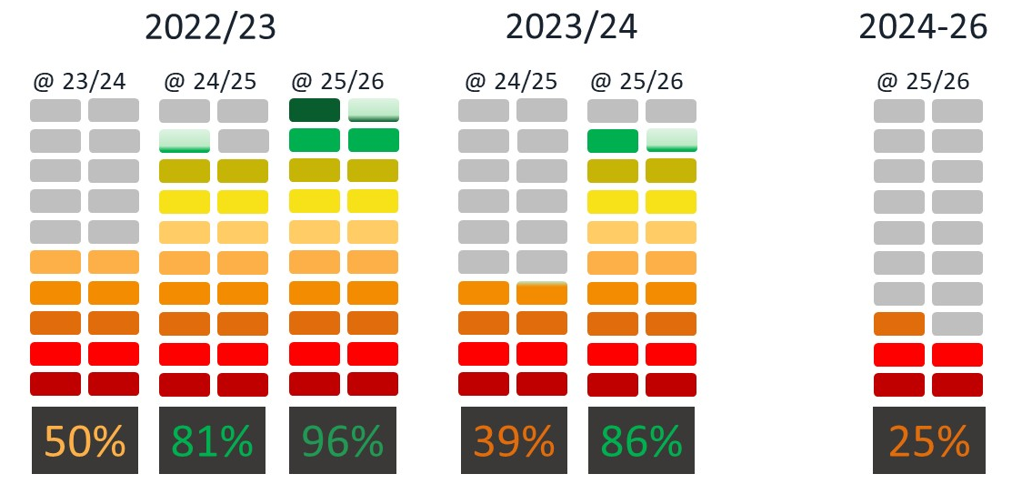
Fig 2. Progress with Audit Plans 2022 to date
It is encouraging to note that the 2023/24 audit year position has surpassed the two-year position of the 2022/23 audit period, which now closes on 96% of topics being accounted for. The remaining topics on the 2022/23 list are awaiting publication. On that basis, the plan will be closed-down and the outcomes process will follow the national publications assurance process described in section 2.6.
While the 2024/26 audit period is currently behind the trajectory of completion rates for the previous two plans, it is hoped that the new presentation templates to the COEG will support improved timeliness of reporting outcomes. In turn, each of the Service Delivery Groups are required to present on key agenda items. To support these presentations and monitoring progress of topics, the CAED have created a dashboard linking into relevant individual records to prompt action by Audit Leads and Project Contacts as required.
Automated contact emails from the AMaT and SharePoint systems are generated to key contacts advising of the need for updates.
Increasing and competing priorities within the CAED work programme affects the frequency of manual chase up emails and meetings with Audit Leads to clear outstanding actions. A new summary overview is provided at the monthly COEG meetings.
2.4 Governance
Timely registration and reporting of audit activity data and the resulting outcomes is a Health Board requirement. The team are aware that there are a proportion of topics that are never registered, resulting in missed opportunities to share learning.
SharePoint and Microsoft Forms replaced the AMaT system for the creation and monitoring of plans, the outcomes and resulting actions (Levels 3 and 4). Emergent necessary topics, Medical Student projects and additional regional and national topics (Level 5) not listed on the Level 1 Welsh Government programme are also recorded in the same way.
2.5 Re-audit
56 of the topics listed on the original 2024/26 plans were listed as re-audit cycles. 11 were subsequently removed.
In a change from the scoring used in previous audit periods, for 2024/26 in aligning with the Health Board Risk/Assurance Matrix, scores ≥12 automatically generate a re-look. Audit Leads are asked to review and approve the outcomes section prior to the CAED releasing certificates of completion.
For this reason, the audit programme is fluid, with triggered re-audit cycles being added as dictated by suggested re-audit dates. This is displayed within the breakdown of each individual Service Group (Section 3.).
2.6 NICE/Health Technology Wales (HTW) Guidance and Recommendations
The COEG monitors compliance with responses to newly published/updated National Institute for Health and Care Excellence and HTW guidance, issued to identified individuals through initial discussion at the monthly Executive Medical Directors Department and Service Delivery Group Medical Directors meetings.
The process for the completion and review of responses to all key national guidance is supported by use of SharePoint. Currently 40/64 topics issued have been completed (63%).

2.7 National Audit/Registry (Level 1) Published Reports
For the report period, assurance proformas were issued following publication of national audit/registry reports. Currently 10/54 remain outstanding and in progress (19%).
The COEG monitors timeliness of responses, escalating issues to the Quality Safety Group as required for support in attaining the required information.
2.8 Deferred/Removed Projects 2024/26
For the 2024/26 period to date, 0 projects have been deferred.
In the 21 cases where topics have been removed, this includes projects removed based on insufficient detail and unrealistic levels of activity for a half audit year. There have also been instances where repeat audit cycles were no longer required as improvement work has been undertaken in a different way.
2.9 Completed Projects 2024/26
As indicated in Figure 2, currently the completion rate for triggered and planned projects in the 2024/26 audit period stands at 25%.
2.10 Service Group and Department Breakdown
The COEG is committed to monitoring all Audit Plans to their conclusion. In the following section updates will be provided for any topics still unaccounted for on the 2022/23 Audit Plan, in addition to the 2023/24 and current periods (Fig 3. & Fig 4.).
Department level information presented is generated from project summaries submitted to date. Outcomes sections include the need for Project Contacts to assign risk/assurance matrix scores. Summaries and scores are subsequently reviewed and signed off by designated Audit Leads prior to release of certificates of completion.
In aligning with the Health Board Risk/Assurance Matrix for the report period, scores of ≥12 automatically triggered the need for a re-audit.
Brief summaries of the outcomes submitted, along with risk/assurance scores, are included for information in Fig. 5.
These outcomes come from different time periods. Where trigger points for re-audits are met, this is clearly stated. In some instances, re-audits are not triggered however the department in question has listed the topic for a relook.

3. Recent Audit Plan Completion Rates, by Service Group

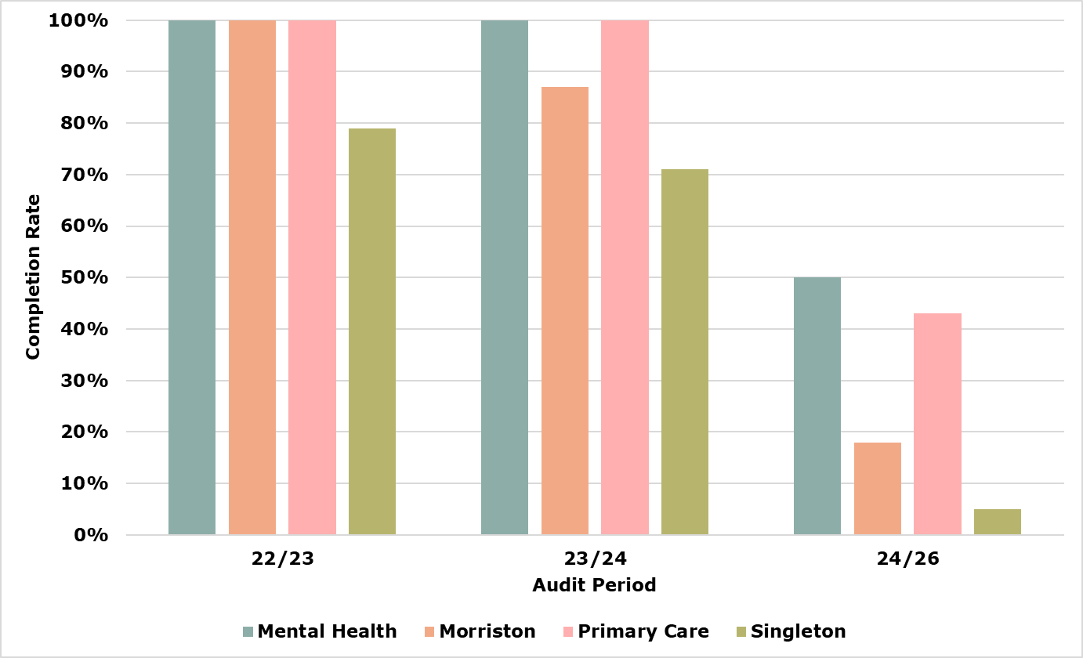
Fig 3. Update on progress with audit plans, all Service Groups
2024-2026 Current Audit Programme Details for Mental Health & Learning Disabilities
Original Plan 24/26 | Removed from 24/26 Plan | Additional triggered by risk/assurance score for re-audit 2024-26 | Additional triggered by risk/assurance score for re-audit 2026-28 | Approved Ad-hoc projects
14 | 4 | 3 | 0 | 20
10 |  | 3 | 0 | 20
13 |  |  | 20
Current confirmed total - 33

 | Planned/Triggered |  |  |  | Ad-hoc
Department/Area | Complete | Deferred | Pending | Removed | Complete | Deferred | Pending | Rejected
Adult Mental Health | 1 | - | 2 | - | - | - | 3 | 1
Community Drugs & Alcohol Team | 3 | - | 4 | - | - | - | - | -
Community Learning & Disability | - | - | 1 | - | 1 | - | - | -
Community Perinatal MH Service | - | - | - | - | - | - | 2 | -
Forensic | - | - | - | 1 | - | - | - | -
Mental Health & Learning Disabilities | 1 | - | 2 | 3 | 4 | - | 3 | 1
Nutrition | - | - | - | - | 1 | - | - | -
Older People’s Mental Health | - | - | - | - | 3 | - | 2 | 1
Psychiatry | - | - | - | - | 1 | - | 5 | -
 | 5 | 0 | 9 | 4 | 10 | 0 | 15 | 3
Complete/Proposals | 5/14 |  |  |  | 10/25
Fig 4. Department breakdown 2024/26, MH&LD
Mental Health & Learning Disabilities outline of completed topic summaries submitted during the report period | Audit Period
 | 22/23 | 23/24 | 24/26
Adult Mental Health
Planned – Audit of long acting injectable or depot antipsychotic side effects among persons with mental disorders in Swansea Bay UHB
Concerns – Low compliance with monitoring and documentation of side effects for long-acting injectable antipsychotics. Successes – Improved documentation of sexual side effects and blood test monitoring. Risk Matrix Score 16, triggering re-audit (also required by department).
Community Drug and Alcohol Team
Planned – Electrocardiogram (ECG) monitoring in patients prescribed high dose methadone and/or antipsychotics
Concerns – Reduced ECG monitoring compliance for patients on >100mg methadone. Successes – Clear cardiovascular risk documentation and 100% ECG completion in Neath Port Talbot. Risk Matrix Score 2. Not listed for re-audit by the department.
Planned – Audit of the prevalence of opiate substitution therapy documentation in patient’s General Practice repeat medication records
Concerns – Corrected QT interval (QTc) prolongation, respiratory depression, poor management of co-morbidities and side effects, interacting medications. Successes – Not specified. Risk Matrix Score 12, triggered for re-audit.
Planned – Audit of monitoring and duration of treatment of alcohol relapse prevention medications
Concerns – No immediate. Successes – Appropriate checks and follow-ups for disulfiram, though prescribing numbers are low and variable. Risk Matrix Score 1. Not listed for re-audit by department.
Community Learning and Disability
Ad-hoc – Audit of Swansea Bay’s Memory Clinic’s adherence to the All-Wales Dementia Pathway Standards (2022)
Concerns – None of the 9 standards were fully met, 5 couldn’t be rated. Successes – Partial compliance with 2 standards. Risk Matrix Score 12 - triggered for re-audit and listed by the department.

Mental Health & Learning Disabilities outline of completed topic summaries submitted during the report period | Audit Period
 | 22/23 | 23/24 | 24/26
Mental Health and Learning Disabilities
Ad-hoc – Annual Risk Acknowledgement Form (ARAF) monitoring for women with epilepsy and Learning Disability of child-bearing age prescribed Valproate containing medicines
Concerns – High number of females on VPA (Valproic Acid), discharge and age-related risks, many under ARAF. Successes – High ARAF compliance and second signatory rates. Risk Matrix Score 2.
Ad-hoc – Physical health monitoring in patients taking antipsychotics
Concerns – None. Successes – Compliance with physical health monitoring guidelines. Risk Matrix Score 1.
Ad-hoc – Re-audit of high dose antipsychotic prescribing and monitoring within community and inpatient settings for people with a Learning Disability
Concerns – Small sample size, potential inconsistency in data collection. Successes – Reduced high-dose antipsychotic use, improved monitoring and prescribing compliance. Risk Matrix Score 4. Department plan re-audit.
Ad-hoc – Improving medical trainee induction in SBUHB
Concerns – None, but improvements recommended; Successes – High satisfaction with handbook and its impact on safe care. Risk Matrix Score 0.
Planned – Investigate how seclusion patients are medically reviewed
Concerns - Significant non-compliance with National Institute for Health and Care Excellence (NICE) 2018 guidelines, especially in physical health monitoring and documentation. Successes - 94% of patients seen by a psychiatrist within 12 months, showing strong psychiatric engagement. Risk Matrix Score 12, re-audit required by department
Planned – Hypoglycaemia (Hypo) Box Audit – Think Glucose
Concerns – Missing or expired hypo supplies, misplaced protocols and stickers. Successes – All wards had basic hypo treatments, 60% had protocol correctly placed, 59% had hypo stickers. Risk Matrix Score 12, triggered for re-audit.

Mental Health & Learning Disabilities outline of completed topic summaries submitted during the report period | Audit Period
 | 22/23 | 23/24 | 24/26
Mental Health and Learning Disabilities
Planned – Attention Deficit/Hyperactivity Disorder (ADHD)monitoring and Prescription in Community Learning Disability Teams
Concerns - Significant non-compliance with National Institute for Health and Care Excellence (NICE) 2018 guidelines in physical health monitoring and documentation. Successes - 94% seen by a psychiatrist within 12 months, showing strong engagement. Risk Matrix Score 6, triggering re-audit on the previous scoring system (also required by the department).
Planned – Discharge Re-audit.
Concerns - Gaps in providing admission packs, mental health education, psychology referrals, and discharge documentation. Successes - Evidence of family support, discharge planning, and multidisciplinary team involvement in discharge decisions. Risk Matrix Score 6, triggering re-audit on previous scoring system.
Planned – Use of medicines with anticholinergic (antimuscarinic) properties
Concerns - High antipsychotic prescribing in over-65s and lack of routine Ambulatory Emergency Care (AEC) scoring highlight risks of cognitive decline and prescribing cascades. Successes - Audit supports a quality improvement project to improve prescribing practices and monitoring. Risk Matrix Score 2, re-audit required by the department.
Planned – POMH UK Topic 7g: Monitoring of patients prescribed lithium
Concerns - Poor communication on lithium side effects and reduced Body Mass Index (BMI)/weight checks, especially in shared care settings. Successes - Improved biochemical monitoring reflects better alignment with clinical guidelines. Risk Matrix Score 2, re-audit required by department.
Planned – POMH QI Project Topic 20b: Improving the quality of Valproate prescribing in adult mental health services
Concerns - Only 7% of long-term valproate patients had plasma levels checked, with most lacking documented rationale, indicating inconsistent monitoring. Successes not specified. Risk Matrix Score 6, triggering re-audit on previous scoring system (also required by department).
Mental Health & Learning Disabilities outline of completed topic summaries submitted during the report period | Audit Period
 | 22/23 | 23/24 | 24/26
Mental Health and Learning Disabilities
Planned – A National audit: Enumerating the relationship between nature of care setting and clinical presentation in adults with intellectual disability and epilepsy.
Concerns - High rates of polypharmacy and side effects with limited structured reviews. Successes - Large, diverse dataset offers valuable insights into complex epilepsy care in adults with intellectual disabilities. Risk Matrix Score 0.
Nutrition
Ad-hoc – WAASP Audit (Weight, Appetite, Ability to Eat, Stress Factor and Pressure Ulcer/Wound)
Concerns - Very low height measurement rates, poor WAASP completion; Successes – High-quality WAASP documentation, healthy average weight, appropriate WAASP score action. Risk Matrix Score 9.
Older People’s Mental Health Services
Ad-hoc – Anti-psychotic medication in Neath and Port Talbot care homes
Concerns – None. Successes – Reduced antipsychotic use and improved review punctuality in care homes. Risk Matrix Score 1. Department plan re-audit.
Ad-hoc – Improving post diagnostic support with patients who has dementia in secondary care.
Concerns – Potential overlap if dementia coordinators appointed. Successes – Patient-centred post diagnostic support, inclusion of advanced care planning and research. Risk Matrix Score 8.
Ad-hoc – Anti-psychotic prescriptions in Neath and Port Talbot care homes
Concerns – None. Successes – Continued reduction in anti-psychotic use, good review adherence. Risk Matrix Score 1. Department plan re-audit.
Planned – Post diagnostic support provision for patients following a diagnosis of Mild Cognitive Impairment (MCI)
Concerns - Only 7.5% received written MCI diagnosis information and 22.5% had follow-ups, indicating poor post-diagnostic support. Successes - 91.3% of clinical files documented MCI diagnosis, supporting continuity of care. Risk Matrix Score 3.

Mental Health & Learning Disabilities outline of completed topic summaries submitted during the report period | Audit Period
 | 22/23 | 23/24 | 24/26
Psychiatry
Ad-hoc – Quality improvement project to decrease time taken to communicate with General Practitioners following an outpatient appointment in the general adult Community Mental Health Team
Concerns – Severe backlog of clinical letters, communication delays with General Practice, risk to patient safety. Successes – Clear identification of issue and proposed mitigation strategies. Risk Matrix Score 9.

Fig 5. MH&LD completed project summaries, completed topics

2024-2026 Current Audit Programme Details for Morriston Service Group
Original Plan 24/26 | Removed from 24/26 Plan | Additional triggered by risk/assurance score for re-audit 2024-26 | Additional triggered by risk/assurance score for re-audit 2026-28 | Approved Ad-hoc projects
36 | 1 | 0 | 0 | 36
35 |  | 0 | 0 | 36
35 |  |  | 36
Current confirmed total - 71

 | Planned/Triggered |  |  |  | Ad-hoc
Department/Area | Complete | Deferred | Pending | Removed | Complete | Deferred | Pending | Rejected
Acute Medicine | - | - | - | - | - | - | 1 | -
Burns and Plastics | - | - | 4 | - | - | - | 7 | -
Cardiology | - | - | - | - | - | - | 2 | -
Cardiothoracic | - | - | 3 | - | 1 | - | - | -
Emergency Department | 1 | - | 6 | - | - | - | - | 1
Endocrinology | - | - | 2 | - | - | - | 1 | 1
ENT | 1 | - | - | - | 1 | - | 4 | -
Gastroenterology/Hepat | - | - | - | - | - | - | 3 | 1
General Surgery | 1 | - | - | - | 1 | - | 9 | -
ICU | - | - | 3 | - | 2 | - | 5 | -
Maxillofacial | 1 | - | - | - | - | - | - | -
Neurology | 1 | - | 3 | - | 1 | - | 4 | -
Neurophysiology | - | - | - | - | - | - | 1 | -
 | Planned/Triggered |  |  |  | Ad-hoc
Department/Area | Complete | Deferred | Pending | Removed | Complete | Deferred | Pending | Rejected
Orthopaedics | - | - | - | 1 | - | - | - | -
Radiology | 1 | - | 3 | - | 2 | - | 2 | -
Renal | - | - | 3 | - | - | - | 1 | -
Respiratory | - | - | - | - | - | - | 1 | -
Spinal Surgery | - | - | - | - | - | - | 2 | -
Stroke | - | - | 1 | - | - | - | - | -
Urology | - | - | 1 | - | - | - | 1 | -
Vascular Surgery | - | - | - | - | - | - | 2 | -
 | 6 | 0 | 29 | 1 | 8 | 0 | 46 | 3

Fig 6. Department breakdown 2024/26, Morriston

Morriston outline of completed topic summaries submitted during the report period | Audit Period
 | 22/23 | 23/24 | 24/26
Burns & Plastics
Planned – Custom breast prosthetic provision - Audit of patient satisfaction and utilisation
Concerns - 35% said the prosthesis made them consider avoiding surgery, showing its impact on treatment decisions. Successes - 100% reported improved confidence in appearance, with high comfort and security ratings. Risk Matrix Score 1.
Planned – Investigating adherence to and documentation of initial first-aid management for adult burns patients presenting to the South-West Burns Centre
Concerns - Only 20% of adults and 39% of paediatrics received adequate cooling; poor documentation and inadequate first-aid linked to higher admissions and surgeries. Successes - 77% of adults and 88% of paediatrics received some first-aid, with better outcomes in those receiving adequate care. Risk Matrix Score 3, re-audit required by department.
Planned – Non-Melanoma Skin Cancer (NMSC) excision margins
Concerns - Documentation gaps limited audit eligibility and analysis. Successes - >20% improvement in Basal Cell Carcinoma and >40% in Squamous Cell Carcinoma size documentation following poster implementation, enabling better guideline adherence analysis. Risk Matrix Score 2, re-audit required by department.
Planned – Environmental impacts of Non-Melanoma Skin Cancer (NMSC) surgery at a day-surgery unit
Concerns - High carbon emissions from energy use, consumables, and waste. Successes - Identified NMSC excision with direct closure as the lowest carbon footprint option. Risk Matrix Score 0.
Cardiothoracic Surgery
Ad-hoc – Pre-Enhanced Recovery After Cardiac Surgery (ERACS) Audit
Concerns – Pre-ERACS patients had longer ventilator dependency, delayed removal of invasive lines, and longer hospital stays. Successes – Post-ERACS implementation led to reduced ventilation time, earlier line removal, and a 4-day reduction in hospital stay. Risk Matrix Score 12, triggered re-audit.

Morriston outline of completed topic summaries submitted during the report period | Audit Period
 | 22/23 | 23/24 | 24/26
Cardiothoracic Surgery
Planned – Repair rate for degenerative mitral valve disease against the national standard
Concerns - National variation in mitral repair rates suggests need for standardisation. Successes -Morriston achieved a 98% repair rate, far exceeding national average and previous performance. Risk Matrix Score 0.
Planned – Consent and EIDO-Cardiothoracic surgery
Concerns - Incomplete documentation of two-way consent and material risks. Successes - Improved use of EIDO forms and quality of consent dialogue documentation. Risk Matrix Score 2.
Planned – The handling of central venous catheters (CVC) line in cardiac ITU
Concerns - Decline in timely CVC removal and incomplete documentation of maintenance records; Successes: High overall compliance with care documentation and reduced infection rates. Risk Matrix Score 2.
Planned – Audit of appropriate use of therapeutic doses of low molecular weight heparin or anticoagulants in cardiothoracic patients
Concerns - Overall compliance was low at 21%, with frequent dosing and frequency errors. Successes - Apixaban prescribing showed 100% compliance with guidance. Risk Matrix Score 3.
Cardiology
Planned – Acute heart failure: diagnosis and management
Concerns - Continued need for earlier identification, specialist input, and rapid therapy to meet British Society for Heart Failure targets. Successes – N-Terminal – pro-B-type Natriuretic Peptide testing and echocardiogram access improved significantly, with better outcomes and reduced readmissions. Risk Matrix Score 4, re-audit triggered on previous scoring system (and required by department).

Morriston outline of completed topic summaries submitted during the report period | Audit Period
 | 22/23 | 23/24 | 24/26
Cardiology
Planned – Service evaluation of the Rapid Access Chest Pain Clinic (RACPC) to determine whether patients with coronary artery disease are being appropriately identified and treated
Concerns - Consent dialogue recording dropped to 75% and some leaflets lacked bilingual formats or EIDO compliance; Successes: Over 90% of cases used appropriate consent forms and documented risk discussions. Risk Matrix Score 0, re-audit required by department.
Planned – Consent and Eido-Cardiology
Concerns - Some referrals not aligned with NICE CG95 guidance; Successes: Rapid access chest pain service effectively identifies and manages coronary artery disease with appropriate diagnostics. Risk Matrix Score 0, re-audit required by department.
Planned – Audit of appropriate use of Therapeutic doses of low molecular weight heparin or anticoagulants in cardiology
Concerns - 25% of doses were inappropriate due to weight, renal function, or guideline misapplication. Successes - 75% of doses were appropriate and aligned with clinical guidance. Risk Matrix Score 2.
Planned – Review of current heart failure treatment in patients with chronic kidney disease
Concerns - Variable use of guideline-directed therapy in complex renal patients with multiple comorbidities. Successes - Audit led to collaborative database development between renal and cardiology teams. Risk Matrix Score 3.
Planned – Audit of documentation of allergy status on inpatient drug charts within the Morriston Hospital Cardiac Centre
Concerns - None identified. Successes – Hospital Electronic Prescribing Medicines Administration (HEPMA) implementation further improved already high compliance levels. Risk Matrix Score 1.
Planned – Diagnosis of suspected heart failure
Concerns - Delays in specialist assessment and paper referrals hinder urgent access and two-week targets. Successes - Service model has remained sustainable over four years despite increased demand. Risk Matrix Score 6, triggering re-audit on previous scoring system.

Morriston outline of completed topic summaries submitted during the report period | Audit Period
 | 22/23 | 23/24 | 24/26
Emergency Department
Planned – Fractured neck of femur
Concerns – 30 patients had no pain score at triage, long wait times for analgesia. Successes – Better-than-average Fascia Iliaca Block rates and faster X-ray times compared to UK average. Risk Matrix Score not assigned.
Planned – Royal College of Emergency Medicine Pain in Children Audit 2022-2023
Concerns – Small sample size, missing pain scores, and suboptimal analgesia in some cases. Successes - Significant improvements in pain scoring, analgesia delivery, and discharge advice since 2022. Risk Matrix Score 2, re-audit required by department.
Planned – Lumber Spine X-Ray request
Concerns – 32% of non-trauma X-rays did not meet Royal College of Radiologists iRefer/National Institute for Health and Care Excellence (NICE) guidance. Successes - Majority of lumbar spine X-rays were trauma-related and appropriately indicated. Risk Matrix Score 0, re-audit required by department.
Planned – Chest x-ray requests
Concerns – Previous gaps in request form completion. Successes - Transition to electronic requests ensured all fields are now completed. Risk Matrix Score 0.
Planned – Paracetamol overdose
Concerns – 0% documentation of SNAP protocol for paracetamol overdose cases. Successes - All treated patients were appropriately triaged and managed. Risk Matrix Score 3.
Planned – Hand injuries presenting via Emergency Department
Concerns – Only 61% had dominant hand documented and 51% received adequate pain relief. Successes - 94% had injury mechanism recorded and 70% had appropriate exclusion of tendon/nerve injury. Risk Matrix Score 0, re-audit required by department.
ENT
Planned – Ear Nose and Throat (ENT) Casualty clinic appointments: are they appropriate?
Concerns – 9% of patients were inappropriately booked into the clinic. Successes - 91% of bookings were appropriate, with junior staff actively supporting clinic delivery. Risk Matrix Score 2, re-audit required by department.
Morriston outline of completed topic summaries submitted during the report period | Audit Period
 | 22/23 | 23/24 | 24/26
ENT
Ad-hoc – Auditing the effectiveness of the Ear Nose and Throat (ENT) SHO Clinical Assessment (CAS) clinic
Concerns – High patient turnover and hidden paediatric charts led to poor oxygen prescribing. Successes – Education and posters improved prescribing, especially in airway-sensitive cases. Risk Matrix Score 1. Not listed for re-audit by department.
Planned – Oxygen Prescribing in the Ear Nose and Throat (ENT) Department
Concerns - Poor oxygen prescribing due to high turnover and hidden paediatric chart sections. Successes – Poster and education improved prescribing, especially in airway-sensitive patients. Risk Matrix Score not assigned.
General Surgery
Planned – Outcome pathway in acute admissions with biliary pathology
Concerns - Still not meeting national guidelines due to limited theatre capacity and rising demand. Successes - Significant reduction in wait times and more surgeries performed during index admissions. Risk Matrix Score 12, re-audit triggered and required by department.
Planned – Global evaluation of cholecystectomy
knowledge and outcomes
Concerns – None identified. Successes - Full assurance provided with no risks reported. Risk Matrix Score 0.
Ad-hoc – Evaluating consent forms for laparoscopic appendicectomy compared to EIDO standards
Concerns – Some consent forms for laparoscopic appendicectomy were missed. Successes – Data was collected, presented, and used to improve the consenting process. Risk Matrix Score 12, triggered re-audit and required by department.
Planned – Outcome pathway in acute admissions with biliary pathology
Concerns – Low treatment rates within national timeframes for biliary pathology. Successes – Raised awareness and better use of hot gallbladder lists. Risk Matrix Score not assigned.

Morriston outline of completed topic summaries submitted during the report period | Audit Period
 | 22/23 | 23/24 | 24/26
Intensive Care
Ad-hoc – Treatment escalation plans on admission to Critical Care
Concerns – Escalation plans were poorly documented and scattered across multiple notes. Successes – Identified the need for unified documentation to improve clarity. Risk Matrix Score 6, re-audit required by department.
Ad-hoc – Blood requesting in Intensive Care Unit
Concerns – Inconsistent test requests due to lack of guidance. Successes – Recognised the need for standardised blood test guidelines and updated forms. Risk Matrix Score 6, re-audit required by department.
Maxillofacial
Planned – Neonate and infant referrals for ankyloglossia
Concerns – None noted. Successes – Improved documentation and assessment quality, better use of standardised tools and referral pathways. Risk Matrix Score 1, re-audit required by department.
Neurology
Ad-hoc – Information given at Multiple Sclerosis (MS) diagnosis
Concerns – None reported. Successes – Most patients were satisfied with the information received at diagnosis. Risk Matrix Score 1, re-audit required by department.
Planned – Review the compliance of disease modifying therapies and fampridine for Multiple Sclerosis (MS) in line with National Institute for Health and Care Excellence (NICE) guidance
Concerns – None. Successes – 100% compliance. Risk Matrix Score 5.
Radiology
Planned – Audit of report of cardiac calcification (CAC)
Concerns - Significant underreporting of CAC/Aortosternal Venous Compression (AVC) and lack of cardiology referrals, even in younger patient. Successes - Detection of CAC/AVC provided valuable insight into undiagnosed cardiovascular risk. Risk Matrix Score 6, re-audit triggered by previous scoring system and required by department.

Morriston outline of completed topic summaries submitted during the report period | Audit Period
 | 22/23 | 23/24 | 24/26
Radiology
Planned – Audit of imaging for acute aortic syndrome
Concerns - Compliance still below target, with room for further improvement. Successes - Marked increase in pre-contrast and Electrocardiogram (ECG)-gated scans following audit-led changes. Risk Matrix Score 1, re-audit required by department.
Planned – Re-audit of recognising and reporting osteoporotic vertebral fragility fractures
Concerns - Only 6% of studies had all fractures reported, indicating ongoing underreporting. Successes - 98% of reports included bone findings, with slight improvement in fracture documentation. Risk Matrix Score 8, re-audit triggered by previous scoring system.
Planned – Audit of compliance with World Health Organisation (WHO) checklists
Concerns – 71% compliance in ultrasound and missing documentation in anaesthetic fluoroscopy cases highlight variability. Successes - Fluoroscopy compliance reached 100% when excluding anaesthetic-only cases, with high compliance in Computed Tomography (CT) and ultrasound. Risk Matrix Score 2, re-audit required by department.
Ad-hoc – Liver biopsy audit
Concerns – Variability in technique and documentation. Successes – Most biopsies were diagnostic, with no repeats or significant complications. Risk Matrix Score not assigned.
Ad-hoc – Audit of liver biopsies performed by Consultant 2013 - 2024
Concerns – Issues around mortality tracking and sharing Mortality and Morbidity (M&M) information. Successes – Outcomes were summarised, reflected upon, and presented. Risk Matrix Score not assigned.
Planned – Indication for plain abdominal X-Ray Concerns – Royal College of Radiologists guideline adherence below 100% target (83%). Successes – Initial audit established a baseline for improvement. Risk Matrix Score 9, re-audit required by department.

Fig 7. Morriston project summaries, completed topics

2024-2026 Current Audit Programme Details for Primary, Community Care & Therapies
Original Plan 24/26 | Removed from 24/26 Plan | Additional triggered by risk/assurance score for re-audit 2024-26 | Additional triggered by risk/assurance score for re-audit 2026-28 | Approved Ad-hoc projects
29 | 8 | 2 | 2 | 5
21 |  | 2 | 2 | 5
23 |  |  | 5
Current confirmed total - 28

 | Planned/Triggered |  |  |  | Ad-hoc
Department/Area | Complete | Deferred | Pending | Removed | Complete | Deferred | Pending | Rejected
Audiology | 2 | - | - | - | 1 | - | 1 | -
Cardiac Rehabilitation | - | - | 1 | - | - | - | - | -
Community Dental Services | 1 | - | 1 | 4 | - | - | - | -
Community Dietetics/ Home Enteral Feeding | 1 | - | 1 | - | - | - | - | -
Dental Practices | - | - | 1 | - | - | - | - | -
Nutrition & Dietetics | - | - | 1 | - | - | - | - | -
GMS | - | - | - | 1 | - | - | - | -
Health Visiting | - | - | - | - | - | - | - | -
Nutrition & Dietetics Oncology | 1 | - | - | 1 | - | - | - | -
Occupational Therapy | 1 | - | - | 2 | 2 | - | - | -
Older Persons MH Occ Therapy | - | - | - | - | 1 | - | - | -
Podiatry | - | - | 1 | - | - | - | - | -
Restorative Dentistry | - | - | 3 | - | - | - | - | -
 | Planned/Triggered |  |  |  | Ad-hoc
Department/Area | Complete | Deferred | Pending | Removed | Complete | Deferred | Pending | Rejected
Sexual Health | 1 | - | 1 | - | - | - | - | -
Specialist Palliative Care | - | - | 2 | - | - | - | - | -
Speech & Language Therapy | 2 | - | - | -
 | 9 | 0 | 12 | 8 | 4 | 0 | 1 | 0

Fig. 8. Department breakdown 2024/26, Primary, Community Care & Therapies

Primary, Community Care & Therapies outline of completed topic summaries submitted during the report period | Audit Period
 | 22/23 | 23/24 | 24/26
Audiology
Ad-hoc - An evaluation of Primary Care audiology patients that require treatment for acute otitis externa.
Concerns – None noted. Successes – Evaluation aligned with national Health and Care Professions Council (HCPC) work on prescribing rights, achieving a productive outcome. Risk Matrix Score 1.
Planned - Minimising numbers of patients unable to receive a direct semi-circular canal function assessment.
Concerns – Direct measurement of semi-circular canal function dropped from 80% in 2022 to 22% in 2023 due to lack of video Head Impulse Test (vHIT). Successes – None noted. Risk Matrix Score 6.
Planned - Meeting standard 2 of the All-Wales Dementia Care Pathway of Standards.
Concerns – Most patients undergoing memory assessments are not receiving hearing assessments within 2 years. Successes – None noted. Risk Matrix Score 15, triggered re-audit and required by department.
Community Dental
Planned – Radiography audit
Concerns - Current software limitations prevent completion of audit reporting. Successes - Not specified due to data constraints. Risk Matrix Score 9, re-audit triggered by previous scoring system and required by department.
Planned – Quality assurance of dental radiographs in the community dental service
Concerns – Radiograph acceptability was 1% below target. Successes – Close to meeting standards. Risk Matrix Score 2. Re-audit required by department.
Community Stroke Rehabilitation
Planned - Community stroke audit
Concerns - High implementation cost (£1.2M) for 5-day Integrated Community Stroke Service (ICSS) with unclear offset from bed day savings due to staffing limits. Successes - Clear service gap aligned with National Institute for Health and Care Excellence (NICE) and Royal College of Physicians (RCP) guidelines, supporting ICSS implementation. Risk Matrix Score 4, triggering re-audit on previous scoring system.
Primary, Community Care & Therapies outline of completed topic summaries submitted during the report period | Audit Period
 | 22/23 | 23/24 | 24/26
Community Dietetics/Home Enteral Feeding
Planned - Audit of oral nutrition support outpatient clinical standards
Concerns - Below-target performance in timeliness, written information and outcome documentation, largely due to staffing and documentation gaps. Successes – 11/17 standards improved, with strong gains in Body Mass Index (BMI), fluid intake, and risk/benefit documentation. Risk Matrix Score 2.
Planned - Oral nutrition support inpatient clinical standards Concerns - Urgent need to improve documentation of outcomes (15%), written information (17%), and assessment timeliness (60%). Successes – 9/15 standards improved, better documentation of Body Mass Index (BMI), nutritional needs, and General Practice/referrer reports. Risk Matrix Score 2.
Planned - Audit of home enteral feeding electronic records against record keeping standards
Concerns – Incomplete files and issues with saving documents due to long filenames. Successes – None noted. Risk Matrix Score 12, triggering re-audit (also required by department).
General Medical Services
Planned – International Normalised Ratio (INR)
Concerns –1 practice reported 4 near misses in warfarin care requiring further investigation. Successes - All practices compliant with Drug-Eluting Stent, with therapeutic range averaging 77%, above national average. Risk Matrix Score 0, re-audit required by department.
Health Visiting
Planned - Health Visiting Specialist Practice Review (SPR) Concerns – Mixed use of paper/ electronic SPRs and time constraints suggest need for standardisation and delegation. Successes - 100% SPR completion with strong documentation and practitioner-service user interaction. Risk Matrix Score 0.
Nutrition and Dietetics
Planned - Dietetic management of Upper Gastrointestinal (UGI) cancer patients
Concerns – Lack of access to local prehabilitation and delays in seeing patients as per the single cancer pathway. Successes – Prehabilitation is in development. Risk Matrix Score 9.
Primary, Community Care & Therapies outline of completed topic summaries submitted during the report period | Audit Period
 | 22/23 | 23/24 | 24/26
Occupational Therapy
Ad-hoc - Audit of Morriston Occupational Therapy Outcome Measure (MOTOM) in SBUHB
Concerns – Inconsistent use of MOTOM due to language and scoring issues. Successes – Treatment plans were consistently documented, and senior staff showed better MOTOM completion. Risk Matrix Score 4, re-audit planned by department.
Ad-hoc - Occupational therapy for adults undergoing total hip replacement 2025
Concerns – Lack of access to local prehabilitation and delays in seeing patients as per the single cancer pathway. Successes – Prehabilitation is in development. Risk Matrix Score 1.
Planned - Occupational Therapy Neurological upper limb splinting audit
Concerns – None raised. Successes – Audit found no issues. Risk Matrix Score 1.
Older Person’s Occupational Therapy
Ad-hoc - Evaluation of Occupational Therapy (OT) service provision Older Person’s Mental Health (MH), Primary Care Concerns – Limited OT role in functional MH, long wait times, poor compliance with dementia standards, under-documented patient concerns. Successes - High OT involvement pre-diagnosis, good self-management support, strong alignment of OT input with patient concerns. Risk Matrix Score 12 triggering re-audit (and required by dept)
Restorative Dentistry
Planned - Dentoalveolar Trauma; Retrospective audit of dental injuries treated at Restorative Dept
Concerns - Inconsistent assessment and documentation, especially for periodontal injuries and treatment planning. Successes - 100% had trauma history recorded, capturing a wide range of complex cases. Risk Matrix Score 0, re-audit required by department.
Planned - Community Stroke Audit
Concerns - High implementation cost (£1.2M) for 5-day Integrated Community Stroke Service (ICSS) with unclear offset from bed day savings due to staffing limits. Successes - Audit identified a clear service gap aligned with NICE and RCP guidelines, supporting ICSS implementation. Risk Matrix Score 4, triggering re-audit on previous scoring system.
Primary, Community Care & Therapies outline of completed topic summaries submitted during the report period | Audit Period
 | 22/23 | 23/24 | 24/26
Sexual Health
Planned - HIV Annual Checks – Impact of New Specialist Role ME/CFS.
Concerns - None raised. Successes -All targets reached, improvement from previous audit cycle. Risk Matrix Score 1.
Speech and Language Therapy
Planned - Connecting people with diagnosed or suspected dementia to Audiology Services; the role of Speech and Language Therapy in Primary Care Mental Health Services
Concerns – None raised. Successes – 64% of standards currently being met, clear future improvement and focus. Risk Matrix Score 6, re-audit required by department.
Planned - To audit the current Speech and Language Therapy SLT) service provision for head and neck cancer patients, who receive their diagnosis and treatment within Swansea Bay UHB, against recommended national head and neck cancer guidelines
Concerns – Extremely low compliance with all four SLT standards for head and neck cancer patients due to staffing shortages, increased demand, and lack of resources. Successes – None reported, but systemic issues clearly identified. Risk Matrix Score 16, re-audit triggered and required by department.

Fig 9. Primary, Community Care & Therapies project summaries, completed topics

2024-2026 Current Audit Programme Details for Singleton & Neath Port Talbot
Original Plan 24/26 | Removed from 24/26 Plan | Additional triggered by risk/assurance score for re-audit 2024-26 | Additional triggered by risk/assurance score for re-audit 2026-28 | Approved Ad-hoc projects
28 | 8 | 0 | 0 | 18
20 |  | 0 | 0 | 18
20 |  |  | 18
Current confirmed total - 38

 | Planned/Triggered |  |  |  | Ad-hoc
Department/Area | Complete | Deferred | Pending | Removed | Complete | Deferred | Pending | Rejected
Anaesthetics | 1 | - | 3 | - | - | - | 3 | -
Cellular Pathology | - | - | 1 | - | 1 | - | - | -
Community Paediatrics | - | - | - | 1 | - | - | 1 | -
Dermatology | - | - | 1 | - | - | - | - | -
General Medicine | - | - | - | - | - | - | 1 | -
Gynae Oncology | - | - | - | - | - | - | 1 | -
Haematology | - | - | - | - | - | - | 1 | -
Neonatal/Neonates | - | - | - | - | - | - | 4 | -
Obstetrics & Gynaecology | - | - | 3 | 2 | - | - | 7 | -
Oncology | - | - | 7 | 1 | - | - | 4 | -
Ophthalmology | - | - | - | - | - | - | 3 | -
Paediatric Palliative Care | - | - | - | - | - | - | 2 | -
 | Planned/Triggered |  |  |  | Ad-hoc
Department/Area | Complete | Deferred | Pending | Removed | Complete | Deferred | Pending | Rejected
Paediatrics | - | - | 4 | - | - | - | 3 | -
Palliative Medicine | - | - | - | - | - | - | 1 | -
Trauma & Orthopaedics | - | - | - | 4 | - | - | 4 | -
 | 1 | 0 | 19 | 8 | 1 | 0 | 36 | 0

Fig. 10. Department breakdown 2024/26, Singleton & Neath Port Talbot

Singleton & Neath Port Talbot outline of completed topic summaries submitted during the report period | Audit Period
 | 22/23 | 23/24 | 24/26
Anaesthetics
Planned - Audit on Anaesthesia Record Keeping
Concerns – Use of two different anaesthetic charts led to inconsistencies, though one chart improved documentation through prepopulated reminders. Successes – Education and reminders effectively enhanced the quality of anaesthetic chart documentation. Risk Matrix Score 4.
Cellular Pathology
Ad-hoc - Evaluation of the technical and clinical effectiveness of Euroclonality-NDC next generation sequencing after 12 months
Concerns – Underutilisation of the assay, especially for Copy Number Variation (CNV) and certain lymphoma subtypes. Successes – High diagnostic impact with Next Generation Sequencing (NGS) contributing to 54% of diagnoses including subtyping and unexpected findings. Risk Matrix Score 16, re-audit triggered.
Community Paediatrics
Ad-hoc - COVID Positive Under 3 Months Review
Concerns - 5 out of 7 patients required antibiotics despite negative cultures, and one lumbar puncture attempt failed. Successes - All had CRP <5, negative blood cultures, and no HDU admissions, supporting consistent diagnosis. Risk Matrix Score 2.
Planned - Health Surveillance of Children with Down Syndrome in Comparison to Down Syndrome Medical Interest Group Guidelines
Concerns - Missed blood tests, appointment non-attendance, and possible over-testing for coeliac disease. Successes - Improved compliance with thyroid antibody testing and vision checks, with high screening attendance. Risk Matrix Score 0, re-audit required by department.
Gynaecology
Planned - Assessing Diagnostic Compliance with Endometrial Cancer Single Cancer Pathway in South-West Wales
Concerns - 0% compliance with 28-day diagnosis target and widespread delays across the pathway due to staffing and capacity issues. Successes - High compliance with hysteroscopy timelines and improved Magnetic Resonance Imaging (MRI) reporting by multidisciplinary team. Risk Matrix Score 3.
Singleton & Neath Port Talbot outline of completed topic summaries submitted during the report period | Audit Period
 | 22/23 | 23/24 | 24/26
Planned - Assessment of surgical compliance with the national optimal pathway for endometrial cancer in South-West Wales
Concerns - Poor documentation, unclear seclusion procedures, and lack of environmental risk assessments. Successes - Audit informed policy development and initiated staff discussions on improving practice. Risk Matrix Score 2, re-audit required by department.
Oncology
Use of SACT consent form usage and appropriate documentation within electronic patient records
Concerns - Gaps in consent form completion and dialogue documentation, with need for ongoing staff training and administration support. Successes - Clear improvement since 2019, with most patients now using Cancer Research UK consent forms. Risk Matrix Score 0.

Fig 14. Singleton & Neath Port Talbot project summaries, completed topics

- Mortality
4.1 Medical Examiner Service and Mortality Reviews
The National Learning from Deaths Framework published by the NHS Delivery Unit and Welsh Government is adopted by the Health Board as the outline for delivering the new learning system. All deaths where the Medical Examiners (ME) Service has identified an issue or query are referred into the Executive Medical Directorate, where initial screening removes cases already undergoing an established redress process.
Those requiring greater scrutiny are passed on to the SBUHB Learning from Deaths Scrutiny Panel, established in May 2021. The multidisciplinary panel meets on a weekly basis, utilising a rota system for the allocation of cases for review and discussion.
The Deputy Executive Medical Director along with colleagues from the Learning from Deaths (LFD) Panel, ensure there is structure in how the ME reviews are addressed within the Health Board. This is inclusive of having oversight of formal review of deaths via Mortality Reviews and the ME cases received, linking the ME cases with the crude mortality and condition specific outcomes.

A specific dashboard built by the Business Intelligence team is yet to be completed. In time, the dashboard will help to identify outliers and bring about improvement plans as needed.

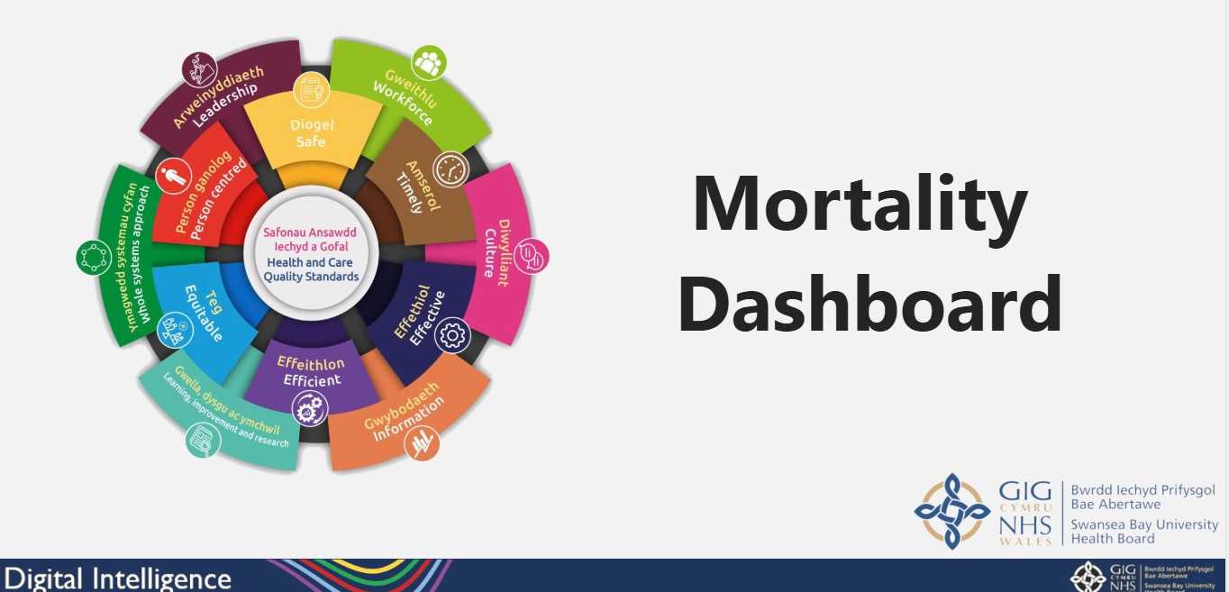

Fig 15., screenshot of new Mortality Dashboard

The LFD have started to identify themes from the ME reviews and improvement work will commence on these once the dashboards are fully developed.

4.1.1 Status of Referrals
There are different levels (1-5) for the ME reviews and as of January 2023, the LFD Panel divided the Level 3 Proportionate Investigation section into three sub-sections;
3a – Close referral and email relevant team for information purposes only
3b – Close referral and email relevant team requesting feedback from discussions with individuals/team
3c – Proportionate Investigation

Fig 16., Five Levels of Medical Examiner Review Process
4.2 Deaths and Referrals 2024/25

For the 2024/25 audit year, the table below provides an overview of the activity in terms of number of deaths per month versus number of referrals received from the ME Service.
Service Delivery Group/Site | Number of Deaths | Number of Medical Examiner Referrals Received
Morriston | 2047 | 642
Singleton / Neath Port Talbot | 202 | 69
Mental Health | 14 | 6
Tonna | 12 | 4
Gorseinon | 24 | 12
Primary Care (Community) | 339 | 173
Other Health Board’s | 14 | 11
Total | 2652 | 917
Fig 17., deaths vs. number of referrals. 2024/25
It should be noted that the number of referrals received within any given month could be generated from different time-periods, depending upon any delays within the ME Service. Cases can also be referred where a death has occurred within other Health Boards, but there are queries related to the care provided by SBUHB.

The LFD review details and themes generated and report them to the COEG meetings. Figure 18 illustrates the top five themes generated for the report period.

These themes are reported on the new dashboard. Service Delivery Groups are now able to drill down into the details to inform discussions and drive improvements.
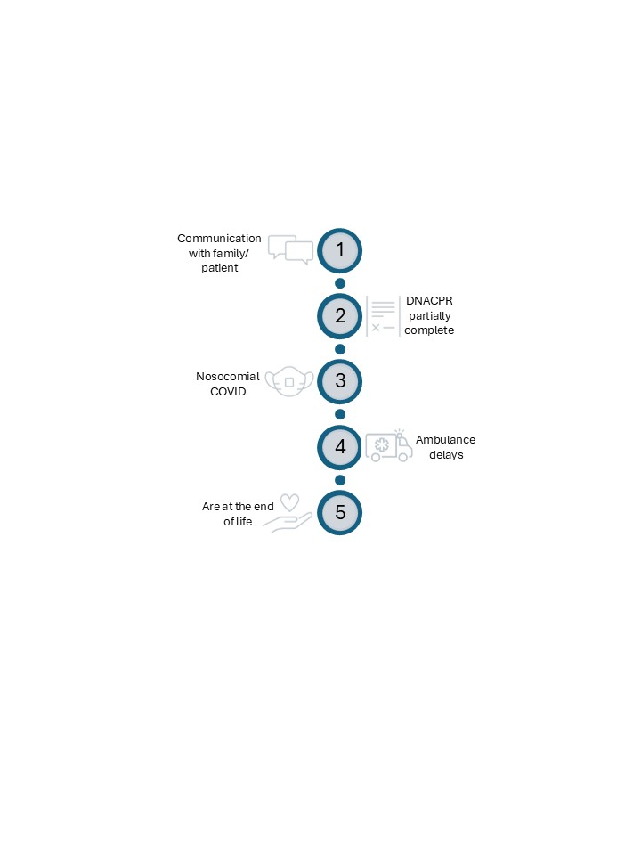

Fig 18., Top 5 themes generated

- Useful Links and Contacts

Thank you for taking the time to read the Clinical Audit Annual Report. Below are some key links and contacts should you have any specific queries in relation to the Clinical Audit Team’s work programme;
Emails | Links
SBU.ClinicalAuditProposals@wales.nhs.uk | Clinical Audit And Effectiveness - Home  Audit Leads  Audit Process at SBUHB  Events
SBU.COEG@wales.nhs.uk | Health Board Priority Topics
SBU.MortalityReview@wales.nhs.uk
SBU.Consent@wales.nhs.uk | Consent - Home

