Meeting Date | 16 September 2025 |  | Agenda Item |  | 6.2
Name of Meeting | Audit Committee
Report Title | Losses and Special Payments Update
Report Author | Alison McLennan, Assistant Director of Finance (Accounting & Governance)
Report Sponsor | Darren Griffiths, Director of Finance and Performance
Presented by | Alison McLennan, Assistant Director of Finance (Accounting & Governance)
Freedom of Information | Open
Purpose of the Report | To provide the Audit Committee with an update on losses and special payments for the period 1 April 2025 to 31 July 2025, and to provide a comparison to the losses and special payments made in the period 1 April to 31 July 2024.
Key Issues | The losses and special payments recorded during the period 1 April 2025 to 31 July 2025 totalled £7,559,386 of which £6,867,880 is recoverable from the Welsh Risk Pool, meaning that the actual loss to the Health Board in the period totals £691,505.  Of the losses and special payments made in the period a total of £320,648 related to cases pre 31 March 2019 for locations which transferred to Cwm Taf Morgannwg Health Board on 1 April 2019 of which the actual loss after recoveries are taken into account was £7,150.  After the recoveries from Welsh Risk Pool are taken into account, there is a net loss of £691,505 to the Health Board for the period 1 April 2025 to 31 July 2025 which is slightly higher than the net loss of £469,082 for the comparable period 1 April 2024 to 31 July 2024.  As in previous years the Welsh Risk Pool risk sharing agreement has been invoked for 2025/26 with the Health Board’s contribution amounting to £5.51m. There is a further £42m potential pressure across NHS Wales, which may require a further contribution of £6.417m for Swansea Bay in 2025/26.
Specific Action Required  (please choose one only) | Information | Discussion | Assurance | Approval
Specific Action Required  (please choose one only) | ☐ | ☐ | ☒ | ☐
Recommendations | Members are asked to:  - RECEIVE the losses and special payments made in the period which will be reported to the Board.

LOSSES AND SPECIAL PAYMENTS UPDATE

- INTRODUCTION
  - The Audit Committee handbook recommends that losses and special payments made by the Health Board be reported to the Audit Committee. This report addresses that requirement by providing an update on losses and special payments, for the period 1 April 2025 to 31 July 2025 and a comparison to the period 1 April 2024 to 31 July 2024.

- BACKGROUND
  - The losses and special payments recorded during the period totalled £7,559,386 with the majority of this comprising payments in respect of Clinical Negligence, Redress and Personal Injury.

  - These losses are detailed in Appendices A to I and summarised below:

Loss Type | Value
 | £
Obsolete Drug Stock | 5,889
Ex Gratia Payments | 8,338
Bad Debts Written Off | 2,073
Redress Payments | 243,563
GP Indemnity Payments | 67,101
Clinical Negligence - Defence Fees | 423,101
Clinical Negligence - Claimant Costs | 1,036,907
Clinical Negligence - Damages | 5,519,101
Clinical Negligence - CRU Payments | 103,999
Personal Injury - Defence Fees | 23,141
Personal Injury - Claimant Costs | 47,078
Personal Injury - Damages | 79,094
Personal Injury CRU Payments | 0
Total | 7,559,386

  - The gross loss of £7,559,386 for the period 1 April 2025 to 31 July 2025 compares to a gross loss of £6,452,628 for the period 1 April 2024 to 31 July 2024. The chart below analyses these losses and special payments on a month-by-month basis. (See 2.4 for an explanation of the negative amount shown for May 2023).

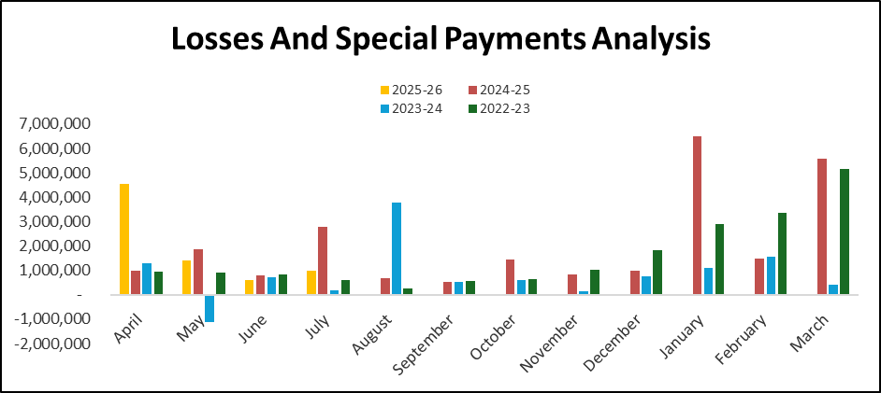

The graph above highlights that there will be variations in payments across the year with there being no discernible trend to when cases are settled.

For the period December 2022 to March 2023 there were also two accrued amounts due for settlement early in the following financial year as shown in the table below.

Case Reference | Location | Specialty | Amount (£)
18RYMMN0122 | Neath Port Talbot Hospital | Women and Child Health | £500,000 paid and £500,000 due for settlement
18RYMMN0107 | Morriston Hospital | Orthopaedics | £1,600,000 due for settlement

During 2024-25 £18,352 defence fees were paid relating to case 0122 (£677k to date)

£460,000 and £29,260 of defence fees (total costs of £ 489,260) has been paid against case 0107, the £1,600,000 provided for at 31 March 2022 was greater than the amount now expected to be paid against this case. During 2023-24 £1,265,000 of the provision was been reversed. This has resulted in the negative amount shown for May 2023 in the graph above.

2.5 The Committee is reminded that as part of the transfer of assets and liabilities arising from the Bridgend boundary change, the transfer order included an exception to the principle that all assets and liabilities transfer for clinical negligence, personal injury and redress cases which were open prior to the date of transfer. Therefore, this report includes payments on cases prior to 31 March 2019 for the Princess of Wales Hospital and will continue to do so until all those cases have closed, a process which will take several years. For the period 1 April to 31 July 2025, the gross losses split by the post boundary change location for these cases is shown in the table below, with the detail shown in Appendices B, D and F to this report.

Loss Type | Total (£) | Swansea Bay Locations (£) | Cwm Taf Morgannwg Locations (£)
Clinical Negligence | 7,083,108 | 6,762,460 | 320,648
Personal Injury | 149,313 | 149,313
Redress | 243,563 | 243,563
Other | 83,402 | 83,402
Total | 7,559,386 | 7,238,738 | 320,648

As at 31 July 2025, the number of open cases for which the Health Board has a provision in its accounts in these 3 categories analysed by location is as follows:

Type of claim | Open Cases Swansea Bay Locations | Open cases Cwm Taf Morgannwg Locations
Clinical Negligence | 244 | 21
Personal injury | 60 | 0
Redress | 146 | 0

- GOVERNANCE AND RISK ISSUES
  - This paper addresses the financial governance requirements for reporting Losses and Special Payments to the Audit Committee. The Health Board adheres to the authorisation process for such payments as prescribed in the Welsh Government Losses and Special Payments manual and Standing Financial Instructions ensuring sound financial governance for such payments.

3.2 The clinical governance issues raised and lessons learned from previous claims are discussed as part of the clinical governance agenda and do not form part of this report to the Audit Committee.
- FINANCIAL IMPLICATIONS
  - The financial implications associated with Losses and Special Payments for the Health Board comprise two elements. Firstly, there is the amount directly taken from the health budget by Welsh Government to fund the Welsh Risk Pool. This is supplemented by a risk sharing agreement across NHS Wales which requires additional contributions to be made from Health Boards and Trusts in the event that the amount required by Welsh Risk Pool exceeds this directly funded amount.

  - For each of the last 4 financial years, the risk sharing agreement has been invoked due to the value of settlements exceeding the amount of the top sliced funding. The risk sharing agreement has again been invoked for 2025/26 and the Swansea Bay share of these costs for 2025/25 amounts to £5.51m, this amount to be deducted from the Health Board’s resource allocation. There is a further £42m potential pressure across NHS Wales, which may require a further contribution of £6.417m for Swansea Bay during 2025/26.

  - The second implication is the net charge to the Health Board’s resource limit of costs incurred which comprise the first £25,000 of all clinical negligence and personal injury claims, legal fees for redress claims which are not reimbursed under the Putting Things Right Scheme and the cost of all other losses and special payments.

  - Of the £7,559,386 net pay out in the period 1st April 2025 to 31st July 2025 and due for payment at 31st July 2025, £6,618,631 in respect of clinical negligence and personal injury claims and £249,249 in respect of redress claims and GP Indemnity Payments is recoverable from the Welsh Risk Pool. Taking this recovery into account, the actual loss to the Health Board in the period totals £691,505.

Losses & Special Payments | Amount
Losses & Special Payments | £
Clinical Negligence | 7,083,108
Personal Injury | 149,313
Redress Payments | 243,563
GP Indemnity | 67,101
Obsolete Drug Stock | 5,889
Ex Gratia Payments | 8,338
Bad Debts Written Off | 2,073
Sub Total | 7,559,386
Less WRP Recovery | (6,867,880)
Health Board Losses in the Period | 691,505

  - Analysing this by location, the net cost to the Health Board split between those cases which are Swansea Bay cases and those pre 31st March 2019 cases relating to locations which have transferred to Cwm Taf Morgannwg Health Board is as detailed in the table below, which shows that £7,150 relates to cases prior to 31st March 2019 for locations which transferred to Cwm Taf Morgannwg Health Board on 1st April 2019.

Loss Type | Total (£) | Swansea Bay Locations (£) | Cwm Taf Morgannwg Locations (£)
Clinical Negligence | 502,595 | 495,445 | 7,150
Personal Injury | 111,196 | 111,196 | -
Redress | 61,400 | 61,400 | -
Other Losses | 16,315 | 16,315 | -
Total | 691,505 | 684,355 | 7,150

  - After the recoveries from Welsh Risk Pool are taken into account, the net loss totals £691,505 for the period 1st April 2025 to 31st July 2025 as compared to £469,082 for the period 1st April 2024 to 31st July 2024.

- RECOMMENDATION

Members are asked to:

- RECEIVE the losses and special payments made in the period which will be reported to the Board

Governance and Assurance

Link to Enabling Objectives  (please choose) | Supporting better health and wellbeing by actively promoting and empowering people to live well in resilient communities
Link to Enabling Objectives  (please choose) | Partnerships for Improving Health and Wellbeing |  | ☐
Link to Enabling Objectives  (please choose) | Co-Production and Health Literacy |  | ☐
Link to Enabling Objectives  (please choose) | Digitally Enabled Health and Wellbeing |  | ☐
Link to Enabling Objectives  (please choose) | Deliver better care through excellent health and care services achieving the outcomes that matter most to people
Link to Enabling Objectives  (please choose) | Best Value Outcomes and High Quality Care |  | ☒
Link to Enabling Objectives  (please choose) | Partnerships for Care |  | ☐
Link to Enabling Objectives  (please choose) | Excellent Staff |  | ☒
Link to Enabling Objectives  (please choose) | Digitally Enabled Care |  | ☐
Link to Enabling Objectives  (please choose) | Outstanding Research, Innovation, Education and Learning |  | ☐
Health and Care Standards
(please choose) | Staying Healthy |  | ☒
(please choose) | Safe Care |  | ☒
(please choose) | Effective Care |  | ☒
(please choose) | Dignified Care |  | ☒
(please choose) | Timely Care |  | ☒
(please choose) | Individual Care |  | ☒
(please choose) | Staff and Resources |  | ☒
Quality, Safety and Patient Experience
Expenditure on losses and special payments arises as a result of clinical negligence resulting in harm to patients and is therefore reflective of poor quality and safety and patient experience. Similarly personal injury payments to patients, visitors and staff reflects poor procedures and management of the hospital environment. Ex-gratia payments also result in poor patient experience through the loss or damage to personal items.

It is therefore imperative that the number and value of losses payments is reduced and the achievement of this reduction will result in improved quality, safety and patient experience.

Financial Implications
The financial implications are detailed in the main body of the report.

Legal Implications (including equality and diversity assessment)
The legal aspects of clinical negligence, personal injury and redress cases are managed through the solicitors employed by Legal and Risk Services who form part of the NHS Wales Shared Services Partnership. The day to day administration of the claims is managed by the Patient Feedback Team within the health board, acting on the advice received from Legal and Risk Services.

Staffing Implications
There are no direct staffing implications associated with this report
Long Term Implications (including the impact of the Well-being of Future Generations (Wales) Act 2015)
The key issue for the “The Well-being of Future Generations (Wales) Act 2015, 5 ways of working is that loss payments and incidents of clinical negligence and personal injury reflect the fact that incidents which cause harm/loss have taken place. It is essential that the occurrence of such incidents is reduced through improved processes, governance and prevention in order to help the Health Board as a public body meet the objective of doing no harm.

Report History |  | This is a regular report to the Audit Committee in line with the agreed work plan.
Appendices |  | Appendices A to I provide the details of all losses and special payments made in the period 1st April 2025 to 31st July 2025.

