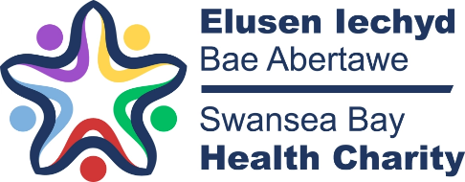
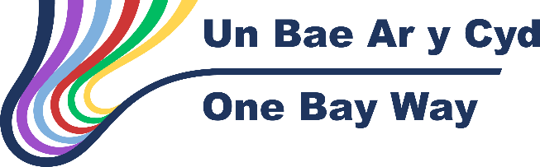

Charitable Funds Expenditure Bids/Legacy Plan Application
This proforma to be completed for expenditure bids >£50,000 and Legacy Plans >£30,000 from a specified charitable fund
Fund Number: YB34

Fund Name: South West Wales Cancer Fund

Type - Expenditure Bid: To Provide a Contribution to Advanced Radiotherapy Cymru (ARC)
Outline the scheme for which you are submitting an expenditure bid or legacy plan (Maximum 250 words)

Advancing Radiotherapy Cymru (ARC) – currently sitting at 3 million pounds over 5 years, with joint contributions from the Moondance Foundation and Velindre Cancer Centre (VCC) Charitable Funds.

Given the All Wales remit, the South West Wales Cancer Centre (SWWCC) and North Wales Cancer Centre (NWCTC) have been asked to consider a contribution.

This proposed contribution has previously been approved in principle by the Health Board’s Charitable Funds Committee in December 2023, following submission of an SBAR outlining the case for the contribution to ARC. At that stage the final TORs etc had not been finalised.

How will funding of this project enhance service provision/benefit staff/enhance patient care (maximum 150 words)

All bids to ARC must meet the following 5 criteria:

- Supporting innovation within radiotherapy treatment, delivering improvement to treatments and services benefitting patients across Wales.
- Training the multi-disciplinary radiotherapy workforce across Wales, supporting service developments within the radiotherapy treatment pathway across Wales.
- Supporting clinically focused radiotherapy research projects.
- Expanding patient access to the SABR service.
- Expanding the stereotactic radiosurgery service.
The Radiotherapy team here at the South West Wales Cancer Centre are continuing to identify projects that can be submitted for consideration for funding from the ARC fund, which fit within the identified aims of the ARC. These are expected to progress the scope and quality of radiotherapy delivered to the population of South West Wales beyond what is currently delivered as core by the HB. Each project will have a clear exit strategy that will not leave the HB responsible for picking up any ongoing costs.
The current status of bids successful and under review are attached,

What are the expected outcomes from this scheme? Maximum (150 words)

The SWWCC has already benefited from access to ARC in the past and sees the potential for our service, radiotherapy staff groups (clinicians, radiographers, physicists) and patients, with the potential to generate more funds than we contribute and gives equity of access as a non-VCC site to the 1.5 million pounds provided by the Moondance Foundation.

Projects funded so far have been supporting development of safer radiotherapy for patients undergoing Radiotherapy to the brain (1st in Wales to implement this technique) and better ways of measuring dose for SABR patients. The findings of the work undertaken in Swansea will subsequently be shared with VCC and NWCTC fulfilling the all Wales remit.

Bid to support bursaries for the Swansea University physics programme will enhance the reputation of SWWCC physics through strengthened collaboration, higher quality research and higher impact publications.

How will you determine if the scheme has been successful and how will success be measured? (Maximum 150 words)

The amount raised through the successful bids being greater than the amount that the SWWCC has contributed (based on yearly totals)
On basis of £10k per year for 5 years, we have in year 1, already received £31,938.
It is anticipated that at end of each year, the amount raised by successful SWWCC bids will be reviewed against the proposed contribution of £10k, and if the former is greater than £10K, then the next £10k will be transferred to the ARC fund.

Has a Business Case been developed for this bid? Has it been discussed with anyone for the HB’s Executive? If so who?

A Business case will be developed for each proposal which will go through the formal SWWCC process, including the Radiotherapy Management Group and Senior Leadership Team (process attached)
It will then be submitted to the ARC Board and undergo a process of external expert review and discussion at the committee meetings.
Why are you preferring to utilise charitable funds for this based as opposed to core funding?

This is a charitable fund scheme – (Moondance and VCC charities have put in the largest amounts of money) and so our contribution is also anticipated to be from our local SWWC charitable fund.

What is the value of funding sought? (Please provide a detailed breakdown of the funding required and how the funding required has been identified) (Maximum 100 words)

The total value of the funding inclusive of VAT is: £50, 000

The plan is for the money to be transferred in 5 divided amounts over the 5 years of the ARC bidding process – i.e. £10k per annum
The CFC would decide at end of each 12 month period if the £10k is to be transferred, based on the amount of money agreed within SWWCC bids approve in the previous year.

Detail any other revenue costs associated with this project and how these will be funded? (Maximum 50 words)

All costs identified in the bid to ARC with no revenue costs for the Heath Board or SWWC Fund

If there are revenue costs, has agreement been sought from the Service Group/Corporate Directorate? Please submit evidence of agreement with this proforma

N/A
see proposal for pathways

Do you any stumbling blocks to implementing this bid/plan?

No further bids approved through the ARC process and in this case, no further funds would be transferred from our charitable fund.

When will the bid/plan be complete?

To date, there have been 2 successful bids, with a further 2 bids currently under review

Total revenue raised for the SWWCC to date is £31,938

The lifetime of the project is 5 years with the total fund divided up into a yearly amount.

Declaration

I confirm that any funding awarded will only be utilised in line with this bid/plan for funding.

Name Sarah Gwynne Role Consultant Clinical Oncologist

Signature Date 15.1.25

I confirm that this bid is supported by the Service Group/Directorate

Name: Sarah Dawtry, Assistant Divisional Manager, Cancer Services

Role: Fund Manager

Signature
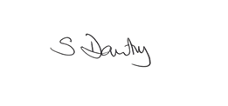
Date: 12-12-2024

FINANCE DEPARTMENT USE ONLY

Date Bid/Plan Received 20th January 2025

Date Scrutinised by Assistant Director of Finance 18th February 2025

Date Discussed by Bids Panel 18th March 2025

DECISION OF CFC

APPROVED/REJECTED/FURTHER INFO REQUIRED

REASON FOR REJECTION

DATE OF CFC

DATE DECISION CONFIRMED TO APPLICANT

Forms to be submitted electronically by e mail to SBU.Endowments@wales.nhs.uk

