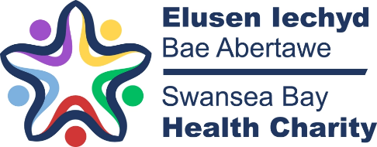
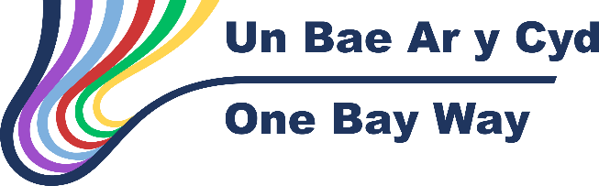

Charitable Funds Expenditure Bids/Legacy Plan Application
This proforma to be completed for expenditure bids >£50,000 and Legacy Plans >£30,000 from a specified charitable fund
Fund Number YB55

Fund Name Ken Holbrook Fund

Type - Expenditure Bid /Legacy Plan
Expenditure bid
Outline the scheme for which you are submitting an expenditure bid or legacy plan (Maximum 250 words)

The Ken Holbrook fund is a restricted fund, set up for the purposes of kidney cancer research. Until now, there have not been any suitable projects to which the funding might be used, but plans are now in place to expand the stereoablative body radiotherapy (where high doses of radiotherapy are given over a smaller number of treatments/fractions) to kidney (renal cell) cancer. We are looking to fund a 1 day a week fellow at SWWCC for 12 months using charitable funds, building on the success of the previous SABR fellow. (funding post using Ken Holbrook fund and Sea Rad Fund already dedicated to funding research fellows)
The focus of this fellowship would be:
- Expansion of SABR for patients with kidney cancer, including move towards this being delivered in single fraction
- Establishment of database to collect toxicity data for patients undergoing SABR.
- Develop a national renal follow up protocol for patients undergoing SABR for renal cell cancer, who are at risk of long-term kidney impairment.
- Engage with local renal oncology /surgical teams to support patients
- Developing a Renal SABR patient information pack, to include:
  - Creating a standard consent form similar to RCR standard form
  - Creating a specific Renal SABR information leaflet
  - Gathering/signposting of resources for patients to access
  - Creating a follow up information leaflet and standard letter for communication with primary care
- Explore the use of Patient reported outcome measures (PROMS) for this patient group

How will funding of this project enhance service provision/benefit staff/enhance patient care (maximum 150 words)

This is one-day a week fellowship that focusses on expanding and enhancing advanced radiotherapy services at SWWCC
It will focus on the expansion of sites for SABR to kidney and subsequently other sites beyond what is currently offered. Having this service available locally will give more treatment options for patients and avoid them needing to travel to Cardiff or further afield for this treatment.
The expansion of the SABR service in SWWCC will enhance the reputation of the SWWCC as a centre of excellence for radiotherapy, with resulting benefit to staff and patients. Recruitment and retention of the multi-disciplinary team is improved.
Having the support of a senior trainee will accelerate the development of the SABR service by implementing the improvement projects in dedicated weekly sessions. The previous fellow demonstrated that significant achievements can be accomplished in one day a week.

What are the expected outcomes from this scheme? Maximum (150 words)

Dedicated time to develop treatment protocols, consent forms, treatment summaries and initial evaluation of PROMS would result in real benefit to patients undergoing renal SABR, and additionally would be applicable to all SABR treatments/patients.
There is interest across Wales to have SABR specific documents which may be adopted by other cancer centres in a pan-Wales approach.
Single fraction SABR and other SABR projects require a significant amount of time working with the wider multi-disciplinary team and coordination across medical and radiotherapy teams. We have already demonstrated that a fellow with dedicated time can manage this complex coordination effectively and in a much shorter timeframe than could be implemented by the SABR consultant team which is currently limited due to time and work constraints. This project will also see advanced training of senior resident doctors in SABR, therefore increasing the number of future doctors trained within this field of oncology.

How will you determine if the scheme has been successful and how will success be measured? Maximum 150 words)

Recruitment of a senior oncology resident doctor in a 1 day a week fellowship
Development of protocols and other supporting documentation for single fraction SABR for kidney and other sites not currently available in the SWWCC. These will be uploaded for local guidelines and used in the management of future patients.
Development of patient centric information to improve communication and understanding of SABR
Local database for monitoring and evaluation of SABR work
Presentation of the work at national conferences (e.g. Wales Cancer Network) and meetings such as the UK SABR consortium
The successful fellow would be expected to produce a report detailing their outputs and achievements over the 12 months.

Has a Business Case been developed for this bid? Has it been discussed with anyone for the HB’s Executive? If so who?

No Business case has been developed for this bid or discussions taken place with HB Executive.
Why are you preferring to utilise charitable funds for this based as opposed to core funding?

The Ken Holbrook fund was set up for the purpose of kidney cancer research and to date it has not been possible to spend these monies for the purposes they were donated. This fellowship provides an ideal opportunity for this.

What is the value of funding sought? (Please provide a detailed breakdown of the funding required and how the funding required has been identified) (Maximum 100 words)

The total value of the funding inclusive of VAT is £ :-

Exact costings for the 0.2 fellow will depend on the experience of the successful applicant. This has been costed at no more than £14,400 .
The Ken Holbrook fuind has £7,1000 in it and the remaining costs of the fellow will be paid from the Sea Rad fund which is for the purpose of funding fellows

Detail any other revenue costs associated with this project and how these will be funded? (Maximum 50 words)

No revenue costs will be associated with this project.

If there are revenue costs, has agreement been sought from the Service Group/Corporate Directorate? Please submit evidence of agreement with this proforma

Not applicable

Do you any stumbling blocks to implementing this bid/plan?

No stumbling block perceived. Once CFC provide consent for the fund to be used for staffing costs a VCF will be submitted for finance approval. The Ken Thomas fund won’t cover all costs of the 1 day a week fellow however there are some funds in the SEA RAD fund (YB50) which are for the purposes of funding staffing that can be utilised to make up the difference in funding
When will the bid/plan be complete?

Plan would be to look to recruit for a January 2026 start with the project being completed January 2027.
Declaration

I confirm that any funding awarded will only be utilised in line with this bid/plan for funding.

Name Kate Ashton Role Oncology Service Manager

Signature 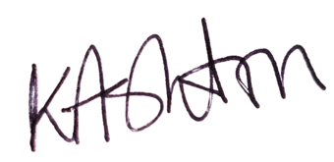 Date 22.9.2025

I confirm that this bid is supported by the Service Group/Directorate

Name Ceri Gimblett Role: Serivce Group Director

Signature 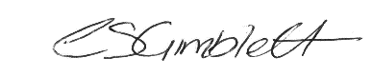 Date 27.11.25

FINANCE DEPARTMENT USE ONLY

Date Bid/Plan Received

Date Scrutinised by Assistant Director of Finance

Date Discussed by Bids Panel

DECISION OF CFC

APPROVED/REJECTED/FURTHER INFO REQUIRED

REASON FOR REJECTION

DATE OF CFC

DATE DECISION CONFIRMED TO APPLICANT

Forms to be submitted electronically by e mail to SBU.Endowments@wales.nhs.uk

