Business Case: Welfare Service provision for Armed Forces Community patients at Swansea Bay University Health Board
Presented by Defence Medical Welfare Service

DMWS Overview

Defence Medical Welfare Service (DMWS) are an independent charity that deliver professional, confidential, and individualised physical and mental health and wellbeing support to members of the Armed Forces Community (AFC) and frontline services including Police and NHS staff.
We are there for those who serve when they need us, through the stress and uncertainty of medical treatment and beyond.
Many of our projects are based in hospital settings, allowing us to provide direct support at the bedside, back home and in the community. Our in-person services reach across the UK and Cyprus, as well as our National Response Phone Service to support those who are not within reach of one of our locations. DMWS services are free to beneficiaries with no limit to our amount of contact.
We have worked in a variety of operational settings, including overseas deployments, day-to-day operational settings, training exercises, and in response to major incidents. Through this we have developed sector-leading ability and experience through long-term organisational innovation, using our current and historical knowledge of working alongside the military for over eight decades.
We are proud to have a highly regarded reputation for delivering professional services and seeing our support through.

Our footprint
- Embedded in over 46 NHS Trusts and Boards with reach into local communities
- UK-wide National Response Service helpline
- MOD Hospital Welfare Service provider
- Supporting accreditation from Veteran Covenant Healthcare Alliance
- Op Restore delivery partner; Op Courage – two-way referral partner
- Specialist support for Police and NHS Staff in frontline high trauma roles

Our objective:
DMWS are there for those who serve when they need us. With our military background and expertise, we take the time to build trust, assess and tackle non-clinical issues that contribute to poor physical and mental wellbeing, stress and anxiety, negative healthcare experiences, delayed discharged from hospital and avoidable readmissions to hospital.

DMWS’s objective is to break down barriers to improved physical and mental wellbeing, to reduce delays from being discharged from hospital, and to reduce unnecessary readmission to hospital.

Our highly trained teams effectively address a wide range of complex issues including poor health, concerns about treatment, social isolation, homelessness or housing precarity, financial worries, substance misuse, relationship issues, chronic pain, neurodiversity, and thoughts of suicide or self-harm., mental health concerns, drug and alcohol misuse and unemployment. Our support caters to fit the unique needs of each individuality, taking into account those who may face barriers to typical pathways, such as people with neurodiversity, accessibility difficulties, and mental and physical disabilities.

Our expert welfare professionals ensure that the needs of the Armed Forces Community and their family members/carers are addressed by supporting their physical and mental health and wellbeing needs and recovery, ensuring they are not facing struggles and fears alone. By dedicating the time to listen, our service ultimately prevents escalation to crises requiring acute services and reduces the time taken to be discharged, reduces unnecessary readmissions, and improves overall wellbeing.

We work within the healthcare pathway and community to develop strong links and interactions across a variety of statutory and non-statutory organisations, that contribute to long-term support for the patient when they leave hospital. DMWS supports the beneficiary and their family members/carers, to assess their needs and provide support to identify and access solutions to improve physical and mental wellbeing. Referral pathways will be built with the NHS Trust and the wider community.

We help people to:
- Have better experiences of healthcare and recover more quickly
- Feel less stressed and anxious
- Access financial support to reduce the stress of money
- Feel less lonely and more connected to their communities
- Enjoy positive relationships with families and friends
- Find and stay in safe housing
- Learn strategies to reduce alcohol and drug misuse
- Access treatment for mental health illnesses such as PTSD
- Stop thoughts of taking their own life, find purpose and happiness
- Find meaningful employment or volunteering after service

Our case studies in Appendix 1 provide useful examples of what we do.

In Appendix 2 We have shared extracts of data from another location as an example of data collected

Our Proposal
DMWS are proposing a joint funding approach with Swansea Bay University Health Board to deliver a Welfare Service (4 day per week equivalent service provision) in Swansea and reaching into the community, with the additional support of the DMWS infrastructure to provide management, supervision, data collection, control and analysis, reporting, training, safeguarding, and business continuity.

Joint funding would be:
- £26,062 contribution from Swansea Bay University Health Board
- £20,000 contribution from Defence Medical Welfare which has been secured via a consortium of donations from supportive Trust and Foundations
A breakdown of the costs of service is provide below.
Item | Welfare Service Provision 1 Year | 4 day a week equivalent service
Welfare Provision including recruitment, Operational Manager and Director oversight, supervision central support, data governance, finance | £48,932.00 | £39,145.60
Nationwide Support line (triages and directs calls) | £1,100.00 | £880.00
IT support and phone | £1,236.00 | £988.80
Training and CPD | £1,143.00 | £914.40
Welfare Officer and Manager Travel | £2,961.00 | £2,368.80
Marketing and promotion | £976.00 | £780.80
Evaluation | £1,230.00 | £984.00
Total 1 year Welfare Provision Costs | £57,578 | £46,062.40

Evidence of Need
Illness or injury, undoubtedly, causes great stress and anxiety and it can be difficult to identify and address the wider issues that can cause barriers to recovery and contribute to unnecessary readmission. It can also be very difficult to navigate the health pathway and to understand and access support from the plethora of statutory and third-sector organisations which can offer support.
We work with patients when their medical needs are being met but other issues, problems or, social influences may be hindering their recovery. We offer support to the service user and their family directly, but also health care providers and clinical staff by freeing up their time concentrate on their core duties.

Those from a military background can be unsure of civilian systems that they may have little experience of, or be hesitant to open up or ask for help if they are used to being in a protector role or taking orders. Physical and mental health issues may also be affecting how they interact and connect with support. However, a military informed approach can help ease communication struggles and stop individuals dropping out of the system, helping them see support through and minimize escalation to crisis or readmission.

In the 2021 Veterans Census, around 8074 people in Swansea reported that they had previously served in the UK armed forces. Representing 4.1% of usual residents aged 16 years or older and is almost 1 in 22 people aged 16 years or older.

Proposed Beneficiary Numbers

The DMWS Welfare service will aim to support, each year, approximately:
  - 65 direct beneficiaries
  - 180 Indirect beneficiaries

These numbers are indicative and will depend on the complexity of cases and number of issues presented, however this is a good estimate of what can be expected.

The Approach

Our Welfare Service will be made of DMWS employees and paid and managed through the DMWS structure. DMWS will supply all equipment (surface pro, computer, and mobile phone).

The team would require an honorary contract from the hospital.
From our experience we know that an identification and tracking system is hugely beneficial for flagging patients with a military connection. DMWS can discuss what systems have been used effectively in other hospitals we operate in.

The DMWS Welfare Officer will provide confidential, independent and holistic practical and emotional support to the Armed Forces Community (serving, reservists, veterans and their families) at the bedside and through their return home. They will take the time to listen and make assessments, using measures such as ONS4 and EQ5DL, to identify the wider social, environmental, and economic determinants of health. These issues can cause barriers to recovery, delay transfer of care, cause unnecessary readmissions, enhance social isolation, and impede confidence and self-management. Our team will then develop a care plan with the individual to tackle these non-clinical barriers to recovery, such as anxiety, stress, poverty, and social isolation.
At a stressful and confusing time, we navigate the individual as well as their family through the complex health service. Our expert welfare professionals ensure that our beneficiaries’ needs are addressed, and their physical and mental wellbeing, their recovery, and their home lives are improved.
Through effective partnership working, we make supported referrals to statutory or third sector organisations where needed. We use our expert knowledge to access and mobilise statutory and third sector support to enable our beneficiaries to return home and reduce the likelihood of unnecessary readmissions. All of this has a positive impact on health and wellbeing as well as a proven financial benefit for the health sector.

Key activities include:
- Unlimited contacts for direct emotional and practical support to the patient and their family.
- Assessment of social care and wellbeing issues to understand, research and identify solutions.
- Advocacy and advice which is sensitive to the military context.
- Liaison with medical and safeguarding teams, support hospital discharge planning, and support in community health settings.
- Engagement with appropriate service providers
- Care navigation and social prescribing.
- Advocacy and supported referrals to appropriate statutory and 3rd sector organisations.
- Develop an individualised support packages that endure and build independence and resilience for the patient and their family.

DMWS Delivery Model
The DWWS Welfare Officer will receive referrals from hospital staff (clinical and administrative), statutory, military and third sector organisations, and self-referrals. Response times are typically within 1-2 days. On initial contact the Welfare Officer will complete a needs-based assessment to identify the issues that the person presents as well as the impact their difficulties arehaving on them. A complexity score is generated and a person-centered support plan agreed. Our staff provide immediate intervention which includes liaison with health teams, social care staff, family and other statutory and third sector organisations.
DMWS work in close collaboration with several military and non-military organisations and statutory and non-statutory organisations to receive referrals and facilitate supported onwards referrals so there is a significant force multiplier effect. This also helps to ensure positive outcomes endure.
The referral process is shown in the following diagram.

Our Welfare Service has proven outcomes for patients which include:
- Improved mental and physical health and wellbeing for members of the military community who are on a physical or medical healthcare pathway
- Improved healthcare experiences
- Reduced stress and anxiety
- Shorter waiting times for discharge from hospital and improved patient flow
- Help to prevent avoidable readmissions
- Alleviated social isolation and loneliness
- Reduced financial worries through securing eligible benefits
- Improved access to safe housing
- Reduced likelihood of issues escalating to crisis
- Enabled independent living

DMWS will also:
- Release clinicians to do clinical work
- Provide experts in NHS, Statutory, and Third Sector Health & Social Care, Care Navigation, Social Prescribing, and a Single Point of Contact
- Provide experts in specialist military organisations and the services that are available to the military community– we are a COBSEO Executive Member
- Help the Trust to meet the Armed Forces Covenant Duty and achieve VCHA accreditation.

Monitoring and Reporting
DMWS use our own bespoke, UK GDPR-compliant case management system to collect service user information, baseline data, progress and outcomes achieved. We also collate all referral organisations that we have mobilised on behalf of the individual. This data is logged using individual tablet devices and enables us to review and analyse cases. This allows us to draw impact measures from the assessment process and show the level of change achieved for each individual as well as the success of the service as a whole. Data that we collect includes:
• Beneficiary data including age, service, sex, ethnicity (by permission and GDPR compliant)
• Referrals in and out (linked organisations)
• Issues and concerns
• Levels of complexity
• Progress of outcomes against the issues
• Number and types of contacts
We conduct a thorough assessment which is person-centred and responsive without being intrusive. The assessment framework is underpinned by the 5 Principles of Welfare to identify needs and includes a wellbeing measure, Office for National Statistics 4 (ONS4), which is a recognised survey consisting of four questions. This allows us to easily assess, identify concerns, and track changes in wellbeing without overwhelming the individual and can be used alongside economic measures. It is user-friendly and can be emailed directly from our Portal to the service user and updated remotely, promoting completion. This is combined with DMWS’s unique Wellbeing Complexity Measure to understand the cumulative impact that issues are having on the individual and the severity of these complexities.
DMWS can therefore evidence its outcomes and impact for beneficiaries and the organisations we work with. We would provide regular reports (time frame to be agreed) showing agreed data and outcomes.

For further information please contact
Jess Liston Director of Services England and Wales Email: jliston@dmws.org.uk or
Siobonne Brewster, Director of Development – sbrewster@dmws.org.uk

Appendix 1 Case Studies
Case study 1 - 67-year-old Navy veteran and his daughter/main carer
DMWS received a referral from Emergency Occupational Therapy to support John, a 67-year-old Navy veteran, and his daughter who is his main carer. Our Welfare Officer visited the veteran at his bedside while he was in hospital, and talked to him about his service history and his current wellbeing. John felt comfortable talking to our Welfare Officer, and with no time constraints the two were able to talk comfortably, allowing John to open up at his own pace. Our Welfare Officer also spoke with his daughter, Jane, and identified ways to help her care for her father; this included accessing benefits and identifying needs at home to prepare him for a successful discharge such as installing a ramp at his door and a medication safe. Our Welfare Officer also connected the veteran and his daughter to local groups so they could feel included in the community and get support from others like them.
One week later, Jane called DMWS in a panic about her father’s leg which was swollen. She felt like no-one was listening and was about to call 999. Our Welfare Officer listened to her concerns and escalated them to a GP who assessed John the same day and prescribed medication to help. This prevented a call to emergency services and alleviated stress for them both.
DMWS also supported John completing his applications for a Blue Badge and bus pass which were approved, allowing him to maintain some independence and get out and about. We arranged a community Occupational Therapy home visit with the Housing Officer to discuss the best ramp for John and sourced funding for this through a veteran’s charity.
After all the support DMWS provided, John is now able to remain at home with confidence and independence. He attends a weekly coffee morning to meet others and Jane has joined a carer’s group, receiving support and training so she can continue to look after her father. Both are very grateful for the support they have received, feeling confident in their ability to tackle the everyday.

Case study 2 - 55-year-old Army veteran Nurse struggling with undiagnosed PTSD
DMWS received a referral from a hospital’s HR department to support Jake, a nurse who had previously served in the Army. Jake was off sick from work due to poor mental health following an investigation. Our Welfare Officer reached out to Jake to see how we could help. After talking with Jake and building trust, we referred him to Op COURAGE, the specialist NHS veteran mental health service, as well as his local Veterans Hub for some social activities. We determined that Jake preferred to be contacted by email as it felt less daunting.
Two weeks later, Jake expressed worries about returning to work after being away for three months. We suggested meeting Jake at the hospital for a coffee to help remove the fear around being back in the hospital setting. During the meeting, Jake revealed he had been struggling with PTSD for many years, but he had thought it was depression from work. He had been engaging well with the support from Op COURAGE and was receiving the appropriate therapy to help him.
Our Welfare Officer met weekly with Jake at the hospital, encouraging him to visit different areas of the site. One month after the referral, Jake planned to return to work as he now felt able to. We agreed to meet him for lunch on his first day back and did this for the first week. Jake returned to full-time work on his original duties and contacted our Welfare Officer as and when he needed support; he also attends a weekly social group.
We recently met with Jake again who now feels well-equipped to self-manage and that he does not need any further support. This is a fantastic outcome and we wish Jake all the best.

Case Study 3 - A frequent attender
Tom was a patient with complex mental health issues and alcohol dependency. There were safeguarding warnings due to mental health (diagnosis schizophrenia) and aggressive behaviours.
In a 12-month period, Tom had 8 inpatient admissions prior to the DMWS referral. These admissions averaged 7-14 days and very sadly this was 30-year pattern and with a known long term history of alcohol misuse. There had been multiple avenues of support previously explored and at the stage DMWS was introduced Tom was refusing to re- engage. There was a very complex social picture and details of any support he had received were similarly complex and confusing.
Tom was completely overloaded, disengaged and confused as who could do what to help him. DMWS started to support Tom, building rapport and trust and our engagement included 138 contacts which provided far reaching comprehensive support including
• Regular engagement, emotional and practical support
• Liaising with health staff in the hospital
• Support to access and engage with Mental health services
• Support to access and engage with Social care
• Support for the family
• Advocacy role
• Supported referrals to ensure these were effective and that Tom stayed engaged
• Support to obtain unclaimed benefits

DMWS coordinated 7 organisations who were all involved with this patient and importantly acted as a bridge of communication for Tom who couldn’t manage all of these avenues independently
DMWS’s engagement with Tom delivered fundamental changes and positive impacts including
• Supporting Tom to attend his first ever therapy sessions to stabilise PTSD
• Helping Tom get and take his first ever prescription of medication for PTSD - previously unsafe due to his alcohol consumption levels
• Decluttered chaotic support environment where Tom found he had too many people to cope with
• Social prescribing to remove loneliness which help reduce his alcohol consumption
• Getting Tom joined in with physical activities: improving his physical and mental wellbeing as well as improving his resilience and reduced recovery time after relapse
• Helping to calm his challenging behaviour as he know felt supported and more able to cope
• Stopping his Do Not Attend behaviour at outpatient appointments

And fantastically this led to an 87% reduction is his avoidable readmissions which presented a cost saving of £30,800 if a readmission cost on average £4,400. This doesn’t include the cost savings for improving his mental health, avoiding a mental health crisis and the effects of ongoing alcohol misuse. Most importantly Tom is feeling positive and is improving his self-management and wellbeing.

Appendix 2 Example data from a current project – data for 2025

Beneficiary numbers and profile
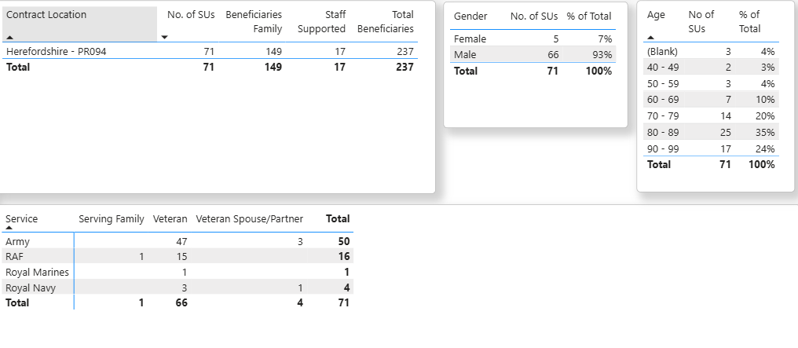

Complexity Impact Levels
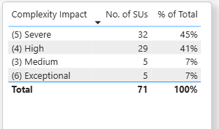

Top complexities reported
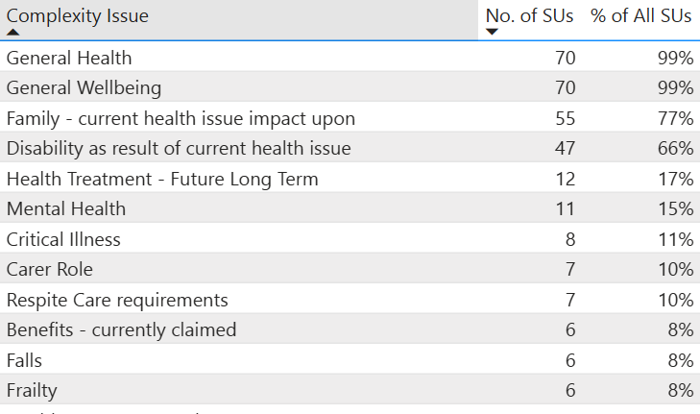

DMWS Typical Top Outcomes
- improved healthcare experience
- from reduced social isolation
- Improved mental wellbeing including reduced mental health care crisis intervention

